Original Research Article

Effect of Applied voltage, Liquid Flow Rate and Electrode Material on Spray Chargeability of Induction-Based Air Assisted Electrostatic Nozzle

ABSTRACT
The success of induction-based electrostatic applications is influenced by the ability of liquid droplets to hold a charge. Dynamic measurement of spray cloud current for assessment of spray chargeability was measured using Faraday cylinder test rig. The chargeability of electrostatic sprays can be improved for more effective use by adjusting the combination of electrode material, the voltage applied to electrode, and the rate at which the liquid flows. Typically, a voltage of 5 kV and a lower flow rate of 60 ml min⁻¹ resulted in higher chargeability, with a spray cloud current of 4.43 µA and a charge-to-mass ratio of 4.43 mC kg⁻¹, while using a copper electrode, as opposed to aluminium and brass electrodes. The findings of this research are expected to aid in more precise and environmentally friendly application of sprays and the development of appropriate and cost economic electrostatic spraying systems.

Keywords: Charge-to-mass ratio; Faraday cylinder; Spray chargeability; Spray cloud current.
1. INTRODUCTION
Pesticide application in agriculture is crucial for reducing crop losses from pests, diseases, and weeds globally as well as in India. The global use of pesticides has significantly increased over the past few decades, driven by intensification of agricultural practices to meet the rising demand for food (FAO 2020). However, concerns about their effects on health and the environment have led to scrutiny of usage pattern (Reddy et al., 2024). Over half of the world's pesticides are used in Asia, with India ranking 12th globally and 3rd in Asia. In 2018, India used about 58,160 tonnes of pesticides, with a per hectare rate of 0.31 kg in 2017 (Nayak & Solanki, 2021). Despite India's low per-hectare usage of 0.4 kg compared to China's 1.83 kg, pesticide contamination in the food chain is a major concern (Reddy et al., 2024). Therefore, efficient pesticide use is crucial, as improper application without suitable technology can lead to environmental contamination, leave residues in food, and increases health risks for farmers. Reports indicate that spraying is often inefficient, with either excessive or insufficient amounts of the active ingredient reaching the target; in some instances, over half of the pesticides are wasted because they fail to hit the intended targets, resulting in environmental problems and ineffective spraying (Jyoti et al., 2019 & Sasaki et al., 2013). To address these application challenges, enhance spraying efficiency, cut costs, and minimize environmental impacts, new technologies have been developed. Notably, the electrification of droplets using electrostatic sprayers is particularly noteworthy. Induction-based air-assisted electrostatic nozzles for agricultural sprayers have shown significant potential for improving pesticide application efficiency and reducing environmental pollution. These nozzles combine the benefits of air assisted atomization and electrostatic charging to enhance droplet deposition and penetration in crop canopy (Dai et al., 2023). Electrostatic charging improves droplet deposition on target surfaces, with charge-to-mass ratios (CMR) playing a crucial role in effectiveness of spray (Zhou et al., 2024). An induction-based atomisation system utilises pneumatic atomisation to produce fine droplets, typically in the range of 30-50 μm volume median diameter (VMD) (Law, 1983). The optimisation of these nozzles requires careful consideration of various parameters. Electrode material plays a key role in induction charging of ﬁnely divided particulate matter in electrostatic pesticide spraying nozzle system because the performance and characteristics of different electrode materials are different in term of the performance parameter i.e. charge-to-mass ratio (Mamidi et al., 2013, Patel et al., 2013). Additionally, factors such as nozzle construction, liquid flow rate, and spray angle should be considered in the design process (Zhang et al., 2021; Zhou et al., 2024). However few literatures have been reported on the inﬂuence of applied voltage, liquid ﬂow rate, and properties on chargeability. It was reported that applied voltage has a categorical inﬂuence on spray chargeability and generally increase in voltage up to a limit increased the spray charge (Maynagh at al., 2009, Yuan et al., 2000, Zhao et al., 2008). Though, sufficient work on induction-based air assisted electrostatic spraying has not been performed to make it economically viable for localised production. This article details an air assisted nozzle which successfully adapted an induction charge based electrostatic spraying. It also discusses the characterisation of parameters like electrode material, applied voltage and liquid flow rate to enhance the efﬁciency of the system that can be attractive for the small and medium scale farmers.
2. MATERIALS AND METHODS
2.1 Spraying nozzle
Electrostatic spraying is predominantly used in ultralow-volume applications. The electrostatic nozzle primarily consisted of two components: an electrode and an air-assistance system. Therefore, a commercially available air-assisted nozzle (Atul.A56.5.082.01) was selected for the development of an electrostatic nozzle (Fig. 1). Atomisation of the spray liquid in air-assisted nozzles is achieved using compressed air at high pressure while maintaining a low water pressure. This process results in the fine atomisation of droplets while ensuring a low application rate. The nozzle is equipped with an anti-dripping diaphragm mechanism, which closes nozzle opening below 3 bar air pressure, hence prevent charge dissipation due to dripping of the spray liquid onto the electrode.
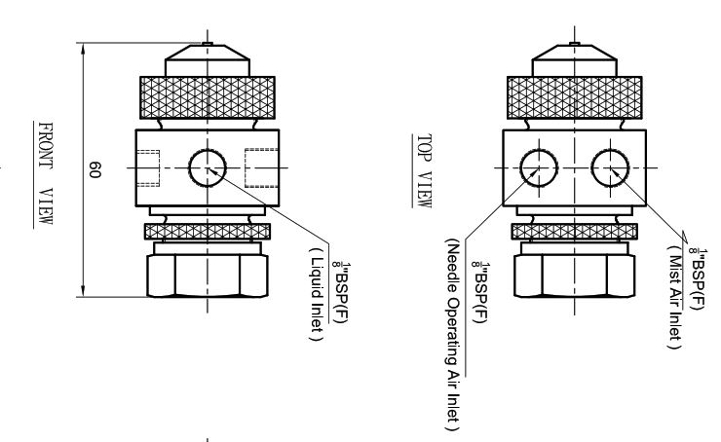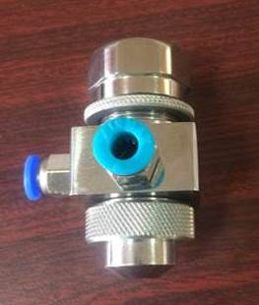
Fig. 1: CAD drawing with different views of air assisted nozzle

This air-assisted nozzle was modified to accommodate the electrode placement for induction-based electrostatic charging. A cone-shaped structure made of Teflon material was fabricated to place the electrode. This Teflon covering served as an insulation chamber, ensuring the prevention of the electrode from charge dissipation (Fig. 2).
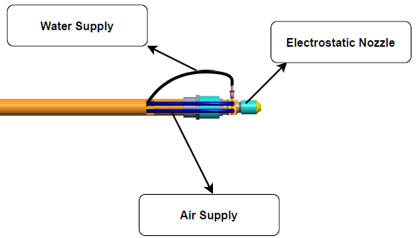 | 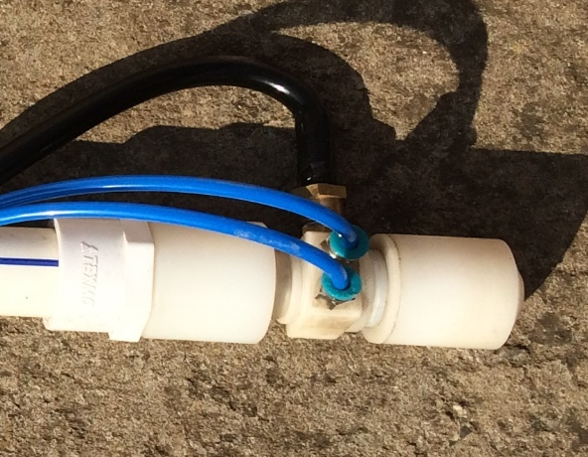
Fig. 2: Air assisted electrostatic nozzle
2.2 Spray charge acquisition and measurement system
An experimental set up was developed for characterization of nozzle operational parameters. The experimental set up consists of Faraday’s cylinder for collection of charged spray droplets and high voltage generations unit to regulate the voltage supply for electrode at five different levels (2,3,4,5 and 6 kV) and a high voltage measurement unit to measure charge carried by spray droplets (Fig. 3).
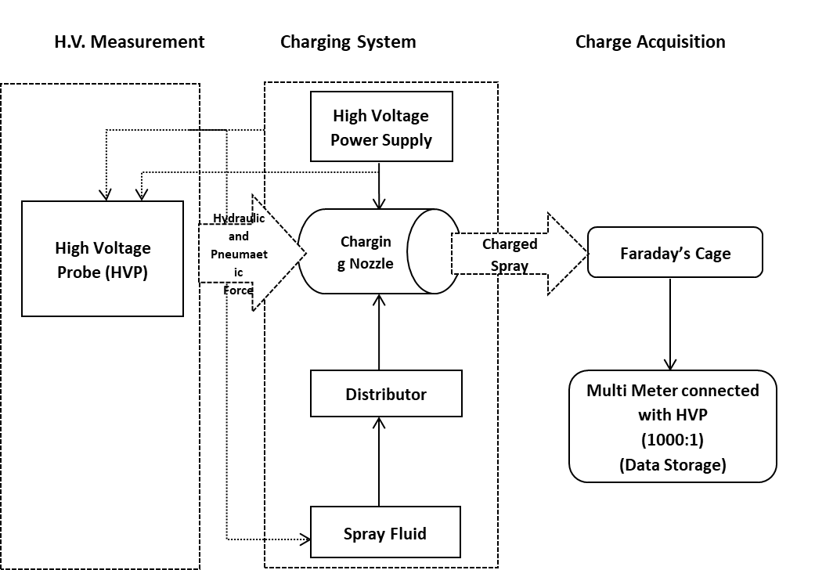
Fig. 3: Experimental setup for testing of electrostatic nozzle
2.2.1 Faraday's cage
A Faraday cylinder test rig was developed to assess the Charge-to-Mass Ratio (CMR) of spray droplets, as outlined by Maski and Durairaj (2004). This apparatus functions on the principle that a Faraday cage captures and transfers all charge carried by the spray fluid to its conductive structure. The Faraday cage comprises a hollow cylindrical drum with length of 900 mm and a diameter of 550 mm, constructed from 16-gauge galvanized iron sheet, featuring an open top to accommodate the charging nozzle and ensure complete entry of the sprayed fluid into the cage. To enhance the interaction between the charged liquid and the conducting surface, three circular sieves made of 1 mm stainless steel mesh were positioned at equal intervals of 200 mm from the bottom. This configuration facilitated efficient charge transmission to the cylinder’s conductive body. A tap was installed at the bottom of the drum to allow for the drainage of the spray liquid as necessary. The cylinder was mounted at 10-degree angle on an insulated frame with nylon wheels (Fig. 4) to enable easy movement and electrical isolation.
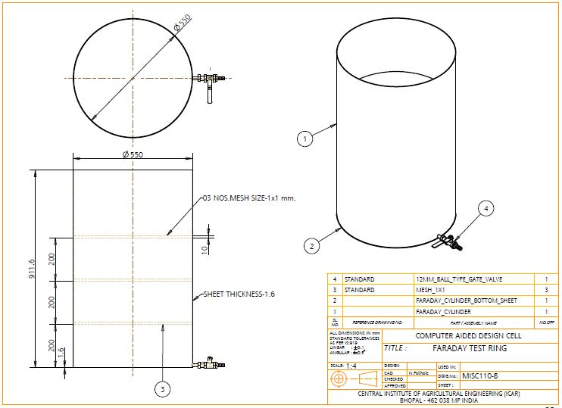 | 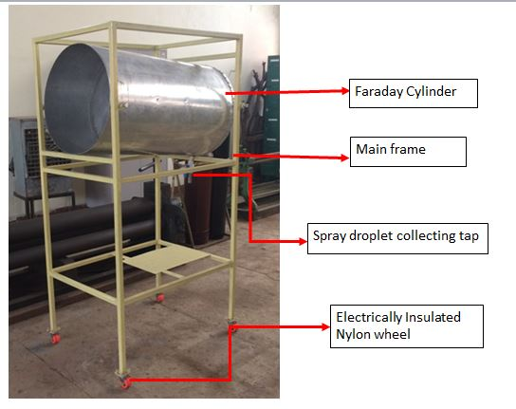
Fig. 4: Dimensional specifications and set up of Faraday cylinder
2.2.2 High voltage generation and measurement unit
A high voltage module was selected to generate the required high voltage for electrostatic charging of the spray droplets. This module was calibrated using oscilloscope and a high voltage probe. The module gave a linear relationship between input and output voltage with attenuation factor of 1kV. A power supply was used to provide regulated DC voltage. Output voltage at the sprayed droplets was measured using Meco 81 USB digital multimeter with PC interface, which had voltage accuracy of ±0.3%.
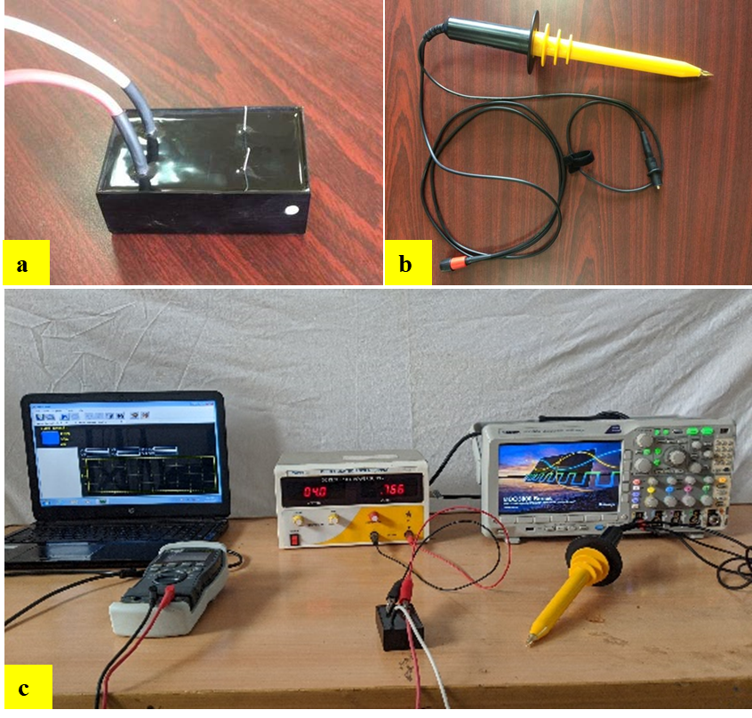
Fig. 5: Instruments used for study, (a) high voltage module, (b) high voltage osciloscopic probe, (c) high voltage generation and measurement unit
Following the development of both components of the experimental setup, namely the Faraday cylinder and the high voltage generation and measurement unit, these components were integrated to create the final setup for testing and optimizing the operational parameters of the nozzle (Fig. 5). As droplets emerge from the nozzle, charge transfer occurs due to the electrostatic induction of electrons onto the axial jet, maintaining it at ground potential in the presence of the nearby charged cylindrical electrode. Individual droplets formed from this negatively charged continuous jet depart with a net negative charge, provided that the droplet-formation zone between the nozzle and the cylindrical electrode is subjected to the inducing electric field acting between the cylinder and the jet. The Faraday cylinder was positioned in front of the induction nozzle to collect the charged spray droplets, thereby estimating the charge acquired by the spray droplets (Fig. 6). The spray cloud current and voltage were recorded using a high voltage probe in conjunction with a multimeter.
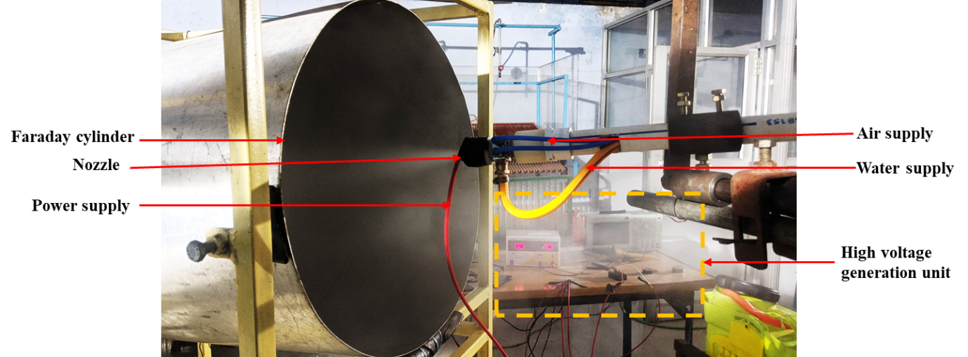
Fig. 6: Charge acquisition on sprayed dropelets and collection in Faraday cylinder
2.3 Experimental plan and analaysis of data
All experiments were conducted at the Plant Protection Laboratory of the ICAR-Central Institute of Agricultural Engineering (CIAE), Bhopal. Temperature and relative humidity of the workplace was recorded as 26±1°C and 60±2%. A Factorial randomized block design was employed to investigate the effects of electrode material, flow rate, and applied voltage. The charge imparted to the droplet is contingent upon the conductivity of the electrode material (Jyoti et al., 2020); therefore, three types of electrode materials, namely aluminum, brass, and copper, were chosen due to their economic viability and availability. The voltage significantly influences the chargeability of spray droplets up to a certain maximum level (Zhao et al., 2005). This effect is particularly pronounced in the case of induction charging, thus five levels of applied voltage, specifically 2, 3, 4, 5 and 6 kV, were selected to meet the requirements of the present study.
List 1- Independent and dependent parameters
S. No. | Independent parameters | Levels | Dependent parameters
1 | Electrode material | 3 | 1. Spray cloud current  2. Charge to mass ratio
2 | Flow rate | 4 | 1. Spray cloud current  2. Charge to mass ratio
3 | Applied voltage | 5 | 1. Spray cloud current  2. Charge to mass ratio
4 | Replications | 5 | 1. Spray cloud current  2. Charge to mass ratio
5 | Total no. of experiments | 300 | 1. Spray cloud current  2. Charge to mass ratio
Statistical Design: Factorial randomized block design

3. RESULTS AND DISCUSSION
The effect of flow rate, applied voltage and electrode material on spray cloud current and CMR were analysed using full factorial method and the comparison of the means of each level was performed using Tukey’s (b) method. The analysis was done at 5% level of significance. The statistical analysis was performed using Design expert-13 and SPSS-V20 software.
Table 1: Mean value of parameters affected by voltage, flow rate and electrode material of electrostatic nozzle
Source of Variation | Spray cloud current (µA) | CMR(mC kg-1)
Voltage (kV)
2 | 2.47^{d} | 1.76^{d}
3 | 3.38^{c} | 2.41^{c}
4 | 3.83^{b} | 2.73^{b}
5 | 4.04ª | 2.89ª
6 | 4.05ª | 2.89ª
Flow rate (ml/min)
60 | 3.57^{b} | 3.57ª
80 | 3.62ª | 2.72^{b}
100 | 3.50^{d} | 2.10^{c}
120 | 3.52^{c} | 1.76^{d}
Electrode material
Aluminium | 3.12^{c} | 2.23^{c}
Brass | 3.68^{b} | 2.62^{b}
Copper | 3.86ª | 2.75ª
**superscript having same alphabets are statistically similar

Table 2: ANOVA table for effect of electrode material, applied voltage and flow rate on spray cloud current and charge to mass ratio (CMR)
Response | Spray cloud current |  |  |  |  | CMR
Source | SS | df | MS | F-value | p-value | SS | MS | F-value | p-value
A- Applied voltage | 105.9 | 4 | 26.477 | 15042.431 | <0.001 | 54.066 | 13.517 | 10097.107 | <0.001
B- Flow rate | 0.72 | 3 | .239 | 135.859 | <0.001 | 143.070 | 47.690 | 35625.338 | <0.001
C-Electrode material | 29.81 | 2 | 14.90 | 8467.442 | <0.001 | 14.890 | 7.445 | 5561.436 | <0.001
AB | 1.40 | 12 | .117 | 66.539 | <0.001 | 5.299 | .442 | 329.870 | <0.001
AC | 0.48 | 8 | .060 | 33.878 | <0.001 | .334 | .042 | 31.162 | <0.001
BC | 1.45 | 6 | .242 | 137.658 | <0.001 | 1.398 | .233 | 174.095 | <0.001
ABC | 2.75 | 24 | .115 | 65.122 | <0.001 | 1.330 | .055 | 41.383 | <0.001
Error | 0.42 | 240 | .002 |  |  | .321 | .001
Total | 3932.6 | 300 |  |  |  | 2153.18
Cor Total | 142.94 | 299 |  |  |  | 220.708
R² | 0.86 |  |  |  |  | 0.94

3.1 Effect of flow rate and applied voltage on spray cloud current for different electrode materials
The statistical analysis indicated that the all the three parameters i.e., flow rate, applied voltage and electrode material had significant effect on the spray cloud current at 1% level of significance (Table 1).
It was observed that both first-order and second-order interactions among flow rate, applied voltage, and electrode material were significant (Table 2). The table indicates that the spray cloud current increased significantly with applied voltage from 2 to 5 kV, but no significant difference was observed between 5 and 6 kV at the 5% level of significance. The means of all four levels of flow rate were significantly different from one another. The values of spray cloud current were significantly different for all three electrode materials. The 3D surface plot demonstrated that the maximum spray cloud current, 4.43 µA, was observed at an applied voltage of 5 kV and a flow rate of 60 ml min⁻¹for the copper electrode (Fig. 7). Conversely, the minimum spray cloud current, 1.80 µA, was observed at an applied voltage of 2 kV and a flow rate of 120 ml min⁻¹for the aluminium electrode. The spray cloud current exhibited an increasing trend with the increase in applied voltage for all three electrode materials. However, the spray cloud current remained nearly constant with the increase in flow rate for all three electrodes. The increase in spray cloud current due to the increase in applied voltage is likely attributable to the intensification of the electric field at the point of liquid atomization (Gaunt et al. 2003).
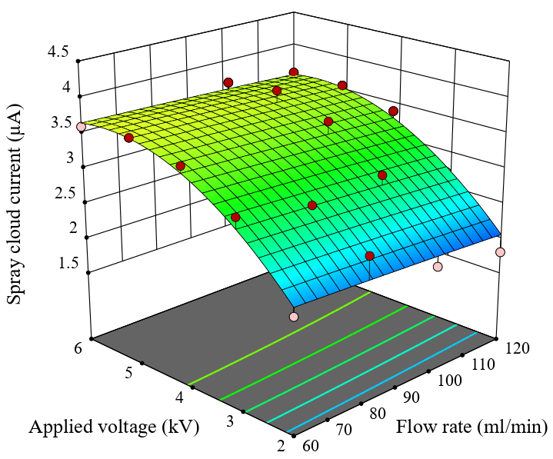 | 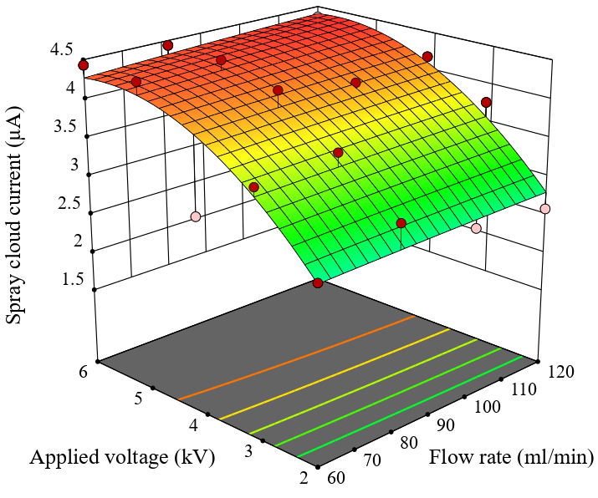 | 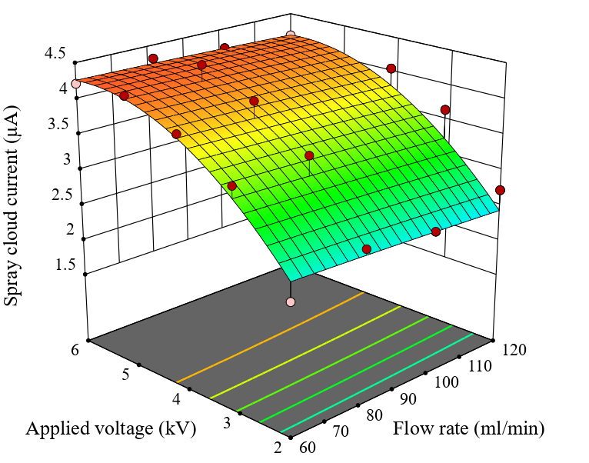
Aluminium | Copper | Brass
Fig. 7: Effect of flow rate and applied voltage on spray cloud current for different electrode materials

3.2 Effect of flow rate and applied voltage on charge to mass ratio (CMR) for different electrode materials
The statistical analysis confirmed that the parameters of flow rate, applied voltage, and electrode material significantly influenced the CMR at the 1% significance level (Table 1). Moreover, both first-order and second-order interactions among these parameters were statistically significant (Table 2). The data revealed a notable increase in CMR as the applied voltage rose from 2 to 5 kV, although no significant change was detected between 5 and 6 kV at the 5% significance level. The means of the four flow rate levels were significantly different from each other. CMR values varied significantly across the three types of electrode materials. According to the 3D surface plot, the highest CMR, 4.43 mC kg⁻¹, was recorded at a 5 kV applied voltage and a 60 ml min⁻¹flow rate using the copper electrode (Fig. 8). In contrast, the lowest CMR, 0.90 mC kg⁻¹, was observed at a 2 kV applied voltage and a 120 ml min⁻¹flow rate with the aluminium electrode. The CMR showed an upward trend with increasing applied voltage from 2 to 5 kV, after which it stabilized for all electrode materials. The plots clearly demonstrate that increasing the applied voltage enhanced the spray charge to a critical threshold, beyond which further increases led to a reduction in charge. This rise in CMR with increased applied voltage likely resulted from the intensified electric field at the point of liquid atomization, which induced a higher charge in the droplets as they separated from the grounded water tank (Carroz et al. 1978, Maski & Durairaj 2010). Conversely, the CMR decreased with higher flow rates for all electrode types. The inverse proportionality of CMR to the square of the jet size (Law 1978) accounts for the high CMR observed at lower spray flow rates. Additionally, the rapid increase in CMR at lower flow rates was attributed to the finer atomization of the spray droplets (Maski & Durairaj 2010).
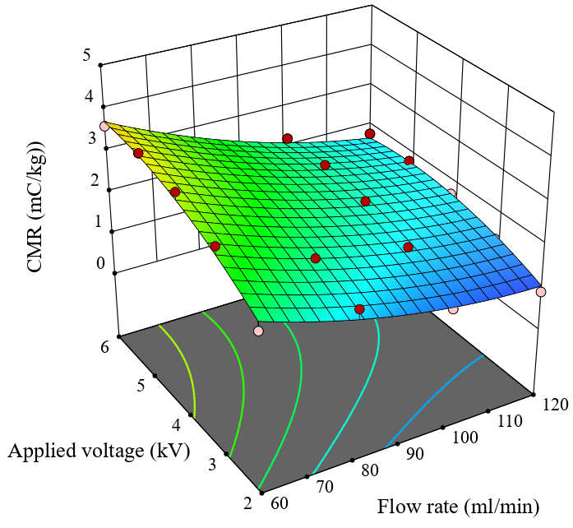 | 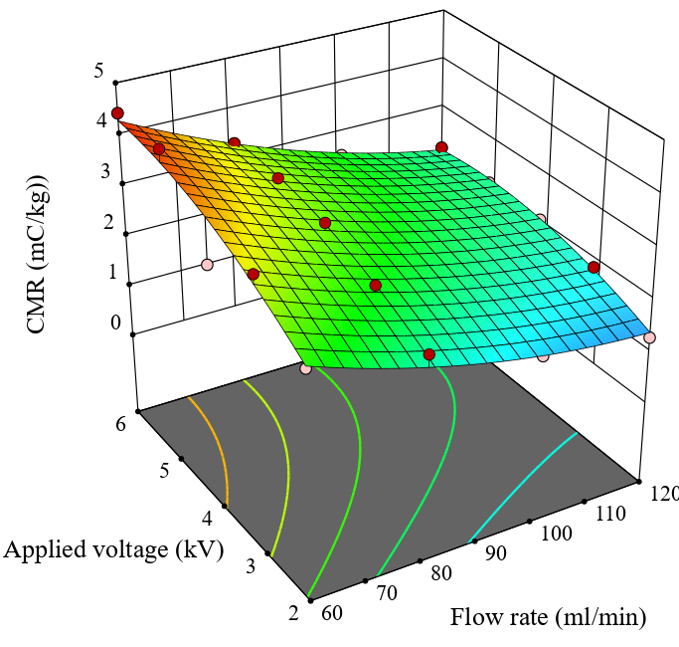 | 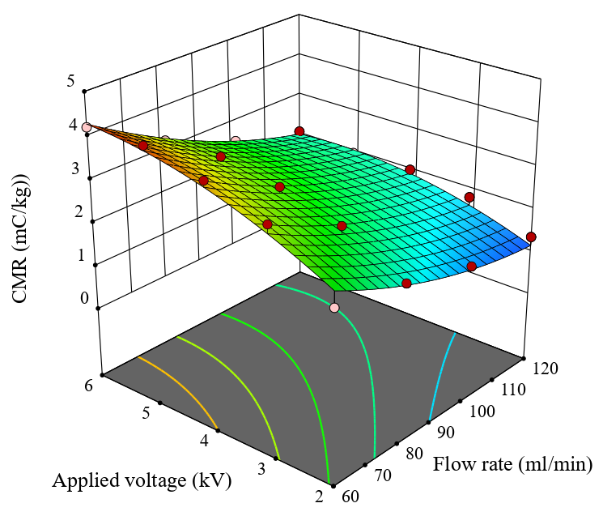
Aluminium | Copper | Brass
Fig. 8: Effect of flow rate and applied voltage on charge to mass ratio (CMR) for different electrode materials

4. CONCLUSIONS
An investigation was conducted to evaluate the performance of aluminium, brass, and copper as electrode materials in an induction-based air-assisted electrostatic spray nozzle. The study assessed the performance and characteristics of these metals as electrode materials for high-voltage applications within electrostatic nozzle systems. The results were characterized by spray cloud current and charge-to-mass ratio factors, which were analyzed as functions of electrode material, applied voltage, and flow rate. Copper emerged as a viable alternative electrode material for high-voltage applications in electrostatic spray nozzles, demonstrating superior performance compared to other materials in terms of spray cloud current and charge-to-mass ratio. The maximum values of spray cloud current and charge-to-mass ratio were recorded as 4.43 µA and 4.43 mC kg⁻¹, respectively, at an applied voltage of 5.0 kV and a flow rate of 60 ml min⁻¹for the copper electrode.

REFERENCES
Carroz, J. W., & Keller, P. N. (1978). Electrostatic induction parameters to attain maximum spray charge. Transactions of the ASAE, 21(1), 63-0069.
Dai, S., Zhang, J., Jia, W., Ou, M., Zhou, H., Dong, X., ... & Yang, S. (2022). Experimental study on the droplet size and charge-to-Mass ratio of an air-assisted electrostatic nozzle. Agriculture, 12(6), 889.
Gaunt, L. F., & Hughes, J. F. (2003). Electrostatic charging of trigger actuated spray devices. Institute of Physics Electrostatics, Edinburgh, UK, March 23–27.
Jyoti, B., Mani, I., Kumar, A., & Khura, T. K. (2019). Characterization of electrical properties of different chemical sprays for electrostatic spraying. Indian Journal of Agricultural Sciences, 89(4), 653-8.
Jyoti, B., Mani, I., Kumar, A., & Khura, T. K. (2020). Studies on chargeability parameters of charged spray droplets for chemical application in agriculture. The Indian Journal of Agricultural Sciences, 90(7), 1245-1249.
Law, S. E. (1978). Embedded-electrode electrostatic-induction spray-charging nozzle: theoretical and engineering design. Transactions of the ASAE, 21(6), 1096-1104.
Law, S. E. (1983). Electrostatic pesticide spraying: concepts and practice. IEEE transactions on Industry Applications, (2), 160-168.
Mamadi, Ghanshyam, V. R., Manoj Kumar, C. P. and Kapur, P. 2013. Electrostatic hand pressure knapsack spray system with enhanced performance for small scale farms. J. Electrostatics, 71: 785-790.
Maski, D. and Durairaj, D. 2010. Effects of charging voltage, application speed, target height, and orientation upon charged spray deposition on leaf abaxial and adaxial surfaces. Crop Protection, 29: 34-141.
Maski, D., & Durairaj, D. (2010). Effects of applied voltage, liquid flow rate, and liquid properties on spray chargeability of an air-assisted electrostatic-induction spray-charging system. Journal of Electrostatics, 68(2), 152-158.
Maynagh, B.M., Ghobadian, M.J. and Hashjin, T.T. 2009. Effect of electrostatic induction parameters on droplets charging for agriculture application. J. Agric.Sci., pp. 249- 257.
Patel, M. K., Ghanshyam, C., & Kapur, P. (2013). Characterization of electrode material for electrostatic spray charging: Theoretical and engineering practices. Journal of Electrostatics, 71(1), 55-60.
Sasaki, R. S., Teixeira, M. M., Fernandes, H. C., Monteiro, P. M. D. B., Rodrigues, D. E., & Alvarenga, C. B. D. (2013). Parameters of electrostatic spraying and its influence on the application efficiency. Revista Ceres, 60, 474-479.
Yuan, H.Y., Z.S. Ma, H.Q. Qin and X. Zhao, 2000. Experiment and research on high voltage electrode for electrostatic coating on food surface [J]. Trans. CSAE, 16(2): 113-115.
Zhao, S., Castle, G. S. P., & Adamiak, K. (2008). Factors affecting deposition in electrostatic pesticide spraying. Journal of Electrostatics, 66(11-12), 594-601.
Zhou, H., Ou, M., Dong, X., Zhou, W., Dai, S., & Jia, W. (2024). Spraying performance and deposition characteristics of an improved air-assisted nozzle with induction charging. Frontiers in Plant Science, 15, 1309088.
Zhao, S., Castle, G. S. P., & Adamiak, K. (2005). The effect of space charge on the performance of an electrostatic induction charging spray nozzle. Journal of Electrostatics, 63(3-4), 261-272.

