**Precision Agriculture: A Strategic Approach to Resource Efficiency and Sustainable Farming**

**ABSTRACT**

The resources conservation and sustainable development are the need of time in agriculture which can be achieved by an impactful farming methods known to be as Precision farming. Precision farming is the transformative approach that focuses on site specific management with integration of advanced technologies. This abstract focuses on the role of key technologies such as GIS, GPS, Remote sensing, Sensores, VRT, and Drones in optimizing resource utilization, minimizing the wastage or excess application and enhances environment soundness. Integration of these technologies also aids in decision making, improving yield, reduces environment degradation and improves economic benefit for farmers. The precision farming can facilitate sustainability and resilience in food systems despite of various challenges such as initial cost and knowledge gap. It is also highlighted that continues research and different policies has vital role in bridging these gaps and achieving full potential of precision farming towards environmental and economically sound agricultural future.

**Keywords:** Environmental health, GIS, GPS, Precision farming, Resource conservation, Sensors, Sustainable development, Variable rate technology.

**INTRODUCTION**

Precision farming is a method that allows agriculture to improve productivity and optimize resource utilization. Precision farming is a farming technique that employs technology to monitor, measure, and analyze the needs of specific crops and fields (Gulaiya et al 2024). It is a method in which the mean output is improved in comparison to conventional growing practices by utilizing inputs in a sufficient concentration. It also utilizes the fundamentals of information technology and management to determine production processes, optimize product durability, enhance crop performance, ensure the optimal use of synthetic chemicals, increase energy efficiency, and promote environmental soundness (Hakkim 2016). Precision farming is defined as "the precise quantity of input applied in soil and agriculture management to address the various challenges encountered on cultivated land" (Rimpika, 2023). Precision farming is a farming process that optimizes efficiency by utilizing irrigation scheduling, crop monitoring technologies, and other methods, while also taking into account the heterogeneity of the field (Rimpika, 2023). The value of "precision farming" increased in the 20th century as it became a subject of research. The significance of this topic was made clear to all by the development of various agricultural technologies that provided real-world demonstrations and results by various agricultural authorities. In addition, farmers are drawn to a variety of credit schemes that incorporate information technology into a variety of agricultural instruments (Hermann Auernhammer, 2001). The application of remote sensing is crucial because it is well-suited for the collection of data across extensive regions with a high frequency of observations, and it can play a crucial role in delivering a prompt and precise overview of the agricultural sector, as monitoring agricultural practices encounters unique challenges that are not typical in other economic sectors (Clement Atzberger2013). The concept of precision agriculture is predicated on the management of specific areas, which acknowledges that the characteristics of soil, landscape, climate, and other factors vary throughout a field. Farmers can make informed decisions about the allocation of resources such as seeds, water, pesticides, and fertilizers by accurately mapping and assessing these changes through the use of technologies such as global positioning systems (GPS), geographic information systems (GIS), and remote sensing. Meanwhile, precision farming is based on the principle of managing specific areas, acknowledging that soil traits, landscape features, climate, and various other factors differ across a field (Kushwaha 2024). The significance of precision farming is rooted in the five "R": the correct input, the correct quantity, the correct location, the correct time, and the correct method. It is also referred to as a utilization of technologies and principles to regulate contiguous and secular variability alliances with all agricultural production characteristics. Precision farming has the potential to enhance the administration of a field or farm from a variety of perspectives, including the agricultural, technological, atmospheric, and cost-effective perspectives. GPS and DGPS have significantly facilitated precision farming and are of significant value. DGPS receivers are capable of providing precise guidance and digital analysis. Future expectations for precision farming, emphasizing its contribution to the enhancement of agricultural efficiency while simultaneously reducing the impact of natural forces. At its core, precision farming is an organizational strategy that employs technology to monitor, predict, and respond to fluctuations in soil health and crop yields within fields. Precision agriculture is significantly influenced by geographic information systems (GIS), which facilitate the geospatial analysis of data pertaining to crops and fields. Remote sensing technology, such as drone-based surveillance and satellite imagery, offers an additional layer of data that is essential for precision cultivation. Precision farming is significantly influenced by the Internet of Things (IoT), which is achieved by strategically placing a variety of sensors throughout the farm. These sensors collect real-time data on soil moisture, temperature, humidity, and other atmospheric parameters (Alazzai 2024). The primary components of a precision agricultural mechanism must regulate fluctuation. Precision farming technology is a data-driven and decision-oriented process that encompasses a variety of components, such as Remote Sensing (RS), Geographical Information Systems (GIS), Global Positioning Systems (GPS), Soil Testing, Yield Monitors, and Precision Application Technology (Rimpika 2023). The development and deployment of limited supply to various sectors of the economy can be facilitated by precision agriculture concepts. The observation and evaluation of crop yields can be revolutionized by remote sensing technology, which is based on the biosystemic qualities of crops and/or soils. The knowledge obtained from remote sensing data is valuable when combined with field data in precision agriculture components. Remote sensing was unable to convey all types of agricultural information; however, it can accurately and timely provide information to assist in economic and financial planning (Liaghat and Balasundram2010). The primary objective of this farming approach, in contrast to conventional farming, is to optimize crop yields and profitability by applying inputs with precision. These days, the Internet of Things and artificial intelligence are indispensable. The advantages of AI and IoT technologies are utilized in contemporary agriculture (Gulaiya et al 2024).

**PRECISION FARMING AND SUSTAINABLE AGRICULTURE**

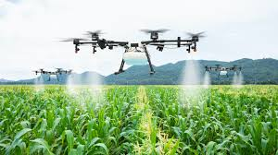Precision farming has made a substantial contribution to the empowerment of farmers' income, the enhancement of the internal and external quality of agricultural manufacturing, and the reduction of the negative environmental impact of agricultural production. These objectives were achieved simultaneously. Precision farming will not serve as a universal solution; however, it can contribute to sustainable agriculture by conserving resources. At present, the potential benefits are only utilized in a limited capacity due to the high cost and the absence of supply mechanisms. In order to achieve sustainability in agriculture, it is necessary to address the challenges of input yield imbalance, environmental degradation, and economic stability. Precision farming is not a universal solution; however, it has the potential to significantly contribute to the sustainable development of the agricultural sector (Finger 2019). In order to mitigate financial and environmental concerns and guarantee sustainable and environmentally favourable development, precision farming instruments must be integrated into agricultural planning and decision-making. Precision agriculture is becoming an oversight practice of increasing interest due to its direct connection to major factors that are directly related to global issues, including food security, climate change, and sustainable agriculture. It is imperative to promote precision agriculture through the implementation of the Common Agricultural Policy (CAP) in order to advance the sustainable and environmentally friendly development of agriculture. Consequently, it is imperative to conduct research in order to concentrate on the specific agricultural sectors or farm practices and their advantages (Dunchev 2019). The effective management of resources is the foundation of sustainable and efficient agriculture. The agricultural industry is rendered more ecologically sustainable through the implementation of artificial intelligence in resource management. The result is a significant improvement in the development of ecologically sustainable and resilient farming methods, in addition to enhancing agricultural productivity. This comprehensive strategy enables the implementation of sustainable agricultural methods, effective planning, and resource optimization. The field of precision agriculture is undergoing a continuous transformation as artificial intelligence (AI) promotes a new era of sustainable farming. In order to develop comprehensive and enduring solutions that address the numerous aspects of artificial intelligence (AI) in precision agriculture, it is imperative to incorporate knowledge from a diverse range of fields, including computer science, ethics, agriculture, and policymaking. It will be essential to address these issues and embrace the potential of artificial intelligence (AI) in precision agriculture in order to establish a sustainable and technologically advanced future for farming methods worldwide as the agricultural environment evolves (Adewusi 2024). The sustainability of agriculture is improved by resource conservation. The impact of utilizing a variety of IT instruments in resource conservation is significant. Sensors and inputs from other technologies, such as weather forecasting data, aid in the efficient utilization of water and reduce the consumption of limited water resources in arid or water-scarce regions. Precision farming also optimizes the use of synthetic fertilizer in accordance with the needs of the plants and the availability of the fertilizer in the soil, thereby reducing issues such as leaching, gaseous losses, and water contamination that are associated with the excessive application of fertilizer.

Fig. 1.

**PRECISION FARMING AND ITS RECENT RESEARCH**

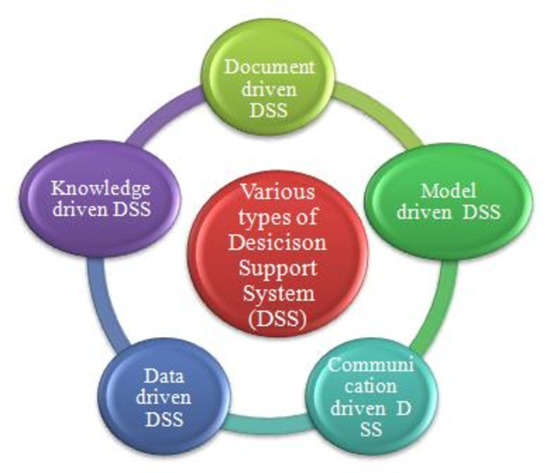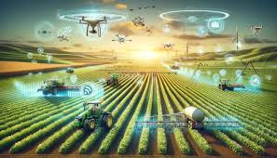On a global scale, agriculture is confronted with complex issues and is enduring extraordinary transformation. Artificial intelligence, mobile internet, and the Internet of Things (IoT) are contemporary technologies that have the potential to address the world's issues. Numerous IoT-based frameworks have been developed across a variety of industries, with the agricultural sector being one of the busiest, as the Internet of Things (IoT) has expanded substantially over the past several years. Some

Fig. 12

of the future trends in smart agriculture include the development of an all-inclusive platform for various livestock and crop types, the use of artificial intelligence to track and manage crop diseases, the improvement of service quality, the standardization of regulations, the encouragement of innovation, and the enhancement of deployment. In order to surmount these challenges, smart farming takes advantage of information and communication technologies (ICT), including the Internet of Things and connected big data analytics. It monitors relevant soil, irrigation, fertility, environmental, and electronic crop factors. Precision farming has entered a new phase that emphasizes crop monitoring as a result of the use of drones in agriculture. Agricultural practices and abilities have significantly contributed to the advancement of humanity. In addition to contributing to the welfare of humanity, agriculture offers individuals employment opportunities and sustenance (Dhanasekar2025). The utilization of state-of-the-art technologies has revolutionized the evaluation and

Fig. 3.

maintenance of crops, and precision agriculture is heavily dependent on crop monitoring. Satellite technology enables the visualization of agricultural landscapes from an aerial perspective, providing invaluable insights into crop conditions, growth trends, and overall state of health. Using high-resolution satellite imaging, farmers can effectively monitor massive expanses of land, identifying areas that may require additional attention, such as insect infestations or nutrient shortages. The integration of Machine Learning (ML) and Decision Support Systems (DSS) has emerged as a formidable force in precision agriculture, providing producers with data-driven insights and predictive analytics. As artificial intelligence (AI) continues to revolutionize precision agriculture and herald in a new era of sustainable agricultural methods, there are a few obstacles and promising future opportunities. The quality and integration of numerous data sources, including sensor data, satellite images, and historical documents, complicate the process of generating a cohesive and reliable dataset for AI algorithms. In regions with inadequate technology infrastructure, the widespread adoption of AI-driven precision agriculture may be hindered by challenges with network connectivity and the availability of state-of-the-art hardware. Edge computing solutions can assist in overcoming infrastructural constraints by reducing the reliance on centralized computer resources and enabling data processing to occur closer to the source. The challenges of AI in precision agriculture offer opportunities for innovation and growth (Adebunmi Okechukwu Adewusi2024). In recent years, the primary areas of research that have been the focus of ICT tools are automation through machine learning or deep learning, sensors, and robotics.

**PRECISION FARMING AND INTEGRATED TECHNOLOGY**

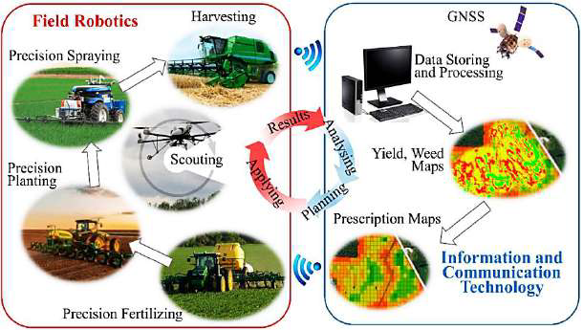The incorporation of artificial intelligence (AI) and the Internet of Things (IoT) into precision agriculture has the potential to revolutionize crop monitoring and management. Wireless Sensor Networks (WSNs) provide essential real-time environmental data that enables resource optimization and well-informed decision-making. As technology advances, the future holds the potential for even more significant advancements in precision agriculture, which will shape a more sustainable, productive, and efficient

Fig. 4.

agricultural landscape. Precision agriculture is the term used to describe the utilization of information and communication technology (ICT) to regulate the temporal and geographical variability of fields (Sharma2024). Technology for remote sensing is a highly useful tool for collection a lot of data at once. It involves the remote collection of information. A miniature device that is satellite-based or installed on an aircraft may serve as a data sensor. Remote sensing may be employed to identify in-season variability that affects crop output, and management actions that enhance the profitability of the current crop can be implemented promptly (Patil Shirish S. and Satish A. Bhalerao 2013). The efficacy of remote sensing can be enhanced by the use of IoT-enabled smart sensors, which are capable of interpreting and analyzing real-time data. Remote sensing may employ both active and passive sensors to regulate numerous aspects of agriculture. IoT-enabled smart sensors are employed in a variety of applications, including soil monitoring, insect manifestation, landscape topography, weather forecasting, and soil quality (Aggarwal 2021). IoT-based technologies enable farmers to precisely monitor the health and development of their crops (Kaloxylos 2013). Sensors that are deployed in the field to capture data on a variety of environmental factors, such as temperature, humidity, soil moisture, and nutrient levels, are the primary components of IoT-based smart crop monitoring systems (Rajak 2023). Traditional crop monitoring technologies, including low-resolution imaging, timing limitations, and imprecise measurements, impede the widespread implementation of smart farming techniques (Lo Presti 2023). Smart sensors are sensors that have been integrated with electronics. In agricultural settings, smart sensors can more accurately and autonomously capture a variety of environmental data and other pertinent information, which they can then store on drives. Smart sensors are indispensable elements of the Internet of Things, which is utilized for data transmission. The actuator and wireless network system are comprised of a few to hundreds of nodes that are connected to sensor centers (Rajak 2023). The efficient management of irrigation and the prevention of unnecessary exploitation of water resources are facilitated by the integration of meteorological data into soil moisture sensors. Geographic information systems (GIS) are computer programs and hardware that generate maps by utilizing feature properties and location information. A primary objective of an agricultural GIS is to store layers of data, such as yields, yield maps, soil survey maps, remotely sensed data, crop reconnaissance reports, and soil nutrient levels. For example. An interactive and user-friendly system known as GIS for Paddy Fields is employed to optimize the management of paddy fields in a cost-effective and efficient manner (Mandal SK. Maity A. 2013). GPS transmits position data in real time while in motion. Soil and crop measurements can be accurately mapped by maintaining precise position data at all times. GPS receivers with electronic yield monitors are frequently employed to accurately collect yield data throughout the region (Shirish S. and Bhalerao 2013). Farm applications encompass field mapping for insurance and documentation purposes (GPS + mapping software), variable rate planting (GPS + variable rate planting system), variable rate fertiliser and lime application (GPS + variable rate controller), yield mapping (GPS + combine yield monitor), and parallel swathing (GPS + navigation tool) (Mandal SK. Maity A.2013).

**TABLE:1. Application of different ICT and IT tools. (Jain, 2025; Xu et al., 2024; Sanyaolu et al., 2024; Medici et al., 2020; Rajesh Basa, 2024)**

|  |  |
| --- | --- |
| Information technology tools | Application in Precision farming |
| GPS | Mapping, navigation of agricultural implements, and data specific to the site. Inputs (such as pesticides and fertilizers) are implemented. |
| Remote Sensing | Real-time crop monitoring, soil health assessment, yield prediction, and analysis of a large area. |
| Internet of things sensors | Real-time weather analysis, soil health monitoring, crop monitoring, automatic reacting machinery (irrigation systems), and livestock monitoring. |
| GIS | Data analysis utility for GPS and RS data, A comprehensive field map is beneficial for the spatial management and decision-making of a farm. |
| Artificial intelligence/ Machine learning | Forecasting instruments for the prediction of yield, insect and disease infestation, and weather; monitoring crop health, and detecting weeds and disease. |
| Robotics | Concentrate on the automation of machines and implements to reduce labor demand, increase efficiency, and conserve resources through precise application. |

**RECENT EXAMPLES FOR BENEFIT FROM APPLICATION OF PRECISION FARMING**

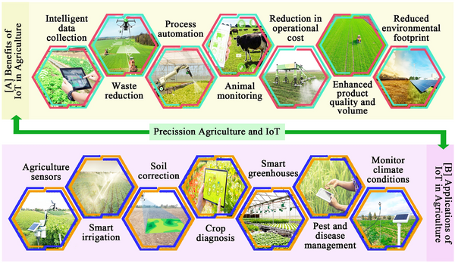The potential of IoT-enabled Precision Agriculture to revolutionize contemporary agricultural methods. The integration of real-time data collection, Internet of Things (IoT) systems, and precision farming methodologies has exemplified the substantial influence of Precision Agriculture on the improvement of crop yield and Sustainability in this research. It is imperative to acquire insights from data analysis, IoT sensor information, Precision Agriculture experimental results, and evaluations of sustainable yields in order to understand the future of agriculture. The considerable increases in crop yields across a variety of crop types

Fig. 6.

are indicative of the versatile solution that precision agriculture provides to food security challenges (Ivanovich Vatin2024). The adoption of precision farming is also accompanied by a variety of challenges, including the significant initial investment that small landholder farmers face, as well as the skills and technological knowledge that farmers must possess. These challenges also impede the efficient decision-making, data interpretation, and analysis processes. The specific requirements of the agricultural sector are met by the collaborative efforts of the government, research institute, self-help groups, communities, and private sectors to provide appropriate training, incentives, and farmer-friendly technologies. The agricultural industry's future is promising due to the integration of agricultural technology, particularly through data-driven solutions and machine learning. Opportunities to enhance resource efficiency and reduce dependence on hazardous chemicals are presented by the implementation of AI-based technologies, including autonomous robotics for weed management and GPS-guided automated irrigation. The utilization of machine learning and deep learning results in enhancements in the diagnosis of plant diseases, water conservation, pesticide management, phenotyping, and overall yield. It is essential to take into account specific limitations when extensively implementing these technologies. Obstacles to the egalitarian adoption of new agricultural technology include the digital divide in rural regions, concerns regarding data privacy and proprietorship, and high upfront costs (GHULAM MOHYUDDIN12024). The Depth Object Detector (DOD) approach is a distinctive computer vision technique for object identification with depth estimates in real-time applications in low-cost embedded or microcontroller systems. The state of the art in object detection at the time had a significant impact on the idea, design, implementation, and functionality of the proposed approach (Jaramillo-Hernández 2024).

**Conclusion**

Precision farming has the potential to significantly alter the agricultural sector and increase production in order to guarantee food security. It has the potential to resolve a variety of contemporary agricultural challenges, including water scarcity, climate change, land degradation, and food security. The resolution of these challenges is guaranteed by the incorporation of information technology tools such as GPS, GIS, remote sensing, and the internet of things in precision farming, which provides valuable insight that aids in decision-making. Precision farming remains a potent instrument for sustainable development and resource conservation; despite the numerous obstacles it faces. Additionally, it was consistent with global sustainable development objectives, including Zero Hunger and others. Farmers can enhance productivity, environmental sustainability, reduce input waste, and increase profits by effectively managing the diverse farm practices and field variability through the implementation of advanced technology. The challenges in precision farming must be addressed in order to achieve these objectives, and this can only be accomplished through the collaboration of farmers and various agencies. The full potential of these practices can be realized to the benefit of farmers and the environment through ongoing research, data-driven management, and various government initiatives.

**REFERENCES**

Adebunmi Okechukwu Adewusi, Onyeka Franca Asuzu, Temidayo Olorunsogo, Temidayo Olorunsogo, Ejuma Adaga, & Donald Obinna Daraojimba. (2024). AI in precision agriculture: A review of technologies for sustainable farming practices. *World Journal of Advanced Research and Reviews*, 2276–2285. https://doi.org/10.30574/wjarr.2024.21.1.0314

Adebunmi Okechukwu Adewusi, Onyeka Franca Asuzu, Temidayo Olorunsogo, Temidayo Olorunsogo, Ejuma Adaga, & Donald Obinna Daraojimba. (2024). AI in precision agriculture: A review of technologies for sustainable farming practices. *World Journal of Advanced Research and Reviews*, 2276–2285. https://doi.org/10.30574/wjarr.2024.21.1.0314

Aggarwal, N., & Singh, D. (2021). Technology assisted farming: Implications of IoT and AI. *IOP Conference Series: Materials Science and Engineering*, *1022*(1), 012080. https://doi.org/10.1088/1757-899X/1022/1/012080

Alazzai, W. K., Abood, B. Sh. Z., Al-Jawahry, H. M., & Obaid, M. K. (2024). Precision Farming: The Power of AI and IoT Technologies. *E3S Web of Conferences*, *491*, 04006. https://doi.org/10.1051/e3sconf/202449104006

Clement Atzberger. (2013). Advances in Remote Sensing of Agriculture: Context Description, Existing Operational Monitoring Systems and Major Information Needs. *Remote Sensing.*

Dhanasekar, S. (2025). A comprehensive review on current issues and advancements of Internet of Things in precision agriculture. *Computer Science Review*, *55*, 100694. https://doi.org/10.1016/j.cosrev.2024.100694

GHULAM MOHYUDDIN1, M. A. K. S. M. M. W., A., (Member, I. A. A. 5. (2024). Evaluation of Machine Learning Approaches for Precision Farming in Smart Agriculture System: A Comprehensive Review. *IEEE Access*.

Gulaiya S, Sharma A, Singh S, Kumar R, Chaudhary D, Yadav K, Kumar M, Kumar R. Precision Agriculture: Transforming Farming Efficiency with Cutting-edge Smart Technologies: A Comprehensive Review. Journal of Experimental Agriculture International. 2024 Sep;46(9).

Hermann Auernhammer. (2001). Precision farming Ð the environmental challenge. *Computers and Electronics in Agriculture*.

Ivanovich Vatin, N., Kumar Joshi, S., Acharya, P., Sharma, R., & Rajasekhar, N. (2024). Precision Agriculture and Sustainable Yields: Insights from IoT-Driven Farming and the Precision Agriculture Test. *BIO Web of Conferences*, *86*, 01091. https://doi.org/10.1051/bioconf/20248601091

Jagvir Dixit1, A. K. D. S. K. L. and D. K. (n.d.). *Importance, Concept and Approaches for Precision Farming in India*.

Jaramillo-Hernández, J. F., Julian, V., Marco-Detchart, C., & Rincón, J. A. (2024). Application of Machine Vision Techniques in Low-Cost Devices to Improve Efficiency in Precision Farming. *Sensors*, *24*(3), 937. <https://doi.org/10.3390/s24030937>

Kaloxylos, A., Wolfert, J., Verwaart, T., Terol, C. M., Brewster, C., Robbemond, R., & Sundmaker, H. (2013). The Use of Future Internet Technologies in the Agriculture and Food Sectors: Integrating the Supply Chain. *Procedia Technology*, *8*, 51–60. https://doi.org/10.1016/j.protcy.2013.11.009

M. Neme´nyi*, P. A. ´. M. Zs. P. Zs. S. ´pa ´n. (2003). The role of GIS and GPS in precision farming. *Computers and Electronics in Agriculture*.

Mandal SK.  Maity A. (2013). Precision Farming for Small Agricultural Farm: Indian Scenario. *American Journal of Experimental Agriculture*.

Manish Kushwaha1, S. S. V. S. S. D. (2024). Precision Farming: A Review of Methods, Technologies, and Future Prospects. *International Journal of Environment, Agriculture and Biotechnology.*

Medici, M., Marcus Pedersen, S., Carli, G., & Tagliaventi, M. R. (2020). Environmental Benefits of Precision Agriculture Adoption. *ECONOMIA AGRO-ALIMENTARE*, *3*, 637–656. <https://doi.org/10.3280/ECAG2019-003004>

Patil Shirish S. and Satish A. Bhalerao*. (2013). Precision farming: The most scientific and modern approach to sustainable agriculture. *Int. Res. J. of Science & Engineering*.

Presti, D., di Tocco, J., Massaroni, C., Cimini, S., de Gara, L., Singh, S., Raucci, A., Manganiello, G., Woo, S. L., Schena, E., & Cinti, S. (2023). Current understanding, challenges and perspective on portable systems applied to plant monitoring and precision agriculture. *Biosensors and Bioelectronics*, *222*, 115005. https://doi.org/10.1016/j.bios.2022.115005

Rajak, P., Ganguly, A., Adhikary, S., & Bhattacharya, S. (2023). Internet of Things and smart sensors in agriculture: Scopes and challenges. *Journal of Agriculture and Food Research*, *14*, 100776. https://doi.org/10.1016/j.jafr.2023.100776

Rajesh Basa. (2024). AI in Agriculture: Revolutionizing Precision Farming and Sustainable Crop Management. *International Journal of Scientific Research in Computer Science, Engineering and Information Technology*, *10*(5), 535–543. <https://doi.org/10.32628/CSEIT241051040>

Rajnish Jain. (2025). Artificial Intelligence in Precision Agriculture: Advanced Systems for Crop Management and Farm Optimization. *International Journal of Scientific Research in Computer Science, Engineering and Information Technology*, *11*(1), 1849–1857. <https://doi.org/10.32628/CSEIT251112183>

Rimpika , A., S. M. c, A. K. N. d‡, S. S. e, A. T. f^, S. a and A. S. g. (2023). An Overview of Precision Farming. *International Journal of Environment and Climate Change.*

Robert Finger, 1 Scott M. Swinton, 2 Nadja El Benni, 3 and Achim Walter4. (2019). Precision Farming at the Nexus of Agricultural Production and the Environment. *Annual Review of Resource Economics*.

ROSITSA PETROVA BELUHOVA-UZUNOVA DOBRI MATEEV DUNCHEV. (2019). PRECISION FARMING – CONCEPTS AND PERSPECTIVES. *Zagadnienia Ekonomiki Rolnej Problems of Agricultural Economics*.

S. Liaghat and S.K. Balasundram. (2010). A Review: The Role of Remote Sensing in Precision Agriculture. *American Journal of Agricultural and Biological Sciences.*

Sanyaolu, M., & Sadowski, A. (2024). The Role of Precision Agriculture Technologies in Enhancing Sustainable Agriculture. *Sustainability*, *16*(15), 6668. <https://doi.org/10.3390/su16156668>

Sharma, K., & Shivandu, S. K. (2024). Integrating artificial intelligence and Internet of Things (IoT) for enhanced crop monitoring and management in precision agriculture. *Sensors International*, *5*, 100292. https://doi.org/10.1016/j.sintl.2024.100292

V. M. Abdul Hakkim1, 2, E. Abhilash Joseph1, A. J. Ajay Gokul2, K. Mufeedha1. (2016). Precision Farming: The Future of Indian Agriculture. *Journal of Applied Biology & Biotechnology*.

Xu, J., Cui, Y., Zhang, S., & Zhang, M. (2024). The evolution of precision agriculture and food safety: a bibliometric study. *Frontiers in Sustainable Food Systems*, *8*. <https://doi.org/10.3389/fsufs.2024.1475602>