Original Research Article

Anti-inflammatory effects of the aqueous extract of leaves of Vernonia colorata (Willd.) Drake (Asteraceae) in Wistar rats and NMRI mice

Abstract
Vernonia colorata leaves are traditionally used in Africa to treat various diseases, including inflammation. This study aimed to evaluate the anti-inflammatory effects of the aqueous extract of Vernonia colorata leaves (AEVC) on both acute and subacute inflammation models. Inducers of acute inflammation, such as dextran and carrageenan-induced paw edema in rats and mice, were used to assess the extract's effect on this type of inflammation. Additionally, the induction of abdominal granuloma with cotton and paw edema with formalin allowed for evaluation of the extract's anti-inflammatory activity in both acute and subacute settings. The results indicated that in the dextran model, AEVC produced an anti-inflammatory effect starting at 0.5 h, 1 h, 1.5 h, and 2 h, with a maximum inhibition of 63.55 ± 6.80% at a dose of 250 mg/kg after 1.5 hours. In the carrageenan model, all doses of the extract significantly (p < 0.05) reduced paw edema volume, with the highest inhibition of 58.39 ± 4.23% at 250 mg/kg at the 6th hour. For cotton pellets, the weight of fresh granulomas was significantly inhibited (p < 0.05) at 250 mg/kg, while dry granuloma weight was notably reduced (p < 0.05) at 100 and 250 mg/kg. In formalin-induced inflammation, reductions in edema volume were statistically significant (p < 0.01) across all doses. Histopathological analysis showed that treatment with the extract significantly decreased inflammatory cell infiltration and reduced formalin-induced edema. These findings suggest that Vernonia colorata leaves might be beneficial in managing inflammatory diseases.
Keywords: Anti-inflammatory, Vernonia colorata, rat, mouse, subacute, aqueous extract

Introduction
Inflammation, a complex process, is implemented by the body to defend itself against inflammatory agents such as infections and/or any tissue damage caused by physical, chemical, or biological stimuli (Fayez et al.,2023). It involves a sequence of cellular and vascular processes leading to the elimination of damaged tissues and the regeneration of new tissues. Inflammation, although normal, can be damaging due to the occurrence of serious pathological complications (Antwi-Adjei et al., 2022). These complications can be rheumatoid arthritis, gastrointestinal diseases, asthma, autoimmune diseases, and, consequently, functional losses. In addition, inflammation is at the origin of acute and chronic inflammatory diseases, atherosclerosis, coronary heart disease, diabetes mellitus, cancer, and many others (Newman, 2015; Penk et al., 2022). Currently, inflammatory diseases are treated with conventional synthetic drugs such as steroidal anti-inflammatory drugs (SAIDs), non-steroidal anti-inflammatory drugs (NSAIDs), and disease-modifying anti-rheumatoid drugs (DMARDs) (Mrid et al., 2022; Antwi-Adjei et al., 2022. However, these drugs cause serious adverse side effects on the human body, such as obesity, dyspepsia, gastric ulcers, kidney damage, and immunosuppression (Obiri et al., 2014). This fact encourages a large part of the population to resort to traditional therapies, which are generally based on plants, including Vernonia colorata. From the Asteraceae family, Vernonia colorata is used in traditional African medicine for the treatment of diabetes, skin rashes, acute hepatitis, and other conditions (Siaka et al., 2012). Other studies have shown that Vernonia colorata leaf extract can prevent induced thrombocytopenia and increased vascular permeability (Ouedraogo et al., 2023). It has already been shown that its use would not present a risk of toxicity (Sawadogo et al., 2022). This study aims to evaluate the acute and subacute anti-inflammatory effects of the AEVC on the induced inflammation model in mice and rats.

Materials and methods

Plant
The leaves of Vernonia colorata were collected in Ouagadougou (Burkina Faso). The sample was taken in August 2024 before 11 a.m. The species identification was conducted by the Herbarium of Joseph KI-ZERBO University, where a sample was preserved with the ID number: 17964 and sample number 6964.

Animal
Adult Wistar rats and NMRI mice from the animal facility of Joseph KI-ZERBO University were used. These animals were kept under standard animal facility conditions (temperature 22 ± 3°C, humidity 50 ± 10%, and a 12-h light/12-h dark cycle). They had free access to drinking water and food. Animal handling and treatment were carried out in accordance with the ethical standards for animal research prescribed by the Institutional Ethics Committee of Joseph KI-ZERBO University under the experimental protocol approval number CE-UJKZ/2020-04.

Preparation of the extract
Vernonia colorata leaves were washed and dried in the laboratory under artificial ventilation. A test sample of 2 x 250 g of leaf powder was placed in a 5000 mL stainless steel beaker. 1500 mL of distilled water was added to each sample of plant material. The homogenized mixture was then macerated at a temperature of approximately 30°C for 24 h under mechanical stirring. The resulting maceration was filtered, and the filtrates were then centrifuged at 2000 rpm for 10 min. The supernatants obtained were collected, distributed in glass crystallizing dishes, and then placed in a freezer at -18°C for 24 h before being freeze-dried. The final product obtained after freeze-drying constitutes the aqueous extract of Vernonia colorata.

Acute anti-inflammatory test
    - Dextran test
The test was carried out according to the method described by Gupta et al. (2006). Twenty-five (25) mice were divided into five groups of five animals each: Group 1 (normal) treated with 0.9% NaCl; Group 2 (positive control) treated with cyproheptadine (5 mg/kg bw) dissolved in 0.9% NaCl; Groups 3, 4 and 5, treated with AEVC at doses of 50, 100 and 250 mg/kg bw respectively. The treatments were administered orally. The initial volumes (Vo) of the paws were measured, and one hour after these treatments, edema was induced by injection under the footpad of the right hind paw of 0.1 mL of the dextran solution. The paw edema was then measured by plethysmography at intervals of 0.5, 1, 1.5, and 2 hours after injection of the dextran solution (Vt). The results were expressed as percentage inhibition of edema in the treated groups compared to the control group using:
$Pi\left(\%\right)=\frac{\left(Vt-V0\right)contol-\left(Vt-V0\right)test}{\left(Vt-V0\right)control}*100$, with Pi, percentages of inhibition of edema; Vt, Volume of the paw at the time considered; V0 = Initial volume of the paw before treatment.
    - Carrageenan test
The carrageenan test was performed as described by Lanher et al. (1991). Thus, 30 rats, divided into five (5) groups of 6, were fasted for 12 hours before the start of the test. The initial volume (Vo) of the left hind paw of each animal was measured using a UGO BASILE plethysmometer. The animals were then treated as follows: Group 1 (control) treated with 0.9% NaCl; Group 2 (positive control) treated with diclofenac (5 mg/kg bw), and Groups 3, 4, and 5, treated with AEVC, respectively, at 50, 100, and 250 mg/kg bw. One hour after these treatments, each rat received a subcutaneous injection of 0.1 mL of 1% carrageenan under the plantar fascia of the right hind paw. Carrageenan-induced edema volumes were measured at 0.5 h, 1 h, 2 h, 3 h, 4 h, 5 h, and 6 h after carrageenan injection. Results were expressed as percentage inhibition of edema in the treated groups compared to the control group, as in the dextran study.

Subacute anti-inflammatory test
    - Cotton pellet test
The cotton granuloma test was performed according to the method of Ismail et al. (1997). This involves inducing inflammation by introducing a foreign body (granuloma) under the skin of the animals, then treating them for one week. Thus, thirty-six (36) rats were fasted for 12 hours. The others were anesthetized by intraperitoneal injection of 1 mL/100 g bw of a ketamine /Xylazine solution (1 mL/0.7 mL). Two cotton balls of 10 mg each, sterilized for 24 hours at 40 ± 0.5 °C, were then inserted subcutaneously in the abdominal region, except for the rats in the normal neutral control group, which received neither induction nor treatment of inflammation. The animals were divided into six groups of 6 rats: Group 1 (normal control); Group 2 (negative control), treated with 0.9% NaCl; Group 3 (positive control) treated with diclofenac (5 mg/kg bw), Groups 4, 5 and 6 treated with AEVC, respectively at 50, 100 and 250 mg/kg bw. On day 8, the animals were anesthetized again, and blood was collected in EDTA tubes for blood count. The animals were then necropsied, and the granulomas were removed and weighed (fresh), then dried at 40 ± 0.5°C for 24 hours and weighed (dry). The percentage inhibition of fresh and dry granulomas was determined as follows:
$Pi(\%)=\frac{({Granuloma}^{'}s weigth in the control group-{Granuloma}^{'}s weight in the test group)}{Granuloma' s weigth in the control group}*100$.
The monitoring also included hematological parameters such as leukocyte, red blood cell, platelet, and hemoglobin concentrations. Morphometric parameters such as the relative weights of the spleen, liver, and kidneys were monitored.
    - Formalin test
The effect of AEVC on subacute inflammation was also tested using paw edema induced by injection of 0.1 ml of 2% formalin into the subplantar area of the right hind paw of mice for seven days (Dharmasiri et al., 2003). Six groups of five mice were formed: Group 1 (normal control) no induction of inflammation, treated with 0.9% NaCl, Group 2 (control), treated with 0.9% NaCl, Group 3 treated with diclofenac 20 mg/kg bw; groups 4, 5 and 6, treated with the extract 50, 100 and 250 mg/kg bw respectively. On the first day, all treatments were performed 1 hour before formalin injection. Paw thickness was measured on the 1st, 3rd, 5th, and 7th days after formalin injection. At the end of the 7th day, the mice are autopsied by cervical dislocation. The right hind paw of the animals is isolated and preserved in 10% formalin for histological sections.

Statistical analysis
Data were entered using Excel 2016 software. GraphPad Prism 5.03 software (GraphPad Software Inc., San Diego, USA) was used for calculations of means and standard errors, statistical tests, and graphical representations. One-way analysis of variance (ANOVA I) followed by Tukey-Kramer post-hoc test was used for data comparison. The difference between values was considered statistically significant if p < 0.05.

Results
  - Dextran
The AEVC significantly inhibited paw edema volumes at 0.5 h, 1.5 h, and 2 h compared to the control. Edema inhibition was very significant (p ˂ 0.01) to highly significant (p ˂ 0.001) at the doses used, except 1 hour later, where it was non-significant (p > 0.05). Cyproheptadine reduced the increase in edema with a percentage inhibition of 73.04±3.36% from half an hour. The percentage inhibition due to the extract varied from 34.55±8.15 (the dose of 100 after 0.5 h of induction) to 63.55±6.80 (the dose of 250 after 1.5 h of induction) (Table 1).
Table 1: Effect of aqueous extract of Vernonia colorata leaves on dextran-induced edema in mice
Times |  | Treatments (mg/kg)
 | Control | Cyproheptadine 5 | AEVC 50 | AEVC 100 | AEVC 250
0.5 hour | 0.37±0.01 | 0.1±0.01 ***  (73.04±3.36) | 0.22±0.02 ***  (40.38±6.80) | 0.243±0.2 **  (34.55±8.15) | 0.165±0.2 ***  (56.06±6.24)
1 hour | 0.24±0.02 | 0.13±0.03 ns  (71.55±7.36) | 0.18±0.03 ns  (46.05±13.18) | 0.17±0.01 ns  (49.74±1.37) | 0.13±0.02 ns  (62.25±3.77)
1.5 hour | 0.28±0.04 | 0.09±0.02 ***  (63.14±8.21) | 0.13±0.03**  (52.34±15.6) | 0.11±0.01 **  (56.49±5.66) | 0.1±0.01 ***  (63.55±6.80)
2 hours | 0.272±0.03 | 0.098±0.02 ***  (56.24±8.88) | 0.138±0.01 **  (59.6±6.38) | 0.129±0.01 **  (63.52±1.71) | 0.125±0.01 **  (52.4±6.97)
Values are expressed as mean ± standard error; n = 5. Values in parentheses represent percentages of inhibition. ns: not significant. Significant difference from control: p < 0.05 (*); p < 0.01 (**); p < 0.01 (***)
  - Carrageenan
From half an hour to 6 hours, all doses of extract resulted in a significant inhibition (p < 0.05) of the volume of paw edema compared to the control. The maximum inhibition percentages observed were (51.68 ± 8.69) and (58.39 ± 4.23), respectively, at 100 mg/kg (3 hours) and 250 mg/kg (6 hours). These results are comparable to those observed with diclofenac (Table 2).
Table 2: Effect of AEVC on carrageenan-induced edema in rats
Times | Treatments (mg/kg)
 | Control | Diclofenac 5 | AEVC 50 | AEVC 100 | AEVC 250
0.5 hour | 0.44 ± 0.04 | 0.21 ± 0.02***  (49.39 ± 7.73) | 0.29 ± 0.02*  (33.34 ±5.31) | 0.28 ± 0.04 *  (32.00 ±1.22) | 0.27 ± 0.01*  (36.23 ± 6.98)
1 hour | 0.44 ± 0.04 | 0.2 ± 0.03***  (50.25 ± 12.67) | 0.30 ± 0.01*  (29.58 ± 6.08) | 0.23 ± 0.01 **  (44.5 6 ± 6.93) | 0.26 ± 0.02 **  (36.69 ± 9.17)
2 hours | 0.48 ± 0.05 | 0.21 ± 0.02***  (56.58 ± 3.83) | 0.28 ± 0.02**  (38.52 ± 6.57) | 0.26 ± 0.01***  (42.20 ± 8.44) | 0.24 ± 0.01 ***  (46.98 ± 5.98)
3 hours | 0.49 ± 0.05 | 0.18 ± 0.02***  (61.86 ± 3.40) | 0.27 ± 0.02***  (42.16 ± 9.13) | 0.21 ± 0.02 ***  (51.68 ± 8.69) | 0.23 ± 0.01 ***  (51.04 ± 5.23)
4 hours | 0.33 ± 0.02 | 0.15 ± 0.01***  (51.46 ± 5.38) | 0.23 ± 0.01**  (26.38 ± 9.73) | 0.18 ± 0.01 ***  (42.09 ± 8.40) | 0.18 ± 0.01 ***  (43.38 ± 5.04)
5 hours | 0.33 ± 0.01 | 0.14 ± 0.01 ***  (57.21 ± 5.21) | 0.22 ± 0.01**  (32.11 ± 6.56) | 0.20 ± 0.01 ***  (38.66 ± 5.97) | 0.17 ± 0.03 ***  (47.98 ± 10.52)
6 hours | 0.31 ± 0.02 | 0.11 ± 0.01***  (60.25 ± 8.09) | 0.23 ± 0.01*  (25.03 ± 4.14) | 0.15 ± 0.01 ***  (49.43 ± 6.21) | - 0.01 ***  (58.39 ± 4.23)
Values are expressed as mean ± standard error; n = 6. Values in parentheses represent percentages of inhibition. Significant difference from control: p < 0.05 (*); p < 0.01 (**); p < 0.01 (***)
  - Cotton pellet
    - Weight of fresh and dry granulomas
Fresh granuloma weight was significantly inhibited (p < 0.05) by EAVC at 250 mg/kg and by diclofenac 5 mg/kg (p < 0.001). Inhibition of granuloma weight was non-significant (p > 0.05) at 50 and 100 mg/kg. The percentages of inhibition due to EAVC were significantly (p < 0.01) lower than those due to diclofenac (Figure 1A).
The weight of dry granulomas was inhibited significantly (p ˂ 0.05) and very significantly (p ˂ 0.01), respectively, at 100 and 250 mg/kg bw of the extract. The 50 mg/kg dose resulted in an inhibition of dry granuloma weights, but not significantly (p > 0.05). Compared with the positive control (diclofenac), the percentages of inhibition due to the extract at doses of 50 and 100 mg/kg were significantly lower (p ˂ 0.05) than that induced by diclofenac (Figure 1B)
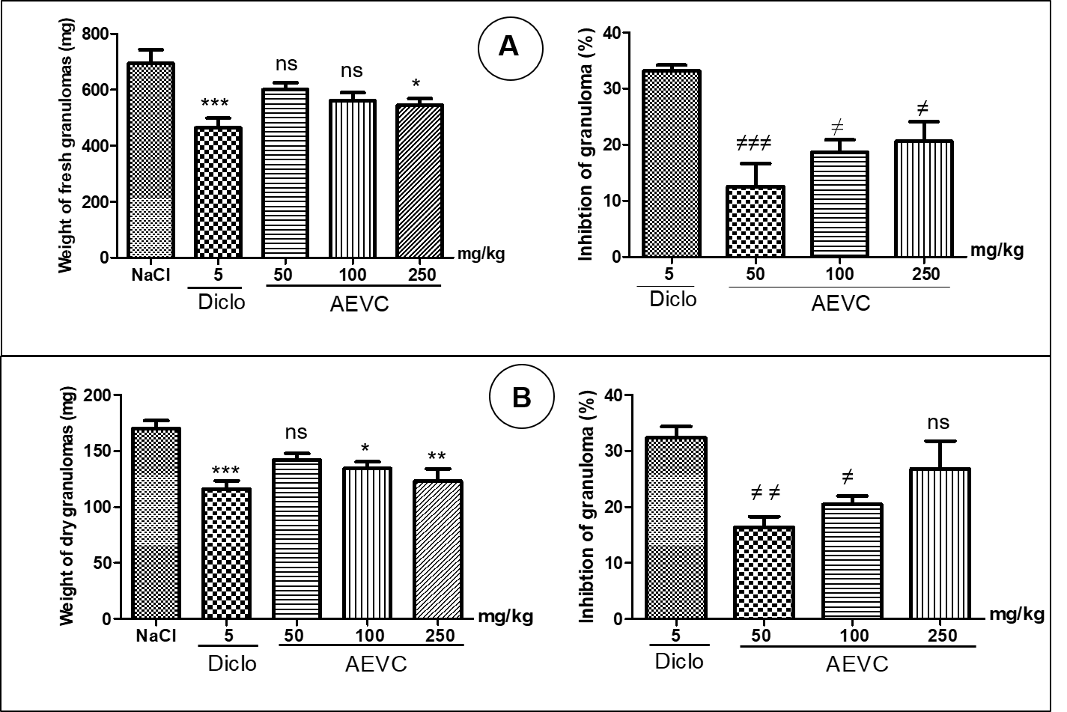
Figure 1: Effects of aqueous extract of Vernonia colorata leaves on cotton-induced fresh (A) and dry (B) granuloma weight and inhibition percentages. Values are expressed as mean ± standard error; n = 6. Significant difference from control (NaCl): p < 0.05 (*); p < 0.01 (**); p < 0.01 (***). Significant difference from diclofenac (NaCl): p < 0.05 (≠); p < 0.01 (≠≠); p < 0.01 (≠≠≠); ns: not significant.
    - Relative weights of organs
The relative weight of the spleen increased very significantly (p ˂ 0.01) and significantly (p ˂ 0.05) at doses of 50 and 100 mg/kg bw of the extract, respectively, compared to the control. The increase was not significant (p > 0.05) at the dose of 250 mg/kg of the AEVC and diclofenac. Compared to the normal control, the increase in the relative weight of the spleen, at all doses of the extract, was highly significant (p ˂ 0.001) (Figure 2A). The relative weight of the liver did not vary significantly (p > 0.05) compared to the normal, nor compared to the control (Figure 2B). Compared to the control, no significant variation (p > 0.05) in the relative weight of the kidneys was observed. Compared with normal control, except for the 250 mg/kg dose, the relative kidney weight decreased significantly (p ˂ 0.05) (Figure 2C).
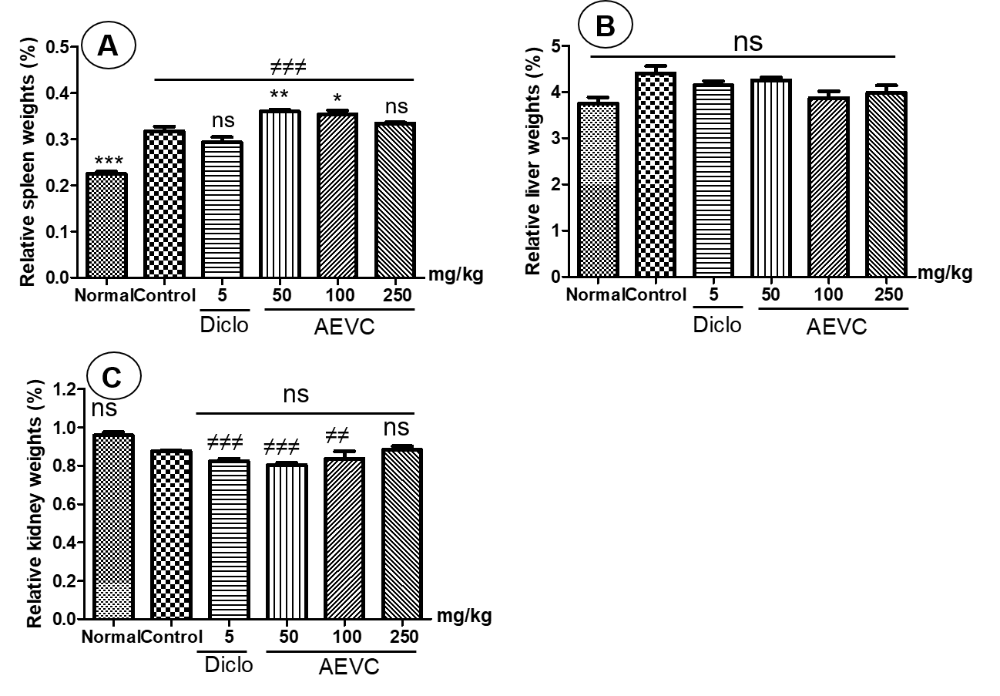
Figure 2: Effects of aqueous extract of Vernonia colorata leaves on the relative weights of spleen (A), liver (B), and kidney (C) after cotton granuloma-induced inflammation. Values are expressed as mean ± standard error; n = 6. Significant difference from control: p < 0.05 (*); p < 0.01 (**); p < 0.01 (***). Significant difference from normal: p < 0.01 (≠≠); p < 0.01 (≠≠≠); ns: not significant.
    - Hematological parameters
The number of white blood cells increased significantly (p ˂ 0.001) at doses of 100 and 250 mg/kg of the extract compared to the normal control. The increase was not significant at the dose of 50 mg/kg of the extract (p > 0.05). The variation in the number of red blood cells, blood platelets, and hemoglobin level were non-significant (p > 0.05) compared to normal and control (Table 3).
Table 3: Effects of aqueous extract of Vernonia colorata leaves on blood cell count variation in the cotton pellet inflammatory model in rats
Cells | Treatments (mg/kg)
 | Normal | Control | Diclofenac 5 | AEVC 50 | AEVC 100 | AEVC 250
WBC  (10³ /μL) | 1.26 ± 0.14 | 3.9 ± 0.38*** | 3.01 ± 0.45* | 2.65 ± 0.26 ns | 3.58 ± 0.49*** | 4.46 ± 0.24***
RBC  (10⁶ /μL) | 7.12 ± 0.22 | 7.09 ± 0.10 ns | 7.19± 0.11 ns | 7.15 ± 0.23 ns | 7.07 ± 0.20 ns | 7.27 ± 0.21 ns
HGB  (g/dL) | 13.52 ± 0.44 | 13.12 ± 0.28 ns | 12.48 ± 0.39 ns | 12.93 ± 0.32 ns | 12.78 ± 0.25 ns | 13.67 ± 0.35 ns
Plt  (10³ /μL) | 604.3 ± 34.1 | 756.8 ± 45.64 ns | 834.2 ± 52.24 ns | 645.7 ± 60.5 ns | 777.7 ± 68.4 ns | 680± 17.9 ns
WBC: White blood cells; RBC: Red blood cells; HGB: Hemoglobin; Plt: Platelets. Values are expressed as mean ± standard error; n = 6. Significant difference from normal: p < 0.05 (*); p < 0.01 (***).; ns: not significant.
  - Formalin
    - Effects of aqueous extract of Vernonia colorata leaves on formalin-induced inflammation
One hour after formalin-induced inflammation, paw edema volumes were significantly inhibited (p < 0.001) at all doses of the extract compared to the control (NaCl). However, the percentage inhibition did not change significantly (p > 0.05) compared to diclofenac.
Three days after inflammation induction, paw edema volumes were highly significantly inhibited (p < 0.01) at 50 and 100 mg/kg doses of the extract, and highly significantly (p < 0.001) at 250 mg/kg. The percentage inhibitions were significantly lower (p < 0.01) at 50 and 100 mg/kg doses of the extract compared to diclofenac.
Five days and seven days after induction, the extract at all doses resulted in a significant inhibition (p ˂ 0.001) of paw edema volumes compared to the control. The inhibition percentages were significantly (p ˂ 0.05) lower compared to those caused by diclofenac (Figure 3).
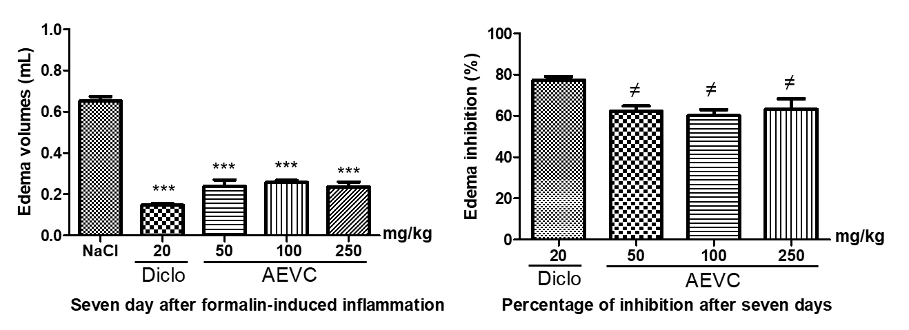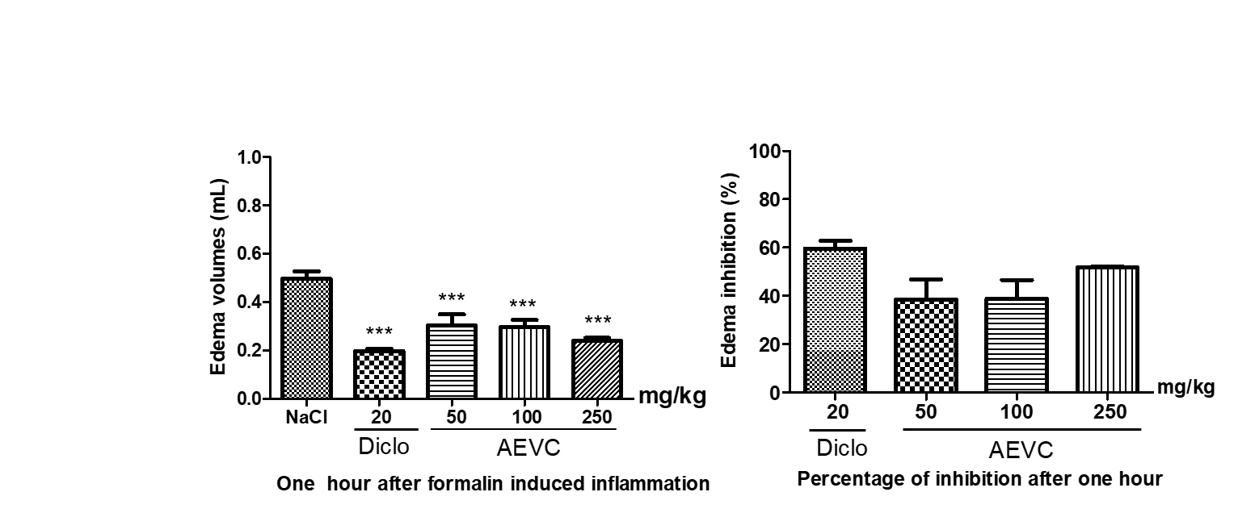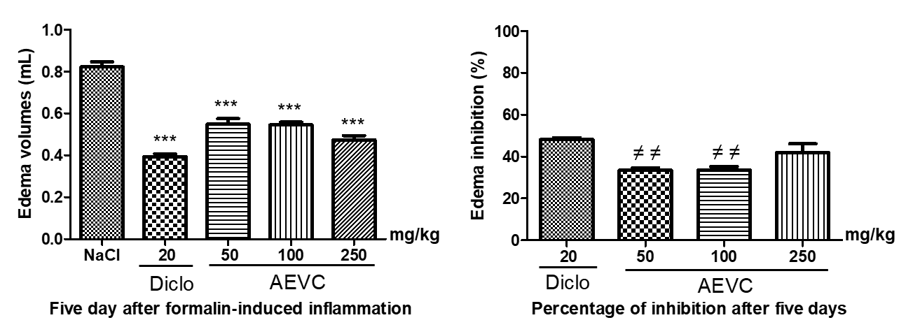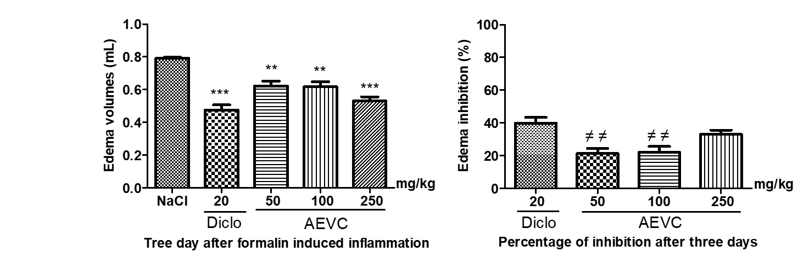
Figure 3: Effects of aqueous extract of Vernonia colorata leaves on formalin-induced chronic inflammation in mice. Values are expressed as mean ± standard error; n = 5. Significant difference from control (NaCl): p < 0.01 (**); p < 0.01 (***). Significant difference from diclofenac: p < 0.05 (≠); p < 0.01 (≠≠).
    - Effect of aqueous extract of Vernonia colorata leaves on the histological structure of the legs
Histopathological examination of paw tissues from the normal control group showed normal tissues without lesions (Figure 4A). However, tissues from mice treated with formalin alone revealed significant edema characterized by epithelial and connective tissue bullae with infiltrated inflammatory cells, epithelial layer loosening, and neutrophil accumulation (Figure 4B). In contrast, tissues from mice treated with the extract showed mild edema and small layer loosening (Figure 4D and E). Inflammatory histological changes showed a significant decrease in edema as well as inflammatory cell infiltration at the 250 mg/kg dose of AEVC (Figure 4F).
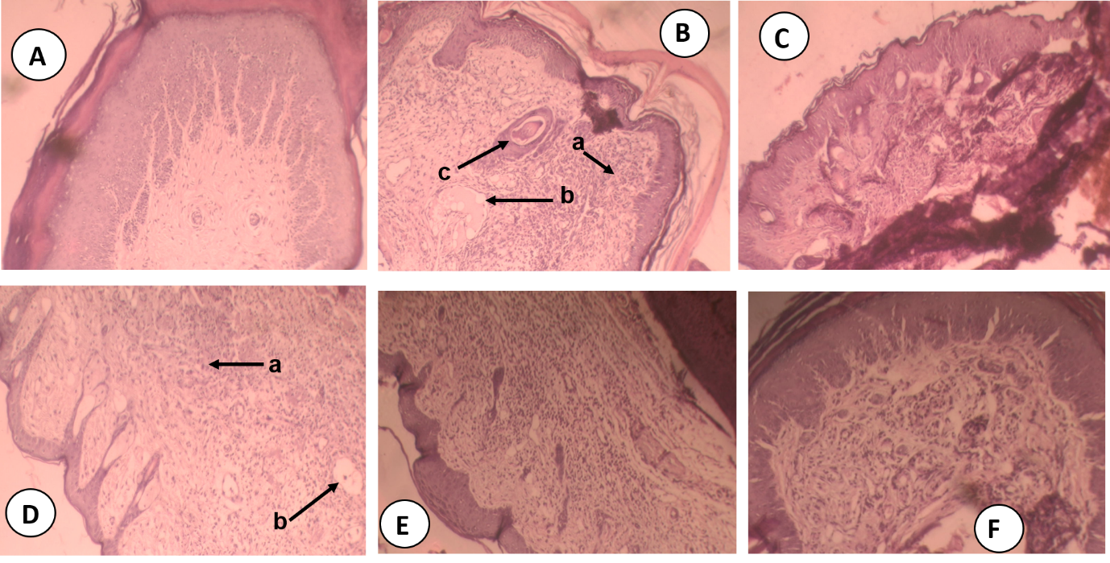
Figure 4: Effect of aqueous extract of Vernonia colorata leaves on histopathological structure of mouse paw in formalin-induced inflammation model. A: Normal control paw tissues (normal epidermis, deep dermis and subcutaneous tissues without lesions); B: The group treated with formalin alone showed marked cutaneous hyperkeratosis with epithelial proliferation, subcutaneous tissues showed inflammatory cell infiltration, edema; D and E: The group treated with the extract at 50 and 100 mg/kg respectively (deep dermis and subcutaneous tissues with slight inflammatory cell infiltration, small edema); F: The group treated with the extract at 250 mg/kg: marked reduction of paw tissue lesions, most of the histological changes were minimized and judged negligible compared with the group treated with formalin alone. a: neutrophils, b: edema, c: vessels. H&E staining, magnification × 100.

Discussion
Inflammation is a natural reaction of the body to an attack, whether physical (injury), chemical (burn), or infectious (bacteria, viruses). Dextran-induced paw edema is a model characterized by increased vascular permeability, kinin activation, and mast cell degranulation, resulting in the release of histamine and serotonin, and leading to edema with low neutrophil and carrageenan-contrasted protein (Lo et al., 1982; Da et al., 2024). Once released, histamine and serotonin act rapidly on blood vessels, triggering vasodilation with consequent increased blood flow to the injured area (Lee et al., 2018; Ramos et al., 2020). Furthermore, histamine, a potent vasodilator and main mediator involved in the initial phase of inflammation, increases the permeability of blood vessels by acting on microcirculation (Andrade et al.,2007; Linardi et al., 2002). Serotonin, released mainly by mast cells and platelets, is also involved in this process. It induces edema and plasma extravasation during acute inflammation (Badilla et al., 2007). In the present study, the aqueous extract of Vernonia colora leaves significantly inhibited the increase in the volumes of paw edema induced by dextran. Its anti-inflammatory action could therefore be justified by the inhibition of the synthesis and/or the release of mediators involved in the inflammatory process, such as serotonin, histamine, and consequently the reduction of vasodilation, and demonstrating an anti-edematogenic activity. Therefore, the extract would have antihistamine and antiserotonergic properties.
Carrageenan-induced inflammation is widely used as an in vivo model of acute inflammatory response to determine the anti-inflammatory activities of plant extracts (Sini et al., 2010; Ou et al., 2019). The anti-edema effect of carrageenan is a biphasic process (Gupta, 2009). The first phase (1–3 h after administration) is mediated by histamines, serotonins, and kinins. Prostaglandins (PGs) appear to be the mediators of the second phase (3–5 h after administration) (Brooks and Day, 1991). In the present study, carrageenan injection caused paw edema, as already shown by previous studies, including those of Oliveira et al. (2019) and Da et al. (2024). Furthermore, AEVC significantly inhibited the effects of carrageenan, an inhibition similar to that of diclofenac. Therefore, the extracts and diclofenac appear to be able to inhibit carrageenan-induced paw edema in the first and second phases, suggesting that the extract may inhibit the release of histamine, serotonin, and prostaglandins. Thus, by directly neutralizing histamine through mast cell degranulation, AEVC may have an antihistamine property. Also, the anti-edema effect of the extract continued significantly in the second phase of edema formation. The extract appears to inhibit cyclooxygenase enzymes involved in prostaglandin formation. These results corroborate those of Oliveira et al. (2019) and Asante et al. (2019), who respectively showed that the ethanolic extract of Vernonia polysphaera and ethanolic extracts of young and old leaves of Vernonia amygdalina decreased carrageenan-induced paw edema in mice by reducing the action of inflammatory mediators.
Granuloma formation, occurring through the development of proliferative cells, occurs in chronic disease or due to failure of the acute response to clear pro-inflammatory agents. The transudative and proliferative components of chronic inflammation are due to neutrophil infiltration, fibroblast proliferation, exudation and angiogenesis, and protein leakage (Posadas et al., 2004; Kahn and Solomon, 2007; Alshehri et al., 2023). In cotton granuloma tests, diclofenac and the extract at doses of 100 and 250 mg/kg significantly decreased the weights of fresh and dry granulomas compared to those of normal control animals. The ability of EAVC to attenuate subacute inflammatory processes could be attributed to its ability to attenuate the formation of granulomatous tissue. This formation is associated with the migration and proliferation of various types of immune cells (neutrophils, fibroblasts, and macrophages) as well as the multiplication of small blood vessels (Zakaria et al., 2011). Thus, AEVC would inhibit the increase in the number of fibroblasts and the synthesis of collagen and mucopolysaccharides during the formation of granuloma tissue (Mazumder et al., 2003). By significantly reducing granuloma formation, its mechanism would be anti-inflammatory action via the attenuation of inflammatory cell infiltration, fibroblast proliferation, angiogenesis, and exudation (Lu et al., 2024). Furthermore, the extract caused a significant increase in relative spleen weight at doses of 50 and 100 mg/kg compared to the control. Indeed, the spleen is a lymphoid organ that stores lymphocytes and monocytes, ensuring the protection of the body. According to Bronte and Pittet (2014), certain infections can induce a splenic accumulation of monocytes and neutrophils. This accumulation of cells would be at the origin of the increase in the relative weight of the spleen in this study and suggests that AEVC would promote the recruitment of macrophages and neutrophils in the spleen (Li et al., 2017). This would demonstrate the involvement of the spleen in the control of infection via the regulation of the formation and destruction of blood cells. AEVC would stimulate the function of the spleen in the control of infection.
Cotton granulomas induced an increase in the number of leukocytes in the control group and the 100 and 250 mg/kg doses of the extract. This increase could be explained by the increase in the volume of the spleen, which also contributes to the supply of leukocytes and platelets to the general circulation as part of the "fight or flight" response to stressors (Shephard, 2015).
The results obtained were confirmed by histopathological results, which showed that treatment with the extract significantly decreased inflammatory cell infiltration and reduced edema, just like diclofenac. Treatment for one hour before the induction of inflammation and for one week attenuated the histopathological features of edema, inflammatory cell infiltration, and neutrophils. A previous study showed that macrophages secrete inducible nitric oxide synthase (iNOS), which is involved in the production of large amounts of nitric oxide (NO) (Ignarro, 2002). These authors suggested that neutrophil adhesion to endothelial cells is mediated by NO. The EAVC-treated groups showed extract exhibited a significant reduction in neutrophils, indicating low NO production. This suggests a decrease in mast cells, which in turn indicates a reduced ability of the extract. This reduction is likely due to the ability of the extract to suppress mast cells. This reduction in neutrophils, in turn, suggests a decrease in mast cells, thereby demonstrating the extract's ability to reduce inflammation. It is important to note that previous studies have shown the presence in the extract of coumarin polyphenols and triterpenoids, bioactive compounds capable of modulating the proliferative phase of inflammation in animal models, thus exhibiting anti-inflammatory effects (Mohammad et al., 2015)

Conclusion
The objective of this study was to evaluate the acute and subacute anti-inflammatory effects of the aqueous extract of Vernonia colorata leaves on the induced inflammation model in mice and rats. The AEVC exhibited acute and subacute anti-edema effects, leading to a reduction in paw edema volumes and inflammatory cell infiltration, as well as a decrease in edema and neutrophils. These results support the use of Vernonia colora leaves in traditional medicine for the management of inflammatory diseases. However, further research is needed to determine the anti-inflammatory mechanism of the aqueous extract of Vernonia colorata leaves.
Conflict of Interest Statement
The authors have declared no conflict of interest.
Ethical Approval Statement
All experimental protocols were approved by the Institutional Ethics Committee of Joseph KI-ZERBO University under Experimental Protocol Approval Number CE-UJKZ/2020-04.

References
Alshehri, S., AlGhamdi, S. A., Alghamdi, A. M., Imam, S. S., Mahdi, W. A., Almaniea, M. A., & al. (2023). Protective effect of fustin against adjuvant-induced arthritis through the restoration of proinflammatory response and oxidative stress. Peer J.; 11. https://doi:10.7717/peerj.15532
Andrade, S. F., Cardoso L. G., Carvalho J. C., & Bastos J. K. (2007). Anti-inflammatory and antinociceptive activities of extract, fractions, and populnoic acid from bark wood of Austroplenckia populnea. Journal of Ethnopharmacology, 109(3):464-71. https://doi:10.1016/j.jep.2006.08.023
Antwi-Adjei, M., YeboahK, O., Oppong-Kyekyeku, J. & Osafo, N. (2022). Inflammation modulating activity of the hydroethanol stem bark extract of Bombax costatum in murine models. Scientific, vol. 2022, Article ID 6882147, 10 pages
Asante, D. B., Henneh, I. T., Acheampong D. O., Kyei, F., Adokoh, C. K., Ofori, E. G., Domey, N. K., et al. (2019). Anti-inflammatory, anti-nociceptive, and antipyretic activity of young and old leaves of Vernonia amygdalina. Biomedicine & Pharmacotherapy, 111:1187-1203. https://doi:10.1016/j.biopha.2018.12.147
Badilla, B., Cambronero, J., Ciccio, J. F., Cordero, T., & Mora, G. (2007). Determination of topical anti-inflammatory activity of the essential oil and extracts of Lippia alba (Mill.) N.E. Brown (Verbenaceae), using the model of mouse ear edema induced by TPA and AA. Pharmacognosy Magazine. 3(11):139-144.
Bronte, V., & Pittet, M. J. (2014). The spleen in local and systemic regulation of immunity. NIH Public Access, 39(5):806–818. https://doi:10.1016/j.immuni.2013.10.010
Brooks, P. M.; & Day, R. O. (1991). Nonsteroidal Anti-inflammatory Drugs–Differences and Similarities. N. Engl. J. Med, 324(24):1716-25, https://doi:10.1056/NEJM199106133242407
Da, F. L., Coulibaly, A. Y., Yaouda, V., Tindano, B., Koussoube, I., Ballo, M., Bayala, B. & Belemtougri, R. G. (2024). Phytochemical screening, antioxidant and antiedematous activities of aqueous extract of Sarcocephalus latilolius (sm.) Bruce ripe fruits in rat. GSC Advanced Research and Reviews, https://doi.org/10.30574/gscarr.2024.20.2.0309
Dharmasiri, M. G., Jayakody, J. R. A. C., Galhena, G., Liyanage, S. S. P., & Ratnasooriya, W. D. (2003). Anti-inflammatory and analgesic activities of mature fresh leaves of Vitex negundo. Journal of Ethnopharmacology. 87(2-3):199-206, https://doi:10.1016/s0378-8741(03)00159-4
Fayez, N., Waleed, K., Essam, A‑S., & Abdel‑Fattah, M. A‑F. (2023). In vitro and in vivo assessment of the anti‑inflammatory activity of olive leaf extract in rats. Inflammopharmacology, 31:1529–1538, https://doi.org/10.1007/s10787-023-01208-x
Gupta, M, Mazumder, U. K., Sambath, K. R., Gomathi, P., Rajeshwar, Y., Kakoti, B. B., & Tamil, S. V. (2006). Anti-inflammatory, analgesic, and antipyretic effects of methanol extract from Bauhinia racemosa stem bark in animal models. Journal of Ethnopharmacology; 98(3):267-73. https://doi:10.1016/j.jep.2005.01.018
Gupta, S. (2009). Drug Screening Methods: Preclinical Evaluation of New Drugs. Jaypee: New Delhi, India, 2009; ISBN 978-81-8448-618-6
Ignarro, L. J. (2002). Nitric oxide as a unique signaling molecule in the vascular system: a historical overview. J. Physiol Pharmacol. Dec;53(4 Pt 1):503-14. PMID: 12512688.
Ismail, T. S., Gopalakrishnan, S., Begum, V. H., & Elango, V. (1997). Anti-inflammatory activity of Salacia oblonga (Wall) and Azima tetracantha (Lam). J. Ethnopharmacol; 56 (2):145-152. https://doi.org/10.1016/S0378-8741(96)01523-1
Kahn, M. A., & Solomon, L. W. (2007). Acute inflammation/wound healing and repair II. Basic Human Pathology lecture. http://www.ocw.tufts.edu/data/51/ 551543.pdf.
Lanher, M. C., Fleurentin. J., Defnyan, P., Mortier, F., & Pelt, J. M. (1991). Analgesic and anti-inflammatory properties of Euphorbia hirta. Planta Medica, 57(3):225-231. https://DOI:10.1055/s-2006-960079
Lee, S.; Stubelius, A.; Hamelmann, N.; Tran, V., & Almutairi, A. (2018). Inflammation-Responsive Drug-Conjugated Dextran Nanoparticles Enhance Anti-Inflammatory Drug Ecacy. ACS Appl. Mater. Interfaces 2018(10):0378–40387. https://DOI:10.1021/acsami.8b08254
Li, Y., Wu, J., Xu, L., Wu, Q., Wan, Z., Li, L., Yu, H., Li, X., Li, K., Zhang, O., Hou, Z., Sun, X., & Chen, H. (2017). Regulation of Leukocyte Recruitment to the Spleen and Peritoneal Cavity during Pristane-Induced Inflammation. Journal of Immunology Research,1-12. https://doi:10.1155/2017/9891348
Linardi, A., Costa, S. K. P., Da Silva, G. R., & Antunes, E. (2002). Involvement of kinins, mast cells, and sensory neurons in the plasma exudation and paw edema induced by staphylococcal enterotoxin-B in the mouse. European Journal of Pharmacology; 399(2-3):235-242. https://doi.org/10.1016/S0014-2999(00)00375-7
Lo, T. N.; Almeida, A. P., & Beaven, M. A. (1982). Dextran and carrageenan evoke different inflammatory responses in rat with respect to composition of infiltrates and effect of indomethacin. J. Pharmacol. Exp. Ther., 221(1):261–267.
Lu, K., Yang, C. Y., & Yan, Z. H. (2024). Analgesic and anti-inflammatory activity of Cotinus coggygria Scop. extract in vivo. Asian Pac J Trop Biomed; 14(6):225-235. https://DOI:10.4103/apjtb.apjtb_132_24
Mazumder, U. K., Gupta, M., Manikandan, L., Bhattacharya, S., Haldar, P.K., & Roy, S. (2003). Evaluation of anti-inflammatory activity of Vernonia cinerea Less. extract in rats. Phytomedicine, 10 (2-3):185–188. https://doi:10.1078/094471103321659915
Mohammad, T. M., Ali, A. H., Bahareh, N., Seyyed, A. M., Anahita, R., & Behnam, G. (2015). A study of the mechanisms underlying the anti-inflammatory effect of ellagic acid in carrageenan-induced paw edema in rats. Indian Journal of Pharmacology, 3(47). https://dOI:10.4103/0253-7613.157127
Mrid, R. B., Bouchmaa, N., Ainani, H., El Fatimy, R., Malka, G., & Mazini, L. (2022). Anti-rheumatoid drugs advancements: new insights into the molecular treatment of rheumatoid arthritis,” Biomedicine & Pharmacotherapy, vol. 151, ID 113126 https://DOI:10.1016/j.biopha.2022.113126
Newman O. (2015). The fruit extract of Xylopia aethiopica (dunal) a. rich. (Annonaceae) and its principal constituent, Xylopic Acid, modulates inflammation,” Doctoral dissertation, Kwame Nkrumah University of Science and Technology, Kumasi, Ghana
Obiri, D. D., Osafo, N., Ayande, P. G., & Antwi, A. O. (2014). Xylopia aethiopica (Annonaceae) fruit extract suppresses Freund’s adjuvant-induced arthritis in Sprague-Dawley rats,” Journal of Ethnopharmacology, 52(3):522-31. https://doi:10.1016/j.jep.2014.01.035
Oliveira, I. dS. dS., Colares, A.V., Cardoso, F. dO., Tellis, C. J. M., Chagas, M. dS. dS., Behrens, M. D., et al. (2019). Vernonia polysphaera Baker: Anti-inflammatory activity in vivo and inhibitory effect in LPS-stimulated RAW 264.7 cells. PLoS ONE 14(12): e0225275. https://doi.org/10.1371/journal.pone.0225275
Ou, Z., Zhaoa, J., Zhu, L., Huang, L., Ma, Y., Ma, C., Luo, C., Zhu, Z., Yuan, Z., Wu, J., Li, R., & Yi, J. (2019). Anti-inflammatory effect and potential mechanism of betulinic acid on λ-carrageenan-induced paw edema in mice. Biomedicine & Pharmacotherapy,118:109347. https://doi.org/10.1016/j.biopha.2019.109347
Ouedraogo, M., Nikiema, W. A., Pagbelguem, B., Delma, T. E., Olusunle, D. F., Sondo, A., Kabore, R. A. F., Kafando, E. (2023). Effects of leaf extracts of Carica papaya L. (Caricaceae) and Vernonia colorata (Willd.) Drake (Asteraceae) on induced thrombocytopenia and increased vascular permeability: an approach to symptomatic treatment of dengue. The Journal of Phytopharmacology, 12(6):358-365. https://doi:10.31254/phyto.2023.12602
Peng, K., Deng, N., Meng, Y., He, Q., Meng, H., Luo, T., Wei, Y., Kang, Y., Zhou, X., & Shen F. (2022). Alpha-Momorcharin Inhibits Proinflammatory Cytokine Expression by M1 Macrophages but Not Anti-Inflammatory Cytokine Expression by M2 Macrophages. J. Inflamm. Res. 2022(15):4853–4872. https://DOI:10.2147/JIR.S372306
Posadas, I., Bucci, M., Roviezzo, F., Rossi, A., Parente, L., Sautebin, L., & Cirino, G. (2004). Carrageenan-induced mouse paw oedema is biphasic, age-weight dependent and displays differential nitric oxide cyclooxygenase-2 expression. British Journal of Pharmacology, 142(2):331-8. https://doi:10.1038/sj.bjp.0705650
Ramos, A. G. B., De Menezes, I. R. A., Da Silva, M. S. A., Torres P. R., De Lacerda, N. L. J., Rocha, S. P. F., Melo, C. H. D., Iriti M., & Quintans-Júnior, L. J. (2020). Antiedematogenic and Anti-Inflammatory Activity of the Monoterpene Isopulegol and Its β-Cyclodextrin (β-CD) Inclusion Complex in Animal Inflammation Models. Foods, 9(5):630. .https://Doi:10.3390/foods9050630
Sawadogo, P., Sawadogo, T. A., Da F. L., Tindano, B., Ouedraogo, Y., & Belemtougri, G. R. (2022). Phytochemical composition and toxicity study of the aqueous extract of the leaves of Vernonia colorata (Willd.) Drake in Wistar rats. GSC Bio Pharma Sci; 18(03):155–163. https://doi.org/10.30574/gscbps.2022.18.3.0103
Shephard, R. J. (2015). Responses of the human spleen to exercise. Journal of Sports Sciences, 34(10):929–936. https://doi.org/10.1080/02640414.2015.1078488
Siaka, S., Golly, K. J., Guessennd, N., Soro, Y., Djama, A. J., & Dosso, M. (2012). Phytochemical assessment and antimicrobial activity of leaves extract of Vernonia colorata (Wild.) Drake on Resistant Germs of Staphylococcus aureus and Pseudomonas aeruginosa. J Chem Pharma Res, 4(5): 2490-2494.
Sini, J. M., Yaro, A. H., Ayanwuyi, L. O., Aiyelero, O. M., Mallum, S. M., & Gamaniel, K. S., 2010. Antinociceptive and anti-inflammatory activities of the aqueous extract of the root bark of Combretum sericeum in rodents. African Journal of Biotechnology, 9(51):8872-8876. https://DOI:10.5897/AJB10.233
Zakaria, Z. A., Hussain, M. K., Mohamad, A. S., Abdullah, F. C., & Sulaiman, M. R. (2011). Anti-Inflammatory activity of the aqueous extract of Ficus Deltoidea. Biological Research for Nursing, 000(00):1-8. https://DOI:10.1177/1099800410395378

