DIRECT IMMUNOFLUORESCENCE – A BEACON OF HOPE IN DIAGNOSING VASCULITIC LESION

.

ABSTRACT

|  |
| --- |
| **Aims:** We assessed the significance of direct immunofiuorescence in the diagnosis of vasculitic lesions and to investigaie the hisiopathological characierises of vasculite iesions.  **Study design:** An cross-sectional study  **Place and Duration of Study:** The Cross-sectional research was conducted at the Blood Center and the Department of Pathology, Vinayaka Mission’s Kirupananda Variyar Medical College & Hospitals, Salem - 636308, Tamil Nadu, India, as a cross-sectional study carried out from January 2024 to December 2024, involving a sample size of 80 clinically diagnosed vasculitis lesions.  **Methodology:** This study included a sample size of 80 clinically diagnosed vasculitis patients selected based on inclusion criteria of having complete clinical data, while excluding suspected cases or those with inadequate/incomplete data. Following informed consent, eligible patients were enrolled. Histopathological and Direct Immunofluorescence (DIF) findings were collected from the Department of Pathology, and clinico-epidemiological data were obtained. The primary outcome measures were the timing of biopsy in relation to DIF positivity and the results of DIF studies.  **Results:** In our study of 80 clinically diagnosed vasculitis cases, the majority of patients were aged 31–40 years (31%), with a female predominance (58%). The lower limb was the most common biopsy site (41%). Direct immunofluorescence (DIF) revealed C3 as the most frequently detected component (25%), followed by fibrinogen (23%) and IgA (20%), while IgM (5%) and IgG (2%) were less common; 25% of patients showed negative results for all markers. DIF positivity was highest (93%) in patients biopsied within one week of symptom onset, decreasing to 50% in the second week, 22% in the third to fourth week, and 0% beyond four weeks, highlighting the importance of early biopsy for optimal detection  **Conclusion:** Direct immunofluorescence (DIF) is a valuable diagnostic tool in cutaneous vasculitis, with the highest yield seen in biopsies taken within one week of symptom onset. C3, fibrinogen, and IgA were the most commonly detected immune components. |

*Keywords: Direct immunofluorescence, Vasculitis, Early biopsy importance, Site involvement, C3, Fibrinogen, South Indian population*

INTRODUCTION

The inflammation of the vascular wall, known as vasculitis, can manifest clinically in a wide range of ways. The skin is frequently affected by vasculitic processes. [1,2] Skin biopsies are frequently carried out when looking for vasculitides because of how simple they are to obtain. [3] Cutaneous vasculitis may be idiopathic, primary, or subsequent to a number of illnesses, including neoplasms, infections, medications, inflammatory diseases, or a spectrum of systemic vasculitis. Vasculitis frequently involves small and/or medium-sized dermal vessels.[4,5]   
Due to its accessibility, cutaneous vasculitis is frequently identified and biopsied. Direct immunofluorescence (DIF) is also performed on the majority of biopsies, albeit the success rates differ. Verification and categorization of vasculitis depend on histopathologic analysis. [6,7] Despite being considered sensitive, DIF has a varied yield and is affected by a number of factors. The majority of studies use a 48-hour cutoff period, and the positive rates are higher in early illness. [8,9] We aim to assess hte significance of direct immunofiuorescence in the diagnosis of vasculitic lesions and to investigaie the hisiopathological characierises of vasculite iesions in our hospital.

2. material and methods

This cross-sectional study was conducted at the Department of Pathology, Vinayaka Mission’s Kirupananda Variyar Medical College & Hospitals, Salem, Tamil Nadu, India, over a period from January 2024 to December 2024. A total of 80 patients with clinically diagnosed vasculitic lesions were included based on predefined inclusion criteria of complete clinical data, while suspected cases and those with inadequate or incomplete records were excluded. After obtaining informed consent, eligible participants were selected. Histopathological and direct immunofluorescence (DIF) findings were obtained from the Department of Pathology, and relevant clinico-epidemiological data were obtained. The primary outcome measures were the timing of biopsy in relation to DIF positivity and the DIF results themselves. Data entry and statistical analysis were performed using SPSS software, with p-values calculated to assess statistical significance in correlations and findings.

3. results and discussion

**AGE DISTRIBUTION**

In our study, individuals under 20 years of age accounted for 6% of the total, with 5 patients in this category. The 20–30 years age group included 15 patients, making up 19% of the total. The largest proportion was observed in the 31–40 years age group, comprising 25 patients or 31%. Both the 41–50 years and 51–60 years age groups had a similar number of patients—15 (19%) and 14 (17%), respectively. The 61–70 years group had 4 patients, representing 5%, while the 71–80 years group had the smallest count with just 2 patients, accounting for 3% of the total.

**TABLE 1: AGE DISTRIBUTION**

|  |  |  |
| --- | --- | --- |
| AGE GROUP | NO OF PATIENTS | PERCENTAGE |
| LESS THAN 20 YEARS | 5 | 6% |
| 20-30 YEARS | 15 | 19% |
| 31-40 YEARS | 25 | 31% |
| 41-50 YEARS | 15 | 19% |
| 51-60 YEARS | 14 | 17% |
| 61-70 YEARS | 4 | 5% |
| 71-80 YEARS | 2 | 3% |

**FIGURE 1: AGE DISTRIBUTION**

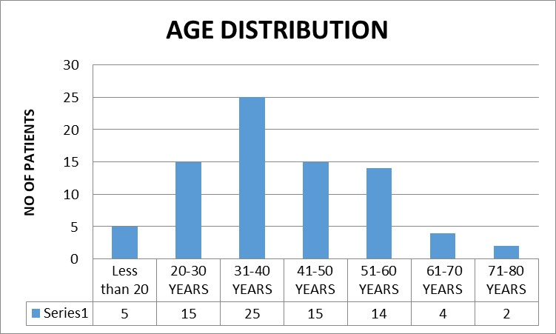

**GENDER DISTRIBUTION**

In our study, 34 patients (42 %) were males and 46 patients (58%) were females

**TABLE 2: GENDER DISTRIBUTION**

|  |  |  |
| --- | --- | --- |
| GENDER | NO OF PATIENTS | PERCENTAGE |
| MALE | 34 | 42% |
| FEMALE | 46 | 58% |

**FIGURE 2: GENDER DISTRIBUTION**

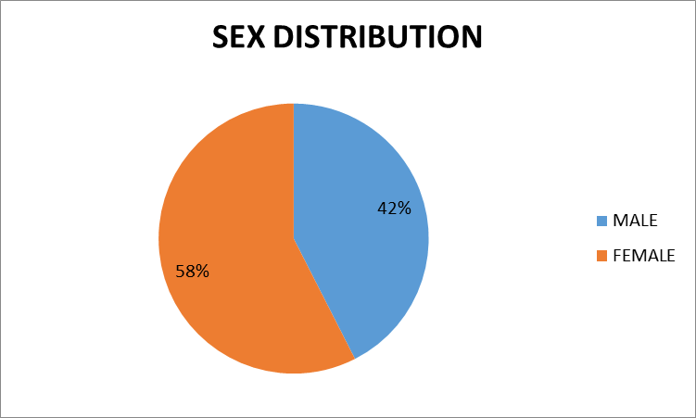

**SITE DISTRIBUTION**

In our study, most common site of biopsy was the lower limb, with 33 patients (41%) undergoing procedures in that area. This was followed by the upper limb, where 20 patients (25%) had biopsies performed. The back was the site of biopsy in 12 patients (15%), while the chest and abdomen accounted for 10 cases (13%). The least common biopsy site was the face and scalp, with only 5 patients (6%) affected.

**TABLE 3: SITE DISTRIBUTION**

|  |  |  |
| --- | --- | --- |
| SITE OF BIOPSY | NO OF PATIENTS | PERCENTAGE |
| LOWER LIMB | 33 | 41% |
| UPPER LIMB | 20 | 25% |
| BACK | 12 | 15% |
| CHEST & ABDOMEN | 10 | 13% |
| FACE & SCALP | 5 | 6% |

**FIGURE 3: SITE DISTRIBUTION**

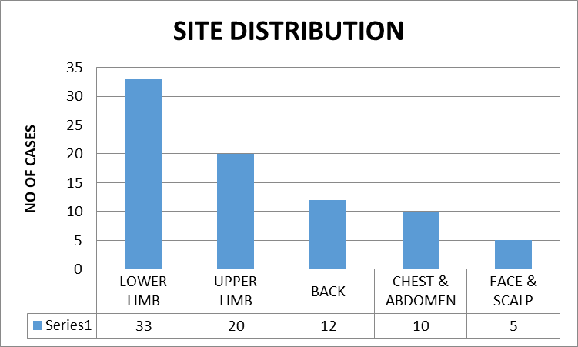

**SYMPTOMS**

The most frequently reported symptom was skin involvement, observed in 30 patients (37%). Joint pain was the next most common, reported by 25 patients (31%). Abdominal pain was present in 10 patients (13%), while 3 patients (4%) experienced neuropathy. Combined symptoms were also noted, with skin and joint involvement seen in 5 patients (6%), and skin and gastrointestinal involvement in another 5 patients (6%). Fever was the least common symptom, reported in only 2 patients (3%).

**TABLE 4: SYMPTOMS**

|  |  |  |
| --- | --- | --- |
| **SYMPTOMS** | **FREQUENCY** | **%** |
| SKIN INVOLVEMENT | 30 | 37% |
| JOINT PAIN | 25 | 31 |
| ABDOMINAL PAIN | 10 | 13 |
| NEUROPATHY | 3 | 4 |
| SKIN & JOINT INVOLVEMENT | 5 | 6 |
| SKIN & GIT INVOLVEMENT | 5 | 6 |
| FEVER | 2 | 3 |

**FIGURE 4: SYMPTOMS**

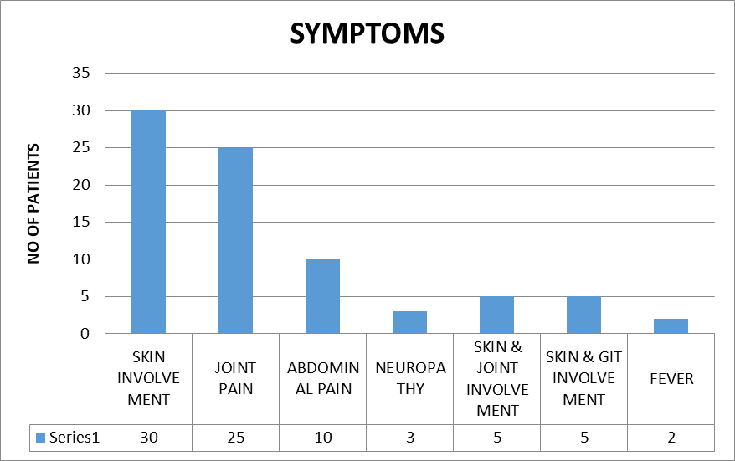

**RESULTS OF DIRECT IMMUNOFLUORESCENCE**

Direct immunofluorescence revealed the presence of C3 in 20 patients (25%), making it the most frequently detected component. Fibrinogen was found in 18 patients (23%), followed by IgA in 16 patients (20%). IgM and IgG were less commonly observed, with frequencies of 4 (5%) and 2 (2%) patients, respectively. Notably, 20 patients (25%) showed negative results for all tested immunoglobulins and complement components.

**TABLE 5: RESULTS OF DIRECT IMMUNOFLUORESCENCE**

|  |  |  |
| --- | --- | --- |
| **IMMUNOGLOBULINS** | **FREQUENCY** | **%** |
| IgA | **16** | **20** |
| IgM | **4** | **5** |
| IgG | **2** | **2** |
| C3 | **20** | **25** |
| FIBRINOGEN | **18** | **23** |
| ALL NEGATIVE | **20** | **25** |

**FIGURE 5: RESULTS OF DIRECT IMMUNOFLUORESCENCE**

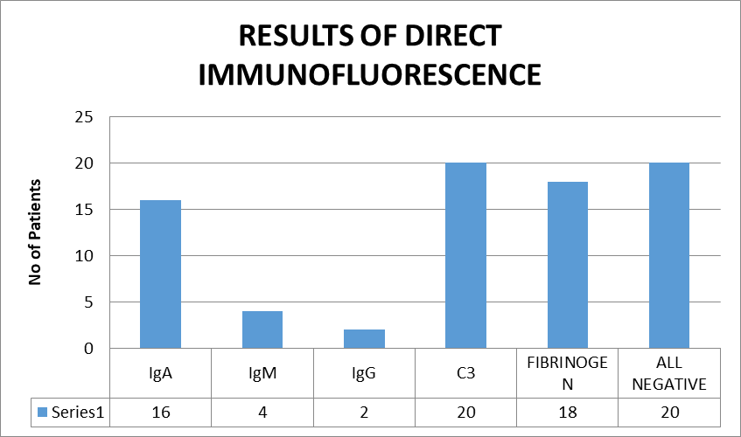

**TIMING OF BIOPSY AND DIF POSITIVITY**

In our study, the highest rate of DIF positivity was observed in patients who underwent biopsy within one week of symptom onset, with 52 out of 56 patients (93%) showing positive results. In those biopsied between the first and second week, DIF positivity dropped to 50%, with 6 out of 12 patients testing positive. The positivity rate further declined to 22% in patients biopsied between the second and fourth weeks (2 out of 9 patients). Notably, no DIF positivity was observed in patients biopsied after more than four weeks, indicating a clear decline in detection rates with delayed biopsy.

**TABLE 6: TIMING OF BIOPSY AND DIF POSITIVITY**

|  |  |  |  |
| --- | --- | --- | --- |
| **TIMING OF BIOPSY** | **NO OF PATIENTS** | **DIF POSITIVITY** | **%** |
| LESS THAN 1 WEEK | 56 | 52 | 93% |
| 1ST TO 2ND WEEK | 12 | 6 | 50% |
| 2ND WEEK TO 4TH WEEK | 9 | 2 | 22% |
| MORE THAN 4TH WEEK | 3 | 0 | 0% |

**FIGURE 6: TIMING OF BIOPSY AND DIF POSITIVITY**

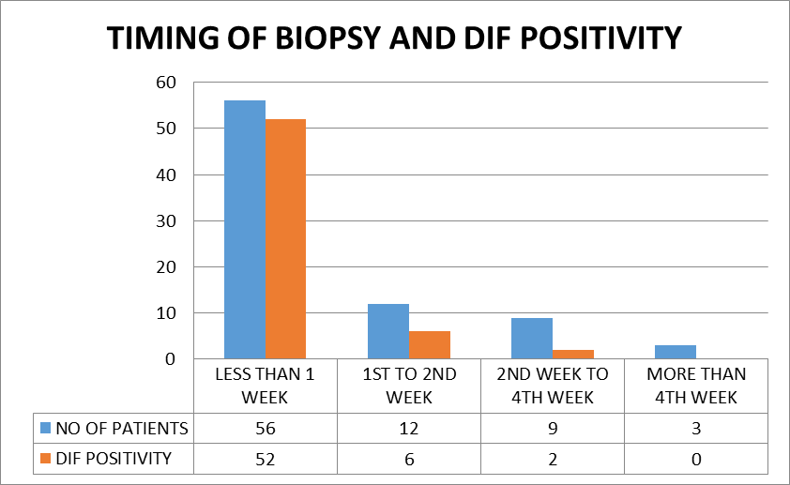

**DISCUSSION**

In our study, the largest proportion was observed in the 31–40 years age group, comprising 25 patients or 31%. Both the 41–50 years and 51–60 years age groups had a similar number of patients—15 (19%) and 14 (17%), respectively. Nandeesh B et al [6] state that the age of the patients ranged from eight to 82 yrs with a mean age of 29.6 years. Seventy percent of the patients were below 40 years.

In our study, 34 patients (42 %) were males and 46 patients (58%) were females. Nandeesh B et al [6] state that women outnumbered men in a ratio of approximately 1.6:1 from their study. Poornimambaa M et al [10] state that among the total 35 patients, 18 were females and 17 males from their study. However, Lath K et al [11] state that there were 102 male and 96 female patients in their study.

In our study, most common site of biopsy was the lower limb, with 33 patients (41%) undergoing procedures in that area. This was followed by the upper limb, where 20 patients (25%) had biopsies performed. The back was the site of biopsy in 12 patients (15%), while the chest and abdomen accounted for 10 cases (13%). The least common biopsy site was the face and scalp, with only 5 patients (6%) affected. Nandeesh B et al [6] state that the commonest site was lower extremity followed by upper extremity from their study.

In our study, the most common symptom was skin involvement (37%), followed by joint pain (31%), abdominal pain (13%), and neuropathy (4%). Combined symptoms included skin and joint (6%) or skin and gastrointestinal involvement (6%). Fever was rare (3%). Nandeesh B et al [6] state that Palpable purpura was the main clinical finding seen in all the patients followed by multiple joint pain from their study. Lath K et al [11] state that skin involvement was present in all the cases and arthralgia in 30 patients (18.8%), pain in abdomen and/or malena in 16 patients (10%), and 10 cases (6.25%) showed simultaneous involvement of 3 organs, that is, skin, joint, and gastrointestinal tract.

Direct immunofluorescence revealed the presence of C3 in 20 patients (25%), making it the most frequently detected component. Fibrinogen was found in 18 patients (23%), followed by IgA in 16 patients (20%). IgM and IgG were less commonly observed, with frequencies of 4 (5%) and 2 (2%) patients, respectively. Notably, 20 patients (25%) showed negative results for all tested immunoglobulins and complement components. Nandeesh B et al [6] state that the C3 was most commonly found with 26% in 52 patients and followed by IgA in 46 patients with 23%. Poornimambaa M et al [10] state that C3 and fibrinogen were the common immune-reactants seen in DIF from their study. Lath K et al [11] state that IgA was the most common immunoreactant (35.3%) and other immunoreactant positivity seen in decreasing order of frequency were C3 (30.3%), IgM (24.7%), and IgG (18.6%).

In our study, DIF positivity was highest (93%) in patients biopsied within one week of symptom onset (52/56). It dropped to 50% between weeks one and two (6/12), 22% between weeks two and four (2/9), and 0% after four weeks, highlighting decreased detection with delayed biopsy. Nandeesh B et al [6] state that DIF was positive in 85% of biopsies performed within seven days, followed by 14% positivity by 1st to 2nd week, 1% positivity by 2nd to 4th week and 0% positivity after 4th week. Poornimambaa M et al [10] state that in 14 patients who had lesions less than 2 days old DIF was positive in 13 (92%) and in 19 patients who had lesions of 3–5 days duration DIF was diagnostic in all of them.

4. Conclusion

This study emphasizes how important direct immunofluorescence (DIF) is for cutaneous vasculitis diagnosis, especially when samples are taken early in the illness. Biopsies obtained within a week of the onset of symptoms had the highest diagnostic yield, confirming that DIF sensitivity is time-sensitive. C3, fibrinogen, and IgA were the most commonly found immune components, indicating typical immunopathological patterns observed in vasculitic processes. Our results also corroborate previous research on the most common clinical characteristic, which is cutaneous manifestations, female preponderance, and lower limb involvement. Accurate classification and treatment of vasculitic illnesses depend on timely biopsy and clinical detection due to the diagnostic importance of DIF and histology, particularly in early lesions.

**RECOMMENDATION**

* Early Biopsy is Crucial: Clinicians should aim to perform skin biopsies within one week of symptom onset to maximize DIF positivity and diagnostic accuracy.
* Routine Use of DIF: Direct immunofluorescence should be routinely included in the evaluation of suspected cutaneous vasculitis for better immunopathological characterization.
* Site Selection Matters: The lower limb remains the most common and accessible site for biopsy and should be prioritized when appropriate.
* Integrated Clinical Approach: Clinical findings, histopathology, and DIF results should be interpreted together to ensure accurate diagnosis and appropriate management.
* Improve Awareness and Training: Enhanced clinician awareness and training on the importance of timing and technique in biopsy collection can improve diagnostic outcomes.

Consent

All authors declare that ‘written informed consent was obtained from the patient (or other approved parties) for publication of this study. A copy of the written consent is available for review by the Editorial office/Chief Editor/Editorial Board members of this journal.

Ethical approval

Before the study, all patients were informed about the contents & type of the study and informed written consents were obtained from all of them. The study was approved by the Institutional ethical committee of Vinayaka Mission's Kirupananda Variyar Medical College & Hospitals. (Reference no: VMKVMC&H IEC/23/032).according to the ICMR guidelines on Biomedical research in human beings and also adhering to the principles of Good Clinical Practice. All authors hereby declare that all experiments have been examined and approved by the appropriate ethics committee and have therefore been performed in accordance with the ethical standards laid down in the 1964 Declaration of Helsinki.”

References

1. Watts RA, Scott DG. Recent developments in the classification and assessment of vasculitis. Best Pract Res Clin Rheumatol. 2009;23(3):429-443. doi:10.1016/j.berh.2008.12.004
2. Jennette JC, Falk RJ. Small-vessel vasculitis. N Engl J Med. 1997;337(21):1512-1523. doi:10.1056/NEJM199711203372106
3. Suresh E. Diagnostic approach to patients with suspected vasculitis. Postgrad Med J. 2006;82(970):483-488. doi:10.1136/pgmj.2005.042648
4. Cassisa A, Cima L. Cutaneous vasculitis: insights into pathogenesis and histopathological features. Pathologica. 2024;116(2):119-133. doi:10.32074/1591-951X-985
5. Braverman IM. The cutaneous microcirculation: ultrastructure and microanatomical organization. Microcirculation. 1997;4(3):329-340. doi:10.3109/10739689709146797
6. Nandeesh B, Tirumalae R. Direct immunofluorescence in cutaneous vasculitis: experience from a referral hospital in India. Indian J Dermatol. 2013;58(1):22-25. doi:10.4103/0019-5154.105280
7. McLaren JS, McRorie ER, Luqmani RA. Diagnosis and assessment of systemic vasculitis. Clin Exp Rheumatol. 2002;20(6):854-862.
8. Palit A, Inamadar AC. Vasculitis: approach to diagnosis and therapy. Indian J Dermatol Venereol Leprol. 2006;72(5):334-345. doi:10.4103/0378-6323.27748
9. Haynes BF, Allen NB, Fauci AS. Diagnostic and therapeutic approach to the patient with vasculitis. Med Clin North Am. 1986;70(2):355-368. doi:10.1016/s0025-7125(16)30958-0
10. Poornimambaa M, Asokan N, Augustine J. Utility of Direct Immunofluorescence in the Diagnosis of Small Vessel Vasculitis of the Skin: A Cross-Sectional Study. *Indian Dermatol Online J*. 2017;8(6):515-517. doi:10.4103/idoj.IDOJ_298_16
11. Lath K, Chatterjee D, Saikia UN, et al. Role of Direct Immunofluorescence in Cutaneous Small-Vessel Vasculitis: Experience From a Tertiary Center. *Am J Dermatopathol*. 2018;40(9):661-666. doi:10.1097/DAD.0000000000001170