**Molecular modeling and virtual screening. Application to computer-aided design of anticancer inhibitors of human dihydroorotate dehydrogenase.**

**ABSTRACT**

In this study, we undertake the virtual design of new anticancer agents with subnanomolar inhibition constants, specifically aimed at inhibiting dihydroorotate dehydrogenase (DHODH), utilizing a structure-based molecular design approach. QSAR models built from 4-quinoline carboxylic acid derivatives (QCADx) showed strong correlation between binding energies free energies (GFE: ${∆∆G}_{com}$) and the observed enzyme inhibition constants (${IC}_{50}^{exp}$) for each training set, according to the following relationship: ${pIC}_{50}^{exp}=-0.2073*{∆∆G}_{com}+7.7444$, with a coefficient of determination $R^{2}=0.88$. The predictive capacity of the QSAR model was validated by generating 3D-QSAR pharmacophores (PH4), yielding : ${pIC}_{50}^{exp}=1.024*{pIC}_{50}^{pre}-0.1419$, with R² = 0.80. A detailed analysis of DHODH catalytic residues was performed to identify key enzyme-inhibitor interactions, guiding the design of a virtual combinatorial library of 59,265 4-quinoline carboxylic acid derivatives (QCADs). 3D-QSAR pharmacophore model guided the screening of the virtual library, identifying 111 promising analogs with predicted ${IC}_{50}^{pred}$ values over 100 times lower than brequinar (7.3 nM). Furthermore, molecular dynamics simulations confirmed the stability of the five (5) best-selected QCADs. The combination of molecular modeling and *in silico* screening with the PH4 model of the VCL has enabled the identification of new potential candidates for anticancer agents with favorable pharmacokinetic profiles.

**Keywords:** Molecular modeling, Dihydroorotate dehydrogenase (DHODH), inhibitors, QSAR, Virtual screening, models, pharmacophore

**1. INTRODUCTION**

Cellular metabolism is essential for biological functions, and its disruption causes cancer, characterized by uncontrolled cell growth **[1]**. Common fatal cancers include lung, colorectal, breast, prostate, and stomach. Despite treatments like surgery, radio/chemo-therapy, hormonal therapy, targeted therapies and immunotherapy, cancer rates remain high globally. In 2020, WHO reported nearly 10 million deaths occurred **[2]**. In 2022, around 20 million new cases were reported and 9.7 million deaths occurred with over 35 million new cases projected by 2050 according International Agency for Research on Cancer IARC **[3].** This alarming trend necessitates urgent preventive and therapeutic strategies. Targeting metabolic enzymes, especially DHODH, a mitochondrial enzyme essential for pyrimidine synthesis is promising **[4]**. DHODH inhibition reduces pyrimidine pools, blocking DNA/RNA synthesis **[5]** and halting cell cycle progression at the S-phase **[6]**. DHODH inhibition not only offers anticancer benefits but also exhibits antiviral activity against viruses such as rotavirus **[7]** and the novel coronavirus SARS-CoV-2 **[8]**. This broad potential has sparked significant interest, leading to the development of several inhibitors including Brequinar **[9]**, Teriflunomide **[9]**, ALASN003 **[10],** BAY 2202234 **[11]** (Figure 1). Despite more than 90 patent applications **[12]**, only ASLAN003 has FDA approval **[10]**. Brequinar showed strong in vitro activity $7.3 nM$**[13]**, but clinical trials in various cancers yielded disappointing results **[14]**. Structurally, carboxylate of brequinar forms a salt bridge interaction with Arg136 and a significant hydrogen bond with the Gln47 residue **[15]**.These interactions justify the importance of the carboxylic acid **[15].** Other interactions between brequinar and DHODH occur in a hydrophobic channel with the biphenyl group (the quinoline nucleus) and residues Met43, Leu58, Ala59 and Pro364 **[15]** (Figure 2).The 4-quinoline carboxylic acid derivatives (QCADx), structurally related to Brequinar **[13]** developed via a structure-guided approach to enhance Brequinar physicochemical properties. The best analogue, QCAD33 (Figure.3), exhibits potent DHODH inhibition (IC₅₀ = 9.71 nM) **[13]**, good oral bioavailability, and a suitable half-life. Madak *et al*. study demonstrates the potential to improve both potency and pharmacokinetics. As part of this work, we designed novel potent DHOHD inhibitors having favourable ADME profiles based on a series of 4-quinoline carboxylic acid derivatives. In this study, new DHODH inhibitors based on QCADx were designed rationally. A multi-step computational approach was used: (1) A QSAR complexation model was developed using modified DHODH-QCAD3 crystal structures **[13]** using a molecular mechanics-Poisson-Boltzmann (MM-PB) complexation approach; (2) A pharmacophore model (PH4) was built from bioactive conformations; (3) The PH4 model was used to screen a virtual library (VL) of QCADx analogues to predict their ${IC}_{50}^{pred}$ inhibitory activities; (4) Molecular dynamics simulations were performed to evaluate the stability and binding of the most promising complexes. This strategy aims to identify potent anticancer agents with optimized ADME properties that target DHODH.



**Figure 1** : Inhibitors of DHODH.



**2. MATERIALS AND METHODS**

The workflow illustrating details of the sequential steps of the whole *in silico* design process of novel QCAD inhibitors of DHODH is presented in Figure 2.

**Figure 2.** General workflow describing the computer-aided novel QCAD analogs design against DHODH target.

**2.1. Training and Validation Sets of** QCAD **inhibitors**

The dataset of 4-quinoline carboxylic acid derivatives, including chemical structures and ${IC}_{50}^{exp}$ values, was sourced from Madak *et* *al*. **[13]**. With a broad activity range ($7,3≤{IC}_{50}^{exp}≤144000 nM)$, it enabled the construction of a robust QSAR model. Discovery Studio software **[16]**, the 42 compounds were split into a balanced training set (32 compounds) and validation set (10 compounds).

**2.2. Model Building**

Molecular models of DHODH-QCADx complexes, free DHODH, and free inhibitors were created using Insight-II. The QCAD3 ligand (PDB ID: 6CJF, 1.63 Å) **[13, 17]**  was modified *in situ*, followed by thorough conformational analysis and gradual energy optimization. Final low-energy conformations were globally minimized, a validated strategy in enzyme-inhibitor modeling and virtual drug design **[18]**. Calculs were performed using Discovery Studio 2.5 **[16]** and Insight II software **[19]**.

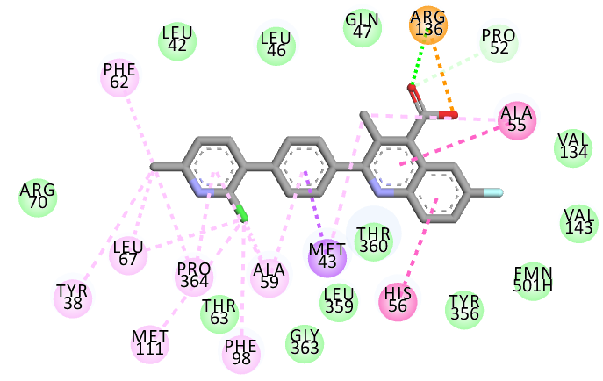

**Figure 3**: 2D interactions of DHODH-QCAD3 at the active site.

**2.3. Molecular mechanics**

The modeling of QCAD inhibitors, apo DHODH enzyme, and their enzyme-inhibitor complexes used all-atom representation and atomic charges per the CFF force field **[20]**. Molecular mechanics calculations followed protocols from Frecer *et al.* **[21]**.

**2.4. Conformational search**

Molecular geometry of bound inhibitors in E-I complexes served as the starting point for conformational searches. A Monte Carlo search with iteration limits explored rotatable bonds (excluding rings) using Discovery Studio **[16]**. For each QCAD inhibitor, 200 conformations were generated by ±15° torsion variations at 5000 K and energy minimized with dielectric screening **[22]**.

**2.5. Solvation Gibbs Free Energies**

The electrostatic component of solvation Gibbs free energy (GFE), reflecting ionic strength effects, was computed by solving the nonlinear Poisson-Boltzmann equation **[22]** using the Delphi module in Discovery Studio **[16]**. This tool models the solvent as a high dielectric continuous medium (ε₀ = 80) and the solute as a cavity with weaker dielectric (εᵢ = 4), employing finite difference methods on cubic with physiological ionic strength (${0.145 mol.dm}^{-3}$) and CFF parameters **[20]**, ultimately calculating GFE as the reaction field energy **[22]**.

**2.7. Interaction energy**

Interaction energies (Eint) between DHODH active site residues and inhibitors were computed using the CFF91 force field **[20]**, following molecular mechanics methodology described by Frecer *et al*. **[21]**.

**2.8. Pharmacophore generation**

The bound bioactive conformations of inhibitors from QSAR-derived E-I complexes were used to construct 3D-QSAR pharmacophore models, employing the Catalyst HypoGen algorithm **[23]** in Discovery Studio **[16]** as reported by Bieri *et al*. **[24]**.

**2.9. ADME Properties**

The QikProp tool **[25]** was used to assess the pharmacokinetic properties of newly designed QCAD analogs based on drug-likeness and 3D molecular descriptors, following established protocols as reported by Bieri *et al*. **[24]**.

**2.10. Generation of Virtual Library**

The virtual library (VL) was built using the CombiLib Design protocol in Discovery Studio 2.5 **[16]** by systematically grafting R-group fragments from commercial databases onto the QCAD scaffold, following established literature procedures **[26]**.

**2.11. ADME-Based Library Screening**

The initially generated virtual library was refined by applying a drug-likeness filter, retaining only QCAD analogs with predicted drug-like properties, as described by Bieri *et al*. **[24]**.

**2.12. Pharmacophore-Based Library Screening**

The focused QCAD library was refined using PH4-based pharmacophore mapping in Discovery Studio **[16]**, retaining only analogs best matching DHODH-targeted features, as described by Bernard *et al.* **[18]**.

**2.13. Inhibitory Potency Estimation**

The inhibitory potency of QCAD analogs was evaluated as described by Bernard *et al.* **[18]**, by selecting best PH4-aligned conformers, computing ${∆∆G}_{com}$ and predicting the potency ${IC}_{50}^{pred}$ using the QSAR-based scoring function ${pIC}_{50}^{exp}=-\text{0,}2073*{∆∆G}_{com}\text{ + 7,7444}$ reported in table 3.

**2.14. Molecular Dynamics Simulations**

Top five DHODH-QCAD complexes were simulated for 200 ns using Nosé-Hoover thermostat, and Martyna-Tobias-Klein barostat **[27, 28]** with the OPLS4 force field **[29]** to assess stability and interactions. All calculations were performed with Desmond software **[30]**.

**3. RESULTS AND DISCUSSION**

**3.1. Training and Validation Sets**

The training and validation sets, sourced from literature **[13]**, include QCAD1-42 DHODH inhibitors with diverse activities, supporting robust QSAR modeling.

**Table 1**: Training set (QCAD1-32) and validation set (QCAD33-42) of DHODH inhibitors with their experimental activities used for QSAR model development **[13]**.

|  |  |  |  |  |  |  |  |  |  |  |  |
| --- | --- | --- | --- | --- | --- | --- | --- | --- | --- | --- | --- |
|  | | | | | | | | | | | |
| $$\#R$$ | $$1$$ | | $$2$$ | | $$3$$ | | $$4$$ | $$5$$ | $$6$$ | $$7$$ | |
| $$R group$$ |  | |  | |  | |  |  |  |  | |
| $$\#R$$ | $$8$$ | | $$9$$ | | $$10$$ | | $$11$$ | $$12$$ | $$13$$ | $$14$$ | |
| $$R group$$ |  | |  | |  | |  |  |  |  | |
| $$\#R$$ | $$15$$ | | $$16$$ | | $$17$$ | | $$18$$ | $$19$$ | $$20$$ | $$21$$ | |
| $$R group$$ |  | |  | |  | |  |  |  |  | |
| $$\#R$$ | $$22$$ | | $$23$$ | | $$24$$ | | $$25$$ | $$26$$ | $$27$$ | $$28$$ | |
| $$R group$$ |  | |  | |  | |  |  |  |  | |
| **Training set** | | $QCAD1 (breq)$ | | $$QCAD2$$ | | $$QCAD3$$ | | $$QCAD4$$ | $$QCAD5$$ | | $$QCAD6$$ |
| $\#R_{1}$**- $\#R_{2}$- $\#R_{3}$- $\#R_{4}$** | | $1$- $26$- $25$- $21$ | | $2$- $21$- $21$- $21$ | | $3$- $26$- $25$- $21$ | | $4$- $21$- $21$- $21$ | $4$- $27$- $25$- $21$ | | $5$- $21$- $21$- $21$ |
| $${IC}_{50}^{exp}(nM)$$ | | $$7,3$$ | | $$22,1$$ | | $$26,2$$ | | $$32,7$$ | $$36$$ | | $$51$$ |
| **Training set** | | $$QCAD7$$ | | $$QCAD8$$ | | $$QCAD9$$ | | $$QCAD10$$ | $$QCAD11$$ | | $$QCAD12$$ |
| $\#R_{1}$**- $\#R_{2}$- $\#R_{3}$- $\#R_{4}$** | | $4$- $25$- $25$- $21$ | | $4$- $21$- $25$- $21$ | | $3$- $27$- $25$- $21$ | | $5$- $21$- $25$- $21$ | $6$- $26$- $25$- $21$ | | $7$- $21$- $21$- $21$ |
| $${IC}_{50}^{exp}(nM)$$ | | $$54,2$$ | | $$54,3$$ | | $$74,4$$ | | $$75,4$$ | $$79,4$$ | | $$127$$ |
| **Training set** | | $$QCAD13$$ | | $$QCAD14$$ | | $$QCAD15$$ | | $QCAD16$* | $$QCAD17$$ | | $$QCAD18$$ |
| $\#R_{1}$**- $\#R_{2}$- $\#R_{3}$- $\#R_{4}$** | | $8$- $21$- $21$- $21$ | | $6$- $27$- $25$- $21$ | | $3$- $21$- $25$- $21$ | | $4$- $28$- $25$ | $3$- $21$- $21$- $21$ | | $9$- $21$- $21$- $21$ |
| $${IC}_{50}^{exp}(nM)$$ | | $$165$$ | | $$165$$ | | $$184$$ | | $$201$$ | $$235$$ | | $$250$$ |
| **Training set** | | $QCAD19$* | | $$QCAD20$$ | | $$QCAD21$$ | | $$QCAD22$$ | $$QCAD23$$ | | $$QCAD24$$ |
| $\#R_{1}$**- $\#R_{2}$- $\#R_{3}$- $\#R_{4}$** | | $4$- $21$- $25$ | | $10$- $21$- $21$- $21$ | | $11$- $21$- $21$- $21$ | | $12$- $21$- $21$- $21$ | $13$- $21$- $21$- $21$ | | $14$- $26$- $25$- $21$ |
| $${IC}_{50}^{exp}(nM)$$ | | $$259$$ | | $$373$$ | | $$391$$ | | $$1040$$ | $$1430$$ | | $$3310$$ |
| **Training set** | | $$QCAD25$$ | | $QCAD26$* | | $$QCAD27$$ | | $$QCAD28$$ | $$QCAD29$$ | | $$QCAD30$$ |
| $\#R_{1}$**- $\#R_{2}$- $\#R_{3}$- $\#R_{4}$** | | $15$- $21$- $21$- $21$ | | $3$- $21$- $25$ | | $16$- $21$- $21$- $21$ | | $17$- $21$- $21$- $21$ | $18$- $21$- $21$- $21$ | | $19$- $21$- $21$- $21$ |
| $${IC}_{50}^{exp}(nM)$$ | | $$3410$$ | | $$5260$$ | | $$7550$$ | | $$8210$$ | $$8400$$ | | $$10100$$ |
| **Training set** | | $$QCAD31$$ | | $$QCAD32$$ | |  | |  |  | |  |
| $\#R_{1}$**- $\#R_{2}$- $\#R_{3}$- $\#R_{4}$** | | $20$- $21$- $21$- $21$ | | $21$- $21$- $21$- $21$ | |  | |  |  | |  |
| $${IC}_{50}^{exp}(nM)$$ | | $$12500$$ | | $$144000$$ | |  | |  |  | |  |
| **Validation set** | | $$QCAD33$$ | | $QCAD34$* | | $QCAD35$* | | $QCAD36$* | $$QCAD37$$ | | $$QCAD38$$ |
| $\#R_{1}$**- $\#R_{2}$- $\#R_{3}$- $\#R_{4}$** | | $4$- $26$- $25$- $21$ | | $22$- $28$- $25$ | | $5$- $28$- $25$ | | $5$- $21$- $25$ | $23$- $21$- $21$- $21$ | | $6$- $21$- $25$- $21$ |
| $${IC}_{50}^{exp}(nM)$$ | | $$9,71$$ | | $$11,8$$ | | $$21,2$$ | | $$28,3$$ | $$148$$ | | $$504$$ |
| **Validation set** | | $$QCAD39$$ | | $$QCAD40$$ | | $$QCAD41$$ | | $$QCAD42$$ |  | |  |
| $\#R_{1}$**- $\#R_{2}$- $\#R_{3}$- $\#R_{4}$** | | $5$- $21$- $25$- $21$ | | $6$- $21$- $21$- $21$ | | $14$- $21$- $25$- $21$ | | $24$- $21$- $21$- $21$ |  | |  |
| $${IC}_{50}^{exp}(nM)$$ | | $$1220$$ | | $$1420$$ | | $$2480$$ | | $$8070$$ |  | |  |

$1-44 :Y=X=C ;45:X=N,Y=C ; 46,48-52:X=C,Y=N$

**3.2. Quantitative Structure-Activity Relationships (QSAR) Model**

**3.2.1. Single Descriptor QSAR Model**

Gibbs free energy (${∆∆G}_{com}$) was computed for each DHODH-QCADx complex derived from the crystal structure of DHODH (PDB:6CJF **[13]**). Table 2 presents computed values of ${∆∆G}_{com}$ and its components for both training and test sets. A linear regression between experimental ${pIC}_{50}^{exp}$ and ${∆∆G}_{com}$ values resulted in a Hansch-type QSAR model, which explained approximately ~88% of the variation in experimental activities (Fig.4). The model robustness is supported by high R² and $R_{XV}^{2}$, as well as a significant Fisher F-value (F = 211.15) (Table 3). Additionally, enthalpy in the gas phase ($∆∆H_{MM}$) was correlated with ${pIC}_{50}^{exp}$ (Equation (A), Table 3), confirming the strong contribution of interatomic interactions, explaining about ~84% of activity variation. To validate the model externally, $∆∆H_{MM}$ and ${∆∆G}_{com}$ were calculated for test set compounds, and predicted values (${pIC}_{50}^{pred}$) were derived using Equations B (Table 3). These values closely matched experimental results ${{pIC}_{50}^{pred}}/{{pIC}_{50}^{exp}}= 1.02±0.04$ (Table 2), confirming the model predictive reliability. Overall, the QSAR model is statistically sound and suitable for predicting DHODH inhibition by novel QCADx analogs that share a similar binding mode.

**3.2.2. Binding mode of QCADs**

Figure 5 illustrates QCAD1 binding to DHODH based on the native X-ray crystal structure **[13]**, showing π-π stacking with Ala55, His56 and polar contacts with Arg136 and Gln47. The quinoline ring form van der Waals contacts with Val134, Val143, Thr360, Tyr356, and Leu359 near the redox site. QCADx form interactions with a hydrophobic pocket Leu42, Met43, Leu42, Met43, Leu46, Pro52, Ala55, Ala59, Phe62, and Thr63 **[13]**. Introduction of substituents that explore this pocket more deeply could improve the inhibitory activity of QCAD analogs.

**3.2.3. Interaction energy**

Interaction energy ($IE, {∆E}_{int}$) analysis of DHODH inhibitors identified key active site residues influencing binding affinity. Inhibitors were grouped by activity, revealing similar residue contributions due to a common linker. Missing specific substitution guidance, a combinatorial approach with 3D-QSAR virtual screening was used to develop new QCAD analogs.

**Table 2**. Gibbs free energy and its components for the training and validation sets of DHODH inhibitors **[13]**.

|  |  |  |  |  |  |  |
| --- | --- | --- | --- | --- | --- | --- |
| $${Training Set }^{a}$$ | $$M_{w}^{ b}$$ ${[ g.mol}^{-1} ]$ | $${∆∆H}_{MM}^{ c}$$ $$[ {kcal.mol}^{-1} ]$$ | $${∆∆G}_{sol}^{ d}$$ $${[ kcal.mol}^{-1} ]$$ | $${∆∆TS}_{vib}^{ e}$$ $${[ kcal.mol}^{-1} ]$$ | $${∆∆G}_{com}^{ f}$$ $${[ kcal.mol}^{-1} ]$$ | $${IC}_{50}^{exp g}$$ $$[ nM ]$$ |
| QCAD1 | 374 | -0.13 | 1.04 | 1.36 | -0.46 | 7.3 |
| QCAD2 | 339 | 2.38 | 2.26 | 3.11 | 1.53 | 22.1 |
| QCAD3 | 406 | 0.00 | 0.00 | 0.00 | 0.00 | 26.2 |
| QCAD4 | 360 | 1.70 | 2.34 | -0.11 | 4.15 | 32.7 |
| QCAD5 | 408 | 2.73 | 0.09 | 0.20 | 2.61 | 36 |
| QCAD6 | 324 | 4.70 | 1.93 | 2.94 | 3.68 | 51 |
| QCAD7 | 388 | 2.76 | 0.21 | 1.32 | 1.65 | 54.2 |
| QCAD8 | 374 | 2.12 | 1.38 | 2.21 | 1.29 | 54.3 |
| QCAD9 | 422 | 1.85 | -0.11 | -0.63 | 2.37 | 74.4 |
| QCAD10 | 338 | 3.21 | 0.91 | 3.63 | 0.49 | 75.4 |
| QCAD11 | 375 | 0.49 | 3.46 | 1.91 | 2.04 | 79.4 |
| QCAD12 | 354 | 7.89 | -0.65 | 1.44 | 5.80 | 127 |
| QCAD13 | 355 | 8.13 | -1.06 | 1.84 | 5.23 | 165 |
| QCAD14 | 392 | 2.56 | 3.50 | 1.42 | 4.64 | 165 |
| QCAD15 | 388 | 7.19 | 0.12 | 1.24 | 6.07 | 184 |
| QCAD16 | 443 | 2.57 | 3.51 | -1.43 | 7.51 | 201 |
| QCAD17 | 374 | 6.95 | 1.06 | 1.19 | 6.81 | 235 |
| QCAD18 | 330 | 7.72 | 2.35 | 4.72 | 5.35 | 250 |
| QCAD19 | 375 | 10.83 | 0.11 | 2.09 | 8.85 | 259 |
| QCAD20 | 339 | 9.36 | 1.39 | 4.32 | 6.44 | 373 |
| QCAD21 | 325 | 7.83 | 1.03 | 3.06 | 5.79 | 391 |
| QCAD22 | 304 | 8.74 | 5.32 | 6.01 | 8.05 | 1040 |
| QCAD23 | 393 | 7.63 | 0.76 | -0.55 | 8.95 | 1430 |
| QCAD24 | 389 | 11.42 | 0.27 | 1.35 | 10.34 | 3310 |
| QCAD25 | 290 | 11.01 | 4.85 | 5.78 | 10.08 | 3410 |
| QCAD26 | 389 | 9.75 | 0.50 | 1.24 | 9.01 | 5260 |
| QCAD27 | 325 | 16.58 | 0.19 | 1.92 | 14.86 | 7550 |
| QCAD28 | 326 | 11.26 | 2.76 | 3.09 | 10.93 | 8210 |
| QCAD29 | 314 | 14.04 | -2.98 | 1.57 | 9.50 | 8400 |
| QCAD30 | 325 | 11.40 | 2.19 | 2.62 | 10.97 | 10100 |
| QCAD31 | 343 | 13.53 | -1.43 | 1.03 | 11.07 | 12500 |
| QCAD32 | 248 | 24.73 | -1.64 | 2.65 | 20.44 | 144000 |
| $${Validation Set}^{ a}$$ | $$M_{w}^{ b}$$ $${[ g.mol}^{-1}]$$ | $${∆∆H}_{MM}^{ c}$$ $${[ kcal.mol}^{-1} ]$$ | $${∆∆G}_{sol}^{ d}$$ $${[ kcal.mol}^{-1} ]$$ | $${∆∆TS}_{vib}^{ e}$$ $${[ kcal.mol}^{-1} ]$$ | $${∆∆G}_{com}^{ f}$$ $${[ kcal.mol}^{-1} ]$$ | $${{pIC}_{50}^{pred}}/{{pIC}_{50}^{exp h}}$$ |
| QCAD33 | 392 | -1.11 | 2.73 | 1.38 | 0.25 | 0.96 |
| QCAD34 | 425 | -1.60 | -0.57 | -1.34 | -0.83 | 1.00 |
| QCAD35 | 407 | -0.90 | -0.93 | -0.03 | -1.80 | 1.06 |
| QCAD36 | 339 | 1.91 | 2.13 | 3.97 | 0.07 | 1.02 |
| QCAD37 | 393 | 5.43 | -0.62 | -0.50 | 5.31 | 0.97 |
| QCAD38 | 357 | 9.76 | -0.16 | 2.21 | 7.39 | 0.99 |
| QCAD39 | 339 | 11.57 | -0.64 | 3.23 | 7.71 | 1.04 |
| QCAD40 | 343 | 8.35 | 0.69 | 1.30 | 7.74 | 1.05 |
| QCAD41 | 371 | 10.87 | -1.26 | 1.83 | 7.78 | 1.09 |
| QCAD42 | 331 | 21.67 | -1.03 | 6.99 | 13.64 | 0.97 |

*a for the chemical structures of training set and validation set see (Table 1) ; b is the molar mass of inhibitors ; c is the relative enthalpic contribution to the GFE change related to E:I complex formation derived by MM : ${∆∆H}_{MM}≅\left[E_{MM}\left\{E:I_{x}\right\}-E_{MM}\left\{I_{x}\right\}\right]-\left[E_{MM}\left\{E:I_{ref}\right\}-E_{MM}\left\{I_{ref}\right\}\right]$, $I_{ref}$ is the reference inhibitor QCDA1(Breq) ; d is the relative solvation Gibbs free energy contribution to the Gibbs free energy related to E:I complex formation : ; e is the relative entropic contribution of the inhibitor to Gibbs free energy to E:I complex formation : ; f is the relative Gibbs free energy to E:I complex formation : ; g is the the experimental half-maximal inhibition concentration obtained from reference [X11] ; h ratio of predicted and experimental half-maximal concentrations ${pIC}_{50}^{pre}/{pIC}_{50}^{exp}$: ${pIC}_{50}^{exp}=-\log_{10}({IC}_{50}^{exp})$ was predicted from computed ${∆∆G}_{com}$ using the regression equation for DHODH show in table 3B.*

**Table 3**: Regression analysis data of computed binding affinities ${∆∆G}_{com}$, its enthalpic component ${∆∆H}_{MM}$, and experimental half-maximal inhibitory concentrations ${pIC}_{50}^{exp}=-\log_{10}({IC}_{50}^{exp})$ of QCADs towards the DHODH target **[13**].

|  |  |  |
| --- | --- | --- |
| **Statistical Data of Linear Regression** | **A** | **B** |
| $${pIC}_{50}^{exp}=-0,1694*{∆∆H}_{MM}+7,6425 \left(A\right)$$ | $$-$$ | $$-$$ |
| $${pIC}_{50}^{exp}=-\text{0,}2073{*∆∆G}_{com}\text{ + 7,7444 (B)}$$ | $$-$$ | $$-$$ |
| Number of compounds n | 32 | 32 |
| Squared correlation coefficient of regression $R^{2}$ | 0,84 | 0,88 |
| LOO cross-validated Squared Correlation coefficient $R_{XV}^{2}$ | 0,81 | 0,86 |
| Standard error of regression $σ$ | 0,42 | 0,37 |
| Statistical significance of regression, Fischer *F-test* | 152,99 | 211,15 |
| Level of statistical significance $α$ | $$>95\%$$ | $$>95\%$$ |
| Range of activities ${IC}_{50}^{exp} \left[nM\right]$ | 7,3 – 144 000 | |

**Figure 4**. (Left) plot of correlation equation (A) (Table 3) between ${pIC}_{50}^{exp}$ and relative enthalpic contribution to the GFE $(∆∆H_{MM }{[kcal.mol}^{-1}])$ of the training and validation sets **[13]**. (Right) similar plot for relative complexation Gibbs free energies of the DHODH-QCAD complex formation $(∆∆G_{om }{[kcal.mol}^{-1}])$ for the two sets **[13]**. The dots from validation set are shown in orange.

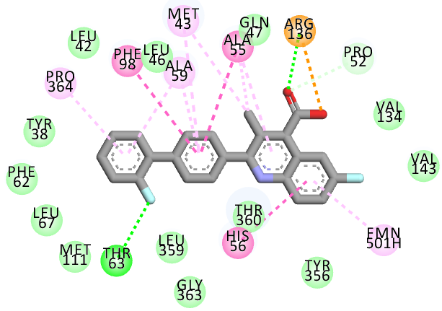

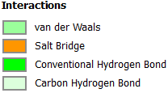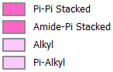

**Figure 5**. (Left) 2D interactions diagram of the most potent inhibitor Breq (QCAD1) at the DHODH active site (from the native crystal structure) and (Right) 3D interactions pattern of QCAD1 at the DHODH active site (from QSAR model).

A

B

C

**Figure 6**. Molecular Mechanics intermolecular interaction energy $E_{int}{(kcal.mol}^{-1})$ breakdown to residue contributions for the most active inhibitors (A:top), moderately active inhibitors (B:middle), and less active inhibitors (C:bottom).

**3.3. Generation and Validation of 3D-QSAR Pharmacophore Model**

3D-QSAR pharmacophore model for DHODH inhibition was generated using active conformations from DHODH-QCAD complexes and validated with a test set using HypoGen algorithm **[16]**. The activity range $7.3$ to $144000 nM$**[13]** met the criteria for robust PH4 model development. HypoGen generates pharmacophores in three stages: (i) the constructive step, (ii) the subtractive step, and (iii) the optimization step **[16]**, as previously described **[22]**. The top 10 hypotheses, ranked by statistical metrics (Table 4), demonstrated strong predictive performance. A cost difference of 2566.03 between null (59.02) and fixed (2625.05) cost far exceeds the 70 threshold, indicating over 90% model reliability and robustness **[16]**. Hypo1 was identified as the best pharmacophore based on cost difference (1997.00), highest correlation (0.89), lowest RMSD (5.80), and an acceptable configuration cost (7.73) **[16]**. Regression analysis confirmed Hypo1 predictive accuracy, with a slope near 1 (1.024) and intercept near zero (0.1419) **[31]**. The regression equation and statistical parameters are ${pIC}_{50}^{exp}=1.024*{IC}_{50}^{pre}-0.1419 : n=32, { R}^{2 }=0.8, R_{XV}^{2}=0.77, F-test=111.52, σ= 0.47, α=95\%$ and correlation scatterplot is plotted in Fig 7E. QCAD1 aligned well with PH4 features (Fig 7D), validating its accuracy. Hypo1 validation confirms a reliable pharmacophore model for DHODH inhibition and virtual screening of drug-like libraries.

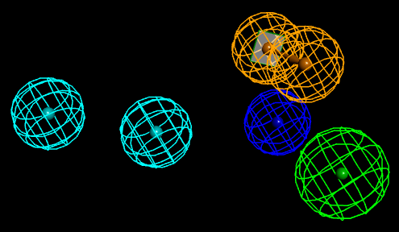 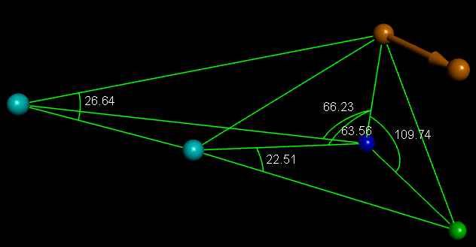 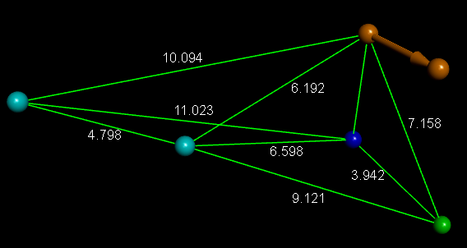

A B C

 

**Figure 7**: The best pharmacophore model (Hypo1) of DHODH inhibition : (A) Relative positions of pharmacophoric feature centers, (B) Angles (°) between centers of pharmacophoric features, (C) Distances (Å) between centers, (D) Mapping of DHODH inhibitor pharmacophore (Hypo1) with the most potent molecule of training set (QCAD1). Pharmacophoric features color code: Negative Ionisable (blue), Hydrophobic (cyan), Hydrogen bond Acceptor Projection (green), Ring Aromatic (orange). (E) Correlation plot of experimental *vs.* predicted inhibitory activity (open cercles correspond to the training set and orange dots to the validation set)

Table 4. Statistical parameters of 10 generated PH4 pharmacophoric hypotheses for the DHODH inhibitor after Cat-Scramble validation procedure [16] (49 scrambled runs for each hypothesis at the selected confidence level of 98%)

|  |  |  |  |  |  |
| --- | --- | --- | --- | --- | --- |
| Hypothesis | $${RMSD}^{ a}$$ | $$R^{2 b}$$ | $${Total costs}^{ c}$$ | $${Costs Difference}^{ d}$$ | $${ Closest random}^{ e}$$ |
| Hypo 1 | 5.80 | 0.89 | 628.05 | 1997.00 | 1334.22 |
| Hypo 2 | 6.90 | 0.84 | 831.62 | 1793.43 | 1437.04 |
| Hypo 3 | 7.41 | 0.81 | 944.67 | 1680.38 | 1596.25 |
| Hypo 4 | 7.45 | 0.81 | 956.33 | 1668.72 | 1601.1 |
| Hypo 5 | 7.69 | 0.80 | 1008.78 | 1616.27 | 1607.05 |
| Hypo 6 | 8.10 | 0.77 | 1116.15 | 1508.90 | 1847.03 |
| Hypo 7 | 8.21 | 0.76 | 1143.43 | 1481.62 | 1875.06 |
| Hypo 8 | 8.40 | 0.75 | 1191.37 | 1433.68 | 1901.49 |
| Hypo 9 | 8.87 | 0.71 | 1321.24 | 1303.81 | 1901.97 |
| Hypo 10 | 9.10 | 0.70 | 1385.48 | 1239.57 | 1923.29 |

*a root means square deviation; b squared correlation coefficient; c overall cost parameter of the PH4 pharmacophore; d cost difference between Null cost and hypothesis total cost; e lowest cost from 49 scrambled runs at a selected confidence level of 98%. The Fixed Cost = 59.02 with RMSD = 0, the Null Cost = 2625.05 with RMSD = 12.69 and the Configuration cost = 7.73*

**3.4. Virtual screening**

Frecer *et al*. **[32]** have shown the hits can be identified through *in silico* screening of a virtual combinatorial library.

**3.4.1. Virtual Library**

A virtual library of 92,598 QCAD analogs was generated via R₁ to R₄ (Table 5) substitutions using 210 R-groups. After applying Lipinski rule of five **[33]** to assess drug-likeness, 59,265 compounds were retained for further investigation.

**3.4.2. *In Silico* Screening of Library of** **QCADs**

59,265 QCAD analogs with favourable Lipinski rules were screened using PH4 Hypo1 model, yielding 312 hits matching pharmacophoric features. These were further evaluated for DHODH binding via GFE (Table 6) and predicted ${IC}_{50}^{pred}$ values from equation B (Table 3) to assess inhibitory potency.

**3.5. Analysis of novel QCAD analogs substituents**

To identify key substituents enhancing DHODH inhibition, 312 virtual hits aligning with PH4 were analyzed. Substituents at R₁, R₂, R₃, and R₄ were evaluated for frequency (Fig.8). Bulky groups at R₁, R₂, and R₄ improved activity. Analog 159-195-195-194 showed a predicted ${IC}_{50}^{pred}=0.066 nM$, about 110 times more potent than the reference $7.3 nM$) **[13]**.

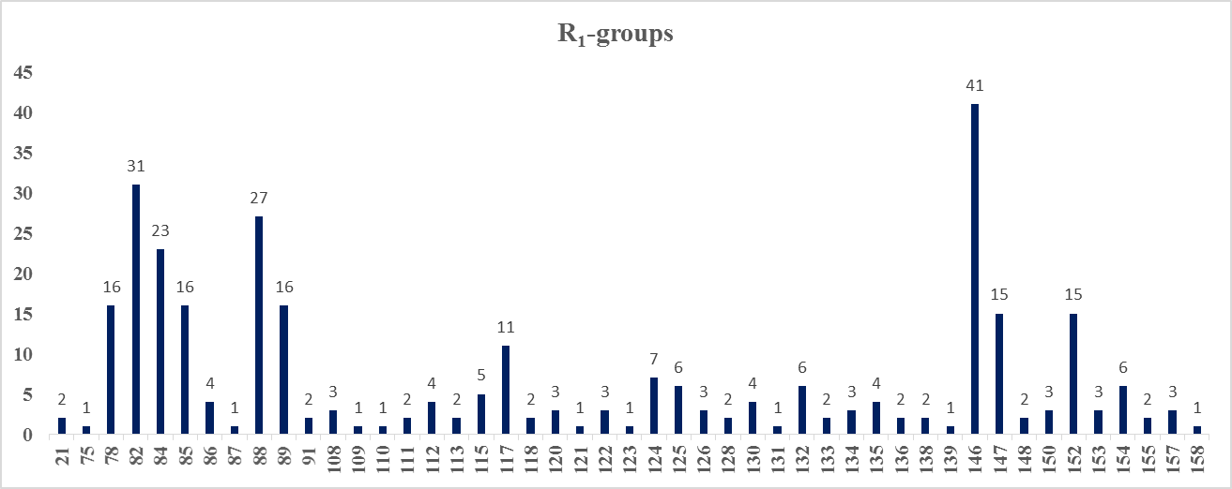

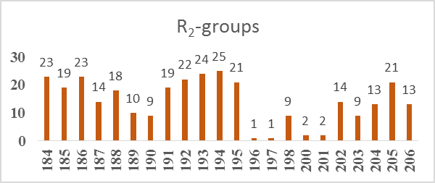

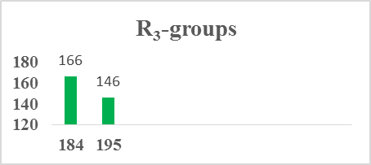



**Figure 8**. Histogram of the frequency of occurrence of Ri clusters among the best QCAD analogues resulting from PH4 screening of the generated virtual library.





${IC}_{50}^{pred}=0.066 nM$ ${IC}_{50}^{pred}=0.080 nM$ ${IC}_{50}^{pred}=0.095 nM$

${IC}_{50}^{pred}=0.098 nM$ ${IC}_{50}^{pred}=0.102 Nm$

**Figure 9.** The most effective QCAD analogues with a scaffold of DHODH are designated $\#R_{1}$- $\#R_{2}$- $\#R_{3}$- $\#R_{4}$

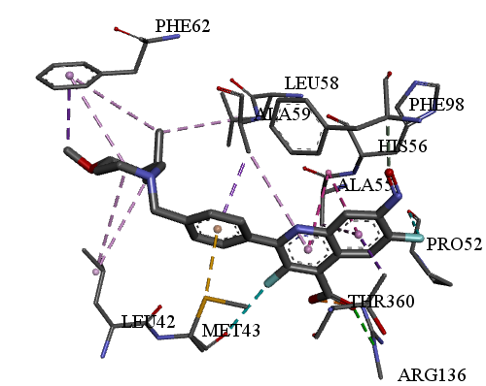 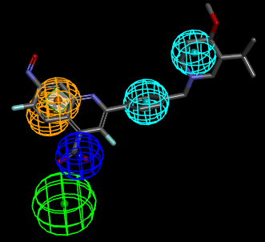

A B

**Figure 10.** Close up of virtual 159-195-195-194 lead compound, the most active designed QCAD analog $({IC}_{50}^{pred}=0.066 nM)$ at the active site of DHODH. (A) 3D interactions pattern of 159-195-195-194 and the active site residues of DHODH; (B) Mapping of the 159-195-195-194 to DHODH inhibition pharmacophore. (C) 2D schematic interaction diagram of 159-195-195-194 at the active site of DHODH. (D) Connolly surface of DHODH active site with bound conformation of 159-195-195-194 lead (the binding site surface was colored according to residue hydrophobicity: red = hydrophobic, blue = hydrophilic and white = intermediate)

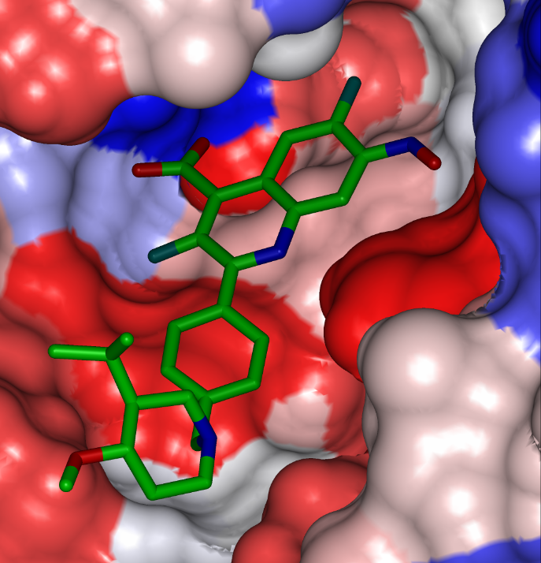

D

C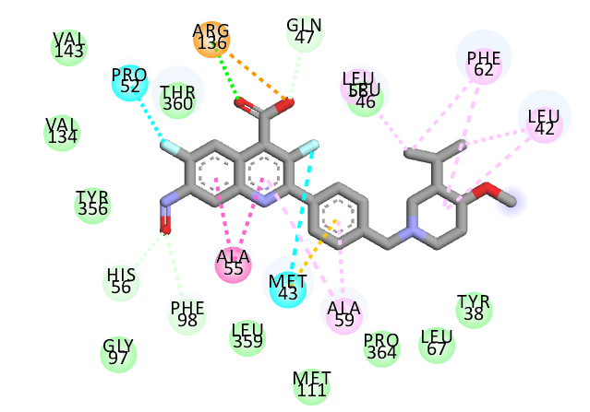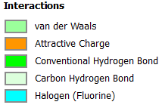 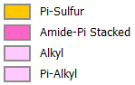

**Table 5**. $R_{1}$, $R_{2}$, $R_{3}$, and $R_{4}$-groups (fragments, building blocks, substitutents) used in the design of the initial virtual combinatorial library of QCAD analogs.

|  |  |  |  |  |  |
| --- | --- | --- | --- | --- | --- |
|  | | | | | |
| $${R-groups}^{*}$$ | | | | | |
| 1 | 5'-ethyl-2'-fluoro-4'-(2-oxoethyl)-phenyl | 2 | 4'-(2-amino-2-oxoethyl)-5'-ethyl-2'-fluorophenyl | 3 | 4'-(2-amino-2-hydroxyethyl)-5'-ethyl-2'-fluorophenyl |
| 4 | 5'-ethyl-2'-fluoro-4'-(2-hydroxyethyl)-phenyl | 5 | 5-ethyl-2-fluoro-6-(2-oxoethyl)pyridin | 6 | 6-(2-amino-2-oxoethyl)-5-ethyl-2-fluoropyridin-3-yl |
| 7 | 6-(2-amino-2-hydroxyethyl)-5-ethyl-2-fluoropyridin-3-yl | 8 | 5-ethyl-2-fluoro-6-(2-hydroxyethyl)pyridin-3-yl | 9 | 5-ethyl-6-(2-oxoethyl)pyridin-3-yl |
| 10 | 5-methyl-6-(2-oxoethyl)pyridin-3-yl | 11 | 6-(2-amino-2-oxoethyl)-5-ethylpyridin-3-yl | 12 | 6-(2-amino-2-oxoethyl)-5-methylpyridin-3-yl |
| 13 | 6-(2-amino-2-hydroxyethyl)-5-ethylpyridin-3-yl | 14 | 6-(2-amino-2-hydroxyethyl)-5-methylpyridin-3-yl | 15 | 5-ethyl-6-(2-hydroxyethyl)pyridin-3-yl |
| 16 | 6-(2-hydroxyethyl)-5-methylpyridin-3-yl | 17 | 5-ethyl-2-methyl-6-(2-oxoethyl)pyridin-3-yl | 18 | 6-(2-amino-2-oxoethyl)-5-ethyl-2-methylpyridin-3-yl |
| 19 | 6-(2-amino-2-hydroxyethyl)-5-ethyl-2-methylpyridin-3-yl | 20 | 5-ethyl-6-(2-hydroxyethyl)-2-methylpyridin-3-yl | 21 | 2,5-dimethyl-6-(2-oxoethyl)pyridin-3-yl |
| 22 | 6-(2-amino-2-oxoethyl)-2,5-dimethylpyridin-3-yl | 23 | 6-(2-amino-2-hydroxyethyl)-2,5-dimethylpyridin-3-yl | 24 | 6-(2-hydroxyethyl)-2,5-dimethylpyridin-3-yl |
| 25 | 6-(2-amino-5-((diaminomethylene)amino)pentyl)pyridin-3-yl | 26 | 6-(2-amino-5-((aminomethylene)amino)pentyl)pyridin-3-yl | 27 | 6-(2-amino-5-((amino(hydroxy)methylene)amino)pentyl)pyridin-3-yl |
| 28 | 6-(2-amino-5-(methyleneamino)pentyl)pyridin-3-yl | 29 | 6-(2-amino-5-((hydroxymethylene)amino)pentyl)pyridin-3-yl | 30 | 6-(5-((diaminomethylene)amino)pentyl)pyridin-3-yl |
| 31 | 6-(5-((diaminomethyl)amino)pentyl)pyridin-3-yl | 32 | 6-(5-((diaminomethyl)imino)pentyl)pyridin-3-yl | 33 | 6-(2-amino-5-((diaminomethyl)imino)pentyl)pyridin-3-yl |
| 34 | 6-(2-amino-5-((aminomethyl)imino)pentyl)pyridin-3-yl | 35 | 6-(2-amino-5-(methylimino)pentyl)pyridin-3-yl | 36 | 6-(5-(methylimino)pentyl)pyridin-3-yl |
| 37 | 6-(2-amino-5-((amino(hydroxy)methyl)imino)pentyl)pyridin-3-yl | 38 | 6-(5-((amino(hydroxy)methyl)imino)pentyl)pyridin-3-yl | 39 | 6-(5-(formylimino)pentyl)pyridin-3-yl |
| 40 | 6-(2-amino-5-(formylimino)pentyl)pyridin-3-yl | 41 | 6-(2-amino-5-formamidopentyl)pyridin-3-yl | 42 | 6-(5-formamidopentyl)pyridin-3-yl |
| 43 | 2-(2-amino-5-((diaminomethylene)amino)pentyl)-2H-pyrrol-4-yl | 44 | 2-(2-amino-5-((aminomethylene)amino)pentyl)-2H-pyrrol-4-yl | 45 | 2-(2-amino-5-((amino(hydroxy)methylene)amino)pentyl)-2H-pyrrol-4-yl |
| 46 | 2-(2-amino-5-(methyleneamino)pentyl)-2H-pyrrol-4-yl | 47 | (4S)2-(2-amino-5-((hydroxymethylene)amino)pentyl)-2H-pyrrol-4-yl | 48 | (R)2-(2-amino-5-((hydroxymethylene)amino)pentyl)-2H-pyrrol-4-yl |
| 49 | 2-(5-((diaminomethylene)amino)pentyl)-2H-pyrrol-4-yl | 50 | 2-(5-((diaminomethyl)amino)pentyl)-2H-pyrrol-4-yl | 51 | 2-(5-((diaminomethyl)imino)pentyl)-2H-pyrrol-4-yl |
| 52 | 2-(2-amino-5-((diaminomethyl)imino)pentyl)-2H-pyrrol-4-yl | 53 | 2-(2-amino-5-((aminomethyl)imino)pentyl)-2H-pyrrol-4-yl | 54 | 2-(2-amino-5-(methylimino)pentyl)-2H-pyrrol-4-yl |
| 55 | 2-(5-(methylimino)pentyl)-2H-pyrrol-4-yl | 56 | 2-(2-amino-5-formamidopentyl)-2H-pyrrol-4-yl | 57 | 2-(2-amino-5-((amino(hydroxy)methyl)imino)pentyl)-2H-pyrrol-4-yl |
| 58 | 2-(5-((amino(hydroxy)methyl)imino)pentyl)-2H-pyrrol-4-yl | 59 | 2-(5-(formylimino)pentyl)-2H-pyrrol-4-yl | 60 | 2-(2-amino-5-(formylimino)pentyl)-2H-pyrrol-4-yl |
| 61 | 2-(5-formamidopentyl)-2H-pyrrol-4-yl | 62 | 5-(5-((1-amino-3-oxopropan-2-yl)amino)pentyl)-1H-imidazol-2-yl | 63 | 5-(4-((1-amino-3-oxopropan-2-yl)amino)butyl)-1H-imidazol-2-yl |

|  |  |  |  |  |  |
| --- | --- | --- | --- | --- | --- |
|  | | | | | |
| 64 | 5-(3-((1-amino-3-oxopropan-2-yl)amino)propyl)-1H-imidazol-2-yl | 65 | 2-(5-((1-amino-3-oxopropan-2-yl)amino)pentyl)-3H-pyrrol-4-yl | 66 | 2-(5-((1-amino-3-oxopropan-2-yl)amino)pentyl)-1H-imidazol-5-yl |
| 67 | 2-(3-((1-amino-3-oxopropan-2-yl)amino)propyl)-1H-imidazol-5-yl | 68 | 2-(4-((1-amino-3-oxopropan-2-yl)amino)butyl)-3H-pyrrol-4-yl | 69 | 2-(4-((1-amino-3-oxopropan-2-yl)amino)butyl)-1H-imidazol-5-yl |
| 70 | 2-(3-((1-amino-3-oxopropan-2-yl)amino)propyl)-1H-imidazol-5-yl | 71 | 6-(6-amino-5-methyl-6-oxohexyl)pyridin-3-yl | 72 | 6-(3-amino-2-methyl-4-oxobutan-2-yl)pyridin-3-yl |
| 73 | 6-(3-amino-4-oxobutan-2-yl)pyridin-3-yl | 74 | 6-(6-amino-7-imino-5-methylheptyl)pyridin-3-yl | 75 | 6-(5-amino-6-imino-4-methylhexyl)pyridin-3-yl |
| 76 | 6-(5-amino-4-methyl-6-oxohexyl)pyridin-3-yl | 77 | (6-fluoropyridin-3-yl)methyl | 78 | (5-fluoropyridin-2-yl)methyl |
| 79 | (5-fluoro-1H-imidazol-4-yl)methyl | 80 | (5-fluoro-1H-pyrrol-3-yl)methyl | 81 | (2-fluorooxazol-5-yl)methyl |
| 82 | 3-(3-fluoropyridin-4-yl)propyl | 83 | 2-(6-fluoro-4-methylpyridin-2-yl)ethyl | 84 | (4-fluoro-6-hydroxypyridin-3-yl)methyl |
| 85 | ((5-fluoropyridin-2-yl)amino)methyl | 86 | ((3-fluoropyridin-4-yl)amino)methyl | 87 | (2-fluoropyridin-4-yl)amino |
| 88 | (3-fluoropyridin-4-yl)amino | 89 | pyridin-3-ylamino | 90 | (4-fluoropyridin-3-yl)amino |
| 91 | (2-fluoropyridin-3-yl)amino | 92 | 2-fluoro-6-(trifluoromethyl)pyridin-3-yl | 93 | 5-(trifluoromethyl)pyridin-2-yl |
| 94 | 2'-fluoro-4'-formyl-phenyl | 95 | 5-formylpyridin-2-yl | 96 | 3-fluoro-5-formylpyridin-2-yl |
| 97 | 4'-acetyl-2'-fluoro-phenyl | 98 | 5-acetyl-3-fluoropyridin-2-yl | 99 | 5-carbamoyl-3-fluoropyridin-2-yl |
| 100 | 4'-carbamoyl-2'-fluoro-phenyl | 101 | 4'-carbamoyl-phenyl | 102 | 4'-(hydroxy(imino)methyl)-phenyl |
| 103 | 2'-fluoro-4'-(hydroxy(imino)methyl)-phenyl | 104 | 3-fluoro-5-(hydroxy(imino)methyl)pyridin-2-yl | 105 | 5-(hydroxy(imino)methyl)pyridin-2-yl |
| 106 | 3-fluoro-5-hydroxypyridin-4-yl | 107 | 2-fluoro-5-hydroxypyridin-4-yl | 108 | (6-fluoro-3-hydroxypyridin-2-yl)methyl |
| 109 | (3-hydroxypyridin-2-yl)methyl | 110 | 2-ethyl-5-fluoro-3-(2-oxoethyl)cyclopenta-1,3-dien-1-yl | 111 | 3-(2-amino-2-oxoethyl)-2-ethyl-5-fluorocyclopenta-1,3-dien-1-yl |
| 112 | 3-(2-amino-2-hydroxyethyl)-2-ethyl-5-fluorocyclopenta-1,3-dien-1-yl | 113 | 2-ethyl-5-fluoro-3-(2-hydroxyethyl)cyclopenta-1,3-dien-1-yl | 114 | 2-ethyl-3-(2-hydroxyethyl)cyclopenta-1,3-dien-1-yl |
| 115 | 3-(2-amino-2-hydroxyethyl)-2-ethylcyclopenta-1,3-dien-1-yl | 116 | 3-(2-amino-2-hydroxyethyl)-2-methylcyclopenta-1,3-dien-1-yl | 117 | 3-(2-amino-2-oxoethyl)-2-ethylcyclopenta-1,3-dien-1-yl |
| 118 | 3-(2-amino-2-oxoethyl)-2-methylcyclopenta-1,3-dien-1-yl | 119 | 2-ethyl-3-(2-oxoethyl)cyclopenta-1,3-dien-1-yl | 120 | 2-methyl-3-(2-oxoethyl)cyclopenta-1,3-dien-1-yl |
| 121 | 3-(2-hydroxyethyl)-2-methylcyclopenta-1,3-dien-1-yl | 122 | 4-ethyl-2-fluoro-5-(2-oxoethyl)-2H-pyrrol-3-yl | 123 | 5-(2-amino-2-oxoethyl)-4-ethyl-2-fluoro-2H-pyrrol-3-yl |
| 124 | 5-(2-amino-2-hydroxyethyl)-4-ethyl-2-fluoro-2H-pyrrol-3-yl | 125 | 4-ethyl-2-fluoro-5-(2-hydroxyethyl)-2H-pyrrol-3-yl | 126 | 4-ethyl-5-(2-oxoethyl)-2H-pyrrol-3-yl |
| 127 | 4-methyl-5-(2-oxoethyl)-2H-pyrrol-3-yl | 128 | 5-(2-amino-2-oxoethyl)-4-ethyl-2H-pyrrol-3-yl | 129 | 5-(2-amino-2-oxoethyl)-4-methyl-2H-pyrrol-3-yl |
| 130 | 5-(2-amino-2-hydroxyethyl)-4-ethyl-2H-pyrrol-3-yl | 131 | 5-(2-amino-2-hydroxyethyl)-4-methyl-2H-pyrrol-3-yl | 132 | 4-ethyl-5-(2-hydroxyethyl)-2H-pyrrol-3-yl |
| 133 | 5-(2-hydroxyethyl)-4-methyl-2H-pyrrol-3-yl | 134 | 4-ethyl-2-methyl-5-(2-oxoethyl)-2H-pyrrol-3-yl | 135 | 5-(2-amino-2-oxoethyl)-4-ethyl-2-methyl-2H-pyrrol-3-yl |
| 136 | 5-(2-amino-2-hydroxyethyl)-4-ethyl-2-methyl-2H-pyrrol-3-yl | 137 | 4-ethyl-5-(2-hydroxyethyl)-2-methyl-2H-pyrrol-3-yl | 138 | 2,4-dimethyl-5-(2-oxoethyl)-2H-pyrrol-3-yl |
| 139 | 5-(2-amino-2-oxoethyl)-2,4-dimethyl-2H-pyrrol-3-yl | 140 | 5-(2-amino-2-hydroxyethyl)-2,4-dimethyl-2H-pyrrol-3-yl | 141 | 5-(2-hydroxyethyl)-2,4-dimethyl-2H-pyrrol-3-yl |
| 142 | 3-ethyl-2-hydroxy-4-(2-oxoethyl)cyclohexyl | 143 | 3-ethyl-4-(2-oxoethyl)cyclohexyl | 144 | 5-ethyl-4-hydroxy-6-(2-oxoethyl)piperidin-3-yl |
| 145 | 3-ethyl-2-hydroxy-4-(2-oxoethyl)piperidin-1-yl | 146 | 4'-formyl-phenyl | 147 | 2H-pyran-4-yl |
| 148 | (5-fluoro-2H-pyran-4-yl)methyl | 149 | 5-ethyl-2-fluoro-4-(2-oxoethyl)benzyl | 150 | (5-ethyl-2-fluoro-6-(2-oxoethyl)pyridin-3-yl)methyl |
| 151 | (5-ethyl-2-fluoro-6-(2-oxoethyl)piperidin-3-yl)methyl | 152 | (5-ethyl-2-fluoro-4-(2-oxoethyl)cyclohexyl)methyl | 153 | (2-fluoro-5-methyl-6-(2-oxoethyl)piperidin-3-yl)methyl |
| 154 | (2-fluoro-5-methyl-4-(2-oxoethyl)cyclohexyl)methyl | 155 | (4-ethoxypiperidin-1-yl)methyl | 156 | (4-acetylpiperidin-1-yl)methyl |

|  |  |  |  |  |  |
| --- | --- | --- | --- | --- | --- |
|  | | | | | |
| 157 | (4-isobutyrylpiperidin-1-yl)methyl | 158 | (4-(pentan-3-yl)piperidin-1-yl)methyl | 159 | (3-isopropyl-4-methoxypiperidin-1-yl)methyl |
| 160 | 5-ethyl-4-(furan-2-yl)-2-hydroxypiperidin-1-yl | 161 | 3-ethyl-5-methyl-4-(1H-pyrrol-1-yl)piperidin-1-yl | 162 | 5-ethyl-4-(furan-2-yl)-2-methoxypiperidin-1-yl |
| 163 | 5-ethyl-2-methoxy-4-(1H-pyrrol-1-yl)piperidin-1-yl | 164 | 5-ethyl-2-methoxy-4-(1H-pyrrol-1-yl)cyclohexyl | 165 | 3'-methoxy-4'-(pyrrolidin-1-yl)-phenyl |
| 166 | 5'-ethyl-2'-methoxy-4'-(pyrrolidin-1-yl)-phenyl | 167 | 4'-(azetidin-1-yl)-5'-ethyl-2'-methoxyphenyl | 168 | 8-ethyl-5-methoxyindolizin-2-yl |
| 169 | 5'-ethyl-4'-(furan-3-yl)-2'-methoxyphenyl | 170 | 3-ethyl-6-methoxycycloheptyl | 171 | 2-ethyl-5-methoxypiperidin-1-yl |
| 172 | 4'-(azetidin-1-yl)-3'-hydroxy-5'-isopropyl-2'-methyl-phenyl | 173 | 4'-(azetidin-1-yl)-3'-isopropyl-5'-methyl-phenyl | 174 | 4'-(azetidin-1-yl)-5'-ethyl-2'-hydroxy-phenyl |
| 175 | 4-(furan-2-yl)-2-hydroxy-5-isopropyl-3-methylcyclohexyl | 176 | 5-ethyl-2-hydroxy-3-methyl-4-(1H-pyrrol-1-yl)cyclohexyl | 177 | 4'-cyclopentyl-2'-hydroxy-5'-isopropyl-3'-methyl-phenyl |
| 178 | 4'-cyclopentyl-5'-ethyl-2'-hydroxy-3'-methyl-phenyl | 179 | 4'-cyclopentyl-3'-ethyl-5'-methyl-phenyl | 180 | 4'-cyclopropyl-5'-ethyl-2'-hydroxy-3'-methyl-phenyl |
| 181 | 4-hydroxy-6-isopropyl-3-methylazepan-1-yl | 182 | 4'-(furan-3-yl)-2'-hydroxy-5'-isopropyl-phenyl | 183 | 2'-hydroxy-4'-(3-hydroxy-1H-pyrrol-1-yl)-5'-isopropyl-phenyl |
| 184 | Methyl | 185 | acetyl | 186 | methoxy |
| 187 | propionyl | 188 | ethoxy | 189 | isopropoxy |
| 190 | isobutyryl | 191 | fluorocarbonyl | 192 | aminomethyl |
| 193 | methyleneamino | 194 | nitroso | 195 | fluoro |
| 196 | (2-methylallyl)carbamoyl | 197 | ((2-methylallyl)oxy)carbonyl | 198 | ((azetidin-1-ylmethyl)amino)methyl |
| 199 | (((1H-pyrrol-1-yl)methyl)amino)methyl | 200 | (isobutylamino)methyl | 201 | isobutoxymethyl |
| 202 | propoxymethyl | 203 | (propylamino)methyl | 204 | (ethylamino)methyl |
| 205 | (methylamino)methyl | 206 | ethoxymethyl | 207 | chloro |
| 208 | amino | 209 | iminomethyl | 210 | hydroxy |

$R1 ∶ 1→183 ; R2 ∶ 184→206 ; R3 ∶ 184 et 195 ; R4 ∶ 184 →186 ; 191 ; 193→195 ; 207→210$

**\***

**Table 6**. GFE and their components for the top scoring 111 of 312 virtual QCAD analogs. The analog numbering concatenates the index of each substituent $R_{1}$ to $R_{4}$ with the substituent numbers taken from Table 5.

|  |  |  |  |  |  |  |  |
| --- | --- | --- | --- | --- | --- | --- | --- |
|  | **Analogs** | $$M_{w}^{ a}$$ ${[ g.mol}^{-1} ]$ | $${∆∆H}_{MM}^{ b}$$ $$[ {kcal.mol}^{-1} ]$$ | $${∆∆G}_{sol}^{ c}$$ $${[ kcal.mol}^{-1} ]$$ | $${∆∆TS}_{vib}^{ d}$$ $${[ kcal.mol}^{-1} ]$$ | $${∆∆G}_{com}^{ e}$$ $${[ kcal.mol}^{-1} ]$$ | $${IC}_{50}^{pre f}$$ $$[ nM ]$$ |
| Ref | QCAD 1 | 374 | 0 | 0 | 0 | 0 | $${7.3}^{ g}$$ |
| 1 | 159-195-195-194 | 484 | -4.46 | -0.06 | 7.23 | -11.75 | 0.066 |
| 2 | 134-186-195-210 | 462 | -21.4 | 13.95 | 3.91 | -11.36 | 0.08 |
| 3 | 110-184-184-186 | 460 | -15.78 | 8.27 | 3.48 | -10.99 | 0.095 |
| 4 | 119-184-184-193 | 439 | -13.38 | 9.34 | 6.88 | -10.92 | 0.098 |
| 5 | 134-184-195-194 | 459 | -10.91 | 4.14 | 4.06 | -10.84 | 0.102 |
| 6 | 152-193-184-195 | 493 | -4.66 | 2.25 | 8.34 | -10.75 | 0.107 |
| 7 | 119-189-195-193 | 487 | -15.05 | 9.08 | 4.73 | -10.7 | 0.109 |
| 8 | 91-187-195-210 | 449 | -20.62 | 9.17 | -2.04 | -9.42 | 0.201 |
| 9 | 141-192-195-195 | 451 | -12.93 | 6.14 | 2.55 | -9.35 | 0.207 |
| 10 | 84-203-184-208 | 475 | -3.38 | -0.25 | 5.74 | -9.36 | 0.207 |
| 11 | 148-188-195-209 | 450 | -16.8 | 8.48 | 0.83 | -9.15 | 0.229 |
| 12 | 149-192-184-195 | 489 | -7.06 | 1.08 | 3.14 | -9.12 | 0.232 |
| 13 | 127-205-195-207 | 466 | -9.62 | 4.25 | 3.57 | -8.94 | 0.252 |
| 14 | 155-192-184-207 | 468 | 1.63 | -2.48 | 7.95 | -8.81 | 0.269 |
| 15 | 136-205-184-195 | 491 | -1.79 | 1.31 | 8.31 | -8.79 | 0.272 |
| 16 | 148-194-184-185 | 446 | -19.83 | 12.51 | 1.26 | -8.59 | 0.299 |
| 17 | 154-186-195-195 | 486 | -19.49 | 13.26 | 2.24 | -8.46 | 0.317 |
| 18 | 119-187-184-208 | 469 | -8.51 | 5.48 | 5.39 | -8.42 | 0.324 |
| 19 | 86-206-184-185 | 488 | -11.93 | 8.02 | 3.94 | -7.85 | 0.425 |
| 20 | 113-195-184-194 | 464 | -11.69 | 6.16 | 2.29 | -7.82 | 0.431 |
| 21 | 112-184-184-184 | 461 | -0.36 | 1.53 | 8.92 | -7.76 | 0.444 |
| 22 | 124-194-195-186 | 496 | -14.69 | 9.68 | 2.74 | -7.75 | 0.446 |
| 23 | 137-193-184-207 | 476 | -8.54 | 4.68 | 3.85 | -7.71 | 0.454 |
| 24 | 126-203-195-184 | 488 | -1.27 | 2.1 | 8.48 | -7.64 | 0.469 |
| 25 | 154-185-184-195 | 494 | -3.14 | 1.01 | 5.48 | -7.61 | 0.477 |
| 26 | 87-191-184-184 | 433 | -10.25 | 4.4 | 1.63 | -7.48 | 0.506 |
| 27 | 122-195-184-193 | 461 | -13.17 | 7.83 | 2.04 | -7.39 | 0.529 |
| 28 | 148-185-184-207 | 452 | -6.66 | 0.73 | 1.35 | -7.28 | 0.558 |
| 29 | 130-188-195-208 | 479 | -2.21 | 3.04 | 8.04 | -7.21 | 0.578 |
| 30 | 111-192-184-210 | 476 | -9.28 | 6.72 | 4.62 | -7.19 | 0.583 |
| 31 | 119-186-195-208 | 446 | -6.59 | 3.55 | 4.01 | -7.05 | 0.623 |
| 32 | 148-194-184-195 | 422 | -7.9 | 0.89 | -0.03 | -6.98 | 0.643 |
| 33 | 132-190-184-193 | 498 | -12.62 | 14.59 | 8.92 | -6.95 | 0.653 |
| 34 | 120-202-195-207 | 494 | -6.18 | 0.51 | 1.27 | -6.94 | 0.656 |
| 35 | 113-188-195-194 | 494 | -18.74 | 13.07 | 1.2 | -6.88 | 0.676 |
| 36 | 88-194-184-184 | 416 | -6.76 | 3.68 | 3.75 | -6.83 | 0.692 |
| 37 | 136-184-184-195 | 462 | -1.59 | 1.26 | 6.27 | -6.59 | 0.774 |
| 38 | 114-194-184-185 | 471 | -11.6 | 9.56 | 4.5 | -6.54 | 0.794 |
| 39 | 135-186-195-184 | 476 | -2.57 | 2.94 | 6.71 | -6.34 | 0.872 |
| 40 | 150-193-184-193 | 497 | -5.04 | 2.06 | 3.29 | -6.27 | 0.905 |
| 41 | 110-195-184-210 | 449 | -9.03 | 5.98 | 3.07 | -6.12 | 0.968 |
| 42 | 114-186-184-191 | 476 | -14.37 | 12.62 | 4.34 | -6.09 | 0.986 |
| 43 | 110-192-184-208 | 460 | -8.64 | 6.51 | 3.94 | -6.08 | 0.988 |
| 44 | 149-192-195-184 | 489 | -3.79 | 1.97 | 4.18 | -6 | 1.025 |
| 45 | 126-193-195-207 | 464 | -6.96 | 3.18 | 2.21 | -5.98 | 1.038 |
| 46 | 117-194-195-185 | 487 | -15.27 | 10.92 | 1.55 | -5.89 | 1.081 |
| 47 | 137-186-195-208 | 464 | -2.97 | 4 | 6.83 | -5.81 | 1.127 |
| 48 | 91-187-195-209 | 460 | -15.75 | 9.57 | -0.53 | -5.65 | 1.212 |
| 49 | 115-186-184-184 | 478 | -0.63 | 0.99 | 5.98 | -5.62 | 1.234 |
| 50 | 154-205-184-184 | 491 | 5.58 | 0.73 | 11.89 | -5.58 | 1.257 |
| 51 | 114-191-195-207 | 484 | -8.69 | 4.48 | 1.35 | -5.56 | 1.268 |
| 52 | 119-205-184-193 | 468 | -7.38 | 8.67 | 6.74 | -5.46 | 1.329 |
| 53 | 86-205-184-184 | 445 | -1.35 | 0.37 | 4.46 | -5.45 | 1.337 |
| 54 | 148-206-184-184 | 448 | -1.31 | 1.12 | 5.2 | -5.38 | 1.379 |
| $$N^{°}$$ | **Analogs** | $$M_{w}^{ a}$$ ${[ g.mol}^{-1} ]$ | $${∆∆H}_{MM}^{ b}$$ $$[ {kcal.mol}^{-1} ]$$ | $${∆∆G}_{sol}^{ c}$$ $${[ kcal.mol}^{-1} ]$$ | $${∆∆TS}_{vib}^{ d}$$ $${[ kcal.mol}^{-1} ]$$ | $${∆∆G}_{com}^{ e}$$ $${[ kcal.mol}^{-1} ]$$ | $${IC}_{50}^{pre f}$$ $$[ nM ]$$ |
| 55 | 127-193-195-185 | 457 | -12.45 | 10.13 | 3.02 | -5.33 | 1.414 |
| 56 | 148-203-184-185 | 489 | -0.46 | 1.72 | 6.58 | -5.31 | 1.426 |
| 57 | 149-193-195-184 | 487 | -5.25 | 3.31 | 3.29 | -5.23 | 1.486 |
| 58 | 140-184-195-185 | 476 | -9.48 | 9.58 | 5.29 | -5.2 | 1.509 |
| 59 | 84-202-195-195 | 482 | -5.45 | -1.04 | -1.36 | -5.14 | 1.551 |
| 60 | 149-193-184-186 | 499 | -1.43 | -1.66 | 1.84 | -4.93 | 1.716 |
| 61 | 80-195-195-186 | 412 | -7.41 | 1.23 | -1.28 | -4.89 | 1.744 |
| 62 | 86-204-195-195 | 466 | -5.93 | 0.46 | -0.62 | -4.85 | 1.779 |
| 63 | 124-192-184-184 | 477 | 0.59 | 2.28 | 7.54 | -4.67 | 1.94 |
| 64 | 134-190-184-210 | 499 | -7.53 | 11.27 | 8.4 | -4.66 | 1.945 |
| 65 | 124-191-184-195 | 497 | -4.89 | 1.62 | 1.31 | -4.58 | 2.025 |
| 66 | 132-191-195-185 | 492 | -12.82 | 10.06 | 1.54 | -4.3 | 2.317 |
| 67 | 125-186-184-195 | 466 | -2.06 | 0.67 | 2.78 | -4.17 | 2.464 |
| 68 | 86-190-195-210 | 477 | -21.55 | 15.13 | -2.3 | -4.12 | 2.526 |
| 69 | 90-192-195-210 | 422 | -15.92 | 11.56 | -0.29 | -4.07 | 2.58 |
| 70 | 91-185-184-191 | 461 | -10.55 | 5.37 | -1.16 | -4.02 | 2.644 |
| 71 | 138-188-195-209 | 474 | -10.31 | 8.82 | 2.51 | -4 | 2.665 |
| 72 | 84-204-184-191 | 491 | -6.76 | 2.53 | -0.27 | -3.96 | 2.72 |
| 73 | 91-184-184-209 | 414 | -12.32 | 11.16 | 2.77 | -3.94 | 2.75 |
| 74 | 86-192-184-210 | 432 | -11.79 | 9.56 | 1.63 | -3.87 | 2.845 |
| 75 | 119-195-195-210 | 435 | -14.43 | 11.38 | 0.81 | -3.86 | 2.85 |
| 76 | 130-191-184-186 | 492 | -8.37 | 8.99 | 4.36 | -3.75 | 3.013 |
| 77 | 149-195-184-208 | 475 | -4.39 | 1.02 | 0.18 | -3.55 | 3.307 |
| 78 | 90-185-195-184 | 433 | -4.52 | 2.96 | 1.96 | -3.51 | 3.368 |
| 79 | 119-194-195-184 | 444 | -2.19 | 2.71 | 3.88 | -3.36 | 3.623 |
| 80 | 80-193-184-184 | 400 | -1.16 | 3.15 | 3.85 | -1.86 | 7.4 |
| 81 | 119-204-195-208 | 473 | -3.57 | 7.06 | 5.11 | -1.63 | 8.288 |
| 82 | 148-205-184-207 | 452 | -0.99 | 3.89 | 4.45 | -1.55 | 8.597 |
| 83 | 84-185-195-210 | 449 | -7.3 | 3.06 | -2.84 | -1.4 | 9.235 |
| 84 | 91-203-195-195 | 465 | -5.9 | 5.12 | 0.61 | -1.39 | 9.282 |
| 85 | 84-184-184-210 | 417 | -4.96 | 3.92 | -0.02 | -1.02 | 11.091 |
| 86 | 148-190-195-195 | 466 | 2.25 | 1.54 | 4.69 | -0.9 | 11.728 |
| 87 | 127-184-195-208 | 416 | -2.74 | 4.14 | 2.17 | -0.77 | 12.481 |
| 88 | 154-205-184-210 | 492 | 6.68 | 1.6 | 8.88 | -0.6 | 13.505 |
| 89 | 91-188-195-184 | 434 | -0.93 | 2.55 | 1.52 | 0.1 | 18.928 |
| 90 | 123-184-184-208 | 459 | -2.31 | 4.99 | 2.57 | 0.11 | 18.944 |
| 91 | 87-189-195-195 | 452 | -8.86 | 7.29 | -1.77 | 0.2 | 19.819 |
| 92 | 154-186-184-209 | 490 | 8.48 | -1.53 | 6.48 | 0.46 | 22.446 |
| 93 | 86-186-195-195 | 438 | -1.6 | 1.42 | -1.16 | 0.98 | 28.768 |
| 94 | 84-191-195-208 | 452 | -2.67 | 1.82 | -2.25 | 1.39 | 35.031 |
| 95 | 84-191-195-208 | 452 | -2.67 | 1.82 | -2.25 | 1.39 | 35.031 |
| 96 | 87-189-195-184 | 448 | -1.75 | 5.51 | 2.32 | 1.44 | 35.853 |
| 97 | 91-184-195-184 | 404 | 2.69 | 1.31 | 1.84 | 2.16 | 50.436 |
| 98 | 148-186-184-185 | 446 | 4.47 | 1.09 | 2.45 | 3.11 | 79.667 |
| 99 | 90-185-195-195 | 436 | -1.56 | 3.1 | -1.72 | 3.26 | 85.42 |
| 100 | 125-184-195-209 | 428 | -7.19 | 9.96 | -0.61 | 3.38 | 90.325 |
| 101 | 91-184-184-185 | 428 | 3.31 | 2.27 | 1.97 | 3.61 | 100.965 |
| 102 | 80-201-195-208 | 464 | 2.01 | 3.17 | 1.46 | 3.71 | 105.981 |
| 103 | 80-201-195-208 | 464 | 2.01 | 3.17 | 1.46 | 3.71 | 105.981 |
| 104 | 154-205-195-208 | 495 | 10.89 | 1.23 | 8.08 | 4.04 | 123.809 |
| 105 | 86-184-195-195 | 422 | 0.14 | 1.67 | -2.74 | 4.55 | 158.346 |
| 106 | 90-195-184-209 | 417 | 1.61 | 4.04 | -0.48 | 6.14 | 336.98 |
| 107 | 148-188-195-207 | 457 | 4.52 | 1.37 | -0.63 | 6.51 | 402.829 |
| 108 | 90-185-195-209 | 445 | 6.25 | -0.08 | -0.36 | 6.53 | 405.987 |
| 109 | 91-191-184-207 | 453 | 3.19 | 5.65 | -1.29 | 10.13 | 2271.02 |
| 110 | 88-195-184-195 | 408 | 8.31 | 1.63 | -0.85 | 10.79 | 3113.228 |
| 111 | 90-185- 195-207 | 453 | 13.2 | 2.58 | -2.17 | 17.95 | 94854.118 |

*a is the molar mass of inhibitors ; b is the relative enthalpic contribution to the GFE change of the DHODH-QCAD complex formation ${∆∆G}_{com}$ (for details see footnote of Table 2); c is the relative solvation GFE contribution to ; d is the relative (vibrational) entropic contribution to ; e is the relative Gibbs free energy change related to the enzyme-inhibitor DHODH-QCAD complex formation : ; f is the predicted inhibition potency towards DHODH calculated from ${∆∆G}_{com}$ using correlation equation B. Table 3; g*  *is given for the reference inhibitor QCAD1 (Brequinar) instead of the ${IC}_{50}^{pred}$*

Table 7. ADME-related properties of the leads QCAD analog ~~s~~ designed and the known anticancer agents currently either in clinical use or under clinical test computed by QikProp **[25]**.

|  |  |  |  |  |  |  |  |  |  |  |  |  |  |  |  |  |  |
| --- | --- | --- | --- | --- | --- | --- | --- | --- | --- | --- | --- | --- | --- | --- | --- | --- | --- |
| $${ Compounds}^{ a}$$ | $${\#stars}^{b}$$ | $$M_{w}^{ c}$$ $$\left[{g.mol}^{-1}\right]$$ | $$S_{mol}^{ d}$$ $$\left[Å^{2}\right]$$ | $$S_{mol.hfo}^{ e}$$ $$\left[Å^{2}\right]$$ | $$V_{mol}^{ f}$$ $$\left[Å^{3}\right]$$ | $${RotB}^{ g}$$ | $${HB}_{don}^{ h}$$ | $${HB}_{acc}^{ i}$$ | $${logP}_{o/w}^{ j}$$ | $${logS}_{wat}^{ k}$$ | $${logK}_{HSA}^{ l}$$ | $${logB/B}^{ m}$$ | $${BIP}_{caco}^{ n}$$ $$\left[{nm.S}^{-1}\right]$$ | $${\#meta}^{ o}$$ | $${IC}_{50}^{pre p}$$ $$\left[nM\right]$$ | $${HOA}^{ q}$$ | $$\%{HOA}^{ r}$$ |
| 159-195-195-194 | 1 | 484 | 769.9 | 339.3 | 1432.9 | 7 | 1 | 8.2 | 2.2 | -5.8 | 0.4 | -1.1 | 13.5 | 2 | 0.066 | 2 | 60 |
| 134-186-195-210 | 0 | 462 | 769.2 | 339.2 | 1391.8 | 7 | 2 | 8 | 3.8 | -6.2* | 0.3 | -2.3 | 17.5 | 5 | 0.080 | 1 | 71.3 |
| 110-184-184-186 | 1 | 460 | 781.5 | 405.4 | 1426.5 | 6 | 1 | 5.8 | 5.6 | -7.5* | 0.9 | -1.4 | 77.6 | 6 | 0.095 | 1 | 80.5 |
| 119-184-184-193 | 2 | 439 | 784.1 | 374.2 | 1424.0 | 7 | 1 | 6 | 4.9 | -7.2* | 0.8 | -2.3 | 20.9 | 5 | 0.098 | 1 | 79.5 |
| 134-184-195-194 | 1 | 459 | 766.6 | 320.0 | 1400.4 | 6 | 1 | 8 | 3.8 | -6.3* | 0.4 | -2.4 | 10.8 | 4 | 0.102 | 1 | 67.6 |
| 148-188-195-209 | 0 | 450 | 731.9 | 260.1 | 1320.2 | 8 | 2 | 6.9 | 4.5 | -5.9 | 0.3 | -1.4 | 97.9 | 3 | 0.229 | 3 | 89 |
| 86-206-184-185 | 0 | 488 | 772.9 | 247.9 | 1442.2 | 9 | 2 | 9.2 | 4.2 | -5.6 | 0.2 | -1.7 | 59.3 | 7 | 0.425 | 2 | 83.3 |
| 154-185-184-195 | 0 | 494 | 722.9 | 295.2 | 1421.8 | 7 | 1 | 7 | 4.9 | -5.9 | 0.7 | -1.6 | 33.6 | 3 | 0.477 | 2 | 82.7 |
| 148-185-184-207 | 0 | 452 | 640.9 | 174.3 | 1229.2 | 5 | 1 | 6.7 | 4.5 | -5.1 | 0.3 | -0.6 | 166.7 | 3 | 0.558 | 3 | 93.2 |
| 148-194-184-195 | 1 | 422 | 646.7 | 153.6 | 1185.1 | 5 | 1 | 6.2 | 4.1 | -5.3 | 0.3 | -1.1 | 72.4 | 3 | 0.643 | 3 | 84.3 |
| 88-194-184-184 | 0 | 416 | 695.9 | 138.2 | 1228.9 | 5 | 2 | 6.5 | 3.8 | -5.8 | 0.3 | -1.7 | 35.5 | 4 | 0.692 | 3 | 76.9 |
| 135-186-195-184 | 0 | 476 | 791 | 388.8 | 1453.2 | 6 | 3 | 7.8 | 3.6 | -5.9 | 0.2 | -1.9 | 17.7 | 6 | 0.872 | 2 | 70.4 |
| 91-184-184-209 | 0 | 414 | 708.8 | 155.9 | 1254.6 | 6 | 3 | 6.0 | 4.1 | -5.9 | 0.3 | -1.6 | 50 | 6 | 2.75 | 3 | 81.6 |
| 90-185-195-184 | 0 | 433 | 661.8 | 90.1 | 1213.3 | 5 | 2 | 7.0 | 3.7 | -5.2 | 0.2 | -1.4 | 45.6 | 4 | 3.368 | 3 | 78.5 |
| Camptothecine | 0 | 348 | 563.3 | 188.9 | 1006.7 | 2 | 1 | 7.8 | 1.7 | -3.5 | -0.2 | -0.8 | 484.7 | 3 |  | 3 | 85 |
| Irinotecan | 1 | 587 | 924.8 | 615.4 | 1748.9 | 4 | 1 | 12.8 | 3.2 | -6.2 | 0.5 | -1.4 | 45.8 | 4 |  | 2 | 62 |
| Belinostat | 0 | 318.3 | 568 | 26.5 | 979 | 8 | 3 | 9 | 0.7 | -1.2 | -0.84 | -2.2 | 0.5 | 1 |  | 1 | 26.3 |
| Amastatin | 4 | 474 | 798.1 | 509.9 | 1476.1 | 16* | 4.5 | 10.7 | -1.6 | -1.5 | -1.5 | -3.1* | 0.1 | 7 |  | 1 | 0.0 |
| Probestin | 0 | 491 | 829.4 | 465.3 | 1573.1 | 15 | 5 | 11.9 | -0.9 | -0.9 | -0.7 | -1.1 | 0.6 | 8 |  | 1 | 5.6 |
| Romidepsin | 15 | 787.6* | 1055* | 307.6 | 1981 | 20* | 10* | 27* | -2.9* | -3.0 | -2.32* | -7.9* | 0.0 | 11* |  | 1 | 0.0 |

*a designed QCAD analogues and known anticancer agents, Tables 6; b drug likeness, number of property descriptors (24 out of the full list of 49 descriptors of QikProp, ver. 3.7, release 14) that fall outside of the range of values for 95% of known drugs; c molecular weight (range for 95% of drugs: $\left[{130-725 g.mol}^{-1}\right]$ [X]; d total solvent-accessible molecular surface, (probe radius 1.4 $Å$) (range for 95% of drugs: 300 – 1000 ); e hydrophobic portion of the solvent-accessible molecular surface (probe radius 1.4 $Å$) (range for 95% of drugs: 0 – 750 ); f total volume of molecule enclosed by solvent-accessible molecular surface, (probe radius 1.4 $Å$) (range for 95% of drugs: 500 - 2000 ); g number of non-trivial (not CX3), non-hindered (not alkene, amide, small ring) rotatable bonds (range for 95% of drugs: 0 - 15); h estimated number of hydrogen bonds that would be donated by the solute to water molecules in an aqueous solution. Values are averages taken over several configurations, so they can assume non-integer values (range for 95% of drugs: 0.0 - 6.0); i estimated number of hydrogen bonds that would be accepted by the solute from water molecules in an aqueous solution. Values are averages taken over several configurations, so they can assume non-integer values (range for 95% of drugs: 2.0 - 20.0); j logarithm of partitioning coefficient between n-octanol and water phases (range for 95% of drugs: -2 - 6.5); k logarithm of predicted aqueous solubility, logS in $\left[{mol.dm}^{-3}\right]$ is the concentration of the solute in a saturated solution that is in equilibrium with the crystalline solid (range for 95% of drugs: -6.0 - 0.5); l logarithm of predicted binding constant to human serum albumin (range for 95% of drugs: -1.5 - 1.5); m logarithm of predicted brain/blood partition coefficient (range for 95% of drugs: -3.0 - 1.2); n predicted apparent Caco-2 cell membrane permeability in Boehringer-Ingelheim scale (range for 95% of drugs: < 25 poor, > 500 nm s-1 great); o number of likely metabolic reactions (range for 95% of drugs: 1–8); p predicted inhibition constants ${IC}_{50}^{pre}$. ${IC}_{50}^{pre}$ was predicted from computed ∆∆Gcom using the regression Equation B shown in Table 3; q human oral absorption (1 = low, 2 = medium, 3 = high); r percentage of human oral absorption in gastrointestinal tract (<25% = poor, >80% = high); * star in any column indicates that the property descriptor value of the compound falls outside the range of values for 95% of known drugs*

**3.6. ADME Pharmacokinetic Profile of Novel QCAD Analogs**

Table 7 presents ADME properties computed using QikProp software **[25]** following Jorgensen’s method **[34]**. Top QCAD analogs exhibit favorable #star values (0–2), indicating good drug-likeness, unlike Romidepsin (15). These profiles suggest QCAD leads are promising for synthesis and drug development.

**3.7. Molecular Dynamics Simulations**

Molecular dynamics simulations confirmed the stability and binding of QCAD analogs in DHODH complexes. Low RMSD (Figure 13), stable rGyr, SASA (Figure 11), and persistent hydrophobic, H-bond, and water bridge interactions confirm binding stability (Figure 12).

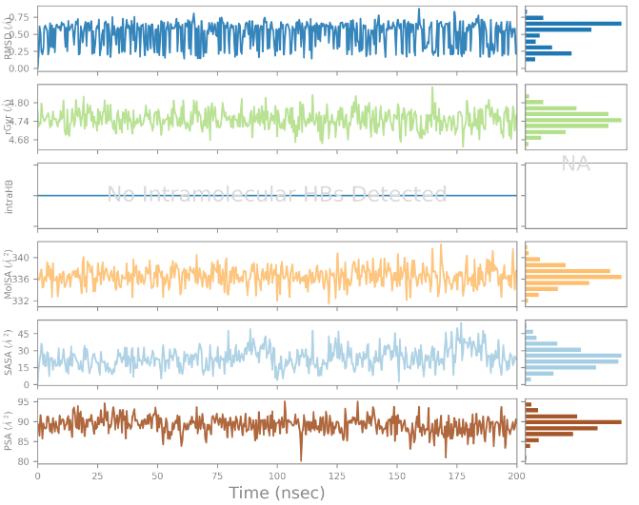 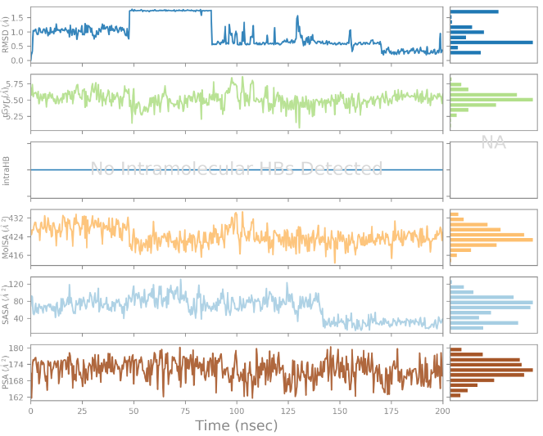

**QCAD1** **159-195-195-194**

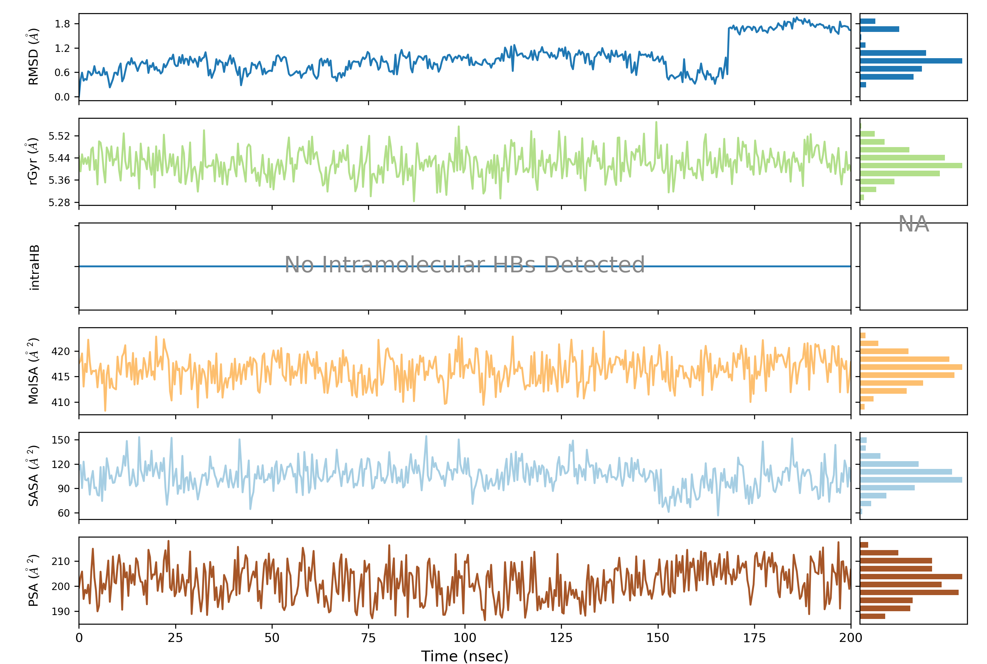 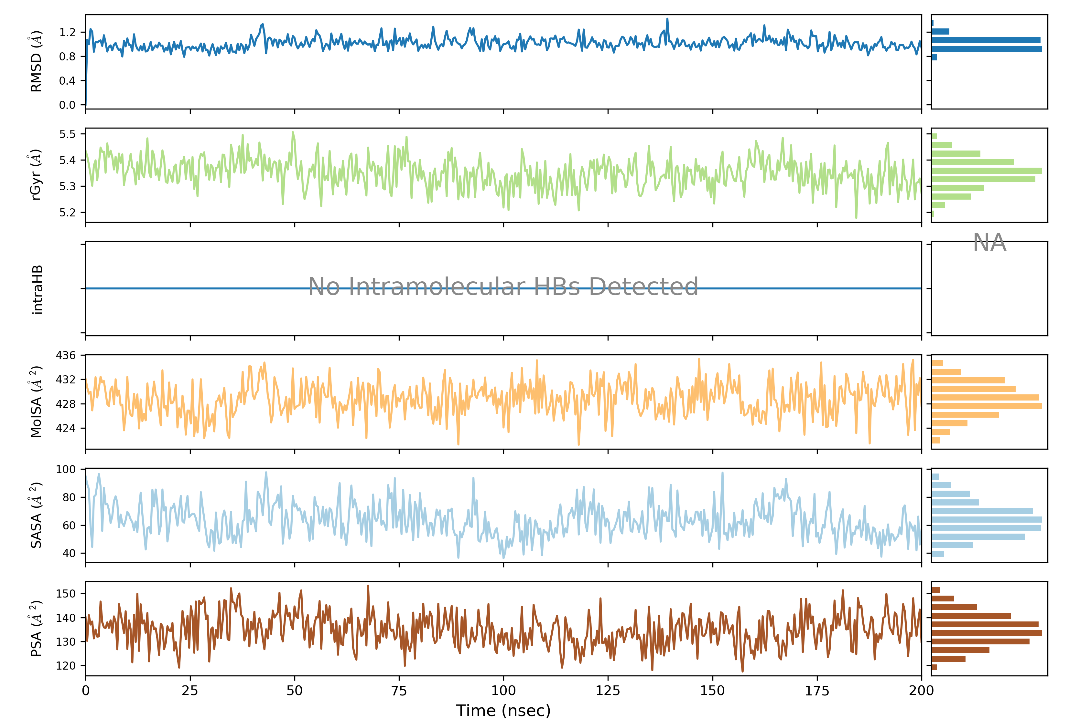

**134-186-195-210 110-184-184-186**

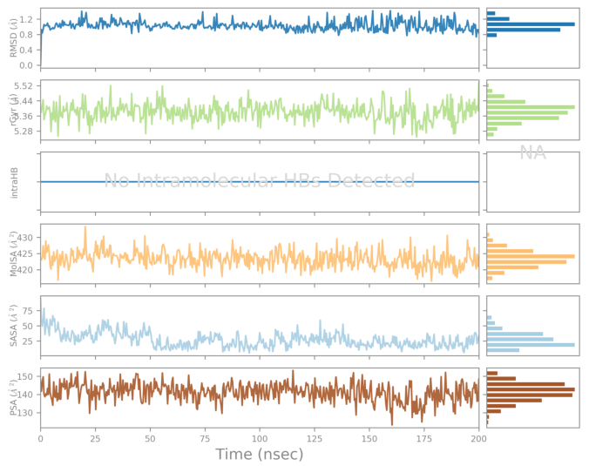 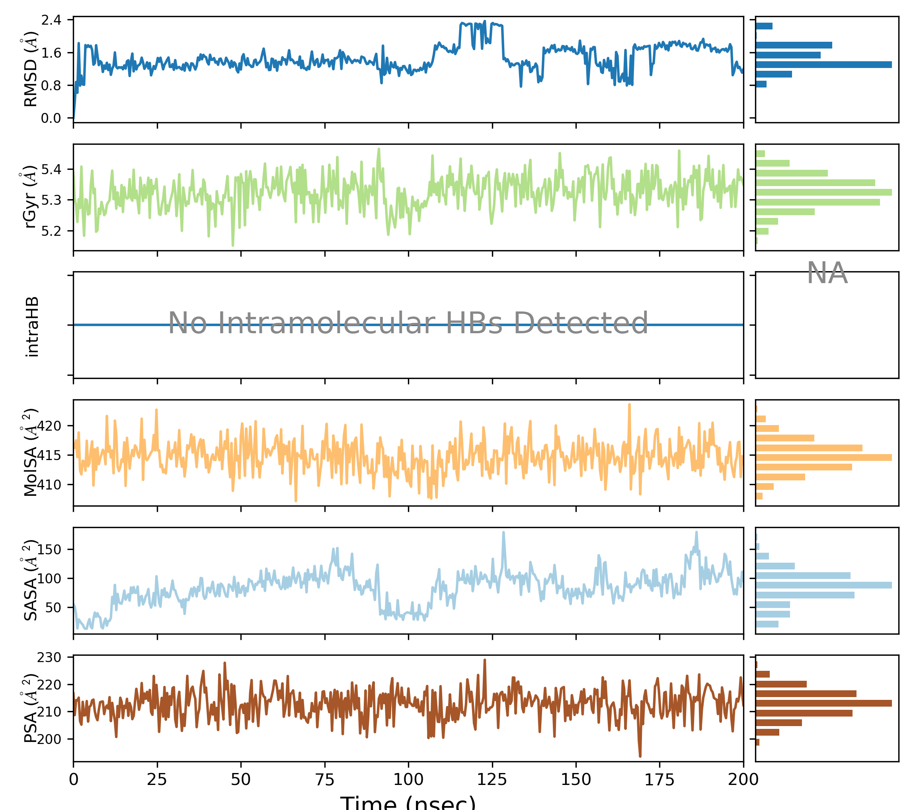

**119-184-184-193 134-184-195-194**

**Figure11**. Time‐evolution of the properties of the DHODH‐ QCADx complexes during 200 ns MD simulation. For each inhibitor, top tobottom: plot of the root mean square deviation (RMSD) with respect to the initial conformation vs. the simulation time, radius of gyration (rGyr), number of in‐tramolecular hydrogen bonds (intraHB), molecular surface area (molSA), solvent‐accessible surface area (SASA), and polar surface area (PSA).

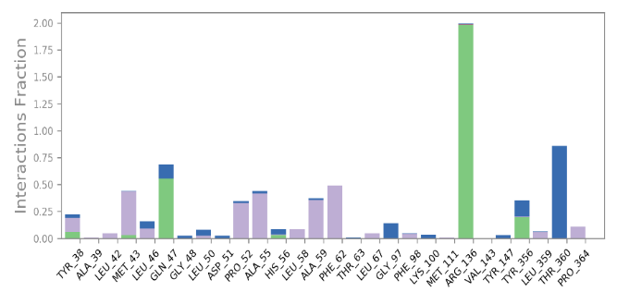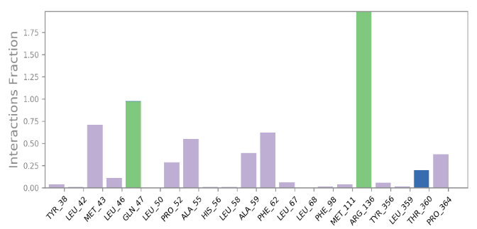

**159-195-195-194**

**Breq (1**

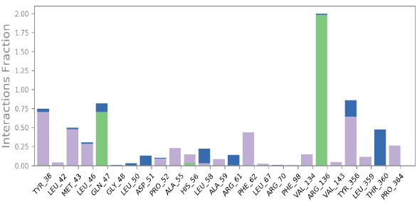

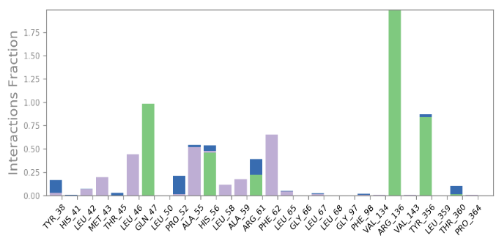

**110-184-184-186**

**134-186-195-210**

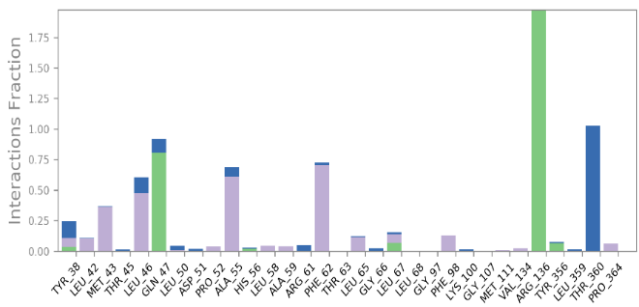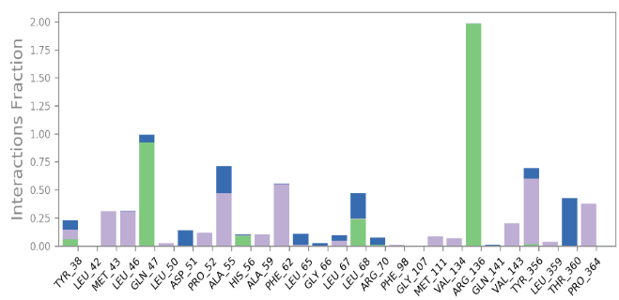

**134-184-195-194**

**119-184-184-193**



**Figure 12**. Contribution of individual active site residues to inhibitor binding in DHODH- QCADx complexes present during MD simulations: HB (green); ionic interactions (magenta); hydrophobic contacts (purple); water bridges (blue).

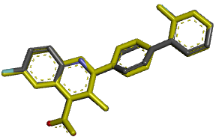 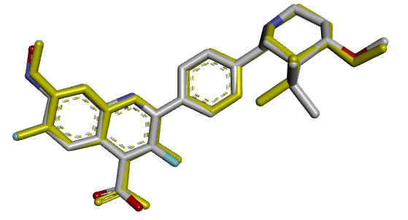 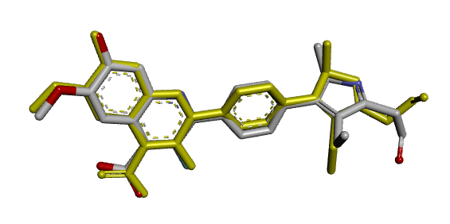

QCAD 1 (Breq) 159-195-195-194 134-186-195-210

(RMSD = 0.22 Å) (RMSD = 0.45 Å) (RMSD = 1.02 Å)

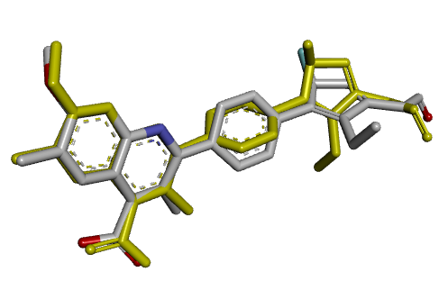 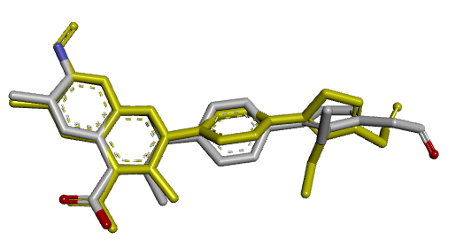 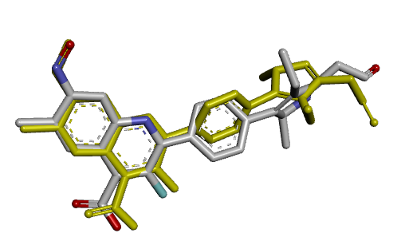

110-184-184-186 119-184-184-193 134-184-195-194

(RMSD = 1.31 Å) (RMSD = 1.60 Å) (RMSD = 1.26 Å)

**Figure 13**. Overlay of the ligand active conformations from complexes refined by molecular mechanics and averaged active conformations (in gold) resulting from MD simulations.

Madak *et al*. **[13]** identified key molecular interactions in DHODH inhibition by QCAD1, including a salt bridge and hydrogen bond between the carboxyl group and Arg136, a hydrogen bond with Gln47, hydrophobic contacts within the pocket (Leu42, Met43, Leu46, Pro52, Ala55, Ala59, Phe62, Thr63), and van der Waals interactions near the redox site (Phe96, Val134, Val143, Thr360, Tyr356, Leu359, Pro364). In our optimized DHODH-DAQCx complexes, the crucial interactions with Arg136 are preserved, while the hydrogen bond with Gln47 is replaced by van der Waals interactions. Additional contacts include π-π stacking with Phe98 and His56, an amide-π interaction with Ala55, and a hydrogen bond between the fluorobenzene and Thr63. In the new analogues, the π-π interaction between the phenyl group and Phe98 is replaced by a π-sulfur interaction with Met43, while the π-π stacking with His56 shifts to a π-sigma interaction. A carbon-hydrogen bond replaces the hydrogen bond with Gln47. Novel interactions include a fluorine bond with Met43 in analogues 159-195-195-194, 134-186-195-210, and 134-184-195-194; a donor-π hydrogen bond with Pro52 and Tyr356 in analogue 134-186-195-210; and a hydrogen bond with Arg70 in analogue 134-184-195-194. Additionally, a hydrogen bond betwen Tyr356 and analogue 134-184-195-194 was observed, consistent with Madak *et al*. **[13]**. The interaction energies between the potent analogues 159-195-195-194, 134-186-195-210, 110-184-184-186, 119-184-184-193, and 134-184-195-194 and residues Leu42, Met43, Leu46, Phe62, and Tyr356 are significantly lower than those of DAQC1, indicating enhanced affinity for the modified fragments (Fig. 14). Molecular dynamics simulations confirm their structural stability and validate their binding mechanisms based on the crystallographic DHODH-DAQC1 complex.

**Figure 14**. Molecular mechanics inter-molecular interaction energy Eint break-down to active site residue contributions in ${[kcal.mol}^{-1}]$: the best four novel designed QCAD analogs (the color coding refers to ligands given in the legend).

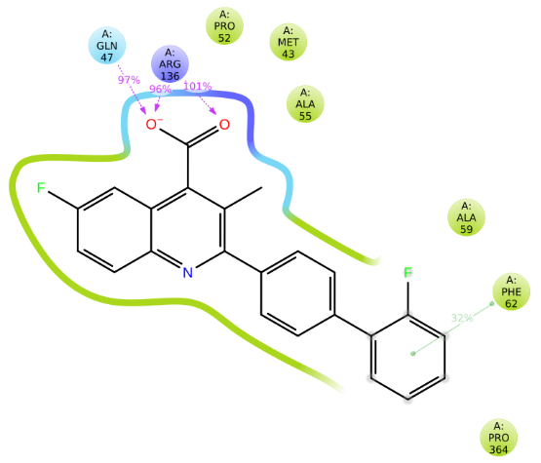 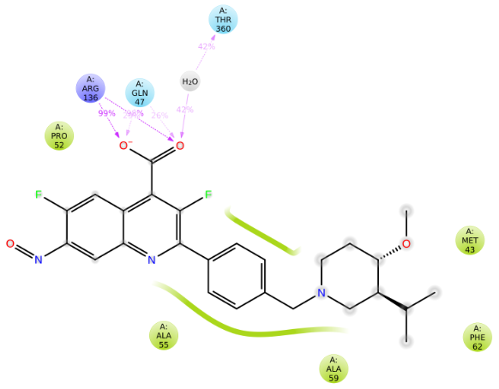 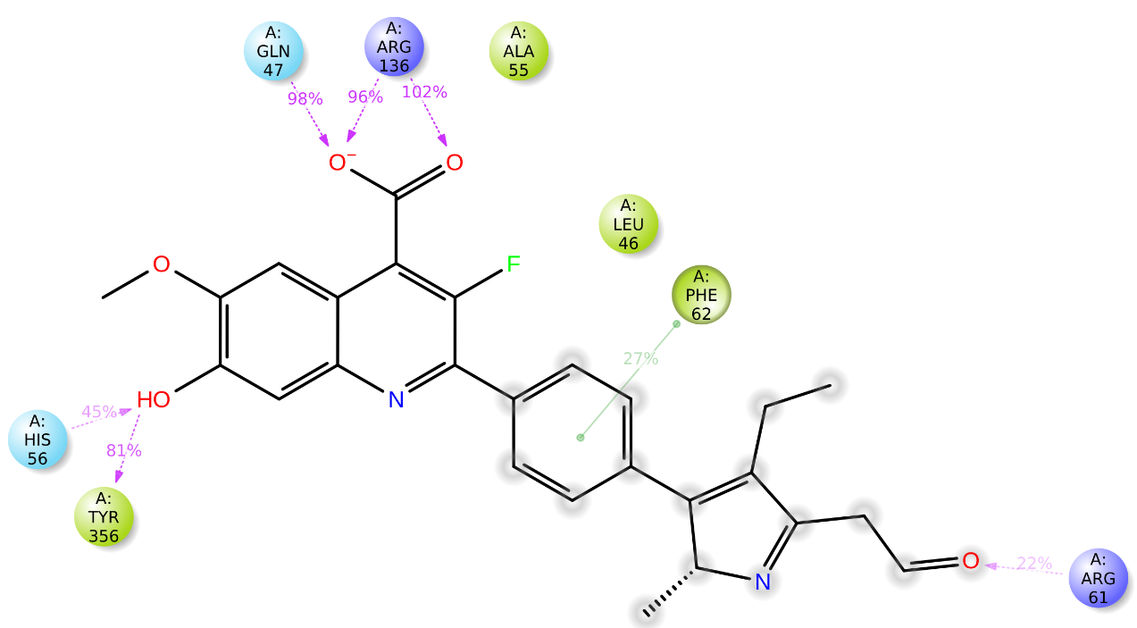

QCAD1 159-195-195-194 134-186-195-210

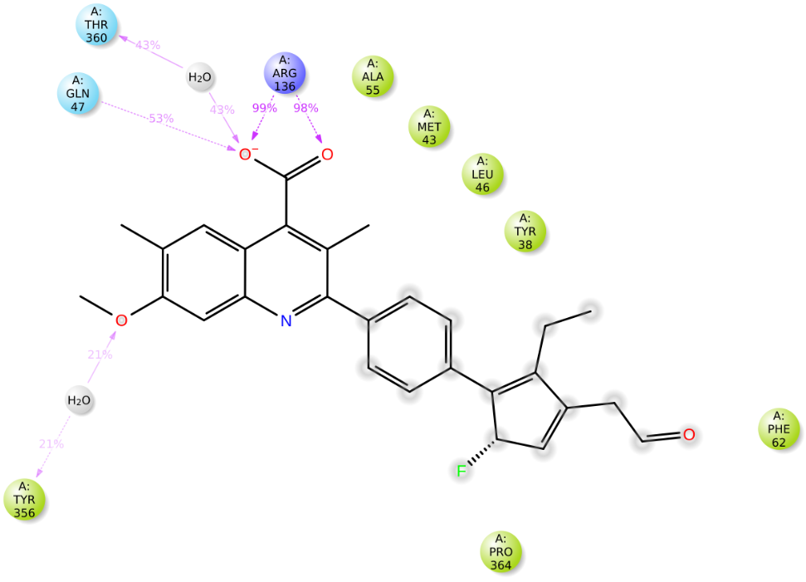 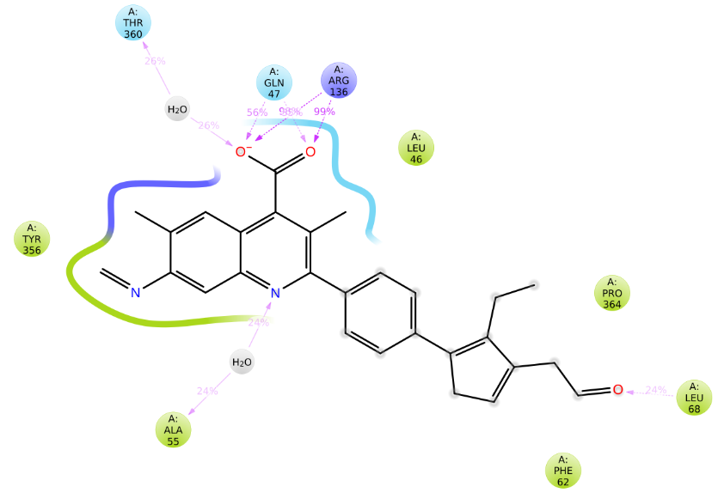 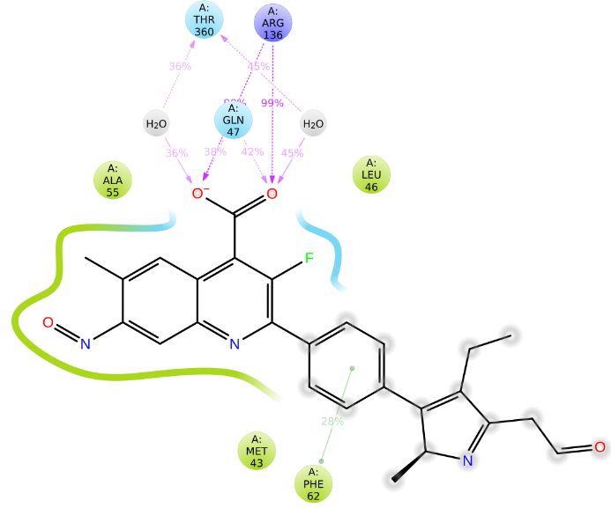

110-184-184-186 119-184-184-193 134-184-195-194



**Figure 15**. 2D representation of the most populated attractive interactions between the function groups of the QCAD1 and five new inhibitors and the individual residues at the active site of DHODH that occur in at least in 1/5 of the 500 analysed frames.

**4. CONCLUSION**

A robust QSAR model was constructed to describe DHODH inhibition by 4-quinoline carboxylic acid derivatives, with structural data from the X-ray crystallographic analysis of the DHODH-QCAD3 complex being leveraged to achieve this objective. This model established a strong correlation between the calculated Gibbs free energies (GFE) of complex formation and the experimentally determined inhibitory concentrations $({IC}_{50}^{exp})$. The development of a 3D-QSAR pharmacophore model (PH4) for QCAD inhibitors was informed by the aforementioned framework. The model was developed utilising a training set of 32 compounds and a validation set of 10 compounds, all of which exhibited well-characterised inhibitory profiles **[13]**. A detailed analysis of DHODH-QCAD interactions within the active site was undertaken to inform the design of a virtual combinatorial library. This library encompassed a broad array of QCAD analogues generated via systematic substitutions at positions $R_{1},$ $R_{2,}$ $R_{3}$ and $R_{4}$ of the core scaffold. The library was screened using two complementary strategies : firstly, by applying ADME-related descriptors, and secondly, by pharmacophore mapping onto PH4. These filtration steps enabled the identification of a bioavailable subset of QCADs, with the 111 most promising virtual hits subjected to predictive (${IC}_{50}^{pred}$) calculations using the QSAR model. The following brequinar analogues have been identified as the top-ranking : 159-195-195-194 (${IC}_{50}^{pred}=0.066 nM)$,134-186-195-210 (${IC}_{50}^{pred}=0.080 nM)$, 110-184-184-186 (${IC}_{50}^{pred}=0.095 nM)$, 119-184-184-193 (${IC}_{50}^{pred}=0.098 nM)$, 134-184-195-194 (${IC}_{50}^{pred}=0.102 nM)$. demonstrated activities in the low nanomolar range, thus highlighting their potential as promising candidates for reversible DHODH inhibition.

**ABREVIATIONS**

*ADME : Absorption, Distribution, Metabolism, and Excretion*

*2D : Two-Dimensional*

*3D : Three-Dimensional*

*QSAR : Quantitative Structure-Activity Relationships*

*GFE : Gibbs Free Energy*

*VCL : Virtual Combinatorial Library*

*DHODH : Dihydroorotate Dehydrogenase*

*QCADx : 4-quinoline carboxylic acid derivatives*

${IC}_{50}^{exp}$*: Experimentally Half-Maximal Inhibitory Concentration*

${IC}_{50}^{pred}$*: Predicted Half-Maximal Inhibitory Concentration*

*PH4 : pharmacophore*

*WHO : World Health Organization*

*IARC : International Agency for Research on Cancer*

*GCO : Global Cancer Observatory*

*RNA : Ribonucleic Acid*

*DNA : Deoxyribonucleic Acid*

*FDA : Food and Drug Administration*

*VL : Virtual Library*

*TS : Trainingt Set*

*VS : Validation Set*

*E-I : Enzyme-Inhibitor*

$E_{int}$*: Enzyme-Inhibitor Interaction Energy per Residue*

*MD : Molecular Dynamics*

*MM : Molecular Mechanics*

${∆∆G}_{com}$*: Relative Complexation GFE*

$∆∆H_{MM}$*: Relative Enthalpy GFE*

$∆∆{TS}_{vib}$*: Relative Entropic GFE*

$∆∆G_{sol}$*: Relative Solvation GFE*

*RMSD : Root-mean square deviation*

*PDB : Protein Data Bank*

*intraHB : intramolecular Hydrogen Bonds*

*rGyr : radius of gyration*

*molSA : molecular Surface Area*

*SASA : Solvent Accessible Surface Area*

*PSA : Polar Surface Area*

*FMN : Flavin mononucleotide*

*CFF : Consistent Force Field*

# REFERENCES

|  |  |
| --- | --- |
| [1] | Vidal M, Gigoux V et Garbay C. SH2 and SH3 domains as targets for anti-proliferative agents. *Critical Reviews in Oncology/Hematology,* **2001**, 40: 175-186. |
| [2] | Available: https://www.who.int/fr/news-room/fact-sheets/detail/cancer. [Accesse on 03/02/2024]. |
| [3] | Available: https://gco.iarc.who.int/media/globocan/factsheets/cancers/39-all-cancers-fact-sheet.pdf. [Accesse on 16/02/2024]. |
| [4] | Counihan J L, Grossman E A et Nomura D K. Cancer metabolism : current understanding and therapies. *Chemical reviews,* **2018**, 118(14): 6893-6923. |
| [5] | Evans D R et Guy H I. Mammalian pyrimidine biosynthesis: fresh insights into an ancient pathway. *Journal of Biological Chemistry,* **2004**, 279(32): 33035-33038. |
| [6] | Fairus A M, Choudhary B, Hosahalli S, Kavitha N et Shatrah O. Dihydroorotate dehydrogenase (DHODH) inhibitors affect ATP depletion, endogenous ROS and mediate S-phase arrest in breast cancer cells. *Biochimie,* **2017**, 135: 154-163. |
| [7] | Chen S, Ding S, Yin Y, Xu L, Li P, Peppelenbosch M P et Wang W. Suppression of pyrimidine biosynthesis by targeting DHODH enzyme robustly inhibits rotavirus replication. *Antiviral research,* **2019**, 167: 35-44. |
| [8] | Xiong R, Zhang L, Li S, Sun Y, Ding M, Wang Y et Xu K. Novel and potent inhibitors targeting DHODH, a rate-limiting enzyme in de novo pyrimidine biosynthesis, are broad-spectrum antiviral against RNA viruses including newly emerged coronavirus SARS-CoV-2. *BioRxiv,* **2020**, 11: 2020-03. |
| [9] | Niaré A, N’Guessan H, Dali B, Megnassan E. Computer-assisted design of hydroxamic acid derivatives inhibitors of M1 Metallo Aminopeptidase of Plasmodium falciparum with favorable pharmacokinetic profile. *J Pharm Res Int*, 2022:21-44. |
| [10] | Niaré A., Alex, A. Y. Z., Bernard, D. A. M., Marius, K. S., Stéphane, D. S., Moise, K. A., Guy-Richard, K. M., Fagnidi,Y. K. H., & Doh, S. (2025). Study by Molecular Docking of the Interactions Between Dihydroorotate Dehydrogenase and a Series of Inhibitors of Pyrrole Derivatives for the Treatment of Malaria. *Asian Journal of Chemical Sciences*, *15*(1):92110. |
| [11] | Niaré, A., N’guessan, A.-B., Djako, B. A. M., Dembélé, G. S., Koné, M. G.-R., Yéo, Y. (2024), QSAR, pharmacophore, and molecular docking studies for the design of novel arylamide- derived inhibitors of *Mycobacterium tuberculosis Chemical ScienceInternationalJournal,33(6),212224.* |
| [12] | Lolli M L, Sainas S, Pippione A C, Giorgis M, Boschi D et Dosio F. Use of human dihydroorotate dehydrogenase (hDHODH) inhibitors in autoimmune diseases and new perspectives in cancer therapy. *Recent Patents on Anti-Cancer Drug Discovery,* **2018**, 13(1): 86-105. |
| [13] | Madak J T, Cuthbertson C R, Miyata Y, Tamura S, Petrunak E M, Stuckey J A et Neamati N. Design, Synthesis, and Biological Evaluation of 4-Quinoline Carboxylic Acids as Inhibitors of Dihydroorotate Dehydrogenase. *Journal of medicinal chemistry,* **2018**, 61(12): 5162-5186. |
| [14] | Maroun J, Ruckdeschel J, Natale R, Morgan R, Dallaire B et Gyves J. Multicenter phase II study of brequinar sodium in patients with advanced lung cancer. *Cancer chemotherapy and pharmacology,* **1993**, 32(1): 64-66. |
| [15] | Liu S, Neidhardt E A, Grossman T H, Ocain T et Clardy J. Structures of human dihydroorotate dehydrogenase in complex with antiproliferative agents *Structure,* **2000**, 8(1): 25-33. |
| [16] | Accelrys Inc. Discovery Studio Molecular Modeling and Simulation Program, Release 2.5. San Diego, CA, USA Accelrys Inc., **2009**. |
| [17] | Berman H M, Westbrook J, Feng Z, Gilliland G, Bhat T N, Weissig H et Bourne P E. The protein data bank,» *Nucleic acids research,* **2000**, 28(1): 235-242. |
| [18] | Bernard Djako A M, Adama N, Issouf F, Mathias M L, Mélalie K et Eugène M. Computer-assisted Design of Novel Polyketide Synthase 13 of Mycobacterium tuberculosis Inhibitors Using Molecular Modeling and Virtual Screening. *ournal of Advances in Medical and Pharmaceutical Sciences,* **2022**, 27(6): 1-18. |
| [19] | Accelrys Inc. Insight-II and Discover molecular modeling and simulation package, Version 2005. San Diego, CA, USA , **2005**. |
| [20] | Maple J R, Hwang M J, Stockfisch T P, Dinur U, Waldman M, Ewig C S et Hagler A T. Derivation of class II force fields. I. Methodology and quantum force field for the alkyl functional group and alkane molecules. *Journal of Computational Chemistry,* **1994**, 15(2): 162-182. |
| [21] | Frecer V, Seneci P et Miertus S. Computer-assisted combinatorial design of bicyclic thymidine analogs as inhibitors of Mycobacterium tuberculosis thymidine monophosphate kinase. *Journal of computer-aided molecular design,* **2011**, 25(1): 31-49. |
| [22] | Gilson M et Honig B. The inclusion of electrostatic hydration energies in molecular mechanics calculations,» *Journal of Computer-Aided Molecular Design,* **1991**, 5(1): 5-20. |
| [23] | Li H, Sutter J et Hoffmann R. HypoGen: An automated system for generating 3D predictive pharmacophore models. *Pharmacophore perception, development, and use in drug design,* **2000**, 171-189. |
| [24] | Bieri C, Esmel A, Keita M, Owono L C, Dali B, Megnassan E et Frecer V. Design of novel dihydroxynaphthoic acid inhibitors of Plasmodium falciparum lactate dehydrogenase. *Med Chem,* **2012**, 8(5): 970-84. |
| [25] | Schrödinger. QikProp, 6.5 (Release 139); Schrödinger LLC,» New York, NY, USA, **2019**. |
| [26] | Ghosh S, Nie A, An J et Huang Z. Structure-Based Virtual Screening of Chemical Libraries for Drug Discovery. *Current Opinion in Chemical Biology,* **2006**, 10(3): 194-202. |
| [27] | Martyna G J, Klein M L et Tuckerman M. Nosé-Hoover chains: The canonical ensemble via continuous dynamics.,» *The Journal of chemical physics,* **1992**, 97 (4): 2635-2643. |
| [28] | Martyna G J, Tobias D J et Klein M L. Constant pressure molecular dynamics algorithms,» *J. chem. Phys,* **1994**, 101(4177): 10-1063. |
| [29] | Lu C, Wu C, Ghoreishi D, Chen W, Wang L, Damm W et Harder E D. OPLS4: Improving Force Field Accuracy on Challenging Regimes of Chemical Space. *Journal of chemical theory and computation,* **2021**, 17(7): 4291-4300. |
| [30] | Schrödinger, Shaw D E Research. Maestro-Desmond Interoperability Tools. Desmond *Molecular Dynamics System*, Version 3.6. New York, NY, USA **2021**. |
| [31] | OECD. Organisation for Economic Co-operation and Development. *Guidance document on the validation of (quantitative) structure-activity relationship [(Q) SAR] models,* **2014**. |
| [32] | Frecer V, Miertus S, Tossi A et Romeo D. Rational design of inhibitors for drug-resistant HIV-1 aspartic protease mutants,» *Drug design and discovery,* **1998**, 15(4): 211-231. |
| [33] | Lipinski C A, Lombardo F, Dominy B W et Feeney P J. Experimental and Computational Approaches to Estimate Solubility and Permeability in Drug Discovery and Development Settings. *Advanced Drug Delivery Reviews,* **2012**, 64: 4-17. |
| [34] | Jorgensen W L et Duffy E M. Prediction of drug solubility from structure,» *Advanced Drug Delivery Reviews,* **2002**, 54(3): 355-366. |