TOXICOLOGICAL STUDY OF CHRONIC ADMINISTRATION OF Zea mays HUSK EXTRACT ON FEMALE RATS

ABSTRACT
Zea mays L (Family-Poaceae) is used locally as a remedy for various diseases. Evaluation of chronic administration of ethanol husk extract of Zea mays for effect on hematological indices, liver and kidney functions as well as lipid profile and organs histologies of female Wistar rats was carried out. The husk extract (187, 374 and 561 mg/kg body weight) was orally administered to female Wistar rats daily for 100 days and the rats were sacrificed under light diethyl ether anesthesia at the completion of the administration. The husk extract caused insignificant (p>0.05) alteration of body and organ weights of rats relative to control. The blood indices of the rats were not altered significantly (p>0.05) except significant (p<0.001) reduction of bleeding time of rats treated with 374 mg/kg of the extract. The extract did not cause any significant (p>0.05) effect on liver function parameters (total protein, albumin, AST,ALT, ALP, GGT, and combined bilirubin) of rats except non-dose dependent and significant (p<0.001) increase in total bilirubin of rats only at middle dose (374 mg/kg) of the extract. The extract did not cause any significant (p>0.05) effect on urea, creatinine, bicarbonate, potassium and sodium levels of female rats except a significant (p<0.001) increase in chloride level of rats at the highest dose of extract (561 mg/kg). The extract did not alter the lipid profile of treated rats except significant (p<0.05 - 0.001) decreases in total cholesterol levels of rats treated with extract (187 mg/kg) as well as VLDL levels of rats treated with low and highest dose (187 and 561 mg/kg) when compared to control. The husk extract exerted mild to moderate effect on the histologies of brains, hearts, livers and kidneys of rats as well as serious effect of ovary. The extract should be taken with caution and high dose should be avoided.
Keywords: Zea mays, haematological parameters, kidney function, liver function
- INTRODUCTION
Herbal preparations are in use world over in the management and treatment of various diseases and ailments. The patronage of these herbal preparations which are believed and claimed to be natural and safe has increased over the years. Although the preparations are often assumed to be devoid of side effects and toxicities, there are indications and reports that attribute some toxicological manifestations such as organs dysfunctions and systemic toxicities to toxic potentials of the constituents of these preparations (Okokon et al., 2025). This is largely due to inadequate information on the toxic potentials of these plants and their preparations as most plants employed as food or medicine produce toxic effects in spite of their claimed safety.

Zea mays L.(Poacae) commonly called maize or corn, is a grass and food plant cultivated for human and animal benefits. The plant is tall and bears ears that are enclosed in modified leaves known as husks (Simmonds, 1979). In addition to its nutritive values, various parts of the plants are used in ethnomedicine for the treatment of several ailments such as diabetes (Foster and Duke, 1990; Gill, 1992; Abo et al., 2008; Brobbey et al., 2017;Okokon et al., 2017a), cough (Gill, 1992), inflammatory diseases (Okokon et al., 2016), pains and arthritis (Owoyele et al., 2010) and ulcer (Jadhav, 2016). Reported pharmacological properties of the husk extract which include; analgesic, anti-inflammatory (Owoyele et al., 2010), antioxidant (Dong et al., 2014), antidepressant (Okokon et al., 2016), antimalarial and antiplasmodial (Okokon et al., 2017a), hepatoprotective (Okokon et al., 2017b; Okokon et al., 2020; Udobang et al., 2019), antidiabetic and hypolipidemic (Okokon and Mandu, 2018) and nephroprotective (Okokon et al., 2017c; Okokon et al., 2019), antiulcer (Okokon et al., 2018), antiobesity (Okokon et al., 2021a), in vivo alpha amylase and alpha glucosidase inhibitory (Okokon et al., 2021b), genotoxic and cytotoxic (Akpan et al., 2024) activities. The median lethal dose (LD₅₀) of the ethanol husk extract was determined to be 1874.83 mg/kg (Okokon et al., 2016). Isolated compounds from the husk extract include; arabinoxylan (Ogawa et al., 2005), phenolic compounds (gallic acid, protocatechuic acid, chlorogenic acid, cafeic acid, femlic acid, rutin, resveratrol, and kaempferol) (Dong et al., 2014), anthocyannins (Li et al., 2008) and stigmasterol, stigmasteryl stearate and stigmasteryl palmitate (Okokon et al.,2021a). In this study, we report the effects of chronic administration of the husk extract of Zea mays on female rats.
- MATERIALS AND METHODS
2.1 Collection of Plant Materials
Fresh husks of Zea mays were collected in August 2020 from farmland in Uruan in Uruan LGA, Akwa Ibom State, Nigeria. The husks were identified and authenticated as Zea mays by a taxonomist in the Department of Botany and Ecological studies, University of Uyo, Uyo, Nigeria. Herbarium specimen (FPH, 614) was deposited at the Faculty of Pharmacy Herbarium, University of Uyo, Uyo.
2.2 Extraction
Fresh husk of Zea mays were washed, cut into smaller pieces and dried under shade for two weeks. The husks were further pulverized to powder using electric grinder. The powdered leaves material (1.5 kg) was macerated in 50% ethanol (7.5 L) for 72 hours at room temperature (28 ±2 40°C). This was thereafter filtered, and the liquid filtrate was concentrated and evaporated to dryness in vacuo 40⁰C using a rotary evaporator (BuchiLab, Switzerland) and stored in a refrigerator at -4°C, until used for the proposed experiments.
2.3 Animals
Swiss albino female rats (125 – 148 g) used for these experiments were gotten from Animal house of Department of Pharmacology and Toxicology, University of Uyo. The animals were housed in standard cages and were maintained on a standard pelleted feed (Guinea feed) and water ad libitum. Permission and approval for animal studies were obtained from the College of Health Sciences Animal Ethics Committee, University of Uyo.
2.4 Chronic Toxicological Study
Adult wistar female rats were used in this study. They were weighed, randomly divided into four groups of 5 rats each and treated as follows; groups I, II, and III were administered 187, 374 and 561 mg/kg of the husk extract respectively on alternate days for 100 days. Group IV was administered with distilled water (10 mL/kg) for the same period of time. The weights of the animals in all the treatment groups were weighed periodically to monitor the weight increases. At the end of the treatment period (100 days), the animals were again weighed and sacrificed under light ethyl ether vapour. Blood samples were collected by cardiac puncture into EDTA-bottles and plain bottles. Blood samples in EDTA bottles were used for haematological study such as bleeding time, clotting time, full blood counts etc. Sera were separated from the blood samples in plain bottles and stored at -20˚C until used for biochemical determinations such as liver function test, kidney function test, and lipid profile
The effects of the extract on some organs were studied. The organs; liver, kidney, spleen, brain, ovary and heart of rats were removed surgically and fixed in 10% buffered formalin. The organs were weighed, processed, sectioned and stained using hematoxylin and eosin (H&E) according to standard procedures.
2.5 Haematological Analysis
Blood samples collected from each diethyl ether euthanized rat into different Ethylene Diamine Tetra-acetic Acid (EDTA)-coated sample bottles were analysed for all the haematological indices (RBC, HGB, PCV, platelets, WBC and differentials – neutrophils, eosinophils, basophils, lymphocytes and monocytes). These parameters were analysed using automated Haematology analyser according to manufacturer’s protocols (Sysmex Haematology-Coagulation Systems®, Model KX-21N, Sysmex Incorporation, Kobe, Japan) at the University of Uyo Teaching Hospital. Also, the bleeding and clotting times of each rat were also determined.

2.6 Biochemical Analysis
Using a centrifuge (Nikon optical Co., Japan), whole blood of each sacrificed rat collected through cardiac puncture into different plain sample bottles were centrifuged at 2500 rpm for 15 min at 10 °C to obtain the serum. The obtained sera were analysed for the concentrations and activities of certain biomarkers of liver and kidney functions. The determinations were done spectrophotometrically using Randox Analytical Kits® according to standard procedures of manufacturer’s protocols (Tietz, 1976) at the Chemical Pathology Department of University of Uyo Teaching Hospital.
2.7 Liver Function Test
The following parameters were determined;Aspartate aminotransferase (AST), Alanine aminotransferase (ALT), Total Cholesterol, Alkaline phosphatase (ALP), Total plasma protein, Total and combined bilirubin. The determinations were done spectrophotometrically using Randox analytical kits according to standard procedures of manufacturer’s protocols (Tietz, 1976) at the Chemical Pathology Department of University of Uyo Teaching Hospital.
2.8 Kidney Function Test
The following biochemical parameters were determined as markers of kidney function using diagnostic kits at the Chemical Pathology Department of University of Uyo Teaching Hospital; Levels of electrolytes ( Na, K, Cl, and HCO₃ ), creatinine, and urea.
2.9 Determination of the Effect of the Crude Extract on the Lipid Profile (Serum TG, TC, HDL, LDL, VLDL levels) of the Treated Rats
Serum cholesterol, triglyceride and high density lipoprotein (HDL) levels of the treated rats were measured by enzymatic colorimetric methods using Randox diagnostic kits. The low and very low-density lipoprotein (LDL and VLDL) levels were estimated from the formula of Friedwald et al., 1972) .
2.10 Histopathological Examination
The kidneys, livers, pancreas, hearts, brains and spleens of each animal that was used in the study was surgically harvested and fixed in buffered formalin. They were then processed and stained with haematotoxylin and eosin (H&E) according to standard procedures at Department of Chemical Pathology, University of Uyo Teaching Hospital, Uyo.Morphological changes were observed and recorded in the excised organs of the sacrificed animals. Histologic pictures were taken as micrographs.
2.11 Statistical Analysis
Data obtained from this work were analysed statistically using Instat Graphpad (California, USA). ANOVA (one –way) followed by a post test (Tukey-Kramer multiple comparison test) were employed in the analysis. Differences between means were considered significant at 5% level of significance ie p≤ 0.05
- RESULTS
3.1 Body weight
The effect of the extract on body weights of female rats treated chronically with husk extract of Zea mays for 100 days is shown in Table 1 . The extract administration produced a non dose-dependent increases in body weights of female rats with the highest dose (561 mg/kg) producing the most significant (p<0.001) weight gain when compared to control statistically.
3.2 Effect of extract on organs weights
Administration of husk extract of Zea mays (187-561 mg/kg) to female rats for 100 days did not cause any significant (p>0.05) effect on the weights of heart, brain, liver, kidney, spleen, pancreas and ovary of the animals when compared to control statistically (Table 2 ).
3.3 Effect on haematological parameters
The results of the effect of chronic administration of ethanol husk extract of Zea mays on haematological parameters of female rats are shown in Table 3. Chronic administration of husk extract of Zea mays to rats for 100 days did not cause any significant (p>0.05) effect on the hematological parameters of female rats when compared to control. However, neutrophils and PCV percentages in the female rats were insignificantly (p>0.05) decreased by the extract treatment when compared to control, while WBC count, lymphocytes and monocytes percentages were raised in the female rats insignificantly (p>0.05) when compared to control.
Administration of husk extract (187-561mg/kg) to female rats for 100 days caused a slight but insignificant (p>0.05) increases in the clotting time of female rats at the higher doses (374 and 561 mg/kg) of the extract when compared to control. Also, a non dose-dependent reduction in bleeding time of the female rats was observed which was significant (p<0.001) at the middle dose (374 mg/kg) when compared to control (Figure 1).

Table 1: Effect of chronic administration of Zea mays husk extract on body weights of female rats
Treatment  R&G /Extract | Dose  (mg/kg) | Initial body weight (g) | Final body weight (g) | Weight gain (g)
Control | 10ml/kg | 112.33± 3.48 | 164.6± 6.66 | 52.27±2.44
Husk extract | 187 | 108.0± 2.16 | 169.75±8.40 | 61.75±3.41
 | 374 | 106.75± 3.54 | 159.5± 4.94 | 52.75±2.18
 | 561 | 100.75± 2.25 | 172.0± 2.67 | 71.25±2.14^{c}
Data are expressed as mean ± SEM. Not significant when compared to control p>0.05.n = 5.

Table 2: Effect of chronic administration of Zea mays husk extract on organs weights of female rats
Treatment | DOSE(mg/ kg) | Heart (g) | Brain (g) | Liver (g) | Kidney  (g) | Spleen (g) | Pancreas (g) | Ovary (g)
Control | 10 mg/ml | 0.58± 0.02 | 1.31±0.12 | 5.47±0.38 | 1.00±0.06 | 0.53± 0.09 | 0.93± 0.11 | 0.09±0.01
Husk extract | 187 | 0.60±0.01 | 1.44±0.03 | 5.61±0.20 | 1.07±0.04 | 0.69± 0.07 | 0.85± 0.04 | 0.10±0.01
 | 374 | 0.52±0.02 | 1.35±0.06 | 6.11±0.34 | 1.00±0.06 | 0.63±0.12 | 0.77±0.05 | 0.10±0.02
 | 561 | 0.61±0.03 | 1.35±0.06 | 4.98±0.23 | 1.02±0.03 | 0.51± 0.04 | 0.74± 0.06 | 0.11±0.04
Data are expressed as MEAN ± SEM, Significant at ªp<0.05, ^{b}p< 0.01, ^{c}p< 0.001, when compared to control. (n=5).
3.4 Effect of extract on liver function indices of rats
Administration of husk extract of Zea mays (187 - 561 mg/kg) to female rats for 100 days did not cause any significant (p>0.05) effect on the levels of total protein and albumin, ALT, AST, ALP, GGT and combined bilirubin when compared to control statistically (Table 4). However, the level of total bilirubin was increased non dose-dependently and was significant (p<0.001) in the group treated with the middle dose (374 mg/kg) when compared to control (Table 4).
3.5 Effect on kidney function parameters of rats
Treatment of female rats for 100 days with husk extract of Zea mays (187-561 mg/kg) did not affect the levels of creatinine, urea, bicarbonate, potassium and chloride of female rats significantly (p>0.05) when compared to control (Table 5), but caused non dose-dependent increases in the level of sodium at low and highest doses (187 and 561 mg/kg) of the extract which was only significant (p<0.001) in the group treated with the highest dose (561 mg/kg) when compared to control (Table 5).

Table 3: Effect of chronic administration of Zea mays husk extract on heamatological parameters of female rats
Treatment | Dose | WBC (x10³/µL) | NEUT.  (%) | LYM  (%) | MONO (%) | ESINO  (%) | BASO  (%) | RBC (x10⁶/µL) | HGB  (g/dL) | PCV  (%) | PLATELETS. (x10³/µL)
Control  normal saline | 10 mg/ml | 11.27±0.14 | 39.83±1.27 | 57.66±1.42 | 0.86±0.17 | 0.93± 0.14 | 0.80±0.05 | 7.83±0.14 | 13..90±0.15 | 47.76±1.72 | 737.33± 91.25
Crude extract | 187 | 12.86±0.51 | 34.72±3.45 | 62.22±3.65 | 0.97±0.07 | 1.15±0.06 | 0.92± 0.16 | 7.50 ± 0.32 | 13.47± 0.19 | 44.90±1.16 | 909.5± 87.56
Crude extract | 374 | 12.28±2.31 | 33.60±3.05 | 61.37±2.35 | 2.22±0.67 | 1.50± 0.19 | 0.80± 0.14 | 7.30± 0.36 | 13.05± 0.42 | 43.70±2.60 | 700.25± 91.47
Crude extract | 561 | 10.91±1.06 | 34.95±2.17 | 62.22±2.08 | 1.22±0.15 | 0.82± 0.18 | 0.77± 0.14 | 7.38± 0.18 | 13.37± 0.14 | 42.80±0.58 | 811.25± 62.19
Data are expressed as MEAN ± SEM, (n=5). MONO- monocytes, ESINO-esinophils, BASO-basophils, LYM- lymphocytes, NEUT- neutrophils, PCV-pack cell volume, HGB-hemoglobin, RBC-red blood cell, WBC-white blood cell
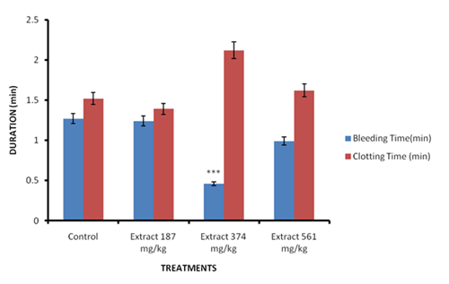
Figure 1: Effect of chronic administration of Zea mays husk extract on clotting and bleeding times of female rats.
Data are expressed as MEAN ± SEM, Significant at ***p<0.001, when compared to control. (n=5).

Table 4: Effect of chronic administration of Zea mays husk extract on liver function parameters of female rats
TREATMENT | DOSE  (mg/ kg) | Total Protein  (mg/dL) | Albumin (mg/dL) | ALT (IU/L) | ALP (IU/L) | AST (IU/L) | Total Bilirubin (µmol/l ) | Combined  Bilirubin  (µmol/l) | GGT  (IU/L)
Control | 10 mg/ml | 69.33±3.28 | 44.0±2.08 | 16.66±1.20 | 33.0±1.15 | 56.66±2.84 | 7.80±3.02 | 6.56±0.44 | 1.83±0.20
Crude extract | 187 | 73.5±1.32 | 43.5±0.64 | 19.0±0.70 | 42.0±5.16 | 53.50±2.36 | 10.50±0.29 | 5.70±0.63 | 1.52±0.22
 | 374 | 71.5±0.64 | 45.0±0.81 | 19.5±1.04 | 30.0±1.58 | 55.25±4.95 | 11.20±0.99^{c} | 7.15±1.27 | 2.00±0.12
 | 561 | 70.0±1.29 | 42.5±1.04 | 17.75±1.31 | 24.5±1.32 | 51.0±4.34 | 10.17±0.95 | 5.72±0.79 | 1.62±0.25
Data is expressed as MEAN ± SEM, Significant at ^{c}p< 0.001, when compared to control. (n=5).

Table 5: Effect of chronic administration of Zea mays husk extract on kidney function parameters of female rats
TREATMENT | DOSE (mg/kg) | CREATININE (mg/kg) | UREA  (mg/dl) | BICARBONATE (mMol/L) | SODIUM (mMol/L) | POTASSIUM (mMol/L) | CHLORIDE (mMol/L)
Control normal saline | 10 mg/ml | 116.0± 8.02 | 8.26± 0.41 | 26.0± 1.15 | 124.0±5.03 | 4.66± 0.12 | 63.33± 0.33
Crude extract | 187 | 111.5± 8.19 | 7.72± 0.53 | 28.0± 0.81 | 141.0±14.40 | 9.47± 4.20 | 62.25± 1.03
Crude extract | 374 | 127.5± 4.59 | 8.87± 0.20 | 27.0± 1.29 | 119.2± 4.71 | 4.25± 0.24 | 60.75± 1.25
Crude extract | 561 | 102.7± 7.88 | 6.80± 0.21 | 25.5±1.70 | 166.2±6.86^{c} | 5.97± 0.22 | 59.50± 2.10
Data is expressed as MEAN ± SEM, Significant at ^{c}p< 0.001, when compared to control. (n=5).
3.6 Effect of husk extract on lipid profile indices of male and female rats
Administration of husk extract (187-561 mg/kg) to female rats for 100 days caused non dose-dependent decreases in the levels of total cholesterol, triglyceride, LDL and VLDL of the treated female rats. However, these decreases were only significant (p<0.05-0.001) in the total cholesterol level of the group treated with the low dose (187 mg/kg) and the VLDL levels of the groups treated with the low and highest doses (187 and 561 mg/kg) when compared to control (Table 6).
3.7 Effect on histology of organs
Figures 2 – 7 show the effects of chronic administration of ethanol husk extract of Zea mays to male and female rats for 100 days on histology of some organs. The husk extract (187-561 mg/kg) caused varying defects on the histology of the organs of male and female rats. Moderate effect was observed on the cerebral cortex of female rats with abnormal presentation of the layer cells showing perinuclear vacoulatory astrocytes, shrinkage of neural cellsand micro-cerebral blood vessels (Figure 2).The histo-structure of hearts of female rats was moderately affected by the extract’s treatment with abnormal cardiomyocytes array, well stained sarcoplasm, wide spread interstitial fibrocytes and fibroblast nuclei, vacoulatory myocyte nuclei, area of inflammatory infiltrates and degenerating myocyte nuclei within the cardiac tissue (Figure 3). Mild effects of the extract was observed on histo-structure of the renal tissue of female rats which showed slight abnormal histo-structure of the renal tissue with glomeruli, areas of occluding bowman’s space and widening bowman’s space (Figure 4). The female rats’ liver mildly affected with the hepatic histo-structure showing areas of vacoulatory hepatocytes within the hepatic lobules (Figure 5). The ovaries were mildly affected with ovarian histo-architecture showing atrophying follicle, follicular artrophy, and vascular hemorrhage (Figure 6). The splenic histoarchitecture of the female rats was normal with no pathological signs and therefore, not affected by the extract’s treatment (Figure 7)

Table 6: Effect of chronic administration of Zea mays husk extract on lipid profile of female rats
TREATMENT | DOSE  mg/kg | TOTAL CHOLESTEROL (mMol/L) | TRIGLYCERIDE (mMol/L) | HDL-C (mMol/L) | LDL-C (mMol/L) | VLDL  (mMol/L)
Control | 10 mL/kg | 2.33± 0.08 | 0.99± 0.07 | 1.16± 0.21 | 1.61± 0.10 | 0.19± 0.01
Crude extract | 187 | 1.85± 0.06^{b} | 0.85± 0.08 | 1.05± 0.07 | 1.18± 0.11 | 0.09± 0.01^{c}
Crude extract | 374 | 2.05± 0.10 | 0.90± 0.04 | 1.17± 0.06 | 1.37± 0.14 | 0.15± 0.01
Crude extract | 561 | 2.12± 0.13 | 0.73± 0.11 | 1.14± 0.12 | 1.31± 0.07 | 0.13± 0.01^{b}
Data are expressed as MEAN ± SEM, Significant at ªp<0.05, ^{b}Pp< 0.01, ^{c}p< 0.001, when compared to control. (n=5).

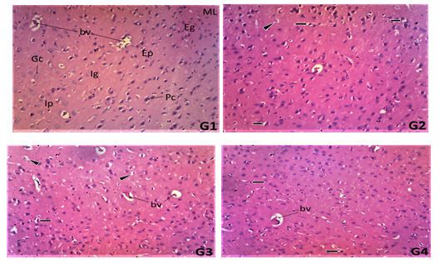
Figure 2: Photomicrograph of the transverse sections of cerebral cortex of female rats treated with distilled water (G1), husk extract of Zea mays at 187 mg/kg (G2), 374 mg/kg (G3) and 561 mg/kg (G4) liver tissue showing external pyramidal layer (EPL), external granular layer (Ep), internal granular layer (Ig), Pyramidal cells (Pc), blood vessels (bv), pyramidal cells (Pc) and granular cells (Gc), astrocytes (As), showing moderate effect on extract treated rats tissue with perinuclear vacoulatory astrocytes (arrow head), shrinkage of neural cells (arrow) and micro-cerebral blood vessels (bv). (x100).

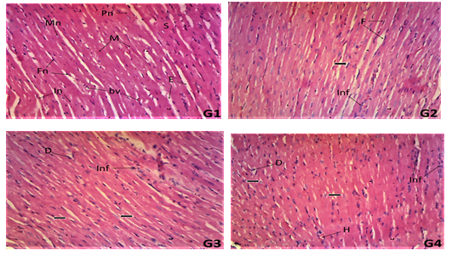

Figure 3: Photomicrograph of the transverse sections of hearts of female rats treated with distilled water (G1), husk extract of Zea mays at 187 mg/kg (G2), 374 mg/kg (G3) and 561 mg/kg (G4) liver tissue showingsarcoplasm (S), wide spread interstitial fibrocytes and fibroblast nuclei (Fn), well stained myocyte central nuclei (Mn), perinuclear sarcoplasm (Ps), interstitial endomysium (E),wide spread interstitial fibrocytes and fibroblast nuclei (F), vacoulatory myocyte nuclei (arrow), area of inflammatory infiltrates (Inf) and degenerating myocyte nuclei (D) within the cardiac tissue.
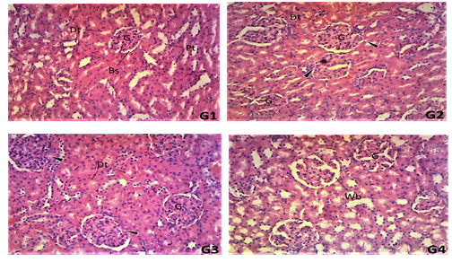

Figure 4: Photomicrograph of the transverse sections of kidneys of female rats treated with distilled water (G1), husk extract of Zea mays at 187 mg/kg (G2), 374 mg/kg (G3) and 561 mg/kg (G4) liver tissue showing glomeruli (G),Bowman’s space (Bs), proximal convulated tubules (Pt), distal convulated tubules (Dt) and infilterating interstitial connective tissues (Ic), widened bowman’s space (Wb), and widening bowman’s space (Wb), (x 100).

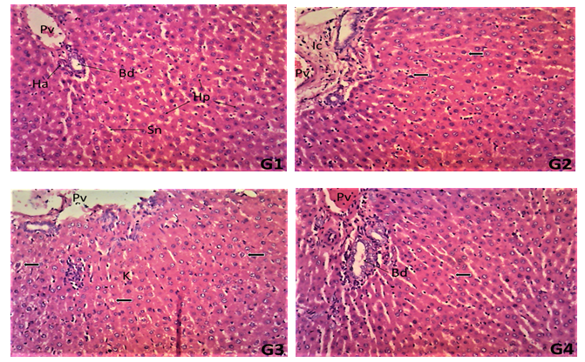

Figure 5: Photomicrograph of the transverse sections of livers of female rats treated with distilled water (G1), husk extract of Zea mays at 187 mg/kg (G2), 374 mg/kg (G3) and 561 mg/kg (G4) liver tissue showing portal vein (Pv), bile duct (Bd) and hepatic artery (Ha) within the connective tissue (Ct) of the portal area, well populated hepatocytes (Hp), kupffer cells (Kc) and arrays of sinusoidal spaces (Sn) ,areas of vacoulatory hepatocytes (arrow), Interstitial connective tissue (Ic) (x 100).

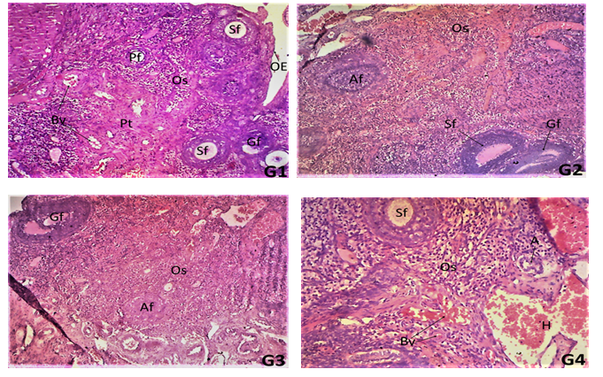

Figure 6: Photomicrograph of the transverse sections of ovaries of female rats treated with distilled water (G1), husk extract of Z. mays at 187 mg/kg (G2), 374 mg/kg (G3) and 561 mg/kg (G4) liver tissue showing different levels of developing follicles, primary follicle (Pf), secondary follicle (Sf), graffian follicle (Gf), blood vessels (Bv), and perivascular connective tissue (Pt) within the Ovarian Stroma (Os) and the ovarian epithelial lining (OE) follicular artrophy (A), and vascular hemorrhage (H),(x 100).
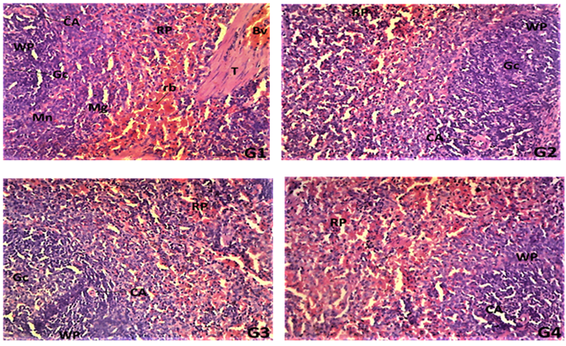

Figure 7: Photomicrograph of the transverse sections of spleens of female rats treated with distilled water (G1), husk extract of Zea mays at 187 mg/kg (G2), 374 mg/kg (G3) and 561 mg/kg (G4) liver tissue showingwhite pulp (WP), germinal center (Gc), central artery (C), central vein (Cv),ramified trabecula (T), mantle layer (Mn), marginal zone (Mz), the red pulp (RP), red blood cells (Rc) and tubercular tissue (Tb), degenerative immunal cells (black arrow) and the central vein (Cv).

- DISCUSSION

In this study, chronic administration of the husk extract caused significant increases in the body weights of female rats compared to untreated control, as observed in the weight gain by all the treated groups. Changes in body weights are markers of adverse effects of drugs and it is considered statistically significant if a body weight loss is more than 10% (Tepongning et al., 2018). In this study there were considerable increases in body weights of female rats in all the extract treated groups but these increases were significant (p<0.05-0.01) at the highest dose (561 mg/kg). This finding indicates that extract treatment did not interfere with the feeding habit of the rats and probably must have increased appetite of the female rats. Furthermore, the administration of the extract did not exert adverse effects on the body growth processes of rats.
Treatment of rats with the husk extract (187-561 mg/kg) for 100 days did not cause any effect on the weights of heart, brain, liver, kidney, spleen, pancreas, testes and ovary when compared to control. Generally, internal organs weights are considered as important indicator to injury and toxicities (Farah et al., 2013). Hypertrophy of organs often indicates toxicity and damaged to organ (Ping et al., 2013). This often results from oedema due to inflammation of the organs which results in weight increases of the affected organs. However, this was not observed in this study.
Assessment of haematological parameters is commonly used to determine the extent of deleterious effect of foreign compounds including plant extract on the blood (Lawal et al., 2015). It can also be used to explain blood-relating functions of a chemical compound including those contained in plant extracts (Bashir et al., 2015). Chronic administration of husk extract of Zea mays to female rats for 100 days did not affect RBC, WBC and platelets counts, hemoglobin concentration,PCV, neutrophils, lymphocytes, basophils, monocytes and eosinophils percentages significantly (p>0.05) when compared to control. Although there were non dose-dependent increases and decreases in the blood parameters, these were not significant when compared to control. This might be an indication that there was no destruction of matured RBC’s and no change in the rate of production of erythrocytes (erythropoiesis) (Berinyuy et al., 2015) as well as leucocytosis. This also indicates that the extract did not inhibit erythropoeitin potential, the humoral regulator of RBC production (Shittu et al., 2015). The lack of significant effect (p> 0.05) on the RBC and Hb also implies that the oxygen-carrying capacity of the blood was not hindered. The non-definite effect of the extract on the platelets can be attributed to adaptation by the animals to the effect of the extract. However, the bleeding time of female rats were observed to be significantly reduced in this study. This may be due to the extract ability to facilitate blood clotting mechanisms in the rats.
In this study, administration of husk extract for 100 days to female rats did not exert any significant (p>0.05) effect on all the liver function parameters except in the combined bilirubin level which was significantly (p<0.001) raised. This suggests that the husk extract did not cause any harm to the liver as both the synthetic and excretory functions indicated by total protein, albumin and bilirubin levels were seriously not affectedat all doses (Kaplan et al., 1979; Yakuba et al., 2003). Also, the fact that the levels of liver enzymes (AST, ALT and ALP) were not affected significantly further confirms the non hepatotoxic and/or hepatoprotective effect of the husk earlier reported (Okokon et al., 2017b; Okokon et al., 2020; Udobang et al., 2019). The significantly raised combined bilirubin in the female rats at middle dose signifies an effect on the excretory functions of the liver (Kaplan et al., 1979; Yakuba et al., 2003). Severe hemolysis causes elevated levels of direct and total bilirubin (Nagana,1989), resulting in the release of more bilirubin into the blood. Since only the combined bilirubin level was elevated without any effect on the total bilirubin, this suggests inseverity of the effect. Bilirubin, a metabolic breakdown product of heme derived from senescent red blood cells. It is removed from the blood by the liver, chemically modified by a process called conjugation (formation of bilirubin), secreted into the bile, passed into the intestine and to some extent, reabsorbed from the intestine (Yakubu et al., 2005).
In this study, the administration of husk extract of Zea mays to female rats for 100 days did not cause any significant effect on any of the kidney function parameters (urea, creatinine, bicarbonate, potassium and chloride) except a slight elevation of sodium level in the female rats which was only significant at the highest dose (561 mg/kg). The significant effect on one of the electrolytes concentrations in this study suggest a slight effect on the glomerular filtration rate as was seen in the mild effect on the histo-structure of the renal tissues in this study. However, this does not portray a serious harmful effect as other parameters were not affected. Blood urea nitrogen (BUN) produced in the liver is derived from the diet or tissue sources and is excreted in the urine via the kidney. Serum urea accumulates in the serum in renal disease when the rate of production exceeds that of excretion (Mayne, 1994). Serum creatinine is basically derived from endogenous sources by tissue creatinine breakdown (Mayne, 1994). Therefore, elevation of urea and creatinine levels in the serum had been taken as the index of nephrotoxicity (Ali et al., 2001; Flaoyen et al., 2001). In this study, there was no significant effect on creatinine and urea levels of rats exposed to prolonged administration of the husk extract. This suggests that the extract does not exert a serious nephrotoxic effect and further support previously reported nephroprotective potentials of the husk extract (Okokon et al., 2017c; Okokon et al., 2019), .
In this study, administration of husk extract to female rats for 100 days was found to exert hypolipidemic effect on all major lipids in the female rats. Alterations in the concentrations of major lipids like total cholesterol, high-density lipoprotein cholesterol, low density lipoprotein cholesterol and triglycerides provide useful information on the lipid metabolism and its attendant effect on heart related diseases (Yakubu et al., 2008). High blood cholesterol concentrations are an important risk factor for cardiovascular disease (Abolaji et al., 2007). Therefore, the reduced levels of serum cholesterol by the husk extract may be a beneficial effect to the animals as the extract is unlikely to be associated with cardiovascular risk. Decreased serum level of triacylglycerides by the extract may be explained as an inhibitory efffect on lipolysis (Yakubu et al., 2008). The reduction in the levels of total cholesterol, tryglycerides, VLDL, LDL and HDL in this study further support the strong hypolipidemic and antiobesity potentials of the husk extract (Okokon et al., 2021a), which perhaps is due to inhibitory activity of its phytoconstituents on lipolysis.
On the histology, chronic administration of ethanol husk extract of Zea mays (187-561 mg/kg) to female rats for 100 days produced mild to moderate defects on the histology of the brain, heart, liver, kidney and spleen tissues but with serious effect to the ovary, indicating that chronic administration of the extract can produce toxic effect though not serious effect on these organs except ovary. These mild to moderate effects observed in this study corroborate the chemical pathology results observed as only the total bilirubin level and sodium concentration were observed to be increased significantly in the female rats, which suggest a high susceptibility of the female rats to the mild toxic effect of the extract. This is supported by the effect on the ovary, the female reproductive system. However, no mortality was recorded throughout the period of chronic study.
- CONCLUSION
The results of this investigation suggests that the husk extract of Zea mays when taken for a long time could have mild to moderate effects on the brain, heart, liver and kidney in the female rats with serious effect to the ovary. However, the husk extract exerted no toxic effect on the spleen and provided hypolipidemic effect. It recommended that high doses should be avoided.
EHTICAL APPROVAL
Approval for the study was given by Faculty of Pharmacy Animal Ethics Committee, University
of Uyo.
DISCLAIMER (ARTIFICIAL INTELLIGENCE)
Author(s) hereby declare that NO generative AI technologies such as Large Language Models
(ChatGPT, COPILOT, etc.) and text-to-image generators have been used during the writing or
editing of this manuscript.

REFERENCES
Abo, K. A., Fred-Jaiyesimi, A. A. & Jaiyesimi, A. E. A. (2008). Ethnobotanical studies of medicinal plants used in the management of diabetes mellitus in South Western Nigeria. Journal of Ethnopharmacology IS: 67-71.
Abolaji, A. O., Adebayo, A. H. & Odesanmi OS (2007). Effect of ethanolic extract of Parinari polyandra (Rosaceae) on serum lipid profile and some electrolytes in pregnant rabbits. Research Journal of Medicinal Plants 1: 121- 127.
Akpan EE, Johnny II, Anagboso MO,Ebong OO,& Okokon JE. (2024). Genotoxic and cytotoxic potentials of cornhusk extracts of Zea mays and leaf extract of Saccharum officinarum. Biology Medicine and Natural Product Chemistry 13(2):531-540.

Ali, B.H., Ben, T.H. & Basheer, A.A. (2001). Sex related differences in the susceptibility of rat to gentamicin nephrontoxicity: influence of gonad-ectomy and hormonal replacement therapy. Industrial Journal of Pharmacology 33: 369-373.
Bashir, L., Shittu, O. K., Busari, M. B., Sani, S., & Aisha, M. I. (2015). Safety evaluation of giant African land snails (Archachatina maginata) haemolymph on hematological and biochemical parameters of albino rats. Journal of Advances in Medical and Pharmaceutical Sciences, 3(3), 122-30.
Berinyuy, E. B., Lawal, B., Olalekan, A. A., Olalekan, I. A., Yusuf, A. A., Sakpe, S., &Ossai, P. C. (2015). Hematological status and organs/body-weight parameters in Wister rats during chronic administration of Cassia occidentalis. International Blood Research and Review, 4(3), 1-7.
Brobbey, A.A., Somuah-Asante, S., Asare-Nkansah, S., Boateng, F. O. & Ayensu, I. (2017). Preliminary phytochemical screening and scientific validation of the anti-diabetic effect of the dried husk of Zea mays L. (Corn, Poaceae) International Journal of Phytopharmacy. 7 (1): 01-05.
Dong, J., Cai, L., Zhu, X., Huang, X., Yin, T., Fang, H. & Ding, Z. (2014). Antioxidant activities and phenolic compounds of cornhusk, corncob and Stigma Maydis. Journal of Brazilian Chemical Society. 25: 1956-1964.
Farah, A. O., Nooraain H, Noriham A, Azizah AH, & Nurul HR. (2013). Acute and oral subacute toxicity study of ethanolic extract of Cosmos caudatus leaf in Sprague Dawley Rats. International Journal of Biosciences, Biochemistry and Bioinformatics. 3(4): 301-305.
Flaoyen, A., Hove, K.& Wilkins, A.L. (2001). Tolerance to nephrotoxic component of Narthecium ossifragum in sheep: The effects of repeated oral doses of plant extracts. Veterinary Research Communication. 25: 127-136.
Foster, S. & Duke, J. A. (1990). Field Guide 10 Medical Plants: Eastern and Central North America. Houghton MifAin, Boston.
Friedewald, W. T., Levy, R. I. & Fredrickson, D. S. (1972). Estimation of the concentration of low-density lipoprotein cholesterol in plasma, without use of the preparative ultracentrifuge. Clinical Chemistry, 18(6): 499 – 502.

Gill, L. S. (1992). Ethnomedical Uses of Plants in Nigeria. Uniben Press, Benin, Nigeria, p: 249.
Jadhav, S. M. (2016). Protective effect of Zea mays on experimentally induced gastric ulcer in rats. Imperial Journal of Interdisciplinary Research, 2: 8.
Kaplan, A., Szabo, L. V. L.& Opheim, K. E. (1979). Clinical Chemistry: Interpretation and Techniques: Lea & Febiger Philadelphia; 1979.
Lawal, I. O., Grierson, D. O. & Afolayan, A. I. (2015). Phytochemical and Antioxidant investigations of ma Clause a Aniston Hook; A South African medicinal plant. African Journal of Traditional complimentary Alternative Medicine. 12(1): 28-37.
Li, C., Kim, H., Won, S., Min, H., Park, K., Park, J., Ahn, M. & Rhee, H. (2008). Corn Husk as a Potential Source of Anthocyanins. Journal of Agricultural Food and Chemistry, 56 (23): 11413–11416.
Mayne, P.D. (1994). The kidneys and renal calculi. In: Clinical chemistry in diagnosis and treatment. 6th ed. London: Edward Arnold Publications, pp.2-24.
Naganna, B. (1989). Plasma proteins. In: Tawlar GP, Srivastava LM, Moudgil KD (Eds.).Textbook of Biochemistry and Human Biology. 2nd edn. India: Prentice-Hall of India Private Ltd. 1989. p. 172.

Ogawa K, Takeuchi M,& Nakamura N. 2005. Immunological effects of partially hydrolysed arabinoxylan from corn husk in mice. Biosciences, Biotechnology and Biochemistry 69:19-25.

Okokon, J. E, Udobang, J. A., Bassey, A. L., Edem, U. A. &Agu, C. E. (2020). Hepatoprotective and nephroprotective activities of Zea mays husk extract against paracetamol-induced liver and kidneys injuries in rats. Tropical Journal of Natural Products Research. 4(3): 69-76.
Okokon, J. E., Antia, B.S., Azare, B. A. & Okokon, P. J. (2017c). Antiplasmodial activity and cytotoxicity of ethanol extract of Zea mays root. Avicenna Journal of Phytomedicine, 7(3):275-284.
Okokon, J. E., Bassey, S., Dinesh, M. & Dinkar, S. (2017a). Antimalarial and anti-plasmodial activity of husk extract and fractions of Zea mays. Pharmaceutical Biology, 55(1): 1394 – 1400.
Okokon, J. E., Nelson, E. & Sunday, M. (2016). Antidepressant activity of ethanol husk extract of Zea mays. Adv Herbal Med. 2(4): 22 -28.
Okokon, J. E., Nyong, M. E., Essien, G. E. &Nyong, E. (2017b). Nephroprotective activity of husk extract and fractions of Zea mays against alloxan-induced oxidative stress in diabetic rats. Journal of Basic Pharmacology and Toxicology. 1(3):1-10.
Okokon, J. E., Nyong, M. E., Essien, G. E. & Nyong, E. (2017c). Hepatoprotective activity of husk extract and fractions of Zea mays against alloxan-induced oxidative stress in diabetic rats. International Journal of Herbal Medicine. 5(4):43-50.
Okokon JE, Nyong ME, Thomas P, Udobang JA, & Enin G. (2021). Antiobesity activities of extract, fractions and pure compounds from husk of Zea mays. Tropical Journal of Natural Products Research 5(10): 1868-1875.
Okokon JE, Obot J, &Amazu LU. (2018). Antiulcerogenic activity of husk extract of Zea mays. African Journal of Pharmacology and Therapeutics 7(2): 41-45.
Okokon JE, Udobang JA, Bassey AL, Edem UA, &Agu CE. (2020). Hepatoprotective and nephroprotective activities of Zea mays husk extract against paracetamol-induced liver and kidneys injuries in rats. Tropical Journal of Natural Products Research 4(3): 69-76.
Okokon JE, &Nyong M. (2018). Antidiabetic and hypolipidemic activities of Zea mays husk extract and fractions. Journal of Herbs Spices and Medicinal Plants 24(3):1-17.
Okokon JE, Udobang JA, Obot D, &Agu CE. (2019). Nephroprotective activity of Zea mays husk extract against gentimicin- induced kidney injury in rats. Journal of Medicinal Plant Studies 7(6): 156-160.
Okokon JE, Enin GU, Nyong ME, Anyanwu BC. & Dick GF. (2021b). Inhibitory effect of husk extract and fractions of Zea mays on alpha amylase and alpha glucosidase enzymes. Advance Pharmaceutical Journal. 6(6): 150-156.
Owoyele, B.V., Negedu, M. N., Olaniran, S.O., Onasanwo, S. A., Oguntoye, S. O., Sanya, J.O., Oyeleke, S. A., Ibidapo, A. J. & Soladoyel, A.O. (2010). Analgesic and anti-inflammatory effects of aqueous extract of Zea mays husk in male wistar rats. Journal of Medicinal Foods, 13:343-347.
Ping KY, Darah I, Chen Y, Sreeramanan S & Sasidharan S. (2013). Acute and subchronic toxicity study of Euphorbia hirta L. methanol extract in rats. Biomedical Research International. 2: 1-14.
Shittu, O. K., Lawal, B., Alozieuwa, B. U., Haruna, G. M., Abubakar, A. N., &Berinyuy, E. B. (2015). Alteration in biochemical indices following chronic administration of methanolic extract of Nigeria bee propolis in Wistar rats. Asian Pacific Journal of Tropical Disease, 5(8), 654-657.
Simmonds, N. W. (1979). Evolution of Crop Plants. Longmans, London, 339p..
Tepongning, R.N., Mbah, J.N., Avoulou, F.L., Jerme, M.M., Ndanga, E-K, K. & Fekam, F.B. (2018). Hydroethanolic extracts of Erigeron floribundus and Azadirachta indica reduced Plasmodium berghei parasitaemia in Balb/c Mice. Evidence-based Complementary and Alternative Medicine. 2018: 5156710. doi: 10.1155/2018/5156710.
Tietz, NW. (1976). Fundamentals of Clinical Chemistry. 2nd Edition. W. B. Saunders, Philadelphia, pp335-337.

Udobang, J. A., Okokon, J. E., Obot, D. & Agu, C. E. (2019). Hepatoprotective activity of Zea mays husk extract against carbon tetrachloride induced liver injury in rats. Research Journal of Life Sciences, Bioinformatics, Pharmaceutical and Chemical Sciences. 5(5):82-94.
Yakuba MT, Bilbis, L. S., Lawal, M. &Akanji, M. A. (2003). Evaluation of selected parameters of rat liver and kidney function following repeated administration of yohimbine. Biokemistri 15 (2): 50-6.
Yakubu, M. T, Akanji, M. A. & Oladiji, A. T. (2008). Alterations in serum lipid profile of male rats by oral administration of aqueous extract of Fadogia argrestis stem. Res. J. Med. Plant. 2: 66-73.
Yakubu, M. T., Akanji, M. A. &Oladiji, A. T.(2005). Aphrodisiac potentials of the aqueous extract of Fadogia agrestis (Schweinf. Ex Hiern) stem in male albino rats. Asian Journal of Andrology, 7 (4), 399-404.

