**Hepatoprotective and Antiplasmodial Effects of Ethanolic Extracts of *Azadirachta indica* and *Cymbopogon citratus* in *Plasmodium berghei*-Infected Mice**

**Abstract**

Malaria remains a significant public health challenge in sub-Saharan Africa, with Nigeria among the most affected countries. This study evaluated the hepatoprotective and antimalarial effects of ethanolic extracts of Azadirachta indica (EAI) and Cymbopogon citratus (ECC) in Plasmodium berghei-infected adult male Wistar mice. Forty mice were randomly assigned to eight groups (n=5). Group A served as the uninfected control. Group B was infected but untreated, while Groups C-H were infected and subsequently treated with respective extracts. Groups C and D received 100 mg/kg and 500 mg/kg EAI, while Groups E and F received 100 mg/kg and 500 mg/kg ECC. Group G received Lonart® (standard antimalarial), and Group H received a combination of 500 mg/kg EAI and ECC. Treatments lasted 14 days. Group A showed significant weight gain, while infected groups exhibited minimal weight change. Relative liver weight was significantly elevated in Group B but normalized in treated groups. Serum AST, ALT, and ALP levels were markedly improved following extract treatment, particularly in the combination group. Parasitemia levels significantly declined by Days 7 and 14 in all treated groups, with the combination extract showing effects comparable to the standard drug. Histological findings revealed hepatic degeneration in Group B, which was substantially ameliorated in extract-treated groups. These results suggest that EAI and ECC possess dose-dependent hepatoprotective and antiplasmodial activities, likely mediated by antioxidant and anti-inflammatory phytochemicals, with the combination of both extracts at higher doses demonstrating synergistic efficacy.

Keywords: *Plasmodium berghei, Azadirachta indica, Cymbopogon citratus*, Hepatoprotective activity.

**INTRODUCTION**

Malaria remains a major global health concern, especially in sub-Saharan Africa, where it significantly contributes to morbidity and mortality (World Health Organization, 2023). The increasing resistance of Plasmodium species to conventional antimalarial drugs and the potential toxicity of some synthetic medications have spurred renewed interest in natural products as alternative or adjunct therapies (World Health Organization, 2022). Medicinal plants, with their wide range of bioactive phytochemicals, offer promising prospects due to their ethnopharmacological relevance, affordability, and comparatively low toxicity (Felicia et al., 2022; Ekor, 2014; Elioku et al., 2015; Ofoego et al., 2020).

Cymbopogon citratus (DC.) Stapf, commonly known as lemongrass, is a perennial tropical grass widely utilized in traditional medicine to treat fever, headaches, digestive disorders, and malaria (Felicia et al., 2022). The therapeutic efficacy of C. citratus is largely attributed to its rich content of bioactive constituents including essential oils such as citral (neral and geranial), citronellal, myrcene, and limonene, as well as flavonoids like quercetin, kaempferol, and luteolin (Shah et al., 2011). These compounds exhibit potent antioxidant, anti-inflammatory, antimicrobial, and antiplasmodial properties (Tona et al., 1999). The hepatoprotective activity of C. citratus has been demonstrated in experimental models where it significantly reduced elevated liver enzymes and histological damage, likely by enhancing endogenous antioxidant defenses and suppressing lipid peroxidation (Felicia et al., 2022; Rahim et al., 2014).

Azadirachta indica A. Juss, commonly referred to as neem, is another widely studied medicinal plant with a rich history in Ayurvedic and African traditional medicine. Almost every part of the neem tree—leaves, bark, seeds, and flowers—has been used to manage fever, malaria, skin infections, and gastrointestinal disturbances (Brahmachari, 2004). Neem is particularly valued for its antimalarial, anti-inflammatory, antioxidant, and hepatoprotective effects, which are attributed to phytoconstituents such as azadirachtin, nimbin, nimbolide, quercetin, and various limonoids (Biswas et al., 2002; Subapriya & Nagini, 2005). These compounds exert their effects by modulating oxidative stress pathways, enhancing glutathione levels, inhibiting inflammatory mediators, and preserving cellular integrity in liver and kidney tissues affected by infections or toxins (Chattopadhyay, 2003; Bhanwra et al., 2000).

In malaria-infected individuals, oxidative stress plays a significant role in hepatic and renal dysfunction, either directly from parasite metabolism or from the host immune response (Percário et al., 2012; Jaramillo et al., 2005; Guha et al., 2006). Thus, medicinal plants like C. citratus and A. indica, which offer both antimalarial and organ-protective properties, are of high therapeutic interest. Previous studies have shown that the co-administration or combined use of such plants could potentiate their protective effects by targeting multiple pathological pathways, including parasite clearance and the mitigation of oxidative and inflammatory damage (**Chianese** et al., 2010; Nogueira & Lopes, 2011; Anyasodor et al., 2023).

Given this background, the present study investigates the antimalarial and hepatoprotective potentials of ethanolic extracts of Cymbopogon citratus and Azadirachta indica in Plasmodium berghei-infected mice, with a focus on hepatic function markers and histopathological outcomes. This work seeks to provide scientific evidence supporting their traditional uses and potential application in the development of phytotherapeutics for malaria-associated liver injury.

**METHODOLOGY**

**Collection and Preparation of Plant Materials**

Fresh leaves of Azadirachta indica (neem) and Cymbopogon citratus (lemongrass) were harvested from verified botanical sources and authenticated at the Department of Botany, Nnamdi Azikiwe University. The leaves were thoroughly rinsed, air-dried under shade to preserve their phytochemical content, and pulverized into fine powder using a mechanical grinder. Two hundred and fifty grams (250 g) of each powdered plant material were subjected to cold maceration in 70% ethanol for 72 hours with regular stirring. The extracts were filtered through Whatman No. 1 filter paper, and the filtrates were concentrated using a rotary evaporator under reduced pressure at 40 °C. The crude extracts were stored in clean, airtight containers and refrigerated at 4 °C until required for experimental use.

**Acute Toxicity Evaluation**

The acute toxicity of the ethanolic extracts of A. indica and C. citratus was evaluated following the protocol described by Lorke (1983). No signs of toxicity or mortality were observed in any of the test subjects, even at the maximum dose of 5000 mg/kg body weight. This indicates that the extracts have an oral LD₅₀ greater than 5000 mg/kg, categorizing them as practically non-toxic according to the Globally Harmonized System of Classification and Labelling of Chemicals (United Nations, 2019).

**Animal Procurement and Ethical Considerations**

Adult male Swiss albino mice weighing between 20 and 22 g were acquired from the Animal House of the College of Health Sciences and Technology, Nnamdi Azikiwe University. The animals were housed in standard plastic cages with access to clean drinking water and commercial pellet feed. They were maintained under a 12-hour light/dark cycle in a controlled environment and acclimatized for 14 days before the start of the experiment. Ethical approval for the study was granted by the Department of Anatomy, Faculty of Basic Medical Sciences, Nnamdi Azikiwe University, Nnewi Campus (Ref No: ANA/EA/UG/AS/08/08/2024). Animal care and experimental procedures complied with the guidelines provided by the National Research Council (2011).

**Parasite Inoculation**

Chloroquine-sensitive Plasmodium berghei (ANKA strain) was sourced from the Nigerian Institute for Medical Research (NIMR), Lagos. Blood containing approximately 30% parasitemia was collected from a donor mouse via cardiac puncture and diluted with normal saline to achieve a final concentration of 1 × 10⁷ parasitized erythrocytes in 0.2 mL. Each experimental mouse was inoculated intraperitoneally with this suspension, as described by Fidock *et al*., (2004).

**Experimental Grouping and Treatment Regimen**

Thirty adult male Swiss albino mice were randomly assigned into eight experimental groups (A to H), with five mice in each group. Group A served as the normal (uninfected and untreated) control and was neither infected with Plasmodium berghei nor given any treatment. All other groups (B to H) were intraperitoneally inoculated with P. berghei prior to the initiation of their respective treatment protocols. Group B served as the positive (malaria-infected untreated) control and received no further treatment. Groups C and D were infected and subsequently treated orally with 100 mg/kg/day and 400 mg/kg/day of Azadirachta indica extract, respectively. Groups E and F, also infected, received 100 mg/kg/day and 400 mg/kg/day of Cymbopogon citratus extract, respectively. Group G received Lonart®, a standard artemether-lumefantrine combination antimalarial therapy, while Group H was administered a combination of A. indica and C. citratus extracts at 200 mg/kg each. All treatments were given once daily by oral gavage for 14 consecutive days, beginning 72 hours post-infection.

All treatments were administered orally once daily for 14 consecutive days, beginning 72 hours post-infection. Dose selections were based on previous studies on toxicity and efficacy (WHO, 2022; CDC, 2023; Ofoego *et al*., 2017). The standard drug, Lonart® (artemether:lumefantrine in a 1:6 ratio), was procured from Syleon-C Pharm. Nig. Ltd., Nnewi, and administered at 20 mg/kg/day of artemether and 120 mg/kg/day of lumefantrine, dissolved in distilled water.

#### **Blood Collection and Biochemical Analyses**

Blood samples were collected via cardiac puncture on days 1, 7, and 14 post-infection for parasitemia analysis. At the end of the experiment, 24 hours after the final treatment, mice were anesthetized using chloroform and blood was again collected by cardiac puncture. The collected blood was allowed to clot at room temperature and then centrifuged to separate the serum, which was stored appropriately for biochemical analyses. Serum levels of liver function biomarkers—including alanine aminotransferase (ALT), aspartate aminotransferase (AST), and alkaline phosphatase (ALP)—were measured using diagnostic kits from Randox Laboratories (UK), according to the manufacturer’s instructions.

**Evaluation of Antimalarial Efficacy**

Parasitemia levels were assessed daily through thin blood smears prepared from tail vein blood. The smears were fixed with methanol, stained with Giemsa, and examined under a light microscope at 100× magnification (Chessbrough, 2006; Schmidt, 2013). Parasitemia was calculated as:

Percentage Parasitemia = $= (\frac{\text{Number of Parasitized RBCs}}{\text{Total Number of RBCs Counted}}) x$ 100

To assess treatment efficacy, percentage chemosuppression—a standardized metric indicating the reduction in parasitemia relative to the untreated infected control—was determined using the following formula:

Percentage Chemosuppression = $\frac{Parasitemia in Control- Parasitemia in Treated}{Parasitemia in Control} x 100$

**Liver Function Tests**

**Aspartate Aminotransferase (AST) Activity**

Serum AST activity was measured using a spectrophotometric method based on the World Health Organization guidelines (WHO, 2017). AST catalyzes the transfer of an amino group from L-aspartate to α-oxoglutarate, forming oxaloacetate. This oxaloacetate subsequently reacts with NADH, resulting in the formation of NAD⁺. Enzyme activity was quantified by monitoring the rate of NADH oxidation.

For the assay, 100 μl of serum was mixed with 0.5 ml of AST Reagent 1 in a test tube and incubated at 37°C for 30 minutes. Then, 0.5 ml of AST Reagent 2 was added, and the mixture was incubated at room temperature for 20 minutes. Sodium hydroxide was subsequently added, and absorbance was measured at 546 nm.

**Alanine Aminotransferase (ALT) Activity**

Serum ALT activity was determined using the spectrophotometric method recommended by the World Health Organization (WHO, 2017). ALT catalyzes the transfer of an amino group from alanine to α-oxoglutarate, yielding pyruvate and L-glutamate. The pyruvate is subsequently reduced to lactate by NADH, and the decrease in NADH absorbance is used to quantify the enzyme activity.

The assay procedure was identical to that used for AST determination.

**Alkaline Phosphatase (ALP) Activity**

Serum ALP activity was assessed using the standard spectrophotometric method recommended by the World Health Organization (WHO, 2017). ALP catalyzes the hydrolysis of *p*-nitrophenyl phosphate to *p*-nitrophenol and inorganic phosphate. The concentration of *p*-nitrophenol, which is directly proportional to enzyme activity, was measured spectrophotometrically.

For the assay, 20 μl of serum was added to test tubes containing ALP reagent. Absorbance was recorded at 1-minute intervals over a 3-minute period. Enzyme activity was calculated using the formula:

**U/L = 2760 × ΔA**

**Histopathological Analysis**

Livers were excised, rinsed in normal saline, and fixed in 10% buffered formalin. The tissues were processed through ascending grades of alcohol for dehydration, cleared in xylene, and embedded in paraffin wax. Sections of 5 μm thickness were obtained using a rotary microtome and stained with hematoxylin and eosin. Microscopic examination of the stained sections was carried out to evaluate pathological features such as hepatic damage, hepatocyte necrosis, and inflammatory infiltration.

**Statistical Analysis**

All results were presented as mean ± standard error of the mean (SEM). Statistical evaluation was performed using one-way analysis of variance (ANOVA), followed by Tukey’s post hoc test for multiple comparisons. Differences were considered statistically significant at p < 0.05.

**RESULTS**

**Body weight Observation**

Table 1 presents the variations in body weight among the eight experimental groups. No significant differences were observed in body weight changes across most groups, except for the normal control group (Group A), which recorded a statistically significant increase (P = 0.02). In contrast, the malaria-infected and treated groups showed no significant alterations in body weight before and after treatment.

Table 1.0 Effect of ethanolic extract of *Cymbopogon citratus* and *Azadirachta indica* on body weight following *plasmodium berghei* induced toxicity.

|  |  |  |  |  |  |
| --- | --- | --- | --- | --- | --- |
|  | Initial weight (g) | Final weight (g) | BWC | P-value | T-value |
|  | MEAN±SEM | MEAN±SEM |  |  |  |
| Group A (Negative control) | 22.46±0.96 | 28.56±0.31 | 6.10 | 0.02a | -6.77 |
| Group B (Malaria control) | 28.67±1.14 | 32.67±0.88 | 4.00 | 0.13b | -2.40 |
| Group C (Malaria + 100mg/kg of EAI) | 27.90±2.30 | 34.00±1.52 | 6.10 | 0.22b | -1.74 |
| Group D (Malaria + 500mg/kg of EAI) | 29.17±1.03 | 34.00±1.73 | 4.83 | 0.22b | -1.79 |
| Group E (Malaria + 100mg/kg of ECC) | 28.40±1.83 | 31.93±1.72 | 3.53 | 0.21b | -1.85 |
| Group F (malaria + 500mg/kg of ECC) | 28.70±1.47 | 28.87±2.00 | 0.17 | 0.91 b | -0.13 |
| Group G (malaria + Standard Drug) | 30.97±1.46 | 30.88±0.76 | -0.09 | 0.92 b | 0.11 |
| Group H (Malaria + 500mg/kg of EAI +ECC) | 29.83±1.02 | 28.31±2.04 | -1.53 | 0.52b | 0.78 |

Data was analyzed using T-test, and values considered significant at *p<0.05*. SEM: Standard error of mean. BWC: Bodyweight change, EAI: ethanolic leaf extract of *Azadirachta indica*, ECC: ethanolic leaf extract of *Cymbopogon citratus* (a= significant, b= not significant when initial weight was compared with final weight).

**Relative Organ (Kidney) weight Observation**

Relative kidney weights did not differ significantly among the experimental groups, as reflected by an F-ratio of 0.32. The values remained consistent across both treated and control groups, as illustrated in Table 2.

Table 2.0 Effect of ethanolic extract of *Cymbopogon citratus* and *Azadirachta indica* on relative kidney weight following *plasmodium berghei* induced toxicity.

|  |  |
| --- | --- |
|  | Relative kidney weight (g) |
|  | MEAN±SEM |
| Group A (Negative control) | 0.72±0.14 b |
| Group B (Malaria control) | 0.77±0.01 |
| Group C (Malaria + 100mg/kg of EAI) | 0.79±0.07 b |
| Group D (Malaria + 500mg/kg of EAI) | 0.71±0.04 b |
| Group E (Malaria + 100mg/kg of ECC) | 0.82±0.01 b |
| Group F (malaria + 500mg/kg of ECC) | 0.72±0.02 b |
| Group G (malaria + Standard Drug) | 0.74±0.02 b |
| Group H (Malaria + 500mg/kg of EAI +ECC) | 0.75±0.05 b |
| F-ratio | 0.32 |

Data was analyzed using ANOVA followed by post Hoc LSD, and values considered significant at *p<0.05*. SEM: Standard error of mean. EAI: ethanolic leaf extract of *Azadirachta indica*, ECC: ethanolic leaf extract of *Cymbopogon citratus* (a= significant, b= not significant when compared with the positive control – Group B).

**Percentage Parasitemia (%) at Day 0, Day 7, and Day 14 Following Treatment with Ethanolic Extracts of Cymbopogon citratus and Azadirachta indica**

At Day 0, all malaria-infected groups (Groups B to H) exhibited significantly elevated Plasmodium parasitemia compared to the uninfected control group (Group A). By Day 7, treatment groups administered ethanolic extracts of Azadirachta indica (EAI), Cymbopogon citratus (ECC), or their combination showed substantial reductions in parasite counts relative to the untreated malaria control group (Group B). This downward trend in parasitemia persisted through Day 14, with all treated groups demonstrating further suppression of parasite load, comparable to the effect observed with the standard antimalarial drug (Group G). The uninfected control group (Group A) maintained the lowest parasitemia levels throughout the study, as shown in Table 3.0.

Table 3.0: Effect of Ethanolic extract of *Cymbopogon citratus* and *Azadirachta indica* on plasmodium count at day 0, 7, and 14 following *plasmodium berghei* induced toxicity.

|  |  |  |  |
| --- | --- | --- | --- |
| Group | Plasmodium Count Day 0 | Plasmodium Count Day 7 | Plasmodium Count Day 14 |
| Group A (Negative Control) | 0.00 ± 0.00a | 0.00 ± 0.00ᵃ | 0.00 ± 0.00ᵃ |
| Group B (Malaria Control) | 37.33 ± 1.45 | 60.00 ± 3.00 | 78.00 ± 4.03 |
| Group C (Malaria + 100 mg/kg EAI) | 43.00 ± 1.52b | 8.67 ± 0.88ᵃ | 4.67 ± 0.88ᵃ |
| Group D (Malaria + 500 mg/kg EAI) | 40.33 ± 0.88b | 10.67 ± 0.88ᵃ | 3.33 ± 0.33ᵃ |
| Group E (Malaria + 100 mg/kg ECC) | 44.33 ± 2.64b | 7.00 ± 1.52ᵃ | 4.33 ± 0.33ᵃ |
| Group F (Malaria + 500 mg/kg ECC) | 42.33 ± 1.76b | 5.00 ± 0.57ᵃ | 3.00 ± 0.00ᵃ |
| Group G (Malaria + Standard Drug) | 41.33 ± 1.20b | 3.67 ± 0.88ᵃ | 3.00 ± 0.57ᵃ |
| Group H (Malaria + 500 mg/kg EAI+ECC) | 44.00 ± 2.08b | 5.00 ± 0.00ᵃ | 2.33 ± 0.33ᵃ |

Data was analyzed using ANOVA followed by post Hoc LSD, and values considered significant at *p<0.05*. SEM: Standard error of mean. EAI: ethanolic leaf extract of *Azadirachta indica*, ECC: ethanolic leaf extract of *Cymbopogon citratus* (a= significant, b= not significant when compared to the Positive Control – Group B).

**Percentage Chemosuppression of Parasitemia**

Table 4.0 summarizes the percentage chemosuppression of parasitemia on Days 7 and 14 across all treated groups. On Day 7, the lowest level of chemosuppression was recorded in Group D (500 mg/kg Azadirachta indica extract) at 82.22%, while the highest was observed in Group G (standard drug) at 93.89%. By Day 14, all treatment groups exhibited enhanced chemosuppressive effects, ranging from 94.01% in Group C (100 mg/kg Azadirachta indica extract) to 97.01% in Group H (combined 500 mg/kg Azadirachta indica and Cymbopogon citratus extracts). The standard drug group (Group G) showed a chemosuppression rate of 96.15% on Day 14. No parasitemia was detected in the uninfected control group (Group A) throughout the study.

Table 4.0: Chemosuppression of parasitemia

|  |  |  |
| --- | --- | --- |
| Group | Day 7 Suppression (%) | Day 14 Suppression (%) |
| Group B | - | - |
| Group C | 85.55% | 94.01% |
| Group D | 82.22% | 95.73% |
| Group E | 88.33% | 94.45% |
| Group F | 91.67% | 96.15% |
| Group G | 93.89% | 96.15% |
| Group H | 91.67% | 97.01% |

**Effect of Ethanolic Extracts of Cymbopogon citratus and Azadirachta indica on Liver Enzymes Following Plasmodium berghei-Induced Hepatotoxicity**

As shown in table 5.0, Serum levels of AST and ALP were elevated in the malaria-infected untreated group (Group B) compared to the normal control (Group A), indicating liver impairment. ALT levels were paradoxically reduced in Group B, possibly reflecting hepatic exhaustion due to infection. Treatment with *Azadirachta indica* and *Cymbopogon citratus* extracts, alone or in combination, generally improved liver enzyme profiles, with Group H (combined treatment) showing the most notable reduction in ALP. ALT levels were significantly different across groups (p < 0.05), suggesting its sensitivity in detecting hepatocellular changes during treatment.

Table 5.0: Effect of ethanolic extract of *Cymbopogon citratus* and *Azadirachta indica* on liver enzymes following *plasmodium berghei* induced toxicity

|  |  |  |  |
| --- | --- | --- | --- |
|  | Aspartate Transaminase (IU/L) | Alanine Transaminase (IU/L) | Alkaline Phosphatase (IU/L) |
|  | MEAN±SEM | MEAN±SEM | MEAN±SEM |
| Group A (Positive control) | 24.33±5.89b | 49.67±7.79a | 23.33±6.01 b |
| Group B (Malaria control) | 40.67±3.71 | 16.00±2.00 | 45.10±15.45 |
| Group C (Malaria + 100mg/kg of EAI) | 32.67±1.33 b | 62.67±8.41 a | 46.56±27.87 b |
| Group D (Malaria + 500mg/kg of EAI) | 68.00±26.63 b | 51.67±6.96 a | 40.33±4.13 b |
| Group E (Malaria + 100mg/kg of ECC) | 86.00±26.63 a | 52.67±2.33 a | 38.87±13.68 b |
| Group F (malaria + 500mg/kg of ECC) | 39.33±1.67 b | 51.00±6.00 a | 28.23±0.36 b |
| Group G (malaria + Standard Drug) | 49.33±0.88 b | 51.67±0.88 a | 29.56±7.10 b |
| Group H (Malaria + 500mg/kg of EAI +ECC) | 44.33±2.02 b | 58.00±0.57 a | 14.63±0.97 b |
| F-ratio | 2.15 | 7.01 | 0.77 |

Data was analyzed using ANOVA followed by post Hoc LSD, and values considered significant at *p<0.05*. SEM: Standard error of mean. EAI: ethanolic leaf extract of *Azadirachta indica*, ECC: ethanolic leaf extract of *Cymbopogon citratus* (a= significant, b= not significant when compared to Group B – Positive control).

**Histological Findings**

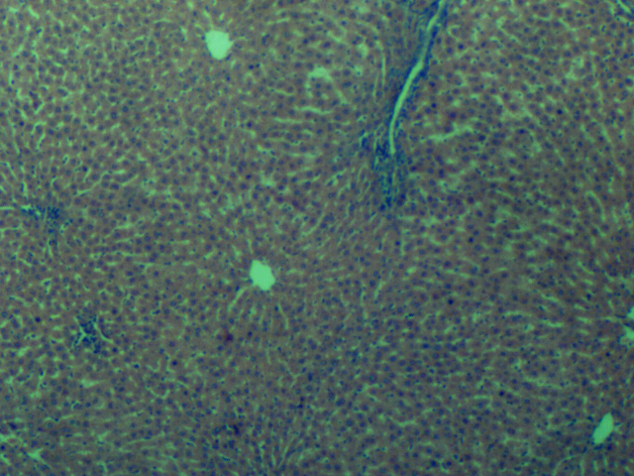

Plate 1.0: **Photomicrograph of liver tissue of Group A (received standard feed and distilled water *ad libitum*) reveals normal histological architecture, with hepatocytes (arrow) and central vein (arrowhead) appearing intact and unaltered (H&E, ×100).**

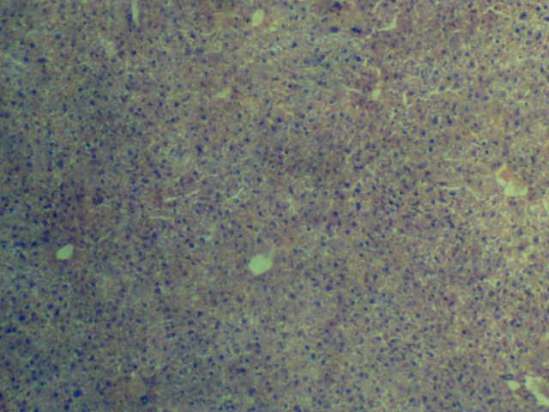

Plate 2.0: Photomicrograph of liver tissue of Group B shows preserved histological architecture consistent with normal liver morphology. The central vein (arrowhead), sinusoids (arrow), and hepatocytes (curved arrow) appear normal, with no evident signs of cellular injury (H&E, ×100).

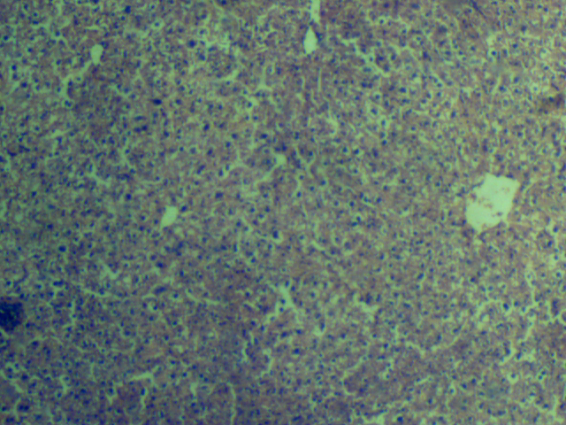

Plate 3.0: Photomicrograph of liver tissue of Group C showing morphology with normal liver histology but with moderate lymphocytic infiltration. The central vein is (arrowhead) in intact (H&E, ×100).

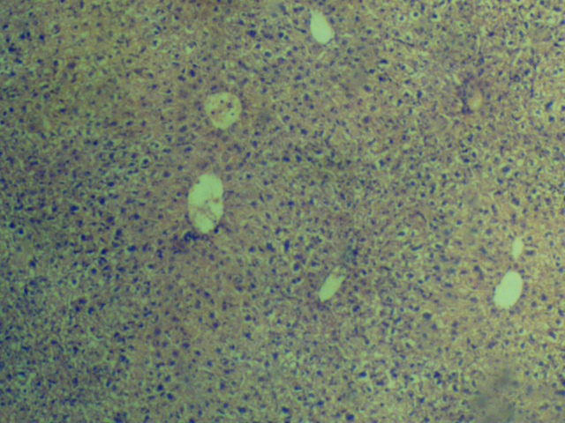

Plate 4.0: Photomicrograph of liver tissue of Group D showing morphology with normal liver histology but with mild inflammatory background. The central vein, (arrowhead) sinusoids (arrow) and hepatocytes (curved arrow) are normal with no obvious sign of injury (H&E, X100).

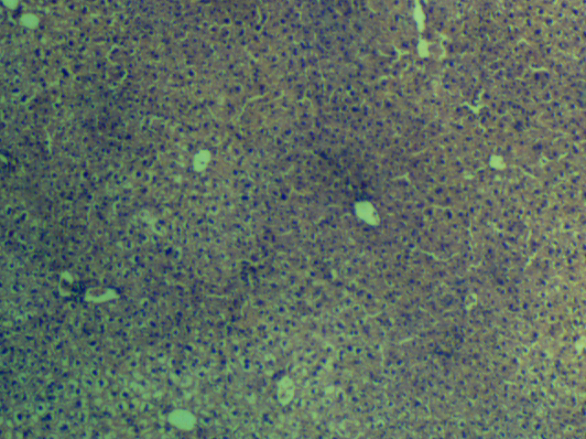

Plate 5.0: Photomicrograph of liver tissue of Group E showing morphology with normal liver histology but with mild inflammatory background. The central vein, (arrowhead) sinusoids (arrow) and hepatocytes (curved arrow) are normal with no obvious sign of injury (H&E, X100).



Plate 6.0: Photomicrograph of liver tissue of Group F showing normal Central vein (arrow) and hepatocytes (arrowhead) (H&E, X100).

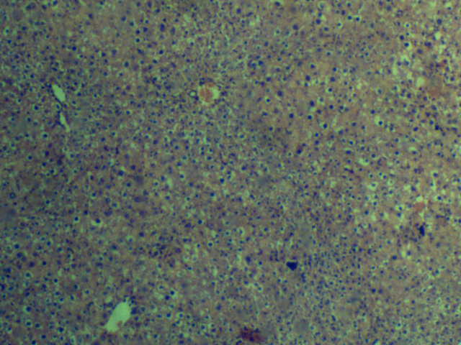

Plate 7.0: Photomicrograph of liver tissue of Group G showing morphology with normal liver histology but with mild inflammatory background. The central vein (arrowhead), sinusoids (arrow) and hepatocytes (curved arrow) are normal with no obvious sign of injury (H&E, X100).

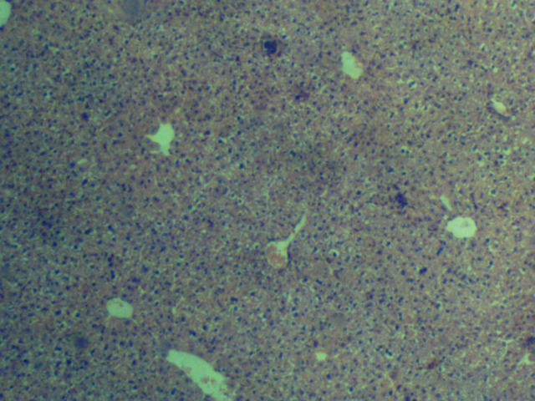

Plate 8.0: Photomicrograph of liver tissue of Group H showing morphology with normal liver histology but with mild inflammatory background. The central vein, (arrowhead) sinusoids (arrow) and hepatocytes (curved arrow) are normal with no obvious sign of injury (H&E, X100).

**DISCUSSION**

Malaria remains a significant global health burden, particularly in sub-Saharan Africa, due to its high morbidity and mortality. The disease, caused by *Plasmodium* species and transmitted by *Anopheles* mosquitoes (Babatunde et al*.,* 2018; Weiss et al*.,* 2024), continues to challenge public health systems, especially with the growing resistance to conventional antimalarial drugs. Consequently, attention has shifted towards plant-derived alternatives, such as *Azadirachta indica* (neem) and *Cymbopogon citratus* (lemongrass), which are widely recognized for their therapeutic potential and ethnomedicinal use (Shah et al., 2011; Acharaike et al., 2022: Ofoego et al., 2025).

In this study, the hepatoprotective effect of ethanolic extracts of *A. indica* and *C. citratus* were evaluated in *Plasmodium berghei*-infected mice. These plants are rich in phytochemicals, including flavonoids, alkaloids, tannins, saponins, and phenolic compounds, which contribute to their broad pharmacological activities (Asaolu et al., 2009; Islas et al., 2020; Subapriya & Nagini, 2005).

Post-infection weight changes reflected systemic stress and treatment responses. The uninfected control group exhibited significant weight gain, consistent with normal physiological development, whereas infected groups showed negligible weight changes. This pattern is similar to our earlier findings on kidney function, where *P. berghei* infection modestly impaired weight gain (Ofoego et al., 2025), potentially due to metabolic disruption (Ubua et al., 2019). Interestingly, weight stabilization in treated groups could be attributed to the metabolic benefits of bioactive compounds, including alkaloids and flavonoids (Agbafor & Akubugwo, 2007), which may support nutrient absorption and counteract infection-related catabolism.

Relative liver weights showed no significant variation, although slight increases in some treatment groups—particularly those receiving *A. indica*—are consistent with previous findings indicating mild hepatomegaly or adaptive detoxification responses to phytochemicals (Sani et al., 2020). Conversely, the combination treatment and standard drug groups exhibited minor reductions in liver weights, possibly due to anti-inflammatory or hepatoregulatory effects, as also observed in our earlier nephrotoxicity model (Ofoego et al., 2025; Abdel Moneim et al., 2014).

The antiplasmodial efficacy of the extracts was clear: all infected groups had high parasitemia at baseline, but significant **parasite clearance occurred by day 7**, and further reduction by day 14. The combination of Azadirachta indica and Cymbopogon citratus achieved chemosuppressive activity **comparable to standard antimalarial drugs** (Slater & Cerami, 1992; Mgbemena et al., 2010; Ukpai & Amaechi 2012). These findings align with earlier reports attributing antimalarial effects to multiple mechanisms, including disruption of parasite mitochondria, inhibition of hemozoin formation, and interference with parasite DNA and protein synthesis. For example, Martiney et al., (1996) demonstrated that hemozoin formation can be effectively blocked, offering a therapeutic strategy against Plasmodium falciparum. Additionally, natural products from neem and lemongrass have been shown to impair parasite metabolic pathways, including interference with mitochondrial function and nucleic acid processes (**Chianese** et al., 2010; Nogueira & Lopes, 2011).

Biochemical analyses revealed that *A. indica* and *C. citratus* significantly reduced serum AST and ALT levels compared to the malaria control group. This suggests a hepatoprotective effect, likely mediated by antioxidant flavonoids that stabilize hepatocyte membranes and inhibit oxidative stress-induced enzyme leakage. These findings align with other studies reporting protective enzyme profiles following phytotherapeutic interventions (Yanpallewar et al., 2003; Ozims et al., 2017; Ogundipe et al., 2025).

Histopathological evaluation revealed that infected, untreated livers displayed inflammatory cell infiltration, hepatocyte degeneration, and sinusoidal congestion—hallmarks of malaria-induced hepatic injury. These lesions are likely due to parasite sequestration, immune response activation, and oxidative damage. However, livers from extract-treated groups, particularly those receiving the combination treatment, showed relatively preserved architecture with minimal inflammatory changes. This aligns with previous renal findings, where extract-treated groups exhibited preserved glomerular and tubular structures despite infection (Ofoego et al., 2025; Ullah et al., 2014; Naqvi, 2015**)**. The improved liver histology further confirms the antioxidant, anti-inflammatory, and membrane-stabilizing properties of the phytochemicals.

In summary, the present findings reaffirm the hepatoprotective and antiplasmodial potentials of *Azadirachta indica* and *Cymbopogon citratus*, complementing our earlier observations on their nephroprotective roles. These extracts may offer a promising adjunct or alternative to conventional antimalarial therapies, especially in regions burdened by drug resistance and limited healthcare access.

**Conclusion**  
Ethanolic extracts of *Cymbopogon citratus* and *Azadirachta indica* exhibited notable antimalarial and hepatoprotective effects in *Plasmodium berghei*-infected mice. The combined administration of both extracts at 500 mg/kg each produced therapeutic outcomes comparable to standard antimalarial treatment, as evidenced by significant reductions in serum ALT and AST levels, decreased parasitemia, and improved liver histoarchitecture.

These findings suggest that the extracts—individually and in combination—may serve as effective, plant-based interventions against malaria-induced hepatic injury. Although the extracts were generally well-tolerated at the tested doses, the occurrence of mild hepatic inflammation at higher doses highlights the need for cautious use.

Future studies should aim to optimize dosing regimens, assess long-term safety, and elucidate the molecular mechanisms responsible for their antiplasmodial and hepatoprotective actions, paving the way for potential therapeutic development.

**Reference**

1. Abdel Moneim, A. E., Othman, M. S., & Aref, A. M. (2014). Azadirachta indica attenuates cisplatin-induced nephrotoxicity and oxidative stress. BioMed Research International, 2014, 647131. <https://doi.org/10.1155/2014/647131>
2. Acharaike, C. A., Ezejindu, D. N., & Ofoego, U. C. (2022). Comparative study of the effects of Vernonia amygdalina and Moringa oleifera on the hippocampal oxidative enzymes of diabetic Wistar rats. International Journal of Innovative Research and Advanced Studies (IJIRAS), 9(10), 60–65.
3. Adebayo, B. K., Mbagwu, S., Hernández-Castañeda, M. A., Adapa, S. R., Walch, M., Filgueira, L., Falquet, L., Jiang, R. Y., Ghiran, I., & Mantel, P.-Y. (2018). Malaria infected red blood cells release small regulatory RNAs through extracellular vesicles. Scientific Reports, 8(1), 884. <https://doi.org/10.1038/s41598-018-19149-9>
4. Agbafor, K. N., & Akubugwo, E. I. (2007). Hypocholesterolemic effect of ethanolic extract of fresh leaves of Cymbopogon citratus (lemongrass). African Journal of Biotechnology, 6(5), 596–598.
5. Anyasodor, C. C., Onyido, A. E., Ogbuefi, E. O., & Anyasodor, E. A. (2023). Antimalarial effects of ethanolic leaf extracts of Azadirachta indica and Ocimum gratissimum, and their histologic effects on some organs (liver, kidney, and heart) of Plasmodium berghei-infected albino mice. [Journal name missing].
6. Asaolu, M. F., Oyeyemi, O. T., & Olanlokun, J. O. (2009). Chemical compositions, phytochemical constituents and in vitro biological activity of various extracts of Cymbopogon citratus. Pakistan Journal of Nutrition, 8(12), 1920–1922.
7. Bhanwra, S., Singh, J., & Khosla, P. (2000). Effect of Azadirachta indica (neem) leaf extract on hepatic enzymes in rats. Indian Journal of Physiology and Pharmacology, 44(1), 64–68.
8. Biswas, K., Chattopadhyay, I., Banerjee, R. K., & Bandyopadhyay, U. (2002). Biological activities and medicinal properties of neem (Azadirachta indica). Current Science, 82(11), 1336–1345. <http://www.jstor.org/stable/24106000>
9. Brahmachari, G. (2004). Neem—An omnipotent plant: A retrospection. Chembiochem: A European Journal of Chemical Biology, 5(4), 408–421. <https://doi.org/10.1002/cbic.200300749>
10. Centers for Disease Control and Prevention (CDC). (2023). Malaria treatment recommendations. <https://www.cdc.gov/malaria>
11. Chattopadhyay, R. R. (2003). Possible mechanism of hepatoprotective activity of Azadirachta indica leaf extract: Part II. Journal of Ethnopharmacology, 89(2–3), 217–219. <https://doi.org/10.1016/j.jep.2003.08.006>
12. Cheesbrough, M. (2006). District laboratory practice in tropical countries. Part 1 (2nd ed.). Cambridge University Press.
13. Chianese, G., Yerbanga, S. R., Lucantoni, L., Habluetzel, A., Basilico, N., Taramelli, D., Fattorusso, E., & Taglialatela-Scafati, O. (2010). Antiplasmodial triterpenoids from the fruits of neem, Azadirachta indica. Journal of Natural Products, 73(8), 1448–1452. <https://doi.org/10.1021/np100325q>
14. Ekor, M. (2014). The growing use of herbal medicines: Issues relating to adverse reactions and challenges in monitoring safety. Frontiers in Pharmacology, 4, 177. <https://doi.org/10.3389/fphar.2013.00177>
15. Elioku, O. G., Anyabolu, A. E., Ofoego, U. C., & Okafor, I. A. (2015). A histological studies of the ameliorative effect of turmeric (Curcuma longa) on the liver of metronidazole-treated albino Wistar rats. World Journal of Pharmaceutical Research, 4(9), 311–320.
16. Felicia, F., Komariah, K., & Kusuma, I. (2022). Antioxidant potential of lemongrass (Cymbopogon citratus) leaf ethanol extract in HSC-3 cancer cell line. Tropical Journal of Natural Product Research, 6(4), 520–528. <https://doi.org/10.26538/tjnpr/v6i4.14>
17. Fidock, D. A., Rosenthal, P. J., Croft, S. L., Brun, R., & Nwaka, S. (2004). Antimalarial drug discovery: Efficacy models for compound screening. Nature Reviews Drug Discovery, 3(6), 509–520. <https://doi.org/10.1038/nrd1416>
18. Guha, M., Kumar, S., Choubey, V., Maity, P., & Bandyopadhyay, U. (2006). Apoptosis in liver during malaria: Role of oxidative stress and implication of mitochondrial pathway. FASEB Journal, 20(8), E439–E449. <https://doi.org/10.1096/fj.05-5338fje>
19. Islas, J. F., Acosta, E., G-Buentello, Z., Delgado-Gallegos, J. L., Moreno-Treviño, M. G., Escalante, B., & Moreno-Cuevas, J. E. (2020). An overview of neem (Azadirachta indica) and its potential impact on health. Journal of Functional Foods, 74, 104171. <https://doi.org/10.1016/j.jff.2020.104171>
20. Jaramillo, M., Godbout, M., & Olivier, M. (2005). Hemozoin induces macrophage chemokine expression through oxidative stress-dependent and -independent mechanisms. The Journal of Immunology, 174(1), 475–484.
21. Lorke, D. (1983). A new approach to practical acute toxicity testing. Archives of Toxicology, 54(4), 275–287.
22. Martiney, J. A., Cerami, A., & Slater, A. F. G. (1996). Inhibition of hemozoin formation in Plasmodium falciparum trophozoite extracts by heme analogs: Possible implication in the resistance to malaria conferred by the β-thalassemia trait. Molecular Medicine, 2(2), 236–246. <https://doi.org/10.1007/BF03401620>
23. Mgbemena, I. C., Opara, F. N., Ukaoma, A., Ofodu, C., Njoku, I. G., & Ogbuagu, D. H. (2010). Prophylactic potential of lemongrass and neem as antimalarial agents. Journal of American Science, 6(8), 503–507.
24. Naqvi, R. (2015). Plasmodium vivax causing acute kidney injury: A foe less addressed. Pakistan Journal of Medical Sciences, 31(6), 1472–1475. <https://doi.org/10.12669/pjms.316.8859>
25. National Research Council. (2011). Guide for the care and use of laboratory animals (8th ed.). The National Academies Press.
26. Nogueira, C. R., & Lopes, L. M. X. (2011). Antiplasmodial natural products. Molecules, 16(3), 2146–2190. <https://doi.org/10.3390/molecules16032146>
27. Ofoego, U. C., Bassey, E. M., Ofoego, A. N., & Udodi, P. S. (2025). Nephroprotective and antimalarial effects of Azadirachta indica and Cymbopogon citratus ethanolic leaf extracts in Plasmodium berghei-infected mice. Journal of Complementary and Alternative Medical Research, 26(6), 88–99. <https://doi.org/10.9734/jocamr/2025/v26i6667>
28. Ofoego, U. C., Mbagwu, S. I., Ekwujuru, E. U., Obiesie, I. J., Madu, C. P., & Ofoego, A. N. (2020). Maydis stigma (corn silk) extract protects the functionality and histoarchitecture of the testis against paraquat induced toxicity. International Journal of Agriculture and Biological Sciences, 15(4), 111–122.
29. Ogundipe, O. J., Ojetola, A. A., Akinpelu, O. F., Sossou, I. T., & Ishola, A. B. (2025). Aqueous leaf extract of Azadirachta indica protects against gentamicin-induced kidney injury via decreases in renal function, inflammation, and apoptosis markers. Journal of Medicinal Food, 28(3), 272–280. <https://doi.org/10.1089/jmf.2023.0294>
30. Ozims, S. J., Agu, G. C., Amah, H. C., Eberendu, I. F., Obioma-Elemba, J. E., Ihekaire, D. E., Akujobi, A. U., Obasi, C. C., Ibanga, I. E., Anokwuru, C. O., Nwobodo, E. I., Obeagu, E. I., & Nwosu, D. C. (2017). Effect of aqueous leaf extract of Cymbopogon citratus (lemongrass–Achara tea) on liver function in paracetamol-induced hepatotoxicity in albino rats. International Journal of Current Research in Chemistry and Pharmaceutical Sciences, 4(11), 43–49. <https://doi.org/10.22192/ijcrcps.2017.04.11.007>
31. Percário, S., Moreira, D. R., Gomes, B. A. Q., Ferreira, M. E. S., Gonçalves, A. C. M., Laurindo, P. S. O. C., ... & Green, M. D. (2012). Oxidative stress in malaria. International Journal of Molecular Sciences, 13(12), 16346–16372. <https://doi.org/10.3390/ijms131216346>
32. Rahim, S. M., Taha, E. M., Al-Janabi, M. S., Al-Douri, B. I., Simon, K. D., & Mazlan, A. G. (2014). Hepatoprotective effect of Cymbopogon citratus aqueous extract against hydrogen peroxide-induced liver injury in male rats. African Journal of Traditional, Complementary and Alternative Medicines, 11(2), 447–451. <https://doi.org/10.4314/ajtcam.v11i2.31>
33. Sani, I., Umar, R. A., Hassan, S. W., Faruq, U. Z., Bello, F., Aminu, H., & Sulaiman, A. (2020). Hepatoprotective effect of Azadirachta indica leaf fractionated extracts against snake venom toxicity on albino rats. Saudi Journal of Biomedical Research, 5(6), 112–117. <https://doi.org/10.36348/sjbr.2020.v05i06.004>
34. Schmidt, G. D. (2013). Essentials of parasitology (7th ed.). McGraw-Hill Education.
35. Shah, G., Shri, R., Panchal, V., Sharma, N., Singh, B., & Mann, A. S. (2011). Scientific basis for the therapeutic use of Cymbopogon citratus, stapf (lemon grass). Journal of Advanced Pharmaceutical Technology & Research, 2(1), 3–8. <https://doi.org/10.4103/2231-4040.79796>
36. Slater, A. F., & Cerami, A. (1992). Inhibition by chloroquine of a novel heme polymerase activity in malaria trophozoites. Nature, 355(6356), 167–169. <https://doi.org/10.1038/355167a0>
37. Subapriya, R., & Nagini, S. (2005). Medicinal properties of neem leaves: A review. Current Medicinal Chemistry – Anti-Cancer Agents, 5(2), 149–156.
38. Tona, L., Ngimbi, N. P., Tsakala, M., Mesia, K., Cimanga, K., Apers, S., De Bruyne, T., Pieters, L., Totté, J., & Vlietinck, A. J. (1999). Antimalarial activity of 20 crude extracts from nine African medicinal plants used in Kinshasa, Congo. Journal of Ethnopharmacology, 68(1–3), 193–203. <https://doi.org/10.1016/s0378-8741(99)00090-2>
39. Ubua, J. A., Ozung, P. O., & Inagu, P. G. (2019). Dietary inclusion of neem (Azadirachta indica) leaf meal can influence growth performance and carcass characteristics of broiler chickens. Asian Journal of Biological Sciences, 12(1), 180–186. <https://doi.org/10.3923/ajbs.2019.180.186>
40. Ukpai, O. M., & Amaechi, E. C. (2012). Evaluation of in vivo antimalarial activity of the ethanolic leaf extracts of Chromolaena odorata and Cymbopogon citratus in mice. Nigerian Journal of Biotechnology, 24, 27–34. <http://www.biotechsocietynigeria.org>
41. Ullah, N., Khan, M. A., Khan, T., & Ahmad, W. (2013). Cymbopogon citratus protects against the renal injury induced by toxic doses of aminoglycosides in rabbits. Indian Journal of Pharmaceutical Sciences, 75(2), 241–246.
42. United Nations. (2019). Globally harmonized system of classification and labelling of chemicals (GHS) (8th rev. ed.). United Nations Publications.
43. Uzozie, O., Nwachukwu, O., Ekwujuru, E., Mbagwu, S., Nwakanma, A., Nweke, O., & Ofoego, A. (2017). Ethanolic seed extract of Cucurbita pepo (pumpkin) protects the testis from Azadirachta indica (neem) induced damage. Journal of Natural Sciences Research, 7(24), 120–131.
44. Weiss, D. J., Bertozzi-Villa, A., Rumisha, S. F., Amratia, P., Arambepola, R., Battle, K. E., ... & Bhatt, S. (2024). Mapping the global prevalence, incidence, and mortality of Plasmodium falciparum and Plasmodium vivax malaria, 2000–22: A spatial and temporal modelling study. The Lancet, 403(10438), 1901–1918. <https://doi.org/10.1016/S0140-6736(25)00038-8>
45. World Health Organization. (2017). Guidelines on hepatitis B and C testing. World Health Organization. <https://www.who.int/publications/i/item/9789241549981>
46. World Health Organization. (2022). World malaria report 2022. World Health Organization.
47. World Health Organization. (2023). World malaria report 2023. World Health Organization.
48. Yanpallewar, S. U., Sen, S., Tapas, S., Kumar, M., Raju, S. S., & Acharya, S. B. (2003). Effect of Azadirachta indica on paracetamol-induced hepatic damage in albino rats. Phytomedicine, 10(5), 391–396. <https://doi.org/10.1078/0944-7113-00230>