**Naturopathy in Theory and Practice: Exploring Its Foundations, Modalities, and Educational Models**

**ABSTRACT**

**Background:**  
Naturopathy, rooted in ancient healing traditions, has evolved as a comprehensive natural medical system emphasizing the body’s innate healing ability. With global interest rising in complementary and alternative medicine, particularly herbal medicine, the role of naturopathy is gaining renewed relevance in both Western and African health systems.  
  
**Aims of the Study:**  
This study explores the foundational principles, philosophical underpinnings, therapeutic order, modalities, and educational structures of naturopathy. It seeks to contextualize naturopathy within African healing traditions and assesses its integration into formal educational frameworks, particularly within Ghana.  
  
**Methodology and Methods:**  
The study employs a qualitative, descriptive review approach grounded in thematic content analysis. It draws on historical records, philosophical doctrines, naturopathic literature, religious texts, WHO standards, and recent curriculum development documents from Ghana to synthesize insights about the evolution, practice, and pedagogy of naturopathy.  
  
**Findings and Results:**The findings reveal that naturopathy is deeply aligned with African traditional medicine, emphasizing vitalism, holism, and the healing power of nature. Core principles include “first do no harm,” treating the whole person, education, and prevention. The therapeutic order—ranging from establishing healthy conditions to using high-force interventions—is central to clinical practice. Additionally, naturopathy incorporates diverse modalities such as botanical medicine, nutrition, hydrotherapy, and spiritual healing. The study highlights Ghana’s pioneering role in institutionalizing naturopathic education through Competency-Based Training (CBT) under the Commission for TVET, with Nyarkotey University College serving as a continental model.

**Conclusion and Recommendations:**Naturopathy remains a vital, adaptable, and culturally resonant healthcare system. Its revival and institutionalization in Africa, particularly in Ghana, demonstrate the potential for integrating traditional healing with modern education standards. The paper recommends the expansion of accredited naturopathic institutions across Africa, the development of indigenous competency-based curricula, and the promotion of naturopathic research. A continent-wide framework guided by WHO strategies and local traditions can empower naturopathy to contribute meaningfully to public health, education, and economic development.

*Keywords: Naturopathy, Therapeutic Order, Competency-Based Education (CBT), African Traditional Medicine, Holistic Health*

**Introduction**

Naturopathy is a holistic and natural system of healthcare rooted in ancient healing traditions that emphasize the body's innate capacity to restore and maintain health (Di Stefano, 2006). As global interest in complementary and alternative medicine grows—especially in herbal medicine—naturopathy has gained renewed relevance in both Western and African health systems. The practice integrates philosophical foundations such as vitalism and holism with therapeutic modalities like botanical medicine, hydrotherapy, nutrition, and spiritual healing (Zeff, Snider & Myers, 2017; Braunwald et al., 2001).

In the African context, the principles of naturopathy resonate strongly with indigenous medical systems, which similarly value plant-based remedies, communal healing, and spiritual balance (Mukherjee, 2002; Obu & Bluwey, 2023). The institutionalization of naturopathy, particularly through Competency-Based Training (CBT) models such as those implemented by Ghana’s Commission for TVET, signifies a shift toward formal recognition and integration of traditional healing systems into modern health education (Obu & Bluwey, 2023). This paper explores the foundational principles, therapeutic theories, and educational models of naturopathy, particularly within African contexts, leaving the detailed literature and historical development for subsequent sections.

**Literature Review**

The introductory part of this paper considers what naturopathy is and why it is relevant in both global and African health systems today. In the rest of the paper, subtopics like the historical and philosophical foundations of naturopathy, core principles of naturopathy, the therapeutic order, naturopathic modalities and scope of the practice, naturopathic education models and curricula, and the future of naturopathy in Africa will be dealt with.

**Definition of Naturopathy**

Naturopathy may be defined as a natural approach to assist the body to heal itself. This medical practice encourages and collaborates with nature’s healing process for a lasting cure for diseases. Records indicate that naturopathic medicine combines traditional healing practices with modern inventions to accelerate healing processes (Fleming, 2010). Unarguably, naturopathy remains a mixture of modalities that may include the use of herbs, homeopathy, acupuncture, hydropathy, diet, and exercise to generate a lasting cure for diseases (Braunwald, Fauci, Kasper, Hauser, Longo & Jameson, eds. 2001, p. 50t).

**Relevance of Naturopathy to global and African health systems**

Currently, Herbal medicine is increasingly recognized as a complementary and alternative medicine with some practitioners integrating it into conventional healthcare. Besides, there is a growing interest in herbal medicine due to its perceived natural origins, holistic approach, and potential for addressing various health concerns. Throughout history, herbal medicine has played a vital role in healthcare and continues to be a significant part of global healthcare systems and individual wellness practices, especially in Africa.

***Origins and Evolution of Naturopathy***

The term ‘Naturopath’ is an Anglicized (English) version of the term ‘physician’, which was used by Hippocrates (the father of Medicine). This powerful physician was right to have traced the etymology of the term *naturopath* to the Greek root word, ‘*physikos*’, meaning ‘nature. Bottom of FormHippocrates was of the view that, like the natural restoration processes of nature, the human body has an innate healing potential (Di Stefano, 2006).  Bone and Mills (2012) argued that the physician’s role is not to heal patients but to remove obstacles that may be hindering the activation of the healing power of nature (white blood cells). Herbalists use herbs, among others, to remove obstacles that hinder the natural healing power of the body. Archaeological (historical) evidence shows that the use of medicinal plants dates to the Paleolithic age (before the Stone era) approximately 60,000 years ago.

The roots of naturopathic medicine go back thousands of years**,** drawing on the healing wisdom of many cultures, including *Indian (Ayurvedic), Chinese (Taoist), Greek (Hippocratic), Arabian, Egyptian, and European (monastic medicine) traditions*. The extant literature names the Sumerians, Egyptians, and Indians as having developed sophisticated systems of herbal medicine thousands of years ago. For example, Sumerians described medicinal uses of plants in written records dating back 5,000 years. In the Ancient Indian Culture, the Ayurveda herbalists, like Charaka and Sushruta, documented numerous herbs and minerals used in traditional medicine. Traditional Chinese Medicine (TCM) also developed with a complex system of herbal remedies and practices. Ancient Greece and Roman physicians documented knowledge about medicinal plants, including that which was recommended by Hippocrates and Dioscorides.

In our modern era, Benedict Lust used the term *“naturopathy”* to describe the Integrated practice of Botanical medicine, Homeopathic medicine, Nutritional and lifestyle counseling, Manipulative therapy, and Acupuncture. Hence, we recognize Benedict Lust as the founder of modern naturopathy in America. We recount that Naturopathy as a medical practice assumed a rise and fall status until 1960 when it became known as Naturopathic Medicine (Zeff, Snider & Myers, 2006; Snider, P., & Zeff, 2019).

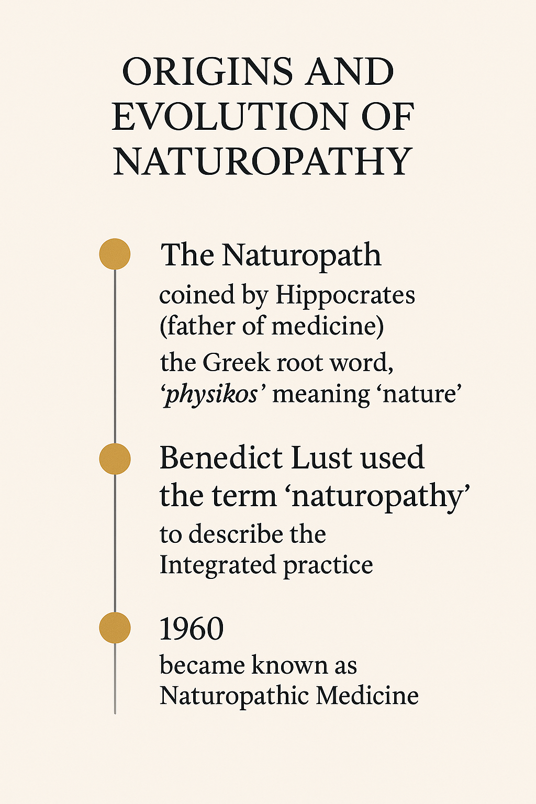

*Fig 1: Author’s Construct-This visual timeline illustrates the historical evolution of naturopathy—from Hippocrates coining the term "Naturopath" based on the Greek word physikos (nature), to Benedict Lust formalizing "naturopathy" as an integrated healing practice, and its recognition as "Naturopathic Medicine" in 1960.*

***Philosophical Foundations of Naturopathy: Vitalism and Holism***

The traditional practices that are also embedded in naturopathy have a philosophy. Philosophy translates two Greek words: phileo (love) and Sophiah, (wisdom). Put together, these two words bring out the meaning of philosophy as *love of wisdom* (Knight, 1980). The Bible describes the levels of wisdom as Knowledge, understanding, and discretion (Proverbs 2:6, 10 & 11). With these components of wisdom, as enshrined in the concept of philosophy, we are not surprised that the most enviable degree in academia is a Ph.D. –Doctor of philosophy--Socrates once said, *“Teaching will not bring knowledge but questioning.”* One thing philosophers keep doing is questioning people for answers to problems. Philosophers are therefore problem solvers (Laska, 1976).

Naturopathy, a health concept, has an underlying philosophy, the quest to know, understand, and, by the combination of knowledge (facts) and understanding, called *discretion,* solve problems in the health of the human body. A few of the various philosophical foundations are worthy of consideration. Vitalism and the holistic power of nature had been the core ontological foundations of naturopathy. In metaphysics—a branch of philosophy that investigates what is real--ontology is a sub-branch in the investigation of whether existence, or matter, is real. The ancient herbalists, for example, knew that food was medicine, and medicine was food (Hippocrates). Thomas Alva Edison also posits that, “ *The doctor of the future will give no medicine but will interest his patients in the care of the human frame, in diet and the cause and prevention of disease.”* These statements resonate with the goal of Naturopathic physicians; for the goal of naturopathic medicine is prevention, which is accomplished through education and promotion of lifestyle habits that foster good health.

Besides, witty and epistemological statements like, “ *Intellectuals solve problems; geniuses prevent them”* (Albert Einstein); “*One way of preventing disease is worth fifty ways of curing it;”* (Trevor Howard); *“ Prevention of disease must become the goal of every physician;”* (Henry E. Sigerist); all underscore the metaphysical, epistemological(knowledge), and axiological (ethics and aesthetics) foundations of naturopathy.

From the foregoing exegeses, we conclude that African healing philosophies have a direct relationship with naturopathic practices. For now, we know that the use of herbs remains paramount among the core philosophy of naturopathy--vitalism, holism, or the healing power of nature. Ezekiel 47:12 says we are to eat the fruit and use the leaves for medicine. Herbalists can be categorized in several ways, based on their focus, training, and approach to practice. Some common types include Clinical herbalists, Community herbalists, Traditional (folk) herbalists, and Medical herbalists.  Additionally, some herbalists specialize in areas like aromatherapy, herbal product making, or even veterinary herbalism. These perspectives of herb use elicit holistic treatment for patients. But there are more: Traditional Herbalists use natural substances like plants, animals, and minerals, as well as spiritual and cultural practices. In Ghana, traditional medicine is recognized as an integral part of the healthcare system, with practitioners playing a significant role in community health (Ross, 2025).

***How African Healing Practices Relate to Naturopathic Thought****.*

It is estimated that up to four billion people (representing 80% of the world’s population) living in the developing world rely on herbal medicinal products as a primary source of healthcare and traditional medical practice with the use of herbs (Mukherjee, 2002; Bodeker et al., 2005). The global herbal medicine market size was estimated at USD 70.57 billion in 2023 and is projected to reach USD 328.72 billion by 2030, growing at a CAGR of 20.91% from 2024 to 2030. The increase in the use of herbal medicine indirectly indicates dissatisfaction with conventional medicine in developed countries (Chan, 2003). If underdeveloped and developed countries use herbs, then we conclude that African healing practices relate to naturopathic thought. A further probe of this conclusion leads us to consider core principles of naturopathy.

**Core Principles and Therapeutic Order**

A principle is a rule or guidance to achieve an objective. However, principles are built on facts. There are three facts about naturopathy. First, the Naturopath (NAP) adopts a holistic life approach to wellness. In wellness, the Naturopath examines an individual’s whole life in terms of body, mind, and spirit. Second, naturopathy supports a healthy lifestyle, where the patient is encouraged to avoid any harmful material that could be injurious to health. Third, the foundations of Naturopathy are based on a healthy diet, clean fresh water, sunlight, exercise, and stress management (Braunwald et al., 2001).

***Analysis of Naturopathic Principles****.*

The three named core facts about naturopathy make way for seven core principles of naturopathy, which will be analyzed presently. First, in naturopathy, care is taken not to do any harm to the patient. This means medications should be prepared under excellent clinical conditions; conversations and interactions with the patient must not involve anything that could bring psychological or emotional pain of any kind or sort, etc.

Secondly, the NAP shall attempt to identify the cause of any pain and shall not hasten to prognose a health complaint. Specifically, they remove the obstacles to healing; stimulate the body’s natural healing process; support weakened physiological systems; correct the body’s structural integrity; and use natural medicine to address the specific disease.

Thirdly, the NAP focuses on treating the whole person. Most of the time, the NAP clinically evaluates the patient and attempts to identify any social, psychological, or cultural factor that may be a bother to the patient’s health. The World Health Organization (WHO) defines health from a holistic context, in terms of physical, social, mental, spiritual, and emotional aspects of an individual. An NAP must therefore aim to get to the bottom of the challenge of a sick person for the restoration of optimum health.

Fourthly, an NAP pays attention to the conditions that invite diseases and prescribes measures that prevent diseases, other than a cure. In this way, the NAP assumes the role of an educator, where education turns people’s eyes from darkness to light, within the context of ignorance, poverty, and disease (Plato, In Boateng, 2012 ). The three: ignorance, poverty, and sickness, are considered diseases which only education can cure. And so, the NAP should also become an educator.

The fifth principle of naturopathy holds that we should make informed choices that would help us choose that which would bring us health rather than disease. The NAP directs the attention of his patients to natural things that can bring health and healing; to factors that could be translated from the acronym, TRAT NEWS--In chemistry and microbiology, we know that Trat is a protein. Each of the letters of TRATNEWS unlocks how a NAP can help patients make good choices for a healthy life:

* Trust in God
* Rest
* Air
* Temperance
* Nutrition
* Exercise
* Water
* Sunlight

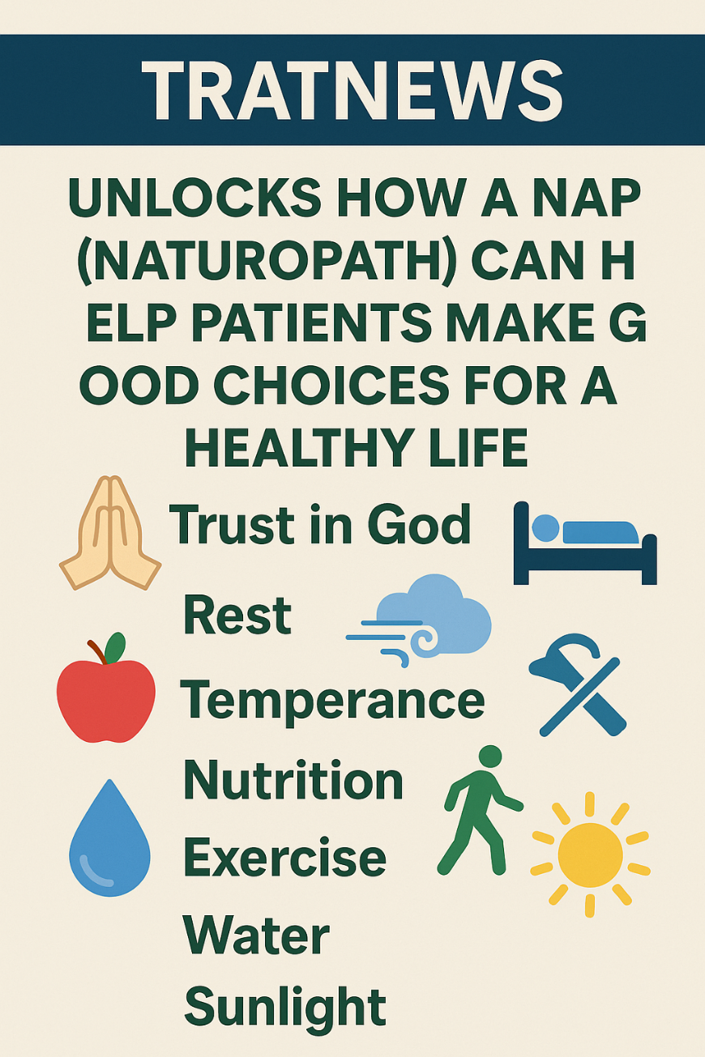

*Fig 2: Author’s Construct- The TRATNEWS visual illustrates how a Naturopath (NAP) guides patients toward healthier living through eight foundational principles:* ***Trust in God, Rest, Air, Temperance, Nutrition, Exercise, Water, and Sunlight****.*

Since protein builds our muscles, and trust in God is paramount in life and healing, TRATNEWS becomes a memorable acronym to help patients remember the good choices they can make to stay healthy and progressive in life.

The foregoing reminds us again that a NAP should fulfill the sixth naturopathic principle of becoming an instructor, a teacher of patients. One thing we know about teachers is that they are role models. The NAP should be an example of healthy habits before they can help others to be healthy. A popular adage goes like this: “*We are books that people are reading.”* An African proverb makes the argument on teaching understandable: *“If a naked man says he will give you a cloth, listen to his name.*” The teacher must therefore be healthy to be able to instruct the sick to be healthy too. Besides, the NAP must be ever-studying to update their knowledge and status in the healing industry. Should we consider the production of natural medicine as our calling?

Finally, the NAP must remove the obstacles to healing for the patient to be well. This calls for factors that boost the immune system. God, in his mercy, has placed in our body white blood cells to fight disease germs. When well nourished, the White cells can powerfully defend our body from attacks of bacteria and viruses that bring many diseases to the body. Fauci and Haynes (2001) have confirmed the need for naturopathy (not allopathy) to address immune system disorders, and in that case, any other therapy depends upon how strong and functional the immune system should be for holistic health. They concluded that “nontoxic therapies,” as found in naturopathy, should be the ideal “for the treatment of immune and inflammatory diseases” (p.1829).

In addition to boosting the immune system, Swarbrick (2006) shared seven components of what we call “wellness.” This authority described wellness, which in fact is the 7th principle of Naturopathy, as comprising seven health concepts as follows: *a) Emotional wellness, where an individual can cope with life and appropriately create satisfying relationships. b) Environmental wellness, here the individual occupies a pleasant and stimulating environment that supports good health, or well-being. c) Intellectual wellness involves the recognition of one’s creative abilities and seeking to expand knowledge and skills. d) Physical wellness is a big asset, much as the others. A witty individual sees physical health as wealth. e) Occupational wellness is considered personal satisfaction and enrichment derived from one’s work. f) Spiritual well-being encapsulates finding purpose and meaning in life.*

When we know why we are on planet earth, we will always face challenges with boldness, knowing that however bitter a cup might be, God will help us to drink from it with smiles, for in all things we are to give thanks, and that all things work together for good to them that love God (Romans 8:28.). *g) Social wellness: The person with this attribute develops a sense of connection and belonging, as well as a well-grounded support system. h) Finally, the person develops financial wellness, where confidence in financial stability has been established for today and tomorrow. Thus, boosting one’s immune system and developing a holistic wellness status are major considerations in naturopathic therapy.*

The question of a strong immune system calls for what is popularly known as the “Therapeutic Order.”

***The Therapeutic Order***

The therapeutic order is a natural hierarchy of therapeutic intervention based on, or dictated by, observations of the nature of the healing process from ancient times through the present. “Therapeutic orders” also exist in traditional Chinese, Tibetan, Ayurvedic, and Unani medicine theories. It is a natural ordering of the modalities of naturopathic medicine and their application. The therapeutic order calls for the evaluation of the unique needs and even the unique healing requirements of the specific patient or situation (Myers, December 2010). However, in general, the nature of healing dictates a general approach to treatment; namely, the “softer option” model of patient care. This model recognizes that, given a choice, the patient will generally choose the softer option if this does not limit a harder option, should the softer option fail. By way of example, given a choice between an antibiotic and amputation for a minor cut finger, most people would choose the softer option. Expanding this range of choice to an herbal cream, antiseptic (herbal or non-herbal), and a Band-Aid, an antibiotic, or amputation, we develop a therapeutic order ranging from the softest option (the least force) to the hardest option (the highest force intervention). The therapeutic order can be seen as a progression of therapeutic interventions that begin with a “softer option.”

. Again, in the therapeutic order, the NAP establishes the conditions for health:

* Identifies and removes disturbing factors
* Institutes a more healthful regimen
* Stimulates the healing power of nature (vis mediatrix naturae): the self-healing processes
* Addresses weakened or damaged systems or organs
* Strengthens the immune system
* Decreases toxicity
* Normalizes inflammatory function
* Optimizes metabolic function
* Balances regulatory systems
* Enhances regeneration
* Helps the patient to be in harmony with their life force
* Corrects structural integrity
* Addresses pathology by use of specific natural substances, modalities, or interventions, or uses specific pharmacologic or synthetic substances.
* Suppresses or surgically removes pathology.

*The actual therapeutic order may change, depending on the individual patient’s needs for safe and effective care.* The needs of the patient are primary in determining the appropriate approach to therapy. Acute and chronic concerns are both addressed using the therapeutic order. Acute concerns are, however, addressed first to avoid further damage, risk, or harm to the patient. The point of entry for assessment and therapy is dependent on each patient’s need for effective, safe care, healing, and prevention of suffering or degeneration (Jeff & Snider, 2005).

These Therapeutic order processes, nonetheless, could be summarized under seven main points as follows: First, the NAP sets an optimal health goal, where the patient has normal health. While the patient has normal health, the NAP wishes for improvement. Then, there arise disturbances in the body function. This leads to inflammation or fever, etc., and there could be chronic reaction from the body organs, leading to degeneration such as ulceration, atrophy, scar, scar, paralysis, or tumors.

Here, the NAP attempts to reverse the condition from degeneration, through inflammation, upwards to normal health, and finally encourages preventative measures to attain optimal health. ***Fig. 3*** below paints the picture better (Zeff, Snider, Myers, & DeGrandpre, 2017).

To this end, a discussion of five naturopathic modalities will open the eyes of many to the care and treatment with natural medicine.

**Naturopathic Modalities and Scope of Practice**

Lindlahr (1913, in Zeff et al., 2017) ultimately presented the most coherent naturopathic theory and summarized it in his *Catechism of Naturopathy,* which presented a five-part therapeutic progression in the following manner:

* “Return to Nature”—attend to the basics of diet, dress, exercise,

rest, etc.

* Elementary remedies—water, air, light, electricity
* Chemical remedies—botanicals, homeopathy, etc.
* Mechanical remedies—manipulations, massage, etc.
* Mental/spiritual remedies—prayer, positive thinking, doing

Good work.

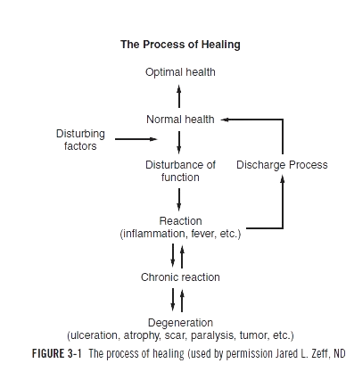

*Fig 3*. Adopted from “The process of healing” (Zeff, J. L., et al. 2017), p.23

Examining Lindlahr’s (1913) presentation, one finds a replica of traditional healing practices. From experience, many an African herbalist has been classified as a Spiritual Herbalist. Some African Herbalists play on the intelligence of their patients and persuade them to believe in their healing strategies. The oracle consultation, however, uses social and cultural psychology to lure patients to believe in the decoction and other materials, such as black powder, amulets, etc., even placebos, to heal patients: Prayers, and positive thinking, elicits miracles; for the Bible says without faith it is impossible to please God (Hebrews 11:6). Once the patient develops faith the result is amazing. Many have witnessed the cure of diseases through these means by the practitioners. The point here is that the five processes outlined above are effective, since nature is not taken out of the picture.

As we all may know, human beings are natural organisms with our genomes developed and expressed in the natural world. The patterns and processes inherent in nature are inherent in us. We exist as a part of complex patterns of matter, energy, and spirit. Many traditional herbalists have observed the natural processes of these patterns in health and disease and determined that there is an inherent drive toward health that lives within the patterns and processes of nature, which are ontologically real and epistemologically a priori truths. The uniqueness of naturopathic medicine, therefore, is not in its therapeutic modalities; it is in the clinical theories that govern the natural alternatives that the herbalists select for healing (Fauci and Hynes, 2001). This remains the global picture of Naturopathy.

**Naturopathic Education Models and Curricula.**

A curriculum may be defined as the experiences, training, and education learners go through in their lives. We have informal education that begins at home; formal education takes place in the classroom; and non-formal education takes place after school (Farrant, 1980). In this section of the topic under review, we describe global models of Naturopathic education and outline the significance of Technical and Vocational Education and Training (TVET) in Ghana and Africa.

***Global Models of Naturopathic Education.***

Global education models of Naturopathy assume similar characteristics and goals. For now, we know that health care delivery techniques, methodology, and principles seek to treat the whole person (Zeff et al. 2017). From the definitions and functions of Naturopathy, we know that traditional knowledge and practices are, however, refined and augmented with scientific procedures of experimentation and analysis. World Health Organization (WHO) refers to a practitioner of herbal(botanical) medicine, which is a traditional form of healthcare, as an Herbalist. WHO recognizes the importance of traditional healing, including herbal medicine, and has established initiatives to ensure its safety and quality. The scope of practice of a Traditional Herbalist covers a wide range of practices based on indigenous knowledge, beliefs, and experiences used for maintaining health and treating illnesses.

To support and optimize this inherent healing ability, practices such as

Maintaining a healthy diet, regular exercise, managing stress, through rest where necessary, and enough sleep, are part of the global naturopathic curriculum. Apart from these, the astute NAP tries to educate clients to reduce their exposure to toxins, observing health rules as recommended in the acronym TRATNEWS, which has been discussed earlier. These natural approaches can help create a favorable environment for the body to heal itself and support overall wellness. But there is a need to train all who wish to become Naturopaths.

***Naturopathy in Africa: The Ghanaian Example and CBT Integration***

Obu and Bluwey (2023) found that in Africa, the only country that had an accredited Naturopathic institution to train practitioners, is “South Africa” (p.29), though many such institutions exist in United Kingdom as the School of Phytotherapy, and in USA as Naturopathy, founded by Benedict Lust, as cited earlier. Extant literature confirms that there are many programs in Naturopathy being taught globally. Some are being run by recognized schools, while others are not.

For Africans, there is much difficulty in assessing such recognized and accredited Naturopathic schools. This, in turn, leaves many Africans to resort to substandard Naturopathic foreign schools, and this further creates credibility and recognition challenges for practitioners in Africa and Ghana, specifically. Fortunately, Ghana has now developed two programs to be offered at the tertiary level under the Commission for Technical and Vocational Education and Training (CTVET).

Ghana’s program was funded and supported by the Nyarkotey University College of Holistic Medicine and Technology (NUCHMT).

The significance of TVET-based Naturopathic education in Ghana and Africa will be outlined presently. First, the Commission for Technical and Vocational Education and Training (CTVET) in Ghana gave accreditation to NUCHMT in 2016. The process for accreditation started in 2021 after the establishment of National Occupational Standards (NOS), which define the outcomes of competent performance. It has become necessary in Ghana as the law mandated the commission for TVET to embrace Competency-Based Training (CBT) in 2020.

Second, NOS has many benefits in the workplace and for the development of the individual. These include recruitment, staff development review, promotion, identifying training or Continuing Professional Development (CPD) needs, and staff planning. National Occupational Standards are also updated, and in the case of Ghana, the regulator mandates that they be updated every five years. Hence, the next NOS is scheduled for 2027. This means that successful products from CTVET-accredited Naturopathic schools are supposed to demonstrate some levels of competency in Naturopathy (Obu, 2023).

Third, the NOS has a General Area of Competence (GAC) which specifies the subject areas students are supposed to exhibit or be taught in the curriculum. It also has the skills and subskills, and the range statements. The skills and sub-skills are embedded in the Learning Outcomes (LO), and each LO has a knowledge area; sub-skills have the Performance Criteria (PCs). Assessment tools and materials are in place to enhance TVET education in NUTCHMT’s Department of Naturopathy.

Next, in the case of Ghana’s Naturopathic institutions, through CTVET’s accreditation procedures, naturopaths will get global recognition to practice. Another area of competence embedded in the case of Ghana is training in African Naturopathy and wider knowledge of biomedical science. The benefits of this in competition in the global market for herbal medicine products cannot be overemphasized. Currently, it has been established that the Naturopathy and holistic medicine competency-based curricula (CBC) are ideal for the changing trends in Naturopathic practice, which is, indeed, unique in naturopathic education.

Thus, understanding competency-based education is important in naturopathic education, in that, unlike the traditional education system, the Naturopathic CBC curriculum is centered on competence in each subject, instead of focusing on writing and passing exams to get good grades in a formalized and structured yearly curriculum schedule. Competency-based education scores, however, are based on the performance levels of each student without bias. It is either achieved or not achieved. Gitahi posits that a Competency-based Curriculum (CBC) is an educational system that emphasizes a learner’s unique talents and abilities rather than focusing wholly on academics and exam performances. Hence, CBC focuses on the acquisition of knowledge, skills, and attitudes to use in the future in society (Ngamkajonviwat et al., 2015, in Obu & Bluwey, 2023, see Fig. 4).



***Fig. 4:*** **Competency-based education curriculum development**.

*Source*: Ngamkajonviwat et al., (2015, In Obu, R. N., & Bluwey, L. A.

2023, Naturopathic education in Ghana; commentary on progress made

towards curriculum development. *Journal of Preventive Medicine and*

*Holistic Health;* 9(1):29–33.), p.30.

**The future of Naturopathic Education in Africa.**

We are proud to relay that Ghana’s first National Naturopathic Medical School: Nyarkotey University College of Holistic Medicine & Technology, located in Ashaiman-Tema, Ghana, has been registered and officially recognized as a Competency Based Training (CBT) Provider Tertiary institution by the Commission for Technical and Vocational Education and Training (CTVET). This is the first Naturopathic competency-based University in the West African sub-region and among the few on the African Continent, and is structured into two sessions—the academic subject section and the section of skill acquisition section. These two sections have learning outcomes (LOS)and performance criteria (PCs).

The benchmark set by CTVET in NUCHMT has three features that could be replicated in future naturopathic colleges in Africa. First, it is competency-based because the student does not go to the next level until mastery is achieved. Secondly, it is learner-centered because it is self-competition—Criterion Reference based, not competition against others (Gronlund & Linn, 1990); and differentiated, because learning is tailored to meet students’ needs (Obu & Bluwey, 2023).

The literature says it is the first of its kind in the West African Sub-Region.

These characteristics of Ghana’s Naturopathic Institution are likely to be a model for African Countries. As NUCHMT strives to follow the support and guidance of CTVET, Ghana’s Naturopathic practices would surely integrate traditional medicine into a fine-tuned and scientific model status, to boost the efficacy of practitioners, in maintaining sound public health practices in Ghana, with a spill over to the African Continent.

***Integration with African Traditional Healing Systems***

This study has traced the evolution of naturopathy from its ancient origins to its present-day relevance. Rooted in the Hippocratic tradition, naturopathy has long advocated healing through nature, initially employing traditional and rudimentary methods. Over time, these evolved into a more scientific system of natural medicine now recognized as naturopathy. The central belief in the body's innate self-healing ability remains at the heart of the discipline. Naturopaths are trained not only to stimulate these self-healing mechanisms but also to serve as educators who empower patients to sustain wellness through lifestyle and dietary changes ( Di Stefano, 2006).

While the dominance of allopathy momentarily overshadowed naturopathic practice, its efficacy persisted, particularly in the United Kingdom, where it is known as phytotherapy, and in the United States under the legacy of Benedict Lust, often regarded as the father of modern naturopathy. Naturopaths, functioning as both healers and health educators, emphasize the interconnection between body, mind, and spirit. In addressing illness, they consider environmental, psychological, social, and spiritual factors—an approach deeply aligned with African traditional medicine (Mukherjee, 2002; WHO, 2023).

One of naturopathy’s most distinctive features is the **therapeutic order**, a structured intervention model that prioritizes the least invasive methods while respecting the body’s natural healing trajectory. As Dr. Zeff and colleagues have argued, this pragmatic model enables practitioners to respond to the body's symptoms as intelligent expressions of imbalance, guiding personalized care that supports immune and systemic function (Zeff, Snider, Myers & DeGrandpre, 2017).

Tools such as the TRATNEWS acronym—Trust in God, Rest, Air, Temperance, Nutrition, Exercise, Water, and Sunlight—embody the naturopathic lifestyle education strategy. These foundational elements are also echoed in African indigenous health systems that prioritize spiritual alignment, environmental harmony, and community-centered wellness. However, the effective fusion of traditional healing with scientific approaches demands structured education and institutional support, which remain underdeveloped in many African nations. Currently, South Africa hosts the only long-standing naturopathic institution on the continent, and even there, challenges persist (Obu & Bluwey, 2023).

Against this backdrop, the establishment of the Nyarkotey University College of Holistic Medicine and Technology (NUCHMT) in Ghana stands out as a landmark initiative. Founded and solely financed by Prof. Raphael Nyarkotey Obu and partners, the institution exemplifies competency-based, learner-centered education and represents a pioneering model for the continent. NUCHMT’s curriculum aligns with the standards of Ghana’s Commission for Technical and Vocational Education and Training (CTVET), offering structured learning outcomes and performance criteria that meet both global benchmarks and African contextual needs (Obu & Bluwey, 2023).

In conclusion, as Obu and Bluwey (2023) affirm, the institutionalization of naturopathic education in Ghana offers significant potential for self-employment and professional autonomy. In the UK, for instance, trained naturopaths can earn between £65 to £90 for initial consultations and £45 to £65 for follow-ups. This reflects the economic promise of naturopathy as a viable career pathway. More broadly, naturopathy's integration with African traditional healing practices presents a culturally congruent, economically viable, and spiritually enriching healthcare model—capable of advancing public health, preserving indigenous knowledge systems, and empowering holistic wellness across the continent.

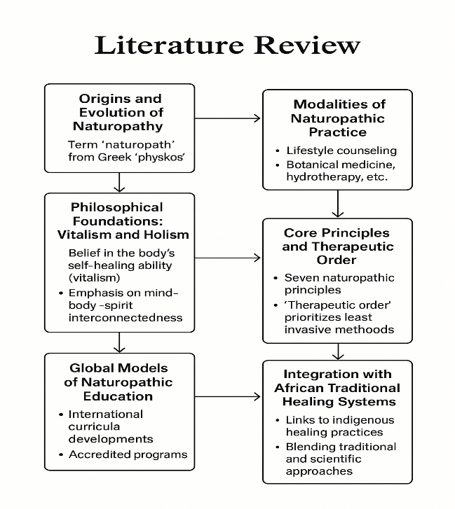

*Fig 5: Author’s Construct- This visual mock-up of the* ***Literature Review*** *section presents a structured flow of key thematic areas examined in the study, beginning with the* ***Origins and Evolution of Naturopathy****, followed by its* ***Philosophical Foundations,*** *such as vitalism and holism. It then progresses through the* ***Core Principles and Therapeutic Order****, highlighting the structured healing strategies used by naturopaths. The diagram continues with the* ***Modalities of Naturopathic Practice****, including lifestyle, herbal, and physical therapies, and explores* ***Global Models of Naturopathic Education****. It concludes with insights into the* ***Ghanaian Example and Competency-Based Training****, and finally, the* ***Integration of African Traditional Healing Systems****, demonstrating how naturopathy aligns with indigenous African medical practices. This framework illustrates the interconnectedness of naturopathic principles with education, clinical models, and cultural relevance.*

**Conceptual Framework**

This study is anchored in a **composite conceptual framework** that integrates philosophical, therapeutic, educational, and cultural paradigms to understand and advance the practice and institutionalization of naturopathy in Africa. The framework reflects the multifaceted nature of naturopathic medicine, drawing from historical, epistemological, and experiential sources of knowledge.

At the core of this framework lies the **philosophical foundation** of naturopathy, deeply rooted in *vitalism* and *holism*. Vitalism, the belief in the body’s inherent ability to heal itself (vis mediatrix naturae), underscores the naturopathic understanding that the healing process is intrinsic to the human body when properly supported (Zeff, Snider, Myers & DeGrandpre, 2017). Holism emphasizes treating the individual as a whole—mind, body, and spirit—aligned with traditional African healing systems, which also recognize the interconnectedness of all aspects of human life.

Building upon this foundation, the **therapeutic order** represents a structured approach to healing interventions, ranging from least to most invasive strategies. These include foundational lifestyle interventions (such as diet, rest, and stress management), stimulation of self-healing mechanisms, support of weakened systems, natural therapeutics, and finally, pharmaceutical or surgical interventions if necessary (Zeff et al., 2017; Myers, 2010). This hierarchy reflects both traditional and contemporary naturopathic practices, paralleling indigenous African approaches that favor minimal intervention and trust in natural remedies (Mukherjee, 2002).

The framework also incorporates **competency-based education (CBE)**, particularly as implemented in Ghana through the Commission for Technical and Vocational Education and Training (CTVET). CBE emphasizes mastery, performance criteria, and learner-centered instruction, ensuring that students not only acquire theoretical knowledge but also practical skills essential for clinical efficacy (Obu & Bluwey, 2023). This shift toward educational rigor marks a turning point in legitimizing naturopathic practice across Africa, aligning training with international standards while honoring local traditions.

Finally, the conceptual framework is situated within the broader context of **cultural integration and policy support**. The recognition of traditional and naturopathic medicine within national health policies—such as Ghana's development of National Occupational Standards (NOS)—illustrates the importance of regulatory frameworks that validate indigenous knowledge systems and facilitate their integration into formal healthcare and education structures (Obu, 2023; WHO, 2023). This inclusion provides a platform for traditional healers and naturopaths to collaborate and advance holistic healthcare delivery.

In sum, the conceptual framework reflects the synergistic interaction of naturopathy’s philosophical roots, clinical theory (therapeutic order), modern educational practices (CBT/CBE), and sociocultural context. This integration not only supports effective naturopathic practice but also contributes to its institutionalization in Africa’s evolving health systems.

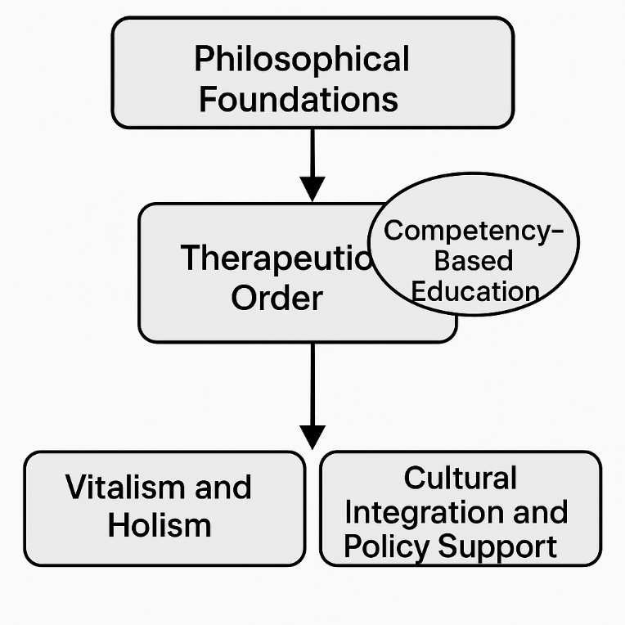

*Fig 6: Author’s Construct- This conceptual framework illustrates how naturopathy is grounded in philosophical foundations, guided by the therapeutic order, supported by competency-based education, and shaped by vitalist and holistic principles alongside cultural integration and policy support.*

**Theoretical Framework**

This study is anchored in a composite theoretical framework that draws from four interrelated perspectives: **Vitalism**, **Holism**, **Experiential Learning Theory**, and **Indigenous Knowledge Systems Theory**. These frameworks collectively offer a foundation for understanding how naturopathy is philosophically rooted, culturally adapted, and educationally applied within the African context.

**1. Vitalism**

Vitalism is a central philosophical tenet of naturopathy that posits the existence of a life force (vis mediatrix naturae) which governs healing and physiological balance (Zeff, Snider & Myers, 2017). This life force is believed to self-regulate the body toward equilibrium when supported by natural therapies. African traditional medicine shares this view through its reliance on spiritual energy, ancestral guidance, and herbal rituals that are seen as activating the body’s natural defenses (Gyasi et al., 2016). The convergence of these views demonstrates the relevance of vitalist theory in African naturopathic education and practice.

**2. Holism**

Holism emphasizes that health is a dynamic equilibrium of the physical, emotional, spiritual, and environmental dimensions of human existence ( Jasemi et al. 2017). Naturopathy promotes holistic care by treating the root causes of disease and addressing the whole person rather than isolated symptoms. Similarly, African indigenous medicine views illness as the disruption of harmony among individuals, the community, the ancestors, and nature (Wreford, 2008). This shared worldview affirms that a holistic approach is essential for developing culturally consonant naturopathic frameworks in Africa.

**3. Experiential Learning Theory (Kolb’s ELT)**

Kolb’s Experiential Learning Theory provides a model for understanding how learners acquire, process, and apply knowledge through experience. It includes four stages: concrete experience, reflective observation, abstract conceptualization, and active experimentation (Kolb, 1984). This theory aligns well with Competency-Based Training (CBT) models adopted in Ghanaian naturopathic institutions under the Commission for TVET, where students engage in practical learning and skills demonstrations (Obu & Bluwey, 2023). By embedding Kolb’s ELT, naturopathic education becomes more responsive to real-world contexts and culturally embedded practices.

**4. Indigenous Knowledge Systems (IKS) Theory**

IKS theory validates traditional African systems of healing as legitimate, context-sensitive knowledge paradigms (Odora Hoppers, 2002). It challenges colonial epistemologies that dismissed African medicine as unscientific and promotes integration with formal education. IKS theory supports the preservation, documentation, and curricular inclusion of indigenous therapies, spiritual beliefs, and herbal practices. Within the naturopathic framework, this theory justifies the blending of modern academic standards with local healing wisdom, making naturopathy more authentic and grounded in African realities.

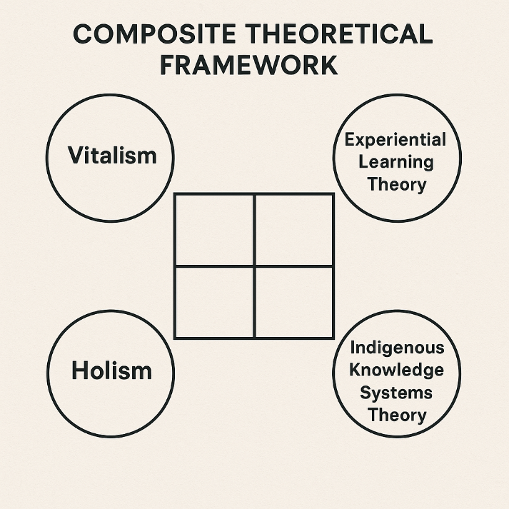

*Fig 7: Author’s Construct- This visual illustrates the composite theoretical framework underpinning the study, showing how Vitalism, Holism, Experiential Learning Theory, and Indigenous Knowledge Systems Theory interrelate to form a holistic foundation for understanding naturopathic and traditional healing practices.*

**Research Objectives:**

**RO1:** To examine the historical and philosophical foundations of naturopathy and its relevance to African traditional healing systems.

**RO2:** To explore the core principles, therapeutic order, and modalities that define naturopathic practice.

**RO3:**To analyze the role of competency-based education in shaping naturopathic training in Ghana and Africa.

**RO4:**To assess the prospects and institutionalization of naturopathy within African healthcare systems.

**Research Questions:**

**RQ1:** How do the historical and philosophical foundations of naturopathy align with African traditional healing practices?

**RQ2:** What are the core principles, therapeutic order, and healing modalities employed in naturopathic medicine?

**RQ3:**How does competency-based education influence the curriculum and training of naturopaths in Ghana?

**RQ4:**What are the future opportunities and challenges for institutionalizing naturopathy within Africa’s formal healthcare and education systems?

**Material and Method**

This paper adopts a qualitative, doctrinal, and exploratory research approach rooted in philosophical analysis and educational policy commentary. Given the historical and evolving nature of naturopathy, the methodology reflects an interdisciplinary framework that encompasses philosophical exegesis, content analysis, and documentary review.

***Research Design***

The study is interpretive and descriptive, relying primarily on secondary sources. It explores the philosophical, historical, and scientific underpinnings of naturopathy and links these with indigenous African healing systems. The design permits reflective discourse on the alignment between traditional African medical practices and global naturopathic principles.

***Sources of Data***

Data was drawn from a wide range of academic and gray literature. These include:

* Textbooks and peer-reviewed journals on naturopathy, traditional medicine, and complementary health (e.g., Braunwald et al., 2001; Zeff et al., 2017).
* Official documents and publications by institutions like the WHO and CTVET.
* Commentary articles and reports on naturopathic education in Ghana and Africa (e.g., Obu & Bluwey, 2023).
* Philosophical texts relevant to the understanding of naturopathy's epistemological and ontological roots.

***Analytical Approach***

The thematic content analysis method was used to synthesize materials into coherent themes around:

* The historical and philosophical roots of naturopathy.
* Core principles, therapeutic order, and modalities.
* The role and structure of competency-based education in Ghana’s naturopathic development.
* The future outlook for institutionalizing naturopathy in Africa.

Each theme is discussed with supporting references, aligning observations with existing scholarship and indigenous health practices.

***Scope and Limitations***

The paper is exploratory and does not include primary data collection such as interviews or surveys. It is limited to literature available in English and relies on documented developments in Ghana and other select African nations. Nevertheless, the study is sufficient to draw informed conclusions and offer grounded recommendations for policy and practice.

**Result and Discussion**

***RQ1. How do the historical and philosophical foundations of naturopathy align with African traditional healing practices?***  
The historical evolution of naturopathy reveals strong parallels with African traditional medicine. Both systems draw on the belief in the body’s innate capacity to heal and emphasize nature as a central healing agent (Di Stefano, 2006). The vitalistic and holistic worldview of naturopathy reflects African ontological perspectives on health and illness. Herbalists, both African and naturopathic, employ plant-based, spiritual, and community-centered interventions that resonate with the metaphysical, epistemological, and axiological foundations of naturopathic philosophy (Knight, 1980; Laska, 1976; Obu & Bluwey, 2023).  
  
***RQ2. What are the core principles, therapeutic order, and healing modalities employed in naturopathic medicine?***  
Naturopathy is structured around seven core principles, including “do no harm,” treating the cause, educating the patient, and supporting the healing power of nature (Braunwald et al., 2001). The therapeutic order—a progressive hierarchy of care—begins with non-invasive techniques and escalates to higher-force interventions only as necessary (Myers, 2010; Zeff, Snider & Myers, 2017). Lindlahr’s therapeutic progression—ranging from basic lifestyle adjustments to mental and spiritual remedies—mirrors African spiritual and herbal healing modalities (Lindlahr, 1913; Fauci & Haynes, 2001).  
 ***RQ3. How does competency-based education influence the curriculum and training of naturopaths in Ghana?***  
The integration of Competency-Based Training (CBT) through the Commission for TVET (CTVET) in Ghana, particularly at NUCHMT, ensures that naturopathic education is outcome-driven and skill-oriented (Obu & Bluwey, 2023). The National Occupational Standards (NOS) define performance outcomes and competencies, with curriculum elements tied to measurable Learning Outcomes (LOs) and Performance Criteria (PCs). This approach aligns with global educational practices and ensures quality assurance in training African naturopaths (Ngamkajonviwat et al., 2015; Gitahi, 2021).  
  
***RQ4. What are the future opportunities and challenges for institutionalizing naturopathy within Africa’s formal healthcare and education systems?***  
The future of naturopathy in Africa lies in institutional expansion, policy support, and educational reform. Ghana’s NUCHMT serves as a blueprint for other African countries aiming to professionalize naturopathic education (Obu & Bluwey, 2023). However, challenges include regulatory inertia, lack of funding, limited public awareness, and the dominance of biomedicine. Advocacy for accreditation, research, and public-private partnerships is essential to elevate naturopathy within formal systems of health and education in Africa.

**Conclusion and Recommendation**

This study set out to examine the foundational tenets of naturopathy within both global and African contexts, and all four research objectives have been effectively addressed.

Firstly, the investigation into the **historical and philosophical foundations of naturopathy** has confirmed a deep and direct alignment with African traditional healing systems. Both traditions emphasize vitalism, holism, and the healing power of nature. From Hippocratic medicine to African herbalism, the shared belief in the body's innate ability to heal—supported by natural agents such as herbs, spiritual practices, and lifestyle—demonstrates a long-standing common ground.

Secondly, the study thoroughly **explored the core principles, therapeutic order, and naturopathic modalities**. It was established that naturopathy is guided by seven core principles and a therapeutic order that prioritizes non-invasive, natural interventions before escalating to more intensive therapies. Modalities such as botanical medicine, hydrotherapy, and spiritual counseling were shown to resonate with both Western naturopathic models and African healing traditions. These findings validate naturopathy as a comprehensive and structured system of healthcare.

Thirdly, the analysis of **competency-based education (CBT)** in Ghana, specifically through the work of the Commission for TVET and the pioneering efforts of Nyarkotey University College of Holistic Medicine & Technology (NUCHMT), confirmed that structured, skills-based naturopathic education is not only feasible but transformative. Ghana’s national occupational standards and performance-based curricula set a precedent for other African nations aiming to professionalize and standardize naturopathic training.

Lastly, the study **assessed the prospects for institutionalizing naturopathy** within Africa’s formal healthcare and education systems. The findings highlight significant opportunities, especially in countries like Ghana that have embraced regulatory frameworks. Nonetheless, challenges persist, such as limited recognition, inadequate policy frameworks, and a lack of public awareness. Overcoming these barriers will require sustained advocacy, investment in accredited institutions, and inclusion of naturopathy in national health agendas.

In conclusion, this paper affirms that naturopathy is both an ancient and a future-oriented health system. When rooted in Africa's traditional healing wisdom and supported by formal education structures like CBT, naturopathy holds immense promise for addressing public health needs, fostering self-reliance, and revitalizing indigenous medical knowledge in Africa.

**Recommendations**

1. **Integrate African Traditional Healing Systems into Naturopathic Curricula:**  
   Given the philosophical and practical alignment between African traditional medicine and naturopathy, institutions should formally incorporate indigenous knowledge systems into naturopathic education. This will preserve cultural heritage, promote contextual relevance, and enhance acceptance among local populations.
2. **Strengthen the Implementation of Competency-Based Education (CBE):**  
   Regulatory bodies such as the Commission for TVET (CTVET) should continue to support and expand Competency-Based Training (CBT) in naturopathic institutions. Emphasis should be placed on practical skills, measurable learning outcomes, and performance criteria to ensure that quality graduates are capable of clinical competence.
3. **Expand Accreditation and Regulatory Frameworks Across Africa:**  
   African governments should replicate Ghana’s model by developing national occupational standards (NOS) for naturopathy and granting accreditation to qualified institutions. This will ensure standardization, credibility, and integration into national health policies.
4. **Promote Public Awareness and Policy Advocacy:**  
   There is a need for coordinated campaigns to raise public awareness about the benefits of naturopathy. Stakeholders, including ministries of health, educational authorities, and professional associations, should engage in policy dialogues to secure naturopathy’s recognition within the broader healthcare system.
5. **Invest in Research and Evidence-Based Practice:**  
   African naturopathic schools and practitioners should be supported to undertake rigorous scientific research to build an evidence base for naturopathic modalities. This will improve clinical outcomes, strengthen legitimacy, and facilitate collaboration with conventional healthcare systems.
6. **Support the Establishment of More Naturopathic Institutions:**  
   Governments, NGOs, and private entities should support the establishment and resourcing of more naturopathic universities and colleges, especially in underserved regions. These institutions should model their curricula on Ghana’s NUCHMT, which balances academic theory with practical skills training.
7. **Facilitate Regional Collaboration and Exchange Programs:**  
   African naturopathic institutions should build partnerships with others globally and regionally to foster faculty exchange, curriculum development, and student mobility. Collaborations with countries like India, South Africa, and China could enrich training and promote global standards.
8. **Encourage Entrepreneurial Training and Clinical Practice for Graduates**  
   Naturopathic training programs should include entrepreneurial and clinical management modules to prepare graduates for self-employment, private practice, and leadership roles in the health and wellness industry.

**DECLARATIONS**

Disclaimer (Artificial intelligence)

The author(s) hereby declare that generative AI technologies such as Large Language Models (ChatGPT 4.0), known as Prof. DKB-AI Holistic Health Assistant, have been used during the writing and editing of this manuscript.

**DECLARATIONS**

* **Competing interests**

The authors declare no competing interests

References

Boateng, S. S. (2012). *Strategies of teaching*. (Accra-Ghana: Valley View University, Oyibi Campus,

Unpublished Manuscript

Braunwald, E., Fauci, A. S., Kasper, D.L., Hauser, S. L., Longo, D. L. && Jameson J. L. Eds.

(2001). *Principles of Internal Medicine. Harrison’s 15th Edition* (USA, NY:

MacGraw- Hill Medical Publishing Association), p. 50t.

Farrant, J. S. (1980), *Principles and Practice of Education*. London: Longman group UK. Ltd

Fauci, A. S. & Haynes, B. F., In E. Braunwald, et al., eds. (2001). *Principles of internal*

*medicine. Harrison’s 15th Edition* (USA, NY: MacGraw- Hill Medical Publishing

Association), p, 1829.

Fugh-Berman, A., In E. Braunwald, et al., eds. (2001). *Principles of internal medicine.*

*Harrison’s 15th ed.* (USA, NY: MacGraw- Hill Medical Publishing

Association), p, 50t.

Gitahi, J. *What is competency-based curriculum: The Explainer 2021,* In Obu, R. N., & Bluwey, L.

A. (2023), Naturopathic education in Ghana: Commentary on progress made

towards Curriculum development. *Journal of Preventive Medicine and Holistic Health.*

<https://www.uwc.ac.za/study/all-areas-of-study/schools/school-of-natural>

medicine/programmes. Retrieved: June 26, 2025.

Gronlund, E. N. & Linn, R. L. (1990). *Measurement and Evaluation in*

*Teaching* ( Canada: Macmillan Publishing Company), p.54.

Gyasi, R. M., Mensah, C. M., Adjei, P. O. W., & Agyemang, S. (2016). Public perceptions of the role

of traditional medicine in the health care delivery system in Ghana. *Global Journal of Health*

*Science*, 8(6), 257–265.

Jasemi M, Valizadeh L, Zamanzadeh V, Keogh B. A Concept Analysis of Holistic Care by Hybrid

Model. Indian J Palliat Care. 2017 Jan-Mar;23(1):71-80. doi: 10.4103/0973-1075.197960.

PMID: 28216867; PMCID: PMC5294442.

Knight, G. R. (1980). *Philosophy and education: An introduction to Christian perspective*. USA:

Michigan, Andrews University Press.

Kolb, D. A. (1984). Experiential Learning: Experience as the Source of Learning and Development.

Englewood Cliffs: Prentice Hall.

Laska, J. A. (1976). *Schooling and education: Basic concepts and problems*. (New York: D. Van

Nostrand Company), p.6

Lindlahr, H. (1913) *Nature cure: philosophy and practice based on the unity of disease and cure.*

Chicago: Nature CurePublishing.

Myers S.P. (December 2010). *Personal communication*. In Zeff, J. L., Snider, P., Myers, S. P.,

DeGrandpre, Z. (2017). *A Hierarchy of healing: The Therapeutic*

*order. A Unifying Theory of Naturopathic Medicine*. In Zeff, J. The process of healing:

a unifying theory of naturopathic medicine. *Journal of Naturopath Med*. 1997; 1:122-

126.

Ngamkajonviwat, A., Atisaba, W. & Kaosaiyaporn, O. (2015). Learning innovation model for

increasing workers competencies in industrial factories in three Southernmost provinces of

Thailand. *International Journal of information education Technology*. 5 (6): 447--550

Obu, R. N. & Bluwey, L. A. (2023). Naturopathic education in Ghana: Commentary on progress made

towards Curriculum development. *Journal of Preventive Medicine and Holistic Health.*

<https://www.uwc.ac.za/study/all-areas-of-study/schools/school-of-natural>

medicine/programmes. Retrieved: June 26, 2025.

Odora Hoppers, C. A. (2002). Indigenous Knowledge and the Integration of Knowledge Systems:

Towards a Philosophy of Articulation. New Africa Books.

Wreford, J. (2008). Working with Spirit: Experiencing Izangoma Healing in Contemporary South Africa.

Berghahn Books.

Swarbrick, M. (2006). A wellness approach. *Psychiatric rehabilitation journal.29 (4)*

311— 314.

Zeff, J. L., Snider, P., Myers, S. P., DeGrandpre, Z. (2017). *A Hierarchy of healing: The Therapeutic*

*order. A Unifying Theory of Naturopathic Medicine*. In Zeff, J. The process of healing:

a unifying theory of naturopathic medicine. *Journal of Naturopath Med*. 1997; 1:122-

126.

Zeff, J. L., Snider., P., Myers, S. A (2006). Hierarchy of Healing: The Therapeutic Order. The

Unifying Theory of Naturopathic Medicine. In Pizzorno, J. E., Murray, M, eds.

*Textbook of Natural Medicine*. Missouri: Churchill Livingston (Retrieved from

scholar.google.com, <https://pmc.ncbi.nlm.nih.gov/articles/PMC7219457/> June 17

2025).

Zeff, J, L., Snider, P. (2005*) Course syllabus*: NM5131, *Naturopathic clinical theory*. Seattle: Bastyr

University, 1997-2005.