**Original Research Article**

**Structural Symmetry Analysis of Mono Sodium L-glutamate Pentahydrate by Whole Powder Pattern Fitting Method: A Powder X-ray Line Diffraction Study**

ABSTRACT

|  |
| --- |
| The crystallographic bibliography of mono sodium l-glutamate pentahydrate (MSLGPH) found a unique, unparalleled structural geometry using powder X-ray diffraction (XRD). The XRD analysis revealed the atomic structure of MSLGPH crystals, providing a detailed refinement of lattice parameters and crystal symmetry of orientation. Crystallography revealed a dislocation density of 2.009 × 10⁻⁴ nm⁻², crystallinity index of 1.98, unit cell density of 1.48 g/cm³ and specific surface area of 57.46 m²/g, contributing to unique structural geometry.Rietveld refinement confirmed a unified 100 % crystalline phase using the WPPF method. The calculated lattice parameters are a= 6.224, b= 16.669, c= 5.992 Å; α= 98.77, β= 99.83, γ= 98.54° in a triclinic crystal system with lattice volume of 595.565 Å³ and strain of 0.163 %. The strongest diffraction distinct 2θ at 20.364° (0-31) plane. Various models were used to estimate crystallite size, with the Scherrer equation exploring an average crystallite size of 70.55 nm for nano confirmation. |

***Keywords:*** MSLGPH, Structural geometry**,** Triclinic,WPPF,XRD.

**1.0 Introduction**

MSLGPH is a hydrated form of crystalline monosodium glutamate (MSG), a common flavor enhancer [1]. Its chemical formula is C5H8NNaO4. 5H2O, indicating that each MSG molecule is associated with five water molecules in its crystal symmetry [2]. The crystalline MSLGPH is significant in food science [2]. The pentahydrate form influences its stability, solubility and crystallinity in functional applications [3].The crystallography of MSLGPH is important because it reveals crucial compound structure and properties [4]. Without understanding its crystal structure, one cannot optimize its use in food industries, ensuring quality control in production [5]. This phenomenon is vital for improving manufacturing processes, enhancing product stability and potentially discovering new applications in food nanoscience and pharmaceuticals [6]. Pointing out this drawback, studying its hydrated interactions within crystal structures of MSLGPH, and exploring crystalline behavior is the prime focus of this study.

**2.0 Materials and Methods**

A branded granular MSLGPH, which is commonly known as testing salt was collected from the available local market in Mohammadpur, Dhaka-1207, Bangladesh. The supplied sample was investigated only for research and development purposes. It was dried for one and a half (1.50) hours at 80 °C in an oven [ED115, BINDER, USA] to eliminate moisture and other organic volatile impurities compounds.

**3.0 Characterization**

The geometrical characteristics of crystal symmetry and lattice parameters were analyzed by multipurpose XRD instrument SmartLab SE [Rigaku, Japan]. The typical X-rays produced by the copper X-ray tube [CuKα, λ= 1.54060 Å] had a voltage of 40.0 kV and a current of 50.0 mA [7-8]. Data were obtained from 5 ° to 100 ° with 0.01° step intervals. To explore the desired CuKα beam, a Ni-Kβ filter was added to the diffracted beam path to minimize Kβ-rays. All experiments employed Bragg-Brentano (BB) para-focusing geometry. The analysis was performed in standard mode, with a 1D scan at a 10 °/min rate and HPAD featured the Hypix-400 horizontal detector [9-10]. Horizontal theta-theta goniometer was employed and both slit boxes 1.0 and 2.0 were open. Data was characterized using SmartLab Studio II software with *ICDD PDF-5+* standard data [11]. The distance between atomic planes in a crystal system is represented by d-spacing (d) values computed by Bragg's law [12-13]. The average crystallite sizes were determined using various models. Multiple studies have utilized different models for calculating crystallite size, and the related equations are listed below [14-15].

Bragg's law: $d=\frac{nλ}{2sinθ}$ (1)

Scherrer equation: $D_{s}=\frac{K λ}{β cos θ}$ (2)

Williamson-Hall method: $β_{total}\cos{θ}= \frac{kλ}{D }+4.ε \sin{θ}$ (3)

Monshi-Scherrer method: $ln\left(β\right)=ln\frac{1}{cos θ}+ln\frac{k λ}{D}$ (4)

Linear straight-line model: $cos θ=\frac{k λ}{D}×\frac{1}{β}$ (5)

Sahadat-Scherrer model: $cos θ=\frac{k λ}{D_{s-s}}×\frac{1}{FWHM}$ (6)

Size-strain plot model: ${(d_{hkl} β_{hkl}\cos{θ})}^{2}= \frac{kλ}{D}({d_{hkl}}^{2}β_{hkl}\cos{θ)+\frac{ε^{2}}{4}}$ (7)

Halder-Wagner method: ${\left(\frac{β_{hkl}}{d_{hkl}}\right)}^{2}= \left(\frac{1}{D}\right) \left(\frac{β_{hkl}}{d_{hkl}^{2}}\right)+ {\left(\frac{ε}{2}\right)}^{2}$ (8)

The quantitative analysis was performed using the whole powder pattern fitting (WPPF) method and structural symmetry was explored using VESTA software.

**4.0 Result and Discussion**

***4.1 Crystallographic Phase Analysis***

The XRD pattern of the MSLGPH nanoparticles was obtained. All the diffractions were identified as belonging to the Triclinic (anorthic) phase of MSLGPH, by ICDD data [Card No. 02-069-1324], as shown in Fig. 1(a). The observed diffraction broadening in the XRD pattern strongly indicates the presence of small nanocrystals in the samples, with no evidence of impurities. The analysis identified nine main diffractions at 2θ angles of 15.541, 20.364, 23.549, 25.609, 26.759, 28.045, 31.026, 35.894 and 46.592°, with corresponding crystallite sizes of 58.00, 88.50, 85.00, 63.90, 46.90, 61.20, 55.10, 65.90 and 110.40 nm, as shown in Table 1. These diffraction patterns are mainly associated with the MSLGPH phase, identified at the (101), (0-31), (1-21), (111), (050), (140), (-102), (1-61) and (003) planes, according to ICDD standard [Card No. 02-069-1324]. The corresponding d-spacing values of 0.56973, 0.43573, 0.37748, 0.34756, 0.33289, 0.31790, 0.28801, 0.24998, and 0.19477 nm closely match the standard ICDD data. The recorded intensities for these planes were 7779 (30.55 %), 25461 (100.0 %), 9721 (38.18 %), 18497 (72.65 %), 2936 (11.53 %), 5700 (22.39 %), 6531 (25.65 %), 2149 (8.44 %) and 2758 (10.83 %) counts per second (cps), with peak heights of 43092, 176530, 68926, 105698, 13671, 32237, 28197, 11061 and 20888 cps, as shown in Table 1. The increased intensity (I.) observed in the MSLGPH nanocrystals suggests a high crystallinity (47.50 %). The primary diffraction for the nanocrystal at 20.199 (0-31) in the ICDD data shifted right to 20.364 (0-31) in the experimental data, as shown in Fig. 1(b). A rightward shift in the 2θ value for the MSLGPH crystal indicates a reduction in the lattice spacing (d-spacing) according to Bragg's law. This shift suggests structural changes within the crystal, such as strain, compression, or alterations in interatomic distances. In crystallography, this shift may also point to variations in the sample's composition, defects, or interactions with external factors like temperature or pressure [7].

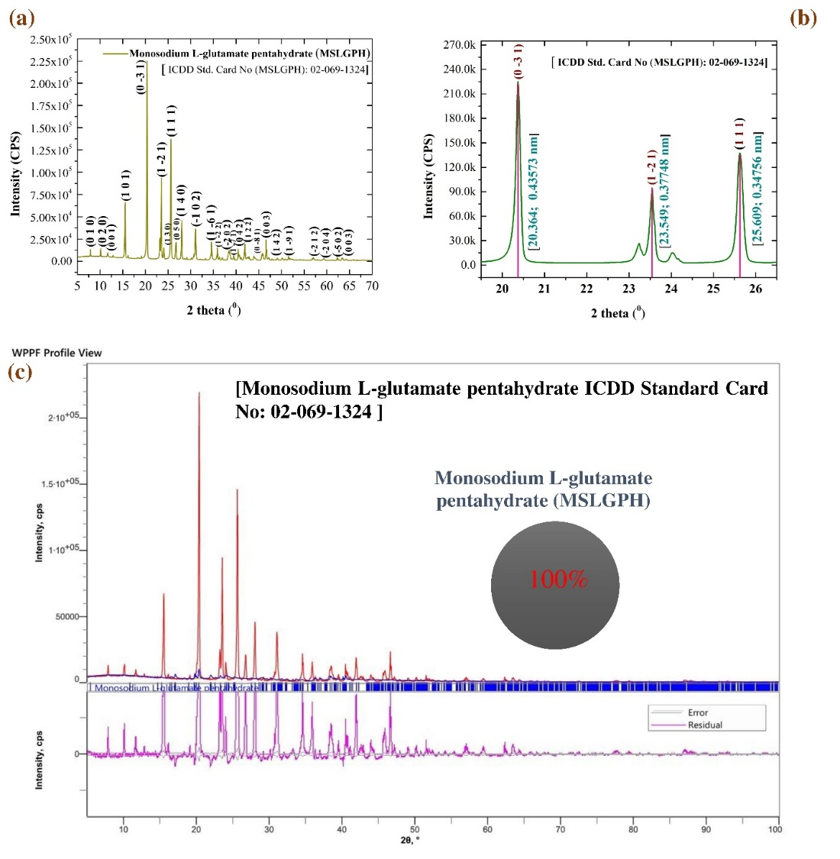

**Fig. 1** (a) X-ray diffraction pattern, (b) peak illustration and (c) quantitative analysis in whole powder fitting method of investigated MSLGPH.

Fig. 1(c) depicted 100.0 % MSLGPH nanocrystals under different fitting conditions [Rwp: 59.51 %, Rp: 47.82 %, S: 8.8316, χ²: 77.9964]. The calculated lattice parameters of the MSLGPH nanocrystals are a= 6.224, b= 16.669 and c= 5.992 Å; α= 98.77, β= 99.83 and γ= 98.54°, with a lattice volume of 595.565 Å³ and a lattice strain of 0.163 %. The crystallographic analysis revealed a dislocation density of 2.009 × 10⁻⁴ nm⁻², crystallinity index of 1.98, unit cell density of 1.48 g/cm³ and specific surface area of 57.46 m²/g, which explored and conformation of high crystallographic MSLGPH was observed [10-11].

**Table 1.** Grain size calculation and crystallographic bibliography of MSLGPH.

|  |  |  |  |  |  |  |  |
| --- | --- | --- | --- | --- | --- | --- | --- |
| Grain size calculation of MSLGPH | | | | | | | |
| Diffraction angle (2Ɵ) | **Theta(Ɵ)** | **d-spacing d (±0.001) nm** | **Height (cps)** | | **FWHM**  **(radians)** | **Crystallite size D (±0.01) nm** | **Reflection** |
| 15.541 | 7.770 | 0.56973 | 43,092 | | 0.144 | 58.00 | (101) |
| 20.364 | 10.182 | 0.43573 | 1,76,530 | | 0.095 | 88.50 | (0-31) |
| 23.549 | 11.774 | 0.37748 | 68,926 | | 0.100 | 85.00 | (1-21) |
| 25.609 | 12.804 | 0.34756 | 1,05,698 | | 0.133 | 63.90 | (111) |
| 26.759 | 13.379 | 0.33289 | 13,671 | | 0.182 | 46.90 | (050) |
| 28.045 | 14.022 | 0.31790 | 32,237 | | 0.140 | 61.20 | (140) |
| 31.026 | 15.513 | 0.28801 | 28,197 | | 0.156 | 55.10 | (-102) |
| 35.894 | 17.947 | 0.24998 | 11,061 | | 0.132 | 65.90 | (1-61) |
| 46.592 | 23.296 | 0.19477 | 20,888 | | 0.082 | 110.40 | (003) |
| Simple peak indexing of MSLGPH | | | | | | | |
| 2Ɵ | **Ɵ** | **1000× Sin2Ɵ** | | | **Reflection** | **Remarks** | |
| 20.364 | 10.182 | 31.249 | | | (0-31) | 02+(-3)2+12=10 | |
| 23.549 | 11.774 | 41.637 | | | (1-21) | 12+ (-2)2+12=6 | |
| 25.609 | 12.804 | 49.113 | | | (111) | 12+12+12=3 | |
| Peak indexing from the d-spacing of MSLGPH | | | | | | | |
| 2Ɵ | **Ɵ** | **d (Å)** | **1000/d2** | | **Reflection** | **Remarks** | |
| 20.364 | 10.182 | 4.3573 | 52.670 | | (0-31) | 02+(-3)2+12=10 | |
| 23.549 | 11.774 | 3.7748 | 70.179 | | (1-21) | 12+ (-2)2+12=6 | |
| 25.609 | 12.804 | 3.4756 | 82.782 | | (111) | 12+12+12=3 | |
| Comparison of Experimental (Exp.) and Standard (Std.) Diffraction Data | | | | | | | |
| 2Ɵ | | **Inter planer distance (d) (Å)** | | | | **Norm. I. (%)** | |
| (Exp.) | (Std.) | (Exp.) | | (Std.) | | (Exp.) | (Std.) |
| 20.364 | 20.199 | 4.3573 | | 4.3925 | | 100.0 | 100.0 |
| 23.549 | 23.594 | 3.7748 | | 3.7676 | | 38.18 | 42.84 |
| 25.609 | 25.299 | 3.4756 | | 3.5175 | | 72.65 | 25.32 |
| Quantitative analysis of MSLGPH by WPPF | | | | | | | |
| Pattern fitting condition | | **Phase (%)** | **Crystallinity & Strain (%)** | | **Lattice volume, (Å³)** | **Lattice parameters** | |
| Rwp, % 59.51; Rp, % 47.82; S, 8.8316; χ², 77.9964. | | 100.0 | 47.50; 0.163 | | 595.565 | a= 6.224, b= 16.669, c= 5.992 Å; α= 98.77, β= 99.83, γ= 98.54° | |
| ICDD (PDF-5+) [Card No: 02-069-1324] | | | a:6.116Å b:16.511Å c: 6.007Å α:97.51° β:100.94° γ:98.20°; [Xtl Cell Z:1.00 c/a:0.982 a/b:0.370 c/b:0.364]; Space Group: P1(1); MolecularWt:518.38 g/mol. | | | | |

***4.2 Estimation of Crystallite Size Using Models***

The average crystallite size of the MSLGPH crystal was found to be 70.55 nm using the Scherrer equation, while the Williamson-Hall plot gave a value of 89.47 nm.

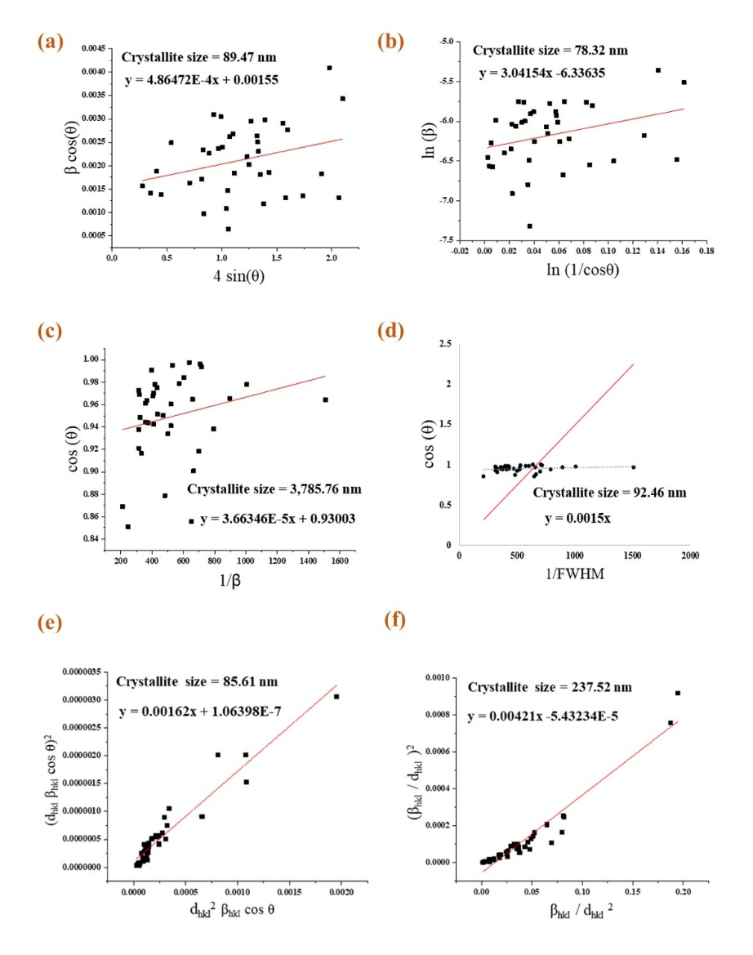

**Fig. 2.** Estimation of crystallite size using (a) Williamson-Hall plot, (b) Monshi-Scherrer method, (c) Linear straight-line model, (d) Sahadat-Scherrer model, (e) Size-strain plot model, (f) Halder-Wagner method for MSLGPH crystal.

The Monshi-Scherrer method produced 78.32 nm, the Linear straight-line model resulted in 3785.76 nm, the Sahadat-Scherrer model gave 92.46 nm, the Size-strain plot model yielded 85.61 nm, and the Halder-Wagner method calculated 237.52 nm as shown in Fig. 2. The calculated microstrain from the Williamson-Hall plot model was 4.86472-4.

***4.3 Structural Mechanism Analysis***

The structures shown in Fig. 3 were created using VESTA [visualization for electronic and structural analysis] software. The Triclinic structure was based on space group P1 (1) with unit cell edge lengths of a= 6.224 Å, b= 16.669 Å, and c= 5.992 Å, and angular parameters α= 98.77°, β= 99.83°, and γ= 98.54°. The crystal shape of the Triclinic was identical and lattice parameters like axial and angular parameters, depicted the atom distribution and volume.

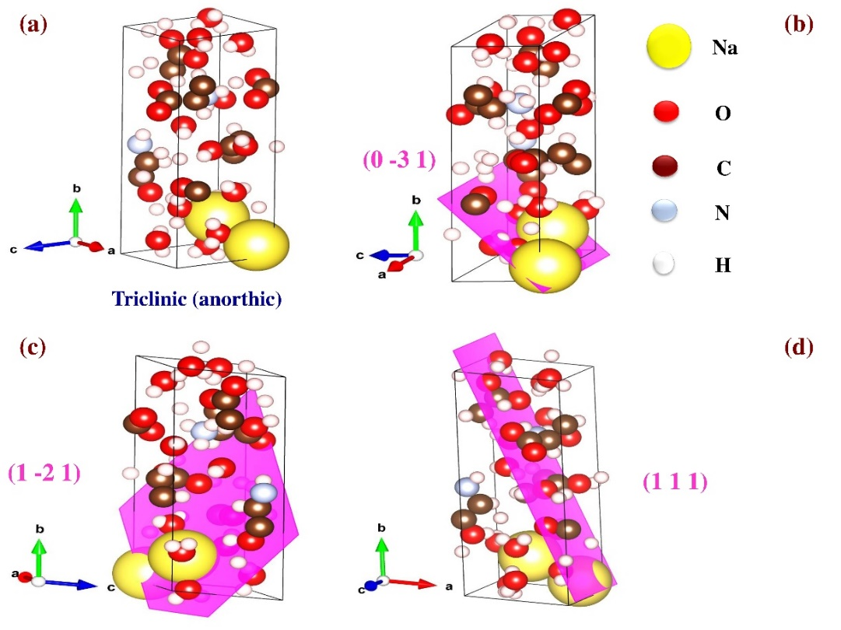

**Fig. 3.** (a) Structural symmetry of triclinic, (b) (0-31), (c) (1-21) and (d) (111) plane of MSLGPH.

The structural analysis of the edge and corner shows the atoms were uniformly oriented in the uniform direction. Fig. 3 illustrates the crystal structure and predominant planes of the MSLGPH crystal where 3(a) depicts the ball-and-stick model, 3(b) (0-31), 3(c) (1-21) and 3(d) (111) plane in 3D space shows for crystal growth and orientation geometry of uniformly distributed atom onto the crystal plane. The plane (0-31), (1-21) and (111) were oriented in identical direction also observed on the predominant zone axis.

**Conclusion**

The XRD analysis of MSLGPH revealed its crystallographic properties in detail. The study confirmed a fully crystalline triclinic structure with precise lattice parameters and crystal symmetry. Various crystallite size estimation methods were employed, with the Scherrer equation indicating an average size of 70.55 nm. We also determined other important crystallographic characteristics such as dislocation density, crystallinity index, unit cell density and specific surface area of the nanocrystals. These findings contribute significantly to understanding the structural properties of MSLGPH and may aid in controlling its crystal growth for functional applications.

**Data Availability**

The data is available on request.

**Reference**

1. Longden, Jonathan Paul. "A Method for the Quantitative Recovery of Mononucleotides from Fermentation Waste by Precipitation." Master's thesis, Lancaster University (United Kingdom), 2015. https://www.proquest.com/openview/35695461088e8f55a04e48395bae67a8/1?pqorigsite=gscholar&cbl=2026366&diss=y

2. Kashiwagi, Tatsuki, Chiaki Sano, Tetsuya Kawakita, and Nobuya Nagashima. "Monosodium L-glutamate pentahydrate." *Crystal Structure Communications* 51, no. 6 (1995): 1053-1056.<https://doi.org/10.1107/S0108270194014472>

3. Perea, C. G., C. F. Ihle, L. Dyer, and H. Estay. "Copper sulfide precipitation from alkaline monosodium glutamate solutions." *Minerals Engineering* 215 (2024): 108816. <https://doi.org/10.1016/j.mineng.2024.108816>

4. Ahmed, Shanawaz, Md Khalid Hossain Shishir, Sumaiya Islam Sadia, Sharif Md Al-Reza, Md Mazedul Haque Sachchu, Allah Rakha Aidid, Md Mynul Islam, Md Rafayet Al-Mahmud, Md Masud Rana, and Md Ashraful Alam. "Crystallographic phase biographs of copper nanocrystalline material: A statistical perspective review." *Nano-Structures & Nano-Objects* 39 (2024): 101275. <https://doi.org/10.1016/j.nanoso.2024.101275>

5. Al-Mahmud, Md Rafayet, Md Khalid Hossain Shishir, Shanawaz Ahmed, Sumaya Tabassum, Sumaiya Islam Sadia, Md Mazedul Haque Sachchu, Rahima Tanbin Tama, Abdur Rahim Miah, and Md Ashraful Alam. "Stoichiometry crystallographic phase analysis and crystallinity integration of silver nanoparticles: A Rietveld refinement study." *Journal of Crystal Growth* 643 (2024): 127815. <https://doi.org/10.1016/j.jcrysgro.2024.127815>

6. Hossain, Md Sahadat, and Samina Ahmed. "Sustainable synthesis of nano CuO from electronic waste (E-waste) cable: evaluation of crystallite size via Scherrer equation, Williamson-Hall plot, Halder-Wagner model, Monshi-Scherrer model, size-strain plot." *Results in Engineering* 20 (2023): 101630. <https://doi.org/10.1016/j.rineng.2023.101630>

7. Pandey, Akhilesh, Sandeep Dalal, Shankar Dutta, and Ambesh Dixit. "Structural characterization of polycrystalline thin films by X-ray diffraction techniques." *Journal of Materials Science: Materials in Electronics* 32 (2021): 1341-1368.

8. Alam, Md Ashraful, Md Khalid Hossain Shishir, Debasish Sarkar, Raton Kumar Bishwas, and Shirin Akter Jahan. "X-ray line diffraction study of preferred oriented hexagonal zincite nanocrystals: A crystallographic investigation." *Journal of Crystal Growth* (2025): 128230. <https://doi.org/10.1016/j.jcrysgro.2025.128230>

9. Aidid, Allah Rakha, Md Khalid Hossain Shishir, Md Ashikur Rahaman, Md Tarikul Islam, Mubashira Mukta, and Md Ashraful Alam. "Powder X-ray line diffraction pattern profiling of anatase-quartz binary oxide: A crystallographic investigation." *Next Materials* 8 (2025): 100571. <https://doi.org/10.1016/j.nxmate.2025.100571>

10. Islam, Mahfuzul, Md Tarikul Islam, Md Khalid Hossain Shishir, Md Ashikur Rahaman, Shanawaz Ahmed, Sumaiya Islam Sadia, and Md Ashraful Alam. "X-ray crystallographic structural Profiling of Polyvinyl Alcohol (PVA) caped Nickel Oxide Nanoparticle." *Nano Trends* 10 (2025): 100106. <https://doi.org/10.1016/j.nwnano.2025.100106>

11. Ahmed, Shanawaz, Md Khalid Hossain Shishir, Md Tarikul Islam, Md Ashikur Rahaman, Sahil Aman, Allah Rakha Aidid, Sumaiya Islam Sadia, Md Masud Rana, and Md Ashraful Alam. "Crystallinity integration of anatase (TiO2) nanocrystal by whole powder pattern fitting (WPPF) method: A Rietveld refinement study." *Results in Materials* 26 (2025): 100673. <https://doi.org/10.1016/j.rinma.2025.100673>

12. Alam, Md Ashraful, Shanawaz Ahmed, Raton Kumar Bishwas, Debasish Sarkar, and Shirin Akter Jahan. "Crystal growth behavior interpret of co-precipitated derived nickel oxide (NiO) nanocrystals." *Nano-Structures & Nano-Objects* 42 (2025): 101494. <https://doi.org/10.1016/j.nanoso.2025.101494>

13. Ahmed, Shanawaz, Md Ashraful Alam, Sumaiya Islam Sadia, Raton Kumar Bishwas, Md Hasanuzzaman, and Shirin Akter Jahan. "Stoichiometry low-temperature dynamics crystal growth interpret of zinc oxide hexagonal nanocrystals." *Next Materials* 7 (2025): 100636. <https://doi.org/10.1016/j.nxmate.2025.100636>

14. Ray, Gorungo, Imdadul Haque, Tanvir Ahmed, Md Maruf Hasan, Mst Meratus Salma, Md Kamal Hossain, Md Sagirul Islam, Md Ashraful Alam, Nahid Sharmin, and Umme Sarmeen Akhtar. "Synthesis of Carbon Capturing NaX Zeolite from Rice Husk Ash: Evaluation of Its Adsorption Properties." *ACS Sustainable Resource Management* 2, no. 4 (2025): 662-672. [https://pubs.acs.org/doi/10.1021/acssusresmgt.5c00019](https://pubs.acs.org/doi/10.1021/acssusresmgt.5c00019?goto=supporting-info).

15. Sachchu, Md Mazedul Haque, Fahim Khandokar Anik, Shanawaz Ahmed, Sahil Aman, Upoma Podder, Nafis Rahman Sayeem, Md Tarikul Islam et al. "Crystallographic Investigation of PVA@ PLA Nanocomposite Film by X-ray Diffraction: Insight from High Resolution TEM." *Journal of Engineering Research and Reports* 27, no. 3 (2025): 310-327. [10.9734/jerr/2025/v27i31436](https://doi.org/10.9734/jerr/2025/v27i31436)