QUANTUM CHEMICAL STUDY OF Cola acuminata AS INHIBITORS FOR CORROSION CONTROL

ABSTRACT

This Study investigate the Quantum Chemical Study of Cola acuminata as inhibitors for Corrosion Control using The Hartree-Fock Density Functional Theory (HF-DFT) with the Becke 3 Lee Yang Parr (B3LYP) method. The aim of the study is to investigate the agreement between theory (quantum chemistry) and practice (experiments) for designing a more effective corrosion inhibitors using computational methods. Quantum chemical parameters such as E_{HOMO} (highest occupied molecular orbital energy), E _{LUMO} (lowest unoccupied molecular orbital energy), energy gap (ΔE), dipole moment (μ), Absolute Hardness (η), softness (S), electron affinity (A), ionization energy (I) were calculated from the chemical structure obtained from Gas Chromatography - Mass spectrometry (GC-MS) and High-Performance Liquid Chromatography (HPLC). The results obtained revealed correlations between quantum chemical studies and experimental inhibition efficiencies method. The agreement between theory (quantum chemistry) and practice (experiments) paves the way for designing even more effective corrosion inhibitors using computational methods.
KEY WORDS: Computational methods, Cola acuminata, corrosion inhibitors., DFT,
INTRODUCTION
Quantum chemical methods have become invaluable tools for understanding molecular structure, electronic properties, and reactivity. These methods are increasingly employed in corrosion inhibition studies to identify potential inhibitors with desired properties. By translating chemical intuition and experience into mathematical models, computational chemistry allows for a systematic and quantitative approach to assessing the efficacy of corrosion inhibitors (Gece, 2008).
Quantum mechanics (QM) provides the fundamental mathematical framework for understanding the behavior of electrons, which is essential for chemistry. While QM, in theory, can precisely predict the properties of individual atoms and molecules, exact solutions to the QM equations are only feasible for one-electron systems. A vast array of computational methods has been developed to approximate solutions for systems with multiple electrons (Young, 2001).
Nearly all computational chemistry methods based on the Schrödinger equation
Ĥ Ψ = E Ψ
Where Ĥ is the Hamiltonian operator, Ψ a wave function, and E the energy. In the language of mathematics, an equation of this form is called an eigen equation. Ψ is then called the eigenfunction and E an eigenvalue (Young, 2001).
The wave function Ψ is a function of the electron and nuclear positions. It can describe the probability of electrons being in certain locations, but it cannot predict exactly where electrons are located. The wave function Ψ is also called a probability amplitude because it is the square of the wave function that yields the probabilities (Young, 2001).
According to DFT-Koopmans’ theorem, the ionization potential (I) can be approximated as the negative of the highest occupied molecular orbital (HOMO) energy (Hmamou et al., 2012).
I = – E_{HOMO}
The negative of the lowest unoccupied molecular orbital (LUMO) energy is similarly related to the electron affinity A,
A = – E_{LUMO}
The values of I and A can be used to obtained the electronegativity χ, and the global hardness η in each of the tested molecule according to the following relations:
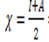
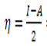
When an inhibitor molecule interacts with a metal surface, electrons transfer from the molecule with lower electronegativity to the metal with higher electronegativity. This electron transfer continues until the chemical potentials of both species are equalized.
Numerous studies have explored the potential of using individual quantum chemical parameters to predict corrosion inhibition efficiency. These investigations aimed to identify correlations between inhibition efficiency and molecular properties like dipole moment, highest occupied molecular orbital (HOMO) energy, lowest unoccupied molecular orbital (LUMO) energy, Mulliken charges, and structural parameters (Eddy et al.,2010).
MATERIALS AND METHOD
Preparation of crude extract
Cola acuminata (Kola nut) seed samples were sourced from Ile Oluji, Ondo State, Nigeria. The samples were thoroughly washed with distill water to remove impurities, shade-dried for three weeks, and then pulverized and sieved using 200 mesh size sieves. A 500 g of the resulting powder was dissolved in 2 L of 50% ethanol for 3 days, after which, it was filtered, concentrated, and stored in a refrigerator.
GC-MS analysis
Sample extracts were analysed with GC-MS analysis using an Agilent Technologies 8860A (GC) model interfaced with a mass selective detector (Model: 5975C (MSD). The ion source temperature was 250 ºC, and the electron ionization was conducted at 70 volts. A HP-5 column (30 mm x 0.25 mm x 0.320 μm) was filled with 99% pure helium gas as a carrier gas. The oven was preheated to 80 °C, held for one minute, and then ramped up to 240°C at a rate of 10°C per minute, kept for five minutes. A 1μL sample was injected.
HPLC Analysis
An Agilent 1260 HPLC with a variable-wavelength detector was used for this study. An Agilent Poros Hell 120EC C18 4um, 150 x 4.6 mm column was utilized. 280 nm was the measuring wavelength, and the mobile phase composition was 0.1% formic acid: 0.2% formic acid in methanol Gradient.
Quantum Chemical Calculations
From the GC-MS and HPLC analysis, the most abundant component present compared with literature was subjected to Quantum Chemical Calculations using density Functional Theory
Density Functional Theory
The Hartree-Fock Density Functional Theory (HF-DFT) with the Becke 3 Lee Yang Parr (B3LYP) method and a 6-31G* basis set within the Spartan '14 VI.1.4 program software was used to perform quantum chemical studies on the corrosion inhibitors (Becke,1993; Lee et al., 1988) Equations (3.8–3.13) were used to compute the parameters that affect the interactions between molecules. HOMO and LUMO energies, which show a molecule's propensity to donate (HOMO) or accept (LUMO) electrons, are among these characteristics; The energy difference between giving and receiving an electron is represented by the energy gap; the ease with which a molecule may acquire or lose an electron is described by the electron affinity (EA) and ionization potential (IP), respectively
The following formulas are used to determine the molecules' ionization (I), electron affinity (A), and energy gap (ΔE).
I = – E_{HOMO}
A = – E_{LUMO}
ΔE = E_{HOMO} – E_{LUMO}
The electronegativity (χ) and the global hardness (η) of the inhibitors were estimated using:
The global softness (S) is the inverse of global hardness.
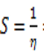
RESULTS AND DISCUSSION
Analysis using GC-MS identified 9 components in Cola acuminata crude extract (Table 1 and Figure 1) detail these compounds based on the NIST database. Caffeine was the most abundant compound, followed by n-Hexadecanoic acid and Theobromine. The remaining seven identified compounds each had a concentration of less than 1%. This finding aligns with Odebunmi et al. (2009) who reported the presence of caffeine in Cola acuminate seed, which is believed to possess aphrodisiac properties.
HPLC analysis shown in (Table 2 and figure 2) revealed the presence of naringin and myricetin. Notably, myricetin was identified as a common bioactive phytochemical present in the seed extract of Cola acuminata (Adesanwo et al., 2017; Blaise et al., 2022)
Table 1: GC-MS analysis results for Cola acuminata crude extract
Pk No | RT | Area% | Library/ID | Ref NO | CAS No | Qual
1 | 3.591 | 0.84 | Furan, 2,5-dimethyl- | 3113 | 000625-86-5 | 46
2 | 5.651 | 0.51 | Cyclopentane, 1-ethyl-3-methyl-, trans- | 7560 | 002613-65-2 | 43
3 | 6.566 | 93.54 | Caffeine | 65390 | 000058-08-2 | 97
4 | 6.755 | 1.10 | Theobromine | 52456 | 000083-67-0 | 97
5 | 7.030 | 1.26 | n Hexadecanoic acid | 129145 | 000057-10-3 | 96
6 | 7.156 | 0.68 | Hexadecanoic acid, ethyl ester | 159424 | 000628-97-7 | 97
7 | 7.928 | 0.70 | 8-Hexadecyne | 93953 | 019781-86-3 | 86
8 | 7.974 | 0.77 | cis-Vaccenic acid | 156903 | 000506-17-2 | 91
9 | 8.088 | 0.60 | Ethyl Oleate | 187619 | 000111-62-6 | 98

Table 2 : HPLC analysis results for Cola acuminata crude extract
S/N | Retention Time [min] | Compound Name | Concentration  mg/L
1 | 8..591 | Myricetin | 6.642
2 | 19.081 | Naringin | 4.312

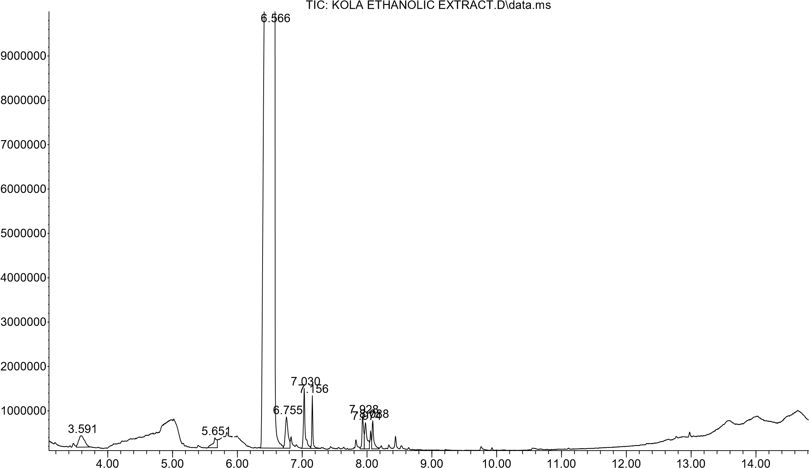
Figure 1: GC-MS Chromatogram for Cola acuminate crude extract
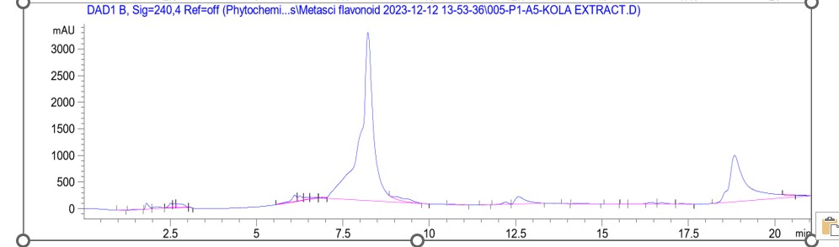
Figure 2: HPLC Chromatogram for Cola acuminate crude extracts
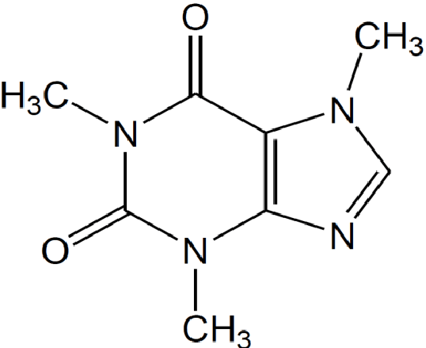
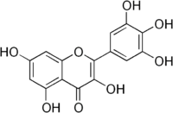

Caffeine Myricetin

Figure 3. Computational and Quantum Studies
Density functional theory was used in this study to explore the role of compound identified by GC-MS and HPLC from the seed of Cola acuminata extracts. The compounds are selected based on those with highest abundance and compared with existing literature.
Density functional theory
DFT/B3LYP is a powerful tool for calculating various molecular properties, including the energies of the HOMO and LUMO, the energy gap, ionization potential, electron affinity, dipole moment, global hardness, and softness. Table 3 provides specific values for these properties.
For a corrosion inhibitor to be effective, it needs two key skills: attracting electrons from the metal surface and offering its own electrons to the metal's vacant d-orbitals to form bonds. These abilities are believed to be linked to the inhibitor's molecular orbitals, specifically the highest occupied molecular orbital (HOMO) and the lowest occupied molecular orbital (LUMO) (Obi-Egbedi et al., 2011). LUMO reflects the molecule's ability to accept electrons from the metal, while HOMO, which is typically electron-rich, is associated with electron donation.
E_{HOMO} AND E_{LUMO}
Higher HOMO values indicate a greater likelihood of electron donation to other molecules with empty orbitals (acceptors). Corrosion inhibitors can act in two ways. The inhibitor acts like a double agent on the metal surface. (1) Electron Donor: It can donate electrons to the empty d-orbitals of metal ions, partially filling them. (2) Electron Acceptor: Conversely, it can also accept electrons from the filled d-orbitals of the metal.
Myricetin's effectiveness as a corrosion inhibitor stems from its ability to both donate and accept electrons. The calculated HOMO energy E_{HOMO} value of –5.46 eV indicates a strong tendency for myricetin to donate electrons, which is a desirable trait for corrosion inhibitors. Myricetin's talent for both donating and accepting electrons likely explains its effectiveness as a corrosion inhibitor (Lebrini et al., 2007). Here's why: Electron Donor: Its high HOMO energy (the energy of the highest occupied molecular orbital) indicates a strong tendency to donate electrons. This is often linked to good corrosion inhibition performance. Electron Acceptor: The low E_{LUMO} value (energy of the lowest unoccupied molecular orbital) (–1.83 eV) suggests Myricetin can also readily accept electrons. This dual ability to give and take electrons might be key to Myricetin's superior performance.
Energy gap (ΔE)
The gap between the HOMO and LUMO energies, known as ΔE (delta E), plays a critical role in how inhibitor molecules interact with the metal surface. This difference is called the energy gap. When the energy gap (ΔE) is smaller, the inhibitor molecule is generally considered more reactive. This increased reactivity can lead to stronger adsorption on the metal surface. Based on the calculations in Table 3, myricetin appears to have the lowest energy gap among the studied molecules. Myricetin's lower HOMO-LUMO energy gap (ΔE) suggests it could be more reactive and potentially adhere (adsorb) more effectively to the metal surface. This stronger interaction might be why myricetin performs better at inhibiting corrosion (Lebrini et al., 2007).
Dipole moment (μ)
The dipole moment (μ) tells us how unevenly charged a molecule is. Some studies suggest a high dipole moment might improve an inhibitor's ability to stick to the metal surface (adsorption) (Khaled, 2008). However, other research contradicts this, indicating that lower dipole moments might be more favorable for adsorption (Wazzan and Mahgoub, 2014). In this study, myricetin has a lower dipole moment compared to caffeine molecules. The influence of the dipole moment on adsorption in this specific case remains unclear and requires further investigation.
Ionization energy (I)
Ionization energy (I) refers to the energy needed to remove the easiest electron from a molecule in its gaseous form. Molecules with lower ionization energy (I) tend to lose electrons more readily. This makes them generally more reactive and better reducing agents (Obi-Egbedi and Obot, 2011). The calculations show that myricetin has a low ionization energy compared to other studied molecules. This suggests myricetin might be more reactive, which could contribute to its effectiveness as a corrosion inhibitor.
Electron affinity (A)
Electron affinity (EA) tells us how much energy is released when a molecule gains an electron (Saranya et al., 2015). A high electron affinity for myricetin suggests it could readily accept electrons from the metal surface. This potential electron acceptance might contribute to its corrosion inhibition efficiency.
Electronegativity (χ) global softness (S) and global hardness (η)
Electronegativity describes an atom's attraction for electrons in a bond. Some studies suggest highly electronegative molecules might be less reactive, leading to lower corrosion inhibition (Geerlings and De Proft, 2002). In this case, both myricetin and caffeine have relatively low and similar electronegativity values. This study also considers absolute hardness, which relates to a molecule's stability and resistance to change. Harder molecules have larger energy gaps, while softer molecules have smaller gaps. The calculations suggest myricetin has a lower hardness value and a smaller energy gap compared to other studied molecules. This indicates myricetin might be softer and more reactive, which could contribute to its effectiveness as a corrosion inhibitor.
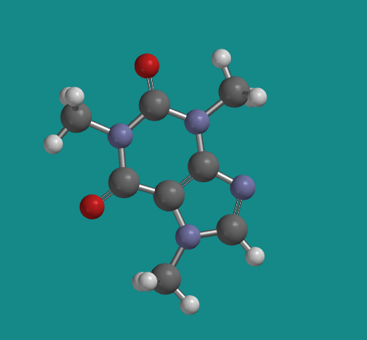
a
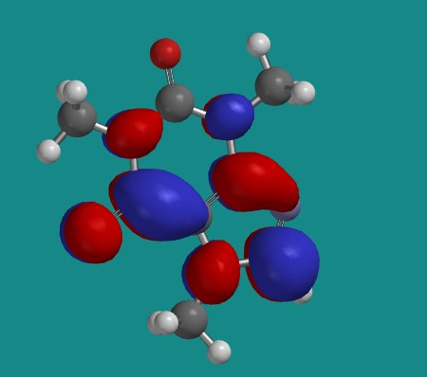
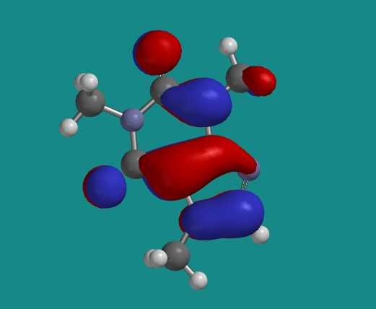
c
b
Plate 1: (a)Optimized Geometry of Caffeine Structure
(b) LUMO (0.34 ev) (c) HOMO (-6.38ev)
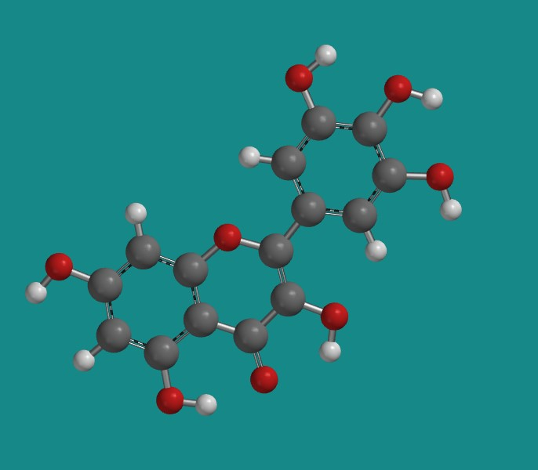
a
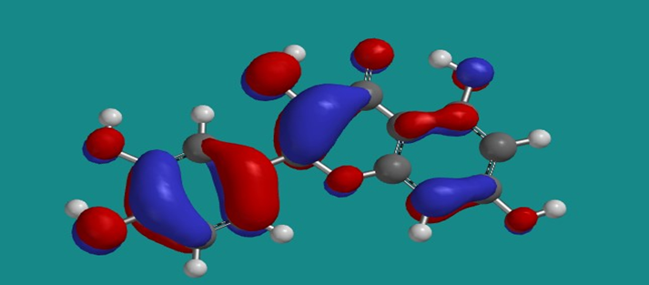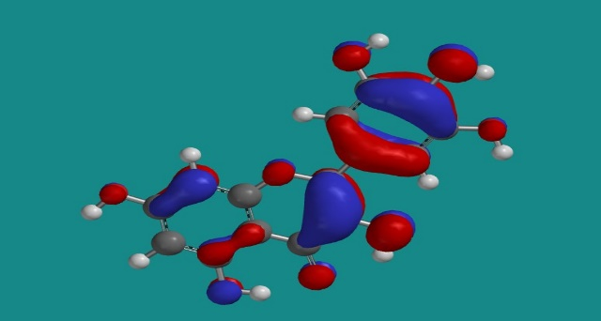
c
b
Plate 2(a) Optimized Geometry of Myricetin
(b) LUMO (-1.84 ev) (c) HOMO (-5.48ev)
Table 3: Quantum parameters for (CA) extract
S/N | Parameters | Caffeine | Myricetin
1 | E _{HOMO} (ev) | -5.97 | -5.46
2 | E _{LUMO} (ev) | -0.86 | -1.83
3 | Energy Gap (∆E) (ev) | 5.11 | 3.64
4 | Ionisation potential (I) | 5.97 | 5.46
5 | Electron Affinity (A) | 0.86 | 1.83
6 | Diapole Moment (μ) | 3.76 | 1.54
7 | Absolute Hardness (η) | 2.56 | 1.82
8 | Absolute Softness (S) | 0.39 | 0.55

CONCLUSION
Quantum chemistry calculations predicted that quercetin, in particular, have superior inhibition properties within the extracts of the CA. The agreement between theory (quantum chemistry) and practice (experiments) paves the way for designing even more effective corrosion inhibitors using computational methods.

COMPETING INTERESTS DISCLAIMER:
Authors have declared that they have no known competing financial interests OR non-financial interests OR personal relationships that could have appeared to influence the work reported in this paper.
REFERENCES
Adesanwo J. K., Odundele S. B., Akinpelu D. A., and McDonald A. G. (2017). Chemical Analyses, Antimicrobial and Antioxidant Activities of Extracts from Cola nitida Seed. Journal of Exploratory Research in Pharmacology, 2, 67–77.
Blaise M. M., Clément L. I., Jean-Jacques O. A., Colette M. A., Jonas M.S. N., Pius T. M., and Koto-Te-Nyiwa, N. (2022). Mini-review on the phytochemistry, pharmacology, and toxicology of Cola nitida (Vent.) Schott & Endl. (Malvaceae): A medically interesting bio-resource of multiple purposes in Africa, Natural Resources Human Health,2 (3), 335–342.
Eddy, N. O, Ebenso E. E. and Ibok, U. J (2010). Adsorption, synergistic inhibitive effect and quantum chemical studies of ampicillin (AMP) and halides for the corrosion of mild steel in H₂SO₄, Journal of Applied Electrochemistry, 40, 445-456.
Gece (2008). The use of quantum chemical methods in corrosion inhibitor studies, Corrosion Science, 50, 2981–2992.
Geerlings P. and De Proft F. (2002). Chemical reactivity as described by quantum chemical methods. International Journal of Molecular Sciences, 3: 276-309
Hmamou, D. B, Salghi, R, Zarrok, H, Zarrouk, A, Hammouti, B, El Hezzat M. and Bouachrine, M (2012). Temperature Effects on the Corrosion Inhibition of Carbon Steel in Acidic
Khaled K. F., 2008. Molecular simulation, quantum chemical calculations, and electrochemical studies of the inhibition of mild steel by triazoles. Electrochemical Acta, 53, 3484–3492.
Lebrini, M., Lagrenée, M., Vezin., H., Traisnel, M., and Bentiss, F. (2007). Experimental and theoretical study for corrosion inhibition of mild steel in a normal hydrochloric acid solution by some new macrocyclic polyether compounds. Corrosion Science, 49, 2254–2269.
Obi-Egbedi, N.O., & Obot, I.B. (2011). Inhibitive properties, thermodynamics, and quantum. chemical studies of alloxazine on mild steel corrosion in H₂SO₄. Corrosion Science, 53, 263-275.
Obi-Egbedi N. O., Obot I. B., El-Khaiary M. I., Umoren S. A., and Ebenso E. E. (2011), “Computational Simulation and Statistical Analysis on the Relationship between Corrosion Inhibition Efficiency and Molecular Structure of Some Phenanthroline Derivatives on Mild Steel Surface,” International Journal of Electrochemical. Science, 6, 5649–5675
Saranya J., Sounthari P., Paranswari K., and Chitra S. (2015). Adsorption and density functional theory on corrosion of mild steel by a quinoxaline derivative. Der Pharma Chemica, 8, 187–196.
Wazzan, N. A., and Mahgoub, F. M. (2014). DFT Calculations for Corrosion Inhibition of Ferrous Alloys by Pyrazolopyrimidine Derivatives, Open Journal of Physical Chemistry, 4, 6–14.
Young, D.C (2001). "Computational Chemistry: A Practical Guide for Applying Techniques to Real-World Problems", John Wiley & Sons, Inc.

