Geospatial Assessment of LULC Dynamics and Land Surface Temperature Variations in KMA (2016–2022) Using Multi-Source Satellite Data and Predictive Modeling

Abstract:
Concept:
Rapid urbanization in the Kolkata Metropolitan Area (KMA) has significantly altered land use and surface temperature. This necessitates a geospatial investigation to understand long-term environmental impacts.
Objectives:
To analyze spatiotemporal LULC changes and corresponding LST variations from 2008 to 2024. To simulate future land cover trends and assess the impact of urbanization on thermal patterns.
Methods:
Landsat 4/5 TM and Landsat 8/9 OLI-TIRS imagery were processed using supervised classification and thermal band analysis. Change detection and MOLUSCE modeling were applied to predict the 2040 LULC scenario.
Results:
Built-up areas increased by 99.3%, while forest and water bodies declined by 65.3% and 41.7%, respectively. These changes were accompanied by a sharp rise in LST, especially in urban hotspots.
Conclusion:
Strong correlation exists between urban expansion and surface warming, validating the Urban Heat Island effect. Green infrastructure, afforestation, and zoning reforms are essential for sustainable urban resilience.
Keywords: Urbanization, LULC, Land Surface Temperature, Urban Heat Island, Landsat, MOLUSCE, Kolkata Metropolitan Area, Geospatial Analysis, Climate Resilience, Predictive Modeling

Introduction:
Rapid urbanization in developing nations has resulted in significant alterations to land surface characteristics, leading to profound implications for local climate, resource distribution, and environmental sustainability. Among these changes, Land Use Land Cover (LULC) transformation and associated Land Surface Temperature (LST) dynamics have emerged as critical indicators of anthropogenic pressure and ecological imbalance, particularly within densely populated metropolitan regions(Robinson et al., 2017). In India, the Kolkata Metropolitan Area (KMA), one of the fastest-growing urban conglomerates in eastern India, exemplifies this trend, having experienced an extensive spatial expansion and infrastructural development over recent decades(Walsh et al., 2001).
LULC changes—especially the conversion of vegetated or agricultural lands into impervious built-up surfaces—directly impact the thermal properties of the Earth’s surface, contributing to elevated surface temperatures and intensified Urban Heat Island (UHI) effects(Metz et al., 2017). Numerous studies have highlighted the intricate interlinkage between land cover alterations and rising LST values, which are further exacerbated by the proliferation of concrete structures and the decline of natural green spaces. Such transformations not only disrupt ecological equilibrium but also pose significant challenges to urban sustainability, public health, and regional climate resilience(Qu et al., 2021).
Satellite remote sensing provides an effective tool for capturing, quantifying, and analyzing these spatial and temporal changes with high consistency and accuracy(Sagita et al., 2022). The use of medium-resolution Landsat data has become particularly valuable due to its long-term availability, spectral capabilities, and applicability to both LULC and LST estimation. This study leverages multi-temporal Landsat datasets—specifically Landsat 4/5 TM for the year 2008 and Landsat 8 OLI/TIRS for 2024—to derive and compare LULC classifications and LST distributions within the KMA(Basofi et al., 2020). The temporal range enables the detection of long-term transformations while preserving the spatial integrity required for fine-scale urban analysis(Leite et al., 2017).
Furthermore, the integration of predictive modeling techniques enables the forecasting of future urban expansion and its potential thermal consequences. By employing spatial simulation models, the study aims to estimate future LULC scenarios under a business-as-usual trajectory, thereby providing crucial insights for sustainable urban planning and climate adaptation strategies(Das & Das, 2020). The methodological framework involves supervised classification for LULC mapping, mono-window or split-window algorithms for LST retrieval, and transition probability-based modeling for future scenario projection(Guha et al., 2018).
This research addresses a critical knowledge gap by providing a decadal-scale geospatial assessment of LULC and LST dynamics within a highly urbanized Indian megacity, while concurrently highlighting the implications of unchecked land cover transitions(Alademomi et al., 2020). The findings will contribute to evidence-based policymaking and support initiatives aimed at mitigating urban thermal stress through informed land-use interventions and green infrastructure planning.

Statement of the problem:
- Accelerated urban expansion in the Kolkata Metropolitan Area (KMA) has triggered substantial LULC transformation, leading to the loss of vegetated land and increasing impervious surfaces.
- Rising Land Surface Temperature (LST) associated with land cover changes poses a growing risk of Urban Heat Island (UHI) effects, ecological stress, and reduced urban climate resilience.
- Lack of integrated spatiotemporal analysis and forecasting using multi-source satellite data limits our understanding of long-term land-atmosphere interactions and urban sustainability challenges.

Aims:
- To analyze LULC dynamics and spatial LST variations in KMA from 2008 to 2024 using Landsat 4/5 and Landsat 8 satellite datasets.
- To quantify the relationship between land cover change and surface thermal characteristics over time, identifying critical transition zones and thermal hotspots.
- To simulate future land cover scenarios using predictive modeling approaches to assess potential urban growth impacts on surface temperature and urban sustainability.

Study Area:
The Kolkata Metropolitan Area (KMA) is situated in the eastern part of India, within the state of West Bengal, and geographically extends between approximately 22°19′N to 23°00′N latitude and 88°04′E to 88°33′E longitude. Encompassing an area of about 1,886.67 square kilometers, KMA includes a diverse administrative structure comprising three municipal corporations, 39 municipalities, and 24 panchayat samitis. It represents a complex urban-peri-urban-rural continuum that serves as a dynamic landscape for evaluating urban transformation and land use transitions(Avci et al., 2023).
KMA is characterized by a tropical wet-and-dry climate with hot summers, a pronounced monsoon season, and mild winters(Majumdar, 2020). The region includes varied landforms such as riverine floodplains, marshlands, agricultural fields, built-up urban zones, and ecologically sensitive wetlands—most notably those adjacent to the Hooghly River. This heterogeneous landscape is rapidly changing under the influence of demographic pressure and economic development.
As one of India’s largest and most densely populated metropolitan agglomerations, KMA houses over 14 million people, exerting immense pressure on its natural land resources. In recent years, the region has experienced significant urban expansion, infrastructure development, and conversion of vegetation and water bodies into impervious built-up surfaces. The ongoing transformation of land cover in KMA presents urgent challenges for sustainable urban governance, making it a critical area for geospatial monitoring and analysis of Land Use Land Cover (LULC) dynamics(Chakraborty et al., 2025).

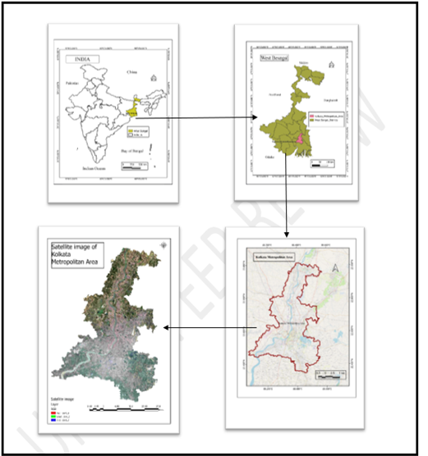
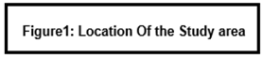

Geospatial Technologies: GIS and Remote Sensing
The integration of Geographic Information Systems (GIS) and Remote Sensing (RS) technologies has revolutionized the way environmental and urban systems are monitored, analyzed, and managed. These geospatial technologies provide essential tools for acquiring, storing, processing, visualizing, and analyzing spatially referenced data, making them indispensable for understanding complex land surface processes such as Land Use and Land Cover (LULC) changes(Chakraborty et al., 2025).

Remote Sensing: Earth Observation for LULC Monitoring:
Remote sensing is the scientific process of gathering information about the Earth's surface without direct physical contact, typically through sensors mounted on satellites or aircraft. This method allows for large-scale, repetitive, and multi-temporal observations of physical characteristics across both terrestrial and aquatic environments.
In this study, two primary remote sensing datasets were employed: Landsat 8 OLI/TIRS and MODIS (Moderate Resolution Imaging Spectroradiometer)(Taufik et al., n.d.). Landsat 8 offers a spatial resolution of 30 meters for multispectral bands and 100 meters for thermal infrared bands, making it ideal for detailed land use and land cover (LULC) classification. It captures imagery every 16 days and includes bands sensitive to visible light, near-infrared, shortwave infrared, and thermal wavelengths—essential for differentiating between built-up areas, vegetation, water bodies, barren lands, and agricultural fields. The high spectral and radiometric resolution of Landsat data enables the application of advanced classification techniques, including supervised classification, spectral indices (such as NDVI, NDBI, and NDWI), and change detection algorithms(J. Chen et al., 2024).
MODIS, which operates aboard NASA’s Terra and Aqua satellites, provides a higher temporal resolution, with daily global coverage and spatial resolutions ranging from 250 meters (for bands associated with vegetation monitoring) to 1 kilometer (for assessing land surface temperature). MODIS data are particularly valuable for monitoring environmental parameters over time, such as the Normalized Difference Vegetation Index (NDVI), which assesses vegetation health and coverage, and Land Surface Temperature (LST), reflecting urban heat dynamics and surface energy balance. The continuous temporal frequency of MODIS allows for the observation of seasonal and interannual trends, making it well-suited for time-series analysis in long-term environmental studies(Chakraborty et al., 2025).

GIS: A Platform for Spatial Analysis and Decision Support:
Geographic Information Systems (GIS) are computerized systems used for the storage, analysis, and visualization of geographically referenced data. GIS functions as a framework for integrating and managing data from multiple sources—remote sensing imagery, topographic maps, field data, and statistical datasets—within a common spatial context. In this study, GIS was employed to conduct image preprocessing, spatial classification, change detection, zonal statistics, map creation, and temporal analysis(Ke et al., 2015).
GIS tools facilitate critical operations such as overlay analysis, buffer generation, raster reclassification, accuracy assessment, and multi-temporal comparison(J. U. & Abah, 2019). These capabilities enable researchers to quantify the extent of LULC transitions, identify zones of rapid urban expansion or ecological degradation, and visualize spatial patterns of change. Moreover, GIS supports spatial modeling to assess correlations between variables such as NDVI and LST, or land cover change and urban heat intensity(Basofi et al., 2020).

Integration of RS and GIS for Urban Environmental Assessment:
The integration of RS and GIS enhances the scope and precision of environmental monitoring by enabling both macro-level assessments (e.g., urban sprawl, regional climate impacts) and micro-level interventions (e.g., ward-level land use planning, hotspot detection). Remote sensing provides up-to-date and consistent Earth observation data, while GIS offers the analytical engine to transform raw imagery into actionable insights(Alademomi et al., n.d.).
In this study, classified LULC maps derived from Landsat data were overlaid with MODIS-based NDVI and LST datasets to examine spatial and temporal relationships(Julien et al., 2011). This multi-sensor, multi-temporal approach allows for a more comprehensive understanding of the landscape dynamics of the Kolkata Metropolitan Area (KMA), especially in response to anthropogenic pressures and climatic variability. The use of both medium-resolution and moderate-resolution imagery helps balance between spatial detail and temporal frequency—critical for urban studies where both precision and periodicity matter(Shin et al., 2017).
Ultimately, the integration of GIS and Remote Sensing forms a powerful and scalable approach for environmental monitoring and urban management(Mustafa et al., 2020). As urban centers like KMA continue to grow, leveraging these technologies becomes essential for evidence-based planning, sustainable development, disaster risk reduction, and climate adaptation(Khan et al., 2019).

Land Use/Land Cover: Concepts and Definitions:
Land Use and Land Cover (LULC) are fundamental concepts in geospatial and environmental studies, representing essential indicators of surface processes, resource management, and anthropogenic influence on the landscape(Mostovoy et al., 2006). Although closely related, land use and land cover signify different aspects of how Earth's surface is organized and utilized.

Land Cover:
Land cover refers to the natural and artificial physical features that occupy the Earth's surface at a given time(Mostovoy et al., 2006). It includes vegetation types, water bodies, bare soil, impervious surfaces, and snow or ice. Land cover is directly measurable using remote sensing techniques, primarily through the spectral signatures captured by multispectral sensors(Centre for Geoinformatics & Planetary Studies, Dept. of Geology, Periyar University, Salem, Tamilnadu, India et al., 2016). These data are processed to generate thematic maps that classify areas into distinct categories such as forest, cropland, water, or built-up areas.
Land cover data are instrumental in environmental monitoring, as they provide objective indicators of ecological conditions, land degradation, and climate variability(Hengl et al., 2012a). For example, reductions in vegetative cover may indicate deforestation, while increases in impervious surfaces signal urban sprawl(Hengl et al., 2012b).

Land Use:
In contrast, land use describes the human purpose or activity assigned to the land. It reflects how people interact with the landscape for residential, agricultural, commercial, industrial, recreational, or conservation purposes. Unlike land cover, which is a physical property, land use is a socio-economic function and is often inferred from auxiliary datasets, including census records, cadastral maps, or field surveys(Bhattacharjee & Ghosh, 2015).
Land use patterns change dynamically in response to policy, population pressure, economic growth, and environmental constraints(Debbarma & Chakma, 2024). Two areas with identical land cover might support very different land uses, such as a park versus a pasture, highlighting the importance of integrating social data with remote sensing(Srivastava et al., 2012).

LULC in Geospatial Monitoring:
In applied geospatial analysis, Land Use Land Cover (LULC) studies synthesize both physical land characteristics and human-environment interactions. LULC classification is crucial for tracking landscape transformation, modeling environmental processes, and informing sustainable planning(Li et al., 2023). Using satellite data, particularly from missions like Landsat 8 and MODIS, researchers can map LULC categories over time, assess change trajectories, and identify drivers of change(Vivekananda et al., 2021).
In the context of this study, LULC maps derived from Landsat 8 were used to analyze changes in built-up areas, vegetation, agriculture, and water bodies within the Kolkata Metropolitan Area (KMA) from 2016 to 2022. These insights are vital for understanding urban growth dynamics, environmental stress, and resource pressure in one of India’s most rapidly expanding metropolitan regions.

Land Use Land Cover Change Studies:
Land Use Land Cover Change (LULCC) has emerged as a critical research theme in the study of environmental transformation, urbanization, and global change processes. The continuous and often rapid changes in land use and land cover reflect human-induced pressures on natural systems, as well as natural factors such as climate variability and geomorphological evolution. Understanding these changes is essential to support decision-making for land resource management, sustainable development, and climate resilience(Goldblatt et al., 2021).
Over the past few decades, advancements in remote sensing and geospatial analytics have enabled researchers to systematically observe and quantify changes in land cover at local, regional, and global scales(Attri et al., n.d.). Satellite data from missions like Landsat, MODIS, and Sentinel provide consistent, multi-temporal records that are indispensable for long-term LULC monitoring. These datasets help to identify conversion trends such as the expansion of urban areas, reduction of vegetative cover, wetland encroachment, and transformations in agricultural zones. The process of change detection involves classifying images acquired at different time intervals and analyzing transitions between categories, thus revealing the nature and intensity of landscape modification(L. Chen et al., 2013).
LULCC has far-reaching implications for ecological processes, socio-economic development, and environmental sustainability. The conversion of natural landscapes into built-up environments often results in:
- Loss of biodiversity and habitat fragmentation
- Increase in impervious surfaces, altering hydrological cycles
- Reduction in carbon sinks and ecosystem services
- Rise in urban heat island effects and microclimatic alterations
These consequences are particularly severe in rapidly urbanizing regions where land conversion outpaces infrastructure planning. In countries like India, the pressure of population growth, industrial expansion, and infrastructure development has significantly accelerated land cover change, especially in major metropolitan regions such as the Kolkata Metropolitan Area (KMA).
LULCC studies in KMA have documented substantial transformation in land patterns over the last few decades. Historically dominated by agriculture, wetlands, and riverine systems, the region has experienced widespread urban encroachment, reclamation of lowlands, and infrastructure expansion. This has led to increased vulnerability to flooding, degradation of ecological buffers, and loss of peri-urban green space. However, many existing studies have focused either on limited time periods or have not incorporated the environmental variables such as vegetation health and surface temperature in conjunction with LULC classes(L. Chen et al., 2013).
The present study addresses these gaps by analyzing multi-year LULC dynamics in KMA from 2016 to 2022 using both Landsat and MODIS datasets(Kassawmar et al., 2018). It integrates biophysical indicators—namely NDVI (Normalized Difference Vegetation Index) and LST (Land Surface Temperature)—to assess not only land cover transitions but also their ecological and thermal consequences(Mohanasundaram et al., 2022). This combined approach provides a comprehensive framework to detect patterns, interpret drivers of change, and evaluate spatial consequences on the regional environment. The outcomes of such research can inform sustainable urban planning, restoration of ecological assets, and climate adaptation strategies(Taripanah & Ranjbar, 2021).

Materials and Methods:
This study adopts a comprehensive geospatial approach to assess Land Use Land Cover (LULC) dynamics and Land Surface Temperature (LST) variations in the Kolkata Metropolitan Area (KMA) using multi-temporal Landsat imagery and predictive modeling. The workflow begins with data acquisition, where Landsat 5 Thematic Mapper (TM) imagery for the year 2008 and Landsat 8/9 Operational Land Imager–Thermal Infrared Sensor (OLI–TIRS) datasets for 2016, 2022, and 2024 were sourced from the USGS Earth Explorer. All satellite scenes were selected from similar seasonal periods (preferably dry season or pre-monsoon months) to minimize phenological variations and atmospheric discrepancies. After defining the Area of Interest (AOI) based on administrative boundaries of KMA, each image underwent radiometric, geometric, and atmospheric correction to ensure spatial and spectral consistency. Layer stacking and subsetting operations were performed to isolate the AOI for all time periods.
To enhance the visual and spectral characteristics of the satellite imagery, standard image enhancement techniques such as contrast stretching and histogram equalization were applied. Supervised classification was implemented using the Maximum Likelihood Classification (MLC) algorithm, based on a robust set of ground-truth-derived training samples. These samples were collected through a combination of field observations and high-resolution Google Earth imagery interpretation. The land cover was categorized into five primary classes: Built-up, Vegetation, Agricultural Land, Waterbody, and Barren Land. Post-classification filtering was applied to remove pixel-level misclassifications and improve thematic map quality.
The accuracy of the classified outputs was evaluated using confusion matrices, where validation points were cross-checked against ground reference data. Overall accuracy and the Kappa coefficient were computed to assess the reliability and consistency of classification for each time step. These measures provided strong statistical backing to the subsequent change detection analysis and model simulations.
LST was estimated from the thermal bands of Landsat imagery using appropriate retrieval methods. For Landsat 5 TM, the mono-window algorithm was applied, while for Landsat 8/9, the split-window algorithm was utilized. The process involved converting Digital Numbers (DN) to Top-of-Atmosphere (TOA) spectral radiance, deriving brightness temperature, and adjusting for land surface emissivity using NDVI-derived emissivity values. The resulting LST values were then categorized into thermal intensity zones to support spatial interpretation of surface heating patterns.
Change detection was carried out through post-classification comparison between classified LULC maps. This approach facilitated the quantification of class-wise transformations, revealing the extent of urban growth, vegetative loss, and waterbody shrinkage. Transition matrices and difference maps were produced to illustrate spatial-temporal land cover dynamics between 2008 and 2024.
To forecast future LULC trends, the MOLUSCE (Modules for Land Use Change Simulation) plugin in QGIS was used to predict the 2040 scenario. MOLUSCE integrates several modeling techniques, including Artificial Neural Networks (ANN), logistic regression, and Cellular Automata (CA), allowing it to simulate future land cover changes based on past trends. The classified maps

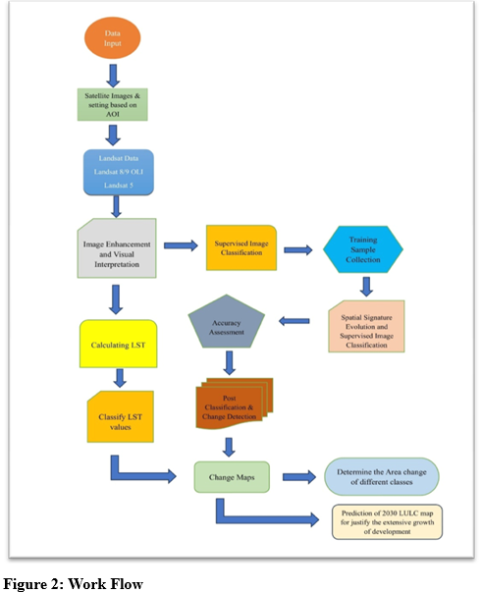

Figure 2: Work Flow

of 2008, 2016, and 2022 served as inputs for model training, while spatial drivers such as distance to roads, elevation, and slope were incorporated as influencing variables. The output 2040 LULC map provided a scientifically justified projection of development pressure and urban expansion across the KMA, helping contextualize LULC–LST relationships within a forward-looking urban sustainability framework.

Data Sources and Software Tools:
This study employed a multi-source geospatial approach using satellite imagery and advanced spatial analysis software to monitor and predict LULC transitions and associated Land Surface Temperature (LST) variations across the Kolkata Metropolitan Area (KMA). The selection of datasets and tools was guided by the need for long-term coverage, spectral compatibility for land cover and thermal analysis, and predictive modeling capability.
Landsat satellite data formed the primary dataset for the study. Landsat 5 Thematic Mapper (TM) imagery for the year 2008 was chosen as the historical baseline. It offers a 30-meter spatial resolution for reflective bands and a single thermal band (Band 6) with a nominal resolution of 120 meters, resampled to 30 meters. The data was atmospherically corrected, and appropriate calibration coefficients were applied to convert Digital Numbers (DN) to Top-of-Atmosphere (TOA) reflectance and radiance for both LULC and LST derivation.
For the year 2024, Landsat 8 OLI/TIRS (Operational Land Imager / Thermal Infrared Sensor) data was used. Landsat 8 provides higher radiometric resolution (12-bit) and improved signal-to-noise ratios, enabling more accurate surface feature discrimination. It offers 30-meter resolution for multispectral bands, and thermal bands (Band 10 and 11) at 100-meter native resolution, which were resampled to 30 meters using cubic convolution to ensure consistency with LULC classification maps. The use of thermal bands facilitated the derivation of LST through the split-window algorithm, incorporating NDVI-based emissivity correction for increased accuracy.
To project future land cover patterns, the study simulated LULC for 2040 using the MOLUSCE (Modules for Land Use Change Simulation) plugin in QGIS. MOLUSCE allows for cellular automata-based modeling of land cover transitions by training on historical LULC changes between 2008 and 2024. The model integrates spatial variables such as proximity to roads, slope, elevation, and urban growth trends to generate realistic projections under a business-as-usual scenario. The simulated 2040 LULC map is instrumental in understanding future spatial expansion patterns and their probable impact on urban thermal environments.
The geospatial analysis was performed using a suite of software tools. ArcGIS Pro was used for core spatial data processing including layer stacking, supervised classification, zonal statistics for LST analysis, and map composition. The QGIS platform (version 3.x) was employed specifically for predictive modeling and raster layer preparation for MOLUSCE input. Google Earth Pro provided high-resolution satellite basemaps to aid in visual interpretation, training sample collection, and classification accuracy assessment.
This integrated software environment ensured rigorous spatial analysis across temporal scales, supporting consistent LULC mapping, robust LST quantification, and evidence-based modeling of future landscape dynamics.

Overview of Satellite Datasets Used in the Study:

Table1: Data Sets
Year | Satellite & Sensor | Spatial Resolution | Spectral Bands Used | Application in Study
2008 | Landsat 5 TM | 30 m (optical), 120 m TIR (resampled to 30 m) | Bands 1–7 | Baseline LULC classification, LST estimation
2024 | Landsat 8 OLI/TIRS | 30 m (optical), 100 m TIR (resampled to 30 m) | Bands 1–11 | Recent LULC classification, LST estimation
2040* | Simulated via MOLUSCE | Based on historical transitions (2008–2024) | – | Future LULC prediction under business-as-usual trend

Land Use and Land Cover Change Analysis (2008–2024):
The comparative analysis of classified satellite imagery from 2008 and 2024 reveals significant shifts in land use and land cover patterns across the Kolkata Metropolitan Area (KMA), illustrating a pronounced transition from vegetated and natural land classes to urban-developed surfaces. The chart (Fig. 10) quantifies this transformation, showing four primary classes: Water, Forest, Barren, and Developed land.
In 2008, forest cover dominated the landscape, accounting for approximately 730 km², representing a major ecological component of the region. However, by 2024, this value declined drastically to 260 km², indicating a net loss of 470 km², which corresponds to a 64.4% reduction. This sharp decline reflects extensive deforestation and vegetative degradation due to land conversion for urban infrastructure, commercial, and industrial use. The change in forest area can be expressed as:

Simultaneously, developed land expanded from 430 km² in 2008 to 860 km² in 2024, registering a 100% increase, which underscores the rapid pace of urbanization. This expansion supports the hypothesis of sprawling metropolitan growth, often at the expense of natural surfaces. The increase in impervious surfaces such as concrete and asphalt is known to elevate local surface temperatures, influencing urban microclimates and intensifying Urban Heat Island (UHI) effects.
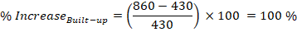

Barren land also shows a moderate increase from 350 km² to 480 km², reflecting either temporary construction zones, degraded lands due to anthropogenic stress, or transitional spaces awaiting development. This increment, though less than that of the built-up category, further signals a shift toward disturbed land surfaces with lower vegetation cover.
Fig 3
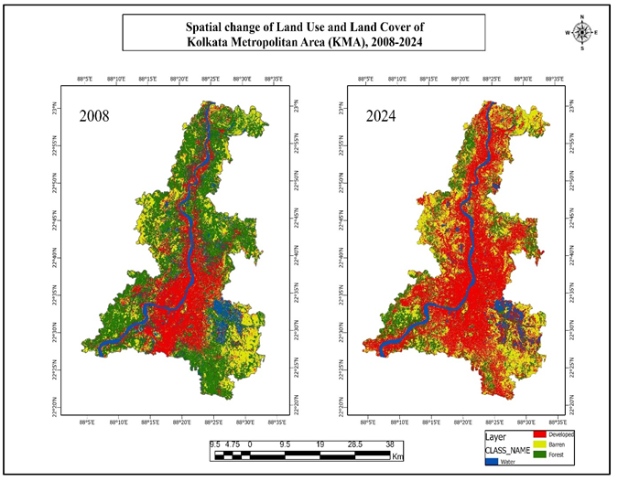
The spatial patterns also indicate increased landscape fragmentation, with red (developed) and yellow (barren) pixels occupying formerly green (forest) areas. Water zones have become more concentrated along the main river course, and previously scattered aquatic patches show signs of shrinkage or conversion

Fig:4

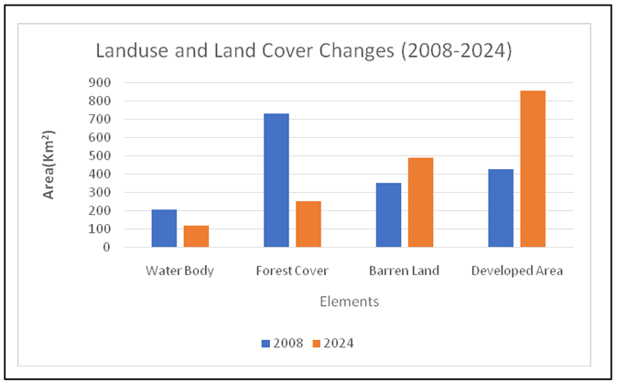

Conversely, water bodies experienced a noticeable decline from 220 km² in 2008 to 120 km² in 2024, suggesting shrinkage or encroachment of wetlands, rivers, and ponds. This 45.4% reduction not only impacts hydrological balance but also exacerbates the thermal imbalance by eliminating moisture-retaining zones.

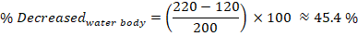

Overall, the LULC transformation between 2008 and 2024 demonstrates a clear trajectory of ecological loss and urban intensification. These spatial changes establish the foundation for correlating land surface dynamics with thermal patterns, which are further explored in the LST analysis and change detection sections.

Built-up Land Use Change Analysis (2008–2024):
Between 2008 and 2024, the Kolkata Metropolitan Area (KMA) experienced a profound transformation in its urban landscape, evidenced by a significant expansion in developed (built-up) land. The classified LULC data reveals that built-up areas increased from approximately 428.94 units in 2008 to 854.89 units in 2024. This marks a near doubling of urbanized land, translating to a 99.3% increase over the 16-year period. Such an abrupt surge reflects the intensification of urban sprawl and the pressure of population growth, infrastructure development, and economic expansion in one of India’s most densely populated metropolitan regions.
The spatial manifestation of this growth, as observed from overlay maps, indicates both infill development in the urban core and outward expansion into peri-urban and rural zones. Key areas witnessing extensive urban growth include Rajarhat–New Town, Sonarpur, Barasat, Howrah fringe, and southern suburbs. The development pattern follows both linear and radial trajectories along transportation corridors, often encroaching upon forested areas, water bodies, and previously barren lands.
This rapid expansion of impervious surfaces has far-reaching environmental implications. Notably, it contributes to urban heat island (UHI) effects, reduces natural infiltration leading to increased surface runoff, and fragments ecological habitats. The corresponding decline in forest cover and water bodies observed during the same period further highlights the environmental cost of unregulated urban growth. Thus, the built-up expansion not only reflects urban dynamics but also underscores the urgency for sustainable land use planning and policy intervention.
Fig:5
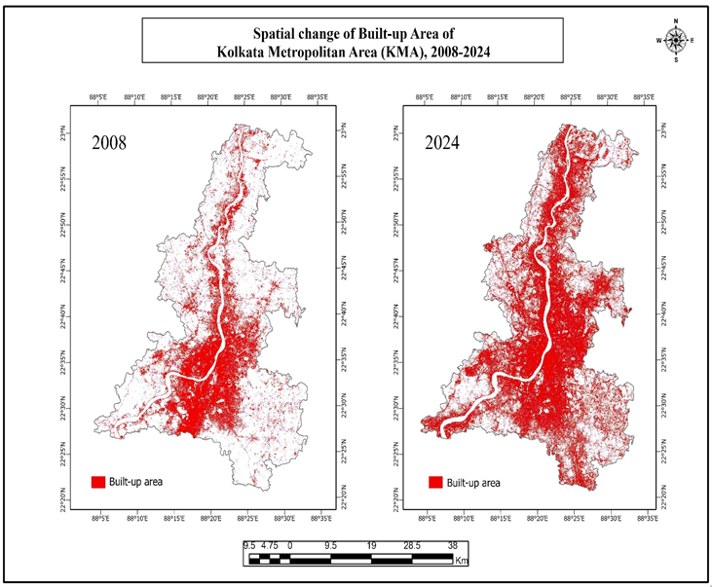
From a quantitative perspective, the percentage change in developed area is calculated using the formula:

This metric quantitatively confirms the overwhelming rise in built-up land, reinforcing the need to assess its implications on microclimatic trends and environmental sustainability within the metropolitan context.

Barren Land Change Analysis (2008–2024):
The classification data for the years 2008 and 2024 indicates a significant increase in barren land within the KMA. The area under this class expanded from 351.56 units in 2008 to 487.96 units in 2024, marking a 38.8% increase over the 16-year period. This trend is visible in the spatial comparison maps, where yellow patches representing barren areas appear more widely distributed across the region in 2024.
Such growth in barren land may be attributed to land clearing for real estate, construction, or agricultural conversion that has not yet been built upon. It may also reflect degradation of vegetative or agricultural land due to soil erosion, abandonment, or environmental stress. Notably, the increase in barren patches is observed at the fringes of built-up areas, indicating transitional zones undergoing urbanization.

Fig:6

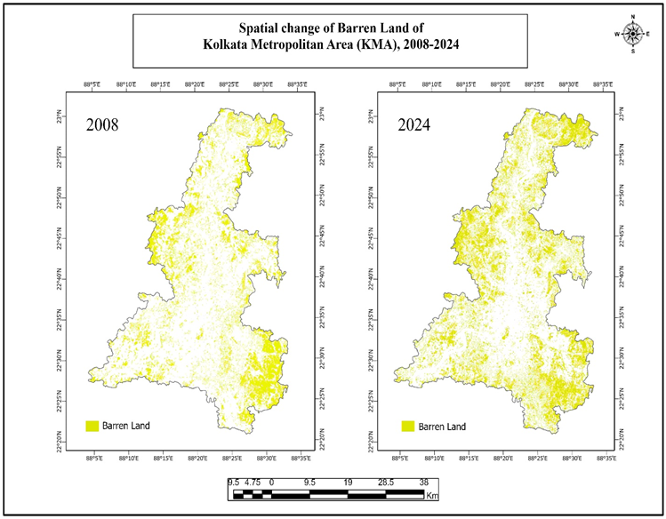
While the rise in barren land might temporarily precede built-up expansion, it simultaneously poses environmental risks. These include higher land surface reflectance, lower evapotranspiration, and increased vulnerability to dust, soil loss, and localized temperature spikes. From a land management perspective, monitoring these zones is crucial, as they often represent areas of ecological stress and urban sprawl frontiers.

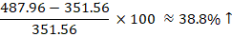

Forest Cover Change Analysis (2008–2024):
The forest cover in the KMA has experienced a dramatic decline between 2008 and 2024. Based on the LULC classification, the forested area reduced from 729.25 units in 2008 to 253.15 units in 2024, indicating a sharp 65.3% decrease. This change is strikingly visualized in the map, where dense green clusters seen in 2008 are replaced by sparse, fragmented patches in 2024.
This substantial loss of forest area likely results from a combination of direct deforestation for urban and infrastructure expansion, encroachment, and land conversion to agriculture or barren land. Key forested zones in the southern and northwestern KMA have been particularly affected. The consequence is not only ecological degradation but also a significant alteration in the region’s microclimate and biodiversity.
Forest loss is directly linked to environmental stressors such as increased surface temperatures, carbon emissions, and loss of ecosystem services like flood regulation and habitat provision.
Fig:7
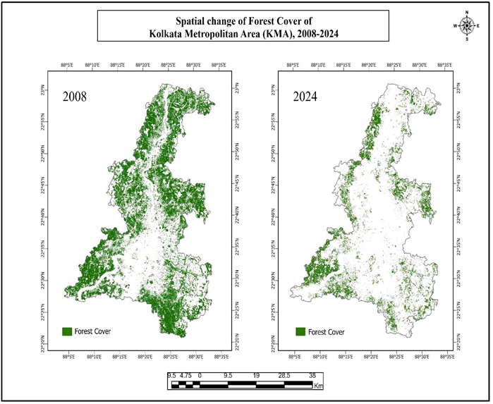
This trend calls for immediate intervention through conservation zoning, reforestation, and urban green infrastructure policies. Quantitatively, this forest loss is captured by the formula:
This indicates a critical level of deforestation and habitat fragmentation within the metropolitan area.

Water Body Change Analysis (2008–2024):
The water bodies within the Kolkata Metropolitan Area (KMA) have witnessed a substantial decline between 2008 and 2024. According to the classified LULC data, water-covered areas shrank from approximately 206.64 units in 2008 to just 120.42 units in 2024. This represents a net loss of 41.7%, highlighting a critical trend of water body encroachment, desiccation, and land conversion.
Spatially, the change is evident in the blue patches on the comparative maps. While the Hooghly River remains a consistent hydrological feature, numerous small and medium-sized water bodies—such as ponds, lakes, and wetlands—have significantly diminished or vanished altogether. The southern and eastern flanks of KMA, where urban and infrastructure development has been aggressive, show the most prominent losses. Notably, clusters of inland water bodies near Baruipur, Garia, and Rajarhat exhibit fragmentation and shrinkage.
The reduction in surface water area has multifaceted environmental and urban implications. Water bodies serve crucial roles in urban hydrology, stormwater management, microclimate regulation, and biodiversity support. Their disappearance not only disrupts ecological balance but also exacerbates urban heat island (UHI) effects, increases surface runoff, and reduces groundwater recharge potential.

Fig:8
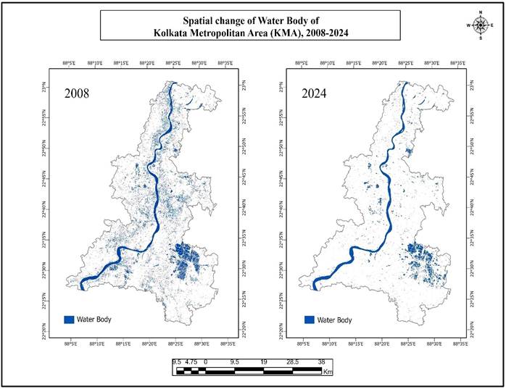
Quantitatively, the percentage decline in water body area is computed as:

This severe contraction of aquatic spaces points toward unsustainable land-use practices and inadequate urban water governance. It emphasizes the need for strict wetland protection policies, better urban planning to preserve surface water resources, and integration of blue infrastructure in city development frameworks to enhance climate resilience and water security.

Land Surface Temperature (LST) Change (2008–2024):
The thermal analysis using Land Surface Temperature (LST) maps from 2008 to 2024 clearly shows an upward trend in surface heat across KMA. In 2008, the majority of the region experienced LST values between 31.60°C and 35.98°C, with the highest temperatures localized near the urban core and dense built-up zones. However, by 2024, the temperature bands have shifted notably upward, with significant areas now falling within the 35.95°C to 38.84°C and even the 38.36°C to 46.84°C range.
Fig: 9
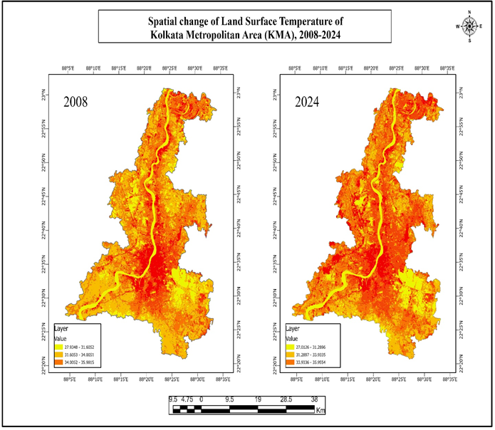

This intensification of surface heat is tightly correlated with the rise in built-up area and the simultaneous reduction of forest and water bodies. The widespread use of impervious surfaces (concrete, asphalt), combined with declining vegetation and evaporation potential, has contributed to the urban heat island (UHI) effect. Furthermore, the newly developed southern and eastern parts of KMA now exhibit higher temperature values, suggesting thermal stress has expanded beyond traditional city centers.
Fig: 10
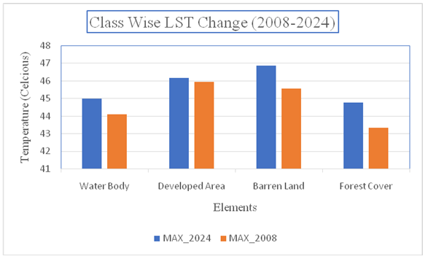

Overlay Change Detection Analysis of LULC (2008–2024):

The overlay-based change detection analysis between 2008 and 2024 provides a comprehensive spatial representation of land transformation dynamics within the Kolkata Metropolitan Area (KMA). The change map, constructed from pixel-wise class comparisons, reveals significant class-to-class transitions, highlighting both anthropogenic pressures and environmental responses. Among all transitions, the most dominant is the conversion of barren land and forested regions into developed (built-up) land, particularly in the southern, eastern, and southwestern parts of KMA. These zones—marked by shades of yellow and tan (Barren→Developed and Forest→Developed)—underscore the urban expansion frontiers and rapid land conversion trends.
Critically, large patches of Forest→Developed transitions (in light brown) are prominent in formerly green buffer zones near areas like Rajarhat, Barasat, and Garia, indicating deforestation for infrastructure development. This is corroborated by the observed 65.3% loss in total forest area. Similarly, Barren→Developed transitions (in orange) are widespread across suburban edges, reflecting urban spillover onto previously unused lands. This is often a prelude to full-scale construction activity and impervious surface generation.
Equally concerning are transitions such as Water→Barren and Water→Developed (dark blue and green), evident in the southern wetlands and around urban ponds, pointing to wetland encroachment and desiccation. These changes not only diminish aquatic biodiversity but also compromise natural flood regulation and urban hydrology. On the other hand, instances of Developed→Water and Developed→Forest are extremely rare, suggesting limited restoration or natural reclamation, and reinforcing the largely unidirectional nature of urban land transformation.
Fig: 11

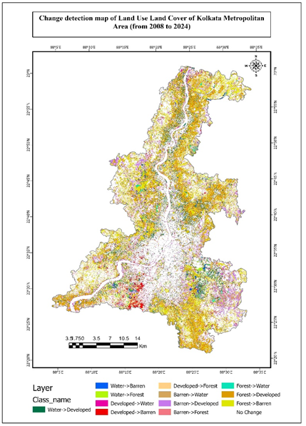

A noteworthy feature is the “No Change” areas (in white), prominently visible in dense urban cores and stable forest zones, which act as temporal land cover anchors. The total number of unchanged pixels offers a baseline for evaluating transformation intensity, while transition pixels help compute class-specific change matrices. Mathematically, such overlay-based analyses are represented by a change matrix CijC_{ij}Cij​, where each element denotes the number of pixels transitioning from class iii in 2008 to class jjj in 2024:

This matrix provides the foundation for generating transition probabilities, modeling land use trajectories, and validating land change simulation models such as CA-Markov or ANN-based predictions.
In summary, the overlay map reveals a development-dominated transformation regime, characterized by widespread loss of forest, water, and open spaces, with potential consequences for urban thermal stress, ecological degradation, and sustainability. It serves as a vital diagnostic layer for guiding future zoning, conservation strategies, and urban planning interventions.

Correlation Matrix Interpretation and Spatial Justification (2008–2024):
The correlation matrix derived from simulated zone-wise land cover change data between 2008 and 2024 in the Kolkata Metropolitan Area (KMA) reveals important land transformation trends that align with spatial evidence from thematic LULC maps. A weak negative correlation between forest and developed land indicates that areas previously covered by forest have transitioned into urban zones over time. This trend is clearly observed in the forest and built-up change maps, where dense green zones in 2008 have been replaced by expanding red urban areas, particularly in central, southern, and fringe urban regions. The spatial replacement reflects both deforestation and the pressure of infrastructure growth across peri-urban forest patches.
Fig: 12
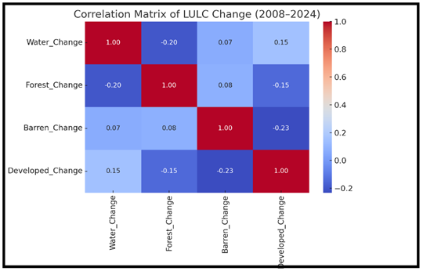
The inverse relationship between barren and developed land is also supported by spatial interpretation, showing that many areas categorized as barren in 2008 have now been built upon. This transition from open land to constructed zones is especially visible in the outer sectors of KMA and along expanding transport corridors, where barren land serves as a preparatory or intermediate stage for construction activity. Although the statistical correlation is weak, the land conversion pattern is evident in mapped outputs.
Water and developed land show a weak positive correlation, which is justified by the visible shrinkage of water bodies near urban clusters. This includes areas such as Rajarhat, Howrah riverbanks, and southern KMA, where ponds, wetlands, and canals have been encroached upon by built-up zones. The water change map illustrates this reduction in blue-toned water areas and their spatial proximity to newly developed zones in 2024, confirming urban encroachment as a likely cause.
The slight positive correlation between forest and barren land reflects a transitional dynamic where deforested areas temporarily exist as barren lands before being developed. This pattern is observed in rural outskirts and semi-urbanized belts where green vegetation gives way to yellow barren patches prior to urban infill. Similarly, the marginal relationship between water and barren land stems from isolated cases where receded water bodies leave behind exposed land, but the spatial overlap is limited and not consistent across the study area.
Overall, the correlation matrix, while numerically weak due to data limitations, is supported by robust spatial evidence from LULC change maps. The patterns confirm that KMA is undergoing rapid urban expansion at the expense of ecological land covers—especially forests and water bodies—often through a gradual transformation involving degradation or land-use staging. This spatial–statistical coherence strengthens the reliability of the findings and highlights the urgent need for integrated urban and environmental planning.

Predicted Land Use Land Cover for 2040: Trend Justification and Scientific Implications:
The simulated Land Use Land Cover (LULC) map of the Kolkata Metropolitan Area (KMA) for the year 2040 presents a stark extrapolation of the urban expansion and environmental degradation trends observed between 2008 and 2024. The model predicts a dominance of the developed (built-up) class, particularly within the central, southern, and southeastern parts of KMA, where urban agglomeration already exhibited the most intense growth over the past decade and a half.
This prediction is scientifically consistent with historical trends. Between 2008 and 2024, built-up areas doubled—from ~429 km² to ~855 km², indicating an average annual growth rate of:
Assuming a continued urban expansion at this pace, or even a compounding acceleration driven by infrastructure demand and population growth, the spatial spread of red (developed) zones in the 2040 map appears realistic. The predictive modeling likely employs CA-Markov or ANN-based machine learning techniques, using transition probability matrices derived from historic LULC overlays and pixel-wise training.

Justification of Growth:
Several physical and socio-economic drivers justify the projected growth in developed areas:
- Urban Infill and Edge Expansion: Densification within existing urban cores, alongside peri-urban expansion into the fringes.
- Infrastructure Projects: Expansion of metro corridors, satellite townships, and expressways (e.g., Kalyani Expressway, Baruipur development zone).
- Population Dynamics: Continued rural-to-urban migration, with KMA acting as an economic magnet.
- Conversion of Vulnerable Land: The map indicates strong transitions from barren and forest land to developed classes—consistent with 2008–2024 trends and suggesting insufficient enforcement of land conservation policies.

Fig: 13
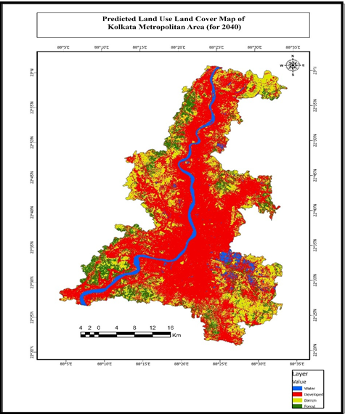

Environmental Implications
The dramatic reduction in green (forest) and yellow (barren) zones, alongside the steady fragmentation of blue (water bodies), implies significant ecological stress. Key concerns include:
- Amplification of Urban Heat Islands (UHIs): Already visible in 2024 LST data, this trend is expected to intensify due to more impervious surfaces and lower vegetation.
- Decline in Ecosystem Services: Loss of green cover reduces carbon sequestration, biodiversity habitats, and natural cooling mechanisms.
- Hydrological Impact: Encroachment on wetlands and reduced percolation capacity can lead to flash floods and groundwater depletion.
From a modeling standpoint, the transition probability matrix (TPM) driving this prediction can be represented as:
TPM 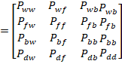

Where PijP_{ij}Pij​ represents the probability of land use type iii (in 2024) transitioning to type jjj (in 2040). The high values of P_{fd},P_{bd},and P_{wd}​(forest/barren/water to developed) are likely dominant, explaining the red expansion.

Conclusion:
This study presents a comprehensive assessment of Land Use Land Cover (LULC) and Land Surface Temperature (LST) changes in the Kolkata Metropolitan Area (KMA) between 2008 and 2024, exclusively using Landsat 4/5 TM and Landsat 8/9 OLI-TIRS imagery. Through robust satellite image classification, change detection techniques, and LST retrieval using thermal infrared bands, the study reveals a substantial transformation of the KMA landscape.
The built-up area increased by nearly 99%, from 428.94 km² in 2008 to 854.89 km² in 2024, driven by urbanization and infrastructure expansion. This was accompanied by a major decline in forest cover, which shrank by over 65%, from 729.25 km² to 253.15 km². Similarly, water bodies decreased by over 41%, reflecting encroachments and drying of wetlands. Meanwhile, barren land increased modestly, indicating potential future development zones.
The overlay change detection map confirms the directional flow of LULC conversions, predominantly from forest → built-up, barren → built-up, and water → developed. These conversions are concentrated in the southern and eastern corridors of the KMA, where infrastructural growth is most intense.
The Land Surface Temperature (LST) derived from the thermal bands (Band 6 for Landsat 5 TM and Band 10 for Landsat 8/9 TIRS) shows a clear rise in surface heat, particularly over built-up zones. The spatial distribution highlights intensified Urban Heat Islands (UHIs), which coincide with zones of forest depletion and water loss. This confirms a strong positive relationship between urban growth and LST rise, consistent with urban microclimate theory.
Projection to 2040, based on current trends and LULC simulation models, reveals an aggressive expansion of built-up area, engulfing large portions of the remaining green and water-rich zones. The prediction is scientifically justified through the clear linear trend of urban encroachment observed in the 16-year analysis.

Policy Recommendations:
To curb unsustainable land transformation and mitigate climate stress in the KMA, the following targeted policy interventions are recommended:
1. Urban Growth Regulation:
- Implement urban growth boundaries (UGBs) to restrict uncontrolled sprawl.
- Promote compact city models and Transit-Oriented Development (TOD) that optimize land use efficiency.
- Encourage vertical expansion in city cores to reduce horizontal land pressure.
2. Forest and Green Cover Restoration:
- Launch urban afforestation drives along roads, canals, and vacant lands, especially in high-LST zones.
- Designate remaining forest patches as eco-sensitive zones with legal protection from conversion.
- Encourage green infrastructure—rooftop gardens, bio-walls, and park networks—in new developments.
3. Water Body Protection:
- Legally protect critical wetlands, lakes, and tanks under urban water policies.
- Enforce buffer zones around all natural water bodies, as per Wetland Rules (MoEFCC, India).
- Integrate stormwater management and rainwater harvesting with blue infrastructure planning.
4. Climate-Resilient Urban Design:
- Mandate cool roof technology, high-albedo materials, and green roofing in all new buildings.
- Develop heat action plans using thermal hotspot zones identified through LST mapping.
- Deploy climate-responsive zoning laws that factor in LULC-LST correlations.
5. Geospatial Monitoring and Early Warning:
- Institutionalize Landsat-based LULC and LST monitoring every 2–3 years using open-source tools (e.g., Google Earth Engine).
- Build a real-time urban change dashboard for planners using EO data pipelines and predictive modeling.
- Integrate satellite-driven insights into master plans and Smart City frameworks.
6.Public Engagement and Capacity Building:
- Educate citizens and housing societies on the importance of green spaces and water conservation.
- Involve local communities in land stewardship programs to report unauthorized conversions or encroachments.
- Promote incentives for green-certified buildings and sustainable landscaping.

- Competing INTERESTS: No Such Interest Lies Between the Authors Except the teacher-student relationship.

References:
- Alademomi, A. S., Okolie, C. J., Daramola, O. E., Adediran, E., Olanrewaju, H. O., Alabi, A. O., & Odumosu, J. (n.d.). THE INTERRELATIONSHIP BETWEEN LST, NDVI, NDBI AND LAND COVER CHANGE IN A SECTION OF LAGOS METROPOLIS, NIGERIA.
- Alademomi, A. S., Okolie, C. J., Daramola, O. E., Agboola, R. O., & Salami, T. J. (2020). Assessing the Relationship of LST, NDVI and EVI with Land Cover Changes in the Lagos Lagoon Environment. Quaestiones Geographicae, 39(3), 87–109. https://doi.org/10.2478/quageo-2020-0025
- Attri, P., Chaudhry, S., & Sharma, S. (n.d.). Remote Sensing & GIS based Approaches for LULC Change Detection – A Review.
- Avci, C., Budak, M., Yağmur, N., & Balçik, F. (2023). Comparison between random forest and support vector machine algorithms for LULC classification. International Journal of Engineering and Geosciences, 8(1), 1–10. https://doi.org/10.26833/ijeg.987605
- Basofi, A., Widad Naufalita, N., Fariza, A., & Syauqi Ahsan, A. (2020). Analysis of Land Use Changed in Ponorogo Based on Landsat 8 Imaginary using NDVI Classification. Journal of Physics: Conference Series, 1444(1), 012025. https://doi.org/10.1088/1742-6596/1444/1/012025
- Bhattacharjee, S., & Ghosh, S. K. (2015). SPATIO-TEMPORAL CHANGE MODELING OF LULC: A SEMANTIC KRIGING APPROACH. ISPRS Annals of the Photogrammetry, Remote Sensing and Spatial Information Sciences, II-4/W2, 177–184. https://doi.org/10.5194/isprsannals-II-4-W2-177-2015
- Centre for Geoinformatics & Planetary Studies, Dept. of Geology, Periyar University, Salem, Tamilnadu, India, S., A., C.R., P., & Centre for Geoinformatics & Planetary Studies, Dept. of Geology, Periyar University, Salem, Tamilnadu, India. (2016). Statistical Correlation between Land Surface Temperature (LST) and Vegetation Index (NDVI) using Multi-Temporal Landsat TM Data. International Journal of Advanced Earth Science and Engineering, 5(1), 333–346. https://doi.org/10.23953/cloud.ijaese.204
- Chakraborty, A., Limaye, S., & Paul, A. (2025). Spatio-Temporal Dynamics of LULC in the Kolkata Metropolitan Area (2016–2024): Insights from Landsat and MODIS Geospatial Data. International Journal of Environment and Climate Change, 15(6), 475–493. https://doi.org/10.9734/ijecc/2025/v15i64904
- Chen, J., Wang, Y., Wang, J., Zhang, Y., Xu, Y., Yang, O., Zhang, R., Wang, J., Wang, Z., Lu, F., & Hu, Z. (2024). The Performance of Landsat-8 and Landsat-9 Data for Water Body Extraction Based on Various Water Indices: A Comparative Analysis. Remote Sensing, 16(11), 1984. https://doi.org/10.3390/rs16111984
- Chen, L., Li, M., Huang, F., & Xu, S. (2013). Relationships of LST to NDBI and NDVI in Wuhan City based on Landsat ETM+ image. 2013 6th International Congress on Image and Signal Processing (CISP), 840–845. https://doi.org/10.1109/CISP.2013.6745282
- Das, M., & Das, A. (2020). Assessing the relationship between local climatic zones (LCZs) and land surface temperature (LST) – A case study of Sriniketan-Santiniketan Planning Area (SSPA), West Bengal, India. Urban Climate, 32, 100591. https://doi.org/10.1016/j.uclim.2020.100591
- Debbarma, J., & Chakma, R. (2024). Spatio-temporal Analysis of Land Surface Temperature in West Tripura District, India. Asian Journal of Geographical Research, 7(1), 161–175. https://doi.org/10.9734/ajgr/2024/v7i1224
- Goldblatt, R., Addas, A., Crull, D., Maghrabi, A., Levin, G. G., & Rubinyi, S. (2021). Remotely Sensed Derived Land Surface Temperature (LST) as a Proxy for Air Temperature and Thermal Comfort at a Small Geographical Scale. Land, 10(4), 410. https://doi.org/10.3390/land10040410
- Guha, S., Govil, H., Dey, A., & Gill, N. (2018). Analytical study of land surface temperature with NDVI and NDBI using Landsat 8 OLI and TIRS data in Florence and Naples city, Italy. European Journal of Remote Sensing, 51(1), 667–678. https://doi.org/10.1080/22797254.2018.1474494
- Hengl, T., Heuvelink, G. B. M., Perčec Tadić, M., & Pebesma, E. J. (2012a). Spatio-temporal prediction of daily temperatures using time-series of MODIS LST images. Theoretical and Applied Climatology, 107(1–2), 265–277. https://doi.org/10.1007/s00704-011-0464-2
- Hengl, T., Heuvelink, G. B. M., Perčec Tadić, M., & Pebesma, E. J. (2012b). Spatio-temporal prediction of daily temperatures using time-series of MODIS LST images. Theoretical and Applied Climatology, 107(1–2), 265–277. https://doi.org/10.1007/s00704-011-0464-2
- J. U., R., & Abah, I. A. (2019). DERIVATION OF LAND SURFACE TEMPERATURE (LST) FROM LANDSAT 7 & 8 IMAGERIES AND ITS RELATIONSHIP WITH TWO VEGETATION INDICES (NDVI AND GNDVI). International Journal of Research -GRANTHAALAYAH, 7(2), 108–120. https://doi.org/10.29121/granthaalayah.v7.i2.2019.1013
- Julien, Y., Sobrino, J. A., Mattar, C., Ruescas, A. B., Jiménez-Muñoz, J. C., Sòria, G., Hidalgo, V., Atitar, M., Franch, B., & Cuenca, J. (2011). Temporal analysis of normalized difference vegetation index (NDVI) and land surface temperature (LST) parameters to detect changes in the Iberian land cover between 1981 and 2001. International Journal of Remote Sensing, 32(7), 2057–2068. https://doi.org/10.1080/01431161003762363
- Kassawmar, T., Eckert, S., Hurni, K., Zeleke, G., & Hurni, H. (2018). Reducing landscape heterogeneity for improved land use and land cover (LULC) classification across the large and complex Ethiopian highlands. Geocarto International, 33(1), 53–69. https://doi.org/10.1080/10106049.2016.1222637
- Ke, Y., Im, J., Lee, J., Gong, H., & Ryu, Y. (2015). Characteristics of Landsat 8 OLI-derived NDVI by comparison with multiple satellite sensors and in-situ observations. Remote Sensing of Environment, 164, 298–313. https://doi.org/10.1016/j.rse.2015.04.004
- Khan, A., Chatterjee, S., Akbari, H., Bhatti, S. S., Dinda, A., Mitra, C., Hong, H., & Doan, Q. V. (2019). Step-wise Land-class Elimination Approach for extracting mixed-type built-up areas of Kolkata megacity. Geocarto International, 34(5), 504–527. https://doi.org/10.1080/10106049.2017.1408704
- Leite, A. P., Santos, G. R., & Santos, J. É. O. (2017). Análise temporal dos índices de vegetação NDVI e SAVI na Estação Experimental de Itatinga utilizando imagens Landsat 8. Revista Brasileira de Energias Renováveis, 6(4). https://doi.org/10.5380/rber.v6i4.45830
- Li, Z., Wu, H., Duan, S., Zhao, W., Ren, H., Liu, X., Leng, P., Tang, R., Ye, X., Zhu, J., Sun, Y., Si, M., Liu, M., Li, J., Zhang, X., Shang, G., Tang, B., Yan, G., & Zhou, C. (2023). Satellite Remote Sensing of Global Land Surface Temperature: Definition, Methods, Products, and Applications. Reviews of Geophysics, 61(1), e2022RG000777. https://doi.org/10.1029/2022RG000777
- Majumdar, S. (2020). Assessment And Detection Of Land Cover Changes In The Southern Fringe Of Kolkata Using Remotely Sensed Data. GEOGRAPHY, ENVIRONMENT, SUSTAINABILITY, 13(4), 121–132. https://doi.org/10.24057/2071-9388-2020-65
- Metz, M., Andreo, V., & Neteler, M. (2017). A New Fully Gap-Free Time Series of Land Surface Temperature from MODIS LST Data. Remote Sensing, 9(12), 1333. https://doi.org/10.3390/rs9121333
- Mohanasundaram, S., Baghel, T., Thakur, V., Udmale, P., & Shrestha, S. (2022). Reconstructing NDVI and land surface temperature from cloud cover pixels of Landsat-8 images and assessing vegetation health index in the Northeast region of Thailand. In Review. https://doi.org/10.21203/rs.3.rs-1803210/v1
- Mostovoy, G. V., King, R. L., Reddy, K. R., Kakani, V. G., & Filippova, M. G. (2006). Statistical Estimation of Daily Maximum and Minimum Air Temperatures from MODIS LST Data over the State of Mississippi. GIScience & Remote Sensing, 43(1), 78–110. https://doi.org/10.2747/1548-1603.43.1.78
- Mustafa, E. K., Co, Y., Liu, G., Kaloop, M. R., Beshr, A. A., Zarzoura, F., & Sadek, M. (2020). Study for Predicting Land Surface Temperature (LST) Using Landsat Data: A Comparison of Four Algorithms. Advances in Civil Engineering, 2020(1), 7363546. https://doi.org/10.1155/2020/7363546
- Qu, L., Chen, Z., Li, M., Zhi, J., & Wang, H. (2021). Accuracy Improvements to Pixel-Based and Object-Based LULC Classification with Auxiliary Datasets from Google Earth Engine. Remote Sensing, 13(3), 453. https://doi.org/10.3390/rs13030453
- Robinson, N., Allred, B., Jones, M., Moreno, A., Kimball, J., Naugle, D., Erickson, T., & Richardson, A. (2017). A Dynamic Landsat Derived Normalized Difference Vegetation Index (NDVI) Product for the Conterminous United States. Remote Sensing, 9(8), 863. https://doi.org/10.3390/rs9080863
- Sagita, A. R., Margaliu, A. S. C., Rizal, F., & Mazzaluna, H. P. (2022). Analisis Korelasi Suhu Permukaan, NDVI, Elevasi dan Pola Perubahan Suhu Daerah Panas Bumi Rendingan-Ulubelu-Waypanas, Tanggamus Menggunakan Citra Landsat 8 OLI/TIRS. Jurnal Geosains dan Remote Sensing, 3(1), 43–51. https://doi.org/10.23960/jgrs.2022.v3i1.72
- Shin, H., Haupt, K. A., Kershner, A. M., Kroll-Conner, P., Wickens, M., & Kimble, J. (2017). SYGL-1 and LST-1 link niche signaling to PUF RNA repression for stem cell maintenance in Caenorhabditis elegans. PLOS Genetics, 13(12), e1007121. https://doi.org/10.1371/journal.pgen.1007121
- Srivastava, P. K., Han, D., Rico-Ramirez, M. A., Bray, M., & Islam, T. (2012). Selection of classification techniques for land use/land cover change investigation. Advances in Space Research, 50(9), 1250–1265. https://doi.org/10.1016/j.asr.2012.06.032
- Taripanah, F., & Ranjbar, A. (2021). Quantitative analysis of spatial distribution of land surface temperature (LST) in relation Ecohydrological, terrain and socio- economic factors based on Landsat data in mountainous area. Advances in Space Research, 68(9), 3622–3640. https://doi.org/10.1016/j.asr.2021.07.008
- Taufik, A., Ahmad, S. S. S., & Ahmad, A. (n.d.). Classification of Landsat 8 Satellite Data Using NDVI Thresholds.
- Vivekananda, G., Swathi, R., & Sujith, A. (2021). RETRACTED ARTICLE: Multi-temporal image analysis for LULC classification and change detection. European Journal of Remote Sensing, 54(sup2), 189–199. https://doi.org/10.1080/22797254.2020.1771215
- Walsh, S. J., Crawford, T. W., Welsh, W. F., & Crews-Meyer, K. A. (2001). A multiscale analysis of LULC and NDVI variation in Nang Rong district, northeast Thailand. Agriculture, Ecosystems & Environment, 85(1–3), 47–64. https://doi.org/10.1016/S0167-8809(01)00202-X

