**Effect of Land Use on Wetland Degradation and Flood Occurrence in Makurdi Metropolis, Central Nigeria.**

**Abstract**

This study evaluates the impact of urbanization on wetland degradation and flood vulnerability in Makurdi metropolis, Benue State, Nigeria, using Geographic Information System (GIS) and remote sensing from 1986 to 2023. Over this 37-year period, the wetland area reduced by 96.08%, from 40.10 km² in 1986 to 1.57 km² in 2023. Land cover analysis within the wetland areas shows a significant increase in built-up areas from 0.79 km² (1.9%) to 24.43 km² (58.4%), while vegetation cover decreased from 31.45 km² (75.1%) to 16.75 km² (40.0%). An overall accuracy assessment yielded 95.81% accuracy for 1986 and 90.14% for 2023, validating the classification results. These changes are primarily attributed to urban expansion, particularly on the south bank of the Makurdi metropolis. Similarly, a strong spatial correlation between wetland loss and increased flood occurrences was identified in south bank regions. Flood risk analysis revealed that 31.78% of buildings (62,694 buildings) are located within wetland areas, exacerbating flood risk in regions such as Nyiman and Achusa. These findings emphasize the importance of sustainable urban planning and wetland conservation to mitigate flood risks and environmental degradation in Makurdi metropolis.

Keywords: Wetland Degradation, Flood Vulnerability, Urbanization

**Introduction**

Wetlands are naturally occurring low-lying areas within a terrain that are consistently inundated with water, either permanently or seasonally [22,7]. These ecosystems are vital for maintaining the ecological balance of urban and rural landscapes alike [14]. Globally, wetlands play a critical role in mitigating floods by absorbing and storing excess water, thus reducing flood peaks and preventing damage to surrounding areas [3]. They also contribute to water purification by filtering pollutants, supporting biodiversity, and replenishing groundwater reserves [3]. Urban wetlands, in particular, are recognized for their capacity to regulate water cycles, improve air quality, and reduce the intensity of the urban heat island (UHI) effect, which exacerbates temperature disparities in cities [3].

However, human activities especially urban development has led to the significant degradation of wetlands worldwide [25]. As cities expand, wetlands are often converted into built-up areas, reducing their ability to manage floodwaters effectively. The loss of wetland ecosystems has been documented to significantly exacerbate urban flooding, with wetlands' capacity to absorb and store water being compromised as they are transformed into impervious surfaces. The growing trend of urbanization, coupled with climate change-induced weather events, further strains the ability of cities to maintain natural flood mitigation mechanisms, leading to increased flood risks [10].

In the case of Makurdi, the capital of Benue State, Nigeria, urban expansion has become a significant driver of wetland degradation. The city has witnessed a rapid increase in urbanization and agricultural activity, particularly over the past few decades. This has resulted in the encroachment upon wetland areas, which were once crucial in moderating flood risks and providing critical ecological services. The conversion of wetlands to built-up areas has led to increased surface runoff, which, combined with increased rainfall intensity due to climate change, has worsened the city's vulnerability to flooding. Major flood events in 2012, 2017, and 2023 have highlighted the direct correlation between the loss of wetlands and the increasing frequency and severity of floods in the region [11].

Globally, wetlands are considered hotspots of biodiversity, offering habitats for a wide range of species, many of which are endangered or at risk due to urban sprawl and industrialization [6]. In Makurdi, however, the pressures of urbanization, along with agriculture, deforestation, and improper waste disposal, have contributed to the deterioration of wetland areas. This degradation, coupled with the absence of effective urban planning, has increased the city's exposure to environmental hazards, such as flooding, water pollution, and biodiversity loss [12, 4].

The challenges faced by Makurdi metropolis is not unique, as cities globally are grappling with similar issues of wetland loss due to rapid urban growth and inadequate urban infrastructure. As cities expand, the destruction of wetlands leads to a vicious cycle of worsening environmental quality, with increased flood risks, water pollution, and heat stress. The loss of these valuable ecosystems diminishes the overall resilience of cities to climate change and natural disasters [8]. In this context, urban wetland conservation and restoration are becoming essential strategies in sustainable urban planning [2]. Cities around the world are beginning to recognize the need to integrate wetland conservation into their development plans to improve flood resilience and enhance the sustainability of urban environments [23].

This study assesses the effect of land use on wetland degradation and flood vulnerability in Makurdi metropolitan using Geographic Information System (GIS) and remote sensing imageries. By analyzing land cover changes between 1986 and 2023, this research explores the extent of wetland loss and its relationship with increasing flood risks. The findings of this study emphasize the need to incorporate wetland conservation strategies into urban planning to mitigate flood risks and enhance the long-term sustainability of Makurdi metropolitan area.

**Materials and Methods**

**Study area**

Makurdi, is the Administrative Headquarter of Benue State located in the North Central of Nigeria; its natural setting is within the floodplains of the River Benue, the second-largest river in Nigeria. The coordinates of the Makurdi metropolitan area bonds between Northing 848000 to 864000 and Easting 442500 to 457600.

**Location and spatial extent**

Makurdi is bordered to the north by Guma, to the south by Gwer-East, to the west by Gwer-West, and to the northwest by Doma Local Government Area of Nasarawa State[15]. The River Benue divides the metropolis into two main regions: the northern and southern banks. This division is critical to the city’s hydrology, ecology, and urban development. The city's strategic location along major transportation routes contribute to its role as a key commercial and administrative hub in the region [16].

**Geology**

Makurdi lies on an alluvial plain, primarily composed of sedimentary rocks, including sandstones and clayey deposits [20]. The region's geological characteristics significantly influence its hydrological patterns and land-use activities, particularly agriculture. Periodic flooding of the river enriches the surrounding soil, making it suitable for cultivation, although erosion and sedimentation in certain areas affect the stability of the landscape [1].

**Relief and drainage (Topography)**

The topography of Makurdi is relatively flat, with gentle undulating areas near the banks of the River Benue. Floodplains are common across the area, with the River Benue serving as the central drainage system. Its seasonal fluctuations affect local agriculture and urban development, with flooding occurring predominantly in the rainy season [15]. The River Benue and its tributaries (Katsina-Ala, Genebe, Kereke, Idye, and Kpege) play a critical role in draining the surrounding area, creating a network of wetlands essential to the local ecosystem [20].

**Climate**

Makurdi experiences a tropical climate characterized by distinct wet and dry seasons. The wet season occurs from April to October, while the dry season spans from November to March. Average temperatures range between 25°C and 32°C, with humidity levels peaking during the wet season. Rainfall ranges from 775 mm to 1792 mm, with the peak of the wet season (June to September) significantly influencing the hydrological cycle and agricultural productivity [21].

**Soils**

The soils in Makurdi are primarily alluvial soils, deposited by the River Benue and its tributaries. These soils are rich in nutrients, making them fertile for agricultural use, especially in the floodplain areas [1]. However, soil erosion is a common challenge, especially along riverbanks, where water action weakens soil structure. Urbanization and construction activities, particularly along the riverbanks, have also led to soil compaction in some parts of the city [20].

**Vegetation**

The natural vegetation of Makurdi consists mainly of tropical rainforest and Guinea savannah, with significant areas of agricultural land. While urban expansion has reduced the extent of natural vegetation, remnants of forests and savannah remain in rural and less-developed areas. The region’s wetlands, nourished by seasonal flooding, support a diverse range of plant species that are essential for maintaining local biodiversity [4]. Urbanization and the development of infrastructure, however, have resulted in the conversion of wetland areas into built-up zones, reducing the extent of the natural landscape.

**The people and their ethnic extractions, population, and economic activities**

Makurdi is home to a diverse population composed of several ethnic groups, all over Nigeria. The population of Makurdi has grown significantly over the years, with an estimated population of 471,754 people residing in the city as of 2024 [24]. This marks a remarkable increase from 33,055 in 1950, reflecting the city’s rapid urbanization and demographic expansion. Similarly, the Macrotrend also estimated the population to be approximately 472,000, with a steady annual growth rate of 3.96% in recent years [17]. The city has transformed into a bustling metropolitan area, largely due to urbanization and migration. The economy of Makurdi is predominantly based on agriculture, with crops such as maize, yam, cassava, and vegetables grown in the surrounding rural areas. In addition to agriculture, small-scale industries, trade, and services contribute to the local economy. Makurdi is an important commercial centre, with markets and retail businesses serving both the city and its surrounding communities [15]. The region’s economic activities are closely linked to the natural environment, particularly the fertile soils of the floodplain, which are ideal for agricultural production.

**Land use**

Land use within Makurdi includes both urban and agricultural activities. The urban areas are characterized by residential, commercial, and industrial zones, while agricultural land, water bodies, and vegetative cover dominate the outskirts of the city. As urbanization continues, the city is facing challenges related to wetland degradation and the conversion of land for built-up areas and infrastructure development. Urban sprawl has resulted in the conversion of wetlands to residential, commercial, and infrastructural uses [4].

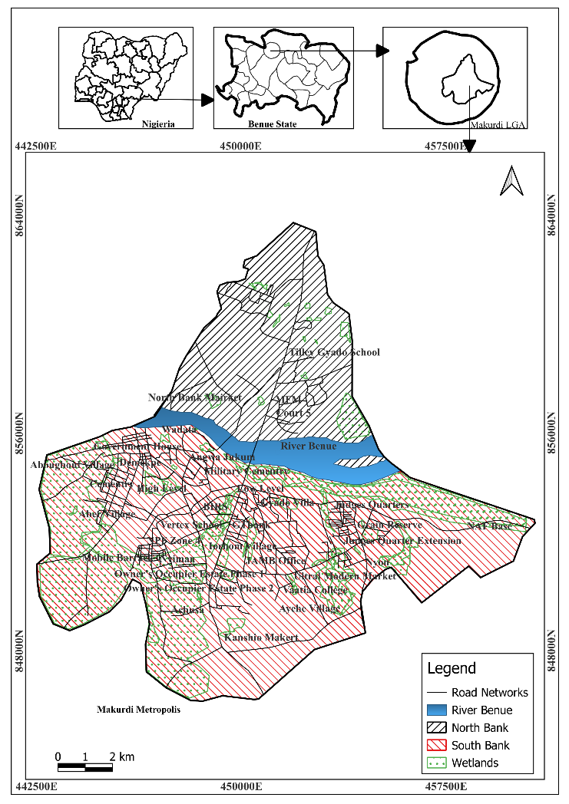

**Figure 1:** Map of Makurdi metropolitan Area Showing the Study Locations

**Data Collection**

**Satellite Imagery**

Landsat imagery was acquired from the United States Geological Survey (USGS) Earth Explorer platform. Landsat 5 TM data were used for 1986, and Landsat 8 OLI data were used for 2023. The imagery was processed to generate land cover maps for each year.

**Vector Data**

1. **Wetland Boundaries:** Wetlands were visually delineated for 1986 and 2023 using historical imagery in Google Earth Pro. The boundaries were converted from Keyhole Markup Language (KML) into vector format for spatial analysis in QGIS.
2. **Building Footprints:** Extracted from the Google Research dataset and used to assess the extent of urban encroachment into wetland areas.
3. **Stream Networks:** Digitized from Google Earth Pro, these were used to evaluate proximity to flood-prone areas.

**Spatiotemporal Data**

Flood Event Dataset: Collected from news reports and government agencies, covering flood events from 2015 to 2024.

**Projection**

All datasets were re-projected using the Minna/UTM Zone 32N coordinate system to ensure spatial alignment and accuracy across the study area.

**Wetland Delineation**

Wetland boundaries for the years 1986 and 2023 were visually delineated using historical imagery in Google Earth Pro. The boundaries were exported as KML files, then converted into shapefiles for spatial analysis in QGIS. These boundaries were used to assess changes in land use within wetlands.

**Supervised Classification**

Land cover classification was performed using the Semi-Automatic Classification Plugin (SCP) in QGIS [9]. This plugin facilitated the loading of Landsat bands for both years and performed the classification.

**Color Composite**

A false-color composite was created using the 5-3-2 band combination for Landsat 5 TM and the 5-4-3 band combination for Landsat 8 OLI. This approach highlights vegetation and urban areas by displaying data in colors outside the visible spectrum.

**Training Sample Selection**

Representative areas for built-up, vegetation, water bodies, and bare soil were identified and polygons were drawn around these representative areas to create training samples, which were then used to train the classifier.

**Classification Algorithm**

The Maximum Likelihood Classification method was employed to classify land cover types. The algorithm used the spectral signatures of the training samples to classify pixels into different land cover types: built-up areas, vegetation, bare soil, and water bodies.

**Post-Classification**

Post-classification processing was performed to reduce noise in the classified images. Misclassified pixels were corrected by overlaying the classified maps on a base map, and vectorized layers were manually inspected and assigned corresponding DN to ensure accuracy.

**Accuracy Assessment**

An overall accuracy assessment was conducted to evaluate the classification results. The classified maps were compared to reference data obtained from Google Earth Pro, and a confusion matrix was generated to calculate Producer's Accuracy (PA), User's Accuracy (UA), and Overall Accuracy (OA).

The accuracy assessment of land cover maps from 1986 and 2023 (Table 1) yielded an overall accuracy of 95.81% for 1986 and 90.14% for 2023. These high accuracy values confirm the reliability of the land cover classification results, ensuring that the observed trends in land cover change are robust and reflect true patterns of urbanization and wetland degradation.

Table 1: Results of Accuracy Assessment for the Classified Images

|  |  |  |  |  |  |  |
| --- | --- | --- | --- | --- | --- | --- |
| Year | Accuracy (%) | Built-up | Bare soil | Vegetation | Water body | OA (%) |
| **1986** | PA | 86.92 | 95.50 | 96.58 | 97.36 | 95.81 |
| UA | 94.40 | 88.40 | 96.79 | 100.00 |
| **2023** | PA | 40.57 | 94.44 | 100.00 | 100.00 | 90.14 |
| UA | 72.45 | 81.53 | 100.00 | 100.00 |

Key: PA = Producer Accuracy, UA = User Accuracy, OA = Overall Accuracy

**Wetland Area Calculation**

The area of wetland was calculated using the field calculator in QGIS. Wetland boundaries from both years were merged and dissolved to summarize the total wetland area for each year.

**Change Detection Within Wetland Areas**

Land cover changes within the wetland boundaries were analyzed by masking the classified images. The area of each land cover class within the wetlands was calculated, with its percentage change between 1986 and 2023.

**Flood Vulnerability Analysis**

Buffer analysis was performed using building footprints and stream networks. A 50-meter buffer zone around streams was created to assess the proximity of buildings to potential flood zones. The number of buildings within this buffer was calculated to evaluate flood vulnerability.

**Spatial Correlation of Flood Events**

Historical flood events were geocoded and mapped to analyze their spatial relationship with areas of wetland degradation and conversion. This helped identify the areas’ most vulnerable to flooding due to urban encroachment into wetlands.

**Statistical Analysis**

All attribute data were exported to Microsoft Excel, where summary statistics were computed. The area of each land cover class was calculated, and percentage change was determined using the following formulas:

Percentage composition = $\frac{Change Area}{{Area }_{1986}}$ x 100 Equation 1

**RESULTS**

**Land Cover Analysis Within Wetlands from 1986 - 2023 in Makurdi Metropolis**

The analysis of land cover within wetland areas of Makurdi metropolis reveals changes in wetland characteristics from 1986 to 2023. Figures 2 and 3 shows the land cover within these wetland areas over the years with the shift in composition of land cover types.

In 1986, the wetland areas in Makurdi were predominantly covered by vegetation, accounting for 31.45 km² (75.1%) of the total wetland area. Bare soil covered 8.97 km² (21.4%), while built-up areas covered 0.79 km² (1.9%). Water bodies, on the other hand, accounted for 0.66 km² (1.6%) of the total area. These reveal that wetlands in 1986 were largely composed of natural vegetation, with minimal urban development, as shown in Table 2.

By 2023, the land cover composition within the wetland areas had changed, Table 3 shows built-up areas had increased to 24.43 km² (58.4%) of the total wetland area. This shift indicates a substantial encroachment of urban development into the wetland zones. The area covered by bare soil reduced to 0.63 km² (1.5%), while the vegetation area dropped to 16.75 km² (40.0%), and water bodies were reduced to 0.06 km² (0.1%). These changes highlight the extent of wetland conversion due to urbanization, with much of the natural vegetation in wetland being replaced by built-up structures.

The land cover conversion within the wetlands of Makurdi Metropolis from 1986 to 2023 resulted in significant changes. Built-up areas increased by 23.64 km², representing a substantial percentage increase of 56.46%. In contrast, bare soil areas decreased by 8.34 km², representing a percentage decrease of 19.91%. Vegetation cover also decreased, with a loss of 14.71 km², representing a percentage decrease of 35.12%. Furthermore, water bodies decreased by 0.60 km², representing a percentage decrease of 1.43%. These changes indicate significant transformations in the land cover of the wetlands over the 37-year period Table 4.

Table 2: Statistics Evidence of Land Cover Map Within Wetland Area in 1986

|  |  |  |
| --- | --- | --- |
| Land Cover Classes | Total Area in 1986 (Km2) | Percentage (%) |
| Build Up Areas | 0.79 | 1.9 |
| Bare Soil | 8.97 | 21.4 |
| Vegetation | 31.45 | 75.1 |
| Water Body | 0.66 | 1.6 |
| Total | 41.87 | 100.0 |

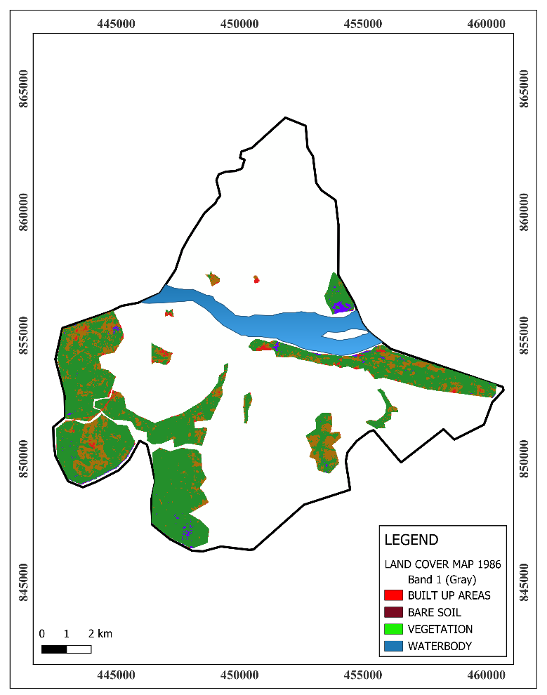

Figure 2: Land Cover Within Wetland Areas in 1986

Table 3:Statistics Evidence of Land Cover Map Within Wetland Area in 2023

|  |  |  |
| --- | --- | --- |
| Land Cover Classes | Area in 2023 (Km2) | Percentage (%) |
| Build Up Areas | 24.43 | 58.4 |
| Bare Soil | 0.63 | 1.5 |
| Vegetation | 16.75 | 40.0 |
| Water Body | 0.06 | 0.1 |
| Total | 41.87 | 100.0 |

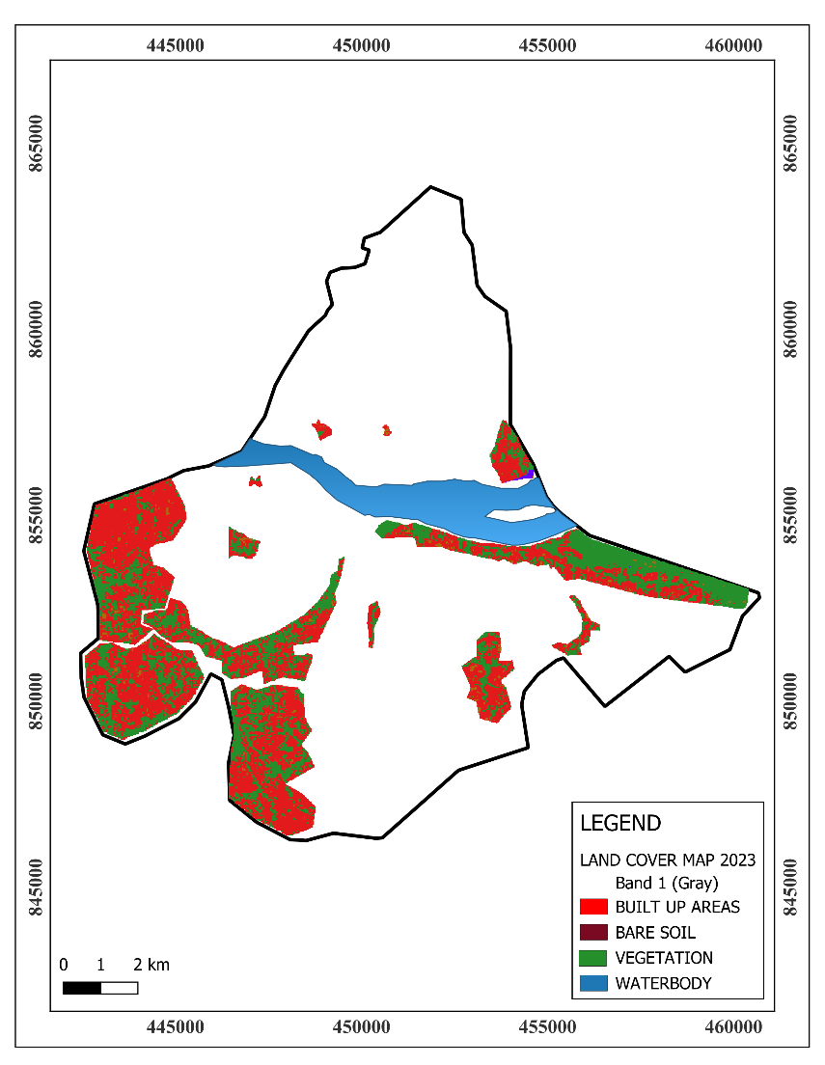

Figure 3:Land Cover Within Wetland Areas in 2023

Table 4: Land Cover Conversion Within Wetland in Makurdi Metropolis from 1986 – 2023

|  |  |  |  |  |
| --- | --- | --- | --- | --- |
| Land Cover Classes | Area in 1956 (Km2) | Area in 2023 (Km2) | Change in Area (Km2) | Percentage Change (%) |
| Build Up Areas | 0.79 | 24.43 | 23.64 | 56.46 |
| Bare Soil | 8.97 | 0.63 | -8.34 | -19.91 |
| Vegetation | 31.45 | 16.75 | -14.71 | -35.12 |
| Water Body | 0.66 | 0.06 | -0.60 | -1.43 |
| Total | 41.87 | 41.87 |  |  |

**Spatial Distribution and Degradation of Wetlands in Makurdi Metropolis**

The spatial distribution of wetland areas in Makurdi Metropolis from 1986 to 2023 reveals a conversion of wetlands to urban land uses, particularly built-up areas. Figure 4 shows the area of wetland distribution in the study epoch. in Table 5, the total wetland area in Makurdi decreased from 40.10 km² in 1986 to 1.57 km² in 2023, resulting in a change of -38.53 km², (96.08%) reduction. This substantial decline reflects the extent of wetland loss, primarily driven by urban expansion. Plate 1 and 2, show filled wetland for development along Ishaya Bakut Street and Wetland serving as dumpsite along Katsina-Ala street respectively. These changes depict the extent of wetland degradation in Makurdi metropolis, driven by urbanization and land use change, resulting in the loss of valuable wetland ecosystems that once provided important ecological functions.

Table 5:Change in Wetland Areas from 1986 – 2023

|  |  |  |  |
| --- | --- | --- | --- |
| Year | Area (Km²) | Change Area (Km²) | Percentage Change (%) |
| 2023 | 1.57 | -38.53 | -96.08 |
| 1986 | 40.10 |  |  |
| Total | 41.67 |  |  |

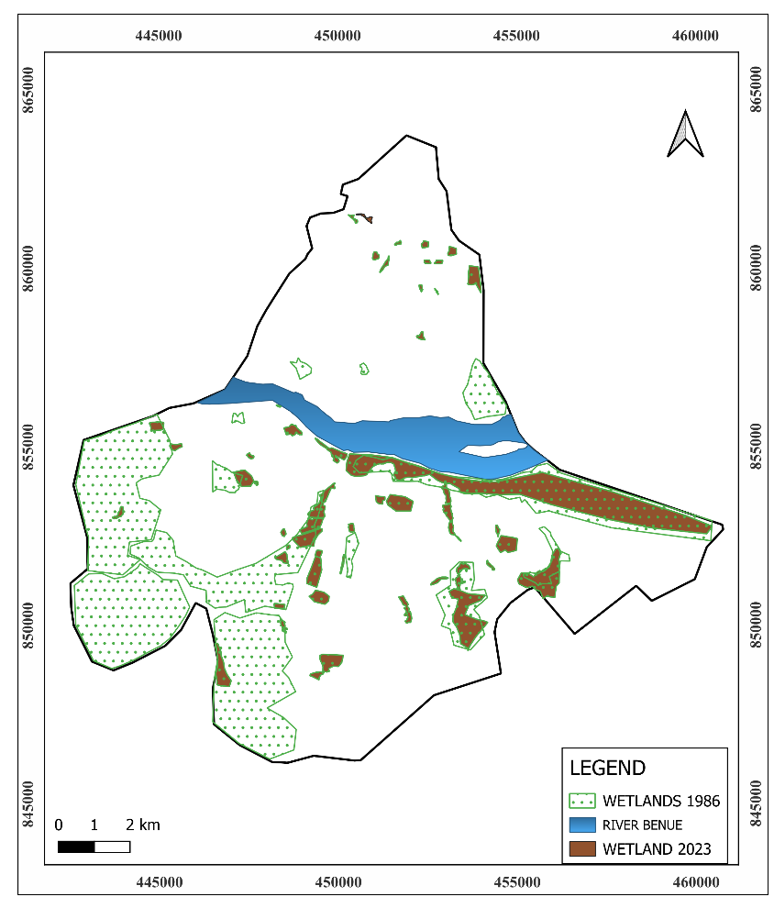

Figure 4: Spatial Distribution of Wetlands in Makurdi Metropolis from 1986 – 2023

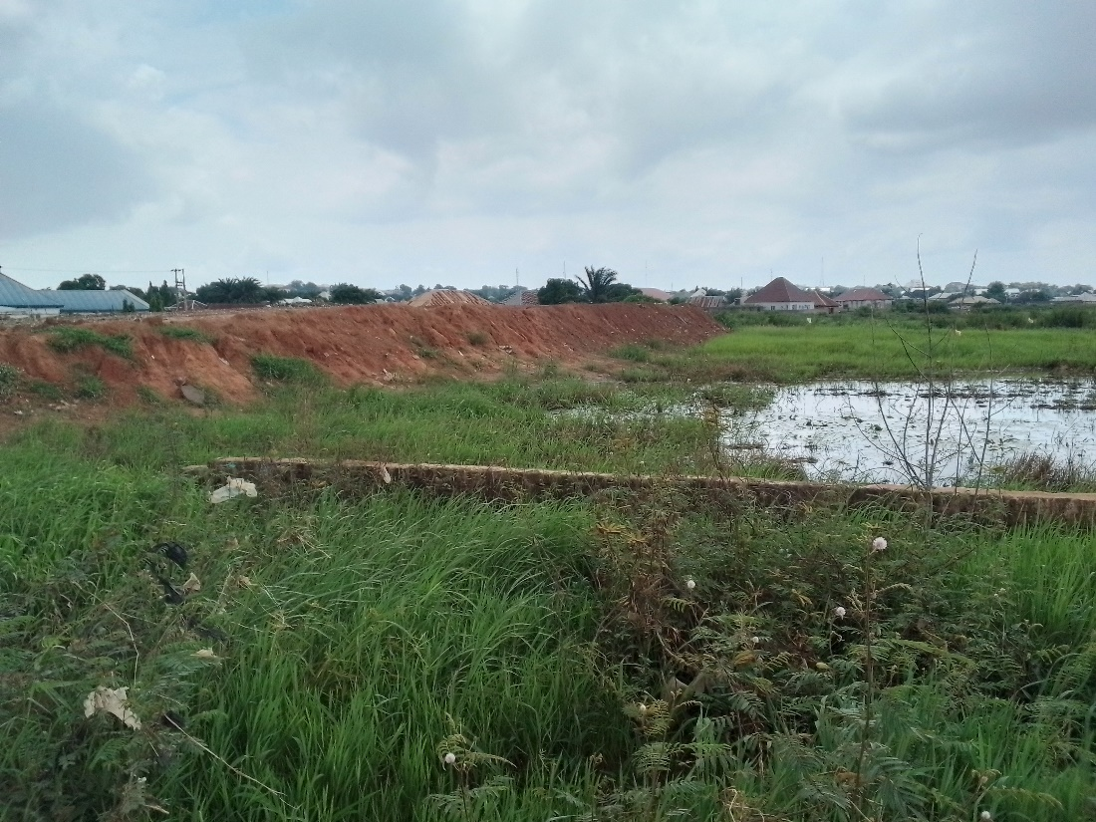

Plate 1: Filled Wetland Ready for Development along Ishaya Bakut Street, Makurdi Metropolis

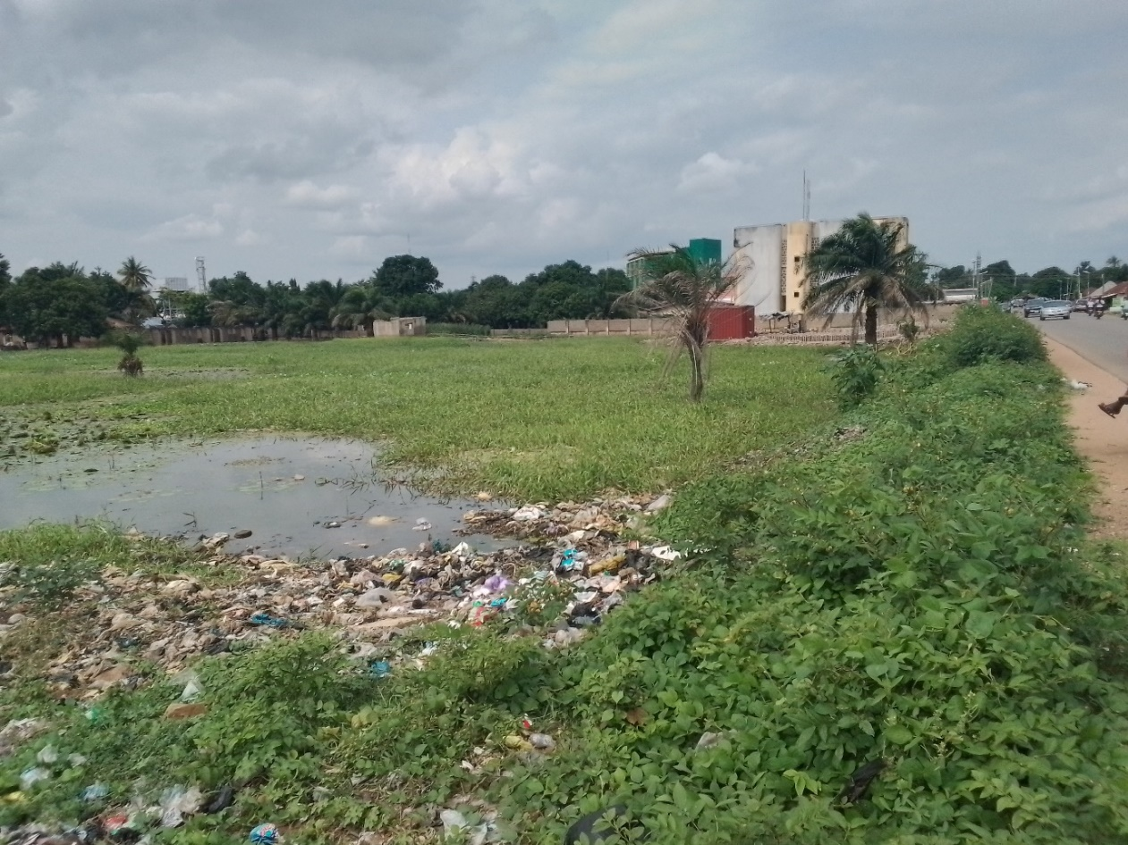

Plate 2: Wetland Serving as Dumpsite along Katsina-Ala Street, Makurdi Metropolis.

**Effect of Building up Areas on Wetland and Flood Vulnerability**

Figure 5 and Table 6, shows a spatial analysis building footprints in the study area, with 62,694 buildings (31.78%), are located within wetland areas, while 134,611 buildings (68.22%) are situated outside these areas. This data highlights the significant overlap between urban development and wetland areas. To assess flood vulnerability, a buffer zone of 50 meters was applied on both sides of the stream networks. This buffer zone is critical, as areas within 50 meters of the streams are typically more exposed to risk of been flooded, especially during periods of high rainfall when stream overflow occurs. figure 6 and Table 7 provides evidence of the number of buildings located within this 50-meter buffer zone. It shows that 10,407 buildings (5.27%) of the total buildings in the study area, are located within the buffer zone, while 186,898 buildings (94.00%) are situated outside this zone. This data suggests that a 5.2% proportion of the built-up areas in the metropolis are directly exposed to flood risks from streams.

The concentration of buildings within wetland areas still poses a significant concern for future flood events. Figure 7 shows buildings located within a 50-meter buffer zone, highlighting areas where urban development has encroached on the streams networks, making them vulnerable to flooding. Plate 3 (a and b) shows actual field results of fences within the 50-meter buffer zone, located along Katsina-Ala street and Iorhom Settlement, which further illustrates how urban development is encroaching wetland areas.

Figure 8 presents a map showing areas liable to flood in Makurdi Town, which identifies zones most at risk of flooding due to the combined effects of wetland loss and urbanization. The map depicts regions where wetlands have been converted to other land uses, increasing the likelihood of flood occurrences in those areas (spatial distribution). The spatial relationship between wetland areas and flood occurrences is explored; showing a flood impact level of 500m occurring in wetland loss areas, the conversion of wetlands has affected flood-prone zones. The loss of wetlands, which once helped to absorb excess water, has increased the vulnerability of certain regions to flooding. Wetland conversion has altered the natural flow of water and reduced the landscape's ability to handle rainfall efficiently.

Table 6: Statistics Evidence of Building Footprints Within Wetland Areas

|  |  |  |
| --- | --- | --- |
|  | No. of Buildings | Percentage (%) |
| Buildings Within Wetland Areas | 62694 | 31.77 |
| Buildings Not Within Wetland Areas | 134611 | 68.22 |
| Total | 197305 | 100 |

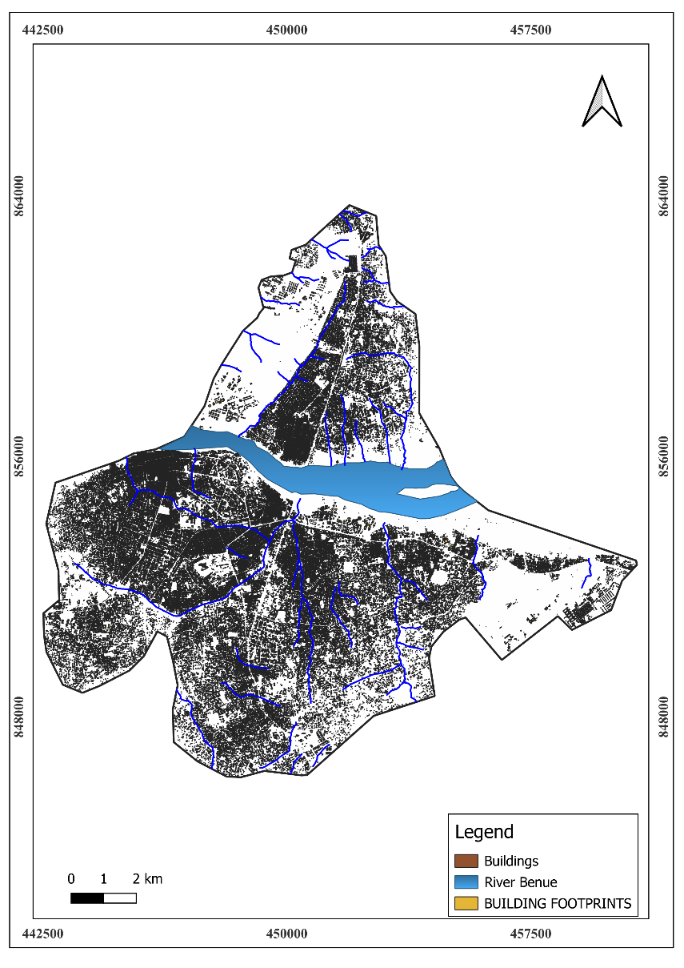

Figure 5: Density of Buildings and Stream Networks in Makurdi Metropolis.

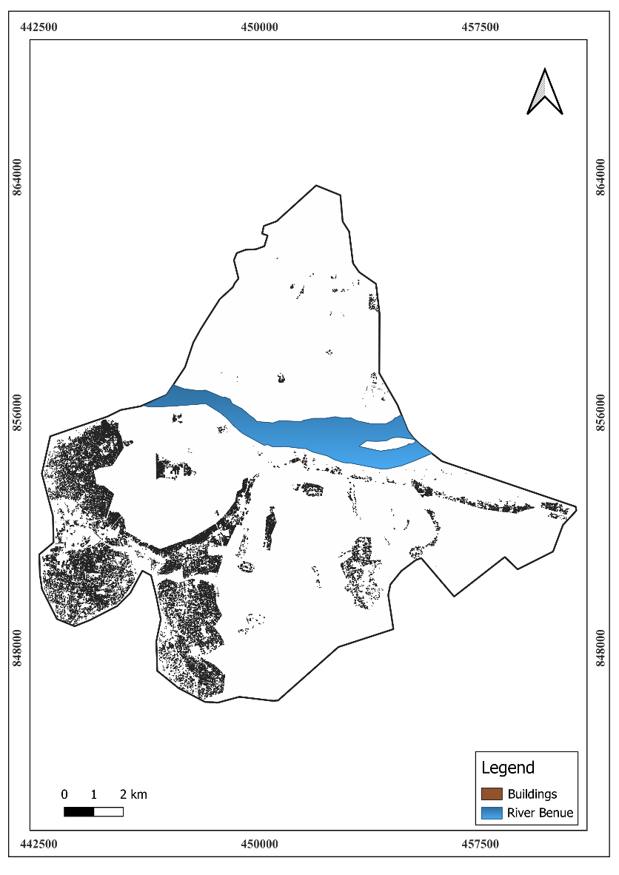

Figure 6: Density of Buildings Within Wetland Areas in Makurdi Metroplis

Table 7:Statistic Evidence of Buildings Within the Buffer (Proximity) of 50 Metres

|  |  |  |
| --- | --- | --- |
|  | **No. of Buildings** | **Percentage (%)** |
| Buildings Within Buffer Zone | 10407 | 5.27 |
| Buildings Not Within Buffer Zone | 186898 | 94.00 |
| **Total** | 197305 | 100 |

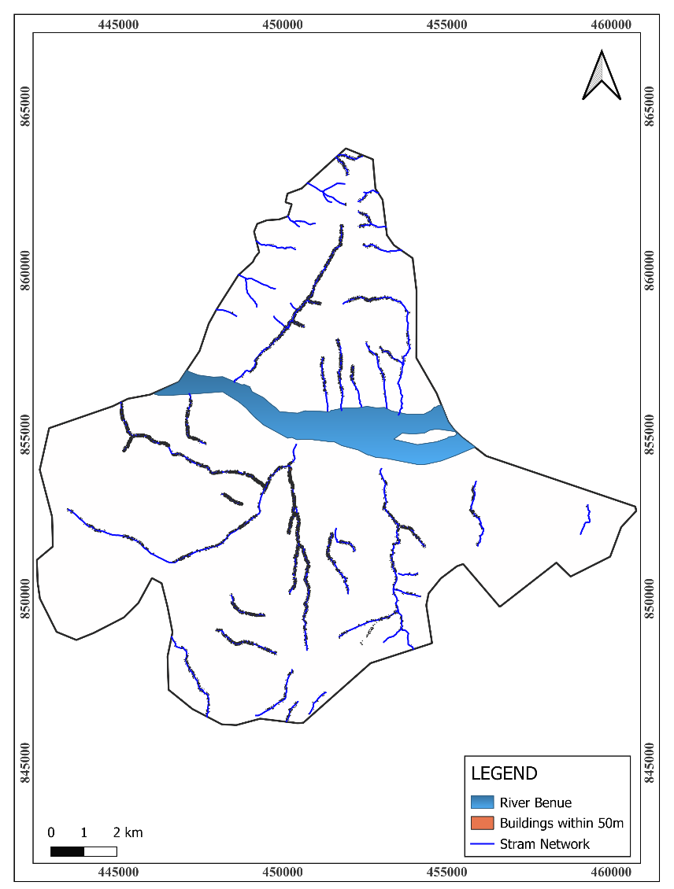

Figure 7: Map of the Study Area Showing Buildings Within Buffer Zone of 50 Meters

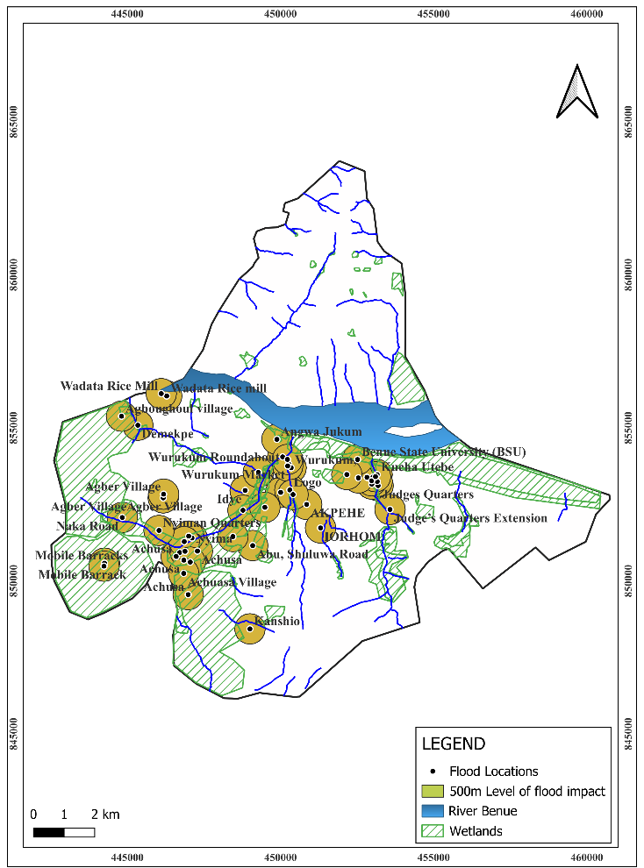

Figure 8:Map of the Study Area Showing the Spatial Relationship of Flood Occurrence and Wetland Areas

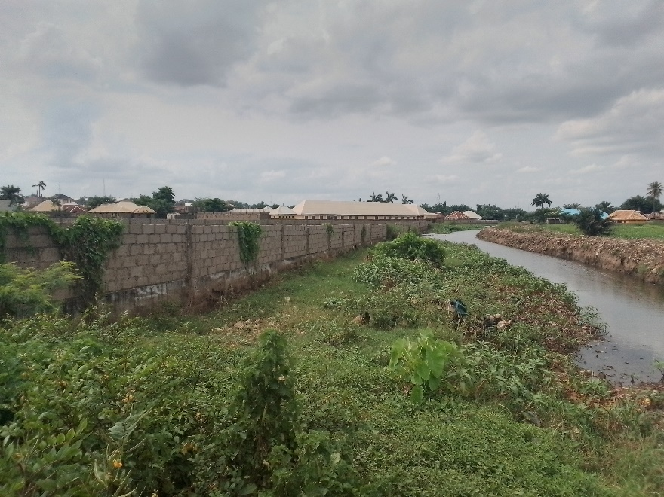

a

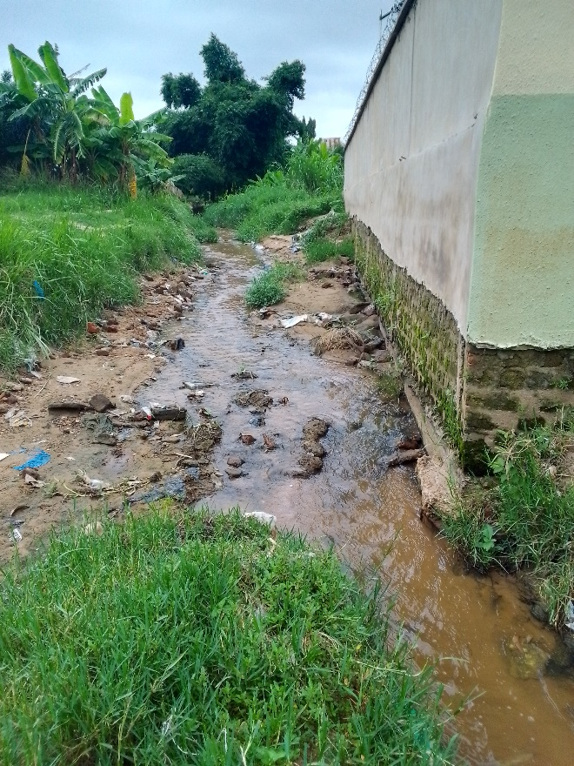 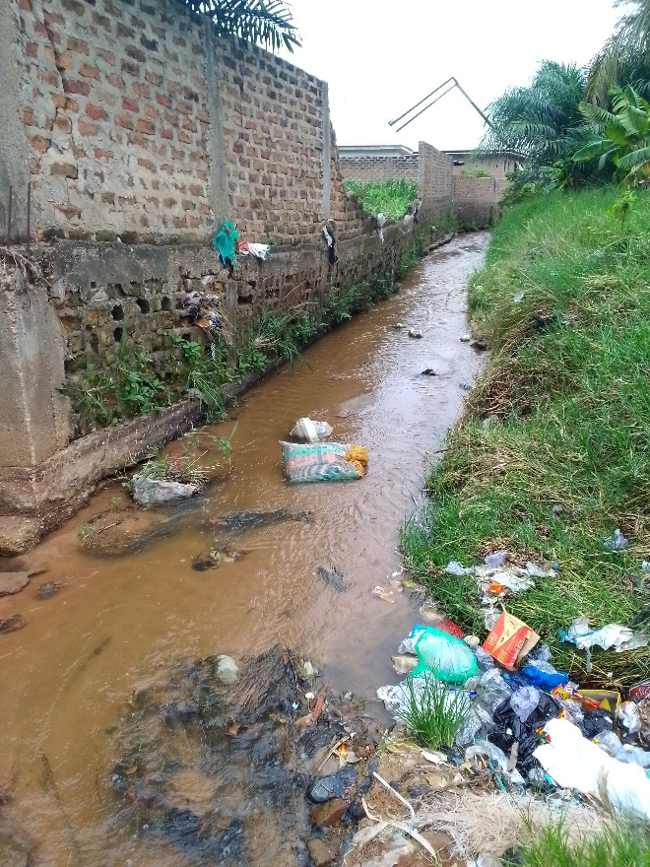

b c

Plate 3:Building Within 50 meters Proximity of Streams (‘a’, along Katsinal-Ala street, ‘b’ and ‘c’ Iorhom settlement)

**DISCUSSION**

**Land Cover Analysis of Wetland in Makurdi Metropolis**

A comparison of land cover in wetland areas between 1986 and 2023 highlights significant urban encroachment into Makurdi’s metropolitan wetlands. In 1986, vegetation occupied 75.1% of the wetland area (31.45 km²), with built-up areas covering only 1.9% (0.79 km²). However, by 2023, built-up areas had increased to 58.4% (24.43 km²), while vegetation shrank to 40.0% (16.75 km²). The substantial reduction in vegetation (35.12%) and the near-total disappearance of water bodies (1.43%) reflect the immense pressure urbanization has placed on wetland ecosystems, disrupting their natural functions, including flood regulation. As noted by [13], urbanization has contributed significantly to increased runoff due to the poor management of drainage networks and waste disposal, further exacerbating flood risks. These factors, combined with the loss of wetlands, have made the urban areas more susceptible to flooding, especially during peak rainfall periods.

**Wetland Degradation**

The overall wetland area in Makurdi has decreased drastically from 40.10 km² in 1986 to 1.57 km² in 2023, representing a 96.08% (-38.53 km²) reduction (Table 5). This alarming loss of wetland area is most prominent on the south bank of the River Benue, where urban expansion has been particularly intense (Fig 4, 5 and 6). Encroachment into wetland areas was further confirmed by the high number of building footprints within these zones. In 2023, 31.78% (62,694 buildings) of the total 197,305 buildings were located within wetland areas (Table 5 and Fig 6). A steady decline in wetland areas, reporting a 22.57% decrease by 2026 if the trends observed between 1996 and 2016 continue as noted by [5]. This projection highlights the ongoing nature of wetland degradation and emphasizes the urgent need for effective management strategies to mitigate the effects of urbanization.

The reduction in wetland areas, coupled with poor drainage infrastructure as identified by [13], exacerbates the flood vulnerability in Makurdi metropolitan area. Urban expansion into wetland zones has led to the deterioration of the city's natural flood mitigation capacity. In addition to the loss of wetlands, inadequate drainage infrastructure and waste disposal within drainage channels further intensify flood risks. The loss of natural water retention areas, coupled with poor urban planning, contributes to increased surface runoff, which heightens flood vulnerability in Makurdi [13].

**The Broader Ecological Consequences of Wetland Degradation**

According to [18], they observed a significant reduction in wetland areas in Makurdi between 1985 and 2020, with a decrease of 26.41 km², representing a 42.97% reduction in the total extent of wetlands. This loss, driven largely by urban expansion, has led to a decline in habitat availability for key aquatic species. The disappearance of wetlands has further compromised biodiversity in the region, affecting species such as Crocodylus niloticus (Nile crocodile) and Trichechus senegalensis (manatee), which depend on these ecosystems for survival. These findings align with the results of this study, where urban encroachment has reduced wetland cover from 75.1% in 1986 to 40.0% in 2023. The ongoing loss of wetlands in Makurdi not only threatens biodiversity but also diminishes the ecosystem services these areas provide, such as water filtration, carbon sequestration, and flood regulation. The degradation of these areas is not only an environmental concern but also a critical issue for sustainable urban development, as wetlands play an essential role in mitigating flood risks and maintaining the balance of local ecosystems.

**Flood Vulnerability**

The flood risk assessment reveals that 5.27% of the total buildings in Makurdi metropolitan area (10,407 buildings) were found within 50 meters of stream networks, significantly increasing their vulnerability to flooding (Table 7, Fig 7 and Plate 3). Figure 8 shows the spatial relationship between flood event occurrences and wetland areas, highlighting regions like Nyiman and Achusa, where wetland loss has been most pronounced and flood events are more frequent. This pattern is consistent with the findings of [5] who both noted that urbanization and wetland loss are key contributors to flooding in Makurdi.

Flooding in Makurdi metropolitan area is primarily driven by rainfall intensity, poor drainage systems, and urban expansion. [19] found that flooding events in Makurdi occur most frequently during the peak rainy season (August/September), when rainfall intensity is high. These findings iterate the critical role that rainfall patterns play in exacerbating flood risks. However, beyond rainfall, the loss of wetlands due to urbanization has significantly diminished the natural water retention capacity of the landscape. Wetlands, which once acted as natural buffers, absorbing excess water and regulating floodwaters, have been reduced, leaving the urban area more vulnerable to flooding. The degradation of wetlands, as identified in this study, has disrupted the flood regulating function, making it more difficult for the metropolis to naturally manage heavy rains during peak flood seasons. The reduction in wetland cover, particularly on the southern part of the metropolitan areas where urban sprawl has been most intense, has compounded the flood risk in the city. Urbanization has led to an increase in impermeable surfaces, which in turn increases surface runoff and reduces the natural infiltration of water into the ground.

In addition, [19] pointed out that inadequate drainage networks and waste dumping in drainage channels exacerbate the flooding problem in Makurdi. These findings align with those of [5, 13] who also identified poor drainage infrastructure and rapid urbanization as critical factors that heighten flood risks. Urban development has led to a decline in wetland areas, further straining the city’s drainage capacity. The loss of wetlands, combined with poor urban planning and insufficient flood management measures, has left Makurdi metropolis highly susceptible to flooding, particularly during the rainy season.

**Effect of Urbanization on Wetland**

The rapid increase in built-up areas within wetlands, from 1.9% in 1986 to 58.4% in 2023, has significantly contributed to the degradation of wetland ecosystems and heightened flood risks in Makurdi Metropolis. The reduction in vegetation cover by 35.12% and the near-total disappearance of water bodies (1.43%) within wetland zones has severely diminished the ability of these areas to absorb and manage excess floodwater, leading to increased surface runoff during rainstorms.

Urban encroachment into wetlands has been extensive, with over 62,000 buildings situated in these zones and more than 10,000 buildings within 50 meters of streams (Table 7). These developments have exacerbated flood vulnerability, as evidenced by the spatial correlation between wetland loss and flood occurrences (Figure 8). Areas such as Nyiman and Achusa, which have experienced the highest levels of wetland loss, are frequently affected by flooding, indicating that the loss of wetlands has compromised the natural flood attenuation capacity of these ecosystems.

Studies such as those by [5] have similarly shown that urbanization, coupled with wetland degradation, significantly increases flood risks. [13] further identified poor drainage networks, improper waste disposal, and rapid urbanization as key contributors to flooding in Makurdi. These issues are compounded by inadequate urban planning, which has allowed continued development in flood-prone areas despite the associated risks (Plates 1 and 2). During the peak of rainfall period, the inability of floodwaters to be absorbed or efficiently channeled results in extensive damage to infrastructure and property. This evidence highlights the need for comprehensive flood management strategies that address both urban expansion and the preservation of wetlands. Restoring degraded wetlands and integrating them into urban planning can enhance the city’s natural flood regulation capacity while mitigating future flood risks.

**Conclusions**

This study highlights the critical consequences of urbanization on wetland degradation and the associated increase in flood vulnerability in Makurdi metropolis. Over the past 37 years, wetland areas have been reduced, with built-up areas expanding by more than 55% within these zones. This encroachment has significantly diminished the natural flood regulation capacity of wetlands, resulting in heightened surface runoff and more frequent and severe flooding events. The spatial analysis reveals that urban expansion into wetland areas has not only disrupted ecological balance but also exposed thousands of buildings to flood risks, particularly in regions like Nyiman and Achusa. Poor drainage infrastructure and improper waste disposal have further increased these vulnerabilities, amplifying the challenges posed by urbanization.

This study emphasis the urgent need for sustainable urban planning that prioritizes wetland conservation and the development of robust flood management strategies. Measures such as enforcing zoning regulations to prevent further encroachment, restoring degraded wetlands, and improving drainage systems are essential to safeguarding Makurdi's metropolitan environment and reducing flood-related risks. More importantly, integrating green infrastructure and promoting community awareness of the ecological and socio-economic importance of wetlands can help ensure a balanced approach to urban development and environmental sustainability.

**REFERENCES**

1. Ahile, S. I., and Ityavyar, E. M. (2014). Household perception and preparedness against flooding in Makurdi town, Benue State, Nigeria. IOSR Journal of Environmental Science, Toxicology and Food Technology (IOSR-JESTFT), 8(11), 1-6. https://www.iosrjournals.org
2. Alikhani, S., Nummi, P., and Ojala, A. (2021). Urban Wetlands: A Review on Ecological and Cultural Values. Water, 13(22), 3301. https://doi.org/10.3390/w13223301
3. Ampatzidis, P.; Kershaw, T. (2020). A review of the impact of blue space on the urban microclimate. *Sci. Total Environ.* 2020, *730*, 139068.
4. Anule, P. and Ujoh, F. (2017) Geospatial Analysis of Wetlands Degradation in Makurdi, Nigeria. *The International Archives of the Photogrammetry, Remote Sensing and Spatial Information Sciences*, Volume XLII-2/W7, 2017 ISPRS Geospatial Week 2017, 18–22 September 2017, Wuhan, China
5. Anule, P., and Ujoh, F. (2018). Geospatial Analysis of Wetlands Degradation in Makurdi, Nigeria. Journal of Geography, Environment and Earth Science International, 14(4), 1-12. DOI: 10.9734/JGEESI/2018/39505
6. Bennett, G.; Mulongoy, K.J. *Review of Experience with Ecological Networks, Corridors and Buffer Zones*; Technical Series; Secretariat of the Convention on Biological Diversity: Montreal, QC, Canada, 2006; Volume 23, p. 100.
7. Butt, M.A., Zafar, M., Ahmed, M., Shaheen, S., Sultana, S. (2021). Types of Wetland and Wetland Plants. In: Wetland Plants. Springer, Cham. https://doi.org/10.1007/978-3-030-69258-2_3
8. Casagrande, D.G. The human component of urban wetland restoration. *Restor. Urban Salt Marsh: Interdiscip. Approach* 1997, *100*, 136–150.
9. Congedo, L. (2021). Semi-Automatic Classification Plugin: A Python tool for the download and processing of remote sensing images in QGIS. Journal of Open Source Software, 6(64), 3172, https://doi.org/10.21105/joss.03172
10. European Environmental Bureau, (2018). <https://meta.eeb.org/2018/02/08/sponge-cities-how-urban-wetlands-reduce-flood-risk/>
11. Hemba, S., Elekwachi, W., Hycienth, O. N. and Emelu, V. (2020) Ecosystem destruction and disaster risk incubation– A case of wetland loss and flood disasters in Makurdi town of Nigeria Cent. *Asian Journal of Environmental Science and Technology* *Innovation* 4(2020) 226-236
12. Hemba, S., Iortyom, E. T., Ropo, O. I., & Daniel, D. P. (2017). Analysis of the physical growth and expansion of Makurdi town using remote sensing and GIS techniques. *Imperial Journal of Interdisciplinary Research (IJIR)*, 3(7), 821-832.
13. Hula, M. A., and Udoh, J. C. (2015). An Assessment of the Impact of Flood Events in Makurdi, Nigeria. Civil and Environmental Research, 7(10), 53-63.
14. Huryna, H., Brom, J. and Pokorny, J. (2014). The importance of wetlands in the energy balance of an agricultural landscape. *Wetlands Ecol Manage* 22, 363–381 (2014). https://doi.org/10.1007/s11273-013-9334-2
15. Ikyapa, T. P., Abdulhamid, A., Rilwanu, T. Y., Daura, M. M., Alogo, P. A. (2022). Appraisal of Socio-economic, Infrastructural and Environmental Impacts of Flood in Makurdi Local Government Ares of Benue State, Nigeria. *Journal of Sustainability and Environmental Management*, 1(2), 210-217.
16. Isma’il, M., and Kersha, A.J., (2018). An assessment of the environmental effects of flooding in Makurdi Area of Benue State, Nigeria. *Journal of Scientific Research and Reports*, 20(5), 1-11. https://doi.org/10.9734/JSRR/2018/9848
17. Macrotrends. (2024). Makurdi population. Retrieved from www.macrotrends.net
18. Modu, M., and Yager, G. (2024). The Effects of Urbanization on Wetland Ecosystem and Aquatic Biodiversity in Makurdi Metropolis, Nigeria. Sustainability and Biodiversity Conservation, 3(3), 15–28. https://doi.org/10.5281/zenodo.13996596
19. Ocheri, M., and Okele, E. (2012). Social Impact and People’s Perception of Flooding in Makurdi Town, Nigeria. Hydrology for Disaster Management, Special Publication of the Nigerian Association of Hydrological Sciences, 97-106. http://www.unaab.edu.ng
20. Oyatayo K. T., Ndabula C., Jeb D. N., Adamu G. K., and Jidauna G. G. (2021). Integrating digital elevation model, landuse/landcover and flood frequency analysis: a deterministic approach to flood inundation and risk modeling of makurdi along its river benue reach. *Fudma Journal of Sciences*, *5*(1), 477 - 489. https://doi.org/10.33003/fjs-2021-0501-593
21. Peter, I.T., Adnan, A., Terwase, S., Adamu, C. S., (2020). Flood risk assessment in urban Makurdi, Benue State, Nigeria. ASIO Journal of Humanities, Management and Social Sciences Invention (ASIO-JHMSSI), 6(1), 07-17. doi: 10.2016-14781119
22. Semeniuk, C.A., Semeniuk, V. (1995). A geomorphic approach to global classification for inland wetlands. In: Finlayson, C. M., van der Valk, A.G. (eds) Classification and Inventory of the World’s Wetlands. Advances in Vegetation Science, vol 16. Springer, Dordrecht. https://doi.org/10.1007/978-94-011-0427-2_9
23. Stefanakis, A. I. (2019). The Role of Constructed Wetlands as Green Infrastructure for Sustainable Urban Water Management. Sustainability, 11(24), 6981. https://doi.org/10.3390/su11246981
24. World Population Review. (2024). Makurdi population 2024. Retrieved from www.worldpopulationreview.com
25. Xiong, Y., Mo, S., Wu, H., Qu, X., Liu, Y., & Zhou, L. (2023). Influence of human activities and climate change on wetland landscape pattern—A review. Science of the Total Environment, 879, 163112. https://doi.org/10.1016/j.scitotenv.2023.163112