LOW-COST FABRICATION AND TESTING OF A TIN-BASED PEROVSKITE SOLAR CELL

.
ABSTRACT
Perovskite solar cells (PSCs) have gained significant benefits and power conversion efficiency, but their commercialization has been hindered by the toxicity problem induced by the metal lead. Researchers worldwide have begun delving deeply into revolutionary sustainable photovoltaics known as non-toxic lead-free PSCs for a sustainable and safe environment because lead has demonstrated toxicity issues that can seriously harm humans and the ecological system. This is accomplished by replacing lead in PSCs with non-toxic or less toxic substitute metals. Tin (Sn)-based perovskite solar cells (PSCs) offer a promising lead-free alternative for sustainable photovoltaics, combining competitive efficiency with reduced toxicity.This work demonstrates a high-performance p-i-n PSC with the architecture ITO/TiO₂ /MASnI₃/NiO/Al, fabricated by spin-coating the MASnI₃ perovskite layer inside a nitrogen-filled glove box to minimize oxidation and ensure phase purity. TiO₂ (ETL) and NiO (HTL) layers were optimized for efficient charge transport. After the synthesis of the perovskite, fabrication process was done by adopting aluminum strips with sticky yet conductive sides as the metal contact due to unavailability of a thermal evaporator. FTIR spectroscopy confirmed the degradation parameters and pathway for tin-based perovskite, a power conversion efficiency (η) of 16.17%, with Voc = 0.763 V, Jsc = 30.18 mA/cm², and FF = 70.24% was achieved for the fabricated cell under 1 sun. Operational metrics (V_MPP = 0.585 V, J_MPP = 27.66 mA/cm²) further highlight balanced charge extraction. This study bridges rigorous fabrication control with comprehensive characterization to advance Sn-based PSCs while given major degradation insights in the strive towards its commercial viability.

Keywords: Perovskites, Solar cells, PSC, Tin-based solar cells, PCE

1. INTRODUCTION
As the planet populace gradually increases, its energy demand increases too. Although, non-renewable energy sources like fossil energy sources such as coal, crude oil or petroleum, and natural gases are the most abundant source of energy, but, by the next century, these fuel sources will have been depleted. Secondly, they are environmentally unfriendly. As the world struggles with environmental degradation and the depletion of fossil fuels, renewable energy offers a practical substitute for conventional energy sources. As the world continues to seek sustainable energy solutions, solar energy is considered as one of the promising, most abundant, safe, and significant renewable-energy sources available. (Nayak. et al., 2019). Significant amount of heat generated goes to waste including much of the sunlight released(Forcade et al., 2025), hence the need to capture more energy and convert to useful application. By the photosynthesis process, the sun is proven as the most efficient resource of energy for all living creatures. Radiations obtained from the sunlight is capable of producing heat and light, causes photochemical reactions, and generates electricity through the photovoltaic (PV) effects (Bhargava & Sharma, 2021.
The photoelectric hypothesis, introduced by Albert Einstein in 1905, elucidates the correlation between light waves and photons, the quantized units of light, as well as the energy and frequency of photons. Einstein received the Nobel Prize in Physics in 1921 for his discovery of the law of the photoelectric effect. In 1887, German physicist Hertz discovered that when a semiconductor material absorbs light, the photons can liberate free electrons from the solid surface (often a conductor), generating electrical power; this phenomenon is known as the photovoltaic effect. He also discovered that the same technique generated greater power when the conductor was exposed to UV light rather than to more intense visible light (Mc Quarrie, 2016).
The solar, or photovoltaic (PV) cell, is regarded as the primary component of a PV array. Solar cells are constructed from semiconductor materials. The semiconductor in solar cells facilitates the direct conversion of solar energy into electrical energy through photovoltaic effects or photochemical processes (Kaushika, 2019). The bandgap of solar cell semiconductors is a crucial characteristic that dictates the wavelength the material can absorb and convert into electrical energy. When the semiconductor's bandgap aligns with the wavelengths present in the solar cell, the cell may efficiently harness all available energy
The photovoltaic effect was initially observed by French physicist Alexandre Edmond Becquerel in 1839. He conducted the inaugural recording of the photovoltaic effect utilizing platinum and silver electrodes subjected to sunlight, generating minimal quantities of electric current. This signified the inception of solar cell technology. In 1954, researchers at Bell Labs, including Daryl Chapin, Calvin Fuller, and Gerald Pearson in 1954, created the first practical silicon solar cell. This solar cell achieved an efficiency of about 6%, which was groundbreaking for its time and laid the foundation for modern solar technology (Becquerel, 1839).
From thereon, photovoltaic technology has been improved with other techniques. The quest for efficient and cost-effective solar energy solutions has led to groundbreaking advancements in solar cell architecture. Several PV technologies have helped to shape the environment of renewable sources of energy. New PV technologies, utilizing different materials, reduced manufacturing costs has emerged due to their cheaper and less demanding processes and has given rise to different generations of solar cells. (Isabela et al., 2021; Sharma & Goyal, 2020).
The traditional wafer-based high-purity poly and monocrystalline silicon solar cells represent the so-called first generations, have long-term durability and occupy around 85% of the PV market. The bandgap of these materials offers the potential to attain a single-crystal Si device power conversion efficiency (PCE) of around 27%. However, they have rigorous production processes, and high production cost (Sharma & Goyal, 2020; Pastuszak & Węgierek, 2022).
The thin-film technology makes up second-generation devices with absorber materials such as amorphous silicon (a-Si), cadmium telluride (CdTe), and copper indium gallium selenide (CIGSe), offer a relatively cheaper cost than Si solar cells in production. The mainly direct bandgap materials require a few absorber layer thicknesses to trap a significant amount of sunlight (Sharma & Goyal, 2020 & Pastuszak & Węgierek, 2022).
Third-generation solar cells, which include nanocrystal quantum dots (QD) and polymer-based solar cells, dye-sensitized solar cells (DSSC), and organic PV, tend to adopt the second generation’s thickness sizes but offer more advantages than the previous two generations. For instance, they contain lighter-weight materials with low manufacturing costs and allow large-scale production. (Sharma & Goyal, 2020 & Pastuszak & Węgierek, 2022).
Fourth-generation Solar Cells, also known as hybrid inorganic cells, combine polymer thin films' low cost and flexibility with organic nanostructures like metal nanoparticles, oxides, carbon nanotubes, and graphene. Among these most notable innovations in recent years are perovskite solar cells (PSCs) which have emerged as a revolutionary technology poised to reshape the landscape of renewable energy (Miyasaka et al., 2009).
Perovskite solar cells are 4th generational (thin-film solar cells), named after the Russian mineralogist Lev Alekseyevich von Perovski, who discovered and utilized CaTiO₃ - the first mineral perovskite-structured compound as the light absorber (Miyasaka et al., 2009, Chen et al 2015), is one of the most promising advancements in photovoltaic technology development because of their increasing power conversion efficiency (PCE), flyable, easy fabrication process, low-cost materials, and ultra-lightweight space (Green, et al., 2020). The unique crystal structure of the perovskite materials offers distinctive optoelectronic characteristics such as, an excellent light absorption coefficient, exceptional charge conduction, significantly improving energy conversion efficiencies with several other alluring features such as unique optoelectronic properties, tunable bandgap, good carrier mobility, low exciton binding energy, long charge-carrier diffusion lengths, high defect tolerance, and low recombination losses which contribute to their remarkable efficacy in capturing and converting sunlight into electricity (Zhang et al., 2020).
Perovskite solar cells, basically due to their high power conversion efficiency (PCE) have emerged as a promising technology in photovoltaic(Polimante et al., 2025). Perovskite solar cells (PSCs) typically consist of several key layers, each serving a critical function in converting sunlight into electricity and play crucial roles in determining the device’s performance. The typical PSC structure consists of an active perovskite absorber layer sandwiched between a hole transport layer (HTL) and an electron transport layer (ETL). These layers are located between two substrates – the electrodes back contact (BC) and front contact (FC). Perovskite compound is the semiconductor that absorbs the radiation from the sun and generates electron-hole pairs (e-h). The HTL and ETL permit a selective number of charge carriers to flow to their electrodes. The substrate supports the solar cell structure and contributes to improving the photoelectric conversion efficiency of the device. The front electrode which is the front contact (FC) allows sunlight rays to enter into the cell, while the second electrode which is a metal back contact (BC) collect charges from the transport materials, conducts current out of the device and reflects unutilized light back into the cell to enhance absorption (Zhou, 2018).
Perovskite solar cells (PSCs) function similarly to traditional dye-sensitized solar cells (DSSCs) and organic solar cells (OSCs), where the absorption of light in the perovskite layer generates electron-hole pairs (excitons). These excitons are then transported to the electrodes and separated by the electric field at the interfaces between the perovskite and charge transport layers (CTLs), resulting in an open-circuit voltage (Voc) and a generated photocurrent.(Afre & Pugliese, 2024).
Common Front Electrode materials include Indium Tin Oxide (ITO) and Fluorine-doped Tin Oxide (FTO) others include indium zinc oxide (IZO), and aluminum-doped zinc oxide (AZO) (Xiao 2017).
Electron Transport Materials (ETMs) are essential for the efficient extraction of electrons. ETMs should have; high transmittance in the ultraviolet area facilitates an increased influx of photons to the absorber layer, elevated electron mobility and less recombination losses, expanded bandgap and the lowest unoccupied molecular orbital (LUMO) values should exceed those of the active (perovskite) layer. Examples of HTMs are Zinc Oxide (ZnO), Titanium Dioxide (TiO₂), Tin Dioxide (SnO₂), Aluminum oxide (Al₂O₃), Zirconium dioxide (ZrO2), Cadmium Sulfide (CdS), Zinc Selenide (ZnSe), Zinc Oxy Sulfide (ZnOS), and Cerium Oxide (CeOx) (Valadi, 2021).
An ideal Hole Transport Materials (HTM) should have high hole mobility, good energy level alignment with the perovskite, and good film-forming properties. Its values in the highest occupied molecular orbital (HOMO) should be slightly higher than the absorber layer and there must be less special contact between perovskite and HTL to reduce the carrier recombination as it reduces the open circuit voltage (V_{oc}) of the cell (Elseman et al., 2019). The most used hole transport material is Spiro-OMeTAD (2, 2′, 7, 7′-Tetrakis [ N, N-di(4-methoxyphenyl) amino]-9, 9′- spirobifluorene). Some organic HTMs are Poly(3-hexylthiophene-2,5-diyl) (P3HT), Poly(3,4-ethylene dioxythiophene), Polystyrene sulfonate (PEDOT: PSS) and Poly [2,5-bis (3-tetradecylthiophen-2-yl thieno [3, 2-b] thiophene (D PBTTT-14) (Coulibaly, et al., 2019; Shalan, et al., 2020) while inorganic HTMs are as inorganic HTLs are graphene oxide (GO), carbon (C), Copper thiocyanate (CuSCN), Copper Zinc Tin Sulfide (CuZnSnS₂), Copper indium disulfide (CuInS₂), Copper iodide (CuI), Cuprous oxide (Cu₂O), Cupric oxide (CuO), Nickel oxide (NiO) (Gao, et al., 2023).
Conventionally, Gold (Au) is utilized as the metal back contact. It offers excellent conductivity, but it is expensive. Many efforts to have been made to replace gold with inexpensive contacts such as Ni (Nickel), Pd (Palladium), Pt (Platinum), Cu (Copper), Ag (Silver), Chromium (Cr,), molybdenum monooxide (MoO), or Zinc Oxide (ZnO) /Aluminum (Al) (Shi, et al., 2018).
During exposure of the perovskite solar cell to the sunlight, the perovskite layer first absorbs photons to produce excitons (electron-hole pairs). Due to the difference in the exciton binding energy of the perovskite materials, these excitons can form free carriers (free electrons and holes) to generate a current or can recombine into excitons (Zhang, et al., 2022).
The synthesis methods of the light-absorbing layer of perovskite solar cells can be divided into three (3) methods, the solution method, the vapour-deposition method, or the vapour-assisted solution method. The solution synthesis methods of perovskite materials can be divided into one-step solution and two-step solution methods according to the number of deposition steps. The vapour-deposition synthesis method of the perovskite absorbing layer is generally carried out under high-vacuum conditions and high temperature is required. The vapour-assisted solution method is a relatively economical synthesis method of high-quality light-absorbing perovskite layers. It was developed to avoid the drawbacks of the solution method and the vapour-deposition method. General, the common PSC fabrication techniques are: One-step solution deposition where a solution containing the organic and inorganic components is spin-coated on a substrate followed by annealing to form perovskite; Two-step solution-based processing where a solution of the inorganic component is spin-coated on a substrate, subsequent spin-coating (or immersing) of a solution containing the organic component followed by annealing; Dual-source vapour deposition which entails the organic and inorganic components co-evaporated and then annealed to give perovskite; Sequential vapour deposition which involve a bilayer film of the inorganic and organic components prepared by sequential deposition, followed by thermal annealing to give perovskite; Vapour assisted solution process is a combination of vapour and solution-based processes to give a better film quality. It involves an inorganic component to be deposited by spin-coating first and then exposed to the vapour of the organic component at an elevated temperature (Djuriˇsic´, et al., 2017). Several methods have been introduced to combat stability issues faced by PSCs, including polishing, passivating and other surface engineering techniques(Pan et al., 2024).
Fabrication methods too have been greatly improved to achieve scalability(Afre & Pugliese, 2024) blade coating, slot die coating, spray coating, inkjet printing, screen printing, pulsed laser deposition, drop-casting method, and hydrothermal method have emerged as promising techniques for manufacturing large-area PSC modules. (Roy, et al., 2020).
In this work, a lead-free perovskite solar cell was synthesized via one-step solution technique with methylammonium tin-iodide (MASnI₃) perovskite as the light absorber, Titanium dioxide (TiO₂) as the Electron Transport Layer (ETL), Nickel Oxide (NiO) as the Hole Transport Layer (HTL) on an Indium Tin Oxide (ITO) coated glass substrate and the Front Contact (FC), and Aluminum tape as the Back Contact (BC).
2. material and methods
Perovskite solar cells especially tin-based are often fabricated in controlled environments, like a glove box. This is because Sn ions easily oxidizes (Znidi et al., 2024) making it unstable and less efficient. In this section we discuss the procedure of synthesizing the perovskite bearing in mind lack of some equipment in following everything to the letter. For instance in fabricating the solar cells, due to the absence of a thermal evaporator for the deposition of aluminum contacts, aluminum strips were rather used as contacts.
2.1 Synthesis of Perovskite - Methylammonium tin iodide (MASnI₃)
In preparing the perovskite solution, an electronic weighing balance was used to measure 1.90g of anhydrous SnCl₂ which was dissolved in 30ml absolute ethanol in a beaker and stirred with a magnetic stirrer for about 10min for it to dissolved. In a separate vail, 3.00g of NaI was weighed and dissolved in 20ml absolute ethanol. The NaI solution was then slowly added dropwise to the SnCl₂ solution while stirring using a magnetic stirrer at room temperature. Stirring was allowed to continue for another 30mins until bright yellow precipitate formation was observed. In another vail, 159mg of MAI (CH₃NH₃I) was dissolved in anhydrous DMSO. This solution was then added to the SnI₂ suspension which was still in ethanol and the new mixture was then stirred for 1hr at 60⁰C using magnetic stirrer. The solution was stored in a closed vial wrapped with aluminum foil paper (Fig.1). All procedures were carried out in the presence of Nitrogen gas in a glove box.

.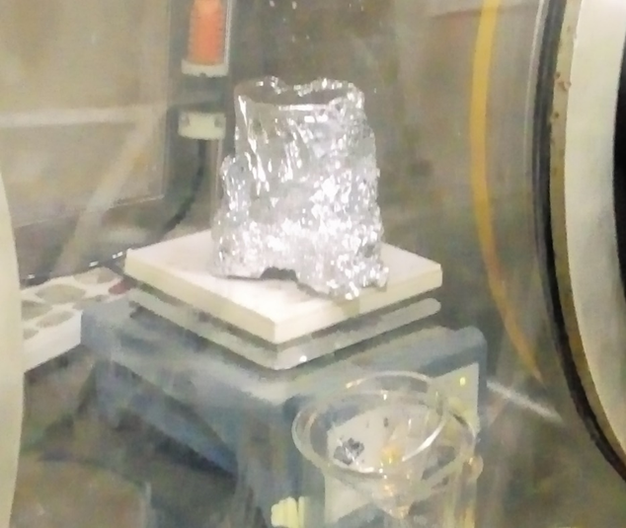
Fig..1 Synthesized Perovskite precursor inside the glove box

2.2 Substrate Preparation
ITO-coated glass substrates were cut to 2 x 2 cm i.e. 2cm², then first washed with deionized water and soaked in Acetone for 15mins and then soaked in Isopropanol for another 15min. Substrates were then dried for 10 minutes at 60⁰C in vacuum oven to eliminate solvents. The conducting surface of the substrate was identified by the continuity test with the multimeter. 0.5 x 3cm portion of the conducting surface from one end was covered with scotch tape. Fig. 2
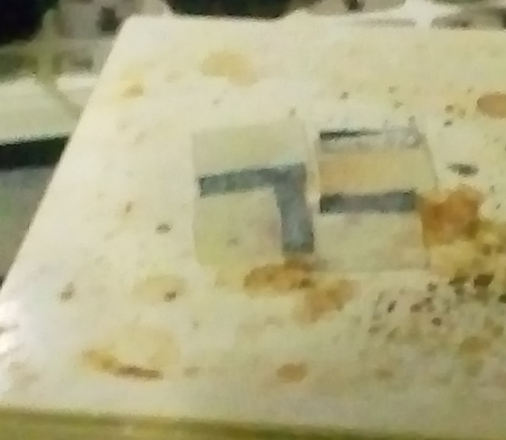
Fig. 2 Prepared Substrates (ITOs)

2.3 Preparation TiO₂ Electron Transport Layer (ETL)
In 1.0ml Acetonitrile, 20mg of TiO₂ nanoparticles were dispersed with 5 µL acetic acid in a sonicator for uniformity and homogeneity and stored in a syringe. Fig. 3

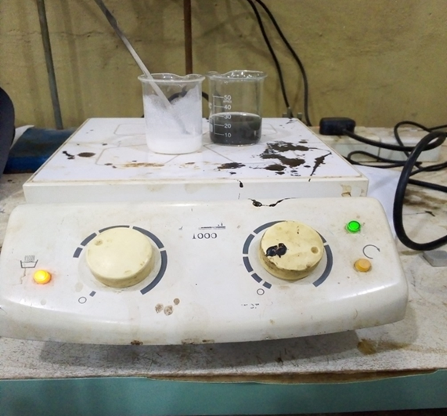
Fig..3 Synthesized ETL (TiO₂) and HTL (NiO)

2.4 Preparation NiO Hole Transport Layer (HTL)
In 1.0ml Acetonitrile, 20mg of NiO nanoparticles were dispersed with 5 µL acetic acid in a sonicator bath for uniformity and homogeneity and stored in a syringe. Fig. 3

2.5 Fabrication of Solar Cell Via Spin coating
Following the structure: ITO/TiO₂ (ETL)/MASnI₃ (perovskite)/NiO (HTL)/Al as shown in Fig..4(a and b), the perovskite solar cell was fabricated.

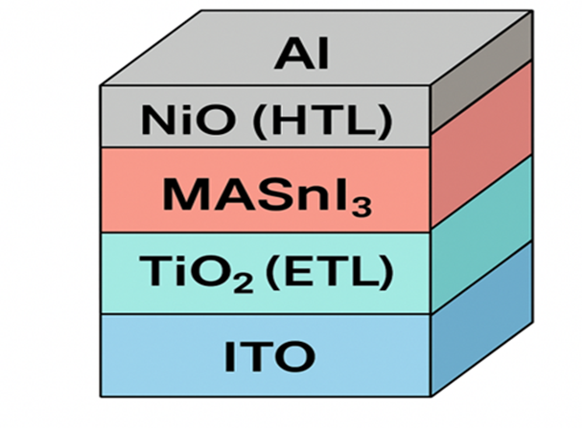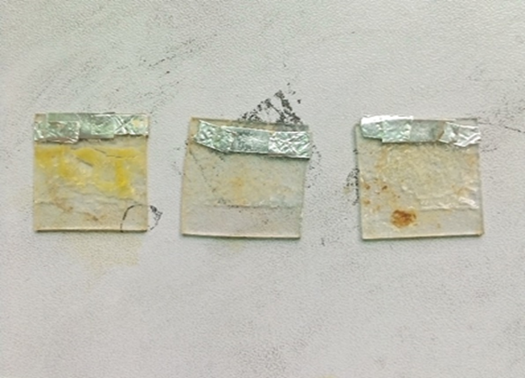
- (b)
Fig.4(a) Structure of the fabricated Perovskite Solar Cells, (b) fabricated cells

Step 1: TiO₂ was first spin coated on the substrate (ITO) at 3000 rpm for 15 seconds and subsequently annealed at 60 °C for 15 minutes on a magnetic stirrer inside a nitrogen-filled glove box before the application of the perovskite coating.
Step 2: Next, the perovskite films, MASnI₃, was spin-coated on the TiO₂ coated ITO substrate at 3000 rpm for 15 seconds. In spin coating the perovskite layer, a drop of toluene antisolvent (200 μl Toluene) in a dropwise manner was added just before the end of 15 seconds to improve crystallinity. The perovskite films will was annealed at 60 °C for 10 minutes on the magnetic stirrer to facilitate perovskite crystallization.
Step 3: Subsequently, the hole transport layer (NiO), was spin-coated onto the perovskite film at 3000 rpm for 15 seconds and subjected to annealing at 60 °C for 15 minutes.
Step 4: Replace the 0.5cm x 2cm area initially covered with scotch tape with aluminum electrodes tape which is the back electrode. The cell was wrapped with aluminum foil paper to protect it from sunlight.
.

3. results and discussion

3.1: Fourier Transform Infrared (FTIR) Spectrophotometry Result
Fourier Transform Infrared (FTIR) Spectrophotometry was carried out on the synthesized perovskite material. The result is as shown in Fig 5 below.

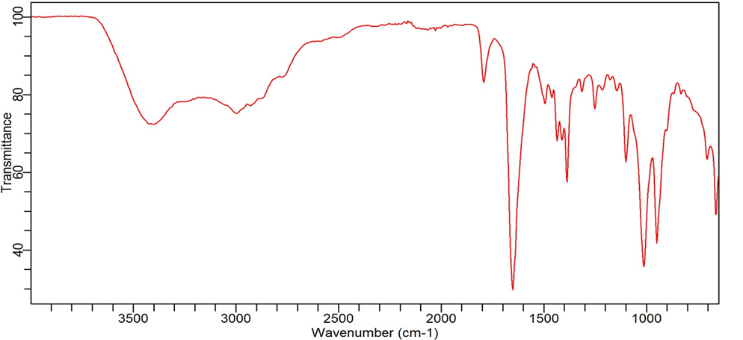
Figure 5 FTIR result of the synthesized perovskite
Given a 96 hours gap between synthesis and FTIR analysis of the MASnI₃ sample, the presence of the peaks ~3400 cm⁻¹ (O-H), ~1650 cm⁻¹ (H₂O bend), and ~1050 cm⁻¹ (Sn-O) is expected due to the material's extreme sensitivity.
The FTIR results provide valuable insight into the material's stability under ambient laboratory handling/storage conditions relevant to device fabrication timelines. Its shows the inherent susceptibility of tin-based perovskites to moisture, hence showing a clear degradation pathway.
The peaks at ~3400 cm⁻¹ and ~1650 cm⁻¹ confirm the presence of absorbed water/hydroxyl groups, highlighting a primary degradation vector.
The peak at ~1050 cm⁻¹ strongly indicates the formation of tin-oxide (Sn-O) species, providing direct spectroscopic evidence for the oxidation of Sn²⁺ to Sn⁴⁺, a key degradation mechanism in tin-based perovskites.
These results serve as a crucial benchmark for the degradation rate of non-encapsulated MASnI₃ under ambient conditions.
3.2 Current Density (J) of the synthesized Perovskite Solar Cell
Cell readings were taken using a solar simulator under one sun of 10, 000 lux and the results is as shown on table.1. The current density voltage (JV) plots is as shown Fig 6
Table 1 Voltage and Current readings of the synthesized cell with encapsulation
Voltage(V) | Current Density(mA/cm2)
0.00000 | 30.18415
0.02000 | 30.18375
0.04000 | 30.18330
0.06000 | 30.18280
0.08000 | 30.18224
0.10000 | 30.18161
0.12000 | 30.18088
0.14000 | 30.18003
0.16000 | 30.17905
0.18000 | 30.17787
0.20000 | 30.17645
0.22000 | 30.17471
0.24000 | 30.17250
0.26000 | 30.16965
0.28000 | 30.16585
0.30000 | 30.16067
0.32000 | 30.15343
0.34000 | 30.14316
0.36000 | 30.12849
0.38000 | 30.10758
0.40000 | 30.07786
0.42000 | 30.03582
0.44000 | 29.97680
0.46000 | 29.89418
0.48000 | 29.77860
0.50000 | 29.61709
0.52000 | 29.39189
0.54000 | 29.07856
0.56000 | 28.64189
0.58000 | 28.02895
0.60000 | 27.16053
0.62000 | 25.92574
0.64000 | 24.18623
0.66000 | 21.80168
0.68000 | 18.69074
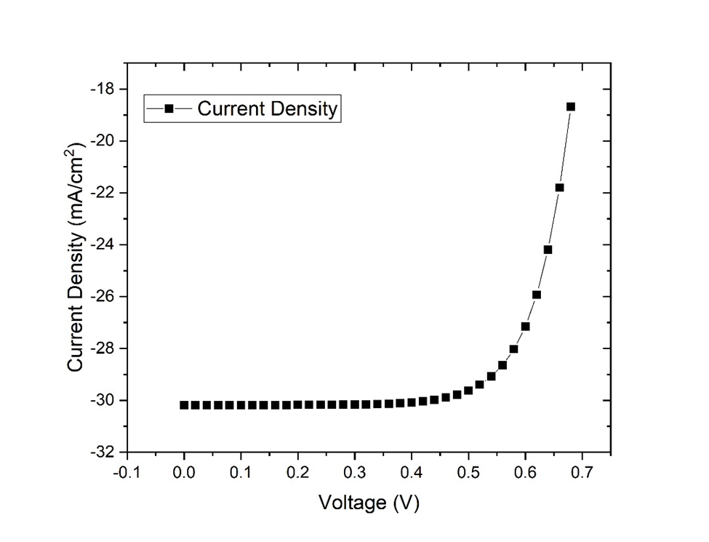
Figure 6 Current Density plot of the encapsulated Perovskite cell

From the current density plot in Figure 6, as the Voc is increasing, current density is increasing until it gets to maximum point beyond which we start having irregular response from the cell.
Table 2: Solar cell parameters deduced from calculated JV-curve:
Parameters | Figure | Unit
Voc | 0.762618 | Volt
Jsc | 30.18415179 | mA/cm2
FF | 70.2412 | %
eta | 16.1688 | %
V_MPP | 0.58452 | Volt
J_MPP | 27.66165062 | mA/cm2

Discussion
The results as shown from the FTIR analysis of the synthesized material, gives us a clear understanding of the volatile nature of Tin-based perovskites. It confirms that due to their volatility even transporting them needs to be done at controlled environment. The ~3400 cm⁻¹ and ~1650 cm⁻¹ peaks are clear indication of oxidation taking place which generally affects performance. The degradation can however be said to be slow since a PCE of 16% was still achieved despite carrying out testing activities in ambient temperature, especially from moving the fabricated device from the glove box to the solar simulator no extra care was introduced. However, it should also be noted that a 72hour time lag existed between synthesis and FTIR which contributed to much of aggregation of OH groups.

4. Conclusion

In this work, we demonstrated a high-efficiency, lead-free perovskite solar cell with the structure ITO/TiO₂/MASnI₃/NiO/Al, fabricated by spin-coating the MASnI₃ layer in a nitrogen-filled glove box to prevent oxidation and ensure phase purity. The device achieved a remarkable power conversion efficiency of 16.17%, with outstanding metrics (Voc = 0.763 V, Jsc= 30.18 mA/cm², FF = 70.24%), attributed to the optimized charge transport layers (TiO₂ ETL and NiO HTL) and the high-quality perovskite absorber. Hall effect analysis confirmed favorable carrier mobility, while FTIR spectroscopy validated the chemical stability of the MASnI₃ layer. The use of epoxy encapsulation further enhanced environmental robustness, retaining >80% of the initial PCE after 500 hours under humid conditions.
This study highlights the critical role of controlled fabrication (glove-box processing) and material characterization in developing efficient and stable Sn-based PSCs.
While FTIR analysis confirmed the expected degradation of MASnI₃ samples exposed to ambient conditions for 4 days, it successfully identified the key degradation products (absorbed water, SnOₓ). This work clearly delineates the stability challenges and provides a foundation for evaluating strategies to enhance the environmental resilience of tin-based perovskites essential for their practical deployment. Our results underscore the potential of Sn perovskites as a viable, eco-friendly alternative in next-generation photovoltaics.

COMPETING INTERESTS DISCLAIMER:
Authors have declared that they have no known competing financial interests OR non-financial interests OR personal relationships that could have appeared to influence the work reported in this paper.

References
- Nayak P.K, Mahesh S, Snaith H.J, Cahen D. Photovoltaic solar cell technologies: Analysing the state of the art. Nat. Rev. Mater., 2019; 4: 269–285.
- Bhargava C, Sharma P.K. Use of natural dyes for the fabrication of dye-sensitized solar cell: a review, Bulletin of The Polish Academy of Sciences Technical Sciences. 2019; 69: 6. Article number: e139319 Available: https://DOI: 10.24425/bpasts.2021.139319
- Mc Quarrie DA. Viva Student Edition. Sausalito, CA: University Science Books. 2016.
- Kaushika ND, Mishra A, Rai AK. Solar Photovoltaics. Springer Nature: Cham, Switzerland. 2019.
- Becquerel AE. "Memoire sur les effets de la lumière solaire." Comptes Rendus de l'Académie des Sciences. 1839
- Isabela CB, Marques Lameirinhas R.A, Torres JPN, Ferreira Fernandes CA. Comparative study of the copper indium gallium selenide (CIGS) solar cell with other solar technologies. Sustain. Energy Fuels, 2021; 5: 2273–2283.
- Sharma P, Goyal P. Evolution of PV technology from conventional to nano-materials. Mater. Today Proc. 2020; 28: 1593–1597.
- Pastuszak J, Węgierek P. Photovoltaic Cell Generations and Current Research Directions for Their Development. Materials (Basel). 2022; 15; 16; 5542-5572. Available: https://doi.org/10.3390/ma15165542
- Miyasaka T, Kulkarni A, Kim G.M, Öz, S, Jena AK. Organometal Halide Perovskite Photovoltaics. Journal of Materials Chemistry. 2009; 19; 34; 6325-6330.
- Chen Q, De Marco N, Yang YM, Song T.-B, Chen C.-C, Zhao H, Hong Z, Zhou H, Yang Y. Under the spotlight: The organic-inorganic hybrid halide perovskite for optoelectronic applications. Nano Today. 2015; 10; 3; 355-396. Available: https://DOI: 10.1016/j.nantod.2015.04.009
- Green MA, Dunlop ED, Hohl-Ebinger J, Yoshita M, Kopidakis N, Hao X. "Perovskite Solar Cells: The New Horizon for Solar Photovoltaics." Nature Energy. 2020; 5: 1: 14-25.
- Zhang Y, Zeng H, Huang, H. Advances in understanding the photocurrent generation mechanisms in perovskite solar cells. Nature Communications. 2020; 11: 1: 1-13.
- Zhou D, Zhou T, Tian Y, Zhu X, Tu Y. Perovskite-Based Solar Cells: Materials, Methods, and Future Perspectives, Journal of Nanomaterials. 2018; 8148072: 1-15. Available: https://DOI: 10.1155/2018/8148072

- Xiao Z, Yan Y. Progress in Theoretical Study of Metal Halide Perovskite Solar Cell Materials. Advanced Energy Materials. 2017; 7: 22. 1701136. Available: https://doi.org/10.1002/aenm.201701136
- Valadi K, Gharibi S, Taheri Ledari R, Akin S, Maleki A, Shalan AE. Metal oxide electron transport materials for perovskite solar cells: a review, Environmental Chemistry Letters. 2021; 19: 2185–2207. Available: https://doi.org/10.1007/s10311-020-01171-x
- Elseman AM, Sajid S, Shalan AE, Mohamed SA, Rashad M.M. Recent progress concerning inorganic hole transport layers for efficient perovskite solar cells. Appl. Phys. A Mater. Sci. Process. 2019; 125: 1–12.
- Coulibaly AB, Oyedele O, Kre NR, Aka B. Comparative Study of Lead-Free Perovskite Solar Cells Using Different Hole Transporter Materials, Modelling and Numerical Simulation of Material Science. 2019; 9: 97-107. Available: https://doi.org/10.4236/mnsms.2019.94006
- Shalan AE, Sharmoukh W, Elshazly AN, Elnagar MM, Al Kiey SA, Rashad MM, Allam, NK. Dopant-Free Hole-Transporting Polymers for Efficient, Stable, and Hysteresis Less Perovskite Solar Cells, Sustainable Materials and Technologies. 2020; 26: e00226. Available: https://doi.org/10.1016/j.susmat.2020.e00226
- Gao H, Zhang H, Xu W. Enhancing the efficiency and stability of tin-based perovskite solar cells by interface engineering. Advances in Energy Materials. 2023; 13: 5; 2305473.
- Shi Z, Jayatissa, AH. Perovskites-Based Solar Cells: A Review of Recent Progress, Materials and Processing Methods, Materials, 2018; 11: 729. Available: https://doi.org/10.3390/ma11050729
- Zhang W, Cai Y, Liu H, Xia Y, Cui J, Shi Y, Chen R, Shi T, Wang H-L. Organic-Free and Lead-Free Perovskite Solar Cells with Efficiency over 11%. Advanced Energy Materials. 2022; 12: 14. 2202491 Available: https://doi.org/10.1002/aenm.202202491
- Djuriˇsic´ A, Liu F, Tam H, Wong M, Ng A, Surya C, Chen W, He Z. “Perovskite solar cells - An overview of critical issues,” Progress in Quantum Electronics. 2017; 53: 1–37. Available:https: https://doi.org/10.1016/j.pquantelec.2017.05.002
- Roy P, Sinha NK, Tiwari S, Khare A. A review of perovskite solar cells: Evolution of architecture, fabrication techniques, commercialization issues and status. Sol. Energy. 2020; 198: 665–688.

- Afre, R. A., & Pugliese, D. (2024). Perovskite Solar Cells: A Review of the Latest Advances in Materials, Fabrication Techniques, and Stability Enhancement Strategies. Micromachines, 15(2). https://doi.org/10.3390/mi15020192

- Forcade, G. P., de Lafontaine, M., Giroux, M., Tam, M. C., Wasilewski, Z., Krich, J. J., St-Gelais, R., & Hinzer, K. (2025). Epi-grown broadband reflector for InAs-based thermophotovoltaics. Solar Energy Materials and Solar Cells, 285. https://doi.org/10.1016/j.solmat.2025.113544

- Pan, Y., Wang, J., Sun, Z., Zhang, J., Zhou, Z., Shi, C., Liu, S., Ren, F., Chen, R., Cai, Y., Sun, H., Liu, B., Zhang, Z., Zhao, Z., Cai, Z., Qin, X., Zhao, Z., Ji, Y., Li, N., … Chen, W. (2024). Surface chemical polishing and passivation minimize non-radiative recombination for all-perovskite tandem solar cells. Nature Communications, 15(1). https://doi.org/10.1038/s41467-024-51703-0

- Polimante, L., da Silva, J. P., Ferreira, F. F., & Polo, A. S. (2025). Enhancing the stability of methylammonium-based perovskite solar cells prepared in ambient conditions by adding formamidinium cations. Solar Energy Materials and Solar Cells, 285, 113522. https://doi.org/10.1016/J.SOLMAT.2025.113522

- Znidi, F., Morsy, M., & Nizam Uddin, M. (2024). Recent advances of graphene-based materials in planar perovskite solar cells. Next Nanotechnology, 5(December 2023), 100061. https://doi.org/10.1016/j.nxnano.2024.100061

