Original Research Article
GEOTECHNICAL CHARACTERISATION OF SPT-N VALUES AND ENGINEERING PROPERTIES OF FIVE REGIONAL NIGER DELTA SANDY SOILS

ABSTRACT: This research provides a thorough geotechnical evaluation of sandy soils from five key sites in Nigeria's Niger Delta. Grain size characteristics, effective overburden pressure, angle of internal friction, and Standard Penetration Test (SPT) N-values were examined in 71 samples taken from the GRA sites, Okansu Bridge, Otuogori Bridge, Rumuibekwe Bridge, and Kana Ataba. Friction angles varied between 26° and 38°, SPT-N values between 4 and 51, and effective overburden pressures between 26.10 and 304.77 kPa. While there were no significant changes in friction angles or effective overburden pressures, statistical analysis demonstrated considerable geographic variability in SPT-N values between sites (p < 0.05). Grain size studies showed that the soils were mostly sandy, with D50 values between 0.002 and 2.008 mm. In this economically significant area, the study establishes baseline geotechnical parameters necessary for foundation design and infrastructure development by offering the first complete regional database for sandy soils in the Niger Delta.
Keywords: Niger Delta, sandy soils, Standard Penetration Test, spatial variability, geotechnical characterization

INTRODUCTION
Nigeria's Niger Delta is one of the most important petroleum-producing regions in the world, with a vast infrastructure development that includes pipelines, refineries, oil platforms, and related facilities. Due to the region's complicated geological past, which is marked by fast sedimentation and deltaic processes, many soil types have been produced, posing particular difficulties for the practice of geotechnical engineering. Although this region is economically significant, there is still a lack of thorough geotechnical characterization of its sandy soils, which leads to knowledge gaps in engineering that affect the design of safe and cost-effective infrastructure. N-values from the Standard Penetration Test (SPT) are essential metrics in geotechnical engineering that give vital details on the density, consistency, and strength properties of soil. Numerous studies have examined the connection between SPT resistance and engineering qualities in a variety of geological contexts around the globe (Cubrinovski & Ishihara, 1999; Hatanaka & Uchida, 1996; Mujtaba et al., 2018). However, there are still few studies that specifically address the circumstances in the Niger Delta. According to earlier studies, SPT-soil property correlations are greatly influenced by regional geological circumstances, which calls for location-specific characterisation investigations (Phoon & Kulhawy, 1999; Anbazhagan & Sitharam, 2010). For SPT-based geotechnical parameter estimation, a number of empirical correlations have been established worldwide. One of the first associations between SPT N-values and bearing capacity for sandy soils was made by Meyerhof (1957), while Cubrinovski and Ishihara (1999) created thorough connections between SPT resistance and relative density. The impact of several elements, such as particle size, uniformity coefficient, and effective overburden stress, on penetration resistance values was highlighted in more recent research by Ghali et al. (2018), which suggested frameworks to enhance SPT-N correlations with geotechnical parameters in sand.
One of the first associations between SPT N-values and bearing capacity for sandy soils was made by Meyerhof (1957), while Cubrinovski and Ishihara (1999) created thorough connections between SPT resistance and relative density. The impact of several elements, such as particle size, uniformity coefficient, and effective overburden stress, on penetration resistance values was highlighted in more recent research by Ghali et al. (2018), which suggested frameworks to enhance SPT-N correlations with geotechnical parameters in sand. Local geological circumstances are crucial for the establishment of SPT correlations, as regional studies have repeatedly shown. SPT-CPT correlations for sandy soils in Brazil were studied by Dos Santos and Bicalho (2017), whereas Khan et al. (2022) created correlations for reclaimed land close to Dubai. Similar associations were created for Tanzanian sandy soils by Lingwanda et al. (2015) and for alluvial deposits in Dhaka city by Arifuzzaman and Anisuzzaman (2022). All of these studies highlight how geographical features, geological history, and soil depositional environment have a big impact on SPT-based correlations. Advanced statistical and machine learning techniques have been used in recent studies to increase correlation accuracy. In order to estimate friction angles for silty sands, Sabab et al. (2022) used machine learning techniques to analyze SPT data. Ullah et al. (2025) created machine learning methods for predicting internal friction angles using SPT records. Tree-based machine learning methods were studied by Demir and Sahin (2022, 2023) for the prediction of geotechnical parameters, and they performed better than conventional regression techniques. The unique depositional environment of the Niger Delta, which is marked by complicated stratigraphic sequences and fast rates of sedimentation, produces soil conditions that could behave differently than in other deltaic settings.
In order to facilitate trustworthy foundation design and geotechnical analysis, the area's sandy deposits—which were created by fluvial, marine, and estuarine processes—display different grain size distributions, density states, and engineering characteristics that call for methodical research (Kalantary et al., 2009; Kim et al., 2022). When it comes to geotechnical characterisation, spatial variability is crucial, especially in intricate depositional systems like the Niger Delta. More precise site-specific design techniques and enhanced risk assessment for infrastructure projects are made possible by an understanding of the distribution and fluctuation of soil qualities across various places (Kumar et al., 2016; Hettiarachchi & Brown, 2009). The capacity to assess spatial variability and detect notable variations in soil qualities across geographic regions has improved due to recent developments in statistical analytic tools. Providing a thorough geotechnical evaluation of sandy soils from five key locations in the Niger Delta area with an emphasis on SPT-N values, engineering characteristics, and spatial variability assessment is the aim of this work. The first regional database of geotechnical characteristics tailored to sandy soils in the Niger Delta is created by this study, offering crucial baseline data for geotechnical engineering practice in this economically vital area.

MATERIALS AND METHOD

2.1 Study Area
In Nigeria's Niger Delta, the research was carried out in five key locations, including parts of the states of Rivers and Bayelsa. Approximately 70,000 km² in size, the Niger Delta makes up 7.5% of Nigeria's landmass and is distinguished by its many natural zones, which include freshwater forests and coastal mangroves, as well as intricate hydrological systems. Kana Ataba (4°46'13.74"N, 7°28'6.42"E) in Andoni Local Government Area, which represents the coastal lowland zone at 5–10 meters above mean sea level; Okansu (5.33°N, 6.69°E) in Ogba/Egbema/Ndoni Local Government Area, which represents the transitional upland zone at 26 meters; and Otuogari (4°39'00"N, 6°16'00"E) in Ogbia Local Government Area, Bayelsa State, which represents the core Niger Delta wetland zone at 2–8 meters above mean sea level; Rumuibekwe in Obio/Akpor Local Government Area, which represents the peri-urban zone at altitudes below 15.24 meters; and GRA in Port Harcourt, which represents the urban zone at elevations between 8 and 15 meters (4°49'16"N, 7°0'4"E). A tropical monsoon climate prevails in the area, with mean annual temperatures of 28.64°C and 2,000–2,900 millimeters of precipitation. The study area's varied soil profiles are a result of marine and estuarine sedimentary impacts, whereas the geological backdrop is composed of Quaternary to Recent alluvial deposits covering coastal plain sands.
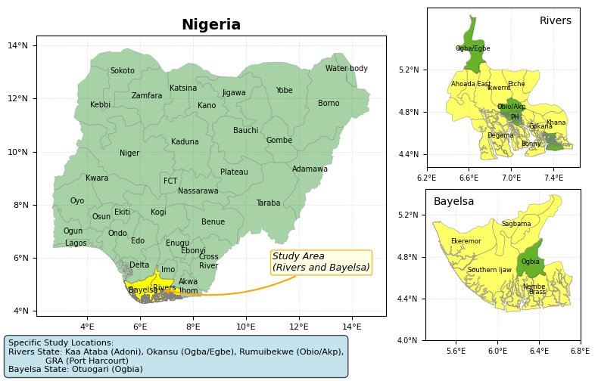
Figure 1: Map of the study Area

2.2 Data Collection
Systematic sampling techniques were used to gather 71 soil samples from the five key sites. To guarantee constant energy delivery and accurate blow count readings, Standard Penetration Testing was carried out in accordance with ASTM D1586 criteria utilizing calibrated drilling equipment with automated trip hammers. Continuous soil logging and description were conducted during the drilling operation, and SPT testing was carried out at regular depth intervals, usually every 1.5 meters.
The laboratory testing programs comprised unit weight measurements utilizing calibrated processes, thorough grain size analysis by sieve analysis, moisture content determination using oven-drying methods, and consolidated drained triaxial compression tests for determining friction angle. All laboratory testing was carried out at approved geotechnical labs in accordance with quality control guidelines and standard operating procedures.
With depths ranging from 3 to 34.5 meters below the surface, the sampling distribution comprised 14 samples from Kana Ataba, 12 from Okansu Bridge, 26 from Otuogori Bridge, 16 from Rumuibekwe Bridge, and 3 from GRA. This distribution preserved enough data density for statistical analysis while guaranteeing proper representation of the various physiographic zones within the Niger Delta.

2.3 Data Analysis
In order to identify suitable statistical methods for further analysis, normality testing was carried out using the Shapiro-Wilk and Anderson-Darling tests. In order to account for different data distribution features, statistical analysis used both parametric and non-parametric approaches. Measures of dispersion (standard deviation, coefficient of variation), central tendency (mean, median), and distribution shape (skewness) were all included in descriptive statistics.
In order to analyze significant variations in geotechnical parameters across sample locations, the Kruskal-Wallis test was used. Dunn's post-hoc multiple comparison test was then used to pinpoint location pairings that showed significant differences. The non-parametric method was used to account for any non-normal data distributions and disparities in sample sizes among sites. The significance levels for all statistical analyses were set at α = 0.05, and the appropriate software was used.

Results

3.1 Statistical Description of Geotechnical Parameters
The thorough examination of SPT-N values at each of the five sampling sites showed significant differences in the properties of soil penetration resistance. The study's summary data for each of the geotechnical parameters examined are shown in Table 1. A coefficient of variation of 39.69% indicated significant variability in SPT-N values, suggesting that soil conditions varied throughout the research region. The distribution with a longer tail toward lower SPT-N values is suggested by the negative skewness (-0.46), which is in line with the deltaic depositional environment where loose to medium packed circumstances are more common. Friction angles exhibited a minor tendency toward higher values, with positive skewness (0.27) and rather moderate variability (CV = 8.55%). Given that the soils under investigation were primarily sandy, the small range (26° to 38°) indicates a uniform mineralogical composition throughout the area. In generally homogenous soil profiles, effective overburden pressure showed a linear relationship between stress and depth, with a nearly symmetrical distribution (skewness = 0.14) and moderate variability (CV = 48.42%).

Table 1: Statistical Summary of Geotechnical Parameters
Parameter | Count | Mean | Median | Std Dev | Min | Max | CV (%) | Skewness
SPT-N | 71 | 28.32 | 30.00 | 11.24 | 4.00 | 51.00 | 39.69 | -0.46
Friction Angle (°) | 71 | 31.55 | 32.00 | 2.70 | 26.00 | 38.00 | 8.55 | 0.27
Effective Stress (kPa) | 71 | 157.78 | 150.75 | 76.40 | 26.10 | 304.77 | 48.42 | 0.14

3.2 Location-Specific Analysis
Significant regional diversity throughout the Niger Delta region is revealed by the statistical summary of SPT-N values by sample location, which is shown in Table 2. The greatest mean SPT-N value was recorded by Okansu Bridge (34.42), closely followed by Kana Ataba (33.79), while the lowest was recorded by GRA (7.00). Different places had different levels of consistency in soil density, as shown by the coefficient of variation, which varied from 12.86% at Otuogori Bridge to 62.27% at GRA.
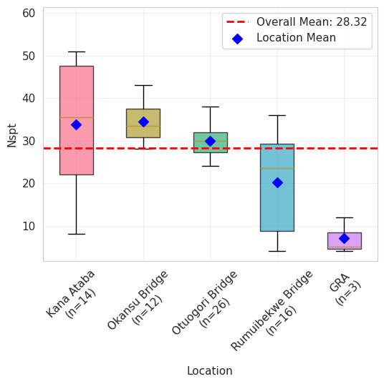
Figure 2: Mean SPT-N values at the five sampling locations

Table 2: SPT-N Values by Sampling Location
Location | Count | Mean | Median | Std Dev | Min | Max | CV (%) | Skewness
Kana Ataba | 14 | 33.79 | 35.50 | 14.89 | 8 | 51 | 44.06 | -0.34
Okansu Bridge | 12 | 34.42 | 33.50 | 4.80 | 28 | 43 | 13.93 | 0.36
Otuogori Bridge | 26 | 30.00 | 30.00 | 3.86 | 24 | 38 | 12.86 | 0.44
Rumuibekwe Bridge | 16 | 20.25 | 23.50 | 11.43 | 4 | 36 | 56.46 | -0.24
GRA | 3 | 7.00 | 5.00 | 4.36 | 4 | 12 | 62.27 | 1.63

3.3 Spatial Variability Assessment
SPT-N values varied significantly between sample locations, according to the findings of the Kruskal-Wallis test (H = 14.65, df = 4, p = 0.005). Rumuibekwe Bridge displayed much lower values than Okansu Bridge, whereas GRA had significantly lower SPT-N values than the majority of other sites, according to post-hoc multiple comparison analysis. Friction angles, on the other hand, did not significantly change between sites (H = 5.711, df = 4, p = 0.222), suggesting that the shear strength characteristics were constant across the research region. The regional variance of effective overburden pressures was also not significant (H = 3.589, df = 4, p = 0.464).

Table 3: Kruskal-Wallis Test Results for SPT-N Values by Location
K (Observed value) | 14.650
K (Critical value) | 9.488
DF | 4
p-value (Two-tailed) | 0.005
alpha | 0.05

Table 4: Post-Hoc Multiple Comparison Test Results for SPT-N Values
Sample | Frequency | Sum of ranks | Mean of ranks | Groups
Nspt | GRA | 3 | 13.000 | 4.333 | A
Nspt | Rumuibekwe Bridge | 13 | 264.000 | 20.308 | A | B
Nspt | Otuogori Bridge | 22 | 670.500 | 30.477 |  | B | C
Nspt | Kana Ataba | 8 | 262.500 | 32.813 |  | B | C
Nspt | Okansu Bridge | 10 | 386.000 | 38.600 |  |  | C

3.4 Subsurface Conditions and Soil Classification
The subsurface analysis showed that each of the five sites has a unique stratigraphic profile. Otuogori Bridge had the most intricate profile, with 26 different layers reaching a depth of 34.5 meters, while GRA had the most straightforward shape, with three layers reaching 16.5 meters. Sand was the most common soil type in all places, with Rumuibekwe Bridge mostly displaying fine-grained features and four locations displaying coarse-grained dominance. Similar mineralogical compositions and oxidation states were revealed by the constant light brown and light grey colorations.

Table 5: Soil Classification Summary by Location
Location | GRA | Kana Ataba | Okansu Bridge | Otuogori Bridge | Rumuibekwe Bridge
Total Layers | 3 | 14 | 12 | 26 | 8
Predominant Grain Size | Coarse | Coarse | Coarse | Coarse | Fine
Predominant Density | Loose | Medium Dense | Dense | Medium Dense | Medium Dense
Predominant Soil Type | Sand | Sand | Sand | Sand | Sand
Predominant Color | Light Grey | Light Brown | Light Brown | Light Brown | Light Brown
Overall Classification | Coarse Loose Sand Light Grey | Coarse Medium Dense Sand Light Brown | Coarse Dense Sand Light Brown | Coarse Medium Dense Sand Light Brown | Fine Medium Dense Sand Light Brown

3.5 Grain Size Analysis
D50 values varied significantly across locations, reflecting diverse depositional environments and energy conditions during sediment formation. GRA exhibited the highest mean D50 value (0.747 mm), while Otuogori Bridge showed the most consistent grain size distribution with the lowest variability (standard deviation = 0.096 mm). Rumuibekwe Bridge demonstrated the most heterogeneous grain size distribution, with D50 values spanning from silt-sized particles (0.002 mm) to gravel-sized materials (2.008 mm), reflecting the complex deltaic progradation sequence characteristic of this location.

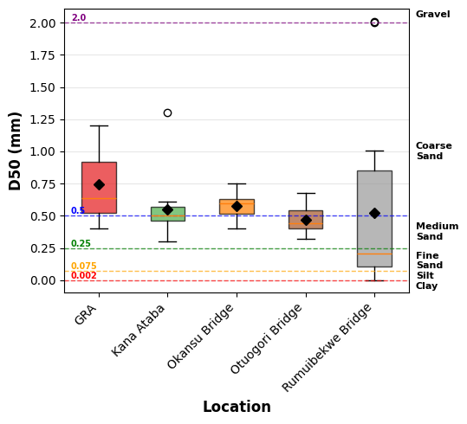
Figure 3: Mean D50 at the various sampling locations

Table 6: Grain Size Analysis by Location
Location | Count | Mean D50 (mm) | Median D50 (mm) | Std Dev | Min D50 (mm) | Max D50 (mm)
GRA | 3 | 0.747 | 0.640 | 0.411 | 0.400 | 1.200
Kana Ataba | 14 | 0.552 | 0.500 | 0.229 | 0.300 | 1.300
Okansu Bridge | 12 | 0.577 | 0.600 | 0.106 | 0.400 | 0.750
Otuogori Bridge | 26 | 0.467 | 0.440 | 0.096 | 0.320 | 0.680
Rumuibekwe Bridge | 8 | 0.522 | 0.204 | 0.666 | 0.002 | 2.008

3.6 Discussion
The region's complicated geological history and varied depositional conditions are reflected in the notable regional heterogeneity in SPT-N levels throughout the five Niger Delta locales. Significant variations in soil density and strength characteristics over comparatively short distances are demonstrated by the wide range of mean SPT-N values from 7.00 at GRA to 34.42 at Okansu Bridge, underscoring the vital significance of site-specific geotechnical investigations in deltaic environments. Similar findings have been documented from different deltaic locations around the world, where soil engineering qualities are greatly influenced by local geological conditions (Dos Santos & Bicalho, 2017; Khan et al., 2022). At GRA, the continuously low SPT-N readings show mostly loose soil conditions, which are probably the result of recent depositional processes and a short history of consolidation. In order to attain sufficient bearing capacity and settlement performance, deep foundation systems or ground modification techniques may be required in metropolitan Port Harcourt. This has important ramifications for foundation design. The high SPT-N values at Kana Ataba and Okansu Bridge, on the other hand, point to well-consolidated sandy deposits with advantageous engineering characteristics for traditional foundation systems. This could be the consequence of diverse depositional energy environments that encouraged better particle packing or larger effective stress histories. In contrast to the SPT-N variability patterns, the lack of notable spatial variation in friction angles among sites is a major result. This constancy implies that although density states differ greatly over the area, the basic shear strength properties stay mostly consistent, most likely due to comparable mineralogical compositions and particle properties across the sandy deposits of the Niger Delta. The small range of friction angles (26° to 38°) is indicative of mostly non-plastic, granular materials with constant internal friction properties and fits within usual values for medium thick sandy soils (Anbazhagan & Sitharam, 2010).
The dynamic depositional history of the Niger Delta area is reflected in the subsurface complexity, which ranges from the straightforward three-layer profile of GRA to the intricate 26-layer sequence of Otuogori Bridge. For geotechnical design, this stratigraphic complexity has important ramifications, especially for deep foundation systems and excavation projects that need to take into consideration changing soil conditions with depth. Four of the five sites have a preponderance of coarse-grained sandy materials, which suggests generally favorable conditions for drainage and foundation stability. However, Rumuibekwe Bridge's fine-grained characteristics point to possible difficulties with consolidation settlement and drainage requirements. The substantial regional range in D50 values sheds light on the sediment transport processes and depositional energy conditions that gave rise to these deposits. While the finer materials at Otuogori Bridge indicate lower energy conditions characteristic of protected deltaic settings, the coarse-grained minerals at GRA and Okansu Bridge reflect greater energy depositional environments, presumably connected to proximal fluvial or nearshore marine conditions. A complicated depositional history involving several energy regimes or post-depositional alteration activities is reflected in the great variability seen at Rumuibekwe Bridge.

Conclusion
The geotechnical evaluation of sandy soils in the Niger Delta at five key locations shows uniform shear strength characteristics throughout the area, but notable spatial diversity in penetration resistance characteristics. Diverse depositional histories and consolidation states are reflected in the wide range of SPT-N values, which range from mostly loose conditions at GRA to dense conditions at Okansu Bridge and Kana Ataba. The regional sandy deposits appear to have identical mineralogical compositions and particle properties, as seen by the remarkable consistency of friction angles across all sites, which show uniform shear strength characteristics despite variable density states. Four out of five sites are dominated by coarse-grained sandy materials, while subsurface conditions vary from straightforward three-layer profiles to intricate 26-layer sequences. Analysis of grain sizes shows that median grain sizes vary significantly.
CONSENT
"All authors declare that ‘written informed consent was obtained from the patient (or other approved parties) for publication of this case report and accompanying images. A copy of the written consent is available for review by the Editorial office/Chief Editor/Editorial Board members of this journal."

REFERENCES
Anbazhagan, P., & Sitharam, T. G. (2010). Relationship between shear wave velocity and SPT-N for different types of soils in India. Geotechnical and Geological Engineering, 28(1), 119-137. https://doi.org/10.1007/s10706-009-9285-4
Arifuzzaman, A., & Anisuzzaman, M. (2022). An initiative to correlate the SPT and CPT data for an alluvial deposit of Dhaka city. International Journal of Geo-Engineering, 13(5), 1-13. https://doi.org/10.1186/s40703-021-00170-3
Asci, M., Kurtulus, C., Kaplanvural, I., & Mataracioglu, M. O. (2014). Correlation of SPT-CPT data from the subsidence area in Golcuk, Turkey. Soil Mechanics and Foundation Engineering, 51(6), 268-272. https://doi.org/10.1007/s11204-015-9294-y
Chen, J. (2004). Axial behavior of drilled shafts in gravelly soils [Doctoral dissertation, Cornell University].
Cubrinovski, M., & Ishihara, K. (1999). Empirical correlation between SPT N-value and relative density for sandy soils. Soils and Foundations, 39(5), 61-71. https://doi.org/10.3208/sandf.39.5_61
Demir, S., & Sahin, E. K. (2022). Comparison of tree-based machine learning algorithms for predicting liquefaction potential using canonical correlation forest, rotation forest, and random forest based on CPT data. Soil Dynamics and Earthquake Engineering, 154, 107130. https://doi.org/10.1016/j.soildyn.2021.107130
Demir, S., & Sahin, E. K. (2023). An investigation of feature selection methods for soil liquefaction prediction based on tree-based ensemble algorithms using AdaBoost, gradient boosting, and XGBoost. Neural Computing and Applications, 35, 3173-3190. https://doi.org/10.1007/s00521-022-07856-4
Dos Santos, M. D., & Bicalho, K. V. (2017). Proposals of SPT-CPT and DPL-CPT correlations for sandy soils in Brazil. Journal of Rock Mechanics and Geotechnical Engineering, 9(6), 1152-1158. https://doi.org/10.1016/j.jrmge.2017.08.001
Fernando, H., Nugroho, S. A., Suryanita, R., & Kikumoto, M. (2021). Prediction of SPT value based on CPT data and soil physical properties using ANN with and without data normalization. International Journal of Artificial Intelligence Research, 5(2), 123-131. https://doi.org/10.29099/ijair.v5i2.192
Ghali, M., Chekired, M., & Karray, M. (2018). Framework to improve the correlation of SPT-N and geotechnical parameters in sand. Acta Geotechnica, 13(6), 1445-1458. https://doi.org/10.1007/s11440-018-0745-3
Hatanaka, M., & Uchida, A. (1996). Empirical correlation between penetration resistance and internal friction angle of sandy soils. Soils and Foundations, 36(4), 1-9. https://doi.org/10.3208/sandf.36.4_1
Hettiarachchi, H., & Brown, T. (2009). Use of SPT blow counts to estimate shear strength properties of soils: Energy balance approach. Journal of Geotechnical and Geoenvironmental Engineering, 135(6), 830-834. https://doi.org/10.1061/(ASCE)GT.1943-5606.0000016
Jarushi, F., AlKaabi, S., & Cosentino, P. (2015). A new correlation between SPT and CPT for various soils. International Journal of Geological and Environmental Engineering, 9(2), 101-107.
Kalantary, F., Ardalan, H., & Nariman-Zadeh, N. (2009). An investigation on the Su-NSPT correlation using GMDH type neural networks and genetic algorithms. Engineering Geology, 104(1-2), 144-155. https://doi.org/10.1016/j.enggeo.2008.09.006
Kara, O., & Gunduz, Z. (2010). Correlation between CPT and SPT in Adapazari, Turkey. In Proceedings of the 2nd International Symposium on Cone Penetration Testing (pp. 1-8). CPT'10.
Khan, Z., Yamin, M., Attom, M., & Al Hai, N. (2022). Correlations between SPT, CPT, and Vs for reclaimed lands near Dubai. Geotechnical and Geological Engineering, 40, 4109-4120. https://doi.org/10.1007/s10706-022-02143-4
Khodaparast, M., Rajabi, A. M., & Derakhshan, M. (2020). Development of practical correlations between cone penetration resistance and SPT values for various types of soils. Iranian Journal of Science and Technology, Transactions of Civil Engineering, 44(Suppl 1), 471-481. https://doi.org/10.1007/s40996-019-00319-2
Kim, M., Okuyucu, O., Ordu, E., Ordu, S., Arslan, Ö., & Ko, J. (2022). Prediction of undrained shear strength by the GMDH-type neural network using SPT-value and soil physical properties. Materials, 15(18), 6385. https://doi.org/10.3390/ma15186385
Kulhawy, F. H., & Mayne, P. W. (1990). Manual on estimating soil properties for foundation design (Report No. EL-6800). Electric Power Research Institute.
Kumar, R., Bhargava, K., & Choudhury, D. (2016). Estimation of engineering properties of soils from field SPT using random number generation. Transactions of the Indian National Academy of Engineering, 1(2), 77-84. https://doi.org/10.1007/s41403-016-0012-6
Liao, S. S. C., & Whitman, R. V. (1986). Overburden correction factors for SPT in sand. Journal of Geotechnical Engineering, 112(3), 373-377. https://doi.org/10.1061/(ASCE)0733-9410(1986)112:3(373)
Lingwanda, M. I., Larsson, S., & Nyaoro, D. L. (2015). Correlations of SPT, CPT and DPL data for sandy soil in Tanzania. Geotechnical and Geological Engineering, 33, 1221-1233. https://doi.org/10.1007/s10706-015-9897-1
Mayne, P. W., & Kulhawy, F. H. (1982). K0-OCR relationships in soil. Journal of the Geotechnical Engineering Division, 108(6), 851-872. https://doi.org/10.1061/AJGEB6.0001306
Meyerhof, G. G. (1956). Penetration tests and bearing capacity of cohesionless soils. Journal of the Soil Mechanics and Foundation Division, ASCE, 82(SM1), 1-19. https://doi.org/10.1061/JSFEAQ.0000074
Meyerhof, G. G. (1957). Discussion on research on determining the density of sands by spoon penetration testing. In Proceedings of the 4th International Conference on Soil Mechanics and Foundation Engineering (Vol. 3, pp. 110-115). Butterworths Scientific Publications.
Mujtaba, H., Farooq, K., Sivakugan, N., & Das, B. M. (2018). Evaluation of relative density and friction angle based on SPT-N values. KSCE Journal of Civil Engineering, 22(2), 572-581. https://doi.org/10.1007/s12205-017-1899-5
Peck, R. B., Hanson, W. E., & Thornburn, T. H. (1974). Foundation engineering handbook. John Wiley & Sons.
Phoon, K. K., & Kulhawy, F. H. (1999). Characterization of geotechnical variability. Canadian Geotechnical Journal, 36(4), 612-624. https://doi.org/10.1139/t99-038
Robertson, P. K., & Campanella, R. G. (1983). Interpretation of cone penetration tests: Sands and clays. Canadian Geotechnical Journal, 20, 719-745. https://doi.org/10.1139/t83-079
Sabab, A. B., Islam, M. S., & Haque, M. N. (2022). Machine learning approach to predict the friction angle of silty sand from standard penetration test. Engineering Research Express, 4(3), 035018. https://doi.org/10.1088/2631-8695/ac7f49
Schmertmann, J. H. (1970). Static cone to compute static settlement over sand. Journal of the Soil Mechanics and Foundations Division, 96(3), 1011-1043. https://doi.org/10.1061/JSFEAQ.0001418
Schmertmann, J. H. (1975). Measurement of in-situ shear strength. In Proceedings of the ASCE Specialty Conference on In Situ Measurement of Soil Properties (Vol. 2, pp. 57-138). American Society of Civil Engineers.
Terzaghi, K., & Peck, R. B. (1967). Soil mechanics in engineering practice (2nd ed.). John Wiley & Sons.
Ullah, S., Khan, L., Hussain, B., Ullah, B., Ullah, I., Rahman, M. U., Khan, M. A., & Ahmad, I. (2025). Machine learning approach for the prediction of angle of internal friction of granular soils using SPT records. Engineering Research Express, 7(1), 015502. https://doi.org/10.1088/2631-8695/add858
Wolff, T. F. (1989). Pile capacity prediction using parameter functions. In Predicted and observed axial behavior of piles (ASCE Geotechnical Special Publication No. 23, pp. 96-106). American Society of Civil Engineers.

