Simulink-Based Modeling and Simulation of a Dual-Loop Speed Regulation System for Permanent Magnet Synchronous Motors

Abstract:
To meet the high-performance speed regulation requirements of Permanent Magnet Synchronous Motors (PMSMs), this paper designs a dual-loop (current loop + speed loop) speed control system model based on the Simulink platform. By analyzing the mathematical model of the PMSM and the principles of vector control, a decoupled control of current and speed is achieved using Space Vector Pulse Width Modulation (SVPWM) technology. A comprehensive simulation model is built in Simulink, incorporating key components such as the PMSM body, coordinate transformation modules, PI controllers, and the inverter. Simulation results demonstrate that the system can rapidly track speed commands, with a steady-state error of less than 5%. Furthermore, under sudden load disturbances, the speed recovery time is less than 0.1 seconds, verifying the effectiveness of the control strategy and the accuracy of the model.
Keywords: Permanent Magnet Synchronous Motor; Dual-Loop Control; Simulink Simulation; PI Controller

0 Introduction
0.1 Permanent Magnet Synchronous Motor
Permanent Magnet Synchronous Motor (PMSM) is a highly efficient and high power density AC motor that uses permanent magnets for excitation. The rotor of a PMSM is excited by permanent magnets, eliminating the need for additional excitation current. Compared to induction motors and electrically excited synchronous motors, PMSMs exhibit lower losses and higher efficiency^{[1]}. Moreover, PMSMs adopt Field-Oriented Control (FOC) strategies, which enable precise torque and speed regulation ^{[16]}. They feature simple structure, reliable operation, fast dynamic response, and high efficiency, making them widely applied in electric vehicles ^{[2]}, industrial servo systems^{[3]}, aerospace, wind power generation^{[4]}, and other fields.
In speed control systems, PMSMs typically employ a dual closed-loop control scheme (current loop + speed loop) combined with Space Vector Pulse Width Modulation (SVPWM) technology to achieve high dynamic response and stable operation^{[5]}.
0.2 Current status of research
Yuan et al^{[6]} reviews simulation-based control strategies for PMSM speed regulation. Common approaches such as Id=0, maximum torque per ampere (MTPA), and field-weakening with leading angle are analyzed within the synchronous reference frame ^{[17]}. A modular MATLAB/Simulink framework integrating coordinate transformation, SVPWM, PI regulators, MTPA, and field-weakening is presented, alongside an App Designer–based interface for real-time monitoring and parameter tuning. Simulation scenarios—including startup, speed variation, load torque surges, and high-speed operation—are used to compare strategies ^{[18]}. Results reported in the literature indicate that MTPA enhances startup torque and inverter efficiency, while field-weakening extends speed capability to high rotational ranges with strong disturbance rejection. The leading-angle approach enables smooth transitions between control modes, broadening the PMSM’s operational envelope.
Nguyen Quynh ^{[7]} reviews recent advances in speed control of permanent magnet synchronous motors (PMSMs) using fuzzy PI controllers. It summarizes the integration of speed loop and current loop controllers, including vector control and space vector pulse width modulation (SVPWM). The implementation of control algorithms via VHDL and their simulation in Matlab/Simulink are discussed. Furthermore, comparisons between simulation and experimental results on FPGA platforms under varying load conditions are highlighted, demonstrating the effectiveness and stability of fuzzy PI control in PMSM applications.
Sira-Ramírez, H^{[8]} discusses an active disturbance rejection control (ADRC) approach for angular velocity tracking in permanent magnet synchronous motors (PMSMs) subject to significant disturbances and uncertainties. Emphasis is placed on a high-gain generalized proportional integral (GPI) observer-based ADR controller designed using system differential flatness and directly measurable outputs. Unlike traditional methods, the d-q-axis current model relies on measured angular displacement rather than unknown position. The method’s robustness and effectiveness are validated through realistic simulations using MATLAB/SIMULINK-PSIM.
Yang, Y^{[9]} summarizes recent variable voltage control strategies aimed at minimizing losses in permanent magnet synchronous motor (PMSM) drive systems, especially for electric vehicles. It highlights methods that reduce inverter and motor losses by optimizing supply voltage and considering iron losses. The discussed approaches improve overall drive system efficiency and reduce stator current harmonics, ensuring stable operation. Simulation studies, typically conducted in MATLAB/Simulink, demonstrate efficiency improvements up to 12.8% for inverters and 0.77% for motors, confirming the practical benefits of loss-minimization control techniques.
Cao, XA^{[10]} addresses sensorless control techniques for permanent magnet synchronous motors (PMSMs) focusing on adaptive back-EMF observers to improve control accuracy amid motor parameter variations ^{[19]}. It summarizes coordinate transformation-based mathematical modeling, online flux linkage identification, and adaptive observer design for precise rotor position and speed estimation ^{[20]}. Comparative simulation studies verify the performance improvements of adaptive observers over traditional methods. Experimental validations on PMSM control platforms further confirm the effectiveness of adaptive back-EMF observers in maintaining accurate control despite parameter changes during operation.
0.3 Study Objectives
In summary, despite the increasing variety of control strategies and continuous improvements in simulation and implementation techniques, practical applications still face challenges in response speed, robustness, efficiency, and adaptability. Therefore, establishing a reliable speed control system for PMSMs remains critically important.
1 Control System Principles
1.1 Mathematical Model of Permanent Magnet Synchronous Motor
In vector control, the Permanent Magnet Synchronous Motor (PMSM) is typically modeled in the rotating reference frame (dq coordinate system) ^{[11]}. In this coordinate system, the stator voltage equations and electromagnetic torque equation are simplified as shown in Equation (1):
$$\begin{aligned}\left\{\begin{aligned}u_{d}=Ri_{d}+L_{d}\frac{di_{d}}{d_{t}}-w_{e}L_{q}i_{q} \\ u_{q}=Ri_{q}+L_{q}\frac{di_{q}}{d_{t}}+w_{e}L_{d}i_{d}+w_{e}ψ_{f}\end{aligned}\right.\#\left(1\right)\end{aligned}$$
where ud​ and uq denote the stator voltages along the d-axis and q-axis, respectively; id​ and iq represent the currents in the d-axis and q-axis; Ld​ and Lq are the inductances of the d-axis and q-axis; R is the stator resistance; ωe is the electrical angular velocity; and ψf denotes the flux linkage produced by the rotor permanent magnets.
The electromagnetic torque of the permanent magnet synchronous motor is expressed as:
$$\begin{aligned}T_{e}=\frac{3}{2}p\left(ψ_{f}i_{q}+\left(L_{d}-L_{q}\right)i_{d}i_{q}\right)\#\left(2\right)\end{aligned}$$
For surface-mounted structure (Ld=Lq), Equation (2) can be simplified as:
$$\begin{aligned}T_{e}=\frac{3}{2}pψ_{f}i_{q}\#\left(3\right)\end{aligned}$$
From Equation (3), it can be seen that the electromagnetic torque is proportional to the q-axis current, which is the key parameter for regulating the output torque in the vector control strategy^{[12]}.
1.2 Coordinate Transformation of Permanent Magnet Synchronous Motor
In the simulation of Permanent Magnet Synchronous Motors (PMSMs), coordinate transformations between the three-phase stationary reference frame (abc) and the two-phase rotating reference frame (dq) are commonly employed to achieve decoupled control of currents and voltages^{[13]}.
- Clarke Transformation
The Clarke transformation is a method that converts the current or voltage signals in the three-phase stationary reference frame (abc) into the two-phase orthogonal stationary reference frame (α–β), simplifying the analysis and control of three-phase systems ^{[14]}. In PMSM control, the Clarke transformation constitutes the first step of implementing vector control and provides the basis for the subsequent Park transformation. By applying this transformation, three-phase AC variables are projected onto the α and β axes, reducing the three-phase variables into two-dimensional variables, which facilitates the controller’s simplified handling of physical quantities such as currents and voltages. The Clarke transformation formula is shown in Equation (4).
$$\begin{aligned}\left[\begin{matrix}i_{α} \\ i_{β}\end{matrix}\right]=\frac{3}{2}\left[\begin{matrix}1 & -\frac{1}{2} & -\frac{1}{2} \\ 0 & \frac{\sqrt{3}}{2} & -\frac{\sqrt{3}}{2}\end{matrix}\right]\left[\begin{matrix}i_{a} \\ i_{b} \\ i_{c}\end{matrix}\right]\#\left(4\right)\end{aligned}$$
- Park Transformation
The Park transformation converts the variables in the two-phase stationary reference frame (α–β), obtained from the Clarke transformation, into the rotating reference frame (dq), allowing the three-phase AC signals to appear as DC quantities in the dq frame ^{[15]}. This transformation uses the electrical angle of the motor rotor as a reference to align the stator variables with the rotor magnetic field, thereby achieving decoupled control of current and torque. In PMSM control, the Park transformation is a critical step in implementing vector control and is often combined with a PI controller to enhance control accuracy and response speed. The Park transformation formula is shown in Equation (5).
$$\begin{aligned}\left[\begin{matrix}i_{d} \\ i_{q}\end{matrix}\right]=\left[\begin{matrix}\cos{θ_{e}} & \sin{θ_{e}} \\ -\sin{θ_{e}} & \cos{θ_{e}}\end{matrix}\right]\left[\begin{matrix}i_{α} \\ i_{β}\end{matrix}\right]\#\left(5\right)\end{aligned}$$
C) Inverse Park Transformation in Motor Simulation
The inverse Park transformation converts the voltage or current components from the rotating dq reference frame back to the stationary αβ reference frame. In the vector control strategy of permanent magnet synchronous motors (PMSMs), this transformation is the final computational step before generating the stationary reference frame signals for modulation. The mathematical expression of the inverse Park transformation is given by:
$$\begin{aligned}\left[\begin{matrix}V_{α} \\ V_{β}\end{matrix}\right]=\left[\begin{matrix}\cos{θ} & -sin{θ} \\ \sin{θ} & \cos{θ}\end{matrix}\right]\left[\begin{matrix}V_{d} \\ V_{q}\end{matrix}\right]\#\left(6\right)\end{aligned}$$
where Vd and Vq are the quantities in the rotating reference frame, Vα and Vβ are the corresponding stationary frame quantities, and θ represents the instantaneous rotor electrical angle.
In PMSM simulation, the inverse Park transformation enables the controlled d and q-axis voltages—optimized for decoupled torque and flux control—to be mapped back to the stationary reference frame. This allows direct integration with Space Vector Pulse Width Modulation (SVPWM) or other modulation schemes, ensuring accurate reproduction of three-phase drive signals in the motor model.
2 Simulink Model Construction
This chapter presents the development of a high-precision control system simulation model for the Permanent Magnet Synchronous Motor (PMSM) based on the Matlab/Simulink environment. Using a modular decomposition approach, the system is divided into four core modules: power electronic inverter, space vector pulse width modulation (SVPWM), motor body, and coordinate transformation. A collaborative operation mechanism among these modules is established. The model focuses on simulating the SVPWM algorithm, parameterized motor modeling, and the implementation of coordinate transformations. The overall Simulink simulation model is shown in Figure 1.
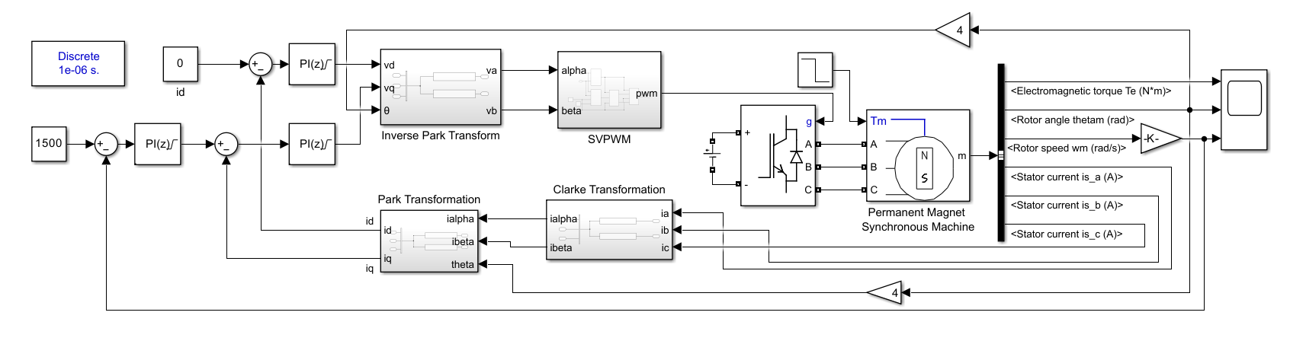
Figure 1 Simulink Overall Model
2.1 Motor Body Module
In the simulation model of the Permanent Magnet Synchronous Motor (PMSM) control system, the motor body is the most critical component. This study employs the Permanent Magnet Synchronous Machine block from the SimPowerSystems/Machines library. This block utilizes a physics-based modeling approach, enabling accurate simulation of both the electromagnetic and mechanical characteristics of the PMSM. Additionally, the block communicates input and output signals via bus interfaces, allowing flexible selection of the required output signals through bus selectors. The selected output signals in this work include the electromagnetic torque (Te ​, N·m), rotor position (θ, rad), rotational speed (ω, rad/s), and three-phase stator currents (Ia ​, Ib ​, Ic ​). The motor parameter settings are listed in Table 1.
Table 1 Motor Parameter Settings
Parameter | Value
Stator phase resistance | 1.5Ohm
Armature inductance | 2.5x10⁻⁵
Inertia | 1.21 x10⁻³
pole pairs | 4
2.2 Inverter Module
The inverter module utilizes the Universal Bridge block from the SimPowerSystems (SPS) toolbox, with the power electronic device configured as an IGBT. The inverter circuit is powered by a DC Voltage Source block, supplying an input voltage of 48 V. The inverter configuration diagram is shown in Figure 2.
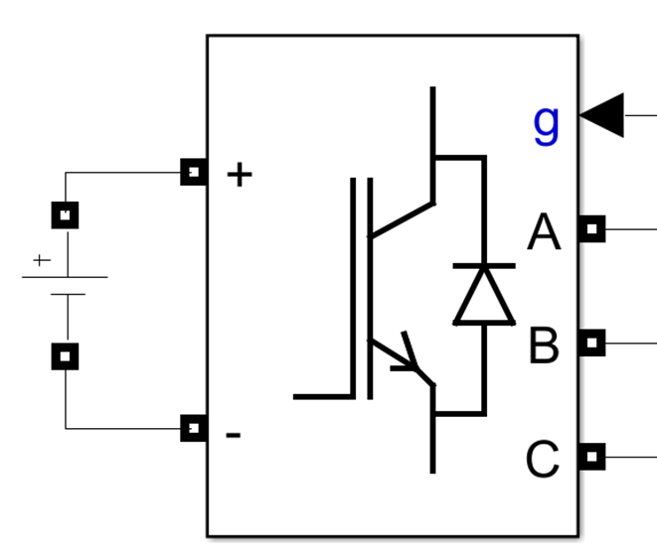
Figure 2 Inverter Circuit Configuration Diagram
2.3 Coordinate Transformation Module
In the modeling and control of Permanent Magnet Synchronous Motors (PMSMs), to achieve coordinate transformations from the three-phase stationary reference frame to the two-phase stationary reference frame (Clarke transformation) and further to the rotating reference frame (Park transformation), this model employs the Fcn block to implement the mathematical expressions of the coordinate transformations. The structural diagram is shown in Figure 3.
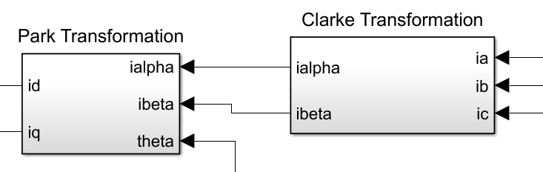
Figure 3 Schematic Diagram of Coordinate Transformation Structure
2.4 SVPWM Module
To achieve efficient control of the Permanent Magnet Synchronous Motor (PMSM), the simulation system employs Space Vector Pulse Width Modulation (SVPWM) technology to drive and control the inverter. The overall structure of the SVPWM module is shown in Figure 4.
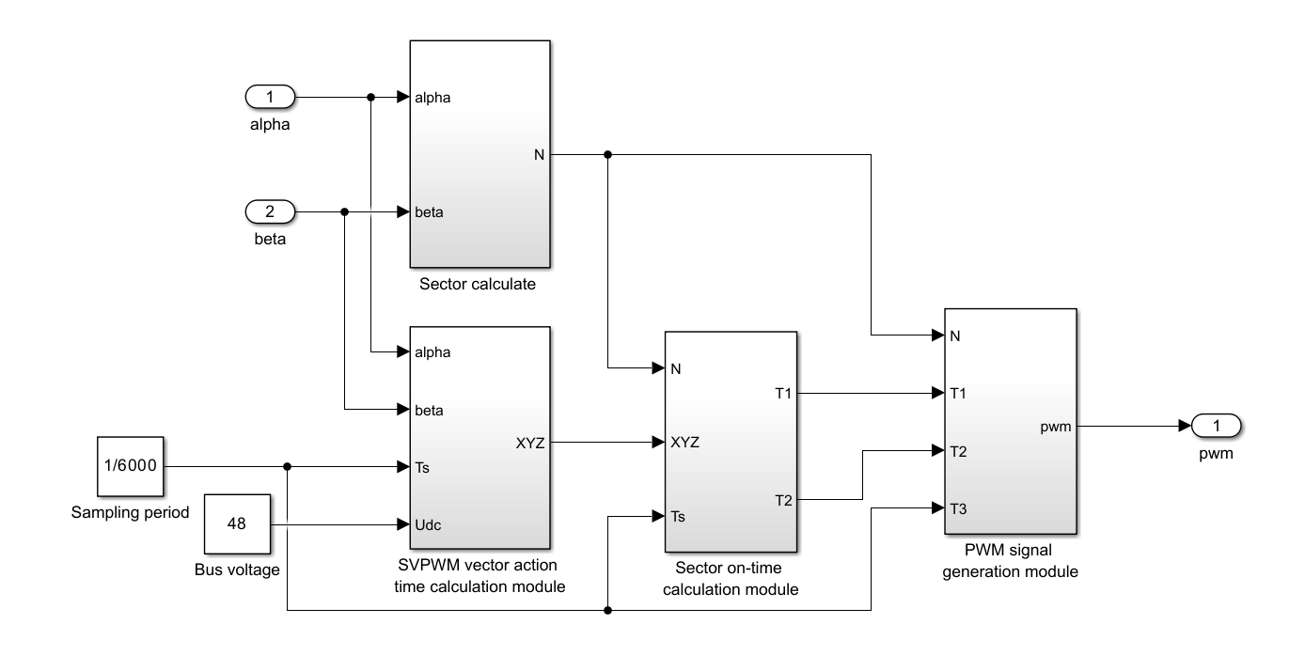
Figure 4 Schematic Diagram of the SVPWM Module Structure
The block diagram shown in Fig. 4 illustrates the overall structure of the Space Vector Pulse Width Modulation (SVPWM) implementation used in the motor control simulation. The inputs to the system are the stationary reference frame voltage components Vα and Vβ​, obtained from the inverse Park transformation, the DC bus voltage Udc ​, and the sampling period Ts​. The SVPWM generation process can be divided into the following functional stages:
- Sector Determination
This module determines the sector number N (ranging from 1 to 6) in which the reference voltage vector (Vα,Vβ) resides within the space vector hexagon. The sector information is essential for selecting the appropriate base voltage vectors in subsequent calculations.
- Intermediate Variable Computation
Using the input voltages Vα​ and Vβ​, together with the DC bus voltage Udc​ and sampling period Ts, this module computes a set of intermediate parameters (X,Y,Z). These parameters represent normalized time durations associated with the active and zero voltage vectors.
- Switching Time Calculation
Based on the identified sector N and the intermediate parameters, this module calculates the exact conduction times (T1,T2,T3) for the three phases within the current sampling period. This stage ensures that the synthesized voltage vector matches the desired reference vector through the combination of two adjacent active vectors and one zero vector.
- PWM Signal Generation
In the final stage, the sector information and calculated conduction times are converted into symmetrical PWM waveforms for the three-phase inverter. This arrangement minimizes harmonic distortion and maximizes DC bus voltage utilization.
Overall, the SVPWM generation process bridges the high-level control algorithm in the dq frame with the low-level switching signals required by the inverter. This structure enables accurate reproduction of the desired voltage vector in both simulation and practical motor drive applications.
2.4.1 Sector Identification Module
The sector identification module designed in this study, as shown in the figure, employs a logical judgment method to map the voltage components α and β in the two-phase stationary reference frame to one of six spatial sectors. The sector is determined based on the following three sets of conditions:
$$\begin{aligned}\left\{\begin{aligned}x_{1}=a>0 \\ x_{2}=\frac{\sqrt{3}α+β}{2}>0 \\ x_{3}=\frac{-\sqrt{3}α+β}{2}>0\end{aligned}\right.\#\left(7\right)\end{aligned}$$
The above conditions are computed using three separate Fcn blocks, each compared against zero to generate three Boolean values (true as 1, false as 0). Finally, the target sector number is determined using Equation (7):
$$\begin{aligned}N=x_{1}+2x_{2}+4x_{3}\#\left(8\right)\end{aligned}$$
2.4.2 SVPWM Vector Action Time Calculation Module
This module calculates the action times of the two adjacent active voltage vectors (T1​ and T2​) and the zero voltage vector (T0​) required for the SVPWM control strategy. The computation is based on the stationary reference frame voltage components (Vα,Vβ), the sampling period Ts, and the DC bus voltage Udc. The objective is to synthesize the desired reference voltage vector within each sampling interval by appropriately allocating the durations of the selected vectors.
Mathematically, the action times can be derived from the geometric projection of the reference vector onto the two active vectors defining the current sector. For a given sector N, the conduction times T1​ and T2 are calculated as:
$$\begin{aligned}\begin{matrix}T_{1}=\frac{\sqrt{3}T_{S}}{U_{dc}}\left(V_{a}\cos{ϕ_{1}}+V_{β}\sin{ϕ_{1}}\right) \\ T_{2}=\frac{\sqrt{3}T_{S}}{U_{dc}}\left(V_{a}\cos{ϕ_{2}}+V_{β}\sin{ϕ_{2}}\right)\end{matrix}\#\left(9\right)\end{aligned}$$
where ϕ1 and ϕ2 represent the phase angles of the two adjacent active vectors. The zero vector time is then obtained from:
$$\begin{aligned}T_{0}=T_{S}-T_{1}-T_{2}\#\left(10\right)\end{aligned}$$
By ensuring that T1 and T0​ are symmetrically distributed within the sampling period, this module minimizes switching losses, reduces harmonic distortion, and fully utilizes the DC bus voltage. In the context of simulation, it enables precise reconstruction of the reference vector trajectory, ensuring accurate torque and flux control in the motor model.
2.4.3 Sector Conduction Time Calculation Module
According to the six-sector switching strategy of the SVPWM algorithm, this module allocates the calculated active vector times T1​ and T2​ to the three-phase bridge arms, thereby determining the conduction times Ta ​, Tb​, and Tc​ for each phase within a sampling period. The allocation process ensures that the synthesized voltage vector maintains a symmetrical distribution around the center of the sampling interval, which is essential for minimizing harmonic distortion and reducing switching losses.
To achieve fast and deterministic execution, the mapping from vector action times to phase conduction times is implemented in a lookup table form. For each of the six possible sectors, the table stores the corresponding time combination (Ta,Tb,Tc),derived from the relationships:
$$\begin{aligned}\begin{matrix}T_{a}=\frac{T_{0}}{2}+T_{1}+T_{2} \\ T_{b}=\frac{T_{0}}{2}+T_{2} \\ T_{c}=\frac{T_{0}}{2}\end{matrix}\#\left(11\right)\end{aligned}$$
where T0​ is the zero vector duration, and the arrangement of T1​ and T2​ among the phases varies according to the sector number N.
The output conduction times are subsequently used to generate symmetrical SVPWM waveforms for the inverter, ensuring maximum DC bus voltage utilization while preserving the desired voltage vector trajectory in both simulation and hardware implementations.
2.4.4 PWM Signal Generation Module
This module receives the three-phase conduction times Ta​, Tb​, and Tc​ calculated in the previous stage and, together with the sampling period Ts​, generates the corresponding three-phase PWM signals within each control cycle. Its primary function is to convert the conduction time information into the binary switching signals Sa​, Sb​, and Sc​ that directly control the three inverter bridge arms.
The generation process is based on a symmetrical PWM strategy, in which the conduction times are centered within the sampling period to reduce harmonic distortion. For each phase, the switching state is determined by comparing the phase’s conduction time with a carrier triangular waveform of period Ts​. Mathematically, the switching signal for phase x (x∈{a,b,c}) is defined as:
$$\begin{aligned}S_{x}\left(t\right)=\left\{\begin{aligned}1, if Carrier\left(t\right)≤Tx \\ 0, ​otherwise\end{aligned}\right.\#\left(12\right)\end{aligned}$$
where Tx denotes the conduction time of the corresponding phase.
By arranging the switching transitions symmetrically with respect to the midpoint of the sampling interval, this module minimizes switching losses and ensures balanced operation of the inverter. The resulting PWM signals Sa ​, Sb ​, and Sc​ are then applied to the gate drivers of the inverter power devices, producing the desired output voltages that synthesize the reference voltage vector computed by the control algorithm.
In the simulation model, this module not only replicates the real-time hardware PWM generation process but also enables accurate assessment of the modulation performance, harmonic content, and switching behavior under various operating conditions.
3 Simulation Results
Based on the PMSM simulation model established in MATLAB/Simulink, simulation experiments were carried out for the speed–current dual closed-loop control system. In the simulation, the proportional and integral gains of the speed PI controller were set to Kp = 0.6 and Ki = 0.2, respectively, with a saturation limit of ±60. For the current PI controller, the parameters were set to Kp = 0.008 and Ki = 500, and the output was constrained within ±25 by the saturation block.
3.1 No-Load Speed Response
This experiment aims to evaluate the steady-state performance of the motor under no-load conditions and to verify the basic tracking capability of the speed control system. By applying a constant reference speed and removing mechanical load torque, the system’s behavior without external disturbances can be observed, enabling assessment of its steady-state accuracy and dynamic response.
In the simulation, the motor starts from standstill, and a constant reference speed command of n = 500 r/min is applied at t = 0 s. A dual closed-loop control strategy is adopted, consisting of an outer speed loop and an inner current loop, to ensure fast dynamic response and minimal steady-state error.
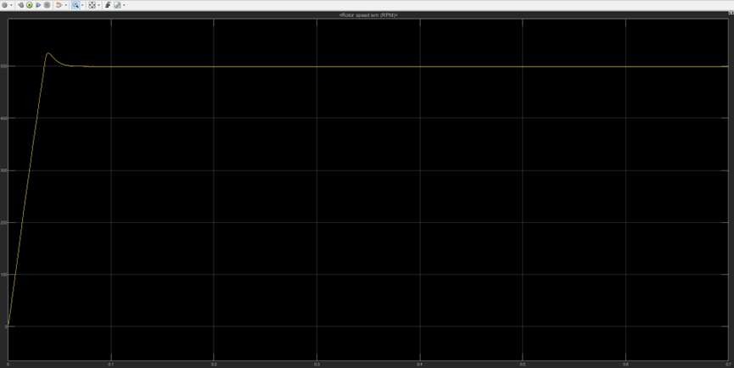
Figure 5 Speed Response Curve
From the simulation results, it can be observed that the motor speed rises rapidly and stabilizes near the given reference value. The overshoot remains within 5%, and no significant oscillation is observed, indicating that the control system exhibits good speed regulation performance and steady-state stability under no-load conditions.
3.2 Speed Step Response
This experiment aims to evaluate the motor control system’s response to a step change in the reference speed, focusing on its dynamic performance and tracking accuracy. By applying a step variation to the reference speed, key performance indicators such as acceleration/deceleration behavior, overshoot, settling time, and steady-state error can be observed, which help assess the appropriateness of the controller parameter design and the overall stability of the system.
In this simulation, the motor initially operates at a reference speed of n = 1000 r/min. At t = 0.6 s, the reference speed is suddenly increased to n = 1500 r/min to simulate a speed-up condition under varying load demand. This experiment primarily investigates the system's dynamic response during the speed transition, including response time, overshoot, and steady-state recovery performance.
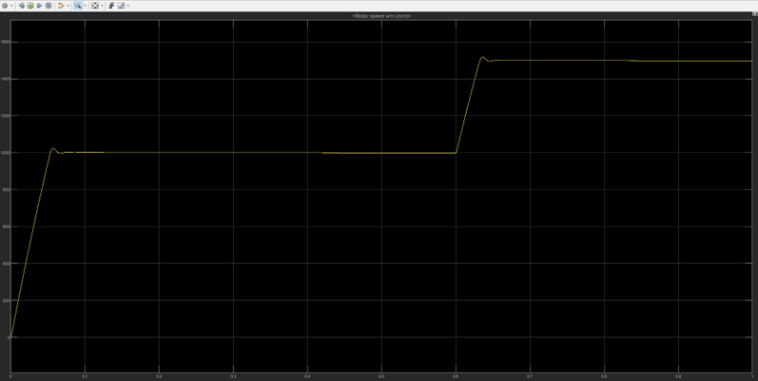
Figure 6 Speed Response Curve
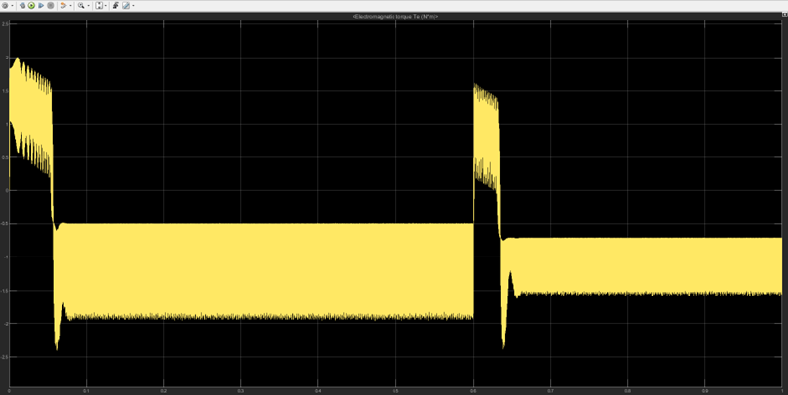
Figure 7 Electromagnetic Torque Curve
As shown in the simulation waveforms in Figures 6 and 7, the results are consistent with theoretical expectations. Under the reference speed of n = 1000 r/min, the motor responds rapidly and smoothly, with an overshoot of less than 5%. At t = 0.6 s, the reference speed increases to n = 1500 r/min, and the motor quickly stabilizes within approximately 0.035 seconds. In steady-state operation, no speed error is observed.
In the electromagnetic torque curve (Figure 7), a noticeable torque fluctuation occurs at t = 0.6 s during the speed transition. This is mainly attributed to the frequent switching behavior of the current PI controller in response to the sudden change in operating conditions.
3.3 Load Disturbance Response
The load disturbance experiment is designed to evaluate the motor control system’s dynamic response and robustness under sudden changes in external mechanical load. By applying a step disturbance in load torque, the resulting speed fluctuation, transient behavior, and steady-state recovery can be observed, allowing for assessment of the control strategy's disturbance rejection capability.
In this simulation, the motor operates at a constant speed of n = 1000 r/min. At t = 0.5 s, the external load torque abruptly changes from –1 N·m to –2 N·m, simulating a sudden load increase in practical applications. All other parameters remain unchanged throughout the experiment.
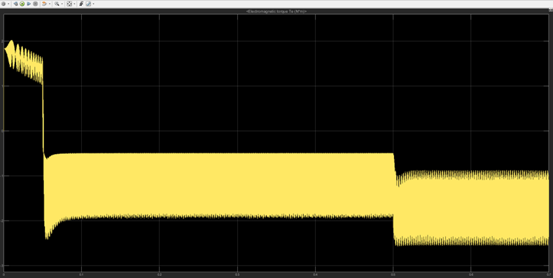
Figure 8 Electromagnetic Torque Response Curve
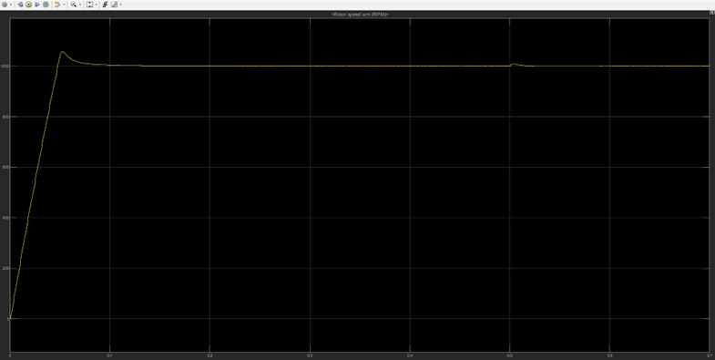
Figure 9 Speed Response Curve
As illustrated in Figures 8 and 9, the waveforms are consistent with theoretical expectations. Under the reference speed of n = 1000 r/min, the motor responds quickly and maintains a stable speed. At t = 0.5 s, a load disturbance causes a temporary fluctuation in speed, but the system recovers rapidly and returns to a steady-state condition within approximately 0.02 seconds, with no steady-state error observed.
In the electromagnetic torque response curve (Figure 8), the torque increases smoothly to match the new load torque following the disturbance at t = 0.5 s. The torque remains stable afterward without significant oscillations, indicating that the control system effectively compensates for the sudden load change.
4 Conclusion
This paper presents the modeling and simulation of a dual closed-loop speed control system for a Permanent Magnet Synchronous Motor (PMSM) based on the Simulink platform. By adopting a vector control strategy that integrates both current and speed loops, and combining it with the Space Vector Pulse Width Modulation (SVPWM) technique, effective decoupled control of motor speed and current is achieved.
Simulation results demonstrate that the designed control system exhibits excellent dynamic response and steady-state regulation performance. The motor speed can track the reference commands rapidly and accurately, with the steady-state error maintained within 5%. Under speed and load step disturbances, the system recovers to steady-state within 0.1 seconds, indicating strong robustness and anti-disturbance capability.
Moreover, the system features a clear structure and tunable parameters, offering good scalability and practical engineering value. It provides both a theoretical foundation and a simulation platform for further research on high-performance control strategies for PMSMs. Future work may incorporate advanced techniques such as adaptive control, feedforward compensation, or model predictive control to enhance control accuracy and intelligence under complex operating conditions.

COMPETING INTERESTS DISCLAIMER:
Authors have declared that they have no known competing financial interests OR non-financial interests OR personal relationships that could have appeared to influence the work reported in this paper.

References
- Li, K., Zhang, Y., & Chen, H. (2024). Overview of sliding mode control technology for permanent magnet synchronous motor system. IEEE Access, 12, 71685-71704.
- Kumar, A., Singh, R., & Patel, M. (2023). Development of electric vehicle with permanent magnet synchronous motor and its analysis with drive cycles in MATLAB/Simulink. Mater Today Proc. 72, 643-651.
- Ma, C., Liu, W., & Wang, Z. (2024). Fuzzy PID control design of mining electric locomotive based on permanent magnet synchronous motor. Electronics, 13(10), 1855.
- Lee, J., and Kim, Y.‐S. Sensorless fuzzy‐logic‐based maximum power point tracking control for a small‐scale wind power generation systems with a switched‐mode rectifier. IET Renew. Power Gener., 2016, 10(2): 194-202.
- Liang, W., Zhou, X., & Wang, Y. (2014). Analytical modeling of current harmonic components in PMSM drive with voltage-source inverter by SVPWM technique. IEEE Trans Power Syst 29(3), 673-680.
- Yuan, M., Meng, Y., & Qi, X. (2025). Research on simulation of permanent magnet synchronous motor in full speed range. PLoS One, 20(4), e0320786.
- Nguyen, V. Q. (2020). The fuzzy PI controller for PMSM’s speed to track the standard model. Math Probl Eng, 2020(1), 1698213.
- Sira-Ramírez, H., et al. On the control of the permanent magnet synchronous motor: An active disturbance rejection control approach. IEEE Trans. Control Syst. Technol., 2014, 22(5): 2056-2063.
- Yang, Y., et al. Efficiency improvement of permanent magnet synchronous motor for electric vehicles. Energy, 2020, 213: 118859.
- Cao, X., Ye, Y., Duan, Y., et al. Sensorless control of permanent magnet synchronous motor based on adaptive back-EMF observer. Adv. Mech. Eng., 2023, 15(2): 16878132231151622.
- Tang, X., Li, F., & Zhou, J. (2023). A novel field-oriented control algorithm for permanent magnet synchronous motors in 60 coordinate systems. Actuators, 12(2), Article 45.
- Urbanski, Konrad, and Dariusz Janiszewski. "Sensorless control of the permanent magnet synchronous motor." Sensors 19.16 (2019): 3546.
- Ghanayem, H., Alathamneh, M., & Nelms, R. M. (2023). Decoupled speed and flux control of three-phase PMSM based on the proportional-resonant control method. Energies, 16(3), 1053.
- O’Rourke, C. J., Heidari, A., & Smith, J. (2019). A geometric interpretation of reference frames and transformations: dq0, Clarke, and Park. IEEE Trans Power Syst, 34(4), 2070-2083.
- Zhou, P., Wu, J., & Li, Q. (2010). Determination of d-q axis parameters of interior permanent magnet machine. IEEE Trans Magn, 46(8), 3125-3128.
- Mercorelli, P. (2023). Control of permanent magnet synchronous motors for track applications. Electronics, 12(15), 3285.
- Sirimanna, S., Balachandran, T., & Haran, K. (2022). A review on magnet loss analysis, validation, design considerations, and reduction strategies in permanent magnet synchronous motors. Energies, 15(17), 6116.
- Grosz, E. A., & Borzan, M. (2025). Modular Robotics Configurator: A MATLAB Model-Based Development Approach. Applied System Innovation, 8(1), 21.
- Rafaq, M. S., Midgley, W., & Steffen, T. (2023). A review of the state of the art of torque ripple minimization techniques for permanent magnet synchronous motors. IEEE Transactions on Industrial informatics, 20(1), 1019-1031.
- Monadi, M., Nabipour, M., Akbari-Behbahani, F., & Pouresmaeil, E. (2024). Speed control techniques for permanent magnet synchronous motors in electric vehicle applications towards sustainable energy mobility: A review. IEEE Access.

