**Behavior of Normal and Hybrid Strength Reinforced Concrete Corbels Strengthened with Steel Plate**

**Abstract:** This paper presents an experimental study of behavior of reinforced concrete corbels strengthened with steel plates. For this purpose, six specimens were prepared and tested. The study inspected the effect of some parameters on the structural behavior of corbels. The parameters included: the strength of concrete and shear span-to-effective depth ratio. Both cracking and ultimate loads increased when shear span-to-effective depth ratio was decreased. Increasing the compressive strength of concrete improved the load bearing and cracking capacity of the corbels. The ultimate load for hybrid strength concrete corbel increased by 22.39% while cracking load increased by 49.75% compared to normal strength concrete corbel. Strengthening corbels with steel plates resulted in up to 24.78% and 19.24% increase in the load bearing capacity of normal strength concrete and hybrid strength concrete corbel samples, respectively. Cracking loads also increased by 66.5% and 44.55% for normal strength concrete and hybrid strength concrete corbels, respectively. The cracking and failure pattern modes of corbels are also presented.

**Keywords:** steel plate, corbels, compressive strength, flexural, shear span.

**1.** **Introduction**

Corbels are structural elements that project from the faces of columns or walls. They are commonly used in precast concrete structures to support components like precast and pre-stressed beams, as well as reinforced concrete, transmitting loads to vertical elements of the structure. Typically made from a single piece of material, corbels function more like simple trusses or deep beams than flexural components, which is why they are often considered shear force transmitters. The term "corbels" generally refers to cantilevers with a shear span-to-depth ratio (a/d = 1.0) [1], and their high strength is attributed to this small ratio. Previous studies have shown that adding steel fibers to concrete corbels can significantly affect their performance. Steel fibers are widely used in various applications [2], and increasing their content has been shown to enhance stiffness, ductility, fracture control, and load-carrying capacity [3]. Research has also indicated that fiber-reinforced concrete corbels exhibit a more gradual failure, with failure modes typically being inclined shear or flexure [4,5].

Steel plates are one of the most commonly used materials for reinforcing concrete beams, particularly in improving both flexural and shear capacities. As infrastructure worldwide increasingly requires upgrading, strengthening, or maintenance, this approach has seen a resurgence in recent decades [6]. Paul Ciobanu (2012) [7] identified external bonding of reinforced fibers (EBR) as a popular technique. However, due to premature debonding, carbon fiber strips applied directly to concrete surfaces using epoxy adhesives have not yet fully utilized the tensile strength of FRP materials. The near-surface mounted (NSM) method offers a solution by maximizing tensile strength. In 2015, Ivanova and Assih [8] studied the effect of bonding carbon fiber textiles on reinforced concrete short corbels. Their findings indicated that wrapping was more effective than steel bonding, increasing failure load by 82% compared to a reference specimen (Kim et al., 2019) [9].

Further research evaluated the design of reinforced concrete brackets used to support center slabs in double-deck tunnels through experimental and computational analysis. These brackets, attached to the tunnel liner, bear the full load transferred to the middle slabs, making their design critical for preventing slab collapse, tunnel liner failure, and associated risks to human life and property. Loading tests were conducted on bracket-attached tunnel liner structures to assess design validation, safety factors, and failure modes. Numerical models were also created to evaluate the impact of bracket shape on the structural capacity of the tunnel brackets.

Khalifa (2012) [10] proposed a macro-mechanical strut-and-tie model to study fibrous high-strength concrete corbels. In this model, steel fibers were used to partially or entirely replace horizontal stirrups. The study examined several variables, including fiber volume, length, and diameter, fiber distribution, the interface between fibers and high-strength concrete (HSC), shear span-to-depth ratio, and concrete strength. Results showed that increasing fiber volume, fiber aspect ratio, and concrete compressive strength enhanced the maximum vertical load-bearing capacity of corbels.

The aim of this study is to investigate the influence of strength of concrete and shear span-to-depth ratio on the behavior and bearing capacity of reinforced concrete corbels with or without strengthening with steel plates.

**2. METHODOLOGY**

**2.1 General**

Six double-sided corbels were constructed, each with a consistent corbel depth of 250mm and a column measuring 150mm in depth, 200mm in width, and 650mm in length. These specimens were subjected exclusively to vertical loading. The specimens were grouped based on the type of concrete used—either hybrid or normal strength concrete. Detailed information about the tested corbels can be found in Table 1 and illustrated in Figure 1.

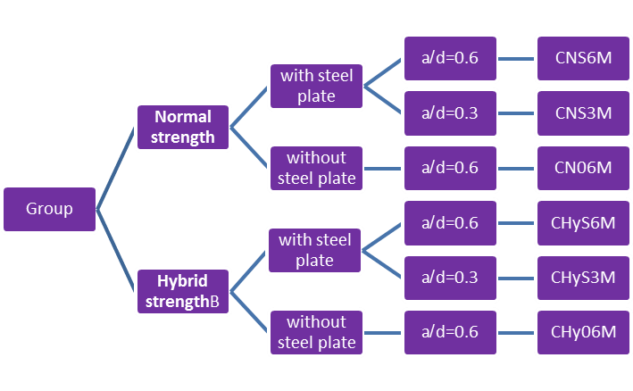

**Figure 1.** Structure of the Experimental Program

Table 1: Details of corbel specimens

|  |  |  |  |  |
| --- | --- | --- | --- | --- |
| Table 1. Details of corbel specimens | | | | |
| Group | **Specimen** | **Type of concrete** | **d/a** | **strengthening** |
| A | CN06M | Normal strength | 0.6 | none |
| CNS6M | Normal strength | 0.6 | Steel plate |
| CNS3M | Normal strength | 0.3 | Steel plate |
| B | CHy06M | Hybrid strength | 0.6 | none |
| CHyS6M | Hybrid strength | 0.6 | Steel plate |
| CHyS3M | Hybrid strength | 0.3 | Steel plate |

**2.2 Materials**

**2.2.1 Cement and Aggregates**

Ordinary Portland cement, washed natural sand, and 12mm coarse aggregates were utilized, with the cement conforming to Iraqi Specification No. 5/1984 [12]. The physical properties of both fine and coarse aggregates were evaluated to ensure they met the requirements of Iraqi Standard No. 45/1984 [13].

**2.2.2 Steel Reinforcement**

The primary tensile reinforcement for the corbel and the longitudinal reinforcement of the supporting column were deformed steel bars with a 12mm diameter. Deformed steel bars with an 8mm diameter were used as connecting rods for the column. Additional reinforcement and frame bars were made of 6mm diameter steel bars. To evaluate the properties, three samples of each bar size were tested according to ASTM C370-05a [14]. The yield strengths of the bars were 498 MPa, 655 MPa, and 620 MPa. Details of tested corbels are shown in Figure 2.

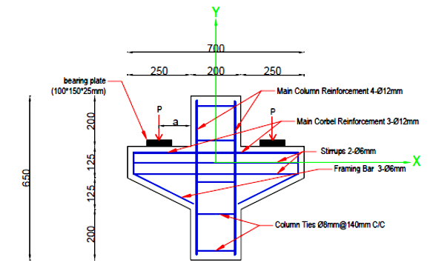

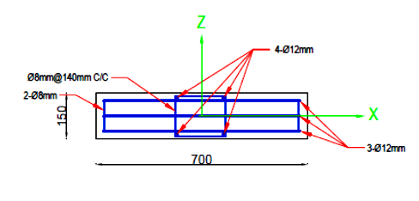

**Figure 2.** Details of Tested Corbel.

**2.2.3 Superplasticizer**

To produce self-consolidating concrete, a superplasticizer known as a High Water Reducing Agent (HWRA), based on polycarboxylic ether, was utilized and incorporated into the mix. The product, branded as Glenium51[15], is chloride-free and complies with ASTM C494 types F and A standards. Additionally, it is highly compatible with all types of Portland cement that adhere to internationally recognized specifications

**2.2.4 Silica Fume**

The silica fume used in this study was Sika micro silica (manufactured by Sika company). It meets the chemical and physical specifications of ASTM C 1240-05 [16].

**2.2.5 Steel Plates and Bolts**

The external stiffeners utilized in this study consist of steel plates with a thickness of 6 mm, a length of 70 mm, and a height of 60 mm. Table 2 presents the yield stress, ultimate strength, and longitudinal elongation properties of the steel plates. These plates were installed using the anchor bolt method.

|  |  |  |  |  |  |
| --- | --- | --- | --- | --- | --- |
| Table 2. Details of steel plate and bolts | | | | | |
| Steel Specimens | **Thickness of Plates (mm**) | **Elongation %** | **Bonding**  **Method** | **Yield Stress**  **(N/mm2)** | **Ultimate Stress**  **(N/mm2)** |
| Steel plate | 6mm | 9.34% | Anchor bolts | 364.44 | 455.56 |

**2.3 Mix Design**

Various mixtures were prepared based on the type and strength of the concrete required. The mixture ratios by weight were designed to produce two types of concrete: hybrid strength concrete, with a cylinder compressive strength of approximately 52 MPa after 28 days of water curing, and normal strength concrete, with a cylinder compressive strength of about 30 MPa after the same curing period.

For the mixing process of hybrid strength concrete, it is crucial to ensure the mixer is clean and moist but free from excess water. Initially, gravel and sand are added to the rotary mixer along with one-third of the mixing water to moisten the aggregates, and they are mixed for one minute. Cement and silica are then introduced, followed by half a minute of mixing. Next, one-third of the water combined with one-third of the superplasticizer is added, and mixing continues for another minute. Finally, the remaining water is gradually incorporated along with the remaining two-thirds of the superplasticizer, with mixing continuing for an additional minute and a half. The total mixing time amounts to four minutes.

For normal strength concrete, the process is identical, except no superplasticizer or silica is added. Detailed proportions and steps are presented in Table 3.

|  |  |  |  |  |  |  |
| --- | --- | --- | --- | --- | --- | --- |
| **Table 3.** Mix properties | | | | | | |
| **Cement kg/m3** | **Gravel kg/m3** | **Sand kg/m3** | **w/c** | **Super plasticizer (L/m3)** | **Silica Fume (Kg/m3)** | **Target Strength MPa (f'c)** |
| 400 | 1200 | 600 | 0.45 | ـــــــ | ـــــــ | 30 |
| 585 | 1136 | 651 | 0.27 | 7 | 58.42 | 70 |

**2.4 Test Arrangement**

The study was conducted in the structural engineering and material construction laboratories at the College of Engineering, Mustansiriyah University. Push-off tests were performed, as illustrated in Figure 3, using a standard hydraulic testing machine with a maximum capacity of 3000 kN. The load was applied incrementally, increasing by 5 kN at each step.

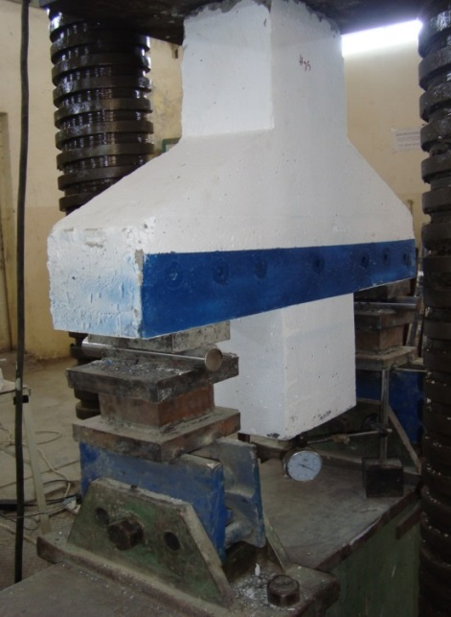

**Figure 3.** Corbel specimen setup

**3. Results and Discussion**

In the following sections, the observed behavior and the failure mode results will be discussed. The specimen test results are presented in Table 4 in the terms of cracking load (Pcr), ultimate load (Pu) and failure mode.

|  |  |  |  |
| --- | --- | --- | --- |
| **Table 4.**  Experimental first cracking and ultimate loads of corbels | | | |
| **Specimen** | **Pcr (KN)** | **Pu (KN)** | **Failure mode** |
| CN06M | 101.5 | 406.5 | Diagonal splitting |
| CNS6M | 169 | 507.25 | Flexural |
| CNS3M | 207.5 | 588.75 | Flexural |
| CHy06M | 152 | 497.5 | Diagonal splitting |
| CHyS6M | 219.72 | 593.25 | Flexural |
| CHyS3M | 288.6 | 664 | Flexural |

**3.1 Behavior of Corbel Specimens**

During the initial phases of stress application, the specimens exhibit significant stiffness and load resistance until the first crack appears. At this stage, the specimens demonstrate higher rigidity compared to later stages, with minimal vertical displacement and no visible cracks. However, once the first cracks form, the rigidity begins to diminish, and vertical displacement increases. Flexural cracks develop on the tension face of the corbels near the column, with the number and width of cracks growing as the applied load increases until the steel reinforcement yields.

Following the onset of nonlinear behavior, deflection increases rapidly, indicating a significant reduction in stiffness. In the advanced stages of stress application, diagonal shear cracks appear near the supports and propagate quickly toward the column face. These diagonal cracks are wider and more prominent than the flexural cracks. For most specimens, failure is abrupt and uncontrolled, except in stronger specimens reinforced with steel plates, which exhibit more ductile behavior.

The failure mechanism of the steel plate reveals no interfacial shear concentration or stress-dependent decohesion between the corbel surface and the steel plate. For the tested specimens, failure is characterized by an increase in deflection accompanied by a decrease in the applied load.

Three distinct failure modes were observed in the tested model samples, as illustrated in Figure 4 and detailed in Table 1. Figure 4 depicts one of the following failure conditions:

1. **Diagonal Partition Failure:**  
   This failure begins with the development of an initial flexural crack, which eventually leads to diagonal splitting of the concrete. It originates at the bearing plate and extends toward the intersection between the shaft face and the sloping face. Corbels with such cracks are prone to shear failure in the stress zone.
2. **Bending Tension Failure:**  
   This mode occurs at the intersection between the shaft and the side face, following the pullout of fibers from the concrete matrix. It is characterized by deep vertical cracks with a wide opening, spreading significantly in the tension zone.
3. **Bending Stress Failure:**  
   This failure arises at the cross-shaft latitude before the fibers are pulled out. The significant yielding of the tensile reinforcement ensures a gradual failure mechanism, reducing the likelihood of catastrophic shear cracks and preventing abrupt shear failure.



(a)



(b)



(c)



(d)



(e)

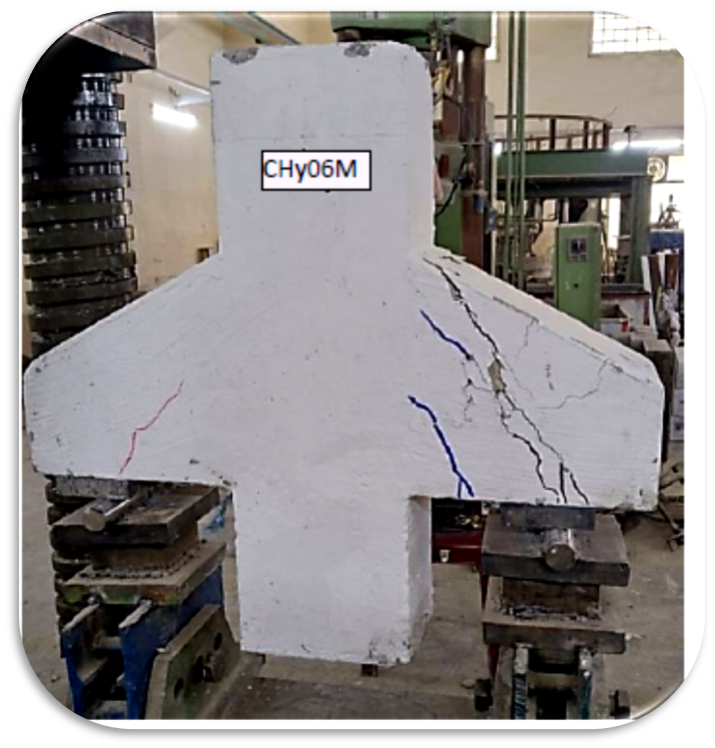

(f)

**Figure 4.** Cracks patterns of corbels after testing (a) Cracks Patterns of Corbel CNS3M (b) Cracks Patterns of Corbel CHyS3M (c) Cracks Patterns of Corbel CNS6M (d) Cracks Patterns of Corbel CHyS6M (e) Cracks Patterns of Corbel CN06M (f ) Cracks Patterns of Corbel CHy06M

**3.2 Inﬂuence of Shear Span** **to Effective Depth Ratio**

The influence of the shear span-to-effective depth ratio (a/d) on the cracking and ultimate loads for hybrid-strength concrete corbels strengthened with steel plates is significant. As the (a/d) ratio decreases, both the cracking and ultimate loads increase. For instance, reducing the (a/d) ratio from 0.6 to 0.3 leads to an approximately 31.35% increase in the cracking load and an 8.55% increase in the ultimate load. This demonstrates that lowering the (a/d) ratio enhances the structural performance of hybrid-strength concrete corbels, particularly in terms of load-bearing capacity. The influence of the shear span-to-effective depth ratio (a/d) on the cracking and ultimate loads for normal-strength concrete corbels strengthened with steel plates is also significant. When the (a/d) ratio is reduced from 0.6 to 0.3, the cracking load increases by approximately 22.78%, and the ultimate load increases by about 16.07%. This suggests that decreasing the (a/d) ratio improves the load-bearing capacity of normal-strength concrete corbels, especially in terms of both the initial cracking and ultimate failure loads. The effects are clearly illustrated in Figures 5 and 6 [17].

**Figure 5.** The Inﬂuence of (a/d) ratio on cracking and final loads for hybrid strength concrete corbels strengthened with steel plate.

**Figure 6.** The Inﬂuence of (a/d) ratio on cracking and final loads for normal strength concrete corbels strengthened with steel plate.

**3.3 Inﬂuence of Concrete Compressive Strength**

The compressive strength of concrete, along with other factors such as section size and reinforcement ratio, plays a crucial role in determining the capacity of the specimen. A comparison of the specimens in this study clearly highlights the positive impact of compressive strength. The ultimate load for hybrid strength concrete specimen CHy06M increased by 22.39% compared to normal strength concrete specimen CN06M, by 16.95% for CHyS6M compared to CNS6M, and by 12.78% for CHyS3M compared to CNS3M. Increasing the compressive strength of the concrete enhances the flexural stiffness of the component, significantly improving the cracking capacity and delaying the onset of the first crack. Figures 7, 8, and 9 show that the improvement in cracking load is approximately 49.75%, 30.01%, and 39.08% for hybrid strength concrete specimens CHy06M, CHyS6M, and CHyS3M, compared to normal strength concrete specimens CN06M, CNS6M, and CNS3M respectively [18, 19, 20].

**Figure 7.** The Inﬂuence of concrete compressive strength on corbels cracking and ultimate loads for corbels strengthened with steel plate and (a/d) ratio of 0.3

**Figure 8.** The Inﬂuence of concrete compressive strength on corbels cracking and ultimate loads for corbels without strengthening and (a/d) ratio of 0.6

**Figure 9.** The Inﬂuence of concrete compressive strength on corbels cracking and ultimate loads for corbels strengthened with steel plate and (a/d) ratio of 0.6

**3.4 Inﬂuence of Steel Plates on Cracking and Ultimate Loads**

Strengthening concrete corbels with steel plates significantly enhances their performance and strength, leading to a notable increase in their ultimate load capacity regardless of concrete type used. Additionally, these strengthening delays the appearance of the first crack, further demonstrating its effectiveness [17]. The results indicate improvements in ultimate loads of approximately 24.78% for specimen CNS6M compared to CN06M, and 19.24% for specimens CHyS6M compared to CHy06M. Cracking loads also increased around 66.5% and 44.55%, for specimens CNS6M and CHyS6M, compared to specimens CN06M and CHy06M, respectively, as illustrated in Figures 10 and 11.

Given the affordability of steel plates and their ease of application to concrete compared to other materials, the authors recommend their use for strengthening corbel models in future research and practical applications.

**Figure 10.** The Inﬂuence of steel plate on cracking and ultimate loads for hybrid strength concrete corbels

**Figure 11.** The Inﬂuence of steel plate on cracking and ultimate loads for normal strength concrete corbels

**3.5 Load Deflection Relationship**

The load-displacement responses for specimens CN06M, CNS6M, CNS3M, CHy06M, CHyS6M, and CHyS3M are presented in Figures 13 and 16. Testing was terminated when the specimens exhibited failure, as indicated by visible damage, an inability to increase the load further, or a load drop accompanied by increased deflection. The recorded deflection corresponds to the movements of the loading jack, which reflects the deflection at the center of the column supporting the double corbels.

The corresponding displacement curves exhibited a linear shape with a nearly constant slope in the initial stages of loading, consistent with the specimens being in their elastic phase. As the first cracks formed, the curves transitioned to a nonlinear shape with varying slopes. This nonlinear behavior persisted as the load increased until failure occurred.

Figures 12, 14, and 15 illustrate the effects of concrete type, steel plate reinforcement, and the shear span-to-effective depth ratio (a/d) on the performance and behavior of the corbels.

**Figure 12.** The Inﬂuence of type of concrete on the load deflection response for corbels strengthened with steel plate and (a/d) ratio of 0.3

**Figure 13.** The Inﬂuence of (a/d) ratio on load- deflection response for normal strength concrete corbels strengthened with steel plate

**Figure 14.** The Inﬂuence of type of concrete on the load deflection response for corbels strengthened with steel plate and (a/d) ratio of 0.6

**Figure 15.** The Inﬂuence of type of concrete on the load deflection response for corbels with (a/d) ratio of 0.6

**Figure 16.** The Inﬂuence of (a/d) ratio on load- deflection response for hybrid strength concrete corbels strengthened with steel plate

**4. Conclusions**

The primary objective of this research was to study the behavior of normal and hybrid strength reinforced concrete corbels strengthened with steel plate. Based on the experimental results and discussions, the following conclusions can be drawn:

1. Strengthening corbels with steel plates significantly improves their performance by increasing both the cracking and ultimate loads. The results demonstrated enhancements of up to 24.78% in ultimate load and 66.5% in cracking load for certain specimens. Furthermore, steel plate reinforcement delayed the onset of the first crack, contributing to the improved structural integrity of the corbels.
2. The compressive strength of concrete was a key factor influencing specimen capacity. Higher compressive strength improved flexural stiffness, delayed cracking, and increased both cracking and ultimate loads. For example, ultimate load capacities increased by 22.39%, 16.95%, and 12.78% for hybrid strength concrete specimens CHy06M, CHyS6M, and CHyS3M compared to their normal strength counterparts.
3. Reducing the (a/d) ratio enhanced both cracking and ultimate load capacities. For normal strength concrete corbels reinforced with steel plates, decreasing the (a/d) ratio from 0.6 to 0.3 increased the cracking load by approximately 22.78% and the ultimate load by 16.06%. Similarly, for hybrid strength corbels, the cracking and ultimate loads increased by 31.35% and 8.55%, respectively.
4. The load-displacement curves were linear in the elastic stage, with a nearly constant slope, transitioning to nonlinear behavior after the first cracks appeared. Nonlinear behavior persisted until failure, with larger deflections observed for specimens with higher loads and ductility.
5. Three primary failure modes were identified: diagonal partition failure, bending tension failure, and bending stress failure. Steel plate reinforcement contributed to more ductile failures, reducing the likelihood of catastrophic shear failures.
6. The use of steel plates as a reinforcement method is highly effective and cost-efficient. The ease of application and the significant performance improvements make steel plates a practical choice for strengthening corbels in both research and real-world construction scenarios.

These findings demonstrate the importance of material selection, reinforcement strategies, and design parameters in enhancing the structural performance of reinforced concrete corbels.

COMPETING INTERESTS DISCLAIMER:

Authors have declared that they have no known competing financial interests OR non-financial interests OR personal relationships that could have appeared to influence the work reported in this paper.

**5. References**

1. ACI committee 318M-19 *(2019). “Metric building code requirements for structural concrete and commentary”*. American Concrete Institute. www.concrete.org.
2. Khaleel, S. I., Ali, B. A., and Othman, Z. S. (2017). *“Shear strength and behavior of reinforced concrete corbels containing either carbon fibers or stirrups”*. (Zanco Journal of Pure and Applied Sciences, Vol. 29, No. 5, pp. 10-21. https://doi.org/10.21271/zjpas.29.5.2.
3. Yang, J. M., Lee, J. H., Yoon, Y. S., Cook, W. D., and Mitchell, D. (2012). “*Influence of steel fibers and headed bars on the serviceability of high-strength concrete corbels”*. Journal of Structural Engineering, Vol. 138, No. 1, pp. 123–129. https://doi.org/10.1061/(asce)0733-9445(2008)134:3(448)
4. FattuhiI, N. I. (1989). “*Reinforced steel fiber concrete corbels with various shear span- to-depth ratios”*. American Concrete Institute, Vol. 86, No. 6, pp. 590–596. https://doi.org/10.14359/2243.
5. Fattuhi, N. I. (1990). “*Strength of SFRC corbels subjected to vertical load”.* Journal of Structural Engineering, Vol. 116, No. 3, pp. 701–718. https://doi.org/10.1061/(asce)0733-9445(1990)116:3(701).
6. Walid Elkamash, C.H., *“Numerical Study of R.C. Beams Strengthening by External Steel Plate”,* AJER Journal, Vol. 6, No.3, Feb.,2017, pp.48-56. http://www.ajer.org.
7. Paul ciobanu, Nicolae ţăranu, Sergiu popoaei and Dragoş Banu*, "Structural response of reinforced concrete beams strengthened in flexure with near surface mounted fiber”,* Research submitted to the Universitatea Tehnică "Gheorghe Asachi” din Iaşi, 29-9-2012.
8. Ivanova, I. and Assih, J., *“Experimental Study of Local Behavior of Strengthened Reinforced Concrete Short Corbel by Bonding Carbon Fiber Fabrics”,* International Journal of Structural and Civil Engineering Researches,vol.4, no.1,February, 2015. http://dx.doi.org/10.18178/ijscer.
9. Kim, S.M., Cho, Y.K., and Pkar, B.K*. “Experimental and Numerical Evaluation of Reinforced Concrete Bracket Design for Supporting Middle Slap in double-Deck Tunnel ”*Journal. KSCEN., Vol. 23, No.8, March 2019, ISSN 3682- 3693. https://doi.org/10.1007/s12205-019-0112-4.
10. Khalifa, E. S., *“Macro-mechanical Strut and Tie Model for Analysis of Fibrous High-Strength Concrete Corbels”,* Ain Shams Engineering Journal, V. 3, Issue 4, December 2012, Pages 359–365. https://doi.org/10.1016/j.asej.2012.04.004.
11. Central Organization for Standardization and Quality Control (1984). *“Ordinary Portland cement”.* Iraqi Standard Specification (IQS). No.5/1984, Baghdad, Iraq.
12. Central Organization for Standardization and Quality Control (1984). *“Ordinary Portland cement”.* Iraqi Standard Specification (IQS). No.5/1984, Baghdad, Iraq.
13. Central Organization for Standardization and Quality Control (1984). Iraqi Standard Specification (IQS). *“Natural Aggregate”.*No.45/ 1984, Baghdad, Iraq.
14. ASTM C370-05
15. ASTM C1240-04, *“Standard Specification for the Use of Silica Fume as a Mineral Admixture in Hydraulic Cement Concrete, Mortar and Grout”,* ASTM International, West Conshohocken, PA,2004.

DOI: 10.1520/C1240-04.

1. ASTM C494/C494M-16, *“Standard Specification for Chemical Admixtures for Concrete”,* Vol. 04.02, 20p. 2016.

https://webstore.ansi.org.

1. Siao, W. B., *“Shear Strength of Short Reinforced Concrete Walls, Corbels, and Deep Beams”,*ACI Structural Journal, V. 91, No. 2, Mar.-Apr., 1994, pp. 123- 132.

https://doi.org/10.14359/4556.

1. Young, Y. K., McCloskey, D. H., and Nawy, E. G., *“Reinforced Corbels*

*of High-Strength Concrete”*,High-Strength Concrete, SP-87, American

Concrete Institute, Detroit, 1985, pp. 197- 212.

https://www.concrete.org.

1. Alliewi J. M*., “Behavior and Strength of Self- Compacting Fiber Reinforced Concrete Corbels”,* Ph.D. Thesis, University of Al-Mustansiriyah Iraq, 2013, pp. 219.
2. Zrar, S. O., *“Shear Strength and Behavior of Reinforced High Strength*

*Concrete Corbels”,* M.Sc. Thesis, University of Salahaddin, 2005, pp. 101.

1. Heidayet A., Ramadhan A. and Qarani O. *“Repairing of Damaged*

*Reinforced Concrete Corbels By Externally Bonded Steel Plate*”, Zanko-Salahassin, Vol. 16, No.1, 2004