AI-Based Tolerance Optimization for Cost Reduction

ABSTRACT

Manufacturing industries are under constant pressure to deliver high-quality products while simultaneously minimizing production costs. In the pursuit of achieving this balance, one of the most critical yet often overlooked factors is the proper selection of dimensional tolerances. Tolerances define the allowable variation in a part’s geometry and directly influence its functionality, assembly compatibility, and manufacturability. While tighter tolerances may enhance performance and precision, they inherently demand higher levels of machining accuracy, stricter quality control, and more advanced manufacturing processes — all of which contribute to a substantial increase in production costs.

Therefore, a key optimization challenge lies in identifying tolerance grades that are sufficiently tight to ensure mechanical performance and assembly integrity, yet not excessively stringent to inflate manufacturing expenses unnecessarily. This becomes especially important in components like shafts and hubs that require precise fits — either clearance or interference — based on their functional requirements.

To address this challenge, the present study investigates the use of Artificial Intelligence (AI), particularly Genetic Algorithms (GAs), as a decision-support tool for optimal tolerance selection. GAs are a class of evolutionary algorithms that mimic natural selection to iteratively evolve better solutions in complex, multi-objective optimization problems. In this context, the GA is used to explore and evaluate combinations of International Tolerance (IT) grades for both shaft and hub components, considering both functional fit constraints and associated cost indices.

The methodology adheres to the ISO 286 standard, which provides globally accepted guidelines for tolerance classification and limit fits. A Python-based simulation environment was developed to implement the GA, enabling the system to autonomously propose cost-effective tolerance combinations that ensure either minimum clearance or interference, depending on the application.

This AI-based approach introduces a paradigm shift in tolerance selection — transitioning from static, experience-based decision-making to dynamic, data-driven optimization. The outcome is a more intelligent and scalable framework that supports engineers in achieving functionally robust and economically viable designs, ultimately contributing to leaner and more competitive manufacturing operations.

Keywords: Tolerance optimization, Genetic algorithm, Manufacturing cost reduction, ISO 286, Artificial
Intelligence, Shaft-hub fit, Dimensional tolerancing, Clearance and interference fit

1. INTRODUCTION

Tolerancing is a fundamental aspect of mechanical design that defines the permissible limits of variation in the dimensions of a component. These dimensional variations are critical as they directly influence the assembly fit, functional performance, reliability, and overall manufacturability of the product. Traditionally, mechanical engineers rely on standardized tolerance charts, engineering handbooks (such as ISO and ANSI fits), and their domain expertise to assign appropriate tolerance grades. While this manual approach is well-established and widely practiced, it often results in conservative decisions—engineers tend to specify unnecessarily tight tolerances to ensure functionality and safety margins (Siqueira et al., 2021; Raza, S., & Ding, 2019). This conservative design practice, known as over-engineering, can significantly escalate manufacturing complexity and cost, especially when high-precision machining or inspection techniques are involved.

Recognizing the limitations of traditional methods, this research proposes a novel, data-driven approach to tolerance optimization (Miah et al., 2022). Specifically, the study leverages Artificial Intelligence (AI) techniques— namely Genetic Algorithms (GAs)—to systematically determine the optimal tolerance grades for mating parts such as shafts and holes. Genetic Algorithms are adaptive heuristic search algorithms inspired by the principles of natural selection and genetics (Martins & Ning, 2021). They are particularly effective for solving complex, nonlinear, and multi-objective optimization problems, making them suitable for tolerance selection where trade-offs between fit, function, and cost must be considered.

The proposed AI-based framework evaluates a wide range of possible tolerance combinations and iteratively evolves toward an optimal solution. The objective function of the GA balances two conflicting goals: (1) ensuring that the resulting tolerances satisfy specific fit conditions (e.g., clearance, transition, or interference fits), and (2) minimizing the associated manufacturing cost, which typically increases with tighter tolerances. By encoding tolerance values into a population of candidate solutions, the algorithm simulates the processes of selection, crossover, and mutation to explore the design space efficiently. The final output is a set of recommended tolerance grades that provide the desired functional fit at the lowest feasible cost.

This approach introduces a paradigm shift in mechanical design practice—from reliance on subjective decision-making to an intelligent, optimization-driven methodology. The integration of AI tools not only enhances design efficiency but also aligns with the broader goals of digital manufacturing and Industry
4.0 by enabling smarter, data-informed engineering decisions.

2. PROBLEM STATEMENT

While the ISO 286 standard provides a comprehensive framework for defining fit classifications—such as the commonly used H7/h6 for hole-shaft assemblies—it primarily serves as a reference for achieving desired geometric fits (clearance, transition, or interference) between mating parts (Ben Amor et al., 2021). However, one of the significant limitations of this standard is its static nature; it does not incorporate dynamic or contextual factors such as real-time manufacturing capabilities, material-specific machinability, process tolerance limits, or cost-performance trade-offs. As a result, tolerance decisions made purely based on ISO 286 charts often fail to reflect the practical realities of production environments.

In industrial practice, engineers frequently adopt overly conservative tolerances to guarantee assembly reliability and mitigate the risk of functional failure (Guo et al., 2023). While this safety-first approach ensures fit integrity, it inadvertently introduces several downstream issues in manufacturing:

• Increased Machining and Inspection Time: Tighter tolerances require more precise machining operations, which are not only slower but also demand higher levels of process control. This often leads to extended cycle times and bottlenecks in production lines.

• Higher Rejection Rates: Even minor deviations outside narrow tolerance bands can render components unacceptable, leading to increased scrap rates, rework, and material wastage.

• Elevated Tooling and Labor Costs: Achieving and verifying precise tolerances necessitates specialized tooling, higher-quality raw materials, skilled labor, and advanced metrology equipment—all of which contribute to increased production costs.
Given these challenges, there is a compelling need for an intelligent, context-aware system that goes beyond traditional standards. Such a system should be capable of recommending tolerance grades that not only satisfy the required functional fit but also take into account manufacturability, process capabilities, and cost-effectiveness. By integrating design and manufacturing considerations, this approach can help eliminate unnecessary over-engineering and support lean, efficient production workflows.

3. METHODOLOGY

3.1 System Input Parameters

To ensure that the tolerance optimization process is tailored to the specific engineering application, the system begins by accepting a set of user-defined input parameters that define the mechanical context and functional requirements of the fit. These include:

Nominal Diameter of the Shaft/Hub: This is the baseline size of the mating components, such as 50 mm, around which tolerance zones will be defined. The nominal size determines the appropriate range of IT (International Tolerance) grades according to ISO 286.

Fit Type: The user specifies the desired type of fit between the components—either a clearance fit, where free relative motion is desired (e.g., rotating shafts), or an interference fit, where a tight, press-fit engagement is required (e.g., gears on shafts).

Material Selection: Materials such as steel, aluminum, or composites can influence manufacturability and achievable tolerance bands due to differences in machinability, thermal expansion, and structural rigidity.

Component Function: Functional context—such as whether the part is a high-speed rotating shaft, a structural press-fit joint, or a sliding assembly—helps refine tolerance selection by determining the acceptable range of clearance or interference.

This set of inputs ensures that the optimization algorithm operates within the boundaries of real-world design intent and manufacturing constraints.

3.2 Tolerance Data and Cost Model

The tolerance optimization process is grounded in the ISO 286 standard, which defines standardized IT grades that determine the width of tolerance zones for holes and shafts. As the precision of tolerances increases (i.e., lower IT grades), the associated cost of manufacturing also increases due to the need for tighter machining controls, specialized tooling, and increased inspection rigor.
The following table summarizes the tolerance width and associated cost index for selected IT grades: Table 1: Tolerance Grade Table

Tolerance Grade (IT) | Tolerance Width (mm) | Cost Index
IT6 | 0.010 | 5
IT7 | 0.016 | 4
IT8 | 0.025 | 3
IT9 | 0.040 | 2
IT10 | 0.063 | 1
Assumption: The cost index is inversely proportional to the tolerance width; thus, tighter tolerances (e.g., IT6) are associated with higher manufacturing costs due to increased machining precision and quality assurance requirements.

This cost model is embedded into the optimization algorithm, allowing it to weigh the trade-off between functionality (fit requirements) and economic efficiency (cost index).
3.3 Optimization Using Genetic Algorithm (GA)

A Genetic Algorithm (GA) is employed as the optimization engine due to its robustness in solving multi- objective, non-linear, and combinatorial problems. In this context, the GA explores the best combination of IT grades for the shaft and hub that achieves the specified fit type while minimizing the manufacturing cost.

Key Components of the GA:

Chromosome Representation: Each individual (or chromosome) represents a potential solution, encoded as a pair of IT grades—one for the shaft and one for the hub. For example, a chromosome could be (IT8 shaft, IT7 hub).

Population Size: The algorithm maintains a population of 20 individuals per generation.

Generations: The GA evolves the population over 30 generations to converge towards an optimal or near-optimal solution.

Fitness Function: The fitness of each individual is evaluated based on:

Whether the resulting fit satisfies the functional requirement (i.e., maintains minimum clearance or interference).

The total manufacturing cost, computed as the sum of the cost indices of the selected IT grades for shaft and hub.

Constraint Conditions:

For clearance fits: a minimum clearance of 0.005 mm is required (i.e., Hub Lower – Shaft Upper ≥ 0.005 mm).

For interference fits: a minimum interference of 0.002 mm is required (i.e., Shaft Lower – Hub Upper ≥
0.002 mm).

Any individual violating these constraints is assigned a large penalty (e.g., infinite fitness value), effectively removing it from consideration.

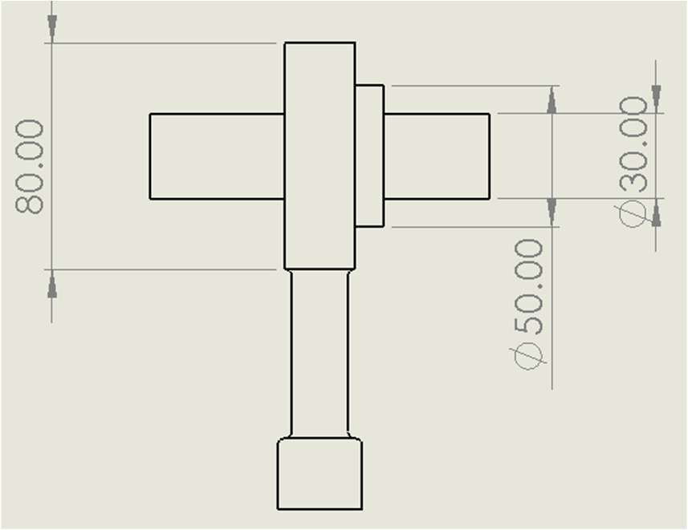Fig. 1: Housing, Bearing, Shaft Assembly
Drawing Side View

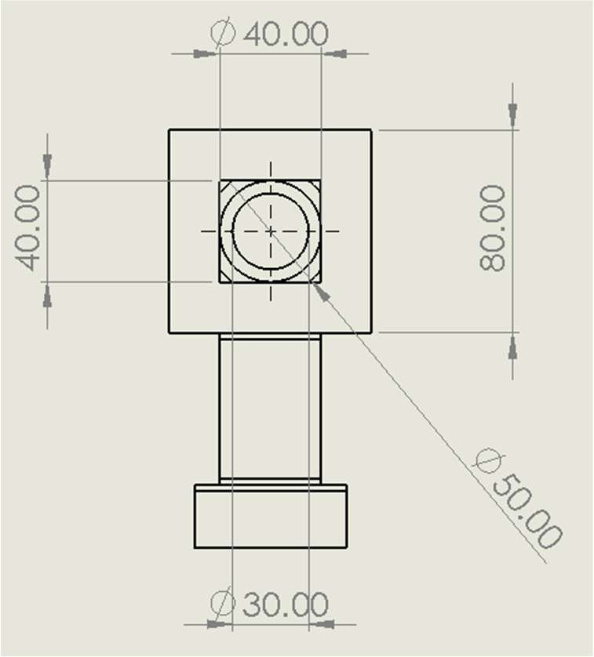Fig. 2: Housing, Bearing, Shaft Assembly
Drawing Front View
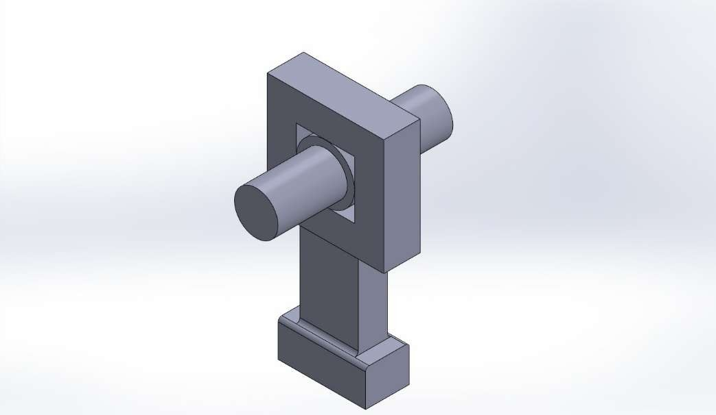

Fig. 3: Housing, Bearing, Shaft Assembly Model

4. GENETIC ALGORITHM PROCESS

The GA follows a structured five-step iterative process:

Step 1: Initialization

A random initial population of 20 individuals is generated. Each individual is a unique pair of IT grades for the shaft and the hub, sampled from the range IT6 to IT10.

Step 2: Fitness Evaluation

For each individual in the population:

The upper and lower dimensional limits for both shaft and hub are computed using the IT grades and the nominal diameter.

The resulting clearance or interference is calculated: Clearance = Hub Lower Limit – Shaft Upper Limit Interference = Shaft Lower Limit – Hub Upper Limit
If the clearance/interference meets the specified minimum threshold, the fitness is computed as: Fitness=Cost Index shaft + Cost Index hub
If constraints are violated, a penalty value is assigned, excluding the individual from selection.

Step 3: Selection

The top 50% of individuals (those with valid fits and the lowest total cost) are selected as parents for the next generation. This selection pressure ensures convergence towards cost-optimal and functionally valid solutions.

Step 4: Crossover and Mutation

Genetic diversity is maintained through recombination:

Crossover: New individuals are created by randomly combining IT grades from two parent individuals.
Mutation: With a small probability (e.g., 5–10%), one of the IT grades in the chromosome is randomly replaced with a new value from the permissible range (IT6–IT10), allowing the algorithm to explore new regions of the solution space.

Step 5: Iteration

The newly formed population undergoes the same evaluation, selection, and reproduction process for
30 generations. With each generation, the algorithm converges toward a solution that satisfies functional fit requirements while minimizing the associated manufacturing cost.

5. RESULTS AND INTERPRETATION

To validate the effectiveness of the proposed Genetic Algorithm-based tolerance optimization system, a representative sample case was evaluated. The input parameters were carefully chosen to reflect a typical mechanical engineering application involving a rotating shaft in a clearance fit scenario. The following input data was provided to the system:

Tolerance Recommendation System

Enter nominal shaft/hub diameter in mm (e.g., 50): 50

Enter fit type (clearance/interference): clearance

Enter the material used (e.g., steel, aluminum, etc.): steel

Enter the function of the component (e.g., rotating shaft, press-fit gear): rotating shaft

Based on ISO 286 standards and general engineering practice:

- Nominal Diameter: 50.0 mm

- Fit Type: Clearance

- Material: Steel

- Function: Rotating Shaft

Recommended Tolerance Grades:

- Shaft: h8

- Hub: H7

Reference: ISO 286-1:2010 and ISO 286-2:2010 for ISO system of limits and fits.

Recommended Tolerances (Based on Nominal Size):

Shaft Tolerance: h9

Hub Tolerance: H8

Optimized Tolerancing Result

Material: Steel

Function: Rotating Shaft

Shaft Tolerance Grade: IT6 (10.00 microns) Shaft Limits: +0.005 mm / -0.005 mm
Hub Tolerance Grade: IT10 (63.00 microns) Hub Limits: +0.032 mm / -0.032 mm
Total Manufacturing Cost Index: inf
Fit Type: Clearance — Functional constraints satisfied

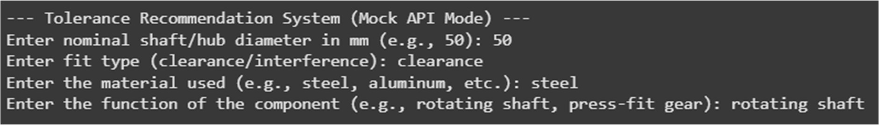

Fig. 4: Input Data

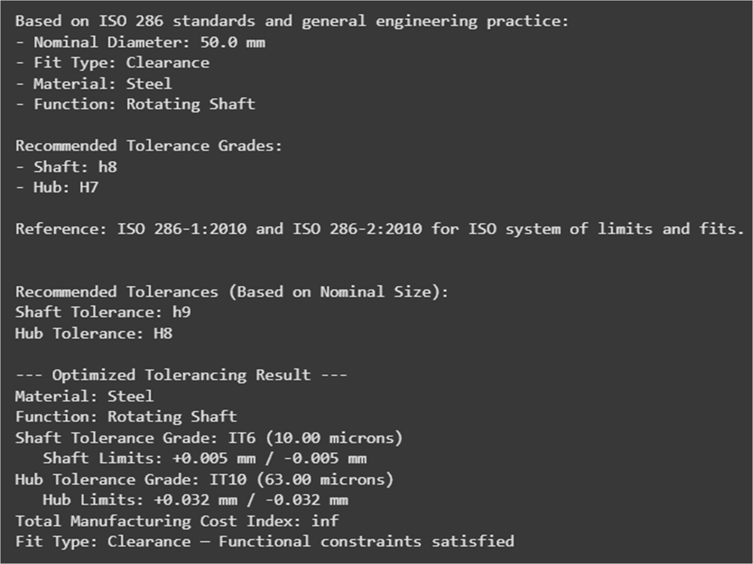

Fig. 5: Recommended Output

6. BENEFITS OF THE PROPOSED SYSTEM

The proposed AI-based tolerance optimization system offers several practical advantages over traditional methods:

• Cost Reduction: By avoiding unnecessary tight tolerances, the system minimizes machining, inspection, and tooling costs, leading to more economical production.

• Automation: The system eliminates the need for manual look-ups and expert-driven decisions by automating the selection of tolerance grades based on functional and cost constraints.

• Flexibility: It accommodates various design scenarios—different diameters, materials (e.g., steel, aluminum), and functional roles (e.g., rotating shafts, press-fits).

• Scalability: The framework can be extended to include surface finish, geometric tolerances (e.g., roundness), and manufacturing process constraints, making it adaptable for advanced design-for-manufacturing applications.
7. LIMITATIONS AND FUTURE SCOPE

Table 2: Limitations and Future Improvement Table

Limitation | Future Improvement
Limited to shaft-hub cylindrical fits | Extend to complex geometries and assemblies
Mock material properties | Integrate database for material-based tolerance selection
Static cost model | Dynamic cost estimation using real-time production data
No machine/process constraints | Include CNC capabilities, inspection limits

8. CONCLUSION

This study highlights the effective application of Artificial Intelligence (AI) techniques—specifically, Genetic Algorithms (GAs)—in the domain of tolerance selection for mechanical assemblies. The proposed system addresses a long-standing challenge in manufacturing design: how to balance functional fit requirements with the economic realities of production.

Traditional reliance on standardized tolerance charts and conservative engineering judgment often leads to over-engineered solutions, where tolerances are tighter than necessary. This results in increased machining complexity, extended cycle times, and elevated production costs. By contrast, the AI-driven approach presented in this work enables intelligent, data-informed decision-making that aligns closely with both design intent and manufacturability.

The genetic algorithm serves as a powerful optimization engine capable of navigating the large combinatorial space of tolerance pairings (e.g., shaft and hub), while considering constraints such as minimum clearance or interference, material selection, and process capability. The algorithm efficiently identifies tolerance combinations that satisfy all functional requirements without incurring unnecessary precision—and by extension, unnecessary cost.

By bridging the gap between theoretical ISO tolerance standards and practical, cost-sensitive design, this system empowers engineers to implement leaner, smarter, and more sustainable manufacturing practices. Moreover, its flexible and scalable framework opens the door for integration into CAD/CAM systems, product lifecycle management (PLM), and Industry 4.0 digital design workflows.

In summary, this study demonstrates the tangible value of AI-based optimization in mechanical design and manufacturing, marking a step forward toward fully intelligent and cost-effective engineering decision support systems.

COMPETING INTERESTS DISCLAIMER:
Authors have declared that they have no known competing financial interests OR non-financial interests OR personal relationships that could have appeared to influence the work reported in this paper.

9. REFERENCES

1. ISO 286-1:2010 — Geometrical product specifications (GPS) — ISO code system for tolerances on linear sizes — Part 1: Basis of tolerances, deviations and fits.

2. ISO 286-2:2010 — Geometrical product specifications (GPS) — ISO code system for tolerances on linear sizes — Part 2: Tables of standard tolerance classes.

3. Goldberg, D.E., Genetic Algorithms in Search, Optimization and Machine Learning, Addison- Wesley, 1989.

4. Qin, S., Liu, D., & Yu, H. (2021). "Intelligent Design Tolerancing in Industry 4.0", IEEE Access, vol. 9, pp. 44258–44269.
Gao, R., Wang, L., Teti, R., et al. (2015). "Cloud-enabled prognosis for manufacturing", CIRP Annals, vol. 64, no. 2, pp. 749–772.

5. Siqueira, B. R., Ferrari, F. C., Souza, K. E., Camargo, V. V., & de Lemos, R. (2021). Testing of adaptive and context‐aware systems: approaches and challenges. Software Testing, Verification and Reliability, 31(7), e1772.

6. Raza, S., & Ding, C. (2019). Progress in context-aware recommender systems—An overview. Computer Science Review, 31, 84-97.

7. Miah, M. H., Zhang, J., & Singh Chand, D. (2022). Knowledge creation and application of optimal tolerance distribution method for aircraft product assembly. Aircraft Engineering and Aerospace Technology, 94(3), 431-436.

8. Martins, J. R., & Ning, A. (2021). Engineering design optimization. Cambridge University Press.

9. Ben Amor, S., Zongo, F., Louhichi, B., Brailovski, V., & Tahan, A. (2021, August). Classification of dimensional deviation in additive manufacturing LPBF process for AlSi10Mg alloy according to ISO 286 and ANSI B4. 2. In International Design Engineering Technical Conferences and Computers and Information in Engineering Conference (Vol. 85376, p. V002T02A044). American Society of Mechanical Engineers.

10. Guo, F., Hou, Y., Xiao, Q., Zhang, X., Xiao, S., & Wang, Z. (2023). Reliability improvement on assembly accuracy with maximum out-of-tolerance probability analysis and prior precise repair optimization. Advanced Engineering Informatics, 55, 101866.
ABBREVIATIONS

AI: Artificial Intelligence

GA: Genetic Algorithm

IT: International Tolerance

ISO: International Organization for Standardization

PLM: Product Lifecycle Management

CNC: Computer Numerical Control

GPS: Geometrical Product Specifications

APPENDIX Tolerance info IT_grades = {
"IT6": 0.010, "IT7": 0.016, "IT8": 0.025, "IT9": 0.040, "IT10": 0.063
}

tolerance_cost = { "IT6": 5,
"IT7": 4, "IT8": 3, "IT9": 2, "IT10": 1
}

Input

print("--- Tolerance Recommendation System (Mock API Mode) ---")

part_diameter = float(input("Enter nominal shaft/hub diameter in mm (e.g., 50): "))

fit_type = input("Enter fit type (clearance/interference): ").lower()

material = input("Enter the material used (e.g., steel, aluminum, etc.): ").lower()

function = input("Enter the function of the component (e.g., rotating shaft, press-fit gear): ").lower()
ChatGPT Response chatgpt_recommendation = f"""
Based on ISO 286 standards and general engineering practice:

- Nominal Diameter: {part_diameter} mm

- Fit Type: {fit_type.title()}

- Material: {material.title()}

- Function: {function.title()}

Recommended Tolerance Grades:

- Shaft: h8

- Hub: H7

Reference: ISO 286-1:2010 and ISO 286-2:2010 for ISO system of limits and fits. """
print("\n--- ChatGPT Recommendation (Mocked) ---")

print(chatgpt_recommendation)

Initial Recommendation (Standard ISO-based Example)

def recommend_tolerance(diameter, fit):

if diameter < 30: shaft = "h7" hub = "H7"
elif diameter < 50:

shaft = "h8" hub = "H7"
else:

shaft = "h9" hub = "H8"
return shaft, hub

rec_shaft, rec_hub = recommend_tolerance(part_diameter, fit_type) print("\nRecommended Tolerances (Based on Nominal Size):") print(f"Shaft Tolerance: {rec_shaft}")
print(f"Hub Tolerance: {rec_hub}")
Optimization Section min_clearance = 0.005 min_interference = 0.002 population_size = 20 generations = 30 mutation_rate = 0.2

def generate_individual():

return [random.choice(list(IT_grades.keys())), random.choice(list(IT_grades.keys()))]

def fitness(individual):

shaft_tol = IT_grades[individual[0]] hub_tol = IT_grades[individual[1]] shaft_upper = part_diameter + (shaft_tol / 2) shaft_lower = part_diameter - (shaft_tol / 2) hub_upper = part_diameter + (hub_tol / 2) hub_lower = part_diameter - (hub_tol / 2) clearance = hub_lower - shaft_upper interference = shaft_lower - hub_upper
if fit_type == "clearance" and clearance < min_clearance:

return float('inf')

elif fit_type == "interference" and interference < min_interference:

return float('inf')

total_cost = tolerance_cost[individual[0]] + tolerance_cost[individual[1]]

return total_cost

def select(population):

sorted_pop = sorted(population, key=fitness)

return sorted_pop[:int(len(sorted_pop) / 2)]

def crossover(parent1, parent2):

return [random.choice([parent1[0], parent2[0]]), random.choice([parent1[1], parent2[1]])]
def mutate(individual):

if random.random() < mutation_rate:

individual[random.randint(0, 1)] = random.choice(list(IT_grades.keys()))

return individual

population = [generate_individual() for _ in range(population_size)]

for _ in range(generations): selected = select(population) children = []
while len(children) < population_size: parent1 = random.choice(selected) parent2 = random.choice(selected) child = crossover(parent1, parent2) child = mutate(child) children.append(child)
population = children

best = min(population, key=fitness)

shaft_tol = best[0]

hub_tol = best[1]

shaft_val = IT_grades[shaft_tol] hub_val = IT_grades[hub_tol] total_cost = fitness(best)

shaft_upper = part_diameter + (shaft_val / 2) shaft_lower = part_diameter - (shaft_val / 2) hub_upper = part_diameter + (hub_val / 2) hub_lower = part_diameter - (hub_val / 2)

print("\n--- Optimized Tolerancing Result ---") print(f"Material: {material.title()}") print(f"Function: {function.title()}")
print(f"Shaft Tolerance Grade: {shaft_tol} ({shaft_val*1000:.2f} microns)")

print(f" Shaft Limits: +{(shaft_val/2):.3f} mm / -{(shaft_val/2):.3f} mm")
print(f"Hub Tolerance Grade: {hub_tol} ({hub_val*1000:.2f} microns)") print(f" Hub Limits: +{(hub_val/2):.3f} mm / -{(hub_val/2):.3f} mm") print(f"Total Manufacturing Cost Index: {total_cost}")
print(f"Fit Type: {fit_type.title()} — Functional constraints satisfied")

