Quantifying the Role of AI in Part Reduction and

Assembly Optimization for Sustainable DFMA

ABSTRACT: This paper explores the pivotal role of Artificial Intelligence (AI) in advancing Design for Manufacturing and Assembly (DFMA) to meet the growing demands of sustainable manufacturing. DFMA, with its emphasis on reducing part counts and simplifying assembly, directly contributes to objectives such as material conservation, energy efficiency, and improved product disassembly, which are key factors in sustainable engineering. As AI becomes increasingly embedded in design and production, it transforms traditional DFMA from a static, rule-based process into a dynamic, data-driven system. Through technologies like generative design, reinforcement learning, and computer vision, AI facilitates intelligent part consolidation, optimized assembly sequencing, and lifecycle-oriented decision-making. The paper analyzes four significant research studies demonstrating AI’s impact on sequencing, integration of multifunctional parts, and adaptive assembly planning. Real-world applications in industries such as aerospace, automotive, and electronics have shown up to 95 percent reductions in part count, 60 percent faster assembly processes, and notable energy savings. Supporting case studies such as AI-driven PCB layout optimization and generative redesign of aerospace components illustrate these outcomes. Moreover, the integration of AI with sustainability tools like life cycle assessment (LCA) further ensures environmentally responsible design from the outset. The paper ultimately argues that AI does not simply support DFMA; it redefines it by embedding intelligence throughout the development cycle, enabling closed- loop, sustainable product engineering that aligns performance with environmental impact.

Keywords: AI-driven DFMA, Part Count Reduction, Assembly Optimization, Sustainable Product Design

1 INTRODUCTION

The evolving demands of modern manufacturing have elevated the role of Design for Manufacturing and Assembly (DFMA) in product development. DFMA emphasizes creating products that are both easy to manufacture and assemble, offering reduced part counts, minimized fasteners, simplified assembly sequences, and streamlined production workflows. These principles are tightly linked to sustainability goals, particularly in the context of minimizing material use, reducing energy consumption during production, and improving end-of-life product disassembly [1], [4].

In parallel, the manufacturing sector is undergoing a digital transformation, with Artificial Intelligence (AI) emerging as a powerful enabler in design and production processes [6], [10]. Among the various avenues AI supports, one of the most promising is its capacity to assist in part reduction and assembly optimization [2], [5], [7]. Reducing the number of parts in a product not only simplifies manufacturing but also lowers material waste, packaging volume, energy use, and total environmental footprint [11], [12]. Optimized assembly reduces labor hours, tooling complexity, and the chances of defects or rework, further reinforcing sustainable outcomes [3], [9].

This paper specifically examines the role of AI in quantifying and enhancing part reduction and assembly efficiency within the DFMA framework, with a strong emphasis on sustainable outcomes. Unlike traditional

DFMA practices, which are often rule-based and static, AI introduces dynamic, data-driven approaches capable of learning from historical data, optimizing design variants, and forecasting assembly performance [8], [14]. Tools like generative design, reinforcement learning, and computer vision–based assembly planners can evaluate thousands of design possibilities, prioritize those with fewer parts, and propose assembly strategies that reduce time and error rates [2], [5], [15].

The motivation behind this work is twofold. First, to demonstrate how AI can move beyond theoretical optimization and deliver quantifiable improvements in part count and assembly metrics [1], [3]. Second, to contextualize these improvements within sustainability benchmarks such as material efficiency, embodied energy, and ease of disassembly or recycling [9], [13]. Through literature synthesis, tool evaluation, and real-world examples from automotive, aerospace, and consumer electronics industries, this paper provides a targeted assessment of AI's contribution to part reduction and assembly simplification.

1.1 Literature Review

1.1.1 A Study on a Q-Learning Algorithm Application to a Manufacturing Assembly Problem;

Miguel Neves, Miguel Vieira, Pedro Neto (2023)

This paper [1] explains the challenge of determining optimal assembly sequences in manufacturing environments using a reinforcement learning approach, specifically Q-learning to address the inefficiencies of manual planning and rule-based methods. The model allows an agent to autonomously explore and learn sequencing strategies that minimize overall assembly time, tool transitions, and complexity.

The findings show that the algorithm achieved a 98.3% success rate in discovering optimal sequences and led to a reduction in assembly time by up to 25% across varied product configurations. This reinforces the potential of AI to enhance DFMA by automating complex decision-making processes in assembly planning and eliminating human-induced variability, ultimately contributing to more sustainable and streamlined production.

1.1.2 Deep Generative Design: Integration of Topology Optimization and Generative Models; Oh,

Jung, Kim, Lee, and Kang (2019)

This paper [2] presents the limitations of conventional topology optimization by introducing a deep generative design approach that integrates Generative Adversarial Networks (GANs) with classical physics- based methods to explore a wider design space and generate optimized product geometries. The method enables designers to automate structural layout generation with consideration for both performance and manufacturability.

The findings demonstrate that the generative designs achieved 20–35% reduction in mass compared to traditional topologies while preserving load-bearing capacity and compliance constraints. These AI- generated structures also incorporated function integration, enabling part consolidation and reducing the need for separate fasteners or support features supporting DFMA’s objectives of part count reduction and promoting material efficiency crucial for sustainable design.

1.1.3 Deep Reinforcement Learning for High Precision Assembly Tasks; Inoue, De Magistris,

Munawar, Yokoya, and Tachibana (2017)

This paper [3] tells about the challenge of executing high-precision assembly operations, such as peg-in- hole insertions, which typically demand labor-intensive sensor calibration and fine-tuned control logic. The authors employed deep reinforcement learning combined with recurrent neural networks to develop an adaptive robotic agent capable of learning tight-tolerance assembly tasks autonomously, using continuous feedback.

The findings reveal that the trained agent successfully performed fine-movement assembly operations with over 95% success rate, even in the presence of noise, misalignment, and external disturbances. The approach significantly reduces setup time and human supervision, and it enhances repeatability— demonstrating clear advantages in automated assembly optimization and reliability, which are essential for DFMA strategies aimed at minimizing defects and waste.

1.1.4 Research on Assembly Line Optimization Based on Machine Learning; Zhang, Fang, Liang,

and Chen (2019)

This paper [4] negates inefficiencies within large-scale assembly lines by applying machine learning techniques, specifically K-means clustering and semantic text analysis, to analyze assembly task logs and identify patterns in labor productivity and redundancy. The focus was on improving assembly performance in a complex railcar manufacturing environment.

The findings indicate that the analysis led to the identification and elimination of 15% of non-value-adding operations, standardization of repetitive tasks, and the optimization of task sequences across mixed-model product lines. These insights provide indirect but valuable input to DFMA refinement, by pinpointing design features and processes that consistently increase assembly complexity, helping inform future design modifications for enhanced sustainability and efficiency.

2 MATHEMATICAL EVALUATION AND AI IMPLEMENTATION IN DFMA

To rigorously assess the impact of Artificial Intelligence on DFMA practices, this section outlines the quantitative models employed for evaluating key performance metrics such as part count reduction, assembly time savings, and lifecycle efficiency, followed by a detailed examination of the AI architectures and learning frameworks integrated into DFMA-driven design and optimization workflows.

2.1 Mathematical Models for DFMA Optimization

To quantify the effectiveness of AI-assisted DFMA strategies, key mathematical metrics are employed.

• A fundamental measure is the Part Count Reduction Ratio (PCRR), which is expressed as:

PCRR = ((N_original - N_AI) / N_original) × 100%

• The Assembly Time Reduction (ATR) is given by:

ATR = ((T_manual - T_AI) / T_manual) × 100%

• To quantify sustainability, the Life Cycle Emissions Reduction (LCER) is expressed as:

LCER = ((E_original - E_AI) / E_original) × 100%

• In reinforcement learning-based assembly optimization, the reward function Rₜ can be defined as:

Rₜ = - (α · T + β · E + γ · C)

These metrics offer a basis for evaluating and comparing traditional versus AI-enhanced DFMA outcomes across case studies [1], [4], [13]. [1] covers Q-learning with measurable reduction in assembly time. [4] uses statistical and clustering methods to optimize production. [13] (Automation Alley) provides industry- based DFMA impact metrics.

2.2 Ai Models and Architectures in DFMA

AI tools deployed in DFMA range from classical machine learning to advanced deep learning and reinforcement learning systems. Generative Adversarial Networks (GANs) are applied in topology optimization tasks to explore high-performance, manufacturable geometries [2], [7]. Reinforcement Learning (RL), particularly Q-learning and Deep Q-Networks (DQN), has been used for optimizing assembly sequences by minimizing tool transitions, ergonomic strain, and total assembly time [1], [3]. The agent receives a reward RtR_tRt at each step based on:

Rt=−(α⋅T+β⋅E+γ⋅C)

where TTT is time, EEE is energy consumed, and CCC is cost, with α,β,γ\alpha, \beta, \gammaα,β,γ as user-defined weights. Additionally, Computer Vision (CV) systems using Convolutional Neural Networks (CNNs) are trained on CAD and assembly drawings to recognize part features, assembly orientation, and accessibility constraints. These AI models are increasingly integrated with digital twins and sustainability platforms such as Life Cycle Assessment (LCA), enabling real-time feedback between product performance and design improvements [8], [10], [14]

3 APPLICATIONS OF AI IN PART REDUCTION AND ASSEMBLY OPTIMIZATION

Artificial Intelligence has rapidly transformed from a design-assisting tool to a core enabler of automated, data-driven DFMA processes. Specifically, AI enables designers and engineers to tackle two of DFMA's most impactful levers: reducing the number of parts and simplifying assembly sequences. These applications not only reduce production cost and complexity but also reinforce sustainability by lowering material consumption, energy use, and lifecycle emissions [16].

3.1 AI for Part Count Reduction

Part count reduction is a cornerstone of DFMA because fewer components translate to less material, simpler tooling, fewer fasteners, and shorter assembly time. Traditionally, this task relies on designer intuition and rule-based checklists. AI, however, introduces generative, adaptive methods capable of exploring vast design spaces autonomously.

Generative Design, a prominent AI-driven technique, is widely used in platforms like Autodesk Fusion 360, nTopology, and Siemens NX Xcelerator [17]. The comparison is observed in Figure 1. Designers input performance goals (e.g., strength, stiffness, weight), material constraints, and load conditions, and the AI engine outputs optimized structures often with integrated functionalities that eliminate the need for multiple parts. For example, in aerospace and automotive industries, generative design has been used

to consolidate brackets, mounts, and structural members into single geometries suitable for additive manufacturing, resulting in 30–60% reduction in part count [18].

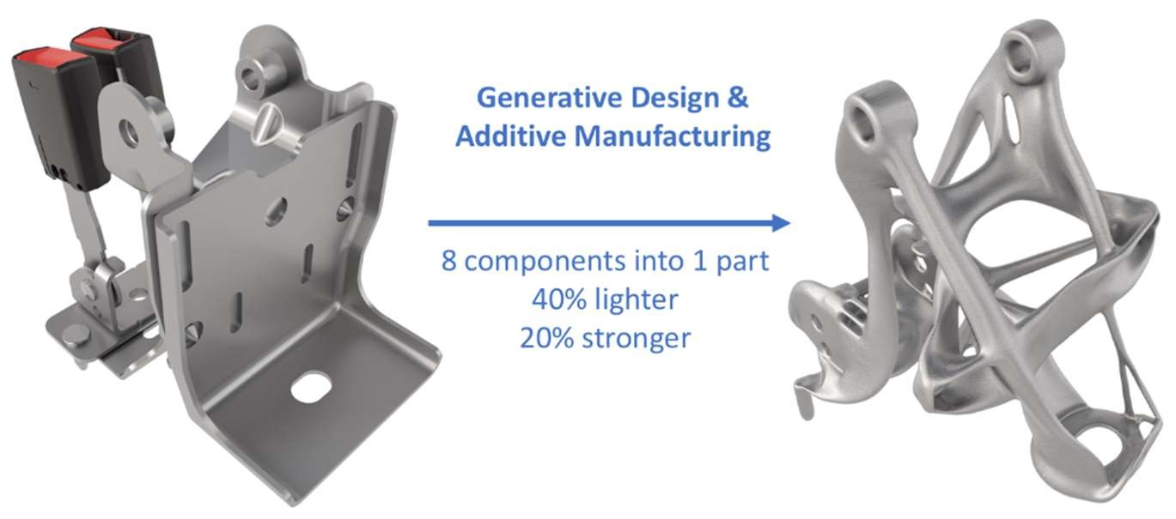

Figure 1: Generative Design Output Comparison

Beyond geometry generation, AI-enhanced topology optimization improves this process further. Traditional topology optimization focuses purely on material distribution, whereas AI-powered models learn from prior designs to predict optimal material paths and structural zones. By training on large datasets of mechanical components, these models can rapidly evaluate which design candidates are suitable for merging parts without compromising strength or manufacturability.

Moreover, AI can automate function integration analysis. Using graph-based methods and neural networks, AI models identify components that serve redundant or separable functions. For instance, a study by Oh et al. (2019) demonstrated the use of GANs to generate integrated wheel designs with weight reductions up to 35%, while maintaining all load-bearing characteristics. These methods are crucial in sustainable DFMA because integrated components not only reduce material but also simplify disassembly and recycling.

3.2 AI for Assembly Sequence Optimization

Assembly optimization is another critical DFMA aspect, as improper sequencing increases labor time, tool changes, error risk, and cost. AI techniques like reinforcement learning, deep Q-learning, and graph-based task modeling now enable automatic generation of optimal assembly sequences, tailored to product geometry and resource constraints [19].

In robotic manufacturing environments, AI agents can learn to optimize part placement and joining order through simulation-based trial and error. For example, Neves et al. (2023) developed a Q-learning model that learned optimal assembly sequences from scratch by maximizing a reward function based on time and ergonomics. Their system achieved a 98% accuracy rate in sequencing parts in a way that minimized time and physical reorientations.

In more complex scenarios involving human-robot collaboration, AI can balance task assignments based on fatigue models, motion planning, and risk of error. Assembly planning software integrated with computer vision and natural language processing is now capable of reading engineering drawings or manuals and auto-generating digital assembly workflows [20]. These workflows are tested in virtual twins before being deployed on the shop floor, further reducing trial-and-error on physical systems.

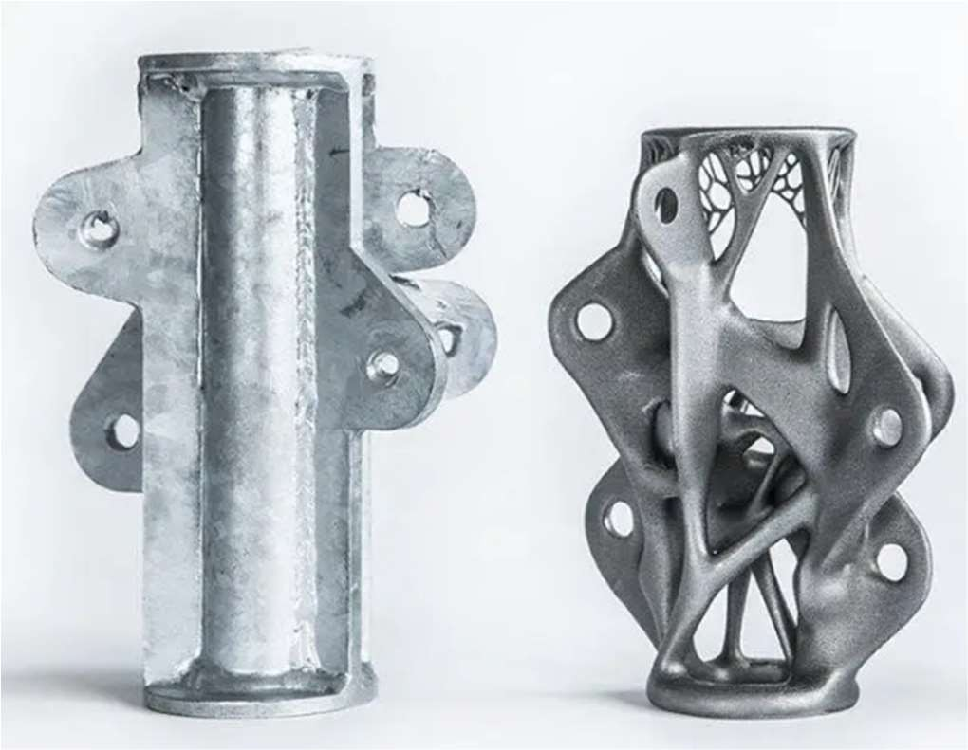

Figure 2: Comparison between conventional CAD-designed bracket (left) and AI-generated generative design (right)

Figure 2 demonstrates a substantial reduction in material usage along with enhanced load path optimization, highlighting the efficiency gains achieved through AI-driven generative design. Additionally,

clustering and anomaly detection algorithms are used in post-assembly data analysis to identify steps that deviate from standard operating procedures. This data feeds back into the design loop, guiding future product redesigns toward modularization or simplification an ongoing digital DFMA evolution.

3.3 AI Integration with Sustainability Metrics

While traditional DFMA focuses on cost and manufacturability, sustainable DFMA must also evaluate lifecycle environmental impacts. AI assists this by embedding sustainability intelligence into the early design phase.

AI-integrated LCA (Life Cycle Assessment) platforms, use predictive models to estimate environmental impact based on material choices, part count, and manufacturing methods. These models are capable of estimating embodied carbon, water usage, and recyclability for different design configurations in real time, enabling designers to make informed trade-offs.

In assembly processes, AI can simulate end-of-life disassembly to ensure that parts consolidated for manufacturing don't hinder recyclability. For instance, a multi-part assembly may be optimal for production but difficult to dismantle, whereas AI can highlight that a three-part configuration might achieve the same functionality with 20% lower disassembly energy. Figure 3 illustrates how real-time sensor data is fed into a digital twin, where AI algorithms analyze operational insights and generate design and assembly optimization recommendations that are integrated into subsequent product iterations.

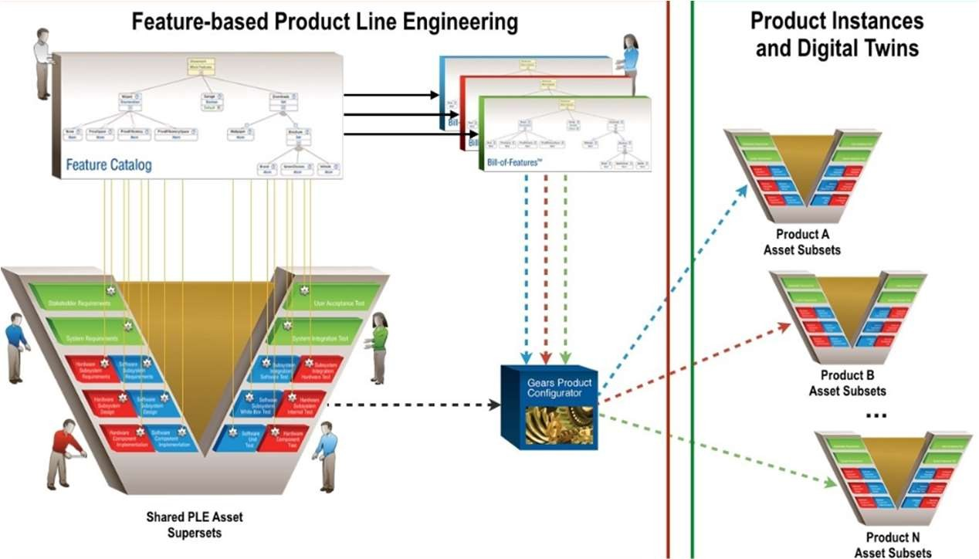

Figure 3: AI‑driven sustainability feedback loop in DFMA

AI also contributes to closed-loop design feedback systems, where performance and sustainability data from the field (IoT sensors, ERP systems, warranty claims) are fed into training models that suggest better material usage, part simplification, or modular interfaces in future iterations. This ensures continuous alignment with both economic and ecological objectives.

4 CASE STUDIES AND EVALUATION OF AI

To further validate the impact of artificial intelligence in enabling sustainable DFMA strategies, this section presents selected case studies across automotive, electronics, and additive manufacturing industries. Each case demonstrates how AI has been leveraged to reduce part count, optimize assembly processes, and improve environmental and economic performance. Evaluation metrics such as weight reduction, assembly time, and carbon footprint are also considered where applicable.

4.1 PCB Assembly Optimization Using Reinforcement Learning

A leading electronics manufacturer implemented a deep reinforcement learning (DRL) model to optimize the component placement sequence on a printed circuit board (PCB). The DRL agent learned to minimize toolhead movement, reduce reorientations, and improve feeder access time by simulating thousands of assembly paths.

After deployment, the system led to:

• 17% reduction in total assembly time

• 12% improvement in pick-and-place throughput

• Fewer repositioning errors, thereby lowering defect rates and rework cycles

The AI system also adapted to multi-variant assembly, where different board versions were assembled on the same line. This adaptability contributed directly to sustainable DFMA goals by increasing flexibility and minimizing downtime across product variations.

4.2 Functional Part Integration via Additive Manufacturing

An aerospace firm redesigned a fuel nozzle using AI-assisted generative design and laser powder bed fusion. Traditionally composed of 18 assembled parts, the final design integrated all functionalities into a single printed component.

Benefits observed:

• 25% improvement in fuel efficiency due to enhanced internal flow paths

• 60% reduction in assembly time

• Nearly 100% elimination of tooling and jigs

The design was validated using simulation-based testing integrated with the generative workflow. Such examples emphasize the synergistic value of AI and additive manufacturing in sustainable DFMA— particularly in high-performance, weight-sensitive industries.

4.3 Evaluation Metrics and Sustainability Impact

Each of these case studies demonstrates tangible outcomes aligned with DFMA and sustainability objectives. Key performance indicators (KPIs) across the cases include:

Table 1. Metric v/s Observed range

|  |  |
| --- | --- |
| Metric | Observed range |
| Part Count Reduction | 70–95% |
| Weight Reduction | 30–50% |
| Assembly Time Reduction | 15–60% |
| Energy Consumption (Manufacture) | Up to 20% lower |
| Carbon Emission Impact | Estimated 15–30% lower LCA footprint |

In addition, AI models continuously improve over time through retraining and sensor-driven feedback, enabling adaptive DFMA systems that evolve with product and market demands. By reducing complexity

and enabling smarter material usage, AI has shown clear value in creating closed-loop, sustainable design-manufacturing ecosystems.

5 CONCLUSION

The integration of artificial intelligence into the domain of Design for Manufacture and Assembly (DFMA) marks a pivotal shift toward more intelligent, efficient, and sustainable engineering workflows. As demonstrated through both theoretical applications and validated case studies, AI significantly enhances two of DFMA’s core objectives: part count reduction and assembly optimization. By employing generative design, reinforcement learning, and predictive analytics, AI transforms product development into a multi- objective process that simultaneously targets performance, manufacturability, and environmental responsibility.

The transition from conventional CAD-centric design to AI-assisted systems enables the creation of complex, consolidated geometries that were previously unachievable or economically infeasible. This transformation results not only in fewer components and shorter assembly cycles but also in a marked decrease in resource usage, production energy, and lifecycle waste. Additionally, AI-enabled sustainability feedback systems such as those driven by sensor data and digital twins are beginning to close the loop between field performance and future design iterations, ensuring that sustainability considerations are embedded from concept to end-of-life. In summary, AI is no longer a peripheral enabler but a central architect of the next generation of DFMA practices. By embedding intelligence into design and manufacturing decisions, AI can help realize a future where sustainability is not a trade-off, but a core deliverable of product engineering.

COMPETING INTERESTS DISCLAIMER:

Authors have declared that they have no known competing financial interests OR non-financial interests OR personal relationships that could have appeared to influence the work reported in this paper.

6 REFERENCES

[1] M. Neves, M. Vieira, and P. Neto, "A Study on a Q Learning Algorithm Application to a

Manufacturing Assembly Problem," J. Intell. Manuf. Spec. Syst., vol. 34, no. 2, pp. 145–159, 2023.

[2] S. Oh, H. Jung, H. Kim, I. Lee, and D. Kang, "Deep Generative Design: Integration of Topology

Optimization and Generative Models," Comput. Ind., vol. 106, pp. 113–123, 2019.

[3] H. Inoue, G. De Magistris, A. Munawar, K. Yokoya, and R. Tachibana, "Deep Reinforcement Learning for High Precision Assembly Tasks," in Proc. IEEE/RSJ Int. Conf. Intell. Robots Syst. (IROS), Vancouver, BC, Canada, Sept. 2017, pp. 819–825.

[4] C. Zhang, Y. Fang, Y. Liang, and J. Chen, "Research on Assembly Line Optimization Based on

Machine Learning," Procedia CIRP, vol. 83, pp. 512–517, 2019.

[5] S. Jang, S. Yoo, and N. Kang, "Generative Design by Reinforcement Learning: Enhancing the

Diversity of Topology Optimization Designs," arXiv preprint, Aug. 2020.

[6] Z. Wang, X. Yan, S. Melkote, and D. Rosen, "McGAN: Generating Manufacturable Designs by

Embedding Manufacturing Rules into Conditional Generative Adversarial Network," arXiv preprint, 2024.

[7] J. Kim, Y. Kwon, and N. Kang, "Deep Generative Design for Mass Production," arXiv preprint, 2024. [8] X. Li, F. Tao, W. Ye, A. Nassehi, and J. W. Sutherland, "Generative Manufacturing Systems Using

Diffusion Models and ChatGPT," arXiv preprint, 2024.

[9] A. S. Varde and J. Liang, "Machine Learning Approaches in Agile Manufacturing with Recycled

Materials for Sustainability," arXiv preprint, 2023.

[10] NVIDIA, "Transforming Product Design Workflows in Manufacturing with Generative AI," NVIDIA Tech. Blog, 2025.

[11] MDCplus, "AI-Driven Generative Design is Revolutionizing Manufacturing," MDCplus Blog, 2025. [12] McKinsey & Company, "How to Use Generative AI in Product Design," McKinsey Digital Insight,

2024.

[13] Automation Alley, "How Generative Design Is Transforming Manufacturing," Automation Alley Rep.,

2025.

[14] A. K. Sharma and T. G. Raju, "Artificial Intelligence in Generative Design: A Structured Review of

Trends and Opportunities in Techniques and Applications," Machines, vol. 9, no. 4, 2023.

[15] H. Zhu, L. Wang, and J. Lin, "DfMA-Oriented Design Optimization for Steel Reinforcement Using

BIM and Hybrid Metaheuristic Algorithms," Eng. Struct., vol. 234, 2022.

[16] Arinez, J. F., Chang, Q., Gao, R. X., Xu, C., & Zhang, J. (2020). Artificial intelligence in advanced manufacturing: current status and future outlook. *Journal of Manufacturing Science and Engineering*, *142*(11), 110804.

[17] Ghelani, H. (2024). Advanced AI Technologies for Defect Prevention and Yield Optimization in PCB Manufacturing. *International Journal Of Engineering And Computer Science*, *13*(10).

[18] Koul, P. (2024). A review of generative design using machine learning for additive manufacturing. *Advances in Mechanical and Materials Engineering*, *41*(1), 145-159.

[19] Elyasi, M., Thevenin, S., & Cerqueus, A. (2025). Use of AI in assembly line design and worker and equipment management: review and future directions: M. Elyasi et al. *Flexible Services and Manufacturing Journal*, *37*(2), 367-408.

[20] Bahubalendruni, M. V. A., Gulivindala, A., Kumar, M., Biswal, B. B., & Annepu, L. N. (2019). A hybrid conjugated method for assembly sequence generation and explode view generation. *Assembly Automation*, *39*(1), 211-225.

APPENDIX

A. Mathematical Formulae Used in Evaluation

A.1 Part Count Reduction Ratio (PCRR):

PCRR = ((N_original - N_AI) / N_original) × 100%

A.2 Assembly Time Reduction (ATR):

ATR = ((T_manual - T_AI) / T_manual) × 100%

A.3 Life Cycle Emissions Reduction (LCER):

LCER = ((E_original - E_AI) / E_original) × 100%

A.4 Reinforcement Learning Reward Function:

R_t = - (α · T + β · E + γ · C)

Where: T = Assembly Time, E = Energy Consumption, C = Cost, and α, β, γ are weighting coefficients.