Bibliometric Analysis Of Material Adaptation On House Building Construction In Coastal Areas Using Vosviewer

.

ABSTRACT

This research employs a quantitative bibliometric approach to elucidate the description, trends, evaluation, relationships, and monitoring of published research in the field of coastal building construction. The study aims to consolidate and evaluate the current understanding of building construction in coastal areas, identifying knowledge gaps, and establishing future study objectives through bibliometric analysis. In this research, the results and discussion are based on data obtained through Publish or perish and VOSviewer software. The data is then visualized through graphs, tables, and figures to present easily comprehensible information. Focusing on coastal construction, material management, and coastal zone management, the research emphasizes the necessity of a resilient foundation. Material management challenges are explored, with proposed technology integration for optimization. Coastal Zone Management is highlighted as a critical framework, balancing housing needs with ecosystem preservation. The study underscores the significance of nature-based solutions and sustainable development strategies, acknowledging the need for education and cooperation for their effective implementation. The research findings indicate a growing trend in coastal construction studies, with a specific focus on ICZM and material adaptation. These identified trends provide valuable insights for academics, stimulating further research to address challenges in coastal building construction, ensuring resilience and sustainability in vulnerable coastal areas.

Keywords: Coastal Construction, Material Management, Coastal Zone Management, Eco-Friendly Construction Materials, Disaster-resilient Building Materials, Innovative Materials for Coastal Structures

1. INTRODUCTION

The coastal area is a unique natural region as it serves as the meeting point between the ocean and the land [1]. The increase in population is significantly correlated with a rise in the number of buildings, especially in coastal areas, leading to various impacts such as the potential conversion of natural land into urban areas, changes in land use, and an increase in pressure on the coastal environment [2]. The construction of houses in coastal areas involves a series of unique decisions and considerations related to the dynamic coastal environment. People living in the coastal region are susceptible because they live in a dynamic estuarine environment facing numerous natural hazards [3]. To possess technical proficiency in the face of challenges such as strong winds and climate change, contemporary architects and planners develop a method for the construction of low-rise buildings in the coastland and water areas with the least labor effort required to erect buildings and ensure their safe operation [4]. This paper further underscores the need for ecological coast construction technology, highlighting the importance of ecological protection, artificial protection, landscape construction, and ecological engineering [5].
Indonesia, acknowledged as a nation of islands, possesses the world’s largest archipelago. The country is comprised of a total of 17,508 islands, with five primary ones identified as Java, Sumatra, Kalimantan, Sulawesi, and Papua [6]. These geographical conditions mean that organizational/housing areas are located inland areas (both highlands and lowlands), waterside areas (fisherman housing and coastal areas) as well as areas above water/water (both rivers, lakes, sea/swamps) [7]. The use of housing materials is highly diverse, allowing their adaptation to the topographic or environmental conditions of a residence [8]. This is particularly important in low-rise residential buildings, where the choice of materials and technologies can significantly impact architectural and environmental aspects [9]. However, the practical and theoretical difficulties in understanding users' spatial needs, especially in social housing, can create a gap in design knowledge [10].
A home is one of the fundamental rights of the people, and therefore, every citizen has the right to reside and have access to a good and healthy living environment. The development of housing and settlements in coastal areas is an important part of supporting sustainable development and can improve the welfare of coastal communities in particular [11]. Furthermore, determining the physical characteristics of buildings, such as elevation, becomes highly relevant in the context of Indonesia, which has numerous islands with varying topography [12]. The influence on the composition of buildings and the coastal environment must consider the sustainability of the richly biodiverse marine and coastal ecosystems [13]. Furthermore, the intricate interplay of environmental factors, such as monsoons and climate variability, with construction design must be carefully considered, while safety aspects encompass the structural resilience of buildings to disasters such as earthquakes, winds, tidal waves, and erosion [14].
The main purpose of the study in the field of coastal building construction is to enhance our understanding of construction in coastal areas. This study includes consolidating and evaluating the current understanding of building construction in coastal areas, reviewing the literature to identify knowledge gaps and establish future study objectives, bibliometric analysis to identify important aspects, leading authors, primary sources, and national contributions, as well as providing inspiring insights to advanced research. This study seeks to comprehensively investigate current understanding, evaluate practices, and identify knowledge gaps in building construction in coastal areas through a literature review and bibliometric analysis, presenting crucial insights for academics and encouraging further research to address challenges in coastal building construction [15]. Overall, the research aims to provide critical insights that inspire academics to advance their studies and make significant progress in addressing challenges related to building construction in coastal regions.

2. LITERATURE REVIEW

2.1 Coastal Construction
Coastal areas are defined as transitional zones or interfaced between land and sea, which also encompass expansive inland lakes [16]. Coastal improvement is inevitable, with almost 60% of the population targeted along the shoreline and the developing risk of rising sea levels and improved storms [17]. Sea level rise poses a major challenge to coastal landscapes and communities. Sustainable adaptation to sea level rise has been a growing concern for coastal management authorities, engineers, ecologists, urban planners, and designers [18]. The coastal building is of great importance for sustainable and energy development. Coastal building hotspot issues are mainly related to urbanization, sea level rise, natural disasters, and environmental pollution [19], which pose a major challenge to sustainable and energy development and therefore need to be explored in depth.
The significance of a strong, enduring, and tough foundation is emphasized, with the need to consider high wind, dynamic wave action, erosion, and scouring [20]. The design and reliability of coastal structures are also crucial, requiring a climate-aware approach and comprehensive risk frameworks [21] These factors underscore the need for a holistic approach to coastal house construction, considering both the environmental challenges and the cultural context. The previous research about cost and integration to coastal house construction is important. The research about cost [22] emphasizes the need for affordable, resilient housing in sinking coastal cities, while integration [23] underscores the importance of integrating heritage, environmental, and sensory analysis in sustainable coastal design.
A robust and resilient foundation is crucial for coastal house construction, given the challenges posed by high winds, dynamic wave action, erosion, and scouring. This is particularly important in the face of climate change, which requires a holistic approach that considers both environmental challenges and cultural context [24]. The concept of "Building with Nature" offers a framework for evaluating coastal protection strategies, emphasizing the need for multifunctional, adaptable, and economically feasible solutions [25]. Coastal communities can enhance their resilience through measures such as governance, structural design, risk knowledge, prevention, warning systems, and recovery [26]. Understanding the natural resilience of coastal systems is also crucial, as it provides a basis for effective planning and management [27].
In conclusion, the challenges faced by coastal areas, encompassing urbanization, sea level rise, natural disasters, and environmental pollution, highlight the urgent need for sustainable adaptation strategies. Coastal building, essential for sustainable energy development, requires a resilient foundation considering high winds, dynamic wave action, and erosion, emphasizing the importance of a holistic, climate-aware approach and comprehensive risk frameworks. Integrating environmental considerations and cultural context into coastal house construction is crucial, as demonstrated by prior research on cost, affordability, and the integration of heritage, environmental factors, and sensory analysis. To address climate change, a holistic approach is necessary, guided by the concept of "Building with Nature" to evaluate coastal protection strategies through multifunctional, adaptable, and economically feasible solutions. Coastal communities can enhance resilience through governance, structural design, risk knowledge, prevention, warning systems, and recovery measures while understanding the natural resilience of coastal systems serve as the foundation for effective planning and management. The amalgamation of sustainable practices, cultural sensitivity, and innovative strategies is crucial for ensuring the resilience and longevity of these vulnerable coastal areas.

2.2 Material Management
Material management is a critical aspect in the construction of residential buildings along coastal areas, demanding meticulous planning and strategic utilization of resources [28]. The selection and management of construction materials become paramount due to the challenging environmental conditions [29]. However, the construction industry still faces problems in executing material management and is at an early stage in adopting new techniques and technologies. Improper application of material management can lead to project cost variance, which can be controlled through corrective actions [30]. Efficient management of material flow on-site is crucial, and innovative techniques such as the pull system, Just-In-Time, Kitting, and off-site fabrication can be effective [31].
The construction industry faces significant challenges in material tracking and management, leading to inefficiencies and wasted resources [32]. To address these issues, advanced technologies like Building Information Modeling (BIM) and Radio-Frequency Identification (RFID) have been proposed. BIM, when integrated with sensor technology, can provide real-time data visualization and analysis, enhancing facility management [33]. Similarly, the combination of BIM and Internet of Things technology can improve material management in construction projects, enabling finer daily management and cost control [34]. The linkage of RFID to BIM has also been explored, with guidelines developed for choosing appropriate solutions in different construction engineering and management scenarios [35]. These technologies offer the potential to enhance accuracy and efficiency in material tracking and management, providing real-time monitoring, reducing manual errors, and enabling proactive decision-making.
The construction industry is increasingly embracing advanced material management technologies to optimize project outcomes, minimize environmental impact, and ensure the long-term sustainability of coastal housing developments [36][37][38]. These technologies, including data acquisition, analytics, visualization, communication, and design and construction automation, have been found to improve work efficiency, health and safety, and productivity. However, their effective use is hindered by challenges such as the scale of construction projects, cultural barriers, environmental challenges, financial constraints, and the behavior of key personnel. Overcoming these challenges requires a change in business approaches and procedures, as well as the implementation of necessary skill sets.
Efficient material management is crucial in coastal residential construction, demanding meticulous planning and strategic resource utilization to address challenging environmental conditions. While the construction industry is in the early stages of adopting new techniques and technologies, problems persist in executing material management, leading to project cost variance. On-site material flow management is enhanced through innovative techniques like the pull system, Just-In-Time, Kitting, and off-site fabrication. Proposed solutions involve advanced technologies such as Building Information Modeling (BIM), Radio-Frequency Identification (RFID), and the Internet of Things, aiming to improve accuracy and efficiency in material tracking and management, offering real-time monitoring, reducing manual errors, and enabling proactive decision-making. Despite the construction industry's increasing embrace of advanced material management technologies to optimize project outcomes and minimize environmental impact, challenges persist. These include the scale of construction projects, cultural barriers, environmental concerns, financial constraints, and personnel behavior. Overcoming these hurdles necessitates a transformative shift in business approaches, procedures, and the implementation of necessary skill sets.

2.3 Coastal Zone Management
Coastal Zone Management (CZM) is a critical framework for sustainable development in the construction of residential buildings along coastal areas, balancing housing needs with ecosystem preservation [39]. However, human activities, such as the construction of hard structures, can disrupt this balance, leading to erosion and the potential disappearance of coastal features [40]. To address this, CZM should prioritize the preservation of unexploited coastal wetlands and the delay of urbanization. CZM can also play a role in rethinking coastal cliff protection zones, with a focus on land-use planning and the avoidance of soil sealing [41]. In the context of waterfront development, CZM can be integrated with urban regeneration, using tools like ENCoRe to prioritize actions that protect the environment and enhance connectivity [42].
The construction of residential buildings in coastal areas requires adherence to Coastal Zone Management (CZM) principles to ensure structural integrity and ecosystem health [43]. The construction of residential buildings in coastal areas requires adherence to Coastal Zone Management (CZM) principles to ensure both structural integrity and environmental health [44]. Nature-based solutions (NbS) such as living shorelines and wave attenuation structures are particularly beneficial for coastal restoration and development [45]. The implementation of landscape design and ecological environment standardization is crucial for the sustainable development of coastal residential areas. Additionally, the design of green buildings with climate adaptability is essential for protecting the natural environment in coastal areas [46]. Homeowners also play a crucial role in climate adaptation and environmental sustainability through their landscaping decisions.
Nature-based solutions (NbS) such as living shorelines and wave attenuation structures are crucial for coastal restoration and development [47]. These solutions can be particularly beneficial for coastal residential areas when implemented alongside landscape design and ecological environment standardization. The design of green buildings with climate adaptability is also essential for protecting the natural environment in coastal areas [48]. To enhance the uptake of NbS, it is important to increase education, training, and knowledge sharing, rationalize cooperation across jurisdictions, enhance environmental monitoring, leverage existing policies, and implement sustainable finance instruments.
The sustainable development of coastal residential areas is contingent on the implementation of landscape design and ecological environment standardization. This can be further enhanced by the design of green buildings with climate adaptability. Nature-based solutions (NbS) such as living shorelines and wave attenuation structures are crucial for coastal restoration and development. However, the uptake of NbS can be improved through education, training, and knowledge sharing, cooperation across jurisdictions, and sustainable finance instruments. However, the uptake of NbS can be improved through education, training, and knowledge sharing, cooperation across jurisdictions, and sustainable finance instruments [49]. Despite the potential of NbS, their reliability, cost-effectiveness, and resilience to climate change need to be rigorously assessed [50].

3. METHODOLOGY

This research employs quantitative methods, explicitly adopting a bibliometric approach to explain the description, trends, evaluation, relationships, and monitoring of published study [51]. With a particular emphasis on these dimensions, this research aims to understand the existing knowledge about coastal construction and housing development trends. This research was reviewed based on various aspects, including author aspects, topic combinations, sources, countries, and quotations. The data collected will be changed through visualized images and graphs with quantitative data processing. The relationship between analysis and quantitative methods is very related because this research requires data that will produce numbers.
In this research, the data to be identified are based on the topic to be discussed, namely, house building construction of coastal areas. The data collection and sources in this study uses the Publish or Perish software. Publish or perish software is used to filter journals using keywords related to house-building construction in coastal areas. The data are filtered using sources from Crossref and Semantic Scholar. Then the results are presented in the form of research titles, researcher names, research years, publishers, and research sources. After obtaining this data, it is processed using VOSviewer software. Once entered, the data is processed to match the desired or selected keywords. VOSviewer software then transforms the entered data into an interconnected data map. In addition, we looked at differences in the number of publications each year and classified the ten articles with the most citations for each publisher out of a total of 1000 articles [52].
4. RESULT & DISCUSSION

This research's results and discussion are based on data obtained through Publish or Perish and VOSviewer software. The data is then visualized through graphs, tables, and figures to present easily understandable information. Keywords used in the Publish or Perish software for this research include coastal construction, material management, coastal zone management, eco-friendly construction materials, disaster-resilient building materials, and innovative materials for coastal structures. The data obtained is in the form of research title, researcher's name, year of research, and journal source. The data is then transformed into graphical form using Ms. Excel to facilitate a concise presentation of information.

4.1 Keyword Correlation
In this section, the author presents descriptive and evaluative analysis results. Bibliographies from various sources, co-occurrences of author keywords, and bibliographic duplicates of authors were extracted using VOSviewer software. These connections can provide relevance between the research topic and the database. Additionally, it also indicates the total link strength between keywords.
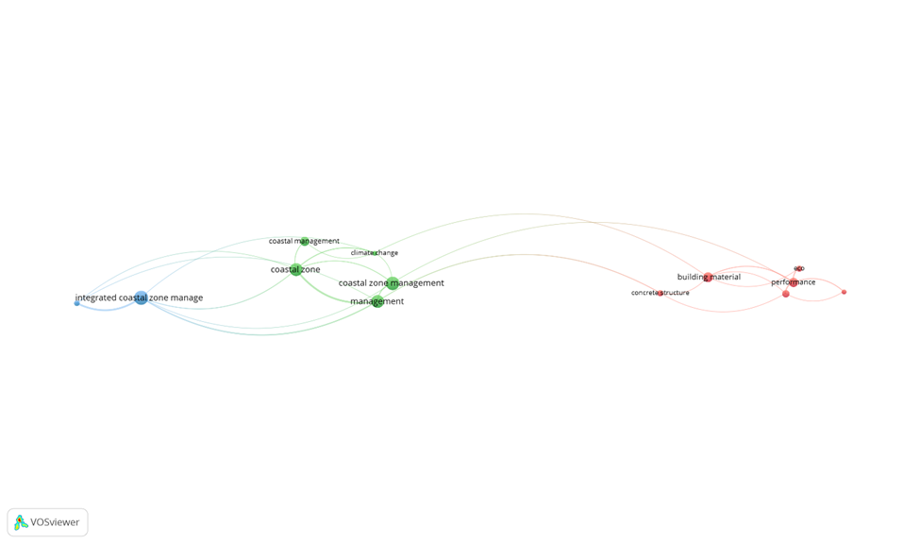
Figure 1. Network visualization of co-word

Figure 1 shows that the network, like connected lines, is visible more clearly through the VOSviewer software. This phenomenon indicates that "coastal zone management" is often used in papers related to material adaptation in house-building construction in coastal areas. The relationship or correlation between research keywords generated by the VOSviewer software can be seen in Figure 1 above. This correlation shows a variety of keywords that are interconnected with each other. As seen in Figure 1, the most dominant keyword is found in “coastal zone management,” with a solid color and the most extensive network, along with other keywords such as “integrated coastal zone management,” “performance,” and other related keywords, although not as extensive. The more prominent nodes, the more relevant it is to the research.
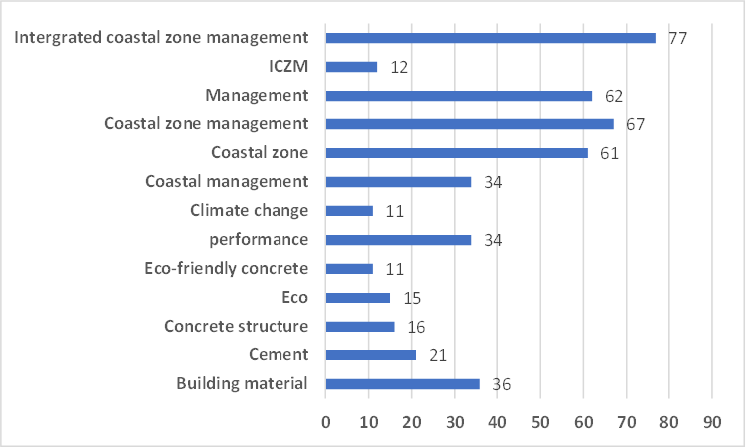
Figure 1. Keywords graph according to occurrences.

The graph in Figure 2 shows that based on occurrence, integrated coastal zone management, coastal zone management, and management are the ones that are the tallest. These three keywords will be the main key to this research paper. Followed by other keywords that are not dominant in this research but are related to the author’s main topic. The author believes that ICZM (Integrated Coastal Zone Management), coastal zone management, and management are the framework that includes integrated planning and management of coastal areas, considering environmental, social, economic, and cultural aspects.

4.2 Research Keyword Density
The VOSviewer software generates an analysis output related to the frequency of search keywords. Examining material adaptation on house-building construction in coastal areas is underway. The keyword categories encompass coastal construction, material management, coastal zone management, eco-friendly construction materials, disaster-resilient building materials, and innovative materials for coastal structures. The author can explore relevant previous research through literary sources by employing these keywords. Figure 3 below is the visual representation of keyword-based density in the VOSviewer software search.
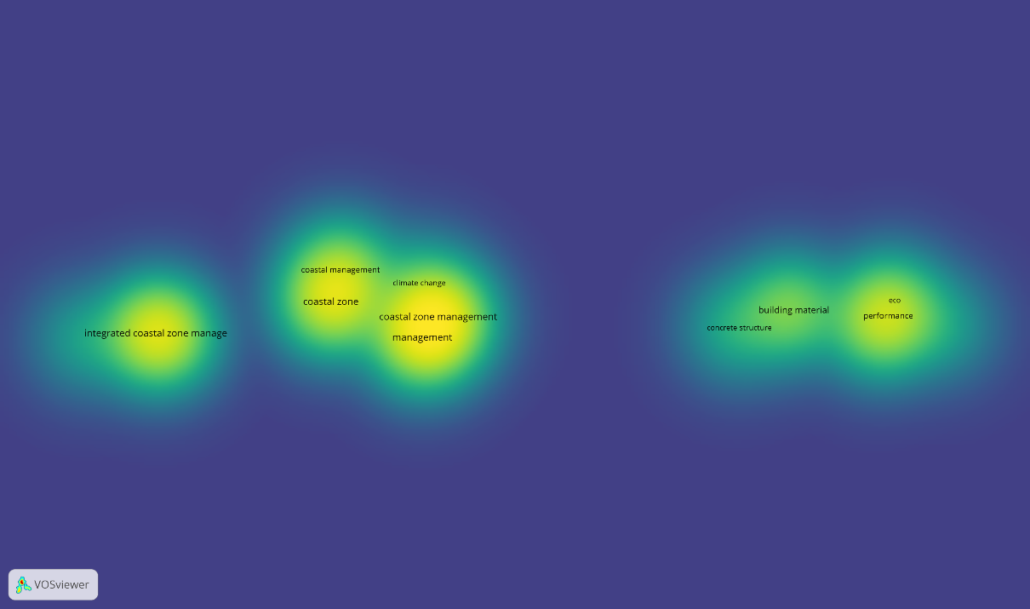
Figure 3. Cumulative data of research from multiple years

From the results of the density visualization shown in Figure 3, it can be identified that there is a density or emphasis on the nodes which means that the authors who research in the field of material adaptation of house construction in coastal areas have a relationship with each other. In Figure 3 the density network related to coastal zone management and integrated coastal zone management can be seen from the brightest light. Referring to Figure 3 the keywords “international coastal zone management” occur 77 times, “coastal zone management” 67 times, and “management” 62 times, and we can conclude that the keywords that appear are from the 778 documents collected. A total of 206 studies contain 3 key keywords, which translates to 20,1% of the most relevant searches out of 1022 studies. So, it can be said that coastal zone management, ICZM, and performance are widely used in research on this research.

4.3 Research Publisher
This research collects data from various publishers after going through a selection process. The information presented by these publishers is related to research in the field of civil engineering globally. By using the Publish or Perish software, data regarding the three publishers most actively publishing journals on material adaptation of house building construction can be found in Figure 4 (below).

Figure 2. Top 3 research publisher data

Then all the publisher data can be seen in Figure 5 (below).
Figure 3. Research publisher data
As seen in Figure 5 above, we have more than 15 publishers on this topic. There were around 17 publishers related to this research of 788 documents that the author collected. The data source most often taken from publishers is "Elsevier BV" with 466 times, followed by "Informa UK Limited" with 60 times, and "CRC Press" with 40 times. This shows how various publishers can support developments in engineering.

4.4 Research Type
A wide variety of search methods have been identified, not only in the variety of publishers used. Types of research include journal articles, books, review articles, series reports, data collections, conferences, components, content, monographs, and peer reviews. This classification also refers to the type of research carried out by each publisher. By utilizing various sources of information, references, and documents from previous studies, this study evaluates the material adaptation of house construction in coastal areas with the findings from the search network. Further details regarding the various search categories are explained below (Figure 6).
Figure 4. Study type
The author believes that there is a relationship between the publisher and the type of research. Figure 6 shows 626 study categories, with journal articles ranking at the top and 172 categories, originating from book sources. It could be said that in today's technological era, research related to engineering is related to each other.

4.5 Research per Year
One of the results of implementing publish or perish is an annual analysis of the research conducted. Data originating from various sources is used to calculate the number of research publications each year at the global level, especially research discussing material adaptation of building house construction in coastal areas. To present a simpler visualization of the results, cumulative data from various research journals around the world are collected and presented. The graph of data processing results from 2000 to 2023 can be seen below (Figure 7).
Figure 5. Research data yearly
Based on the graph Figure 7 above it explains the distribution of 1022 studies that occurred in the period 2000 to 2023. This data shows a significant change from 2014 to 2010. Other facts show that 2023 is the highest year in terms of the number of studies in terms of the number of studies 81 studies. The author considers that the rise and fall of the number of studies based on the following year periods concludes that there is a research trend that continues to develop over time.
4. Conclusion

This research uses bibliometric analysis to identify research topic networks, disseminate the relevance of literature sources, and update research on public transport passenger satisfaction to maintain sustainable transport. The publish or perish software produced 1022 articles about the adaptation of coastal house building construction materials between 2000 and 2023 consisting of 626 journal articles, 172 books, 21 proceeding articles, 4 conferences, 3 monographs, 2 posted content, 1 dataset, 2 components, 1 report series, 2 reports, 2 reference entries, 1 reference book and 13 others. Research findings show that international coastal zone management (ICZM), coastal zone management, and management are the three main keywords, as well as additional keywords related to the research topic. Based on research on building construction in coastal areas, it can be concluded that the number of studies continues to increase from 2000 to 2023, with the highest number in 2023. The research trend regarding house construction in coastal areas continues to grow every year and will continue to increase in the coming years..

COMPETING INTERESTS DISCLAIMER:
Authors have declared that they have no known competing financial interests OR non-financial interests OR personal relationships that could have appeared to influence the work reported in this paper.

References

Agyefi-Mensah, S. S., Kpamma, Z. E., & Hagan, D. E. (2020). Residential adaptations as users’ tacit means of communicating spatial needs in housing design. Journal of Engineering, Design and Technology, 18, 1593–1613.
Al-Awadhi, T., Nasiri, N. A., Ahsan, R., Hereher, M. E., & Charabi, Y. (2021). An Integrated Approach to Coastal Zone Management to Control Development and Ensure Sustainability in a Rapidly Increasing Coastal Urban Environment: The Sultanate of Oman. Environmental Justice.
Beatly, T. (2014). Planning for Resilient Coastal Communities: Emerging Practice and Future Directions. 123–144.
Brisibe, W. (2020). A Comparative Review of the Implications of Flooding on Architecture and Planning Policies in the UK and Nigeria. Journal of Architectural Engineering Technology, 9(1). https://doi.org/10.35248/2168-9717.20.09.230
Castillo Rodríguez, R., Antionio, J., Lepe, D., Felipe, L., & Torrez, J. (2022). Current situation of construction material management at the international level. Construction Engineering Journal. www.ricuc.cl
Chang, Y., Chu, K. W., & Chuang, L. Z. (2018). Sustainable coastal zone planning based on historical coastline changes: A model from a case study in Tainan, Taiwan. Landscape and Urban Planning.
Chee, S. Y., Firth, L. B., Then, A. Y. H., Yee, J. C., Mujahid, A., Affendi, Y. A., Amir, A. A., Lau, C. M., Ooi, J. L. S., Quek, Y. A., Tan, C. E., Yap, T. K., Yeap, C. A., & McQuatters-Gollop, A. (2021). Enhancing Uptake of Nature-Based Solutions for Informing Coastal Sustainable Development Policy and Planning: A Malaysia Case Study. Frontiers in Ecology and Evolution, 9. https://doi.org/10.3389/fevo.2021.708507
Chen, X., Alice, C. Y., Pelosi, A., Jia, Y., Shen, X., Siddiqui, M., & Yang, N. (2021). Implementation of technologies in the construction industry: a systematic review. Engineering, Construction and Architectural Management.
Chowdhury, T. (2014a). Significance of Foundation in Residential Building Construction in Coastal Regions. International Journal of Engineering, 2, 134–141.
Chowdhury, T. (2014b). Significance of Foundation in Residential Building Construction in Coastal Regions. International Journal of Engineering, 2, 134–141.
Cibro, B. D., & Nasution, I. N. (2019). KAJIAN DESAIN RUMAH PESISIR PANTAI DI KELURAHAN BAGAN DELI MELALUI PENDEKATAN RAMAH LINGKUNGAN. EDUCATIONAL BUILDING Jurnal Pendidikan Teknik Bangunan Dan Sipil, 5(1).
Cohn, J., Copp Franz, S., Mandel, R., Nack, C. C., Brainard, A. S., Eallonardo, A. S., & Magar, V. (2021). Strategies to work towards long-term sustainability and resilience of nature-based solutions in coastal environments: A review and case studies. Integrated Environmental Assessment and Management, 18.
Dakhli, Z., & Lafhaj, Z. (2018). Considering Materials Management in Construction: An Exploratory Study. Logistics, 2(1), 7. https://doi.org/10.3390/logistics2010007
Ewing, L. C., Flick, R. E., & Synolakis, C. (2010). A review of coastal community vulnerabilities toward resilience benefits from disaster reduction measures. Environmental Hazards, 9, 222–232.
Fauzy, B., Antariksa, & Salura, P. (2011). Form and Structure of Architectural Construction of Houses in the North Coastal Area of East Java.
Finandhita, A., Mega, R. U., Jumansyah, R., Rafdhi, A. A., & Oktafiani, D. (2022). VOSviewer Application Analysis: Computational Physical Chemistry Case Study. Moroccan Journal of Chemistry, 10(1), 91–101. https://doi.org/10.48317/IMIST.PRSM/morjchem-v10i1.31756
Guo, W. (2020). Climate Adaptability of Green Buildings in Coastal Areas. Journal of Coastal Research, 106, 368–371.
Hamdani, R. S., Hadi, S. P., & Rudiarto, I. (2022). Housing challenges in a sinking coastal city: Rethinking urban housing in a subsidence area for a more resilient community. IOP Conference Series: Earth and Environmental Science, 1007(1). https://doi.org/10.1088/1755-1315/1007/1/012017
Hamdy, M. A., & Setiawan, A. (2017). STRUCTURAL AND MATERIAL DEVELOPMENT MODEL FOR PILLAR/LEGAL ELEMENTS (SUPERSTRUCTURE) IN TRADITIONAL BUGIS-MAKASSAR HOUSE SETTLEMENTS IN THE COASTAL AREA OF MAKASSAR CITY. SINALTSUB, 149–165.
Janani, R., & Sankar, A. G. (2021). Material management and effective utilization of materials. Materials Today: Proceedings, 37, 3118–3124.
Journal, I. (2022). Construction Materials Management: A case study of Residential Building Construction Project. INTERANTIONAL JOURNAL OF SCIENTIFIC RESEARCH IN ENGINEERING AND MANAGEMENT, 06(06). https://doi.org/10.55041/ijsrem14510
Kar, S., & Jha, K. N. (2021). Exploring the Critical Barriers to and Enablers of Sustainable Material Management Practices in the Construction Industry. Journal of Construction Engineering and Management-Asce, 147.
Kazado, D., Kavgic, M., & Eskicioglu, R. (2019). INTEGRATING BUILDING INFORMATION MODELING (BIM) AND SENSOR TECHNOLOGY FOR FACILITY MANAGEMENT. In Journal of Information Technology in Construction (ITcon) (Vol. 24). http://www.itcon.org/2019/23
Kereri, J. O., & Turner, B. (2018). USE OF TECHNOLOGY IN MATERIAL TRACKING IN THE CONSTRUCTION INDUSTRY BUSINESS.
Lautetu, L. M., Kumurur, V. A., & Warouw, F. (2019). Characteristics of community settlements in the coastal area of Bunaken District. Spatial, 6(1), 126–136.
Legionosuko, T., Madjid, M. A., Asmoro, N., & Samudro, E. G. (2019). Indonesia's Position and Strategy in Facing Climate Change to Support National Resilience. National Resilience Journal, 25(3), 295. https://doi.org/10.22146/jkn.50907
Mallick, B., Ahmed, B., & Vogt, J. (2017). Living with the risks of cyclone disasters in the South-Western Coastal Region of Bangladesh. Environments - MDPI, 4(1), 1–17. https://doi.org/10.3390/environments4010013
McFadden, Loraine., Nicholls, R. J., & Penning-Rowsell, E. C. (Edmund C. (2007). Managing coastal vulnerability. Elsevier.
Mendonça, R., Roebeling, P., Fidélis, T., & Saraiva, M. (2021). Policy Instruments to Encourage the Adoption of Nature-Based Solutions in Urban Landscapes. Resources.
Neumann, B., Vafeidis, A. T., Zimmermann, J., & Nicholls, R. J. (2015). Future coastal population growth and exposure to sea-level rise and coastal flooding - A global assessment. PLOS ONE, 10(3). https://doi.org/10.1371/journal.pone.0118571
Nugraha, A. R. (2017). SEA SAND MINING AND THREATS TO COASTAL CONDITIONS OF THE WAKATOBI MARINE NATIONAL PARK.
Oke, A. E., Odubiyi, T. B., Aigbavboa, C. O., Thwala, W. D., & Nelwamondo, Z. T. (2019). Roles and effects of using recent technologies on material management for construction work in South Africa. IOP Conference Series: Materials Science and Engineering, 640(1). https://doi.org/10.1088/1757-899X/640/1/012023
Papatheochari, T., & Coccossis, H. (2019). Development of a waterfront regeneration tool to support local decision making in the context of integrated coastal zone management. Ocean & Coastal Management.
Pastukh, O., Mähner, D., Panin, A., & Elistratov, V. (2022). MODERN MATERIALS AND STRUCTURES USED IN HOUSING CONSTRUCTION: INTERNATIONAL EXPERIENCE. Architecture and Engineering, 7(3), 53–64. https://doi.org/10.23968/2500-0055-2022-7-3-53-64
Pena, S. B., Abreu, M. M., & Magalhães, M. R. (2021). Rethinking coastal cliff protection zones for landscape planning. What limits are enough? Applied Geography, 127.
Sahavacharin, A., Sompongchaiyakul, P., & Thaitakoo, D. (2022). The effects of land-based change on coastal ecosystems. Landscapes and Ecological Engineering, 18(3), 351–366.
Scyphers, S. B., & Lerman, S. B. (2014). Residential Landscapes, Environmental Sustainability and Climate Change.
Shen, W. (2022). Application of BIM and Internet of Things Technology in Material Management of Construction Projects. Advances in Materials Science and Engineering, 2022. https://doi.org/10.1155/2022/5381252
Sinou, M., Skalkou, K., Perakaki, R., Jacques, S., & Kanetaki, Z. (2023). Holistic Strategies Based on Heritage, Environmental, Sensory Analysis and Mapping for Sustainable Coastal Design. Sustainability (Switzerland), 15(13). https://doi.org/10.3390/su15139953
Slinger, J., Stive, M., & Luijendijk, A. (2021). Nature-based solutions for coastal engineering and management. In Water (Switzerland) (Vol. 13, Issue 7). MDPI AG. https://doi.org/10.3390/w13070976
Slobbe, E. V., Vriend, H. J., Aarninkhof, S. G., Lulofs, K. R., Vries, M. B., & Dircke, P. (2013). Building with Nature: in search of resilient storm surge protection strategies. Natural Hazards, 65, 947–966.
Subbotin, O. S. (2018). Architectural and Planning Principles of Organization and Reconstruction of Coastal Areas. Materials Science Forum, 931, 750–753.
Subbotin, O. S. (2019). Building materials and technologies of modern housing: Architectural and environmental aspects. IOP Conference Series: Materials Science and Engineering, 698(3). https://doi.org/10.1088/1757-899X/698/3/033044
Talib, R., & Sulieman, M. Z. (2011). Towards more Manageable Coastal Buildings; Initial Coastal Building Construction Guidelines. American J. of Engineering and Applied Sciences, 4(2), 307–313.
Toimil, A., Losada, I. J., Nicholls, R. J., Dalrymple, R. A., & Stive, M. J. (2020). Addressing the challenges of climate change risks and adaptation in coastal areas: A review. Coastal Engineering.
Usman, F., Hariyani, S., & Shoimah, F. (2021). Participatory Planning for Tsunami Disaster Emergency Response on the South Coast of Watulimo, Trenggalek. TATALOKA, 23(1), 138–150. https://doi.org/10.14710/tataloka.23.1.138-150
Wikantari, R., Ishak, R. A., Imriyanti, & Radja, A. M. (2018). Environmental Planning and Disaster Response on Sapuli Island, Pangkajene and Kepulauan Regency, South Sulawesi. TEPAT Journal of Applied Technology for Community Service, 2(1).
Xue, F., Chen, K., Lu, W., Niu, Y., & Huang, G. Q. (2018). Linking radio-frequency identification to Building Information Modeling: Status quo, development trajectory, and guidelines for practitioners. Automation in Construction.
Y.-n. Luan, D. Li, H.-b. Chen, B.-l. Geng, & H.-y. Liu. (2020). Review of Ecological Coast Construction Technology. 2020 International Conference on Intelligent Transportation, Big Data & Smart City (ICITBS), Vientiane, Laos, 181–186.
Yudina, A., & Kukushkina, Y. (2021). Construction of low-rise buildings in the coastland and water areas. Architecture and Engineering, 6(1), 58–63. https://doi.org/10.23968/2500-0055-2021-6-1-48-53
Zefri, & Nurwahyi. (2019). Concept Development Housing and Settlement of Coastal Areas based on Eco-Green: Case Study-Coastal Areas Babelan and Tarumajaya District Bekasi West Java, Indonesia. Journal of Environmental Science and Public Health, 03(03). https://doi.org/10.26502/jesph.96120076
Zupic, I., & Cater, T. (2015). Bibliometric Methods in Management and Organization. Organizational Research Methods, 18(3), 429–472. https://research.gold.ac.uk/id/eprint/26859/

