RENEWABLE DIESEL SYNTHESIZED FROM MORINGA SEEDS OIL USING HETEROGENEOUS BIOCATALYSTS DERIVED FROM PLANTAIN PEELS ASH

Abstract:
This study focuses on exploring the potential of Moringa seed oil as a viable source for biodiesel production using heterogenous biocatalysts derived from plantain peels ash. The research entails the extraction of moringa oil using a Soxhlet extraction process and normal hexane as a solvent. The chemical and physical properties of the oil were found to align with the quality standards set by the American Society for Testing and Materials (ASTM). However, the oil's viscosity was too high, and it was identified as a challenge. Through transesterification process, biodiesel was successfully produced, with a thorough analysis of key process variables such as residence time, reaction temperature, amount of biocatalyst and the volume of methanol using Design Expert version 13 software and Box-Behnken design. The statistical analysis of variance (ANOVA) revealed that the yield of biodiesel was influenced by both individual and interaction effects. The optimization process resulted in a remarkable biodiesel yield of 98.322%, achieved at a residence time of 360 minutes, reaction temperature of 55 °C, methanol of 60 ml and amount of biocatalyst of 12.50g. While most properties of the produced biodiesel met ASTM standards, the density and viscosity exceeded the limits, indicating a need for blending with diesel fuel before use. Its recommended that exploration on other heterogenous biocatalysts, investigating other non-edible oil seeds and develop novel reactor designs for biodiesel synthesis, collaboration and knowledge sharing between the industry and the academic sector to determine scalability and commercial viability. This study not only contributes to the advancement of renewable energy but also underscores the potential for a more environmentally sustainable future through the utilization of Moringa seed oil for biodiesel production.
Keywords: Biocatalyst, Plantain peels, Renewable, Moringa seed, Physico-chemical properties
INTRODUCTION
The continuing increase in global economic activities and quest for people’s well-being has led to ever-increasing demand for energy across all sectors of human endeavor (Dash and Lingfa, 2017). Fuels derived from petroleum play very significant roles in industrial developments and the entire economy of every nation (Mahmudul et al., 2017). Meanwhile, high energy demand by industrialized nations poses very big challenges to the entire globe since widespread emissions from combustion of fuels during energy generation pave way to environmental pollutions, land degradation and global warming (Bateni et al., 2019). The energy and transport sectors account for most of the greenhouse emissions globally (Dash and Lingfa, 2017). The adverse effects on the environment that result from energy use are mainly promoted by combustion of fossil fuels (Deep et al., 2019). Meanwhile, the world’s petroleum reserves are unevenly distributed in ways such that, many countries largely depend on others for the supply of most fuels that they consume domestically in their country (Moser, 2019). Petroleum products and other fossil fuels are on the other hand being depleted at very high rates and manner that, if the present consumption rates of those non – renewable energy resources remain unchecked, they may eventually go into extinction (Olujobi and Olusola-Olujobi 2020). Efforts to proffer range of secure and sustainable solutions to overcome the adverse effects that arise from usage of petroleum products as energy sources, and future challenges which could result from their scarcity has continued to pave way for the development of more sustainable alternatives that are renewable which also have less negative environmental impacts (Chen et al., 2010).
Biodiesel is environmentally friendly and can be blended with petro-diesel in various proportions. When this is done, it brings about some beneficial characteristics to diesel engine (Olujobi and Olusola-Olujobi, 2020). Biodiesel has received very wide attention in recent years due to various properties associated with it in comparison to petro-diesel (Deep et al., 2019). Some of the key factors that favour the use of biodiesel as an alternative energy resource when compared with petro-diesel include its renewability, biodegradability, non - toxicity, less sulphur content, closed carbon cycle, higher cetane number, better lubricity and octane rating, less flammability as well as less emission of carbon dioxide (CO₂) and particulate pollutants. Also in most cases, no modification is required in already existing diesel engines before use of biodiesel by those engines (Mathew et al., 2021).
Currently, edible oils are the most widely used oil for biodiesel production. Almost 95 % of biodiesel produced in the world is made from edible vegetable oils which are too much costly. The use of these oils as feed stock for biodiesel production results in food price competition (Leung et al., 2010). Since recent years, nonedible oils have become attractive feed stock for biodiesel production because of their low cost compared to those edible oils and the plants from which non-edible oils obtained are easy to cultivate in lands where edible plant oils cannot be grown and the cultivation cost for nonedible oil producing plants is much lower than the cost for edible plants oils (Neupane, 2023).
Transesterification reaction is the most widely used method for biodiesel production in which the triglycerides in the vegetable oils are reacted with a monohydric alcohol (Meher et al., 2016). This reaction is usually carried out in the presence of catalyst and many different chemical and enzymatic catalysts have been used in the process (Shahla et al., 2010). However, alkalis, mainly sodium hydroxide, sodium methoxide and potassium hydroxide are more widely used The choice of acid and alkali catalyst depends on the free fatty acid that the oil contains and base catalyzed transesterification is more suitable for oils with low free fatty acid (Demirbas, 2013). Methanol and ethanol are the most widely used alcohols during transesterification. Moreover, alcohols like propanol, butanol can also be used. Ethanol is preferred compared to methanol because it is derived from agricultural products and is renewable and low environmental impact. However, methanol is the most widely used because of its low cost and high reactivity (Enweremadu and Prutto, 2013).
Since biodiesel production is technically feasible, easily accessible, and its usage found to be environmentally friendly (Olayomi, et al., 2020). Economic viability of its production can boost its portfolio such that it could become very competitive alternative fuel that would play significant roles in transportation, power generation etc. Recently, research has been conducted on production of biodiesel through transesterification of triglycerides that are sourced from various edible and non-edible oils which constitute biodiesel feed-stocks in different parts of the world. Some of these feed stocks include soybean oil, palm oil, rapeseed oil, cottonseed oil, coconut oil, palm kernel oil, olive oil, jatropha oil, castor oil, rubber seed oil, waste oils and oil from oil bean seed, waste vegetable oils (WVOs), used frying oils (UFOs) and animal fat (Ahmad et al., 2013; Oboh et al.,2015 ).
RSM is a collection of mathematical and statistical techniques in which a response of interest is influenced by several variables in a system (Montgomery and Runger, 2015). The eventual objective of RSM is to determine the optimum operating conditions for a system or to determine a region of factor space in which the operating specifications are satisfied (Montgomery, 2018). The optimization technique basically requires sets of experimental data whereby the parameters that determine the response which are under investigation are varied within a chosen range (Khuri and Mukhopadhyay, 2010). The response values form a surface placed above the plane of these variables. It is therefore convenient to produce the response surface in the plane of two or more variables such that curves are obtained by connecting the points with the same yield (Myers and Montgomery, 2020). Localization of optimal response is done by graphic analysis, which allows for a visual detection of the response, and this determines the robustness of the response surfaces (Montgomery, 2018).
Response Surface Methodology (RSM) was adopted in this research so that the coefficients of cross product terms of the variables in the model used to predict the yield of biodiesel during production from moringa seeds oil could be ascertained alongside the linear and quadratic terms (Myers and Montgomery, 2020).
In view of all these, this research seeks to optimize the production conditions to obtain optimal yield of biodiesel from locally sourced feedstock, moringa seeds oil through transesterification of the oil with methanol, in the presence of potassium hydroxide, which is a catalyst, using Response Surface Methodology. Efforts of this study are geared towards obtaining biodiesel whose properties meet the specifications recommended by the American Society for Testing and Materials (ASTM) and Europe Normalization (EN) standards.
Fossil fuels are the major sources of energy across the world. However, these energy sources are the major sources of greenhouse gases, air pollution and global warming. These factors have stimulated scientists and researchers to search a renewable energy source such as biodiesel hydro, biomass, wind, solar, geothermal, hydrogen and nuclear is of vital importance.
Despite global awareness of environmental challenges occasioned by utilization of non-renewable fuels as major energy sources, some factors still constitute challenges to full commercialization of biodiesel which is an alternative source of energy to petro-diesel in many countries. Currently, edible oils are the most widely used oil for biodiesel production. Almost 95 % of biodiesel produced in the world is made from edible vegetable oils which are costly. The use of these oils as feed stock for biodiesel production results in food price competition.
Thus, in recent years, non-edible oils have become attractive feed stock for biodiesel production because of their low cost compared to those edible oils and the plants from which non-edible oils obtained are easy to cultivate in land where edible plant oils cannot be grown and the cultivation cost for non-edible oil producing plants is much lower than the cost for edible plants oils.
Moringa seeds oil belong to the family of nonedible oils having a promising potential for biodiesel production. It has high oil content of about 30% – 55%. Nigeria is highly endowed with wide variety of nonedible oils plants that can be used as a feed stock for biodiesel production but not well exploited (Omonhinmin et al., 2020). Thus, production of biodiesel from moringa seeds oil can be a potential solution to the problems encountered with the use of fossil fuels. Hence, the aim of the study is to synthesized renewable diesel from moringa seeds oil using heterogeneous biocatalysts derived from plantain peels ash.
2.0 MATERIALS AND METHOD:
Moringa Oleifera seeds were harvested from a farmland along Nwaniba Road Uyo, Akwa Ibom State, Nigeria. The chemicals that were used in carrying out the experiments were analytical grade and used without further purification and equipment/apparatus used were based on the literature.
2.1 Methods
The methods and procedure used for the production of biodiesel and optimization is has shown in Figure 1 and Where MOSBD is Moringa seeds biodiesel.

Processing Flow Chart
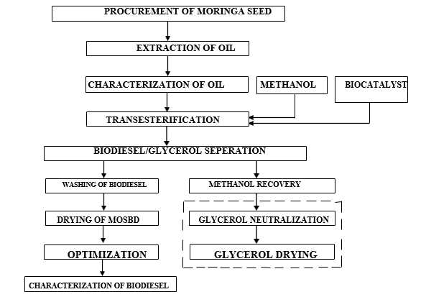
Figure 1: Flow Chart of biodiesel Production and Optimization Steps
2.2 Moringa Oleifera Seed Preparation
The methods by Oniya et al., (2017) were adopted in this stage. The obtained moringa seed were parboiled in a cooler filled with hot water (heated to 100 ºC) to soften the shell for easy de-shelling of the seeds, thereafter sundried to remove the moisture absorbed during parboiling. The seeds were further dried at 105 ⁰C to constant weight for two (2) hours in an oven. The seeds were ground to a paste using laboratory blinder, prior to extraction.

2.3 Synthesis of Catalyst from Plantain Peels
The synthesis of plantain peel catalyst was done following the method by Falowo et al., (2022). Unripe plantain peels used for this study were treated separately before calcination. The unripe plantain peels collected were cut into small pieces, and then washed in distilled water to remove the dirt and stones. The washed peels were oven-dried at 100 ºC, until a constant weight was observed. The dried plantain peels were crushed and the powdered ash was load in the porcelain crucible and calcinated in the muffle furnace at 500 ºC for four (4) hours, according to Betiku and Ajala (2014). After calcination, the calcined plantain ash was sieved using 80 mesh size, and the obtained ash was stored for further used.
2.4 Extraction of Oil from Moringa Seed
Solvent extraction method as described by Akpan et al. (2006) was adopted for the extraction of the oil and normal hexane was used as a solvent. Two hundred (200) grammes of ground moringa seed were packed in a filter paper and placed in Soxhlet apparatus. Then approximately 500 ml normal hexane was poured into 1000 ml round bottom flask. Then after the flask and the Soxhlet apparatus were fixed together and placed into a hot water bath. The extraction process was carried for five hours at a constant temperature of 72 ºC. After the extraction was completed, the oil was obtained by removing the solvent using rotary evaporator. The amount of oil extracted was calculated using Equation 1.
$\% Yield of oil=\frac{Mass of oil obtained }{Mass of seed used }×100$ Equation 1

2.5 Optimization of the Transesterification Reaction
Design Expert software (Version 13) was used for the optimization of the production process of biodiesel from the oil extracted. The biodiesel was produced from moringa seeds oil via transesterification with methanol and biocatalyst blends. Box-Bhenken was used to design the experiment and investigate the effects of the process variables on the yield of the biodiesel. Biodiesel yield was selected as response. Range and levels of the investigated variables are listed in Table 1. The process variables residence time and speed of the stirrer was taken as constant variables based on literature data. Seventeen experimental runs were conducted, and the resulting data were analyzed using design expert software to develop an appropriate model describing the yield of the biodiesel as function of the chosen process variables.
Table 1: Factor levels of the independent variables for the biodiesel production
Variables | Units | Low | High
Reaction Temperature | Degree Centigrade | 40 | 70
Amount of Methanol | Milliliters | 5 | 10
Amount of Biocatalyst | Grams | 15 | 30
The range of values in Table 1 is based on several literature sources and preliminary studies on biodiesel production that employed similar vegetable oils. The minimum temperature of the reaction during the production of biodiesel was 40 ºC which is well above the room temperature. This is to avoid the requirement for a cooling system on the reactor whereas; the maximum temperature (70 ºC) is set just a little above the boiling point of methanol (64.7 ⁰C) (Silva et al., 2010). The experimental runs were also fully randomized to minimize the effects of unexpected variability in the observed response.

Table 2: Independent Variables and Biodiesel Yield
 |  | Factor 1 | Factor 2 | Factor 3 | Factor 4 | Response 1
Std | Run | A:Amount of Biocatalyst | B:Temperature | C:Residence Time | D:Amount of Methanol to oil ratio | Biodiesel Yield
 |  | g | ^{O}C | Min | Ml | %
18 | 1 | 20 | 55 | 120 | 45 | 92.62
10 | 2 | 20 | 55 | 240 | 30 | 87.84
12 | 3 | 20 | 55 | 240 | 60 | 97.09
19 | 4 | 5 | 55 | 360 | 45 | 94.39
23 | 5 | 12.5 | 40 | 240 | 60 | 90.58
2 | 6 | 20 | 40 | 240 | 45 | 91.25
16 | 7 | 12.5 | 70 | 360 | 45 | 87.92
5 | 8 | 12.5 | 55 | 120 | 30 | 99.89
14 | 9 | 12.5 | 70 | 120 | 45 | 96.26
9 | 10 | 5 | 55 | 240 | 30 | 98.96
7 | 11 | 12.5 | 55 | 120 | 60 | 91.54
1 | 12 | 5 | 40 | 240 | 45 | 98.61
24 | 13 | 12.5 | 70 | 240 | 60 | 92.92
6 | 14 | 12.5 | 55 | 360 | 30 | 89.95
11 | 15 | 5 | 55 | 240 | 60 | 90.92
20 | 16 | 20 | 55 | 360 | 45 | 98.14
3 | 17 | 5 | 70 | 240 | 45 | 96.47
21 | 18 | 12.5 | 40 | 240 | 30 | 90.14
15 | 19 | 12.5 | 40 | 360 | 45 | 96.56
8 | 20 | 12.5 | 55 | 360 | 60 | 98.83
26 | 21 | 12.5 | 55 | 240 | 45 | 87.21
13 | 22 | 12.5 | 40 | 120 | 45 | 89.36
4 | 23 | 20 | 70 | 240 | 45 | 94.26
25 | 24 | 12.5 | 55 | 240 | 45 | 87.49
17 | 25 | 5 | 55 | 120 | 45 | 97.82
22 | 26 | 12.5 | 70 | 240 | 30 | 91.63

2.6 Biodiesel production from moringa seed oil
Biodiesel were produced by base catalyzed trans-esterification. This was carried out using the transesterification reaction mechanism reported by Ogunkunle et al. (2017). The combination of biodiesel production variables (residence time, reaction temperature, amount of Methanol and Amount of biocatalyst) using moringa seed oil as the feedstock was carried out according to experimental design generated by RSM given in Table 2. The transesterification reactions were carried out at temperatures 40, 55, and 70°C in the presence of biocatalyst which is an alkaline catalyst with catalyst concentration varied as 15, 22.5 and 30g respectively. The duration of time of each transesterification reaction were kept at constant time of 90 minutes while amount of methanol at 5, 7.5 and 10 mL are seen in Table 2.
The reaction was carried out in a 500 ml glass flask that served as a reactor which was equipped with a condenser (to avoid methanol loss) with stirrer set at 300 rpm and detector thermocouple. The required amount of catalyst was weighed and dissolved completely in the required amount of methanol to form potassium methoxide solution. The methanol and the catalyst were prepared according to the amounts established for each experiment in the
experimental design. The oil was loaded to the reactor and temperature, adjusted to the desired value. The mixture was continuously stirred by the magnetic stirrer throughout the duration of the reaction while the heating at the required temperature was carried out using a thermostatic heater. To ensure that the temperature of the mixture was maintained at the required temperature throughout the reaction time, a thermocouple was inserted into the mixture while the heating is going on. At the end of each reaction time, the entire content was poured into a separation funnel and left for 24hrs for gravitational phase separation of biodiesel from glycerol to occur.
The lower layer which is glycerol was drained off from the separating funnel leaving only the crude biodiesel. The upper layer which is a yellow liquid biodiesel was washed with warm water severally to get rid of residual catalyst, glycerol and other impurities; and also, to bring down the pH of the biodiesel to a value very close to 7.0. After washing and separation, the final product was dried in an oven set at 75 ºC to get rid of any residual alcohol. The drying process was continued until when bubbles of water ceased to appear from the biodiesel. The same procedure was adopted for all sets of runs given in Table 2. The volume of the biodiesel produced during each experimental run was recorded and the percentage yield for each run was calculated using the Equation 1.
$\% Biodiesel Yield (Weight basis)=\frac{Weight of Biodiesel Produced }{Weight of Oil used }×100$ Equation 2

3.0 Characterization of Produced Biodiesel
The obtained biodiesel was subjected to characterization to determine if it can fulfill the standard biodiesel specifications (requirements). The procedures used to determine the various physicochemical properties of the produced biodiesel are discussed below. Properties such as density, viscosity, acid value, saponification values, heating value were also used for that of the biodiesel produced. Other properties like, cetane number, flash point, cloud point and pour point were also tested.

3.1 Density Determination
The density of the produced biodiesel was determined according to America Standard of Testing Material (ASTMD 1298) using pycnometer. The pycnometer was washed with de-ionized water and dried in an oven at 110 ºC. After it was dried well, its weight was weighted using digital balance and then filled with the sample (biodiesel) and reweighted. Finally, the density was obtained by subtracting the weight of the empty pycnometer from the weight of the pycnometer plus the sample (biodiesel) and dividing the resulting with the volume of the pycnometer (Olayormi et al., 2020).

3.2 Viscosity Determination
The viscosity of the produced biodiesel was determined using digital vibro viscometer which detects dynamics viscosity. The sample (biodiesel) was first heated up to a temperature of 40 ºC upon inserting in water bath. After maintaining the equilibrium temperature, the sample was inserted into the cup of the viscometer and then the tip of the viscometer was inserted into the viscometer cup containing the sample. The measurement of the viscometer was taken and converted to kinematic viscosity by dividing it with the density of the biodiesel (ASTMD 445) (Olayormi et al., 2020).

3.3 Acid Value Determination
To determine the acid value of the biodiesel produced is, a 0.1N of ethanolic potassium hydroxide (KOH) solution was prepared by dissolving 0.56 g KOH in 100 ml absolute ethanol (99.5%). Then a neutral solvent was prepared by mixing equal amount of ethanol and diethyl ether (v/v) in another 250 ml conical flask. Then after, 3ml (2.74g) of biodiesel produced was measured and poured into 25 ml mixture of ethanol and diethyl ether and shaken to dissolve. Then few drops of phenolphthalein were added to the mixture as a color indicator and the resulting mixture was titrated with 0.1N ethanolic KOH until the color of the solution(colorless) changed to pink and the volume(v) of the titrant (ethanolic KOH) was noted (Silva et al., 2010). Finally, the acid value of the produced biodiesel was calculated according to Equation 3.3.
$AV=\frac{56.1×V×N}{M}$ Equation 3

3.4 Determination of Saponification Value (SV)
The saponification value of the biodiesel was determined using a titration method. About 3 ml of biodiesel (2.74 g) was measured and added to 250 ml conical flask containing 25 ml of 0.1N of ethanolic potassium hydroxide solution. The mixture was heated in hot plate and stirred using magnetic stirrer for about 30 minutes to dissolve the biodiesel. Thereafter, few drops of color indicator (phenolphthalein) were added, and the resulting mixture was titrated with 0.5N hydrochloric acid and a blank test was also conducted under the same condition and the same time on the same amount of the ethanolic KOH solution but with no any sample (biodiesel). The volume of the titrant (0.5N HCl) was then recorded and the saponification value was calculated using Equation 3.4.
$SV=\frac{56.1×(V_{b}-V_{a})×N}{M}$ Equation 4

Where, V_{b} and V_{a} are volume of HCl solution used for blank test and sample test and N the actual normality of the HCl and M is mass of the sample used.

3.5 Determination of Heat Value and Iodine Value
An empirical formula suggested by Demirbas, (1998) was used to determine the heating value of the biodiesel from its density value using Equation 5:
Heat content (HV) = 79.014 − 43.126 × ρ Equation 5

3.6 Determination of Iodine Value
The iodine value of the biodiesel was determined empirically from its heat value, and saponification value using Equations 5 and 6:
HV = 49.43 − [0.041 × SV + 0.015 × IV] Equation 6
Then iodine value was calculated by rearranging Equation 6.
$IV=\frac{HV-49.43+0.041×SV}{-0.015}$ Equation 7

3.7 Determination of Cetane Number (CN)
The cetane number which is a measure of ignition quality of the biodiesel was determined using the empirical formula suggested by (Neupane, 2023). Using the result of Saponification number (SN) and the iodine value (IV) of the biodiesel is express using Equation 8.
$CN=46.3+\frac{5458}{SV}-0.225IV$ Equation 8

3.8 Flash Point Determination
An open cup method was used to determine the flash point of the produced biodiesel. The cup was first filled with the sample (biodiesel) then heated with heating plate. Then after an externally sourced flame was passed over the surface of the open cup containing the sample repeatedly until it burns and the temperature at which the biodiesel starts to burn was recorded and taken to be as the flash point of the biodiesel (ASTM D 93) (Atabani et al., 2022).

3.9 Determination of Cloud Point (CP)
The method used by Abdulkareem et al., (2012) was adopted to determine the cloud point. The produced biodiesel was poured into 250 ml capacity beaker and the level to which the biodiesel raised was marked and then placed in a refrigerator (cooler) and the temperature of the beaker was measured using thermometer as soon as the sample starts forming visible crystals it was recorded to be the cloud point of the biodiesel (ASTM D 2500) (Olayormi et al., 2020).

3.10 Determination of Pour Point
The ASTMD-97 standard method was used to determine the pour point of the biodiesel produced from moringa seed oil (Abdulkareem et al., 2012). The sample was placed in refrigerator allowed to cool up to -5 ºC. Then after, it was taken off and placed in heating plate and the temperature at which the biodiesel starts to melt, and flow was noted and recorded to be the pour point of the obtained biodiesel.
4.0 RESULT AND DISCUSSION
Table 3 shows the various physio-chemical properties carry out on the produced biodiesel from moringa seed oil to check its suitability as a fuel by comparing with ASTM.
Table 3: Comparison of Fuel Properties of Biodiesel with ASTM Standard
Properties | Units | This Study | ASTM Standard.
Density | Kg/m³ | 882 | 850 to 900
Flash Point | ºC | 153 | ˃135min
Pour Point | ºC | 7.50 | -15 to 13
Cloud Point | ºC | 9.75 | -3.15 to 11.85
Viscosity (40ºC) | Mm²/s | 2.94 | 1.90 to 6.0
Specific gravity | kg/l | 0.81 | 0.87 to 0.98
Acid Value | (mgKOH/g) | 0.62 | 0.80 max
Cetane No. | - | 41 | 47min
Iodine Value | (gI₂/100g) | 91.81 | 120max

Table 3 shows the physicochemical properties of biodiesel produced from moringa seed oil; to determine the implementing feasibility of the produced fuel, these values were compared with the ASTM standard. From the results in Table 3, the produced biodiesel complies with the specifications of the international standards. The results correspond with the findings of other researchers for biodiesel produced from others feedstock.
Figure 2: Comparison of Fuel Properties of the Produced Biodiesel with ASTM
As observed in Figure 2, the fuel properties were compared with ASTM standards and the selected properties that were determined from moringa seed oil biodiesel fell within the specifications of ASTM standard.
The Properties of biodiesel fuel must meet international standard of (ASTM) before it can be classified as biodiesel and used as a pure fuel in diesel engine. Thus, since biodiesel is produced from vegetable oils of varying origin and quality, the properties do vary.
4.1 Density
Density is one of the principal fuel properties used to estimate the quantity of fuel injected by the injection systems to provide proper combustion. The density of the biodiesel fuels depends on several factors like feedstock used, method of biodiesel conversion and methyl ester profile (Sakthivel et al., 2017). The ASTM for biodiesel indicates that the density of the biodiesel should be in the range of 870 - 900kg/m³. A density in this range ensures good running of engine. Therefore, the density of biodiesel produced as indicated in Table 1 was evaluated to be 882 kg/m³ which is in agreement with ASTM standard and also in the work reported by Adebayo et al., (2011).
4.2 Pour point
Pour point of a liquid fuel is the minimum temperature at which the fuel loses its flow characteristics. Pour Point is also a crucial parameter in cold flow operation since the fuel is suitable for operation only above the pour point value. The pour point of biodiesel is found to be 7.50 °C. By comparing the results as presented in Table 1 with the standards of ASTM of -15 to 13 °C. Thus, the biodiesel produced revealed pour point values in conformity to the ASTM specification. Also, this result agreed with the previous work report of Kafuku and Mbarawa, (2010) which was 10°C. Higher pour point of biodiesel is the major complications for operating in cold weather conditions. During cold weather biodiesel causes fuel starvation and operational problem which cease the fuel flow in engine. It also causes pumping problem in engine in cold climate (Dwivedi and Sharma, 2014).
4.3 Cloud point
The cloud point is defined as the temperature at which a cloud of wax crystals first appears in a liquid fuel when it is cooled under controlled conditions during standard test (Melero et al., 2018). Using fuel at low temperature causes fuel filter clogging because of crystal formation. As depicted in Table 1, the produced biodiesel has a 9.75 °C of cloud point temperature. This result showed conformance to the ASTM standard of -3.15 to 11.85°C. In a similar work, the value of 4.33° C was obtained for biodiesel obtained from moringa seed oil by Ezekoye et al. (2019).
4.4 Viscosity
Viscosity is one of the vital characteristics of a fuel which signifies the ability of fuel to flow. Being resistance to the flow, viscosity plays a major role in spray atomization and spray penetration; this is a very important property of a diesel fuel because it affects the engine fuel injection system predominantly at low temperatures. A highly viscous fuel will result in poor atomization hence a loss of power of the engine and production of smoke (Sanjay, 2013). High values of kinematic viscosity give rise to poor fuel atomization, incomplete combustion, and carbon deposition on the injectors. Therefore, the biodiesel viscosity must be low. As presented in Table 1, the produced biodiesel was observed to have viscosity of 2.94 cst at 40 °C and the result is within the ASTM range for the requirement of biodiesel kinematic viscosity.
4.5 Specific gravity
The specific gravity of biodiesel is a crucial parameter that measures its density relative to the density of water. It is typically expressed as a ratio or numerical value. Specific gravity is an important indicator of biodiesel's mass per unit volume and can offer insights into its purity, composition, and overall quality. A lower specific gravity often suggests a lighter and potentially cleaner biodiesel, while a higher specific gravity may indicate the presence of impurities or heavier components. As presented in Table 1, the specific gravity of biodiesel produced was 0.81g/mol. This value was in range of standard value of 0.86 – 0.9 set by ASTM. It also agreed with 0.85 g/mole which were reported by Adebayo et al., (2011).
4.6 Flash Point
Flash point is an important indicator for fuels production that defines the lowest temperature at which the vapors of the material ignite, thus, flash point is the measure of flammability of the fuel. Also, the flash point temperature is an important property for a fuel, especially in terms of handling, storage and forming of a combustible mixture. For biodiesel, a flash point below 130°C is considered to be out of specification according to ASTM D6751 standard. The flash point indicates the difference between a highly flammable, volatile and a relatively non-flammable nonvolatile material. As indicated in Table 1 and Figure 2, the obtained value of the produced biodiesel from moringa seed oil was evaluated to be 153 ºC. Thus, this value is higher than the minimum established value of 135ºC minimum by ASTM D6751 standard for biodiesel as quoted by Igbum et al. (2012) and is within the range of biodiesel obtained from other fish species of 103 –162 °C. High values of flash point decrease the risk of fire (Sanjay, 2013). Therefore, this value indicates the safety of the produced biodiesel for its transportation, storage, and handling.
4.7 Acid value
The acid value of biodiesel is a critical parameter that measures the amount of acidic substances present in the fuel. It is expressed as the quantity of potassium hydroxide (KOH) in milligrams required to neutralize the acids present in one gram of biodiesel. A higher acid value suggests a greater concentration of acidic compounds, which can have detrimental effects on engine components and fuel system integrity. Monitoring the acid value is vital for assessing the biodiesel's acidity and potential corrosiveness, enabling the identification of impurities or inadequate processing during biodiesel production. The recommended Acid value of biodiesel is (≤ 0.80 maximum) mg KOH/g for ASTM D 6751. The acid value of the biodiesel produced from moringa seed oil was found to be 0.62 mgKOH/g. This result showed that the acid value agreed with the range of international standard 0.8 maximum set by ASTM.
4.8 Cetane Number
The cetane number of a fuel is a measure of the ignition quality of the fuel, the higher the cetane number the better the ignition quality, which is conceptually similar to the octane number used for gasoline. The cetane number measures how easily ignition occurs and the smoothness of combustion. The higher the cetane number, the better it is in its ignition properties. Cetane number affects a number of engine performance parameters like combustion, stability, drivability, white smoke, noise and emissions of CO and hydrocarbons. Fuels with low cetane number will result in difficult starting, noise and exhaust smoke. In general, diesel engines will operate on fuels with cetane number > 47 (ASTM D613). As presented in Table 1, the obtained cetane number for the biodiesel produced was found to be 41 which is a very a good agreement with the specification of ASTM standard.
4.9 Iodine value
Iodine value is the most important parameters used to describe the physiochemical properties of biodiesel. The Iodine value of biodiesel produced was 91.81g I₂/100g. Since the maximum Iodine value of biodiesel is 120 maximum gI₂/100g, the experimental result iodine value obtained shown in Table 1 was in conformance with the ASTM specification. It’s worthy to know that Iodine value of biodiesel affects oxidation stability, polymerization and degree of unsaturation. Highly saturated fuels form deposits in internal combustion engines.
5.0 EXPERIMENTAL DESIGN ANALYSIS FOR THE YIELD OF BIODIESEL
In this study, Design Expert version 13.0.5 software was used in the regression analysis and analysis of variance (ANOVA) moringa seed oil biodiesel. The Statistical software program was used to generate surface plots. Biodiesel production experiments were carried out using transesterification according to the Box-Behnken Design (BBD) of the response surface methodology. The percentage biodiesel yield from the interaction of the four processes factors, (amount of biocatalyst, temperature, residence time and amount of methanol), were used for the model generation. The major statistical analysis of the biodiesel process (i.e. model generation, model fitness test and ANOVA analysis) presented and discussed in this section.
A total of 26 runs were generated and employed in the biodiesel production process, with each experimental run meticulously assessed and the corresponding biodiesel yields recorded in Table 4. The actual biodiesel yields were calculated using Equation 2. As observed in Table 4, the result revealed a maximum yield of 99.89 % at Run 8, this occurred at 120 minutes residence time, reaction temperature of 55ºC, 12.5g of biocatalyst and 30 ml of methanol. Conversely, the lowest biodiesel yield of 87.21% was observed in Run 21 with residence time of 240 minutes, reaction temperature of 55°C, 12.5g of biocatalyst, and 45 ml of methanol. These results align with findings reported by Dipak et al., (2022) and Omonhinmin et al., (2020), demonstrating the consistency and agreement of the study's outcomes with existing literature.
Table 4: Experimental Factors and the Corresponding Biodiesel Yield
 |  | Factor 1 | Factor 2 | Factor 3 | Factor 4 | Response 1
Std | Run | A:Amount of Biocatalyst | B:Temperature | C:Residence Time | D:Amount of Methanol | Biodiesel Yield
 |  | G | ^{O}C | Min | ml | %
18 | 1 | 20 | 55 | 120 | 45 | 92.62
10 | 2 | 20 | 55 | 240 | 30 | 87.84
12 | 3 | 20 | 55 | 240 | 60 | 97.09
19 | 4 | 5 | 55 | 360 | 45 | 94.39
23 | 5 | 12.5 | 40 | 240 | 60 | 90.58
2 | 6 | 20 | 40 | 240 | 45 | 91.25
16 | 7 | 12.5 | 70 | 360 | 45 | 87.92
5 | 8 | 12.5 | 55 | 120 | 30 | 99.89
14 | 9 | 12.5 | 70 | 120 | 45 | 96.26
9 | 10 | 5 | 55 | 240 | 30 | 98.96
7 | 11 | 12.5 | 55 | 120 | 60 | 91.54
1 | 12 | 5 | 40 | 240 | 45 | 98.61
24 | 13 | 12.5 | 70 | 240 | 60 | 92.92
6 | 14 | 12.5 | 55 | 360 | 30 | 89.95
11 | 15 | 5 | 55 | 240 | 60 | 90.92
20 | 16 | 20 | 55 | 360 | 45 | 98.14
3 | 17 | 5 | 70 | 240 | 45 | 96.47
21 | 18 | 12.5 | 40 | 240 | 30 | 90.14
15 | 19 | 12.5 | 40 | 360 | 45 | 96.56
8 | 20 | 12.5 | 55 | 360 | 60 | 98.83
26 | 21 | 12.5 | 55 | 240 | 45 | 87.21
13 | 22 | 12.5 | 40 | 120 | 45 | 89.36
4 | 23 | 20 | 70 | 240 | 45 | 94.26
25 | 24 | 12.5 | 55 | 240 | 45 | 87.49
17 | 25 | 5 | 55 | 120 | 45 | 97.82
22 | 26 | 12.5 | 70 | 240 | 30 | 91.63

5.1 Analysis of Variance (ANOVA) for Response Surface Model of Biodiesel Yield
Statistical analysis of variance (ANOVA) using Box-Behnken Design (BBD) as shown in Table 5 was evaluated for the yield of the produced biodiesel from moringa seed oil.

Table 5: Analysis of variance (ANOVA) for the yield of biodiesel from moringa seed oil
Source | Sum of Squares | df | Mean Square | F-value | p-value
Model | 380.90 | 14 | 27.21 | 9.10 | 0.0004 | Significant
A-Amount of Biocatalyst | 21.25 | 1 | 21.25 | 7.11 | 0.0219
B-Temperature | 0.7301 | 1 | 0.7301 | 0.2442 | 0.6309
C-Residence Time | 0.2408 | 1 | 0.2408 | 0.0806 | 0.7818
D-Amount of Methanol | 1.00 | 1 | 1.00 | 0.3356 | 0.5740
AB | 6.63 | 1 | 6.63 | 2.22 | 0.1645
AC | 20.03 | 1 | 20.03 | 6.70 | 0.0252
AD | 74.74 | 1 | 74.74 | 25.00 | 0.0004
BC | 60.37 | 1 | 60.37 | 20.19 | 0.0009
BD | 0.1806 | 1 | 0.1806 | 0.0604 | 0.8104
CD | 74.22 | 1 | 74.22 | 24.83 | 0.0004
A² | 96.67 | 1 | 96.67 | 32.33 | 0.0001
B² | 15.84 | 1 | 15.84 | 5.30 | 0.0419
C² | 72.30 | 1 | 72.30 | 24.18 | 0.0005
D² | 26.12 | 1 | 26.12 | 8.74 | 0.0131
Residual | 32.88 | 11 | 2.99
Lack of Fit | 32.85 | 10 | 3.28 | 83.79 | 0.0848 | not significant
Pure Error | 0.0392 | 1 | 0.0392
Cor Total | 413.79 | 25

From Table 5, the Model F-value of 9.10 implies the model is significant. There is only a 0.04% chance that an F-value this large could occur due to noise. P-values less than 0.0500 indicate model terms are significant. In this case A, AC, AD, BC, CD, A², B², C², D² are significant model terms. Values greater than 0.1000 indicate the model terms are not significant. The Lack of Fit F-value of 83.79 implies there is 8.48% chance that a Lack of Fit F-value this large could occur due to noise.
Table 6: Model Adequacy (validity) Measures
Std. Dev. | 1.73 |  | R² | 0.9925
Mean | 93.41 |  | Adjusted R² | 0.9894
C.V. % | 1.85 |  | Predicted R² | 0.9542
 |  |  | Adeq Precision | 9.5314
The goodness of the fit of the developed model was summarized in Table 6, which can be evaluated from the R² (correlation coefficients) values, Adjusted and predicted R² values, percentage of the coefficient of variance (% CV) and adequate precision.
A negative Predicted R² implies that the overall mean may be a better predictor of your response than the current model. Adeq Precision measures the signal to noise ratio. A ratio greater than 4 is desirable. The results are consistent with those of other investigations (Sharma et al., 2015; Okolie et al., 2020). A ratio greater than 4 is desirable. Thus, ratio of 9.5314 indicates an adequate signal, Therefore, the model can be used to navigate the design space. As shown in Table 6, the value obtained can be used to decide whether the model can be used or not. The "Pred R-Squared" of 0.9542 is in reasonable agreement with the "Adj R-Squared" of 0.9894 because their difference is 0.0352 which is less than 0.2. From this finding it can be infer that the developed model can be matched with actual response data.
Guan and Yao (2008) reported that an R² should be at least 0.80 for the good fit of a model. In this case, the R² value of 0.9925 indicated that the sample variation of 0.9925% for the biodiesel production is attributed to the independent factors (temperature, time, and alcohol to oil molar ratio) and only 0.0262 % of the total variations are not explained by the model. In this work, the adjusted R² and predicted R² values are very close to the values of the correlation coefficient (R²), inferring the regression model is more promising. Thus, the value obtained in this study is similar to findings obtained from the studies of Das and Goud, (2021). All of these validations showed that the simulated data for pyrolysis oil production from pyrolysis process matched the model's projected value accurately.
The % coefficient of variation (CV) value is used to determine the replicability of the model by measuring the standard deviance by dint of a percentage of the mean. The CV as the ratio of the standard error of estimation to the mean value of the observed response is a measure of reproducibility of the model, generally a model can be considered reasonably reproducible if is CV is not greater than 10 per cent. Hence, the low variation coefficient value (CV = 1.85%) obtained indicates a high precision and reliability of the experiments. The model's statistical parameters in Table 6 can also be used to evaluate the model's fit quality.
Table 7: Actual Value versus Predicted Value
Run Order | Actual Value | Predicted Value
1 | 92.62 | 92.70
2 | 87.84 | 88.56
3 | 97.09 | 97.78
4 | 94.39 | 95.08
5 | 90.58 | 91.53
6 | 91.25 | 91.10
7 | 87.92 | 89.55
8 | 99.89 | 98.03
9 | 96.26 | 97.60
10 | 98.96 | 99.87
11 | 91.54 | 89.99
12 | 98.61 | 96.33
13 | 92.92 | 92.45
14 | 89.95 | 89.13
15 | 90.92 | 91.80
16 | 98.14 | 96.89
17 | 96.47 | 94.25
18 | 90.14 | 91.38
19 | 96.56 | 96.82
20 | 98.83 | 98.32
21 | 87.21 | 87.35
22 | 89.36 | 89.34
23 | 94.26 | 94.17
24 | 87.49 | 87.35
25 | 97.82 | 99.84
26 | 91.63 | 91.45

Table 7 compares the actual values of a variable (biodiesel yield) with the values predicted by a model, such as the quadratic model mentioned earlier. This comparison is crucial for assessing the accuracy and reliability of the predictive model. If the actual and predicted values closely match, it suggests that the model is effective in capturing the relationships between the factors and the response variable.
As observed in Table 7, the comparison between actual and predicted values derived from the quadratic model for the biodiesel yield. The overall trend suggests that the model generally captures the data patterns well, Notably, Run Order 1 stands out as the most accurate. A high degree of concordance indicates that the model's predictions are reliable and can be trusted for biodiesel production from moringa seed oil.
Conversely, if there are significant discrepancies between the actual and predicted values, it may suggest limitations or inadequacies in the model. Thus, the examination of actual versus predicted values in Table 7 is a pivotal step in assessing the model's performance. It helps researchers to gauge the accuracy of predictions and provides valuable information for improving the model for future applications.
5.2 Model Equation
A model Equation serves as a mathematical representation that explained the connection between the factors and the resultant yield. In this instance, Equation 9 demonstrates that a quadratic model adequately predicts the biodiesel yield. As shown in Equation 9, the suggested choice of model was a quadratic model that fits the data.

Biodiesel Yield = 87.35 - 1.33A + 0.2467B - 0.1417C + 0.2892D + 1.29AB + 2.24 AC + 4.32 AD - 3.89BC + 0.2125BD + 4.31 CD + 4.71A² + 1.91B² + 4.07C² + 2.45 D² Equation 9

The Equation, expressed in terms of coded factors, provides a means to predict the response based on the designated levels of each factor. High factor levels are conventionally coded as +1, while low levels are coded as -1. Within the equation, positive values denote a synergistic effect, signifying cooperative influence, while negative values indicate an antagonistic effect, suggesting conflicting impacts. This coded formulation of the equation is instrumental for assessing the relative significance of factors through a comparison of their respective coefficients.
From Equation 9, the amount of biocatalyst, temperature, residence time and amount of methanol have high coefficient, which means they play an important role as a variable affecting the biodiesel yield in this research.
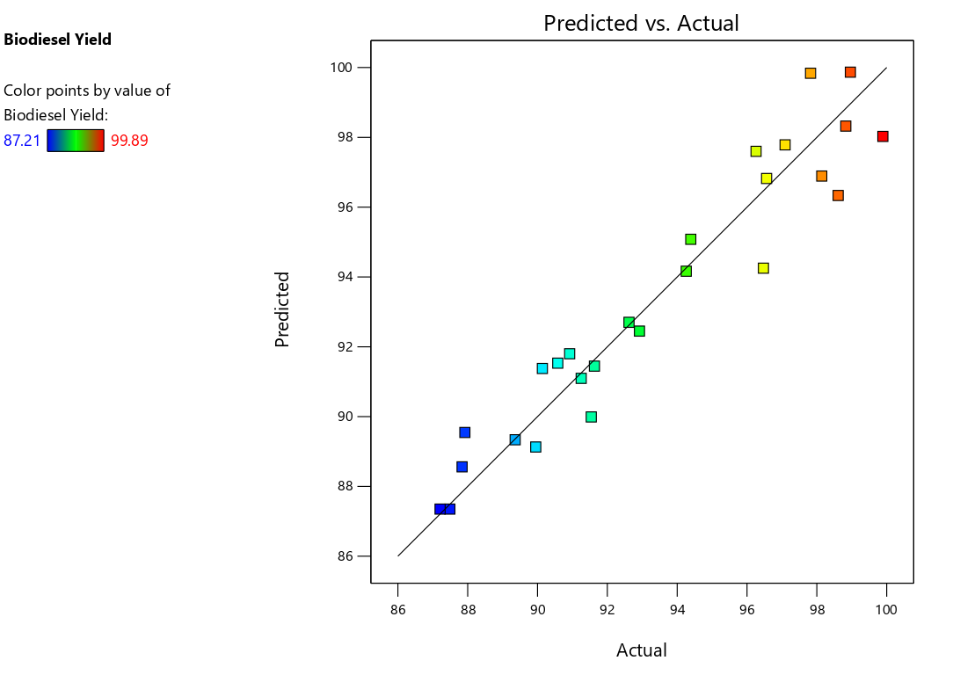Figure 3: Predicted yield versus Actual yields of the produced Biodiesel

The graph of the predicted values (obtained using the developed correlation) versus actual response values is shown in Figure 3. A model is considered to be well if the data obtained from expert design model actual versus predicted points are lies along the straight line which concludes zero error. All the points are very close to the line of perfect fit and splits evenly by the 45-degree line. The data points should be split evenly by the 45-degree line. As shown in Figure 3, the data developed from the actual versus predicted values model were along the line. So, the model of the regression model equation is very accurate. The result showed that effective in capturing the correlation between the four-transesterification process variable yields of biodiesel.
5.3 Effect of Interaction between Factors on Biodiesel Yield
Three- dimensional plot (3D plot) and contour plot were generated by Design-Expert software Version 13. The 3D and the contour plots are used to estimate the effects of the combination of independent variables (amount of biocatalyst, temperature, residence time and amount of methanol) on the response biodiesel yield.
Figures 4, 5 and 6 are 3D plots and the contour plots are presented in this section to estimate the effects of the combination of the independent variables on the response for biodiesel yield.

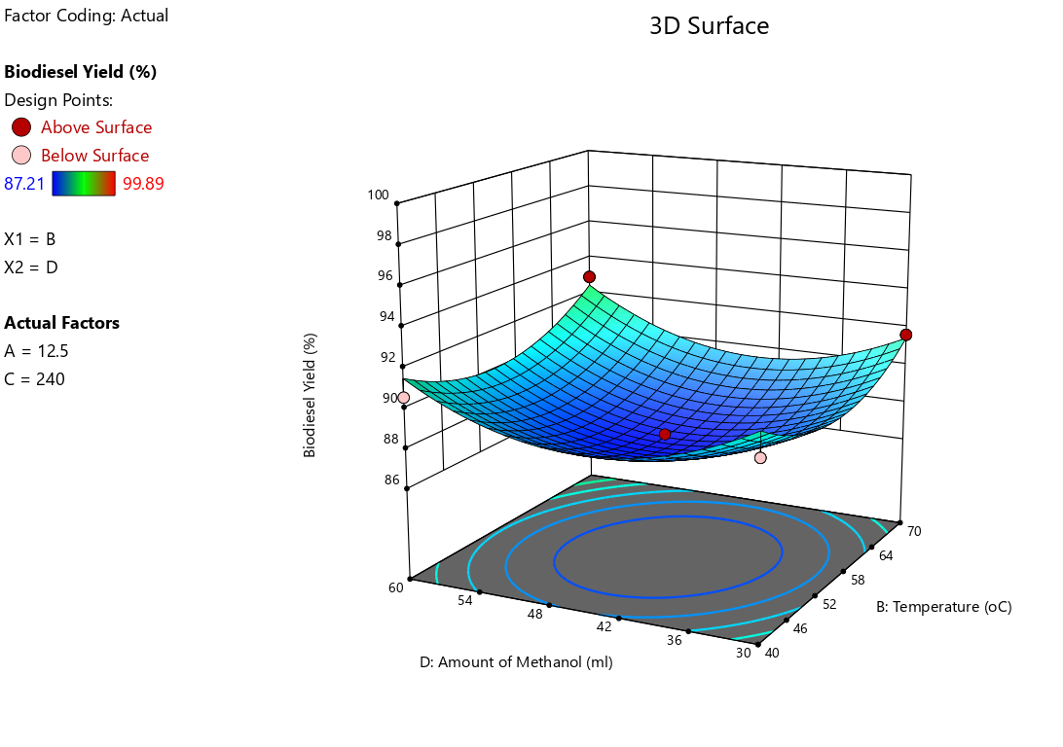
Figure 4: 3D plot of amount of methanol (ml) and reaction temperature on biodiesel yield

Figure 4 presents a 3D plot showing how the biodiesel yield is influenced by the amount of methanol and reaction temperature. Peaks and troughs in the plot indicate specific conditions where changes in methanol quantity and reaction temperature have a notable impact on biodiesel yield. As observed in Figure 4, the yield of biodiesel increases as the amount of methanol and reaction temperature increases, similar trend was observed in reaction temperature. Higher volume of methanol would allow complete transesterification of the seed oil and favour the forward reaction while lower volume of methanol can only allow partial transesterification of the oil. From the graph, the result reveals similar result with the same feedstock as obtained by Adebayo et al., (2017).

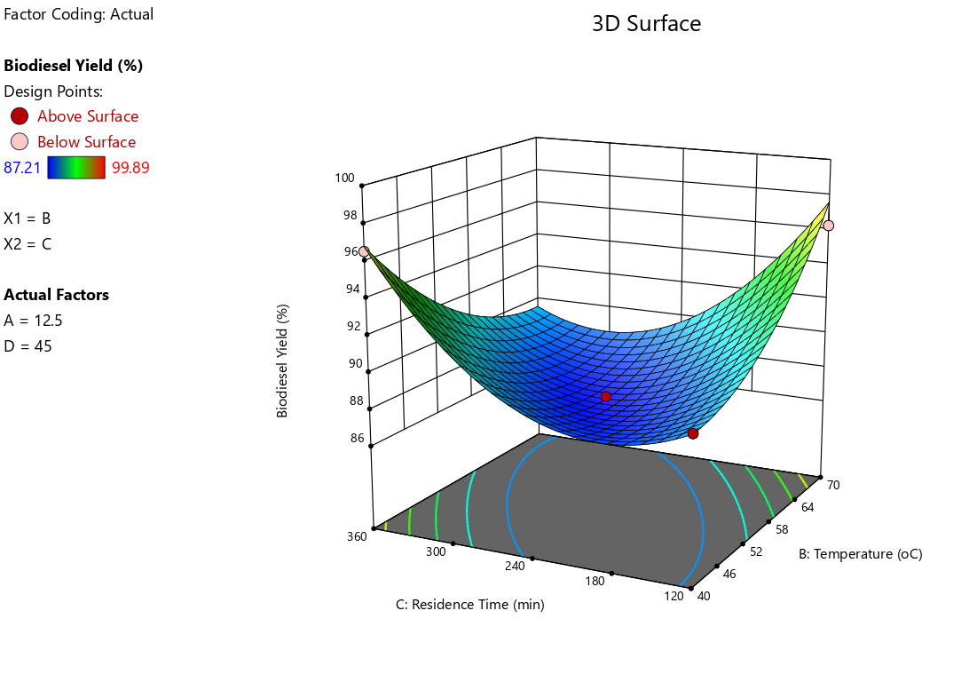
Figure 5: 3D Plot of residence time and temperature on biodiesel yield

Figure 5 shows the significant interaction term for residence time and temperature indicates these two factors have significant impact on the percentage yield of the biodiesel. Thus, increase in temperature and residence time increases the percentage yield of the produced biodiesel. The trend observed in Figure 4 is also noticeable here in Figure 5. It shows that there is a decrease in yield of biodiesel with a decrease in temperature and residence. As the temperature increases with increasing residence time, yield of biodiesel gradually increases. This trend is in agreement with previous study by Tan et al., (2019).
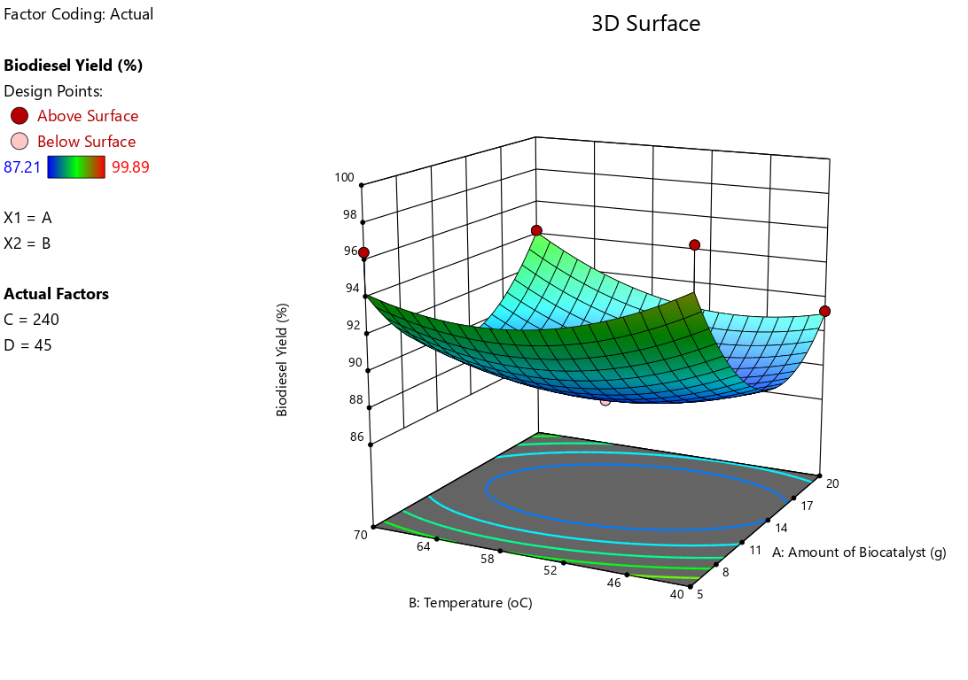
Figure 6: 3D plot of temperature and amount of biocatalyst on biodiesel yield

Figure 6 presents a 3D plot illustrating the impact of two key variables, the amount of amount of biocatalyst and reaction temperature on biodiesel yield. The graph shows how changing levels of amount of biocatalyst and reaction temperature simultaneously affect biodiesel yield. As observed, in the graph, when the amount of biocatalyst was 5g the maximum biodiesel yield was obtained, further increase in the biocatalyst decreases the biodiesel yield, this trend explain the impact potassium hydroxide play in biodiesel production. Similarly, increase in reaction temperature decreases the biodiesel yield. This shows the areas in the parameter space where the amount of biocatalyst and reaction temperature notably affect biodiesel yield. Oniya et al., (2016) and siti (2019) reported in their works that increased in potassium hydroxide and reaction temperature decreases biodiesel yield. Thus this research findings is in conformity with the report of Ogunkule et al., (2017).
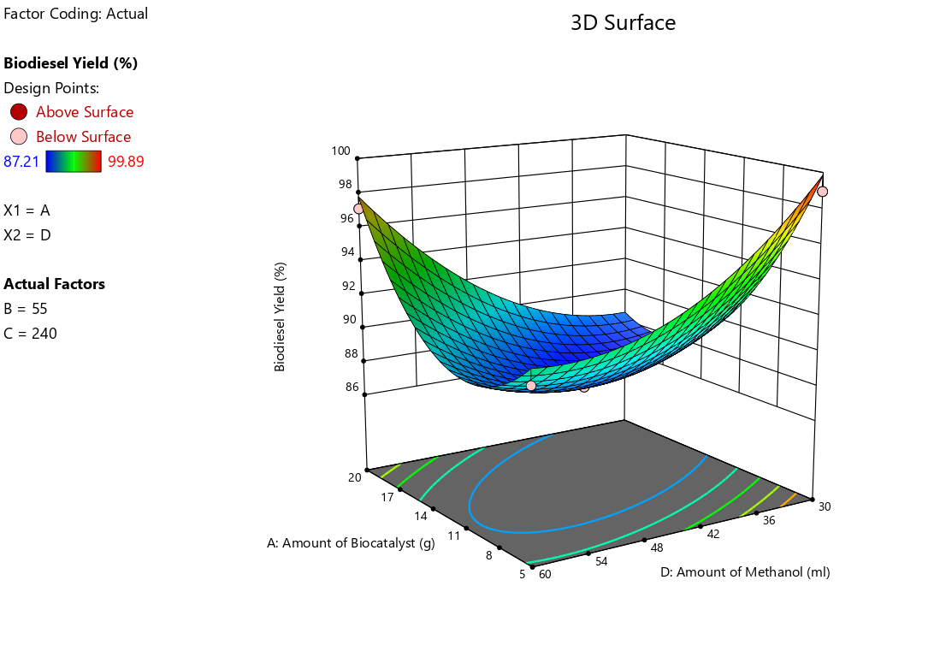
Figure 7: 3D plot of amount of biocatalyst and amount of methanol on biodiesel yield

The interactive effect of the amount of biocatalyst and amount of methanol on biodiesel yield was also very significant upon biodiesel production via transesterification process as seen in Figure 7. Increase in the amount of methanol increases the biodiesel yield to maximum yield of 99.89%, similarly, increase in the amount of biocatalyst increases the biodiesel yield. This suggests that percentage yield was inhibited at 8g to 14 g of the biocatalyst. Thus, this result is consistent with previous research carried out by Adebayo et al., (2011) and Hem (2008).

6.0 Numerical Optimization of the Biodiesel Produced
In this study, we utilized Response Surface Methodology (RSM) analysis to optimize the process variables for biodiesel production from sandbox seed oil. Numerical features of the design software were used to identify a perfect combination of optimizing variables needed to achieve a desired biodiesel yield. The findings, summarizing the optimized process parameters for biodiesel production via transesterification reaction using moringa seed oil, are outlined in Table 8.
Table 8: Optimum numerical solutions by RSM
Number | Amount of Biocatalyst | Temperature | Residence Time | Amount of Methanol | Biodiesel Yield | Desirability
1 | 12.500 | 55.000 | 360.000 | 60.000 | 98.322 | 1.000 | Selected
2 | 12.500 | 55.000 | 360.000 | 30.000 | 89.129 | 1.000
3 | 12.500 | 70.000 | 360.000 | 45.000 | 89.546 | 1.000
4 | 12.500 | 40.000 | 240.000 | 60.000 | 91.532 | 1.000
5 | 5.000 | 55.000 | 240.000 | 60.000 | 91.801 | 1.000
6 | 12.500 | 40.000 | 360.000 | 45.000 | 96.823 | 1.000
7 | 12.500 | 55.000 | 120.000 | 60.000 | 89.990 | 1.000
8 | 12.500 | 70.000 | 120.000 | 45.000 | 97.599 | 1.000
9 | 20.000 | 40.000 | 240.000 | 45.000 | 91.097 | 1.000
10 | 12.500 | 70.000 | 240.000 | 30.000 | 91.447 | 1.000

As indicated in Table 8, the Response Surface Method identified 10 solutions and chose optimal values to minimize the economic costs associated with amount of biocatalyst, temperature, residence time and amount of methanol needed for the transesterification reaction while maximizing biodiesel yield. The selected optimum conditions resulted in a biodiesel yield of 98.322%, achieved at a residence time of 360 minutes, reaction temperature of 55 °C, methanol of 60 ml and amount of biocatalyst of 12.50g. This optimal yield was experimentally verified under the specified conditions and was found to correlate very well with the predicted maximum biodiesel yield.

7.0 Conclusion
As the world faces increasing energy demands and environmental concerns, the development of alternative and renewable energy sources is paramount. Moringa seed oil, with its potential as a biodiesel feedstock, contributes to the diversification of renewable energy options. The exploration of biodiesel production and optimization from Moringa seed oil using Design Expert has yielded valuable insights and promising results. The utilization of alternative sources for biodiesel production, such as Moringa seeds, presents a sustainable and eco-friendly approach in the quest for renewable energy. The application of Design Expert in optimizing the biodiesel production process has proven to be a crucial tool, allowing for the systematic exploration of various factors and their interactions. This systematic approach not only enhances the efficiency of biodiesel production but also contributes to minimizing waste and resource consumption. The findings from this study highlight the importance of careful parameter optimization to achieve maximum yield and quality in biodiesel production. Thus, the use of statistical models and experimental designs has provided a robust framework for understanding the intricate relationships between different variables, facilitating the identification of optimal conditions for Moringa seed oil conversion to biodiesel. It was shown that the properties determined from the biodiesel were within the range of the properties of biodiesel required according to ASTM standard
The produced biodiesel was characterized for it fuel properties and compared with international standards (ASTM). Physicochemical properties such as density, kinematic viscosity, pour point, cloud point, flash point, acid value, iodine value, cetane number and specific gravity of biodiesel produced was found to be within the limit according to ASTM standards. Also a total of 25 runs were generated and employed in the biodiesel production process, with each experimental run meticulously assessed and the corresponding biodiesel yields recorded. The optimization result revealed maximum biodiesel yield of 98.322%, achieved at a residence time of 360 minutes, reaction temperature of 55 °C, methanol of 60 ml and amount of biocatalyst of 12.50g. This optimal yield was experimentally verified under the specified conditions and was found to correlate very well with the predicted maximum biodiesel yield. Hence, the production and optimization of biodiesel from Moringa seed oil using Design Expert not only contribute to the expanding knowledge in the field of renewable energy but also hold promise for a greener and more sustainable future.
It is recommended that different feed stocks beyond Moringa seed oil for biodiesel production should be investigated, various oil-rich plant sources to diversify feedstock options and enhance the resilience and sustainability of biodiesel production. Also, incorporate advanced optimization techniques, such as artificial intelligence algorithms or machine learning models, to further enhance the efficiency and accuracy of the biodiesel production process. These techniques can handle complex data sets and uncover nuanced relationships between variables for more precise optimization.
REFERENCES
Abdulkareem, A. S., Jimoh, A., Afolabi, A. S., Odigure, J. O., and Patience, D. (2012). Production and Characterization of Biofuel from Non-Edible Oils: An Alternative Energy Sources To Petrol Diesel. In An Alternative Energy Sources to Petrol Diesel, 5(6):9 – 21
Adebayo, G..B., Ameen, O..M. and Abass, L. T. (2011) Physico-chemical properties of biodiesel produced from Jatropha Curcas oil and fossil diesel, Journal of Microbiology and Biotechnology Research, 1 (1):12 - 16
Ahmad, M., Khan, M.A., Zafar, M. and Sultana, S. (2013). Practical Handbook of Biodiesel Production and Properties. New York., NY. Taylor and Francis Group, 2(11):4 – 11.
Akpan, U. G., Jimoh, A., and Mohammed, A. D. (2006). Extraction, Characterization and
Modification of Castor Seed Oil. Leonardo Journal of Sciences, 8:43 – 52.
American Society for Testing and Materials, ASTM International (2003). American and European biodiesel quality standards: Standard specification for biodiesel fuel (B100) blend stock for distillate fuels. ASTM D6751. West Conshohocken,PA, USA
Atabani, A. E., Silitonga, A. S., Mahlia, T. M. I., and Mekhilef, S. (2022). A Comprehensive Review on Biodiesel as an Alternative Energy Resource and Its Characteristics. Renewable and Sustainable Energy Reviews, 16(4):70 – 93.
Bateni, H., Saraeian, A., Able, C., and Karimi, K. (2019). Biodiesel purification and upgrading technologies. International journal of technology, 5(7): 97 - 110.
Betiku, E. and Ajala, S. (2014). Modeling and optimization of Thevetia peruviana (yellow oleander) oil biodiesel synthesis via Musa paradisiacal (plantain) peels as heterogeneous base catalyst: a case of artificial neural network vs. response surface methodology, Ind. Crops Prod. 7(53):314 – 322
Chen, T., Kuo, H., and Chen, C. (2010). “Modelling the Relationship Between the oil Price and Global Food Prices”. Applied Energy, 3(87):2517 – 2525.
Dash, S. K., and Lingfa, P. (2017). A review on production of biodiesel using catalyzed transesterification. Paper presented at the AIP conference proceedings, 1(1), 48-53.
Deep, A., Sandhu, S., and Chander, S. (2019). Optimization of reaction parameters of Transesterification for Castor oil. Journal of scientific and Industrial research,76 (2):115 - 118.
Demirbas. (1998). Fuel Properties and Calculation of Higher Heating Values of Vegetable Oils
Fuel, 77(10):1117 – 1120.
Demirbaş, A. (2013). Chemical and fuel properties of seventeen vegetable oils. Energy Sources, 25(7):721 - 728.
Dipak, K. J., Samyabrata, B., Sudipta, R. P. D., and Barnali, B. (2022). The optimization of biodiesel production from waste cooking oil catalyzed by ostrich-eggshell derived CaO through various machine learning approaches. Cleaner Energy Systems, 3, 100033.
Dwivedi, G., and Sharma, M.P., (2014) Renewable and Sustainability Energy. Review 32:114 –122.
Enweremadu, C. and Prutto, H. (2013). “Optimization of Production Variables of Biodiesel Using Calcium Oxide as a Heterogeneous Catalyst: An Optimized Process”. Materials and Processes for Energy, 17(2): 320 – 326.
Ezekoye, V., Adinde, R., Ezekoye, D. and Ofomatah, A. (2019) Syntheses and characterization of biodiesel from citrus sinensis seed oil, Scientific African, 6:e00217
Falowo, O. A., Oladipo, B., Taiwo, A. E., Olaiya, A. T., Oluwaseun O. Oyekola, O. O. and Betiku, E. (2022) Green heterogeneous base catalyst from ripe and unripe plantain peels mixture for the transesterification of waste cooking oil, Chemical Engineering Journal Advances, 10:1 – 11
Guan, X. and Yao, H. (2008): Optimization of viscozyme L-assisted extraction of oat bran protein using response surface methodology. Food Chemistry, 106: 345 – 351.

Hem, C.J. (2008): Optimization and Characterization of Biodiesel Production Form Cottonseed
and Canola Oil. A thesis presented to the graduate school of Clemson university., USA.

Igbum, O. G., Leke, L., Ande, S., Okoronkwo, M.U. and Nwadinigwe, C.A. (2012). Effects of
transesterification variables on the characteristics of the methyl esters obtained from four virgin tropical seed oils in Nigeria. International Research Journal of Pure & Applied Chemistry, 2(4), 230-478.
Kafuku, G and Mbarawa, M. (2010) Biodiesel production from Croton megalocarpus oil and its process optimization, Fuel, 89(9):2556 - 2560
Khuri, I., Mukhopadhyay, S. (2010). “Response Surface Methodology: Advanced Review”. John Wiley and Sons WIREs Comp. Statist. 2(5):128 - 149.
Leung, D. Y. C., Wu, X., and Leung, M. K. H. (2010). A Review on Biodiesel Production Using Catalyzed Transesterification. Applied Energy, 87(12):1083 – 1095
Mahmudul, H. M., Hagos, F. Y., Mamat, R., Adam, A. A., Ishak, W. F. W., and Alenezi, R. (2017). Production, characterization and performance of biodiesel as an alternative fuel in diesel engines - A review. Renewable and Sustainable Energy Reviews, 72(33):497 - 509.
Mathew, M., Raina, D.; Narisetty, V., Kumar, V., Saran, S., Pugazhendi, A., Sindhu, R., Pandey, A., Binod, P. (2021). Recent advances in biodiesel production: Challenges and solutions. Science Total Environment, 4(7): 148-151.
Meher, C., Sagar, V., and Naik, S. (2016). Technical aspects of biodiesel production by transesterification—A review. Renewable and Sustainable Energy Reviews, 10(3):248 -268.
Montgomery, D. and Runger, C. (2015). Applied Statistics and Probability for Engineers. 6th edition, New York, NY: John Wiley and Sons Inc., pp. 478 - 482.

Montgomery, D. (2018). Design and Analysis of Experiments, 8th Edition. New York, NY: John Wiley and Sons Inc.,, pp. 478 - 553.

Moser, B. R. (2019). Biodiesel production, properties, and feedstocks. In Vitro Cell Development Biology Plant, 45(23):229 - 266.

Myers, H and Montgomery D. (2020). Response Surface Methodology: Process and Product Optimization Using Designed Experiments. 2nd ed., New York, NY: John Wiley and Sons, Inc.

Neupane, D. (2023). Biofuels from Renewable Sources, a Potential Option for Biodiesel Production. Bioengineering, 5(10):1 – 29.

Oboh, O. I., Inyang, U. E., Bassey, E. N., Aluyor, O. E. and Silas, E. E. (2015). Used cooking oils from fish and Bean Cake frying as Potentials in the Biodiesel Production, The Journal of the Nigerian Institution of Production Engineers, 18(3): 20 – 27

Olayomi, A. F., Babatunde, O., Abiola E. T., Ayomiposi T. O., Oluwaseun O. O. and Eriola, B. (2020). Green heterogeneous base catalyst from ripe and unripe plantain peels mixture for the transesterification of waste cooking oil. Chemical Engineering Journal Advances, 2(12):1 - 11.

Olujobi, J., and Olusola-Olujobi, T. (2020). Nigeria: Advancing the Cause of Renewable Energy in Nigeria’s Power Sector Through its Legal framework. Environmental Policy and Law 5(16):433 – 444.
Ogunkunle, O., Oniya, O.O., and Adebayo, A.O. (2017): Yield Response of Biodiesel Production from Heterogeneous and Homogeneous Catalysis of Milk Bush (Thevetia peruviana) Oil, Advances in Multidisciplinary and Scientific Research Journal, 3(1):9 – 22.
Omonhinmin C., Olomukoro E., Ayoola A., and Egwim E. (2020) Utilization of Moringa oleifera oil for biodiesel production: a systematic review. AIMS Energy. 8(1):102 – 121

Oniya, O.O., Adebayo, A.O. and Ogunkunle, O. (2016): Optimization of Biodiesel Production
from Milk Bush (Thevetia peruviana) Oil Using Snail Shell as Catalyst. Advances in
Multidisciplinary and Scientific Research Journal, 3(1): 9 – 22

Oniya, O. O., Adebayo, A. O., Olatoye, O. S. and O. Ogunkunle, O. (2017) Optimization Of Biodiesel Production From Loofah Oil Using Response Surface Methodology, Journal of Agricultural Engineering and Technology (JAET), 23(2):26 – 36
Sakthivel, R., K. Ramesh, R. Purnachandran, and P. M. Shameer. (2017). “A Review on the Properties, Performance and Emission Aspects of the Third- Generation Biodiesels.” Renewable and Sustainable Energy Reviews, 82 (3):2970–2992
Sanjay,B. (2013.) Non-Conventional Seed Oils as Potential Feedstocks for Future Biodiesel Industries: A Brief Review. Research Journal of Chemical Sciences, 3(5): 99 - 103.
Shahla, S., Cheng, N. G., and Yusoff, R. (2010). An Overview on Transesterification of Natural
Oils and Fats. Biotechnology and Bioprocess Engineering, 15(55): 891–904.
Silva, F., Fernando, L., Camargo, L., and Ferreira, O. (2010). “Application of Response Surface Methodology for Optimization of Biodiesel Production by Transesterification of Soybean Oil with Ethanol”. Fuel Processing Technology, 92(3): 407 – 413

Tan, R., Aviso, K. B. and Ng, D. K. S (2019) Optimization models for financing innovations in green energy technologies, Renewable and Sustainable Energy Reviews, 113: 109258.

