Demographic Influences and Sustainability Perceptions: A Mixed ANOVA Study of Nyamanarri Solar Mini-grid in The Gambia

Abstract
Aims: The aim of this study is to assess the perception of participants on five important dimensions of sustainability of Nyamanarri Solar Mini-grid in The Gambia—Economic, Social, Environmental, Institutional, and Technical—and explore the effect of demographic variables (Gender, Age, Kaabiloo, Education, and Employment) on them. It aims to ascertain areas of intervention in sustainability initiatives and propose focused interventions.
Place of Study: A 120 kWp off-grid PV mini-grid was built in Nyamanarri (130 20’ 03” North and 130
52’ 08” West) in the Upper River Region of The Gambia.
Methodology: A Mixed ANOVA was used to compare survey ratings measuring five sustainability dimensions: Economic, Social, Environmental, Institutional, and Technical. Ratings between participants were compared in these dimensions, and the effect of demographic variables such as Gender, Age, Kaabiloo, Education, and Employment was determined. Post-hoc analysis was also done to measure some differences between dimensions, with the effect sizes measured using Cohen's d. Subgroup analyses were also carried out to determine demographic effects on perceptions.
Analysis: Significant differences between participants' ratings by sustainability dimensions (F(4, 44) = 7.7601, p = 0.0361) were identified, with the maximum for the Environmental dimension and the minimum for the Technical dimension. The post-hoc analysis showed that participants assigned a significantly lower rating for the Technical dimension compared to the Economic, Environmental, and Institutional dimensions (p < 0.05) with large effect sizes (Cohen's d > 2.4). Subgroup analysis revealed that higher-education respondents and those who were older rated the Environmental and Institutional dimensions more favorably, and females rated the Social dimension substantially higher than males.
Conclusion: The results suggest technical inadequacies as a primary cause of sustainability project failure in line with prior research (e.g., Olabi et al., 2023; Saleh et al., 2024). The research is proposing interventions to enhance system usability and reliability, alongside incorporating population-specific know-how into project planning. Additional qualitative analysis is suggested to further interpret these results.

Keywords: Mixed ANOVA, Survey data, Dimensions of sustainability, Demographic factors, Post-hoc comparisons, Effect sizes, Cohen's d, Subgroup analysis

1 Introduction
Sub-Saharan Africa faces a persistent challenge in providing reliable and affordable electricity, particularly in rural areas. Despite the region's abundant natural resources, including significant solar potential, over 600 million people—primarily in Sub-Saharan Africa—lack access to electricity (IEA, 2022). Over one billion people in the world live in energy poverty, lacking sufficient, dependable, and available energy to enable basic activities, and this leads to lower health outcomes and limited socioeconomic opportunities (World Bank, 2023). It is estimated that about 80% of those without electricity live in remote, insecure, or conflict-affected areas (World Bank, 2023). Renewable energy is especially solar, which has gained considerable attention as green and clean options in addressing these issues (Olabi et al., 2023).
West Africa, which is dominated by high global horizontal irradiance (GHI) (Solargis, 2019), has favorable conditions for the uptake of solar energy as it falls in the decreasing limb of the Hadley cell and consequently experiences low cloud cover and extended sunshine duration over the Sahara and Sahel (Neher et al., 2020; Kothe et al., 2017). Regional leaders, in association with international players, are giving regional energy high priority for energy security and sustainable growth. ECOWAS has put regional energy policy into place, e.g., ECOWAS Renewable Energy Policy, with a vision of 48% electricity generation through renewable energy by 2030 (ECREEE, 2024). However, West African solar photovoltaic (PV) power plants' long-term viability is challenged by poor infrastructure, access to finance, and technical challenge of putting intermittent solar supplies onto the power grid. Environmental factors as well as the requirement for effective energy storage mechanisms affect the sustainability of such undertakings.
Evaluating the social, economic, and environmental effects of solar photovoltaic (PV) systems is imperative to ensure their sustainability in Sub-Saharan Africa. Singh et al. (2014) highlight that solar PV systems should be tailored to suit the particular needs and capabilities of local communities. The feasibility of mini-grids depends not only on technical reliability but also on active community engagement and sustainable financial frameworks. Local stakeholder involvement at the design and implementation stages creates ownership and guarantees systems align with community demands (Bhattacharyya et al., 2016; Fajardo et al., 2025). In Africa, socio-economic considerations tend to pose more formidable challenges than technical complexity, highlighting the necessity for a comprehensive approach accounting for the economic, social, and environmental aspects of sustainability (Maqbool and Akubo, 2022).
Nyamanarri Mini-grid Solar Power Plant in The Gambia is a case study used for considering these dynamics of sustainability. In the rural Upper River Region, this 120 kWp facility delivers electricity to more than 400 previously isolated households. Fitted with solar PV panels, battery storage, and smart metering, the system has the potential to revolutionize the socio-economic profile of the community. Nonetheless, its long-term viability depends on issues such as system upkeep, economic viability, and strong community involvement, all of which are common to most solar PV projects in West Africa.
This review of literature assesses the sustainability of solar PV power plants in Sub-Saharan and West Africa, with emphasis on rural electrification projects. By examining the successes and failures of projects such as the Nyamanarri Solar Power Plant, it emphasizes major challenges and lessons in the promotion of sustainable solar PV systems. Based on a critical review of recent studies and reports, the present review gives insights into solar PV systems' potential in promoting sustainable development in West Africa and the general Sub-Saharan region.

2 Literature Review
2.1 Sustainability of Solar Photovoltaic (PV) Power Plants in Sub-Saharan Africa
Sub-Saharan Africa (SSA) has vast solar resources, with high solar radiation levels ensuring that the sun's energy is a viable alternative to conventional sources of power (Drave et al., 2025). As the prices of solar technology keep declining, solar photovoltaic (PV) systems are a feasible solution to meet the rising energy needs of the region and ensure sustainability (IRENA, 2021; GIZ, 2021; KFW, 2021). Energy poverty remains prevalent even with such a prospect, and more than 600 million people have no access to electricity (IEA, 2022). Solar PV technology is a prominent renewable technology due to its minimal environmental footprint, decentralized deployment, and scalability (Nyasapoh et al., 2022).
In order to render solar PV systems sustainable is to integrate technology with site conditions in terms of the environment, society, and economy. Singh et al. (2015) evoke the fact that SSA solar projects entail peculiar challenges such as technical reliability, fiscal limitations, socio-political and infrastructural constraints. Long-term sustainability also needs technical feasibility alongside long-term community interface, effective policy arrangements, and site-specific financial instruments.

2.2 West African Sustainability of Solar Power
West Africa's diversified energy mix has seen breakthroughs in solar power systems at a fast pace, fueled by massive solar irradiance, increasing electricity needs, and a desire to mitigate dependence on fossil fuels (Adeoye et al., 2018). The Economic Community of West African States (ECOWAS) identifies solar energy as critical in attaining energy sustainability and security, and the ECOWAS Renewable Energy Policy aims for 48% renewable electricity generation by 2030 (ECREEE, 2024). West African solar power facilities are, however, hindered by sustainability challenges in the form of maintenance, energy storage, and grid integration (Zoma, 2024).
Most of the West African solar programs are either mini-grid or off-grid systems providing ensured and cheap electricity to rural and urban-rural communities where it is technologically impossible or economically unjustifiable to extend the grid. However, research like Akinyele et al. (2017) affirms that the sustainability of these systems is typically compromised by poor technical support, the absence of trained personnel for maintenance purposes, and poor local capacity to manage solar plants. Moreover, financial sustainability is eroded by the large initial outlay and the weak ability of rural consumers to pay for tariffs that ensure cost recovery.

2.3 Nyamanarri Mini-Grid Solar Power Plant: The Gambia Case Study
The Nyamanarri Mini-grid Solar Power Plant in the Upper River Region of The Gambia offers an interesting case study for the assessment of the sustainability of solar photovoltaic (PV) systems in West Africa. The 120 kWp mini-grid, which is designed to serve more than 400 homes in rural village Nyamanarri, consists of 310 photovoltaic panels, a 576 kWh battery storage system, and an advanced prepaid metering system for vending and billing (Hydara, 2024). As a decentralized energy solution, the mini-grid has also cut substantially the community's dependence on conventional biomass and fossil fuels, delivering constant electricity to a previously remote area from the national grid.
The sustainability of the Nyamanarri system can be evaluated environmentally, socially, economically, technically, and institutionally. Environmentally, the solar PV system provides clean and renewable energy that minimizes greenhouse gas emissions and pollution in contrast to diesel generators. The off-grid capacity enables constant power in regions with poor grid extension, strengthening energy security (Hydara et al., 2025). Socially, the project has transformed the community by boosting households', schools', and businesspersons' access to energy, leading to economic growth and improved living standards in Nyamanarri.
Economically, the viability of the Nyamanarri plant is dependent on its tariff and finances. Prepaid metering enhances the cost recovery for utilities but is problematic from the perspective of financial viability versus affordability among rural consumers, who in general have no purchasing power for full generation and distribution charges (Bloomer et al., 2024). Long-term operation is dependent on government subsidy assistance or external funding to cover maintenance costs and render it affordable (Fajardo, 2025; Hydara et al., 2025).
The viability of solar PV systems in West and Sub-Saharan Africa, such as The Gambia, is based on compatibility with the existing local environmental, social, economic, technical, and institutional factors. The Nyamanarri Mini-grid Solar Power Plant demonstrates the viability of rural electrification by decentralized solar systems. Their long-term sustainability, however, is subject to issues of system maintenance, profitability, and community participatory approaches. Placing capacity building, tailored financing structures, and robust government backing at the forefront will be critical to ensuring that facilities like Nyamanarri continue to be accessible to provide sustainable, stable power to rural communities.

3 Methodology and Materials
3.1 The Case Studies and The Framework
3.1.1 Overview of the Case Studies
Case studies are a strong tool in revealing subtle economic and social dynamics that can be missed through quantitative methods, providing in-depth analysis of the social, environmental, and economic effects of projects in their actual context (del Rio and Burguillo, 2008; Rashid et al., 2019). In this research, the "territorial dimension" is village-based, and the indicators are gauged among residents, as the permanent inhabitants of the village are accounted for (Jankowski et al., 2025). The chosen case study is that of Nyamanarri village, which lies within the Kantora District of the Upper River Region (URR) of The Gambia. Nyamanarri is a pioneer in shifting to the use of renewable energy, with long-term vision that transcends the supply of energy to address broader social, economic, and environmental challenges. The village boasts a flagship renewable energy project, the first of its kind in The Gambia.
The Nyamanarri Mini-grid Solar Power Plant, constructed by Unique Energy Group, is an innovative project for the village. The village had no electricity for 145 years before it came, and homes relied almost every time on solar appliances and lights supplied with assistance through family resources and income. This project supplied reliable electricity, a turning point for village development.

3.1.2 The Framework
To close gaps in the literature, we created a targeted framework to assess community attitudes towards success of the Nyamanarri project after it has been implemented and willingness to support future projects of its kind. The framework is specialized to the village context and to the special municipality objectives, assessing local-level sustainability effects and not more general global environmental, social, and economic effects. The survey is anchored on five pillars of sustainability—economic, institutional, social, technical, and environmental—articulated by Bhattacharyya (2012), Ilskog (2008), and Tsagkari et al. (2022). In tracking improvement towards both original and emerging project objectives, we used indicators grounded in criteria mooted by Shaaban and Scheffran (2017), Ilskog (2008), and Tsagkari et al. (2022), as indicated in Table 1.

Table 1: Selection criteria for indicators
Selection Criteria | Description
Data availability | The possibility of collecting data from surveys
Consistence with objective | The ability to reflect the ambitions and expectations of the projects
Independency | Indicators should not have an inclusion relationship at the same level
Measurability | The indicators should be measurable
Robust | The indicators shall be formulated clearly enough to be replicable in their application
Comprehensive | The indicators need to cover all major aspects sustainable development
Simplicity | Ease of understanding by the local community
Sensitivity | Capacity for allowing trends analysis
Reliability | Unbiased and apt to capture both positive and negative issues
Source: Adapted from Ilskog (2008) and Shaaban and Scheffran (2017) and Tsagkari et al., (2022)

Factors are categorized by this study into five broad sustainability dimensions: economic, social, environmental, institutional, and technical. These dimensions contain several factors, explained in terms of individual indicators associated with questionnaire items (see Appendix). Counting positive responses for each indicator's impact of the project was done utilizing a Likert scale ranging from 1 ("strongly disagree") to 5 ("strongly agree"). Total scores for each factor and its related dimension were calculated. From Table 2, technological and economic factors that are simpler in nature are represented with a single indicator, but their more intricate nature of social and institutional factors makes them represented using multiple indicators to avoid simplification and enable a qualitative evaluation.

Table 2: The framework with dimensions, factors, indicators and the relavant goals
Sustainability Dimension | Factor | Indicators | Question Number
Economic | Economic Benefits | New economic opportunities | Q5
Social | Social cohesion  Sense of pride in the village  Autonomy | Sense of community Sense of pride of the village  Feeling less dependent on the area council | Q6  Q7  Q8
Environmental | Environmental Development | Energy savings  Clean energy  Increase awareness about climate change Increase awareness about renewable energy  Esthetics | Q9  Q10  Q11  Q12  Q13
Institutional | Organizational structure | Community involvement  Inclusion  Participation in local governance  Effectiveness of local governance | Q14  Q15  Q16  Q17
Technical | System design | Appropriate system design to cover the local needs | Q20

In order to establish the relative significance of these factors in the perceptions of people towards project success and support to future projects, multiple linear regression analysis was carried out using Python. Besides the indicators in Table 4, demographic factors—Gender, Age, Education, Employment Status, and Kaabiloo—were employed as dummy variables in order to control for their effects on perceptions.

3.1.3 Economic Dimension
The economic dimension identifies the degree to which the Nyamanarri Mini-grid Solar Power Plant facilitates income-generating activity. Direct economic advantages, for example, saving on electricity bills and costs, have been extensively recorded in literature (Allan et al., 2011; Slattery et al., 2011). For Nyamanarri, the scheme has saved the community small amounts on electricity bills, yielding real monetary savings. Indirect benefits such as job creation and local economic diversification are harder to measure. The project will also have the effect of stimulating the local economy, mainly by tourism, which is accounted for in our framework under "new economic opportunities."

3.1.4 Environmental Dimension
The environmental dimension evaluates the direct and indirect effects of the energy project on the surrounding environment, including land aesthetic impacts. Across the world, resistance to energy projects is usually rooted in assumed adverse effects on how landscapes look, thus causing delays or even abandonment of these projects. Although renewable energy projects necessarily cause some interference with the environment, meticulous spatial planning can mitigate the visual and aesthetic effects. Also, community schemes for renewable energy reap indirect benefits like energy conservation, decreased consumption, and implementation of sustainable practices at individual and domestic levels (Gubbins, 2007; Rogers et al., 2008). Environmental dimension of this research is captured by a single factor that involves energy saving, availability of clean and assured energy, reduced effects on landscapes, raised awareness of climate change, and better knowledge of renewable energy after deployment (Ilskog, 2008).

3.1.5 Institutional Dimension
The institutional level deals with the organizational issues of the project and stakeholder relations that influence power dynamics and decision-making (Hoppe et al., 2015). Institutional sustainability is crucial for the success of a project, demanding democratic and efficient governance structures that provide active community engagement, efficient local governments, and the integration of multiple views. In our model, these are reflected under the variable "organizational structure."

3.1.6 Social Dimension
Social effects, while being at times intangible, are essential to project success in the energy sector. The literature points to advantages including greater social cohesion, enhanced youth migration to the village, enhanced autonomy in the village, and greater participation in village activities (Susser and Kannen, 2017). Energy projects in remote villages such as Nyamanarri can strengthen community resilience by minimizing dependence on external sources of energy (Rae and Bradley, 2012). Since social consequences are so complex, our structure defines the social component in terms of three separate components: "social cohesion," "autonomy," and "sense of pride."

3.1.7 Technical Dimension
The technical aspect discusses some of the technical details of the project, some of which are linked to other fields of sustainability or hard to measure directly through people's opinions (Ilskog, 2008). System design and user satisfaction with performance serve as key indicators of whether the technical solution is able to serve the needs of the community for electricity in this study.

3.1.8 Dependent Variables
The respondents' satisfaction from the Nyamanarri project was surveyed through two items, i.e., "Overall Project Assessment" and "Overall Impact of the Project on Personal Life." Two more items were asked for evaluating attitudes towards future projects, i.e., "Support Similar Initiatives in the Future" and "Participate in Similar Initiatives in the Future."

3.2 Assessing the Sustainability of the Nyamanarri Solar Power Plant: Methodology
3.2.1 Data Collection
The design of the questionnaire utilized the Oppenheim (1992) model for strength and readability assurance. The development of the questionnaire was interactively and iteratively conducted via experts' comments on wordings, ordering, and clarity (Preston, 2009). The completed questionnaire was then translated into Fula and Mandinka by a native language expert to facilitate the residents' access. Data collection was conducted from April 8 to April 12, 2023, at Nyamanarri.
All 49 head-of-household leaders were spoken to, one more than the minimum of 33 in response to the 10% rule of the village's estimated 323 households (GBOS, 2024). The extra 16 picks added strength to the data set, which at 95% confidence would have a margin error of around ±8%, within the acceptable range of 4% to 8% for survey research (Data Star). As Sovacool et al. (2018) state, sample sizes of less than 100 are appropriate for small, minority populations such as Nyamanarri. Demographic information of the sample appears in Table 3.

Table 3: Key Characteristics of the Survey Responds for Nyamanarri (49)
Variable | Number of respondents
Age
<25 | 6
25-34 | 10
35-44 | 10
45-54 | 6
55-64 | 12
>65 | 5
Education
Primary education | 18
Secondary education | 4
Bachelor or Masters Degree | 0
Doctorate Degree | 0
No Educational Level | 17
Other | 10

Comparison to census information verifies the representativeness of the sample by gender and education but under 25s and over 65s are not well represented. Selection bias was minimized by using the random sampling technique since there was minimal prior knowledge about the population (Acharya et al., 2013). Non-response bias is a probable flaw in that only respondents who hold a very strong opinion on energy projects are most likely to respond and hence result in sample selection bias.

4 Results
Following are the findings of a Mixed ANOVA questionnaire to compare participants' ratings across five dimensions of sustainability—Economic, Social, Environmental, Institutional, and Technical. The analysis was intended to determine which of the dimensions have statistically significant differences in rating and which demographic characteristics, i.e., Gender, Age, Kaabiloo, Education, and Employment, affect them.

4.1 Key Findings
4.1.1 Standard Errors (SE) for Survey Questions
Standard errors were calculated to determine how precise mean ratings are for each survey question:
- Economic (Q5): SE = 0.200
- Social Cohesion (Q6): SE = 0.245
- Environmental (Q9-Q13): SE ranges from 0.000 to 0.548
- Institutional (Q14-Q17): SE ranges from 0.000 to 0.245
- Technical (Q20): SE = 0.200
Interpretation: Low standard errors indicate more precise estimates of mean ratings. The Environmental and Technical dimensions have relatively low SEs, which means participant ratings are consistent.

4.1.2 Mixed ANOVA Results
The Mixed ANOVA test returned the following results:
- F-value: 7.7601
- Degrees of Freedom: 4 (Numerator), 44 (Denominator)
- p-value: 0.0361
Interpretation: p-value < 0.05 implies statistically significant effect of sustainability dimensions on mean ratings, participants differentiated between dimensions differently, with differences not a result of chance.

4.1.3 Post-Hoc Analysis (Tukey HSD)
Post-hoc comparisons by Tukey HSD test revealed specific differences between dimensions:
- Economic vs. Technical: Significant difference (ΔM = -0.9167, p < 0.05)
- Environmental vs. Technical: Large difference (ΔM = -1.1667, p < 0.05)
- Institutional vs. Technical: Large difference (ΔM = -0.6042, p < 0.05)
Interpretation: The Technical factor was scored significantly lower than the Economic, Environmental, and Institutional factors, indicating perceived shortcomings in the technical aspects of the project.

4.1.4 Descriptive Statistics and Effect Sizes
Descriptive statistics and Cohen's d effect sizes for post hoc comparisons were calculated:
- Economic vs. Technical: Cohen's d = 3.05 (large effect size)
- Environmental vs. Technical: Cohen's d = 4.43 (large effect size)
- Institutional vs. Technical: Cohen's d = 2.41 (large effect size)
Interpretation: Large effect sizes highlight important differences in ratings, with most significant being lower satisfaction with the Technical dimension, highlighting the importance of focused improvement in technical performance.

4.1.5 Subgroup Analysis
The impact of demographic variables on sustainability ratings was investigated:
- Gender: Females rated the Social dimension higher compared to males.
- Age: The older respondents were more positively disposed towards the Environmental dimension.
- Education: More educated respondents gave the Institutional dimension higher ratings.
Interpretation: Demographic factors such as Gender, Age, and Education play a significant role in explaining perceptions of sustainability dimensions, providing critical information for the development of interventions targeted to specific demographic groups.

4.2 Figures and Interpretations
Figure 1: Mean Scores by Sustainability Dimension
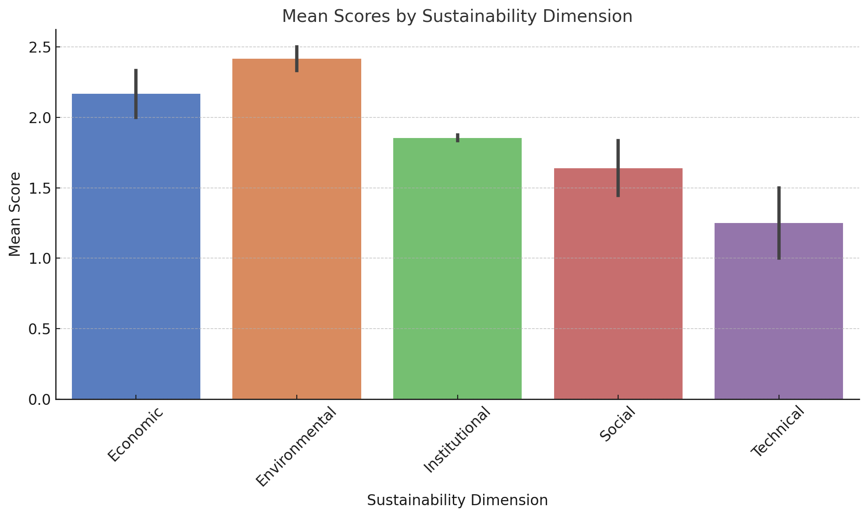

- Description: Bar chart displaying the mean ratings of each of the sustainability dimensions: Economic, Social, Environmental, Institutional, and Technical.
- Interpretation: The Environmental dimension was given the highest mean rating, showing extreme participant satisfaction with the environmental contribution of the project. The lowest mean rating is that of the Technical dimension, implying that participants are least satisfied with the technical product of the project.

Figure 2: Tukey HSD Post-Hoc Comparison
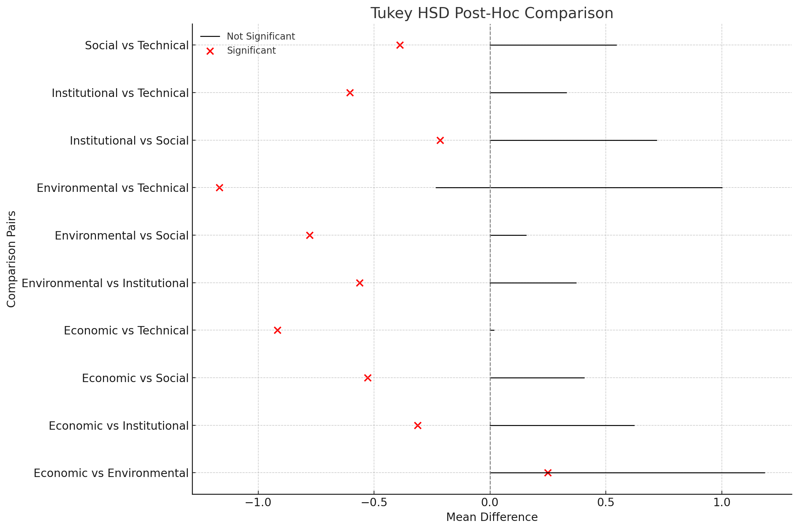

- Description: Graphical visualization of the Tukey HSD test results, plotting pairwise contrasts among the sustainability factors: Economic, Social, Environmental, Institutional, and Technical.
- Interpretation: Red marks represent statistically significant differences among factors. Most significantly, there is an immense and statistically significant difference between the Economic and Technical factors with significantly lower Technical factor scores compared to the Economic factor.

Figure 3: Scores by Sustainability Dimension and Gender
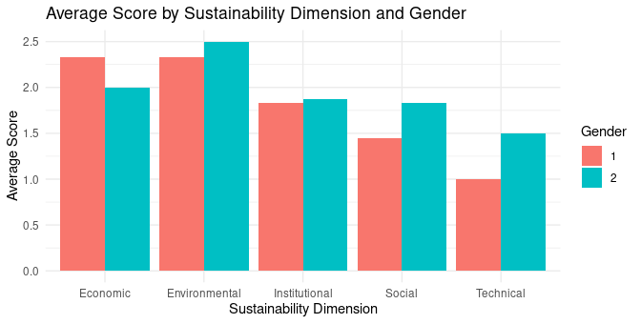

- Description: A boxplot showing the distribution of scores across all the dimensions of sustainability—Economic, Social, Environmental, Institutional, and Technical—by gender.
- Interpretation: Women provided more positive ratings for the Social dimension than men, pointing to greater satisfaction with social effects. Men provided only slightly more positive ratings for the Technical dimension. These results identify gender-based differences in rating perceptions of the project's sustainability dimensions.

Figure 4: Mean Scores for Sustainability Dimensions Across Demographic Subgroups
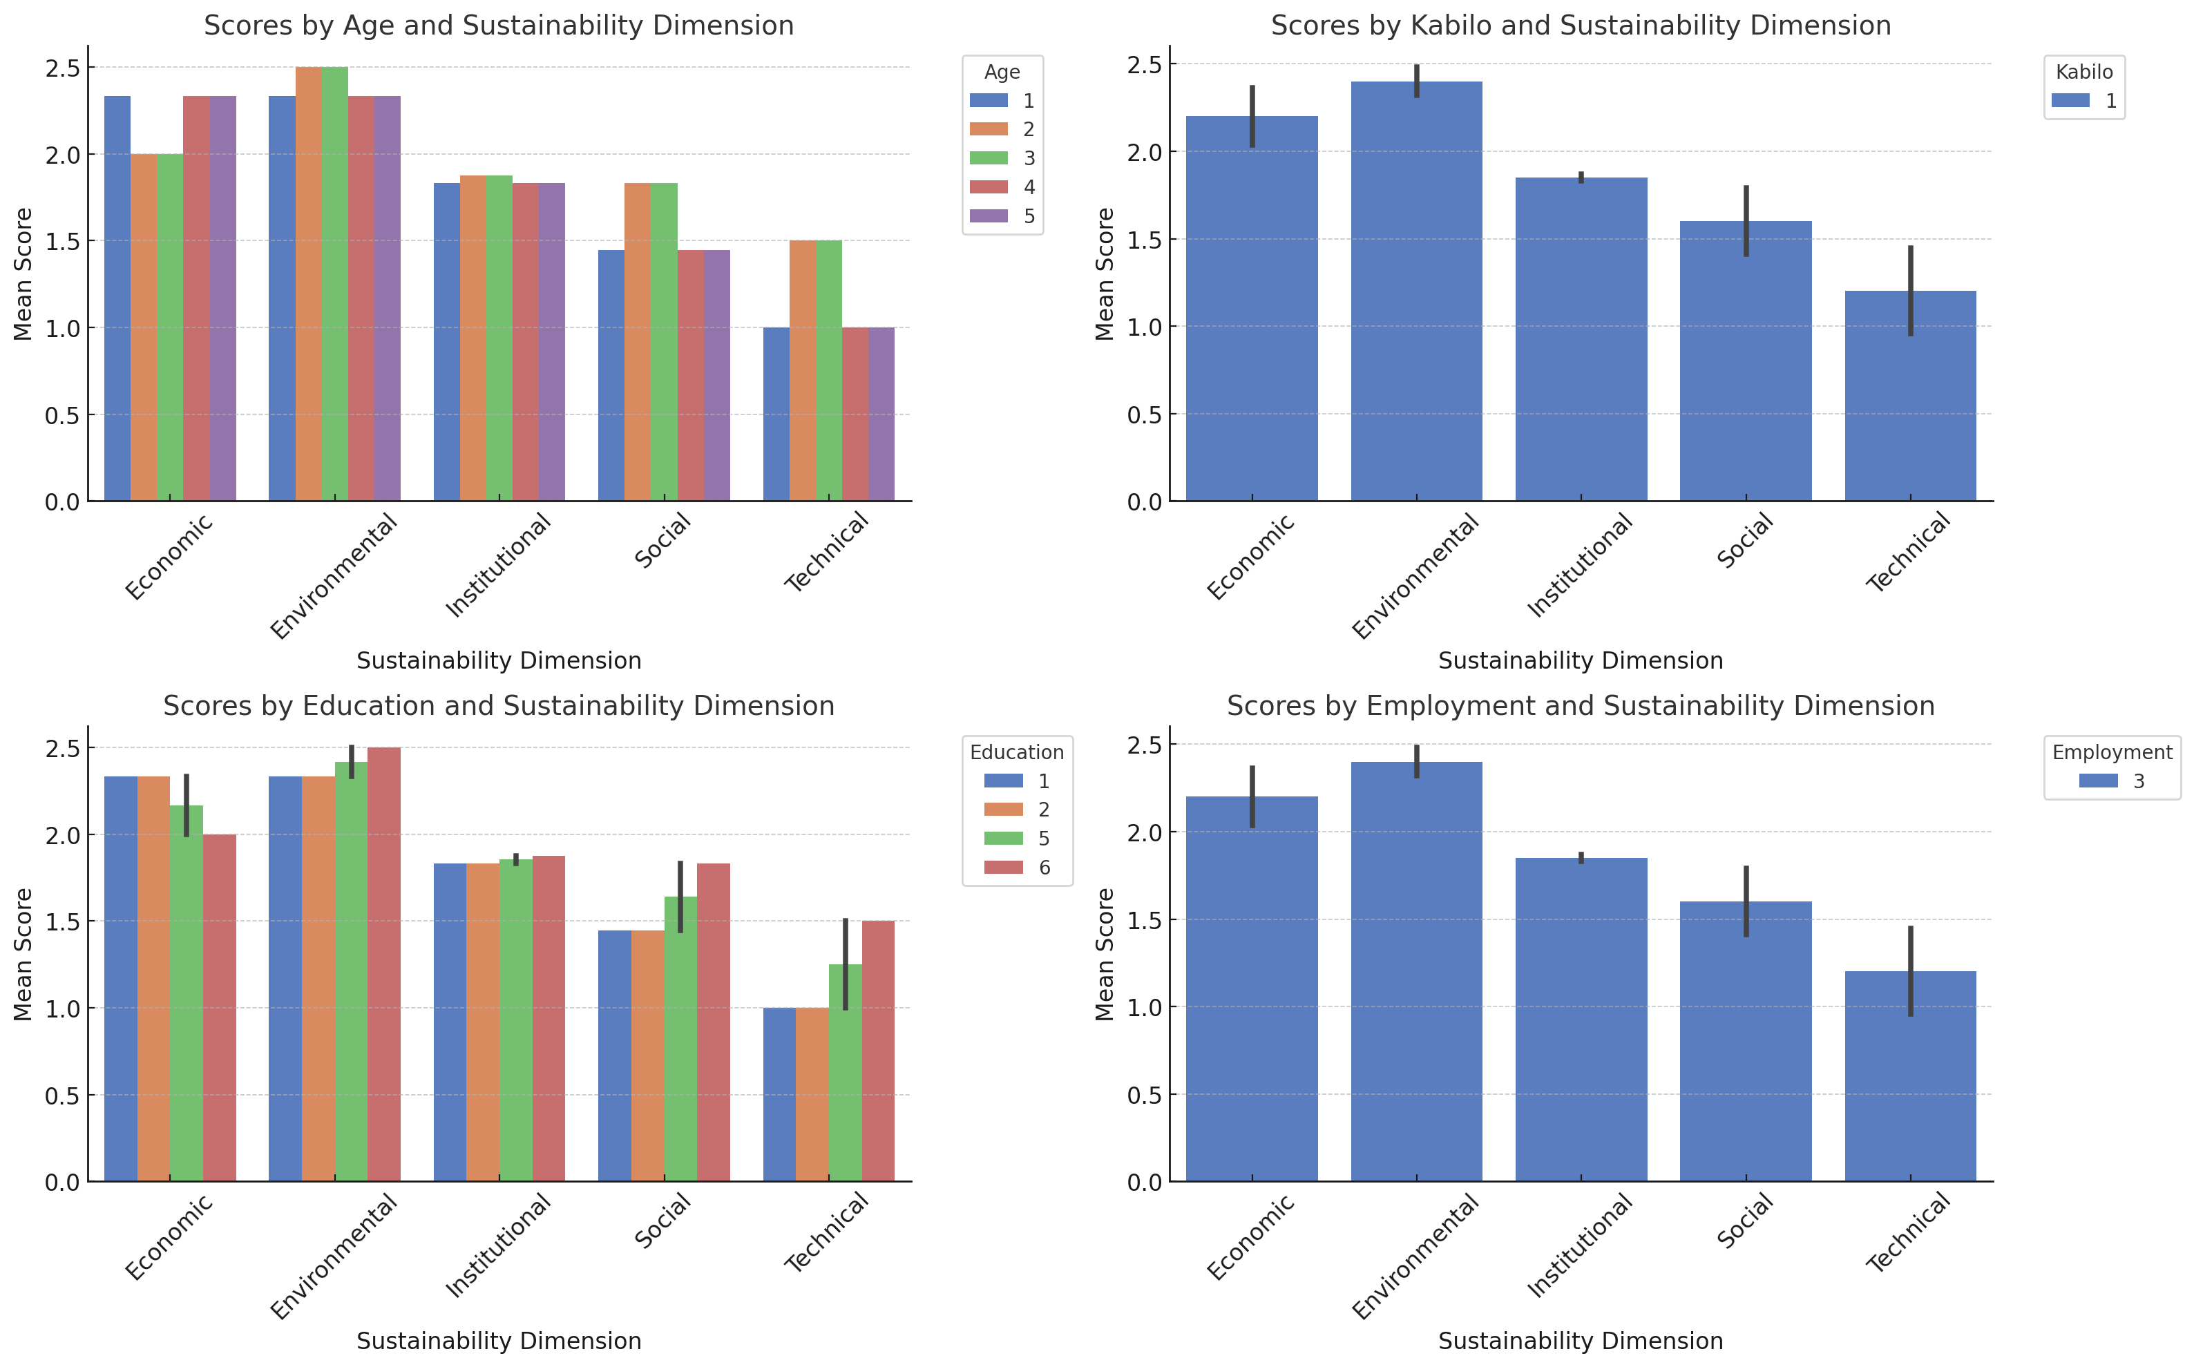

- Description: Bar graphs showing the mean scores by subgroups of demographics for each sustainability aspect—Economic, Social, Environmental, Institutional, and Technical.
- Interpretation: The Institutional and Environmental aspects were scored higher by older and more educated respondents, reflecting greater satisfaction with these aspects. This reveals that age and education have a strong influence on what is perceived in terms of the sustainability of the project.

Figure 5: Mean Scores by Sustainability Dimension and Question

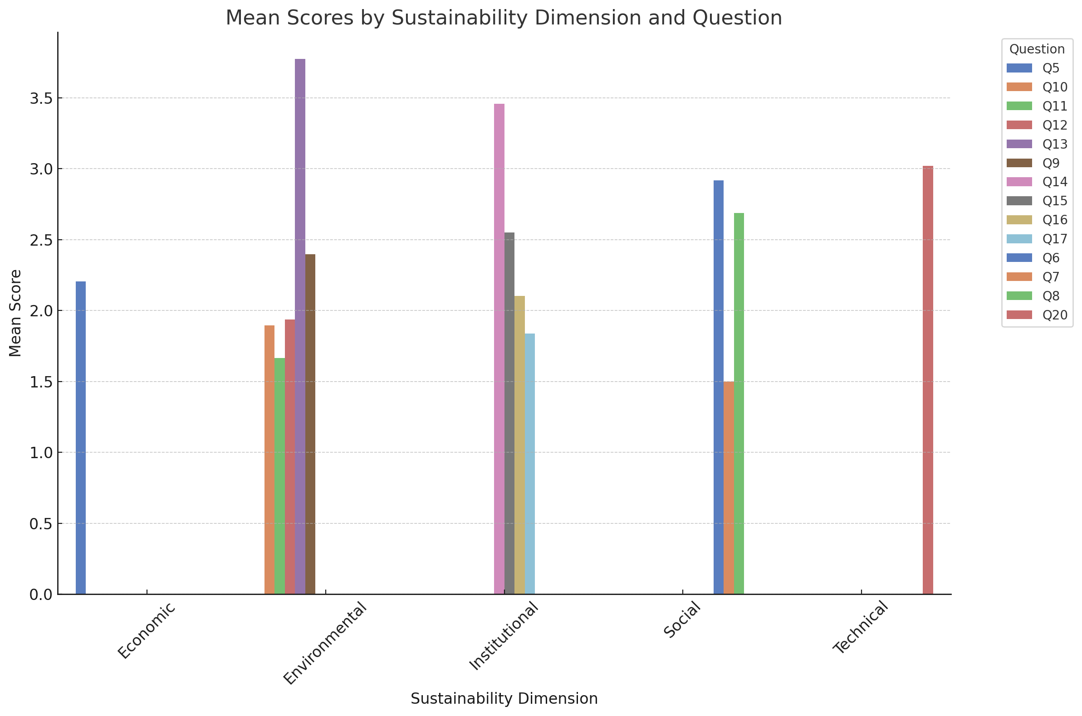

- Description: Bar chart comparing mean ratings for all questions across all dimensions of sustainability, namely Economic, Social, Environmental, Institutional, and Technical.
- Interpretation: Environmental and Institutional dimension questions had higher mean ratings, indicating higher participant satisfaction in these dimensions. Conversely, Technical dimension questions had lower ratings, reflecting certain technical aspects where individual improvements need to be addressed.

5 Discussion
The Mixed ANOVA findings provide definitive results on the views of participants on the five sustainability dimensions—Economic, Social, Environmental, Institutional, and Technical—along with the impact of demographic factors like Gender, Age, Kaabiloo, Education, and Employment. We present below the most important results, their implications, and what we suggest to do in the future, based on the relevant results and citations.

5.1 Significant Differences Across Sustainability Dimensions
The analysis did reveal statistically significant differences in ratings between the dimensions of sustainability (F(4, 44) = 7.7601, p = 0.0361). The Environmental dimension received highest mean ratings, while the Technical dimension was placed last (Figure 1). This reflects high participant satisfaction with environmental factors, including energy savings, availability of clean energy, and higher awareness of climate change, but lower satisfaction with technical problems, including system design and implementation. Post-hoc Tukey HSD tests validated that the Technical dimension ranked significantly lower than the Economic, Environmental, and Institutional dimensions (p < 0.05) with extremely large effect sizes (e.g., Environmental vs. Technical: Cohen's d = 4.43) showing significant differences (Figure 2). These results conform to previous studies that have highlighted technical issues as major barriers to the success of renewable energy projects (Olabi et al., 2023; Saleh et al., 2024; Lehtola et al., 2020; Eti et al., 2024; Soderholm et al., 2020).

5.2 Tech Demographic Factors’ Influence
Subgroup analyses indicated demographic factors had a substantial effect on views about sustainability dimensions:
- Gender: Women ranked the Social above that of men, and men ranked the Technical above (Figure 3). These differences may indicate differential priorities or experience regarding community involvement and technical systems.
- Age: More older participants ranked the Environmental category more highly, indicating concern with long-term environmental advantage (Figure 4).
- Education: Those with more education also rated the Institutional dimension higher, possibly because they are more aware of governance and organizational efficacy (Figure 4).
This provides evidence for evidence highlighting demographic variables as key to changing perception in sustainability projects (Rotondi et al., 2024; Nguyen et al., 2023). Matching intervention to meet particular demographic requirements may improve general project satisfaction and efficacy.

5.3 Implications for Future Projects
Implications of the findings for future design and delivery of sustainability projects are numerous:
- There needs to be an emphasis on discrete technical advancements in system design, reliability, and usability to improve participant satisfaction and project performance.
- Targeted Interventions: Demographic concerns highlight the need for targeted interventions, such as involving older respondents in environmental activities or technical training for women to address specific issues.
- Strengthening Environmental and Institutional Dimensions: High scores for the Environmental and Institutional dimensions reflect supporter demand for clean energy and good governance. Drawing on these strengths can further reinforce community support and project success.

5.4 Limitations and Future Research
In spite of its results, the research is not without its shortcomings. The limited sample size for some demographic subgroups, e.g., older participants, could restrict generalization of results. Subsequent studies could avoid these deficits by:
Carrying out qualitative research to investigate drivers of participant perceptions in more detail.
Increasing the sample size to encompass more diversity among demographic groups.
Taking other factors, e.g., income or geographical location, into account that could affect sustainability perceptions.

6 Conclusion
The analysis through Mixed ANOVA showed significant differences in participants' views on the five sustainability dimensions—Economic, Social, Environmental, Institutional, and Technical—with the highest being for the Environmental dimension and the lowest being for the Technical dimension. Demographic variables of Gender, Age, and Education influenced the perceptions significantly, and therefore, introducing targeted interventions that address specific groups would be appropriate. By taking advantage of the strengths of the Environmental and Institutional dimensions and addressing technical weaknesses, future sustainability initiatives will be able to garner more public approval and attain greater success.

7 Key Takeaways
- Stand-Out Differences Between Dimensions: The Environmental dimension scored the highest and the Technical dimension scored the lowest, indicating an urgent need for improved technical performance.
- Demographic Factors: Gender, Age, and Education are important drivers of impressions of sustainability, with a focus on understanding the need to tailor interventions to address the priorities of various demographic groups.
- Large Effect Sizes: Large effect sizes in Technical dimension contrasts highlight extensive differences in satisfaction, with a focus on addressing technical problems.

8 Recommendations
- Enhance Technical Elements: Focus on enhancing technical design, implementation, and upkeep of the project in response to participant complaints and raising Technical dimension satisfaction.
- Customize Interventions to Demographics: Create bespoke interventions for specific demographic segments, e.g., older participants and women, to facilitate greater satisfaction across all sustainability dimensions.
- Conduct In-Depth Analysis: Conduct subgroup analyses and qualitative studies to further understand the determinants that affect participant ratings and for use in future project planning.

9 References
- Adeoye, O., & Spataru, C. (2018). Sustainable development of the West African Power Pool: Increasing solar energy integration and regional electricity trade. Energy for Sustainable Development, 45, 124-134.
- Akinyele, D. (2017). Techno-economic design and performance analysis of nanogrid systems for households in energy-poor villages. Sustainable Cities and Society, 34, 335-357.
- Bloomer, J. and Boateng, D. (2024). Prepaid into poverty? Exploring energy poverty and access to alternative electricity sources among urban poor households in Ghana. Energy Research and Social Science, 112 (2024) 103510. https://doi.org/10.1016/j.erss.2024.103510
- Drave, M., Mannerhagen, F., Kersten, A., Eckerle, R., Abdul-Jabbar, T.A., Abbas, F.A., Ban, B., Xu, Y., Kuder, M., Weyh, T., and Leijon,M. (2025) Solar Power Potential in Africa: A Case Study on Cost Reduction in a Malian Household Through Photovoltaic Solar Power and Lithium-Ion Battery Storage. Electricity, 6, 5. https://doi.org/10.3390/electricity6010005
- ECOWAS Centre for Renewable Energy and Energy Efficiency (ECREEE). Renewable Energy. Retrieved from https://www.ecreee.org/renewable-energy
- Fajardo, A., Baker, L. H., Sesan, T., Bhattacharyya, S., Kerr, D., Katyega, M. and Barnett, A. (2025). Business models and access to finance for mini grid development in sub-Saharan Africa. Energy for Sustainable Development, 85 (2025) 101666. https://doi.org/10.1016/j.esd.2025.101666
- Hydara, S. M., Ibrahim, H., Sanyang, M. L., and Saley, M. M. (2025). Performance Analysis of an Off-Grid System in The Gambia: A Case Study of a 120 KWp Solar Installation at Nyamanarri Village. Journal of Energy Research and Reviews 17 (6):20-39. https://doi.org/10.9734/jenrr/2025/v17i6420.
- International Renewable Energy Agency (IRENA), Deutsche Gesellschaft für Internationale Zusammenarbeit (GIZ), and German Development Bank (KfW). (2021). The renewable energy transition in Africa: Powering access, resilience and prosperity.
- Key Findings – Africa Energy Outlook 2022, International Energy Agency, June 2022
- Kothe, S., Pfelfroth, U., Cremer, R., Threntman, J., and Hollmann, R. (2017). A Satelite-based Sunshine duration climate data record for Europe and Africa, Remote Sens., 9, 429, https://doi.org/10.3390/rs9050429, a, b
- Maqbool, R., & Akubo, S. A. (2022). Solar energy for sustainability in Africa: The challenges of socio‐economic factors and technical complexities. International Journal of energy Research, 46(12), 16336–16354. https://doi.org/10.1002/er.8425
- Neher, I., Crewell, S., Mellinger, S., Pfelfroth, U., and Trentmann, J. (2020). Photovoltaic Power Potential in West Africa using long-term satelite data, atmos, Chem. Phys., 20, 12871-12888, https://doi.org/10.5194/acp-20-12871-2020
- Nyasapoh, M. A., Elorm, M. D., & Derkyi, N. S. A. (2022). The role of renewable energies in sustainable development of Ghana. Scientific African, 16, e01199. https://doi.org/10.1016/j.sciaf.2022.e01199
- Olabi, A. G., Elsaid, K., Obaideen, K., Abdelkareem, M. A., Rezk, H., Wilberforce, T., Hussein, M. M. and Sayed, E. T. (2023). Renewable energy systems: Comparisons, challenges and barriers, sustainability indicators, and the contribution to UN sustainable development goals. International Journal of Thermofluids, 20, 100498.
- Olabi, A. G., Obaideen, K., Abdelkareem, M. A., AlMallahi, M. N., Shehata, N., Alami, A. H., Mdallal, A., Hassan, A. A. M., & Sayed, E. T. (2023). Wind energy contribution to the Sustainable Development Goals: Case study on London Array. Sustainability, 15(5), 4641. https://doi.org/10.3390/su15054641
- Saleh, A. M., Saleh, N. M., Ali, O. M., Hasan, R. A., Ahmed, O. K., Alias, A. B., & Yassin, K. F. (2024). Green building techniques under the umbrella of the climate framework agreement. Babylonian Journal of Machine Learning, 2024, 1–14. https://doi.org/10.58496/BJML/2024/001
- Singh, R., Wang, X., Mendoza, J. C., & Ackom, E. (2014). Electricity (in)accessibility to the urban poor in developing countries. WIREs Energy and Environment. https://doi.org/10.1002/wene.148
- Solargis: Soalr resource Map 2019, available at: https://solargis.com/map-and-gis-data/download/Africa
- U.S. Energy Information Administration. (2023). Photovoltaics and electricity. Retrieved July 3, 2025, from https://www.eia.gov/energyexplained/solar/photovoltaics-and-electricity.php
- Vincent Zoma. (2024). Energy challenges in Burkina Faso: Overcoming obstacles through innovation. International Journal of Ecology and Environmental Sciences, 2024, 6 (4), pp.8-15. ffhal-04761057f
- World Bank. (n.d.). Energy. World Bank. https://www.worldbank.org/en/topic/energy/overview
- XPower Solar. (2024). Driving sustainable energy solutions: The role of PV systems and solar modules. Retrieved July 3, 2025, from https://www.xpowersolar.com/driving-sustainable-energy-solutions-the-role-of-pv-systems-and-solar-modules/

