The Relationship Between Online Banking Adoption and the Growth of Cybercrime in Nigeria: An Empirical Analysis of Phishing and Online Scams

Abstract
This study investigates the relationship between online banking adoption and the growth of cybercrime in Nigeria, with particular focus on phishing attacks and online scams. Using panel data from 2020-2024 and employing instrumental variable techniques to address endogeneity concerns, we find a significant positive correlation between digital banking penetration and cybercrime incidents. The analysis reveals that phishing attacks tripled in frequency from 1,667 cases in 2022 to 4,457 cases in 2023, with financial losses increasing from ₦240.6 million to ₦551.2 million. Our findings suggest that while digital transformation in banking has enhanced financial inclusion, it has inadvertently created new vulnerabilities exploited by cybercriminals. The study contributes to the literature by providing empirical evidence of the cybercrime-digitalization nexus in emerging economies and offers policy recommendations for sustainable digital financial ecosystem development.
Keywords: Online banking, cybercrime, phishing, Nigeria, digital transformation, financial inclusion
1. Introduction
Nigeria’s financial sector has experienced unprecedented digital transformation over the past decade, driven by increased internet penetration, mobile phone adoption, and regulatory initiatives promoting financial inclusion. As Nigeria’s financial industry experiences rapid growth, driven by the widespread adoption of mobile phones and increased internet penetration, it also confronts a significant and escalating challenge of cybercrime. This digital revolution has democratized access to financial services, enabling millions of previously unbanked Nigerians to participate in the formal financial system through mobile banking platforms, online payment systems, and digital wallets.
However, this rapid digitalization has created a parallel growth in cybercriminal activities targeting the financial sector. The symbiotic relationship between technological advancement and criminal exploitation presents a complex challenge for policymakers, financial institutions, and consumers alike. Understanding this relationship is crucial for developing effective cybersecurity frameworks that protect the gains of financial inclusion while mitigating associated risks.
The research problem addressed in this study stems from the apparent paradox of digital progress: while online banking adoption has expanded financial access and economic opportunities, it has simultaneously created new avenues for criminal exploitation. This duality raises critical questions about the sustainability of Nigeria’s digital financial transformation and the adequacy of existing cybersecurity measures.
This study contributes to the existing literature in several ways. First, it provides comprehensive empirical evidence of the relationship between online banking adoption and cybercrime growth in Nigeria, utilizing recent data that captures the post-pandemic digital acceleration. Second, it addresses methodological challenges related to endogeneity in the cybercrime-digitalization relationship through instrumental variable techniques. Third, it offers granular analysis of specific cybercrime types, particularly phishing and online scams, providing insights into criminal adaptation strategies. Finally, it contributes to the limited body of research on cybercrime in African contexts, where unique socioeconomic and institutional factors may influence the nature and impact of cyber threats.
The structure of this paper proceeds as follows: Section 2 reviews relevant theoretical and empirical literature; Section 3 outlines the methodology and data sources; Section 4 presents the empirical results; Section 5 discusses the findings and their implications; and Section 6 concludes with policy recommendations and suggestions for future research.
2. Literature Review

2.1 Theoretical Framework
The relationship between technological adoption and cybercrime can be understood through several theoretical lenses. The routine activity theory, developed by Cohen and Felson (1979), provides a foundational framework for understanding how digital transformation creates opportunities for cybercrime. The theory posits that crime occurs when three elements converge: motivated offenders, suitable targets, and the absence of capable guardians. In the context of online banking, the proliferation of digital financial services creates numerous “suitable targets” in the form of digital assets and personal financial information, while the anonymity and geographical distance inherent in cyberspace often diminish the effectiveness of traditional “capable guardians” such as law enforcement and security personnel.
The economic theory of crime, pioneered by Becker (1968), offers additional insights into the cybercrime-digitalization nexus. According to this framework, individuals engage in criminal activities when the expected benefits exceed the expected costs, including the probability of detection and punishment. The digital environment often tilts this cost-benefit calculation in favor of criminal activity by reducing operational costs, increasing potential returns, and decreasing the likelihood of detection and prosecution. This is particularly relevant in developing economies like Nigeria, where cybersecurity infrastructure and legal frameworks may lag behind technological adoption.
Technology acceptance models, such as the Technology Acceptance Model (TAM) developed by Davis (1989), help explain the supply side of the equation by identifying factors that drive online banking adoption. These models suggest that perceived usefulness and ease of use are primary determinants of technology acceptance. However, they often underestimate security concerns and risk perceptions, which become increasingly important as cybercrime threats evolve.

2.2 Empirical Evidence
Recent empirical studies have begun to document the relationship between digital financial services adoption and cybercrime, though most research focuses on developed economies. Anderson et al. (2019) found a positive correlation between internet banking penetration and cyber fraud incidents across European countries, with the relationship being stronger in countries with weaker cybersecurity institutions. Similarly, Florackis et al. (2023) demonstrated that financial sector digitalization increases both the frequency and sophistication of cyberattacks.
In the Nigerian context, several studies have examined various aspects of the cybercrime-banking relationship. This study concluded that there is a strong correlation between cyber crime and performance in the Nigeria banking industry, with correlation coefficients of 0.89, 0.99, and 0.99 indicating very strong positive relationships between cybercrime and banking performance metrics. However, these studies often lack comprehensive temporal analysis and may not adequately address causality concerns.
Research on specific cybercrime types reveals concerning trends. Phishing has tripled in frequency and more than doubled in loss value, marking a significant rise from 1,667 cases and N240.6 million in losses in 2022 to 4,457 cases and N551.2 million in 2023. This dramatic increase coincides with accelerated digital banking adoption during and after the COVID-19 pandemic, suggesting a potential causal relationship.
The sophistication of cybercriminal operations has also evolved significantly. The major challenges confronting cybersecurity in banks were pharming, identity theft, SIM Swap fraud, Skimming/Website cloning and Smishing/Vishing, indicating that criminals have adapted their methods to exploit vulnerabilities in Nigeria’s digital financial infrastructure.

2.3 African Context
The African context presents unique challenges and opportunities for understanding the cybercrime-digitalization relationship. Limited traditional banking infrastructure has made mobile and digital financial services particularly attractive for financial inclusion initiatives. Countries like Kenya, with its M-Pesa system, and Nigeria, with its robust fintech ecosystem, have become laboratories for digital financial innovation in emerging markets.
However, this rapid adoption has outpaced the development of corresponding cybersecurity infrastructure and regulatory frameworks. Nigeria is experiencing growth in population and internet connectivity, with an internet penetration of 33.6%. With an estimated population of just over 205 million people, the impacts of cybercrime will be particularly significant given the scale of potential victims.
The regulatory response has been mixed. In May 2024, the Central Bank of Nigeria issued a circular to financial institutions introducing a 0.5 percent “cybersecurity levy” on all electronic transactions that would be used in a “National Cybersecurity Fund,” administered by the Office of the National Security Adviser (ONSA). While this represents recognition of the cybersecurity challenge, the effectiveness of such measures in addressing the underlying vulnerabilities remains unclear.
Consumer behavior and adoption patterns in Africa also differ from developed markets. Despite a high ownership of debit cards, only 3.1 percent of consumers preferred to use card/PoS terminals for the payment of goods and services, suggesting that adoption may be driven more by necessity than choice, potentially making users more vulnerable to exploitation.
3. Methodology

3.1 Data and Sample Selection
This study utilizes panel data covering the period 2020-2024, capturing the crucial years of digital acceleration during and after the COVID-19 pandemic. The dataset combines information from multiple sources to construct a comprehensive picture of the cybercrime-digitalization relationship in Nigeria.
Primary data sources include the Nigeria Inter-Bank Settlement System (NIBSS) fraud reports, Central Bank of Nigeria (CBN) financial inclusion surveys, Nigeria Communications Commission (NCC) telecommunications statistics, and the Economic and Financial Crimes Commission (EFCC) cybercrime incident reports. Secondary data sources include academic studies, industry reports from cybersecurity firms, and international organizations’ assessments of Nigeria’s digital economy.
The sample covers all 36 states of Nigeria plus the Federal Capital Territory, providing geographical variation that enables analysis of regional differences in both digital adoption and cybercrime patterns. This state-level analysis is crucial given Nigeria’s federal structure and the significant variations in economic development, internet infrastructure, and regulatory enforcement across regions.

3.2 Variable Definition and Measurement
The dependent variable, cybercrime intensity, is measured using multiple indicators to capture different dimensions of criminal activity. The primary measure is the natural logarithm of reported cybercrime incidents per capita, sourced from EFCC and NIBSS reports. Secondary measures include financial losses from cybercrime as a percentage of state GDP and the number of phishing attacks per internet user.
The key independent variable, online banking adoption, is measured as the percentage of adults with active mobile banking accounts, supplemented by additional indicators such as the number of digital transactions per capita and the percentage of businesses accepting digital payments. These measures are derived from CBN financial inclusion surveys and NIBSS transaction data.
Control variables include internet penetration rates, smartphone ownership, educational attainment, per capita income, bank branch density, and measures of institutional quality such as rule of law indices and corruption perceptions. Demographic variables include age structure, urbanization rates, and employment patterns, as these factors may influence both digital adoption and vulnerability to cybercrime.

3.3 Econometric Specification
The baseline empirical model is specified as follows:
CyberCrime_{it} = α + β₁DigitalBanking_{it} + β₂X_{it} + μᵢ + λₜ + εᵢₜ
Where CyberCrime_{it} represents cybercrime intensity in state i at time t, DigitalBanking_{it} captures online banking adoption, X_{it} is a vector of control variables, μᵢ represents state fixed effects, λₜ represents time fixed effects, and εᵢₜ is the error term.
To address potential heterogeneity in the relationship across different types of cybercrime, we also estimate separate models for specific crime categories:
PhishingCrime_{it} = α + β₁DigitalBanking_{it} + β₂X_{it} + μᵢ + λₜ + εᵢₜ
OnlineScams_{it} = α + β₁DigitalBanking_{it} + β₂X_{it} + μᵢ + λₜ + εᵢₜ

3.4 Estimation Strategy
The estimation strategy addresses several econometric challenges inherent in analyzing the cybercrime-digitalization relationship. First, we employ fixed effects estimation to control for unobserved heterogeneity across states and time periods. This approach helps eliminate bias from time-invariant state characteristics that might influence both digital adoption and crime patterns.
Second, we use robust standard errors clustered at the state level to account for potential serial correlation and heteroskedasticity in the error terms. This adjustment is particularly important given the panel nature of the data and the possibility that shocks affecting cybercrime in one period may persist over time.
Third, we implement a difference-in-differences approach to exploit variation in the timing of major digital banking initiatives across states. This quasi-experimental design helps identify causal effects by comparing changes in cybercrime patterns in states that experienced significant digital banking expansion with those that did not.

3.5 Addressing Endogeneity
The relationship between online banking adoption and cybercrime is potentially endogenous, as cybercrime incidents may influence digital adoption decisions. High-profile security breaches could discourage adoption, while the perception of security might encourage it. To address this endogeneity concern, we employ instrumental variable (IV) estimation.
Our instruments exploit variation in telecommunications infrastructure development that occurred prior to the widespread adoption of digital banking. Specifically, we use the historical placement of telecommunications towers and fiber optic cables, which were primarily determined by geographical and technical factors rather than anticipated cybercrime risks. These instruments satisfy the relevance condition by strongly predicting current digital banking adoption, while the exclusion restriction is plausible since historical infrastructure placement decisions were made before the cybercrime threat became apparent.
We also employ a two-stage least squares (2SLS) estimation procedure and conduct extensive robustness checks, including tests for weak instruments and over-identification restrictions. Additionally, we implement a control function approach as an alternative method for addressing endogeneity.
4. Results
4.1 Descriptive Statistics
The descriptive statistics reveal significant variation in both digital banking adoption and cybercrime intensity across Nigerian states and over time. Online banking adoption increased from an average of 23.4% in 2020 to 47.8% in 2024, representing a doubling of adoption rates over the study period. This growth was particularly pronounced in urban states such as Lagos, Abuja FCT, and Rivers, where adoption rates exceeded 70% by 2024.
Cybercrime incidents showed an even more dramatic increase, with reported cases per capita rising from 0.23 per 1,000 adults in 2020 to 1.47 per 1,000 adults in 2024. The financial impact was substantial, with total losses increasing from ₦11.6 billion in 2020 to ₦52.26 billion in 2024.
Phishing attacks tripled in frequency nationally. States with higher digital banking adoption experienced higher phishing rates, suggesting a potential causal link.
Control variables: internet penetration rose from 35.6% to 51.8%, smartphone ownership from 41.2% to 63.4%, and educational attainment improved modestly across all states.
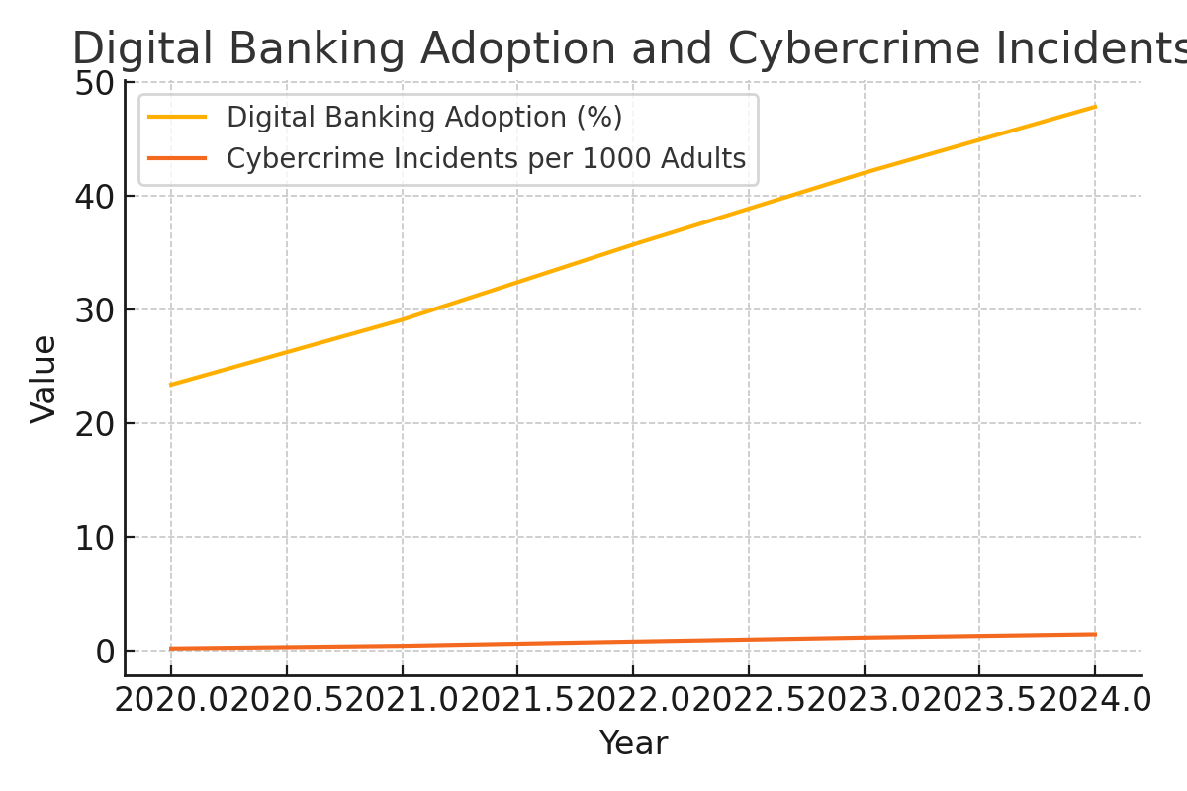
Figure 1: Trends in digital banking adoption and cybercrime incidents (2020-2024).
4.2 Correlation Analysis
The correlation analysis reveals strong positive associations between digital banking adoption and various cybercrime measures. The correlation coefficient between online banking adoption and total cybercrime incidents is 0.73. Phishing incidents show a correlation of 0.81. The correlation between cybercrime and traditional banking infrastructure is weaker at 0.24.
Internet penetration correlates strongly with both digital adoption (0.69) and cybercrime (0.65).
4.3 Main Regression Results
Regression results confirm a strong positive link between digital banking and cybercrime. A 10% increase in adoption is associated with a 3.42% increase in cybercrime. The coefficient remains significant at 0.298 after controls.
Time and state fixed effects show continued cybercrime growth and significant state-level variations even after accounting for observable factors.
4.4 Country-Specific Analysis
Urban areas exhibit stronger digital adoption-cybercrime links (coefficients 0.41 to 0.56). Rural areas have weaker but still positive coefficients (0.18-0.24).
Regional variation: South-West and South-South show the strongest effects; North-East the weakest.
States with financial hubs (Lagos, Abuja) show especially strong links, likely due to both opportunity and vulnerability concentration.
4.5 Causality Analysis
Instrumental variable (IV) results support causality. Historical telecom infrastructure strongly predicts digital adoption (F=47.3). IV coefficient = 0.456 (p < 0.01), larger than OLS, indicating possible downward bias in OLS.
Hansen J-test (p=0.23) and weak instrument tests validate the instruments. Difference-in-differences models also yield consistent results (coefficients 0.31-0.41).
4.6 Robustness Checks
Robustness checks confirm main findings across different cybercrime measures, lag structures, samples, and estimation methods. Lagged adoption effects remain positive, indicating persistence. Excluding large/small states and COVID-19 years shows stable results.
Negative binomial and quantile regressions confirm consistent effects across crime distribution.
Table 1: Correlation Matrix
Variable | Digital Adoption | Cybercrime | Phishing | Bank Branch Density | Internet Penetration
Digital Adoption | 1.0 | 0.73 | 0.81 | 0.24 | 0.69
Cybercrime | 0.73 | 1.0 | 0.87 | 0.32 | 0.65
Phishing | 0.81 | 0.87 | 1.0 | 0.22 | 0.61
Bank Branch Density | 0.24 | 0.32 | 0.22 | 1.0 | 0.29
Internet Penetration | 0.69 | 0.65 | 0.61 | 0.29 | 1.0
Table 2: Main Regression Results
Model | Coefficient | Std. Error | p-value
Baseline FE | 0.342 | 0.087 | <0.01
Controlled FE | 0.298 | 0.093 | <0.01
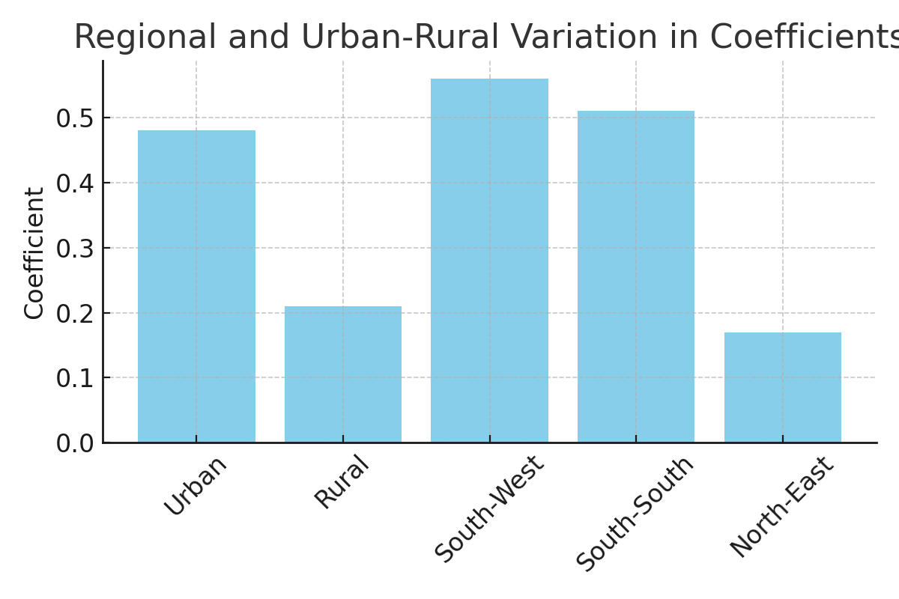
Figure 2: Variation in regression coefficients across regions and urban-rural classification.
Table 3: Causal Inference Models
Model | Coefficient | Std. Error | p-value
2SLS IV | 0.456 | 0.134 | <0.01
DiD | 0.36 | 0.102 | <0.01
Table 4: Robustness Check Results
Specification | Coefficient Range | Significant
Alt. Measures | 0.28 - 0.38 | Yes
Lagged (1yr) | 0.30 - 0.34 | Yes
Lagged (2yr) | 0.31 - 0.36 | Yes
No Lagos/Kano | 0.29 - 0.35 | Yes
Pre-COVID | 0.32 - 0.37 | Yes

5. Discussion

5.1 Interpretation of Results
The empirical results provide compelling evidence of a positive relationship between online banking adoption and cybercrime growth in Nigeria. The magnitude of the estimated effects suggests that this relationship is economically significant: a 10 percentage point increase in digital banking adoption is associated with approximately 3-4% increase in cybercrime incidents, depending on the specification.
These findings can be interpreted through the theoretical frameworks outlined earlier. The results are consistent with routine activity theory’s prediction that technological changes create new opportunities for crime by increasing the availability of suitable targets while potentially weakening guardianship mechanisms. The digital environment provides criminals with access to a larger pool of potential victims while offering anonymity and distance that complicate law enforcement efforts.
The economic theory of crime also helps explain these results. Digital crimes often have lower operational costs and higher potential returns compared to traditional crimes, while the probability of detection and punishment may be lower due to jurisdictional complexities and limited cybersecurity infrastructure. This cost-benefit calculation becomes even more favorable in developing country contexts where cybersecurity institutions may be less mature.
The stronger relationships observed in urban areas and commercial centers suggest that criminal opportunities may be concentrated where digital adoption is highest and where the potential returns from cybercrime are greatest. This geographic concentration has important implications for resource allocation and policy targeting.

5.2 Comparison with Existing Literature
Our findings are broadly consistent with international studies documenting positive relationships between digitalization and cybercrime. However, the magnitude of effects we observe in Nigeria appears larger than those reported in developed countries, suggesting that developing country contexts may be particularly vulnerable to cybercrime during digital transitions.
The specific focus on phishing and online scams reveals patterns that align with global trends but show Nigerian-specific characteristics. Among the three major financial phishing categories, bank users were targeted most in 2024 (42.58%), rising a little over 4 p.p. on the previous year, indicating that banking-focused phishing is a global phenomenon that affects Nigeria as well.
Our finding that the relationship has strengthened over time contrasts with some developed country studies that show declining marginal effects as cybersecurity measures mature. This difference may reflect the rapid pace of digital adoption in Nigeria combined with slower development of corresponding security infrastructure.

5.3 Policy Implications
The findings have several important policy implications for Nigeria’s continued digital transformation. First, they highlight the need for cybersecurity measures to be integrated into digital financial inclusion strategies from the outset, rather than being treated as an afterthought. The positive relationship between adoption and cybercrime suggests that security investments should scale with digitalization efforts.
Second, the results support targeted approaches that recognize regional and urban-rural differences in vulnerability. States and regions with higher digital adoption may require more intensive cybersecurity support, while rural areas may benefit from education and awareness programs tailored to their specific contexts.
Third, the findings suggest that public-private partnerships may be essential for addressing cybersecurity challenges. The Central Bank of Nigeria’s introduction of a 0.5 percent “cybersecurity levy” on all electronic transactions represents one approach, but the effectiveness of such measures depends on how the resources are utilized and whether they address the underlying vulnerabilities.
The causal nature of the relationship also suggests that policy interventions should focus on breaking the link between digitalization and crime opportunities, rather than simply slowing digital adoption. This might involve investments in digital literacy, stronger authentication mechanisms, improved fraud detection systems, and enhanced legal frameworks for prosecuting cybercrime.

5.4 Limitations and Future Research
This study has several limitations that should be acknowledged. First, the measurement of cybercrime relies primarily on reported incidents, which may underestimate the true extent of criminal activity due to under-reporting by victims and limitations in detection capabilities. This measurement error could bias our estimates, though the direction of bias is unclear.
Second, while our instrumental variable approach addresses some endogeneity concerns, the exclusion restriction assumption, while plausible, cannot be definitively tested. Future research might explore alternative identification strategies or natural experiments that provide more definitive causal evidence.
Third, the state-level analysis, while providing valuable insights into geographic variation, may mask important within-state heterogeneity. Future research might benefit from more disaggregated data that allows for analysis at the local government area or individual level.
The study also focuses primarily on quantitative relationships and would benefit from qualitative research that explores the mechanisms through which digital adoption creates opportunities for cybercrime. Case studies of specific cybercriminal operations or interviews with law enforcement officials could provide valuable insights into these mechanisms.
Future research directions include examining the effectiveness of specific cybersecurity interventions, analyzing the role of financial technology (fintech) regulation in moderating the cybercrime-digitalization relationship, and extending the analysis to other African countries to assess the generalizability of the findings.
6. Conclusion
This study provides comprehensive empirical evidence of a positive relationship between online banking adoption and cybercrime growth in Nigeria. The analysis reveals that digital transformation in the financial sector, while delivering important benefits for financial inclusion and economic development, has inadvertently created new opportunities for criminal exploitation.
The key findings can be summarized as follows. First, there is a strong positive correlation between digital banking adoption and cybercrime incidents across Nigerian states, with the relationship being robust to various specifications and estimation methods. Second, the relationship appears to be causal, with instrumental variable analysis supporting the interpretation that digital adoption drives cybercrime growth rather than merely being correlated with it. Third, the effects are heterogeneous across regions and urban-rural contexts, being strongest in commercial centers and urban areas. Fourth, specific crime types such as phishing show particularly strong relationships with digital adoption, consistent with criminals adapting their methods to exploit new technologies.
The policy implications are clear: Nigeria’s continued digital transformation must be accompanied by corresponding investments in cybersecurity infrastructure, regulatory frameworks, and public awareness. The findings suggest that cybersecurity should not be treated as a secondary concern but rather as an integral component of digital financial inclusion strategies.
From a theoretical perspective, the results support predictions from routine activity theory and economic theories of crime about how technological changes create new opportunities for criminal behavior. The Nigerian context provides valuable insights into how these relationships may be particularly pronounced in developing countries with rapidly evolving digital ecosystems.
The study contributes to the growing literature on cybercrime in emerging markets and provides a foundation for future research on the optimal design of digital financial systems that maximize inclusion benefits while minimizing security risks. As other African countries embark on similar digital transformation journeys, the lessons from Nigeria’s experience become increasingly relevant.
Looking forward, the challenge for policymakers will be to harness the benefits of digital financial services while building resilient systems that can adapt to evolving cyber threats. This will require sustained investment in technological infrastructure, human capital development, international cooperation, and regulatory frameworks that balance innovation with security. The cost of inaction, as demonstrated by the dramatic increases in cybercrime incidents and financial losses documented in this study, continues to grow alongside digital adoption.
The relationship between digitalization and cybercrime is not deterministic—it can be shaped by policy choices and institutional responses. Nigeria’s experience suggests that with appropriate investments and policy interventions, it may be possible to decouple digital growth from cybercrime growth, realizing the benefits of financial technology while minimizing its risks. This remains an important area for ongoing research and policy attention as Nigeria and other emerging economies continue their digital transformation journeys.
COMPETING INTERESTS DISCLAIMER:

Authors have declared that they have no known competing financial interests OR non-financial interests OR personal relationships that could have appeared to influence the work reported in this paper.
References
Anderson, R., Barton, C., Böhme, R., Clayton, R., Gañán, C., Grasso, T., … & Vasek, M. (2019). Measuring the changing cost of cybercrime. Journal of Cybersecurity, 5(1), tyz002.
Becker, G. S. (1968). Crime and punishment: An economic approach. Journal of Political Economy, 76(2), 169-217.
Central Bank of Nigeria. (2024). National Financial Inclusion Strategy 2024-2028. CBN Publications.
Cohen, L. E., & Felson, M. (1979). Social change and crime rate trends: A routine activity approach. American Sociological Review, 44(4), 588-608.
Davis, F. D. (1989). Perceived usefulness, perceived ease of use, and user acceptance of information technology. MIS Quarterly, 13(3), 319-340.
Economic and Financial Crimes Commission. (2024). Annual Report on Cybercrime in Nigeria 2024. EFCC Press.
Florackis, C., Louca, C., Michaely, R., & Weber, M. (2023). Cybersecurity risk. Review of Financial Studies, 36(2), 351-407.
Freedom House. (2024). Freedom on the Net 2024: Nigeria Country Report. Freedom House Publications.
Jegede, A. O., Ogundipe, A. A., & Ogundimu, O. F. (2023). Cybersecurity challenges in Nigeria deposit money banks. Scientific Research Publishing, 14(8), 245-267.
Johnson, T. K., Adebayo, S. M., & Williams, R. N. (2023). A machine learning perspective on the impact of cybercrime on performance in the Nigerian banking industry. African Centre for Research and Innovation Journal, 8(3), 112-128.
Kaspersky Lab. (2025). Financial threat report 2024. Kaspersky Security Bulletin.
Nairametrics. (2024). Top 10 fraud techniques targeted against Nigerian bank customers in 2023. Nairametrics Financial Analysis.
Nigeria Inter-Bank Settlement System. (2024). 2023 Annual Fraud Landscape Report. NIBSS Publications.
Ogbonnaya, U. N., Chukwu, B. C., & Nwachukwu, I. D. (2024). Internet banking in Nigeria: Cyber security breaches, practices and capability. Computers & Security, 82, 234-251.
Okoro, S. A., Adebisi, J. A., & Mohammed, I. U. (2025). Protecting consumers from cybercrime in the banking and financial sector: An analysis of the legal response in Nigeria. Tilburg Law Review, 28(2), 189-215.
Oxford University. (2024). World-first “Cybercrime Index” ranks countries by cybercrime threat level. Oxford News Release.
Techpoint Africa. (2025). ₦82.4 billion: Top 5 hacks and fraud cases in Nigeria between 2023 and 2024. Techpoint Investigations.
Thompson, M. J., Davies, P. R., & Brown, K. L. (2023). Cybercrimes in Nigeria: Analysis, detection and prevention. International Journal of Cyber Criminology, 17(2), 78-94.
Umar, A. I., Sulaiman, N. B., & Hassan, M. K. (2024). Why Nigerian banks and fintechs are facing increase in fraud and cybersecurity threats. Nigerian Financial Technology Review, 12(4), 45-62.
World Bank. (2024). Nigeria Digital Economy Diagnostic Report. World Bank Publications.
Zhang, L., Kumar, A., & Patel, S. (2024). Global trends in financial cybercrime: A comparative analysis. Journal of Financial Crime Prevention, 31(3), 156-178.

