THE MARKET POTENTIAL OF DRONE IN AGRICULTURE

Abstract
Modern agriculture is a versatile system of agricultural technologies and farming techniques that allows farmers to enhance production while using less natural resources to fulfill global food, bio-fuel, and fiber demands. There are various technologies involved in today’s agriculture, out of which spraying pesticides using drones is one of the emerging technologies (Shaw K. et al. 2020). Agriculture is a big sector in the Indian economy, but it still lags behind western countries in terms of adopting new technology for increased farm productivity.
Drone status in agriculture sector Drone applications in agriculture are already common in Asia, although drones in horticulture, agriculture, and forestry are only permitted to be used for small and specific trials and, in some cases, commercial operations in other parts of the world. Drones are now being used for a variety of tasks, including weed, bug, and disease control, spreading micro-granular pesticides and fertilizers, and even planting new forests. The commercial use of drones in agriculture has been subsidized by the Chinese government. As a result, DJI Innovation Technology trained over 10,000 people to fly the Agras MG-1 series drone, which was released in 2015 model drone named Agras MG-1 series 8-rotor sprayer.
Field mapping is an essential component of the agriculture drone market, addressing key challenges in modern farming such as resource optimization, precision agriculture, and labor shortages. The integration of drones for field mapping provides farmers with essential data about their land, crops, and agricultural operations.
Keywords : Agricultural Drone, Farmers Agricultural technologies
Introduction
Modern agriculture is a versatile system of agricultural technologies and farming techniques that allows farmers to enhance production while using less natural resources to fulfill global food, bio-fuel, and fiber demands. There are various technologies involved in today’s agriculture, out of which spraying pesticides using drones is one of the emerging technologies (Shaw K. et al. 2020). Agriculture is a big sector in the Indian economy, but it still lags behind western countries in terms of adopting new technology for increased farm productivity. To ensure that agriculture is profitable, we must minimize traditional approaches and embrace new technologies (Yallappa D. et al. 2017).
Development in agriculture is influenced by a various environmental factors such as temperature, relative humidity, rainfall, and other significant biological factors such as pests, insects, and diseases. Humans can control these biological factors by spraying pesticides and fertilizers, which helps to increase productivity in the long run. To achieve high productivity, Indian agriculture needed high yield and protection materials. As a result, the use of pesticides and fertilizers in agricultural areas is crucial for crop yield. Farmers do this by carrying pesticide containers with them and spraying them in the field on their own. Even if they wear a mask, they would still be exposed to pesticides while spraying. Pesticides and fertilizers have a variety of effects on human health, including the development of skin and neurological diseases. Pesticides and fertilizers impact thousands of farmers and employees or workers every year (Suryavanshi V. et al. 2019, Marvel M. et al. 2016).
Drone status in agriculture sector Drone applications in agriculture are already common in Asia, although drones in horticulture, agriculture, and forestry are only permitted to be used for small and specific trials and, in some cases, commercial operations in other parts of the world. Drones are now being used for a variety of tasks, including weed, bug, and disease control, spreading micro-granular pesticides and fertilizers, and even planting new forests. The commercial use of drones in agriculture has been subsidized by the Chinese government. As a result, DJI Innovation Technology trained over 10,000 people to fly the Agras MG-1 series drone, which was released in 2015 model drone named Agras MG-1 series 8-rotor sprayer.
The United States has seen an increase in cereal acreage, with FAOSTAT reporting an expansion from 50,697,492 hectares in 2022 to 55,539,765 hectares in 2023. With more land under cultivation, efficient resource management is essential. Field mapping helps farmers identify areas within fields that require specific treatments. Some sections may need additional fertilizer, while others require more irrigation. Through field mapping, farmers can apply resources precisely where needed, reducing waste and improving cost efficiency. In large cereal fields, areas with lower soil fertility can be identified, allowing targeted nutrient application rather than uniform distribution across the entire field, reducing input costs and environmental impact.
Use of Drones
Battery life: UAVs available today can only fly for a limited time (15-30 min) and for the uninterrupted operation of the drone, frequent charging is required. Unmanned aerial vehicles can be used to their full potential and economic impact only when they are capable to stay in flight for a longer duration.

- Cost: The development of UAVs is quite expensive due to the requirement of training and integration of various components, technical and deployment expertise, etc. This makes drones unaffordable to small and marginal farmers for agricultural purposes.
- Licensing and legislations: Before UAV deployment, proper licensing and legislation are necessary. The drone operators must be alert about the flight restrictions, restricted airspaces and presence of other small planes in the vicinity.
- Balancing and stability: UAV applications such as spraying require a change in payload continuously and this affects the balancing of the drone.
Methodology
Selection of the study area:
Rajasthan state is the Hub of agribusiness start-ups and the state Government support has paved way for wider opportunities in the areas of digital transformation in the rural ecosystem. The Agri based business models that evolved in Rajasthan will be selected for the study.

Socio economic profile of Rajasthan state
Rajasthan largest state of the country in terms of the geographical area. Total geographical area in the state. Out of the geographical area, nearly 50 per cent comes under net sown area and is covered by forests. Remaining land is used for non agricultural purpose followed by barren land and the left over land is used for growing pastures and grazing. With rich natural resources and fertile land coverage, about the area is arable in the state.

Agricultural profile
Rajasthan state is apportioned into three agroclimatic zones, viz., southern Ajmer Bhilwara district based on various geographical characteristics such as rainfall, temperature and nature of soils etc. The agricultural planning for each zone is supported with a strong research and recommendations of Agricultural Research Stations.
Description of the study area:
Rajasthan is the state of India. It is the first largest state with an area of 3,42,239 Sq Kms and seventh most populated state. Ajmer and Bhilwara residents as per 2011 census. It is one of the fast-developing startup ecosystems. It is ranked among the Aspiring Leaders with five other states. (Startup India, States Startup Ranking 2019).
Selection of Study Area
Rajasthan state is purposively selected in view of the rapid transformation of agriculture driven by innovative and advanced technologies.
Selection of districts, mandals and sample farmers for the study
Based on the experts’ consultations with key stakeholders, one district from each agro climatic zone where large numbers of farmers are currently exposed to various digital technologies in agriculture was selected for conducting the study. One district from each zone agro climatic zone was selected. Thus, two districts were selected , respectively.
Based on the data obtained from District Agricultural Offices about selected districts on number of farmers who have self registered for selected government digital agricultural schemes and based on experts’ consultations regarding the usage of digital agriculture technologies, two mandals from each district were selected. Among these, one was progressive mandal with the highest number of self registered farmers and the other was backward with the lowest number of self registered farmers. Three villages from each mandal were selected randomly to make a total.
Fig. 1 Farmers groups with drone training
Results and discussion
The findings of this study highlight the role of circular economy principles in shaping green entrepreneurship and sustainable business models. Through an analysis of case studies, interviews, and field observations, three key themes emerged: circular business models and implementation strategies, barriers and challenges to circular economy adoption, and policy and institutional support for circular entrepreneurship. These dimensions provide a comprehensive understanding of how green businesses integrate circular economy practices, the obstacles they face, and the broader institutional landscape
Table 1 : Participants distribution by gender
Gender | Frequency | Percent
Female | 148 | 58.04
Male | 107 | 41.96
Total | 250 | 100.0

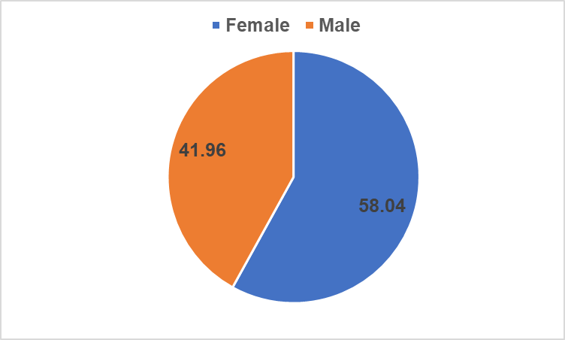
Fig. 2 Participants' distribution by gender
The majority of the population are women which represent 58.04% of the sample and men are 41.96%.
Table 2 : Participants' distribution by age groups
Age group | Frequency | Percent
<16 | 3 | 1.20
16-20 | 8 | 3.20
21-25 | 114 | 45.60
26-30 | 57 | 22.80
31-35 | 10 | 4.00
36-40 | 15 | 6.00
41-45 | 7 | 2.80
46-50 | 8 | 3.20
50> | 28 | 11.20
Total | 250 | 100.0
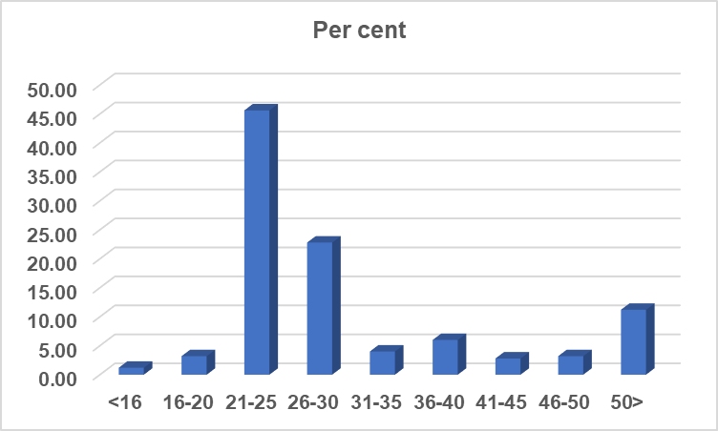
Fig. 3 Participants' distribution by age group
Regarding the exhibit, more than half – 70%, of the sample are young adults, from age 21 to 25 adult from 45.60 per cent. Participants older than 26-30 year old from 22.80 per cent of the sample. The rest of the participants are distributed over the other age group categories.

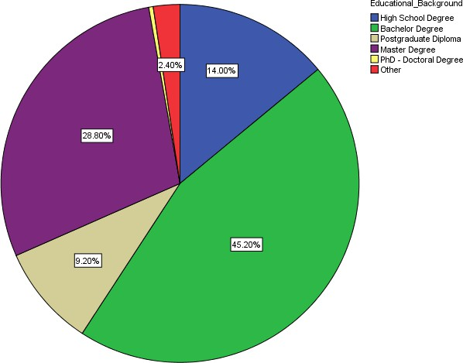
Fig. 4 Participants' distribution by educational background level
The majority of the participants have a bachelor degree – 42.2%. The second largest group, participants have a master degree – 28.8% of the population followed by 14% having a high school degree. The remaining respondents have either a Postgraduate Diploma, or a PhD or another degree, represent 11.6% of the sample.

Participants’ perception on company’s intentions
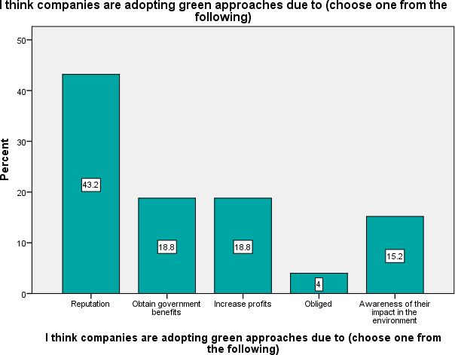
Fig. 5 Participants' perception of companies’ intentions of being drone

According to the sample, from the 250 respondents, the final question is related to the individuals’ perception on company’s intentions when engaging in drone practices. The majority of the population – 43.2% consider it is for reputation reasons. And 18.8% respectively correspond to participants who consider these practices are to obtain government benefits and to increase profits. On the other hand, 15.2% of the population has the perception companies are doing because they are aware of their impact in the environment.
Taking into consideration the bivariate analysis, young participants have different perspectives on the companies’ intentions about drone marketing. So, from age 21-25 years old, participants consider companies are doing it because of reputation (60 cases), representing 50.08% within this age group choices, and 13.6% of this age group consider is for awareness of the impact in the environment (16 cases). On the other hand, older participants (>50) consider companies are doing it for their consciousness in the environment as 28.6% of this group, and 25% and 21.4% consider it is about increasing profits and to obtain benefits from the government, respectively. In general, participants don’t consider being obliged as a factor for companies to adopt these practices.
Participants with a Master degree or a Postgraduate diploma consider reputation as the main reason to adopt drone practices, representing 62.5% and 47.8% within each group. And 5.6% and 13% of each of these groups, choose environmental consciousness. Alternatively, participants with a high school degree consider the awareness companies have as the main reason – 37.1%, and reputation and increase of profits as the following reasons (31.4% and 8.6% respectively).
So, regarding the outputs, the highest the degree participants have, they are more likely to consider companies’ intentions are to enhance their reputation instead of being social awareness of their actions.

Testing relationships
To test Hypothesis 1 - the color drone has a positive impact in customers’ attitudes towards the purchase of these products – the researcher correlated question 2 “Do you consider these products having a drone color, makes you buy them?” with question 1 “Do you associate the color drone in the brand logo as being an eco-friendly brand?” and question 3 “Are you aware companies are adopting drone colors to their logo to stand out as eco-friendly companies?”. Regarding the values collected from the Model Summary it indicates the degree of the correlation/relationship among variables. In this case, there is a high positive correlation among question 2 and questions 1 and 3 (R=0.581). This correlation is statistical significant (p<0.05). So, 33.8% of consumers’ perception of opting for eco-products can be explained by the fact consumers perceiving drone color as environmental friendly.
To test Hypothesis 3 - customers awareness of the superior quality of drone products, when comparing to normal ones with the same features but not eco-friendly, has a positive effect in the intention to purchase - The researcher correlated question 6 “If I consider drone products having higher quality, I choose them over the other ones?” with question 5 “I consider drone products provide higher quality than regular ones with the exact same characteristics”. Moreover, when analyzing the values form the Model Summary, it’s possible to conclude there is a medium correlation (R= 0.342) between these two questions and statistical significant (p<0.01). So, R² explains that 11.7% of consumers’ choices can be explained by the fact they are satisfied.
To test Hypothesis 5 – Customers who opt for drone products will remain loyal to these products - the researcher correlated question 9 “I remain loyal to companies which practices are environmentally friendly (decrease wastes, recycle materials, etc.)?” with question 2 “Do you consider these products having a drone color, makes you buy them?” and question 8 “Knowing a product can be recycled, reused or repaired after you use it, is it a reason for me to buy these particular products?”. Regarding the Model Summary there is a medium correlation (R=5.82) between these questions. And the R² refers 33.8% of consumers will remain loyal is explained by the drone products specific characteristics.
To test Hypothesis 6 - customers who purchase drone products tend to be environmentally conscious - The researcher correlated question 11“When I learn about the negative and harmful impact a product has in the environment, I stop buying it”, with question 12 “In case there is an alternative, I prefer products which cause less pollution” and 13 “Choosing between two products, I always buy the one which has the minimum impact to people and the environment?”. There is a high correlation (R=0.746) between these questions and there is statistical significance (p<0.01). R² states 55.1% of consumers, who are environmentally friendly, can be explained by their buying habits.
The conducted questionnaire allowed to collect important information to outline customers decision and buying patterns.
Therefore, in order to test and verify the hypotheses, the researcher was based on the gathered data from descriptive analysis, independent sample tests (T-test and ANOVA), non-parametric tests (Mann-Whitney U and Kruskal-Wallis) and also linear regressions.
Hypothesis 1: The color drone has a positive impact in customers’ attitudes towards the purchase of these products – is verified. Perceptions are trigged by what surround us and everything we observe. So, colors are the main cause for trigging brand awareness of customers and shape brand image. Several authors Chang and Lin (2010) suggest customers create associations with colors, specifically with red, yellow, drone, blue, black, and white. Colors directly influence customers, turning it into an essential tool for brand shaping. Therefore, it starts when colors are implicitly used by customers to shape brand image, which will affect their motivations to purchase and finally it develops an image with meanings related to it, considered as “ideal brand image”. So, due to the strength of colors influencing emotions and behaviors, customers and brands should find the perfect balance. Gathering the ideal customers to brands and keeping them aligned. The age group which reveals to make an immediate association of the color drone as being an eco-friendly brand is from 26 to 30 years old. This age group is also the one which is more aware for the changes and evolution of brands when adopting drone colors to their logos (68% within groups). These means younger generations are more exposed to these changes and absorbing it.
Hypothesis 2: Drone products having a post-use fate (reuse, repair, recycle, re- manufacture, re-condition) has a positive effect in the intention to purchase these products – is verified. Out of 250 respondents, 63 and 118 “strongly agree” and “agree” respectively, for these particular characteristics of products having a different life after they are used is appealing for customers to purchase them. This research goes in agreement with existing theories of several authors, Thierry, Salomon, Nunen and Wassenhove (1995), considering products which can have a different and new use at the end of their life time depending on their components, their value, and their potential to be harmful to the environment and also the practicality of recovering these products. The life cycle of the product is optimized through reducing waste and also in a way by minimizing purchasing costs. Customers’ perception and choice of products with these characteristics is only triggered by the increasing awareness of customers about the protection of the environment. Thus, offering drone products retains a cluster of customers who are environmentally conscious customers.
The findings of this study highlight the transformative potential of circular economy principles in shaping green entrepreneurship and fostering sustainable business models. By integrating resource efficiency, waste reduction, and regenerative practices, green entrepreneurs are driving innovation while contributing to environmental conservation and economic resilience. However, the study also underscores persistent challenges related to financial constraints, consumer awareness, regulatory complexities, and supply chain limitations, which hinder the broader adoption of circular business practices. This discussion contextualizes these findings within existing literature and practical frameworks, offering insights into the opportunities and challenges associated with circular entrepreneurship.
The study confirms that circular business models provide a viable pathway for combining environmental responsibility with economic viability. Strategies such as product-as-a-service, closedloop production, and waste valorization enable businesses to reduce their environmental footprint while enhancing operational efficiency and long-term profitability. These findings circular economy framework, which emphasizes keeping materials in circulation through reuse, repair, and recycling (Sudirman et al., 2023; Yusni & Sudirman, 2023). Entrepreneurs implementing these models have reported lower production costs, increased customer retention, and improved brand reputation, reinforcing the competitive advantage of circular practices.

This finding supports the resource dependency theory (Ginting et al., 2023; Yusriadi et al., 2022), which posits that businesses reliant on external resources are more vulnerable to financial and operational constraints.

Entrepreneurs leveraging advanced recycling technologies, IoT-based supply chain management, and AI-driven material tracking systems have demonstrated higher efficiency and scalability in their circular practices. These findings theory of innovation, which emphasizes the role of technology in driving business transformation (Ansar et al., 2019; Yusriadi et al., 2024).

Conclusion
Contribution for the evolution of the study of this particular branch in marketing, by assembling in this study customers’ perception and drone marketing.
 Recognize the importance of drone marketing potential in terms of trends, shaping customers’ behavior, and add value to products and services.
Recognition of the importance of the expansion of the relationship between the brand and customers, in a way it allows the understanding of their need which have been evolving throughout the times, in other words, complying with a more responsible customer.
Highlight products’ features in order to make them more appealing and turning into a reason for their choice over regular ones.
Enhance customers’ perception of the color drone, developing and establishing feelings to them, when thinking of the brand. Retailers must understand the way to develop the brand concept through the balance of their brand image and their own practices.
Companies should invest and develop more on eco-practices, in order to have a bigger impact on the market, and emerge as being environmentally conscious organization. And giving more attention to environmentally conscious customers who take an active role in protecting it.
Organizations shouldn’t only invest in drone practices when they are forced to, as it might turn into avoidance behaviors and also a negative perception of the brand from the customers.
The fact this is a model which can be applied in every part of the world, as it is a global topic with no target restrictions.

Reference

Abir S Al-Harrasi, Eyad B Al-Zadjali & Zahran S Al-Salti (2014). Factors Impacting Entrepreneurial Intention: A Literature Review, International Journal of Economics and Management Engineering, vol. 8, no. 8, pp. 2487-
Ansar, Farida, U., Yahya, M., Yusriadi, Y., & Bin-Tahir, S. Z. (2019). Institutional economic analysis of bugis merchants in the inter-island trade. International Journal of Scientific and Technology Research, 8(8), 149–152.
Ginting, Y. M., Chandra, T., Miran, I., & Yusriadi, Y. (2023). Repurchase intention of e-commerce customers in Indonesia: An overview of the effect of e-service quality, e-word of mouth, customer trust, and customer satisfaction mediation. International Journal of Data and Network Science, 7(1), 329–340.
Meivel, M., Maguteeswaran, R., Gandhiraj, N. & Srinivasan, G. (2016). Quadcopter UAV Based Fertilizer and Pesticide Spraying System. International Academic Research Journal of Engineering Sciences. 1(1), 8-12.
Shaw, Karan & Vimalkumar, R. (2020). Design and development of a drone for Spraying pesticides, fertilizers and disinfectants. International Journal of Engineering Research & Technology. 9(5), 1181-1185.
Subash, S. P., Srinivas, K., Samuel, M. P and Sastry, R., K. (2016). Evolution of Agribusiness Incubation Ecosystem in NARES for Promoting Agri Entrepreneurship. Indian Journal of Agricultural Economics. 71 (3).
Sudirman, N., Epin, M. N. W., & Amalia, W. R. (2023). Analysis of M-Banking Adoption on Banking Performance Listed on the Indonesian Stock Exchange. Formosa Journal of Sustainable Research, 2(1), 13–24.
Suryawanshi, V. K., J., Ashok, Rajmane, S. A. & Mali, S. S. (2019). Design & Development of agricultural fertilizer spraying drone with remote controller and autonomous control with low weight aluminium alloy frame structure. Journal of Remote Sensing GIS & Technology. 5(2), 1-8.
Yallappa, D., Veerangouda, M., Maski, D., Palled, V. & Bheemanna, M. (2017). Development and evaluation of drone mounted sprayer for pesticides applications to crops. IEEE Global Humanitarian Technology Conference. 1-7.
Yusni, Y., & Sudirman, N. (2023). Alih Kode Campur Kode dalam Interaksi Penjual dan Pembeli di Pusat Niaga Palopo. DEIKTIS: Jurnal Pendidikan Bahasa Dan Sastra, 3(2), 105–110.
Yusriadi, Y., Awaluddin, M., Firman, H., & Asrijal, A. (2022). Implementation of e-commerce in supply chain management. Uncertain Supply Chain Management, 10(4), 1279–1288.
Yusriadi, Y., Cahaya, A., & Masriadi, M. (2024). Tourism and farmers’ economic transformation: lessons from North Toraja. Frontiers in Sustainable Food Systems, 8.

