Impact of Irrigation Water Requirements and Fertigation Levels on Wheat Growth, Yield, and Water Productivity

Abstract
The present experiment entitled “Impact of Irrigation Water Requirements and Fertigation Levels on Wheat Growth, Yield, and Water Productivity” was conducted during rabi season of 2024–25 at Research Farm of the School of Agriculture Science, Vikrant University, Gwalior, Madhya Pradesh. The experiment was laid out in factorial randomized complete block design (FRBD) with 3 replications, viz., three irrigation levels of irrigations - I1 (100%), I2 (80%), and I3 (60%) - and 3 fertigation levels based on the recommended dose of fertilizers (RDF) - F1 (100%), F2 (75%), and F3 (50%). Results of the study revealed that among the Irrigations, fertilizers and interactions I₁, F₁, and I₁F₁ maximum plant height (88.67, 92.85 and 96.20 cm), tiller number (6.20 , 6.47 and 6.80), leaf area index ( 4.18, 4.44, 4.72), dry matter accumulation (39.27, 40.30 and 42.60 g/plant), spike density( 382.60, 394.0 and 410.0), grain number per spike ( 45.07, 46.33 and 48.30), 1000-grain weight (44.10, 45.03 and 46.80 g), grain yield per plot (3.13, 3.25 and 3.48 kg ) and grain yield per hectare (52.17, 54.17 and 58.00 q) and straw yield( 7427.00 , 7643 and 7980 kg ), Harvest Index (41.28, 40.80 and 42.15 %) Nitrogen uptake (104.38, 105.42and 112.50 Kg/ha), Phosphorus uptake ( 25.20, 22.84 and 25.20Kg/ha), and Potassium Uptake (110.84, 112.47 and 118.25 Kg/ha) respectively. However, the highest water productivity was recorded under I3F1, demonstrating the potential of deficit irrigation combined with full fertigation in improving resource use efficiency. These findings underscore the agronomic and environmental benefits of integrated irrigation and fertigation strategies for enhancing wheat productivity and resource-use efficiency in semi-arid regions.
Keywords: Biological yield, Harvest Index, Wheat and Water productivity
Introduction
Wheat (Triticum aestivum L.) is one of the most important cereal crops globally, contributing substantially to human caloric intake and food security (Curtis et al., 2002). It occupies a significant position in the global agricultural economy, covering approximately 220 million hectares and accounting for about 18% of the dietary intake in terms of calories and proteins (FAO, 2021). In the context of increasing population pressure, projected to reach nearly 10 billion by 2050 (UN, 2019), the demand for wheat is expected to rise substantially. Concurrently, challenges such as climate change, soil degradation, and freshwater scarcity threaten the sustainable production of wheat worldwide (Foley et al., 2011; Lesk et al., 2016).
Maximizing wheat yield and resource-use efficiency under these constraints is imperative. Water and nutrient management are two pivotal agronomic factors directly influencing wheat productivity. Traditional irrigation practices often involve excessive or insufficient water application, leading to water wastage, nutrient leaching, reduced plant growth, and ultimately lower yields (Fereres and Soriano, 2007; Zhang et al., 2018). Similarly, conventional fertilization methods, particularly broadcast application of chemical fertilizers, suffer from low nutrient-use efficiencies - for instance, nitrogen-use efficiency in cereal crops often remains below 50% (Ladha et al., 2005) leading to substantial environmental pollution and economic losses.
To address these issues, fertigation, the technique of applying soluble fertilizers through the irrigation system, has emerged as an efficient strategy. Fertigation allows precise application of nutrients in synchrony with crop developmental stages, resulting in improved nutrient uptake, minimized losses, and enhanced yield potential (Bar-Yosef, 1999; Enciso et al., 2009). In wheat, fertigation has been reported to improve growth parameters, optimize nutrient availability, and significantly boost water use efficiency compared to traditional fertilization methods (Siyal et al., 2009).
Maximizing wheat yield and resource-use efficiency is critical, particularly in the context of increasing resource constraints and environmental challenges. Among the key agronomic factors influencing wheat productivity, water and nutrient management play a central role. Traditional irrigation methods, which often rely on fixed schedules or surface flooding, tend to apply either excessive or insufficient water. This inefficiency not only results in water wastage but also contributes to nutrient leaching, poor root development, and ultimately lower crop yields (Fereres and Soriano, 2007; Zhang et al., 2018). Similarly, conventional fertilization practices, especially the broadcast application of chemical fertilizers, exhibit low nutrient-use efficiency, with nitrogen-use efficiency in cereals frequently falling below 50% (Ladha et al., 2005). Such inefficiencies lead to both economic losses for farmers and environmental problems, including soil degradation and water contamination. In response to these limitations, fertigation—the practice of delivering soluble fertilizers through the irrigation system—has emerged as a promising and efficient alternative. This technique enables the precise timing and placement of nutrients in accordance with the crop's developmental needs, thus enhancing nutrient uptake, minimizing losses, and supporting better plant growth (Bar-Yosef, 1999; Enciso et al., 2009). In wheat cultivation, fertigation has shown significant advantages over traditional fertilization methods by improving key growth parameters, optimizing nutrient availability, and substantially increasing water use efficiency (Siyal et al., 2009). Consequently, integrating fertigation into wheat production systems offers a viable pathway toward sustainable intensification, ensuring higher productivity while conserving vital natural resources.
Simultaneously, optimizing irrigation based on crop evapotranspiration (ETc) or real-time soil moisture status is essential for conserving scarce water resources while maintaining wheat productivity. Traditional irrigation often fails to align with the actual water needs of the crop, leading to inefficiencies and resource wastage. In contrast, precision irrigation strategies grounded in ETc or soil moisture monitoring ensure that water is applied only when and where it is needed, thereby improving water use efficiency. Among these strategies, deficit irrigation- the deliberate application of less water than the full crop-water requirement — has emerged as a practical approach to enhancing water productivity without severely affecting yield (Geerts and Raes, 2009). This method has been successfully applied in various cereal cropping systems, where controlled water stress triggers physiological adaptations that improve drought tolerance (Kang et al., 2002; Zhang et al., 2004). In wheat, moderate water stress imposed during specific growth stages such as tillering or grain filling can stimulate deeper root development, enhance nutrient uptake, and promote yield stability under water-limited conditions (Fang et al., 2010). These findings highlight the importance of fine-tuning irrigation schedules to synchronize with critical crop developmental stages, thereby achieving a balance between water conservation and yield optimization in wheat production systems.
Material and Methods
The field experiment was conducted during rabi season of 2024-25 at Research Farm of the School of Agriculture Science, Vikrant University, Gwalior, Madhya Pradesh. It was laid out into Factorial Randomized Complete Block Design (FRBD) with 3 replications and two factors I= Irrigation and F= Fertilizers) viz. I1= 100% Crop evapotranspiration I2= 80% Crop evapotranspirationI3: 60% Crop evapotranspiration and. F1= 100% recommended dose of fertilizers (RDF) F2= 75% RDF and F3= 50% RDF. Standard culture practices recommended for Wheat were followed uniformly in all experimental plots.

Result and Discussion
Plant Height
Among the irrigation levels, the highest mean plant height (92.85 cm) was recorded under I1 (100% ETc), followed by I2 (85.30 cm), while the lowest (78.40 cm) was noted under I3 (60% ETc). This trend indicates a positive correlation between irrigation water availability and plant height.With respect to fertigation levels, F1 (100% RDF) recorded the maximum plant height (88.67 cm), followed by F2 (85.42 cm), while the minimum plant height (82.47 cm) was observed in F3 (50% RDF). These results highlight the beneficial effect of higher fertilizer application on vegetative growth. However, the interaction effect between irrigation and fertigation (I × F) was found to be non-significant. These results are accordance with the findings of Ali et al., (2020).
Number of Tillers per Plant
Among the irrigation treatments, I1 (100% ETc) resulted in the highest mean number of tillers (6.47), followed by I2 (5.90), and the lowest number (5.30) was observed under I3 (60% ETc). This demonstrates the importance of adequate irrigation in promoting tillering. Among fertigation levels, F1 (100% RDF) recorded the highest mean number of tillers (6.20), followed by F2 (5.90), and the lowest (5.57) was under F3 (50% RDF). This trend indicates a positive response of tiller production to increased nutrient availability. However, their interaction (I × F) was not statistically significant. similar results were noted by Choudhary et al., (2017)
Leaf Area Index (LAI)
Among the irrigation levels, I1 (100% ETc) exhibited the highest mean LAI (4.44), followed by I2 (80% ETc) with 3.93, while the lowest LAI (3.41) was observed under I3 (60% ETc). This trend indicates that higher irrigation levels promote leaf development and canopy expansion. Regarding fertigation levels, the maximum LAI (4.18) was recorded in F1 (100% RDF), followed by F2 (75% RDF) with 3.96, and the lowest LAI (3.65) was observed under F3 (50% RDF). This implies that sufficient nutrient supply contributes significantly to leaf growth. However, the interaction between irrigation and fertigation (I × F) was found to be non-significant. These results are closely related with the result of Lesk et al., (2016).
Dry Matter Accumulation
Among the irrigation levels, the highest dry matter accumulation was recorded under I1 (100% ETc) with a mean of 40.30 g/plant, followed by I2 (80% ETc) with 37.50 g/plant. The lowest accumulation (33.80 g/plant) was observed under I3 (60% ETc), indicating the importance of adequate moisture for biomass production. Fertigation levels also had a significant impact. The highest dry matter accumulation was recorded in F1 (100% RDF) with 39.27 g/plant, followed by F2 (37.13 g/plant), and the lowest was in F3 (35.20 g/plant), suggesting that higher nutrient availability promotes biomass accumulation. While the interaction between them was non-significant. Similar results were found by Patel et al., (2021)

Table 1: Effect of Irrigation Water Requirements and Fertigation Levels on Wheat Growth, Yield, and Water Productivity

 | Plant Height  (cm) | Number of Tillers per Plant | Leaf Area Index (LAI) | Dry Matter Accumulation | Number of Spikes per m² | Number of Grains per Spike | 1000-Grain Weight | Grain Yield per Plot
Irrigation
I1 | 88.67 | 6.20 | 4.18 | 39.27 | 382.6 | 45.07 | 44.10 | 3.13
I2 | 85.42 | 5.90 | 3.96 | 37.13 | 369.0 | 43.07 | 42.43 | 2.93
I3 | 82.47 | 5.57 | 3.65 | 35.20 | 351.7 | 40.80 | 40.63 | 2.72
CD (p=0.05) | 1.87 | 0.38 | 0.29 | 1.42 | 14.6 | 1.86 | 1.31 | 0.18
SE(d) | 0.91 | 0.18 | 0.14 | 0.69 | 7.1 | 0.89 | 0.63 | 0.09
SE(m) | 0.64 | 0.13 | 0.10 | 0.49 | 5.0 | 0.63 | 0.45 | 0.06
Fertilizers
F1 | 92.85 | 6.47 | 4.44 | 40.30 | 394.8 | 46.33 | 45.03 | 3.25
F2 | 85.30 | 6.47 | 3.93 | 37.50 | 368.1 | 43.03 | 42.40 | 2.93
F3 | 78.40 | 5.30 | 3.41 | 33.80 | 340.5 | 39.57 | 39.73 | 2.60
CD (p=0.05) | 1.62 | 0.33 | 0.25 | 1.25 | 12.5 | 1.62 | 1.14 | 0.16
SE(d) | 0.78 | 0.16 | 0.12 | 0.61 | 6.1 | 0.78 | 0.55 | 0.08
SE(m) | 0.55 | 0.11 | 0.09 | 0.43 | 4.3 | 0.55 | 0.39 | 0.06
Interactions
I1F1 | 96.20 | 6.80 | 4.72 | 42.60 | 410.3 | 48.3 | 46.80 | 3.48
I1F2 | 92.75 | 6.50 | 4.50 | 40.20 | 395.7 | 46.5 | 45.00 | 3.25
I1F3 | 89.60 | 6.10 | 4.10 | 38.10 | 378.4 | 44.2 | 43.30 | 3.01
I2F1 | 88.30 | 6.47 | 4.20 | 39.80 | 382.1 | 45.1 | 44.10 | 3.12
I2F2 | 85.10 | 6.20 | 3.95 | 37.30 | 370.5 | 43.2 | 42.50 | 2.94
I2F3 | 82.50 | 5.90 | 3.65 | 35.40 | 351.6 | 40.8 | 40.60 | 2.72
I3F1 | 81.50 | 5.60 | 3.61 | 35.40 | 355.4 | 41.8 | 44.10 | 2.78
I3F2 | 78.40 | 5.60 | 3.42 | 33.90 | 340.8 | 39.5 | 42.43 | 2.61
I3F3 | 75.30 | 5.30 | 3.20 | 32.10 | 325.2 | 37.4 | 40.63 | 2.42
CD (p=0.05) | NS | NS | NS | NS | NS | NS | NS | NS
SE(d) | 1.58 | 0.32 | 0.24 | 1.21 | 12.2 | 1.58 | 1.11 | 0.15
SE(m) | 1.12 | 0.23 | 0.17 | 0.86 | 8.6 | 1.58 | 0.78 | 0.11

Con’t…..
 | Grain yield per hectare (q) | Straw Yield | Harvest Index | Water Productivity | Nitrogen Uptake | Phosphorus Uptake | Potassium Uptake
Irrigation
I1 | 52.17 | 7427 | 41.25 | 11.96 | 104.38 | 25.20 | 110.84
I2 | 49.07 | 7140 | 39.98 | 11.21 | 95.42 | 22.60 | 102.77
I3 | 45.33 | 6800 | 38.67 | 10.64 | 91.57 | 20.72 | 97.43
Mean
CD (p=0.05) | 2.41 | 185.6 | 0.94 | 0.87 | 4.92 | 1.14 | 5.26
SE(d) | 1.17 | 90.1 | 0.46 | 0.43 | 2.40 | 0.56 | 2.56
SE(m) | 0.83 | 63.7 | 0.33 | 0.30 | 1.70 | 0.40 | 1.81
Fertilizers
F1 | 54.13 | 7643 | 40.80 | 9.74 | 105.42 | 22.84 | 112.47
F2 | 48.77 | 7123 | 39.93 | 10.95 | 96.46 | 20.70 | 103.27
F3 | 43.67 | 6600 | 39.17 | 13.19 | 89.53 | 18.92 | 95.30
CD (p=0.05) | 2.12 | 162.4 | 0.81 | 0.75 | 4.12 | 0.96 | 4.45
SE(d) | 1.03 | 78.8 | 0.40 | 0.37 | 2.01 | 0.47 | 2.17
SE(m) | 0.73 | 55.7 | 0.28 | 0.26 | 1.42 | 0.33 | 1.53
Fertilizers
I1F1 | 58.00 | 7980 | 42.15 | 10.42 | 112.50 | 25.20 | 118.25
I1F2 | 54.20 | 7650 | 40.80 | 9.67 | 106.25 | 22.60 | 112.30
I1F3 | 50.20 | 7300 | 39.45 | 9.13 | 97.50 | 20.72 | 106.86
I2F1 | 52.00 | 7420 | 41.20 | 11.68 | 104.23 | 22.10 | 110.34
I2F2 | 49.00 | 7150 | 39.90 | 10.92 | 96.74 | 21.06 | 102.60
I2F3 | 45.30 | 6800 | 38.70 | 10.24 | 88.42 | 18.94 | 96.87
I3F1 | 52.00 | 6880 | 40.40 | 13.78 | 96.42 | 19.86 | 103.94
I3F2 | 49.00 | 6620 | 39.25 | 13.03 | 83.26 | 18.92 | 93.41
I3F3 | 45.30 | 6300 | 37.85 | 12.75 | 88.90 | 18.00 | 88.55
CD (p=0.05) | NS | NS | NS | NS | NS | NS | NS
SE(d) | 2.00 | 153.6 | 0.78 | 0.73 | 3.97 | 0.93 | 4.29
SE(m) | 1.41 | 108.6 | 0.55 | 0.52 | 2.81 | 0.66 | 3.03
Fig 2: Effect of Irrigation Water Fertigation Levels on Water productivity
Fig 1: Effect of Irrigation Water Fertigation Levels on Yield

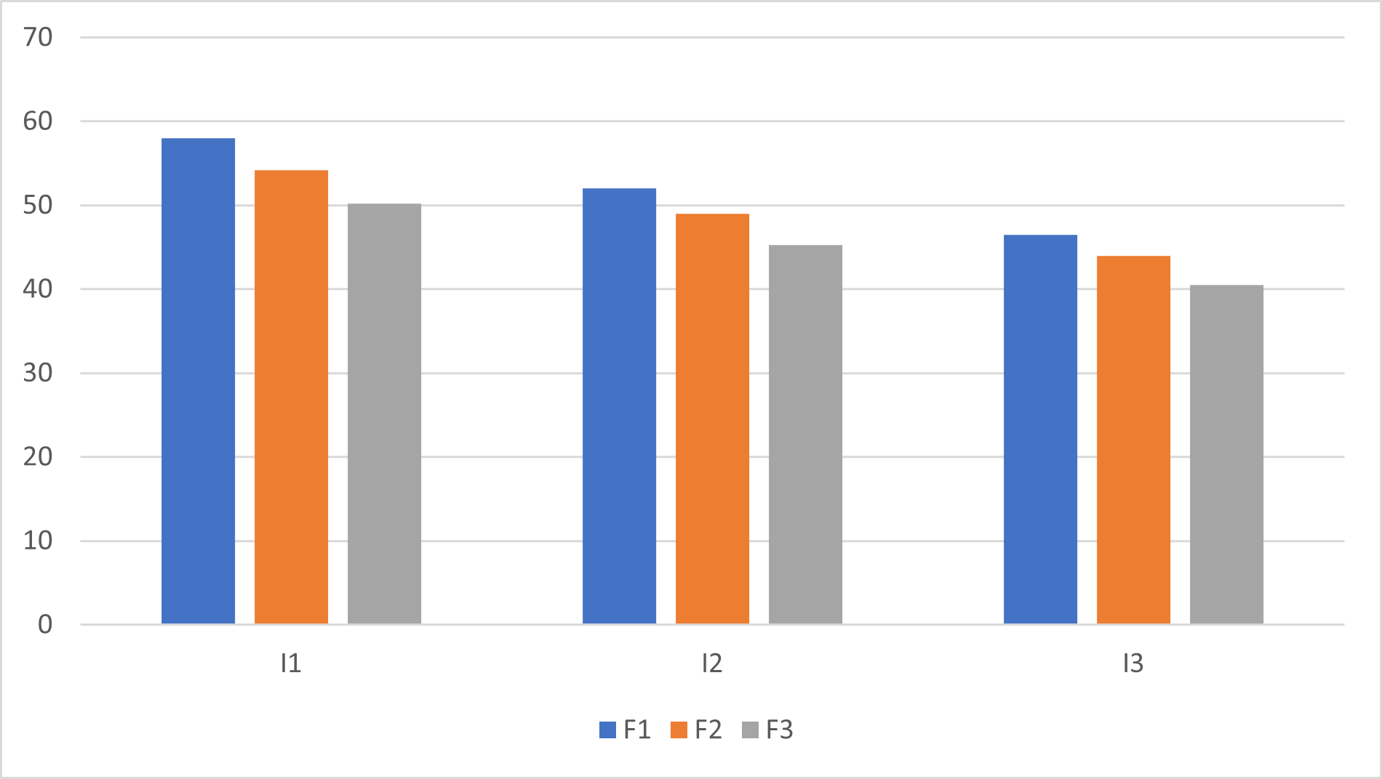
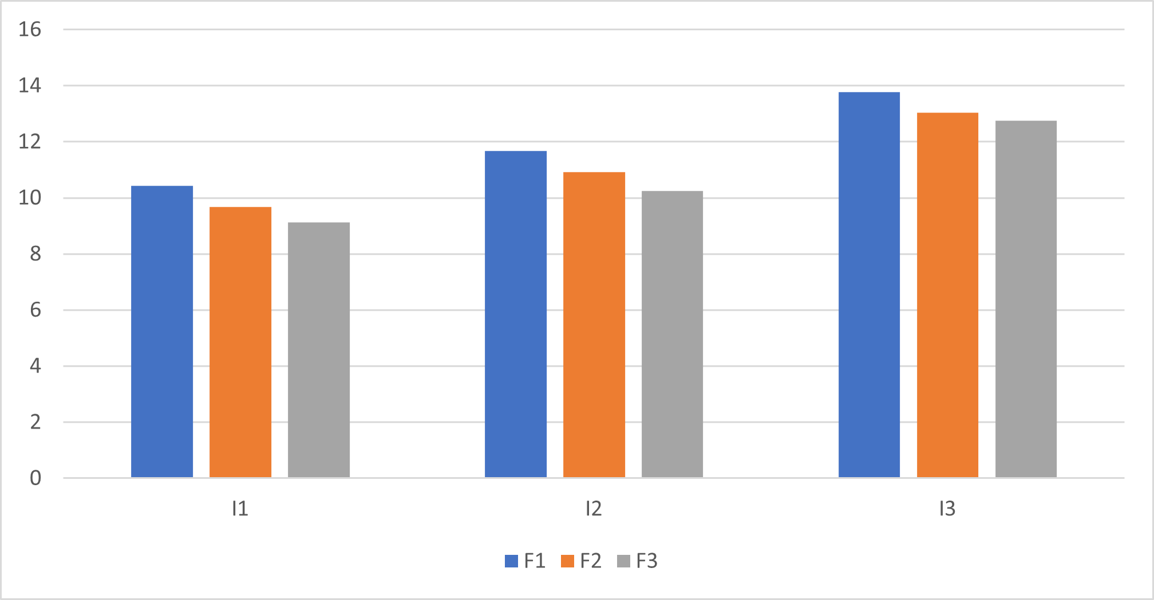

Number of Spikes per m²
While their interaction effect was found to be non-significant. Among irrigation treatments, the highest spike density was recorded under I1 (100% ETc) with a mean value of 394.8 spikes/m², followed by I2 (80% ETc) with 368.1 spikes/m². The lowest number of spikes (340.5/m²) was observed under I3 (60% ETc), indicating the positive influence of optimal irrigation on spike formation. Fertigation treatments also showed significant differences. F1 (100% RDF) produced the highest number of spikes (mean: 382.6/m²), followed by F2 (369.0/m²), while the lowest was recorded in F3 (351.7/m²). This trend suggests that adequate nutrient supply through fertigation enhances spike development. These results are accordance with Kumar et al, (2019).
Number of Grains per Spike
The number of grains per spike was significantly influenced by both irrigation and fertigation levels, whereas the interaction between these two factors was non-significant. Among irrigation treatments, I1 (100% ETc) recorded the highest grain number per spike (mean: 46.33), followed by I2 (80% ETc) with 43.03 grains/spike. The lowest grain number (39.57) was observed under I3 (60% ETc), suggesting the importance of adequate water supply for spike fertility. With respect to fertigation, F1 (100% RDF) resulted in the highest number of grains per spike (mean: 45.07), followed by F2 (43.07), and the lowest was recorded under F3 (40.80). This clearly indicates that nutrient availability directly supports grain formation and filling. The number of grains per spike is a critical yield component in wheat and is highly sensitive to both water and nutrient availability. In this experiment, higher values were consistently observed under full irrigation and complete RDF fertigation, emphasizing their roles in improving floret fertility and grain set. The absence of significant interaction implies that both factors independently contributed to the improvement in grain number per spike. These results are similar to Rani et al., (2019)
1000-Grain Weight
The 1000-grain weight of wheat was significantly influenced by both irrigation and fertigation treatments. However, their interaction effect was found to be non-significant. Among irrigation levels, I1 (100% ETc) recorded the highest average 1000-grain weight (45.03 g), followed by I2 (80% ETc) with 42.40 g. The lowest grain weight (39.73 g) was noted under I3 (60% ETc), indicating the role of adequate irrigation in improving grain filling. Fertigation treatments also showed significant differences. F1 (100% RDF) resulted in the highest 1000-grain weight (mean: 44.10 g), followed by F2 (42.43 g), while the lowest was observed under F3 (40.63 g). These findings suggest that sufficient nutrient supply through fertigation improves the grain development process These findings are closely related with Saha et al., (2017) Rani et al., (2021).
Grain Yield per Plot
Grain yield per plot was significantly affected by both irrigation and fertigation levels. However, the interaction between the two was found to be non-significant. Among irrigation levels, I1 (100% ETc) gave the highest grain yield (mean: 3.25 kg/plot), followed by I2 (80% ETc) with 2.93 kg. The lowest yield (2.60 kg) was recorded under I3 (60% ETc), highlighting the positive effect of adequate irrigation on final yield. These findings are closely related with Saha et al., (2017).
In terms of fertigation, F1 (100% RDF) produced the highest yield (mean: 3.13 kg), followed by F2 (2.93 kg), while F3 gave the lowest yield (2.72 kg). These results emphasize the importance of sufficient nutrient availability through fertigation for improving productivity.
Grain Yield per Hectare
Grain yield per hectare was significantly affected by irrigation and fertigation treatments, while their interaction effect was non-significant. Among irrigation levels, I1 (100% ETc) resulted in the highest yield (mean: 54.13 q/ha), followed by I2 (80% ETc) with 48.77 q/ha. The lowest yield (43.67 q/ha) was observed under I3 (60% ETc), emphasizing the positive role of adequate irrigation in enhancing yield potential. Fertigation treatments also showed significant effects. F1 (100% RDF) recorded the maximum yield (mean: 52.17 q/ha), followed by F2 (49.07 q/ha), while F3 had the lowest yield (45.33 q/ha). These results underline the importance of complete nutrient supply in improving grain productivity.
Straw Yield
The significant influence of irrigation and fertigation on straw yield can be attributed to their vital role in ensuring sustained vegetative growth and biomass accumulation in wheat. The highest straw yield under I1 suggests that adequate irrigation (possibly optimal scheduling or higher frequency) maintained favorable soil moisture conditions, promoting tillering and enhanced biomass production. Similar trends have been reported by Singh et al. (2020), who observed increased straw yield with improved irrigation scheduling.
The superior performance of F1 fertigation treatment might be due to the timely and efficient nutrient availability through fertigation, which ensures a continuous supply of essential nutrients to support vegetative growth. The gradual decline in straw yield from F1 to F3 indicates that reduced or imbalanced fertigation may limit the vegetative potential and dry matter accumulation.
The non-significant interaction (I×F) implies that irrigation and fertigation acted independently in influencing straw yield, and their effects were additive rather than synergistic. This suggests that while both factors individually improve yield, no specific combination provided a distinct advantage over others.
Harvest Index
The data on harvest index (%) revealed that both irrigation and fertigation treatments significantly influenced the partitioning efficiency of wheat, while their interaction was non-significant. The highest harvest index was recorded under I1 (40.80%), followed by I2 (39.93%) and I3 (39.17%), indicating that optimal irrigation improved the conversion of total biomass into grain yield. Among fertigation treatments, F1 (41.25%) performed best, followed by F2 (39.98%) and F3 (38.67%), suggesting that higher nutrient availability through fertigation enhanced grain development. The absence of a significant interaction effect (I × F) implies that irrigation and fertigation acted independently. Overall, the results highlight the importance of adequate irrigation and balanced fertigation in improving harvest index and thereby enhancing productivity and resource-use efficiency in wheat. Tripathi et al. (2022) also reported same findings.
Water Productivity
The results revealed that water productivity (kg grain/m³ water) in wheat was significantly influenced by both irrigation and fertigation levels, while their interaction effect was non-significant. Among irrigation treatments, the highest water productivity was observed under I3 (13.19), followed by I2 (10.95) and I1 (9.74), indicating that reduced irrigation enhanced water-use efficiency due to less water applied and relatively stable yield. In terms of fertigation, F1 recorded the highest water productivity (11.96), followed by F2 (11.21) and F3 (10.64), suggesting that higher nutrient input through fertigation improved crop yield per unit of water used. The non-significant interaction between irrigation and fertigation indicates that their effects on water productivity were independent. Sharma et al., (2020) reported same similar finding.
Nitrogen Uptake
The results on nitrogen uptake (kg/ha) in wheat revealed that both irrigation and fertigation treatments had a significant effect, while their interaction was non-significant. Among irrigation levels, the highest nitrogen uptake was recorded under I1 (105.42 kg/ha), followed by I2 (96.46 kg/ha) and the lowest in I3 (89.53 kg/ha), indicating that adequate water availability enhanced nutrient absorption. In terms of fertigation, F1 (104.38 kg/ha) showed the highest nitrogen uptake, followed by F2 (95.42 kg/ha) and F3 (91.57 kg/ha), reflecting the positive influence of higher nutrient supply on nitrogen assimilation. The significant differences were confirmed by the critical difference (CD) values for irrigation (4.92) and fertigation (4.12), while the non-significant A × B interaction indicated independent effects. These findings suggest that optimal irrigation and fertigation strategies are crucial for maximizing nitrogen uptake and improving nutrient-use efficiency in wheat cultivation. Similar results were noticed by Yadav et al., (2021)
Phosphorus Uptake
The data on phosphorus uptake (kg/ha) in wheat showed that both irrigation and fertigation treatments significantly influenced phosphorus absorption, while their interaction was non-significant. Among irrigation treatments, the highest mean phosphorus uptake was recorded under I1 (22.84 kg/ha), followed by I2 (20.70 kg/ha) and I3 (18.92 kg/ha), indicating that adequate irrigation enhanced phosphorus availability and root absorption. Regarding fertigation, F1 (25.20 kg/ha) resulted in the highest uptake, followed by F2 (22.60 kg/ha) and F3 (20.72 kg/ha), suggesting that higher nutrient application through fertigation improved phosphorus assimilation. The significance of main effects was confirmed by the critical difference (CD) values for irrigation (1.14) and fertigation (0.96), whereas the non-significant interaction (A × B) implies that irrigation and fertigation acted independently. These findings highlight the importance of efficient water and nutrient management in enhancing phosphorus uptake and supporting optimal wheat growth. Similar result was noticed by Verma et al., (2017).
Potassium Uptake
The results on potassium uptake (kg/ha) in wheat showed that both irrigation and fertigation levels had a significant impact, while their interaction was non-significant. Among irrigation treatments, the highest mean potassium uptake was recorded under I1 (112.47 kg/ha), followed by I2 (103.27 kg/ha) and I3 (95.30 kg/ha), indicating that greater water availability enhances nutrient mobility and uptake. Similarly, among fertigation levels, F1 (110.84 kg/ha) resulted in the highest uptake, followed by F2 (102.77 kg/ha) and F3 (97.43 kg/ha), underscoring the importance of nutrient-rich fertigation in promoting potassium absorption. The significance of the main effects was confirmed by the critical difference values for irrigation (5.26) and fertigation (4.45), while the non-significant interaction (A × B) suggests that the two factors acted independently. Similar result was noticed by Yadav et al., (2021).
Conclusion
Based on the results of this study we can conclude that adequate irrigation (100% ETc) and full fertigation (100% RDF) significantly enhanced wheat growth, yield, and nutrient uptake, while their interaction effects were non-significant. Optimal water and nutrient management independently contributed to improved productivity, resource-use efficiency, and nutrient assimilation.
References
Ali, M., Arshad, M., Mahmood, R., Shahid, M., Yousaf, M., & Ahmad, R. (2020). Interactive effects of irrigation and fertilization on growth and yield of wheat under arid conditions. Agricultural Water Management, 231, 106022.
Bar-Yosef, B. (1999). Advances in fertigation. Advances in Agronomy, 65, 1–77.
Choudhary, R. L., Jat, R. K., Rathore, S. S., & Ratre, G. K. (2017). Effect of irrigation and nitrogen management on wheat productivity and resource use efficiency. International Journal of Chemical Studies, 5(4), 1515–1518.
Curtis, B. C., Rajaram, S., & Macpherson, H. G. (Eds.). (2002). Bread wheat: Improvement and production (Vol. 30). FAO Plant Production and Protection Series.
Enciso, J., Jifon, J., Anciso, J., & Ribera, L. (2009). Productivity of onions using subsurface drip irrigation and fertigation. Agricultural Water Management, 96(3), 528–536.
FAO. (2021). FAOSTAT statistical database. Food and Agriculture Organization of the United Nations.
Fang, Y., Xue, X., Li, Z., & Wang, J. (2010). Improved wheat growth, grain yield and water use efficiency by deficit irrigation: A review. Agricultural Water Management, 97(8), 1141–1151.
Fereres, E., & Soriano, M. A. (2007). Deficit irrigation for reducing agricultural water use. Journal of Experimental Botany, 58(2), 147–159.
Foley, J. A., Ramankutty, N., Brauman, K. A., Cassidy, E. S., Gerber, J. S., Johnston, M., ... & Zaks, D. P. M. (2011). Solutions for a cultivated planet. Nature, 478(7369), 337–342.
Geerts, S., & Raes, D. (2009). Deficit irrigation as an on-farm strategy to maximize crop water productivity in dry areas. Agricultural Water Management, 96(9), 1275–1284.
Kang, S., Zhang, L., Liang, Y., Hu, X., Cai, H., & Gu, B. (2002). Effects of limited irrigation on yield and water use efficiency of winter wheat in the Loess Plateau of China. Agricultural Water Management, 55(3), 203–216.
Kumar, R., Sharma, S., & Choudhary, A. (2019). Grain quality and yield attributes of wheat as influenced by different irrigation and nitrogen levels. Journal of Pharmacognosy and Phytochemistry, 8(1), 1923–1927.
Ladha, J. K., Pathak, H., Krupnik, T. J., Six, J., & van Kessel, C. (2005). Efficiency of fertilizer nitrogen in cereal production: Retrospects and prospects. Advances in Agronomy, 87, 85–156.
Lesk, C., Rowhani, P., & Ramankutty, N. (2016). Influence of extreme weather disasters on global crop production. Nature, 529(7584), 84–87.
Mehta, R. S., Meena, R. S., Meena, N. L., & Singh, S. (2020). Effect of irrigation and nutrient management on growth and yield of wheat. International Journal of Chemical Studies, 8(1), 2654–2657.
Patel, D., Patel, N. R., & Patel, M. M. (2021). Effect of irrigation and nutrient management on leaf area index and yield of wheat. International Journal of Current Microbiology and Applied Sciences, 10(3), 750–757.
Rani, S., Sihag, S. K., & Sharma, R. (2019). Impact of irrigation regimes and nitrogen levels on growth attributes of wheat. Journal of Pharmacognosy and Phytochemistry, 8(3), 1541–1544.
Rani, S., Choudhary, A., & Sharma, R. (2021). Interactive effect of irrigation and nitrogen on productivity and profitability of wheat. Journal of Pharmacognosy and Phytochemistry, 10(2), 1403–1407.
Saha, S., Mondal, P., & Ray, K. (2017). Effect of irrigation scheduling on growth, yield, and harvest index of wheat. Environment and Ecology, 35(1C), 302–306.
Sharma, S. K., Mehta, R. S., & Singh, D. (2020). Impact of irrigation scheduling and integrated nutrient management on wheat growth and productivity. International Journal of Chemical Studies, 8(2), 2071–2076.
Singh, D., Mehta, R. S., & Yadav, B. D. (2018). Impact of fertigation and irrigation scheduling on growth and yield of wheat. Journal of Pharmacognosy and Phytochemistry, 7(5), 904–907.
Singh, R., Choudhary, A., & Meena, N. (2020). Effect of different irrigation levels and nutrient management on nutrient uptake in wheat. Journal of Pharmacognosy and Phytochemistry, 9(2), 2155–2158.
Siyal, A. A., Mashori, A. L., & Mari, I. A. (2009). Impact of drip irrigation and fertigation on yield and water use efficiency of wheat. Pakistan Journal of Agriculture, Agricultural Engineering and Veterinary Sciences, 25(2), 29–36.
Tripathi, R. P., Verma, S. K., & Yadav, M. K. (2022). Effect of integrated nutrient and irrigation management on nutrient uptake and productivity of wheat. International Journal of Bio-resource and Stress Management, 13(1), 40–45.
UN. (2019). World population prospects 2019: Highlights. United Nations Department of Economic and Social Affairs, Population Division.
Verma, A. K., Yadav, R. K., & Singh, R. (2017). Response of wheat to irrigation scheduling and nutrient management practices. Journal of Eco-friendly Agriculture, 12(2), 113–117.
Yadav, R. K., Singh, B. D., & Meena, H. R. (2018). Effect of water and nutrient management on tiller formation and yield in wheat. Green Farming, 9(3), 482–485.
Yadav, M. K., Verma, S. K., & Tripathi, R. P. (2021). Influence of irrigation and nutrient management on yield and water productivity of wheat. International Journal of Bio-resource and Stress Management, 12(4), 363–368.
Zhang, H., Oweis, T., & Pala, M. (2004). Water use efficiency of rainfed and irrigated wheat in a Mediterranean environment. Agronomy Journal, 96(2), 397–405.
Zhang, X., Chen, S., Sun, H., Wang, Y., & Shao, L. (2018). Water use efficiency and associated traits in winter wheat under drought stress. Agricultural Water Management, 193, 240–250

