Original Research Article
Integrated management of Saccharum officinarum Artsch-Wager using fertilisers in forest areas in the context of climate-smart agriculture,
Central African Republic

Abstract:

Despite its many uses, sugar cane (Saccharum officinarum L.) remains a neglected plant in scientific research in the CAR. The aim of the study, conducted in a forest area with the participation of farmers, is to assess the production of this crop in an integrated management system based on fertilisers. A completely randomised block design (BCR) was used, with five treatments and three replications. Treatments were randomly assigned from 1 to 5 (T1, T2, T3, T4 and T5), and included 15 elementary plots measuring 3.6m² (3m by 1.2m). The variability of growth, yield and economic productivity parameters of sugarcane in pure cultivation according to the treatments was measured and quantified. Software ® version 3.1.2 and XLSTAT 2016 version 4.2.1 were used to analyse the data. Analysis of variance (ANOVA) and Principal Component Analysis (PCA) were performed on all the parameters. This study revealed variability in growth and production parameters according to the recommended treatments. T4 (sugar cane + NPK + cow dung), T2 (sugar cane + NPK) and T3 (sugar cane + NPK) had plants with the best growth in height and diameter, unlike T1 (control plot) and T5 (sugar cane + NPK + cow dung), which had the lowest values. Principal component analysis (PCA) confirms that the variability between treatments is 72.74% on the two axes (1 and 2). Parameters such as internode length, stipule length, bud size and stem diameter showed positive correlations between the agronomic variables. However, on axis 2, between the different types of ridge (open furrow, micro-basin and wide bed), there was variability in sugarcane growth and production. These observations have shown that the treatments adopted have no impact on morphological characteristics. They do not influence growth, development or productivity, which explains the high correlation between these parameters. Organo-mineral fertilisation can help to improve sugarcane production.

Key words: Sugar cane, Fertilisers, Production, Integrated management, CAR.

INTRODUCTION:
Sugar cane (Saccharum officinarum L.) is a perennial plant in the Poaceae family (grasses) grown for its stalks, which contain a sweet juice [1,2]. Native to New Guinea, sugar cane produces sucrose and numerous products used in the cosmetics and pharmaceutical sectors [3,4]. Sugar cane is mainly used for direct consumption (potable cane) or in the sugar industry [5,6]. The juice extracted from sugarcane stalks contains 70% water, 14% sucrose, 14% woody matter and 2% impurities, and is very rich in minerals, fibre and vitamin B6 [3,6]. Ethanol is a liquid alcohol resulting from the fermentation of sugar or starch converted into sugar. It is technically possible to produce this biofuel from sugar cane, and it plays a major role in reducing greenhouse gases and, consequently, in cleaning up the environment. It is already used in some countries, such as Brazil, the world's leading sugarcane producer [4,7]. It is currently grown throughout the world's tropical and sub-tropical regions, on either side of the equator in an area roughly bounded by the 35° North and 35° South parallels. In 2007, the main sugar cane-producing countries were Brazil (33% of world production), India (23%), China (7%), Thailand and Pakistan (4%), Mexico and Colombia (3%), Australia, the United States and the Philippines (2%).
Sugar cane was introduced to the West Indies by Christopher Columbus on his second voyage in 1493, where it quickly flourished thanks to the favourable climate. This labour-intensive crop fuelled the Arab slave trade from Africa, particularly Egypt. In the 17th century, sugar cane was widely grown in the French colonies. It is now grown in several African countries, including the Central African Republic.
Despite the importance of this crop, in the Central African Republic, sugar cane cultivation is relegated to second place and is not a national priority in terms of agricultural development [8]. As a result, its cultivation has remained traditional and is faced with numerous as yet undocumented biotic (insects, pests, diseases) and abiotic (water stress, soil salinity, soil poverty, etc.) constraints, which are known to cause huge losses and diversity [9].
The main constraints identified in this sugarcane-growing region are armourstone, gravelly soils and termite mounds. CAR's sugar production structure is unable to meet the needs of the national population. So, in order to support production efforts, trials are being carried out, mainly in forest areas, using an integrated approach in the context of Climate Intelligent Agriculture (CIA), in order to assess the adaptive capacities of the crop in terms of yield under different treatments.

The general objective of the study is to evaluate the production of this crop in an integrated management system based on fertilisers in a forest area in the context of climate-smart agriculture.

Specifically, the aim is to: (i) assess growth and production parameters in line with the treatments; (ii) assess the effect of fertilisers on the treatments, while identifying the best treatment.

2. MATERIALS AND METHODS
- Study environment
The study was carried out in the commune of PISSA, located in a forested area in south-western CAR, 75 km from the capital. The climate is of the Guinean-forest type, with nine (09) months of rainy season and three (03) months of dry season, with rainfall varying from 1600 to 1800 mm/year, and average annual temperatures in this region are between 23 and 26°C. The maximum annual temperature is 29°C and the minimum is 18°C; the average relative humidity is 77%. The predominant vegetation is forest, but as a result of various human activities, savannah has gradually become established, colonised by: Chromoleana odorata (L.), Panicum maximum, Purera javanica (Roxb.) Benth, Mimosa sp (L.), etc. The soil is of the ferralitic, moderately desaturated type (sandy-clay texture) [10].

Figure 1: Location of the experimental site

- Experimental site
The study was carried out in collaboration with members of the Farmer Field School group in PISSA, more precisely in the village of GBOLET (latitude 04°04.267'N; longitude 018°12730'E and altitude 354m). The plot is located on the M'baïki road in the Prefecture of Lobaye in the south of the CAR. The climate in this area is Guinean forest type. In view of these climatic differences, the commune of PISSA is located in agro-ecological zone No. 1, which is specific to cash crops (coffee, cocoa, oil palm, banana, etc.). The experimental site is characterised by a sandy-clay soil, located close to the national road N°6, and the choice of this plot was made with the participation of the farmers.

It is a fallow of more than five (05) years, dominated by fertility indicator plants such as Peuraria javanica (Roxb.) Benth, Chromoleana odorata (L.) etc. which colonise the plot.

- Site preparation

A total area of 1,225 m2 (35m by 35m) was demarcated and then cleared. The parcelling out resulted in elementary plots for the creation of ridges measuring 3.62 m² (3 m by 1.2 m). The stakes were cut to two metres (2 m) apart and one (01) metre long stakes were used to mark out the plot while making the ridges; the area is divided into three (3) blocks and each block comprises five (5) ridges or elementary plots whose treatments are allocated randomly, the ridge is separated by two (02) metres of alley between the blocks and sixty centimetres (60 cm) between the ridges or elementary plots and a border is cleared to avoid the border effect and predators.

- Plant material
The plant material used is a local sugarcane cultivar available from certain growers (Figure 2). It was chosen for its resistance and ease of adaptation. The cultivar was identified on the basis of direct observations of average stem diameter, average length and crop cycle.
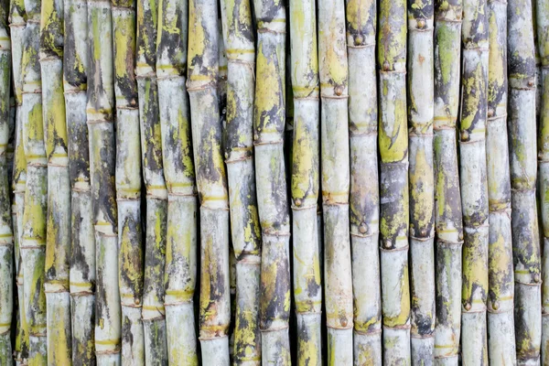
Figure 2 : Local cultivar cuttings used

Mineral and organic fertilisation equipment

Mineral fertilisation
Table I shows the doses of fertilisers based on urea, P2O5, K2O and cow dung applied to different types of ridge.
Table I: Mineral and organic fertilisation
Traitments | Mineral and organic fertilisation in kg/ha
Traitments | Urea | P₂O₅ | K₂O | Cow dung
T1 | 0 | 0 | 0 | 0
T2 | 105 | 22.5 | 45 | 0
T3 | 210 | 45 | 90 | 0
T4 | 105 | 22.5 | 45 | 5000
T5 | 105 | 22.5 | 45 | 10000
Proportions (%) | 46 | 46 | 50

Urea with 46% Nitrogen (N): in granulated form is not directly assimilated by the plants in its ammoniacal form but hydrolysed into ammonium or ammonia in two or three days in the soil before being used by the absorbent hairs of the roots.
This element plays a part in the plant's vegetative or foliar development process, but is highly volatile and also very soluble in water; hence the need to spread its application over the crop cycle to avoid its loss.
Super Triple Phosphate (P2O5) with 46% phosphorus (P): this is used to prepare the soil during ploughing and is buried for young sugar cane plantations.

Potassium sulphate (K2O4) containing 50% Potassium (K): this element is very important in root formation.

Organic fertilisation

The use of organic fertilisers is one of the strategies for improving the fertility of ferralitic soils, which are known to be low in nitrogen (N) and phosphorus [11]. In our case, cow dung is used as an organic fertiliser at a rate of 5,000 kg/ha for ridge T4 and 10,000 kg/ha for ridge T5. This material supplies nutrients and organic carbon to improve the physical properties of the soil, such as water retention and microbial activity, resulting in healthy soil. Straw is used to maintain moisture levels in the soil. It also protects the soil from sunlight and erosion. After decomposition, it acts as a fertiliser. Manure, on the other hand, also supplies N and contains other nutrients to improve the soil's nutrient balance.

The spreading technique was used by applying the fertiliser 5 cm from the sown sugarcane cuttings. This was done by tracing a 5 cm hollow furrow around the cane stalk, one month after cutting. This method consists of applying the quantity of inputs split in two according to the sugar cane's vegetative cycle and the treatments used during the experiment.
Urea and potassium sulphate were applied twice, while phosphorus and cow dung were applied once during soil preparation.

First, ½ the amount of urea and potassium was applied one to two months and three to four months after planting. The full amount of phosphorus was applied in the first treatment. After 12 months of testing, the sugarcane stalks were harvested to assess the average yield by weight of sugarcane per plant according to the treatments.

Table II: Timing of fertiliser application
Fertilisers | T1 | T2 | T3 | T4 | T5
N | - | Application of ½ of N one to two months and three to four months after planting | Application of ½ of N one to two months and three to four months after planting | Application of ½ of N one to two months and three to four months after planting | Application of ½ of N one to two months and three to four months after planting
P | - | Total P at soil preparation | Total P at soil preparation | Total P at soil preparation | Total P at soil preparation
K | - | Application of ½ of K one to two months and three to four months after planting | Application of ½ of K one to two months and three to four months after planting | Application of ½ of K one to two months and three to four months after planting | Application of ½ of K one to two months and three to four months after planting
Cow dung | 0 | 0 | 0 | Cow dung for soil preparation | Cow dung for soil preparation

- Experimental methods

Installation of the experimental set-up

The experimental plot installed covers an area of 109.2 m² (13 m × 8.4 m) and is divided into three blocks, each of which comprises five elementary plots or ridges measuring 3.6m² (3 m × 1.2 m). The plot was planted on 05 August 2020 and harvested on 05 August 2021. Sugar cane is propagated by cuttings. The cuttings are taken from the top of the stalk, almost at harvest time. They are cut into small sections 20 to 30 centimetres long. The land is ploughed and ridged according to the blocks and treatments. Furrows about 20 cm deep are made, 0.90 m apart between the rows and 1 metre apart on the rows in three (3) rows and two (2) columns with a total number of 6 cuttings per ridge. The total number of cuttings is 270 for the useful area. The cuttings are laid end to end and covered with 5 centimetres of soil. The spacing between the blocks is 2 m. Each block has a cultivable surface area of 18m2 (3 m x 1, 2 m x 5). In total, the plot has a surface area of 109.2 m2 or 0.0109.2 ha. A 4m border was laid around the plot. No phytosanitary treatments were applied during the experiment.

For observations and measurements of growth parameters, three (3) central plants were selected per elementary plot or ridge, taking into account the border effect.
The experimental design chosen was a completely randomised block design (BCR) with five (5) treatments and three (3) replications comprising 15 ridges of 3.6m² (3m by 1.2 m). The five recommended treatments are randomly assigned from 1 to 5 (T1, T2, T3, T4 and T5).

Open ridges and furrows
On the ridges and open furrows, the trial was conducted in completely randomised blocks. The crop plot consisted of three (3) blocks, including one block with five (5) elementary plots for a total of fifteen (15) elementary plots. The spacing between the elementary plots was 0.6 m and 2 m between the blocks. An elementary plot was 3 m long and 1.2 m wide, giving a surface area of 3.6 m2 and a total surface area of 109.2 m2. The density on the elementary plot is 1 between the rows, making 2 rows, and 90 cm on the row, making 3 rows (Figure 3).
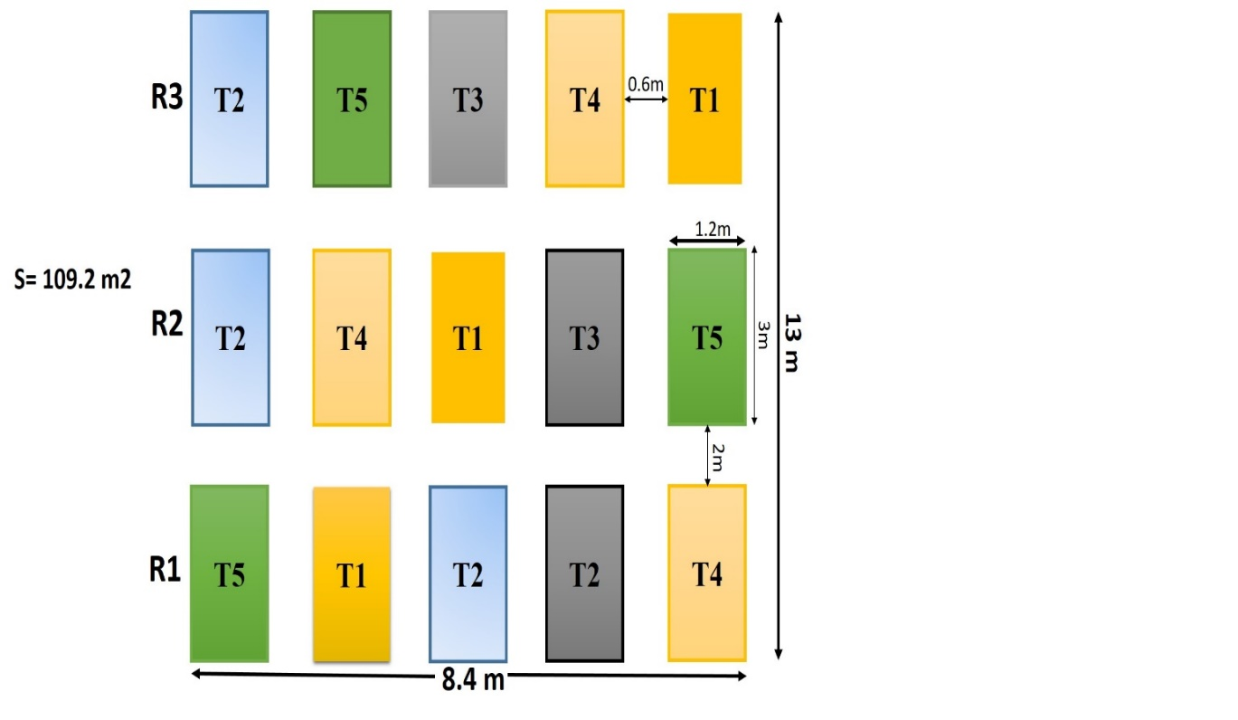
Figure 3: experimental system for open ridges and furrows

Plant density and on ridges

Spacing varies widely from region to region. In the case of this study, the average is 1 m between the lines and 0.9 m on the lines (Figure 4).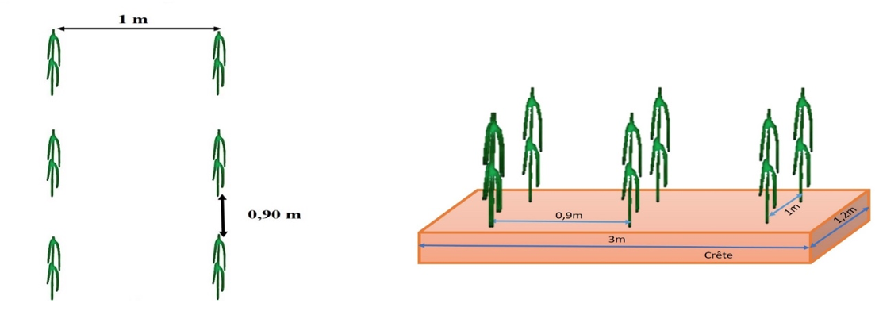
Figure 4: plant density
Ridges and furrows attached (micro basin) at 60 cm intervals
For the second system, the trial was always conducted in completely randomised blocks. The crop plot is made up of three (3) blocks, including one block with five (5) elementary plots (Figure 5) for a total of fifteen (15) elementary plots. The elementary plots are ridges and are attached to form a micro-basin 2 m in diameter in the middle and 0.5 m deep. The spacing between the ridges is 0.6 m, and a ridge is 3 m long and 1.2 m wide, giving a surface area of 3.6 m2 and a total surface area of 109.2 m2. The density on a ridge is 1 m between rows and 90 cm on the ridge lines, with 2 rows and three (3) rangers.
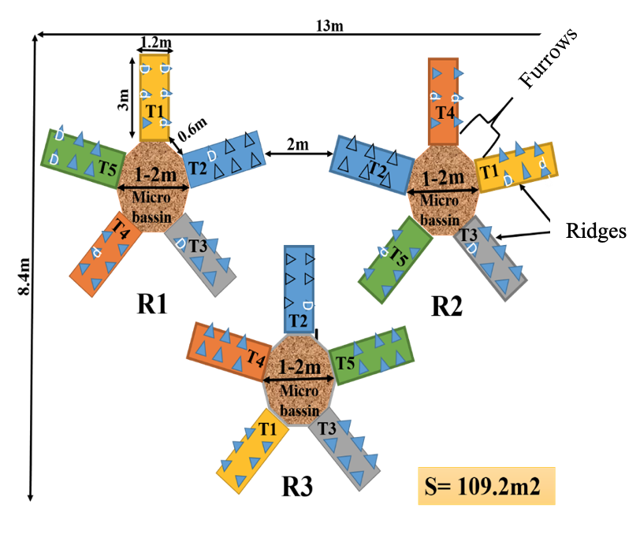
Figure 5: Ridges and grooves attached to the pelvis

Wide beds and furrows with mulch
The trial was conducted in completely randomised blocks. The sugarcane plot consisted of three (3) blocks, including one block with five (5) elementary plots for a total of fifteen (15). The elementary plots are ridges, each covered with straw. The spacing between ridges is 0.6 m and 2 m between blocks. A ridge is 3 m long and 1.2 m wide, giving a surface area of 3.6 m2 and a total surface area of 109.2 m2. The density on a ridge is 1 m between rows, giving 2 rows, and 90 cm on the ridge rows, giving 3 rows (Figure 6).

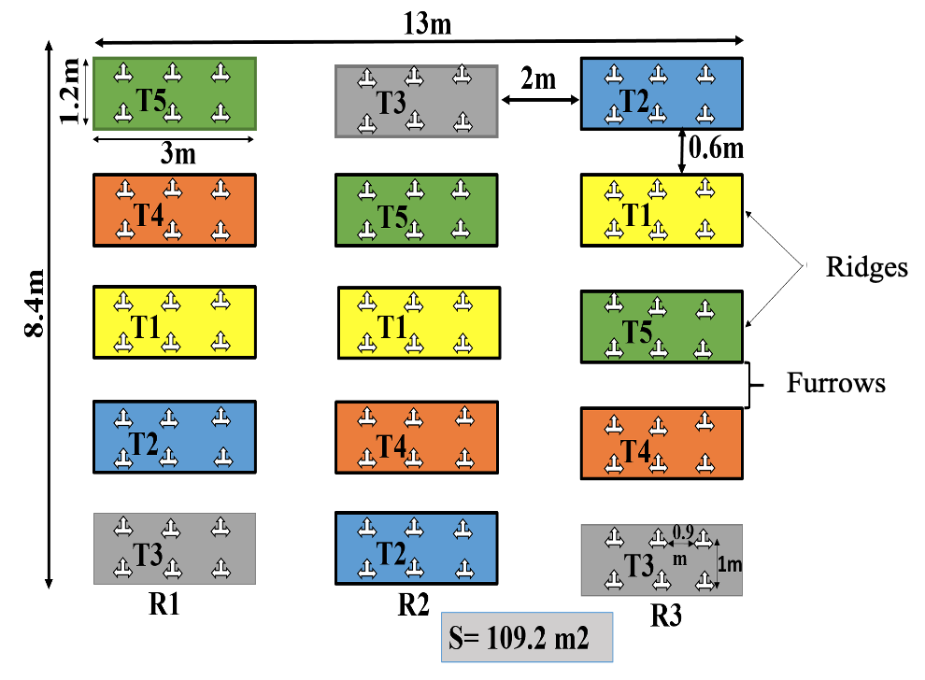
Figure 6 : wide beds and furrows with mulch
Cultural maintenance

This operation is essentially based on the frequency of weeding. This depends on the requirements of the plot.
1st weeding, 1 month after cutting;
2nd weeding, three months after the 1st,
3rd weeding, 6 months after the second and the
4th weeding 9 months after the third before harvesting.

Data collection
The 24 descriptors (Table III and IV) were used for data collection at six (06) and twelve (12) months for agro-morphological characterisation. Three central seedlings were selected on each ridge or plot for the evaluation of growth and production parameters in accordance with the two factors retained for this study (fertiliser and system).

Table III: Quantitative descriptors
Data collection periods | Descriptor n^{o.} | Quantitative characteristics | Measurement techniques
Six months after planting | 1 | Leaf width (cm) | Width of the widest part of the third leaf completely open from the tip measured
Six months after planting | 2 | Leaf length (cm) | Between the tip of the leaf and the base measured on the third leaf fully open from the apex
Six months after planting | 3 | Stipule length (cm) | Measured in cm
Six months after planting | 4 | Stem diameter (cm) | Recorded after cutting the stem and on three different plants
Six months after planting | 5 | Length of internode (cm) | Distance between two consecutive nodes measured on the stem
Six months after planting | 6 | Bud size (cm) | Distance between the base of the bud and its tips
Six months after planting | 7 | Number of internodes | Count the number of knots over 1m
Six months after planting | 8 | Node diameter (cm) | A horizontal measurement of the cross-section of the stem at the node
12 months after planting | 9 | Stem weight (Kg) | Leaves removed and stem cut then weighed
 | 10 | Plant size | Measured from the ground to the top of the plant

Table IV: Qualitative descriptors
Data collection periods | Descriptor n^{o.} | Qualitative characteristics | Code | Assessment level
Six mois après la plantation | 11 | External colour of stem | CET | Yellow and black
Six mois après la plantation | 12 | Internal colour of stem | CIT | White
Six mois après la plantation | 13 | Colour of the leaf blades | CL | Green
Six mois après la plantation | 14 | colour of Stipule | CS | Green
Six mois après la plantation | 15 | Leaflet colour | CF | Brown
Six mois après la plantation | 16 | Leaf pubescence | PF | Present
Six mois après la plantation | 17 | Bud shape | FB | Oval
Six mois après la plantation | 18 | Bud cover | CB | Present
Six mois après la plantation | 19 | Sheet cover | CF | Close
Six mois après la plantation | 20 | Aligning the internode | AEN | Heterogeneous
Data taken 12 months after planting | 21 | Flowering | Flo | Absent
Data taken 12 months after planting | 22 | Stem splitting | FT | Present
Data taken 12 months after planting | 23 | Shape of the knot | FEN | Cylindrical
Data taken 12 months after planting | 24 | Swelling of knots | GN | swelling

- Data analysis
The data collected was entered and recorded in Excel ®2016. Analyses of variance (ANOVA) and Principal Component Analysis (PCA) were performed on the quantitative variables using R software version 3.1.2. The various tests (Turkey test) were validated at the 5% threshold.

- RESULTS
Growth parameters
Stem diameters according to treatments
The analysis of variance (ANOVA) revealed that, in accordance with the different ridge treatments according to the systems, the average stem diameters of the plants on ridges T1 (3.2 cm), T2 (3.6 cm), T3 (3.4 cm) and T4 (3.9 cm) have approximate values, while the smallest is that of T5. The difference observed from a statistical point of view is highly significant (p-value= 5.632 0.000327 ***) between the ridge treatments according to the devices (figure 7).
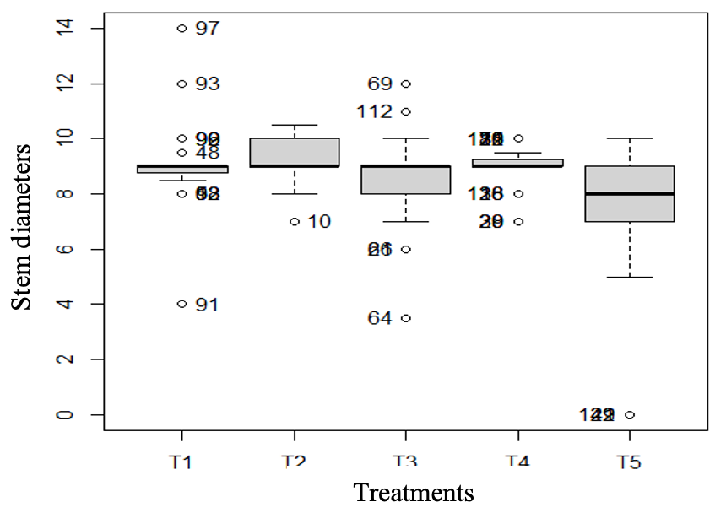
Figure 7: stem diameters as a function of treatments

Node diameter as a function of treatment

Figure 8 shows that the plants from treatments T1 (8.6 cm), T2 (8.9 cm), T3 (9.2 cm) followed by T4 (9.6 cm) have the largest node diameters, depending on the system. The smallest diameters are those of the T5 ridge plants (7.5 cm). Analysis of variance revealed that the difference between the means of node diameters according to treatments was highly significant (P- value = 4.932 0.000982 ***). This proves that the application of organic and mineral fertiliser had a positive effect on the growth in node diameter of the plants compared with the other treatments in the different systems.
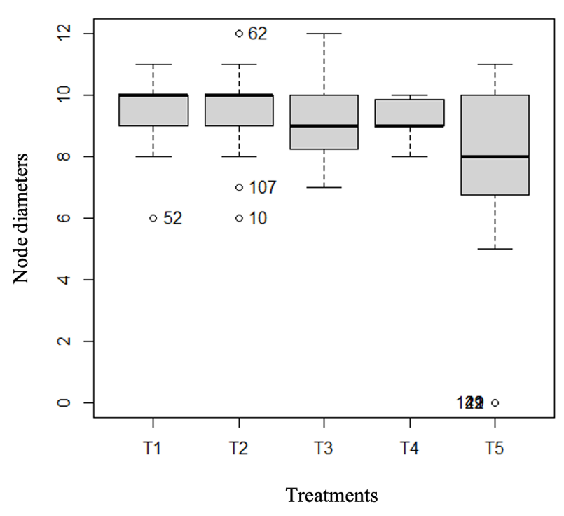
Figure 8: Node diameters as a function of treatments

Leaf widths according to treatments

Leaf widths were measured 6 months after planting. The treatments did not affect leaf size, except for the control (T1) where the plants in the open ridges and furrows had larger leaves (Figure 12). The results obtained showed a statistically significant difference (P-Value=3.995 0.00433 **) compared with the T1 control (Figure 9).

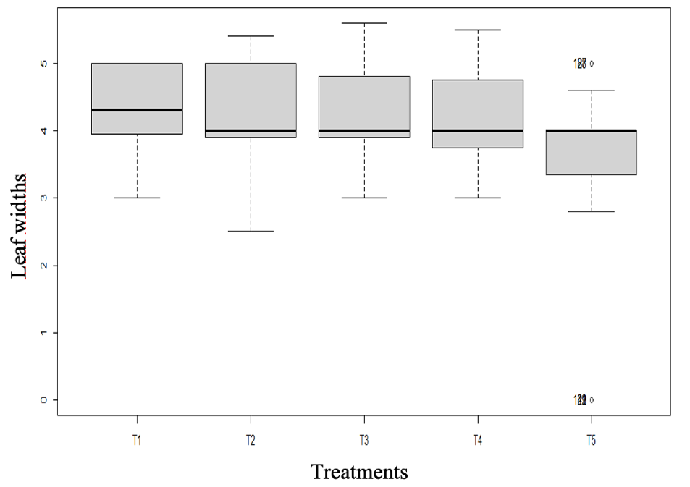
Figure 9: leaf widths according to treatments

Lengths between nodes as a function of treatments

In Figure 10, on the ridges, the sugarcane plants show significant internode lengths of around 13.6 cm for T2 and T3, respectively, followed by T4 (13.9 cm) in all three systems. T1 (8.9 cm) and T5 (9.2 cm) are reliable for the micro-basin and wide beds with mulch. The difference observed from a statistical point of view is significant (P- Value = 1.578 0.184).
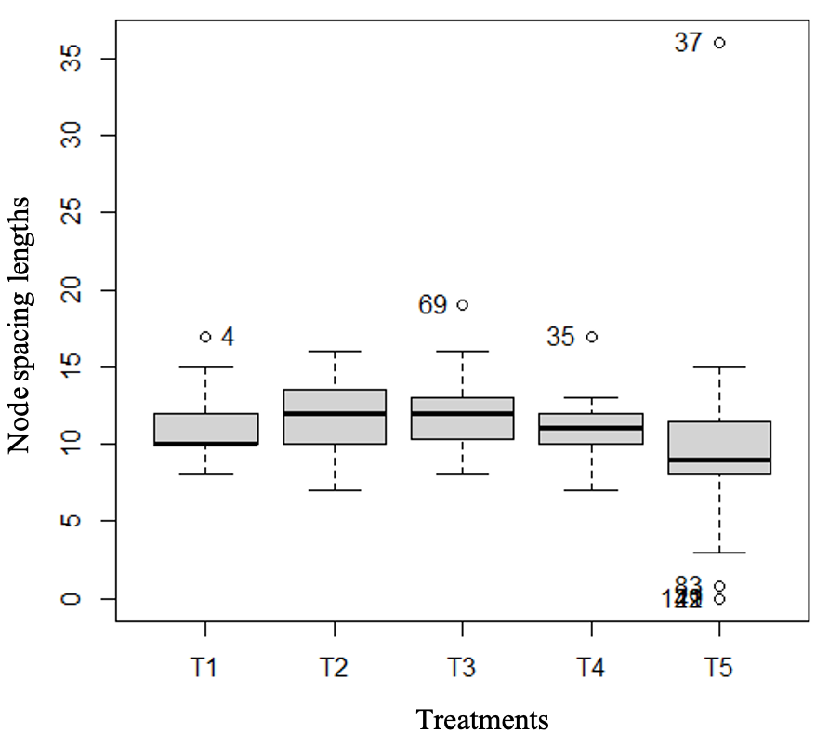
Figure 10: internode lengths as a function of treatments
Stipule lengths according to treatments
The stipule lengths of sugarcane in treatments T2 (36.6 cm), T3 (27.4 cm) and T4 (29.1 cm) were high in the plants grown in the three systems (Figure 11); they were low for T1 (21 cm) and T5 (27 cm) in the micro-basins. However, the differences observed are small. The results obtained show a highly significant difference from a statistical point of view (P-Value= 6.212 0.000132 ***).

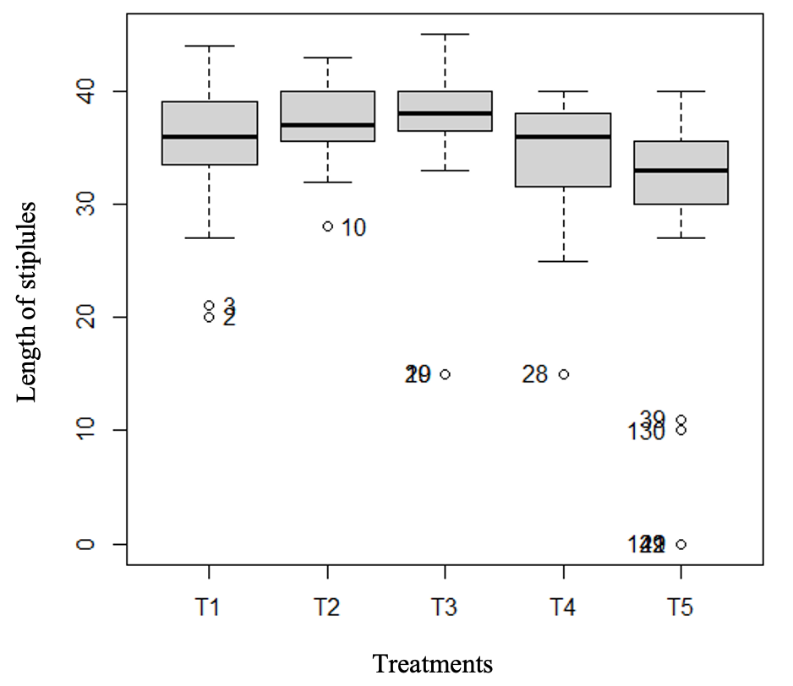
Figure 11: length of stipules according to treatment
Leaf lengths according to treatments
With regard to leaf length, there was no difference between treatments across all systems. The application of fertilisers associated with the structuring of the systems did not affect leaf lengths (Figure 12). The results obtained did not show a statistically significant difference (P- Value= 5.191 0.000653***).
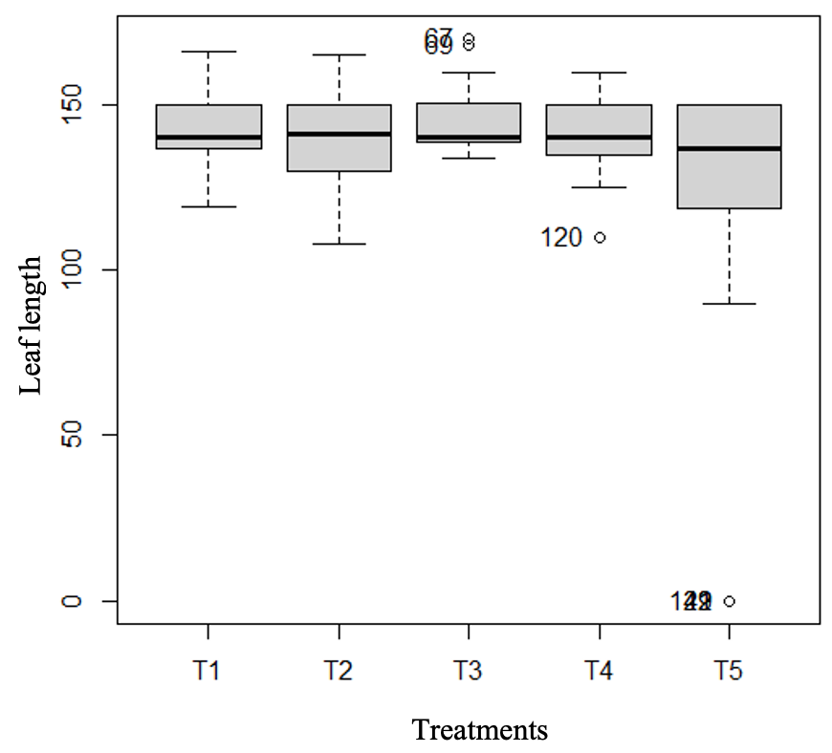

Figure 12: leaf lengths according to treatments

Relationship between different parameters for different types of peak

The nature and degree of divergence of the descriptors were assessed using Principal Component Analysis (PCA) based on the quantitative and qualitative variables. The projection of the variables onto the factorial plane formed by the two principal axes of the Principal Component Analysis (PCA), which together account for 72.74% of the total variability, revealed positive correlations between the agronomic variables (stem mass, leaf length and width, internode length, stipule length, etc.) and the qualitative variables (plant growth, plant growth, etc.), internode lengths, stipule lengths, bud sizes, stem diameters, number of internodes, internode diameters and node diameters) with 63.51% variability and, secondly, between the different types of ridge (open furrow, micro-basin and wide bed). Variability in sugarcane growth and production was observed at ridge level, with 9.23% variability (Figure 13).
These observations showed that the treatments adopted had no impact on the morphological characteristics of the crop. The ridges and open furrows showed good development of the sugarcane plants, followed by wide beds with mulch and, finally, the micro-basin.
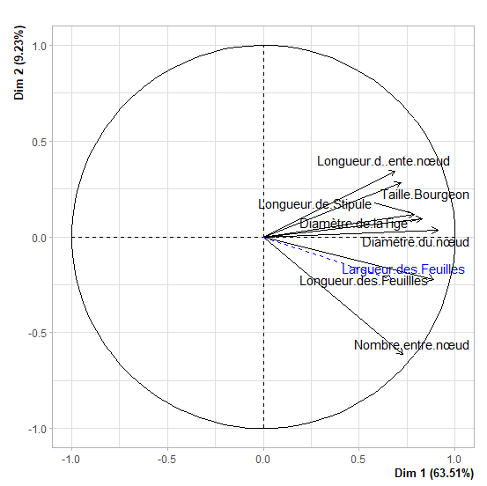
Figure 13: link between different parameters for different types of peak
Stem weight according to treatments
Average sugarcane stalk weights showed a statistically significant difference (p-value = 0.7566) between treatments (Figure 14). The greatest weight was that of T2 (0.83kg), followed by T3 (0.7 Kg), T4 (0.5Kg) and T5 (0.49Kg) respectively. T1 (0.2kg) weighed very little.
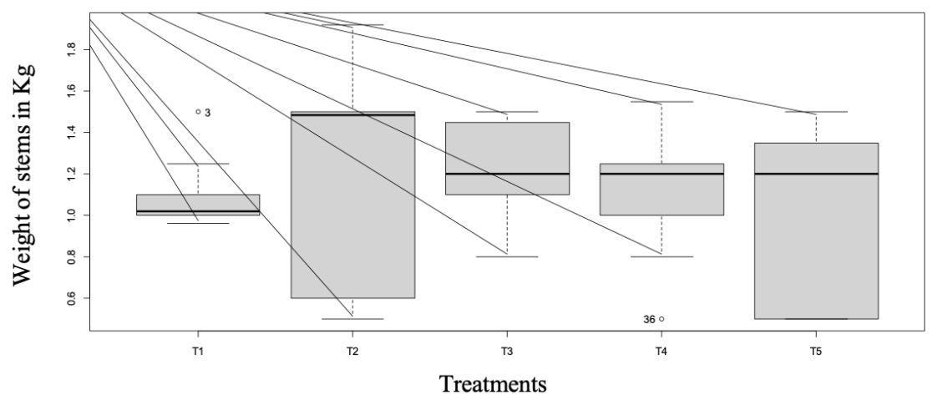
Figure 14: Stem weight according to treatment

Size of plants

Figure 15 shows the heights measured from the ground to the top of the plants under the experimental conditions. Variability was observed between the different treatments in terms of plant height. The difference observed was statistically significant (p-value = 0.05254). Treatment T3 (2.7m) had higher plant heights than T4 (2.1m), T2 (1.9m) and T5 (1.3m). The lowest heights are those of T1 (0.8m).
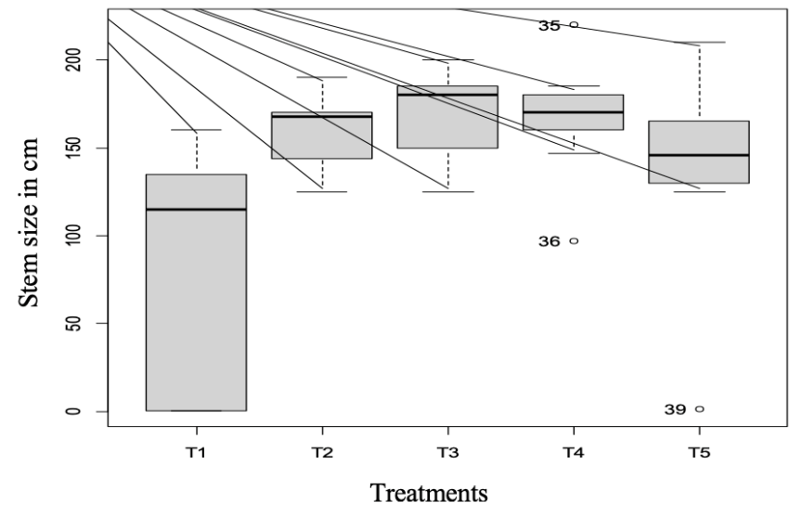
Figure 15: Size of plants
Correlations between plant weight and size
Figure 16 shows a weak correlation (R2= 0.0412) between plant weights and heights according to treatments and systems. Plant height growth is not related to stem weight. The parameters evaluated in a correlation approach are not related.

Figure 16: Correlations between plant weight and size

- DISCUSSION
The integrated management study of sugarcane (Saccharum officinarum L.) in the forest zone of the CAR, in collaboration with the farmers of an agro-pastoral group, was carried out on the basis of three types of soil system, fertilisers applied at different doses and agro-morphological characterisation using 24 descriptors. The results show that there is variability between the different parameters assessed, depending on the treatments and systems. This can be explained by the influence of the type of treatment in relation to the type of system, as well as the agro-ecological parameters.
Analysis of the variations with a significant difference (P-value <0.000327) for the height growth parameter shows that the plants on the linked ridges (micro-basin) have low heights, which can be explained by the fact that the micro-basin retains a lot of water and increases soil humidity. [12] who worked on "excess water and the development of grass yields" explain that stagnant water prevents the height growth of plants and also slows down their development. [13] showed that soil water saturation reduces root growth and affects overall final yield. [14] in their respective studies on soil and climate change and soil management, demonstrated that the fermentation of organic matter in an anoxic environment produces methane and carbon dioxide, which contribute to the greenhouse effect. [15] have shown that the nitrogen cycle is also disrupted, with saturation favouring denitrification in particular. The various results of these authors' work show that excess soil water significantly reduces sugarcane growth and yield. For the other arrangements, the analysis shows that T2 of open ridges and furrows performs best with an average height of 3.3m followed respectively by T3 (3.2m) of wide beds with mulch; T4 (3.2m) of open ridges and furrows and T5 (3.2m) of open ridges and furrows and also T4 of wide bed with mulch and T5 of open ridges and furrows.
Two main factors from the Principal Component Analysis (PCA), one agro-morphological and the other the different types of ridge, explain the variability observed. However, 72.74% of the total variability is explained by these factors being revealed by the PCA. Positive correlations between agronomic variables were found for sugarcane. These results show that a still significant proportion of the variability could be explained by other traits such as resistance or tolerance to diseases endemic to sugarcane, as reported by certain authors [16]. The variations observed between the average height growth rates explain why the combined application of mineral and organic fertilisers (cow dung) favoured height growth better than the blocks that did not benefit from the fertilisers. As the trials were set up in a forest zone and during the rainy season, the improved water nutrition of the crops thanks to soil moisture is a significant advantage [17,18,19,20].
Other studies, such as those by [21,22,23], have also highlighted the impact of microdosing in improving yields. [24] had also shown that variables such as fertiliser microdosing, improved varieties, organic manure, water and soil conservation techniques were positive determinants in sugarcane production.
The correlations found between plant weight and size were weak, depending on the treatments and systems. Plant height growth was not related to stem weight. These results are confirmed by the work of Hema (2005) using completely randomised block trials.

CONCLUSION
The aim of this study is to assess the productivity of this crop under an integrated fertiliser-based management system. Sugar cane is an agricultural product that provides an economic gain through sustained exploitation, and requires negligible labour compared with certain crops. Despite its importance, sugar cane production has declined in recent years in the CAR due to a number of biotic and abiotic constraints, the most important of which are insect attack, rodent attack, susceptibility to weeds and susceptibility to drought. However, these constraints can be overcome by using tolerant and/or resistant cultivars. Agricultural research can therefore contribute to the development of resistant and productive varieties.

The results of this study showed that the best sugarcane yields were obtained from T2 (sugarcane+ N=105 kg/ha +P=22.5 kg/ha+ K=45 kg/ha) on open ridges and furrows and T3 (sugarcane+ N=210 kg/ha +P=45kg/ha + K=90 kg/ha) on wide-bed ridges with mulch. The profitability of sugarcane cultivation in the forest zone is better if the combined use of organo-mineral fertilisers is envisaged. However, soil and climatic conditions are fundamental for sugarcane production. There is no doubt that the use of fertilisers has had a positive impact on the production potential of sugar cane.

Applying the recommended fertilisers to sugar cane would be one way of improving yields.

REFERENCES :

- Soopramanien G, 2000. Sugarcane morphology, anatomy and physiology. A guide to sugarcanediseases. P. Rott, R. A. Bailey, J. C. Comstock, B. J. Croft et A. S. Saumtally, ed. CIRAD and ISSCT, Montpellier, France P., 13-20p.
- Meslien S. 2009. Sugar cane and its challenges in the French Antilles, from its origins to the beginning of the 20th century. Regional Center for Educational Documentation of Martinique, 22p
3. Rondeau. P. 2002. Sugarcane and renewable energy: Contribution to the reduction of greenhouse gas emissions, International multidisciplinary meetings, Perspectives for the development of sugarcane in island environments, Stella Matutina, Ile de La Réunion, 9p.
4. Uppal H., 2008. Potentiel of sugarcane bagasse for production of furfural and itsderivatives. SugarTechnologies. 10(4) : 298-301p.
5. Hamelinck C., Hooijdonk G.V., Faaij A. P. C. 2005. Ethanol fromlignocellulosic biomasse: technico-économique performance in short; middle; and long term. Biomasse and Bioenergy, 28-384-410p.
6. Archimede H., Xande X., Gourdine J.-L., Fanchone A., Alexandre G., Boval M., Coppry O., Arquet R., Fleury J., Regnier C. Renaudeau D. 2011. Sugarcane and its co-products in animal feed. Agronomic Innovations, 16-165-179p.
7. Caro Canne. 2013. Sugar cane: development and innovations, 1- 96p.
8. FAO. 2012. The State of Food and Agriculture, 1-202p.uujnhnh
9. Rott P. et Davis M., 2000. Leafscald. In: A guide to sugarcanediseases, ed. Rott P, Bailey R, Comstock J, Croft B,Saumtally A, Montpellier: CIRAD-ISSCT, 339p.10.Plan de Développement Local de la commune de Pissa., 2019. Revised with funding from UNICEF, 55 pages11. Koné Y. Wamffler B. Beliere J.B, 2009. Stakeholders' perceptions of soil fertility management in the savannah zone of Niger.270p.
12.MasseJ., Capy Y., 1988. Excess water and the development of cereal yields. Agricultural Perspectives, 126, 37-47p.
13. Rebière B., 1996. Effect of excess water on the growth of a winter wheat crop. Identification of a stress variable and analysis of the crop response.. Thèse Univ. De Strasbourg, 234 p.
14. Germon J.C., Cellier P., Gabrielle B., Hénault C., Laville P., 2009. Soil and climate change. In: Le Sol. INRA file, Paris: 42-47p.
15. Cellier P., Germon J.C., Hénault C., Genermont S., 1996. Ammonia (NH3) and nitrogen oxide (NOx and NO2) emissions from cultivated soils: production mechanisms and quantification of flows. In: Nitrogen control in agrosystems. INRA, Paris, Les colloques, n°83 : 25-37p.
16. Cocherfau P. et Jean-Bart A., 1999. Sugarcane sampling in Grande-Terre (Guadeloupe): losses in standing tonnage and their causes. ORSTOM Guadeloupe Center - Antilles-Guyane Agronomic Research Center, Pointe à Pitre, 25 p.
17. Liniger HP, Studer RM, Hauert C, Gurtner M. 2011. Sustainable Land Management in Practice – Guidelines and Best Practices for Sub-Saharan Africa. TerrAfrica, World Overview of Conservation Approaches and Technologies (WOCAT) and Food and Agriculture Organization of the United Nations (FAO): Rome, Italy, 26p.
18. Zougmoré R, Jalloh A, Tioro A. 2014. Climate- smart soil water and nutrient management options in semiarid West Africa: a review of evidence and analysis of stone bunds and zaï techniques. Agric. & Food Secur, 3(16) : DOI https://doi.org/10.1186/2048-7010-3-16p.
19. Shaxson TF, Roose E. 2017. Chapitre 4 : An ecological perspective on the restoration of degraded soils. In Restoration of the Productivity of Tropical and Mediterranean Soils: Contribution à l'Agroécologie, Roose E (Ed). IRD Éditions, 65-74p.
20.Tabo R, Bationo A, Hassane O, Amadou B, Fosu M,SawadogoKabore S, Fatondji D, Ouattara K, Abdou A, Koalas. 2009. Fertilizer microdosing for the prosperity of resource poor farmers: a success story. In Increasing the Productivity and Sustainability of Rainfed Cropping Systems of Poor SmallholdeFarmers, Humphreys E, Bayot RS (Eds). Proceedings of the CGIAR Challenge Program on Water and Food International Workshop on Rainfed Cropping Systems, Tamale, Ghana, 269-277p.
21.Woittiez L, Descheemaeker K, Ken GE. 2015. Adoptability of sustainable intensification technologies in dryland smallholder farming systems of West Africa. Research Report no. Patancheru. Telangana, India: International Crops Research Institute for the Semi-Arid Tropics. 324-502p.
22.Sissoko P, Berti F, Gry S, Lebailly P. 2018. Effects of adopting the fertilizer microdosing technique on cereal availability and accessibility in millet and sorghum-based farms in Mali. Agron. Afr. 30 (2) : 193-204p.
23. Tovihoudji GP. 2018. Improving maize productivity in northern Benin through localized placement of amendments and fertilizers. Joint thesis presented with a view to obtaining the degree of: Doctor of Agricultural Sciences and Biological Engineering from UCL and Doctor of Sciences Agronomiques de l’UAC, 201p.
24.Sissoko P, Lebailly P. 2019. Determinants of millet and sorghum yields using the fertilizer microdosing technique. Rev. Mar. Sci. Agron. Vét., 7 (2): 213-222p.

