**Original Research Article**

**PERFORMANCE EVALUATION OF A SENSOR BASED TRACTOR DRAWN GINGER PLANTER**

**ABSTRACT**

The use of single-seed planters is essential for ensuring uniform plant distribution in agricultural operations. In these planters, seed metering units are typically powered by a drive wheel, which transfers motion through various transmission components like chains, gears, shafts, and belts. However, during planting, the force exerted by the transmission system and the seed metering unit’s drive mechanism on the drive wheel can cause slippage or a loss of traction. This affects the overall performance of the seed metering units, leading to uneven plant spacing due to the shared transmission system.

To mitigate these challenges, a sensor-based control system was developed. This study delves into the design of this sensor-based system and evaluates its impact on planting quality, particularly in terms of plant spacing uniformity and field performance. Field trials conducted using the sensor-based system showed encouraging results, with a quality of feed index (Iqf) of 97.34 per cent, multiple index (Imult) of 0.95 per cent, missing index (Imiss) of 1.5 per cent, and a cell fill efficiency of 93.33 per cent. The average hill-to-hill distance was measured 20.03 cm, and it gives the field efficiency was 84 per cent. These metrics indicate that plant spacing uniformity was effectively maintained. The sensor-based system demonstrated significant improvements in planting consistency during field trials. Additionally, the system offers the ability to regulate seed rates, reduce labour input, and save time. For future enhancements, further research should focus on optimizing the structural design of seed metering units. This includes refining aspects such as cell diameter and thickness, number of cells, and methods used for connecting components to ensure better mechanical integration between the sensor system and the planter.

***Key words*:** ***Planter, Electronic control unit, Metering speed and Forward speed***

**INTRODUCTION**

India is the largest producer of spices in the world and ginger contributes 43.00 per cent of world production of ginger. Ginger, turmeric, garlic, clove, etc. are some of the common spice crops. The production of ginger in Kerala was 51.18 million tonnes in an area of 2.58 thousand hectares with the productivity level of 19820 kilogram per hectare in 2022-2023 (Indiastat, 2022-2023).

The major constrains in raising of ginger crop is non-availability of labour in time, especially, during peak periods of sowing and harvesting. Traditional methods of growing ginger involve manual planting of excess rhizomes and thinning of the plants is needed to obtain the desired plant population at uniform plant spacing (Inman, 1968). Planting is a crucial cultural practice in crop production, as it significantly impacts crop yield, reliability, frequency, and profitability. Achieving uniform and timely establishment of optimal plant populations is essential for enhancing these factors (Murray *et al.,* 2006). The planting technique plays a vital role among various agronomic practices, as it ensures optimal plant population and efficient utilization of land and resources (Ali *et al.,* 1998).

For high production, it is essential to use high-yielding seed varieties. However, achieving higher productivity is not possible without precise placement of seeds at the right depth and spacing at the proper time. Proper seed placement in the optimal growing environment is crucial for ensuring both high yield and crop quality. Uniform spacing allows roots to grow uniformly, contributing to consistent plant development. Therefore, to maximize yields, seeds must be planted with accurate spacing to ensure that all viable seeds germinate and emerge quickly.

Mechanical planters, which are widely used, typically employ various seed metering mechanisms such as fluted feed, internal double run, cup feed, cell feed, brush feed, auger feed, picker wheel, or star wheel types. These mechanisms are designed to place seeds in furrows at a uniform rate and controlled depth, with a system for covering the seeds with soil. However, during mechanical metering, seeds may come into direct contact with the mechanism, potentially causing damage and reducing their viability, leading to lower germination rates. In fact, mechanical planters can damage up to 71.7 per cent of seeds (Kopak., 1997). Moreover, traditional mechanical devices in seed drills are often unable to function effectively at higher travel speeds (Kumar and Durairaj, 2000). Therefore, to achieve higher productivity, the metering unit of a seed planter must be precise enough to plant seeds at the required spacing within a row, without causing issues such as doubling or missing seeds. Doubling is undesirable as it negatively impacts yield and dry matter, while missing seeds lead to reduced yield (Rintelen., 1971).

To achieve optimal yield, it is crucial to precisely deposit the correct number of seeds in rows, ensuring accurate seed rate and spacing during the metering process. Among the different planting techniques, precision planting is the preferred method, since it provides Precise spacing of individual seeds within the row, along with appropriate planting depth, is essential to create a uniform germination environment for each seed (Karayel and Ozmerzi, 2004).

An electronic ginger planter work with a sensor-based operated metering system, enhances precision in planting. Using a pneumatic precision planter is crucial for achieving uniform distribution of planting areas in the field. It also significantly impacts the duration of plant emergence (Karayel., 2009; Karayel *et al.,* 2004; Scott A. Staggenborg *et al.,* 2004). Additionally, the use of machinery plays a vital role in reducing competition for nutrients and water among plants during the cultivation period, thereby minimizing yield loss (Cay *et al.,* 2017). In precision planting, accurately placing seeds at the desired spacing is essential. Previously, seed rate adjustments were made using a kg/area ratio, but recently, the number of seeds/area ratio has become the standard. The most effective way to achieve this is by properly operating the seed metering unit, which is the crucial component of the planter. The seed metering unit is crucial for ensuring consistent seed distribution (Li *et al.,* 2015; Onal *et al.,* 2012; Yazgi and Degirmencioglu 2014). Historically, this unit has been a major focus for improvements in machinery design. Nonetheless, research on the mobilization of the seed metering unit has been relatively limited until recently. The motion transmitted from the ground wheel to the planter is relayed through various transmission components, including chains, gears, shafts, and belts, before reaching the seed metering unit. During this process, issues such as friction, slippage, and tire pressure variations between the wheel and soil are unavoidable (Iacomi and Popescu, 2015; Liang *et al.,* 2015). The incorporation of a sensor system enhances seed metering accuracy and helps minimize losses. The benefits of electronic planters over mechanical ones include:

1. Timely sowing with accurate spacing of seed to seed
2. Minimize seed wastage
3. Reduce losses caused by slipping and skidding of the ground wheel
4. Seed rate can be easily adjusted by using electronic control system
5. Decreases the missing & multiple indices as well as increases cell fill efficiency
6. Machine design to be compact & viable
7. Electronic transmission system can prove a very good option for precision of sowing

**2. MATERIALS AND METHODS**

**2.1 Planter and System Components**

Three-row sensor based ginger planter with a chain and sprockets transmission system operating based on the drive wheel with the help of encoder. Seed metering unit operate in accordance with the principle of drive from the driving wheel and providing a common movement through chain and sprockets with attached cells. Developed electronic control system, seed metering unit runs through single common shaft and electric motor controlled by using (PMW) pulse width modulation technique. Detailed information regarding the electronic components and the system design was provided in this study. The selected diameter of cell is 50 mm was choosen based on the physical properties of seeds. Average length of ginger rhizome after cutting one or two buds was 3-5 cm (KAU POP., 2016). Each seed metering contains 9 cells, total 27 cells were selected for the test parameters to investigate the performance parameters. The developed cell as shown in Fig.1 (a) & (b).

**2.2 Field Trails**

Field trails were conducted at Kelappaji College of Agricultural Engineering and Food Technology, Tavanur under Kerala Agricultural University. In this trail the planter was operated at different forward speeds of 1, 1.5 and 2 km h-1, Speed of chain is 86±10, 96±10 and 106±10 rpm was tested. For planting, Johndeere 60 hp tractor was selected. The planting process were done by the sensor-based control system. This process replicated 3 times to reduce the experimental errors. The program was made in C++ language with Arduino IDE software. In this programme have to give the input data regarding spacing between seeds, length of chain, no of selected cell sizes, sprocket diameter as well as diameter of ground wheel.

The performance indicators for mean rhizome spacing uniformity, which are hill to hill distance, missing index, multiple index, quality of feed index and cell fill efficiency were calculated from the equations in below (Kachman and Smith, 1995; Al-Gaadi, 2011; Madhu Kumar, 2017 and Kepner *et al.,* 1987). The effects of drive system on planting performance indicators were statistically analysed by variance analysis. Statistical analysis was performed by using Design Expert Software V13 version.

**Table. 1. Dimensions of cells**

|  |  |  |
| --- | --- | --- |
| **Specifications, mm** | **Athira variety of ginger rhizome, mm** | **Cell size, mm** |
| Length, mm | 46.95 ± 1.78 | 50 |
| width, mm | 33.37 ± 1.41 |
| Thickness, mm | 18.84 ± 2.45 |
| No of cells | 27 |

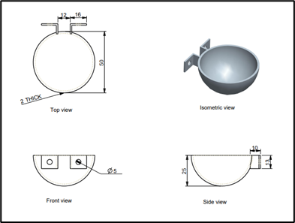 

**All dimensions are in, mm**

**Fig. 1 (a) Schematic view of cell size, (b) Developed cell size**

Seed metering shaft was used to provide drive for seed metering mechanism and it was made up of using a mild steel shaft with length 1200 mm and diameter of 20 mm. It was fitted with six numbers of 13 teeth sprockets were used at an equidistant of 400 mm. The other end of the shaft was fitted with a sprocket to provide power transmission from the DC motor through chain drive to the metering.

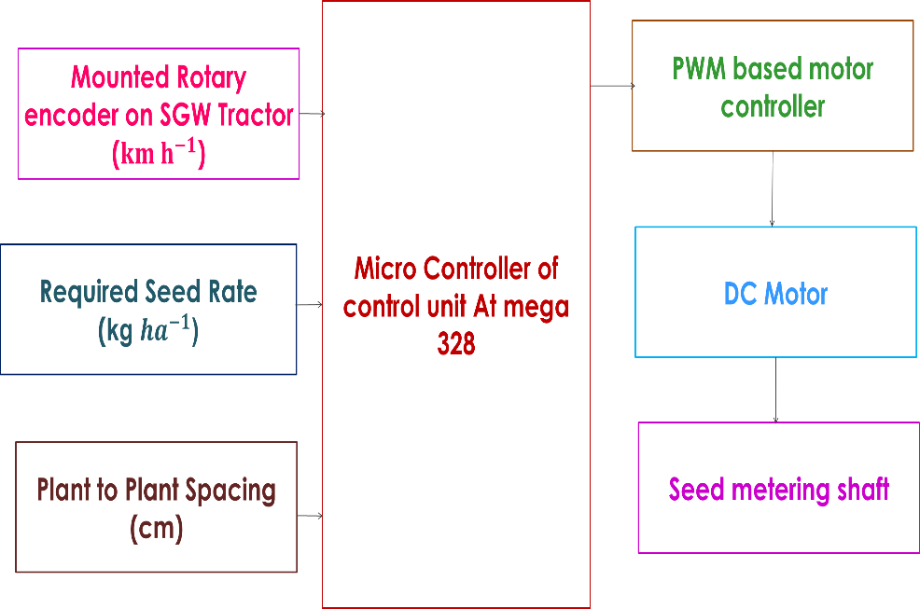

**Fig. 2 Block diagram of sensor control system**

**Table 2 Effect of Forward Speed and Speed of Chain on Performance of Ginger Planting**

|  |  |  |  |  |  |  |
| --- | --- | --- | --- | --- | --- | --- |
| **Sl. No** | **Experiment runs** | **Hill to hill distance, cm** | **Missing index,**  **Per cent** | **Multiple index,**  **Per cent** | **Quality of feed index,**  **Per cent** | **Cell fill efficiency**  **Per cent** |
| 1 | S1R1 | 10.5 | 3.3 | 1.85 | 94.85 | 93.33 |
| 2 | S2R1 | 14.5 | 9.28 | 2.85 | 87.86 | 92.78 |
| 3 | S3R1 | 22.05 | 14.16 | 3.45 | 82.38 | 89.55 |
| 4 | S1R2 | 16.7 | 2.16 | 1.05 | 96.73 | 92.28 |
| 5 | S2R2 | 20.03 | 2.05 | 2.11 | 95.83 | 92.56 |
| 6 | S3R2 | 27.7 | 9.16 | 3.13 | 87.70 | 89.23 |
| 7 | S1R3 | 24.03 | 1.71 | 0.95 | 97.34 | 86.49 |
| 8 | S2R3 | 28.03 | 1.5 | 1.33 | 97.16 | 85.32 |
| 9 | S3R3 | 32.5 | 4.88 | 2.2 | 92.92 | 82.16 |

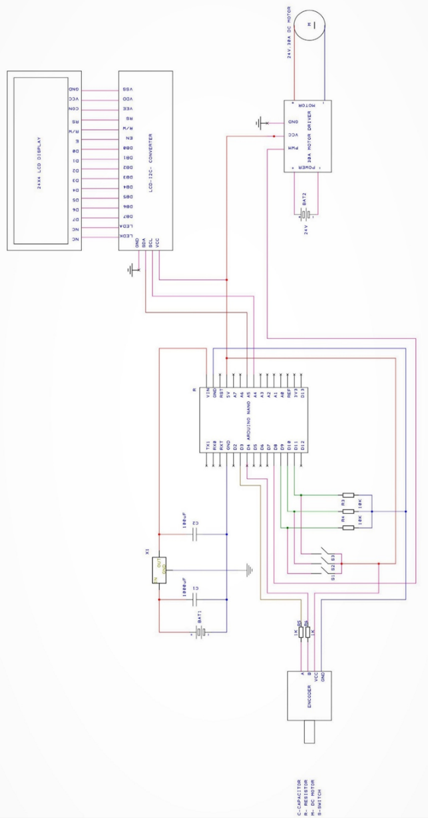

**Fig. 3 Schematic view of electronic circuit for a sensor-based tractor drawn ginger planter**

**2.2.5 Electronic control unit**

The electronic control unit consists of

1. Arduino Nano board
2. Rotary Encoder
3. Cytron 30 Amp DC Motor Driver
4. LCD display
5. Amaron 12 V DC Battery

**2.2.5.1 Arduino Nano**

Arduino Nano is a versatile microcontroller board designed for use on a breadboard, featuring integrated USB connectivity. Its pin layout is compatible with other popular microcontrollers like the Mini and Basic Stamp, with TX, RX, ATN, and GND conveniently grouped on one side, power and ground pins on the other. In this research, version 3.0 of the Arduino Nano was used, equipped with the ATMEGA328 microcontroller, for establishing communication with various controllers and computers. This communication primarily occurs through the digital pins, with pin 0 (Rx) used for receiving data and pin 1 (Tx) used for data transmission. To facilitate this communication, the Arduino Software includes a serial monitor that enables the exchange of textual data between the board and external devices. The Arduino nano as shown in below Fig. 4.

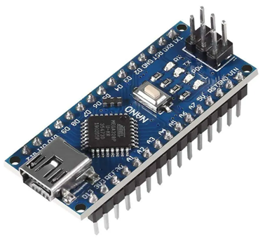 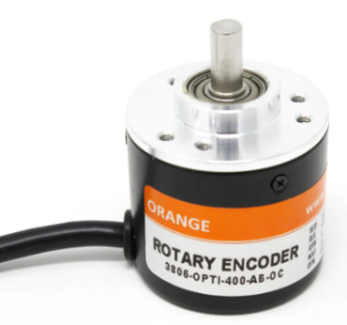

**Fig. 4 Arduino Nano Fig. 5 Rotary encoder**

**2.2.5.2 Rotary Encoder**

A rotary encoder, or shaft encoder, is an electromechanical device that converts the angular position or movement of a shaft into analog or digital signals. In this study, a 5-24 VDC rotary encoder measured the ground wheel’s speed. Acting as a forward speed sensor, it helped establish a relationship between the rotational speed of the rhizome metering and the ground wheel. Attached to the ground wheel and connected to the Electronic Control Unit (ECU), the encoder provided pulses to the Arduino Nano. The Arduino processed these pulses to determine travel speed and distance, synchronizing the seed metering motor to maintain proper rhizome spacing via the PWM channel. The Rotary encoder as shown in above Fig. 5.

**2.2.5.3 Cytron 30 Amp DC Motor Driver**

The Cytron 30 Amp DC Motor Driver, known as the MD30C, is engineered to handle medium to high-powered brushed DC motors with an impressive current capacity of up to 80 A at peak performance and 30 A for continuous operation. Its fully NMOS design not only ensures rapid switching times but also enhances efficiency, eliminating the need for additional heatsinks or fans. Notably, MD30C boasts user-friendly features like reverse polarity protection and an onboard PWM generator, enabling standalone operation without a host controller. Motor control becomes effortless using the built-in switches and speed potentiometer, while external switches and potentiometers can also be seamlessly integrated for added flexibility and control. The Cytron 30 Amp DC Motor Driver as shown in Fig. 6.

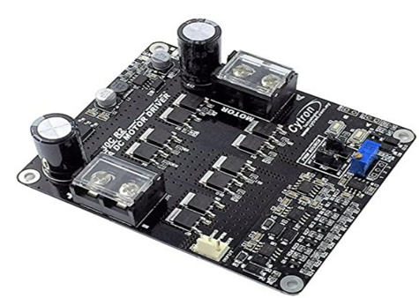 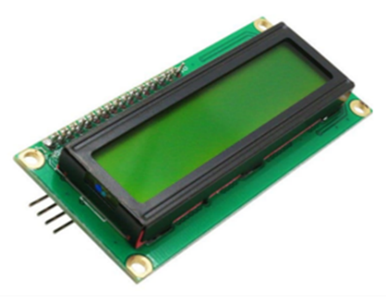

**Fig. 6 Cytron 30 Amp DC Motor Driver Fig. 7 Rotary encoder**

**2.2.5.4 LCD display**

An LCD (Liquid Crystal Display) is an electronic module that uses liquid crystals to display information. A 16 × 2 LCD module is commonly used for showing text in various devices and circuits due to its flexibility and user-friendly interface. Unlike seven-segment and other multi-segment LEDs, a 16 × 2 LCD requires a dedicated driver to interface with an Arduino Nano. This driver, featuring an 8-bit data interface and control pins, acts as an intermediary, enabling the display of data received from the Arduino. In the context of monitoring crop spacing, the LCD provides real-time feedback during both lab and field operations. When the switching regulator is adjusted to a range of 15-20 cm, as programmed in the Arduino, the system ensures precise spacing. The LCD display as is shown in Fig**.7.**

**2.2.5.5 Amaron 12 V DC Battery**

A battery is a device that provides electric power supply to Cytron 30 Amp DC Motor Driver. In this drive connects the connections for DC motor, Arduino Nano, rotary shaft encoder and LCD display. For this study we used two 12 V DC batteries connected through series to get 24 V DC supply to DC geared motor (24V, 30 Amp, 430 RPM and 450 W). The amaron 12 v DC battery as shown in below Fig. 8.

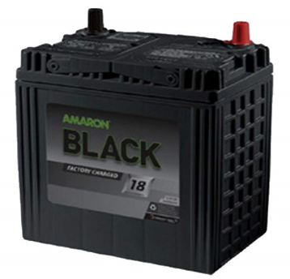

**Fig. 8 Amaron 12 V DC Battery**

**2.3 Performance parameters during field operation**

The planter’s performance indices, including hill to hill distance, multiple index, miss index, quality of feed index and cell fill efficiency were calculated along with the theoretical spacing as a reference. The calculations based on the measured spacing between dropped rhizomes, were conducted following the methods outlined by Kachman and Smith (1995) and Al-Gaadi (2011).

**2.3.1 Missing index**

Miss index (Imiss) is an indicator of how often the seed skips desired spacing. It is the percentage of spacing greater than 1.5 times the theoretical spacing S in mm. The missing index is mathematically as follows. $$I_{miss}=\frac{n_{1}}{N}×100$$

Where,

n1 = Number of spacing in the region > 1.5 S

N = Total number of observations

The seeds are misses could be due to the failure of planter to drop a seed or the failure of the seed to germinate.

**2.3.2 Multiple index**

The multiple index (Imult) is an indicator of more than one seed dropped within a desired spacing. It is the percentage of spacing that are less than or equal to half of the theoretical spacing S in mm. The multiple index is mathematically expressed as follows.

$$I_{mult}=\frac{n_{2}}{N}×100$$

Where,

n2 = Number of spacing in the region ≤ 0.5 S

N = Total number of observations

**2.3.3** **Quality of feed index**

The quality of feed index (Ifq) is the measure of how often the spacing were close to the theoretical spacing. It is the percentage of spacing that are more than half but not more than 1.5 times the theoretical spacing S in mm. The quality of feed index is mathematically expressed as follows.

Ifq = 100 - (Imiss + Imult)

Where,

Imiss - Miss index, per cent, Imult - Multiple index, per cent

**2.3.4 Cell fill efficiency**

Per cent cell fill for a given planter is influenced by such factors as the diameter of the cell, speed of the metering mechanism and size of seeds are picked. The shape and uniformity of seed cell sizes, the exposure time of a cell to seed in the picking chamber of hopper and speed of the cell. Per cent cell fill is defined as the total number of seeds discharged divided by the total number of cells passing the discharge point. The most uniform seed distribution is obtained with a combination of uniform size of seeds that suits the cell size and cell shaped will give about 100 per cent cell fill.

Generally, experience has indicated that the cell diameter or length should be about 10 per cent greater than the maximum seed dimension and the cell depth should be about equal to the average seed minor diameter or thickness (Kepner *et al.,* 1987).

**2.3.5 Hill to hill distance**

Average rhizome spacing indicates average value of spacing measured between two consecutive seeds in row. It was measured using a standard measuring scale. (Madhukumar, 2017).

D = $\frac{Ʃs_{a}}{N}$

Where,

Sa = Actual spacing between two consecutive seeds

N = Total number of observations

The designed components of a sensor based ginger planter were assembled to a cultivator with three-point linkage having a length of 1600 mm in order to set the furrow openers for planting. The width was limited to 400 mm to set the seed. The supporting frame consisting the metering mechanism used in the seed hoppers as well as fitted to the middle of main frame. Cultivator was aligned so that all seeds are directly comes out in the seed delivery tube respectively. The height of the cultivator was maintained at 50 cm from the ground level.

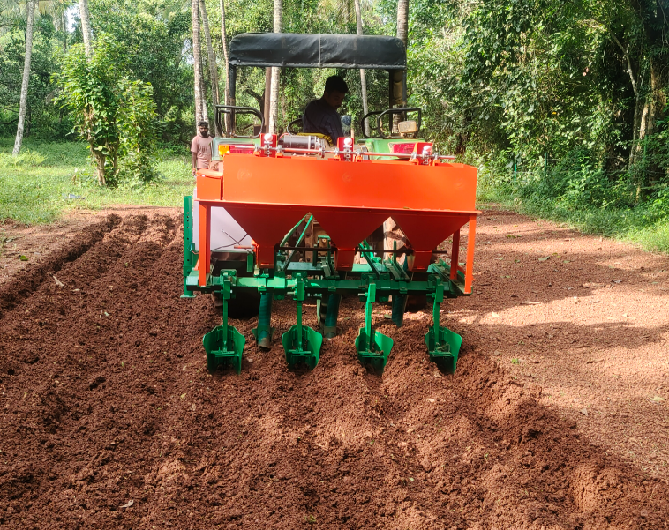

**Plate. 1. Working view of developed tractor drawn ginger planter**

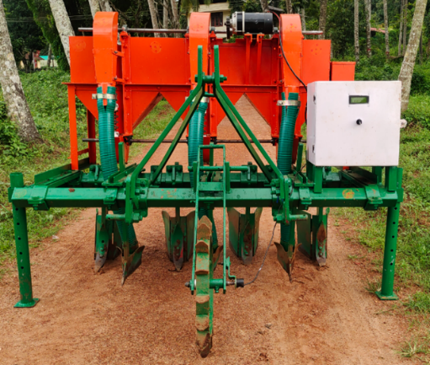 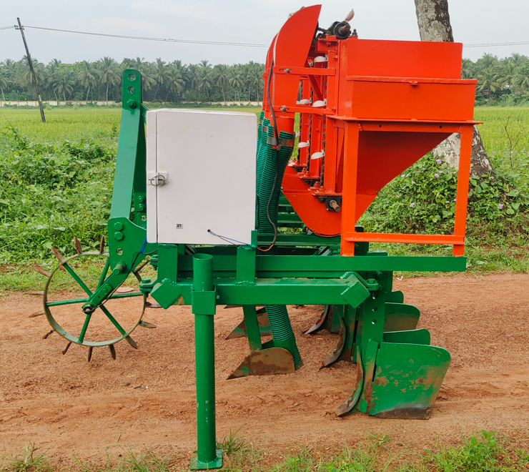

1. **Front view (b) Side view**

|  |  |
| --- | --- |
| No. | Description |
| 1 | Ginger hopper Frame |
| 2 | Ginger hopper |
| 3 | Seed collecting device |
| 4 | Ginger delivery hopper |
| 5 | Ginger metering shaft |
| 6 | DC motor |
| 7 | Chain |
| 8 | Cell size |
| 9 | Tool box |
| 10 | Seed delivery tube |
| 11 | Electronic control box |
| 12 | LCD |
| 13 | Switch |
| 14 | Rotary encoder |
| 15 | Main frame |
| 16 | Shoe type furrow opener |
| 17 | Shovel |
| 18 | Ridger |
| 19 | Hitch point |
| 20 | Supporting stands |

**Plate. 2. Developed sensor-based tractordrawn ginger planter**

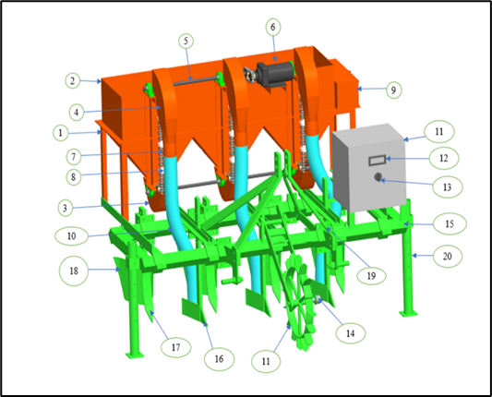

**Fig. 9 Schematic diagram of sensor-based**

**tractor drawn ginger planter**

**2.4 Torque and Power requirement of DC Motor**

In field evaluation it is necessary to maintain the torque for lifting the ginger rhizomes from inside the hopper. The obtained torque was 4.089 N m-1 from maximum capacity of 7.45 N m-1 and required power was recorded 182.76 watts from maximum rated power of 450 W.

**3.0 Results and Discussion**

**3.1 Missing index**

The effect of forward speed and speed of chain on missing index is showed in Table 3. The missing index ranged from 1.5 to 14.16 per cent for different combinations of forward speeds and speed of chains as shown in Fig. 10.

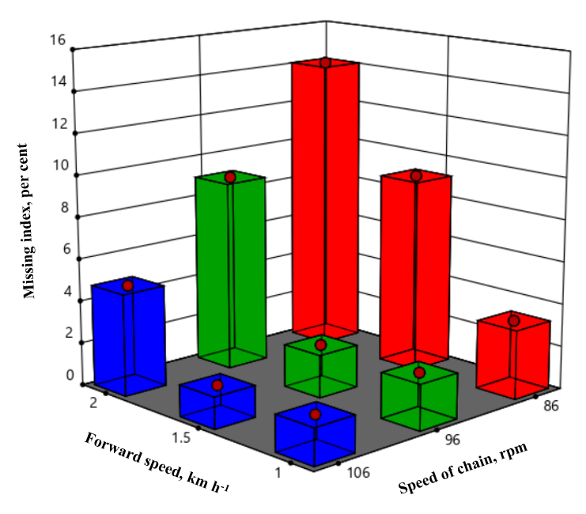

**Fig. 10 Effect of forward speed and speed of chain on missing index with**

**50 mm cell size**

The highest miss index 14.16 per cent was observed at highest forward speed of 2 km h-1 and lowest speed of chain is 86±10 rpm. This was due to decreasing the speed of chain from 96±10 rpm to 86±10 rpm. The lowest missing index 1.5 per cent was observed with a forward speed of 1.5 km h-1 due to increasing the speed of chain from 96±10 rpm to 106±10 rpm.

The analysis of variance (ANOVA) in Table 3 Showed the planter forward speed, speed of chain had a significant effect (p<0.0001) on missing index and the interactions S×V between planter forward speed and metering speed of chain was non-significant effect on missing index at (p > 0.05) probability. With increasing in forward speed from 1 km h-1 to 2 km h-1 resulting an increase in percentage of missing index. This was due to the decrease in speed of chain to 86±10 rpm from 106±10 rpm. Similar results were reported by mathanker and Mathew (2002); Singh *et al*., (2005); Kachman and Smith, (1995); (Madhu kumara., 2017).

**Table 3. Analysis of variance on missing index for ginger**

|  |  |  |  |  |  |  |
| --- | --- | --- | --- | --- | --- | --- |
| Source of variances | Sum of  Squares | DF | Mean  Square | F  Value | p-value |  |
| Model | 421.66 | 4 | 105.42 | 37.56 | < 0.0001 | significant | |
| Forward speed (S) | 236.84 | 2 | 118.42 | 42.16 | < 0.0001 |  | |
| Speed of chain (V) | 184.82 | 2 | 92.41 | 32.92 | < 0.0001 |  | |
| S×V  Residual | 61.75  61.75 | 4  22 | 15.44  2.81 |  |  |  | |
| Lack of Fit | 61.75 | 4 | 15.44 |  |  |  | |
| Cor Total | 483.42 | 26 |  |  |  |  | |
| Std. Dev. | 1.68 | | R2-Squared | | 0.87 |  | |
| Mean | 5.36 | | Adj R-Squared | | 0.8490 |  | |
| C.V. per cent | 32.18 | | Pred R-Squared | | 0.8076 |  | |
|  | | | Adeq Precision | | 18.3457 |  | |

Pvalue < 0.05 is significant

**3.2 Multiple index**

The influence of the forward speed and speed of chain on multiple index of rhizome planter performance is presented in Table 4. The number of rhizomes placed less than 50 per cent spacing as per the recommended distance between spacing is indicated as multiple index of planter. The multiple index of ginger ranged from 0.95 per cent to 3.45 per cent for all levels of forward speeds and speed of chain. However, the lowest multiple index is 0.95 per cent was observed at lowest level of forward speed is 1 km h-1 and highest level of speed of chain is 106±10 rpm as shown in Fig. 11.

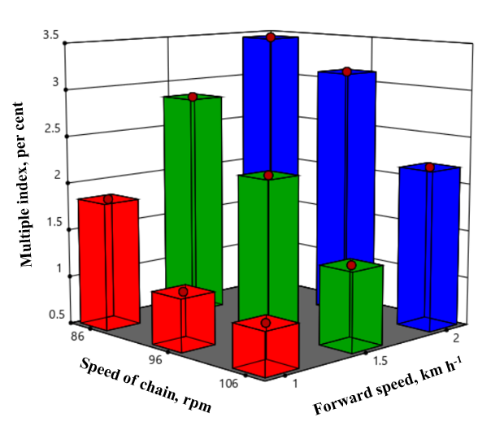

**Fig. 11 Effect of forward speed and speed of chain on multiple index with**

**50 mm cell size**

The analysis of variance (ANOVA) given in Table 4. Revealed that the planter forward speed (p<0.0001), speed of chain (P<0.0001) had a significant effect on the multiple index of ginger rhizomes and the interactions of S×V non-significant at p value > 0.05. From Table 4, it was observed that as forward speed increased with decrease in speed of chain, there was increase in multiple index may be attributed to less time available to pick the seed in the cell due to skid. Increase in multiple index as cell size increase from 50 mm to 60 mm. As cell size increased bulk number of seeds picked up by cell, so multiple indices will increase. As the forward speed increases multiple will increases this was due to increasing metering of chain speed from 86±10 rpm to 108±10 rpm. The maximum multiple index obtained from the study was 3.45 per cent. Similar results are reported by (Madhu kumar., 2017).

**Table 4. Analysis of variance on multiple index for ginger**

|  |  |  |  |  |  |  |  |
| --- | --- | --- | --- | --- | --- | --- | --- |
| Source of variances | Sum of  Squares | DF | Mean  Square | F  Value | p-value |  | |
| Model | 18.89 | 4 | 4.72 | 144.01 | < 0.0001 | significant |
| Forward speed (S) | 12.15 | 2 | 6.08 | 185.33 | < 0.0001 |  |
| Speed of chain (V) | 6.73 | 2 | 3.37 | 102.70 | < 0.0001 |  |
| Residual | 0.7213 | 22 | 0.0328 |  |  |  |
| Lack of Fit | 0.7213 | 4 | 0.1803 |  |  |  |
| Cor Total | 19.61 | 26 |  |  |  |  |
| Std. Dev. | 0.1811 | | R2-Squared | | 0.9632 |  |
| Mean | 2.10 | | Adj R-Squared | | 0.9565 |  |
| C.V. per cent | 8.61 | | Pred R-Squared | | 0.9446 |  |
|  | | | Adeq Precision | | 36.7890 |  |

Pvalue < 0.05 is significant

**3.3 Quality of feed index**

The results pertaining to quality of feed index is given in Table 5. From the Table 5, it is clearly observed that, the quality of feed index of ginger ranged from 82.38 per cent to 97.34 per cent. The highest quality of feed index (97.34 per cent) was observed at a forward speed of 1 km h-1 with a speed of chain of 108±10 rpm, whereas lowest quality of feed index, 82.38 was observed at highest forward speed of 2 km h-1 and lowest level of speed of chain is 86±10 rpm. The quality of feed index decreased from 97.34 per cent to 82.38 per cent with increase in forward speed as shown in Fig. 12. Similar result was observed for potato planter with high quality of feed index at lower forward speed as reported by Gaadi and Marey, (2011); (Madhu kumara., 2017).

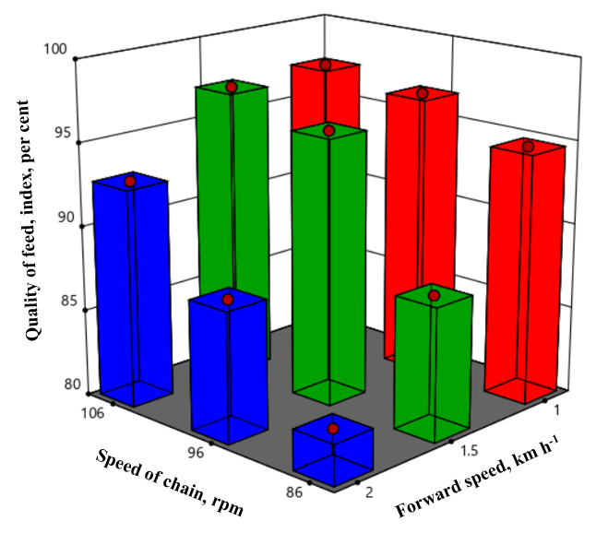

**Fig. 12 Effect of forward speed and speed of chain on quality of feed index with 50 mm cell size**

The analysis of variance (ANOVA) in Table 5. Revealed that the planter forward speed and speed of chain are significant at (p < 0.0001). The interaction S×V between planter forward speed and speed of chain had non-significant effect on quality of feed index of ginger rhizome at (p < 0.05) probability.

**Table 5. Analysis of variance on quality of feed index for ginger**

|  |  |  |  |  |  |  |
| --- | --- | --- | --- | --- | --- | --- |
| Source of variances | Sum of  Squares | DF | Mean  Square | F  Value | p-value |  |
| Model | 611.87 | 4 | 157.97 | 49.11 | < 0.0001 | significant | |
| Forward speed (S) | 351.86 | 2 | 175.93 | 56.49 | < 0.0001 |  | |
| Speed of chain (V) | 260.01 | 2 | 130.00 | 41.74 | < 0.0001 |  | |
| Residual | 68.52 | 22 | 3.11 |  |  |  | |
| Lack of Fit | 68.52 | 4 | 17.13 |  |  |  | |
| Cor Total | 680.39 | 26 |  |  |  |  | |
| Std. Dev. | 1.76 | | R2-Squared | | 0.89 |  | |
| Mean | 92.53 | | Adj R-Squared | | 0.8810 |  | |
| C.V. per cent | 1.91 | | Pred R-Squared | | 0.8483 |  | |
|  | | | Adeq Precision | | 21.1774 |  | |

Pvalue < 0.05 is significant

**3.4 Cell fill efficiency**

The impact of forward speed, and speed of chain on cell fill efficiency was investigated. The experiment involved varying the forward speed between 1 km h-1, 1.5 km h-1 and 2 km h-1, the cell size of 50 mm and the speed of chain are 86±10 rpm, 96±10 rpm and 108±10 rpm. At lowest level of forward speed gives the highest level of cell fill efficiency and decreasing cell fill efficiency at highest level of forward speed as depicted in Fig. 13.

In contrast, the cell fill efficiency was observed at a forward speed of 1 km h-1, cell size of 50 mm and a speed of chain is 96±10 rpm. These parameters outperformed the other configurations and showed better results, particularly when picking rhizomes. This suggests that a combination of forward speed, medium cell size and optimal speed of chain is essential for achieving superior cell fill efficiency in this particular context.

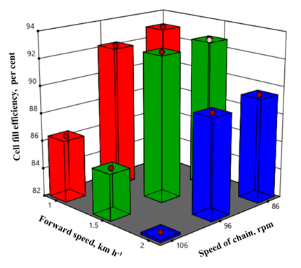

**Fig. 13 Effect of forward and speed of chain on cell fill efficiency with 50 mm cell size**

The effect of forward speed and metering speed of chain for size of cell were analysed statistically and presented in ANOVA Table 6. It is observed from that main factors Forward speed (S), Speed of chain (V) was significant at p < 0.05. However, the effect of cell size (C) was significant for the quality of feed index. The interactions S×V non-significant at p value < 0.05. The cell fill efficiency depends on medium cell seize to get the desired cell fill efficiency. It is revealed from the study that the cell size affects the picking of rhizomes from the picking chamber during singulation of rhizomes. The singulation also depends upon the sphericity and roundness characterisation of the rhizomes. Per cent of cell fill efficiency method was followed by Kepner *et al,.* 1987.

**Table 6. Analysis of variance on cell fill efficiency for ginger**

|  |  |  |  |  |  |  |
| --- | --- | --- | --- | --- | --- | --- |
| Source of variances | Sum of  Squares | DF | Mean  Square | F  Value | p-value |  |
| Model | 703.26 | 4 | 175.81 | 146.46 | < 0.0001 | significant | |
| Forward speed (S) | 136.57 | 2 | 68.28 | 56.88 | < 0.0003 |  | |
| Speed of chain (V) | 566.69 | 2 | 283.34 | 236.03 | < 0.0001 |  | |
| Residual | 26.41 | 22 | 1.20 |  |  |  | |
| Lack of Fit | 26.41 | 4 | 6.60 |  |  |  | |
| Cor Total | 729.67 | 26 |  |  |  |  | |
| Std. Dev. | 1.10 | | R2-Squared | | 0.9683 |  | |
| Mean | 85.39 | | Adj R-Squared | | 0.9572 |  | |
| C.V. per cent | 1.28 | | Pred R-Squared | | 0.9455 |  | |
|  | | | Adeq Precision | | 34.8681 |  | |

Pvalue < 0.05 is significant

**3.5 Hill to hill distance**

The effect of forward speed and speed of chain on hill-to-hill distance is presented in Table 7. from Fig. 14, it is observed that the mean spacing between rhizomes increased with increasing the forward speed and speed of chain during planting. The mean spacing between the rhizomes was observed in between 16.7 to 20.03 cm, while the forward speed ranges from 1 to 1.5 km h-1 with speed of chain is 96±10 rpm as given in Table 7.

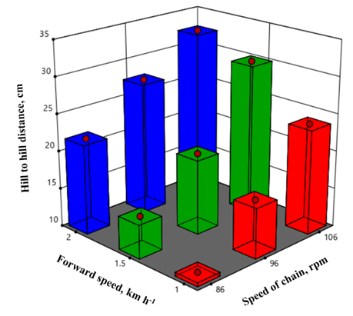

**Fig. 14 Effect of planter forward speed and speed of chain on hill-to-hill distance of ginger**

As shown in Table 7. Shows the planter forward speed and speed of chain had significant effect (P<0.001) on hill-to-hill distance and interactions of S×V between planter forward speed and speed of chain was non-significant effect on hill-to-hill distance (P>0.005). lowest level of speed of chain and highest level of speed of chain are increasing the missing because of less time available to pick the rhizome into the cell. Similar results were reported by Gaadi and Marey (2011); (Madhu kumara., 2017).

**Table 7. Analysis of variance on hill-to-hill distance for ginger**

|  |  |  |  |  |  |  |
| --- | --- | --- | --- | --- | --- | --- |
| Source of variances | Sum of  Squares | DF | Mean  Square | F  Value | p-value |  |
| Model | 1275.10 | 4 | 318.77 | 245.13 | < 0.0001 | significant | |
| Forward speed (S) | 483.81 | 2 | 241.91 | 186.02 | <0.0001 |  | |
| Speed of chain (V) | 791.29 | 2 | 395.64 | 304.24 | < 0.0001 |  | |
| S×V  Residual | 28.61  28.61 | 4  22 | 7.15  1.30 |  |  |  | |
| Lack of Fit | 28.61 | 4 | 7.15 |  |  |  | |
| Cor Total | 1303.71 | 26 |  |  |  |  | |
| Std. Dev. | 1.14 | | R2-Squared | | 0.97 |  | |
| Mean | 22.02 | | Adj R-Squared | | 0.97.41 |  | |
| C.V. per cent | 5.18 | | Pred R-Squared | | 0.9669 |  | |
|  | | | Adeq Precision | | 48.02 |  | |

Pvalue < 0.05 is significant

**4. Conclusion**

The aim of this study was development of a sensor-based system which enable the steeples adjustments of the seed/plant spacing in single seed plater. This study shows the performance and operational evaluation under field conditions. In the evaluations of all experiments performed by using the sensor-based system. While the hill to hill spacing is 20 cm, Imiss 1.55 per cent, Imult 0.95 per cent, Iqf 97.34 per cent and Cell fill 93.33 per cent were found in trials. While plant spacing uniformity obtained in trails using the sensor-based system has given superior performance. By using sensor-based system can control the seed rate, labour power and time. In order to provide a complete mechanical rapport between sensor-based system and planter. **Future studies:** Various structural improvements in the seed metering unit design and optimization of the diameter of cell and thickness, number of cells and connection methods may be required.

**COMPETING INTERESTS DISCLAIMER:**

Authors have declared that they have no known competing financial interests OR non-financial interests OR personal relationships that could have appeared to influence the work reported in this paper.

**REFERENCES**

Al-Gaadi, K. A. and Marey. 2011. Effect of forward speed and tuber characteristics on tuber spacing uniformity for a cup belt potato planter. *Middle E. J. Sci. Res*. 8(4): 753-758.

Ali, M., Khalil, S.K, Ayaz, S and Marwat, M.L. (1998). Phenological stages, flag leaf area, plant height, and leaves per plant of corn influenced by phosphorous level and plant spacing. *Sarhad Journal of Agriculture*, 14:515-522.

Cay, A., Kocabiyik, H., Karaaslan, B., May, S., Khurelbaatar., M. 2017. Development of an opto electronic measurement system for planter laboratory tests. Measurement 102, 90 95. http://dx.doi.org/10.1016/j.measurement.2017.01.060

Iacomi, C., Popescu, O., 2015. A new concept for seed precision planting. *Agric. Sci*. Procedia 6, 38–43. https://:10.1016/j.aaspro.2015.08.035

Indiastat.2023. www.indiastat.com.

Inman, J.W. 1968. Precision planting reality for vegetables. *Agrl. Eng*. 49(6): 344-345.

Kachman, S. D. and Smith, J.A. 1995. Alternative measures of accuracy in plant spacing for planters using single seed metering. *Trans. of the ASAE*, 38 (2): 379-387.

Karayel, D. A. V. U. T., Barut, Z. B., and Ozmerzi, A. 2004. Mathematical modelling of vacuum pressure on a precision seeder. *Biosystems Eng,* 87(4), 437-444.

Karayel, D., 2009. Performance of a modified precision vacuum seeder for no-till sowing of maize and soybean. Soil & Tillage Res. 104, 121-125. <http://dx.doi.org/10.1016/j>. still.2009.02.001.

Karayel, D., Barut, Z.B., Ozmerzi, A., 2004. Mathematical modelling of vacuum pressure on a precision seeder. Biosyst. Eng. 87, 437-444. <http://dx.doi.org/10.1016/j>. biosystemseng.2004.01.011.

KAU [Kerala Agricultural University]. 2016. *Package of Practices Recommendations: Crops.* Kerala Agricultural University, Thrissur.

Kepner, R.A., Bainer, R., and Barger, E.L. 1987. Principles of farm machinery, CBS Publishers and distributors Pvt. Ltd, New Delhi.

Kopak, R. (1997). Effect of planting method on yield and growth dynamics of potatoes grown from mini tubers. Zeszyty Problemowe Postepow Nauk Rolniczych. 439: 281-287.

Kumar, V. J. F. and Durairaj, C. D. (2000). Influence of head geometry on the distributive performance of air-assisted seed drills, *J. Agric. Eng. Res*., 75: 81-95.

Li, Y., He, X.T., Tao, C., Zhang, D.X., Song, S., Rui, Z., Mantao., W. 2015. Development of mechatronic driving system for seed meters equipped on conventional precision corn planter. *Int. J. Agric. Biol. Eng*. 8, 1–9. <http://dx.doi.org/10.3965/j.ijabe.20150804>. 1717.

Liang, Z., Zhang, D., Yang, L., Cui, T., Hao, Y., 2015. Experimental study on motor driven pneumatic precision seed-metering device for maize, in: ASABE Paper No: 152189758. St Joseph, Michigan. https://:10.13031/aim.20152189758.

Madhu Kumar, D. M. 2017. Design, development and testing of a tractor drawn semi- automatic rhizome planter for ginger and turmeric. M.Tech.(Ag. Engg.) thesis, Kerala Agricultural University. Mathanker, S. K. and Mathew, M. 2002. Metering mechanisms for ginger planter. *Agric. Eng. J.* 11(1): 31-39.

Murray, J. R., Tullberg, J. N. and Basnet, B. B. (2006). Planters and their components, types, attributes, functional requirements, classification and description. *Australian Centre for Int. Agric Res*, 135-137.

Onal, I., Degirmencioglu, A., Yazgi, A., 2012. An evaluation of seed spacing accuracy of a vacuum type precision metering unit based on theoretical considerations and experiment. *Turkish J. Agric.* For. 36, 133–144. <http://dx.doi.org/10.3906/tar-1010> 1316.

Rintelen, P. (1971). Eon Handbook use production static and economic, DLG VERLAG, Frankfurt. Fruits and Vegitable Sector TEDO. 243 - 251.

Staggenborg, S.A., Taylor, R.K., Maddux, L.D., 2004. Effect of planter speed and seed firmers on corn stand establishment. *Appl. Eng. Agric*. 20, 573–580. <http://dx.doi>.org/10.13031/2013.17457.

Yazgi, A., Degirmencioglu, A., 2014. Measurement of seed spacing uniformity performance of a precision metering unit as function of the number of holes on vacuum plate. Measurement 56, 128–135. <http://dx.doi.org/10.1016/j.measurement.2014>. 06.026.