**Influence of Lifestyle, Environmental, and Socioeconomic Factors Associated with Sickle Cell Disease in the Centre Region of Cameroon**

**ABSTRACT**

**Background**

This study explores clinical clusters of sickle cell anemia and their associations with lifestyle, environmental, and socioeconomic factors among patients in the Centre region of Cameroon.

**Methods**

We enrolled 185 participants from four hospitals in Yaoundé between October 2023 and September 2024. Information on lifestyle, environmental, and socioeconomic factors within the 12 months preceding enrollment was collected using self-reported questionnaires and clinical data was retrieved from patients’ medical records. Patients clustering was performed using KAy-means for Mixed Large data. Associations between clinical clusters and exogenous factors were evaluated using association plots, chi-square tests and regression analysis to quantify relationships.

**Results**

Two distinct clinical clusters were identified (Cluster 1 and Cluster 2) sharing common symptoms and sickle-related complications, but differing significantly in disease severity, with Cluster 1 exhibiting a higher burden of hospitalizations, transfusions, painful episodes and pain severity. Lifestyle factors (stress, anxiety, physical inactivity, routine checkups) and environmental conditions (sensitivity to windy, humidity, dust and smoke) were significantly associated with cluster membership, and contributed to the greater clinical burden observed in Cluster 1.

**Conclusion**

The study provides a foundation for further research into the multifactorial drivers of disease severity in Cameroon and highlights the importance of patient and caregiver education on lifestyle optimization and the health risks of environmental exposures, with potential benefits for healthcare burden reduction among sickle cell patients.

**Keyword**:

Sickle cell disease, sickle cell anemia, lifestyle factor, weather, climate, socioeconomic factors, sickle cell crisis, patient clusters.

**BACKGROUND**

Sickle cell disease (SCD) is widely regarded as the most severe monogenic disease globally, characterized by recurrent episodes of acute illness and progressive damage to vital organs [1]. It is predominantly found in individuals of Sub-Saharan descent, as well as in populations from India, Middle East and parts of South America, the Caribbean, and the Mediterranean region [2]. In Africa alone, it is estimated that about 1,000 children are born with SCD daily, predominantly sickle cell anemia (SCA) [2,3]. Projections by experts suggest a 30% increase in the global prevalence of SCD by 2050, driven by declining infant mortality rates due to advancements in healthcare and management of SCD among affected infants [2]. As of 2021 published data, the estimated prevalence of SCD in Cameroon ranged between 0.3% to 0.7% [2], with SCA being the most dominant genotype. Sickle cell disease imposes a profound physical and mental burden on both patients and their families in Cameroon [4].

Vaso-occlusion crisis (VOC), arising from obstructed blood flow in the microvasculature when sickled hemoglobin S red blood cells become trapped and are unable to pass through narrow blood vessels, serves as the primary driver of all acute and chronic complications seen in patients with SCD [5]. The complications of SCD are far reaching, involving multiple organs, and patients often present with multiple symptoms that can vary in severity at different stages throughout a patient’s lifetime. Acute symptoms can differ within the same patient from one episode to another and may change over time with age, as well as due to influences from endogenous and exogenous factors such as lifestyle, environment and infections [6–8]. Understanding patient’s clinical severity differences in homozygous SCD of the same haplotype is complex, as some patients with chronic complications can survive for extended periods while others may experience sudden death without prior acute indications [9]. The severity of SCD can be regarded as a spectrum of clinical manifestations that may or may not vary over time, potentially predisposing patients to an increased risk of morbidity and mortality. Many studies have attributed differences in clinical severity to the modifying effects of genetic and environmental influences [6,10]. The effect of environmental factors, such as pollution, climate, and weather conditions, has been studied through retrospective or prospective distributed lag models of these factors with emergency department visits, and hospital admissions [6,11,12]. Conducting such studies in settings where daily quantitative local data on pollution and weather are scarce poses unique challenges. Descriptive exploratory analysis may offer an alternative approach.

This study aims to identify clusters of SCA patients in the Centre Region of Cameroon based on shared clinical characteristics and investigate the associations between these clusters and lifestyle factors, environmental influences and socioeconomic factors. By doing so, it seeks to inform the development of targeted interventions for high-risk patients, enhance patient education and caregiver support, and improve complication monitoring and healthcare provider training in primary care centers.

**Material and Methods**

**2.1. Study design and participants**

This observational multicenter cross-sectional study recruited SCD patients from October 2023 to September 2024 at four health facilities in Yaoundé: Central Hospital, Cite Vert District Hospital, Gyneco-Obstetric and Pediatric Hospital, and *Centre D’animation Sociale et Sanitaire*. These centers were selected to capture a diverse patient population from primary, secondary and tertiary care settings, representing various ethnic groups and socioeconomic backgrounds. Only patients who had resided in the Centre Region for the past year were recruited to ensure consistent exposure to similar weather and climatic conditions and minimize variations. All recruited participants were homozygous SCD patients, as documented in their patient-held health (PHH) booklets. Patients were eligible if they were in steady state or experiencing a sickle cell crisis, defined as acute mild-to-severe pain or severe anemia with no underlying cause other than VOC. Additionally, patients aged 4 years or older who had not received hydroxyurea for at least the past 12 months were eligible. The sample size was estimated using a formula for survey sampling based on prevalence [13], assuming a published estimated prevalence of SCD in Cameroon of 0.3%−0.7% [2], a 1% margin of error, and a 95% confidence interval. A minimum of 114 patients was considered appropriate for this study. The study received approval from each study center’s ethics committee, and all patients (or their parents/guardians) provided signed, dated informed consent and assent from children where applicable, authorizing the use of their personal and medical information for research purposes.

**2.2. Design of the study questionnaire**

Study questionnaires were designed to collect face-to-face data on lifestyle factors, environmental influences, socioeconomic impacts, and patients’ clinical history, providing insight into the characteristics of the population under study. The questionnaires underwent review by two hematologists specializing in SCD treatment, two general practitioners experienced in managing SCD, a nurse supervisor from a hematology department who frequently interacts with SCD patients, a pediatrician, and our scientific research committee. The questionnaire was pretested and validated by the supervisory team of the study. To ensure accurate responses, patients were asked simple and concise questions, which were read aloud and further explained as needed. The questionnaires focused on three key domains: (1) lifestyle and well-being factors, (2) meteorological risks, and (3) socioeconomic conditions. A fourth domain gathered patients’ personal accounts of their painful episodes, transfusions, and frequency of hospitalizations. All patient-reported information were cross-checked against medical records to minimize recall bias. When patient-provided information could not be verified, responses were assumed to be valid.

**2.3. Demographic characteristics**

Information regarding participants demographic information including gender, age (in years), ethnic group, height (in centimeters), weight (in kilograms) and residential council area were registered.

**2.4. Assessment of well-being and lifestyle**

The perceived stress scale (PSS) score was used to assess stress level related to living with SCD in patients aged 17 and older. Two questions from the PSS, as previously described [14] were included: “How often have you felt that you were unable to control the important things in your life?” and “How often have you found that you could not cope with all the things that you had to do?” (in the context of living with SCD in the past 3 months). Responses were rated on a five-point Likert scale: 1 (never), 2 (almost never), 3 (sometimes), 4 (fairly often) and 5 (very often). Factor analysis using polychoric correlations was conducted, and factors scores were derived through the regression method [14]. Factor scores were scaled from 0 to 100 by subtracting the minimum score from each score, dividing the result by the range and multiplying by 100. Patients were asked to identify the life events (stressors) that had the greatest impact on their stress levels. These stressors included anticipation of pain, cold weather, feeling dehydrated, academic or work-related pressure, mood fluctuations, lack of sleep, not being physically active, loneliness and financial difficulties.

The Patient-Reported Outcomes Measurement Information System (PROMIS®) short form for anxiety, consisting of eight items selected from a 56-item bank, was used to assess perceived anxiety in patients aged 17 and older. PROMIS is a validated item bank widely used to measure emotional distress, including depression, anxiety and anger [15], and has been applied to evaluate anxiety level in individuals with other debilitating conditions [16]. The short form used in this study included eight questions, and each rated in a five-point scale: 1 (Never), 2 (Rarely), 3 (Sometimes), 4 (Often) and 5 (Always). The raw score was calculated by summing the item scores, multiplying the total by 8 (number of items), dividing by the number of answered items, and then converting it into a T-score ranging from lowest to highest anxiety [17].

To evaluate the impact of SCD on the daily lives of patients aged 17 and older, patients responded to four questions assessing different aspects of daily living. These questions were phrased as: “How does this condition impact your daily life in the following areas?”: (1) engaging in physical activity, (2) school/wok life, (3) perform household tasks, and (4) family and social life. Response options included: not at all, slightly, moderately, very much and extremely.

To assess the frequency of physical activity, patients reported the number of times they engaged in physical exercise per week over the past 12 months. Responses were categorized as: none, less than three times per week, three to six times per week, and daily. Physical activity was defined according to the World Health Organization’s guidelines for adults and children living with disability, as 150−300 minutes of moderate- to high-intensity aerobic exercise per week (approximately 25−45 minutes per day) [18].

Additionally, participants estimated average daily water intake over the past 12 months was recorded and classified into three groups: less than 1 liter per day, about 1 liter per day, and more than 1 liter per day, across all age groups. Nutrition habits were assessed based on the number of meals consumed per day, excluding snacks taken between meals. Intake was categorized as: 1−2 meals per day, 3−4 meals per day and more than 4 meals per day. The frequency of fruit and green vegetable consumption was recorded as binary measure (daily/not daily).

Participants were also evaluated for tobacco use and passive exposure to cigarette smoke at home. Additional data on well-being included the number of routine checkup visits patients had in the past 12 months. Routine checkup was defined as scheduled outpatient health assessment at a health facility (primary, secondary, or tertiary) during steady state, including vital sign monitoring, physical examination, and routine laboratory tests, excluding post-hospitalization follow-up appointments.

**2.5 Environmental influences**

Due to the lack of local meteorological data for the Centre region of Cameroon, the impact of environmental factors was assessed based on patient’ self-reported-exposure over the past year to various conditions, including cold, heat, high wind, humidity, seasonal changes, road dust and smoke fumes (including indoor biomass burning for cooking, vehicle exhaust, and other sources). Patients reported whether these factors consistently coincided with mild-to-severe painful episodes or other symptoms within 1−3 days post-exposure. Road dust and smoke fumes comprises of pollutants like metals, CO, NO2, and particulate matters(PM10 and PM2.5) [19,20] which are harmful to health. Additionally, patients and caregivers identified the season during which patients most frequently experienced painful episodes, categorized as rainy season, dry season and no specific season.

**2.6 Socioeconomic impact**

The questionnaire assessing socioeconomic status was designed to identify factors influencing patients access to adequate medical care. Parental level of education was categorized as follows: no formal education, primary education, secondary education, high school or vocational training, and university education. Household size was grouped based on the number of residents: 1−3, 4−6, and more than 6 individuals per household.

Patients were asked to assess the ventilation in their bedrooms, categorized as well-ventilated, inadequate ventilation and lacking ventilation. Poor bedroom ventilation and overcrowding can disrupt the indoor CO2/O2 balance, affect temperature regulation, increase indoor particulate matter exposure, and negatively impact sleep quality, as well as mental and physical well-being [21]. Additionality, inadequate ventilation may exacerbate chronic respiratory conditions including hypoxemia in symptomatic patients, chronic lung disease and sleep-disordered breathing. Adequate bedroom ventilation was defined as the natural flow of air between indoor and outdoor spaces, ensuring the room is neither airtight nor stuffy at night and that air quality does not interfere with normal breathing during sleep.

Total household income was categorized into three groups: less than XAF 100,000 ($165 USD) per month, XAF 100,000–200,000 ($165−330 USD) per month, and more than XAF 200,000 ($330 USD) per month ($1 USD = XAF 606.35, based on World Bank average local currency unit per US dollar in 2024) [22]. These thresholds were determined based on the poverty line in Cameroon, which was set around XAF 24,724 per person per month according to the National Institute of Statistics [23]. Additionally, consideration was given to the fact that most participants aged 17−25 were unaware of their household income. Household income was defined as the combined monthly earnings of all individuals permanently residing in the same household.

**2.7 Clinical data**

Patient medical records (PMR) were obtained from PHH booklets, hospital inpatient files, and patient-reported health experiences gathered through open-ended questionnaires.

Data on the number of painful episodes in the past three months, hospitalizations in the past 12 months, and blood transfusion units received in the past 12 months due to sickle cell crisis (no patient was receiving routine blood transfusion stroke prevention) were retrieved from PMR. A transfusion unit was defined as one whole blood unit, approximately 450 mL. To minimize response bias, the analysis focused on the number of mild to severe painful episodes lasting a few hours to several days within the past 3 months, as patients and caregivers struggled to accurately recall events over a longer period. Pain severity was categorized as mild (1–4), moderate (5–7) and severe (8–10) on a 1−10 scale. Hospitalization was defined as inpatient stay of ≥24 hours due to acute painful episodes, VOC, anemia, infection, or other VOC-related complications.

Data on frequent signs and symptoms experienced by patients in the past 12 months were extracted from PMR, and baseline clinical findings were documented during a physical examination by a physician at enrollment. Medical records and patient/caregiver provided information were used to document patients’ histories of sickle cell-related complications such as avascular necrosis and ulceration since birth. Cardiopulmonary risk was defined as: (1) resting or sleeping partial oxygen saturation <90% on a pulse oximeter [24], during at least two consecutive VOC episodes or (2) history of systemic hypertension (systolic blood pressure ≥130 mmHg or diastolic blood pressure ≥85 mmHg). Hypoxia and hypertension were considered markers of cardiopulmonary involvement [25], due to their ease of measurement in low-resource settings.

**2.8. Statistical analyses**

Summary statistics were computed for categorical variables (frequency and percentage) and continuous variables (average and standard deviation). In SCD, a single clinical outcome variable such as hospitalizations or emergency department visits may insufficiently capture disease severity, as patients often experience multiple clinical conditions simultaneously or over time. Still, real-world medical data often comprise mixed data types (categorical and continuous) [26], which rarely satisfy traditional multivariate model assumptions. Furthermore, patients may not always seek emergency care when needed due to limited access to comprehensive healthcare program, access to healthcare and financial constraints (out-of-pocket affordability). Therefore, clustering was used to group patients based on shared medical history (frequency of hospitalization, painful episodes and transfusion), systemic assessments and history of signs/symptoms (Table 1). Data suitability for clustering was assessed using Hopkin’s statistics and collinearity acceptance range was <0.55 correlation. The Adjusted Rand Index was used to compare and select KAy-means for Mixed Large data (KAMILA) method over alternative clustering methods, including K-prototype, partitioning around medoids (PAM), hierarchical clustering and latent class model. The optimal number of clusters was determined using a heuristic approach: silhouette score (for K-prototype, hierarchical clustering, and PAM) and statistical criteria (Bayesian information criteria for latent class model, and log-likelihood for KAMILA). Associations between lifestyle factors, environmental influences and socioeconomic factors and cluster groups were examined using mosaic plots, Chi-square tests, and regression models with binomial link function as appropriate. Analysis were performed using R software for statistical computing and graphics with various packages [27].

Table 1. Clinical outcome variables used for clustering based on data accessibility in a primary health setting.

|  |  |  |
| --- | --- | --- |
| **Clinical outcome**  **parameter** | **Description** | **Variable type** |
| **Medical history** | |  |
| Hospitalization | The number of SCD related hospitalizations over the past 12 months | Numeric |
| Transfusion | The number of blood transfusions over the past 12 months | Numeric |
| Painful episodes | The total number of mild to severe periodic painful episodes, lasting from a few hours to several days over the past 3 months | Numeric |
| Pain severity | Pain severity level (mild moderate, or severe) reported during the past 3 consecutive hospitalizations | Ordinal |
| **Signs and symptoms** | |  |
| Bone/joint pain | The patient frequently had bone or joint pain during crisis | Binary |
| Abdominal pain | The patient frequently had abdominal pain during crisis | Binary |
| Fever | The patient usually had fever during crisis (axillary temperature >37.5ºC) | Binary |
| Cough | Frequently had acute/chronic cough during crisis | Binary |
| Chest pain | Have experienced a sharp chest pain at least twice during crisis | Binary |
| Dark urine | Often had dark urine during crisis | Binary |
| Other symptoms/diagnosis | Presence of other symptoms during the past 3 hospitalizations | Binary |
| **Other clinical assessment** |  |  |
| Avascular necrosis | The patient had a history of avascular necrosis | Binary |
| Infection | Whether the patient was diagnosed with an infection over the past 12 months | Binary |
| Ulceration | The Patient has a history of ulceration | Binary |
| Cardiopulmonary | PaO2 was <90% during 2 or more conservative crisis and/or a history of systemic hypertension (≥130/85 mmHg) | Binary |
| Comorbidity | Presence of other comorbidities associated or not associated to SCD | Binary |
| PaO2; partial oxygen saturation taken with a pulse oximeter.  Binary data were coded as Yes or No. | | |

**Results**

The demographic characteristics of the participants are presented in Table 2. A total of 210 SCD patients from 10 municipalities in Yaoundé and surrounding areas were approached, of whom 185 met the inclusion criteria. The participants belonged to 44 different ethnic groups across Cameroon, with 70% of the participants representing the six ethnic groups: Béti (16%), Bamiléké (15%), Bulu (12%), Bassa (11%), Éton (8%) and Ewondo (8%). The study included 102 females (55%) and 83 males (45%). Participant ages ranged from 4 to 59 years, old with the majority (42%) falling between 17 and 25 years old.

Table 2. Demographic characteristics. Continuous variables are expressed as averages and categorical variables as frequencies

|  |  |  |
| --- | --- | --- |
| **Variable** | **Mean (SD)** | **Range**  **(Min-Max)** |
| Age (years) | 19.79 (11.68) | 4-59 |
| Height (cm) | 151.58 (23.81) | 99-189 |
| Weight (kg) | 45.13 (17.19) | 13-90 |
|  | **Frequency** | **Percent**  **(%)** |
| Age category |  |  |
| Under 17 years old | 68 | 37 |
| 17-25 years old | 74 | 40 |
| 26-35 years old | 23 | 12 |
| Over 35 years old | 20 | 11 |
| Gender |  |  |
| Female | 102 | 55 |
| Male | 83 | 45 |
| Tribe or ethnic group |  |  |
| Béti | 29 | 16 |
| Bamiléké | 27 | 15 |
| Bulu | 23 | 12 |
| Bassa | 20 | 11 |
| Éton | 15 | 8 |
| Ewondo | 15 | 8 |
| Bamoun | 5 | 3 |
| Mbamois | 5 | 3 |
| Hausa | 4 | 2 |
| Yambassa | 4 | 2 |
| Douala | 3 | 2 |
| Bayangi | 2 | 1 |
| Bené | 2 | 1 |
| Mankong | 2 | 1 |
| Others* | 29 | 16 |
| * Ethnic groups with a single participant: *Bafut, Bakaka, Bakossi, Bakweri, Bama'a, Bamvélé, Banen, Bangwa, Banna'a, Bayangam, Gbaya, Guiziga, Maka, Mbam, Mbo, Mbouda, Ngemba, Ngimba, Nguemba, Ngwo, Ntumu, Nzambo, Podoko, Tika, Widikum, Wom, Yabassi, Zimé* | | |

The average PSS score was 56.7 (SD 23.3; range 0−100), while the average perceived anxiety score was 57.5 (SD 8.5; range 37.1−78.2). No significant difference in PSS score or perceived anxiety score were observed across ages (see supplemental Table S1). The most frequent stress triggers reported by patients included cold weather, academic or work-related demands, financial difficulties, and the anticipation of pain (Figure 1). However, in patients aged 25 years and older, lack of sleep emerged as a significant source of stress. A mild positive correlation was observed between the number of stressful events to which a patient was susceptible (stress triggers) and their PSS score (r=0.23, *p*=.01). The relation was more pronounced in patients who experienced at least six of the nine identified stressful events.

For patients aged 17 and older, SCD had a mild to extreme impact on daily life, affecting their ability to engage in physical activities, attend school or work, meet occupational demands, perform household tasks, and participate in family and social activities. Among these patients, school or work demands had the greatest impact on daily life (71%), Additionally, a limited ability to engage in physical activity and difficulty performing household chores were other factors reported as significantly affecting daily life (Figure 1).

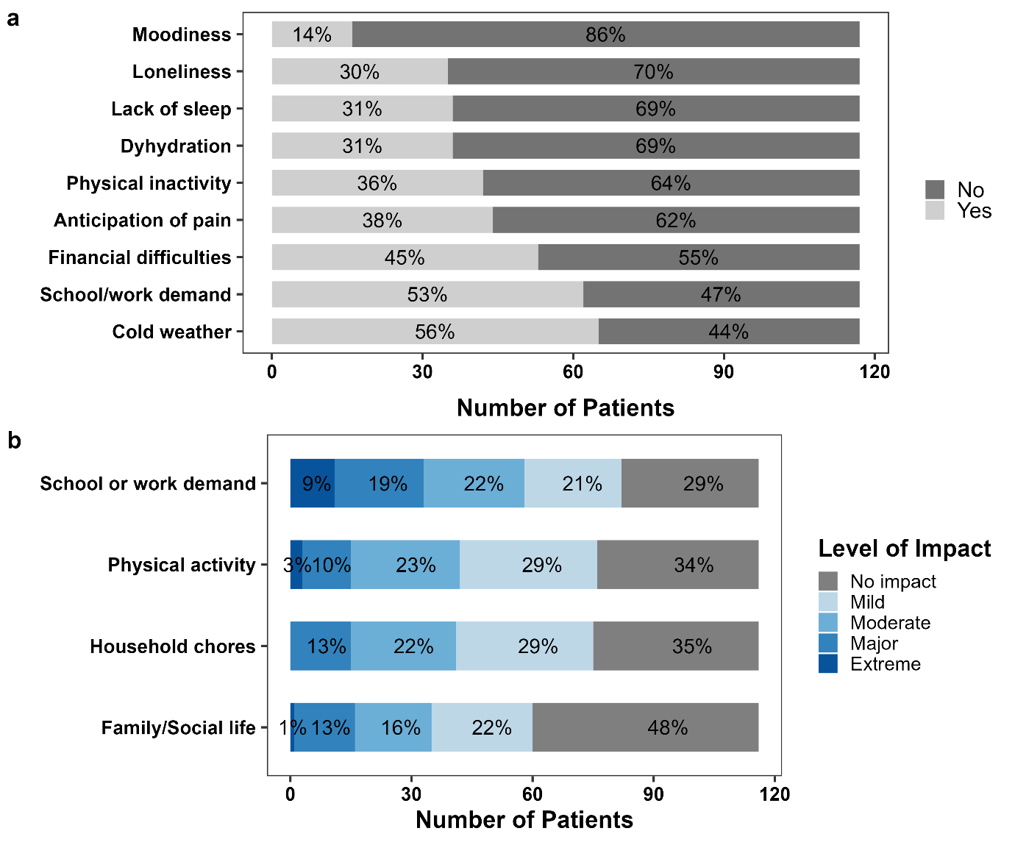

Figure 1. Impact of SCA on well-being among patients aged 17 and older. **(a)** Most stressful events experienced by patients as a result of living with SCA. **(b)** Degree to which SCA impacts patients’ day-to-day life.

A limited proportion of patients engaged in moderate-to high-intensity aerobic physical activity daily (11%, n=21), while 18% (n=33) reported engaging in physical activity 3 to 6 times per week. Most patients either exercised fewer than three times per week (35%, n=65) or did not engage in physical activity at all (36%, n=66). The majority of those who exercised daily were children (under 17 years old). Among 117 individuals aged 17 or older, three (2%) were smokers. Daily water intake exceeded 1 Liter for most patients (81%, n=150), compared to 15% (n=27) who drank about 1 Liter/day and 4% (n=8) who usually drank less. Although many patients reported adequate hydration, a notable proportion of those consuming one liter or less per day were under the age of 17. Sixty percent (n=111) of patients reported consuming on average 3 to 4 main meals per day, whereas 31% consumed only 1 to 2 meals daily, with 43% of this group being young adults aged between 17 to 25. Only a small proportion of patients regularly consumed fruits (16%, n=30) and leafy vegetables (6%, n=11). The average number of routine checkups was 2.63 (SD 43) per year and showed a mildly negative correlation with age (r=-0.21, *p*=.003). Patients younger than 17 had on average 3.40 (SD 2.44) checkups per year, while the average for those aged 17 to 25 was 1.61 (SD 2.13), 1.73 (SD 1.98) for those 26 to 35 years and 2.44 (SD 2.77) for patients older than 35 years.

The seasonal influence on sickle cell crises varied among patients: 44% (n=81) reported frequent painful crisis episodes during the rainy season, 5% (n=9) during the dry season, and 51% (n=95) across both seasons without a consistent seasonal pattern over the years. A substantial proportion of patients reported multiple weather-related triggers for sickle cell crises, with 84% (n=155) identifying cold weather, 36% (n=66) high humidity, 29% (n=54) hot weather, and 26% (n=48) windy conditions as contributing factors. Remarkably, only 5% of patients reported no discernible weather-related VOC trend over recent years. Regarding road dust and smoke fumes exposure as potential triggers, 19% (n=35) cited frequent exposure to road dust and 17% (n=31) reported smoke fumes as preceding their crises. Importantly, the proportion of individuals impacted by these environmental factors appeared to increase with age (Figure 2).

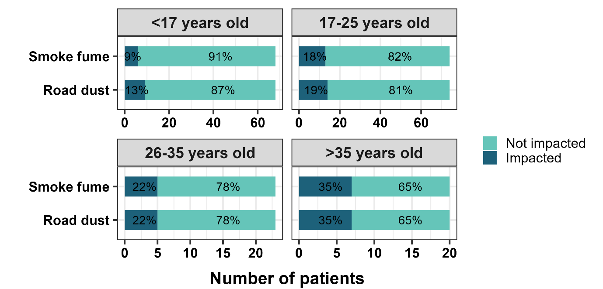

Figure 2. Patient self-reported impact of smoke fumes and road dust on their health: Proportion of patients frequently experiencing ill-health 1 to 3 days post-exposure across all ages.

Regarding the socioeconomic impact, the response rate for household income was low, with 72% (n=133) of participants providing an answer. Meanwhile, 28% (n=52) either lacked knowledge of their household income or opted not to disclose this information. Those whose household income per month was less than XAF 100,000 ($165 USD) per month stood at 29% (n=39) compared to 33% whose household income per month exceeded XAF 200.000 ($330 USD) (n=44). Household income for most patients ranged between XAF 100,000 to 200,000 (38%, n=50). Most patients lived in medium-sized households (four to six persons), accounting for 47% (n=38). Small households (one to three persons) made up 21% (n=38), while large households (more than 6 persons) comprised 32% (n=60). Most patients resided in household where two or three individuals shared a single room, with 25% classified as belonging to the low-household income (XAF <100,000/month) category. Households with four or more persons per room were predominantly low-income (XAF <100,000/month), whereas those with one person per room were primarily high-income (XAF >200,000/month) (Figure 3). Bedroom ventilation was adequate in most households (72%, n=134) while the rest either had inadequate ventilation (9%) or lacking ventilation (19%). Other socioeconomic characteristics are provided in the supplementary material (Table S2).

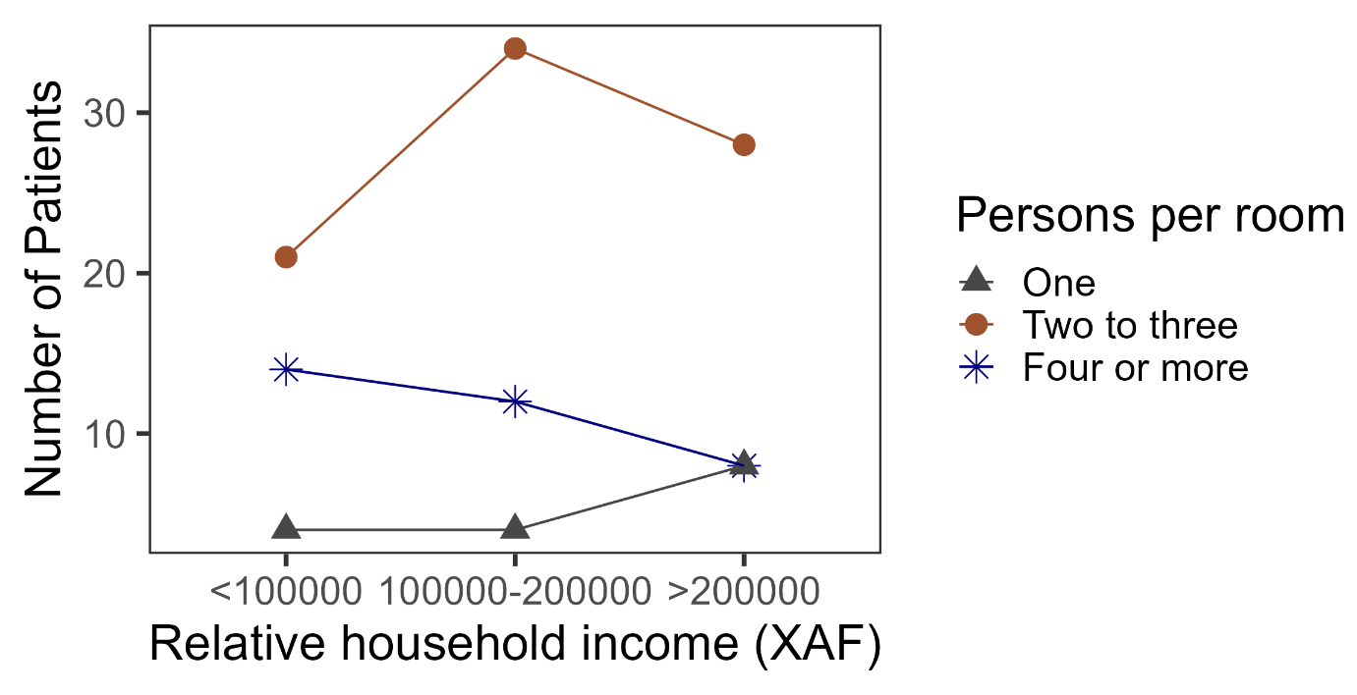

Figure 3. Relationship between household income and the number of persons per room among sickle cell patients, illustrating socioeconomic conditions. XAF: Central African CFA Franc ($1 USD = XAF 606.35) [22]

Table 3 presents the clinical characteristics of the participants in this study. The frequency of mild to severe painful episodes in the three months preceding enrollment ranged from 0 to 15, with 37% (n=68) reporting zero to one episode and 30% (n=55) reporting more than three episodes. Among the participants, 46% frequently experienced severe pain, 23% reported moderate pain, and 31% described their pain as mostly mild. The number of hospitalizations ranged from 0 to 10, with 26% (n=49) reporting no hospitalization and 14% (n=25) experiencing more than three hospitalizations in the 12 months preceding enrollment. A substantial proportion of patients received no blood transfusion ((51%, n=59) during the 12 months prior to enrollment. On the other hand, 29% (n=53) reported receiving 1 to 2 units of whole blood, while the remaining patients received at least 3 units. The maximum number of transfusions received was 10 units (n=2). The most frequent signs and symptoms during sickle cell crisis included bone and joint pain (n=118), fever (n=93), chest pain (n=52), cough (n=46), dark urine (n=43), and abdominal pain (n=23). Among those who reported abdominal pain, 74% were children under the age 17. Malaria was the most diagnosed infection during crisis, accounting for 38% (n=13) of all infections recorded in the 12 months preceding enrollment. Pneumonia was the second most common, representing 15% of diagnosed infections. Seventeen patients (9%) had a history of avascular necrosis prior to study enrollment.

Table 3. Clinical characteristics of study participants.

|  |  |  |
| --- | --- | --- |
| **Clinical characteristic** | **Frequency** | **Percent**  **(%)** |
| Bone/joint pain |  |  |
| No | 67 | 36 |
| Yes | 118 | 64 |
| Abdominal pain |  |  |
| No | 162 | 88 |
| Yes | 23 | 12 |
| Fever |  |  |
| No | 92 | 50 |
| Yes | 93 | 50 |
| Cough |  |  |
| No | 139 | 75 |
| Yes | 46 | 25 |
| Chest pain |  |  |
| No | 133 | 72 |
| Yes | 52 | 28 |
| Dark urine |  |  |
| No | 142 | 77 |
| Yes | 43 | 23 |
| Other symptoms and diagnosis |  |  |
| Cholecystitis | 6 | 25 |
| Dyspnea | 2 | 8 |
| Periorbital edema | 2 | 8 |
| Malaise | 2 | 8 |
| Cholelithiasis | 2 | 8 |
| Acute chest syndrome | 2 | 8 |
| Others **a** | 8 | 33 |
| Avascular Necrosis |  |  |
| No | 168 | 91 |
| Yes | 17 | 9 |
| Infection |  |  |
| Malaria | 13 | 38 |
| Pneumonia | 5 | 15 |
| Pulmonary infection | 3 | 9 |
| Hepatitis A | 2 | 6 |
| Pyelonephritis | 2 | 6 |
| Tuberculosis | 2 | 6 |
| Urinary tract infection | 2 | 6 |
| Other types of infections **b** | 5 | 15 |
| Ulceration |  |  |
| No | 179 | 97 |
| Yes | 6 | 3 |
| Stroke |  |  |
| No | 183 | 99 |
| Yes | 2 | 1 |
| Cardiopulmonary |  |  |
| No | 168 | 91 |
| Yes | 17 | 9 |
| Other comorbidities |  |  |
| Asthma | 2 | 25 |
| Ocular condition | 2 | 25 |
| Vascular epilepsy | 1 | 13 |
| Psychomotor development retardation | 1 | 13 |
| Mitral valve regurgitation | 1 | 13 |
| HIV | 1 | 13 |
| Hospitalizations **c** |  |  |
| Zero | 49 | 26 |
| 1-3 | 111 | 60 |
| >3 | 25 | 14 |
| Painful episode **d** |  |  |
| 0-1 | 68 | 37 |
| 2-3 | 62 | 33 |
| >3 | 55 | 30 |
| Transfusions **c** |  |  |
| Zero | 59 | 51 |
| 1-2 | 53 | 29 |
| 3-4 | 20 | 11 |
| 5-6 | 11 | 6 |
| >6 | 6 | 3 |
| **a** Symptoms and diagnosis with a single case: Angina, Dysphagia, Gynecomastia, chronic Sciatica, Osteitis, Priapism, Supraclavicular Swollen Lymph and Tachycardia.  **b** Infections with a single case: Helicobacter pylori, Osteomyelitis, Otitis, Salmonellosis and Tonsillitis.  **c** Number of hospitalizations and transfusions during the past 12 months preceding hospitalization.  **d** Number of mild to severe painful episodes over the past three months preceding enrollment. | | |

We identified two clusters of sickle cell patients in the Centre region of Cameroon based on the predefined clinical characteristics, as described in the Methods section (Table 1), which we referred to as Cluster 1 and Cluster 2. Cluster 1 comprised 56 patients, while Cluster 2 included of 129 patients, approximately 50% of whom were aged 17 or younger. The odds of being classified in Cluster 2 (compared to Cluster 1) were significantly lower with each hospitalization per year (OR 0.45, 95% CI 0.34−0.58, *p*<.001), transfusion units per year (OR 0.37, 95% CI 0.26−0.48, *p*<.001) and mild to severe painful episodes in the past three months (OR 0.27, 95% CI 0.17−0.39, *p*<.001). The clusters also exhibited significant differences in the proportion of patients reporting severe pain (70% in Cluster 1 vs. 50% in Cluster 2; *Z*21=7.93, *p*=.005) and cough (11% in Cluster 1 vs. 31% in Cluster 2; *Z*21=7.56, *p*=.006) (see supplemental Table S3 and Figure S1). Notably, the clusters exhibited overlap in terms of common symptoms and sickle related complications (Figure 4).

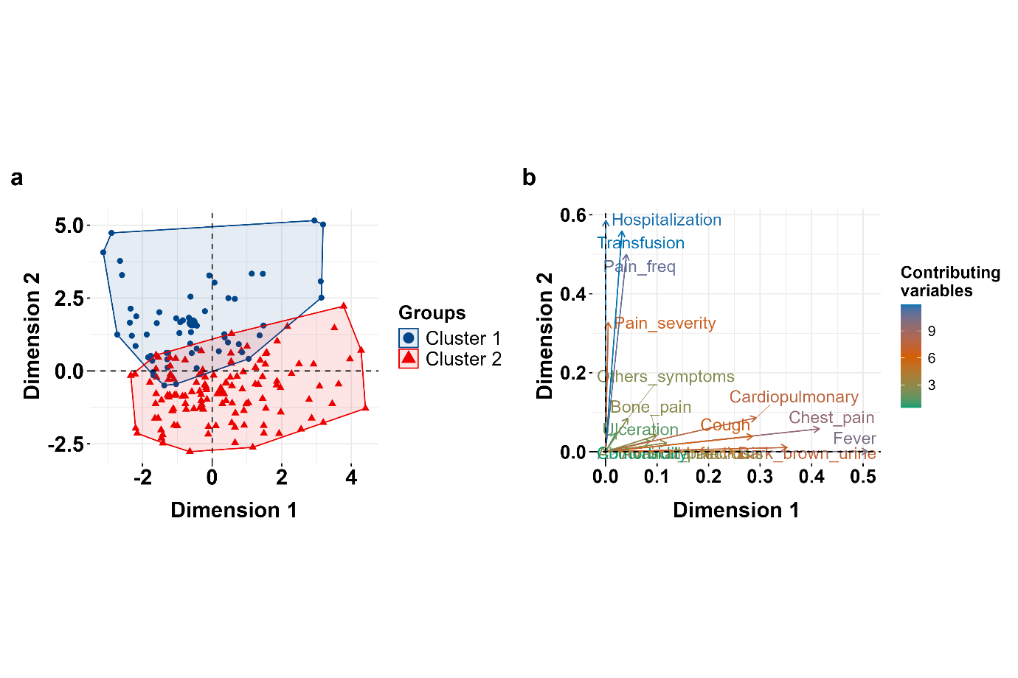

Figure 4. Patient clusters based on clinical characteristics projected onto the first two-dimensions of Factor Analysis of Mixed Data. **(a)** Cluster representation: Ellipses denote Cluster 1 and Cluster 2, derived using KAy-means for Mixed Large data. **(b)** Clinical features plot: Gradient scale represents variable contributions, and vector length indicates importance. Arrow direction shows the influence of the clinical feature on cluster groups.

Table 4 summarizes the associations between lifestyle, environmental and socioeconomic factors and the clusters. Emotional variables were significantly associated with cluster membership. Patients in Cluster 1 exhibited higher average scores for PSS, perceived anxiety and stress triggers compared to Cluster 2.

Table 4. Association between cluster groups and lifestyle, environmental influences and Socioeconomic factors.

|  |  |  |  |  |  |  |  |  |
| --- | --- | --- | --- | --- | --- | --- | --- | --- |
|  | **Cluster 1** | **Cluster 2** |  |  |  | **95% Confidence Interval** | |  |
| **Factor** | **Mean (SD)** | **Mean (SD)** | **Chi-square(*df)*** | ***p* Value** | **Odds Ratio a** | **Lower** | **Upper** | ***p* Value** |
| PSS score | 63.37 (20.09) | 51.25 (24.54) |  |  | 0.98 | 0.96 | 0.99 | .006 |
| PA Score | 59.75 (7.59) | 55.71 (8.79) |  |  | 0.94 | 0.90 | 0.99 | .012 |
| Number of stress triggers | 3.75 (1.73) | 2.97 (1.57) |  |  | 0.74 | 0.58 | 0.94 | .015 |
| Routine checkups | 1.27 (1.98) | 2.84(2.46) |  |  | 1.45 | 1.21 | 1.76 | <.001 |
|  | **Count (%)** | **Count (%)** |  |  |  |  |  |  |
| **Season** |  |  | 0.66* | .745 |  |  |  |  |
| Dry season | 2 (3.6) | 7 (5.4) |  |  | 3.50 | 0.84 | 23.49 | .118 |
| Rainy season | 23 (41.1) | 58 (45) |  |  | 0.72 | 0.10 | 3.25 | .696 |
| No specific season | 31 (55.4) | 64 (49.6) |  |  | 0.59 | 0.08 | 2.61 | .525 |
| **Weather** |  |  |  |  |  |  |  |  |
| Cold |  |  | 2.42(1) | .12 |  |  |  |  |
| No | 5 (8.9) | 25 (19.4) |  |  | 5.00 | 2.08 | 14.81 | .001 |
| Yes | 51 (91.1) | 104 (80.6) |  |  | 0.41 | 0.13 | 1.05 | .084 |
| Hot |  |  | 2.91(1) | .088 |  |  |  |  |
| No | 45 (80.4) | 86 (66.7) |  |  | 1.91 | 1.34 | 2.76 | <.001 |
| Yes | 11 (19.6) | 43 (33.3) |  |  | 2.04 | 0.99 | 4.52 | .063 |
| High Winds |  |  | 4.75(1) | .029 |  |  |  |  |
| No | 35 (62.5) | 102 (79.1) |  |  | 2.91 | 2.01 | 4.33 | <.001 |
| Yes | 21 (37.5) | 27 (20.9) |  |  | 0.44 | 0.22 | 0.88 | .019 |
| High humidity |  |  | 10.12(1) | .001 |  |  |  |  |
| No | 26 (46.4) | 93 (72.1) |  |  | 3.58 | 2.35 | 5.63 | <.001 |
| Yes | 30 (53.6) | 36 (27.9) |  |  | 0.33 | 0.17 | 0.64 | .001 |
| **Dust exposure** |  |  | 7.96(1) | .005 |  |  |  |  |
| No | 38 (67.9) | 112 (86.8) |  |  | 2.95 | 2.06 | 4.31 | <.001 |
| Yes | 18 (32.1) | 17 (13.2) |  |  | 0.32 | 0.15 | 0.68 | .003 |
| **Smoke exposure** |  |  | 6.87(1) | .008 |  |  |  |  |
| No | 40 (71.4) | 114 (88.4) |  |  | 2.85 | 2.00 | 4.13 | <.001 |
| Yes | 16 (28.6) | 15 (11.6) |  |  | 0.33 | 0.15 | 0.73 | .006 |
| **Exercise** |  |  | 22.86(3) | <.001 |  |  |  |  |
| Never | 34 (60.7) | 32 (24.8) |  |  | 0.94 | 0.58 | 1.53 | .805 |
| <3 times/week | 14 (25) | 51 (39.5) |  |  | 3.87 | 1.83 | 8.51 | <.001 |
| 3 to 6 times/week | 4 (7.1) | 29 (22.5) |  |  | 7.70 | 2.67 | 28.15 | <.001 |
| Daily | 4 (7.1) | 17 (13.2) |  |  | 4.51 | 1.48 | 16.99 | .013 |
| **Hydration** |  |  | 1.97(2) | .356 |  |  |  |  |
| Less than 1L | 3 (5.4) | 5 (3.9) |  |  | 1.67 | 0.41 | 8.13 | .484 |
| About 1L | 11 (19.6) | 16 (12.4) |  |  | 0.87 | 0.15 | 4.34 | .869 |
| More than 1L | 42 (75) | 108 (83.7) |  |  | 1.54 | 0.30 | 6.57 | .564 |
| **Meals per day** |  |  | 2.91(1) | .088 |  |  |  |  |
| 1 to 2 | 23 (41.1) | 35 (27.1) |  |  | 1.52 | 0.90 | 2.61 | .118 |
| 3 or more | 33 (58.9) | 94 (72.9) |  |  | 1.87 | 0.96 | 3.62 | .062 |
| **Fruit per day** |  |  | 0.064(1) | .800 |  |  |  |  |
| Not daily | 48 (85.7) | 107 (83) |  |  | 2.23 | 1.60 | 3.16 | <.001 |
| Daily | 8 (14.3) | 22 (17.1) |  |  | 1.23 | 0.53 | 3.13 | .639 |
| **Vegetable per day** |  |  | 2.48* | .171 |  |  |  |  |
| Not daily | 55 (98.2) | 119 (92.3) |  |  | 2.16 | 1.58 | 3.0 | <.001 |
| Daily | 1 (1.8) | 10 (7.8) |  |  | 4.62 | 0.85 | 85.87 | .149 |
| **Socioeconomic factors** | | |  |  |  |  |  |  |
| Household income (XAF/month) **b** | |  | 1.22(2) | .542 |  |  |  |  |
| <100,000 | 13 (36.1) | 26 (26.8) |  |  | 2.00 | 1.05 | 4.01 | .041 |
| 100,000-200,000 | 13 (36.1) | 37 (38.1) |  |  | 1.42 | 0.57 | 3.59 | .451 |
| >200,000 | 10 (27.8) | 34 (35.1) |  |  | 1.70 | 0.65 | 4.57 | .283 |
| Household size | |  | 6.0(2) | .049 |  |  |  |  |
| 1 to 3 | 17 (30.4) | 21 (16.3) |  |  | 1.23 | 0.65 | 2.37 | .517 |
| 4 to 6 | 20 (35.7) | 67 (51.9) |  |  | 2.71 | 1.20 | 6.15 | .016 |
| > 6 | 19 (33.9) | 41 (31.8) |  |  | 1.75 | 0.75 | 4.07 | .193 |
| Bedroom ventilation | |  | 2.70(2) | .259 |  |  |  |  |
| No ventilation | 14 (25) | 21 (16.3) |  |  | 1.50 | 0.77 | 3.01 | .240 |
| Inadequate ventilation | 6 (10.7) | 10 (7.8) |  |  | 1.11 | 0.33 | 3.91 | .865 |
| Well ventilated | 36 (64.3) | 98 (76) |  |  | 1.81 | 0.82 | 3.93 | .132 |
| Parental level of education | |  | 1.03(3) | .795 |  |  |  |  |
| Primary | 3 (6.3) | 8 (6.7) |  |  | 2.67 | 0.77 | 12.17 | .147 |
| Secondary | 11 (22.9) | 20 (16.8) |  |  | 0.68 | 0.13 | 2.93 | .621 |
| High school/vocational | 13 (27.1) | 31 (26.1) |  |  | 0.89 | 0.17 | 3.67 | .882 |
| University | 21 (43.8) | 60 (50.4) |  |  | 1.07 | 0.22 | 4.1 | .924 |
| a Odds ratio using unadjusted logistic regression.  b XAF: Central African CFA Franc ($1 USD = XAF 606.35) [22].  * Approximation using Monte Carlo simulation.  PA: Perceived anxiety.  PSS: Perceived Stress Scale.  All analysis were performed at 0.05 significance level. | | | | | | | | |

As shown in Figure 5, a larger proportion of individuals in Cluster 1 experienced high emotional distress. In unadjusted logistics regression analysis, each unit increase in PSS score was associated with significantly lower odds of being classified in Cluster 2 (vs. Cluster 1) (OR 0.98, 95% CI 0.96–0.99, *p*=.006). Likewise, a unit increase in perceived anxiety was associated with significantly lower odds of being classified in Cluster 2 (OR 0.94, 95% CI 0.90–0.99, *p*=.012).

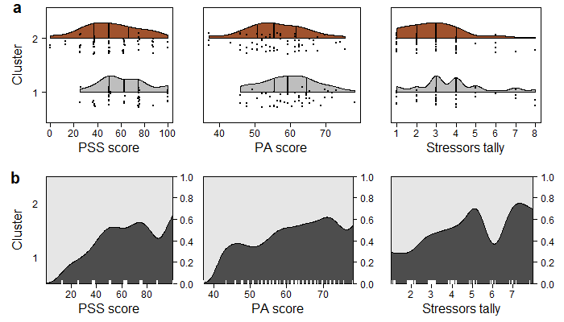

Figure 5. Distribution of emotional factors across cluster groups. **(a)** Violin plot comparing perceived stress scale (PSS) score, perceived anxiety (PA) score and number of stress triggers between Cluster 1 and Cluster 2. Each plot displays the median as well as the 25th and 75th percentiles. Dots represent individual patients’ data. **(b)** Conditional density plots illustrating the distribution and variation of PSS score, PA score and number of stress triggers within each Cluster.

A significant association was observed between cluster membership and the proportion of patient engaging in physical activity (χ23=22.86, *p*<.001). Many patients in Cluster 1 never engaged in moderate to high-intensity aerobic physical activity, whereas a substantial proportion of patients in Cluster 2 reported exercising at least once per week. No significant association was observed between cluster membership and average daily water intake. Similarly, there were no direct associations between cluster membership and nutritional factors (Figure 6).

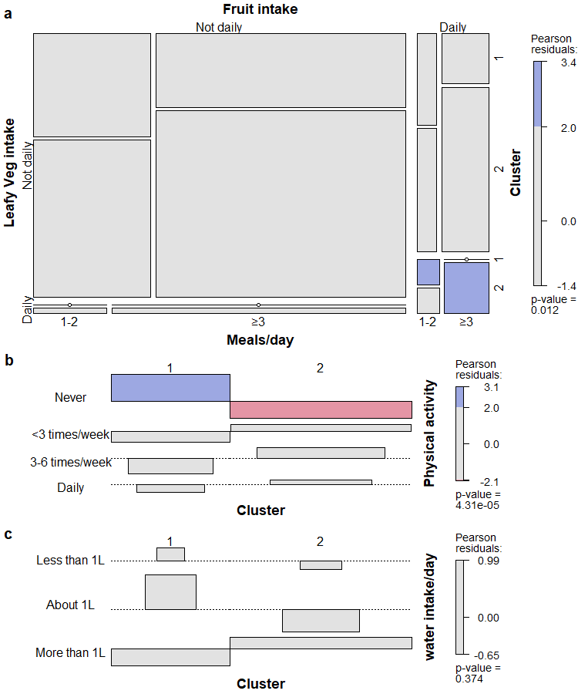

Figure 6. Relationships between lifestyle factors and cluster groups **(a)** Four-way mosaic plot of cluster groups vs. nutritional lifestyle. Tile width represents proportion of patients in each category combination, shading indicates magnitude of differences between observed and expected frequencies. **(b)** Association plot: Cluster group vs. frequency of moderate to high aerobic physical activity over the past 12 months. **(c)** Association plot: Cluster group vs. average daily water intake frequency over the past 12 months.

The mean number of scheduled routine clinical checkups per year was 1.27 (SD 1.98) in Cluster 1 and 2.84 (SD 2.46) in Cluster 2. Each additional checkup per year was associated with significantly higher odds of being classified in Cluster 2 (OR 1.45, 95% CI 1.21–1.76, *p*<.001), adjusting for household income.

Figure 7 and Figure 8 illustrate the associations between cluster membership and environmental factors. While a substantial proportion of patients in both clusters reported being prone to VOC during cold weather, exposure to cold, hot weather, and seasonal variations was not associated with cluster classification. In contrast, high humidity (*χ*21=10.12, *p*=.001) and windy conditions (*χ*21=4.75, *p*=.029) were significantly associated with cluster membership, based on chi-square tests of independence. Patients belonging to Cluster 2 had significantly lower odds of reporting sensitivity to high humidity (OR 0.33, 95% CI 0.17–0.64, *p*=.001) or windy conditions (OR 0.44, 95% CI 0.22–0.88, *p*=.019). Similarly, self-reported sensitivity to environmental pollutants−specifically road dust (*χ*21=7.96, *p*=.005) and smoke fumes (*χ*21=6.87, *p*=.008), was significantly associated with cluster membership. Patients in Cluster 2 had significantly lower odds of reporting sensitivity to road dust (OR 0.32, 95% CI 0.15–0.68, *p*=.003) and smoke fumes (OR 0.33, 95% CI 0.15–0.73, *p*=.006).

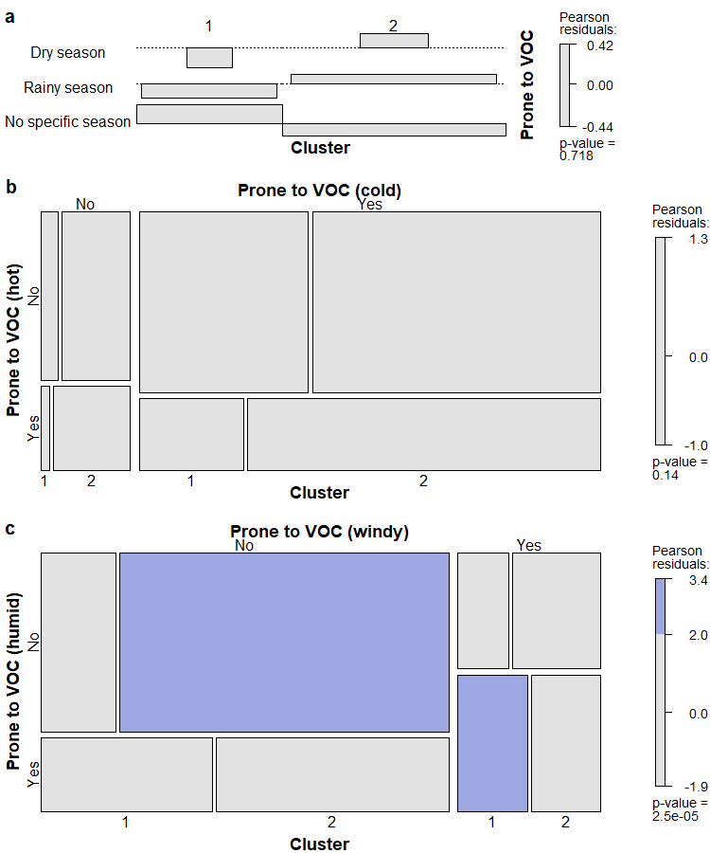

Figure 7. Association between self-reported sensitivity to seasonal variations and weather conditions across cluster groups over the past 12 months. The area of each tile represents the relative proportions across clusters. **(a)** Association plot illustrating the relationship between cluster membership and sensitivity to seasonal variation. **(b)** Mosaic plot showing the association between sensitivity to cold and hot weather and cluster membership. **(c)** Mosaic plot showing the association between sensitivity to windy and humid conditions and cluster membership.

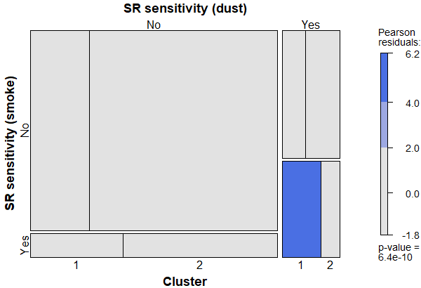

Figure 8. Mosaic plot of self-reported sensitivity to dust and smoke. Patients reported whether exposure to road dust and smoke-fumes consistently triggered mild-to-severe painful episodes or other symptoms within 1−3 days post-exposure over the past 12 months. Pearson residuals represent standardized differences between observed and expected frequencies across cluster groups. SR; Self-reported.

Socioeconomic factors, including household income, parental educational level, and bedroom ventilation, were not associated with cluster membership (Figure 9). However, household size demonstrated a modest associated (*χ*22=6.0, *p*=.049). Patients from medium households (4−6 persons) had significantly higher odds of belonging to Cluster 2 compared to those from smaller households (1−3 persons) (OR 2.7, 95% CI 1.2−6.15, *p*=.016). No significant differences in cluster membership were observed among participants from large households (>6 persons).

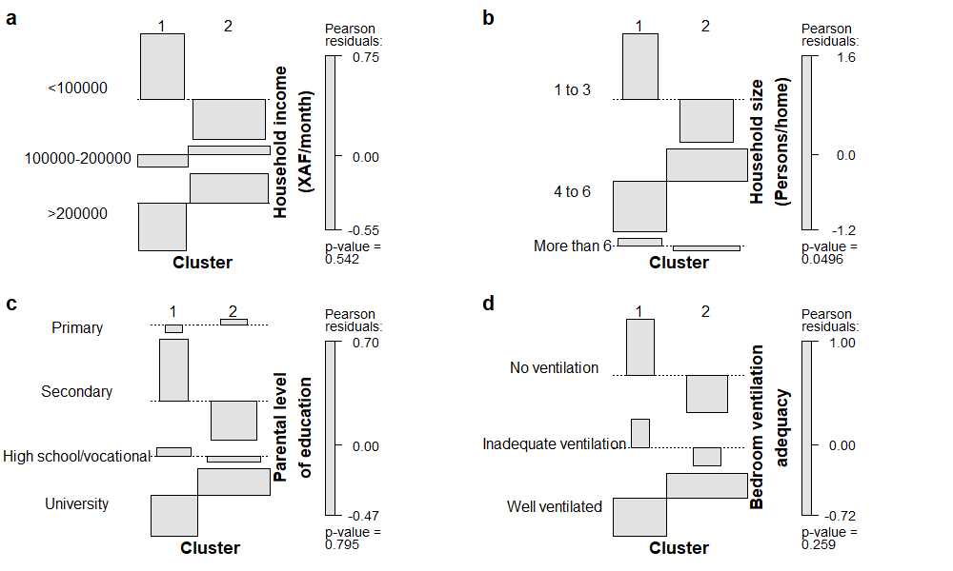

Figure 9. Association plots between socioeconomic factors and cluster groups. Each plot shows how the proportion of patients is distributed across different socioeconomic categories and cluster membership. **(a)** Monthly household income and cluster membership (XAF: Central African CFA Franc, $1 USD = XAF 606.35) [22]. **(b)** Household size (number of persons per home) and cluster memberships. **(c)** Parental educational level and cluster membership. **(d)** Association between bedroom ventilation adequacy (natural airflow between indoor and outdoor spaces) and cluster membership.

**Discussion**

Numerous studies have investigated the impact of environmental factors on SCD, employing varied approaches such as retrospective or prospective lagged-association between hospital emergency visits with environmental data [6,12]. However, the lack of readily accessible meteorological records and emergency hospital visit data in the Centre region of Cameroon poses significant challenges to conducting similar studies. In this study, we employed a cross-sectional exploratory approach to examine how lifestyle, environmental exposure and socioeconomic conditions influences the clinical severity of SCA patients not undergoing disease-modifying treatment with hydroxyurea. Given the absence of an established clinical severity scoring system for SCA in Cameroon and recognizing that a single outcome variable-such as the number of hospitalizations or painful crises is insufficient to comprehensively reflect disease severity, clustering was employed. This approach grouped patients based on multiple easily obtainable clinical characteristics commonly recorded in primary healthcare settings across Cameroon.

In this study, 51% of patients reported experiencing VOC year-round, while 44% indicated that VOC episodes were more frequent during the rainy season, which in the Centre region typically spans from early April to early November and is characterized by light to heavy rainfall and fluctuating temperatures [28]. In addition, a significant proportion of participants (84%) identified cold exposure as a trigger for illness episodes. These findings are consistent with previous studies conducted in both temperate and tropical regions which, despite differing annual temperature ranges have shown associations between annual temperatures, seasonal fluctuations, and increased hospitalization rates [6,12,29–31]. This underscores the potential role of weather variations as significant contributors to disease exacerbation. Sickle cell disease patients are believed to be more sensitive to temperature fluctuations compared to individuals without SCD [32]. This increased sensitivity has been linked to a persistent reflex vasoconstriction response during rapid body cooling, which may contribute to the onset of vaso-occlusion [33], possibly due to increased transit time of RBCs in the microvasculature [34].

A minority of patients reported road dust (19%) and smoke fumes (17%) as perceived triggers of VOC preceding their crises. Noticeably, the proportion of individuals who identified these environmental exposures as precipitating factors increased with age. This trend may reflect age-related decline in respiratory function of individuals with SCD, potentially enhanced by chronic inflammation and recurrent VOC events, which are known to cause progressive pulmonary damage and reduced lung function over time [35,36]. Yaoundé, which is Cameroon’s second largest city, is characterized by heavy road traffic, unpaved roads in many neighborhoods, widespread use of old vehicles, and the use of biomass for cooking in some households, all of which likely contributed to elevated levels of fine particulate matter (PM2.5and PM10) surpassing the World Health Organizations’ guideline limits [37]. Previous studies demonstrated positive association between exposure to both PM2.5 and PM10 and increased emergency department visits [11,38]. Particulate matter-10 exposure has been specifically linked to increased blood velocity in the extracranial internal carotid artery, a marker of stroke risk, in children with SCA [19]. Examining the relationship between environmental factors and cluster membership revealed that patients in Cluster 1 were more likely to report adverse effects from dust exposure, smoke fumes, high winds and high humidity compared to those in Cluster 2. While a causal link cannot be inferred, one possible explanation is that Cluster 1 patients maybe more vulnerable to inflammation and oxidative stress triggered by air pollution and meteorological changes due to compromised cardiopulmonary function. This observation aligns with previous studies on environmental influences in SCD, which primarily focused on association with hospitalization rates and emergency visits following exposure lags.

Our study revealed that most patients experienced moderate to high stress sensitivity as measured by the PSS. Patients average anxiety score was 7.5 points higher (T score 57.5) than the standardized average of 50 in the US general population [17]. The primary stressors identified were cold weather, academic or work-related demands, and financial difficulties. Patients in Cluster 1 reported higher levels of stress, anxiety and stressors compared to those in Cluster 2, highlighting the significant mental and physical burden associated with living with a chronic condition. This finding is consistent with previous research showing that high stress and negative mood are associated with painful episodes in SCD adolescents [39]. Furthermore, a study among SCD youths ages 8 to 17 suggested that anxiety may influence pain and social functioning [40]. Repeated exposure to stress may increase the risk of VOC by inducing vasoconstriction, reducing microvascular flow and enhancing the prospect of RBC getting entrapped [41]. This potential mechanism may partly explain why patients in Cluster 1, who exhibited more severe clinical outcome, also reported higher stress and anxiety levels. The role of stress triggers is increasing becoming a major focus in the standard management of VOC, serving as a non-pharmacological adjunct to personalized interventions specific to individual patient needs and circumstances. This dual approach to VOC management can be particularly beneficial in primary healthcare settings with limited resources.

A significant lifestyle-related difference was observed in the frequency of routine checkups between pediatric patients (<17 years), and younger adults who have transitioned to adult care (17 to 25 years), and adults aged 25 to 35. This disparity may be attributed to the increased parental involvement in pediatric care, where parents or caregivers often facilitate and accompany children to scheduled checkup appointments, in contrast to adult patients who may assume full responsibility for their appointments. Regular checkups are important for preventing complications and morbidity, as they provide opportunities for counseling, emotional support, education, vital signs monitoring, routine laboratory tests, and early detection of organ damage. These benefits can lead to reduced hospitalizations, shorter hospital stays, reduced need of blood transfusion, and lower healthcare costs [42,43]. Our analysis showed that each additional checkup per year, increased 1.45 times the odds of being classified in Cluster 2, characterized by less severe clinical features compared to Cluster 1. Furthermore, the frequency of routine checkups was not associated with household income, even after adjusting for household size using hurdle model. This suggest that financial means may not be a primary determinant of patients’ ability to attend scheduled checkups among the study population Implementing strategies to remind SCD patients in Cameroon of upcoming appointments may help reduce unnecessary hospital resource utilization and improve patients’ quality of life.

The association between aerobic physical activity and cluster group, where most patients with more severe disease (Cluster 1) reported no engagement in physical activity, may be attributed to concerns about triggering VOC, fatigue and worsening health condition. Previous studies have shown that mild to moderate aerobic exercise is safe and potentially beneficial for patients with SCD, without precipitating inflammation or oxidative stress [44,45]. Moreover, mild endurance exercise has not been associated with substantial peripheral oxygen desaturation or lactate accumulation in SCD patients [46,47]. Our observation supports these findings, suggesting that engaging in moderate to high-intensity aerobic physical activity at least once a week does not appear to have adverse effects on clinical outcomes of SCA patients.

While many patients reported adequate daily hydration, a significant proportion of those aged 17 or younger were not hydrating adequately. This underscores the need for educating and encouraging younger children and adolescent patients on the importance of adequate hydration and implementing daily follow-up strategies to monitor their fluid intake. Although our study did not reveal a significant relationship between nutritional habits and cluster membership, it does not rule out the possibility of an association between clinical severity of SCD and nutrition. Previous research has shown that deficiencies in macro- and micronutrients are common among SCD patients with severe disease outcome [48–51]. The lack of association in our study may be attributed to the qualitative nature of our nutritional assessment, which might not have captured the impact of dietary intake on SCD clinical severity.

Patients from medium households (4−6 persons) were more likely to be in Cluster 2 than Cluster 1, whereas no difference was observed for large households (>6 persons). This may be attributed to the beneficial effects of day-to-day support from multiple caregivers in medium households, including symptom monitoring, emotional support, and stress/anxiety reduction. Contrary, large households may experience resource constraints and increased stress, potentially negatively impacting patients’ quality of life and disease management. A large study exploring multimorbidity and unplanned hospitalization among older adults in Wales, observed that individuals living with multimorbidity in household sizes of 3 or persons had the least hazard ratio of unplanned hospitalization when the co-residents did not have any multimorbidity while those living alone had the highest hazard ratio of unplanned hospitalization and early transition to care home [52].

This study has several strengths and limitations. One key strength is the inclusion of patients who had not received hydroxyurea for the past 12 months preceding enrollment, which eliminate a potential treatment factor that may bias disease severity outcome. Furthermore, clustering patients based on multiple clinical outcome characteristics provided a more comprehensive understanding of disease severity in the study population, rather than relying on a single outcome measure. However, several limitations should be acknowledged. The small sample size and relatively short study duration may have limited our ability to fully capture the impact of environmental factors on disease severity in the Centre region of Cameroon. Confounding intra-individual disease-modifying molecular and endogenous factors that may influence disease severity were not considered. Our reliance on self-reported health information from patients and caregivers may have introduced retrospective recall bias. Finally, challenges in verifying and retrieving complete patient information, as well as the absence of accessible local quantitative environmental data, further limited our ability to make inferential findings. Despite these limitations, this study is the first to explore the association between environmental influences, lifestyle challenges, socioeconomic factors, and cluster classification of SCD patients based on select clinical outcome in Cameroon. As such, it provides a foundation for hypothesis generation, future research and development of targeted interventions to improve the outcome of patients suffering from SCD.

**Conclusion**

While much remains to be understand about the influence of lifestyle, seasonal variations, meteorological patterns, pollution, and socioeconomic conditions on the severity of SCD, this exploratory study provides important new insights. For the first time, we report that many SCD patients in the Centre region of Cameroon experience elevated levels of stress and anxiety, which significantly impact daily functioning and are closely related to VOC, particularly during the rainy season and colder weather. We also identified two severity clusters among patients, characterized by differences in select clinical features as well as significant variation in lifestyle habits (stress, anxiety, frequency of medical checkups, physical activity), environmental exposures (high winds, humidity, dust, smoke fumes), and socioeconomic factors such as household size. The study lays a foundation for future investigations involving a larger patient population across Cameroon, with a view to exploring the complex interplay between exogenous and endogenous factors of disease severity. These study underscores the continuous need for patient and caregiver education focused on managing stress and anxiety, optimizing lifestyle choices and understanding the health implications of pollution and meteorological changes. Such interventions could help reduce the burden on healthcare while improving patients and their family’s mental well-being.

**List of abbreviations**

KAMILA Kay-Means for Mixed Large Data

PAM Partitioning Around Medoids

PHH Patient-Held Health

PM2.5 Particulate Matter-2.5

PM10 Particulate Matter-10

PMR Patient Medical Records

PROMIS Patient-Reported Outcomes Measurement Information System

PSS Perceived Stress Scale

SCA Sickle Cell Anemia

SCD Sickle Cell Disease

VOC Vaso-Occlusion Crisis

XAF Central African CFA Franc

**DECLARATIONS**

**Ethical approval and consent to participants**

The study was approved by the ethical committee of each study center. Yaoundé Central Hospital, ref: 2023/463/AR/MINSANTE/SG/DHCY/UAF; Cite Vert District Hospital, ref: 024/L/MINSANTE/DRC/DSCV/HDCV; Gyneco-Obstetric and Pediatric Hospital Yaoundé, ref: 755/CIERSH/DM/ATTD/2024; and *Centre D’animation Sociale et Sanitaire* Yaoundé, ref: OECX/07/24/080/CASS/D/CE/tge. Written informed consent was obtained from all patients or parents in the case of children, with assent obtained from children were applicable.

**aReferences**

1. Tebbi CK. Sickle Cell Disease, a Review. Hemato. 2022 May 30;3(2):341–66.

2. Thomson AM, McHugh TA, Oron AP, Teply C, Lonberg N, Vilchis Tella V, et al. Global, regional, and national prevalence and mortality burden of sickle cell disease, 2000–2021: a systematic analysis from the Global Burden of Disease Study 2021. The Lancet Haematology. 2023 Aug;10(8):e585–99.

3. De Franceschi L, Castiglioni C, Condorelli C, Valsecchi D, Premoli E, Fiocchi C, et al. Real-World Evidence on Disease Burden and Economic Impact of Sickle Cell Disease in Italy. JCM. 2022 Dec 23;12(1):117.

4. Andong AM, Ngouadjeu EDT, Bekolo CE, Verla VS, Nebongo D, Mboue-Djieka Y, et al. Chronic complications and quality of life of patients living with sickle cell disease and receiving care in three hospitals in Cameroon: a cross-sectional study. BMC Hematol. 2017 Dec;17(1):7.

5. Sundd P, Gladwin MT, Novelli EM. Pathophysiology of Sickle Cell Disease. Annu Rev Pathol Mech Dis. 2019 Jan 24;14(1):263–92.

6. Piel FB, Tewari S, Brousse V, Analitis A, Font A, Menzel S, et al. Associations between environmental factors and hospital admissions for sickle cell disease. Haematologica. 2017 Apr;102(4):666–75.

7. Kayle M, Docherty S, Tanabe P, Sloane R, Maslow G, Pan W, et al. Trajectories of Sickle Cell Disease Severity during Transition to Adult Care. Blood. 2018 Nov 29;132(Supplement 1):318–318.

8. Osarogiagbon RU, Haider SN, Tang J. Effect of Sickle Cell Disease Type, Age and Gender On the Prevalence of Chronic Organ Damage in Adults with Sickle Cell Disease. Blood. 2009 Nov 20;114(22):4607–4607.

9. Njoku F, Pugh N, Brambilla D, Kroner B, Shah N, Treadwell M, et al. Mortality in adults with sickle cell disease: Results from the sickle cell disease implementation consortium (SCDIC) registry. American J Hematol. 2024 May;99(5):900–9.

10. Kirkham JK, Estepp JH, Weiss MJ, Rashkin SR. Genetic Variation and Sickle Cell Disease Severity: A Systematic Review and Meta-Analysis. JAMA Netw Open. 2023 Oct 18;6(10):e2337484.

11. Blumberg AH, Ebelt ST, Liang D, Morris CR, Sarnat JA. Ambient air pollution and sickle cell disease-related emergency department visits in Atlanta, GA. Environ Res. 2020 May;184:109292.

12. Guerzoni ME, Marchesi S, Palazzi G, Lodi M, Pinelli M, Venturelli D, et al. Environmental Factors in Northern Italy and Sickle Cell Disease Acute Complications: A Multicentric Study. Children (Basel). 2022 Sep 27;9(10):1478.

13. Serdar CC, Cihan M, Yücel D, Serdar MA. Sample size, power and effect size revisited: simplified and practical approaches in pre-clinical, clinical and laboratory studies. Biochem med (Online). 2021 Feb 15;31(1):27–53.

14. Vancampfort D, Koyanagi A, Ward PB, Veronese N, Carvalho AF, Solmi M, et al. Perceived Stress and Its Relationship With Chronic Medical Conditions and Multimorbidity Among 229,293 Community-Dwelling Adults in 44 Low- and Middle-Income Countries. American Journal of Epidemiology. 2017 Oct 15;186(8):979–89.

15. Pilkonis PA, Choi SW, Reise SP, Stover AM, Riley WT, Cella D, et al. Item Banks for Measuring Emotional Distress From the Patient-Reported Outcomes Measurement Information System (PROMIS®): Depression, Anxiety, and Anger. Assessment. 2011 Sep;18(3):263–83.

16. Schalet BD, Pilkonis PA, Yu L, Dodds N, Johnston KL, Yount S, et al. Clinical validity of PROMIS Depression, Anxiety, and Anger across diverse clinical samples. Journal of Clinical Epidemiology. 2016 May;73:119–27.

17. PROMIS. Anxiety Scoring Manual. A brief guide to scoring the PROMIS Anxiety Instruments [Internet]. PROMIS; 2021 [cited 2025 May 12]. Available from: https://www.healthmeasures.net/images/PROMIS/manuals/Scoring_Manuals_/PROMIS_Anxiety_Scoring_Manual.pdf

18. World Health Organization. WHO Guidelines on Physical Activity and Sedentary Behaviour. 1st ed. Geneva: World Health Organization; 2020. 1 p.

19. Mittal H, Roberts L, Fuller GW, O’Driscoll S, Dick MC, Height SE, et al. The effects of air quality on haematological and clinical parameters in children with sickle cell anaemia. Ann Hematol. 2009 Jun;88(6):529–33.

20. Lai HK, Kendall M, Ferrier H, Lindup I, Alm S, Hänninen O, et al. Personal exposures and microenvironment concentrations of PM2.5, VOC, NO2 and CO in Oxford, UK. Atmospheric Environment. 2004 Dec;38(37):6399–410.

21. Sekhar C, Akimoto M, Fan X, Bivolarova M, Liao C, Lan L, et al. Bedroom ventilation: Review of existing evidence and current standards. Building and Environment. 2020 Oct;184:107229.

22. World Bank Group. Official exchange rate (LCU per US$, period dollar). International Monetary Fund, International Financial Statistics. [Internet]. 2025 [cited 2025 May 9]. Available from: https://data.worldbank.org/indicator/PA.NUS.FCRF

23. National Institute of Statistics. Fifth Cameroon household (ECAM5). Situation of household living conditions in 2021-2022 policy guidance note. [Internet]. Yaounde: National Institute of Statistics; 2024 Jan [cited 2025 Mar 20]. Report No.: 5. Available from: https://ins-cameroun.cm/stattistique/english-fifth-cameroon-household-survey-ecam5situation-of-household-living.conditions-in-2021-2022polycyguidance-noterue/

24. Ortiz FO, Aldrich TK, Nagel RL, Benjamin LJ. Accuracy of pulse oximetry in sickle cell disease. Am J Respir Crit Care Med. 1999 Feb;159(2):447–51.

25. Shah N, Beenhouwer D, Broder MS, Bronte-Hall L, De Castro LM, Gibbs SN, et al. Development of a Severity Classification System for Sickle Cell Disease. CEOR. 2020 Oct;Volume 12:625–33.

26. Rana K, Chimoriya R. A Guide to a Mixed-Methods Approach to Healthcare Research. Encyclopedia. 2025 Apr 11;5(2):51.

27. R Core Team. R: A Language and Environment for Statistical Computing. [Internet]. Vienna, Austria: R Foundation for Statistical Computing; 2023. Available from: https://www.R-project.org

28. Fantong W Y, Fouepe A T, Issa, Djomou S L, B, Banseka H S, Anazawa K, et al. Temporal pollution by nitrate (NO3) and discharge of springs in shallow crystalline acquifers: Case of Akok Ndoue catchmen Yaounde (Cameroon). AJEST. 2013;7(5):175–91.

29. G. Ahmed S, B Kagu M, A. Abjah U. Seasonal Variations in Frequencies of Acute Vaso-Occlusive Morbidities among Sickle Cell Anaemia Patients in Northern Nigeria. J Blood Disord Transfus [Internet]. 2012 [cited 2024 Jan 12];03(02). Available from: https://www.omicsonline.org/seasonal-variations-in-frequencies-of-acute-vaso-occlusive-morbidities-among-sickle-cell-anaemia-patients-in-northern-nigeria-2155-9864.1000120.php?aid=5675

30. Parriault MC, Cropet C, Fahrasmane A, Rogier S, Parisot M, Nacher M, et al. Air Drep—A Retrospective Study Evaluating the Influence of Weather Conditions and Viral Epidemics on Vaso-Occlusive Crises in Patients with Sickle Cell Disease Living in French Guiana. IJERPH. 2019 Jul 31;16(15):2724.

31. Mekontso Dessap A, Contou D, Dandine-Roulland C, Hemery F, Habibi A, Charles-Nelson A, et al. Environmental Influences on Daily Emergency Admissions in Sickle-Cell Disease Patients. Medicine. 2014 Dec;93(29):e280.

32. Brandow AM, Stucky CL, Hillery CA, Hoffmann RG, Panepinto JA. Patients with sickle cell disease have increased sensitivity to cold and heat. American J Hematol. 2013 Jan;88(1):37–43.

33. Mohan J, Marshall JM, Reid HL, Thomas PW, Hambleton I, Serjeant GR. Peripheral vascular response to mild indirect cooling in patients with homozygous sickle cell (SS) disease and the frequency of painful crisis. Clin Sci (Lond). 1998 Feb;94(2):111–20.

34. Lu L, Li Z, Li H, Li X, Vekilov PG, Karniadakis GE. Quantitative prediction of erythrocyte sickling for the development of advanced sickle cell therapies. Sci Adv. 2019 Aug 2;5(8):eaax3905.

35. MacLean JE, Atenafu E, Kirby-Allen M, MacLusky IB, Stephens D, Grasemann H, et al. Longitudinal Decline in Lung Volume in a Population of Children with Sickle Cell Disease. Am J Respir Crit Care Med. 2008 Nov 15;178(10):1055–9.

36. Radu I, Farcas AO, Voidazan S, Radu CC, Brinzaniuc K. Is Lung Disease a Risk Factor for Sudden Cardiac Death? A Comparative Case–Control Histopathological Study. Diseases. 2025 Jan 6;13(1):8.

37. Feuyit G, Nzali S, Lambi JN, Laminsi S. Air Quality and Human Health Risk Assessment in the Residential Areas at the Proximity of the Nkolfoulou Landfill in Yaoundé Metropolis, Cameroon. Journal of Chemistry. 2019 Jul 4;2019:1–9.

38. Barbosa SM de M, Farhat SCL, Martins LC, Pereira LAA, Saldiva PHN, Zanobetti A, et al. Air pollution and children’s health: sickle cell disease. Cad Saude Publica. 2015 Feb;31(2):265–75.

39. Gil KM. Daily Stress and Mood and Their Association With Pain, Health-Care Use, and School Activity in Adolescents With Sickle Cell Disease. Journal of Pediatric Psychology. 2003 Jul 1;28(5):363–73.

40. Valrie C, Floyd A, Sisler I, Redding-Lallinger R, Fuh B. Depression and Anxiety as Moderators of the Pain-Social Functioning Relationship in Youth with Sickle Cell Disease. J Pain Res. 2020;13:729–36.

41. Shah P, Khaleel M, Thuptimdang W, Sunwoo J, Veluswamy S, Chalacheva P, et al. Mental stress causes vasoconstriction in subjects with sickle cell disease and in normal controls. Haematologica. 2020 Jan;105(1):83–90.

42. Landau DA, Steininger K, Landis E. Increased Outpatient Care Can Reduce Hospital Stays for Sickle Cell Patients. Blood. 2015 Dec 3;126(23):5578–5578.

43. Amendah DD, Mukamah G, Komba A, Ndila C, Williams TN. Routine paediatric sickle cell disease outpatient care in a rural Kenyan hospital: utilization and cost. PLOS ONE. 2013;8(4):e61130.

44. Faes C, Balayssac‐Siransy E, Connes P, Hivert L, Danho C, Bogui P, et al. Moderate endurance exercise in patients with sickle cell anaemia: effects on oxidative stress and endothelial activation. Br J Haematol. 2014 Jan;164(1):124–30.

45. Barbeau P, Woods KF, Ramsey LT, Litaker MS, Pollock DM, Pollock JS, et al. Exercise in Sickle Cell Anemia: Effect on Inflammatory and Vasoactive Mediators. Endothelium. 2001 Jan;8(2):147–55.

46. Messonnier LA, Gellen B, Lacroix R, Peyrot S, Rupp T, Mira J, et al. Physiological Evaluation for Endurance Exercise Prescription in Sickle Cell Disease. Med Sci Sports Exerc. 2019 Sep;51(9):1795–801.

47. Gellen B, Messonnier LA, Galactéros F, Audureau E, Merlet AN, Rupp T, et al. Moderate-intensity endurance-exercise training in patients with sickle-cell disease without severe chronic complications (EXDRE): an open-label randomised controlled trial. Lancet Haematol. 2018 Nov;5(11):e554–62.

48. Kamal S, Naghib MM, Al Zahrani J, Hassan H, Moawad K, Arrahman O. Influence of Nutrition on Disease Severity and Health-related Quality of Life in Adults with Sickle Cell Disease: A Prospective Study. Mediterr J Hematol Infect Dis. 2021;13(1):e2021007.

49. Martyres DJ, Vijenthira A, Barrowman N, Harris‐Janz S, Chretien C, Klaassen RJ. Nutrient Insufficiencies/Deficiencies in Children With Sickle Cell Disease and Its Association With Increased Disease Severity. Pediatric Blood & Cancer. 2016 Jun;63(6):1060–4.

50. Pereira Gomes IC, Costa Machado Teles JP, Sousa Coelho AC, Passos Cruz MC, Costa De Albuquerque L, Carvalho MA, et al. Lipid Profile, Nutritional Status and Severity Biomarkers in Adults With Sickle Cell Anemia. Clin Med�Insights�Blood�Disord. 2023 Jan;17:26348535231193889.

51. Engle-Stone R, Williams T, Nankap M, Ndjebayi A, Gimou MM, Oyono Y, et al. Prevalence of Inherited Hemoglobin Disorders and Relationships with Anemia and Micronutrient Status among Children in Yaoundé and Douala, Cameroon. Nutrients. 2017 Jul 3;9(7):693.

52. MacRae C, Mercer SW, Abubakar E, Lawson A, Lone N, Rawlings A, et al. Impact of household size and co-resident multimorbidity on unplanned hospitalisation and transition to care home. Nat Commun. 2025 Feb 17;16(1):1718.

Supplementary materials

Table S1. Perceived stress scale (PSS) score, perceived anxiety (PA) score across and stress triggers across age groups

|  |  |  |  |  |  |
| --- | --- | --- | --- | --- | --- |
| **Variable** | **17 to 25 years old**  **(n = 74)** | **26 to 35**  **years old**  **(n = 23)** | **Over 35 years old**  **(n = 20)** | **Chi-square(*df*)** | ***p* Value** |
| PSS score; **median (IQR)** | 50.3 (37.0) | 62.2 (30.7) | 50.0 (37.2) | 0.4(2) **a** | .799 |
| PA score; **median (IQR)** | 57.4 (10.4) | 56.4 (12.0) | 58.4 (12.7) | 0.3(2) **a** | .859 |
| Triggers of stress; **n (%)** |  |  |  |  |  |
| Anticipation of pain |  |  |  | 3.09(2) | .212 |
| No | 43 (58) | 18 (78) | 12 (60) |  |  |
| Yes | 31 (42) | 5 (22) | 8 (40) |  |  |
| Cold weather |  |  |  | 0.30(2) | .860 |
| No | 32 (43) | 10 (43) | 10 (50) |  |  |
| Yes | 42 (57) | 13(57) | 10 (50) |  |  |
| Feeling dehydrated |  |  |  | 2.97(2) | .225 |
| No | 55 (74) | 15 (65) | 11 (55) |  |  |
| Yes | 19 (26) | 78 (35) | 9 (45) |  |  |
| School work/job load |  |  |  | 6.59(2) | .037 |
| No | 29 (39) | 16 (70) | 10 (50) |  |  |
| Yes | 45 (61) | 7 (30) | 10 (50) |  |  |
| Moody |  |  |  | 0.04 **b** | 0.999 |
| No | 64 (86) | 20 (87) | 17 (85) |  |  |
| Yes | 10 (14) | 3 (13) | 3 (15) |  |  |
| Lack of sleep |  |  |  | 16.51(2) | <.001 |
| No | 61 (82) | 11 (48) | 9 (45) |  |  |
| Yes | 13 (18) | 12 (52) | 11 (55) |  |  |
| Not being physically active |  |  |  | 2.70(2) | .258 |
| No | 48 (65) | 17 (74) | 10 (50) |  |  |
| Yes | 26 (35) | 6 (26) | 10 (50) |  |  |
| Loneliness |  |  |  | 2.81(2) | .246 |
| No | 55 (74) | 16 (70) | 11 (55) |  |  |
| Yes | 19 (26) | 7 (30) | 9 (45) |  |  |
| Financial difficulties |  |  |  | 2.48(2) | .289 |
| No | 44 (59) | 12 (52) | 8 (40) |  |  |
| Yes | 30 (41) | 11 (48) | 12 (60) |  |  |
| **a** Kruskal-Wallis chi-square  **b** Approximation using Monte Carlo simulation, no degree of freedom  PA: Perceived Anxiety, PSS: Perceived Stress Scale, IQR: Interquartile range, *df*: degree of freedom | | | | | |

Table S2. Socioeconomic characteristics of the study participants.

|  |  |  |
| --- | --- | --- |
| **Variable characteristics** | **Frequency (n)** | **Percent (%)** |
| **Parental level of education** | | |
| Primary | 11 | 6.0 |
| Secondary | 31 | 16.8 |
| High school or vocational training | 44 | 23.8 |
| University or higher professional training | 81 | 43.8 |
| Preferred not to disclose | 18 | 9.7 |
| **Household size (persons/home)** | | |
| One to three | 38 | 20.5 |
| Four to six | 87 | 47.0 |
| More than 6 | 60 | 32.4 |
| **Number of persons per room** | | |
| One | 29 | 15.7 |
| Two to three | 117 | 63.2 |
| Four or more | 39 | 21.1 |
| **Household income (XAF/month)**\* | | |
| Less than 100,000 | 39 | 21.1 |
| Between 100,000 - 200,000 | 50 | 27.0 |
| More than 200,000 | 44 | 23.8 |
| Preferred not to disclose | 52 | 28.1 |
| * XAF; The Central African CFA franc is the official currency of Cameroon. | | |

Table S3. Differences in proportions between Cluster 1 and Cluster 2. Table shows squared z-score (chi-square approximation) of the conditional difference in proportions.

|  |  |  |  |  |  |  |
| --- | --- | --- | --- | --- | --- | --- |
|  |  |  |  | 95% Confidence  interval * | |  |
| **Outcome** | **Cluster 1** | **Cluster 2** | **Z-squared (*df*)** | **Lower** | **Upper** | ***p* Value** |
| Pain severity |  |  |  |  |  |  |
| Mild | 1 | 30 |  |  |  |  |
| Moderate | 14 | 35 |  |  |  |  |
| Severe | 41 | 64 | 7.93(1) | 0.08 | 0.39 | 0.005 |
| Bone pain |  |  |  |  |  |  |
| No | 19 | 48 |  |  |  |  |
| Yes | 37 | 81 | 0.07(1) | -0.13 | 0.195 | 0.195 |
| Chest pain |  |  |  |  |  |  |
| No | 45 | 88 |  |  |  |  |
| Yes | 11 | 41 | 2.28(1) | -0.26 | 0.02 | 0.131 |
| Fever |  |  |  |  |  |  |
| No | 33 | 59 |  |  |  |  |
| Yes | 23 | 70 | 2.22(1) | -0.3 | 0.03 | 0.137 |
| Cough |  |  |  |  |  |  |
| No | 50 | 89 |  |  |  |  |
| Yes | 6 | 40 | 7.56(1) | -0.33 | -0.08 | 0.006 |
| Abdominal pain |  |  |  |  |  |  |
| No | 53 | 109 |  |  |  |  |
| Yes | 3 | 20 | 2.82(1) | -0.2 | -0.003 | 0.093 |
| Dark-brown urine |  |  |  |  |  |  |
| No | 44 | 98 |  |  |  |  |
| Yes | 12 | 31 | 0.04(1) | -0.17 | 0.12 | 0.845 |
| Other symptoms |  |  |  |  |  |  |
| No | 47 | 116 |  |  |  |  |
| Yes | 9 | 13 | 0.83(1) | -0.06 | 0.18 | 0.363 |
| Infection |  |  |  |  |  |  |
| No | 49 | 103 |  |  |  |  |
| Yes | 7 | 26 | 1.08(1) | -0.2 | 0.05 | 0.298 |
| Avascular necrosis | |  |  |  |  |  |
| No | 50 | 118 |  |  |  |  |
| Yes | 6 | 11 | 0.04(1) | -0.08 | 0.13 | 0.844 |
| Comorbidity |  |  |  |  |  |  |
| No | 55 | 122 |  |  |  |  |
| Yes | 1 | 7 | 0.52(1) | -0.1 | 0.03 | 0.468 |
| Ulceration |  |  |  |  |  |  |
| No | 52 | 127 |  |  |  |  |
| Yes | 4 | 2 | 2.31(1) | -0.03 | 0.14 | 0.128 |
| Cardiopulmonary |  |  |  |  |  |  |
| No | 48 | 120 |  |  |  |  |
| Yes | 8 | 9 | 1.70(1) | -0.04 | 0.19 | 0.187 |
| * Confidence interval of the difference in proportions between Cluster 1 and Cluster 2  *df*; degree of freedom | | | | | | |

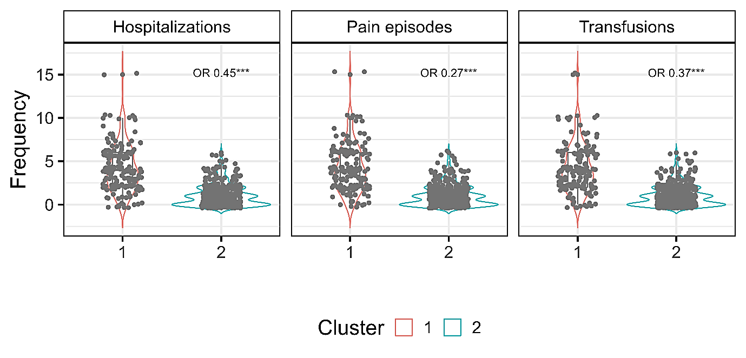

Figure S1. Violin plot showing the distribution of number of hospitalizations, frequency of painful episodes and number of transfusions among patients in Cluster 1 and Cluster 2. OR: unadjusted odds ratio derived from logistics regression with cluster membership as the dependent variable. *\*\*\*p*<0.01