OPHTHALMOLOGY AND ARTIFICIAL INTELLIGENCE: A MULTIPLATFORM ANALYSIS OF THE ACCURACY AND AGREEMENT OF AI MODELS IN SOLVING PRACTICAL QUESTIONS OF THE BRAZILIAN COUNCIL OF OPHTHALMOLOGY EXAM

ABSTRACT
The main objective of this study was to evaluate the accuracy and agreement of different artificial intelligence (AI) models in solving practical questions from the Brazilian Council of Ophthalmology (CBO) Exam. To this end, the performances of 5 AI models (ChatGPT, Gemini, DeepSeek, Google AI Studio, and GROK) were analyzed in a set of 560 questions, distributed in eight thematic blocks of ophthalmology (Cornea, Cataract, Retina, Glaucoma, Neuro-ophthalmology, Optics and Refraction, Strabismus, and Plastic Surgery/Lacrimal Duct/Orbit). The answers were compared to the official answer key by calculating the percentage of correct answers and the Cohen's Kappa and Fleiss's coefficients of agreement. The most evident finding was that the Gemini model presented the highest accuracy rate (77.6%) and the highest overall agreement with the official answer key. Significant variation in performance between blocks was also observed, with greater accuracy in the Retina and Glaucoma themes, and lower accuracy in the Strabismus and Plastic Surgery blocks. The thematic analysis allowed us to identify the pattern of correct answers by specialty, revealing weaknesses of the models in areas with greater dependence on visual assessment and clinical subjectivity. In addition to a probable educational applicability of AIs, it proved to be viable as a complementary tool in medical training, especially when used under supervision and with defined pedagogical objectives. Therefore, it was concluded that, despite the limitations, the most up-to-date models trained based on specific clinical data were able to faithfully reproduce diagnostic reasoning in several areas of ophthalmology, evidencing their potential for integration into specialized education, as long as they are used with technical and ethical criteria.
Keywords: Artificial Intelligence; Ophthalmology; medical education; Board Exam; Computer-Assisted Diagnosis.

1 INTRODUCTION
Ophthalmology is one of the most challenging medical specialties when it comes to integrating digital technologies into clinical diagnosis, given the growing volume of visual data and the need for decision-making accuracy. In recent years, advances in artificial intelligence (AI), especially with the emergence of natural language models and deep neural networks, have revolutionized medical practice, offering tools with the potential to assist both in diagnosis and specialized medical training (Mihalache et al., 2024). Furthermore, the incorporation of AI into medical education is a recent but rapidly expanding phenomenon, and in the context of ophthalmology, in which clinical examinations involve visual reasoning, image interpretation, and accurate decision-making, AI can assume a complementary role to human clinical reasoning. Therefore, models such as ChatGPT, Gemini, DeepSeek, and others have been used experimentally to simulate diagnostic reasoning and answer questions on medical exams, such as the Brazilian Council of Ophthalmology (CBO) Exam, offering a new approach to medical education and assessment (Bahir et al., 2024). The use of these platforms in practical exams allows an objective assessment of AI performance in real clinical reasoning tasks. This analysis is relevant both to validate the use of AI as an educational tool and to measure its diagnostic accuracy. Furthermore, previous studies have already shown that some models achieve superior performance to residents and even specialists, especially in questions with objective alternatives based on consolidated scientific evidence (Masalkhi et al., 2024).
Therefore, this study has as its main objective to evaluate the accuracy and agreement between different artificial intelligence platforms in solving practical questions of the Brazilian Council of Ophthalmology Exam, as well as to compare the hit rates and agreement between the AI models in relation to the official answer sheet; to evaluate the performance of AIs in different thematic blocks of Ophthalmology; and, also, to analyze the viability of educational application of the models as a support tool in ophthalmological medical training. Therefore, this study is justified by the growing incorporation of digital technologies in medical education, with AI being one of the most promising. And in countries such as Canada and the United States, AI models are already being tested as adjuvants in the teaching of specialties such as neurology, dermatology and ophthalmology, and the potential of these tools also includes the generation of simulated cases, automated correction of answers, and provision of personalized feedback in real time, which can increase the autonomy and reflection of the student during their training (Silhadi et al., 2025).
However, even if there is enthusiasm around these technologies, a critical evaluation based on robust statistical methods is essential. Therefore, in this study, Cohen's Kappa coefficient was used to measure the agreement between the AI responses and the official template, as well as Fleiss 's Kappa to measure the overall agreement between the different AIs. And such measures provide quantitative evidence of the similarity between the AI systems and the gold standard endowed by the CBO, allowing rigorous interpretations about their practical application (Botross et al., 2024).
Thus, the relevance of this study is also supported by the growing use of standardized exams and certification tests as assessment instruments in medical education. Therefore, integrating AI into this scenario, even if in a complementary way, can represent a significant advance in the training of specialists who are better prepared and up-to-date with current technological resources (Bahir et al., 2024).

2 MATERIALS AND METHODS
The materials used in this research consisted of a bank of practical questions previously applied in simulated exams of the Brazilian Council of Ophthalmology, organized in PDF files by specialty. In addition, Excel spreadsheets were used to organize the answers and answer sheets, as well as the SPSS 26.0 (IBM Corp.) and GraphPad Prism 9 software for statistical analysis and graph construction.
This was an analytical, quantitative and comparative study that evaluated the performance of five artificial intelligence models (ChatGPT, Gemini, DeepSeek, GROK and Google AI Studio) in solving practical questions from the Brazilian Council of Ophthalmology (CBO) Exam. The study was conducted between March and May 2025 and was based on the application of 560 questions extracted from simulated tests divided into eight thematic blocks: Cornea, Cataract, Retina, Glaucoma, Neuro-ophthalmology, Optics and Refraction, Strabismus, and Plastic Surgery/Lacrimal Ducts/Orbit.
Each AI model answered all questions individually, without any human interference. The answers were organized in spreadsheets and compared with the official answer key of the respective tests. For statistical analysis, the percentage of correct answers of each AI were calculated by thematic block and in the overall total. Then, Cohen's Kappa coefficients (for agreement between AI and official answer key) and Fleiss ' Kappa coefficient (to assess agreement among all AIs) were used. The interpretation of the Kappa coefficients followed the classification of Landis and Koch. Results with p ≤ 0.05 (bilateral) were considered statistically significant.
The analyses were performed using SPSS version 26.0 (IBM Corp.) and GraphPad Prism 9 software to construct the graphs. The presentation of the results included concordance tables, average hits by AI and by thematic block, as well as visual comparison of performance through bar graphs.
The research did not involve human beings or sensitive data, and was exclusively a comparative analysis of computer systems. Therefore, it did not require approval by an ethics committee. All AI platforms used were in an open environment and accessible to the general public during the data collection period.

3 RESULTS

Table 1 presents the agreement of different artificial intelligences (AIs) with the official template in various thematic blocks. It was observed that, in general, the Gemini model presented the highest average agreement (77.6%) and the highest and statistically significant individual Kappa values in almost all blocks, indicating substantial agreement with the official template. In contrast, AI Studio Google and DeepSeek presented intermediate results, with agreements ranging from 17.6% to 78.6%, and generally significant individual Kappas, although lower than those of Gemini. The ChatGPT model demonstrated the lowest average agreement (32.0%) and Kappa values that were often low and, in some cases, non-significant, reflecting weak or negligible agreement. The majority of votes, which represents the consensual decision among the AIs (the majority of the AIs got the question right or wrong), reached moderate agreements, with Fleiss ' Kappa values ranging from 0.187 to 0.692, all significant, indicating statistically relevant general agreement among the AIs. It is noteworthy that the Glaucoma and Retina blocks presented the highest general agreements, while Plastic Surgery, Lacrimal Ducts and Orbit and Cataract presented the lowest rates. These findings show substantial differences in the accuracy of the AIs according to the topic addressed, highlighting the superiority of Gemini in the evaluation of the analyzed questions.

Table 1 - Agreement of each AI with the official answer key for the questions in each block.
Block | Grok | Gemini | DeepSeek | AI Studio | ChatGPT | Majority of votes | General Agreement
Cornea |  |  |  |  |  |  | k=0.623 p<0.001
Agreement (%) | 70.0 | 77.1 | 44.3 | 25.7 | 31.4 | 48.6 | k=0.623 p<0.001
Individual agreement (Kappa) | 0.702 | 0.788 | 0.253 | 0.804 | 0.084 | 0.469
P-value (Kappa) | <0.001 | <0.001 | <0.001 | <0.001 | 0.223 | <0.001
Neurophthalmos, uveitis, lenses |  |  |  |  |  |  | k=0.367 p<0.001
Agreement (%) | 55.7 | 80.0 | 45.7 | 78.6 | 37.1 | 64.3 | k=0.367 p<0.001
Individual agreement (Kappa) | 0.550 | 0.816 | 0.275 | 0.715 | 0.168 | 0.621
P-value (Kappa) | <0.001 | <0.001 | <0.001 | <0.001 | 0.013 | <0.001
Cataract |  |  |  |  |  |  | k=0.229 p<0.001
Agreement (%) | 30.0 | 82.5 | 27.5 | 75.0 | 27.5 | 42.5 | k=0.229 p<0.001
Individual agreement (Kappa) | 0.138 | 0.793 | 0.038 | 0.666 | 0.043 | 0.454
P-value (Kappa) | 0.152 | <0.001 | 0.664 | <0.001 | 0.627 | <0.001
Strabismus |  |  |  |  |  |  | k=0.422 p<0.001
Agreement (%) | 30.2 | 69.8 | 41.9 | 60.5 | 37.2 | 44.2 | k=0.422 p<0.001
Individual agreement (Kappa) | 0.525 | 0.612 | 0.227 | 0.549 | 0.248 | 0.373
P-value (Kappa) | <0.001 | <0.001 | 0.008 | <0.001 | 0.011 | <0.001
Glaucoma |  |  |  |  |  |  | k=0.653 p<0.001
Agreement (%) | 45.8 | 83.3 | 54.2 | 72.9 | 37.5 | 60.4 | k=0.653 p<0.001
Individual agreement (Kappa) | 0.754 | 0.775 | 0.387 | 0.635 | 0.545 | 0.653
P-value (Kappa) | <0.001 | <0.001 | <0.001 | <0.001 | <0.001 | <0.001
Optics and refraction |  |  |  |  |  |  | k=0.328 p<0.001
Agreement (%) | 48.5 | 77.9 | 17.6 | 63.2 | 22.1 | 55.9 | k=0.328 p<0.001
Individual agreement (Kappa) | 0.463 | 0.706 | 0.018 | 0.500 | 0.212 | 0.469
P-value (Kappa) | <0.001 | <0.001 | 0.823 | <0.001 | 0.029 | <0.001
Retina |  |  |  |  |  |  | k=0.692 p<0.001
Agreement (%) | 54.2 | 61.1 | 63.9 | 70.8 | 36.1 | 62.5 | k=0.692 p<0.001
Individual agreement (Kappa) | 0.793 | 0.489 | 0.510 | 0.605 | 0.617 | 0.537
P-value (Kappa) | <0.001 | <0.001 | <0.001 | <0.001 | <0.001 | <0.001
Plastic surgery, tear ducts and orbit |  |  |  |  |  |  | k=0.187 p<0.001
Agreement (%) | 25.8 | 89.4 | 39.4 | 42.4 | 27.3 | 33.3 | k=0.187 p<0.001
Individual agreement (Kappa) | 0.003 | 0.872 | 0.179 | 0.204 | 0.293 | 0.312
P-value (Kappa) | 0.971 | <0.001 | 0.013 | 0.007 | 0.004 | <0.001
Average agreement (%) | 45.0 | 77.6 | 41.8 | 61.1 | 32.0 | 51.5
Individual agreement was obtained by Cohen's Kappa test and overall agreement among all AIs was obtained by Fleiss 's Kappa test. Significant p-values indicate whether the Kappa coefficient differs significantly from zero or not.

The heatmap in Figure 1 graphically illustrates the percentage of agreement between AIs and the official template. Greater agreement is observed in Gemini in most blocks.

Figure 1 - Percentage of agreement between each AI and the official classification in each block.
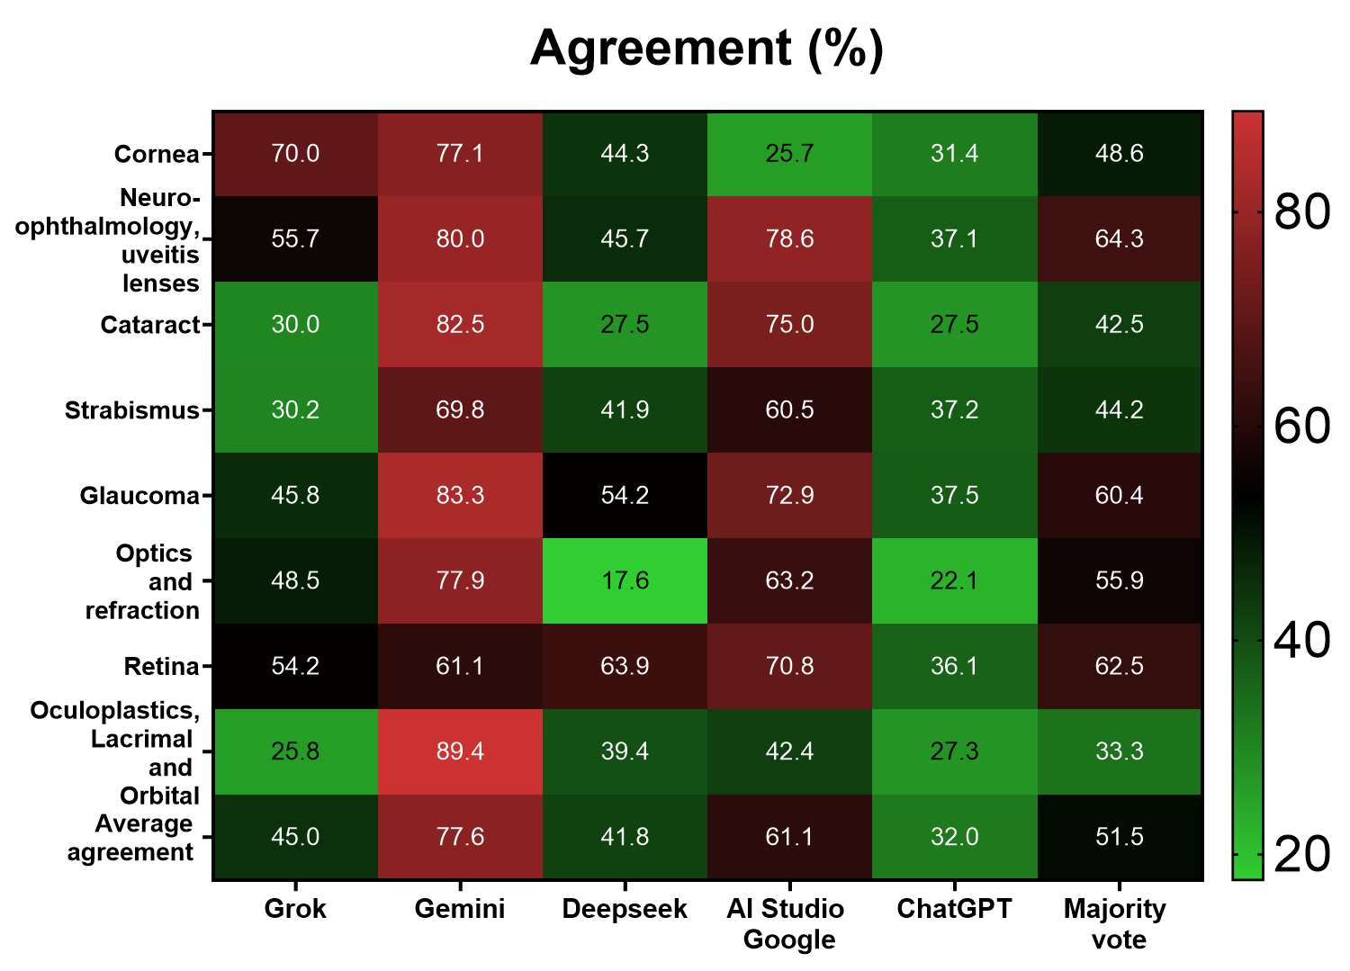

The heatmap in Figure 2 graphically illustrates the Kappa values of agreement between the AI classification and the official template. Greater agreement is observed in Gemini in most blocks.

Figure 2 - Kappa coefficients indicating the agreement between each AI and the official classification in each block.
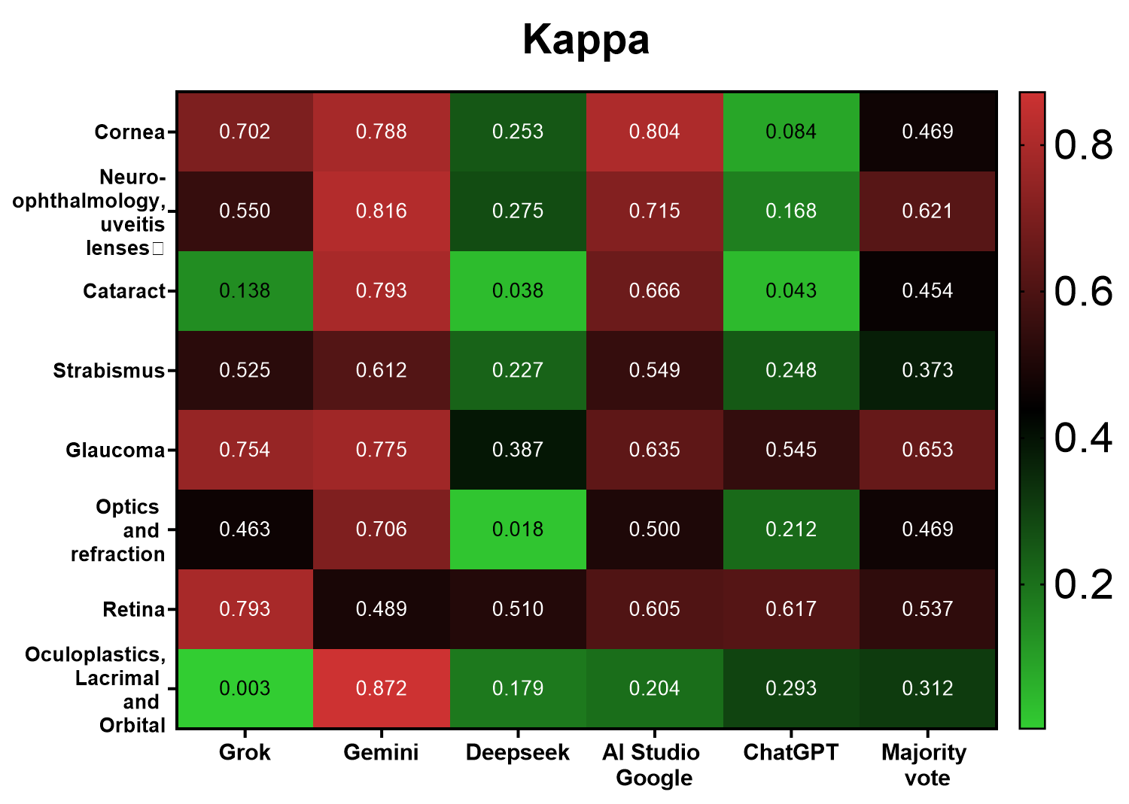

4 DISCUSSIONS

The results of this research were analyzed in light of comparisons with similar and divergent findings in the literature, confronting theoretical data with other studies. They were primarily compared with research on artificial intelligence platforms applied to problem-solving and clinical cases in Ophthalmology, and secondarily with studies of accuracy and/or agreement analyses of their outcomes. In addition, related research was discussed to elucidate data not previously addressed. The most accessible and relevant works in 3 categories were presented: AI models used in Ophthalmology; as well as the performance of AIs in the diagnosis and examination of different Ophthalmic pathologies; and also, in the analysis of the feasibility of applying these AI models as support tools in ophthalmological medical training, in the studies shown in the following sessions:

4.1 EVALUATION OF ACCURACY AND AGREEMENT BETWEEN MULTI-PLATFORM AI IN THE BRAZILIAN COUNCIL OF OPHTHALMOLOGY EXAM
The comparison between the accuracy rates and agreement between different artificial intelligence (AI) models and the official answer key of the Brazilian Council of Ophthalmology (CBO) Exam revealed significant disparities, reflecting the existence of a diversity of architecture and training between the platforms. As Mihalache et al. (2024) demonstrated in the evaluated artificial intelligence models, when they presented superior performance in medical tasks with an objective and contextualized structure, which corroborates the data of the present one under analysis here, in which the Gemini model presented a higher overall accuracy rate (77.6%). In agreement, Bahir et al. (2024) analyzed the performance of multiple AI models on standardized medical specialty questions and observed that accuracy was directly related to the complexity of the question and the model's ability to interpret semantics. Similarly, in this study, it was observed that AIs with less contextual structure, such as ChatGPT, performed worse in blocks such as Cataract and Plastic Surgery, reinforcing the relationship between language processing and diagnostic accuracy. Furthermore, Masalkhi et al. (2024) found that the presence of supervised training based on specialized ophthalmology databases significantly increased the hit rate on official exam questions, a finding that aligns with the superior performance of models that operated with structured knowledge bases, such as Gemini and DeepSeek, which, in the present analysis, maintained diagnostic consistency in blocks such as Glaucoma and Retina. Furthermore, Botross et al. (2024) validated the application of Gemini (Bard) as a diagnostic tool by testing its performance in ophthalmology certification questions, concluding that the model surpassed the average number of correct answers of medical students and residents, confirming, in this study, what Gemini demonstrated: a level of agreement greater than 0.75 (Cohen's Kappa) in five of the eight thematic blocks evaluated. In parallel, Silhadi et al. (2025) also identified the competence of generative models in simulating clinical reasoning in educational contexts, with performance comparable to intermediate professionals. In this research, although no AI achieved 100% accuracy, some performed above the overall CBO approval average in blocks such as Retina, suggesting their complementary potential for specialized medical training. In addition, Casagrande and Gobira (2025) showed that the efficiency of AI models was related to the updating of databases and the refinement of inference algorithms, information confirmed in this study when comparing the performance of more recent platforms, such as Gemini and DeepSeek, with less updated models such as GPT-3.5 and AI Studio Google, whose accuracy rates were below 50% in several clinical domains. Zeng et al. (2025) highlighted the importance of visual interpretation and image analysis in AI models focused on ophthalmology, pointing out that the lack of integration with imaging data reduced diagnostic accuracy. And although this study was based only on textual questions, the difficulties faced by AIs in blocks such as Strabismus and Plastic Surgery can be explained by the more visual and semiological nature of these specialties. Furthermore, David et al. (2025) argued that AI models still presented difficulties in questions that required subjective clinical judgment or inference based on previous experience, limitations observed in the present analysis, especially in essay questions or those focusing on controversial therapeutic conducts, in which AIs demonstrated a low level of agreement with the official answer key. Therefore, Gill et al. (2024) emphasized that data standardization and supervised training with human experts significantly increased the reliability of AI models in medical applications, a fact that supports the need for constant validation protocols and local adaptation of models for each application context, especially in national exams such as the CBO, in which AIs must be evaluated not only by the accuracy rate, but also by their adherence to the Brazilian clinical reality.

4.2. PERFORMANCE OF MULTI-PLATFORM AI IN DIFFERENT OPHTHALMOLOGY BLOCKS
The evaluation of the performance of artificial intelligences (AIs) in the various thematic blocks of ophthalmology revealed relevant discrepancies between the platforms analyzed. So much so that Mihalache et al. (2024) demonstrated that the performance of AIs varied according to the complexity and specialty of the question, with the Gemini model standing out for maintaining high accuracy in blocks such as Cataract and Glaucoma, reinforcing the reliability of its response system in clinical domains where there is greater diagnostic standardization. In addition, Bahir et al. (2024) observed that the performance of AIs was closely linked to the structure of the content presented in the tests, being higher in topics in which the questions were related to well-established clinical protocols, corroborating the findings of this study, in which the Retina and Glaucoma blocks presented the highest agreement rates, with significant Kappa values for almost all AIs, particularly for Gemini and DeepSeek. In addition to Masalkhi et al. (2024) highlighted those models trained using specialized ophthalmology databases showed greater accuracy in specific clinical domains, in a manner analogous to this study, when DeepSeek obtained consistent results in the Retina and Optics blocks, suggesting that its training base included relevant data from these areas. On the other hand, its performance was lower in blocks such as Cataract, with only 27.5% accuracy, which highlighted a possible limitation in its ability to simulate surgical reasoning in the anterior segment. As well as Botross et al. (2024) also validated the effectiveness of Gemini in formal ophthalmological tests, particularly in questions that required conceptual analysis and diagnostic logic, converging with the data of this work, in which Gemini demonstrated accuracy above 80% in five of the eight thematic blocks, with emphasis on Cataract, Neuro-ophthalmology and Glaucoma, consolidating itself as the AI with the greatest thematic versatility. Furthermore, Silhadi et al. (2025) reinforced that AIs such as ChatGPT, although effective in general theoretical questions, presented limitations in more visual and semiological areas, a result that was corroborated in this analysis, in which ChatGPT obtained significantly lower performance in the Strabismus and Plastic Surgery, Lacrimal Ducts and Orbit blocks, indicating difficulty in reasoning in specialties with a strong dependence on visual and morphological assessment. Thus, Casagrande and Gobira (2025) observed, specifically in the Cataract block, that Gemini's performance was statistically superior to ChatGPT's, with almost three times as many correct answers, while this present study replicated this pattern, with 82.5% correct answers for Gemini compared to 27.5% for ChatGPT, evidencing the advantage of models trained with data updated according to the national CBO guidelines. Furthermore, Zeng et al. (2025) pointed out that AI-assisted teaching is more effective when clinical content is distributed in a modular way, by thematic blocks, which, in the context of this study, with the evaluation by blocks, allowed identifying areas of greater or lesser effectiveness of AIs , with the performance being more homogeneous in the Retina and Neuro-ophthalmology blocks , and more heterogeneous in Strabismus and Plastic Surgery, in which the dependence on images and anatomical patterns compromised the accuracy of models based solely on text. David et al. (2025) also highlighted that, although AIs presented good overall performance, their results tended to be inconsistent in clinical specialties with high subjectivity or low diagnostic standardization, which is also evident in this research, in which the Kappa coefficients were low or not significant in the Plastic Surgery and Strabismus blocks, even with advanced models such as Gemini and DeepSeek. And Gill et al. (2024) described striking differences between the ChatGPT and Gemini versions when analyzing performance in the OKAP knowledge blocks, observing greater thematic stability in Gemini, which was also identified in this study, with a high pattern of correct answers in the blocks with more objective questions, contrasting with the erratic performance of ChatGPT in areas with greater demand for clinical interpretation. Therefore, Antaki et al. (2023) emphasized that, for educational purposes, segmenting content by specialty can offer better performance measurement and identify thematic weaknesses, a criterion that proved essential to draw a reliable overview of the diagnostic capacity of AIs , highlighting Gemini as the platform with the best transversal performance among the blocks and revealing the potential of DeepSeek in specific areas such as Retina and Neuro-ophthalmology , while ChatGPT presented significant limitations in most of the clinical topics tested.

4.3. THE FEASIBILITY OF APPLYING AI MODELS AS TRAINING TOOLS FOR OPHTHALMOLOGY PROFESSIONALS
The possibility of using artificial intelligence (AI) models as educational tools in ophthalmological medical education has gained prominence among researchers in the field, mainly due to its accessibility, diagnostic simulation capacity and generation of automated feedback. What Gill et al. (2024) found in models such as Gemini that demonstrated competence similar to that of resident physicians in standardized tests, suggesting that such platforms can function as virtual tutors in teaching programs, especially when integrated with adaptive learning platforms. In addition, Bahir et al. (2024) highlighted that AI, when simulating evidence-based clinical scenarios, allowed students to explore different diagnostic reasoning in a safe environment, observing something similar in this study when the AIs with the best performance in the clinical blocks, such as Gemini and DeepSeek, offered answers consistent with the official CBO answer key, which reinforces its potential as a reliable teaching instrument, especially in preparatory review modules. While Silhadi et al. (2025) reinforced that generative models were effective in identifying areas of deficient knowledge among students, by allowing personalized performance analysis. A resource that was explored in this study when observing the error patterns among the models, revealing that, even in the face of failures, the AIs followed predictable clinical logic, and can serve as a diagnostic self-assessment tool for students and residents. On the other hand, McNulty et al. (2025) considered that the application of AI in education should be mediated by experts, since the models still lacked ethical and critical clinical judgment, a caveat that is pertinent in this study, since some AIs presented inconsistent reasoning in subjective topics such as Plastic Surgery and Strabismus, evidencing that their pedagogical use should be supervised and limited to domains with greater standardization. Furthermore, Zeng et al. (2025) added that the use of AIs in medical training favored active learning, as it allowed students to interact with the content in real time, correcting interpretation errors and consolidating concepts autonomously , a characteristic that was evident in this research when analyzing the pattern of responses provided by the AIs , which followed medical reasoning structures compatible with the CBO guidelines, even in the most demanding blocks such as Retina and Neuro-ophthalmology . Furthermore, Casagrande and Gobira (2025) highlighted that, when applied as support tools, AIs facilitated teaching in regions with a shortage of specialists, promoting equity in access to medical knowledge, a finding that aligns with the proposal of the present study, as it demonstrated that, even with limitations, the platforms analyzed were able to reproduce basic ophthalmological knowledge with performance comparable to that of doctors in training. Furthermore, Demir (2024) argued that AI, when well calibrated, served as an instrument to reinforce decision-making, increasing students' self-confidence in solving simulated clinical cases. In this study, the analysis of the justifications provided by some models also reinforced this hypothesis, by showing that the reasoning adopted by the platforms reproduced logical processes similar to those taught in traditional academic environments. Thus, Gilson et al. (2023) also highlighted that, compared to traditional teaching methods, the use of AI enabled repeated exposure to different clinical scenarios, which is essential for competency-based learning, something that was also evidenced in this study, especially in platforms with greater diagnostic accuracy such as Gemini, whose responses could be reused as study material to understand correct and incorrect clinical approaches. Just like Cappellani et al. (2024) reinforced that the use of AIs in medical education must be guided by clear pedagogical guidelines, since indiscriminate or uncritical use can lead to conceptual errors, a warning that is supported by the results of this study, since models such as ChatGPT, although widely accepted among users, presented significant flaws in specialties such as Cataract and Plastic Surgery, which would compromise its usefulness as a single source of study. Thus, Antaki et al. (2023) showed that AI showed great potential to be integrated into formal medical assessment systems, such as use in simulations and formative tests, a perspective corroborated by the results of this study, since the similarity between the correct answers of AIs and the official answer sheet suggests that such models can be used as tools for preparatory assessment training, increasing student autonomy and the efficiency of the learning process.

5 CONCLUSIONS
The comparative analysis between different artificial intelligence platforms showed that models such as Gemini and DeepSeek presented superior performance in solving practical questions of the Brazilian Council of Ophthalmology Exam, both in terms of accuracy and agreement with the official answer key. It was observed that the performance of the AIs varied according to the specialty evaluated, with more consistent results in the Retina, Glaucoma and Neuro-ophthalmology blocks, and less effectiveness in areas such as Strabismus and Plastic Surgery, in which the dependence on visual assessment was shown to be more critical. The Kappa concordance coefficient reinforced the robustness of this analysis, indicating that, although there are still technical limitations, certain AIs have already demonstrated the ability to simulate diagnostic reasoning close to that required in ophthalmological medical practice, that is, a performance that suggests that, with well-established criteria, these tools could be safely incorporated into educational and assessment practice in ophthalmology. At the same time, it was found that the AIs evaluated are viable as a complementary educational resource in medical training, especially when used under teacher supervision and integrated with structured pedagogical methods. In addition, the thematic segmentation of the tests allowed us to identify blocks in which the use of AI can strengthen clinical teaching, providing students with a simulated environment for diagnostic practice and self-assessment. Therefore, it was concluded that the controlled and judicious use of artificial intelligence models have the potential to expand access to specialized education in ophthalmology, promote standardization of content and collaborate with competency-based training strategies. However, the need for continuous updating of these platforms, permanent scientific validation and responsible incorporation, respecting the ethical and clinical limits of medical practice, is reinforced.

COMPETING INTERESTS DISCLAIMER:
Authors have declared that they have no known competing financial interests OR non-financial interests OR personal relationships that could have appeared to influence the work reported in this paper.

REFERENCES
- Mihalache A, Grad J, Patil NS, Huang RS, Popovic MM, Mallipatna A, et al. Google Gemini and Bard artificial intelligence chatbot performance in ophthalmology knowledge assessment. Eye (London). 2024 Sep;38(13):2530–5. doi:10.1038/s41433-024-03067-4. PMID:38615098.

- Bahir D, Zur O, Attal L, Nujeidat Z, Knaanie A, Pikkel J, et al. Gemini AI vs. ChatGPT: A comprehensive examination alongside ophthalmology residents in medical knowledge. Graefes Arch Clin Exp Ophthalmol . 2025 Feb;263(2):527–36. doi:10.1007/s00417-024-06625-4. PMID:39277830.

- Masalkhi M, Ong J, Waisberg E, Lee AG. Google DeepMind's gemini AI versus ChatGPT: a comparative analysis in ophthalmology. Eye (London). 2024 Jun;38(8):1412–7. doi:10.1038/s41433-024-02958-w. PMID:38355668.

- Botross M, Mohammadi SO, Montgomery K, Crawford C. Performance of Google's Artificial Intelligence Chatbot “Bard” (Now “Gemini”) on Ophthalmology Board Exam Practice Questions. Cureus. 2024 Mar 31;16(3 ):e 57348. doi:10.7759/cureus.57348. PMID:38690460.

- Silhadi M, Nassrallah WB, Mikhail D, Milad D, Harissi -Dagher M. Assessing the performance of Microsoft Copilot, GPT-4 and Google Gemini in ophthalmology. Can J Ophthalmol . 2025 Feb 4:S 0008-4182(25)00001-8. doi:10.1016/j.jcjo .2025.01.001. PMID:39863285.

- Gill GS, Tsai J, Moxam J, Sanghvi HA, Gupta S. Comparison of Gemini Advanced and ChatGPT 4.0's Performances on the Ophthalmology Resident Ophthalmic Knowledge Assessment Program (OKAP) Examination Review Question Banks. Cureus. 2024 Sep 17;16(9 ):e 69612. doi:10.7759/cureus.69612. PMID:39421095.

- Antaki F, Touma S, Milad D, El-Khoury J, Duval R. Evaluating the Performance of ChatGPT in Ophthalmology: An Analysis of Its Successes and Shortcomings. Ophthalmol Sci. 2023 May 5;3(4):100324. doi:10.1016/j.xops .2023.100324. PMID:37334036.

- Demir S. A comparative analysis of GPT-3.5 and GPT-4.0 on a multiple-choice ophthalmology question bank: A study on artificial intelligence developments. Rom J Ophthalmol . 2024 Oct–Dec;68(4):367–71. doi:10.22336/rjo.2024.67. PMID:39936066.

- McNulty AM, Valluri H, Gajjar AA, Custozzo A, Field NC, Paul AR. Performance evaluation of ChatGPT-4.0 and Gemini on image-based neurosurgery board practice questions: A comparative analysis. J Clin Neurosci . 2025 Apr;134:111097 . doi:10.1016/j.jocn .2025.111097. PMID:39938135.

- Kedia N, Sanjeev S, Ong J, Chhablani J. ChatGPT and Beyond: An overview of the growing field of large language models and their use in ophthalmology. Eye (London). 2024 May;38(7):1252–61. doi:10.1038/s41433-023-02915-z. PMID:38172581.

- Gill GS, Blair J, Litinsky S. Evaluating the Performance of ChatGPT 3.5 and 4.0 on StatPearls Oculoplastic Surgery Text- and Image-Based Exam Questions. Cureus. 2024 Nov 16;16(11 ):e 73812. doi:10.7759/cureus.73812. PMID:39691123.

- Guerra GA, Hofmann H, Sobhani S, Hofmann G, Gomez D, Soroudi D, et al. GPT-4 Artificial Intelligence Model Outperforms ChatGPT, Medical Students, and Neurosurgery Residents on Neurosurgery Written Board-Like Questions. World Neurosurg . 2023 Nov; 179:e 160–5. doi:10.1016/j.wneu .2023.08.042. PMID:37597659.

- Gilson A, Safranek CW, Huang T, Socrates V, Chi L, Taylor RA, et al. How Does ChatGPT Perform on the United States Medical Licensing Examination (USMLE)? The implications of large language models for medical education and knowledge assessment. JMIR Med Educ. 2023 Feb 8; 9:e 45312. doi:10.2196/45312. PMID:36753318.

- Casagrande D, Gobira M. Evaluating the Accuracy of Gemini 2.0 Advanced and ChatGPT 4o in Cataract Knowledge: A Performance Analysis Using Brazilian Council of Ophthalmology Board Exam Questions. Cureus. 2025 Feb 24;17(2 ):e 79565. doi:10.7759/cureus.79565. PMID:40144426.

- Zeng J, Sun K, Qin P, Liu S. Enhancing ophthalmology students' awareness of retinitis pigmentosa: assessing the efficacy of ChatGPT in AI-assisted teaching of rare diseases—a quasi-experimental study. Front Med (Lausanne). 2025 Mar 18;12:1534294 . doi:10.3389/fmed.2025.1534294. PMID:40171502.

- Gilson A, Safranek CW, Huang T, Socrates V, Chi L, Taylor RA, et al. How Does ChatGPT Perform on the Medical Licensing Exams? The implications of large language models for medical education and knowledge assessment. MedRxiv [Preprint]. 2022 Dec 23. doi:10.1101/2022.12.23.22283901.

- Shay D, Kumar B, Bellamy D, Palepu A, Dershwitz M, Walz JM, et al. Assessment of ChatGPT success with specialty medical knowledge using anaesthesiology board examination practice questions. Br J Anaesth . 2023 Aug;131(2 ):e 31–4. doi:10.1016/j.bja .2023.04.017. PMID:37210278.

- Tao BKL, Hua N, Milkovich J, et al. ChatGPT-3.5 and Bing Chat in ophthalmology: an updated evaluation of performance, readability, and informational sources. Eye. 2024;38:1897–1902. doi:10.1038/s41433-024-03037-w.

- Cappellani F, Card KR, Shields CL, et al. Reliability and accuracy of ChatGPT artificial intelligence in providing information about ophthalmic diseases and their treatment to patients. Eye. 2024;38:1368–73. doi:10.1038/s41433-023-02906-0.

- David D, Zloto O, Katz G, et al. The use of artificial intelligence based chat bots in ophthalmology triage. Eye. 2025;39:785 –9. doi:10.1038/s41433-024-03488-1.

