Original Research Article

Epidemiological Profile of Maternal Deaths from Eclampsia from 2013 to 2022 in Brazil

.
ABSTRACT

Aims: This study aims to analyze the characteristics of maternal mortality by eclampsia in Brazil.
Place and Duration of Study: The data was searched through the platform of the Department of Informatics of the Unified Health System (DATASUS) with studies published between 2013 and 2022.
Methodology: Maternal deaths were analyzed by variables such as age, color/race, geographic region and causes of death due to eclampsia. The scientific research was carried out using death certificates and the Mortality Information System (SIM) in Brazil from 2013 to 2022.
Results: In total, 1,532 deaths from eclampsia were recorded between 2013 and 2022. The most affected age group was 20 to 39 years old, with 721 deaths (47.1%). With regard to ethnicity, the majority of women declared themselves brown, totaling 885 cases (57.8%). The highest frequency of schooling was between 8 and 11 years of study. As for marital status, 671 women were single (43.8%) and 410 were married (26.8%). Most maternal deaths occurred in hospitals, with 1,397 cases.
Conclusion: The evaluation of the epidemiological profile of maternal deaths from eclampsia in Brazil from 2013 to 2022 showed an alarming scenario, despite variations in the rates over the years. The findings indicate that even with the efforts of public policies, eclampsia persists as one of the main causes of maternal death, highlighting deficiencies in prenatal care and in the implementation of prevention and control strategies. Thus, the research emphasizes the need to intensify public policies aimed at maternal health, implementing effective health education strategies, early diagnosis and constant monitoring to reduce maternal mortality from eclampsia.

Keywords: [maternal mortality. pre-eclampsia. Epidemiology. Nursing}

1. INTRODUCTION

Maternal mortality is defined by the World Health Organization (WHO) in the Organization (WHO) in the International Classification of Diseases (ICD-10) as the death of women during pregnancy or up to 42 days after childbirth, excluding causes related to accidents or incidents (WHO, 1994). accident or incident (WHO, 1994). Gestational Hypertensive Syndromes (GHS) represent challenges related to blood pressure during pregnancy (Bezerra et al.,2005). Pregnant women diagnosed with Gestational Hypertensive Syndrome are subject to a significantly increased risk of complications before, during and after delivery (Garovic et al., 2020). This condition can negatively affect the health of both the mother and the developing baby (Garovic et al., 2022). Pre-eclampsia is associated with chronic pre-existing hypertension (Freire, 2010). Preventing these complications requires prenatal care by trained health professionals, assistance during childbirth and postpartum support. Improving maternal health systems globally and implementing effective measures are crucial to ensuring that all women receive the necessary care during pregnancy. women receive the care they need during pregnancy and childbirth (United Nations, 2019).
Several factors contribute to this worrying reality, including unfavorable socioeconomic conditions, low levels of education and information, as well as the presence of domestic violence, limited access to quality services and quality health care also represents a significant obstacle (Ministério da Health, 2009). The consequences associated with inadequate diet during pregnancy pregnancy can lead to complications. The study carried out to develop the Healthy Eating Index for Brazilian Pregnant Women (HEIP-B) revealed that more than half of the pregnant women analyzed had dietary patterns classified as as “in need of improvement”, highlighting the importance of promoting an during pregnancy (Melere et al., 2013).
A study conducted in Brazil revealed that pre-eclampsia had an incidence rate of 1.5%, while eclampsia had an incidence of 0.6% (Peraçoli et al., 2019). However, in less privileged areas, this prevalence increased to 8.1%, with a corresponding maternal mortality rate of 22%. (Erez et al., 2022)
Between 2010 and 2017 in Brazil, pre-eclampsia emerged as the second leading cause of maternal mortality. second leading cause of maternal mortality, accounting for 10.48% of cases, surpassed only by eclampsia, which reached 14.06%. A regional analysis showed that the regions most affected were the Southeast, with 329 deaths related to pre-eclampsia (35%), followed by the Northeast, with 326 deaths (34.6%) (Gomes et al., 2020).
The North, Midwest and South had lower rates, with 10.8%, 10.2% and 9.4% (Gomes et al., 2020). Recent estimates suggest that every year, between 50 and 100,000 women die from complications resulting from pre-eclampsia and eclampsia worldwide (Palazuelos et al., 2023).
In 1983, the Program for Integral Assistance to Women's Health (PAISM) was implemented as part of the measures to reduce maternal mortality in the country, with the aim of expanding the health services available to women (Ministério of Health, 1983).
Finally, in 2011, the Stork Network was set up in the country as an innovative innovative approach to organizing and planning labour and birth care in Brazil. (Brasil, 2011). Although maternal deaths are preventable in almost 95% of of cases, it is estimated that every minute in the world a woman loses her life due to complications in childbirth, with an even higher incidence in developing countries (Faria et al, 2019).

2. metodology

2.1 Type of Stury

This is a descriptive study, with a quantitative approach. approach in which strategies for investigating epidemiological cases of cases of eclampsia in Brazil from 2013 to 2022.
The characteristic of an epidemiological study is to take as a basis fact that have already occurred, identifying causal and exposure factors that may contribute to the evolution of a clinical condition. After data collection, the data was analyzed and those that fit the theme in question were presented in the table. The descriptive study used in the epidemiological environment is characterized by a research capable of describing phenomena and characteristics of a population. É data is collected through interviews, questionnaires and analysis of data records. which seek to identify the health characteristics of the population of interest (Merchán-Hamann and Tauil, 2021).
Quantitative research is where numerical data on variables is collected and analyzed. variables are collected and analyzed. In this way, this type of research is able to identify the nature of realities, can determine the strength of association or correlation between variables; the generalization and objectification of the results, through a sample that interferes with the whole. The data collected is presented in the form of percentages, numbers or quantities (Esperón,2017).
2.2 Data Collection

Data was collected using the platform of the Department of Information Technology of the Unified Health System (DATASUS). Department of Informatics of the Unified Health System (DATASUS). data collection, studies, processing and dissemination of health surveys to the population. the population. This data can contain information to help public health decision-making.

2.3 Population and Sample

For the purposes of this study, individuals affected by cases of cases of eclampsia found in DATASUS and occurring in Brazil between 2013 and 2022. 2013 to 2022. Therefore, the variables that were analyzed are: maternal deaths by variables such as age, color/race, geographic region and causes of death due to eclampsia.

2.4 Inclusion Criteria

For this study, we used as inclusion criteria only cases of eclampsia that occurred in Brazil between 2013 and 2022.

2.4 Exclusion Criteria

For this study, we used as exclusion criteria data that were not related to cases of eclampsia and the variables we addressed in the study.

3.6 Research Instrument

The scientific research was carried out using death certificates (DC) and the mortality information system (MIS) in Brazil from 2013 to 2022. A research was carried out in two stages. In the first, we used a tabulation tool, TABNET, developed by DATASUS, which allows for quick quick tabulations based on SUS data, through an exploratory analysis. which provides information on live births, mortality, hospitalizations, outpatient hospitalizations, outpatient production, as well as information on the population. In the second stage, the data collected was organized using spreadsheets Microsoft Office 365 Excel spreadsheets.
3.7 Data Analysis

Data analysis was carried out in two stages: in the first stage using the health tabulator TABNET, developed by the Department of Information and Informatics of the SUS (DATASUS) with the aim of allowing quick tabulations to be carried out with the variables referring to the databases that make up the health information systems of the SUS, through an exploratory analysis. The user is the one who defines the content of the tabulation, and the databases available here are referring to live births, mortality, hospital admissions, outpatient production, as well as information on the population. The second stage involved organizing the data collected using microsoft excel spreadsheets office 365.

3.8 Ethical Aspects

As this is a study of secondary data, tabulated in DATASUS, it is not necessary to submit it to the Research Ethics Committee (CEP). The research was governed by the ethical precepts of Resolution No. 466 of December 12, 2012, of the National Health Council (CNS), which provides for research: autonomy, beneficence, non-maleficence, justice and equity.

3. results

In total, 1,532 deaths from eclampsia were recorded between 2013 and 2022. Analysis of the graphs showing mortality from eclampsia in the regions Brazil reveals that the highest mortality rate occurred in the Northeast region, with (42%), followed by the Southeast with (26%). The lowest rate was observed in the South region, with (5%).
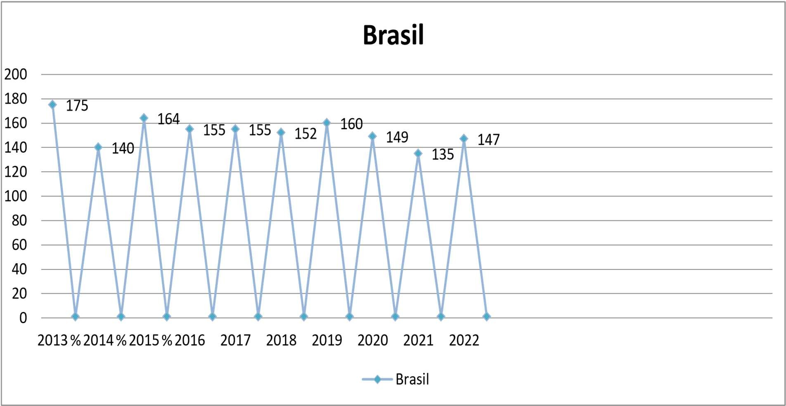

Fig. 1. Deaths due to eclampsia from 2013 to 2022.
The most affected age group was 20 to 39 years old, with 721 deaths (47.1%). The second highest incidence group was 10 to 19 years old, with 256 cases (16.7%). The lowest rate was observed in the 40 to 59 age group, with only 1 death (0.1%).









0

200

400

600

800

Age range

20

a

39

60

a

79

Range Etária

Fig. 2. Age group most affected by eclampsia.

In terms of ethnicity, the majority of women declared themselves to be brown, totaling 885 cases (57.8%), followed by white women, with 366 cases (23.9%). The lowest rate was observed among self-declared yellow women, with 7 deaths (0.5%).
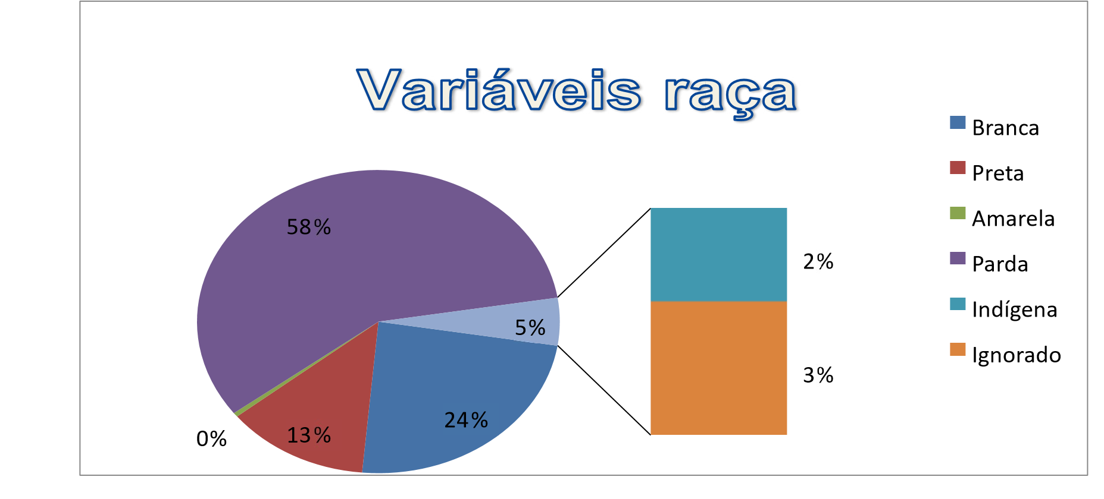
Fig. 3. Ethnicities most affected by eclampsia.
The highest frequency of schooling observed was between 8 and 11 years of schooling, corresponding to 604 deaths (39.4%), followed by the 4 to 7 year bracket, with 389 deaths (25.4%). (The lowest rate was found in the no schooling group, which registered 37 deaths (2.4%).
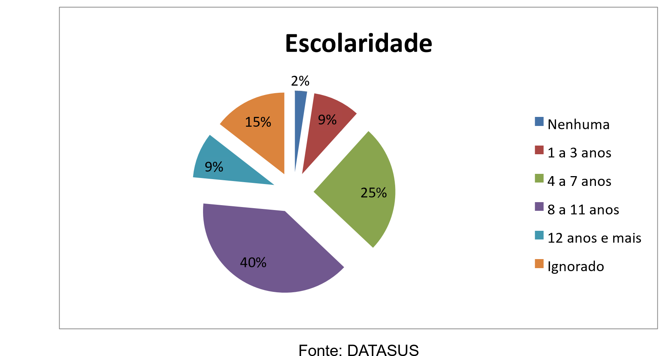
Fig. 4. Frequency of schooling in women affected by eclampsia.


















As for marital status, 671 women were single (43.8%) and 410 were married (26.8%). The lowest proportion was registered among widows, with 9 deaths (0.6%).

%

44

%

27

%

0

1

%

28

%

%

29

Estado Civil

Solteiro

Casado

Viúvo

Separado

Ignorado

Fig. 5. Rate of marital status of women affected by eclampsia.

Most maternal deaths occurred in hospitals, with 1,397 cases (91.2%), followed by deaths at home, which amounted to 52 cases (3.4%). The lowest frequency was recorded on public roads, with 21 deaths (1.4%).
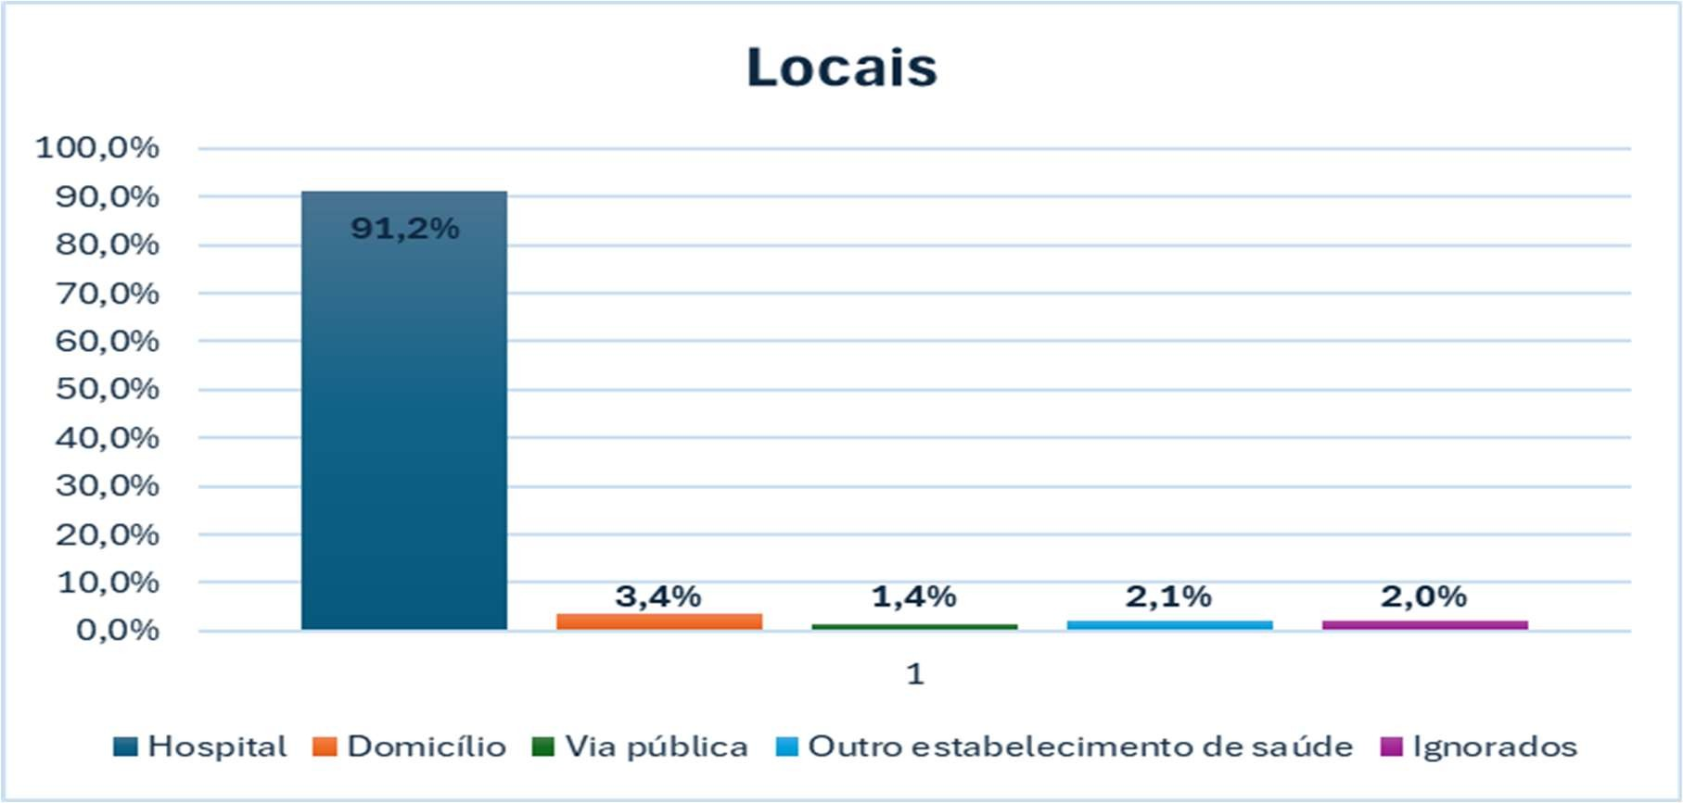
Fig. 6. Frequency of eclampsia-related deaths.

4. discussion

Pre-eclampsia is one of the diseases included in Gestational Hypertensive Syndromes (GHS) and occurs in between 2% and 8% of all pregnancies. In Brazil, it is the leading cause of maternal death, especially in its more severe forms, such as eclampsias and HELLP Syndrome. The research is analyzed by DATASUS and is extremely relevant to public health, given that maternal deaths are related to social inequalities. From 2013 to 2022, 1,532 maternal deaths from eclampsia were recorded in Brazil, with the highest mortality rate recorded in the northeastern state in 2015, and the lowest rate in the southern state in 2017.

According to the studies carried out by Kahhales et al (2018), eclampsia is a pathology that affects the maternal side as well as the fetal side, consequently causing a significant number of deaths in neonates and when they survive, they are damaged by perinatal hypoxia. The clinical picture of this disease is the onset of seizures in a patient previously suffering from pre-eclampsia, after ruling out epilepsy and other diseases that can cause seizures. One of the explanations for this high number of maternal deaths due to pre-eclampsia has been the failure of prenatal care during pregnancy at a national level. Miranda FFS et al (2019). In their study, they also reported on ineffective care in obstetric and perinatal urgencies and emergencies. These failures are also due to the poor management of Brazilian financial resources and the poor application of public policies. However, all of these factors can be corrected, since by acting correctly from the start of prenatal care, together with the correct physical and complementary examination, many deaths could have been avoided.

This scenario continues despite the establishment of international and national pacts and policies such as the Millennium Development Goals (MDGs), agreed by several countries in 2000 with the aim of reducing maternal mortality by three quarters. Marinho CSR et al (2020) found that among the targets set by this pact, the reduction in mortality was the one with the least progress. Specifically in Brazil, the target was to reduce maternal deaths by 35 deaths per 100,000 live births (LB) by 2015, which was not achieved. In addition, poorer countries or those at a similar level of development to Brazil have lower maternal death rates, such os countries in Latin America like Chile, Uruguay and Costa Rica.

In Brazil, the National Humanization Policy (NHP) was instituted in 2003, with the aim of generating changes in health practices and in the perspective of the population's reality. Barros and Moraes (2020) set out to ensure the right of access to humanized and qualified care throughout the process that pregnant women go through, i.e. prenatal care, childbirth, puerperium and neonatal care. It also includes improving the conditions of care for pregnant women in the Unified Health System (SUS), with a view to reducing maternal and perinatal mortality, by means of minimum parameters, such as the start of prenatal consultations at the beginning of the gestational period up to a maximum of the fourth month of pregnancy, with at least six prenatal consultations together with examinations. The focus is therefore on the need to reduce the incidence of various health problems in the maternal-fetal binomial.

In this context, Ribeiro (2018), Mello (2020) and Guerra (2020) explain that although mortality has decreased in the last two decades, it still remains a serious public health problem, and so as a national strategy, the Stork Network was implemented in the Unified Health System through Ordinance No. 1,459 of 2011, which seeks to guarantee actions to humanize childbirth, quality prenatal care and family planning, with measures that also directly interfere in the prevention of maternal deaths. In the studies by Rodrigues (2019), it was observed that the actions recommended by public health policies, such as the Stork Network, influence the maternal mortality coefficient, and it was possible through this study to verify that in the Northeast this rate fluctuated throughout the period, however, a slight reduction in the absolute number of deaths was observed, with 2017 showing the lowest value, with 56.36%, despite 2013, which showed 73.42%.

The results and information presented in this research by Carvalho and Meirinho (2020) are of great relevance since data provided by the health information system contribute not only to epidemiological analysis, but also to evaluating the quality and implementation of public policies, being indispensable tools for health planning.

As such, studies by Galvão (2019) and Azevedo (2018) point out that according to social factors such as age, race, schooling and marital status, there is a population at greater risk of complications that lead to maternal death, constituting a more vulnerable group. And this profile is also seen in this research: it is made up of women in the young adult age group (between 20 and 29 years old), with a reasonable level of schooling (around 4 to 7 years), single and brown. Ethnicity alone is not a risk factor, but studies have shown that brown women, as well as black women, are more vulnerable to maternal death, which may be related to their biological predisposition to develop diseases such as hypertension/pre-eclampsia. Miranda (2019), Carvalho and Mineirinho (2020) report that, however, in terms of social inclusion, black/brown women are more vulnerable, as most of them are below the poverty line and have an illiteracy rate twice as high as white women.

Poor communities with poor access to health services have higher rates of maternal mortality, because women's economic poverty associated with a lack of adequate information favors the occurrence of deaths from obstetric causes, in this case according to researchers Scarton et al (2020) and Mendes (2020) it is reported that poor and disadvantaged women are more likely to die prematurely than wealthy women. Despite the significant reduction, Andrade (2019) reports that maternal mortality in Brazil and the Northeast remains a serious public health problem, as since 2016 more than four women die every day as a result of complications in the pregnancy-puerperal cycle.

Given that improving the quality of prenatal, childbirth and puerperium care has a direct impact on maternal mortality rates, other strategies need to be implemented to ensure an effective reduction in the number of maternal deaths. Lima et al (2016) say that social investments are needed, aimed at public policy for basic education, reducing poverty and social inequalities, as they are capable of interfering in women's living conditions and well-being. And in agreement with Juinor Raof (2020), it is the responsibility of the Federal, State and Municipal Governments to adopt positive and protective measures capable of guaranteeing women the right to life, as well as ensuring that the health professionals who assist them receive adequate training, because whenever medical, social and/or health system factors put a woman's life at risk during pregnancy, childbirth or the puerperium, there is a violation of her rights. Despite the downward trend from 2013 to 2022, the results presented in these studies indicate that the maternal mortality ratio in Brazil is still worrying, and that the search for strategies to tackle this challenge is necessary.

5. Conclusion

The evaluation of the epidemiological profile of maternal deaths due to eclampsia in Brazil from 2013 to 2022 showed an alarming scenario (1.53 deaths), despite variations in the rates over the years. Despite the efforts of public policies and actions such as the Stork Network, eclampsia persists as one of the main causes of maternal death, highlighting deficiencies in prenatal care and the implementation of prevention and control strategies. The findings indicated an increase in prevalence among young, brown, poorly educated and unmarried women, suggesting the presence of social and economic vulnerabilities as aggravating factors. Furthermore, the predominance of deaths in hospital settings indicates the need to re-evaluate care practices during prenatal care, childbirth and the postpartum period. Thus, the research emphasizes the need to intensify public policies
maternal health, investing in training professionals, expanding access to health services and improving the quality of the service provided. It is important to implement effective health education strategies, early diagnosis and constant monitoring to reduce maternal mortality from eclampsia.

Consent (where ever applicable)

It is not applicable.

Ethical approval (where ever applicable)

It is not applicable.

References

- Bezerra, E. H. M. et al. Maternal mortality due to hypertension: index and analysis of its characteristics in a maternity hospital. Brazilian Journal of Gynecology and Obstetrics, 2005. https://doi.org/10.1590/S0100-72032005000900008

- Garovic VD, White WM, Vaughan L, Saiki M, Parashuram S, Garcia-Valencia O, Weissgerber TL, Milic N, Weaver A, Mielke MM. Incidence and Long-Term Outcomes of Hypertensive Disorders of Pregnancy. J Am Coll Cardiol. 2020 May 12;75(18):2323-2334. doi: 10.1016/j.jacc.2020.03.028. PMID: 32381164; PMCID: PMC7213062.

- Garovic VD et al,. American Heart Association Council on Hypertension; Council on the Kidney in Cardiovascular Disease, Kidney in Heart Disease Science Committee; Council on Arteriosclerosis, Thrombosis and Vascular Biology; Council on Lifestyle and Cardiometabolic Health; Council on Peripheral Vascular Disease; and Stroke Council. Hypertension in Pregnancy: Diagnosis, Blood Pressure Goals, and Pharmacotherapy: A Scientific Statement From the American Heart Association. Hypertension. 2022 Feb;79(2):e21-e41. doi: 10.1161/HYP.0000000000000208. Epub 2021 Dec 15. Erratum in: Hypertension. 2022 Mar;79(3):e70. doi: 10.1161/HYP.0000000000000212. PMID: 34905954; PMCID: PMC9031058.

- Freire, C. M. V. et al. Hypertension during pregnancy. Brazilian Archives of Cardiology. 2010. https://doi.org/10.1590/S0066-782X2009001300017

- United Nations. The sustainable development goals report. New York: United Nations; 2019;

- Brazil. Ministry of Health. Manual of maternal mortality committees. Brasília, DF 2009.

- Melere, C et al. Healthy eating index for pregnant women: adaptation for use in Brazilian pregnant women. Public health journal. São Paulo, 2013 v.47, n.1. https://doi.org/10.1590/S0034-89102013000100004

- Peraçoli, J. C. et al. Preeclampsia/Eclampsia. Brazilian Journal of Gynecology and Obstetrics v. 41, n. 05, May 2019. DOI: 10.1055/s-0040-1702167

- Erez, O. et al. Preeclampsia and eclampsia: the conceptual evolution of a syndrome. American Journal of Obstetrics and Gynecology, v. 226, n. 2, fev. 2022. PMID: 35177220PMCID: PMC8941666 DOI: 10.1016/j.ajog.2021.12.001

- Gomes TB, Silva LILP, Mangueira NP. et al. Preeclampsia: important causes of maternal deaths in Brazil between 2010 and 2017. Braz. J. of velop. 2020 DOI:10.34117/bjdv6n10-107

- Palazuelos, C, Bermudez M, et al Polymorphisms associated with Preeclâmpsia: A review. Medicine (Baltimore) [publicação online]; 2022; PMID: 36181055 PMCID: PMC9524891 DOI: 10.1097/MD.0000000000030870

- Brazil. Ministry of Health. Comprehensive Women's Health Care: bases for programmatic action. Brasília: Ministry of Health, 1983.

- Brazil. Ministry of Health. Secretariat of Health Care. Department of Strategic Programmatic Actions. High-Risk Pregnancy: Technical Manual [Internet]. 5th ed. Brasília. Ministry of Health. 2012. http://bvsms.saude.gov.br/bvs/publicacoes/manual_tecnico_gestacao_alto_risco.p df Accessed on: April 5, 2024.

- Faria, DR.; Sousa RC.; Costa TJNM.; Leite ICG. Maternal mortality in a healthcare hub city in the Southeast region: temporal trend and social determinant. See Méd Minas Gerais [Internet]. 2012. https://doi.org/10.1590/1413-812320242910.05012023

- Merchán-Hamann, E.; TAUIL, Pedro Luiz. Proposal for classification of different types of descriptive epidemiological studies. Epidemiology and Health Services, v. 30,2021.

- Esperón, J. M. T. Quantitative research in nursing science. Escola Anna Nery, v. 21, n. 1, 2017. DOI:10.5935/1414-8145.20170027

- Kahhale S, et al. Pre-eclampsia. Revista de Medicina, 2018; 97(2): 226-234. doi: http://dx.doi.org/10.11606/issn.1679-9836.v97i2p226-234

- Miranda FFS, et al. Preeclampsia and maternal mortality. Medical Journal, 2019; 2(1).

- Marinho CSR, et al. Millennium Development Goals: impact of assistance actions and socioeconomic and health changes on child mortality. Cad. of Public Health, 2020; 36 https://doi.org/10.1590/0102-311X00191219

- Barros M.N.C, Moraes TL. Humanized childbirth: a perspective of the national humanization policy. Revista Extensão, 2020; 4(1): 84-92.

- Ribeiro RFS. A. Reducing maternal mortality in Pernambuco: reality or challenge? Center for Philosophy and Human Sciences; Department of Science.

- 22. Mello LCF, et al. Rede Cegonha: perception of high-risk pregnant women in the middle Itajaí valley region. Interdisciplinary Journal of Health Studies of UNIARP. 2020; 9(1): (19)76-87. DOI:10.33362/ries.v9i1.1712

- Guerra HS, et al. Analysis of the actions of the stork network in the Brazilian scenario. Scientific initiation CESUMAR –2016; 18(1): 73-80.

- Rodrigues ARM, et al. Maternal mortality in Brazil between 2006-2017: temporal analysis. Journal of Professional Nursing Trends, 2019; 1(11): 3-9. https://doi.org/10.1590/1413-812320242910.05012023

- Carvalho D and Meirinho D. The color/race issue: challenges of racial indicators of maternal mortality as a subsidy for planning public health policies. Reciis – Rev Eletron Comun Inf Inov Saúde, 2020; 14(3):656-80. https://doi.org/10.29397/RECIIS.V14I3.1905

- Galvão LR. Temporal evolution of maternal mortality in adolescents and young adults in the state of Bahia in the period 2000-2016. Dissertation (Master's in Public Health) – State University of Feira de Santana, Feira de Santana, Bahia, Brazil, 2019; 92p.

- 27. Azevedo LMC. Maternal mortality in the state of Paraíba from 2007 to 2016. Research project (Course Completion Work). Federal University of Campina Grande – Cajazeiras campus, 2018.

- Miranda BKB, et al. Maternal Mortality: distribution and causes in the state of Pará between 2012 and 2016. Xingu Journal of Education, Health and Science. 2019, 1(1).

- Scarton J, et al. Maternal death profile in a city in southern Brazil: an ecosystem perspective. Research, Society and Development, 2020, 9(3): e109932524. DOI:10.33448/rsd-v9i3.2524

- Mendes A. Epidemiological profile of maternal mortality in the national reference hospital of Guinea-Bissau - 2013 to 2018. Dissertation (Master's in Public Health) - Federal University of Ceará, Fortaleza, 2020, 123p.

- Andrade, Jéssica Areque. A contribution to the knowledge of underreporting of maternal mortality in Manaus, 2007 to 2016. 2019. 72 p. Dissertation (Master's in Public Health) - Leônidas and Maria Deane Institute, Oswaldo Cruz Foundation, Manaus, 2019.

- Lima DR, et al. Analysis of the factors involved in maternal mortality. Obstetric Nursing, Rio de Janeiro, 2016; 3: e25.

- Junior RAOF. Preventable maternal mortality as a social injustice. Rev. Bras. Mater. Infant. Health, Recife, 2020, 20(2): 615-622. DOI:10.1590/1806-93042020000200016

