**Modelling Fluid Flow in an Open Circular Channel with Three Lateral Inflows**

**Abstract**

Kenya’s recent experiences with heavy rainfall have highlighted the need for effective flooding management strategies. Flooding, a common natural disaster worldwide can occur gradually or suddenly, causing significant damage to properties and infrastructure. To mitigate this, researchers are working on designing efficient drainage systems, navigation channels, and irrigation canals. However, circular channels with three lateral inflows have received limited attention. This study investigates fluid flow in such channels, focusing on incompressible Newtonian fluids. It is examined the impact of lateral entry channel length and (0 0 to 900) on the main channel’s velocity and cross-sectional area. Using similarity transformation and finite difference methods, numerically solve the continuity and momentum equations. Python software was employed to analyses the results, which were presented graphically. The findings indicate that increasing lateral inflow, angle, and cross-sectional area lead to decreased main channel velocity. These results can inform the design of hydraulically efficient open circular channels for flood migration, hydroelectric power generation, irrigation, and water mill operations.

**Keywords**: Lateral input, Open Channel, Circular Channel, Cross-section area, Fluid, Laminar Flow.

**1.0. Introduction**

**1.1. Background Information**

Recently, Kenya has faced significant heavy rainfall, resulting in the destruction of bridges, buildings, livestock, and farms due to flooding rivers and overflowing lakes. In February 2024, a major environmental disaster struck when Lake Victoria in Kisumu breached its banks, leading to the death of at least thirty individuals (Attfield, 2024). This catastrophe swept away essential resources, including schools, homes, trees, vehicles, and agricultural produce in the affected village. Furthermore, in 2023, the Suswa-Naivasha landslide blocked roads and damaged several bridges. The latest incident occurred on April 29, 2024, in Mai Mahiu, Nakuru County, claiming 51 lives and causing significant damage to infrastructure (Githeko *et al* ., 2024).

Flooding continues to be a major issue in Kenya, highlighting the need to design channels that effectively manage this environmental challenge. Furthermore, it’s important to use the same water resources for both irrigation and hydroelectric power generation. The flow in open channels is driven by differences in potential energy. The persistent flooding problems, along with the demand for water transportation for irrigation and hydroelectric generation, emphasize the necessity for an efficient channel model featuring three lateral inflows to maximize water conveyance.

In Kenya, many towns and roads, particularly in rural areas, lack proper drainage systems. This deficiency often leads to transportation disruptions and economic hardship, especially during the rainy season. Such challenges have negative implications for achieving Kenyas Vision 2030, which aims to establish a high-quality, competitive, and prosperous nation by 2030. The government has identified three main pillars to support this vision, which are fundamental to economic, political, and social values. These pillars are closely related to my research, as inadequate drainage systems significantly affect local economies. For instance, transportation is hampered during rainfall, leading to roads being impassable due to runoff, which disrupts the flow of goods and raw materials to markets. Furthermore, many farms are damaged by flooding, resulting in crop loss and diminished food production (Alshuwaikhat and Mohammed, 2017).

This research is grounded in Newton’s second law of motion and the Navier - Stokes equation, which have been simplified under the open channels of arbitrary shaped assumption where the characteristic length scale is much smaller than the flow depth. The analysis has focused on determining the appropriate cross-sectional area, lateral inflow length, and angle to effectively manage three inflow channels, thereby helping to prevent blockages in the drainage channel.

**1.2. Specific objective**.

(i) To examine how changing the three lateral inflow channels' lengths affects the main open channel's velocity.

(ii)To examine how changing the lateral inflow channels' angle affects the main open channel's velocity

(iii) To find out how changing the cross-sectional size of three lateral inflow channels affects the main open channel's velocity

**1.3. Literature review**

Tuitoek and Hicks (2001) investigated flood management by simulating compound channels with erratic flow in order to better manage floods. By developing a model based on the Saint Venant equation of flow, they added some terminology like flow depth (h), flow rate (Q), friction slope (*sf*), and hydraulic radius (R) in order to account for the momentum phenomenon of move to integrate an inconsistency in the flow in the circular channel and for open channel flows with uniform and localized lateral inflow Chirchir (2021) investigated fluid flow in an open channel with a horseshoe cross-section.

Ojiambo *et al*., (2018) and Kinyanjui *et al*., (2011) did an investigation that focused on unsteady non-uniform flow on open channels with circular cross-section. The continuity equation embodies the concept that a conserved quantity can shift in location but cannot be generated or destroyed, combining the transport theorem and the law of mass conservation (Chow, 1959). Saint- Venants equation of continuity, which was developed by two mathematicians, De Saint Venant and Bousinnesque. In the 19th century from Navier equation for Shallow water and one dimension. Dynamic routing is a solution to the St Venant equation; and it is often used to measure or compare other techniques (Singh, 2017).

Guo *et al*., (2022) examined the flow of fluid in an open channel with an elliptical cross-section. The findings showed a greater hydraulic depth due to an increased hydraulic radius; because of the buildup of eroded particles, the depth of fluid flow decreases throughout the channel, decreasing the fluid velocity in the process. Velocity of flow is also impacted by variations in friction slope. The flow velocity reduces as the friction increases. Shear pressure on the channel bed and walls produces friction, which prevents the water from flowing smoothly. The impact of lateral inflow on the channel’s velocity was not examined in this study. This study will model a circular channel to address this gap.

Simegnaw *et al.,* (2021) researched on open channel flows with parabolic cross-section. The results showed that higher channel slopes and energy coefficients result in higher flow velocities. Conversely, a reduction in top breadth results in a rise in velocity. The effects of lateral inflow on the channel’s velocity were not examined in this study. This study will help in modeling of open circular channel that will address this gap.

Rotich *et al* ., (2021) studied fluid flow in an open rectangular and triangular channel. The findings showed that hydraulically, open channels with rectangular cross-sections are more efficient than those with triangular cross-sections. Also, the research showed that an increase in the channel’s energy coefficient, top width, and slope causes a rise in flow velocity for both rectangular and triangle channels. Moreso, the flow velocity increases with depth and reaches its maximum just below the free surface. The rectangular channel moves more water faster than an open triangular channel at the same depth and width, according to the velocity profile for both types of channels. The impact of lateral intake on the primary flow velocity was not examined in this study.

Thiong’o *et al* ., (2013) focused on open rectangular and triangular channel flows. The goal was to ascertain the hydraulic efficiency of the open rectangular and triangular channels. There are non-linear partial differential equations as a result of the conservation of mass and momentum rules. The finite difference approach was adopted since such equations cannot be solved analytically. The depth and velocity of the flow are crucial variables in figuring out discharge. Research has been done on how altering different parameters affects velocity. It has also been studied how fluid velocity changes with depth. The finite element approach can yield findings that are more accurate than those obtained by the finite difference method utilized in this study to solve its equations.

Many studies on open channel flow have focused on rectangular, parabolic, trapezoidal, and horseshoe-shaped channels, while circular-shaped channels with three lateral inflows have received minimal attention, indicating the need for further study to fill the gap. This research aims to investigate the modeling of a circular channel that can move the maximum amount of water from the most flooded area into irrigation land.

The discussed research studies above show that the effects of three lateral inflows in the velocity inside the main channel have not been adequately addressed. Therefore, the existing reservoir of literature is inadequate for addressing the complex dynamics pertain to the interplay between circular channels and three lateral inflows, highlighting the importance of more thorough investigations in this particular field

**2.0. Mathematical Model Development**

Let Q, be the discharges into the main circular open channel as well as: *q*1, *q*2, and *q*3 be the discharges onto first, second and third lateral inflow respectively. Let *L*1, *L*2, and *L*3 and *θ*1, *θ*2, and *θ*3 denote the length of the first, second and third lateral inflow channels and inclination angles of the first, second and third lateral inflows, respectively. The top diameter of the first, second and third lateral inflow channel is *T*1, *T*2, and *T*3 respectively (McGuirk and Rodi, 1978). At a time interval dt, the total amount of fluid that reaches the cell dx is taken into account as shown in the figure below

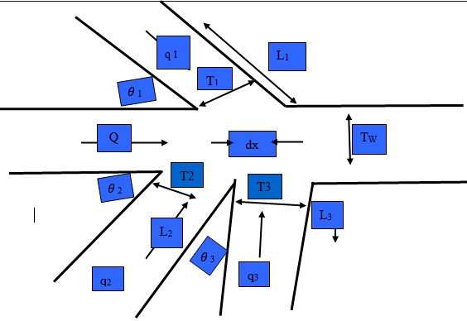

**Picture 1 : Development of a Mathematical Model**

**2.1. Model Assumption**

(i) Between the main channel and the three lateral inflow channels, there is not much solid particle buildup.

(ii)The three lateral inflows have a direct proportionality in length, angles, depth, and lateral inflow velocities. q1 = q2 = q3, L1 = L2 = L3, and θ1 = θ2 = θ3,

(iii) The main canal and the three lateral inflows have circular cross sections.

.

**3.0. Governing Equations**

**3.1. Equation of Continuity**

A differential equation that characterizes the movement of a conserved variable inside a specified mass is called an equation of continuity. The basic notion behind all instances of continuity equations is the same: the amount that enters or exits an area through its border is the sole factor that may alter the overall amount of the conserved quantity inside that region (Serrin, 1959). A conserved amount can only travel from one place to another; it cannot grow or shrink. Unsteady flow in open channels of any shape is governed by the Saint-Venant equation of continuity, which is:

$\frac{∂Q}{∂x}+ \frac{∂A}{∂t}= m$ (1) Net volume of the fluid is $\frac{∂Q}{∂x}dxdt$, lateral inflow is $\frac{q}{L}\sin{θdxdt}$ and discharge for 3 lateral inflows is $3\frac{q}{L}\sin{θdxdt}$. Increment of the fluid is $\frac{∂A}{∂t}dxdt$. Considering that our fluid's density is constant and consistent with the fluid's conservation law then,

$\frac{∂Q}{∂x}dxdt+ \frac{∂A}{∂t}dxdt=3\frac{q}{L}\sin{θdxdt}$. (2)

Dividing equation (2) through out by $dxdt$ equation (3) is obtained

$\frac{∂Q}{∂x}+ \frac{∂A}{∂t}=3\frac{q}{L}\sin{θ}$ (3)

Discharge is given by the product of cross-sectional area and velocity

$Q=AV$ (4)

Substituting equation (4) above into equation (3) and differentiating partially with respect to *e*quation (5) is obtained

$V\frac{∂A}{∂x}+A \frac{∂V}{∂x}+\frac{∂A}{∂t} =3\frac{q}{L}\sin{θ}$ (5)

The flow area can be assumed to be a known function of the depth and therefore the derivatives of A can be expressed in terms of y.

$\frac{∂A}{∂x}= \frac{dA}{dy}\frac{∂y}{∂x}=T\frac{∂y}{∂x}$ (6)

$\frac{∂A}{∂t}= \frac{dA}{dy}\frac{∂y}{∂t}=T\frac{∂y}{∂t}$

Where *T* is thechannel top width and Franz (1982) assumed that T is determined by

$T= \frac{dA}{dy}$ (7)

Substituting equations (6) into (5), equation (8) is obtained,

$VT\frac{∂y}{∂x}+A \frac{∂V}{∂x}+T\frac{∂y}{∂t} =3\frac{q}{L}\sin{θ}$ (8)

Dividing equation (8) throughout by T and rearranging, equation (9) is obtained,

$\frac{∂y}{∂t}+V\frac{∂y}{∂x}+\frac{A}{T}\frac{∂V}{∂x} =3\frac{q}{TL}\sin{θ}$ (9)

Equation (9) is the general equation of continuity for open channel flow with 3 lateral inflows S channel at an angle.

**3.2 Momentum equation**

Fluid motion is described by momentum equations. These formulas are based on Newton's second rule of motion and the idea that fluid stress is made up of a pressure term and a diffusing viscous term that is proportional to the gradient of velocities. They establish a connection between a fluid element's acceleration or rate of change of momentum and the total force exerted on it. Convective acceleration, which is linked to variations in velocity over location, is the cause of the non-linearity in these non-linear partial differential equations (White and Majdalani, 2006).

According to the conservation law in the momentum equation;

$\frac{∂Q}{∂t}dxdt+\frac{∂(QV)}{∂x}dxdt+g\frac{∂(yA)}{∂x}dxdt+gA\left(S_{f}-S_{O}\right)dxdt= 3\frac{q}{L}sinθucosθdxdt$ (10)

Dividing equation (10) through out by $dxdt$ to obtain equation (11)

$\frac{∂Q}{∂t}+\frac{∂(QV)}{∂x}+g\frac{∂(yA)}{∂x}+gA\left(S_{f}-S_{O}\right)= 3\frac{q}{L}sinθucosθ$ (11)

Substituting equation (4) into equation (11) above and differentiating partially with respect to x considering the area A is a constant to obtain equation (12).

$A\frac{∂V}{∂t}+V\frac{∂A}{∂t}+Q\frac{∂V}{∂x}+V\frac{∂Q}{∂x}+gA\frac{∂y}{∂x}+gA\left(S_{f}-S_{O}\right)= 3\frac{q}{L}sinθucosθ$ (12)

Rearranging equation (12) to obtain equation (13)

$V\left(\frac{∂A}{∂t}+\frac{∂Q}{∂x}\right)+A\frac{∂V}{∂t}+Q\frac{∂V}{∂x}++gA\frac{∂y}{∂x}+gA\left(S_{f}-S_{O}\right)= \frac{q}{L}sinθucosθ$ (13)

Substituting Equation (3) into equation (13) to obtain equation (14)

$V\left(\frac{q}{L}\sin{θ}\right)+A\frac{∂V}{∂t}+Q\frac{∂V}{∂x}++gA\frac{∂y}{∂x}+gA\left(S_{f}-S_{O}\right)= 3\frac{q}{L}sinθucosθ$ (14)

Dividing equation (14) throughout by  to obtain equation (15)

$\frac{∂V}{∂t}+V\frac{∂V}{∂x}++g\frac{∂y}{∂x}+g\left(S_{f}-S_{O}\right)+\frac{V}{A}\left(\frac{q}{L}\sin{θ}\right)= 3\frac{q}{AL}sinθucosθ$ (15)

Equation (15) is rearranged to obtain equation (16) we get,

$\frac{∂V}{∂t}+V\frac{∂V}{∂x}++g\frac{∂y}{∂x}+g\left(S_{f}-S_{O}\right)= 3\frac{q}{AL}sinθ(ucosθ-V)$ (16)

Equation (16) is the general momentum equation of an open channel with 3 lateral inflow channels at varying angles.

4.0 Equations Governing the Fluid Fow in Finite Difference Form

Velocity profiles for three Lateral Inflows

The Continuity and Momentum equations is given by equations (17) and (18) and solved numerically by the Finite method

$y_{(i,j+1)}=∆t\left\{3\frac{A}{TL}\sin{θ}-{v^{*}}_{\left(i,j\right)}\frac{y_{\left(i+1,j\right) -y_{\left(i-1,j\right)} }}{2∆x}-\frac{A}{TL}\frac{v_{\left(i+1,j\right) -v_{\left(i-1,j\right)}}}{2∆x}+y_{(i,j)}\right\}$ (17)

$v_{(i,j+1)}=∆t\left\{\frac{qv}{{Fr}^{2}AgL}\sin{θ(u\cos{θ-v_{\left(i,j\right)}-\frac{1}{{Fr}^{2}}}(}\frac{n^{2}v^{2}}{R^{\frac{4}{3}}}-s_{0})-(\frac{1}{{Fr}^{2}}\frac{y_{\left(i+1,j\right) -y_{\left(i-1,j\right)}}}{2∆x}-(v_{\left(i,j\right)}\frac{v_{\left(i+1,j\right)-v_{\left(i-1,j\right)}}}{2∆x})\right\}-v_{(i,j)}$ (18)

**5.0 Results and Discussion**

**Effects of Variation of Length of Lateral Inflow on velocity of the Main Channel**

Figure 1 : The effects of increasing Lateral Inflow Length on Velocity of the main channel is illustrated

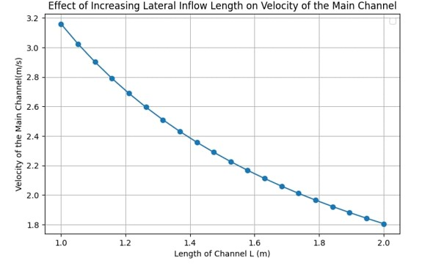

Figure 1 demonstrates how the velocity of the main channel decreases when lateral inflows are introduced. This is because the water flows over a larger total cross-sectional area. In laminar flow, velocity and cross-sectional area are inversely correlated at a constant flow rate, according to the principle of continuity. Consequently, a drop in velocity is required for a bigger cross-sectional area. The average velocity is lowered because the additional water from the lateral inputs efficiently disperses the flow across a larger region. Laminar flow, in which water flows in smooth, stratified streams, is characterized by this redistribution of flow in addition to a decrease in velocity. Because turbulence is more likely to arise at higher speeds, lower velocity also aids in maintaining the laminar flow regime. By adding water along their path, lateral flows essentially redistribute the flow of the main channel. As a result, the concentrated flow from the channel's centre is dispersed, resulting in a more even distribution of water across its breadth. More water enters the system as the inflow length grows, which may increase the main channel's overall discharge (flow rate). The velocity may initially increase as a result of the increased discharge if the amount of water entering the main channel increases noticeably.

**Effects of Varying Angles**

figure2 : The effect of increasing the angle on velocity of the main channel is illustrated.

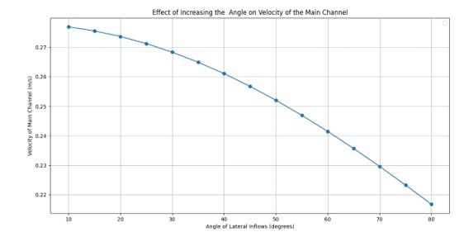

Figure 2 demonstrates how flow dynamics, including the main channel's velocity, may be greatly impacted by increasing the angle of lateral inflow channels into the main channel. The water's behavior while interacting with the major flow is significantly influenced by the angle at which it enters the main channel from a lateral inflow channel. The possible impacts of raising the angle of lateral input on the main channel's velocity are broken down as follows:

Turbulence is increased by sharp angles: The flow from the tributary enters the main channel flow more abruptly when a lateral inflow channel meets the main channel at a sharper angle (near perpendicular). As a result of the two flows interacting from opposite directions, there is more turbulence. Localized speed variations can result from turbulence-induced changes in the velocity of the main channel.

The amount of water entering the main channel gets more direct as the angle of lateral inflow rises, especially as the angle approaches perpendicular. The water's velocity downstream will rise if the lateral inflow is substantial since it will increase the discharge in the main channel, provided the channel can handle the extra flow. Stream power, or the energy available to move sediment and form the channel, is closely correlated with the main channel velocity. Higher lateral input angles and the corresponding rise in discharge cause stream power to rise, which can raise the velocity, especially downstream from the confluence.

**Effects of Cross-Sectional Variation on Velocity in the Main Channel**

figure 3 : The effects of increasing the Cross- Sectional Area of Lateral Inflows on Velocity is illustrated.

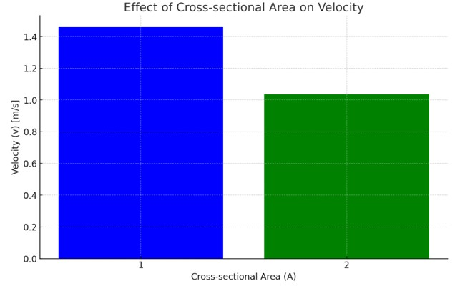

Figure 3 demonstrates how basic concepts like the continuity equation, flow distribution, and momentum conservation may have a substantial impact on the velocity of the main flow in an open channel system by varying the cross-sectional area of the lateral inflow channels. Any change in a channel's cross-sectional area (A) will result in a proportional change in the flow's velocity (V), according to the continuity equation, which stipulates that the flow rate (Q) in an incompressible fluid must remain constant. In particular, the formula is Q = AV, which states that, under the assumption that the discharge rate remains constant, a decrease in the cross-sectional area of lateral inflows will result in an increase in the main flow velocity.

**6.0 Recommendation**

There is still a room for verification of these theoretical results with laboratory result.

The geometrical model above can be developed in laboratory for more investigation.

Additionally, it is recommended to pursue further studies on;

(i) Effects of lateral outflow on discharge.

(ii) The flow in trapezoidal, rectangular and triangular with three lateral inflow channels in different point of the main flow.

(iii) Fluid flow through elliptic channels.

**Nomenclature:**

**Q** Discharge

**H** Radius

**A** Area

**V**  Velocity of the Channel

**S**  Slope of the Channel bottom

**Y** Depth of Flow

**REFERENCES**

Chen, J., Steffler, P., and Hicks, F. (2007). Conservative formulation for natural open channels and finite-element implementation. *Journal of Hydraulic Engineering*,

133(9):1064–1073.

Chhabra, R. P. (2010). Non-Newtonian fluids: an introduction. In *Rheology of complex fluids*, pages 3–34. Springer.

Chirchir, A. C. (2021). *The effect of two lateral inflow channels on main channel discharge*. PhD thesis, University of Eldoret.

Chow, V. T. (1969). Spatially varied flow equations. *Water Resources Research*,

5(5):1124–1128.

Dandekar, M. and Sharma, K. N. (1979). *Water power engineering*. Vikas Publishing

House.

Das, M. M. (2008). *Open channel flow*. PHI Learning Pvt. Ltd.

Duffy, T. S. and Wang, Y. (1998). Pressure-volume-temperature equations of state. *Reviews in Mineralogy*, 37:425–458.

Eason, E. D. (1976). A review of leastsquares methods for solving partial differential equations. *International Journal for Numerical Methods in Engineering*, 10(5):1021–1046.

Fan, J. (2008). Stratified flow through outlets. *Journal of Hydro-Environment Research*,

2(1):3–18.

Gao, Y., Yang, H., Wang, L., and Zhao, M. (2022). Three-dimensional numerical investigation on flow behaviors around a diversion dike. *Physics of Fluids*, 34(12).

Githeko, A. K. (2024). Responding to climate change in the health sector, kenya. In *Climate Change and Human Health Scenarios: International Case Studies*, pages 303–316. Springer.

Neary, V., Sotiropoulos, F., and Odgaard, A. (1999). Three-dimensional numerical model of lateral-intake inflows. *Journal of Hydraulic Engineering*, 125(2):126– 140.

Odgaard, A. J. (1986). Meander flow model. i: Development. *Journal of Hydraulic engineering*, 112(12):1117–1135.

Oertel, H. (2004). *Prandtls essentials of fluid mechanics*. Springer.

Ojiambo, V., Kinyanjui, M., and Kimathi, M. (2018). A mathematical model of angular two-phase jeffery hamel flow in a geothermal pipe. *International Journal of Advances in Applied Mathematics and Mechanics*, 6:1–13.

Omari, P., Sigey, J., Okelo, J., and Kiogora, R.(2018). Modeling circular closed channels for sewer lines. *International Journal of Engineering Science and Innovative Technology*.

Prakash, S. and Adarsh, S. (2023). Modelling for fluid flow with linear characteristics in rectangular open-channel. *International Journal of Scientific Research in Modern Science and Technology*, 2(6):75–86.

Ramamurthy, A. S. and Satish, M. G. (1988). Division of flow in short open channel branches. *Journal of hydraulic engineering*, 114(4):428–438.

Rotich, F. K. (2021a). *Mathematical Modeling of flow of water in an open Channel of*

*Parabolic Cross - section*. PhD thesis, University of Eldoret.

Rotich, F. K. (2021b). *Numerical Modeling and Analyses of Water Diversion Tunnels at Thwake Multi-Purpose Dam, Kenya*. New Mexico Institute of Mining and

Technology.

Safarzadeh, A. and Khaiatrostami, B. (2017). Mean flow characteristics, vertical structures and bedshear stress at open channel bifurcation. *Journal of Applied Research in Water and Wastewater*, 4(1):299–304.

Salman, A. Z. and Ahmed, R. T. (2013). The compration analysis of fixed pitch angle wind turbine that of a double output induction generator. In *National Renewable Energies Conference and Their Applications*, pages 96–107.

Samani, H. M., kazemi Mohsenabadi, S., Kashkouli, H. A., and Sedghi, H. Evaluating velocity and discharge in horseshoe and d-shape cross sections. *Basic and Applied Scientific Research*, 3.