Original Research Article

Effect of transplanting density on leaf yield and pest tolerance of amaranth (Amaranthus cruentus) in the tropics

ABSTRACT
Amaranth, a food crop with a high nutritional value, stands out for its great adaptability to environmental conditions. From a sustainable agriculture perspective, adjusting the transplanting density is an essential lever for improving plant productivity and health. This study aims to evaluate the impact of transplanting density on leaf yield and tolerance to pests of amaranth. It was carried out in the south of Côte d'Ivoire, a region with a bimodal equatorial climate alternating rainy and dry seasons favourable to this crop. The trial was conducted using a randomized full block design with three transplanting densities : D1 (20 × 20 cm), D2 (10 × 20 cm) and D3 (5 × 20 cm), with three replicates. Amaranth plants were transplanted onto 16 m² boards, previously ploughed. The observations focused on the number of branches, the flowering time, the leaf yield (t/ha) and the sensitivity to pests, evaluated on a scale of 1 (very tolerant) to 5 (very sensitive). The data were subjected to an ANOVA, followed by the Tukey test at the 5% level. The results indicate that transplanting density positively influences the number of twigs and leaf yield. Density D2 (10 × 20 cm) produced the highest number of twigs (686 ± 20) and the highest leaf yield (16.0 ± 0.9 t/ha). Better tolerance to stem necrosis was also observed at this density (score 3.3), compared to a higher sensitivity (score 4.3) at density D1 (20 × 20 cm). In contrast, the spike density did not have a significant effect on the degree of attack of the caterpillar. Similarly, the flowering time remained stable, around 45 days after transplanting. These results highlight the importance of choosing an optimal transplanting density to improve productivity and resistance to pests without disrupting the phenological cycle. In this respect, the D2 density appears to be the best compromise, combining high productivity with better plant health.
Keywords : Amaranthus cruentus, Transplanting density, Leaf yield, Resilience, Tropical zone

- INTRODUCTION
Amaranth (Amaranthus cruentus), a tropical leafy vegetable, is a vegetable plant widely grown and consumed in Côte d'Ivoire. It plays a pivotal role in the food and nutrition security of populations (Koné et al., 2017). Rich in proteins, vitamins (A, C, K), essential minerals (iron, calcium, magnesium) and antioxidants, amaranth is known for its high nutritional value. Thus, it contributes to the fight against malnutrition, particularly among children and pregnant women (Shukla et al., 2021). In addition to its nutritional contribution, its cultivation provides substantial income for smallholder farmers, especially women, thus contributing to rural economic development and poverty reduction (Ajao and Ilukor, 2020).
In a global context marked by rapid population growth and the disruptive effects of climate change, the need to sustainably intensify agricultural production has become a top priority (Pretty, 2008 ; FAO, 2020). Côte d'Ivoire, like many countries in sub-Saharan Africa, is facing growing challenges related to land degradation, water scarcity and climate variability, which threaten agricultural productivity (Traoré et al., 2018). To meet these challenges, the optimization of cultivation practices is an essential strategy to maximize the yield of food crops while minimizing the environmental footprint. Among the key agronomic factors, planting density is a major determinant of amaranth productivity, directly influencing inter-plant competition and resource use efficiency (Bello et al., 2022).
Inappropriate seeding or transplanting densities can have harmful consequences on the development of amaranth. Planting densities that are too low can lead to underutilization of available land and, consequently, low production per unit area. Conversely, excessive density causes intense competition between plants for light, water, nutrients, and space, which can result in reduced leaf size, elongation of stems, and decreased individual biomass (Adepoju et al., 2018). Ultimately, this increased competition can increase the vulnerability of plants to diseases and pests, and ultimately significantly decrease yield and crop quality (Gbadamosi et al., 2015). Several studies on other vegetable crops have shown that the precise adjustment of planting density is crucial to achieve an optimal balance between the number of plants per unit area and their individual performance. This maximizes total biomass and marketable yield (Okpe et al., 2020).
Despite the socio-economic and nutritional importance of amaranth in Côte d'Ivoire, specific scientific data regarding optimal planting densities under local pedoclimatic conditions remain limited. Current farmers' practices are often based on ancestral traditions or empirical observations, which can lead to suboptimal yields and inefficient use of inputs (Kouadio et al., 2019). In addition, well-managed planting density can not only improve productivity, but also contribute to more sustainable crop management by reducing weed growth (through shading) and optimizing irrigation and fertilization efficiency (Gwandu et al., 2021).
This study aims to evaluate the impact of different planting densities on growth parameters (height, number of leaves, biomass), yield characteristics (fresh leaf weight) and efficiency of the use of amaranth (Amaranthus cruentus) resources in the specific agro-ecological conditions of Côte d'Ivoire. The objective is to determine the optimal planting density that will allow Ivorian producers to maximize the yield and profitability of amaranth, while being part of a sustainable and resilient agricultural production approach in the face of current environmental and socio-economic challenges. The results of this research will provide evidence-based technical recommendations to improve the productivity and sustainability of amaranth cultivation, and by extension, the food security and livelihoods of rural Ivorian populations.
- MATERIALS AND METHODS
  - Study site
The study was carried out in the south of Côte d'Ivoire, characterized by an equatorial climate with a bimodal regime, with two rainy seasons (March to June and September to November) and two dry seasons (July to August, then December to February). During the experimental period, monthly temperatures ranged from 27°C to 31°C, while the mean relative humidity was around 73.6%. The soil of the experimental plot was ferrallitic, sandy-textured, with an acidic pH of 4.5 and a carbon/nitrogen (C/N) ratio of 10.5.
  - Plant material
The plant material used for this study consisted of amaranth seeds (Amaranthus cruentus), obtained from market gardeners specializing in the cultivation of leafy greens in the urban areas of Abidjan. The choice of these local seeds is explained by their adaptation to the agroecological conditions of the Ivorian urban environment, their availability among producers, as well as their relevance for the study of agronomic variability in a real production context. In addition, the use of plant material from the farmers' circuit allows a better representativeness of local cultivation practices and promotes the transposability of the results to the operational scale.
  - Setting up the trial
To better conduct this study, a nursery was set up in August. To this end, a 5 m long and 1 m wide cultivation bed was created, following manual ploughing of the soil. In order to disinfect the substrate, a Furadan treatment was applied at a rate of 50 g/m², followed by an organic amendment by incorporating poultry manure at a dose of 4 kg/m². The amaranth seeds were then sown in rows, spaced 10 cm apart. After sowing, the board was covered with palm leaves placed directly on the ground to maintain moisture and promote emergence. These leaves were removed as soon as the seedlings appeared. A temporary shade was then erected at a height of 80 cm to protect the young shoots from direct sunlight. This was gradually lightened one week before transplanting, by partial removal of the palm leaves, and then completely removed two days before transplanting. For transplanting in the field, a second manual ploughing of the soil was carried out. Plant spacings were defined based on the expected seeding densities of the experimental treatments. The control of the caterpillars required two phytosanitary interventions, carried out at the fifth and seventh week after transplanting, using a mixture of Callidim (dimethoate 400 g/l) and Stork 50 EC (cypermethrin 50 g/l). At the same time, weeding operations have been carried out regularly in order to limit competition from weeds.
  - Experimental design
The test was conducted using a split-plot design, with three replicates for each of the three transplant densities. Each repeating block consisted of two ridges, each measuring 4 m long by 1 m wide, representing a total area of 16 m². The ridges were spaced 0.5 m apart, while a distance of 0.75 m separated the blocks. In each block, one ridge was dedicated to yield evaluation, while the others were used for experimental measurements. Three transplanting densities were tested within the repeating blocks :
- D1 : 20 cm × 20 cm, i.e. 25 plants/m² (equivalent to 250,000 vines/ha), considered as the standard control ;
- D2 : 10 cm × 20 cm, i.e. 50 plants/m² (500,000 vines/ha);
- D3 : 20 cm × 10 cm, i.e. also 50 plants/m² (500,000 vines/ha).
  - Observations and measurements
The observations and measurements focused on several agronomic and phenological parameters :
- Vegetative development: noted at 30 days after transplanting (JAR) according to a scale of appreciation from 1 to 5 (Table 1).
- Morphological characteristics: the height of the plants, the diameter of the stems at the flowering stage and the length of the inflorescences were measured using a tape measure.
- Susceptibility to pests: assessed at 30 JARs based on the intensity of damage caused by diseases and pests, using an assessment scale of 1 to 5 (Table 1).
- Phenology: Flowering, first harvest and last harvest dates were systematically recorded for each treatment.
- Plant productivity: assessed through two indicators:
- the number of branches per elementary plot;
- the total weight of harvested leaves, used to estimate leaf yield expressed in tonnes per hectare (t/ha).
Table 1. Vegetative development and biotic sensitivity of amaranth
Score | Vegetative development | Description des plants | Biotic sensitivity (caterpillar + necrosis) | Description of symptoms | References
1 | Very Low | Stunted, poorly developed, weak green colouration, few leaves | Very low (or absent) | Stems healthy, no necrosis; Little to no track attack | Yao & Koffi (2021)
2 | Weak | Slow development, thin stems, sparse foliage | Weak | Some superficial necrosis at the base;  Slight bites or caterpillar galleries | Yao & Koffi (2021)
3 | Medium | Moderate growth, balanced habit, medium-dense foliage | Moderate | Necrosis on several stems; Visible presence of tracks without major damage | Traoré et al. (2020)
4 | Good | Visible vigour, strong stems, numerous and well-formed leaves | High | Extensive necrosis with local wilting;  More frequent attacks by caterpillars | Coulibaly et al. (2023)
5 | Very good | Vigorous growth, dense foliage, well-structured habit, intense green colouration | Very high | Generalized necrosis and desiccation; Severe infestation of caterpillars | N'Guessan et al. (2022)

  - Statistical analysis of the data
The data collected were subjected to a one-factor analysis of variance (ANOVA), according to the experimental design model in subdivided plots (split-plot). The objective was to evaluate the effect of different transplanting density on the measured agronomic parameters. When ANOVA revealed significant differences between treatments, a comparison of means was performed using the Tukey test at the 5% significance level (p < 0.05). All statistical analyses were performed using R software, version 4.2.

- RESULTS
  - Effect of Transplanting Density on Vegetative Growth of Plants
Analysis of the results presented in Table 2 reveals a significant influence of transplanting density on vegetative state and inflorescence length (p < 0.05), while plant height and stem diameter were not significantly affected. Plants grown at the D1 density (20 × 20 cm), corresponding to 250,000 vines/ha, showed a significantly lower vegetative state than the higher densities (D2 and D3), with a low score of 2.00 compared to 3.00 (average score). In contrast, inflorescence length was significantly higher in plants grown at density D1 (36.40 cm) compared to D2 (30.20 cm), with an intermediate value for D3 (33.30 cm). Regarding the height and diameter of the plants, no significant difference was observed between the different treatments (p > 0.05).
Table 2. Vegetative development, flower size and diameter according to transplanting density
Transplanting density | Vegetative state (score 1-5) | Plant height (cm) | Plant diameter (mm) | Length of inflorescences (cm)
D1 (20 x 20 cm) | 2 ± 0.27 b | 22.40 ± 8.20 a | 7.90 ± 0.20 a | 36.40 ± 3.30 a
D2 (10 x 20 cm) | 3 ± 0.20 a | 32 ± 6.15 a | 9.10 ± 0.40 a | 30.20 ± 3.17 b
D3 (20 x 10 cm) | 3 ± 0.17 a | 30.20 ± 7.12 a | 8.40 ± 0.30 a | 33.30 ± 3.10 ab
Average  p  CV (%) | 2.70  0.0047  25.40 | 28.20  0.27  45.00 | 8.50  0.4  22.70 | 33.30  0.0047  9.50
Different letters in the same column indicate a significant difference at the 5% threshold according to the Tukey test.
  - Effect of Transplanting Density on Plant Health
The results regarding the effect of transplanting density on plant health are presented in Figure 1. The main fungal disease observed in the trial was the appearance of longitudinal necrosis along the stems, usually detected after flowering. Infected plants showed progressive weakening followed by desiccation, compromising their development and potential yield. Regarding pests, no statistically significant difference was found between the different transplant densities for the degree of attack of the caterpillar (p = 0.17). This parasite pressure remained relatively moderate and constant regardless of the spacing scheme with an average score of 3.5. In contrast, a significant variation was observed in susceptibility to stem necrosis (p = 0.008). Density D2 (10 × 20 cm) had the best tolerance with a mean score of 3.3, while control D1 (20 × 20 cm) showed the highest sensitivity (4.3). The density D3 (20 × 10 cm) recorded an intermediate value (3.8). These results suggest that higher planting densities could limit the incidence of the disease, probably by inducing a wetter microclimate or by reducing the period of tissue vulnerability through faster growth.
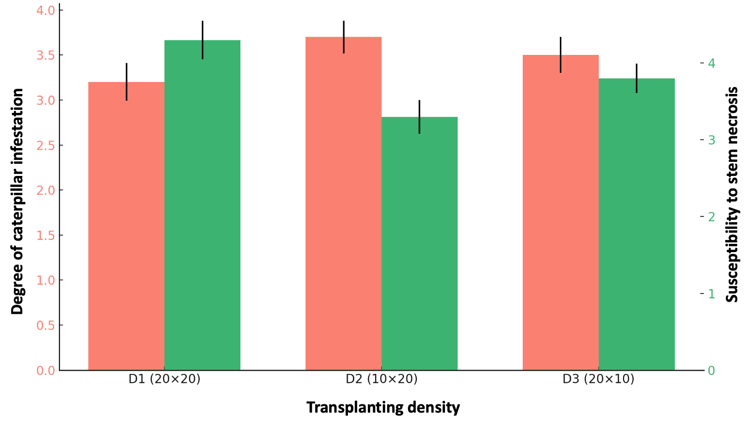
Fig. 1. Susceptibility of pigweed to caterpillar and stem necrosis by transplanting density

  - Effect of transplanting density on floral earliness
The data presented in Table 3 indicate that there are no significant differences between the different transplant densities in the flowering time of pigweed plants (p = 0.40). On average, plants started flowering 45 days after transplanting (JAR), with slight non-significant variations between treatments : 46 JAR for D1 (20 × 20 cm), 45 JAR for D2 (10 × 20 cm) and 44 JAR for D3 (20 × 10 cm).
Table 3. Flowering of 50% of plants by transplanting density
Transplanting density | Flowering Time (JAR)
D1 (20 x 20 cm) | 46 ± 1.21 a
D2 (10 x 20 cm) | 45 ± 0.90 a
D3 (20 x 10 cm) | 44 ± 1.10 a
Average  p  CV (%) | 45.00  0.40  4.70
Different letters in the same column indicate a significant difference at the 5% threshold according to the Tukey test.

  - Effect of Transplanting Density on Twig Number and Leaf Yield
The results presented in Figure 2 show a highly significant influence of transplanting density on the number of branches produced per elementary plot (p = 0.02). Density D2 (10 × 20 cm) generated the highest number of twigs (686 ± 20), followed by D3 (20 × 10 cm) with 483 ± 18, while control density D1 (20 × 20 cm) recorded the lowest value (298 ± 15). This trend suggests that higher densities promote increased branching, likely due to more intense competition that stimulates secondary stem production. Regarding leaf yield, a significant difference was also observed (p = 0.03). D2 and D3 yields were significantly higher (16.0 ± 0.9 t/ha and 14.0 ± 0.7 t/ha respectively) compared to D1 (8.1 ± 0.6 t/ha). This indicates that increasing planting density can improve leaf productivity, likely by maximizing space occupancy and vegetation cover.
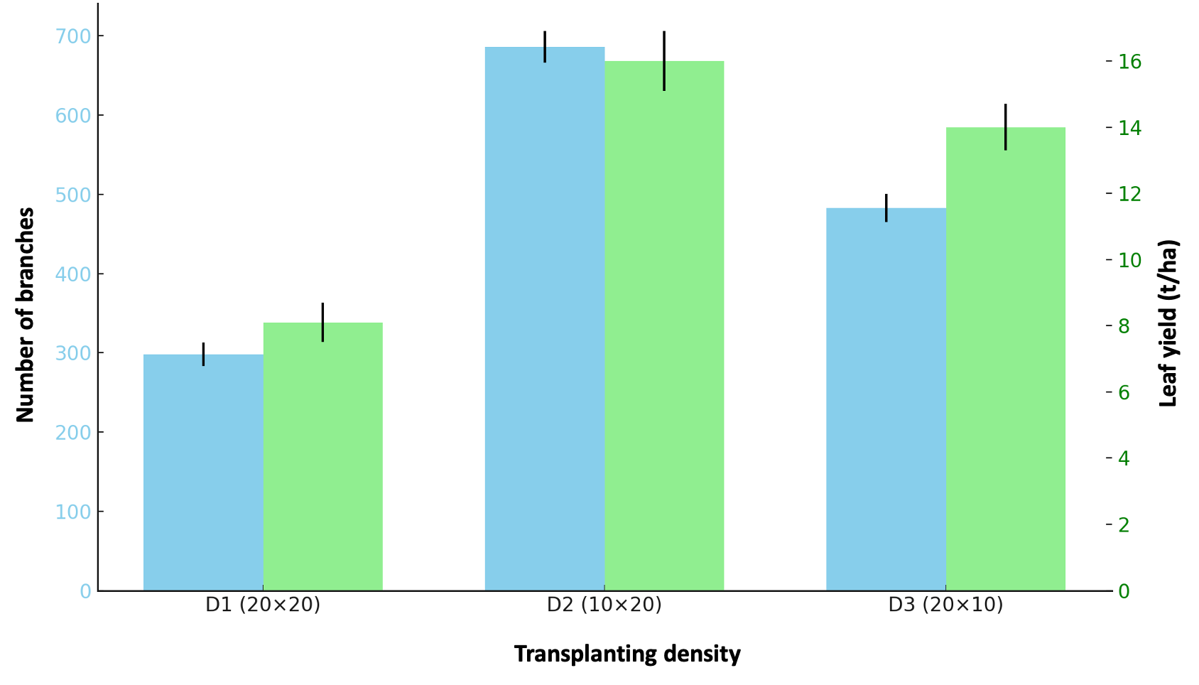
Fig. 2. Number of twigs produced and leaf yield by transplanting density

- DISCUSSION
  - Impact of transplanting density on vegetative status and inflorescence length
The results obtained confirm that transplanting density plays a decisive role in the expression of certain vegetative growth parameters, in particular the general vegetative state and the length of the inflorescences, while the height of the plants and the diameter of the stems seem to be less influenced. The observation of a lower vegetative state at the D1 density (20 × 20 cm; 250,000 plants/ha) compared to the higher densities (D2 and D3 at 500,000 plants/ha) is consistent with the work of Mwangi et al. (2021) who emphasize that low-density crops tend to favor more aerated but less vigorous growth, due to a less competitive use of resources such as light and nutrients. Indeed, according to Ali et al., 2020, higher density can induce beneficial moderate competition, stimulating lateral growth and the formation of vegetative structures such as twigs. Paradoxically, inflorescence length was significantly greater in the lowest density (D1), which can be explained by better light exposure and less interplant competition in this configuration (Zhang et al. 2022). A low density could therefore promote the elongation of reproductive structures, without necessarily increasing the total number of inflorescences per area, which remains a common trade-off in crop production.
On the other hand, the height and diameter of the stems were not significantly affected, suggesting that these traits are less sensitive to transplanting density under the experimental conditions considered. This finding is consistent with the observations of Yao et al. (2020), who found that certain morphological variables such as height may be more strongly influenced by pedoclimatic conditions or variety than by plant spacing. Overall, these results highlight the importance of a trade-off between optimal density and agronomic objectives. A lower density (such as D1) may improve some qualitative components (such as inflorescence size), while a higher density promotes better overall vegetative vigour, which may result in higher productivity at the plot level.
  - Impact of Transplanting Density on Susceptibility to Stem Necrosis and Larcater Attack
The appearance of longitudinal necrosis on the stems, observed after flowering, is likely consistent with a systemic fungal disease. According to observations by Singh et al., 2023, this is typical of many pathogenic species of the genus Fusarium or Phoma, which affect vascular tissues and induce progressive weakening of plants. For Tchatchoua et al., 2020, this type of pathology is often favored by mechanical injuries, water stress or excessive leaf density, which create conditions conducive to the penetration and development of the pathogen. The absence of a significant difference in the degree of attack of the caterpillar suggests that the transplanting density did not influence the entomological pressure in this specific case. This is in line with the observations of Nyembo et al. (2022), who showed that populations of pests such as Spodoptera or Helicoverpa caterpillars are more correlated with climatic conditions and the cycle of vegetative development than with the spatial configuration of the plants.
On the other hand, the susceptibility to stem necrosis was significantly affected by the planting density, with a better tolerance observed at the D2 density (10 × 20 cm). This result is particularly interesting because it suggests that optimal spacing could induce changes in the microclimate or the vegetative cycle with an indirect protective effect against fungal diseases. Indeed, Fagbemigun et al., 2021 showed that moderate density can accelerate vegetation cover, reduce prolonged exposure of young tissues and limit overelongation injuries, conditions often linked to fungal infection. Conversely, the density D1 (20 × 20 cm), which is more widely spaced, recorded the highest sensitivity. This could be attributed to slower growth, keeping young tissue vulnerable for an extended period of time, thus promoting opportunities for infection. This phenomenon has been highlighted by Aidoo et al. (2020) in vegetable trials, where too wide spacing has been associated with increased stress on seedlings. These results support the hypothesis that the management of transplanting density is not limited to yield optimization, but also represents an agronomic lever for disease prevention, by indirectly acting on the conditions of pathogen development and the physiology of the plant.
  - Influence of plant spacing on amaranth flowering
The results indicate that transplanting density does not have a significant effect on the flowering time of amaranth plants, with an average start to flowering around 45 days after transplanting regardless of the spacing pattern. This lack of difference suggests that, under the experimental conditions of the study, planting density does not influence the physiological mechanisms regulating the vegetative transition to the reproductive phase. This observation is consistent with the work of Khan et al. (2021), who showed that flowering in some herbaceous species remains relatively stable in the face of moderate variations in density, provided that light, water and nutrient resources are adequately available. In addition, Smith et al. (2022) reported that in amaranth, the length of the growing cycle is determined more by genetic factors and environmental conditions than by planting density.
On the other hand, the similarity in flowering times between densities can be explained by a balance between competition and available space, where the effect of higher density on growth is offset by physiological adaptation of plants, as highlighted by Lopez et al. (2020). In particular, they showed that amaranth exhibits a phenotypic plasticity that allows it to maintain its phenological phases despite space constraints. These results suggest that for the management of amaranth crops, the transplanting density can be chosen mainly according to other agronomic criteria (yield, plant health) without fear of delaying flowering.
  - Impact of transplanting density on twig number and leaf yield
The results highlight a significant influence of transplanting density on plant branching and leaf yield, which is in line with numerous studies showing that planting density is a key factor in optimizing vegetative production (Chen et al., 2021). Density D2 (10 × 20 cm) favoured the highest twig production, followed by D3, while the lowest density (D1) recorded a significantly lower number. This increase in branching with density can be explained by a phenomenon of competition between plants, which stimulates the production of secondary stems to maximize access to light and resources (Liang et al., 2020). Indeed, according to Gomez et al., 2019, plants subjected to a higher density develop morphological adaptations to optimize light capture and increase their photosynthetic capacity. In addition, leaf yield follows the same trend, with significantly higher values for densities D2 and D3. This confirms that maximizing vegetation cover through increased density improves total production, a result consistent with the work of Zhang et al. (2022), who showed that efficient land use reduces bare ground areas and promotes better biomass yield. However, it is important to note that densities that are too high could lead to excessive competition, which can limit leaf quality or increase susceptibility to disease, as pointed out by Khan et al., 2021. In this context, densities D2 and D3 appear to be an optimal compromise between productivity and plant health. Future research could explore the impact of these densities on leaf nutritional quality and adaptation to varied abiotic conditions.
- CONCLUSION
The study shows that transplanting density has a significant influence on plant vegetative growth, particularly on the number of shoots produced and leaf yield. Higher densities, especially the D2 configuration (10 × 20 cm), promote increased branching and better leaf production, which translates into a more efficient occupation of the cultivated space. On the other hand, densities that are too low limit vegetative vigour and productivity. In addition, transplanting density also influences susceptibility to certain diseases, as well as phenological characteristics such as inflorescence length, without affecting flowering time. These results underscore the importance of choosing optimal spacing to reconcile productivity, plant health, and morphological quality. In short, the D2 density appears to be an effective agronomic compromise, maximizing both yield and tolerance to biotic stresses. This study thus provides a solid basis for the optimization of cultivation practices in plantation development, contributing to a more sustainable and efficient agriculture.

DISCLAIMER (ARTIFICIAL INTELLIGENCE)
Author(s) hereby declare that NO generative AI technologies such as Large Language Models (ChatGPT, COPILOT, etc.) and text-to-image generators have been used during the writing or editing of this manuscript.

COMPETING INTERESTS
Authors have declared that no competing interests exist.

REFERENCES
Adepoju, S., Jimoh, K.A., & Ogunniyi, D.S. (2018). Influence of planting density on the growth and yield of Amaranthus hybridus. Journal of Applied Agricultural Research, 10(1), 80-86. Aidoo, R., Boateng, E., & Mensah, J. (2020). Plant spacing and its influence on growth and pest pressure in vegetable crops. International Journal of Horticultural Science, 25(3), 112-119.
Ajao, A.O., & Ilukor, J. (2020). Women's participation in African indigenous vegetable value chains: Evidence from Amaranth in Uganda and Nigeria. African Journal of Rural Development, 5(4), 57-66.
Ali, M., Khan, A., & Bashir, S. (2020). Plant density and its impact on vegetative growth and yield parameters: A review. Journal of Agronomic Research, 9(2), 135-142.
Bello, R.S., Musa, M., & Umaru, I. (2022). Effect of spacing on the growth and yield of Amaranthus cruentus in northern Nigeria. Journal of Agricultural Sciences and Practice, 7(1), 34-40.
Chen, L., Zhang, H., & Zhao, Y. (2021). Density-dependent modulation of branching and yield components in leafy vegetables. Agricultural Science and Technology, 22(4), 275-282.
Coulibaly, K., Diomandé, S., & N’Diaye, T. (2023). Évaluation comparative de la sensibilité biotique des plantes maraîchères. Cahiers Agricoles Africains, 12(1), 55-66.
FAO (2020). The State of Food and Agriculture 2020 : Overcoming water challenges in agriculture. Rome, Italy, 484 p.
Fagbemigun, T.K., Adeoye, G.O., & Kolawole, A.O. (2021). Influence of plant population on disease development and yield performance in tropical vegetable systems. African Journal of Agricultural Research, 16(12), 1518-1525.
Gbadamosi, A.E., Akinrinde, E.A., & Adeniyan, O.N. (2015). The effect of spacing and fertilizer on weed suppression and yield of Amaranthus cruentus. Nigerian Journal of Weed Science, 28, 1-10.
Gomez, P., Martins, C., & Silva, R. (2019). Effects of canopy structure and density on photosynthetic efficiency and biomass production. Journal of Plant Physiology, 234, 65-73.
Gwandu, J.H., Musa, A.B., & Usman, M.A. (2021). Integrated weed management and water use efficiency under different planting densities in vegetable cropping systems. International Journal of Agronomy and Agricultural Research, 19(4), 58-66.
Khan, M.A., Rahman, M., & Bibi, A. (2021). Phenological responses of leafy vegetables to plant spacing under varying environmental conditions. Journal of Crop Science and Biotechnology, 24(1), 54-62.
Koné, M., Kati-Coulibaly, S., & Kouamé, L.P. (2017). Contribution des légumes-feuilles à la sécurité alimentaire des ménages urbains à Abidjan (Côte d’Ivoire). Cahiers Agricultures, 26(4), 45003.
Kouadio, K.A., Kouamé, F.N., & N’guessan, B.A. (2019). Analyse des pratiques culturales des maraîchers dans les zones périurbaines de Yamoussoukro. Revue Ivoirienne des Sciences et Technologies, 33, 67-77.
Liang, X., Zhou, Y., & Zhang, J. (2020). Influence of planting density on shoot architecture and leaf development in amaranth. Agronomy, 10(10), 1506.
Lopez, A.R., Diallo, K., & Traoré, S. (2020). Phenotypic plasticity and reproductive stability of Amaranthus spp. under different planting configurations. Tropical Crop Science Journal, 18(2), 87-95.
Mwangi, P., Omondi, W., & Chebet, D. (2021). Influence of spacing on growth performance of leafy vegetables in East African farming systems. African Journal of Horticultural Science, 29, 44-53.
N’Guessan, K.M., Yapi, A. & N’Dri, A. (2022). Impact des infestations de Spodoptera sur la productivité maraîchère en Côte d’Ivoire. Afrique Verte, 11(4), 101-115.
Nyembo, K., Lukusa, B., & Mufuta, A. (2022). Factors influencing pest incidence in field-grown vegetables in Central Africa. Journal of Tropical Entomology, 11(2), 103-111.
Okpe, O.O., Ezeaku, P.I., & Ukwueze, S.C. (2020). Effects of plant spacing on the yield of Amaranthus species in a sandy loam soil. Nigerian Agricultural Journal, 51(2), 112-118.
Pretty, J. (2008). Agricultural sustainability: Concepts, principles and evidence. Philosophical Transactions of the Royal Society B: Biological Sciences, 363(1491), 447-465.
Shukla, S., Bhargava, A., & Chatterjee, A. (2021). Amaranth: A promising crop of nutraceutical importance. In Functional Foods and Nutraceuticals, pp. 303-322.
Singh, D., Kumar, R., & Yadav, S. (2023). Emerging fungal threats in vegetable production and strategies for control. International Journal of Plant Health, 15(1), 45-60.
Smith, L., Boateng, P., & Atieno, M. (2022). Floraison et stabilité phénologique chez l’amarante en fonction des conditions agroécologiques. Revue Africaine d’Agronomie, 40(2), 123-130.
Tchatchoua, T.M., Ngatchou, F.A., & Mbarga, S.A. (2020). Épidémiologie des maladies fongiques dans les systèmes de culture maraîchère. Bulletin de Recherche Agronomique du Cameroun, 16(1), 39-47.
Traoré, K., Yéo, N., & Bamba, I. (2018). Changements climatiques et agriculture vivrière en Côte d'Ivoire : Impacts et stratégies d’adaptation. Revue de Géographie Tropicale, 15(2), 77-90.
Traoré, A., Koné, D., & Bamba, F. (2020). Croissance végétative et attaque des chenilles sur les cultures maraîchères. Sciences et Développement Durable, 18(1), 67-79.
Yao, A. & Koffi, E. (2021). Nécroses foliaires et développement des légumes-feuilles en zone tropicale. Journal Ouest-Africain de Biologie Appliquée, 6(3), 22-30.
Yao, K., Kouassi, J., & Amani, A. (2020). Influence des densités de semis sur la morphologie de cultures vivrières en zone tropicale humide. Agronomie Africaine, 32(4), 213-221.
Zhang, Q., Liu, H., & Wang, Y. (2022). Plant spacing strategies for optimizing inflorescence architecture and yield components in leafy vegetables. Journal of Horticultural Science, 57(1), 77-88.

