**RNA-loops (DNA/RNA hybrids) mechanisms, genomic and cellular roles-A review with emphasis on neuropsychiatric diseases**

**Abstract**

RNAs adopt heterogenous folded structures that are essential for function and thus play critical roles in cellular biology. An example of this is the ribosome, a complex, three-dimensionally folded macromolecular machine that coordinates protein synthesis. Advances in RNA biochemistry, structural and molecular biology, and bioinformatics have unveiled other non-coding RNAs whose functions are dictated by their structure. It is not surprising that aberrantly folded RNA structures enable disease.

R-loops are nucleic acid structures encompassing an RNA-DNA hybrid and a displaced single-stranded DNA (ssDNA) (Hegazyet al., 2019). Once thought to be uncommon transcriptional byproducts, but reclassified as prevalent and functionally significant in a variety of eukaryotic and prokaryotic species. During transcription, R-loops naturally form when the developing RNA hybridizes with the DNA template strands; displacing the non-template strand and creating a three-stranded structure. RNA loops are fundamental secondary structural elements that play crucial roles in RNA function and interaction within cells. Recent developments in immunoprecipitation techniques (e.g., DRIP-seq) and high-throughput sequencing have made it possible to profile R-loops throughout the genome, demonstrating their occurrence in both coding and non-coding areas. The RNA loops are involved in a wide range of biological processes spanning genome regulation, physiology and repair. Mounting evidence also supports R-loop deregulation as a frequent, initiating, event during the development of several human pathologies, such as cancer and neurological disorder. Several applications of RNAloop in biomedical research, clinical and diagnostics underscores their application potential. With this background, we update the current available literature nd review diverse aspects of RNAloops traversing from their roles in cell biology and physiology, genome regulation and instability, the cellular mechanisms and methods of detection. Finally, we in detail curate literature of their roles in Human diseases with emphasis on neurodegenerative diseases.

**1.Introduction**

A variety of topological, structural and hybridization events occur during DNA replication and gene transcription. Unwinding of the DNA double helix provides access for polymerase to a template strand, and creates torsional stress that can manifest anomalous formation of “non-traditional” moieties. One such structure is known as an R-loop (Allison and Wang 2019). As RNA polymerase progresses along the DNA double helix, newly transcribed RNA threads back to hybridize with the transiently accessible template strand and displace the non-template strand (Cooper and Hausman 2013). Structurally, the hybrid adopts an intermediate conformation between B-form double-stranded (ds) DNA and A-form dsRNA. This form carries more stability than dsDNA and must be enzymatically resolved in order to restore the native double helix. The presence of RNA-Loop has biological relevances in regulating gene expression and specialized rearrangement events (Crossley et al., 2019). Misregulation of R-loop homeostasis promotes genomic instability is associated with progressive neurodegenerative disorders.Figure-1 represents the dual nature of RNAloop in cells.

Over the course of almost 50 years, R-loop research has developed from a structural curiosity to a crucial component of genomic biology. In RNA paired regions form stems, and the unpaired segments connecting them are called loops. R-loops are three-stranded nucleic acid structures made up of displaced single-stranded DNA (ssDNA) and an RNA:DNA hybrid. There are various types of loops, including: Hairpin loops: Formed when a single strand of RNA folds back on itself, creating a stem and a loop at the end.Internal loops: Occur within a double-stranded RNA region where non-complementary sequences are looped out.Bulge loops: A type of internal loop where only one side of the stem has looped-out bases. Multibranch loops: Formed when three or more stems converge (scitable). These loops, along with other structural motifs, contribute to the complex three-dimensional structures of RNA molecules, which are essential for their stability and function. Hydrogen bonding between nucleobases plays a crucial role in the formation of RNA secondary and tertiary structures (Kornienko et al., 2024); only 60–70% of bases in structured RNA form classic Watson-Crick contacts. Non-canonical Hoogsteen and wobble pairs are common in RNA and contribute to the diversity of folding and function (Olson et al., 2019).

R-loops are now understood to be dynamic structures with crucial roles in gene regulation, replication, genomic stability, and illness, despite previously being believed to be uncommon transcriptional byproducts or artifacts of *in vitro* research (Zhu et al., 2024). R-loops were initially discovered in 1970s when Thomas, White, and Davis (1976) used electron microscopy to visualize these unusual three-stranded nucleic acid structures. In their groundbreaking discovery, they found that mRNA transcripts displaced one DNA strand, creating a loop of single-stranded DNA, when they hybridized back to their DNA templates. These hybrid structures—consisting of a DNA: RNA duplex and a displaced ssDNA—were coined “R-loops” due to the prominent looping of the DNA strand. These findings opened new avenues for exploring nucleic acid interactions beyond classical Watson-Crick pairing and laid the groundwork for later studies on the interplay between transcription and genome structure. Around 2010 witnessed a dramatic transformation in R-loop research with the advent of genome-wide mapping technologies. A key development was the introduction of DRIP-seq (DNA: RNA Immunoprecipitation followed by sequencing) by Ginno et al., 2012, which enabled researchers to detect R-loops at high resolution across the genome. Their study revealed that R-loops are abundant at unmethylated CpG island promoters, especially in human embryonic stem cells, suggesting a regulatory role in gene expression. Subsequent research revealed that R-loops influence DNA methylation patterns, chromatin accessibility, and RNA polymerase II pausing. They are also enriched at transcription termination sites (Skourti-Stathaki et al., 2011; Chen et al., 2015). Normally, mRNP biogenesis machinery targets nascent RNA and processes and prepares the strand for nuclear export. Thus a homeostasis exists between formation and removal of R-loops across the genome.

Topoisomerases and Helicases aid in preventing R-loop formation by reducing exposure times of ssDNA during transcription (Davletgildeeva et al., 2025). RNase H removes R-loops by specifically digesting RNA in helical formation. Together these processes reduce R-loop accumulation during transcription. Factors that lead to pausing of RNA polymerase render conditions favorable for R-loop formation (replication stress, DNA damage, fork collisions, etc)( Saxena and Lee Zou 2022). R-loops nucleate from G-clusters. The loop then extends along GC rich sequences within the gene during elongation (Roy and Lieber 2009). The balance between removal and formation creates equilibrium at nucleation sites across the genome. In general, R loops may interfere with DNA replication, repair and transcription, thus compromising genome integrity and function. Therefore, cells have developed different mechanisms to either prevent or resolve such DNA-RNA hybrids. When any of these mechanisms fail, R loops become a threat to genome integrity and cell proliferation, becoming a potential source of cellular pathologies (García-Muse and Tatiana et al., Cell, 2019). Features that can apply to the displaced ssDNA of an R loop, accumulated evidence suggests that R-loop-mediated replication fork (RF) stalling is a major feature of transcription-replication conflicts and R-loop-induced DNA damage. Apart from the fact that an ssDNA may be highly accessible to metabolites, reactive oxygen species (ROS), DNA modifying enzymes, or nucleases that would increase the incidence of DNA damage (Lindahl, 1993).Figure-2 illustrates the role of R‐loops in genome stability.

Topoisomerase I suppresses genomic instability by preventing interference between replication and transcription (Yadav et al., 2016 ). In order to understand the impact of R loops in cell fate and proliferation, we need to answer questions such as what differentiates physiological from unscheduled pathological R loops, how often unscheduled R loops form along genomes, how cells protect themselves from pathological R loops, or how R loops can affect chromatin structure and compromise genome integrity. (García-Muse and Tatiana et al., 2019). Genome-wide analyses have unveiled R loops are present in normal/wild-type cells at more DNA regions than anticipated. Genome coverage data oscillate from 8% in yeast to 10% in Arabidopsis or 5% in human cells (Wahba et al., 2016; Xu et al., 2017; Sanz et al., 2016). Altogether the data indicate that DNA-RNA hybrids accumulate preferentially at highly transcribed genes, including the rRNA and tRNA loci, as well as in some transposable elements (Ty in yeast), centromeres and telomeres, antisense-RNAs or ncRNAs regions (Chan et al., 2014; Chen et al., 2017). In yeast, the R-loop-prone open reading frames (ORFs) are generally highly transcribed and have high GC content, but the proportion of ORFs observed fluctuates from 20% to more than 65% depending on the study (El Hage et al., 2014). In the case of mammalian cells, R loops are also detected mainly at active genes, and they also accumulate at promoter and terminator regions in which they play a role in gene expression regulation (Rinaldi et al., 2021).

**2.Biological roles of RNA-Loop**

**2.1.Genomic roles of R-Loops**

The myriad roles of RNA loops at genomic, cell biology and physiology levels are summarized briefly in the section.

**Transcription Regulation**

R-loops are now recognized as epigenetic markers and regulators of transcription. R-loops naturally occur during transcription and depending on the context, can either stimulate or suppress gene expression (Li et al., 2023). In their genome-wide R-loop mapping study of human cells, Brian and Luke 2020 report that unmethylated CpG island promoters are enriched in R-loops. Since, these structures identify the 5' ends of active genes, it is possible that they aid in defining transcription start sites and support open chromatin conditions. By either stalling RNA polymerase II or aiding in the recruitment of chromatin modifiers, R-loops could be a component of a regulatory mechanism that modifies transcription. Conversely, in some contexts, R-loops can act as physical barriers, impeding polymerase progression and repressing transcription (Sollier and Cimprich 2015). R-loop involvement in gene regulation is reported in plants (Sun et al., 2013). In *Arabidopsis thaliana*, antisense transcripts, named *COOLAIR*, is found to promote transcriptional silencing of *FLOWERING LOCUS C* (*FLC*) during cold exposure (Csorba et al., 2014). *FLC* is a gene that encodes the floral repressor, FLC, whose epigenetic silencing occurs as a result of effective vernalization, a process of prolonged cold exposure that accelerates flowering. R-loop formation and stabilization at the *COOLAIR* promoter region was found to reduce the expression of these antisense transcripts (Sun et al., 2013). In yeast R-loop formation is found to be responsible for transcriptional blocks in rDNA repeats in the absence of topoisomerase I (Hage et al., 2010).

**2.1.Genome organization, RNA processing and DNA damage.**

Aberrant or excessive R-loop formation can lead to genomic instability (Hegazy et al., 2020). R-loops serve important physiological roles; their dysregulation can threaten the genomic integrity. Unscheduled R-loops can stall replication forks leading to double-strand DNA breaks and rearrangements of chromosomes (Kemiha et al., 2021). R-loop formation is facilitated by factors such as impaired RNA processing, RNA-binding protein dysfunction and histone modification defects. Coordination with RNA processing machinery is necessary to minimize detrimental genomic instability caused by transcription-coupled R-loop creation (Santos-Pereira and Aguilera, 2015). RNA-binding proteins like FUS and TDP-43 along with the components of the THO/TREX complex aid in the resolution of R-loops by encouraging effective RNA export and splicing (Groh and Gromak 2014). Deficits or mutations in these proteins may result in the buildup of R-loops and related genomic stress.

**Class Switch Recombination in Immune cells**

R-loops play a crucial role in promoting immunoglobulin class switch recombination (CSR) in activated B cells (Pavri 2017). They develop at the switch (S) regions of the IgH locus, where they supply ssDNA substrates for AID, an enzyme that triggers DNA breaks and recombination events. The immune system's capacity to react to infections and the production of a variety of antibodies depend on this process.

**Telomere maintenance and TERRA Regulation**

TERRA (telomeric repeat-containing RNA) is a lengthy non-coding RNA that is produced by transcription of telomeres, the protective caps at the ends of chromosomes (Chebly et al., 2022). It has been demonstrated that TERRA controls telomere stability by forming R-loops by hybridization with telomeric DNA. In ALT (alternative lengthening of telomeres) cancer cells, Arora et al., 2014, demonstrated that TERRA-derived R-loops are regulated by RNase H1, an enzyme that breaks down RNA in RNA-DNA hybrids. For telomerase-negative cells, these R-loops may help in homologous recombination-based telomere elongation. They are also necessary for appropriate telomere maintenance.

**2.3.Cellular and Biological Roles**

R-loops play critical roles across various cellular processes, including DNA replication, repair, gene regulation, DNA and histone modifications. These roles have significant implications for stem cell biology and disease pathogenesis, immunogenesis. Additional roles include gene silencing maintenance of genome stability and the formation of epigenome signatures (Chen et al., 2025; Ivanov et al., 2024). They do play essential positive functions required for important biological processes they can also contribute to DNA damage and genome instability. Research evidences suggests that dysregulation of R-loops are involved in a number of human diseases, including neurological disorders, cancer, and autoimmune diseases (Richard and Manley 2017).

R-loop is crucial for maintaining the normal cellular functions. In mouse ESCs, R-loops at polycomb target genes modulate gene repression by influencing the recruitment of PRC1 and PRC2. Removing R-loops decreases these complexes' recruitment, leading to Pol II activation and gene derepression, while stable removal of PRC2 affects only R-loop-negative genes (Skourti-Stathaki et al., 2019). R-loops are emerging as pivotal regulators of stem cell biology. R-loop structures can compromise genomic stability by obstructing DNA replication and transcription processes, leading to replication stress and potential DSBs (Chen et al., 2025).

A significant cause of replication stress is persistent R-loops. They prevent fork advancement, which can result in genomic instability and the buildup of DNA breaks (Chang and Stirling 2017). By using helicases like *Senataxin* and *RNase H* enzymes to unwind RNA-DNA hybrids the cell reduces this danger (Yang et al., 2023). Increased mutagenesis and genomic fragility are linked to deficiencies in these processes. According to Chédin 2017, Histone modifications and higher-order genome structure can be influenced by R-loop interactions with chromatin-modifying complexes. R-loops, for example, have been demonstrated to interact with H3K4me3 and H3K27ac histone marks or recruit polycomb repressive complexes, influencing transcriptional outcomes at particular loci(Kim and Wang 2021). This interaction highlights R-loops capacity to function as dynamic epigenetic regulators.

**2.4.Genome stability**

In addition, R-loops may transiently form in response to double-strand breaks in order to stabilize the damaged location and attract repair components, which will aid homologous recombination (Alonso and Noordermeer 2021). Aberrant R-loop emergence during repair, however, can potentially result in harmful chromosomal rearrangements and translocations (Fang Li, et al., 2023). The R-loop formation efficiency is greatly influenced by DNA end structures, which can range from 2.8% to 73%, and notably higher on sticky ends with 3′ or 5′ single-stranded overhangs compared to blunt ends without any overhangs (Lim et al., 2023). The R-loops can interfere with ongoing-round transcription by extending unidirectionally upstream from the DSB sites and reaching the transcription start site. R-loops have been shown to be linked to histone modifications like histone H3 Ser-10 phosphorylation (H3S10P), which is a known mark of chromatin compaction (Castellano-Pozo et al., 2013). Moreover, the extended R-loops have the ability to endure and maintain their structures, which effectively hinders the efficient initiation of further transcription rounds (Belotserkovskii, et al., 2018). R-loops may also play important role in DNA modification. The DNA methyltransferase DNMT3B1 binds DNA:RNA hybrids less efficiently than dsDNA (Fernandez, et al., 2023). Therefore, R-loop formation in promoter regions can promote gene expression by blocking DNA methylation.

R-loops have been regarded as a threat to genome stability due to the vulnerability of the exposed single-stranded DNA regions to modifications or damages (Anindya R., 2020). Furthermore, replication stress results from the accumulation of R-loops (Promonet et al., 2020). Therefore, R-loops are regarded as detrimental byproducts of transcription, and their formation should be suppressed by topoisomerases and eliminated by helicases and ribonucleases.

**4.Detection methods**

Different methodologies have been developed to detect DNA RNA hybrids *in vivo* that include the isolation and physical analysis of nucleic acids resistant to ribonuclease (RNase) A and sensitive to RNase H (Huertas and Aguilera, 2003); electron microscopy (EM) (Backert, 2002) or chromatin immunoprecipitation (ChIP) and/or immunofluorescence (IF) using an inactivated RNaseH (Chen et al.,2017) and the RNaseH1 hybrid-binding domain (HB) fused to the green fluorescent protein (GFP) (Bhatia et al., 2014). Nevertheless, the most commonly used methods rely on the S9.6 anti-10 nucleotide DNA-RNA hybrid monoclonal antibody (Boguslawski et al., 1986). This antibody has been extensively used for DNA-RNA hybrid immunoprecipitation (DRIP) followed by either qPCR at specific DNA regions or by sequencing for genome wide studies, as well as for IF. These analyses have enabled a relatively precise idea on the distribution of hybrids along the different regions of eukaryotic genomes. Technically, DRIP and IF assays, treatment with RNaseH1, which specifically degrades the RNA moiety of the hybrid, is required because the S9.6 antibody is also able to recognize double-stranded RNAs (dsRNAs) present at high concentration at specific sites (Hartono et al., 2018). Several techniques using next-generation sequencing now exist to map the positions of R loops and answer questions about how their distribution changes between cell types or growth conditions. In footprinting, bisulfite treatment converts cytosine in the displaced ssDNA of the R-loop to uracil, which is read as thymine during sequencing. As with many R-loop driven phenotypes, exogenous RNase H treatment is used to ensure this signal depends on an RNA-DNA hybrid (Yu et al., 2003). Most widely adopted method for R-loop mapping is DRIP-seq, which uses next generation sequencing to map R-loops isolated by S9.6 immunoprecipitation (Mukhopadhyay et al., 2025). In DRIP-seq, nucleic acids are extracted from unfixed cells and gently fragmented using restriction enzymes. After immunoprecipitation, sequencing libraries are created using a standard dsDNA approach. Alternatively, the material can be used for targeted, higher precision quantification by qPCR. Additional methods include, DRIP-RNA-seq (Chan, et al., 2014), RDIP-seq (Nadel et al., 2015) and DRIPc-seq (Sanz et al., 2021) which address both strand-specificity and resolution by sequencing the RNA component of the hybrid instead of the DNA. Finally, bis-DRIP-seq combines in situ ssDNA bisulfite footprinting with S9.6 hybrid pulldown, theoretically improving the specificity by targeting both. Interestingly, there are some differences in where hybrids map depending on the method used bis-DRIP-seq and R-ChIP-seq both involve an *in situ* step and show R-loops to be highly concentrated at gene promoters and almost entirely absent from the 3’ end of genes(Khan and Danckwardt 2022).

**5.RNA-loop cellular regulation mechanisms**

The process of R-loop formation is the result of several factors working together rather than the result of a single factor acting alone. The DNA-RNA hybrid structure is robust and resistant to dissociation because of the three hydrogen bond connections between the C and G bases (Fakharzadeh et al., 2023). Numerous enzymes are essential for DNA-associated physiological processes, and one of the main causes of R-loop formation is the lack of pertinent helicases or RNases (Rinaldi et al., 2020).Certain binding proteins may act as catalysts for the development of R-loops. The production and accumulation may also be impacted by variations in the relative protein content. Replication protein A (RPA), which is widely distributed in eukaryotic cells and is thought to be the protective protein of ssDNA, is one of the proteins that are present after ssDNA formation in eukaryotic cells and keep the DNA in the single-stranded state (Nasheuer et al., 2024). RPA has a high binding affinity for both DNA and RNA during the transcription process. Additionally, RNase H1, an enzyme that binds tightly to DNA-RNA hybrids and eliminates the RNA strand within them, is aided by RPA (Bento, et al., 2019). According to Zacco et al.,2018 TDP-43 has highly conserved RNA recognition motifs (RRMs) that firmly attach to RNA strands. Because of its capacity to bind RNA, the TDP-43 (TAR DNA-binding protein) can encourage the shedding of RNA from the template strand and stop it from cross-linking with ssDNA (Prasad et al., 2019). The stability of R-loops is also aided by certain secondary DNA structures. According to Sato and Knipscheer et al. (2020), G-quadruplex (G4) structures are mostly produced on single strand DNA (ssDNA) and are made up of four guanine bases using the Hoogsteen base pairing principle. According to studies, G4 structures and R-loops at telomeres are formed in part by the loss of ATRX (Yang et al., 2021). Additionally, the G4 structures directly impede transcription and DNA replication, leading to genomic instability (Valton et al., 2016). By causing cells to produce G4 structures, reactive oxygen species (ROS) may also encourage the formation of R-loops, which might then be further boosted by ligands (Wang et al., 2020). The creation of R-loops can be influenced by the DNA sequence. According to recent scientific studies, DNA sequences with a high GC content are more likely to form the R-loop, particularly when GC-rich DNA sequences are transcribed to create GC-rich transcripts (Palmer et al., 2025). In addition, Pol II-transcribed RNA from the telomere terminal region typically contains UUAGGG repeats; this type of RNA is known as telomeric repeat-containing RNA/TERRA. The R-loop is formed when a nascent RNA invades dsDNA, according to the sequence features of TERRA (Gong and Liu.et al. 2023). As an unmethylated promoter sequence often found in the human genome, CpG islands (CGI: C-G and G-C rich sequences) manifests a significant strand asymmetry in the distribution of guanines and cytosines, a property known as GC skew (Angeloni and Bogdanovic 2021). Such a property also makes it a hotspot for R-loop formation.

Transcription-replication collision (TRC).Possible route for excessive R-loop accumulation is TRCs, a crucial pathogenic mechanism that is intimately linked to cell viability and genomic stability (Yea-Lih and Philippe et al., 2021). Inappropriate regulatory systems may produce TRCs, which can halt both transcription and replication and cause additional genome damage when they occur concurrently in the same genomic areas (Hamperl et al., 2017). The negative impacts are more severe and the accumulation of R-loops is likely to occur in head-on collisions, where transcription and replication proceed in opposite directions (Milano. et al., 2024). When transcription and the replication fork are moving in the same direction, co-directional collision takes place, the transcriptome follows the replication fork, and significantly fewer R-loops are generated (Merrikh et al., 2012). Inhibiting BRD4 expression can increase the formation of R-loops and facilitate TRC, DNA damage, and cell death mediated by replication stress and fork slowing.

Splicing factor and relevant RNase SRSF1 (Serine/Arginine-rich Splicing Factor 1)- splicing regulatory factor that can excise longer pre-mRNA transcripts, generating shorter mature mRNA molecules (Kretova et al., 2023).This process accelerates the dissociation of mRNA from the DNA template, thereby facilitating the renaturation of the double stranded DNA. However, some of the longer pre-mRNA transcripts fail to be properly spliced into multiple shorter mature mRNA molecules when SRSF1 is mutated. These unspliced pre-mRNA transcripts often contain enriched G-cluster sequences, which prevent the mRNA from dissociating from the template strand, leading to the formation of R-loop structures (Han, et al., 2023). Additionally, Top I recruitment was impacted by a mutant SRSF1, which resulted in highly twisted dsDNA and ultimately double-strand breaks (DSBs). According to Sorrells et al. (2018), mutations in splicing factors, such as SF3B1, can cause dsDNA breakage and neuronal cell death, which is followed by a continuous buildup of R-loops. As a result, splicing irregularities impact many cellular processes and are intimately linked to genome instability (Shkreta and Chabot. et al., 2015).

**6.R-loops as important risk factors for human diseases**

Numerous biological processes, such as transcription, DNA replication, and epigenetic control, depend on R-loops. As scientific knowledge has evolved over the past ten years, the pathogenic roles of R-loops in human disease have grown in significance. Their significance in physiological cell processes and illness is highlighted by this duality. Cells with abnormalities in regulatory function are more likely to exhibit pathological states (Lloyd et al., 2013). R-loop accumulation results in the formation of transcription arrest complexes, which impede DNA replication and regular transcription processes (Brickner et al., 2022). This exacerbates the disease phenotype and amplifies the pathological state of the defective cells (Zeman and Cimprich, 2014). Disease development is aided by pathological R-loops, which trigger innate immunity (Crossley et al., 2023). The last characteristic shared by many human diseases, including cancer, severe hereditary disorders, aging-related disorders, myelodysplastic syndromes, childhood cancers, Ewing's sarcoma, and neurodegenerative diseases, is the large number of pathological R-loops caused by imbalances in cellular physiological functions (Richard and Manley, 2017). Table 1 provides a summary of the human illnesses linked to the R-loop and the causal agents.   
Briefly the role of RNA loop and mechanisms with associated pathology is described in the following paragraphs.

Cancer-According to Hanahan and Weinberg (2011), cancer cells have high levels of DNA damage and mutagenesis and depend on hyperactive growth factor signaling. R-loops created during transcription damage DNA, which may be a connection between the characteristics of cancer. R-loops have been shown to accumulate and cause DNA damage at estrogen-induced genes in breast cancer cells exposed to high levels of estrogen signaling (Stork et al., 2016). Oncogenic mutations in HRAS also result in R-loop accumulation, DNA damage, and replication stress (Kotsantis et al., 2016). Carcinogenic aldehyde-treated cells break down BRCA2, which leads to the accumulation of R-loops that damage DNA (Tan et al., 2017). R-loop accumulation at halted transcription complexes is another effect of BRCA1 mutations (Zhang et al., 2017). R-loops created during oncogenesis may degrade DNA and apply selection pressure to cancer cells. Several seemingly unrelated splicing factor mutations were discovered to all cause R-loop formation in a study of pre-leukemic myelodysplastic syndromes, indicating a shared mechanism of action (Chen et al., 2018). According to recent research, innate immune and pro-inflammatory reactions are triggered by genomic instability and DNA damage, namely through the activation of the cGAS-STING axis (Li and Chen. et al., 2018).   
Autoimmune Diseases-Mutations in enzymes that break down nucleic acids cause Aicardi Goutieres Syndrome (AGS), a rare inflammatory condition that affects the brain, skin, and immune system. DNA fragments produced from stalled replication forks and cytoplasmic DNA in micronuclei has been directly associated with cGAS-STING activation in AGS cells (Coquel et al., 2018). The genome of AGS cells contains high RNA-DNA hybrids and novel locations where RNA-DNA hybrids occurance overlap with locations where DNA methylation is lower (Lim et al., 2015). The lack of the WAS protein, WASp, results in R-loop accumulation, abnormalities in the splicing of certain genes, and R-loop-mediated DSBs in T helper cells in Wiskott-Aldrich syndrome (WAS) childhood leukemia (Sarkar et al., 2018).   
Blood diseases, Acute myeloid leukemia (AML), myelodysplastic syndromes (MDS), adult T-cell leukemia, and B-cell lymphoma are all linked to R-loop abundance (Lee et al., 2023; Chen et al., 2018). One of the crucial mechanisms for the advancement of R-loop-induced illness is the activation of DDX41-inflammation pathways. In addition to unwinding DNA-RNA hybrids, the helicase dead-box helicase 41 (DDX41) in blood diseases stimulates the cGAMP synthase (cGAS)-Stimulator of Interferon Genes (STING) pathway (Winstone et al., 2024). Furthermore, abnormally high levels of R-loops in blood disorders can result from aberrant expression of transcriptional regulators like SRSF2 and U2 small nuclear RNA auxiliary factor 1 (U2AF1), epigenetic factors like m6A methylation (Hwang et al., 2024), and lncRNAs like HOTTIP (Luo et al., 2022).Figure-4 illustrates R-loops and their by-products in immune functions.

**5.1.Role of R-loops in human neurodegenerative diseases**

Neurodegenerative diseases are associated with the progressive loss of neurons. Whilst R-loops are important regulators of cellular processes, they are also associated with the pathologies of multiple disorders, including repeat expansion, motor neuron, inflammatory, and aging diseases. Decades of research from basic to clinical studies have unveiled key genetic factors and biochemical pathways implicated in NDDs. Eight major hallmarks of NDDs have emerged from these studies: protein aggregation, synaptic and neuronal network dysfunction, aberrant proteostasis, cytoskeletal abnormalities, altered energy homeostasis, DNA and RNA defects, inflammation, and neuronal cell death (Wilson III et al., 2023). These hallmarks are highly interconnected, suggesting that neuronal vulnerability stems from a combination of these pathological features. Most of the pathology of NDDs is associated with non-dividing neuronal cells, highlighting the importance of transcriptional processes in underlying disease mechanisms (Firdaus et al., 2024). Recent evidence suggests that R-loops contribute to the pathology of several NDDs.Figure-5 depicts virus mediated RNA loop origin and pathology in the CNS. An increasing body of research associates R-loop dysregulation and mutations in R-loop factors with various NDDs. The vast area is summarized and organized briefly under the subsections.

1.R-loop-associated processes in neurodegeneration—R-loops and transcription— The misregulation of R-loops can trigger a range of transcriptional changes that contribute to neurodegeneration. Most R-loops are formed co-transcriptionally, and these structures can constitute a roadblock to RNA polymerase (Pol) progression (Khan et al., 2022). In conditions including Friedreich ataxia (FRDA), fragile X syndrome (FXS), and C9orf72-associated amyotrophic lateral sclerosis (ALS), it has been demonstrated that R-loops accumulate across enlarged repeats (Cooper-Knock et al., 2015). Given that Pol II kinetics have an impact on splice site selection, R-loops may have an impact on splicing (Yustis et al., 2024). The retention of their host intron in impacted patient cells and brain tissue is caused by CG-rich repeat expansions in myotonic dystrophy type 2 and ALS/frontotemporal dementia (FTD) (Sznajder, et al., 2018). R-loops have the ability to start epigenetic gene silencing as well. The RNA/DNA hybrid that FMR1 mRNA creates in FXS encourages H3K9 dimethylation and FMR1 promoter inactivation. The deposition of repressive chromatin marks and the ensuing silence of the FXN gene are driven by FRDA, R-loop development across the FXN expansion.RNA/DNA helicase senataxin (SETX), mutated in ALS4 and ataxia with oculomotor apraxia type 2 (AOA2), is recruited to R- loops that promote Pol II transcription termination(Richard et al., 2020). Loss of SETX is associated with global R-loop accumulation and elevated Pol II stalling in AOA2 patient cells(Kannan et al., 2024). Finally, R-loops act as promoters for antisense transcription; hence, they highlight a role for these structures in driving the antisense and bidirectional transcription observed at expanded repeats.

2.Repeat instability and R-loops Repeat expansion causes earlier disease onset in subsequent generations and accelerates the course of disease. While transcription through enlarged repeats also encourages instability, DNA replication is a key factor in repeat growth. The formation of R-loops during transcription of these regions has been shown to increase with repeat tract length (Reddy et al., 2011). They promote repeat instability, driving either repeat expansions or contractions and contributing to neurodegeneration (Freudenreich 2019).R-loop formation occurs during transcription, independently of DNA replication, R- loop-mediated instability may be particularly relevant to neuronal cells (Westover et al., 2024). ssDNA exposed by R-loops are targets for cytosine deamination, oxidative stress, and processing by nucleases. Nucleases generate DNA nicks, and subsequent misaligned repair can result in expansions or contractions of repeat regions(R Iyer et al., 2015).Base excision repair (BER) enzymes have also been implicated in processing R-loops, resulting in repeat deletion (Laverde, et al., 2020). xeroderma pigmentosum transcription-coupled nucleotide excision repair (TC-NER) factors, complementation group F and group G (XPF and XPG) flap endonucleases can process R-loops and affect repeat instability (Sollier et al., 2014).

3.R-loops as a cause of genome instability and DNA damage—R-loops are a serious danger to the stability of the genome. Cells have countered this by developing systems that control the development and resolution of R-loops, preventing damage to DNA (Patel, et al., 2022). For instance, helicases like SETX or RNase H can resolve R-loop(Yang et al., 2023). By eliminating the negative torsional tension behind Pol II, which otherwise encourages the annealing of the nascent RNA with the DNA template, Topoisomerase I (Top1) inhibits the creation of R-loops. Furthermore, by attaching to the RNA as it leaves the polymerase, additional RNA processing factors help prevent the development of R-loops(Shafiq et al., 2017). Increased R-loop-related DNA damage in NDDs is associated with mutations in a number of R-loop regulators, such as SETX, RNase H2, fused in sarcoma (FUS), and TAR DNA-binding protein 43 (TDP-43)(). R-loops cause DNA damage in a number of ways. DNA breakage and transcriptional stress can be brought on by R-loop accumulation, altered Pol II kinetics, and Pol II stalling (Zhao et al., 2022). Because neurons consume large amounts of oxygen, they are especially vulnerable to the accumulation of transcriptional double-strand breaks (DSBs) (Zhao et al., 2023). These DSBs can trap transcription-blocking topoisomerase cleavage complexes (Top1ccs) by producing reactive oxygen species (ROS) (Cristini, et al., 202o). A number of NDDs, including ALS/FTD and spinocerebellar ataxia with axonal neuropathy type 1 (SCAN1), show transcriptional DSBs, R-loop misregulation, and impaired Top1cc elimination(Yeo, et al., 2014).The exposed ssDNA that R-loops release is vulnerable to DNA damage and mutagenesis due to the activity of nucleases and enzymes that change DNA (Chatzidoukaki et al., 2021). In TC-NER, scheduled R-loops can be converted into DSBs via XPG and XPF (Lin and Pasero 2014). A mechanism related to multiple NDDs, mutations in TC-NER factors cause R-loop accumulation and DSBs. Loops are known to have an impact on DNA repair mechanisms and to be a possible cause of DNA damage. DDR factors can be recruited via RNA/DNA hybrids created by de novo transcription or hybridization of pre-existing nascent RNA at DSBs (Stirling and Hieter 2016).

4.R-loops, cell death, and neuroinflammation. R-loops are becoming more widely acknowledged as inflammatory mediators. Early studies showed that synthetic RNA/DNA hybrids directly bind to the DNA-sensing receptor cyclic GMP-AMP synthase (cGAS), triggering its activation (Mosallanejad, et al., 2022). Additionally, Toll-like receptor 9 (TLR9) and NLR family pyrin domain-containing 3 (NLRP3) have been implicated in immune responses to viral and bacterial RNA/DNA hybrids (Vanaja, et al., 2014). Misregulation of R-loop homeostasis in cells results in the formation and cytoplasmic release of R-loop by-products, such as RNA/DNA hybrids or ssDNA, which directly trigger inflammation in neurodegeneration (Zhang et al., 2025). Autoimmune disorder AGS with RNase H2 mutations results in the accumulation of R-loops, which are processed by XPG and XPF, as well as micronuclei formation, initiating cGAS/STING and NLRP3 inflammasome signaling (Bradley and Savage 2023). XPF and XPG process enhanced nuclear R-loops in SETX-mutated AOA2 patient cells to produce RNA/DNA hybrids, which are then actively trafficked into the cytoplasm (García-Muse, Andrés Aguilera 2019). When cGAS and TLR3 recognize these hybrids, interferon regulatory factor 3 is activated, which results in immunological reactions and cell death. When transposable elements (TEs) in neural progenitors are abnormally mobilized in Alzheimer's disease, cytoplasmic RNA/DNA hybrids build up and activate the cGAS–STING pathway and apoptotic signaling.

5.Protein aggregation R-loops: Proteins must be disrupted to go from liquid-like droplets to aggregates in order for cells to function normally; an imbalance can result in the creation of protein aggregates in NDDs. Intrinsically disordered regions (IDRs), which promote liquid–liquid phase separation (LLPS) and condensate production, are frequently found in proteins linked to NDDs. IDR-containing proteins, which can create membrane-less R-loop foci via LLPS and are crucial for coordinating R-loop-related events, are more abundant in the R-loop proteome (Basha et al., 2025). The primary R-loop binding site, for instance, is located in the C-terminal IDR of fragile X mental retardation protein (FMRP), which may alter R-loop processing and encourage LLPS (Dettori et al., 2021).

6. Protein aggregates may occur as a result of mutations in R-loop regulators. Mutations in FUS linked to ALS impair poly (ADP-ribose) polymerase (PARP)-dependent DDR signaling, increasing DNA damage and causing FUS to mislocalize, which encourages protein aggregation (Naumann et al., 2018). Protein aggregation may be directly influenced by R-loops. Furthermore, elevated transcriptional activity in ATM-mutant cells and brain tissue activates PARP enzymes by increasing ROS, RNA/DNA hybrids, and ssDNA breaks (Woolley, et al., 2023). RNase H1 overexpression was demonstrated to reduce aggregation formation in these SETX-depleted cells, indicating once more a reliance on R-loops. NDDs with R-loop misregulation are also found to exhibit altered autophagy and proteolysis (Barmaki et al., 2023). For instance, models of C9orf72-related illness with elevated R-loops showed accumulation of p62, a protein that mediates the effective autophagic clearance of protein aggregates.

7. R-loops, reactive oxygen species, and mitochondrial dysfunction— Given the high metabolic demand of neuronal cells, mitochondrial dysfunction is a common hallmark of NDDs (Xu et al., 2024). Mitochondrial dysfunction can lead to deleterious levels of ROS, a source of DNA damage (Nissanka et al., 2016). R-loops can be both damaged and induced by ROS. Due to the presence of exposed ssDNA, R-loops are highly susceptible to ROS-induced damage, most frequently 8-oxoguanine (8-oxoG) formation (Poetsch 2019). The accumulation of this damage has been suggested to alter R-loop processing. 8-oxoG adducts impair the recruitment of the R-loop processing enzyme RNase H1 to R-loops in mitochondrial DNA (mtDNA), eliciting R-loop accumulation (Renaudin et al., 2021).

**Applications of RNA loop**

Recent advances of biological drugs have broadened the scope of therapeutic targets for a variety of human diseases. Recent shift in RNA-based therapeutics several RNA variants including RNAloop are under clinical investigation for diseases ranging from genetic disorders to HIV infection to various cancers (Zhu et al., 2022). RNA loops, particularly in the form of aptamers or RNA nanoparticles, are being explored as targeted drug delivery agents due to their ability to bind specific molecules and facilitate cellular uptake. Advantages of the method include delivery to targeted cells, precise therapeutic payloads and improved treatment efficacy and reduction of off-target effects (Xin Li et al., 2022). RNA loops are employed in RNA-derived oligonucleotides as tools for (antisense/small interfering RNA) are currently designed for a number of human diseases (Ertural et al., 2025).

In the diagnosis of cancer RNAloops represent a potential biomarker for determining the prognostic outcomes in the XLT-WAS(X-linked thrombocytopenia (XLT)) clinical spectrum (Struve et al., 2021). R-loops have been identified to correlate with MM’s (Multiple myeloma) progression (Bruno et al., 2022). Unravelling the origin of genetic alterations from point mutations to chromosomal rearrangements is greatly enhanced by the discovery of RNA-DNA hybrids (R-loops) that behave as hotspots of genomic instability (Boros-Oláh, 2019). Embryonal tumours with multilayered rosettes (ETMRs) targeting with R-loops with topoisomerase and PARP inhibitors is now suggested as an effective treatment strategy for this deadly disease (Lambo et al., 2019). Finally, manipulating R-loop dynamics has potential in several areas of stem cells viz., therapeutics, stem-cell stability and differentiation efficiency. In some diseases, mutations can disrupt R-loop formation, leading to genomic instability and disease progression. By correcting these R-loop abnormalities, researchers could potentially develop new therapeutic strategies (Chen, et al., 2025).

**Conclusion**

R-loops are DNA–RNA hybrids that play multifunctional roles in gene regulation, including replication, transcription, transcription–replication collision, epigenetics, and preserving the integrity of the genome. The aberrant formation and accumulation of unscheduled R-loops can disrupt gene expression and damage DNA, thereby causing genome instability. Recent links between unscheduled R-loop accumulation and the abundance of proteins that modulate R-loop biogenesis have been associated with numerous human diseases, including various cancers. Although R-loops are not necessarily causative for all disease entities described to date, they can perpetuate and even exacerbate the initially disease-eliciting pathophysiology, making them structures of interest for molecular diagnostics. They have emerged as swiss-army knife to cells with broad functional spectrum functions in genome organization, gene regulation, and genome integrity. Additional and precise insights into the mechanisms, and proteins involved will foster basic and application in clinical diagnosis. The abundance of R-loop-binding proteins and can also be exploited as a potential biomarker for diseases.

From a diagnostic point of view scope for further technical improvements are required for example, it would be desirable to acquire techniques that can differentiate between scheduled and unscheduled R-loops, techniques that permit the detection of R-loops from circulating cells, or techniques that allow for detection from widely available clinical (paraffin-embedded) material. It seems possible that perturbations of R-loop biology could also confer detrimental effects during early (human) development. Such effects are not normally searched for, e.g., in human fetal tissue, and hence the further evolution of technologies used to detect R-loops could provide novel insights into the biology and consequences of scheduled and unscheduled R-loops. While several experimental methods are now available to detect, quantify, and study R-loop dynamics, the structural and functional characterization of an R-loop still remains a major challenge. Along these lines, studies that structurally characterize and target R-loops with the help of systematic prediction and detection pipelines will enable development of new clinically relevant therapeutic probes.

The review has not covered perturbations of R-loops exhaustively or the detection methods. Our major focus was to infer cellular and genomic insights into pathology and disease biology of neurodegenerative diseases. Considerable progress has been made in understanding the complexity and regulation of R-loops and their resulting biological functions. With burgeoning genome sequencing of genomes across tree of life and availability of data it could be expected it will fuel basic and clinical research on RNA loop.

**Ethics-Declaration:** No Human or animal study was conducted hence no ethics required.

**Tables and figures.**

**Table.1-Brief list of Human diseases associated with RNA-loop.**

|  |  |  |  |
| --- | --- | --- | --- |
| Sl.no | Disease/Phenotype | RNA-loop factor/Mechanism | Reference |
| 1. | ALS and FTD | C9ORF72/repeat expansion induce aberrant transcriptional interference, leading to DNA damage | Chiara Beghѐ et al., 2025  Tatiana Garcı´a-Muse1 and Andre´s Aguilera 2019 |
| 2. | AOA2 | SETX/ Recessive mutations reduce helicase activity, leading to elevated levels in AOA2 cells |
| 3. | FXS | (CGG)n > 200 expansion  FMR1 silencing and repeat contraction. Global accumulation of R-loops and DSBs |
| 4. | SCAN1 | TDP1 elevated Top1cc levels and DSBs |
| 5. | BRCA1 | BRCA1  Insufficient processing and accumulation of co-transcribed DNA damage. |
| 6. | BRCA2 | BRCA2  Interferes with the regulation of RNAPII, and exacerbates genome instability. mRNAexport, leading to genome damage. |
| 7. | SRSF1 | The downregulation leads to the accumulation of R-ring dysregulation |
| 8. | AML and MDS | DDX41/replication stress, DSB, and remodeling of inflammatory signaling pathways |
| 9. | Xeroderma pigmentosum | XP/Processes R-loops to limit their levels. |
| 10. | Immunodeficiency centromere instability, and facial anomalies syndrome (ICF) | ICF/ RNA: DNA hybrids promote damage and instability at telomeric regions in ICF. |

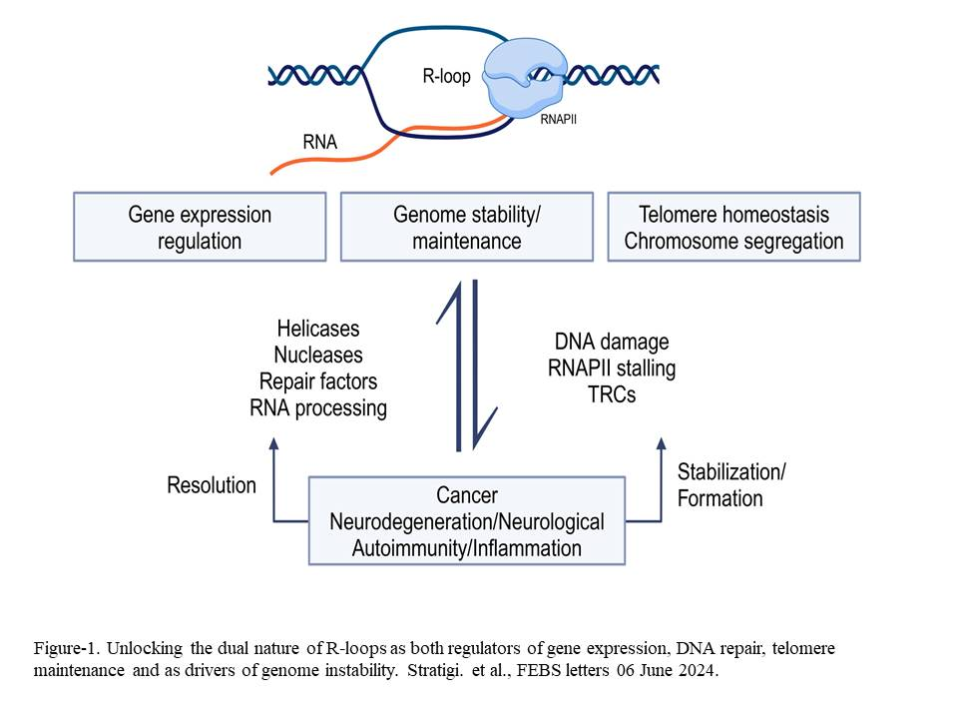

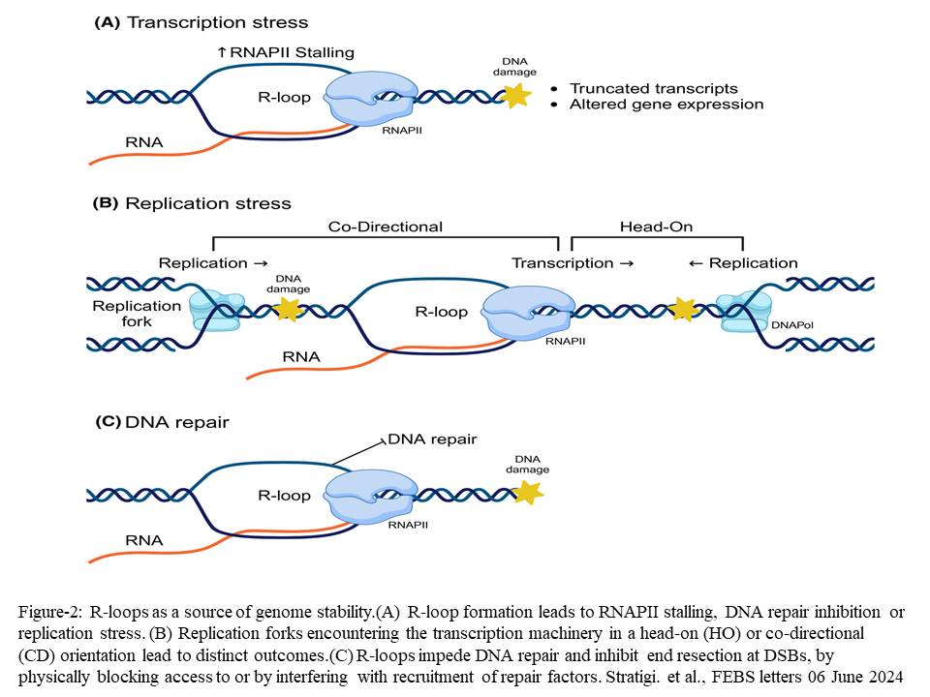

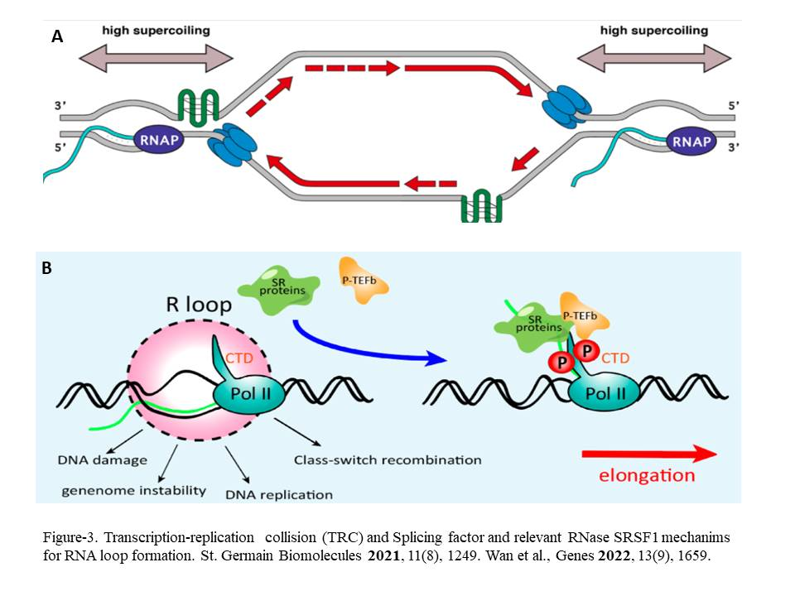

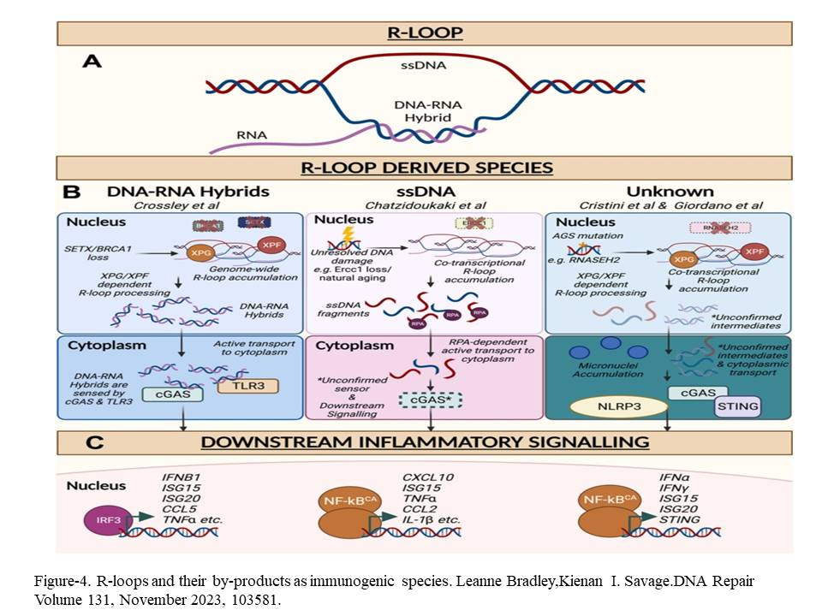

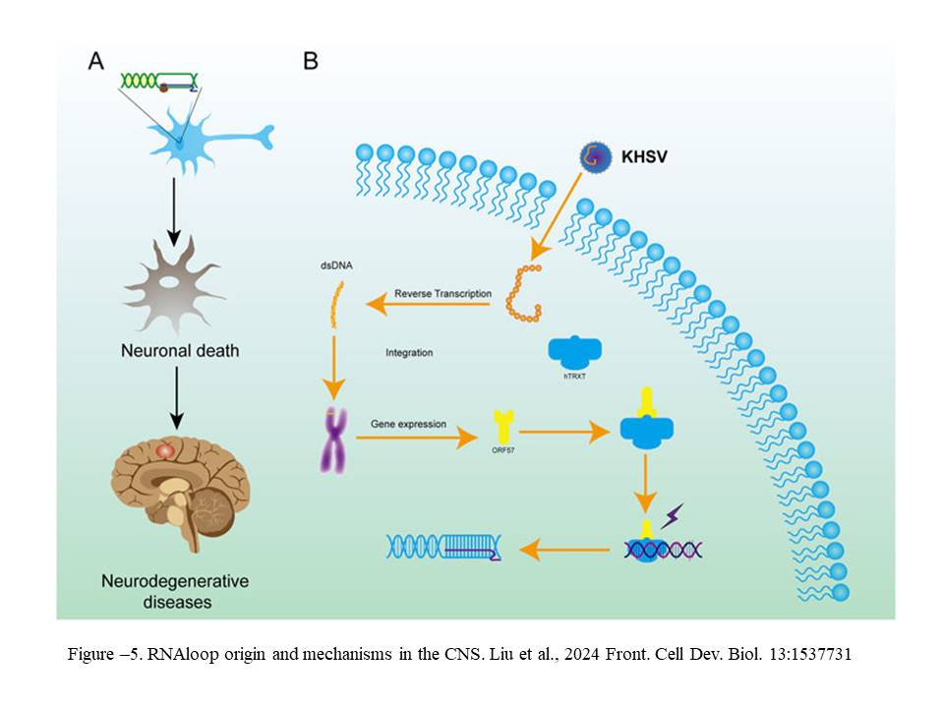

**References**

Youssef A Hegazy, Chrishan M Fernando, Elizabeth J Tran..The balancing act of R-loop biology: The good, the bad, and the ugly.J Biol Chem. 2019 Dec 16;295(4):905–913. doi: 10.1074/jbc.REV119.011353

David F Allison, Gang Greg Wang. R-loops: formation, function, and relevance to cell stress.Cell Stress. 2019 Jan 21;3(2):38–46. doi: 10.15698/cst2019.02.175.

Cooper, G. M., & Hausman, R. E. (2013). The cell: A molecular approach (6th ed.). Sunderland (MA): Sinauer Associates.

Madzia P. Crossley,Michael Bocek,Karlene A. Cimprich.R-Loops as Cellular Regulators and Genomic Threats.Molecular Cell.Volume 73, Issue 3, 7 February 2019, Pages 398-411.

Kirk Szafranski,Kirk Szafranski,Karan J. Abraham,Karan J. Abraham,Karim Mekhail,Karim Mekhail1..Non-coding RNA in neural function, disease, and agingFront. Genet., 09 March 2015. Sec. Genetics of Aging. Volume 6 - 2015 | https://doi.org/10.3389/fgene.2015.00087.

https://www.nature.com/scitable/definition/hairpin-loop-mrna-314/

Igor V. Kornienko, Olga Yu. Aramova,Anna A. Tishchenko,Dmitriy V. Rudoy and Michael Leonidas Chikindas.RNA Stability: A Review of the Role of Structural Features and Environmental ConditionsMolecules 2024, 29(24), 5978; https://doi.org/10.3390/molecules29245978

Wilma K Olson, Shuxiang Li, Thomas Kaukonen, Andrew V Colasanti, Yurong Xin, Xiang-Jun Lu.Effects of Noncanonical Base Pairing on RNA Folding: Structural Context and Spatial Arrangements of G·A Pairs.Biochemistry. 2019 May 8;58(20):2474–2487. doi: 10.1021/acs.biochem.9b00122.

Min Zhu,Xinyu Wang,Hongchang Zhao,Zhenjie Wang.Update on R-loops in genomic integrity: Formation, functions, and implications for human diseases.Genes Dis. 2024 Aug 30;12(4):101401. doi: 10.1016/j.gendis.2024.101401.

Bender, W., Davidson, N., 1976, Mapping of poly (A) sequences in the electron microscope reveals unusual structure of type B oncornavirus RNA molecules, *Cell* **7**: 595–607.

Paul A Ginno, Yoong Wearn Lim, Paul L Lott, Ian Korf, Frédéric Chédin.GC skew at the 5' and 3' ends of human genes links R-loop formation to epigenetic regulation and transcription termination.Genome Res. 2013 Oct;23(10):1590-600. doi: 10.1101/gr.158436.113. Epub 2013 Jul 18.

Konstantina Skourti-Stathaki 1, Nicholas J Proudfoot, Natalia Gromak.Human senataxin resolves RNA/DNA hybrids formed at transcriptional pause sites to promote Xrn2-dependent termination. Mol Cell. 2011 Jun 24;42(6):794-805. doi: 10.1016/j.molcel.2011.04.026.

Chen, P.B., et al. (2015). R-loop formation promotes antisense transcription through decreased nucleosome occupancy in fission yeast. Molecular Cell, 60(5), 867–881.

Anastasiia T. Davletgildeeva and Nikita A. Kuznetsov.Participants in Transcription–Replication Conflict and Their Role in Formation and Resolution of R-Loops. Int. J. Mol. Sci. 2025, 26(14), 6951; https://doi.org/10.3390/ijms26146951.

Sneha Saxena,Lee Zou.Hallmarks of DNA replication stress.Molecular CellVolume 82, Issue 12, 16 June 2022, Pages 2298-2314.

Deepankar Roy, Michael R Lieber.G Clustering Is Important for the Initiation of Transcription-Induced R-Loops In Vitro, whereas High G Density without Clustering Is Sufficient There after.Mol Cell Biol. 2009 Mar 23;29(11):3124–3133. doi: 10.1128/MCB.00139-09.

Tatiana García-Muse, Andrés Aguilera.R Loops: From Physiological to Pathological Roles.Cell. 2019 Oct 17;179(3):604-618. doi: 10.1016/j.cell.2019.08.055. Epub 2019 Oct 10.

T Lindahl. Instability and decay of the primary structure of DNA.Nature. 1993 Apr 22;362(6422):709-15. doi: 10.1038/362709a0.

Puja Yadav , Norah Owiti , Nayun KimThe role of topoisomerase I in suppressing genome instability associated with a highly transcribed guanine-rich sequence is not restricted to preventing RNA:DNA hybrid accumulation.Nucleic Acids Research, Volume 44, Issue 2, 29 January 2016, Pages 718–729.

Lamia Wahba, Lorenzo Costantino, Frederick J Tan, Anjali Zimmer, Douglas Koshland.S1-DRIP-seq identifies high expression and polyA tracts as major contributors to R-loop formation.Genes Dev. 2016 Jun 1;30(11):1327-38. doi: 10.1101/gad.280834.116.

Xu,W.,Xu,H.,Li,K.,Fan,Y.,Liu,Y.,Yang,X.,andSun,Q.(2017).TheR-loopis a common chromatin feature of the Arabidopsis genome. Nat. Plants 3, 704–714.

Sanz, L.A., Hartono, S.R., Lim, Y.W., Steyaert, S., Rajpurkar, A., Ginno, P.A., Xu, X., and Che´din, F. (2016). Prevalent, Dynamic, and Conserved R-Loop Structures Associate with Specific Epigenomic Signatures in Mammals. Mol. Cell 63, 167–178.

Chan,Y.A.,Aristizabal, M.J., Lu, P.Y., Luo, Z.,Hamza,A., Kobor,M.S.,Stirling, P.C., and Hieter, P. (2014). Genome-wide profiling of yeast DNA:RNA hybrid prone sites with DRIP-chip. PLoS Genet. 10, e1004288.

Chen, L., Chen, J.Y., Zhang, X., Gu, Y., Xiao, R., Shao, C., Tang, P., Qian, H., Luo, D., Li, H., et al. (2017). R-ChIP Using Inactive RNase H Reveals Dynamic Coupling ofR-loopswithTranscriptional Pausing at Gene Promoters. Mol.Cell 68, 745–757.

El Hage, A., Webb, S., Kerr, A., and Tollervey, D. (2014). Genome-wide distri bution of RNA-DNA hybrids identifies RNase H targets in tRNA genes, retro transposons and mitochondria. PLoS genetics 10, e1004716.

Carlo Rinaldi, Paolo Pizzul, Maria Pia Longhese, Diego Bonetti,Sensing R-Loop-Associated DNA Damage to Safeguard Genome Stability.Front Cell Dev Biol. 2021 Jan 11;8:618157. doi: 10.3389/fcell.2020.618157.

Li, F., Zafar, A., Luo, L., Denning, A. M., Gu, J., Bennett, A., Yuan, F., & Zhang, Y. (2023). R-Loops in Genome Instability and Cancer. *Cancers*, *15*(20), 4986. https://doi.org/10.3390/cancers15204986.

Christof Niehrs,Brian Luke.Regulatory R-loops as effectors of gene expression and genome stability. Nat Rev Mol Cell Biol. 2020 Jan 31;21(3):167–178. doi: 10.1038/s41580-019-0206-3.

Julie Sollier, Karlene A Cimprich. R-Loops Breaking Bad. Trends Cell Biol. 2015 Jun 1;25(9):514–522. doi: 10.1016/j.tcb.2015.05.003.

Sun Q., Csorba T., Skourti-Stathaki K., Proudfoot N. J., Dean C. R-loop stabilization represses antisense transcription at the *Arabidopsis* FLC locus. Science. 2013; 340, 619–621. doi: 10.1126/science.1234848.

Csorba T., Questa J. I., Sun Q., Dean C. Antisense COOLAIR mediates the coordinated switching of chromatin states at FLC during vernalization. Proc. Natl. Acad. Sci. U.S.A. 2014; 111, 16160–16165. doi: 10.1073/pnas.1419030111.

Hage A.E., French S.L., Beyer A.L., Tollervey D. Loss of Topoisomerase I leads to R-loop-mediated transcriptional blocks during ribosomal RNA synthesis. Genes Dev. 2010; 24:1546–1558. doi:10.1101/gad.573310.

Hegazy A.Y., Fernando M.C., Tran J.E. The balancing act of R-loop biology: The good, the bad, and the ugly. J Biol Chem. 2019; 295(4):905–913. doi: 10.1074/jbc.REV119.011353.

Samira Kemiha, Jérôme Poli,Yea-Lih Lin,Armelle Lengronne,Philippe Pasero.DNA Repair Toxic R-loops: Cause or consequence of replication stress?.DNA Repair Volume 107, November 2021, 103199

José M Santos-Pereira, Andrés Aguilera.R loops: new modulators of genome dynamics and function.Nat Rev Genet. 2015 Oct;16(10):583-97. doi: 10.1038/nrg3961. Epub 2015 Sep 15.

Groh, M., & Gromak, N. (2014). Out of balance: R-loops in human disease. PLoS genetics, 10(9), e1004630. https://doi.org/10.1371/journal.pgen.1004630.

Rushad Pavri.R Loops in the Regulation of Antibody Gene Diversification.Genes (Basel). 2017 Jun 2;8(6):154. doi: 10.3390/genes8060154.Genes (Basel). 2022 Mar 18;13(3):539. doi: 10.

Alain Chebly,Joana Ropio 1,3,4,†, Lyla Baldasseroni, Martina Prochazkova-Carlotti, Yamina Idrissi, Jacky Ferrer, Chantal Farra, Marie Beylot-Barry,Jean-Philippe Merlio, Edith Chevret.Telomeric Repeat-Containing RNA (TERRA): A Review of the Literature and First Assessment in Cutaneous T-Cell Lymphomas. Genes (Basel). 2022 Mar 18;13(3):539. doi: 10.3390/genes13030539.

Arora, R., Lee, Y., Wischnewski, H., Brun, C. M., Schwarz, T., & Azzalin, C. M. (2014). RNaseH1 regulates TERRA-telomeric DNA hybrids and telomere maintenance in ALT tumour cells. Nature communications, 5, 5220.

Chen X., Mai Z., Zheng Y., Lin P., Lu Y., Zheng J., Lin Y., Zhou Z., Xu R., Zhao X., Cui L. The hidden weavers: A review of DNA/RNA R-loops in stem cell biology and therapeutic potential. International Journal of Biological Macromolecules. 2025; 297. doi: 10.1016/j.ijbiomac.2025.139895.

Ivanov P.M., Zecchini H., Hamerlik P. Simultaneous Visualization of R-Loops/RNA:DNA Hybrids and Replication Forks in a DNA Combing Assay. Genes. 2024; 15(9), 1161. doi; 10.3390/genes15091161.

Patricia Richard, James L Manley.R Loops and Links to Human Disease.J Mol Biol. Author manuscript; available in PMC: 2017 Oct 27.

Konstantina Skourti-Stathaki,Elena Torlai Triglia,Marie Warburton,Philipp Voigt,Adrian Bird,Ana PomboR-Loops Enhance Polycomb Repression at a Subset of Developmental Regulator Genes.Molecular Cell Volume 73, Issue 5, 7 March 2019, Pages 930-945.e4.

Xu Chen,Zizhao Mai,Yucheng Zheng,Pei Lin,Ye Lu,Jiarong Zheng,Yunfan Lin,Zihao Zhou,Rongwei Xu,Xinyuan Zhao,Li CuiThe hidden weavers: A review of DNA/RNA R-loops in stem cell biology and therapeutic potential.International Journal of Biological Macromolecules Volume 297, March 2025, 139895.

Emily Yun-Chia Chang, Peter C Stirling.Replication Fork Protection Factors Controlling R-Loop Bypass and Suppression.Genes (Basel). 2017 Jan 14;8(1):33. doi: 10.3390/genes8010033.

Shizhuo Yang, Lacey Winstone, Sohaumn Mondal, Yuliang Wu.Helicases in R-loop Formation and Resolution.J Biol Chem. 2023 Sep 29;299(11):105307. doi: 10.1016/j.jbc.2023.105307.

Frédéric Chédin.Nascent connections: R-loops and chromatin patterning.Trends Genet. 2016 Oct 25;32(12):828–838. doi: 10.1016/j.tig.2016.10.002.

Arum Kim,Gang Greg Wang.Biochimica et Biophysica Acta (BBA) - Gene Regulatory Mechanisms.Volume 1864, Issues 11–12, November–December 2021, 194750. R-loop and its functions at the regulatory interfaces between transcription and (epi)genome

Marta San Martin Alonso , Sylvie M Noordermeer.Untangling the crosstalk between BRCA1 and R-loops during DNA repair.Review Nucleic Acids Res. 2021 May 21;49(9):4848-4863. doi: 10.1093/nar/gkab178.

Fang Li, Alyan Zafar, Liang Luo, Ariana Maria Denning, Jun Gu, Ansley Bennett, Fenghua Yuan, Yanbin Zhang.R-Loops in Genome Instability and Cancer.Cancers (Basel). 2023 Oct 14;15(20):4986. doi: 10.3390/cancers15204986.

Gunhyoung Lim, Seungha Hwang, Kilwon Yu, Jin Young Kang, Changwon Kang, Sungchul Hohng.Translocating RNA polymerase generates R-loops at DNA double-strand breaks without any additional factors.Nucleic Acids Res. 2023 Aug 28;51(18):9838–9848. doi: 10.1093/nar/gkad689.

Castellano-Pozo M., Santos-Pereira J. M., Rondón A. G., Barroso S., Andújar E., Pérez-Alegre M., García-Muse T., and Aguilera A.R loops are linked to histone H3 S10 phosphorylation and chromatin condensation. Mol. Cell. 2012; 52, 583–590. doi: 10.1016/j.molcel.2013.10.006.

Lim G., Hwang S., Yu K., Kang Y.J., Kang C., Hohng S. Translocating RNA polymerase generates R-loops at DNA double-strand breaks without any additional factors. Nucleic Acids Res. 2023;51(18):9838–9848. doi: 10.1093/nar/gkad689.

Boris P Belotserkovskii, Silvia Tornaletti, Alicia D D’Souza, Philip C Hanawalt.R-loop generation during transcription: formation, processing and cellular outcomes.DNA Repair (Amst). 2018 Aug 25;71:69–81. doi: 10.1016/j.dnarep.2018.08.009.

Nicolas L Fernandez, Ziyuan Chen, David E H Fuller, Lieke A van Gijtenbeek, Taylor M Nye, Julie S Biteen, Lyle A Simmons,Boris P.DNA Methylation and RNA-DNA Hybrids Regulate the Single-Molecule Localization of a DNA Methyltransferase on the Bacterial Nucleoid .mBio. 2023 Jan 16;14(1):e03185-22. doi: 10.1128/mbio.03185-22.

Anindya R. Single-stranded DNA damage: protecting the single-stranded DNA from chemical attack. DNA Repair (Amst.). 2020; 87:102804. doi: 10.1016/j.dnarep.2020.102804.

Promonet A., Padioleau I., Liu Y., Sanz L., Biernacka A., Schmitz A.-L., Skrzypczak M., Sarrazin A., Mettling C., Rowicka M. Topoisomerase 1 prevents replication stress at R-loop-enriched transcription termination sites. Nat. Commun. 2020; 11:3940. doi: 10.1038/s41467-020-17858-2.

Pablo Huertas, Andrés Aguilera.Cotranscriptionally formed DNA:RNA hybrids mediate transcription elongation impairment and transcription-associated recombination.Mol Cell. 2003 Sep;12(3):711-21. doi: 10.1016/j.molcel.2003.08.010.

Backert, S. (2002). R-loop-dependent rolling-circle replication and a new model for DNA concatemer resolution by mitochondrial plasmid mp1. EMBO J. 21, 3128–3136.

Chen, L., Chen, J.Y., Zhang, X., Gu, Y., Xiao, R., Shao, C., Tang, P., Qian, H., Luo, D., Li, H., et al. (2017). R-ChIP Using Inactive RNase H Reveals DynamicCoupling ofR-loops with Transcriptional Pausing at Gene Promoters.Mol.Cell 68, 745–757.

Vaibhav Bhatia, Sonia I. Barroso, María L. García-Rubio, Emanuela Tumini, Emilia Herrera-Moyano & Andrés Aguilera. BRCA2 prevents R-loop accumulation and associates with TREX-2 mRNA export factor PCID2.Nature volume 511, pages362–365 (2014)

Boguslawski, S.J., Smith, D.E., Michalak, M.A., Mickelson, K.E., Yehle, C.O., Patterson, W.L., and Carrico, R.J. (1986). Characterization of monoclonal antibody to DNA.RNA and its application to immunodetection of hybrids. J. Immunol. Methods 89, 123–130.

Stella R Hartono, Amélie Malapert, Pénélope Legros, Pascal Bernard, Frédéric Chédin,Vincent Vanoosthuyse. The Affinity of the S9.6 Antibody for Double-Stranded RNAs Impacts the Accurate Mapping of R-Loops in Fission Yeast J Mol Biol. 2017 Dec 28;430(3):272–284. doi: 10.1016/j.jmb.2017.12.016.

Yu K, Chedin F, Hsieh CL, Wilson TE, and Lieber MR (2003). R-loops at immunoglobulin class switch regions in the chromosomes of stimulated B cells. Nat Immunol 4, 442–451.

Pramiti Mukhopadhyay, Henry Miller, Aiola Stoja, Alexander J R Bishop.Approaches for mapping and analysis of R-loopsCurr Protoc. 2024 Apr;4(4):e1037. doi: 10.1002/cpz1.1037

Chan, YA; Aristizabal, MJ; Lu, PY; Luo, Z; Hamza, A; Kobor, MS; Stirling, PC; Hieter, P. 2014. "Genome-wide profiling of yeast DNA:RNA hybrid prone sites with DRIP-chip.PLOS Genetics. 10 (4): e1004288.

Julie Nadel, Rodoniki Athanasiadou, Christophe Lemetre, N. Ari Wijetunga, Pilib Ó Broin, Hanae Sato, Zhengdong Zhang, Jeffrey Jeddeloh, Cristina Montagna, Aaron Golden, Cathal Seoighe & John M. Greally. RNA:DNA hybrids in the human genome have distinctive nucleotide characteristics, chromatin composition, and transcriptional relationships.Epigenetics & Chromatin volume 8, Article number: 46 (2015)

Lionel A Sanz, Daisy Castillo-Guzman, Frédéric Chédin. Mapping R-loops and RNA:DNA hybrids with S9.6-based immunoprecipitation methods. J Vis Exp. 2021 Aug 24;(174):10.3791/62455. doi: 10.3791/62455.

Essak S. Khan,Sven Danckwardt. Pathophysiological Role and Diagnostic Potential of R-Loops in Cancer and Beyond. Genes 2022, 13(12), 2181; https://doi.org/10.3390/genes13122181.

Ashkan Fakharzadeh, Jing Qu, Feng Pan, Celeste Sagui, Christopher Roland.Structure and Dynamics of DNA and RNA Double Helices Formed by d(CTG), d(GTC), r(CUG), and r(GUC) Trinucleotide Repeats and Associated DNA–RNA Hybrids.J Phys Chem B. 2023 Sep 8;127(37):7907–7924. doi: 10.1021/acs.jpcb.3c03538

Carlo Rinaldi,Paolo Pizzul,Maria Pia Longhese,Diego Bonetti.Sensing R-Loop-Associated DNA Damage to Safeguard Genome Stability.Front. Cell Dev. Biol., 11 January 2021.Sec. Cell Growth and Division.Volume 8 - 2020 | https://doi.org/10.3389/fcell.2020.618157

Heinz Peter Nasheuer, Anna Marie Meaney, Timothy Hulshoff, Ines Thiele, Nichodemus O Onwubiko.Replication Protein A, the Main Eukaryotic Single-Stranded DNA Binding Protein, a Focal Point in Cellular DNA Metabolism.Int J Mol Sci. 2024 Jan 2;25(1):588. doi: 10.3390/ijms25010588.

Fabio Bento, George Yakoub.Helle D. Ulrich, Brian Luke.Arianna Lockhart, Vanessa Borges Pires,RNase H1 and H2 Are Differentially Regulated to Process RNA-DNA Hybrids.Cell Reports 29, 2890–2900.November 26, 2019 .https://doi.org/10.1016/j.celrep.2019.10.108.

Elsa Zacco, Stephen R Martin, Richard Thorogate, Annalisa Pastore..The RNA-Recognition Motifs of TAR DNA-Binding Protein 43 May Play a Role in the Aberrant Self-Assembly of the Protein.Front Mol Neurosci. 2018 Oct 9;11:372. doi: 10.3389/fnmol.2018.00372Alison C. Lloyd. The Regulation of Cell Size.CellVolume 154, Issue 6, 12 September 2013, Pages 1194-1205.

Archana Prasad, Vidhya Bharathi, Vishwanath Sivalingam, Amandeep Girdhar, Basant K Patel. Molecular Mechanisms of TDP-43 Misfolding and Pathology in Amyotrophic Lateral Sclerosis.Front Mol Neurosci. 2019 Feb 14;12:25. doi: 10.3389/fnmol.2019.00025

Koichi Sato, Puck Knipscheer. G-quadruplex resolution: From molecular mechanisms to physiological relevance.DNA Repair.Volume 130, October 2023, 103552.

Sunny Y Yang, Emily Y C Chang, Joanne Lim, Harwood H Kwan, David Monchaud, Stephen Yip, Peter C Stirling, Judy M Y Wong.NAR Cancer. 2021 Jul 21;3(3):zcab031. doi: 10.1093/narcan/zcab031.G-quadruplexes mark alternative lengthening of telomeres

Anne-Laure Valton,Marie-Noëlle Prioleau..G-Quadruplexes in DNA Replication: A Problem or a Necessity? Trends in Genetics.Volume 32, Issue 11, November 2016, Pages 697-706

Jun Tan, Xiangyu Wang, Laiyee Phoon, Haibo Yang, Li Lan.Resolution of ROS-induced G-quadruplexes and R-loops at transcriptionally active sites is dependent on BLM helicase.FEBS Lett. 2020 May;594(9):1359-1367. doi: 10.1002/1873-3468.13738. Epub 2020 Feb 9.

Bradleigh Palmer, Chun-Ying Lee,Leya Yang,Tapas Pau,Sua Myong.High-frequency transcription leads to rapid R-loop formationJournal of Biological Chemistry, Volume 301, Issue 6, 108514.

Yi Gong, Yie Liu.R-Loops at Chromosome Ends: From Formation, Regulation, and Cellular Consequence.Cancers (Basel). 2023 Apr 6;15(7):2178. doi: 10.3390/cancers15072178.

Allegra Angeloni,Ozren Bogdanovic.Sequence determinants, function, and evolution of CpG islands.Biochem Soc Trans (2021) 49 (3): 1109–1119.

Yea-Lih Lin, Philippe Pasero. Replication stress: from chromatin to immunity and beyond Curr Opin Genet Dev. 2021 Dec:71:136-142. doi: 10.1016/j.gde.2021.08.004. Epub 2021 Aug 26.

Stephan Hamper, Michael J. Bocek,Joshua C. Saldivar,Tomek Swigut,Karlene A. CimprichTranscription-Replication Conflict Orientation Modulates R-Loop Levels and Activates Distinct DNA Damage Responses. Cell Volume 170, Issue 4, 10 August 2017, Pages 774-786.e19.

Larissa Milano.Amit Gautam.Keith W. Caldecott.DNA damage and transcription stress.Molecular CellVolume 84, Issue 1, 4 January 2024, Pages 70-79.

Houra Merrikh, Yan Zhang, Alan D Grossman, Jue D Wang.Replication-transcription conflicts in bacteria.Nat Rev Microbiol. 2012 Jun 6;10(7):449–458. doi: 10.1038/nrmicro2800.

Miroslava Kretova, Tomas Selicky, Ingrid Cipakova, Lubos Cipak.Regulation of Pre-mRNA Splicing: Indispensable Role of Post-Translational Modifications of Splicing Factors.Life (Basel). 2023 Feb 21;13(3):604. doi: 10.3390/life13030604

Zhong Han,George A. Moore,Richard Mitter,David Lopez Martinez,Li Wan,A. Barbara Dirac Svejstrup,David S. Rueda,Jesper Q. Svejstrup.DNA-directed termination of RNA polymerase II transcription. Molecular Cell Volume 83, Issue 18, 21 September 2023, Pages 3253-3267.e7.

Shelly Sorrells, Sara Nik, Mattie Casey, Rosannah C. Cameron, Harold Truong, Cristhian Toruno, Michelle Gulfo, Albert Lowe, Cicely Jette, Rodney A. Stewart, Teresa V. Bowman.Spliceosomal components protect embryonic neurons from R-loop-mediated DNA damage and apoptosis.Dis Model Mech (2018) 11 (2): dmm031583.https://doi.org/10.1242/dmm.031583

Lulzim Shkreta, Benoit Chabot.The RNA Splicing Response to DNA Damage.Biomolecules. 2015 Oct 29;5(4):2935–2977. doi: 10.3390/biom5042935.

Stella R Hartono, Ian F Korf, Frédéric Chédin.Nucleic Acids Res. 2015 Nov 16;43(20):9729-41. doi: 10.1093/nar/gkv811. Epub 2015 Aug 7.GC skew is a conserved property of unmethylated CpG island promoters across vertebrates

Alison C. Lloyd.The Regulation of Cell Size.Cell.Volume 154, Issue 6, 12 September 2013, Pages 1194-1205.

Joshua R. Brickner, Jada L. Garzon,Karlene A. Cimprich.Walking a tightrope: The complex balancing act of R-loops in genome stability.Molecular Cell Volume 82, Issue 12, 16 June 2022, Pages 2267-2297.

Michelle K Zeman, Karlene A Cimprich.Causes and consequences of replication stress.Review Nat Cell Biol. 2014 Jan;16(1):2-9. doi: 10.1038/ncb2897.

Magdalena P. Crossley, Chenlin Song, Michael J. Bocek, Jun-Hyuk Choi, Joseph N. Kousouros, Ataya Sathirachinda, Cindy Lin, Joshua R. Brickner, Gongshi Bai, Hannes Lans, Wim Vermeulen, Monther Abu-Remaileh & Karlene A. Cimprich. 2023.R-loop-derived cytoplasmic RNA–DNA hybrids activate an immune response.Nature volume 613, pages187–194.

Patricia Richard, James L Manley.R Loops and Links to Human Disease.Review J Mol Biol. 2017 Oct 27;429(21):3168-3180. doi: 10.1016/j.jmb.2016.08.031. Epub 2016 Sep 4.

Douglas Hanahan, Robert A Weinberg.Hallmarks of cancer: the next generation.Cell. 2011 Mar 4;144(5):646-74. doi: 10.1016/j.cell.2011.02.013.

Caroline Townsend Stork, Michael Bocek, Madzia P Crossley, Julie Sollier, Lionel A Sanz, Frédéric Chédin, Tomek Swigut, Karlene A Cimprich.Co-transcriptional R-loops are the main cause of estrogen-induced DNA damage.Elife. 2016 Aug 23:5:e17548. doi: 10.7554/eLife.17548.

Panagiotis Kotsantis, Lara Marques Silva, Sarah Irmscher, Rebecca M Jones, Lisa Folkes, Natalia Gromak, Eva Petermann.Increased global transcription activity as a mechanism of replication stress in cancer.Nat Commun. 2016 Oct 11:7:13087. doi: 10.1038/ncomms13087.

Shawn Lu Wen Tan,Saakshi Chadha,Yansheng Liu,Evelina Gabasova,David Perera,Karim Ahmed,Stephanie Constantinou,Xavier Renaudin,MiYoung Lee, Ruedi Aebersold,Ashok R. Venkitaraman.A Class of Environmental and Endogenous Toxins Induces BRCA2 Haploinsufficiency and Genome Instability.Cell Volume 169, Issue 6, 1 June 2017, Pages 1105-1118.e15.

Xiaowen Zhang, Huai-Chin Chiang, Yao Wang, Chi Zhang, Sabrina Smith, Xiayan Zhao, Sreejith J. Nair, Joel Michalek, Ismail Jatoi, Meeghan Lautner, Boyce Oliver, Howard Wang, Anna Petit, Teresa Soler, Joan Brunet, Francesca Mateo, Miguel Angel Pujana, Elizabeth Poggi, Krysta Chaldekas, Claudine Isaacs, Beth N. Peshkin, Oscar Ochoa, Frederic Chedin, Constantine Theoharis, Rong Li.Nature Communications volume 8, Article number: 15908 (2017).

Liang Chen, Jia-Yu Chen, Yi-Jou Huang, Ying Gu, Jinsong Qiu, Hao Qian, Changwei Shao, Xuan Zhang, Jing Hu, Hairi Li, Shunmin He,Yu Zhou, Omar Abdel-Wahab, Dong-Er Zhang 2,*, Xiang-Dong Fu.The Augmented R-Loop Is a Unifying Mechanism for Myelodysplastic Syndromes Induced by High-Risk Splicing Factor Mutations.Mol Cell. 2018 Jan 27;69(3):412–425.e6. doi: 10.1016/j.molcel.2017.12.029

Tuo Li, Zhijian J Chen.The cGAS–cGAMP–STING pathway connects DNA damage to inflammation, senescence, and cancer.J Exp Med. 2018 May 7;215(5):1287–1299. doi: 10.1084/jem.20180139.

Flavie Coquel,Christoph Neumayer,Yea-Lih Lin,Philippe Pasero.SAMHD1 and the innate immune response to cytosolic DNA during DNA replication.Current Opinion in Immunology.Volume 56, February 2019, Pages 24-30.

Flavie Coquel,Christoph Neumayer,Yea-Lih Lin,Philippe Pasero.SAMHD1 and the innate immune response to cytosolic DNA during DNA replication.Current Opinion in Immunology.Volume 56, February 2019, Pages 24-30.

Yoong Wearn Lim, Lionel A Sanz, Xiaoqin Xu, Stella R Hartono, Frédéric Chédin.Genome-wide DNA hypomethylation and RNA:DNA hybrid accumulation in Aicardi–Goutières syndrome.eLife. 2015 Jul 16;4:e08007. doi: 10.7554/eLife.08007

Seo-Yun Lee, Kyle M Miller, Jae-Jin Kim.Clinical and Mechanistic Implications of R-Loops in Human Leukemias.Int J Mol Sci. 2023 Mar 22;24(6):5966. doi: 10.3390/ijms24065966

Excessive R-loops trigger an inflammatory cascade leading to increased HSPC production

Joshua T Weinreb, Noura Ghazale, Kith Pradhan, Varun Gupta, Kathryn S Potts, Brad Tricomi , Noah J Daniels, Richard A Padgett, Sofia De Oliveira, Amit Verma, Teresa V Bowman . Dev Cell. 2021 Mar 8;56(5):627-640.e5. doi: 10.1016/j.devcel.2021.02.006. Epub 2021 Mar 1.

Jinglin Zhou, Zhan Zhuang, Jiamian Li, Zhihua Feng. Significance of the cGAS-STING Pathway in Health and Disease.Int J Mol Sci. 2023 Aug 28;24(17):13316. doi: 10.3390/ijms241713316.

Huacheng Luo, Ganqian Zhu, Melanie A Eshelman, Tsz Kan Fung, Qian Lai, Fei Wang, Bernd B Zeisig, Julia Lesperance, Xiaoyan Ma, Shi Chen, Nicholas Cesari, Christopher Cogle, Baoan Chen, Bing Xu, Feng-Chun Yang, Chi Wai Eric So, Yi Qiu, Mingjiang Xu, Suming Huang.HOTTIP-dependent R-loop formation regulates CTCF boundary activity and TAD integrity in leukemia.Mol Cell. 2022 Feb 17;82(4):833–851.e11. doi: 10.1016/j.molcel.2022.01.014.

David M. Wilson III, Mark R. Cookson, Ludo Van Den Bosch, Henrik Zetterberg, David M. Holtzman, Ilse Dewachter. Hallmarks of neurodegenerative diseases.Cell Volume 186, Issue 4, 16 February 2023, Pages 693-714.

Zeba Firdaus, Xiaogang Li.Unraveling the Genetic Landscape of Neurological Disorders: Insights into Pathogenesis, Techniques for Variant Identification, and Therapeutic Approaches. Int J Mol Sci. 2024 Feb 15;25(4):2320. doi: 10.3390/ijms25042320

Essak S Khan, Sven Danckwardt.Pathophysiological Role and Diagnostic Potential of R-Loops in Cancer and Beyond.Genes (Basel). 2022 Nov 22;13(12):2181. doi: 10.3390/genes13122181.

Johnathan Cooper-Knock, Janine Kirby, Robin Highley, Pamela J Shaw. The Spectrum of C9orf72-mediated Neurodegeneration and Amyotrophic Lateral Sclerosis Neurotherapeutics. 2015 Mar 3;12(2):326–339. doi: 10.1007/s13311-015-0342-1.

Juan-Carlos Yustis,Maëva Devoucoux,Jacques Côté.The Functional Relationship Between RNA Splicing and the Chromatin Landscape.Journal of Molecular Biology.Volume 436, Issue 16, 15 August 2024, 168614.

Łukasz J Sznajder, James D Thomas, Ellie M Carrell, Tammy Reid, Karen N McFarland, John D Cleary, Ruan Oliveira, Curtis A Nutter, Kirti Bhatt, Krzysztof Sobczak, Tetsuo Ashizawa, Charles A Thornton, Laura P W Ranum, Maurice S Swanson.Intron retention induced by microsatellite expansions as a disease biomarker.Proc Natl Acad Sci U S A. 2018 Apr 17;115(16):4234-4239. doi: 10.1073/pnas.1716617115. Epub 2018 Apr 2.

Veronica Nobile, Cecilia Pucci, Pietro Chiurazzi, Giovanni Neri, Elisabetta Tabolacci.DNA Methylation, Mechanisms of FMR1 Inactivation and Therapeutic Perspectives for Fragile X Syndrome.Biomolecules. 2021 Feb 16;11(2):296. doi: 10.3390/biom11020296.

Patricia Richard, Shuang Feng, Yueh-Lin Tsai, Wencheng Li, Paola Rinchetti,Ubayed Muhith, Juan Irizarry-Cole, Katharine Stolz, Lionel A Sanz, Stella Hartono, Mainul Hoque, Saba Tadesse, Hervé Seitz, Francesco Lotti, Michio Hirano, Frédéric Chédin, Bin Tian,James L Manley. SETX (senataxin), the helicase mutated in AOA2 and ALS4, functions in autophagy regulation.Autophagy. 2020 Aug 7;17(8):1889–1906. doi: 10.1080/15548627.2020.1796292

Annapoorna Kannan, Shyni Gangadharan Leela, Dana Branzei, Laxman Gangwani. Brain Role of senataxin in R-loop-mediated neurodegeneration.Commun. 2024 Jul 15;6(4):fcae239. doi: 10.1093/braincomms/fcae239.

Kaalak Reddy , Mandy Tam , Richard P. Bowater , Miriam Barber , Matthew Tomlinson , Kerrie Nichol Edamura , Yuh-Hwa Wang , Christopher E. Pearso.Determinants of R-loop formation at convergent bidirectionally transcribed trinucleotide repeats.Nucleic Acids Research, Volume 39, Issue 5, 1 March 2011, Pages 1749–1762.

Catherine H Freudenreich.R-loops: Targets for Nuclease Cleavage and Repeat Instability Curr Genet. 2018 Jan 11;64(4):789–794. doi: 10.1007/s00294-018-0806-z

Katherine R Westover, Peng Ji,Bing Yao.Bridging the gap: R-loop mediated genomic instability and its implications in neurological diseases. Epigenomics. 2024 Mar 26;16(8):589–608. doi: 10.2217/epi-2023-0379.

Ravi R Iyer, Anna Pluciennik, Marek Napierala, Robert D Wells.DNA Triplet Repeat Expansion and Mismatch Repair.Annu Rev Biochem. 2015 Jan 2;84:199–226. doi: 10.1146/annurev-biochem-060614-034010.

Eduardo E Laverde, Yanhao Lai, Fenfei Leng, Lata Balakrishnan, Catherine H J Freudenreich, Yuan Liu.R-loops promote trinucleotide repeat deletion through DNA base excision repair enzymatic activities. Biol Chem. 2020 Aug 6;295(40):13902–13913. doi: 10.1074/jbc.RA120.014161.

Julie Sollier, Caroline Townsend Stork, María L García-Rubio, Renee D Paulsen, Andrés Aguilera, Karlene A Cimprich. Transcription-coupled nucleotide excision repair factors promote R-loop-induced genome instability.Mol Cell. 2014 Nov 26;56(6):777–785. doi: 10.1016/j.molcel.2014.10.020.

Parasvi S. Patel, Rehna Krishnan,Razqallah Hakem.Emerging roles of DNA topoisomerases in the regulation of R-loops.Mutation Research/Genetic Toxicology and Environmental Mutagenesis.Volumes 876–877, April–May 2022, 503450.

Shizhuo Yang, Lacey Winstone,Sohaumn Mondal,Yuliang Wu. Helicases in R-loop Formation and Resolution. JBC ReviewsVolume 299, Issue 11105307November 2023

Sarfraz Shafiq,Chunli Chen,Jing Yang,Lingling Cheng,Fei Ma,Emilie Widemann,Qianwen Sun.Molecular PlantVolume 10, Issue 6, 5 June 2017, Pages 821-833DNA Topoisomerase 1 Prevents R-loop Accumulation to Modulate Auxin-Regulated Root Development in Rice. Senataxin and RNase H2 act redundantly to suppress genome instability during class switch recombination

Hongchang Zhao, Stella Hartono, Kirtney Mae De Vera, Zheyuan Yu, Krishni Satchi, Tracy Zhao, Lionel Sanz, Frederic Chedin, Jacqueline Barlow.Senataxin and RNase H2 act redundantly to suppress genome instability during class switch recombination.bioRxiv 2021.10.18.464857; doi: https://doi.org/10.1101/2021.10.18.464857.

Agnese Cristini, Natalia Gromak, Olivier Sordet.Transcription-dependent DNA double-strand breaks and human disease. Mol Cell Oncol. 2020 Jan 10;7(2):1691905. doi: 10.1080/23723556.2019.1691905.

Abrey J. Yeo,Olivier J. Becherel,John E. Luff,Jason K. Cullen,Thidathip Wongsurawat,Piroon Jenjaroenpoon,Vladimir A. Kuznetsov,Peter J. McKinnon,Martin F. Lavin. R-Loops in Proliferating Cells but Not in the Brain: Implications for AOA2 and Other Autosomal Recessive Ataxias.PLOS ONE 9(8): e105258.

Ourania Chatzidoukaki, Kalliopi Stratigi,Evi Goulielmaki, George Niotis, Alexia Akalestou-Clocher,Katerina Gkirtzimanaki, Alexandros Zafeiropoulos, Janine Altmüller, Pantelis Topalis, George A Garinis. R-loops trigger the release of cytoplasmic ssDNAs leading to chronic inflammation upon DNA damage.Sci Adv. 2021 Nov 19;7(47):eabj5769. doi: 10.1126/sciadv.abj5769

Yea-Lih Lin and Philippe Pasero.Caught in the Act: R-Loops Are Cleaved by Structure-Specific Endonucleases to Generate DSBs.Molecular Cell 56, December 18, 2014.

Peter C Stirling, Philip Hieter.Canonical DNA repair pathways influence R-loop driven genome instability. J Mol Biol. 2016 Jul 22;429(21):3132–3138. doi: 10.1016/j.jmb.2016.07.014.

Kenta Mosallanejad, Jonathan C Kagan.Control of innate immunity by the cGAS-STING pathway. Immunol Cell Biol. 2022 May 25;100(6):409–423. doi: 10.1111/imcb.12555.

Sivapriya Kailasan Vanaja, Vijay A. K. Rathinam, Maninjay K. Atianand, and John M. Leong kate.Bacterial RNA:DNA hybrids are activators of the NLRP3 inflammasome.pnas.May 14, 2014.111 (21) 7765-7770.

Fan Zhang, Dingyun Wang, Guodong Zhao, Dingmao Wang.Unraveling R-loops: The hidden drivers of inflammation and immune dysregulation.Medicine (Baltimore). 2025 Jun 13;104(24):e42833. doi: 10.1097/MD.0000000000042833.

Leanne Bradley,Kienan I. Savage.DNA Repair‘From R-lupus to cancer’: Reviewing the role of R-loops in innate immune responses. DNA Repair.Volume 131, November 2023, 103581.

Tatiana García-Muse, Andrés Aguilera.R Loops: From Physiological to Pathological Roles.ReviewVolume 179, Issue 3p604-618October 17, 2019.

Yujuan CHEN, Junhong LIN, Yao ZHAO, Xianping MA, Huashan YI.Toll-like receptor 3 (TLR3) regulation mechanisms and roles in antiviral innate immune responses.J Zhejiang Univ Sci B. 2021 Aug 15;22(8):609–632. doi: 10.1631/jzus.B2000808.

Chiara Scopa, Samantha M. Barnada, Maria E. Cicardi, Mo Singer, Davide Trotti & Marco Trizzino .JUN upregulation drives aberrant transposable element mobilization, associated innate immune response, and impaired neurogenesis in Alzheimer’s disease.Nature Communications volume 14, Article number: 8021 (2023).

Shaik Basha,Darshan Chikkanayakanahalli Mukunda,Aparna Ramakrishna Pai,Krishna Kishore Mahato.Assessing amyloid fibrils and amorphous aggregates: A review. International Journal of Biological Macromolecules.Volume 311, Part 3, June 2025, 143725.

Leonardo G Dettori, Diego Torrejon, Arijita Chakraborty, Arijit Dutta, Mohamed Mohamed, Csaba Papp, Vladimir A Kuznetsov, Patrick Sung, Wenyi Feng, Alaji Bah.A Tale of Loops and Tails: The Role of Intrinsically Disordered Protein Regions in R-Loop Recognition and Phase Separation.Front Mol Biosci. 2021 Jun 10;8:691694. doi: 10.3389/fmolb.2021.691694.

Marcel Naumann, Arun Pal, Anand Goswami, Xenia Lojewski, Julia Japtok, Anne Vehlow, Maximilian Naujock, René Günther, Mengmeng Jin, Nancy Stanslowsky, Peter Reinhardt, Jared Sterneckert, Marie Frickenhaus, Francisco Pan-Montojo, Erik Storkebaum, Ina Poser, Axel Freischmidt, Jochen H Weishaupt, Karlheinz Holzmann, Dirk Troost, Albert C Ludolph, Tobias M Boeckers, Stefan Liebau, Susanne Petri, Nils Cordes, Anthony A Hyman, Florian Wegner, Stephan W Grill, Joachim Weis, Alexander Storch, Andreas Hermann.Impaired DNA damage response signaling by FUS-NLS mutations leads to neurodegeneration and FUS aggregate formation.Nat Commun. 2018 Jan 23;9(1):335. doi: 10.1038/s41467-017-02299-1.

Phillip R Woolley, Xuemei Wen, Olivia M Conway, Nicolette A Ender, Ji-Hoon Lee, Tanya T Paull.Regulation of transcription patterns, poly-ADP-ribose, and RNA-DNA hybrids by the ATM protein kinase.bioRxiv [Preprint]. 2023 Dec 7:2023.12.06.570417. [Version 1] doi: 10.1101/2023.12.06.570417.

Haleh Barmaki, Alireza Nourazarian, Fatemeh Khaki-Khatibi.Proteostasis and neurodegeneration: a closer look at autophagy in Alzheimer's disease.Front Aging Neurosci. 2023 Nov 2;15:1281338. doi: 10.3389/fnagi.2023.1281338.

Lei Xu, Tao Zhang, Baojie Zhu, Honglin Tao, Yue Liu, Xianfeng Liu, Yi Zhang, Xianli Meng.Mitochondrial quality control disorder in neurodegenerative disorders: Potential and advantages of traditional Chinese medicines.J Pharm Anal. 2024 Nov 14;15(4):101146. doi: 10.1016/j.jpha.2024.101146.

Nadee Nissanka, Carlos T Moraes.Mitochondrial DNA damage and reactive oxygen species in neurodegenerative disease.FEBS Lett. 2018 Jan 9;592(5):728–742. doi: 10.1002/1873-3468.12956.

Anna R. Poetsch. The genomics of oxidative DNA damage, repair, and resulting mutagenesis.Computational and Structural Biotechnology Journal.Volume 18, 2020, Pages 207-219.

Xavier Renaudin, Miyoung Lee,Mona Shehata,Eva-Maria Surmann,Ashok R. Venkitaraman.BRCA2 deficiency reveals that oxidative stress impairs RNaseH1 function to cripple mitochondrial DNA maintenance.Cell Reports.Volume 36, Issue 5, 3 August 2021, 109478.

Xin Li, Abhjeet S Bhullar, Daniel W Binzel, Peixuan Guo.The dynamic, motile and deformative properties of RNA nanoparticles facilitate the third milestone of drug development.Adv Drug Deliv Rev. 2022 May 5;186:114316. doi: 10.1016/j.addr.2022.114316

Yiran Zhu, Liyuan Zhu, Xian Wang & Hongchuan Jin.RNA-based therapeutics: an overview and prospectus.Cell Death & Disease volume 13, Article number: 644 (2022).

Burkhard Jansen, Uwe Zangemeister-Wittke. Antisense therapy for cancer--the time of truth.Review Lancet Oncol.2002 Nov;3(11):672-83. doi: 10.1016/s1470-2045(02)00903-8.

Betül Ertural, Büşra Nur Çiçek and Işıl Aksan Kurnaz.RNA Therapeutics: Focus on Antisense Oligonucleotides in the Nervous System.Biomolecules & Therapeutics 2025; 33(4): 572-581 https://doi.org/10.4062/biomolther.2025.022.

Beáta Boros-Oláh,Nikoletta Dobos,Lilla Hornyák,Zoltán Szabó,Zsolt Karányi,Gábor Halmos,Jason Roszik,Lóránt Székvölgyi. Drugging the R-loop interactome: RNA-DNA hybrid binding proteins as targets for cancer therapy.DNA Repair Volume 84, December 2019, 102642.

Sander Lambo, Susanne N. Gröbner, Tobias Rausch, Sebastian M. Waszak, Christin Schmidt, Aparna Gorthi, July Carolina Romero, Monika Mauermann, Sebastian Brabetz, Sonja Krausert, Ivo Buchhalter, Jan Koster, Danny A. Zwijnenburg, Martin Sill, Jens-Martin Hübner, Norman Mack, Benjamin Schwalm, Marina Ryzhova, Volker Hovestadt, Simon Papillon-Cavanagh, Jennifer A. Chan, Pablo Landgraf, Ben Ho, Till Milde, Marcel Kool.The molecular landscape of ETMR at diagnosis and relapse.Nature volume 576, pages274–280 (2019).

Struve, N.,Hoffer, K., Weik, A.S., Riepen, B., Krug, L., Cetin, M.H., Burmester, J., Ott, L., Liebing, J., Gatzemeier, F. et al., Increased replication stress and R-loop accumulation in EGFRvIII-expressing glioblastoma present new therapeutic opportunities. Neurooncol. Adv. 2021, 4, vdab180.

Bruno, T., Corleone, G, Catena, V, Cortile, C, de Nicola, F, Fabretti, F,Gumenyuk, S,Pisani, F, Mengarelli, A, Passananti, C, et al. AATF/Che-1 localizes to paraspeckles and suppresses R-loops accumulation and interferon activation in Multiple Myeloma. EMBO J. 2022, 41, e109711.

Xu Chen, Zizhao Mai,Yucheng Zheng,Pei Lin,Ye Lu,Jiarong Zheng,Yunfan Lin,Zihao Zhou,Rongwei Xu,Xinyuan Zhao,Li Cui. The hidden weavers: A review of DNA/RNA R-loops in stem cell biology and therapeutic potential.International Journal of Biological Macromolecules.Volume 297, March 2025, 139895.