A study on the Flora of Yanbu Province - Saudi Arabia

ABSTRACT
The current study aimed to inventory and document the flora of Yanbu province (the study area) during a field survey conducted between January – march 2025. The whole plant was collected for in case of herbs and twigs with leaves and flowers and /or fruits in case of shrubs and trees. Localities were recorded by determining the locations using Global Positioning System (GPS). The collected plant specimens were identified and named by using references for Flora of Saudi Arabia. A total of 50 species belong to 46 genera and 21 families were inventoried. A number of 44 species were Dicotyledonous belong to 18 genera and 18 families while 6 species were monocotyledonous belong to 7 genera and 3 families. The most represented families were Lamiaceae followed by Amaranthaceae, Poaceae, Fabaceae and Zygophyllaceae. Herbs comprise the predominant type of growth habit followed by shrubs, trees and vines (twinners) respectively. Sandy dunes were the most plant habitat occupied by plant species in the study area, followed by arid area and others habitats. This study enriches Saudi Arabia’s botanical records, also serves as a baseline reference for future ecological and conservation-related research.

Keywords: Yanbu province; growth habit; sandy dunes; Saudi Arabia; conservation.
1. INTRODUCTION
Flora is all the plant life present in a particular region or time, generally the naturally occurring native plants (Hamad et al., 2020). Kinkdom of Saudi Arabia (KSA) Possesses a large diversity of topography; comprises mountains, valleys, sand dunes, high plateaus, rocky slopes and plains (Al-Nafie, 2004 ; Abdelhady, 2021; Al-Shareef, 2002; Alzamel, 2021). These variations in topography resulting in distinctive ecological habitats, vegetation zones and consequently rich flora (Mossa et al., 1987; Al- Farhan, 2001; Collenette, 1999; Al-Turki and Al-Olayan, 2003; Thomas, 2011).
KSA has about 2,300 species of wild plants, included Bryophytes, Pteridophytes, Gymnosperms, and Angiosperms, belonging to 855 Genera and 142 Families, 160 of these species are endemic to Saudi Arabia. There are many of studies had shed light into the flora of KSA (Migahid, 1978; Chaudhary and MOSSA, 1991; Chaudhary 2001; Chaudhary and Al-Jowaid, 2013). Moreover, numerous articles had discussed the Contributions of the Flora of KSA (AlTurki and Al-Olayan, 2003; Al-Farhan, 2001; Al-Khamis, et al., 2012). Besides that, regional floras investigations were conducted in different parts of KSA by many of authors (Al-Gifri et al., 2019; Moawed, 2016; Al Atar et al., 2012; Abdel et al., 2013; Al-Eisawi, and Al-Ruzayza, 2015 ; Al-Mutairi et al., 2016 ). These contributed valuable information into the native flora.
Yanbu is a coastal city located on the western shore of KSA along the Red Sea. It is known for its strategic location, industrial development. The unique combination of desert and coastal environments in Yanbu supports diverse plant species adapted to saline, sandy and arid conditions. This study aims to inventory and document the flora composition of the yanbu province in order to provide reliable data that reflecting the plant composition and help in implementing planning approach to conserve the unique plant diversity in the study area. 2. MATERIAL AND METHOD
2.1. THE STUDY AREA
2.1.1. Location
Yanbu is located on the western coast of KSA along the eastern shore of the Red Sea. It lies approximately 330 km northwest of Medina and is one of the major cities in Al Madinah Province. Its coastal position gives it unique environmental conditions that influence the types of vegetation found there. The geographical coordinates of Yanbu are approximately 24.1°N latitude and 38.0°E longitude (Chaudhary, 2001; General Authority for Statistics, 2020).

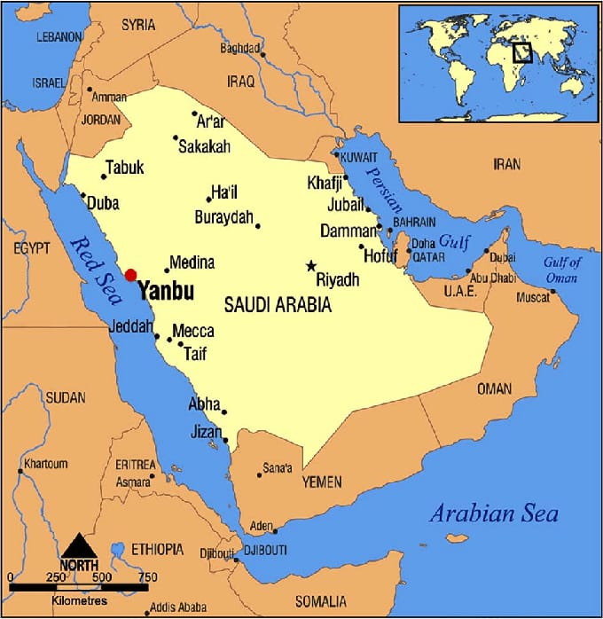
Figure (1): Map illustrates the Study Area.
2.1.2. Climate
Yanbu has a hot desert climate (Zahran and Willis, 2008), in summer temperatures are extremely high, often reaching above 45°C.
Winter is mild and dry, with temperatures ranging between 15°C to 25°C.
Rainfall is scarce and irregular, usually occurring between November and March. Humidity is generally low but increases slightly in coastal areas.
This climate favors xerophytes and halophytic plant species (Batanouny, 2001) adapted to heat, drought, and salinity.
2.1.2. Topography
‏The topography of yanbu is characterized by a combination of:
‏• Coastal plains
‏• Sandy soils
‏• Gravelly wadis
‏• Salt flats (sabkhas)
‏• Desert expanses and mountainous regions such as Radwa Mountain.
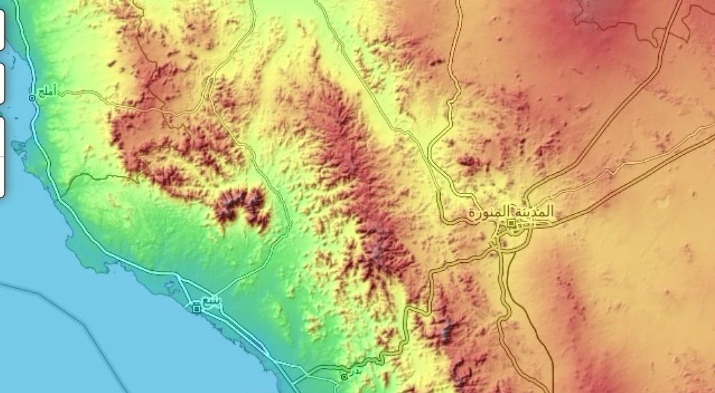
Figure (2): Topography of the Study Area.

‏These landforms provide diverse microhabitats for plant growth. The coastal areas near the Red Sea are dominated by salt-tolerant species (halophytes), especially around mangrove zones (Zahran and Willis, 2009)
‏Inland areas are generally arid, with sandy and rocky soils that support desert-adapted shrubs and grasses.
‏The desert environment of Yanbu includes wide open plains and sand dunes that host xerophytes plants.
‏The presence of Radwa Mountain adds topographical variation, creating rocky slopes and elevated habitats that support distinct plant communities. Some seasonal water flow in wadis allows the growth of temporary annual plants during rainy periods.
2.2. Data Sampling and Analysis:
The data compilation for the plants of the study area was carried out from january – march 2025. The whole plant was collected for in case of herbs and twigs with leaves and flowers and /or fruits in case of shrubs and trees. Localities were recorded by determining the locations using Global Positioning System (GPS).
The specimens were stretched to dry between newspapers and firmly pressed inside a herbarium press. Newspaper was continuously changed during the drying to avoid rotting of material. Subsequently, the specimens were mounted and labeled. The collected plant specimens were identified and named by using references of the Flora of Saudi Arabia, (Chaudhary, 1989; Chaudhary, 1999-2001; Chaudhary and Al-Jowaid, 1999; Chaudhary and Zawawi, 1983).
3. Result and Discussion
3.1. Result
A total of 50 species belong to 46 genera and 21 families were inventoried (Table1). A number of 44 species were Dicotyledonous belong to 40 genera and 18 families. Besides, 6 species were monocotyledonous belong to 7 genera and 3 families. The most represented families were Lamiaceae (6 species), followed by Amaranthaceae, Poaceae, Fabaceae and Zygophyllaceae (4 species), and Malvaceae, Apocynaceae, (3species each). Other families were represented by one or two species (figure 3).
Table (1): List of the Inventoried Plant species in the Study Area.
Family | Scientific Name | Coordinates | No. of Plant | Date of collection
Acanthaceae | Blepharis ciliaris | 24°31'28.9"N 38°17'03.6"E | 1 | 7-2-2025
Acanthaceae | Avicennia germinans | 24°02'34.9"N 38°06'53.6"E | 2 | 27-1-2025
Amaranthaceae | Haloxylon salicornicum | 24.1318622, 38.0025509''E | 3 | 11-2-2025
Amaranthaceae | Salsola vermiculata | 24°31'28.9"N 38°17'03.6"E | 4 | 24-1-2025
Amaranthaceae | Halopeplis perfoliata | 24°02'34.9"N 38°06'53.6"E | 5 | 27-1-2025
Amaranthaceae | Sueada maritima | 24°02'34.9"N 38°06'53.6"E | 6 | 27-1-2025
Apocynaceae | Calotropis procera | 24°07'00.7"N 38°05'05.7"E | 7 | 15-3-2025
Apocynaceae | Catharanthus roseus | 24°06'09.5"N 38°04'10.5"E | 8 | 15-3-2025
Apocynaceae | Rhazya stricta | 24°16'42.8"N 38°16'54.6"E | 9 | 25-2-2025
Asphodelaceae | Aloe vera | 24°12'57.9"N 38°16'38.8"E | 10 | 25-2-2025
Asphodelaceae | Asphodelus tenuifolius | 24°31'28.9"N 38°17'03.6"E | 11 | 7-2-2025
Asteraceae | Pulicaria incisa | 24°31'28.9"N 38°17'03.6"E | 12 | 7-2-2025
Asteraceae | Pluchea sericea | 24°31'28.9"N 38°17'03.6"E | 13 | 7-2-2025
Bataceae | Batis maritima | 24°02'34.9"N 38°06'53.6"E | 14 | 27-12-025
Boraginaceae | Heliotropium crispum | 24°21'09.1"N 37°36'45.0"E | 15 | 28-22025
Boraginaceae | Heliotropium supinum | 24°31'28.9"N 38°17'03.6"E | 16 | 7-2-2025
Brassicaceae | Limonium axillare | 24°09'30.2"N 37°56'50.7"E | 17 | 12-3-2025
Burseraceae | Commiphora gileadensis | 24°31'28.9"N 38°17'03.6"E | 18 | 7-2-2025
Cucurbitaceae | Citrullus colocynthis | 24°12'57.9"N 38°16'38.8"E | 19 | 25-2-2025
Cucurbitaceae | Citrullus lanatus | 24.1318622, 38.0025509''E | 20 | 11-2-2025
Cyperaceae | Cyperus rotundus | 24.1318622, 38.0025509''E | 21 | 11-2-2025
Fabaceae | Indigofera oblongifolia | 24°31'28.9"N 38°17'03.6"E | 22 | 7-2-2025
Fabaceae | Senna alexandrina | 24°31'28.9"N 38°17'03.6"E | 23 | 24-1-2025
Fabaceae | Pithecellobium dulce | 24°07'07.1"N 38°05'17.6"E | 24 | 23-2-2025
Fabaceae | Abrus precatorius | 24°07'07.1"N 38°05'17.6"E | 25 | 23-2-2025
Lamiaceae | Lavanula coronopifolia | 24°12'57.9"N 38°16'38.8"E | 26 | 25-2-2025
Lamiaceae | Salvia aegyptica | 24°31'28.9"N 38°17'03.6"E | 27 | 7-2-2025
Lamiaceae | Teucrium fruticans | 24°31'28.9"N 38°17'03.6"E | 28 | 7-2-2025
Lamiaceae | Thymus vulgaris | 24°31'28.9"N 38°17'03.6"E | 29 | 7-2-2025
Lamiaceae | Ocimum basilicum | 24°07'07.1"N 38°05'17.6"E | 30 | 23-22025
Lamiaceae | Mentha longifolia | 24°31'28.9"N 38°17'03.6"E | 31 | 7-2-2025
Malvaceae | Abutilon pannosum | 24°21'09.1"N 37°36'45.0"E | 32 | 28-2-2025
Malvaceae | Corchorus depressus | 24°21'09.1"N 37°36'45.0"E | 33 | 28-2-2025
Malvaceae | Hibiscus tiliaceus | 24°09'30.2"N 37°56'50.7"E | 34 | 12-3-2025
Mimoaceae | Acacia ehrenbergiana | 24°12'16.8"N 37°59'55.8"E | 35 | 20-2-2025
Mimoaceae | Acacia senegal | 24°31'28.9"N 38°17'03.6"E | 36 | 7-2-2025
Moraceae | Fucus palmata | 24°31'28.9"N 38°17'03.6"E | 37 | 7-2-2025
Poaceae | Phragmites australis | 24°02'34.9"N 38°06'53.6"E | 38 | 27-1-2025
Poaceae | Stipa capensis | 24°12'16.8"N 37°59'55.8"E | 39 | 20-2-2025
Poaceae | Desmostachya bipinnata | 24°31'28.9"N 38°17'03.6"E | 40 | 24-1-2025
Poaceae | Aeluropus lagopoides | 24°02'34.9"N 38°06'53.6"E | 41 | 27-1-2025
Polygonaceae | Rumex vesicaius | 24°31'28.9"N 38°17'03.6"E | 42 | 7-2-2025
Rhamnaceae | Ziziphus spina _ christi | 24°31'28.9"N 38°17'03.6"E | 43 | 7-2-2025
Solanaceae | Datura innoxia | 24°12'57.9"N 38°16'38.8"E | 44 | 25-2-2025
Solanaceae | Lycium shawii | 24.1318622, 38.0025509''E | 45 | 11-2-2025
Tamaricaceae | Tamarix aphylla | 24°02'34.9"N 38°06'53.6"E | 46 | 27-1-2025
Zygophyllaceae | Tribulus terrestris | 24°12'16.8"N 37°59'55.8"E | 47 | 20-2-2025
Zygophyllaceae | Zygophyllum coccineum | 24°31'28.9"N 38°17'03.6"E | 48 | 24-1-2025
Zygophyllaceae | Zygophyllum fontanesii | 24°02'34.9"N 38°06'53.6"E | 49 | 27-1-2025
Zygophyllaceae | Zygopyllum simplex | 24°09'30.2"N 37°56'50.7"E | 50 | 12-3-2025

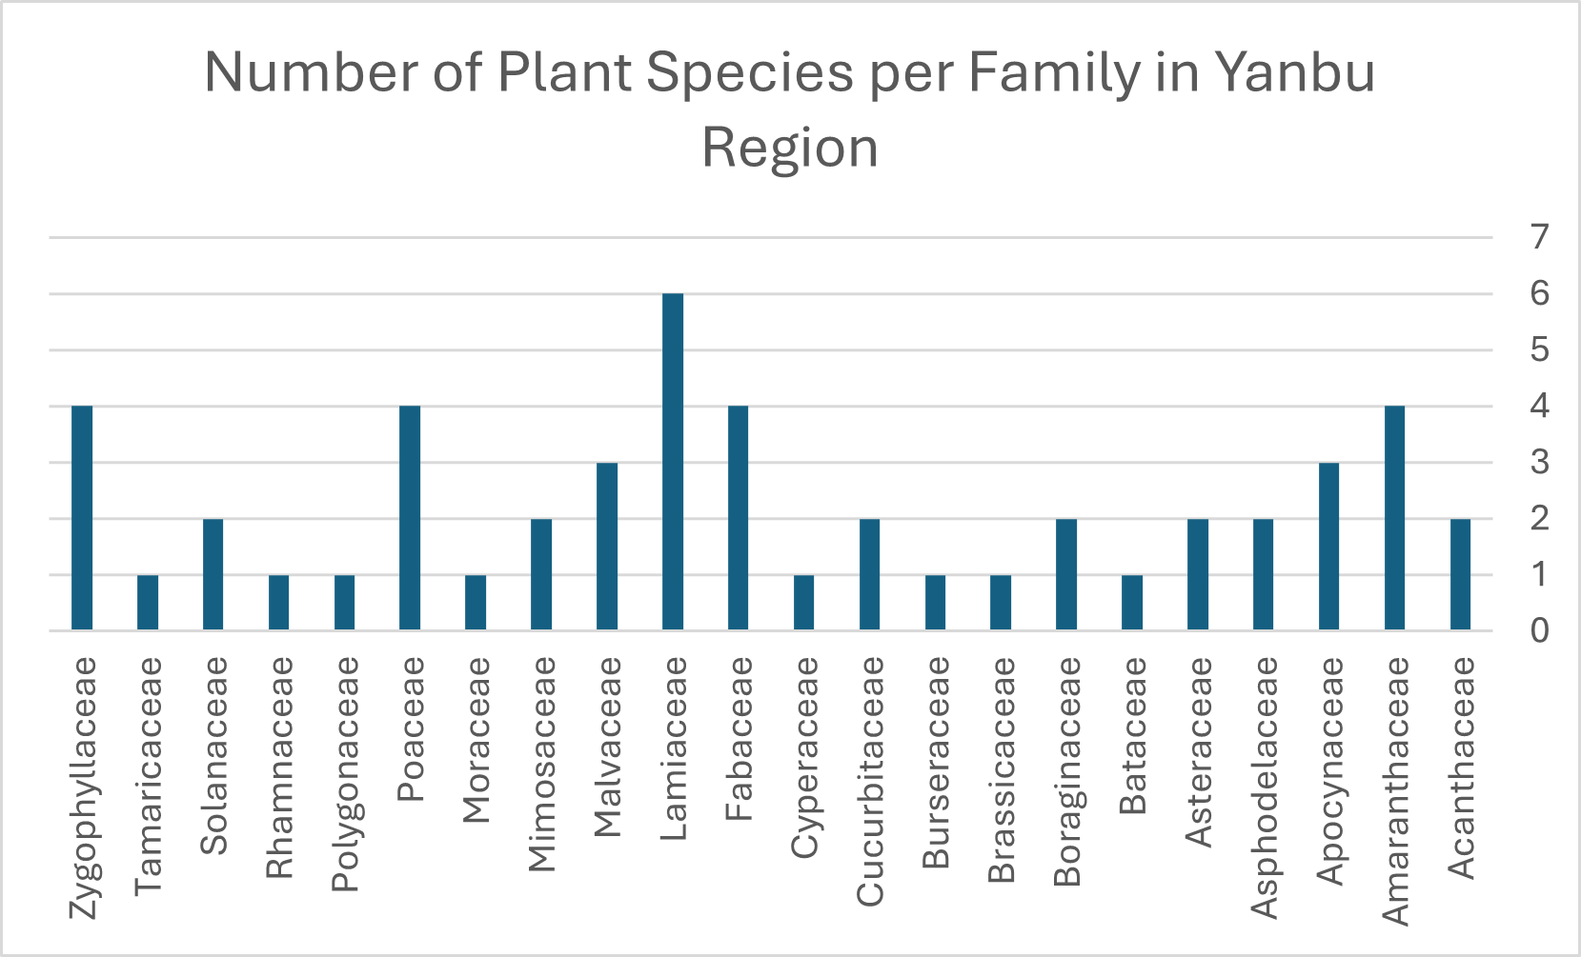
Figure (3): Number of Plant Species per Family in the Study Area. Herbs represent the most representative type of growth habit followed by shrubs, trees and vines respectively (Figure 5).
These species were distributed across diverse habitats, including:
•Sandy soils (21 species)
•Arid areas (16 species)
• the rest of species occupied the Saline flats, rocky sites, coastal zones, and mountainous terrain (Figure 6) .
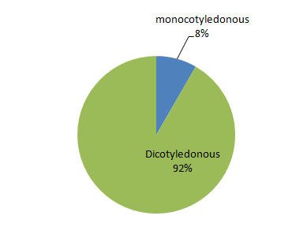

Figure (4): Chart illustrates the Ratio of Monocotyledonous and Dicotyledonous Plant in the Study Area.

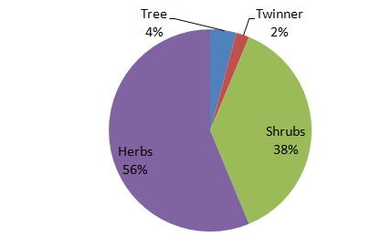
Figure (5): Chart illustrate the most Reprehensive Type of Growth form of the studied species in the Study Area.

Table (2): List of Plant Species Habitats of the study Area.
Sand Dunes/Desert | Arid Areas | Others Habitats
Haloxylon salicoricum | Blepharis ciliaris | Ficus palmate
Salsola vermiculata | Aloe vera | Orchradenus baccatus
Halopeplis perfoliata | Asphodelus tenuiflolius | Datura innoxia
Sueada maritime | Pluchea sericea | Batis maritima
Calotropis procera | Commiphora gileadensis | Phragmites australis
Rhazya strica | Heliotropium supinum | Aeluropus lagopoides
Pulicaria incisa | Lavandula coronopifolia | Stipa capensis
Heliotropium crispum | Salvia aegyptiaca | Desmostacha bipinnata
Citrullus colocynthis | Teucrium fruticosa | Tamarix aphylla
Indigofera oblongifolia | Thymus vulgaris
Senna alexandrina | Ocimum basilicum
Acacia ehrenbergiana | Mentha longifolia
Acacia Senegal | Abutilon pannosum
Ziziphus spina-christi | Corchorus depressus
Lycium shawi | Hibiscus tiliaceus
Tribulus terrstris | Rumex vesicarius
Zygophyllum simplex
Zygophyllum coccineum
Zygophyllum fontanesii
Limonium axillare
Pitheocellobium dulce

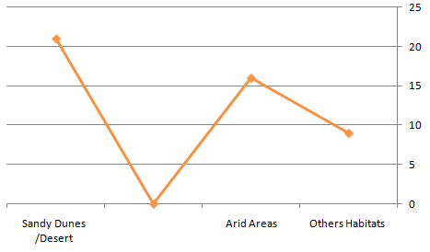
Figure (6): Chart illustrates the most Diverse of the Ecological Habitats in the Study Area.

3.2. DISCUSSION
This study provided a comprehensive floristic survey of the yanbu region, documenting a total of 50 plant species across 21 botanical families. This diversity reflects the unique ecological features of the area, which includes coastal, desert, saline, rocky, and mountainous habitats.
When compared with previous studies((Al-Gifri et al., 2019; Moawed, 2016; Al Atar, et al., 2012 ; Abdel et al., 2013), Yanbu displays a moderate level of plant diversity. This can be attributed to its transitional location between the Red Sea coastline and the inland deserts. Although the total species count is lower than in highly biodiverse of the others regions, the ecological range of the recorded species indicates remarkable adaptability to aridity, salinity, and seasonal climatic shifts.
The most represented families were Lamiaceae (6 species), followed by Amaranthaceae, Poaceae, Fabaceae and Zygophyllaceae (4 species), and Malvaceae, Apocynaceae, (3 species each). This pattern is consistent with other arid regions in KSA, where these families dominate due to their morphological and physiological adaptations to drought and poor soil conditions. Families like Boraginaceae were also well represented, reflecting their prevalence in saline and sandy environments, and emphasizing the role of halophytic and xerophytes species in maintaining ecological stability.
Life form analysis revealed the dominance of herbs which are well-suited for short seasonal growth during rainfall events, a typical adaptation in desert ecosystems. The presence of shrubs and succulent shrubs in saline areas and wadis further adds structural diversity to the local flora, enhancing the ecosystem's resilience.
The broad ecological range—from mangrove habitats to rocky mountain slopes highlights the environmental heterogeneity of the Ynbu region.
Notably, many of the documented species possess ecological, medicinal, or economic value, such as:
- Calotropis procera: Traditionally used for its medicinal properties (Batanouny, 2001).
- Haloxylon salicornicum: a key forage plant in arid zones
- Ziziphus spina-christi (Chaudhary, 2001) – culturally valued fruit-bearing tree (Thomas, 2011).
- Batis maritime: helps stabilize saline coastal zones.
- Avicennia germinans: one of the most ecologically significant coastal species. It plays a critical role in stabilizing shoreline soil, preventing erosion, and absorbing carbon dioxide from the atmosphere, making it vital in climate change mitigation (Zahran and Willis, 2009). It also provides essential habitats for marine biodiversity, such as fish and mollusks, and offers economic potential in pharmaceutical and environmental applications.
4. CONCLUSION
This study emphasized the importance of botanical documentation in underexplored areas like Yanbu, supporting environmental education, land-use planning, and biodiversity conservation policies.
This study enriches Saudi Arabia’s botanical records, also serves as a baseline reference for future ecological and conservation.

5. REFERENCES
- Abdel, M.E., El-Shikh, M.A. & El-Aidarous, A. (2013). Flora of Mecca: A Floristic Survey. Saudi Journal of Biological Sciences, 20(1), pp.1–10.
- Abdelhady, M. (2021). A comparative of the Saudi Arabia Flora, Medicinal Plants of AL-Mandq Province, AL-Baha Region. Al-Azhar Journal of Pharmaceutical Sciences, 63(1), 57-71.
- Al Atar, M.A., El Sheikh, M.A. and Thomas, J. (2012). Floristic composition of Wadi Al-Rummah in the Qassim Region. Journal of Arid Environments, 86, pp.35–45.
- Al-Eisawi, D. M., and Al-Ruzayza, S. (2015). The flora of holy Mecca district, Saudi Arabia. International Journal of Biodiversity and conservation, 7(3), 173-189.
- Alfarhan, A. H. (2001). A floristic account on Raudhat Khuraim central province Saudi Arabia. Saudi Journal of Biological Sciences, 8(1), 80-103.
- Al-Farhan, A.H. (2001). A floristic account on Raudhat Khuraim, central province, Saudi Arabia. Saudi Journal of Biological Sciences, 8(1), pp.80–89.
- Al-Gifri, A. N., Kasem, W. T., Shehata, R. S., and Eldemerdash
- M. M. (2019). The African paleotropical influence on the biogeography of the flora of Jazan, KSA. Asian J. Soil Sci. Plant Nutr, 4(1), 1-10.
- Al-Khamis, H. H., Al-Hemaid, F. M., & Ibrahim, A. S. S. (2012). Diversity of perennial plants at Ibex reserve in Saudi Arabia. Journal of Animal Plant Science 22: 484-492.
- Al-Mutairi, K., Al-Shaami, S. A., Khorshid, Z., & Moawed, M. M. (2016). Floristic diversity of Tabuk province, north Saudi Arabia. JAPS: Journal of Animal & Plant Sciences, 26(4).
- Al-Nafie, A. H. (2004). Botanical Geography of Saudi Arabia. King Fahd National Library, El-Riyadh, Saudi Arabia 3.
- Al-Sharif, A.S. (2002) Geography of Saudi Arabia. Riyadh, Dar AlMareekh
- Al-Turki, T.A. & Al-Olayan, H.A. (2003). A checklist of the flora of Saudi Arabia. Botanical Journal of the Linnean Society, 142(3), pp.275–285.
- Alzamel, N. M. (2021). Vegetation Structure and Floristic Features of Al Rayn Region, Saudi Arabia. Advances in Environmental Studies, 5(2), 436-442.
- Batanouny, K. H. (2001). Deserts of the Middle East. In Plants in the Deserts of the Middle East (pp. 5-10). Berlin, Heidelberg: Springer Berlin Heidelberg.
- Chaudhary, A., and Mossa, J. S. (1991). Contribution to the flora of Saudi Arabia. Pak J Bot, 23(2), 257-82.
- Chaudhary, S. A. (1989). Grasses of Saudi Arabia. National Herbarium, National Agriculture and Water Research Center, Ministry of Agriculture and Water.
- Chaudhary, S. A. (1999). Flora of the Kingdom of Saudi Arabia illustrated. v. 1, v. 2, pt. 1, 3, v. 3.
- Chaudhary, S. A., & Zawawi, M. A. (1983). A manual of weeds of central and eastern Saudi Arabia.
- Chaudhary, S. and Al-Jowaid A (2013) Vegetation of the Kingdom of Saudi Arabia. National agriculture and water research center ministry of agriculture and water kingdom of Saudi Arabia. Riyadh, Saudi Arabia, 1: 1-680.
- Collenette, S. (1999). Wildflowers of Saudi Arabia. Riyadh: National Commission for Wildlife Conservation and Development.
- General Authority for Statistics. (2020). Statistical Yearbook of Saudi Arabia. [online] Available at: https://www.stats.gov.sa/ [Accessed 8 May 2025].
- Hamad, M. S., Ali, F. S. M., Mohammed, S. A. A., & Kordofani, M. A. (2020). Checklist of the flora of Tutti Island, Khartoum Province, Sudan. Journal of Agriculture and Ecology Research International, 21(4), 27-40.
- Migahid, A. M. (1978). Flora of Saudi Arabia: Dicotyledons. University.
- Moawed, A.A. (2016). Flora of Tabuk: Diversity of Desert Plants. Journal of Desert Research, 6(2), pp.112–123
- Mossa, J.S. (1987) Medicinal plants of Saudi Arabia. King Saud University Press, Riyadh, Saudi Arabia.
- Thomas, D. S. (Ed.). (2011). arid zone geomorphology: process, form and change in drylands. John Wiley & Sons.
- Zahran, M. A., & Willis, A. J. (2008). The vegetation of Egypt (Vol. 2). Springer Science & Business Media.

