Original Research Article
Assessment of Plant growth promoting traits of bacterial endophytes resides in the mulberry (Morus indica L.) through laboratory analysis

ABSTRACT:
Endophytes are the microorganisms living internal tissues of plants without causing any negative effect. They use various direct and indirect mechanisms to promote plant growth. This study involved in the isolation and identification the growth promoting traits of bacterial endophytes present in the mulberry (Morus indica). The PGP assessments like IAA production, ammonia production, HCN production and siderophore production were carried out. Among obtained 30 isolates, all the isolates showed positive reaction for IAA test, 22 isolates for ammonia test, 12 isolates for siderophore production test and 2 isolates for HCN production tests showed positive reaction. Out of 22 isolates, 2 superior isolates were selected and identified as Enterobacer cloacae using 16s rRNA sequencing.
Key words:
Mulberry, Endophytes and Growth promotion
INTRODUCTION:
Endophytic bacteria have several effects on their host plant, including growth promoting activity, modulation of plant metabolism and phyto-hormone signaling that leads to adaptation to environmental abiotic and biotic stress (Miliute et al., 2015).IAA is the most principal and natural auxin, involved in root initiation (Harikrishnan et al., 2014). Siderophores are organic compounds produced by micro-organisms and plants growing under low iron conditions (Ahmed and Holmström, 2014). Nitrogen (N) is the most important mineral nutrient required by plants, some plants can directly utilize N, ammonium (NH₄⁺) and nitrate (NO₃⁻) (Amoo and Babalola, 2017). Ammonia is a primary energy substrate and important nitrogen source for microorganisms in the soil (Daebeler et al., 2014). Hydrogen cyanide (HCN) may play a dual role in plants, may be used in defence against herbivores at high toxic concentration and may have a regulatory function at lower concentration (Siegień and Bogatek, 2006). This study was aimed to isolate and identify the growth promoting traits of bacterial endophytes present in the plant parts of mulberry.
- MATERIALS AND METHODS:
2.1. ISOLATION OF ENDOPHYTES:
The fresh plant parts (leaves, stem and roots) collected fromV1 and G4 varieties of mulberry and used for the isolation of bacterial endophytes. Isolation was done using standard protocol of Bacon et al., 2000 with some modifications.
2.2.GROWTH PROMOTING CHARACTERIZATION:
2.2.1..HCN Production:
The isolates were screened for HCN production according to Lorck (1948) using the medium supplemented with glycine and whatmanfilter paper No.1 soaked in 0.5% (w/v) picric acid solution.

2.2.2.Ammonia Production:
Endophytic isolates were tested for the production of ammonia in peptone water according to the protocol of Cappuccino and Sherman, 1992.
2.2.3.IAA Production:
IAA production was determined according to (Bric et al., 1991).
2.2.3.1.Standards preparation:
The different concentrations of IAA standards were prepared in LB culture medium according to the standard protocol reported by Aniruddha sarkar and Rashid (2018).Based on the results of invitro tests, the best performing isolates has been identified through molecular studies.
2.2.4.Siderophore Production
Siderophore production was detected by CAS assay using standard protocol of (Schwyn and Neilands, 1987).
3.RESULTS:
3.1.Testing for growth promoting traits:
The isolated endophytes were screened for plant growth promoting traits with various assays for IAA production, ammonia production, HCN production and siderophore production. The results are presented in the Tables 1, 2 and 3.
3.1.1.IAA production test:
From the results of the assay, all the isolates were found to produce IAA with a range of low, medium and high production (Plate 1). Quantification of IAA produced by bacterial endophytes was done with the help of IAA standard curve and expressed as µg/ml. (Figure 1). Among 30 isolates, only two isolates showed the highest production of IAA. Based on the quantity of IAA production of the bacterial endophytes were categorized into four categoriesviz., very low (0-15 µg/ml), low (15-30 µg/ml), moderate (30-45 µg/ml) and high (45-60 µg/ml) (Figure 2). A high range of IAA production (45-60 µg/ml) was achieved by 50% of cultures (Figure 2). The maximum production of IAA was exhibited by isolates LB7-V1 and LB3-G4. (Plate 2) and their production was 57.73 and 57.69 µg/ml respectively (Table 1).
3.1.2.Ammonia production test:
The results of ammonia production test revealed that some of the isolates exhibited yellow colours while adding Nessler’s reagent varies like greenish yellow (6 isolates), pale and light yellow (6), turbid yellow (1), pale greenish yellow (7) and transparent yellow (2) with the production of yellow colour (Plate 3). Apart from this, some of the isolates showed negative reaction by exhibiting the colours like green (1), pale green (6) and turbid green (1) when the Nessler’sreagent was added (Table 2).
3.1.3.HCN production test:
All the isolates were screened for HCN production test by keeping the Whatman filter papers under the petriplates inoculated with the cultures. Among 30 isolates, two isolates showed positive reaction for HCN production test with little colour change of filter paper from yellow to slight red colour with minimal production of hydrogen cyanide (Plate 4).
3.1.4.Siderophore production test
The isolates were screened for siderophore production assay. Among 30 isolates, 13 isolates showed positive reaction for this test with the formation of yellow halo zone around the colonies (Plate 5) the diameter of the halo zone varied from 1.5 cm to 4 cm (Table 3). The maximum halo zone is formed by the isolate SB6G4 (4 cm).
3.1.5.Identification of bacterial endosymbionts:
The strains considered as best isolates through nursery studies, were identified using 16s rRNA analysis. The both strains were identified as Enterobacter cloacae, one was isolated from stem of G4 (SB6G4) variety and another one obtained from leaf of variety V1 (LB7V1) (Figure 3 and 4).
4.DISCUSSION:
The isolates were screened for growth promotion traits under invitro conditions to test their capability for promoting growth. Among these tests, maximum number of isolates exhibited positive result for IAA production followed by ammonia production, siderophore production, and HCN production test and phosphate solubilisation (Figure 3).
IAA a member belonging to the group of phyto-hormones, is generally considered to be the most important native auxin (Strzelczyk and Pokojska-Burdziej, 1984). Prasad and Sunayana (2014) isolated the endophytic bacteria from avacado crops and analyzed their capacity to produce IAA. They recorded the maximum production was exhibited by the isolate SA3 (54.83 µg/ ml). IAA production by different forest and agricultural soil bacteria estimated by Sadhana baggam et al. (2017) i.e., 39.7 µg/ ml and 35.4 µg/ ml was found to be less than the IAA production by mulberry endophytes.
Geetha and Murugan (2017) studied the effect of plant growth regulators in mulberry and observed the rooting percentage, root length, average number of roots and leaves, shoot weight and survival percentage at different concentrations of IAA application i.e., 150 ppm and 200 ppm and found that the application of IAA increased these plant growth promoting factors.
Endophytic bacterial strains present in the Withania coagulans and Olea ferruginea i.e., WC2, WC58, WC138and OFR115 were identified as Enterobacter cloacae, Enterobacter dissolvens, Enterobacter hormaechei and Cronobacter sakazakii. These strains produced IAA at a level of 10.571 μg/ml, 9.976 μg/ml, 10.809 μg/ml and 9.6 μg/ml, respectively (Ullah et al., 2018). These strains produced lesser amount of IAA compared to the endophytic isolates of mulberry.
Bacterial endophytes associated with chilli (Capsicum annum), expressed positive result for siderophore production, phosphate solubilization and IAA production (Amaresan et al., 2014). IAA produced by the strain BEC 14is slightly higher(84.5 μg/ml) than the IAA production by mulberry strains.IAA production by the bacterial endophytes present in the Arachis hypogea was 69.68mg l^{-1.} This quantity of production was little higher than the IAA produced by isolates of Morusindica L. (Herlina et al., 2017).
HCN production by the endophytes was identified by the colour change of filter paper from yellow to light brown red. The isolates obtained from mulberry stem parts (SB6G4 and SB4G4) indicated the production of hydrogen cyanide. According to Reetha et al.(2014) bacterial strains of Pseudomonas fluorescence pf1 and pf5 showed strong production of HCN through colour change. Like this, the strains of Bacillus isolated from avocado and black grapes also showed positive reaction for the production of hydrogen cyanide (Prasad and Sunayana, 2014). Therefore, many of the bacterial endophytes promote plant growth indirectly by inhibiting the growth and activities of phyto-pathogens by the production of antimicrobial substances like HCN through a variety of different mechanisms.
Ammonia and ammonium are the primary energy substrates and are key nitrogen sources for microorganisms in the soil (Daebeler et al., 2014). From 30 isolates, nearly 22 isolates (73%) indicated the ammonia production ability with the colour change to light yellow, pale yellow, turbid yellow, greenish yellow. According to Devendhra Singh et al. (2017), only 57% of the isolates expressed a positive result for ammonia production. This production range is lesser when compared to the isolates of mulberry.

Siderophore chelates iron and supply to bacterial cells by outer membrane receptors (Ali and Vidhale, 2013).Among the 30 isolates, nearly 13 isolates (Figure 4) could produce the siderophore as revealed by the formation yellow coloured halo zone around the colonies. Xu et al., 2019 identified the endophyte Pantoea spp. CA15-44 and CA15-30 and Bacillus spp. QW16-12 and HW16-12 produced siderophore. Ting ou et al., (2022) analysed and confirmed the PGP traits of endophyte Klebsiella aerogenes HGG15 i.e., phosphate solubilization, indole-3-acetic acid and siderophore acetoin production.

5.CONCLUSION:
The endophytic bacterial isolates having the ability to accelerate the plant growth by the presence of potentially colonize inside the plant tissues. This study further helps the researchers to work on the utilization of endosymbionts in field locations.

Table 1. Absorbance values and IAA production of endophytic cultures
S.No | Isolates | OD value @ 530 nm | IAA Production (µg/ml) (mean)
1. | SB1- V1 | 1.418 | 44.75^{i}
2. | SB2- V1 | 1.253 | 38.81^{j}
3. | SB3- V1 | 1.460 | 46.26^{ghi}
4. | SB4- V1 | 0.847 | 24.21^{l}
5. | SB5- V1 | 1.566 | 47.91^{fgh}
6. | SB6- V1 | 0.651 | 17.16º
7. | SB7- V1 | 1.019 | 30.39^{k}
8. | SB1-G4 | 0.564 | 14.03^{p}
9. | SB2- G4 | 0.396 | 7.98^{q}
10. | SB3- G4 | 0.785 | 21.98^{lm}
11. | SB4- G4 | 0.791 | 22.19^{lm}
12. | SB5- G4 | 0.864 | 24.82^{l}
13. | SB6- G4 | 0.742 | 20.43^{mn}
14. | SB7- G4 | 0.680 | 18.20^{no}
15. | LB1- V1 | 1.001 | 29.75^{k}
16. | LB2- V1 | 1.669 | 53.77^{b}
17. | LB3- V1 | 1.242 | 38.41^{j}
18. | LB4- V1 | 0.714 | 19.42^{mno}
19. | LB5- V1 | 1.596 | 51.15^{bcde}
20. | LB6- V1 | 1.606 | 51.51^{bcd}
21. | LB7- V1 | 1.779 | 57.73ª
22. | LB1- G4 | 1.520 | 48.41^{efg}
23. | LB2- G4 | 1.624 | 52.16^{bc}
24. | LB3- G4 | 1.778 | 57.69ª
25. | RB1- V1 | 1.676 | 54.03^{b}
26. | RB2- V1 | 1.609 | 51.62^{bd}
27. | RB3- V1 | 1.538 | 49.06^{defg}
28. | RB1- G4 | 1.565 | 50.03^{cdef}
29. | RB2- G4 | 1.662 | 53.52^{b}
30. | RB3- G4 | 1.432 | 45.25^{hi}
 |  | SE(d)= 1.5194 | CD (@ 5%)= 3.0392

Table 2.Variations in expression of colours by the isolates for ammonia production test
S.No | Isolates | Ammonia production test
1. | SB1- V1 | Greenish yellow
2. | SB2- V1 | Pale green
3. | SB3- V1 | Light greenish yellow
4. | SB4- V1 | Light yellowish colour
5. | SB5- V1 | Pale green
6. | SB6- V1 | Turbid greenish yellow
7. | SB7- V1 | Light yellow
8. | SB1-G4 | Pale green
9. | SB2- G4 | Light turbid yellow
10. | SB3- G4 | Pale green
11. | SB4- G4 | Light turbid yellow
12. | SB5- G4 | Green
13. | SB6- G4 | Turbid yellow
14. | SB7- G4 | Light yellow
15. | LB1- V1 | Light greenish yellow
16. | LB2- V1 | Light greenish yellow
17. | LB3- V1 | Light green
18. | LB4- V1 | Light yellow
19. | LB5- V1 | Transparent yellow
20. | LB6- V1 | Pale yellow
21. | LB7- V1 | Pale greenish yellow
22. | LB1- G4 | Pale greenish yellow
23. | LB2- G4 | Pale greenish yellow
24. | LB3- G4 | Pale greenish yellow
25. | RB1- V1 | Turbid green
26. | RB2- V1 | Pale greenish yellow
27. | RB3- V1 | Pale green
28. | RB1- G4 | Pale yellow
29. | RB2- G4 | Pale greenish yellow
30. | RB3- G4 | Pale greenish yellow

Table 3.Diameter of the halo zone formed by the isolates in siderophore production assay
S.No | Isolates | Diameter of halo zone (cm)
1. | SB1- V1 | 2.5 cm
2. | SB5- V1 | 2 cm
3. | SB3-G4 | 2 cm
4. | SB4-G4 | 3 cm
5. | SB6- G4 | 4 cm
6. | SB7- G4 | 2 cm
7. | LB3- V1 | 2 cm
8. | LB5- V1 | 3 cm
9. | LB7- V1 | 3.5 cm
10. | LB3- G4 | 3 cm
11. | RB1- G4 | 2.5 cm
12. | RB3- G4 | 1.5 cm

Plate 1.IAA production by the bacterial endophytic isolates
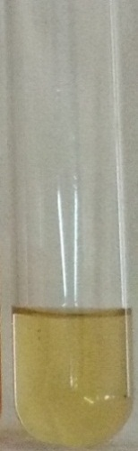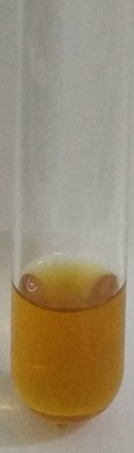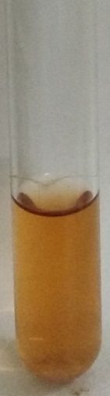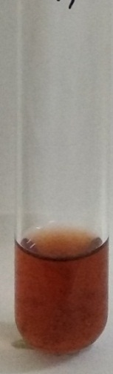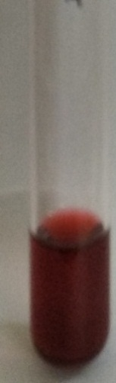
A
E
D
B
C

A-control B- Very low (SB1G4) C- Low (LB4V1) D- Moderate (SB1V1) E- High (RB1V1)

Plate2. IAA production by promising isolates
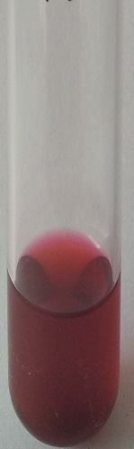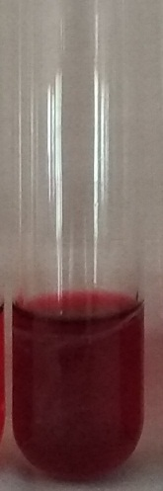
LB3G4
LB7V1
Plate 3. Ammonia produced by the endophytic bacteria
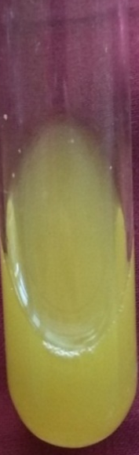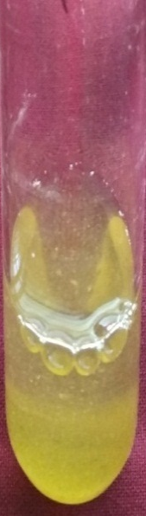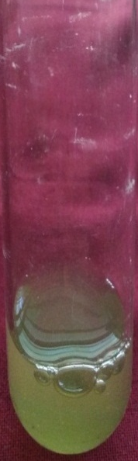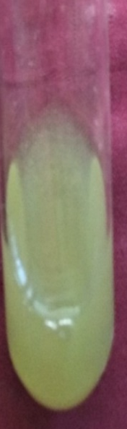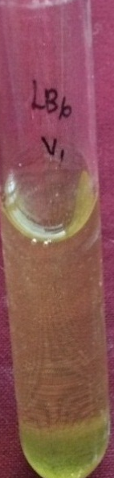
LB6V1
LB1G4
SB1G4
SB6G4
SB4G4

Plate 4. Colour change in filter paper due to HCN production
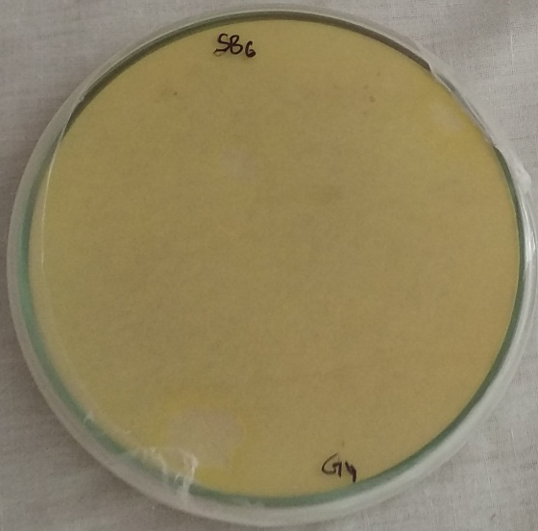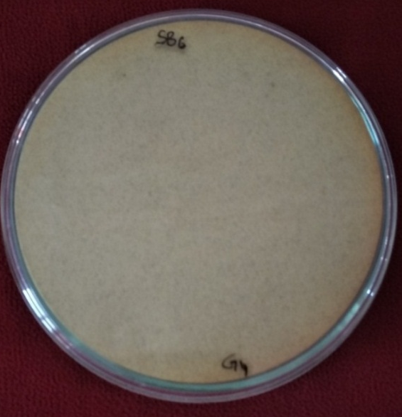
SB4G4
SB6G4

Plate 5. Yellow halo zone formed by the isolates during siderophore production
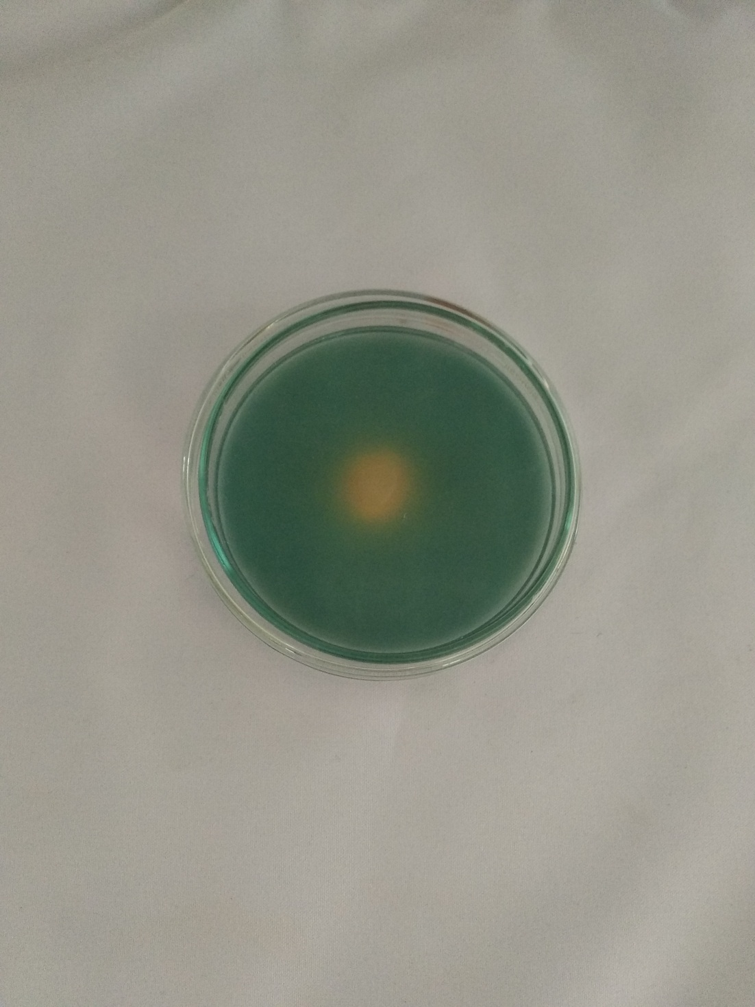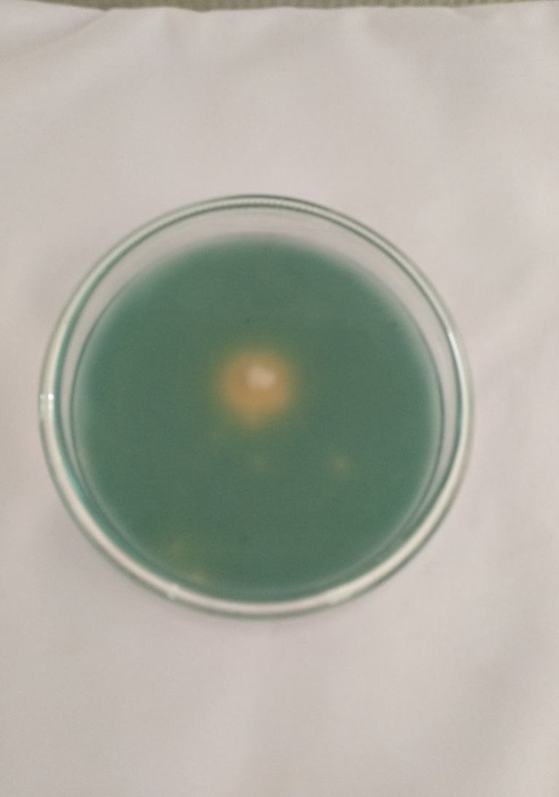
SB4G4
SB6G4
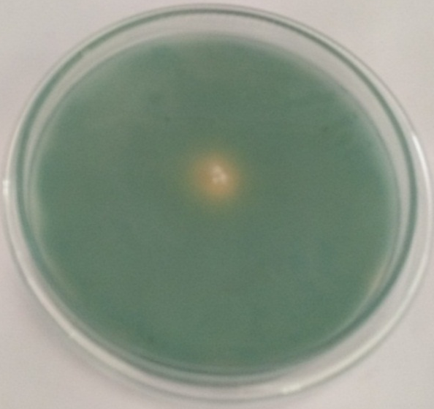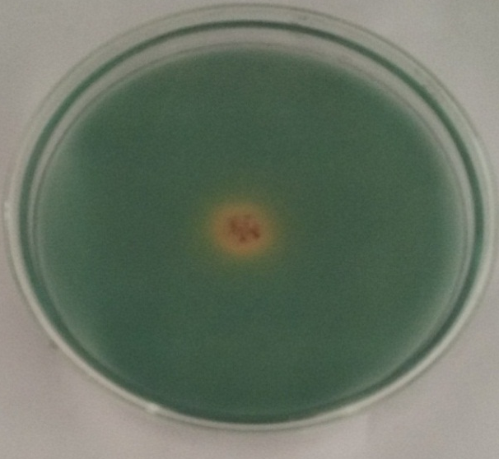
LB3G₄
LB7V₁

Figure 1.IAA standard curve

Figure 2. IAA production by bacterial endophytes

Figure 3. Number of isolates exhibiting positive reaction for various growth promotion assays

References:
Ahmed, Engy and Sara JM Holmström. (2014). Siderophores in environmental research: roles and applications. Microbial Biotechnology, 7 (3):196-208.
Ali S S and N N Vidhale. (2013). Bacterial siderophore and their applicaiton: A review. International Journal of Current Microbiology and Applied Sciences, 2 (12):303- 312.
Amaresan N, V Jayakumar and N Thajuddin. (2014). Isolation and characterization of endophytic bacteria associated with chilli (Capsicum annuum) grown in coastal agricultural ecosystem.
Amoo, Adenike Eunice and Olubukola Oluranti Babalola. (2017). Ammonia-oxidizing microorganisms: key players in the promotion of plant growth. Journal of Soil Science and Plant Nutrition, 17 (4):935-947.
Aniruddha Sarkar and Jubair Al- Rashid. (2018). Analytical protocol for detrmination of Indole-3- Acetic acid (IAA) production by Plant growth pormoting Rhizobacteria (PGPB).
Bacon C W and J F White. (2000). Microbial endophytes.
Bric, John M, Richard M Bostock and Sara E Silverstone. (1991). Rapid in situ assay for indoleacetic acid production by bacteria immobilized on a nitrocellulose membrane. Applied and Environmental Microbiology, 57 (2):535-538.
Cappuccino JC and N Sherman. (1992). Microbiology: A Laboratory Manual Pp. 125-79. Academic Distributors, New York.
Daebeler, Anne, Paul LE Bodelier, Zheng Yan, Mariet M Hefting, Zhongjun Jia and Hendrikus J Laanbroek. (2014). Interactions between Thaumarchaea, Nitrospira and methanotrophs modulate autotrophic nitrification in volcanic grassland soil. The ISME Journal, 8 (12):2397.
Devendhra Singh, Neelam Geat, Mahendhra VIkram Singh Rajawat, Radha Prasanna, Anil Kumar Saxena and Rajeev Kaushik.(2017). Isolation and Characterization of plant growth promoting diazotropic bacteria from Wheat genotypes and their influence on plant growth promotion. International Journal of Current Microbiology and Applied Sciences, 6 (4):1533-1540.
Geetha T and N Murugan. Plant Growth Regulators in Mulberry. (2017). Annual Research & Review in Biology:1-11.
Harikrishnan, Hariharan, Vellasamy Shanmugaiah and Natesan Balasubramanian. (2014) Optimization for production of Indole acetic acid (IAA) by plant growth promoting Streptomyces sp VSMGT1014 isolated from rice rhizosphere, 3 (8):158-171.
Herlina, Lina, Krispinus Kedati Pukan and Dewi Mustikaningtyas. (2017). The endophytic bacteria producing IAA (Indole Acetic Acid) in Arachis hypogaea. Cell Biology and Development, 1 (1):31-35.
Lorck H. (1948) Production of hydrocyanic acid by bacteria. Physiologia Plantarum,
1 (2):142-146.
Miliute, Inga, Odeta Buzaite, Danas Baniulis and Vidmantas Stanys. (2015). Bacterial endophytes in agricultural crops and their role in stress tolerance: a review. Zemdirbyste-Agriculture, 102 (4):465-478.
Prasad MP and Dagar Sunayana. (2014). Identification and characterization of endophytic bacteria from fruits like Avacado and Black grapes. International Journal of Current Microbiology and Applied Sciences, 3 (8):937-947.
Reetha S, G Bhuvaneswari, P Thamizhiniyan and T Ravi Mycin.( 2014). Isolation of indole acetic acid (IAA) producing rhizobacteria of Pseudomonas fluorescens and Bacillus subtilis and enhance growth of onion (Allim cepa L.). International Journal of Current Microbiology and Applied Sciences, 3 (2):568-574.
Sadhana baggam, S B Padal, V Ravishankar Ummidi, Ashok Paltati and Nikitha Thangala. (2017). Isolation of IAA producing bacteria from soil and optimization of culture conditions for maximum IAA production. International Journal of Advanced Research, 5 (10):1003-1010.
Schwyn B and JB Neilands. (1987). Universal chemical assay for the detection and determination of siderophores. Analytical Biochemistry, 160 (1):47-56.
Siegień, Irena and Renata Bogatek. (2006). Cyanide action in plants-from toxic to regulatory. Acta Physiologiae Plantarum, 28 (5):483-497.
Strzelczyk E and A Pokojska-Burdziej. (1984). Production of auxins and gibberellin-like substances by mycorrhizal fungi, bacteria and actinomycetes isolated from soil and the mycorrhizosphere of pine (Pinus silvestris L.). Plant and Soil, 81 (2):185-194.
Ting Ou, Haiying Gao, Kun Jiang, Jing Yu, Ruolin Zhao, Xiaojiao Liu, Zeyang Zhou, Zhonghuai Xiang and Jie Xie. (2022). Endophytic Klebsiella aerogens HGG 15 stimulates mulberry growth in hydro-fluctucation belt and the potential mechanisms as revealed by microbiome and metabolomics. Frontiers in Microbiology, 13: 978550.
Ullah A, H Mushtaq, U Ali, Hakim, E Ali and S Mubeen. (2018) Screening, isolation, biochemical and plant growth promoting characterization of endophytic bacteria. Microbiology Current Research, 2 (2):24-30.
Xu W, Wang F, Zhang M, Ou T, Wang R, Strobel G, Xiang Z, Zhou Z and Xie J. (2019). Diversity of cultivable endophytic bacteria in mulberry and their potential for antimicrobial and plant growth-promoting activities. Microbial research, 229: 126328.

