Analysis of Geo-morphometric Indices of Kal River Basin using Quantum GIS

ABSTRACT
Morphometric parameters are important indicators to understand the hydrological and morphological behavior of any river basin. GIS and remote sensing techniques were effectively used to analyze the geomorphometric parameters of the Kal River Basin in the Raigad district, Maharashtra, India. The work outlines the significance of digital elevation model (SRTM 30m) for assessment of drainage pattern and extraction of relative parameters including linear, areal and relief parameters were delineated and computed by using QGIS 3.18 software. The findings of the study categorize Kal River Basin as a Vth order drainage basin based on Strahler order with a total area of 272.64 km². the linear aspects, stream length ratio, bifurcation ratio, and rho coefficient indicated that presence of mountain environment and plateau, dendritic drainage pattern and higher hydrologic storage during floods within the basin. In areal aspects, drainage density (1.18 km/km²), stream frequency (1.03 km²), circulatory ratio (0.19), form factor (0.38), length of overland flow (0.42) and sinuosity index (1.57) implied that area having coarse drainage texture, permeable sub-soil materials, low density of streams, highly elongated shape, younger stage of basin, high length of overland flow during intensive rainfall with more channel erosion and moderate runoff potential and the basin has meandering topology. Further the relief parameters depict geo-morphologically mature stages of the basin development, presence of rolling and gentle slopes in the basin, having complex structures of an erosion prone landscape. The relevance of work shows the appropriate measure structure locations for preventing the soil from getting eroded from the study area.

Keywords: Kal River Basin, Morphometric analysis, Digital elevation model, Remote Sensing, Geographic information system, QGIS

- INTRODUCTION
The two most important natural resources on earth are land and water since they are necessary for life and other growth processes. These resources are finite, and as the population grows, so are the demands placed on them. Thus, for a country like India to grow sustainably, planning, conservation, and improved management of its water resources are necessary for their sustainable usage. The sustainable growth of soil and water resources and their conservation are greatly aided by watershed management. The problems of drought, flood, excessive runoff, inadequate infiltration, soil erosion, human health, and low productive yield are resolved by the use of improved watershed management techniques. Horton (1932, 1945) has explained the need of quantitative geomorphological analysis in management of water resource. Afterwards many geomorphologists have further developed the methods of watershed morphometry (Gregory, 1966; Schumm, 1956; Strahler, 1957, 1964). The term "morphometric analysis" describes the quantitative investigation of the different nature, forms, and characteristics of the earth's surface as well as any landform, such as a river basin (Strahler, 1952). According to Sangma and Guru (2020), a river basin is a region of land where all surface water from rivers, precipitation, and snowmelt flows into one location, usually a bigger river or body of water like a lake or the ocean.
River basins are essential for maintaining ecosystems, sculpting landscapes, and gathering and moving water. Morphometric parameters such as basin size, drainage patterns, and relief aspects are analysed in order to determine their properties. The morphometric analysis of rivers clarifies the appropriate relationship between the drainage basins' surface area and the density, length, and characteristics of their river networks. Different hydrological processes define a drainage basin's physiographic nature. Various linear aspects include description and analysis of stream order (u), stream length (L_{u}), mean stream length (L_{sm}), bifurcation ratio (R_{b}), mean bifurcation ratio (R_{bm}) and Rho coefficient ($ρ)$. The relief parameter includes basin relief (R), relief ratio (R_{r}), relative relief (R_{hp}) and ruggedness number (R_{n}). The relief feature of the drainage basin could be efficiently used in calculating surface and subsurface water flow, permeability, landform development. Measurement of areal parameters includes drainage density (D_{d}), circulatory ratio (R_{c}), elongation ratio (R_{e}), stream frequency (F_{s}), Form factor (F_{f}), Drainage texture (D_{t}), Drainage intensity (D_{i}) and constant channel maintenance (C_{cm}), and all these facets have the potential for drainage development (Horton, 1945). The acquisition of watershed’s morphometric parameters by traditional survey method is not easy due to several difficulties like enormous area of land, irregular topographic features, time and cost factor (Meshram et al. 2020).
Geographic Information Systems (GIS) and Remote Sensing have demonstrated to be an indispensable means for the interpretation and analysis of watershed morphometry. Studies have shown the indispensableness of geospatial technique in the morphometric study of a watershed. Mahala (2019), in his study, highlights the effectiveness of remote sensing and geospatial tools in the understanding and delineation of a River watershed in northern and eastern India. In another study by Venkatesh and Anshumali (2019) GIS was used to evaluate the morphometric properties of the Betwa River watershed in Central India. By understanding the morphometric and hydraulic characteristics of Kal River basin, it becomes conceivable to identify susceptible areas and implement targeted measures to minimize soil losses. With this information, land use planners will be better able to create appropriate land management strategies, like afforestation initiatives and the application of erosion control techniques. Determining the geomorphometric parameters—including linear, relief, and areal aspects—for the Indian Kal River basin is the aim of the current work.
- MATERIALS AND METHODS
2.1 Study area details
The Kal River Basin belongs to Raigad district in Konkan region of Maharashtra state (Fig.1). It is one of the main tributary of the Savitri River basin. The geographical coordinates of the Kal basin lie between North latitudes of 18°22' to 18°15' and East longitudes of 73°26' to 73°19' approximately. The region falls within hot-humid climate with alternate dry and wet periods This region experiences a subtropical climate characterized by alternating dry and wet periods. Categorized as the 2nd VRN (Very High Rainfall Zone) by the Agriculture Department of the Government of Maharashtra (2005), it witnesses an average annual rainfall of 3390 mm, indicating substantial precipitation spread across the year.
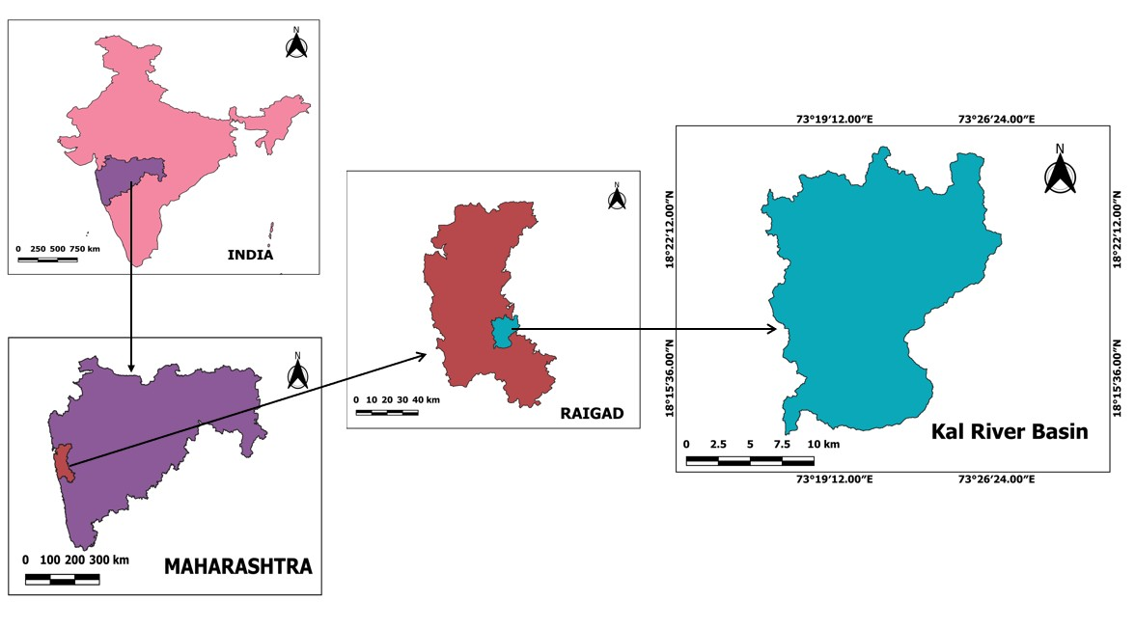
Fig 1: Location Map of the Study Area
2.2 Data sources and methods
The 30-m SRTM (Shuttle Radar Topographic Mission) DEM (Digital Elevation Model) was acquired directly from the USGS Earth Explorer website (link: https://earthexplorer.usgs.gov/). The DEM was used to extract stream network, slopes, and terrain features. The methodological flow of the research is shown in Fig. 2. The watershed boundary of Kal Basin and the stream network were automatically extracted from SRTM DEM in QGIS environment. All the geo-morphometric parameters are calculated by measuring the length, width, area, and perimeters of the basin with the help of specific algorithms in the QGIS environment.
2.3 Morphometric Analysis of Watershed
Quantitative morphometric analysis of various aspects of linear, areal, and relief parameters for drainage networks has been conducted. Linear morphometric parameters describe the linear dimensions and characteristics of features related to linear landforms especially river networks in the natural landscape (Rai et al., 2017). The linear aspects comprise stream number (N_{u}), stream length (L_{u}), Mean stream length ($L_{sm}$), stream order (u), bifurcation ratio (R_{b}), Mean bifurcation ratio ($R_{bm}$), Mean stream length ($L_{sm}$), Stream length ratio ($R_{L}$) and Rho Coefficient (ρ). Geometric parameters measure the shape and form of landforms and drainage features by measuring and encompassing the length, width, area and perimeter of the basin (Horton,1932).

QGIS

Add DEM

Fill Dem (wang and liu)
Linear, Areal, Relief aspects

Catchment area, length & perimeter

Strahler order

Analysis
Channel networks and
Drainage Basins Tool

conversion tool (Convert raster to vector)

Add base map and pour point

Watershed Delineated

Upslope area tool

Fig 2: Watershed delineation and stream network extraction process using QGIS 3.18

The Basin Aerial (Texture) aspect focuses on the spatial arrangement of different features specifically relevant to streams into the basin boundary (Melton,1957). The areal aspects include drainage density (Dd), Drainage Texture ($D_{t}$), Elongation Ratio ($R_{e}$), Constant of Channel Maintenance ($C_{cm}$), Stream Frequency ($F_{s}$), Form Factor ($F_{f}$), Circulatory Ratio ($R_{c}$), Drainage Intensity ($D_{I}$), Length of overland flow ($L_{g}$) and Sinuosity Index (SI). Basin relief characteristics describe the vertical dimension and variation of elevation, terrain, topographic features and landforms in the basin area (Melton,1957). The relief aspects, viz., basin relief (R), relief ratio (R_{r)}, ruggedness number ($R_{n}$), and relative relief ($R_{hp}$), maximum (H) and minimum (h) elevation of the basin have been taken into account for the evaluation of the channel network. The morphometric aspects obtained with the help of the mathematical equations have been specified in Table 1.
Table 1: Formulas for estimation of morphometric parameters:
Sr. No | Parameter | Unit | Formula | Reference
1 | Basin Area (A) | (km²) | QGIS analysis
2 | Basin perimeter (P) | (km) | QGIS analysis
3 | Basin length ($L_{b}$) | (km) | QGIS analysis
4 | Maximum elevation (H) | (m) | QGIS analysis
5 | Minimum elevation (h) | (m) | QGIS analysis
6 | Stream order (u) | Dimensionless | Hierarchical rank | Strahler (1964)
7 | Stream number (Nu) | Dimensionless | $N_{u}$=$N_{u1}$+$N_{u2}$+$N_{u3}$+……$N_{un}$ | Horton (1945)
8 | Stream length (Lu) | (km) | $L_{u}$ = $L_{u1}$ + $L_{u2}$ + $L_{u3}$ + ⋯ +$L_{un}$ | Horton (1945)
9 | Mean stream length ($L_{sm}$) | (km) | $L_{sm}$ = $L_{u}$/$N_{u}$ | Horton (1945)
10 | Stream length ratio ($R_{L}$) | Dimensionless | $R_{L}$ = $L_{u}$/$L_{u-1}$ | Horton (1945)
11 | Mean Stream length ratio ($R_{Lm}$) | Dimensionless | $R_{Lm}$= $R_{L1}$+$R_{L2}$+$R_{L3}$+...$R_{Ln}$/n | Horton (1945)
12 | Bifurcation ratio ($R_{b}$) | Dimensionless | $R_{b}$ = $N_{u}$/$N_{u+1}$ | Schumm (1956)
13 | Mean bifurcation ratio ($R_{bm}$) | Dimensionless | $R_{bm}$=$R_{b1}$+$R_{b2}$+$R_{b3}$+...$R_{bn}$+ /n | Schumm (1956)
14 | Rho Coefficient (ρ) | Dimensionless | ρ = $R_{L}$ / $R_{b}$ | Horton (1945)
15 | Drainage Density ($D_{d}$) | (km/km²) | $D_{d}$ = $L_{u}$/A | Horton (1945)
16 | Drainage Texture ($D_{t}$) | (km/km²) | $D_{t}$=$N_{u}$/p | Horton (1945)
17 | Elongation Ratio ($R_{e}$) | Dimensionless | $R_{e}$ = 2*$\left(\frac{A}{π}\right)/L_{b}$ | Schumm (1956)
18 | Constant of Channel Maintenance ($C_{cm}$) | (km/km²) | $C_{cm}$ = 1/$D_{d}$ | Schumm (1956)
19 | Stream Frequency ($F_{s}$) | (km²) | $F_{s}$ = (∑$N_{u}$)/A | Horton (1945)
20 | Form Factor ($F_{f}$) | Dimensionless | $F_{f}$ = 𝐴/$L_{b}$² | Horton (1945)
21 | Circulatory Ratio ($R_{c}$) | Dimensionless | $R_{c}$ = 4πA/P² | Strahler (1964)
22 | Drainage Intensity ($D_{I}$) | (km⁻¹) | $D_{I}$ = $F_{s}$/$D_{d}$ | Schumm (1956)
23 | Length of overland flow ($L_{g}$) | (km) | $L_{g}$ = 1/2 $D_{d}$ | Horton (1945)
24 | Sinuosity Index (SI) | Dimensionless | SI = AL/EL | Schumm (1956)
25 | Basin Relief (R) | (m) | 𝑅 = 𝐻 − ℎ | Schumm (1956)
26 | Relief Ratio ($R_{r}$) | Dimensionless | $R_{r}$ = 𝑅/L | Schumm (1956)
27 | Relative Relief ($R_{hp}$) | Dimensionless | $R_{hp}$ = 𝑅/𝑃 × 100 | Melton,1957
28 | Ruggedness Number ($R_{n}$) | Dimensionless | $R_{n}$ = 𝑅 ×$D_{d}$ | Schumm (1956)
- RESULTS AND DISCUSSION
Quantitative drainage morphometric analysis of Kal River Basin was carried out with the help of QGIS software. Some of the geomorphometric parameters were directly chalked out in QGIS environment and some of them were calculated by using respective morphometric formulas. The following is a discussion of the outcomes of different parameters.
3.1 Basic morphometric parameters
In this analysis, the values of fundamental morphometric parameters such as area (A), perimeter (P), length ($L_{b}$), maximum elevation (H) and minimum elevation (h) were calculated and are tabulated in Table 4.
3.2 Linear morphometric parameters
A linear aspect reflects details about one-dimensional morphometric parameter. It shows topological characteristics of the stream segments and channel patterns of the drainage system. Linear aspects of a drainage basin exhibit spatio-temporal variations, hence influences hydrological behavior of a basin (Soni, 2017).
3.2.1 Stream Order (u)
The first step towards drainage basin analysis is stream ordering. Stream order articulates the hierarchical association with segments which is an essential characteristic of stream networks because it has a relation with the relative discharge of a channel segment (Strahler, 1964). The stream order provides a kind of stream classification, e.g. the smallest stream in the watershed has lower most order. On the other hand, the largest streams include highest order. The lowest order streams may be the tributaries or rivulets, while highest order stream is the outlet of watershed (Bhange et.al., 2020). In the present study the stream order was obtained as fifth-order drainage basin shown in (Figure. 2), which indicated the presence of a large, well-developed stream network with multiple tributaries and were connected drainage network.
3.2.2 Stream Number ($N_{u}$)
The order wise cumulative measurement of stream segment gives stream number (Yadav et al., 2014). In the present study, the stream segments of each order form a reverse geometric arrangement with the order number that displayed linear relationship according to (Horton, 1945). The log of the stream numbers of each individual order is plotted against the stream order (Figure. 3) a total of 281 stream segments have been identified in the study region (Table 2). Nearly 206 of the total streams belong to 1st order, 50 are 2nd order, 17 are 3rd order, 7 are 4th order and 1 are 5th order shown in Table 2. Results reveal that the number of streams decreases as stream order increases which reflect the quantity of surface runoff stream flow capacity due to structural and geomorphological features of the basin.
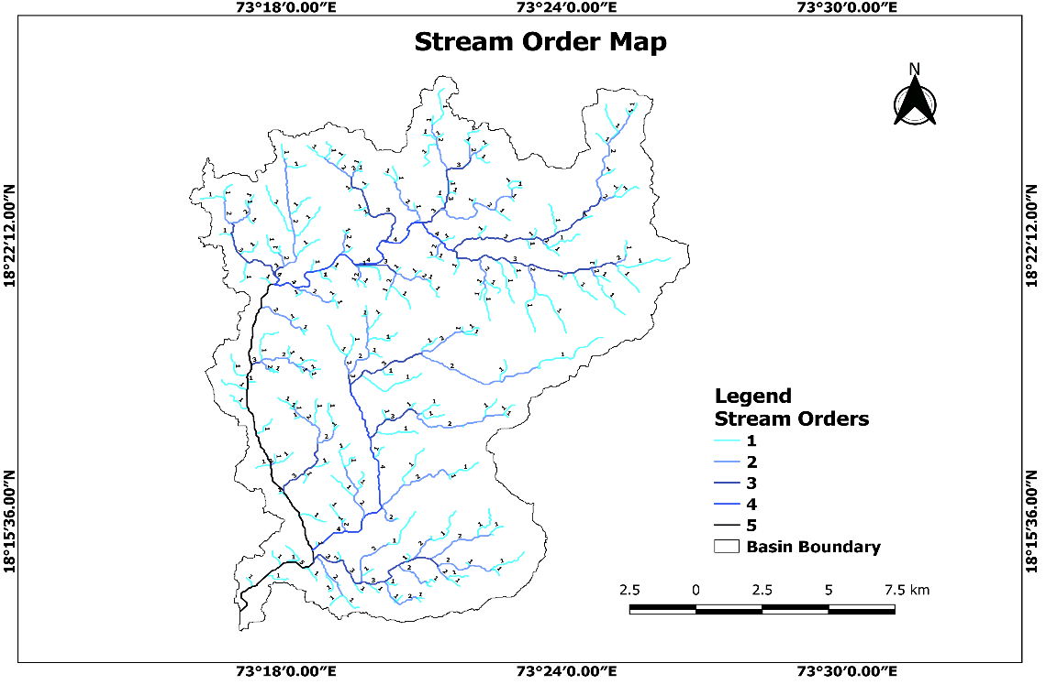
Fig.3. Drainage Network Map of Kal River Basin

Fig.4. Log of stream number vs stream order
3.2.3 Stream length ($L_{u}$)
The length of a stream is combining the total length of all streams in a specific order and then divides it by the number of streams of the same order. It expresses the hydrological characteristics such as surface runoff and sediment properties as well as contributing area of a basin (Magesh et al., 2011). As proclaimed by Horton (1945) the total stream length of respective orders decreases with increasing order of streams. In the present study, the total stream length was observed to be 166.88 km with order-wise stream lengths being 156.76 km, 82.33 km,45.64 km, 20.94 and 17.98 of Ist to Vth orders respectively. The highest stream length was obtained from Ist order streams which reveals that the maximum study area comes under a hydrologically high rainfall zone with uneven topography (Sharma, 2014).
3.2.4 Mean stream length ($L_{sm}$)
A dimensional property showing the characteristic size of components of a drainage network and its contributing watershed surfaces is known as mean stream length ($L_{sm}$) (Strahler, 1964). In the present study the mean stream length varies from 0.76, 1.64, 2.68, 2.99 and 17.98 km for Ist to Vth orders of streams respectively.
3.2.5 Stream length ratio ($R_{L}$)
The stream length ratio denotes ratio between total stream lengths of a particular order and total stream length of its subsequent previous order (Horton, 1945). In the present study, the stream length ratio for order Ist to Vth ranges from 0.52 to 0.85 respectively, which shows an inverse proportion between stream length & stream order. The highest stream length ratio belongs to 5th order stream (0.85) whereas the lowest is of 4th stream order (0.45) shown in Table 3. The inconsistencies in stream length ratio between successive stream orders represent uneven topography and spatial variation in infiltration rate in the basin. The calculated stream length ratio values of Kal River Basin are indicative of its mature geomorphic developments. Similar type of results were also observed by (Singh and Singh 2022).
3.2.6 Mean Stream length ratio ($R_{Lm}$)
It has been derived by dividing the sum of calculated stream lengths ratio’s by total of stream segment number. The computed mean stream length ratio of basin is 0.59 which corresponds to mountain environment and plateau.
3.2.7 Bifurcation ratio ($R_{b}$)
Bifurcation ratio in a drainage system is a proportion of the total numbers of stream segments of a specified order to the total number of streams of the subsequent higher order (Schumm, 1956). In this study the values of bifurcation ratio show significant variation from 2.42 to 7, for different stream orders depicting it as a natural drainage system with dendritic drainage pattern (Joji et al.,2013). The higher bifurcation ratio between 2nd and 5th order streams than their successive higher orders due to active ravines and gullies (Verstappen 1983) represents accelerated state of erosion due to higher overland flow.
3.2.8 Mean bifurcation ratio ($R_{bm}$)
The computed value of mean bifurcation ratio of entire study area is 4.12. This indicates that some part of the stream network was influenced by the lithology and geological structure of the watershed and signifying that these are geologically stable and less disturbed, moderate to hilly region, moderate ground slope and moderate to high run-off.
3.2.9 Rho Coefficient (ρ)
The rho coefficient is an important factor connecting drainage density to physiographic development of a drainage basin. It enables the calculation of storage capacity of drainage network (Horton 1945). The rho coefficient value for the study area is 0.66 which indicates moderate to higher hydrologic storage during floods. Similar type of results was also observed by (Soni,2017).
Table.2. Stream order wise stream number
Stream Order | Stream Number
I | 206
II | 50
III | 17
IV | 7
V | 1
Total | 281

Table.3. Stream order wise stream length, stream length ration and bifurcation ratio
Stream Order | Stream Length | Stream Length Ratio | Bifurcation Ratio
I | 156.76
II | 82.33 | 0.52 (II/I) | 4.12 (I/II)
III | 45.64 | 0.55 (III/II) | 2.94 (II/III)
IV | 20.94 | 0.45 (IV/III) | 2.42 (III/IV)
V | 17.98 | 0.85 (V/IV) | 7 (IV/V)
Mean | 5.20 | 0.59 | 4.12

3.3 Areal morphometric parameters
3.3.1 Drainage Density ($D_{d}$)
Drainage density (Dd) represents the ratio of cumulated length of streams of all orders within the basin to the total area of the drainage basin (Horton, 1945). Generally, drainage density value in humid region ranges between 0.55 to 2.09 km/km² (Joji et al., 2013). It is influenced by the climate, rock types, soil, terrain relief, permeability, runoff intensity, and vegetation cover of the basin (Bhat et al., 2019). Drainage density has been categorized into six classes (Fig. 5). The calculated drainage density in the QGIS environment, is about 1.18, which indicates moderate drainage densities, implies an area having coarse drainage texture, lower relief with variation in vegetation coverage and to some extent permeable subsoil in the basin, moderate infiltration capacity, low to moderate surface runoff, and higher potential of ground water. Similar results also found by (Mishra et al., 2023).
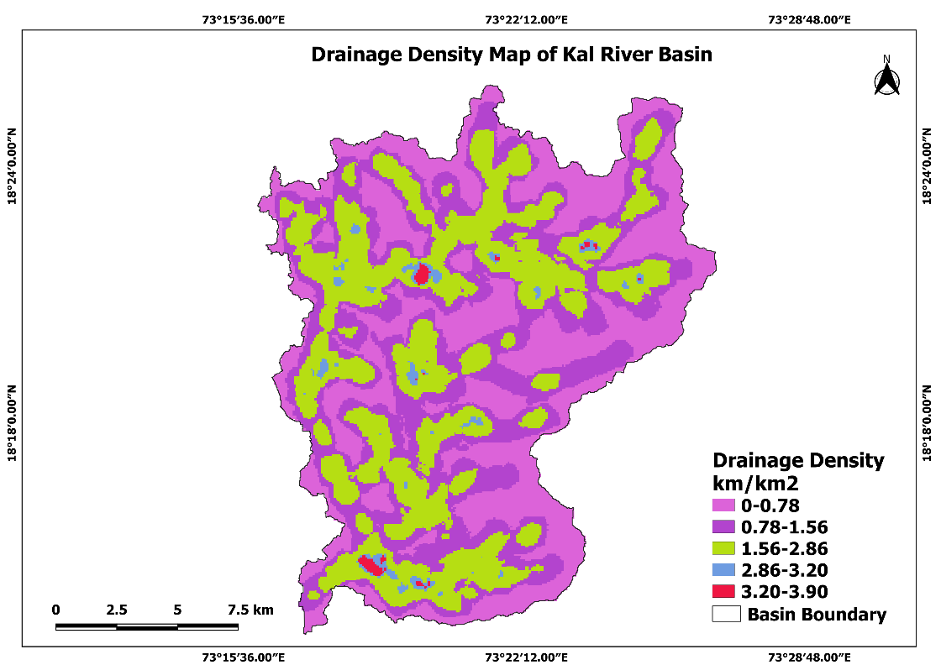
Fig.5. Drainage density map of Kal River Basin
3.3.2 Drainage Texture ($D_{t}$)
Drainage texture is the ratio of the total number of stream sections of all orders per unit perimeter of a basin (Horton, 1945). It describes relative arrangement of drainage network in a basin. Drainage network arrangement generally depends on climate, slope, soil type, vegetation, rainfall, lithology and infiltration capacity of the basin (Horton, 1945; Smith and Clark, 1950; Soni, 2017). The drainage texture value of Kal River Basin is 2.06 km⁻¹ hence as per the drainage texture classification of Smith and Clark, (1950) the basin encompasses coarse drainage texture formed on basalt rock.
3.3.3 Elongation Ratio ($R_{e}$)
Elongation ratio is dimensionless and represents the basin shape and hydrological characteristics. The value of elongation ratio generally ranges between “0” to “1” where zero depicts highly elongated basin shape and one represents highly circular shape of basin (Strahler, 1964). These values categorized in different groups as 0.9 to 1 for circular, 0.8 to 0.9 for oval, 0.7 to 0.8 for less elongated, 0.5 to 0.6 for elongated and <0.5 for more elongated (Biswas et.al., 1999). In the present study area, an elongation ratio of 0.69 indicated that the basin is highly elongated shape. Similar type of results was also observed by (Bhange et.al., 2020).
3.3.4 Constant of Channel Maintenance ($C_{cm}$)
Is the reciprocal of drainage density as property to define overland flow (Schumm 1956). Indirectly, it can be expressed as a required minimum area for the maintenance and development of a channel. In the present study the value of constant of channel maintenance is 0.85 km²/km indicated that least erodible nature of basin and also implies that on an average 0.85 km² basin surface area is needed for the development and maintenance of one km long linear stream channel.
3.3.5 Stream Frequency ($F_{s}$)
Stream frequency (Fs) of a basin represents the ratio between cumulative stream segment number irrespective of their orders and basin area (Horton, 1945). The climatic conditions, rock and soil types, vegetation thickness, terrain relief, infiltration capacity, permeability, and other runoff processes of a basin play vital role in controlling stream frequency distribution (Bali et al., 2012). The results showed that the value of stream frequency was 1.03, indicating a relatively low density of streams and this is likely due to a large area of the plateau having a gentle slope and the existence of a permeable subsurface material and moderate runoff potential.
3.3.6 Form Factor ($F_{f}$)
Form factor ratio is a dimensionless proportion between basin area and the square of the basin length (Horton, 1945). It indicates the flow intensity of a basin on a defined scale (Sreedevi et al., 2013). The form factor varies between zero to unity where value “0” indicates strongly elongated shape of basin and “1” suggests near-circular shape of basin. The estimated form factor value for the Kal River Basin is 0.38, which indicates elongated shape of the basin and thus it will generate low peak flow for longer duration. Similar type of results was also observed by (Kumari et.al.,2023).
3.3.7 Circulatory Ratio ($R_{c}$)
Circulatory ratio, a dimensionless parameter, is defined by Miller (1953) as the ratio of the area of the basin to the area of the circle having the same circumference as the perimeter of the basin. The values of the ratio are influenced by a wide variety of factors like stream length and frequency, geological structures, land use/land cover, and climate. The high, medium, and low values of circulatory ratio represent old, mature, and young stages of the drainage system (Rai et al., 2018). The calculated circularity ratio value of Kal River Basin is 0.19, which indicates the highly elongated characteristics of the basin with early to late mature landforms showing active denudational process in basin. Similar results were observed by (Singh and Singh 2022).
3.3.8 Drainage Intensity ($D_{I}$)

According to Schumm (1956), drainage intensity is the ratio of stream frequency and drainage density of the watershed. In the present study, drainage intensity value (0.87) indicating comparatively moderate to high surface runoff, highly vulnerable to flash floods and watershed is more prone to soil erosion. Denudation process is active in the study area and the terrain affects the streams and erosional process. Similar results were also found by (Chowdhury et.al., 2024).
3.3.9 Length of overland flow ($L_{g}$)
The length of overland flow is the distance that water travels over the ground surface before condensing into a specific stream channel (Horton, 1945). In the present study, the computed value of length of overland flow is 0.42 km, which represents the high length of overland flow during intensive rainfall with more channel erosion and moderate to high runoff potential. Similar type of results was observed by (Kale et.al., 2022a and Mishara et.al., 2023).
3.3.10 Sinuosity Index (Si)
Sinuosity index (Si) Sinuosity is defined as the ratio of channel length to down valley distance, which demonstrates the pattern of the channel of any drainage basin. Sinuosity generally ranges from 1 to 6 or more, where rivers with sinuosity above 1.5 are called meandering streams, and rivers with sinuosity less than 1.5 are called sinuous (Pareta and Pareta, 2011). Calculated value of sinuosity index is 1.57, indicates the basin has meandering topology which results gradual migration of the river course and erosion at river banks.
3.4 Relief Morphometric Parameters
3.4.1 Basin Relief (R)
Basin relief (R) is the difference in the elevation between the highest point and the lowest point of a watershed. It is a crucial factor to understand the ongoing denudation processes and is highly influenced by the underlying geology, geomorphology, and drainage pattern of the drainage basin (Thomas et al., 2010). In this study, the total relative relief of the whole basin is 1042 m, indicates dissected and erosional landforms, moderate stream gradient, moderate runoff and geo-morphologically mature stages of the basin development (Rai et al., 2017).
3.4.2 Relief Ratio ($R_{r}$)
It is defined as the ratio between the total relief (R) and the maximum basin length parallel to the main drainage line (L). Generally, the value of relief ratio decreases with increase in the area and size of the basin (Adhikary and Dash 2018). In this study, the value of relief ratio was obtained as 0.03, which suggests that the basin is elongated in shape and the presence of rolling and gentle slopes in the basin and susceptible to more erosion.
3.4.3 Relative Relief ($R_{hp}$)
Relative relief (Rhp) is a measure of the basin's steepness and susceptibility to erosion. It is calculated as the ratio of basin relief to the perimeter of the basin. In this study, the value of relative relief was obtained to be 0.76 suggests erosional characteristics within the basin.
3.4.5 Ruggedness Number ($R_{n}$)
The ruggedness number is a measure of surface roughness and structural complexity of a basin, (Strahler 1957) and it is calculated by multiplying the basin relief (R) and the drainage density (Dd). In the present study value of ruggedness number was obtained as 1.22 represents extremely rough surface, complex structures of an erosion-prone landscape.
Table.4. Results of evaluated morphometric parameters

Sr. No | Parameter | Unit | Result
Basic Morphometric Parameters
1. | Area (A) | (km²) | 272.63
2. | Perimeter (P) | (km) | 135.99
3. | Length ($L_{b}$) | (km) | 26.73
4. | Maximum elevation (H) | (m) | 1049
5. | Minimum elevation (h) | (m) | 7
Linear Morphometric Parameters
6. | Stream order (u) | Dimensionless | I to V
7. | Stream number (Nu) | Dimensionless | 281
8. | Stream length (Lu) | (km) | 166.88
9. | Mean stream length ($L_{sm}$) | (km) | 0.76 to 17.98
10. | Stream length ratio ($R_{L}$) | Dimensionless | 0.52 to 0.85
11. | Mean Stream length ratio ($R_{Lm}$) | Dimensionless | 0.59
12. | Bifurcation ratio ($R_{b}$) | Dimensionless | 2.42 to 7
13. | Mean bifurcation ratio ($R_{bm}$) | Dimensionless | 4.12
14. | Rho Coefficient (ρ) | Dimensionless | 0.66
Areal Morphometric Parameters
15. | Drainage Density ($D_{d}$) | (km/km²) | 1.18
16. | Drainage Texture ($D_{t}$) | (km/km²) | 2.06
17. | Elongation Ratio ($R_{e}$) | Dimensionless | 0.69
18. | Constant of Channel Maintenance ($C_{cm}$) | (km/km²) | 0.85
19. | Stream Frequency ($F_{s}$) | (km²) | 1.03
20. | Form Factor ($F_{f}$) | Dimensionless | 0.38
21. | Circulatory Ratio ($R_{c}$) | Dimensionless | 0.19
22. | Drainage Intensity ($D_{I}$) | (km⁻¹) | 0.87
23. | Length of overland flow ($L_{g}$) | (km) | 0.42
24. | Sinuosity Index (SI) | Dimensionless | 1.57
Relief Morphometric Parameters
25. | Basin Relief (R) | (m) | 1042
26. | Relief Ratio ($R_{r}$) | Dimensionless | 0.03
27. | Relative Relief ($R_{hp}$) | Dimensionless | 0.76
28. | Ruggedness Number ($R_{n}$) | Dimensionless | 1.22

- CONCLUSION
River basin is an important geomorphological unit which reflects topographic and hydrological unity. Remote sensing and GIS techniques have proved to be a more accurate and efficient tool in drainage network delineation and watershed management than conventional methods. In the present paper, the linear, areal and relief morphometric aspects of Kal River Basin was carried in the QGIS software. Findings obtained from this analysis suggests that the basin falls under Vth order basin with high number of headwater streams. The Kal River is part of west flowing river system flow in dendritic drainage pattern. The variation in stream length ratio might be due to change in slope and topography. According to elongation ratio, from factor and circulatory ratio it is an elongated shape basin. Values of drainage density and drainage texture suggesting that it has coarse drainage texture, lower relief with variation in vegetation coverage and to some extent permeable subsoil in the basin. Results obtained from stream frequency, drainage intensity and sinuosity index indicating a relatively low density of streams, more prone to soil erosion and basin has meandering topology which results gradual migration of the river course. Further the relief parameters depict geo-morphologically mature stages of the basin development, presence of rolling and gentle slopes in the basin, having complex structures of an erosion prone landscape. This study's findings suggest the necessity of implementing measures to conserve water and soil resources for the watershed's sustainable long-term development.
DISCLAIMER (ARTIFICIAL INTELLIGENCE)
Author(s) hereby declares that NO generative AI technologies such as Large Language Models (ChatGPT, COPILOT, etc) and text-to-image generators have been used during writing or editing of this manuscript.

COMPETING INTERESTS DISCLAIMER:
Authors have declared that they have no known competing financial interests OR non-financial interests OR personal relationships that could have appeared to influence the work reported in this paper.

REFERENCES

Adhikary, P P., and Dash, C J. 2018. Morphometric Analysis of Katra Watershed of Eastern Ghats: A GIS Approach. Int J Curr Microbiol Appl Sci.7(3):1651-1655.
Bali, R., Agarwal, K.K., Nawaz, A S., Rastogi, S. K., and Krishna, K. 2012. Drainage morphometry of Himalayan Glacio-fluvial basin, India: Hydrologic and neotectonic implications. Environmental Earth Sciences, 66(4), 1163–1174.

Bhange, H N., Kurlikar, G M., Shelar, Y A., Idate, S S., and Kolhe P R. 2020. Estimation of geomorphological characteristics of raigad district using geospatial technology. The Pharma Innovation International Journal. 9(3): 678-684.
Bhat, A H., Askary, T H., Ahmad, M J., Chaubey, A K., and Chaubey, A K. 2019. Description of heterorhabditis bacteriophora (Nematoda: Heterorhabditidae) isolated from hilly areas of Kashmir Valley. Egyptian Journal of Biological Pest Control, 29(1), 1–7.
Biswas, S., Sudhakar, S., and Desai, V. R. 1999. Prioritisation of subwatersheds based on morphometric analysis of drainage basin a remote sensing and GIS approach. Jour. Indian Soc. Remote Sensing, 27, 155.
Chowdhury, S. 2024. Morphometric analysis of Halda River basin, Bangladesh, using GIS and remote sensing techniques. Heliyon. 2405-8440.
Gregory, K.J. 1966. Dry valley and the composition of the drainage net. Journal of Hydrology, 4, 327–340.
Horton, R E. 1932. Drainage basin characteristics. Trans. Amer. Geophys. 13: 350-361.
Horton, R E. 1945. Erosional development of streams and their drainage basins: Hydrological approach to quantitative morphology. Geological Society of American Bulletin,56: 275-370.
Joji, V. S., Nair, A. S. K., and Baiju, K. V. 2013. Drainage basin delineation and quantitative analysis of Panamaram Watershed of Kabani River Basin, Kerala using remote sensing and GIS. Journal of the Geological Society of India, 82(4), 368–378.
Kumari, N., Ayare, B L., Bhange, H N., Ingle, P M., and Kasture M C. 2023. Geospatial analysis of morphometric parameters in the Kal River Basin, Western Konkan: Implications for hydrological characteristics. The Pharma Innovation Journal. 12(12): 2657-2667.
Magesh, N S., Chandrasekar, N., & Soundranayagam, J P. 2011. Morphometric evaluation of Papanasam and Manimuthar watersheds, parts of Western Ghats, Tirunelveli district, Tamil Nadu, India: A GIS approach. Environmental Earth Sciences, 64(2), 373–381.
Mahala, A. 2019. The signifcance of morphometric analysis to understand the hydrological and morphological characteristics in two different morpho-climatic settings. Appl Water Sci 10(1):1–16. https://doi.org/10.1007/s13201-019-1118-2.
Melton, M A. 1957. An Analysis of the Relations among Elements of Climate, Surface properties, and Geomorphology. Technical Report No. 11, Office of Naval Research Project NR 389-042, Department of Geology, ONR, Columbia University, New York.
Meshram, S G., Alvandi, E., Meshram, C., Kahya, E., and AlQuraishi A. 2020. Application of SAW and TOPSIS in prioritizing watersheds. Environ Manage.34(2):715-732.
Miller, V C. 1953. A Quantitative Geomorphic Study of Drainage Basin Characteristics in the Clinch Mountain area, Virginia and Tennessee. Project NR389-042, Technical Report: 3, Columbia University, Dept. of Geology, ONR, Geography Branch, New York.
Pareta, K., Pareta, U., 2011. Quantitative morphometric analysis of a watershed of Yamuna basin, India using ASTER (DEM) data and GIS. Int. J. Geomatics Geosci. 2 (1), 248–269.
Rai, P K., Mohan, K., Mishra, S., Ahmad, A., and Mishra, V N. 2017. A GIS-based approach in drainage morphometric analysis of Kanhar River Basin, India. Applied Water Science. 7:217–232.
Rai, P.K., Chandel, R.S., Mishra, V.N., Singh, P. 2018. Hydrological inferences through morphometric analysis of lower Kosi River basin of India for water resource management based on remote sensing data. Appl. Water Sci. 8 (1).
Sangma, F, Guru, B. 2020. Watersheds Characteristics and Prioritization Using Morphometric Parameters and Fuzzy Analytical Hierarchical Process (FAHP): A Part of Lower Subansiri Sub-Basin. J Indian Soc Remote Sens.48(12):473-96.
Schumm, S A. 1956. Evolution of drainage systems slopes in badlands in Perth, Amboy, New Jersey. Geol. Soc. Amer. Bull.67: 597-646.
Sharma, S A. 2014. Morphometrical analysis of Imphal River basin using GIS. Int J Geol Earth Environ Sci. 4(2):138-144.
Smith, K.G. 1950. Standards for grading texture of erosional topography. Am. J. Sci. 248, 655–668. https://doi.org/10.2475/ajs.248.9.655.
Soni, S. 2017. Assessment of morphometric characteristics of Chakrar watershed in Madhya Pradesh India using geospatial technique. Applied Water Science, 7, 2089–2102
Sreedevi, P D., Sreekanth, P D., Khan, H H., and Ahmed, S. 2013 Drainage morphometry and its influence on hydrology in an semi-arid region: using SRTM data and GIS. Environ Earth Sci 70(2):839–848.
Strahler, A N. 1952. Hypsometric (area-altitude) analysis of erosional topography. Geol. Soc. Amer. Bull. 63: 1117-1142.
Strahler, A N. 1957. Quantitative analysis of watershed geomorphology. Trans. Am. Geophys. Union. 38: 913-920.
Strahler, A N. 1964. Handbook of Applied Hydrology. In Quantitave Geomorphology of Drainage Basins and Channel Networks; Section 4-II; McGraw Hill Book Company: New York, NY, USA.
Thomas, J., Joseph, S., and Thrivikramaji, K P. 2010. Morphometric aspects of a small tropical mountain river system, the southern Western Ghats. India Int J Digital Earth 3(2):135–156.
Venkatesh, M., and Anshumali, A. 2019. GIS-based assessment of recent changes in drainage and morphometry of Betwa River basin and sub-basins, Central India. Applied Water Science. 9(7):157. Available from: https://doi.org/10.1007/s13201-019-1033-6.
Verstappen, H T. 1983. Applied geomorphology-geomorphological surveys for environmental development. Elsevier, New York, pp 57–83.
Wandre, S S., and Rank, H D.2013. Assessment of morphometric characteristics of Shetrunji river basin using remote sensing and geographical information system (GIS). Afr J Agric Res. 8(18):2003-2015.
Yadav, S K., Singh, S K., Gupta, M., and Srivastava, P K. 2014. Morphometric analysis of Upper Tons basin from Northern Foreland of Peninsular India using CARTOSAT satellite and GIS. Geocarto International, 29(8), 895–914.

