Original Research Article
Exploring Self-Incompatibility and Pollination Approaches in Commercial cultivars of mango (Mangifera indica L.)

ABSTRACT
Mango (Mangifera indica L.) popularly known as ‘King of fruits’ or ‘apple of tropics’ belonging to the family Anacardiaceae is a major fruit crop in tropical and subtropical regions. Many mango cultivars exhibit low productivity for several reasons, including alternate bearing, malformation, reduced fruit set and increased fruit drop at various growth stages. The challenges related to fruit set are primarily linked to ineffective pollination. While numerous varieties have been identified as self-fruitful, cross-pollination appears essential for achieving satisfactory yields. A key factor affecting fruit set in different mango cultivars has been recognized as self and cross incompatibility. In this context, four mango cultivars (Alphonso, Dashehari, Mallika and Totapuri) were examined to assess the effects of open, self and cross-pollination on fruit set and the retention of fruits. The results of the current study indicated that, open pollination followed by cross-pollination produced the highest fruit set and retention rates among all the cultivars analyzed, outperforming the results obtained through self-pollination. Among the combinations tested, Alphonso x Totapuri exhibited the greatest fruit set percentage of 30.18%. This was closely trailed by Alphonso x Dashehari, which recorded 29.60% and Dashehari x Alphonso, which achieved a percentage of 29.06%. In contrast, the self-pollination treatments for Dashehari and Mallika produced the least successful results, with percentages of 11.26% and 12.08%, respectively. The combinations of Totapuri x Dashehari (24.14%), Alphonso x Dashehari (20.77%), and Dashehari x Alphonso (19.34%) exhibited the highest rates of fruit retention. Conversely, the cross combination of Mallika x Dashehari resulted in no fruit retention, which was also the case for the self-pollinated treatments of both Dashehari and Mallika. These findings suggest that the mango varieties ‘Dashehari’ and ‘Mallika’ are self-incompatible, whereas ‘Alphonso’ and ‘Totapuri’ are self-compatible.
Keywords: Incompatibility, Fruit set, Fruit retention, Pollination, Mangifera indica
- INTRODUCTION
Mango is an andromonoecious plant having both staminate and hermaphrodite flowers in the same inflorescence, but only a small percentage of these hermaphrodite flowers are capable of producing fruits. Depending on the cultivar and the age of the tree, the number of flowers in each panicle can vary significantly, ranging from 1000 to 6000. The percentage of fruit set in mango varies with cultivar and ranges between 0.50 % to 28 %. In each panicle, fewer than 1% of flowers successfully develop into fruits. This low fruit set and/or high rate of immature fruit drop is associated with several factors, including pollen viability, the presence of hermaphrodite flowers, compatibility among cultivars and the environmental conditions at the time of pollination. One of the major factors influencing fruit set in many mango cultivars has been reported to be the self and cross incompatibility (Iqbal and Virk 2005). Investigations into mango embryos shows that pollen tubes grow along the style to promote fertilization, yet zygote development is obstructed, which results in a sporophytic form of self-incompatibility. (Mukherjee et al. 1968).
Many commercially cultivated mango varieties grown in isolation have experienced significant fruit loss at different stages of growth due to shortage of pollinizers. Popenoe (1917) highlighted the critical need for pollinizers in mango cultivation. The first evidence of self-incompatibility was reported in the Dashehari cultivar by Singh et al. in 1962. Subsequent studies discovered various mango cultivars that exhibited self-incompatibility and their requirement for cross-pollination to facilitate successful fruit production (Sharma and Singh 1972). Furthermore, Saha and Chhonkar (1972) documented cross-incompatibility between the Langra and Fazri varieties, which underscores the importance of understanding mango reproductive biology for effective breeding and cultivation strategies. Although many varieties were found to be self-fruitful, cross-pollination was deemed necessary for maximizing crop yields, as noted by Ali and Mazhaar in 1960.
The efficiency of mango breeding can be improved by selecting a female parent that is self-incompatible, which reduces the need for emasculation during the hybridization process. Recent advancements in hybridization techniques and the identification of self-incompatibility in mango cultivars, open up new avenues for developing hybrids with desirable horticultural characteristics. Self and cross-incompatibility in mango cultivars remains a significant obstacle and the development of compatible pollinizer combinations is crucial to bridge this knowledge gap and advance mango breeding and production. This study focuses on identifying the optimal pollinizer for commercial mango cultivars such as ‘Mallika’, ‘Alphonso’, ‘Dashehari’ and ‘Totapuri’.

- MATERIAL AND METHODS
The present study was conducted at the experimental orchard of the Department of Fruit Science, College of Horticulture, Bengaluru, UHS, Bagalkot during the year 2023-2024. The experimental site is situated at a latitude of 13.09° N and a longitude of 77.56° E, with an elevation of 924 meters above mean sea level. Throughout the experimentation period, the highest average monthly temperature was recorded in April at 36°C, while the lowest was in January at 18.3°C. This region experienced an average annual rainfall of approximately 915.8 mm, predominantly occurring during the monsoon season. Four mango cultivars (Alphonso, Dashehari, Mallika, and Totapuri) were selected to assess the effects of pollination on mango fruit set. The plants used in the study were eight years old, healthy and free from diseases and pests. The plants of these mango cultivars were maintained under uniform cultural practices. The experiment was laid out in RBD with five replications. ANOVA was calculated to separate the means.
2.1 Pollen viability assessment
Pollen viability was determined by employing the acetocarmine stain test. Freshly dehisced anthers were collected from male flowers of each cultivar between 8 a.m. and 10 a.m. Then, the pollen grains were gently transferred to glass slides and stained with 1% acetocarmine. After 10 minutes, the slides were examined under a microscope, and the number of normal, well-filled, and fully stained (viable) pollen grains was counted, along with the number of unstained, poorly developed (non-viable) pollen grains. This count was performed in 10 random microscopic fields. The percentage of viable and non-viable pollen grains was then calculated from the total number of pollen grains observed. (Mandal et al. 2020)
$Pollen viability \left(\%\right)=$ $\frac{ \left(number of viable pollen grains\right) }{(number of total pollen grains counted)}× 100$
2.2 Pollen germination study
Flowers were collected after anthesis between 8-10 a.m. and their anthers were carefully removed using forceps and dehisced under sunlight for 5-10 minutes, depending on light intensity, to release pollen. The dehisced pollen was then subjected to in vitro germination using a medium consisting of sucrose (15%), polyethylene glycol (15%), boric acid (100 ppm), CaNO₃ (300 ppm), MgSO₄ (200 ppm) and KNO₃ (100 ppm) employing the sitting drop technique in cavity slides, with three replications per slide. After overnight incubation in petri dishes, pollen germination was observed using a light microscope, and the percentage of germination was calculated by observing 10 microscopic areas from each slide. The slides were then stained with Alexander's stain for preservation and further observation (Veena et al. 2017)
$Pollen germination \left(\%\right)=$ $\frac{ \left(number of germinated pollen grains\right) }{(number of total pollen grains counted)}$ $× 100$
2.3 Pollination
Healthy panicles developed from secondary and tertiary branches were selected for controlled hand pollination. Before pollination, the selected panicles were bagged with perforated polythene bags (45 x 30 cm, 100 gauge thickness) in the afternoon, after removing all the flowers that had already opened. The next morning, 10-12 freshly opened, perfect flowers located in the middle of each panicle were carefully selected for pollination, while all remaining unopened buds were removed. The chosen hermaphrodite flowers were then rebagged with polythene bags to ensure strict isolation and precise control over the pollination process. Similarly, panicles on the male donor were bagged in the afternoon of the previous day. The next morning, freshly opened male flowers were collected in a petri dish lined with moist blotting paper and exposed to sunlight for 10 -30 minutes to induce anther dehiscence. Following anther dehiscence, the bags were removed from the female parent panicles and pollen grains from the male parents were transferred to the stigma of the female parent by gently rubbing the stigma with the dehisced anthers. The pollinated panicles were then immediately rebagged and labeled with the date of crossing, number of flowers crossed and cross combination. The bags were removed 72 hours after crossing and fruit set was monitored and recorded at various intervals (Dutta et al. 2013). Self-pollination was performed by emasculating the flower buds a day before anthesis, followed by pollination with their own pollen in the next morning. For open pollination, the panicles were allowed to set fruits naturally by external agents like house fly, wind, etc.
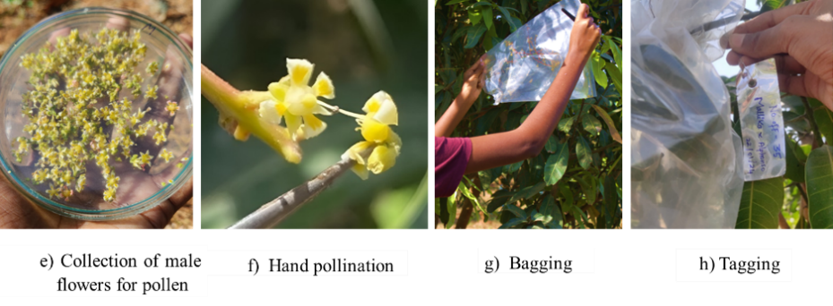
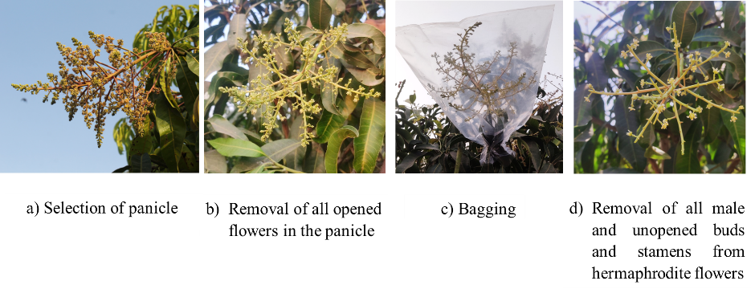
Fig. 1:Steps in hand pollination of mango
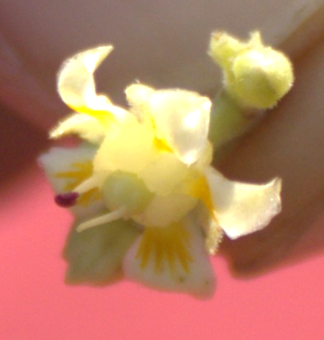
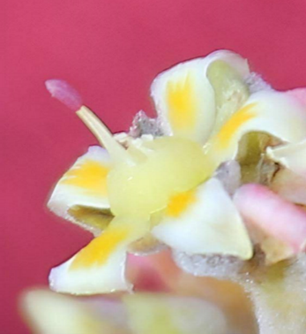

a) b)
Fig. 2: Flowers of mango a) Male flower b) Hermaphrodite flower

2.4 Statistical analyses
The experimental data was analyzed statistically in randomized completely block design as per Panse and Sukhatame, 1978. The significance of variance was tested by applying 'F' test at 5 per cent level of significance.
3. RESULTS AND DISCUSSION
3.1 Pollen viability and germination
The cultivars differed significantly in pollen viability percentage. The maximum viability percentage was measured in cultivar Alphonso (97.50%) followed by Mallika (95.68%) and Totapuri (94.20%). While, the cultivar Dashehari (84.80%), had the minimum pollen viability percentage (Table 1). The high pollen viability in Alphonso and Mallika varieties may be attributed to their greater tolerance to environmental factors. The cultivars differed significantly in pollen germination percentage. The maximum germination percentage was measured in cultivar Alphonso (69.00%) which was followed by Mallika (64.00%) and Totapuri (60.00%). The lowest germination percentage was recorded in Dashehari (58.00) (Table 1). The variation in pollen viability and germination observed among different mango cultivars can be linked to their distinct genetic characteristics and the influence of environmental conditions. This suggests that genetic variations exist among the genotypes, a phenomenon consistently reported by numerous researchers across various fruit tree species and cultivars (Sharafi and Bahmani 2011).
Fig. 3: Pollen viability and pollen germination of four mango cultivar a) Alphonso b) Dashehari c) Mallika d) Totapuri
Table 1: Pollen viability and germination percentage in selected mango cultivars
Sl. No. | Variety / Hybrid | Pollen viability (%) | Pollen germination (%)
1 | Alphonso | 97.50 | 69
2 | Dashehari | 84.80 | 58
3 | Mallika | 95.68 | 64
4 | Totapuri | 94.20 | 60
 | S.Em+ | 0.50 | 0.90
 | CD @ 1% | 2.07 | 3.75

3.2 Fruit set, drop and retention (%)
The data presented in Table 2 highlights a significant effect of various pollen parents on fruit set under conditions of open, self, and cross-pollination and the initial fruit set percentage was calculated at 15 days after pollination. The initial fruit set obtained from open and cross-pollination was considerably greater than that from self-pollination. Significantly, the highest initial fruit set was achieved with Dashehari open pollination (40.94) which was followed by Alphonso open pollination (37.15). Similarly, Roemer (2011) and Gehrke-Velez et al. (2012) reported higher fruit set in open-pollination compared to self-pollination in mango. Singh (1990) supported the fact that fruit set in mango is a varietal trait dependent on factors such as flowering time, sex ratio, cross-pollination efficiency and fruit drop intensity. It was reported that varieties differed from one another in these respects and this lead to varying fruit set in different varieties. Among the cross combinations, the highest fruit set percentage was observed in Mallika × Totapuri at 32.14%, closely followed by Alphonso × Totapuri with a percentage of 30.18%. In contrast, the lowest fruit set percentage was noted in Totapuri selfed at 11.26%, which was followed by Mallika selfed at 12.08%. The other cross combinations yielded intermediate fruit set percentages (Fig. 4).
The maximum fruit retention per cent was recorded in Totapuri open pollination (28.84) followed by Alphonso (27.88) and Dashehari (27.81) open pollination. In cross combinations, Totapuri × Dashehari (24.14) followed by Alphonso × Dashehari (20.77) recorded the maximum fruit retention percentage. The cross combinations, Dashehari × Totapuri and Mallika × Alphonso recorded the minimum fruit retention percentage of 1.59 and 1.85 respectively. Selfing in Dashehari and Mallika showed no fruit retention. In the cross combination of Mallika × Dashehari, no fruits were retained (Table 2).
The rapid decline in fruit set and retention after self-pollination can also be attributed to ovule degeneration, which halts fruit growth and leads to subsequent abscission. Observations by Sedgley and Granger (1996) on ovule degeneration at various developmental stages revealed a higher incidence of degeneration following self-pollination. Ovule degeneration was due to impaired pollen tube growth, characterized by slower growth rates, reduced penetration and low fertilization success. Even when fertilization occurs, the zygote often failed to undergo cell division, further contributing to ovule degeneration. In 'Mallika' and 'Dashehari' cultivars, self-pollination led to a higher incidence of ovule degeneration compared to open-pollination, suggesting that these varieties were not conducive to self-pollination and instead preferred cross-pollination. The self-incompatibility observed in 'Mallika' may have been inherited from its parent cultivar 'Dashehari', which was used in breeding 'Mallika' (Singh et al. 1962). On the other hand, cross-pollinated flowers in the four cultivars successfully carried some fruits to maturity except the cross combination of Mallika × Dashehari, where no fruits were retained. This may be due to the fact that Mallika's self-incompatibility likely originated from its parent 'Dashehari', which is also self-incompatible, made the cross incompatible.
It is evident from the data presented in the Table 2 that pollinizer treatment had a significant effect on fruit drop. Among the treatments, the highest fruit drop of 100% was recorded in both Dashehari and Mallika selfed treatments and also in the cross combination Mallika × Dashehari. Minimum fruit drop per cent was recorded in Totapuri open pollination (71.16) followed by Dashehari (72.19) and Alphonso (72.12) open pollination treatments. Among the cross combinations, minimum percentage of fruit drop was recorded in Totapuri × Dashehari (75.86) which was followed by Alphonso × Dashehari (79.23) and maximum fruit drop percent in Dashehari × Totapuri (98.41) and Mallika × Alphonso (98.15)
A gradual reduction in fruit set and retention was observed in 17 treatment combinations, progressing from the initial stage (15 days post-pollination) to the final stage (105 days post-pollination), following a normal pattern of fruit development and abscission. They were Alphonso (Open pollination), Dashehari (Open pollination), Mallika (Open pollination), Totapuri (Open pollination), Alphonso (Selfing), Totapuri (Selfing), Alphonso × Dashehari, Alphonso × Mallika, Alphonso × Totapuri, Dashehari × Alphonso, Dashehari × Mallika, Dashehari × Totapuri, Mallika × Alphonso, Mallika × Totapuri, Totapuri × Alphonso, Totapuri × Dashehari and Totapuri × Mallika. However, it was not so in remaining three treatment combinations viz. Dashehari (Selfing), Mallika (Selfing) and Mallika × Dashehari (Fig. 6). Sharma and Singh (1969) similarly observed a decline in fruit number in incompatible cross-combinations and Dag et al. (2009) reported significant abscission of selfed fruitlets in mango. However, Naik and Rao (1941) and Singh (1954) reported that mango ovaries could grow to a substantial size without pollination stimulus. Consistent with this, the present study found high initial fruit set in all cross-combinations, followed by a gradual drop in fruitlets over time.

Fig. 4. Percentage of fruit set in different pollination treatments

Fig. 5. Percentage of fruit retention in different pollination treatments
Table 2: Percentage of fruit set, fruit retention and fruit drop in different pollination treatments
Sl. No. | Treatments | No. of flowers pollinated | Fruit set (%) | Fruit retention (%) | Fruit drop (%)
1 | Alphonso (Open pollination) | 235 | 37.15 | 27.88 | 72.12
2 | Dashehari (Open pollination) | 237 | 40.94 | 27.81 | 72.19
3 | Mallika (Open pollination) | 231 | 36.33 | 21.40 | 78.60
4 | Totapuri (Open pollination) | 224 | 32.12 | 28.84 | 71.16
5 | Alphonso (Selfing) | 220 | 20.40 | 4.18 | 95.82
6 | Dashehari (Selfing) | 214 | 13.19 | 0.00 | 100.00
7 | Mallika (Selfing) | 215 | 12.08 | 0.00 | 100.00
8 | Totapuri (Selfing) | 227 | 11.26 | 12.63 | 87.37
9 | Alphonso × Dashehari | 230 | 29.60 | 20.77 | 79.23
10 | Alphonso × Mallika | 215 | 14.79 | 16.49 | 83.51
11 | Alphonso × Totapuri | 225 | 30.18 | 10.56 | 89.43
12 | Dashehari × Alphonso | 221 | 29.06 | 19.34 | 80.66
13 | Dashehari × Mallika | 226 | 21.66 | 2.56 | 97.44
14 | Dashehari × Totapuri | 223 | 27.74 | 1.59 | 98.41
15 | Mallika × Alphonso | 217 | 24.95 | 1.85 | 98.15
16 | Mallika × Dashehari | 223 | 21.06 | 0.00 | 100.00
17 | Mallika × Totapuri | 228 | 32.15 | 4.12 | 95.88
18 | Totapuri × Alphonso | 213 | 17.31 | 6.11 | 93.89
19 | Totapuri × Dashehari | 228 | 18.84 | 24.14 | 75.86
20 | Totapuri × Mallika | 219 | 22.78 | 6.10 | 93.90
 | Maximum | - | 40.94 | 28.84 | 100.00
 | Minimum | - | 11.26 | 0.00 | 71.16
 | S.Em+ | - | 1.67 | 2.91 | 2.91
 | CD @ 5% | - | 4.80 | 8.34 | 8.34

Fig. 6. Percentage of fruit drop in different pollination treatments

CONCLUSION
This study concludes that open pollination is the most effective method among the various pollination strategies examined, outperforming both self and cross pollination. Cross-pollination led to earlier fertilization, a higher rate of fruit set and improved fruit retention when compared to self-pollination. The crosses Alphonso x Dashehari, Dashehari x Alphonso and Totapuri x Dashehari were identified as the most effective in terms of fruit set and retention. Furthermore, the research indicates that the mango cultivars Dashehari and Mallika are self-incompatible and exhibit cross-incompatibility with certain cultivars. The differing reactions of these cultivars to common pollen sources emphasize the need for further investigation to identify more effective pollinizers. Insights into pollen viability, germination, and their effects on fruit set are crucial for the advancement of successful breeding programs in the future.

REFERENCES

Ali, N., & Mazhar, H.(1960). The tree flower and fruit characteristics of the mango. Punjab Fruit Journal, 80-86.
Dag A., Degani, C., & Gazit, S. (2009). Gene flow in mango orchards and its impact on yield. Acta Horticulturae 820, 347-350.
Dutta, S K., Srivastav, M., Rymbai, H., Chaudhary, R., Singh, A.K., Dubey, A. K., & Lal, K. (2013). Pollen–pistil interaction studies in mango (Mangifera indica L.) cultivars. Scientia Horticulturae, 160, 213-221.
Gehrke-Velez, M., Castillo-Vera, A., Ruiz-Bellom, C., Moreno-Martinez, J. L., & Moreno-Basurto, G. (2012). Delayed self-incompatibility causes morphological alterations and crop reduction in ‘Ataúlfo’ mango (Mangifera indica L.). N. Z. J. Crop Horticulture Science 40(4), 215-227.
Iqbal, N.,Virk, & N. A. (2005). Compatibility studies in some mango, Mangifera indica L. cultivar. Pakistan Journal of Forestry, 55, 1.
Maklad, M F., 2015. Studies on sexual compatibility and or incompatibility in langra mango cultivar. Egypt Journal of Plant breeding 19(3);343-356.
Mandal, S. K., Karuna, K., Kumari, N., Kumar, A., & Kumari, S. (2020). Study on compatibility of different coloured mango pollinizer among commercial cultivar. International Journal of Conservation Science 8(3), 1215-1217.
Mukherjee, S. K., Singh, R. N., Majumder, P. K., & Sharma, D. K. (1968). Present position regarding breeding of mango (Mangifera indica L.) in India. Euphytica 17, 462-467.
Naik, K. C., & Rao, M. M. (1941). Cropping behaviour in mangoes. Madras Agricultural Journal, 29, 276-282.
Panse, V. G., & Sukhatme, P. V. (1978). Statistical method for agricultural workers. ICAR, New Delhi, India.
Popenoe, W. (1917). The pollination of the mango. USDA Bur Pl Ind Bull 542.
Roemer, M. G. (2011). Premature fruit drop in mango (Mangifera indica L.) in Northern Vietnam. Ph.D. Thesis, Univ Hohenheim, Stuttgart (Germany).
Saha, B. P., & Chhonkar, V. S. (1972). Studies on floral biology pollen viability, and intervarietal compatibility in mango (Mangifera indica L.). Proc. Third Int Symp Sub-tropical and Tropical Hort, 8-14 February, 1972, Bangalore, India, 5.
Sedgley, M., & Granger, L. (1996). Embryology of Eucalyptus spathulata and E. platypus (Myrtaceae) following selfing, crossing and reciprocal interspecific pollination. Australian Journal of Botany, 44, 661-671.
Sharafi, Y., & Bahmani, B. (2011). In vitro study of pollen traits after short storage in some almond apricot and sweet cherry favourable genotypes. Journal of Medicinal Plants Research 5(2), 266-269.
Sharma, D. K., & Singh, R N. (1969). Investigations on self-incompatibility in Mangifera indica L. In: Symposium on Mango and Mango Culture 24. June 30, held at New Delhi, India 126-130.
Sharma, D. K., & Singh, R N. (1972). Investigation of self-incompatibility in (Mangifera indica L.). Acta Horticulturae, 24; 126-130.
Singh, L. B. (1990). The Mango-Botany, Cultivation and Utilization. International Journal of Recent Science Research, 9343-9346.
Singh, R. N. (1954). Studies on floral biology and subsequent development of fruits in mango var. Dashehari and Langra. Indian Journal of Horticulture 11, 69-88.
Singh, R. N., Majumdar, P. K., & Sharma, D. K. (1962). Self-incompatibility in mango (Mangifera indica L. var. Dashehari). Current Science, 31, 209.
Veena, G. L., Rajashekaran, P. E., Dinesh, M. R., & Sankaran, M. (2017). Pollen conservation and in vitro germination studies in 'Appemidi' mango. In: XII International Mango Symposium 1244. July 10-16, held at ISHS, Baise, China. pp. 39-42.

