Review Article

POTENTIALITY OF SILKWORM LITTER IN CIRCULAR ECONOMY

ABSTRACT
Silkworm litter, a by-product of sericulture comprising larval excreta, uneaten mulberry leaves, and rearing bed residues, represents a nutrient-rich organic resource with significant potential in the framework of a circular economy. Its diverse applications include use as organic manure, vermicompost substrate, animal and fish feed, raw material for biogas production, and source of bioactive compounds for pharmaceuticals and cosmetics. Leveraging these applications not only promotes waste valorisation but also enhances resource efficiency, reduces environmental pollution, and supports sustainable agricultural practices. Despite its high agronomic and economic value, comprehensive studies integrating silkworm litter utilization within a structured circular economy model remain limited. This review synthesizes existing knowledge on the chemical composition, agronomic benefits, industrial uses, and environmental implications of silkworm litter, while identifying research gaps and opportunities for developing integrated, closed-loop systems in sericulture. The potential adoption of such models could contribute to rural livelihoods, sustainable resource management, and alignment with global sustainability goals.

Keywords: Silkworm litter, recycling, value addition, Sustainable sericulture, circular bioeconomy

- INTRODUCTION
Sericulture is an agro-based industry that has immense potential both on economic and social fronts and is a major livelihood option for poor farmers. The industry provides employment to more than 6 million people especially empowering livelihood for woman community in the country. During different phases of sericulture various seri-wastes are produced. The rearing waste constitutes about 61 % that contain 48.38 % silkworm excreta, 40.43 % shoot waste and 11.18 % leaf waste which together constitute silkworm litter. (Grzeskowiak et al., 2022). It is shown that around 60 % of the mulberry leaves consumed by silkworms are excreted without being digested and the rest of 40 % are that resulted from functionalization of enzymes and microorganisms in the silkworm’s digestive system (Li et al., 2021; Liao et al., 2020; Sohn et al., 2009).
It is estimated that about 2794 kg of litter per acre per year could be obtained by rearing 300 layings (one laying = 400 eggs) per acre. Marginal farmers may produce 250-300 kg of silkworm waste, which is equal to 2500 kg farm manure and may be used to fertilize 0.067 ha farmland (Wenhua, 2001). Rearing of 100 Disease free layings (dfls) require 1000 kg of mulberry leaves. This produces approximately 300 kg of litter and 500 kg of leftover mulberry waste (Mala & Chandrashekhar., 2020).
Physically, silkworm excreta have a cylindrical shape of 2-3 mm in length with a deep green colour. The chemical constituents of silkworm excreta that have principally been reported are chlorophyll and chlorophyll derivatives, xanthophyll, carotenoid, and flavonoids (Park et al., 2011). Waste is wealth, nothing goes waste in Sericulture. Since, 1970s the silkworm faeces are being utilized by Chinese to produce paste chlorophyll, sodium copper chlorophyllin, phytol, carotene, triacontanol and pectin etc. Infact, Chinese earn more income from byproducts rather than the main product silk. For example, the sericulture farmer could get the income of 3,00,000 RMB (Rs. 24,00,000) by selling 1000 tonnes of silkworm faeces alone (Zhu & Xu, 2004).
China, India, Brazil, Japan, Thailand, Vietnam, North Korea, Iran and many countries are engaged in mulberry cultivation and silkworm rearing. Currently China and India are the world’s leading producers for silk. In China alone, silk production accounts for 60 % of global production (Manjunath et al., 2020). During sericulture process, a large amount of Silkworm excreta is produced. According to statistics, the annual production of silkworm excreta in China is as high as 5 million tons (Liu et al., 2022; Zhang et al., 2019).
Literature sources report that silkworm excreta has pharmaceutical and food commercial uses. In traditional Asian medicine excreta have been used as a therapeutic agent to treat infectious diseases, headache and abdominal pain, as well as lower LDL cholesterol and blood pressure (Tulp and Bohlin, 2004; Vimolmangkang et al., 2014). However, limited data are available on the bioactive compound profile of silkworm faeces, although some interesting substances have been reported so far. The groups of lipids were identified, while chlorophylls, fatty acids, sterols, carotenoids, fatty alcohols and sterol glycosides predominated (Vimolmangkang et al., 2014). Due to the fact that silkworm excreta are rich in flavonoids, chlorophyll, alkaloids, carotenoids and lutein compounds they show high antioxidant activity (Xu et al., 2014). Moreover, the high content of these compounds presents faeces as a good source of a natural colorant for the food industry (Vimolmangkang et al., 2014). In industrial production 1 kg of chlorophyll is obtained from 200 kg of silkworm excreta (Wenhua, 2001). This shows sericulture focuses not only on the cocoon production, but also on other ways that can benefit the farm’s economy. It is very important to find new sources of income for small-scale farmers not only through cocoon selling, but also by the multiple uses of by-products.
This review explores the multifaceted potential of silkworm litter as a valuable component in the circular economy, focusing on its agronomic, ecological, and industrial applications. By highlighting existing research and future prospects, the paper aims to position silkworm litter not as waste, but as a vital resource for sustainable development and bio-circular innovation in sericulture and beyond.

- CONCEPT OF CIRCULAR ECONOMY
The global economy relies heavily on a linear model that use raw materials to produce products that turn into unnecessary waste after use (Sekowski, 2016). This method of production leads to an imbalance between the availability of raw materials and the amount of waste generated. Similarly, agriculture aimed at increasing the efficiency of crops and livestock production has led to the excessive exploitation of the natural environment. Currently, the process of transforming the world economy, including agriculture into a circular economy model based on assumptions that waste from one production process becomes a raw material for another process is underway (Shevchenko et. al., 2021). In this way, the amount of waste is significantly reduced and the negative impact of economic development on the natural environment. In the case of agriculture, a good direction is the further development of organic farming, which due to the practices used in both plant cultivation and animal husbandry, significantly reduces the negative effects of agricultural activity on the natural environment (Jarecki et al., 2019).
The growing global emphasis on sustainability has spurred a paradigm shift from linear production models to circular economy frameworks, which aim to minimize waste and maximize resource efficiency. Within this context, the sericulture industry, though traditionally focused on silk production, presents untapped opportunities for value addition through by-products. One such underutilized by-product is silkworm litter, a nutrient rich organic waste composed of silkworm faeces, uneaten mulberry leaves, and leftover larval exuviae. Silkworm litter is an excellent example of the practical application of sustainable development in agricultural production and the circular economy (Grzeskowiak and Lochynska, 2021).
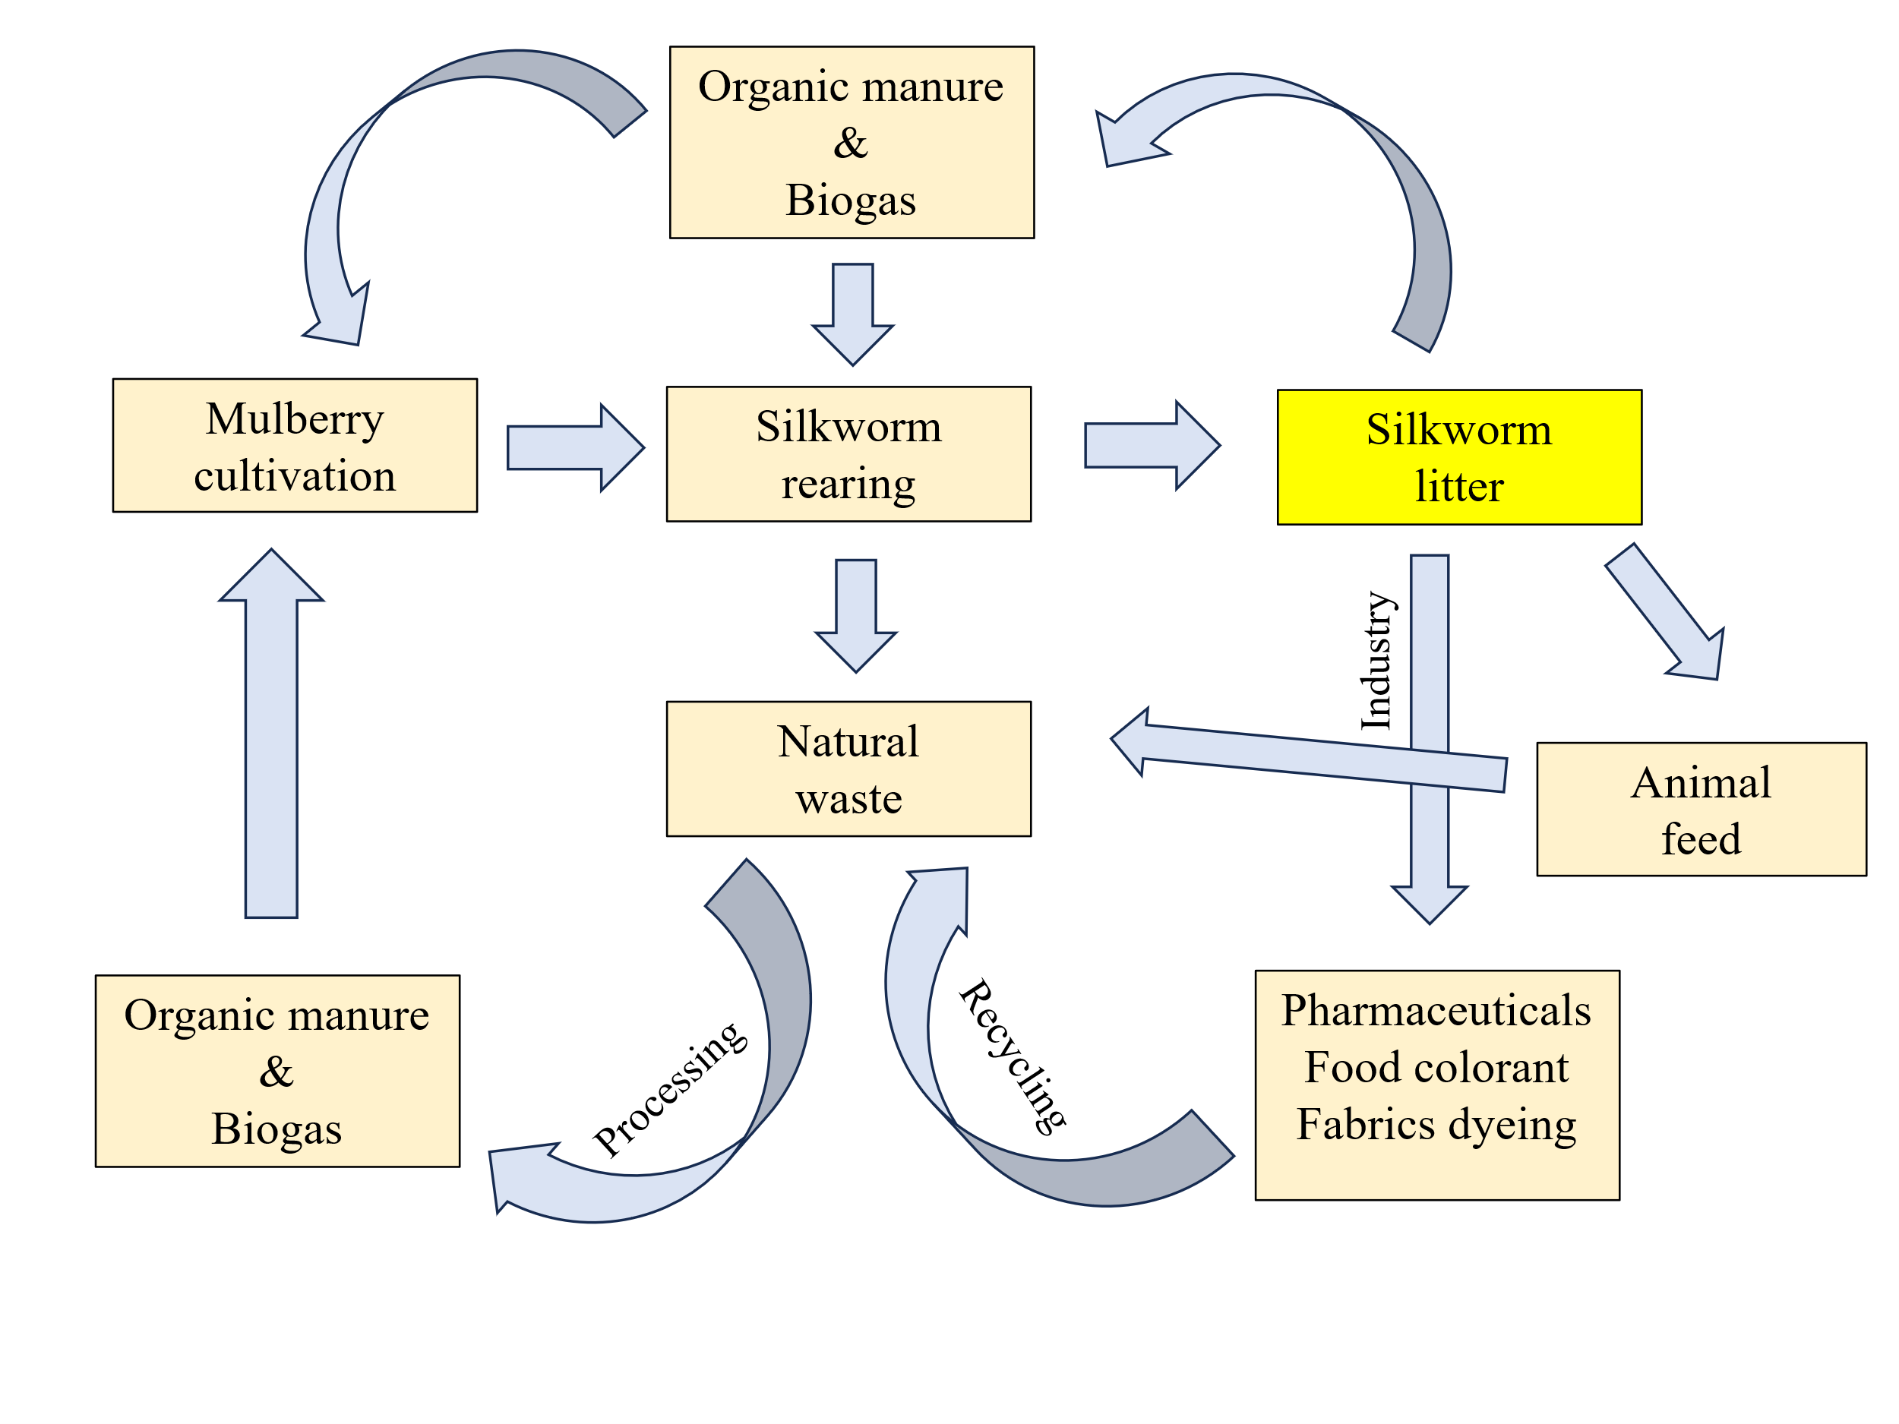
Silkworm litter is a bio-resource rich in organic matter, macro and micronutrients, and beneficial microbial populations, making it a promising input for sustainable agriculture. Its potential conversion into liquid organic manure, compost, biogas, cattle, prawn, fish, poultry feed at farm level or as a raw material in various industries aligns with the principles of circular

Fig. 1: Circularity in sericulture by value addition and recycling of Silkworm litter
economy by closing nutrient loops, reducing dependency on chemical fertilizers, and promoting soil health (Fig. 1).
Silkworm litter adds higher value through industrial utilization viz.,
• It is used in pharmaceutical industry
• Chlorophyll content in litter is used in food industry as natural content
• It is used in textile industry as natural dye Farmers can get additional income by selling silkworm excreta to industries for further higher value addition.
Presently Indian Sericulture industry is passing through a lean phase, and there is a need to boost the income of sericulturists by effectively utilizing the bioresources particularly the silkworm excreta. It is necessary to find new sources of income for small farmers through reuse of by-products that leads to circular economy. The concept of circular economy paves a way to reduce imbalance between availability of raw materials and amount of waste generated.
- ORGANIC MANURE:
One hectare of mulberry farm produces 15 MT of sericultural waste annually. It is equivalent to 280-300 kg of nitrogen, 90-100 kg of phosphorus and 150-200 kg of potash (Dandin & Giridhar, 2014). Utilization of these byproducts reduces reliance on chemical fertilizers, improves soil health and nutrient availability to mulberry plants enhancing leaf quality. The litter can be used as excellent organic manure. Yang and Zhu, (2002) revealed that every 100 kg of silkworm manure contains 1.28 kg of pure nitrogen, 0.48 kg of available phosphorus, 0.21 kg of potassium. Its fertilizer effect is equivalent to 14 kg of ammonium sulphate, 6 kg calcium phosphate, 15.5 kg of urea, and 5 kg of potassium sulphate. Xiao-ping et al. (2011) studied the nutrient properties of silkworm excreta organic fertilizer (SEOF). The results showed a significant increase in total nitrogen, phosphorus and potassium contents by 58.0 per cent, 84.4 per cent and 29.7 per cent higher than those in the raw material, respectively after fermentation. The addition of microbial inoculants reduced fermentation time and carbon and nitrogen losses.
Adding silkworm excreta fertilizer increases nutrient contents in the soil as well as organic matter content and soil enzyme activities, much more than goat faeces (Yang et al., 2025). Chen et al. (2022) showed that application of silkworm excreta organic fertilizer to paddy field is an effective method to decrease Cadmium availability. It also improved pH and Organic matter (OM) content of soil. Application of manure produced out of silkworm litter is highly beneficial for mulberry cultivation and is much effective than conventional use of farm yard manure (Shen et al., 2024).
Shanmugam et al. (2020) showed that compost made from silkworm excreta alone (400 g/plant) recorded the longest shoot length (99 cm), greater number of branches (9.5), greater number of leaves (28.15), highest 100 leaf weight (450.35 g) and highest leaf yield (12935 kg/ha/harvest). Further, highest values of larval weight, single cocoon weight, shell ratio, single cocoon filament length and denier were also recorded.
Mala and Chandrashekhar (2020) studied the influence of seri-waste bio-digester on growth and yield of mulberry. The results indicated that the maximum plant height (163.19 cm), number of branches plant-1 (13.32), number of leaves per branch (33.00) and leaf yield (1012.33 g/plant) was recorded in mulberry plot applied with 50 per cent seri bio-digester effluent + 25 per cent bio-digester effluent + 25 per cent RDF over control. Further, the highest macronutrients and secondary nutrient content of mulberry leaf was recorded maximum in 50 per cent seri bio-digester effluent + 25 per cent biodigester effluent + 25 per cent RDF over 100 per cent RDF.
Shravanilakshmi et al., (2025) studied effective utilization of silkworm litter as liquid manure. The study showed the effectiveness of silkworm litter based liquid organic manure (SLLM) at different doses along with Recommended Dose of Fertilizers (RDF) in improving the growth, yield and nutritional quality of mulberry. The results showed that SLLM being liquid manure contained nutrients in readily available form which supplied the nutrients that are required for mulberry growth and development. Indicating enhanced mulberry growth, yield along with improved quality parameters. Quality of mulberry leaves has direct influence on quality of cocoon, underlining the need for better quality feed for silkworms (Vijaya et al., 2009).
The above studies shows that it is possible to fertilize mulberry with silkworm excrement, which is an ideal example of a circular economy. The waste from silkworm rearing becomes fertilizer for the host plant mulberry which is again utilized as food for silkworms.
- VERMICOMPOSTING
Vermicomposting is an eco-friendly method that uses earthworms to break down organic waste, producing nutrient-rich compost ideal for agriculture (Lim et al., 2016; Lee et al., 2018). It has a tremendous scope in the recycling of sericultural wastes. proper utilization of sericultural waste as raw material for vermicomposting serve as organic manure and helps to improve the soil health and nutrient availability. Farmers are increasingly opting for organic agricultural methods that require little chemical fertilizers. Mulberry production can be made sustainable and cost-effective by reusing natural wastes from sericulture as compost and vermicompost. While synthetic fertilizers have rapid effects on vegetation, organic manure plays a significant role in improving output. Vermicompost is an environmentally beneficial and effective way to recycle agricultural residues.
Venugopal et al., (2010) given the protocol for vermicomposting involves utilizing organic residues such as silkworm litter, bed refuse, farm weeds and similar materials. These residues are first loaded into an open pit or trench and moistened with sufficient water mixed with cow dung or biogas plant slurry. The mixture is left for 25-30 days for partial decomposition, which serves as a starter feed for earthworms. During this process, the temperature of the semi-decomposing material rises to 50-60 °C. To bring the temperature down to the optimum level, the material should be turned once or twice. After cooling, the chamber is filled with 200-300 kg of semi-decomposed sericultural waste containing 30-40% moisture. Recommended species of earthworms are then introduced into the feed, with juvenile worms released at the rate of 1.5 kg per metric tonne of residue. Water is sprinkled every 2-3 days to maintain adequate moisture (30-40%), and the setup is covered with dry weeds to protect against predators. Earthworms begin depositing brown to black vermicasts on the surface of the feed within 1-2 weeks. Once vermicasts are detected, watering is stopped to allow drying, after which the vermicasts are harvested. Harvesting is done by scraping the top 6 cm layer using a lawn rake after one week of drying. The conversion of waste into vermicompost may range from 65-80% of the raw material, depending on the earthworm species used. Within 60-70 days from the introduction of earthworms, the entire semi-decomposed residue is transformed into vermicasts. The process can be repeated 2-3 times a year with fresh feed (Dandin et al., 2006). The nutrient composition of vermicompost includes Nitrogen (1.5%), Phosphorus (0.9-1.7%), Potassium (1.5-2.4%), Calcium (0.5-1.0%), Magnesium (0.2-0.3%), Sulphur (0.4-0.5%), along with micronutrients, vitamins, enzymes and plant growth regulators.
Vasanthi (2019) studied the vermi-stabilization of silkworm litter mixed with pre-decomposed leaf litter in different combinations using the earthworm Eisenia fetida. The total nutrient content like N, P, K was higher in all the treatments with combination of earthworm and silkworm litter than in treatments without combination of both. The nutrient content of vermicompost increased gradually according to the ratios of substrates. The microorganism isolated from silkworm and leaf litter (compost without inoculation of earthworms) was Bacillus sp. and Streptococcus sp., Pseudomonas sp. and Solmenella sp., respectively. and E.coli in vermicompost.
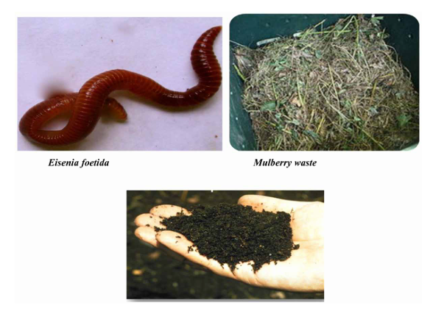

Fig. 2: Silkworm litter utilization in vermicomposting

- BIOGAS PRODUCTION
Energy crisis is one of the greatest challenges faced by the mankind today. The reliance on petroleum stocks for energy raises a number of problems including cost and uncertain supplies of petroleum. The demand for energy is also increasing due to increase in population. Hence, there is a need to tap both conventional and non-conventional energy sources to meet the growing energy demand of the country. The need for environmental safety and the atmosphere as a result of the negative impacts of using non-renewable energy sources has raised awareness about the usage of renewable energy sources, including biomass. The prospect of rising energy consumption and global warming has made it difficult to create alternative and renewable energy sources (Medipally et al., 2015; Ellabban, 2014). Renewable energy uses eco-friendly raw materials produced from ecosystems and garbage (Hastik et al., 2015). Biogas has been regarded as one of the most capable and dependable energy sources (Scarlat et al., 2018). According to Lyytimaki et al. (2018), the advantages of using biogas include its economic feasibility, cheap monetary input, eco-friendliness, and endless potential. It is now clearly proven that all organic waste is used without any harmful consequences (Paolini et al., 2018). Biogas is a 'zero-waste' energy resource that generates both energy and bio-manure.
Biogas production not only provides a financial benefit, but the manure is also considerably more homogeneous. Defatted mulberry silkworm pupae have already been studied as a biogas feedstock (Viswanath & Nand 1994). Insect technology produces waste mostly as food residue combined with excreta. It is an excellent substrate for producing biogas using an anaerobic fermentation method because it provides a suitable environment for the development and optimal metabolic activity of the bacteria involved. This substrate comprises exclusively biodegradable organic matter, has an ideal C/N ratio of 15-35 (Mao et al., 2015), and contains no inhibitory chemicals. However, to achieve optimal hydraulic retention and biogas generation, it's important to consider the substrate composition, organic loading rate, process temperature (25-35.5ºC), and pH (6.7-9.4). According to Mao et al. (2015), increasing the organic loading rate improves process efficiency, while exceeding it can inhibit bacterial activity.
In rural areas, cattle dung is the commonest source of feed material for biogas production. For a family of 4 to 5 persons, approximately 2 m³ size biogas units produce the necessary energy in the form of methane. However, the quantity of cattle manure available with small and marginal farmers may not be sufficient to feed the 2 m 3 biogas plant. Hence, there is a need to exploit other alternative sources of feed materials for bio - gasification process. Silkworm larval Litter, a best supplement: Being a labour-intensive and highly renumarative agro-based industry, sericulture is fast expanding in the rural sector. The silkworm larval litter, generated by feeding mulberry leaves from one acre, will be around 1,000 kg on the feed stock equivalent and this can replace the feedstock from one cattle. In addition, this nitrogen rich waste is a possible supplement to the nitrogen deficient agricultural wastes that are put into the plant for biogas generation.
Lochynska and Frankowski (2018) showed that both silkworm breeding waste and silkworm excreta have a high potential for obtaining biogas. The biogas yield from these by-products is comparable to other substrates of agricultural origin, such as cattle, pig and chicken manures. Fermentation in mesophilic conditions allows for the production of 167.32 m³ / Mg TS of methane and 331.97 m³ / Mg TS of biogas from silkworm excreta and 256.59 m³ / Mg TS of methane and 489.24 m³ / Mg TS of biogas from silkworm breeding waste. Both of the materials were decomposed in 19 days, while approximately 80% of accumulated methane production was achieved in the first 10 days.
Table 1: Biogas production and energy potential of Silkworm excreta and rearing waste (Łochyńska and Frankowski, 2018)
Sources | Silkworm excreta | Rearing waste
Biogas production (m³/ton of Fresh mass) | 105.81 | 125.59
Biogas production (m³/ton of Fresh mass) | 53.33 | 65.81
Biogas production (m³/ton of Fresh mass) | 50.4 | 52.4
Heat energy (GJ/ 1 ton of fresh mass) | 0.80 | 0.99
Electrical energy (MWh / 1 ton of fresh mass) | 0.20 | 0.24
- MUSHROOM CULTIVATION
The cultivation of mushrooms has increased significantly in recent years. Mushroom is a rich source of protein, vitamins and minerals, which provide nutritional security, economic stability and employment to rural people (Royse, et al., 2016). Agaricus mushroom is an efficient lignin degrader that can be grown on different lignocellulosic wastes (Navi et al., 2011; Reddy et al., 2011). Cultivation begins with spawn, which is used to inoculate the substrate. Under optimal conditions, mushrooms can be harvested between 10 days and 6 months after spawning, depending on the species and strain used. It is believed that prehistoric humans consumed mushrooms as food. Silkworm litter due to its nutrient composition, can be used in mushroom cultivation, which involves several stages viz., preparing compost from silkworm excreta, compost completion, spawning, casing, pinning, and cropping. The following procedure is followed for mushroom cultivation using silkworm litter (Reddy et al., 2018).
Substrate Preparation: Silkworm litter is mixed with other substrate materials, typically paddy straw, chicken manure and sometimes spent silk moth residue. The standard substrate for button mushroom (Agaricus species) includes paddy straw, chicken manure, wheat bran, and gypsum, but these can be partially substituted with silkworm litter and related sericulture residues.
Composting Process: The litter is composted along with the other ingredients using fermentation, which improves the breakdown of cellulose and lignin, thus making nutrients more available for mushroom growth.
Application: After composting, this substrate is inoculated with mushroom spawn and kept under controlled conditions for fruiting.
Reddy et al., (2018) reported that substituting up to 50% of paddy straw with silkworm litter and other sericulture residues results in a slightly higher mushroom yield than the pure paddy straw control. Mushrooms grown on substrates containing silkworm litter tend to have higher protein and fat content compared to those cultivated on pure paddy straw, while the sugar content can also be enhanced depending on the mix ratio. The nutrient profile and structure of silkworm litter makes it a suitable material for mushroom substrates with minimal processing.

- ANIMAL / POULTRY FEED
Presently Indian Sericulture industry is passing through a lean phase, and there is a need to boost the income of sericulturists by effectively utilizing the bioresources particularly the silkworm excreta. Silkworm litter contain proteins (50-60%), lipids (30-35%), carbohydrates (5-10%), chlorophyll (2-5%) (Ghosh et al., 2020).
Silkworm litter is rich in protein content approximately 19 % in chawki worm litter, 15 % in late age silkworm (PM X CSR 2). It is much more than wheat (5.7 %), paddy husk (13.2 %) and wheat bran (18.3 %). Due to this characteristic silkworm litter can be effectively utilized as poultry feed for broilers (Patil et al., 2006) as partial substitute for traditionally used feeds soya meal or fishmeal. Shivashankar and Ashoka (1997) opined that use of silkworm litter as feed cum fertilizer in fresh water prawn culture could improve the production rate of prawns (701.55 kg/ ha/180 days).
Patil et al., (2006) exploited the possibility of supplementing the vegetable based poultry feed with animal protein source utilizing the silkworm litter, an abundant natural resource which would otherwise go as waste. They monitored the effect of fortification of poultry feed with Silkworm excreta on growth and development of broiler birds. The fortified poultry feed extrafoliated at different concentrations (1, 2, 3, 4 & 5 %) to the finisher feed was fed to 3 weeks old broiler birds till 6th week. Fortified poultry feed at 1 % could significantly enhance broiler biomass at 6th week (1043 g) (Fig. 3). The chicken produced out of extrafoliated feed recorded higher Iron (24.30 ppm), Na (7.00 %) content and fat body (4.45 %) as compared to control. The higher fat content is attributed due to presence of higher (2.84 %) lipid in feed supplement and can be removed during dressing.
The biochemical analysis of the extrafoliant revealed presence of higher fat / oil content enabling its scope to use the extrafoliant especially in starter feeds which contain high protein low energy crumbs. This technology is low cost, ecofriendly and leads to value addition of silkworm litter.
There is great potential to supplement the conventionally used soya meal based poultry feed with silkworm excreta presently going as huge natural waste into value added product particularly in the changing global scenario and market trend influenced by WTO and GATT. There is scope to use the extrafoliant especially in starter feeds which contain high protein low energy crumbs.
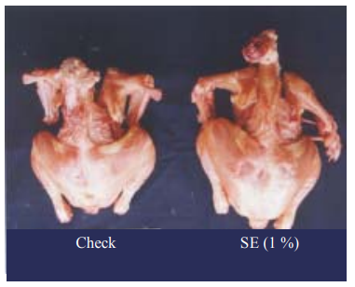

Fig. 3: Effect of supplementation of silkworm excreta on broiler size

- PHARMACEUTICAL AND FOOD INDUSTRY
Silkworm (Bombyx mori) excreta have long been used in the pharmaceutical and food industries as a natural colorant. In some countries, instant silkworm tea is available due to its traditional Eastern medicine health benefits. In traditional medicine, silkworm faeces have been used as a therapeutic agent in China, Korea and some Eastern Asian countries to treat infectious diseases, headache and abdominal pain (Tulp and Bohlin, 2004). Moreover, silkworm excreta are a good source of natural colorant for the food industry. Silkworm excreta are also available in the form of an instant tea, which is claimed to be a nutraceutical product. Silkworm fed on mulberry leaves were found to excrete more than half of the leaves without digestion, suggesting that some of the compounds in the excreta are from mulberry leaves and some are bio transformed in the silkworm intestine.
Vimolmangkang et al. (2014) for the first time identified 1-tritriacontanol, a very long chain fatty alcohol (VLCFA) and lupeol, a phytosterol, in addition to β-sitosterol in silkworm excreta. The cytotoxic activity of 1-tritriacontanol was assayed against vero cells and different human cancer cell lines and were found to be inactive, demonstrating their safety. These data support the use of silkworm excreta in traditional medicine and show its potential as a novel natural source of very long chain fatty alcohols. This would increase the value of litter in sericulture industry and raise the income of local farmers.
1 - tritriacontanol is a Very long chain fatty acid (VLCFA) containing 33 carbon atoms. It is produced by microbes within the silkworm intestine. Silkworm excreta have been used to lower blood cholesterol in traditional medicine. Clinical studies have shown that it lowers cholesterol levels and blood pressure. This biological activity would be due to VLCFAs present in silkworm excreta. According to numerous studies, consumption of VLCFAs decrease LDL cholesterol and increase HDL cholesterol in humans (Mas, 2000).
Lupeol and β-Sitosterol are terpenoid compounds that are found in silkworm excreta. However, lupeol and β-sitosterol would not be produced from silkworm itself but from mulberry leaves (Morus alba L.), which is the only food source for silkworm (Raju, 1996). Traditionally, silkworm excreta have been used in treatment of abdominal pain suggesting its analgesic and anti-inflammatory effects. In addition, crude extract of silkworm faeces used in traditional Chinese medicine has shown anti-inflammatory activity in carrageenan-induced edema rats (Imam et al., 2007). Recently, flavonoids newly isolated from silkworm droppings exhibited an anti-inflammatory activity via a suppression of inflammatory mediators (Park et al., 2003). However, lupeol in faeces is also partly responsible for this activity (Vimolmangkang et al. 2014).

Table 2: Medicinal uses of silkworm litter
Chlorophyll derivatives | Extracted from silkworm excreta could be used as a photosensitizer (650 nm) for photodynamic therapy of cancer tumors
Solanesol | The feces have been found to contain solanesol, a highly valued precursor for many cardiac drugs
Phytol | Phytol extracted from silkworm faeces is used in the preparation of vitamin E, K, and carotene as a source of vitamin A
Chlorophyll | Chlorophyll extracted from the feces of silkworm is used as a medicine for gastric disorders such as ulcer and hepatitis.  It is also used to treat liver and blood diseases
Pectin | Pectin from silkworm feces reduces blood triglyceride and blood cholesterol
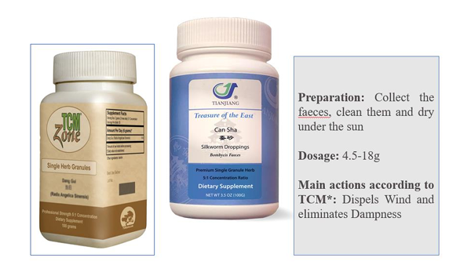
CAN SHA – A dietary supplement herb granules
Silkworm feculae (also called Can-Sha in Chinese) is the droppings of silkworm (Bombyx mori L.; Bombycidae). In traditional Chinese medicine, it is used to expel wind, harmonize stomach, disperse dampness, and transform turbidity. It has been reported to promote wound healing, haematopoiesis by bone marrow, liver protection, antiulcer, antitumor, antidiabetic, and anti-hyperlipidaemia. The mulberry leaf, the fodder of silkworm, is also a traditional Chinese medicine. (Chou et al., 2018)
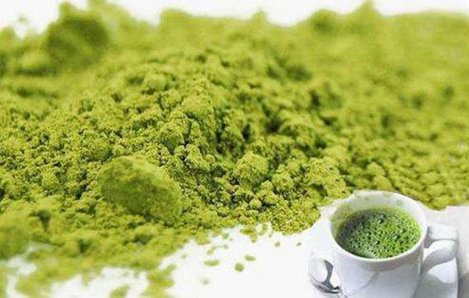
MATCHA- a powdered tea product
Matcha is a powdered tea product with the water removed, usually brewed in hot water and consumed, but also commonly used for making pastries and desserts. (Chou et al., 2018)

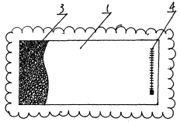
Silkworm excreta health pillow
It is made of cotton cloth and cylindrical particulate. Silkworm excreta are loaded in the bag and account for 80 - 95 percent of the cubage of the pillow core bag. It improves sleep, strengthens the brain, enhances intelligence and refresh the mind (Chou et al., 2018).

- FABRICS DYEING
A number of active substances, such as chlorophyll (and derivatives), flavonoids and carotenoids are found in silkworm excreta (SE). Chlorophyll for instance, which accounts for 0.8-1% of dry matter content of SE, is higher in SE than that in mulberry leaves (ML) (Hu et al., 2005; Wu et al., 2012). Chlorophyll and carotenoids are the natural colorants presented in SE (Vimolmangkang et al., 2014), making the sericulture byproduct possible to be used in textile dyeing industry.
One of the most common processes is to extract chlorophyll from SE with organic solvents, and the extracted chlorophyll was then processed further into sodium copper chlorophyllin by saponification and other chemical reactions (Han et al., 2013). Mordant dyeing is another technique commonly used to improve colour fastness of fabrics dyed with natural colorants extracted from SE (Vila et al., 2018). Mud dyeing is a traditional dyeing technique from ancient China and Japan, which uses iron in certain type of local soil to react with tannic acid in dye. Fabric with rare dark or black shade can thus be achieved.
Tang et al., (2024) investigated the efficiency of chlorophyll and its derivatives from mulberry leaves and silkworm excrement on dyeing of fabrics. It is seen that fabrics dyed with ML shows bright green colour whereas SE dyed dark green brown. These fabric colours are similar to the natural colour of their dye origin, indicating a successful adsorption of natural colorants onto fabric surface in the paste dye bath. It is seen that fabrics dyed with SE exhibit deeper green brown colour shade than that dyed with ML due to the presence of pyropheophytin. In addition to chlorophyll derivatives, a small amount of flavonoid and carotenoid (such as lutein and β-carotene) are known presented in SE. These natural colorants can bond well with protein fibers in dyeing process which also contribute to the green brown colour seen in SE dyed fabrics (Zhu and Zhang, 2014).
Table 3: UV protective performance of dyed fabrics. (Tang et al., 2024)
Fabric | Source of dye | Transmittance |  | Ultraviolet protection factor | Grade
Fabric | Source of dye | T (UVA) | T (UVB) | Ultraviolet protection factor | Grade
Silk | Undyed (control) | 8.2 | 4.41 | 15.25 | Poor
Silk | Mulberry leaves | 2.0 | 1.86 | 44.68 | Good
Silk | Silkworm excreta | 1.76 | 1.65 | 50.77 | Excellent
Wool | Undyed (control) | 9.29 | 4.32 | 15.68 | Poor
Wool | Mulberry leaves | 2.05 | 1.87 | 45.03 | Good
Wool | Silkworm excreta | 1.81 | 1.58 | 52.66 | Excellent

Table 3 shows that fabrics dyed with ML and SE shows a significantly reduced transmittance in the UVA and UVB regions of the UV spectrum and an increase in UPF values when compared with the undyed fabrics used as control, for both silk and wool fabrics. This could be because flavonoid and carotenoid presented in natural dye have strong ability to absorb UV light. It is seen that SE dyed samples have lower UVA and UVB transmittance and higher UPF values than that of the samples dyed with ML. This could be due to the darker shade presented in SE dyed fabrics. It has been shown in previous studies that dark fabrics transmit less UV light than light coloured fabrics, and that the darker the shade of any color, the higher the protection.

- CONCLUSION
The potential of silkworm litter can be harnessed in diverse ways, including its use as manure, feed for fishes, milch animals, and poultry, as well as in biogas production, pharmaceuticals, cosmetics, carrier materials, and organic manure formulations, thereby generating additional income for farmers and small-scale industries. However, in-depth studies exploring these applications within the circular economy framework are still lacking, particularly in the agricultural sector, where such theoretical frameworks have yet to be widely adopted. The global economy’s prevailing linear model-relying on raw materials to produce goods that become waste has resulted in resource depletion and environmental degradation, a trend mirrored in agriculture due to intensive plant and livestock production. Transitioning to a circular economy, where waste from one process becomes a resource for another, can reduce waste generation and mitigate environmental impacts.
DISCLAIMER (ARTIFICIAL INTELLIGENCE)
Author(s) hereby declare that NO generative AI technologies such as Large Language Models (ChatGPT, COPILOT, etc) and text-to-image generators have been used during writing or editing of manuscripts.

REFERENCES
Chen, J., Bian, P., Huang, H., Zhong, K., Huang, D., Nong, X. & Zhang, C. (2022). The mechanism of silkworm excrement organic fertilizer to reduce the Cd availability in paddy soil. Soil and Sediment Contamination: An Int. J., 31(1), 1-14.
Chou, T.Y., Yang, M.J., Tseng, S.K., Lee, S.S. & Chang, C.C. (2018). Silkworm droppings as an enriched source of tea flavonoids. J. Food Drug Analysis, 26(1), 41-46.
Dandin, S. B. & Giridhar, K. (2014). Hand Book of Sericulture Technologies, Central Silk Board, Bangalore, P. 427.
Ellabban, O., Abu-Rub, H., & Blaabjerg, F. (2014). Renewable energy resources: Current status, fu ture prospects and their enabling technology. Renewable Sustain. Energy Reviews, 39, 748-764. doi:10.1016/j.rser.2014.07.113
Ghosh, A. et al. (2020). Evaluation of proximate composition and antioxidant properties in silk-industrial byproduct. LWT 132, 109900–109909
Grzeskowiak, J., & Lochynska, M. (2021). Prospects and directions of development of mulberry silkworm (Bombyx mori L.) breeding, Przegląd Hodowlany, 6,12-17.
Grzeskowiak, J., Lochynska, M. & Frankowski, J. (2022). Sericulture in terms of sustainable development in agriculture. Problemy Ekorozwoju, 17(2), 210-217.
Han, J., Wang, Y., Ma, J. J., Wu, Y. C., Hu, Y. T., Ni, L., & Li, Y. F. (2013). Simultaneous aqueous two-phase extraction and saponification reaction of chlorophyll from silkworm excrement. Sep. Purif. Technol. 115, 51-56. https://doi.org/10.1016/j. seppur.2013.04.047.
Hastik, R., Basso, S., Geitner, C., Haida, C., Poljanec, A., Portaccio, A., ... Walzer, C. (2015). Renew able energies and ecosystem service impacts. Renewable Sustain. Energy Reviews, 48, 608-623. doi:10.1016/j.rser.2015.04.004.
Hu, J., Zhang, Y., Li, H., Yao, T., Liu, H., Lei, H., & Lu, H. (2005). Studies on the stability of Cu, Na-chlorophyll from the Silkworm Excretion. Acta Sericol. Sin. 370-373. https://doi.org/10.3969/j.issn.0257-4799.2005.03.030.
Imam, S., Azhar, I., Hasan, M. M., Ali, M. S. & Ahmed, S. W. (2007). Two triterpenes lupanone and lupeol isolated and identified from Tamarindus indica linn, Pak. J. Pharm. Sci., 20, 125-127.
Jarecki, W., Tobiasz-Salach, R. & Bobrecka-Jamro, D. (2019). Development of organic farming in Poland over the period of 2004-2018. Acta Agrophysica, 26(4), 23-30, DOI: 10.31545/aagr/118013.
Lee, L. H., Wu, T. Y., Shak, K. P. Y., Lim, S. L., Ng, K. Y., Nguyen, M. N., & Teoh, W. H. (2018). Sustainable approach to biotransform industrial sludge into organic fertilizer via vermicomposting: A mini-review. Journal of Chemical Technology and Biotechnology (Oxford, Oxfordshire), 93(4), 925–935. doi:10.1002/jctb.5490.
Li, M. Q., Chen, L., Dai, Y. T., Li, J. C., Li, F., Li, Q., Yu, Z. H., Chai, K. Q. & Zhu, Y. Q. (2021). Differential metabolomics and network pharmacology analysis of silkworm biotransformation between mulberry leaves and silkworm droppings. Evid. Based Complement. Altern. Med. https://doi.org/10.1155/2021/8819538.
Liao, Q. H., Peng, X. F., Fang, H., Turng, L. S., Huang, A. & Chang, C. C. (2020). Fabrication of poly (lactic acid)/silkworm excrement composite with enhanced crystallization, toughness and biodegradation properties. J. Polym. Environ. 28, 295-303. https:// doi.org/10.1007/s10924-019-01595-9.
Lim, S. L., Lee, L. H., & Wu, T. Y. (2016). Sustainability of using composting and vermicomposting technologies for organic solid waste biotransformation: Recent overview, greenhouse gases emissions and economic analysis. Journal of Cleaner Production, 111, 262–278. doi:10.1016/j.jclepro.2015.08.083.
Liu, Q., Zhao, S., Zhang, Y., An, X., Wang, Q., Li, S., Lin, A., Du, Y. & Wei, H. (2022). Biochar nanozyme from silkworm excrement for scavenging vapor-phase free radicals in cigarette smoke. ACS Appl. Bio Mater. 5, 1831–1838. https://doi.org/ 10.1021/acsabm.1c01080.
Lochynska, M., Frankowski, J. (2018). The biogas production potential from silkworm waste, Waste Manag., 79, 564-570, DOI: 10.1016/j.wasman.2018.08.019.
Lyytimäki, J. (2018). Renewable energy in the news: Environmental, economic, policy and technology discussion of biogas. Sustain. Prod. Consum., 15, 65-73. doi:10.1016/j.spc.2018.04.004
Mala, P. H. & Chandrashekhar, S. (2020). Influence of seri-waste bio-digester on biochemical constituents, growth and yield of mulberry. Int. J. Che. Stud., 8(4), 2373 2377.
Manjunath, R., Kumar, A. & Arun Kumar, K. (2020). Utilisation of sericulture waste by employing possible approaches. Contam. Agric. Sources, Impacts Manag. 1, 385-398. https://doi.org/10.1007/978-3-030-41552-5_19.
Mao, C., Feng, Y., Wang, X., & Ren, G. (2015). Review on research achievements of biogas from anaero bic digestion. Renewable Sustain. Energy Reviews, 45, 540–555. doi:10.1016/j.rser.2015.02.032
Mas, R. (2000). Policosanol. Drugs Future, 25(6).
Medipally, S. R., Yusoff, F. M., Banerjee, S., & Shariff, M. (2015). Microalgae as sustainable renewable energy feedstock for biofuel production. BioMed. Res. Int. PMID:25874216.
Narayana Reddy, R., K. G. Banuprakash, T. H. Shankarappa, & Mallesha, B. C. (2018). Utility of Different Silkworm (Bombyx mori L.) Residues for Cultivation of Button Mushroom. Int. J. Curr. Microbiol. App. Sci. 7(4), 473-479. doi: https://doi.org/10.20546/ijcmas.2018.704.055
Navi, V., Patil, C. R., Shankarappa, T. H. & Naik, S. T. (2011). Suitability of agro forest residues for cultivation of Pleurotus florida. Environ. Ecol., 29(1), 179-182.
Paolini, V. (2018). Environmental impact of biogas: A short review of current knowledge. J. Environ. Sci. Heal. Part A, 1–8, doi:10.1080/10934529.2018.1459076
Park, J. H., Lee, D. Y., Yun, P., Yeon, S. W., Ko, J. H., Kim, Y. S. & Baek, N. I. (2011). Flavonoids from silkworm droppings and their promotional activities on hemeoxygenase-1. J. Asian Nat. Prod. Res., 13, 377-382.
Park, Y. J., Kim, W. S., Ko, S. H., Lim, D. S., Lee, H. J., Lee, W. Y. & Lee, D.W. (2003). Separation and characterization of chlorophyll degradation products in silkworm using HPLC-UV-APCI-MS, J. Liq. Chromatogr. Related Technol., 26, 3183-3197.
Patil, R. R., Mulla, J. A., Ankad, G., Kusugal, S. & Rayar, S.G., (2006). Silkworm Excreta - A Potential Animal Source Poultry Feed Supplement. In Int. Workshop on Silk Handcrafts Cottage Ind. Silk Enterprises Dev. in Turkey, 6th–10th March, pp.566-571.
Qayoom Kahkashan, and Shaista Manzoor. 2024. “Recent Sustainable Practices for Eco-Friendly Utilisation of Sericultural Waste Products”. Journal of Experimental Agriculture International 46 (7):918-27. https://doi.org/10.9734/jeai/2024/v46i72646.
Raju, S. (1996). Utilization of sericultural by products - A Chinese example, Indian Silk, 35: 19-20.
Reddy, R. N., Shankar, S., Mallesha, B. C. & Santhosh, G. P. (2011). A novel approach to silkworm litter management. In: Golden Jubilee Conference- Sericulture Innovations: Before and Beyond 2011, Proceedings of the national conference, 28-29th Jan. 2011. CFTRI, Mysore, 481 485.
Royse, D. J., Baars, J. & Ta, Q. (2016). Current overview of mushroom production in the world. In: Zied DC, editor. Edible and medicinal mushrooms: technology and applications. New York: Wiley.
Scarlat, N., Dallemand, J. F., & Fahl, F. (2018). Biogas: Developments and perspectives in Europe. Renewable Energy, 129, 457–472. doi:10.1016/j.renene.2018.03.006.
Sekowski, M. (2016). Gospodarka o obiegu zamkniętym - szanse dla rolnictwa i leśnictwa, Centrum Doradztwa Rolni czego w Brwinowie.
Shanmugam, R. P., Mohanraj, P., Krishnamoorthy, S. V. & Chozhan. (2020). Stimulus of Silkworm Excreta on quality and quantity of cocoon production. Int. J. Creat. Res. Thoughts, 8, 1166-1171.
Shen, X., He, J., Zhang, N., Li, Y., Lei, X., Sun, C., Muhammad, A. & Shao, Y. (2024). Assessing the quality and eco-beneficial microbes in the use of silkworm excrement compost. Waste Manag., 183, 163-173.
Shevchenko, T., Vavrek, R., Danko, Y., Gubanova, O., Chovancova, J. & Mykhailova, L. (2021). Clarifying a Circularity Phenomenon in a Circular Economy under the Notion of Potential. Problemy Ekorozwoju/ Probl. Sustain. Develop., 16(1), 79-89.
Shivashankar, N. & Ashoka, J. (1997). Use of silkworm rearing waste in Freshwater prawn culture. Indian J. Seric., 36 (7), 161-163.
Shravanilakshmi, V., C S Kallimani, Vinoda, K. S., Doreswamy, C., & Asha, N. N. (2025). Exploring Silkworm Litter as a Liquid Manure: A Key to Boost Mulberry Growth and Productivity. J. Adv. Bio. Biotech. 28(1), 144-154. https://doi.org/10.9734/jabb/2025/v28i1186 9
Sohn, B. H., Park, J. H., Lee, D. Y., Cho, J. G., Kim, Y. S., Jung, I. S., Kang, P. D. & Baek, N. I. (2009). Isolation and Identification of Lipids from the Silkworm (Bombyx mori) Droppings. J. Korean Soc. Appl. Biol. Chem. 52, 336-341. https://doi.org/10.3839/ jksabc.2009.060.
Tang, Y., Xia, W., Li, Z. & Li, Q. (2024). Novel and environmentally friendly paste-bath dyeing of protein fibers with mulberry leaf and silkworm excrement. Ind. Crops. Prod., 209, 11793.
Tulp, M. & Bohlin, L. (2004). Unconventional natural sources for future drug discovery. Drug Discov. Today, 9, 450-458.
Tulp, M. & Bohlin, L. (2004). Unconventional natural sources for future drug discovery, Drug Discov. Today, 9, 450-458.
Vasanthi Padmanabhan, (2019). Efficiency of the earthworm, Eisenia fetida in vermi stabilization of silkworm litter mixed with leaf litter. J. emerging tech. innovative res., 6(6), 57-63.
Venugopal, A., Chandrasekhar, M., Naidu, B. V., & Raju, S. (2010). Vermicomposting in Sericulture using Mixed Culture of Earthworms (Eudrillus eugineae, Eisenia foetida and Perionyx excavatus)-A Review. Agric. Reviews, 31(2), 150-154.
Vila, N., Silva, M., Musialak, A., Fernandes, M., Souto, A. & Ferreira, A. (2018). Silkworm excrement used for dyeing textiles. IOP Conf. Ser. Mater. Sci. Eng. IOP Publishing, 012028.
Vimolmangkang, S., Somkhanngoen, C. & Sukrong, S. (2014). Potential pharmaceutical uses of the isolated compounds from silkworm excreta. Chiang Mai J. Sci. 41, 97–104. https://www.thaiscience.info/Journals/Article/CMJS/10905208.pdf.
Viswanath, P., & Nand, K. (1994). Anaerobic digestion of silk industry wastes. Bioresource Tech., 49(3), 273–276. doi:10.1016/0960-8524(94)90052-3.
Wenhua, L. (2001). Agro-ecological Farming Systems in China (Man and the Biosphere Series). Chinese Academy of Sciences. Beijing, China: UNESCO.
Wu, Z., Kang, L., & Cong, Y. (2012). Improvement on extraction of chlorophyll and synthesis of pheophorbide from silkworm excrement by orthogonal experiment. Chin. J. Inf. Tradit. Chin. Med. 19, 52-54. https://doi.org/10.13748/j.cnki.issn1007- 7693.2012.08.003.
Xiao-Ping, C., Ya-Jun, X., Guang-En, L. & Wei Yong, S. (2011). Silkworm excrement organic fertilizer: Its nutrient properties and application effect. Yingyong Shengtai Xuebao, 22(7), 843-857.
Xu, L., Wang, C., Liu, C., Liu, J. & Xiang, W. (2014). Antioxidant activity and total flavonoids of silkworm excrement extract. J. Curr. Res. Sci. 2, 264-267.
Yang, H., & Zhu, X. (2002). Research Process on Exploiting and Utilizing of Silkworm Faeces. Bull. Seric., 33, 9-12.
Yang, Z., Zhao, J. & Ni, H. (2025). Silkworm excrement organic fertilizer substitution compound fertilizer improves bamboo shoot yield by altering soil properties and bacterial communities of Moso bamboo (Phyllostachys edulis) forests in subtropical China. Frontiers in Plant Science, 16, 155-163.
Zhang, X. Z., Wang, Z. Y., Dang, G. J., Zhang, D. M., Zhou, D. F., Fan, Y. P., Yu, M., Zhang, Q. S. & Xie, J. Y. (2019). Mesoporous biochar derived from silkworm excrement for high- performance supercapacitors. Int. J. Electrochem. Sci. 14, 8793–8804. https://doi. org/10.20964/2019.09.34.
Zhu Xiangrui & Xu Junliang (2004). Utilization of silkworm faeces in China. Paper Published in Proc. of Int. Symp. on Sericulture and Biological Resource Sciences, 17-20th November, Hangzhou, China.
Zhu, L. & Zhang, Y. Q. (2014). Identification and analysis of the pigment composition and sources in the colored cocoon of the silkworm, Bombyx mori, by HPLC-DAD. J. Insect Sci. 14, 10. https://doi.org/10.1093/jis/14.1.31.

