Original Research Article
Coalchar-Mediated Soil Moisture Conservation under Dryland Agroecosystem

.
ABSTRACT
Aims: To evaluate the effect of coalchar application on soil moisture retention and maize performance under semi-arid agroecosystem conditions, and to assess whether functional groups present in coalchar contribute to improved soil water-holding properties.
Study design: Randomized Block Design.
Place and Duration of Study: The experiment was conducted in a Kallakudi, Tiruchirappalli district during the rabi (October to January) cropping season
Methodology: Soil moisture dynamics were monitored using the gravimetric method and tensiometer readings at regular intervals in both coalchar-amended and control plots. Coalchar amended samples were analyzed using Fourier Transform Infrared (FTIR) spectroscopy to identify functional groups, particularly hydroxyl groups. Soil samples from coalchar-amended plots were also examined to detect the transfer of these functional groups. Maize growth and vigour parameters were recorded to evaluate crop performance.
Results: Coalchar application consistently enhanced soil moisture content compared to unamended control plots. FTIR analysis confirmed the presence of hydroxyl functional groups in coalchar, which were also detected in coalchar-amended soils, indicating functional group transfer. This was associated with improved water-holding capacity and better maize growth and vigour under moisture-limiting conditions. The improvement in crop performance was directly linked to enhanced soil moisture retention in treated plots.
Conclusion: Coalchar application is an effective non-conventional amendment for conserving soil moisture and improving maize productivity in semi-arid regions, with its hydroxyl functional groups potentially contributing to better soil water-holding capacity.

Keywords: Coalchar, Soil moisture, Functional groups, Maize

1. INTRODUCTION

Agriculture has been greatly influenced by global climate change since it has changed weather patterns, made water scarcity worse, and decreased soil health. Temperature unpredictability and changes in rainfall patterns and intensity brought on by climate change are degrading the soil and aquatic environments. High rates of evaporation and unpredictable precipitation make it extremely difficult to maintain soil moisture in dry and semi-arid regions, which make up around 40% of the world's geographical area. In these areas, maintaining agricultural productivity depends on effective water management, which makes the implementation of water-saving techniques imperative (Rehman et al., 2025). Currently, there are two ways to mitigate the effects of drought on crop growth; adding biochar materials to soils and cultivating cover crops to improve water infiltration and surface soil quality. In this article, we will examine the use of coalchar as a potential amendment to increase agricultural systems ability to buffer the effects of growing drought (Li et al., 2021). The physical characteristics of the soil are crucial for enhancing soil water retention and plant growth. As a result of climate change-induced variations in rainfall patterns and intensity as well as temperature variability, the soil and water habitats are worsening (Kang et al., 2022). A carbon-rich substance known as coalchar is produced when bituminous coal is thermally converted at high temperatures (1200^{O}C) without oxygen or with very little oxygen present. This process is known as pyrolysis or charring. Because of its porous structure, coalchar has a great capacity to store water. By adding it to the soil, the available water content (or soil's capacity to hold water) can be increased by 14% in fine-texture soil, 21% in medium-texture soil, and 45% in coarse-texture soil (Gholamahmadi et al., 2025). In agricultural and environmental systems, water retention, plant availability, and appropriate drainage are crucial characteristics, particularly in tropical regions and areas with water scarcity. In order to increase agricultural yield and lower the hazards of soil and water degradation, it is crucial to enhance the soil water dynamics. To increase productivity, however, different soil types need different management (Santos et al., 2022). The addition of coalchar to clay can likely maintain a reasonably high suction that corresponds to a relatively high-water content, preventing or minimizing cracks caused by desiccation and enhancing the hydraulic barrier's serviceability (Wong et al., 2022).
2. materialS and methods

2.1. Materials collection
The coalchar utilized in this study was procured from RHI Magnestia India Refractories Limited (RHIMIRL), located in Dalmiapuram, Tiruchirappalli district, Tamil Nadu. This material represents the final waste product generated during the sintering process of bituminous coal at approximately 1200 °C. The industrial process produce this by-product as a solid waste, with an estimated annual production of around 1200 metric tonnes.
2.2. Field Experiment
A field experiment was conducted at Kallakudi nearby RHIMIRL factory to evaluate the impact of coalchar application on soil moisture retention using two treatments. Soil tensiometers were installed in maize plots to monitor moisture dynamics, and periodic soil samples were analysed for gravimetric moisture content and water-holding capacity. Enhanced water-holding capacity was observed in coalchar -amended soils, likely due to the porous structure and mineral composition of the material, which improved soil aggregation and reduced water loss.
2.2.1. Treatment details
Treatment
T₁ | Control with Tensiometer installed
T₂ | Coalchar @ 3.5 t ha⁻¹ (Tensiometer installed)

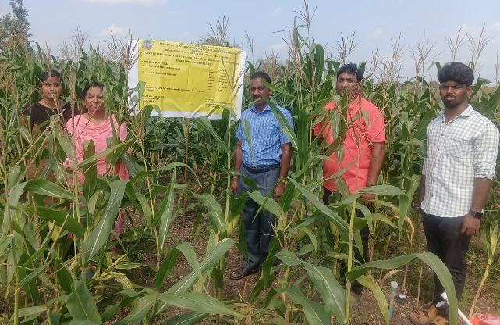
Overview of Experimental field
2.3. Soil properties analysis
Physical characteristics of the experimental soil, such as hydraulic conductivity, WHC, and infiltration rate and physicochemical properties were measured using the methods outlined in Table 1.

Table:1. Methods adopted for soil physical and physicochemical characterization

S.No | Parameters | Methods | References
A. Physical Properties
1. | Soil Texture | International pipette method | Robinson (1922)
2. | Bulk Density & Particle Density | Cylinder method | Gupta and Dakshinamurthi (1981)
3. | Water Holding Capacity | Keen – Raczkowski box method | Keen- Raczkowski, (1921)
4. | Infiltration rate | Double Ring Infiltrometer | Parr and Bertrand (1960)
5. | Hydraulic conductivity | Constant water head method | Henry Darcy, (1986)
B.Physico-chemical properties
1. | pH | soil:water (1:2.5) suspension using pH meter | Jackson (1973)
2. | Electrical Conductivity (EC) | soil: water (1:2.5) suspension using EC meter | Jackson (1973)
3. | Available Nitrogen | Alkaline permanganate method | Subbiah and Asija (1956)
4. | Available Phosphorus | Olsen Method | Olsen (1954)
5. | Available potassium | Extraction with Neutral normal NH₄OAc and Flame photometry | Stanford and English (1949)
6. | Organic carbon | Chromic acid wet digestion | Walkley and Black (1934)

2.4. Moisture content
The difference between the initial and final weights, while the weight is constant, indicates the moisture content of the soil, (Agrafioti et al., 2013).
$$Moisture content \left(\%\right)= \frac{W_{1}-W_{2}}{W_{1}} × 100$$
Where W₁ is the initial weight of the sample (g) and W₂ is the final weight of the sample (g)
2.5. Functional group analysis
A Thermo Fisher Nicolet IS5 mid-FTIR spectrometer was used to examine the chemical structures of coalchar amended and unamended soil. To prepare pellets, about 1 mg of the sample was ground with 100 mg of KBr. The samples' IR spectra were recorded in the wavenumber range of 4000–400 cm⁻¹, and the band assignments in the spectra were completed in accordance with the literature (Singh et al., 2020).
3. RESULTS AND DISCUSSION
3.1 Initial characteristics of experimental soil
The experimental site soil was classified as sandy loam in texture. The infiltration rate was measured at 12.21 Cm hr⁻¹ with a hydraulic conductivity of 29.7 Cm hr⁻¹ indicating rapid water movement through the profile. The soil exhibited a water-holding capacity of 50.86%, a bulk density of 1.25 Mg m⁻³ and a particle density of 2.2 Mg m⁻³. chemically, the soil was moderately alkaline, with a pH of 7.86, and had an electrical conductivity of 0.54 dS m⁻¹ falling within the non-saline range. The available macronutrient status revealed 389.20 Kg ha⁻¹ of Nitrogen, 27.40 Kg ha⁻¹ of Phosphorus, and 354.16 Kg ha⁻¹ of Potassium. Organic carbon content was 6.8 g kg⁻¹ indicating a medium level of organic matter
Table 2. Initial characteristics of experimental soil

S.No | Particulars | Value
Physical Properties
1. | Texture | Sandy Loam
2. | Infiltration rate (Cm hr⁻¹) | 12.21
3. | Hydraulic Conductivity (Cm hr⁻¹) | 29.7
4. | Water Holding Capacity (%) | 50.86
5. | Bulk Density (Mg m⁻³) | 1.25
6. | Particle Density (Mg m⁻³) | 2.2
Physicochemical Properties
1. | Soil pH | 7.86
2. | Soil EC (dSm⁻¹) | 0.54
3. | Available Nitrogen (Kg ha⁻¹) | 389.20
4. | Available Phosphorus (Kg ha⁻¹) | 27.40
5. | Available Potassium (Kg ha⁻¹) | 354.16
6. | Organic Carbon (g Kg⁻¹) | 6.8

3.2. Effect of coalchar on soil moisture content

The application of coalchar significantly influenced soil moisture retention throughout the maize growth period was given in the table 3. Gravimetric moisture content was consistently higher in plots amended with coalchar @ 3.5 t ha⁻¹ compared to control. At 15 DAS, the moisture content in coalchar @ 3.5 t ha⁻¹ treated soil was 13.5%, while the control plot recorded only 7.7%. This trend persisted, with notable differences at 30 DAS (12.4% vs. 7.1%) and 60 DAS (14.0% vs. 11.9%), indicating enhanced water-holding capacity in the treated plots.
Tensiometer readings further supported this observation. At 15 DAS, the soil water tension in coalchar treated plots was 8 bars, while the control required more tension to extract water, reflecting drier conditions. Even towards crop maturity, these plots maintained relatively higher moisture (9.0% vs. 7.2% at final harvest), despite higher soil tension (20 bars). These results suggest that the porous nature and mineral content of coalchar improved soil aggregation and reduced moisture loss through percolation and evaporation.
The overall pattern indicates that coalchar serves as an effective soil amendment to enhance moisture conservation, especially under rainfed conditions. Its ability to sustain higher moisture levels during critical crop growth stages can contribute to improved water use efficiency and potentially better crop performance.
Coalchar has recently become prominent in soil management and carbon sequestration challenges. It is a porous, fine-grained solid product of pyrolysis that contains 65 to 90% carbon (Kolodynska et al., 2012). Applying this coalchar is a cost-effective, practical, and secure way to lower environmental pollutants and runoff, soil erosion, and sediment concentration (Gholami et al., 2019). The findings demonstrated that the coalchar applied to the soil's surface could lengthen the time it takes for runoff by absorbing the force of raindrops. When the amount of soil moisture changed due to biochar, the runoff time was
distinct, and using biochar as a surface covering effectively contributed to water conservation (Ghahramani et al., 2011). According to reports, this biochar lengthened the period for soil infiltration and runoff. It could be because the biochar can store water and lengthen the time it takes for runoff to reach the plot surface. Applying biochar reduced soil erosion in the direction of the control treatment, which was consistent with previous research (Li et al., 2017). It has been demonstrated that adding biochar to clay improves pore growth in the 6 to 45 μm range and increases soil water retention, which is advantageous for arid areas and mine reclamation initiatives. Because of its porous nature, biochar has been added to soil as an amendment to increase its ability to hold water (Bikbulatova et al., 2018).

Table:3 Effect of coalchar on soil moisture content
Interval | Tensiometer reading (Bar) | Gravimetric Moisture (%) |  | SED | CD (5%)
Interval | Tensiometer reading (Bar) | Coalchar @ 3.5 t ha⁻¹ (Tensiometer installed) | Control with Tensiometer installed | SED | CD (5%)
Before Sowing | 0 | 11.5 | 11.5 | 0.43 | 1.19
15 DAS | 8 | 13.5 | 7.7 | 0.32 | 0.90
30 DAS | 10 | 12.4 | 7.1 | 0.38 | 1.05
45 DAS | 15 | 13 | 11.5 | 0.53 | 1.47
60 DAS | 11 | 14 | 11.9 | 0.38 | 1.06
75 DAS | 10 | 16.4 | 14.7 | 0.79 | 2.20
90 DAS | 14 | 10.7 | 7.6 | 0.35 | 0.96
Before Harvest | 20 | 9 | 7.2 | 0.30 | 0.85

The results were represented as mean of three independent experiments using one way ANOVA at p<0.05

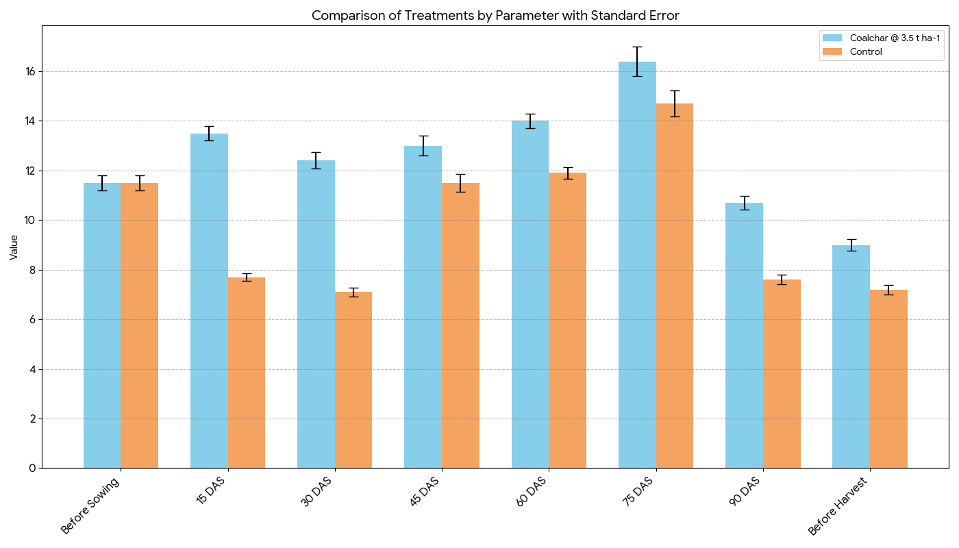

Figure: 1. Effect of coalchar on soil moisture content
3.4. Functional groups analysis of coalchar amended and unamended soil
Fourier Transform Infrared Spectroscopy (FTIR) was employed to identify the functional groups present in the soil treated coalchar @ 3 t ha⁻¹. The resulting spectrum revealed distinct absorption peaks that correspond to key organic and inorganic compounds, indicating chemical interactions between the amendment and the soil matrix. A broad absorption band observed around 3240.20 cm⁻¹ was attributed to O–H stretching vibrations, characteristic of hydroxyl groups commonly associated with alcohols and hydroxy compounds. Another broad and strong peak near 2880.43 cm⁻¹ also suggested the presence of O–H groups, likely linked to carbonyl-containing substances, pointing to organic matter enrichment. The presence of a medium-intensity peak at 2158.67 cm⁻¹ indicated C≡C triple bond vibrations, suggesting alkyne-type structures. A less intense peak around 2028.33 cm⁻¹ may correspond to metal carbonyl interactions, possibly due to residual trace elements or industrially influenced compounds within the coalchar. A clear signal at 1641.31 cm⁻¹ indicated C=C stretching, a typical feature of alkenes, while the peak at 1427.37 cm⁻¹ suggested carbonate ions, likely resulting from interactions between calcium in the coalchar and native soil components. The absorption at 872.41 cm⁻¹ was assigned to the C–O–O stretching mode, indicating the potential formation of peroxides. Additionally, a minor peak at 776.21 cm⁻¹ corresponded to C–Cl stretching, implying the presence of aliphatic chloro compounds (Ghorbani et al., 2022). The coalchar developed a microporous structure that produced numerous micropores, low density, and low weight so it will be used for moisture and nutrient retention (Saha et al., 2020).
The FTIR analysis of the untreated (control) soil sample provided insight into the native chemical composition and functional groups present without any external amendment. Compared to the coalchar-amended soil, the control showed fewer and less diverse functional groups. A moderate-intensity peak at 2158.98 cm⁻¹ was attributed to C≡C stretching vibrations, indicating the presence of alkyne-type organic structures. A signal around 2030.95 cm⁻¹, although of low intensity and undefined assignment, is likely related to trace amounts of transition metal carbonyls, possibly arising from minor industrial residues or soil mineral interactions. The spectrum also showed a medium-intensity peak at 1632.98 cm⁻¹, corresponding to C=C bonds typically found in alkenes. A peak near 1428.79 cm⁻¹ suggests the presence of carbonate ions, potentially from naturally occurring calcium carbonates in the soil profile. Further absorption bands were detected at 873.06 cm⁻¹, representing the C–O–O stretching of peroxides, and 776.03 cm⁻¹, indicating C–Cl stretching associated with aliphatic chloro compounds. These latter features reflect the soil’s inherent mineral and organic composition, possibly influenced by past agricultural inputs or environmental exposure. Overall, the FTIR spectrum of the unamended soil reveals a narrower chemical profile compared to the coalchar treated counterpart. The absence of prominent hydroxyl and carbonyl group peaks suggests limited organic matter complexity and fewer reactive sites, which may affect the soil's capacity to retain moisture and interact with nutrients.
Table:4. FTIR result for coalchar amended and unamended soil
Coalchar @ 3.5 t ha⁻¹ (Tensiometer installed) | Control with Tensiometer installed
  Peak (cm⁻¹) | Intensity | Group | Vibration | Compound Class
  3240.20 | Strong | O–H | Stretching | Alcohol & hydroxy compounds
  2880.43 | Strong, broad | O–H | Stretching | Carbonyl compounds
  2158.67 | Medium | C≡C | Stretching | Alkyne
  2028.33 | – | – | – | Transition metal carbonyls
  1641.31 | Medium | C=C | – | Alkene
  1427.37 | Strong | CO₃²⁻ | Stretching | Carbonate ion
  872.41 | Strong | C–O–O | Stretching | Peroxides
  776.21 | Medium | C–Cl | Stretching | Aliphatic chloro compounds
  Peak (cm⁻¹) | Intensity | Group | Vibration | Compound Class
  2158.98 | Medium | C≡C | – | Alkyne
  2030.95 | – | – | – | Transition metal carbonyls
  1632.98 | Medium | C=C | – | Alkene
  1428.79 | – | – | – | Carbonate ion
  873.06 | – | C–O–O | Stretch | Peroxides
  776.03 | – | C–Cl | Stretch | Aliphatic chloro compounds
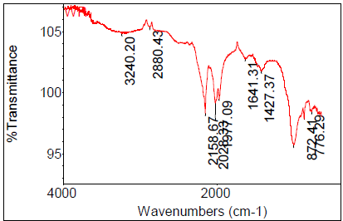 | 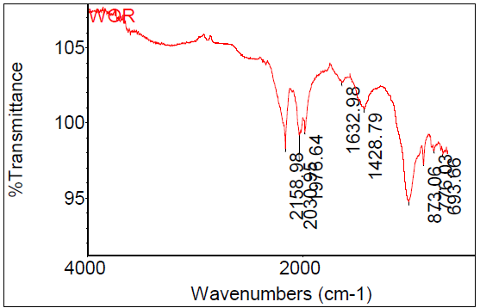

3.5. Effect of coalchar on yield attributes of Maize
Maize growth and yield parameters varied markedly between treatments (Table 5). The plots amended with coalchar at 3.5 t ha⁻¹ with tensiometers installed recorded the highest plant height (123.34 cm), cob girth (16.54 cm), cob length (14.56 cm), and grain yield (5777.78 kg ha⁻¹). In contrast, control plots with tensiometers installed showed comparatively lower values for plant height (82.34 cm), cob girth (13.24 cm), and cob length (12.45 cm), resulting in a reduced grain yield of 3428.51 kg ha⁻¹. Coalchar application in soil was increased the plant growth and yield attributes by increased plant height, cob length, girth and finally grain yield by increasing moisture retention capacity and moisture content (Yan et al., 2022).
Table: 5. Effect of coalchar on yield attributes of Maize
Treatment | Plant height (Cm) | Cob girth (Cm) | Cob length (Cm) | Grain yield (Kg ha⁻¹)
Control with Tensiometer installed | 82.34 | 13.24 | 12.45 | 3428.51
Coalchar @ 3.5 t ha⁻¹ (Tensiometer installed) | 123.34 | 16.54 | 14.56 | 5777.78
SEd | 3.37 | 0.49 | 0.45 | 126.07
CD | 9.35 | 1.36 | 1.24 | 350.3
The results were represented as mean of three independent experimentsusing one way ANOVA at p<0.05

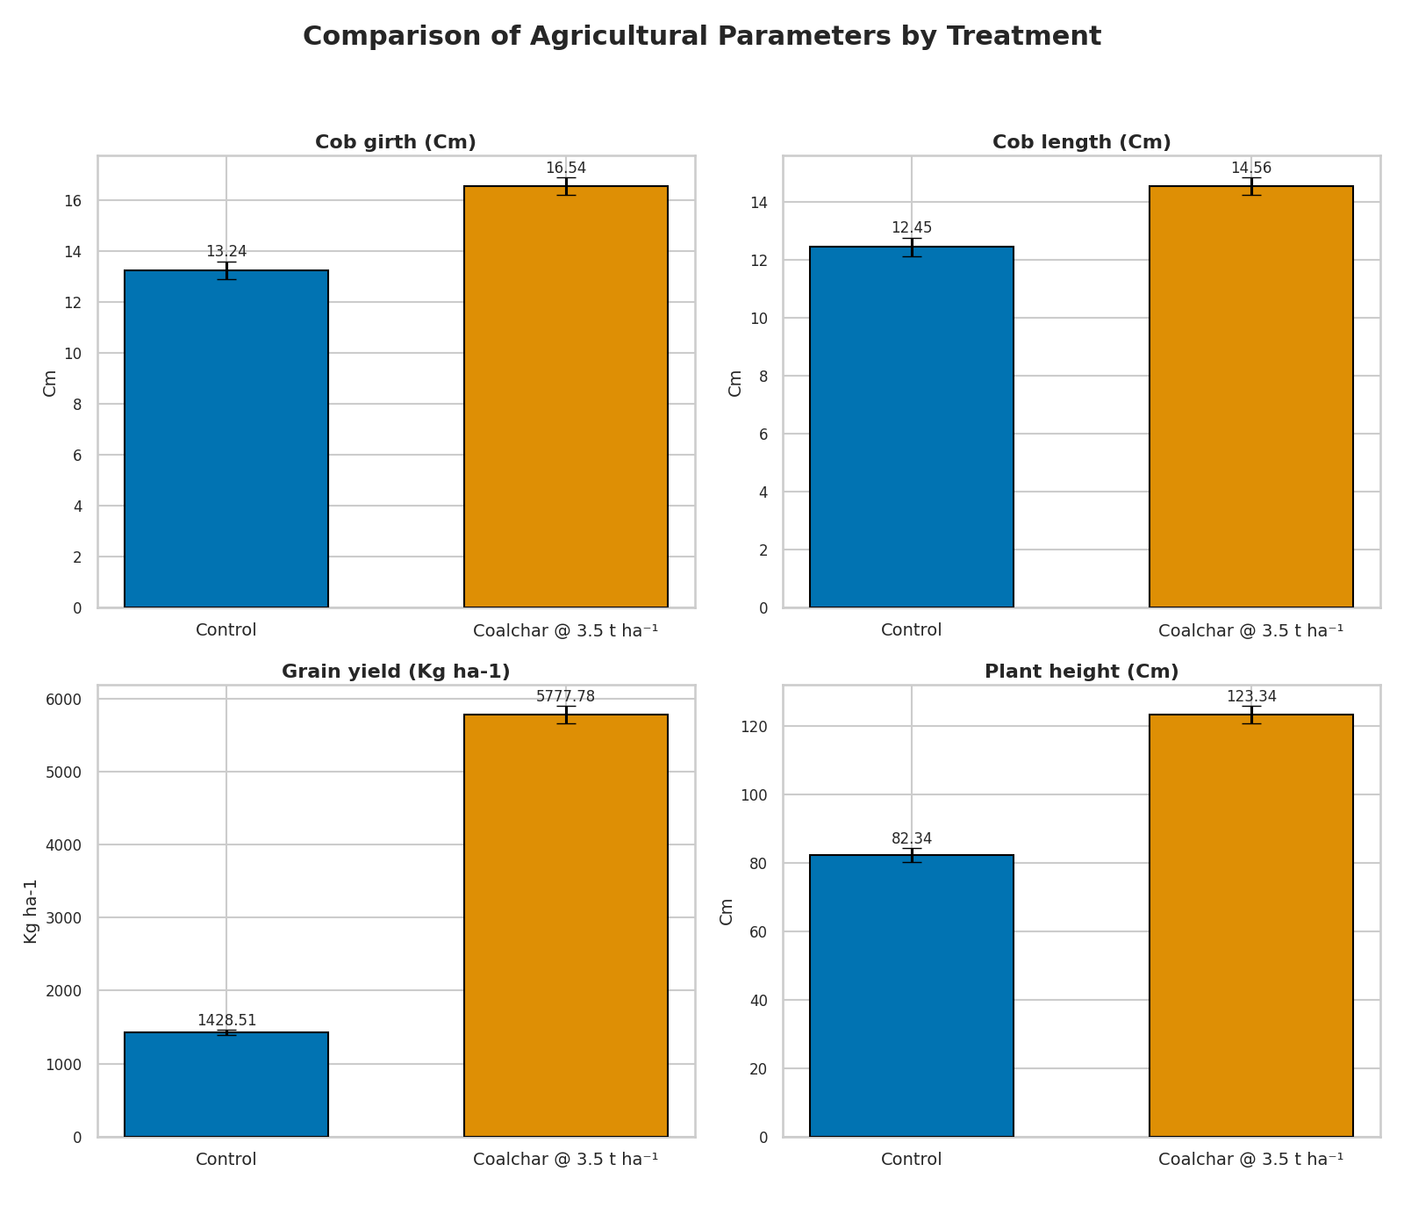
Figure 2. Effect of coalchar on yield attributes of Maize
4. Conclusion
The present field investigation under semi-arid agroecosystem conditions clearly demonstrated that coalchar application has a positive and consistent effect on soil moisture conservation and maize productivity. The enhanced soil moisture retention observed in coalchar-amended plots was attributable not only to its porous structure and high surface area, but also to the functional chemistry of the amended material. Fourier Transform Infrared (FTIR) spectroscopy confirmed the presence of hydroxyl functional groups in coalchar, and their detection in amended soils indicates possible functional group transfer or surface interaction with soil colloids. This suggests a dual mechanism physical enhancement of water storage and chemical modification of soil contributing to improved water-holding capacity.

Consent
Not applicable.
Ethical approval
Not applicable
References

Agrafioti, E., Bouras, G., Kalderis, D. and Diamadopoulos, E., (2013). Biochar production by sewage sludge pyrolysis. Journal of analytical and applied pyrolysis, 101, pp.72-78.
Bikbulatova, S., Tahmasebi, A., Zhang, Z., Rish, S.K. and Yu, J., (2018). Understanding water retention behavior and mechanism in bio-char. Fuel Processing Technology, 169, pp.101-111.\
Bikbulatova, S., Tahmasebi, A., Zhang, Z., Rish, S.K. and Yu, J., (2018). Understanding water retention behavior and mechanism in bio-char. Fuel Processing Technology, 169, pp.101-111.
Ghahramani, A., Ishikawa, Y., Gomi, T., Shiraki, K. and Miyata, S., (2011). Effect of ground cover on splash and sheetwash erosion over a steep forested hillslope: A plot-scale study. Catena, 85(1), pp.34-47.
Gholamahmadi, B., Ferreira, C.S., Gonzalez-Pelayo, O., Bastos, A.C. and Verheijen, F.G., (2025). Soil conservation benefits of biochar in Mediterranean vineyards: enhancing soil sponge function and mitigating erosion.
Gholami, L., Karimi, N. and Kavian, A., (2019). Soil and water conservation using biochar and various soil moisture in laboratory conditions. Catena, 182, p.104151.
Gholami, P., Dinpazhoh, L., Khataee, A. and Orooji, Y., (2019). Sonocatalytic activity of biochar-supported ZnO nanorods in degradation of gemifloxacin: synergy study, effect of parameters and phytotoxicity evaluation. Ultrasonics sonochemistry, 55, pp.44-56.
Ghorbani, M., Amirahmadi, E., Neugschwandtner, R.W., Konvalina, P., Kopecký, M., Moudrý, J., Perná, K. and Murindangabo, Y.T., (2022). The impact of pyrolysis temperature on biochar properties and its effects on soil hydrological properties. Sustainability, 14(22), p.14722.
Ghorbani, M., Karampela, M. and Tonner, A., (2022). Consumers’ brand personality perceptions in a digital world: A systematic literature review and research agenda. International Journal of Consumer Studies, 46(5), pp.1960-1991.
Gupta RP, Dakshinamurthi C (1981) Procedures for physical Analysis of soils. IARI, New Delhi
Jackson ML (1973) Soil chemical analysis, pentice hall of India Pvt. Ltd, New Delhi, India 498:151–154
Kang, M.W., Yibeltal, M., Kim, Y.H., Oh, S.J., Lee, J.C., Kwon, E.E. and Lee, S.S., (2022). Enhancement of soil physical properties and soil water retention with biochar-based soil amendments. Science of the total environment, 836, p.155746.
Keen BA, Raczkowski H (1921) The relation between the clay content and certain physical properties of a soil. J Agric Sci 11:441–449
Kołodyńska, D., Wnętrzak, R., Leahy, J.J., Hayes, M.H.B., Kwapiński, W. and Hubicki, Z.J.C.E.J., (2012). Kinetic and adsorptive characterization of biochar in metal ions removal. Chemical Engineering Journal, 197, pp.295-305.
Li, H., Dong, X., da Silva, E.B., de Oliveira, L.M., Chen, Y. and Ma, L.Q., (2017). Mechanisms of metal sorption by biochars: Biochar characteristics and modifications. Chemosphere, 178, pp.466-478.
Li, L., Zhang, Y.J., Novak, A., Yang, Y. and Wang, J., (2021). Role of biochar in improving sandy soil water retention and resilience to drought. Water, 13(4), p.407.
Piper CS (1966) Mechanical analysis of soil by International Robinson’s Pipette method. Soil plant Anal 368:
Saha, R., Galagedara, L., Thomas, R., Nadeem, M. and Hawboldt, K.,(2020). Investigating the influence of biochar amendment on the physicochemical properties of podzolic soil. Agriculture, 10(10), p.471.
Saha, R.; Galagedara, L.; Thomas, R.; Nadeem, M.; Hawboldt, K. Investigating the Influence of Biochar Amendment on the Physicochemical Properties of Podzolic Soil. Agriculture (2020), 10, 471. [Google Scholar] [CrossRef]
Santos, J.A., Gonzaga, M.I.S., dos Santos, W.M. and da Silva, A.J., (2022). Water retention and availability in tropical soils of different textures amended with biochar. Catena, 219, p.106616.
Sims, j.t.,(2000). Soil Test Phosphorus: Olsen P. methods of Phosphorus analysis for soils, sediments, residuals, and waters, 20.
Singh, A., Singh, J., Sinha, M.K., Kumar, R. and Verma, V., (2020). Investigations on microstructural and microhardness developments in sintered iron–coal fly ash composites. Sādhanā, 45(1), p.167.
ur Rehman, O., Rizvi, S.A., Khan, M., Aulakh, A.M., Yunas, M., Hussain, T., Naseem, W., Bibi, R., Malik, S.N. and Majeed, M.D., (2025). Mulching Technology for Moisture Conservation: Strategies and Applications for Rainfed Area. Planta Animalia, 4(2), pp.179-195.
Walkley A, Black IA (1934) An examination of the Degtjareff method for determining soil organic matter, and a proposed modification of the chromic acid titration method. Soil Sci 37:29–38
Wong, J.T.F., Chow, K.L., Chen, X.W., Ng, C.W.W. and Wong, M.H., (2022). Effects of biochar on soil water retention curves of compacted clay during wetting and drying. Biochar, 4(1), p.4.
Yan, S., Zhang, S., Yan, P. and Aurangzeib, M., (2022). Effect of biochar application method and amount on the soil quality and maize yield in Mollisols of Northeast China. Biochar, 4(1), p.56.

