Comparative Evaluation of Methanolic and Aqueous Extracts of Medicinal Plants on Growth Performance of Silkworm (Bombyx mori L.)

Abstract
Sericulture is an important agro-based industry that plays a significant role in rural livelihoods, especially in developing countries like India. The productivity and quality of silk depend largely on the health and nutrition of silkworms, which can be enhanced through natural and sustainable means. The present investigation studied the effects of various medicinal plant extracts on the growth and development of the silkworm Bombyx mori L. The study was conducted at the College of Temperate Sericulture, SKUAST-K, Mirgund during the spring seasons of 2022 and 2023. The study utilized completely randomized design with 48 treatment combinations involving six medicinal plants Viz; Viscum album, Curcuma longa, Allium sativum, Ocimum basilicum, Ammi copticum and Thymus vulgaris. Two extraction methods (methanolic and aqueous) and three concentrations (1%, 1.5% and 2%) along with a control were used to carry out the study. Results indicated that methanolic extracts particularly of Curcuma longa at 2% concentration significantly enhanced larval weight (46.52 g), reduced larval duration (170.43 hours) and improved cocoon weight (1.945 g) and shell weight (0.438 g) as well as effective rate of rearing than control where no treatment was given. The improved performance is attributed to the bioactive phytochemicals with antimicrobial and growth-promoting properties present in the plant extracts especially by using methanol as solvent. The study concludes that dietary supplementation of mulberry leaves with selected medicinal plant extracts, especially C. longa, is a promising eco-friendly and cost-effective approach to enhance silkworm health, yield and silk productivity in sericulture.
Introduction
The process of silk production known as sericulture revolves around the rearing of silkworms (Bombyx mori) for their precious silk threads. Sericulture is an agriculture-based industry of global importance, influencing both culture and commerce is an integral part of the human history. The silkworm, B mori L. is an important economic insect which convert leaf protein into silk. China and India lead in silk production with China producing around 140,000 Metric tons (MT) and India contributing approximately 35,000 metric tons of raw silk annually, together accounting for over 90% of global silk production (Anonymous, 2024). Sericulture is both an art and science of rearing silkworms for silk production. The economic significance of silk production and its widespread use across the world led to the silkworm promotion as a potent laboratory model for fundamental biological study (Xu et al.,
2017). The average silkworm crop loss in India due to various diseases is to the tune of 15–47 percent, while it is 10–15 percent in other countries like Japan, China and Italy. The incidence of silkworm diseases is more during autumn season (35–47 percent) than spring (15–20 percent) in North West India (Tayal and Chauhan, 2017). Prevention of silkworm diseases is the only way to change sericulture into a sustainable activity by treating silkworms (B. mori L.) that are diseased. Nutrition particularly as it relates to the physiology of digestion is the most fundamental and important challenges in the sericulture. If the optimum required nutrients are not present in the leaves then silkworm acquire disease and the percentage of effective rate of rearing will decrease as nutritional requirements are the key factors of ingested food essential for normal metabolism and development of an insect so it is vital to enhance the nutritive quality of mulberry leaves to ensure proper growth and development of silkworms for quality cocoon crop production (Ito, 1960). This can be achieved by the supplementation of mulberry leaves with extra nutrients. It has frequently been proved that mulberry leaves supplemented with extra nutrients are advantageous for larval and pupal characteristics (Chavan et al., 2024). Medicinal plants have been used for centuries in various cultures for their healing properties. These plants contain a wide range of bioactive compounds, such as alkaloids, flavonoids, terpenoids, saponins and phenolic compounds which are known for their antioxidant, antimicrobial and growth-promoting effects. In the context of sericulture, the use of medicinal plants as dietary supplements for silkworms represents a promising approach to improve both health of the larvae and quality of the silk. One of the most significant benefits of medicinal plants in silkworm rearing is their antimicrobial properties. Pathogen-induced diseases are among the most critical factors affecting the success of sericulture and medicinal plants offer a natural solution to this problem. Medicinal plants have evolved to produce secondary metabolites that serve as defence mechanisms against microbial attacks. These compounds exhibit antimicrobial activities that can inhibit the growth of bacteria, fungi and viruses thereby reducing the incidence of diseases in silkworms they produce (Hassan et al., 2020).
2017). The average silkworm crop loss in India due to various diseases is to the tune of 15–47 percent, while it is 10–15 percent in other countries like Japan, China and Italy. The incidence of silkworm diseases is more during autumn season (35–47 percent) than spring (15–20 percent) in North West India (Tayal and Chauhan, 2017). Prevention of silkworm diseases is the only way to change sericulture into a sustainable activity by treating silkworms (B. mori L.) that are diseased. Nutrition particularly as it relates to the physiology of digestion is the most fundamental and important challenges in the sericulture. If the optimum required nutrients are not present in the leaves then silkworm acquire disease and the percentage of effective rate of rearing will decrease as nutritional requirements are the key factors of ingested food essential for normal metabolism and development of an insect so it is vital to enhance the nutritive quality of mulberry leaves to ensure proper growth and development of silkworms for quality cocoon crop production (Ito, 1960). This can be achieved by the supplementation of mulberry leaves with extra nutrients. It has frequently been proved that mulberry leaves supplemented with extra nutrients are advantageous for larval and pupal characteristics (Chavan et al., 2024). Medicinal plants have been used for centuries in various cultures for their healing properties. These plants contain a wide range of bioactive compounds, such as alkaloids, flavonoids, terpenoids, saponins and phenolic compounds which are known for their antioxidant, antimicrobial and growth-promoting effects. In the context of sericulture, the use of medicinal plants as dietary supplements for silkworms represents a promising approach to improve both health of the larvae and quality of the silk. One of the most significant benefits of medicinal plants in silkworm rearing is their antimicrobial properties. Pathogen-induced diseases are among the most critical factors affecting the success of sericulture and medicinal plants offer a natural solution to this problem. Medicinal plants have evolved to produce secondary metabolites that serve as defence mechanisms against microbial attacks. These compounds exhibit antimicrobial activities that can inhibit the growth of bacteria, fungi and viruses thereby reducing the incidence of diseases in silkworms they produce (Hassan et al., 2020).
Natural products present in the medicinal plants are inhibitory to the deleterious effects of oxidative stress as they help in protecting the cells by scavenging free radicals (Imran et al., 2011). Among various compounds, the phenolic ones have been identified to be the main active agents against microorganisms (Dorman and Deans, 2000).
For example, basil (Ocimum sanctum) often referred to as holy basil has been shown to improve the growth rate of silkworm larvae when added to their diet (Prasad and Govindah, 2010).
In sericulture, medicinal plants are essential since they improve the health and productivity of silkworms considerably, there by provides natural remedies for treating and preventing diseases in silkworms. Moustafa (2023) studied the impact of Echinacea purpurea on some biological and biochemical parameters of silkworm larvae reared on mulberry leaves enriched with different concentrations of E. purpurea and found that 2% concentration of extract increased all the economic and biological characteristics whereas, larvae fed at 1% concentration recorded high ascorbic acid values. Saharia et al. (2023) have reported an overall increase in all the economic parameters in silkworm (B. mori L.) by treating infected silkworm larva from white muscardine disease with 10% methanolic rhizome extract of C. longa (turmeric). Khezrian et al. (2022) studied the effects of feed supplements on economical traits in various silkworms breeding lines and reported that the supplementation of mulberry leaves with 1.0% Lactobacillus rhamnosus and 0.5% Echinacea purpurea plant extract resulted in improvement of economic traits in B. mori. Studies have shown that turmeric sprayed mulberry leaf fed to silkworm, improved metabolic functions and enhanced cocoon and silk parameters (Karthikairaj et al., 2013). The nutrients complemented by bioactive compounds make basil a general medically important plant. Its extract has growth promoting effect on silkworm which helps to enhance the commercial qualities of silk and can be used in sericulture for yield improvement (Saad et al., 2019).

MATERIALS AND METHODS

Study Site and statistical design
The present investigation titled “Effect of Various Medicinal Plant Extracts on the Growth and Development of Silkworm (Bombyx mori L.)” was conducted at the College of Temperate Sericulture (CoTS), SKUAST-K, Mirgund, Jammu and Kashmir during the spring seasons of 2022 and 2023. A total of 48 treatment combinations were evaluated with 100 larvae per replication. The experiment involved six medicinal plant extracts, two extraction methods (methanolic and aqueous) and three concentrations (1%, 1.5% and 2%) along with a control.

Statistical analysis
The design of the experiment followed was completely randomized design (CRD). Data was analysed by three way analysis of variance (ANOVA).
Medicinal plants used in the study were:
- Viscum album (leaves)
- Curcuma longa (rhizome)
- Allium sativum (cloves)
- Ocimum basilicum (seeds)
- Ammi copticum (seeds)
- Thymus vulgaris (shoots)
The fresh plant materials were collected from Baramulla, Budgam and Jammu districts. They were shade-dried, pulverized using an electric blender and stored in airtight containers until extraction (Plate 1).
Preparation of Plant Extracts
Powdered plant material (100 g) was soaked in methanol (99%) in 1:8 ratio for 7 days with intermittent shaking (Plate 2). The mixture was filtered using Whatman filter paper and the filtrate was concentrated using a rotary evaporator. Extracts were stored at 4°C until use. For aqueous extraction, 100 g of plant powder was boiled with 1 L of distilled water at 30–40°C for 20 minutes. After filtration the extracts were refrigerated for subsequent use.

Silkworm Rearing
Disease-free layings (DFLs) of Bombyx mori (CSR2) were sourced from the CoTS Germplasm. Rearing was carried out as per standard recommended practices (Anonymous, 2003) up to the 5th instar stage. The plant extracts were applied by spraying the respective concentrations (C1: 1%, C2: 1.5% and C3: 2%) onto fresh mulberry leaves during 4th and 5th instar larval duration which were then fed to larvae during the 4th and 5th instars. The control group (C0) served as control where no treatment was given.

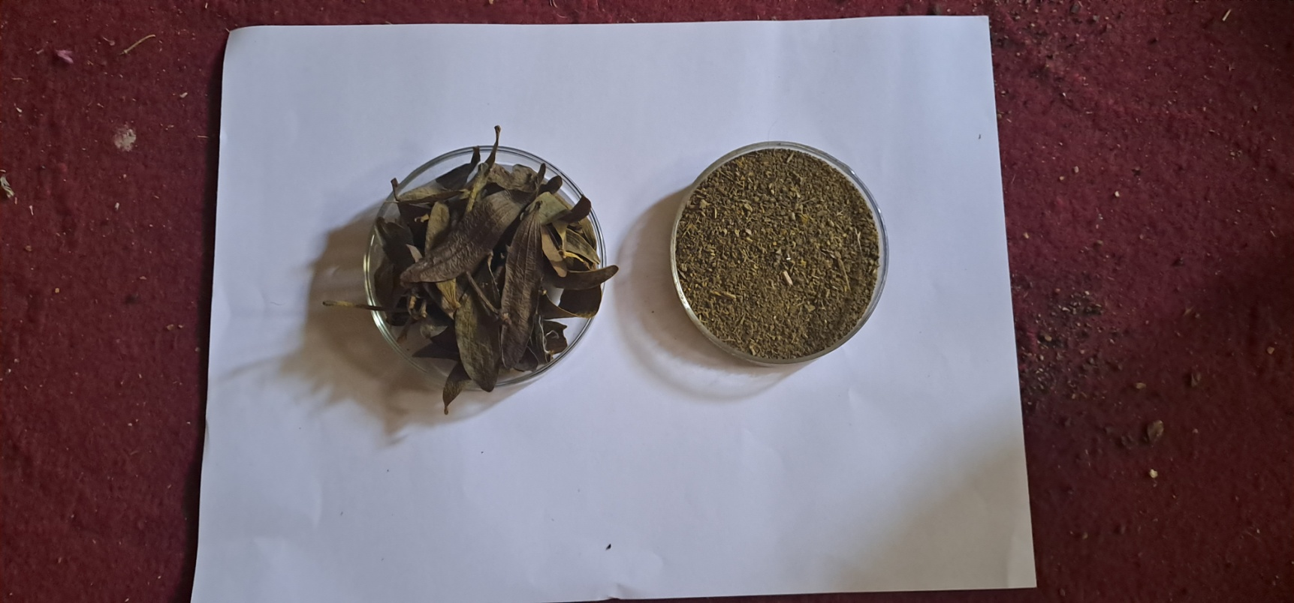 | 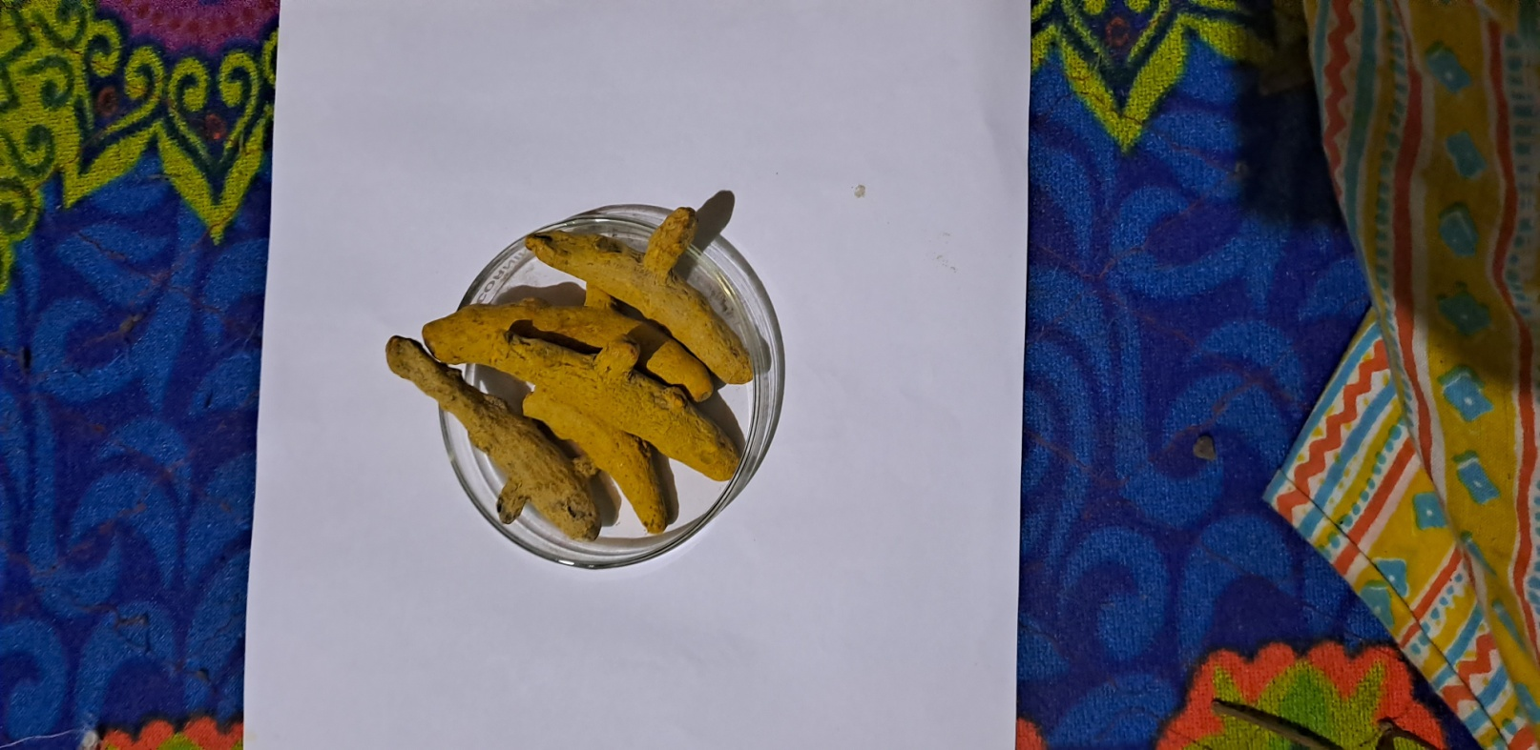 | 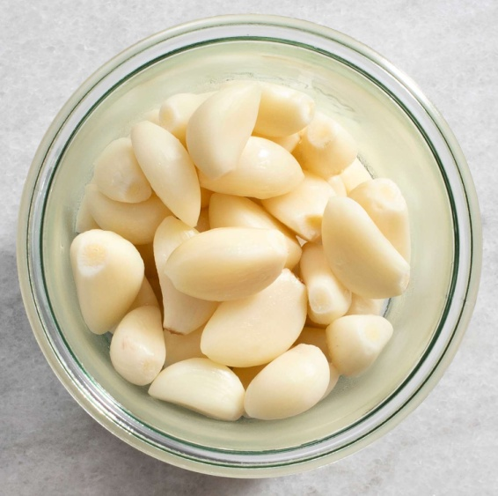
Mistletoe (Viscum album) | Turmeric (Curcuma longa) | Garlic (Allium sativum)
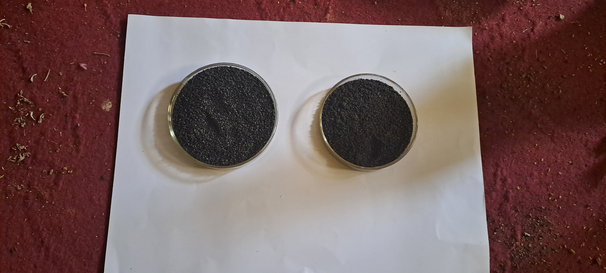 | 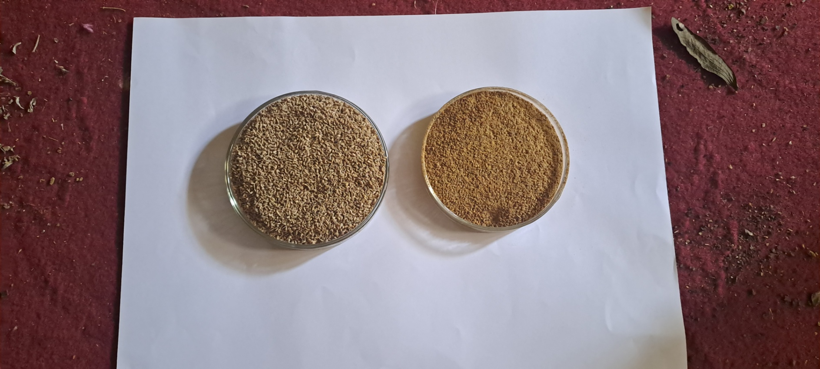 | 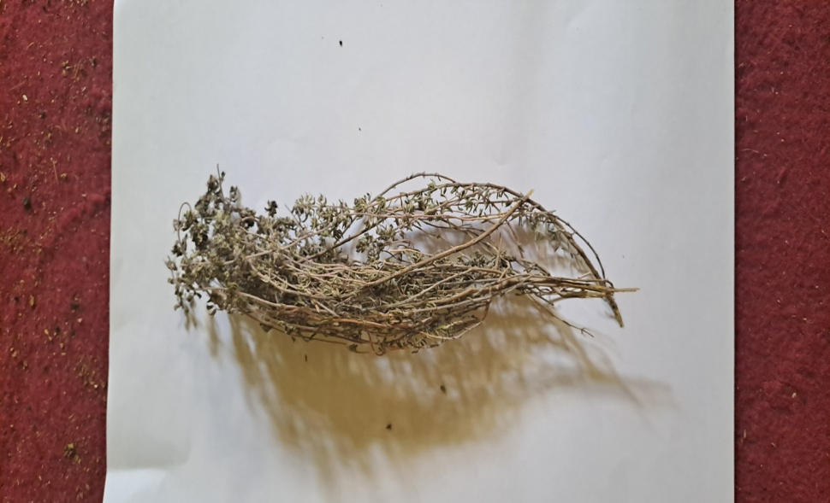
Basil (Ocimum basilicum) | Ajowan (Ammi copticum) | Thyme (Thymus vulgaris)
Plate 1: Dried Plant Materials Used in the Study

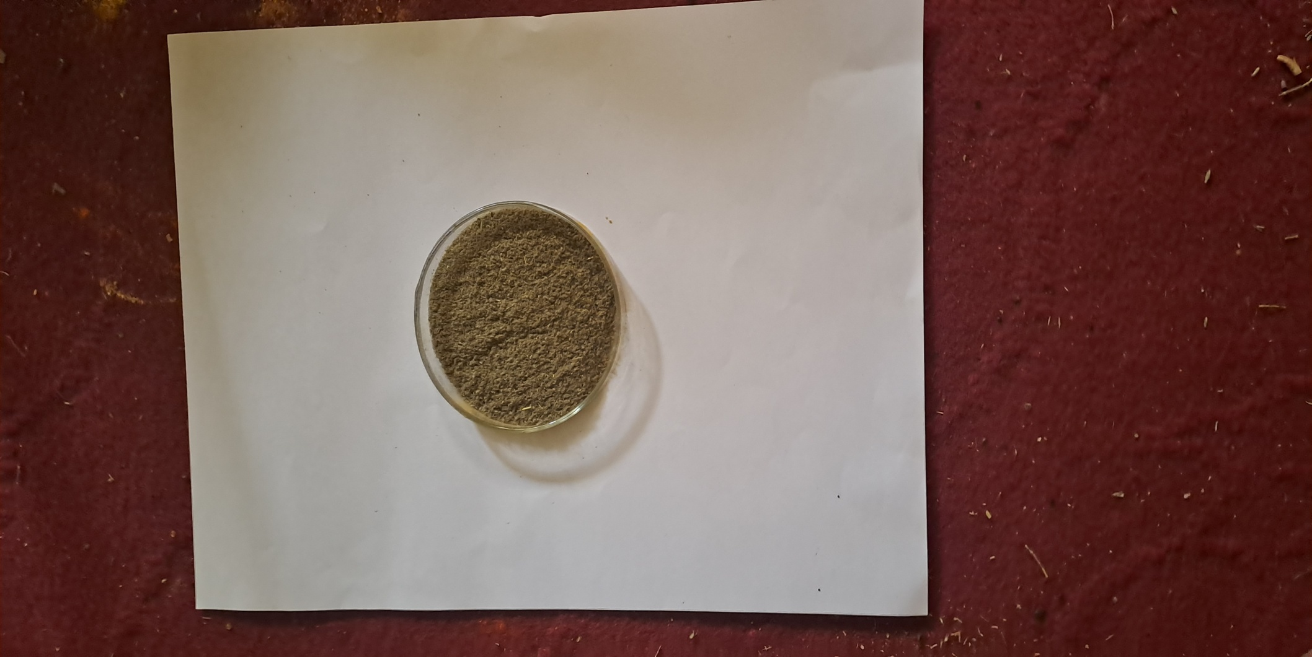 | 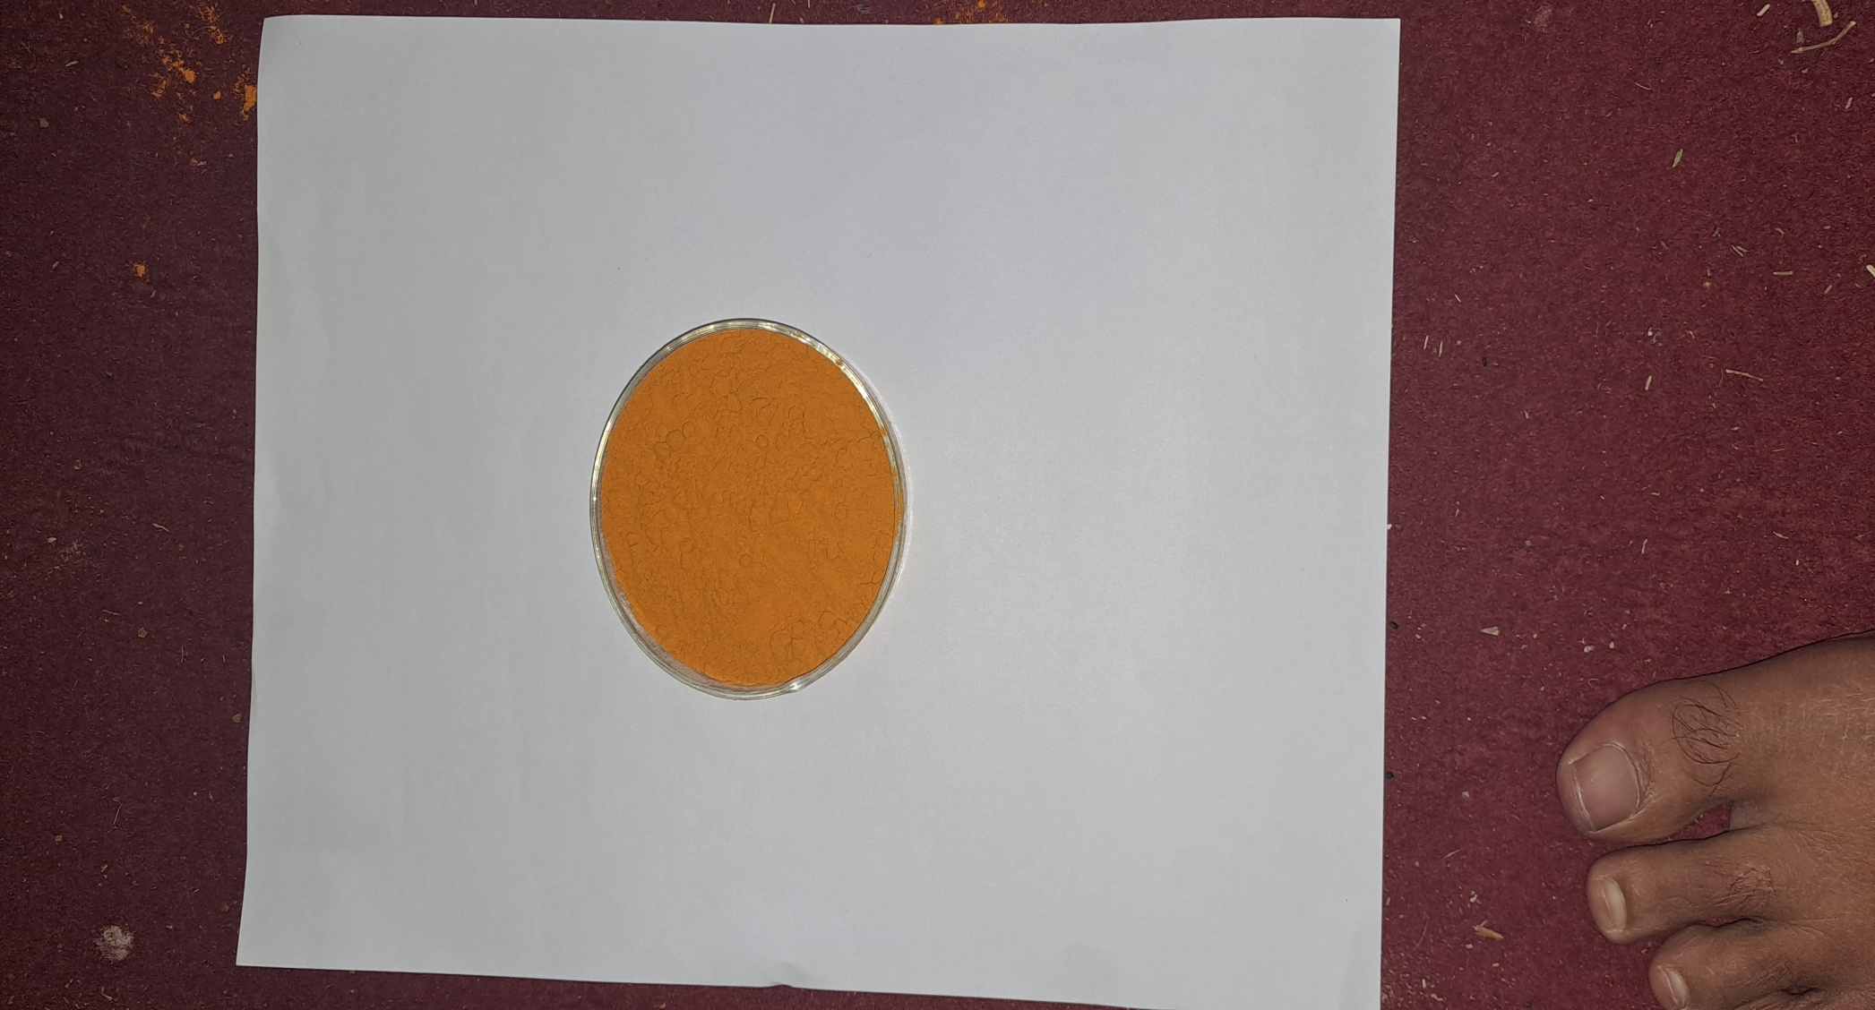 | 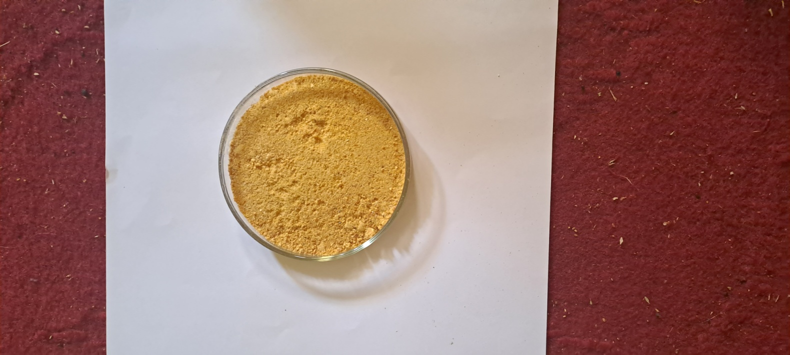
Mistletoe (Viscum album) | Turmeric (Curcuma longa) | Garlic (Allium sativum)
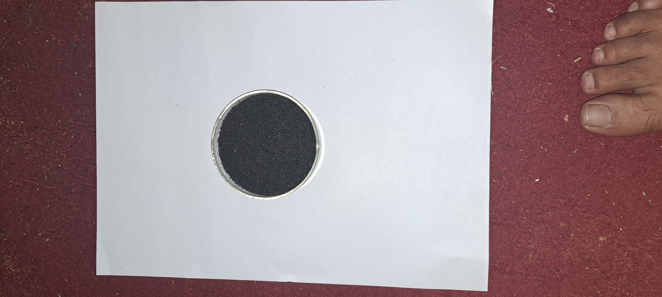 |  | 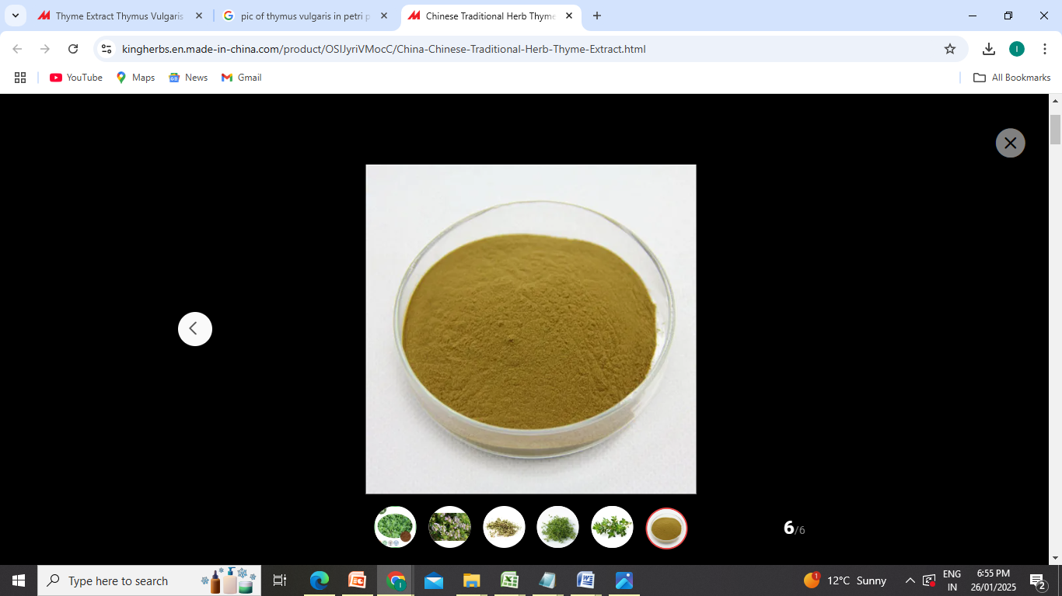
Basil (Ocimum basilicum) | Ajwain (Ammi copticum) | Thyme (Thymus vulgaris)
Plate 2: Processed Plant Materials Used in the Study

Parameters Recorded
- Larval weight:
Ten mature larvae were randomly picked from each replication on 5th day of 5th instar and were weighed on a digital balance to record the weight.
- Fifth age larval duration:
It was calculated as total time taken from the initiation of fifth larval instar till mounting.
- Single cocoon weight (g)
Twenty male and twenty female cocoons were randomly picked from each replicate and were weighed to record the cocoon weight.
- Single shell weight (g)
The cocoons used for determining single cocoon weight were cut open to obtain the shells .The resultant shells were weighed to determine the average shell weight.
- Cocoon yield/10,000 larvae by number
This was calculated by the following formula:
Cocoon yield = | Number of cocoons harvested | ×10,000
Cocoon yield = | Number of worms retained after 3rdmoult-Worms taken for biochemical studies | ×10,000
Results and discussion
The effect of plant extract treatments on economic parameters were evaluated by analyzing the following economic parameters:
- Larval weight (g)
The study evaluated the impact of different medicinal plant extracts, extraction methods and concentrations on the weight of ten mature silkworm larvae (Table 1). Pooled analysis of the two year data (spring 2022 and spring 2023) revealed that among the interactions between treatments and extraction methods the highest larval weight of 46.52g was obtained in C. longa (T2E1) at C3 (2%) which was followed by 45.04 g in methanol extract of C. Longa (T2E2) at C3. Among the treatments, C. longa (T2) showed highest mean larval weight of 42.78 g, followed by V. album (T1) with 41.60 g and A. copticum (T5) with 41.32 g. The extraction method E1 showed significantly higher mean larval weight of 41.63 g in comparison to E2 with 40.53 g. Among all treatments, the highest concentration C3 recorded the maximum weight of 43.04 g which was followed by C2 with 42.12 g, C1 with 41.37 g while the control (C0) recorded the lowest with 37.80 g. Larval weight is one of the important parameter which determines not only the health of the larvae, but also the quality of the cocoon spun. In the present study, an increasing trend was recorded for mature larval weight with an increase in concentration. The increase in larval weight of ten mature larvae might be due to the bio availability of phytochemicals from plant extracts that are beneficial to insect and also for their robust growth and development. The present results are in conformity with the study of Raju et al. (2012) who reported that 1% C. longa appeared to be more beneficial in improving the larval biomass and cocoon yield.
The present results are in conformity with the findings of Raju et al. (2012), who reported that 1% C. longa appeared to be more beneficial in improving larval biomass and cocoon yield. The increase in larval weight with methanol extracts as seen from the present study, is supported by the results of Gobena and Bhaskar (2015) who reported that increased concentrations of Sida acuta methanol extracts enhanced growth parameters such as larval weight. Simlarly, Ebrahim et al. (2023) showed that methanolic extracts of rosemary (Rosmarinus officinalis) and moringa (Moringa oleifera) increased larval weight to a greater extent than aqueous ones. Similar findings were also reported by Mahesha et al. (2018) who observed improved larval growth in Bombyx mori fed with neem (Azadirachta indica) and tulsi (Ocimum sanctum) extracts. In another study Kumari et al. (2020) documented that phytochemical-rich botanical supplements led to a significant enhancement in larval weight and silk productivity.
- Fifth age Larval duration (hours)
The study revealed significant variations in the fifth-age larval duration of silkworms due to different medicinal plant extracts, extraction methods and concentrations (Table 2). The pooled data (spring season 2022 and 2023) showed that that C. longa (T2E1) at C3 concentration recorded the shortest larval duration of 170.43 hours. Among all the treatments, C. longa (T2) recorded the shortest mean larval duration of 180.63 hours, followed by 182.64 hours in V. album (T1) and 187.87 hours in A. copticum (T5). However, the longest larval duration of 201.03 hours was recorded in T. vulgaris (T6). Among the extraction methods, E1 resulted in a shorter mean larval duration of 188.88 hours compared to E2 with 190.99 hours. However, among the concentrations C3 showed the shortest larval duration of 183.50 hours which was statistically significant than C2 and C1, whereas the control (C0) recorded the longest larval duration of 204.11 hours. The larval duration is regarded as an important parameter of economic value in sericulture as the reduction in larval duration would help in minimizing the quantum of the total food consumption and labour requirement, besides completion of larval period in desirable time period. Larval duration in all the batches was found to decrease and also the higher concentration of the extracts reduced the larval duration significantly. Further the variation in larval duration was recorded in the plant extracts obtained through two different extraction methods (methanol and aqueous). Shorter larval duration was recorded in the methanol extracts as compared to aqueous extracts. This may be due to the recovery of maximum bioactive compounds through this method. The findings are in agreement with the results of Gobena and Bhaskar (2015) who reported that feeding silkworms with aqueous plant extracts of medicinal plants decrease moulting duration, fifth instar and total larval duration and the significant reduction in mouting and larval duration may be due because of the growth promoting properties of botanicals. Similar results were also obtained by Murari et al. (2008) who reported that the application of C. sativus extract to fifth instar larvae significantly reduces larval duration.
- Cocoon weight (g)
The study revealed that different medicinal plant extracts, extraction methods and concentrations had a significant effect on the single cocoon weight of silkworms (Table 3). Pooled analysis of the two year data (spring 2022 and 2023) revealed that interaction between treatments and extraction methods showed the highest cocoon weight of 1.945 g in C. longa (T2E1) at C3.Among the treatments, C. longa (T2) resulted in the highest mean cocoon weight of 1.793 g followed by V. album (T1) with 1.744 g and A. copticum (T5) with 1.723 g. However, among extraction methods E1 produced higher mean cocoon weight of 1.726 g compared to E2 with 1.703 g. Among the concentrations, C3 recorded the maximum cocoon weight of 1.785 g, followed by C2 with 1.757 g and C1 with 1.739 g, while the control (C0) recorded the lowest with 1.570 g. The silk yield in sericulture is directly influenced by cocoon production and is regarded as an important parameter. Increase in cocoon weight is directly related to productivity. The cocoon weight can be enhanced by providing the balanced feed to the silkworms. It has been reported that if the silkworm is fed with fortified mulberry leaf, increased the cocoon production and productivity. In the present study supplementation of medicinal plant extracts at different concentrations have resulted in the significant increase in cocoon weight in all the treated batches as the growth and development of silkworm and their economic characters are influenced to a great extent by the nutritional content of mulberry leaf. The significant difference with regard to cocoon weight was also recorded between the extraction methods. The significantly higher cocoon weight was recorded in the batches fed with the mulberry leaves supplemented with the extract obtained by methanol extracts, which may be due to the maximum yield recovery of the bioactive compounds required for the trait. The significant improvements in cocoon weight may be because of improved appetite of silkworms, increasing tolerance towards disease, active biochemical components of the plant extracts and enhanced nutritional effectiveness of feed utilized by worms. Talari et al. (2013) achieved similar results by feeding the silkworms with stem bark extracts of Oroxyllum indicus. The present results are also in line with the results of Saharia et al. (2023) who reported that administration of methanolic extract of C. longa rhizome in silkworm significantly improved the cocoon weight. The present results are also in line with the findings of Gouda at al. (1997), Hippragi et al. (2001) and Murugesh (2002) who reported an increase in cocoon weight with supplementation of different botanical extracts to silkworm.
- Shell weight (g)
The study showed that different medicinal plant extracts, extraction methods and concentrations had a significant impact on the single shell weight of silkworms (Table 4). Pooled analysis of the two-year data (spring 2022 spring 2023) revealed that among the treatment and extraction combinations C. longa (T2E1) at 2 percent concentration yielded the highest single shell weight of 0.438 g. From the treatments, C. longa (T2) recorded the highest mean single shell weight of 0.382 g followed by V. album (T1) with 0.367 g and A. copticum (T5) with 0.362 g. The extraction method E1showed higher mean single shell weight of 0.363 g compared to E2 irrespective of the plant materials. Among concentrations the highest concentration (C3) resulted in the maximum single shell weight of 0.380 g, followed by C2 with 0.375 g and C1 with 0.370 g, while the control (C0) recorded the lowest shell weight of 0.312 g. The improvement in shell weight and shell ratio is due to effects of nutrients present in the extracts and that fortified feed supplied to the silkworm which stimulate the protein synthesis in the silk gland and enhances cocoon traits. Data and Gupta, (2002) and Duby and Shrivatava (2005) who reported better cocoon yield, cocoon weight, shell weight and cocoon shell ratio from silkworms fed with mulberry leaves fortified with medicinal plant extracts.
- Effective rate of rearing by number
The effect of different medicinal plant extracts on cocoon yield by number (cocoons/10,000 larvae) in silkworm B. mori was analysed considering different extraction methods and concentrations (Table 5). The pooled results (spring 2022 and 2023) showed significant variations among treatments, extraction methods and concentrations. Among the treatment and extraction combinations C. longa (T2E1) at C2 recorded highest yield of 9428 cocoons/10,000 larvae. Whereas, among the treatments the highest cocoon yield of 9063 cocoons/10,000 larvae was recorded in C. longa (T2) followed by 8984 cocoons/10,000 larvae in V. album (T1) and 8862 cocoons /10,000 larvae in A. copticum (T5). The lowest cocoon yield of 8794 cocoons/10,000 larvae was recorded in T. vulgaris (T4). Among all concentrations C3 resulted in the highest mean cocoon yield of 9066 cocoons/10,000 larvae however, the lowest yield of 8482 cocoons/10,000 larvae was observed in control (C0). From extraction methods, E1 showed higher mean cocoon yield of 8939 cocoons/10,000 larvae compared to E2 irrespective of the plant materials. ). The present study revealed that there was significant increase in cocoon yield with increase in concentration in most of the treatments. Also methanol treatments showed improved results than aqueous extracts. This could be due to maximum recovery of bioactive compounds by methanol from the botanicals as compared to aqueous that helped an insect to enhance its assimilation, digestion and absorption. The results are supported by Manjunath et al. (2020) who reported that feeding of silkworms (CSR2) with mulberry leaves applied with extracts of medicinal plant extracts increased the cocoon yield significantly. The higher yield in treated batches could be due to phagostimulant and antimicrobial activity of plant extracts that have resulted in increased survival rate. Similar type of study was carried out by Sridevi, (2003). The findings of current study are also well supported by the studies of Priyadarshani et al. (2009), Sujatha and Rao (2003) and Jayapaul (2003) who reported that under in vivo conditions the medicinal plant extracts increased the survival rate in silkworms.

Conclusion
The present study showed that the supplementation of mulberry leaves with various medicinal plant extracts significantly improved the economic traits of the silkworm Bombyx mori L. Among the treatments methanol extract of Curcuma longa (T2E1) at 2% concentration (C3) showed better performance. These results affirm the positive influence of botanical supplements particularly C. longa, V. album and A. copticum on silkworm health and cocoon traits. The enhanced performance can be attributed to increased nutritional assimilation, disease resistance and improved metabolic efficiency by phytochemical-rich extracts. Thus, incorporating such medicinal plant extracts especially using methanol as an extraction solvent can serve as an eco-friendly, cost-effective strategy to boost silk production in sericulture
Acknowledgement
The first author sincerely acknowledges the support provided by Associate Dean, CoTS, SKUAST-K, Mirgund and Head Division of Sericulture Crop Improvement, CoTS, SKUAST-K, Mirgund for providing the required facilities in pursuit of this research program.
Competing interest
The authors declare no conflict of interest in the publication of this manuscript.

Table-1: Effect of medicinal plant extracts on larval weight (g) in silkworm B.mori L. during spring season (Pooled data 2022 and 2023)
Treatments  (T) | Extraction methods  (E) | Concentrations |  |  |  | Mean  (T)
Treatments  (T) | Extraction methods  (E) | C1:1% | C2:1.5% | C3:2% | C0:Control | Mean  (T)
T1  (Viscum album) | E1 | 42.49 | 43.18 | 44.39 | 37.84 | 41.98
T1  (Viscum album) | E2 | 41.07 | 42.72 | 43.28 | 37.81 | 41.22
T1  (Viscum album) | Mean | 41.78 | 42.95 | 43.83 | 37.83 | 41.60
T2  (Curcuma longa) | E1 | 44.82 | 45.04 | 46.52 | 37.77 | 43.54
T2  (Curcuma longa) | E2 | 42.42 | 43.23 | 44.68 | 37.80 | 42.03
T2  (Curcuma longa) | Mean | 43.62 | 44.13 | 45.60 | 37.78 | 42.78
T3  (Allium sativum) | E1 | 41.01 | 42.76 | 43.48 | 37.81 | 41.27
T3  (Allium sativum) | E2 | 40.38 | 40.47 | 41.17 | 37.80 | 39.96
T3  (Allium sativum) | Mean | 40.70 | 41.61 | 42.32 | 37.80 | 40.61
T4  (Ocimum basilicum) | E1 | 40.84 | 41.36 | 42.77 | 37.82 | 40.70
T4  (Ocimum basilicum) | E2 | 40.07 | 40.17 | 40.69 | 37.79 | 39.68
T4  (Ocimum basilicum) | Mean | 40.45 | 40.76 | 41.73 | 37.80 | 40.19
T5  (Ammi copticum) | E1 | 42.13 | 42.88 | 43.88 | 37.75 | 41.66
T5  (Ammi copticum) | E2 | 41.21 | 42.07 | 42.78 | 37.85 | 40.98
T5  (Ammi copticum) | Mean | 41.67 | 42.47 | 43.33 | 37.80 | 41.32
T6  (Thymus vulgaris) | E1 | 41.12 | 41.61 | 42.17 | 37.77 | 40.67
T6  (Thymus vulgaris) | E2 | 38.89 | 40.01 | 40.71 | 37.75 | 39.34
T6  (Thymus vulgaris) | Mean | 40.01 | 40.81 | 41.44 | 37.76 | 40.00
Mean (C) |  | 41.37 | 42.12 | 43.04 | 37.80
Mean (E) | E1: 41.63  E2: 40.53
C.D (p≤0.05)
Treatments (T) | 0.695
Extraction (E) | 0.401
Intraction T X E | 0.021
Concentrations (C) | 0.568
Intraction T X C | 1.391
Intraction E X C | 0.803
Intraction T X E X C | 0.004

Table-2: Effect of different medicinal plant extracts on fifth age larval duration in silkworm B.mori L. during spring season (Pooled data 2022 and 2023)
Treatments  (T) | Extraction methods  (E) | Concentrations |  |  |  | Treatments  (T)
Treatments  (T) | Extraction methods  (E) | C1:1% | C2:1.5% | C3:2% | C0:Control | Treatments  (T)
T1  (Viscum album) | E1 | 175.83 | 173.89 | 172.26 | 204.07 | 181.51
T1  (Viscum album) | E2 | 180.69 | 177.26 | 173.54 | 203.55 | 183.76
T1  (Viscum album) | Sub Mean | 178.26 | 175.58 | 172.90 | 203.81 | 182.64
T2  (Curcuma longa) | E1 | 172.62 | 172.01 | 170.43 | 203.44 | 179.63
T2  (Curcuma longa) | E2 | 175.37 | 173.71 | 173.34 | 204.11 | 181.63
T2  (Curcuma longa) | Sub Mean | 173.99 | 172.86 | 171.88 | 203.77 | 180.63
T3  (Allium sativum) | E1 | 188.42 | 185.61 | 183.92 | 204.05 | 190.50
T3  (Allium sativum) | E2 | 191.68 | 189.05 | 187.32 | 203.55 | 192.90
T3  (Allium sativum) | Sub Mean | 190.05 | 187.33 | 185.62 | 203.80 | 191.70
T4  (Ocimum basilicum) | E1 | 194.69 | 193.08 | 191.25 | 204.05 | 195.77
T4  (Ocimum basilicum) | E2 | 194.74 | 192.99 | 191.00 | 204.08 | 195.70
T4  (Ocimum basilicum) | Sub Mean | 194.71 | 193.04 | 191.12 | 204.07 | 195.74
T5  (Ammi copticum) | E1 | 182.64 | 181.21 | 179.07 | 203.55 | 186.62
T5  (Ammi copticum) | E2 | 184.75 | 184.95 | 182.75 | 204.08 | 189.13
T5  (Ammi copticum) | Sub Mean | 183.69 | 183.08 | 180.91 | 203.81 | 187.87
T6  (Thymus vulgaris) | E1 | 199.20 | 199.51 | 194.72 | 203.59 | 199.25
T6  (Thymus vulgaris) | E2 | 204.34 | 200.43 | 202.39 | 204.10 | 202.81
T6  (Thymus vulgaris) | Sub Mean | 201.77 | 199.97 | 198.55 | 203.84 | 201.03
Mean (C) |  | 187.08 | 185.31 | 183.50 | 203.85
Mean (E) | E1: 188.88  E2: 190.99
C.D (p≤0.05)
Treatments (T) | 2.123
Extraction (E) | 1.226
Intraction T X E | 0.021
Concentrations (C) | 1.734
Intraction T X C | 4.247
Intraction E X C | 0.004
Intraction T X E X C | 0.018

Table-3: Effect of different medicinal plant extracts on single cocoon weight (g) in silkworm B.mori L. during spring season (Pooled data 2022 and 2023)

Treatments  (T) | Extraction methods  (E) | Concentrations |  |  |  | Treatments  (T)
Treatments  (T) | Extraction methods  (E) | C1:1% | C2:1.5% | C3:2% | C0:Control | Treatments  (T)
T1  (Viscum album) | E1 | 1.799 | 1.815 | 1.834 | 1.577 | 1.756
T1  (Viscum album) | E2 | 1.777 | 1.764 | 1.812 | 1.573 | 1.731
T1  (Viscum album) | Sub Mean | 1.788 | 1.789 | 1.823 | 1.575 | 1.744
T2  (Curcuma longa) | E1 | 1.829 | 1.919 | 1.945 | 1.588 | 1.820
T2  (Curcuma longa) | E2 | 1.802 | 1.821 | 1.860 | 1.579 | 1.765
T2  (Curcuma longa) | Sub Mean | 1.815 | 1.870 | 1.903 | 1.584 | 1.793
T3  (Allium sativum) | E1 | 1.734 | 1.739 | 1.756 | 1.570 | 1.700
T3  (Allium sativum) | E2 | 1.712 | 1.727 | 1.739 | 1.578 | 1.689
T3  (Allium sativum) | Sub Mean | 1.723 | 1.733 | 1.747 | 1.574 | 1.694
T4  (Ocimum basilicum) | E1 | 1.708 | 1.719 | 1.749 | 1.578 | 1.688
T4  (Ocimum basilicum) | E2 | 1.705 | 1.725 | 1.734 | 1.579 | 1.686
T4  (Ocimum basilicum) | Sub Mean | 1.707 | 1.722 | 1.741 | 1.578 | 1.687
T5  (Ammi copticum) | E1 | 1.753 | 1.772 | 1.82 | 1.575 | 1.730
T5  (Ammi copticum) | E2 | 1.740 | 1.758 | 1.792 | 1.572 | 1.715
T5  (Ammi copticum) | Sub Mean | 1.746 | 1.765 | 1.806 | 1.573 | 1.723
T6  (Thymus vulgaris) | E1 | 1.677 | 1.681 | 1.707 | 1.578 | 1.661
T6  (Thymus vulgaris) | E2 | 1.632 | 1.651 | 1.671 | 1.581 | 1.634
T6  (Thymus vulgaris) | Sub Mean | 1.655 | 1.666 | 1.689 | 1.579 | 1.647
Mean (C) |  | 1.739 | 1.757 | 1.785 | 1.577
Mean (E) | E1: 1.726  E2: 1.703
C.D (p≤0.05)
Treatments (T) | 0.025
Extraction (E) | 0.014
Intraction T X E | 0.002
Concentrations (C) | 0.020
Intraction T X C | 0.050
Intraction E X C | 0.028
Intraction T X E X C | 0.057

Table-4: Effect of different medicinal plant extracts on single shell weight (g) of silkworm B.mori L. during spring season (Pooled data 2022 and 2023)
Treatments  (T) | Extraction methods  (E) | Concentrations |  |  |  | Mean (T)
Treatments  (T) | Extraction methods  (E) | C1:1% | C2:1.5% | C3:2% | C0:Control | Mean (T)
T1  (Viscum album) | E1 | 0.384 | 0.388 | 0.394 | 0.315 | 0.370
T1  (Viscum album) | E2 | 0.379 | 0.374 | 0.387 | 0.316 | 0.364
T1  (Viscum album) | Sub Mean | 0.381 | 0.381 | 0.390 | 0.316 | 0.367
T2  (Curcuma longa) | E1 | 0.395 | 0.402 | 0.438 | 0.319 | 0.389
T2  (Curcuma longa) | E2 | 0.387 | 0.393 | 0.399 | 0.316 | 0.374
T2  (Curcuma longa) | Sub Mean | 0.391 | 0.397 | 0.405 | 0.319 | 0.382
T3  (Allium sativum) | E1 | 0.373 | 0.382 | 0.382 | 0.313 | 0.363
T3  (Allium sativum) | E2 | 0.367 | 0.373 | 0.378 | 0.315 | 0.358
T3  (Allium sativum) | Sub Mean | 0.370 | 0.378 | 0.380 | 0.314 | 0.360
T4  (Ocimum basilicum) | E1 | 0.366 | 0.369 | 0.373 | 0.318 | 0.357
T4  (Ocimum basilicum) | E2 | 0.353 | 0.361 | 0.358 | 0.321 | 0.349
T4  (Ocimum basilicum) | Sub Mean | 0.360 | 0.365 | 0.366 | 0.320 | 0.353
T5  (Ammi copticum) | E1 | 0.377 | 0.381 | 0.387 | 0.318 | 0.366
T5  (Ammi copticum) | E2 | 0.366 | 0.371 | 0.377 | 0.320 | 0.359
T5  (Ammi copticum) | Sub Mean | 0.371 | 0.376 | 0.382 | 0.319 | 0.362
T6  (Thymus vulgaris) | E1 | 0.351 | 0.354 | 0.360 | 0.312 | 0.344
T6  (Thymus vulgaris) | E2 | 0.341 | 0.347 | 0.355 | 0.315 | 0.340
T6  (Thymus vulgaris) | Sub Mean | 0.346 | 0.350 | 0.357 | 0.313 | 0.342
Mean (C) |  | 0.370 | 0.375 | 0.380 | 0.317
Mean (E) |  | E1: 0.363  E2: 0.357
C.D (p≤0.05)
Treatments (T) | 0.012
Extraction (E) | 0.004
Intraction T X E | 0.013
Concentrations (C) | 0.008
Intraction T X C | 0.006
Intraction E X C | 0.004
Intraction T X E X C | 0.015

Table-5: Effect of different medicinal plant extracts on cocoon yield by number (cocoons/10,000 larvae) in silkworm B.mori L. during spring season (Pooled data 2022 and 2023)
Treatments  (T) | Extraction methods  (E) | Concentrations |  |  |  | Mean (T)
Treatments  (T) | Extraction methods  (E) | C1:1% | C2:1.5% | C3:2% | C0:Control | Mean (T)
T1  (Viscum album) | E1 | 9015 | 9044 | 9341 | 8487 | 8972z
T1  (Viscum album) | E2 | 9098 | 9179 | 9203 | 8508 | 8997
T1  (Viscum album) | Sub Mean | 9056 | 9111 | 9272 | 8497 | 8984
T2  (Curcuma longa) | E1 | 9386 | 9428 | 9398 | 8482 | 9174
T2  (Curcuma longa) | E2 | 9000 | 9262 | 9055 | 8494 | 8952
T2  (Curcuma longa) | Sub Mean | 9193 | 9345 | 9226 | 8488 | 9063
T3  (Allium sativum) | E1 | 8954 | 8894 | 9065 | 8489 | 8851
T3  (Allium sativum) | E2 | 8820 | 8976 | 8964 | 8489 | 8812
T3  (Allium sativum) | Sub Mean | 8887 | 8935 | 9014 | 8489 | 8831
T4  (Ocimum basilicum) | E1 | 8884 | 9083 | 8908 | 8496 | 8843
T4  (Ocimum basilicum) | E2 | 8694 | 8838 | 8760 | 8495 | 8697
T4  (Ocimum basilicum) | Sub Mean | 8789 | 8961 | 8834 | 8495 | 8770
T5  (Ammi copticum) | E1 | 9133 | 9051 | 9194 | 8491 | 8967
T5  (Ammi copticum) | E2 | 8757 | 8856 | 8924 | 8488 | 8756
T5  (Ammi copticum) | Sub Mean | 8945 | 8954 | 9059 | 8489 | 8862
T6  (Thymus vulgaris) | E1 | 8895 | 8850 | 9089 | 8496 | 8832
T6  (Thymus vulgaris) | E2 | 8812 | 8828 | 8887 | 8496 | 8756
T6  (Thymus vulgaris) | Sub Mean | 8853 | 8839 | 8988 | 8496 | 8794
Mean (C) |  | 8953 | 9023 | 9066 | 8492
Mean (E) | E1: 8939  E2: 8828
C.D (p≤0.05)
Treatments (T) | 60.315
Extraction (E) | 34.823
Intraction T X E | 85.298
Concentrations (C) | 49.247
Intraction T X C | 120.629
Intraction E X C | 69.645
Intraction T X E X C | 13.48

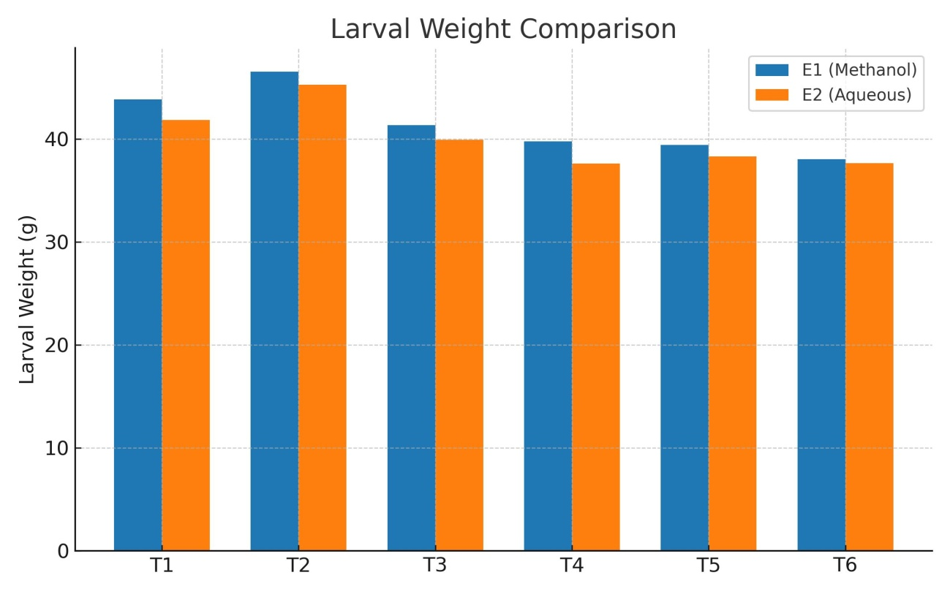
Figure 1. Silkworm larval weight comparison with methanol and aqueous extracts of medicinal plants

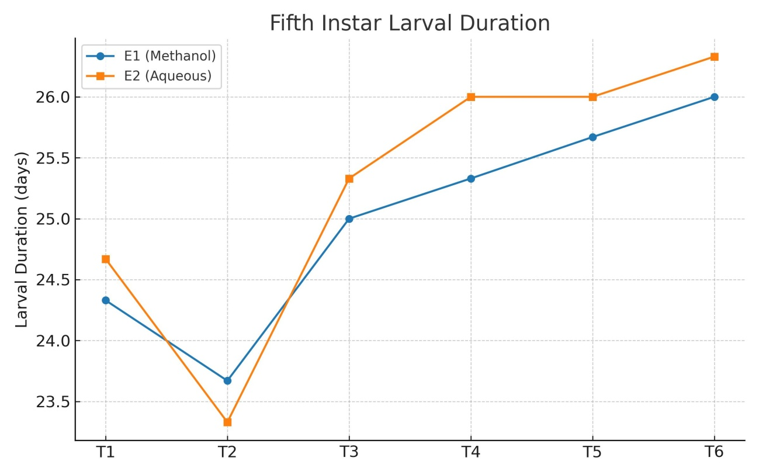
Figure 2. Fifth instar larval duration comparison with methanol and aqueous extracts of medicinal plants

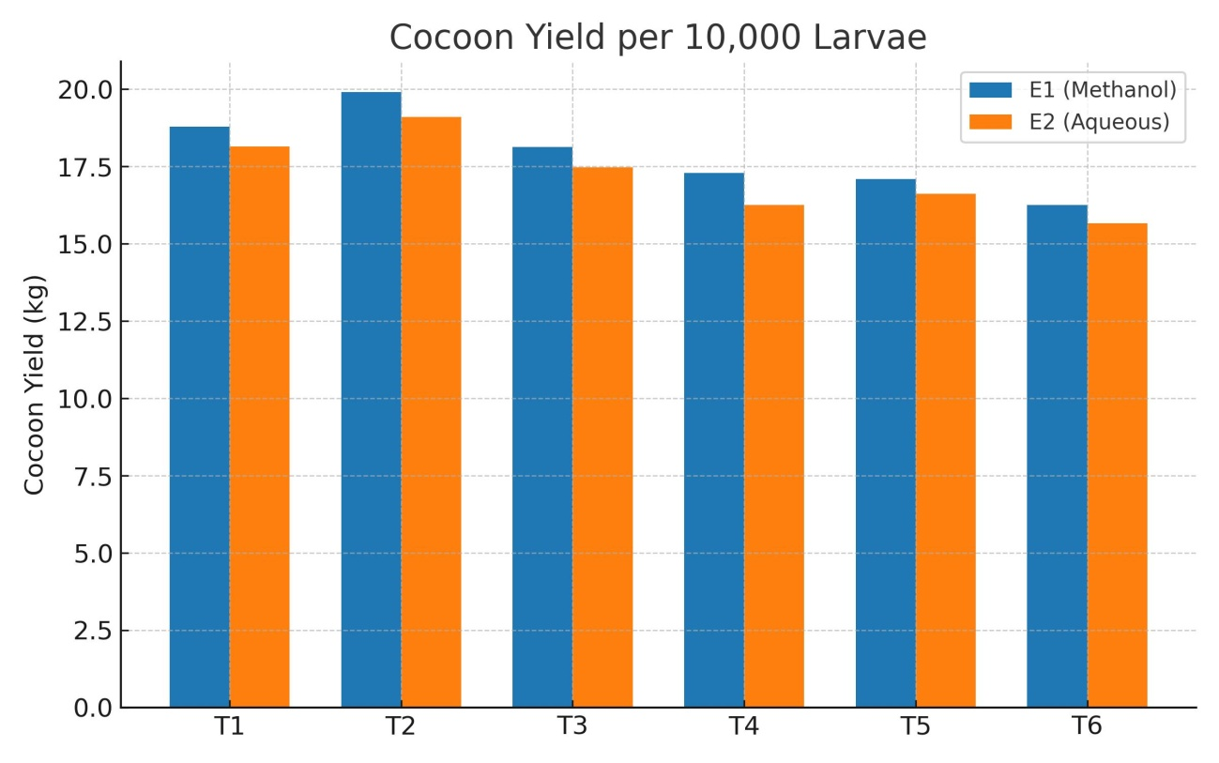
Figure 3. Cocoon yield comparison with methanol and aqueous extracts of medicinal plants

Literature Cited
Anonymous. Functioning of Central Silk Board & performance of Indian silk industry. Central Silk Board; c 2024. p. 1-20
Anonymous. 2003. Package of Practices. College of Temperate Sericulture, Mirgund, SKUAST-Kashmir.
Chavan, K. K., Galande, S. M., Kharbade, S. B., Hole, U. B., & Badge, A. S. (2024). Effect of mulberry leaves enrichment with nutritional supplements on growth parameters of FC1 × FC2 silkworm, Bombyx mori L. Journal of Entomology and Zoology Studies, 12(2), 482–486
Datta, M. and Gupta, J. (2002). Application of plant extract-based Ayurvedic medicines with feed to the silkworm Bombyx mori L. Nistari race to assess its effect on cocoon production. Environ. Ecol., 20: 505–510.
Dorman, H. J. D. and Deans, S. G. (2000). Antimicrobial agents from plants: Antibacterial activity of plant volatile oils. J. Appl. Microbiol., 88(2): 308–316.
Dubey, A. and Srivastava, R. P. (2005). Manifestation of three narcotic plant extracts on biological parameters of Bombyx mori L. In: Proc. 20th Congr. Int. Sericult. Comm., December 15–18, 2005, Bangalore, India, pp. 362–365.
Ebrahim, A. A., El-Naggar, A. M. and Saleh, M. M. (2023). Using of some plant extracts and honeybee products for feeding of imported and local hybrids of mulberry silkworm (Bombyx mori L.). Egypt. Acad. J. Biol. Sci. A. Entomol., 16(1): 153–165.
Ebrahim, A. H., Moustafa, M. A., & Mohamed, S. A. (2023). Effect of some plant extracts on growth and silk production of the silkworm Bombyx mori L. Egyptian Academic Journal of Biological Sciences, A. Entomology, 16(1), 65–78.
Gobena, A. and Bhaskar, M. (2015). Influence of dietary supplementation of Sida acuta plant extract on the biochemical and economic parameters of silkworm (Bombyx mori L.). Int. J. Zool. Stud., 3(2): 40–43.
Gouda, B., Seetharam, R. N. and Ananthanarayana, S. R. (1997). Effect of feeding Momordica charantia on cocoon and reeling parameters of silkworm. Sericologia, 37(3): 523–528.
Hassan, S. I., Rateb, S. H., Mohanny, K. M. and Hussein, M. H. (2020). Efficiency of some plant powder mix as a dietary supplement for silkworm (Bombyx mori). SVU-Int. J. Agric. Sci., 2(2): 378–383.
Hipparagi, G. D., Rayar, S. G., & Karabhantanal, S. S. (2001). Field spray of extract of botanicals on mulberry and its effect on silkworm, Bombyx mori L., growth and development. In Proceedings of the National Seminar on Mulberry Sericulture Research in India (pp. 127). KSSRDI, Bangalore, India.
Imran, M., Arshad, M. and Aslam, F. (2011). Role of medicinal plants in antioxidant defense. J. Med. Plants Res., 5(23): 5540–5547.
Jeyapaul, C., Padmalatha, C., Ranjitsingh, A. J. A., Murugesan, A. G. and Dhasarathan, P. (2003). Effect of plant extracts on nutritional efficiency in mulberry silkworm, Bombyx mori L. Indian J. Sericult., 42(3): 128–131.
Jeyapaul, C., Padmalatha, C., Ranjitsingh, A. J. A., Murugesan, A. G. and Dhasarathan, P. (2003). Effect of plant extracts on nutritional efficiency in mulberry silkworm, Bombyx mori L. Indian J. Sericult., 42(3): 128–131.
Karthikairaj, K., Sureshkumar, P. and Isaiarasu, L. (2013). Influence of turmeric extract on the growth and commercial parameters of Bombyx mori L. (Lepidoptera: Bombicidae). Afr. J. Basic Appl. Sci., 5(5): 228–231.
Khezrian, P., Ebadollahi, A., & Qolami, F. (2022). The effects of feed supplements and Nosema bombycis infection on economic traits in various silkworm (Bombyx mori) breeding lines. Entomologia Experimentalis et Applicata, 170(3), 203–213.
Kumari, S., Sharma, S., & Thakur, R. (2020). Influence of phytochemical-rich botanical supplements on growth and silk productivity of Bombyx mori. Journal of Entomology and Zoology Studies, 8(4), 1300–1305.
Mahesha, H. B., Savithri, G., & Sannappa, B. (2018). Effect of feeding neem (Azadirachta indica) and tulsi (Ocimum sanctum) extracts on larval growth and cocoon characters of Bombyx mori L. International Journal of Sericulture Science, 53(1), 12–18.
Manjunath, G. C., Doreswamy, C., & Bhaskar, R. N. (2020). Evaluation of certain medicinal plant extracts for the management of late larval flacherie disease of silkworm, Bombyx mori L. Journal of Entomology and Zoology Studies, 8(4), 260–264.
Moustafa, M. N. (2023). The effect of fortificated mulberry leaves with Echinacea purpurea on silkworm (Bombyx mori L.) physiology and production. Egyptian Academic Journal of Biological Sciences. A. Entomology, 16(4), 163–171.
Murugesh, S. (2002). Efficacy of aqueous botanicals (Tridax procumbens, Tribulus terrestris, Parthenium hysterophorus) in improving larval weight of Bombyx mori. Journal of Sericulture Research, 5(2), 45–51.
Prasad, B., & Govindan, R. (2010). Effect of basil (Ocimum sanctum) leaf extracts on the economic traits of silkworm (Bombyx mori L.). Sericologia, 50(3), 279–286.
Priyadarshani, M., Singh, B. M. K., & Singh, A. K. (2009). Influence of plant extract feeding on cocoon yield and reeling traits in silkworm (Bombyx mori L.). Journal of Advanced Zoology, 30(1), 23–27.
Raju, P. J., Reddy, K. D., & Prasad, M. S. (2012). Effect of turmeric (Curcuma longa Linn.) on growth and economic traits of mulberry silkworm, Bombyx mori L. Journal of Environmental Biology, 33(1), 55–58.
Saad, M. S., Elyamani, E. M., & Helaly, W. M. (2019). Controlling of bacterial and fungal diseases that contaminating mulberry silkworm, Bombyx mori by using some plant extracts. Bulletin of the National Research Centre, 43(1), 1–9.
Saharia, S., Kalita, S., Kalita, D., Ojah, A., & Bardoloi, S. (2023). Assessment of the effect of methanolic herbal extract on cocoon parameters and tensile properties of silk fiber spun by Beauveria bassiana infected Muga silkworm, Antheraea assamensis Helfer. Asian Journal of Biological and Life Sciences, 12(2), 395.
Sridevi, G. (2003). Effect of mulberry leaves fortified with medicinal botanicals on the performance of mulberry silkworm, Bombyx mori L. (M.Sc. thesis). University of Agricultural Sciences, Bangalore, 116 pp.
Sujatha, R., & Rao, D. R. (2003). Studies on the effect of turmeric extracts on silk productivity. Sericologia, 43 (3), 345–350.
Talari, K., Kumari, A. M., & Prasad, T. N. V. K. V. (2013). Effect of Oroxyllum indicum extracts on economic traits of silkworm. Journal of Pharmacognosy and Phytochemistry, 2(1), 113–116.
Tayal, M. K., & Chauhan, T. P. S. (2017). Silkworm diseases and pests. In Industrial Entomology (pp. 265–289).
Xu, H. J., Meng, F., Zhu, L., & Chen, H. Y. (2017). The silkworm (Bombyx mori): A powerful model organism for basic and applied research in life sciences. Applied Microbiology and Biotechnology, 101(5), 1717–1727.

