Original Research Article
Micropropagation of Bacopa monnieri (L.) Pennell

ABSTRACT
Bacopa monnieri, commonly known as "Brahmi," is widely used in the traditional Indian Ayurvedic system of medicine. The present study was conducted to standardize the explants used for micropropagation and to standardize the surface sterilant concentration and duration. Nodules and leaf segments of Bacopa monnieri were used as explants for in vitro propagation. Effective micropropagation of any plant under in vitro conditions relies on the use of the correct type of plant growth regulator at the optimal concentration. Murashige and Skoog (MS) medium was used as the basal medium and was supplemented with different combinations of auxins (NAA, 2,4-D), cytokinins (BA), and BAP. Effective surface sterilization is essential for aseptic cultures, and mercuric chloride was selected as the sterilizing agent. Concentration and duration analysis showed that 0.05% HgCl₂ for 4 minutes and 0.1% for 2 minutes effectively reduced fungal contamination. Thus, the tissue culture technique can be further utilized for the genetic modification of the germ line, followed by micropropagation to obtain a large number of new plants with the desired properties. Conclusively, the present study presents a fast, reliable, and most importantly, reproducible micropropagation protocol for the selected plants of B. monnieri that can be utilized for commercial-level production of quality planting material to ensure the reproducibility of developed plantlets with efficient medicinal properties.
KEY WORDS: Bacopa monnieri, Micropropagation, MS medium, Explant, Surface sterilization

INTRODUCTION
One of the technological interventions that provides some of the best prospects and answers to a number of issues encountered in the agricultural area is biotechnology. Biotechnology encompasses any methods that use living organisms or parts of organisms to enhance plants or animals and modify their products for certain purposes. Genetic engineering, tissue culture, bioprocessing, protein engineering, and other techniques are the mainstays of biotechnology. Micropropagation, also known as plant tissue culture or cell culture, is a technology that quickly and efficiently generates a large number of commercially significant crop species from minute plant fragments. It is a technique for quick multiplication that makes use of aseptic artificial media. An entire superior specimen plant can produce an entire crop population with superior traits
Bacopa mediates the GABAergic system. Gamma-aminobutyric acid is an inhibitory neurotransmitter that has been shown to possess anticonvulsive, antinociceptive (prevention of pain due to hyper-sensitive nerve endings), locomotor, and sedative effects. Because Bacopa also has all these properties, it is reasonable to speculate that a similar mechanism of action explains its effects on the brain and the body. It has previously been demonstrated that the standardized extract significantly improves memory retention in Alzheimer's patients and has substantial antioxidant and anxiolytic effects (Agular S, Borowski 2013). Currently, animal models of depression are being used to study the possible antidepressant efficacy of Bacopa monnieri's standardized methanolic extract (bacoside A). Clinical studies on the use of bacopa for children with attention-deficit hyperactivity disorder (ADHD) provide another usage for the herb. It is crucial to use several techniques to ensure the medicinal plant. One of the fundamental uses of biotechnology in the preservation and propagation of Brahmi is plant culture. One of the most advantageous ways to quickly and widely grow these helpful medicinal plants is by micropropagation.
MATERIALS AND METHODS
The study was conducted using explants, which include the leaves (1”- 5th from the apex), shoot segments (3rd to 5th from the apical node), and meristem portions, which were collected from the medicinal garden of ONATTUKARA REGIONAL AGRICULTURAL RESEARCH STATION, KAYAMKULAM. The explants were obtained from healthy specimens of Bacopa monnieri kept at the station. Murashige and Skoog media is used as the basal media in this work to culture the explant. From the stock solution desired volume of MS was prepared (Table 1). The appropriate amount of MS was generated using the stock solution and supplemented with various combinations of growth regulators such as BA, BAP, Kinetin, NAA, IBA, and 2,4-D, The nodal segments were inoculated in MS media supplemented with different amounts and combinations of cytokinin (BA, DAP, and Kn), such as MS ± 3BA, MS ± 2BA +1 NAA, and MS + BA 1ppm, NAA + BA 1 ppm + MS 1 ppm (Table 6). The solution's pH was then adjusted to 5.8 by adding 1N HCI or 1N NaOH solution drop by drop. Culture tubes were transferred for sterile inoculation.
Before the inoculation of the explant to the MS medium, it was surface sterilized with Bavistin (fungicide) and mercuric chloride. Six bottles containing 0.05% and 0.1% of mercuric chloride were taken; the explants previously treated with Bavistin were inoculated into the first three bottles containing 0.05% of mercuric chloride, with an increasing exposure time from 2 to 6 minutes, with a difference of 2 minutes.
Before inoculation, the explants were placed aseptically on the medium's surface. After inoculation, the culture tubes were transferred to the incubation room. The room was provided with artificial illumination with cool fluorescent lamps. The light intensity was maintained at around 3000 lux. The relative humidity was maintained at 60-70% and the temperature 25±2°C. For rooting, the culture was kept in the dark. The explants with bud proliferation cultures were transferred to culture bottles containing fresh MS medium. After 10-15 days of incubation, the initiated plants were taken out of the culture bottle and transferred into fresh semi-solid MS media. Then the bottles were kept in a culture room at 25±2°C. After experimental days, the fully mature culture was obtained, and they were further subcultured in MS medium supplemented with different plant growth hormones at different concentrations for regeneration of shoots.

Stock | Compounds | Quantity (mg/l) | Stock concentration | Quantity required for 1L | Quantity required for mg | Volume of stock | Volume required for 1L media
A | Macronutrients  Ammonium nitrate  Potassium nitrate  Potassium phosphate dibasic anhydrous  Magnesium sulphate | 1650  1900  170  370 | 40X | 66000  76000  6800  14800 | 33000  38000  3400  7400 | 500ml | 25ml  For 11medium
B | Calcium chloride dihydrous | 440 | 100X | 44000 | 4400 | 100ml | 10ml
C | Iron source  Sodium EDTA  Ferrous sulphate heptahydrate | 37.3  27.8 | 200X | 5560  5560 | 556  746 | 100ml | 5ml
D | Micronutrients  Manganese sulphate monohydrate  Zinc sulphate heptahydrate  Boric acid  Potassium iodide  Sodium molybdate dihydrate  Cobalt chloride hexahydrate  Copper sulphate pentahydrate | 22.3  8.6  6.2  0.83  0.25  0.025  0.025 | 200X | 4460  1720  1240  166  50  5  5 | 2230  860  620  83  25  2.5  2.5 | 500ml | 5ml
E | Organic supplements  Glycine  Nicotinic acid  Pyridoxine HCl  Thiamine  Inositol | 2  0.5  0.5  0.1  100 | 1000X | 2000  500  500  100  100 | 200  50  50  10  10 | 100ml | 1ml

Table 1: stock for MS medium

Table 2: Preparation of plant growth hormones from the solutions.
Concentration | Duration | Recovery of culture % | Remarks
0.05% | 2  4  6 | 50  95  48 | Fungal contamination  Effective  Drying
0.1% | 2  4  6 | 90  45  5 | Effective  Drying  Drying

Compounds | Quantity (mg)  for 10 ml stock | Preparation | Concentration
NAA | 10 | Dissolve in 1N NaOH and made up to 10 ml | 1ml=1mg
BA | 10 | Dissolve in 1N NaOH and made up to 10 ml | 1ml=1mg
2,4-D | 10 | Dissolve in 1N NaOH and made up to 10 ml | 1ml=1mg
Table 3: Effect of mercuric chloride on the growth rate of Bacopa monnieri in the MS medium

Sl. No | Duration of Bavistin (0.2%) treatment (min) | Rate of growth | Rate of contamination
1 | 5 | - | +
2 | 10 | - | +
3 | 15 | + | -
4 | 20 | ++ | -
5 | 25 | +++ | -
Table 4: Effect of Bavistin on the growth rate of Bacopa monnieri in the MS medium

Sl. No | Concentration of sucrose | Rate of growth | Rate of contamination
1 | 20 g/l | - | -
2 | 25 g/l | - | -
3 | 30 g/l | ++ | +
4 | 35 g/l | + | ++
5 | 40 g/l | ++ | -
Table 5: Response of nodal explants on various concentrations of sucrose in MS Medium
*
- | No

+ | Low

++ | Medium

+++ | High

Sl. No | Hormone treatment in the medium | Observation after 5 days
1 | MS + BA 1ppm | -
2 | MS + BA 1ppm + NAA 1ppm | -
3 | MS + BA 3ppm | 1
4 | MS + NAA 1ppm | -
5 | MS + 2,4-D 2ppm | -
6 | MS + BA 2ppm | -
7 | MS +BA 2ppm +NAA 1ppm | 1

Table 6: Response of nodal segments of Bacopa monnieri in varying levels and combinations of hormones in shoot induction

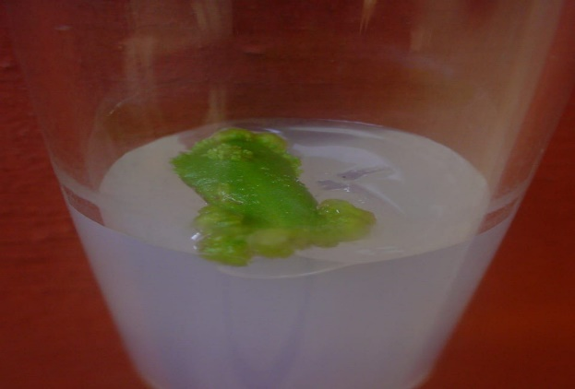
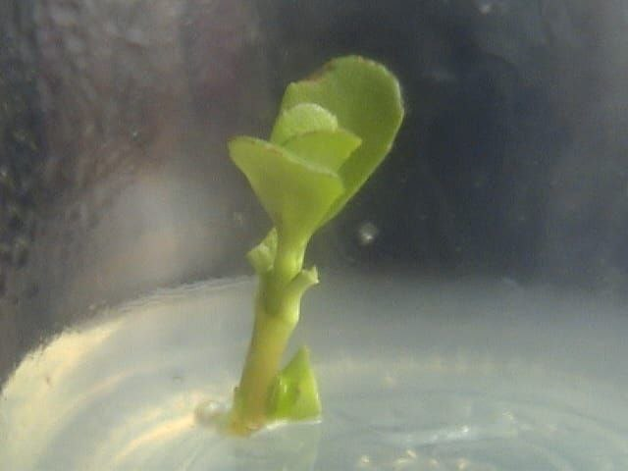

Figure 1: Explant inoculation in to the medium.
Figure 2: Induction of shoot bud from cut edge of the leaf after 8 days.

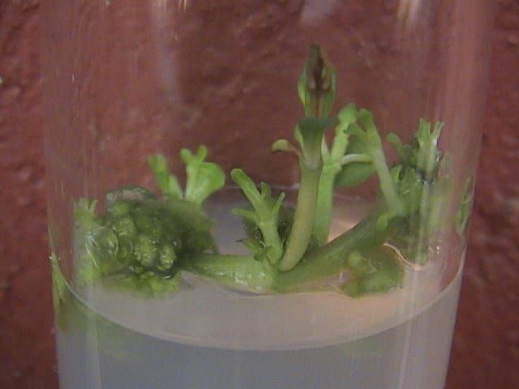
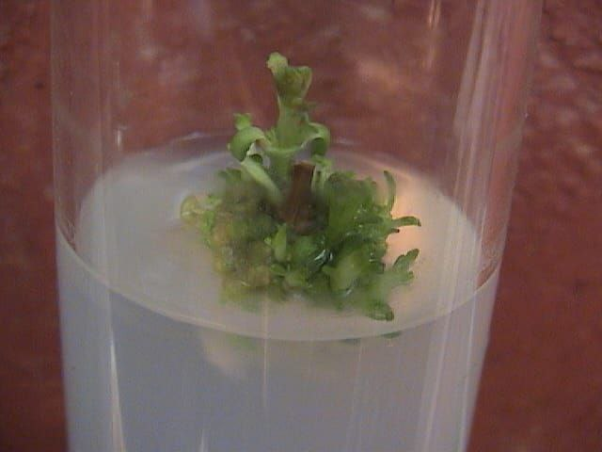

Figure 3: Shoot multiplication on MS medium supplemented with 3ppm BA after 5 days.
Figure 4: Shoot elongation on MS medium supplemented with 3ppm BA.

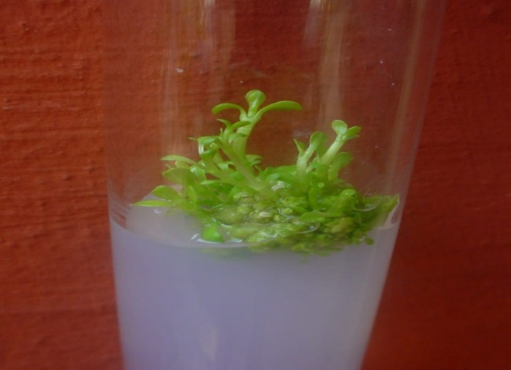

Figure 5: Elongated shoot in MS medium after 30-35 days.

RESULT AND DISCUSSION
This presents information on the several study phases. To propagate the Bacopa monnieri in vitro, nodule and leaf segments were obtained as explants in this work. As the base medium, Murashige and Skoog (MS) medium was utilized. A variety of auxin combinations, including 2,4-D, NAA, cytokinins (BA), and BAP, were added to the medium.
Explant Selection and Surface Sterilization
Nodal and leaf segments were selected as explants due to their rapid regeneration potential. Successful micropropagation begins with proper surface sterilization. Among the various sterilization combinations tested, treatment with 0.1% Bavistin for 30 minutes, followed by 0.05% HgCl₂ for 4 minutes, provided the most effective decontamination while preserving explant viability. Higher concentrations or prolonged HgCl₂ exposure (e.g., 6 minutes) resulted in explant necrosis, while shorter treatments were inadequate to prevent fungal contamination. This method enabled a contamination-free environment for culture establishment and is consistent with protocols reported in earlier studies on medicinal plants, where lower HgCl₂ concentrations (0.05%) and shorter durations (<5 minutes) preserved tissue integrity.
Shoot Induction
Shooting was initiated as early as 5 days in nodal segments inoculated in MS medium supplemented with 3 ppm benzyl adenine (BA). In another combination, 2 ppm BA + 1 ppm NAA promoted shoot development from nodal segments within 8 days. The shoots were robust and well-elongated, and shoot frequency was highest in this combination. Multiple shoot induction was most successful with MS + 3 ppm BA, confirming the efficacy of BA in promoting apical meristem activity. BA at 6 ppm and BAP at 5 ppm also supported shoot development but were comparatively less consistent. These findings align with earlier reports where BA concentrations between 2–4 ppm promoted optimal shoot induction in medicinal plants, especially in nodal explants.
Callus Induction and Proliferation
Callus initiation was first noticed 18–24 days post-inoculation, and well-developed calli formed by 30–35 days. Callus formation was most prominent in:
- Leaf explants cultured in MS + 2,4-D (2 ppm) + kinetin (1 ppm)
- Nodal explants cultured in MS + 2,4-D (3 ppm)
Callus appearance was friable, white to cream in color, and showed regenerative potential. The type and concentration of auxins significantly affected callus morphology and size. This suggests that 2,4-D plays a pivotal role in dedifferentiation, especially when used with kinetin. The result is consistent with previous findings in medicinal plants where leaf explants responded better to 2,4-D-based media, supporting somatic embryogenesis and dedifferentiation.
Rooting and Regeneration
Calli were subcultured in MS + BAP (5.5 ppm) + NAA (0.2 ppm) medium for regeneration. Both shoot and root primordia appeared within 10–14 days. Additionally, IBA (3 ppm) was effective in inducing direct multiple shoot formation from nodal segments, supporting both shoot multiplication and basal root initiation. BAP + NAA combination was particularly beneficial for shoot elongation and rooting simultaneously, an outcome critical for complete plantlet development suitable for acclimatization.
Optimization of pH and Sucrose Concentration
Growth and regeneration were strongly influenced by pH and sucrose levels. Optimal growth was recorded at pH 5.8, which supported higher shoot elongation and leaf expansion. Sucrose at 30,000 mg/L (3%) gave the best results in terms of shoot number, callus weight, and explant vigor.35,000–40,000 mg/L sucrose also supported growth but increased contamination rates. This suggests that Bacopa monnieri is sensitive to carbon source concentrations and osmotic potential, and a balanced osmotic environment promotes morphogenesis.
CONCLUSION
The commercial propagation and preservation of potentially endangered medicinal plant resources can be accomplished through the use of this protocol. When the growth patterns of different types of explants were studied, it was found that nodal segments had higher rates of off shoot branching and multiplication than shoot tips, which were mostly associated with low levels of shoot elongation and multiplication. Primordia were present in several shoot clusters, indicating the maximum growth rate. For every type of explant, rooting was essentially consistent. Comparisons of plant growth and survival in the field under various conditions also differ. The survival percentage of plants that were directly transplanted from in vitro settings was relatively low upon planting out. Even after a week, transplants cultured on MS media without cytokinins were unable to form shoots. BAP significantly improved the percentage of regeneration, the number of shoots, and the length of the shoots when combined with 2,4-D and NAA. Out of all the cytokinin-auxin combinations tested, IAA and BAP/2,4-D produced the highest percentage of regeneration, 90% of shoots, and 4.95±0.9 shoot length per explant produced the highest percentage of shoots, 95% of shoot length, and 4.90±00 shoot length per explant. Numerous occurrences have been reported regarding the impact auxin plays in the medium when combined with cytokinins to promote shoot multiplication.
REFERENCE
- Bhattacharya, S. K., Bhattacharya, A., Kumar, A., & Ghosal, S. (2000). Antioxidant activity of Bacopa monnieri in rat frontal cortex, striatum and hippocampus. Phytotherapy Research 14(3): 174-179.
- Bhusari, W., Wanjari, R., & Khobragade, P. (2013). Cost effective in vitro clonal propagation of Bacopa monnieri L. Penell. International Journal of Industrial Medicinal Plants 46: 1239-1244.
- Ceasar, S. A., Maxwell, S. L., Prasad, K. B., Karthigan, M., & Ignacimuthu, S. (2010). Highly efficient shoot regeneration of Bacopa monnieri (L.) using a two-stage culture procedure and assessment of genetic integrity of micropropagated plants by RAPD. Acta Physiologiae Plantarum 32: 443-452.
- Deepa, M., Sangli, G. K., Arun, P. C., & Amit, A. (2003). Quantitative determination of the major saponin mixture bacoside A in Bacopa monnieri by HPLC. Phytochemistry 66(8): 665-667.
- George, F., Geetha, S. P., Balachandran, I., & Raveendran, P. N. (2004). In vitro medium term conservation of Bacopa monnieri (L.) Pennell - the memory plus plant under flow growth conditions. Plant Genetic Resources Newsletter 151: 49-55.
- Jain, P., Khanna, N. K., Trehal, N., Tendse, V. K., & Godhwani, J. L. (1994). Anti-inflammatory effect of an Ayurvedic preparation, Brahmi Rasayana, in rodents. International Journal of Experimental Biology 32: 633-636.
- Joshi, A. G., Pathak, A. R., Sharma, A. M., & Singh, S. (2010). High frequency of shoot regeneration on leaf explant of Bacopa monnieri. Environmental Experimental Biology 8: 81-84.
- M., Aasim, M., Dogan, M., & Khawar, K. M. (2013). Adventitious shoot regeneration of the medicinal aquatic plant water hyssop (Bacopa monnieri L. Pennell) using different internodes. Archives of Biological Sciences 65: 297-303.
- Mehta, J., Ansari, R., Syedy, M., Khan, S., Sharma, S., Gupta, N., Rathore, R., & Vaishnav, K. (2012). An effective method for high frequency multiple shoots regeneration and callus induction of Bacopa monnieri (L.) Pennel: An important medicinal plant. Asian Journal of Plant Science and Research 2: 620-626.
- Mohapatra, H. P., & Rath, S. P. (2005). In vitro studies of Bacopa monnieri: An important medicinal plant with reference to its biochemical variations. Indian Journal of Experimental Biology 43(4): 373-376.
- Patra, K. N. (2003). In vitro studies of Bacopa monnieri with reference to its biochemical variation. Phytomedicine 11(2): 333-345.
- Obta, T., Nakamura, S., Nakashima, S., Oda, Y., Matsumoto, T., Fukaya, M., Yono, M., Yoshikawa, M., & Matsuda, H. (2016). Chemical structure of constituents from the whole plant of Bacopa monnieri. Journal of Natural Medicines 70: 404-411.
- Pandiyan, P., & Selvaraj, T. (2012). In multiplication of Bacopa monnieri (L.) Pennell from shoot tip and nodal explants. Journal of Agricultural Technology 8: 1099-1108.
- Skoog, F., & Miller, C. O. (1957). Chemical regulation of growth and organ formation in plant tissue cultures in vitro. Symposium of the Society for Experimental Biology 11: 118-131.
- Tejavathi, D. H., Sowmya, R., & Shailaja, K. S. (2001). Micropropagation of Bacopa monnieri using shoot tip and nodal explants. Journal of Tropical Medicinal Plants 2(1): 39-45.
- Tiwari, V., Tiwari, K. N., & Singh, B. D. (2006). Shoot bud regeneration from different explants of Bacopa monnieri (L.) Wettst by trimethoprim and Bavistin. Plant Cell Reports 25: 629-635.
- Vijayakumar, M., Vijayakumar, R., & Stephen. (2010). In vitro propagation of Bacopa monnieri L. - a multipurpose medicinal plant. Indian Journal of Science and Technology 3(7).
- Vohora, B. S., Khanna, T., Athar, M., & Ahmad, B. (1997). Analgesic activity of bacosine, a new triterpene isolated from Bacopa monnieri. Fitoterapia 68: 361-365.

