Original Research Article
Investigation on the occurrence of Sclerotial wilt infecting Jasminum sambac (L). Aiton

ABSTRACT
Aim:
This study aimed to investigate the occurrence, pathogenicity, and severity of Sclerotium spp. induced wilt in Jasminum sambac from Tamil Nadu, and to evaluate oxalic acid degradation and disease suppression under controlled conditions.
Study Design:
The research utilized a completely randomized design (CRD)
Place and Duration of Study:
The experiment was conducted from 2024 to 2025 at SRM College of Agricultural Sciences in Chengalpattu
Methodology:
Infected Jasminum sambac plants showing typical wilt symptoms were collected, and the pathogen was isolated on PDA medium. Morphological traits such as mycelial growth and sclerotia characteristics were examined. Pathogenicity was confirmed by artificial inoculation and re-isolation. Oxalic acid produced by the fungus was quantified and its degradation potential by rhizosphere antagonistic bacteria was evaluated in vitro. Pot culture experiments were conducted with varying sclerotia loads (2, 10, and 20 per pot) for different inoculum density.
Result:
Sclerotium spp. was consistently isolated from diseased samples and produced abundant white mycelium and mustard-sized sclerotia. Pathogenicity tests confirmed its virulence, with higher sclerotia loads causing increased wilt incidence. Oxalic acid was detected in culture filtrates, and selected MS13 bacterial isolate effectively degraded it.
Conclusion:
The study confirmed Sclerotium spp. as the causal agent of jasmine wilt in Tamil Nadu. Oxalic acid plays a significant role in pathogenicity. Sclerotia load directly influences disease severity. Biocontrol agents capable of degrading oxalic acid may offer an effective disease management strategy.

Keyword: Sclerotium spp, Oxalic acid, pathogenicity test, sclerotia

1. Introduction
Jasmine (Jasminum spp.), belongs to “Oleaceae” family and is one of the earliest cultivated fragrant flowers. The name jasmine comes from the Arabic word “Jessamine,” while in Persian, it is referred to as “Yasmin” or “Yasmyn,” which translates to fragrance (Bailey, 1951). Out of 200 available species of Jasmine worldwide, 40 are identified from India with 20 species only from South India (Bhattacharjee, 1980). Among commercially grown flowers, jasmine is the most significant flower due to its high export value and substantial income it generates.
The crop J. sambac (L.) Aiton, commonly known as Arabian jasmine, Sambac jasmine, or jasmine flower, is renowned globally for its aromatic blooms. The aromatic flowers of J. sambac are utilized for extracting essential oil, a popular natural component in the perfume and cosmetics sectors, and also in pharmaceutical uses and aromatherapy. Jasmine is cultivated in India, China, and Malaysia (Ganga et al., 2020), and India ranks among the top countries in J. sambac cultivation, with significant growing regions located in Maharashtra, Uttar Pradesh, West Bengal, and the southern states of Tamil Nadu, Karnataka, Andhra Pradesh, and Kerala (Yoganandan, 2020). In Tamil Nadu, J. sambac thrives in regions including Dindigul, Madurai, Salem, Trichy, Tirunelveli, and Virudhunagar, with smaller-scale cultivation in districts like Erode, Chengalpattu, and Ramanathapuram (Ganga et al., 2015; Vetrivel and Karunan, 2020).
J. sambac plant has been reported to be incited by plant diseases including leaf spot/leaf blight, root rot, collar rot, phytoplasma and etc (Muthulakshmi, 2024; Al‐Zadjali et al., 2007; Nawaz and Yousaf, 2023). Among them collar rot/ sclerotial wilt caused by Sclerotium spp. have been found to cause a yield loss of about 30-40% (Muthulakshmi, 2024).
The pathogen's ability to survive in the soil as sclerotia has made the management of the pathogen quite difficult. Field studies have also demonstrated the impact of the disease on yield can be quite severe, even in the absence of classic symptoms like wilting and sudden plant death.
Broad-spectrum systemic fungicides such as tebuconazole and azoxystrobin, along with flutolanil, are commonly used for the management of Sclerotium spp. However, the overuse of chemical fungicides leads to resistance and environmental concerns. In contrast, the biological control method offers a safer and eco-friendly alternative. These biocontrol strategies not only reduce the dependence on chemicals but also contribute to sustainable agricultural practices, promoting soil health and biodiversity. Considering the adverse effect of fungicides in the management of the pathogen, we have explored the potential of rhizosphere antagonistic bacteria for the management of Sclerotium spp. infecting Jasminum sambac
2. Materials and methods:
2.1. Survey, symptomatology, and isolation of the pathogen and biocontrol bacteria
A survey was carried out to assess the incidence of collar rot in various J. sambac cultivated districts of Tamil Nadu, specifically in Kanchipuram, Ramanathapuram, and Villupuram. The percentage of disease incidence was calculated using the formula (Teng et al., 2001).
At the collar region, the infected tissue was observed and documented. The pathogen was isolated from infected plants that displayed a whitish fungal growth along with numerous mustard-like sclerotia in the collar region and was isolated using the tissue segment method (Rangaswami and Mahadevan, 1999) on sterile Potato dextrose agar (PDA) medium. The inoculated plates were incubated at 27°C in incubator for 5 days and the observations were recorded.
During the survey, soil samples were taken from the rhizosphere region of different plants including neem, palm tree, sesbania, tulsi and etc, to isolate the potential bacterial antagonists (Table 2). One gram of soil from the rhizosphere was taken in a sterile conical flask with 100 ml of sterile distilled water. The antagonist from the rhizospheric soil was isolated by serial dilution method (Pramer and Schmidt, 1956). One ml of aliquot from dilutions such as 10⁻³ 10⁻⁵, and 10⁻⁶ was poured onto sterilized petri dish containing nutrient agar medium; gently rotated in both directions for even distribution and incubated at room temperature (27°C) for 24 hours. After incubation, antagonistic bacteria were identified based on the inhibition zone, and individual bacterial colonies were transferred to sterile nutrient agar (NA) medium for storage and further studies.
2.2. Morphological characterization of the fungal pathogen
Morphological characters of the fungal pathogen were observed and recorded. The characters taken into consideration were radial growth of mycelia (growth rate), colony morphology, and sclerotial characters, mainly time required for sclerotial formation, sclerotial maturity, pattern of sclerotial production, color of sclerotial bodies, number of sclerotial bodies produced per plate, and weight of 100 sclerotial bodies were observed and documented using Leica DM750 (Las X software, Germany). The pathogen was inoculated onto Potato Dextrose agar (PDA) media and incubated at 27±1°C (Punja and Rahe, 1992). Similarly, the colony characteristics of the bacterial antagonists were recorded based on the colour and colony morphology.
2.3 Pathogenicity test
2.3.1 Selection of Planting material
J. sambac varieties were used for the study. The plastic pots of 9” diameter were filled with a 2:1:1 autoclaved mixture of red soil, sand, and farmyard manure. The pot accommodated six kilograms of potting mixture. One plant per pot was transplanted and maintained
2.3.2. Preparation of pathogen inoculum
The inoculum of all the isolates of Sclerotium spp. was prepared separately on sorghum grain media (SGM) (Pande et al., 1994). SGM was prepared by soaking 200 g of sorghum grains for 16 h. The soaked grains were autoclaved at 121°C (1.5 kg/cm2) for 20 min. Each bag was seeded separately with a mycelial disc of 1 cm size from a 5-day-old actively growing culture of Sclerotium spp. isolates, and incubated at 25±1°C for 20 days.
2.3.3 Inoculation and observations
Thirty-five-days-old J. sambac transplanted cuttings were inoculated with 5g of inoculum per pot by spreading the inoculum on the surface of the soil. A suitable untreated control without inoculation was maintained. The observations were taken 15 days after inoculation. Re-isolation of the pathogen was made from symptomatic plant tissues to compare with that of the original isolate for conformity.
2.4 Efficiency of biocontrol agents in degrading oxalic acid
PDA broth was prepared, with 100 ml being transferred to a conical flask (250 ml) and subjected to autoclaving at 121 °C for 15 minutes. To assess the impact of antagonists on oxalic acid production by Sclerotium spp (SS1), a culture disc of Sclerotium spp and a loop of bacterial colony were co-inoculated in the conical flask. A control group was established using PDA broth inoculated solely with Sclerotium spp. The conical flasks were incubated at a temperature of 27±1 °C for a duration of 10 days. The mycelial mat was extracted by passing the broth via Whatman No. 1 filter paper, and the resultant was centrifuged at 5000 rpm for 10 minutes to remove the mycelial fragments. An 8 ml volume of calcium chloride-acetate buffer (pH 4.5) was incorporated into 10 ml culture filtrate, and the mixture was thoroughly mixed. The mixture was allowed to rest overnight, followed by centrifugation for 10 minutes at 5000 rpm. The supernatant was discarded, and the residue was rinsed with H₂SO₄ at a concentration of 10 ml. The resultant solution was placed in a 100 ml conical flask and heated to 80°C in a water bath. While still hot, titration was conducted with 0.02N potassium permanganate until a pale pink color appeared. A quantity of 1.2653 mg of oxalic acid was dissolved in 1 ml of 0.02 N potassium permanganate. The oxalic acid content in filtered broth was determined and expressed in terms of mg/ml (Mahadevan and Sridar, 1986).
2.5 Pot culture studies on the effect of sclerotial load in disease hastening
2.5.1 Preparation of Inoculum:
Sclerotium sp SS1 was isolated from infected J. sambac plants and cultured on Potato Dextrose Agar (PDA) plates. After 7 days of incubation at 28 ± 2°C, mature sclerotia were harvested, air-dried, and stored at 4°C until use (Yaqub et al,2005).
2.5.2 Experiment
Sterilized soils were artificially infested with Sclerotium spp @ 2, 10 and 20 sclerotia g-1 and transferred into 5 cm pots. Each cutting of J.sambac were transplanted in each pot. The pot not inoculated with Sclerotium spp served as a control. In a comparable set, mungbean was used as a test plant. Soil moisture was adjusted to 50% WHC and amount of water lost was restored after each 24 hrs. There were three replicates of each treatment and the pots were randomized. Data on mortality and wilting were recorded after 20 days growth.

3.Result and discussion
3.1. Survey, Symptomatology, and isolation of pathogen and biocontrol bacteria
Three Sclerotium spp. isolates were collected from different districts such as kanchipuram, Villupuram, and Ramanathapuram of Tamil Nadu to study regional severity and variability (Table 1).
The highest incidence of 22.5% was reported from Villupuram (SS2) followed by kanchipuram (SS1) (21.8%) and Ramanathapuram (SS3) with the minimum incidence of 17.1%. Isolates were georeferenced based on their collection sites using GPS coordinates (Fig. 1). The pathogen was isolated from a tissue size of 1cm, collected from the collar region and grown on PDA. Sclerotium spp. was isolated from the infected tissue and the pathogen took 3-4 days for full fungal growth (Fig. 2).
Sclerotium spp has long been recognized for its variation across different geographical regions and host plants (Punja and Gregon, 1983). Our findings were on par with the previous study.
Biocontrol agents were isolated from the rhizosphere soil of less-explored plants (Table 2). A countable number of bacterial colonies were found in the dilutions 10⁻³ and 10⁻⁶. A total number of 21 isolates were obtained and used for screening. Along with that, an antagonistic culture from Department of Plant Pathology, SRM College of Agricultural College was obtained for the study.

3.2. Morphological characterization of pathogen
All the three isolates of Sclerotium spp. (SS1, SS2, and SS3) exhibited distinct morphological characteristics.
3.2.1 Mycelial character of Sclerotium spp.
The growth rate and biomass production of three Sclerotium spp. isolates were assessed on PDA medium (Fig.3). Among the tested isolates, SS1 exhibited the highest radial growth rate of 22.5 mm/day along with a sparse, dull white colony morphology and produced 11.2 mg/day biomass. SS2, with a dense white colony, exhibited the slowest growth rate (15 mm/day) and the lowest biomass (9.23 mg/day). Isolate SS3, characterized by a cottony upright colony type, recorded a moderate growth rate (19 mm/day) and biomass (9.88 mg/day). These variations in growth behaviour reflect possible genetic diversity among the isolates (Table .3)
Morphological differentiation among S. rolfsii, S. delphinii, and S. coffeicola based on sclerotial and colony features has also been studied well (Punja and Damiani, 1996), providing additional taxonomic relevance to our observations
3.2.2 Sclerotial character of Sclerotium spp.
The isolates of Sclerotium spp. (SS1 to SS3) were evaluated for their sclerotial formation characteristics, including time to maturity, pattern of formation, color, weight, number per plate, and size. (Fig.4) All three isolates exhibited a peripheral pattern of sclerotia formation. The earliest sclerotial maturity was observed in SS1, which developed mature sclerotia in 5 days, followed by SS3 (6 days) and SS2 (9 days). In terms of color, SS1 produced orange sclerotia, while SS2 and SS3 produced brown sclerotia. Significant variation was observed in sclerotial weight, number, and size. The heaviest sclerotia were recorded in SS1 (0.57 g/100 sclerotia), with a moderate number (154 sclerotia/plate) and the largest average size (1.41 mm). In contrast, SS3 produced the most numerous sclerotia (237/plate), but these were smaller (0.37 mm) and lighter (0.17 g/100 sclerotia). SS2 showed intermediate characteristics in number (169/plate) and weight (0.32 g), but had relatively small sclerotia (0.52 mm) and the longest maturation period (9 days) (Table 4).
3.3 Pathogenicity
A pot culture experiment was conducted to test the pathogenicity of 3 isolates of Sclerotium spp collected from major J.sambac growing areas of Tamil Nadu using Ramnad gundumalli varieties (Table.5). Results indicated that isolates tested were pathogenic on the J.sambac variety and exhibited 100 per cent disease incidence. However, the isolates differed with respect to expressing wilting disease severity and mortality. The fungus was re-isolated from the plant expressing the typical symptoms. The re-isolated fungus showed similar characteristics of the original culture. Thus, Koch's postulate was confirmed (Fig.5)
Sennoi et al. (2012) proved the pathogenicity of ten isolates of S. rolfsii on three varieties of Jerusalem artichoke. They observed the variation in virulence of isolates and grouped them in to most aggressive and the least aggressive present study concise with this study
3.4. Efficiency of biocontrol agents in degrading oxalic acid
The untreated control recorded the highest oxalic acid production (2.195 mg/ml), confirming the virulant behaviour of Sclerotium sp (SS1). Among the biocontrol agents, MS19 significantly reduced oxalic acid accumulation to 0.290 mg/ml, followed closely by BC13 (0.260 mg/ml). The lowest oxalic acid production was observed in MS13 (0.061 mg/ml), indicating its potential to suppress pathogens' virulence factors, despite showing moderate antagonism in vitro (Fig.6). suggesting that this combination influences pathogenicity mechanisms by reducing oxalic acid synthesis. The reduction in oxalic acid production by biocontrol agents may indicate interference with the pathogen's virulence pathways, possibly via microbial antagonism, competition for nutrients, or enzymatic. The current results also reaffirm the critical role of oxalic acid in pathogenicity. (Table .6) Punja and Jenkins (1984) reported that S. rolfsii isolates vary in oxalic acid synthesis, a key virulence factor. Our data suggest that our study isolate may exhibit similar variation, reinforcing the need to consider oxalic acid levels when assessing isolate aggressiveness. Similarly, a species of Sclerotium such as S. delphinii isolates from Chafa, Khirni, and Jackfruit in Maharashtra region displayed significant variation in oxalic acid levels, ranging from 4.94 mg/g to 8.86 mg/g of mycelial mat, indicating that pathogenic traits may be isolate-specific. This concurs with findings by Adandonon (2000), who reported similar variability in isolates from the Oueme valley.

3.5 Pot culture studies on the effect of sclerotial load in disease hastening
Pot culture experiments demonstrated between sclerotial load and disease expression in J. sambac. In the treatment with 2 sclerotia per pot (T1), no wilt symptoms were observed throughout the 30-day observation period, indicating insufficient inoculum load for disease initiation. In 10 sclerotia per pot (T2), partial wilting symptoms were observed in 2 out of 5 plants, while 1 plant remained healthy, suggesting a moderate level of infection pressure. In contrast, 20 sclerotia per pot (T3) led to complete wilting in all three plants by 20 days post-inoculation, confirming that higher sclerotia density significantly accelerates disease development and hastens wilt expression. The control (T0), which received no sclerotia, showed no disease symptoms, confirming the pathogenic role of Sclerotium sp (SS1) sclerotia. These results suggest that a threshold inoculum level (between 10–20 sclerotia per pot) is necessary to induce consistent wilt symptoms under controlled conditions. (Fig.7)
The results of the present study corroborate well with the report made by Khalequzzaman (2003) where soybean plants inoculated with different inoculum levels of S. rolfsii and M. javanica, showed a gradual reduction in plant growth, nodulation, and yield per plant with a gradual increase in inoculum levels.

4. CONCLUSION
This study highlights the significant impact of Sclerotium spp. on J. sambac cultivation and identifies effective biocontrol strategies for its management. Among the tested isolates, MS19 emerged as the most promising biocontrol agent, demonstrating a substantial inhibition zone (35.0 mm) and a marked reduction in oxalic acid production (0.290 mg/ml), indicating its dual mode of action—direct suppression of mycelial growth and reduction of virulence. Although MS13 showed limited inhibition (17.0 mm), its strong suppression of oxalic acid (0.061 mg/ml) suggests an alternative mechanism via virulence attenuation. The combined treatment of MS19 had an impact on oxalic acid levels (0.120 mg/ml). These results lend credence to MS19 potential as an efficient and sustainable method of controlling Sclerotium spp. in J. sambac.

DISCLAIMER (ARTIFICIAL INTELLIGENCE)
Author(s) hereby declares that NO generative AI technologies such as Large Language Models (ChatGPT, COPILOT, etc) and text-to-image generators have been used during the writing or editing of this manuscript.
ACKNOWLEDGEMENT
We are grateful to the Department of Plant Pathology, SRM College of Agricultural Sciences, Chengalpattu.
COMPETING INTERESTS
Authors have declared that no competing interests exist

5. REFERENCE
Adandonon, A. (2000). Damping-off of cowpea in Benin and South Africa (MSc Thesis). University of Pretoria, South Africa.
Al‐Zadjali, A. D., Natsuaki, T. and Okuda, S. (2007). Detection, identification, and molecular characterization of a phytoplasma associated with Arabian jasmine (Jasminum sambac L.) witches’ broom in Oman. Journal of Phytopathology, 155(4), 211–219.
Bailey, L. H. (1951). Manual of cultivated plants. The McMillan Co., New York, 7–9.
Bhattacharjee, S. K. (1980). Native jasmine of India. Indian Perfumes, 24(3), 126–133.
Ganga, M., Jawaharlal, M. and Thamaraiselvi, S. P. (2020). Jasmine. Floriculture and Ornamental Plants, 1–22.
Ganga, M., Ranchana, P., Ganesh, S. and Kannan, M. (2015, August). Jasminum nitidum – a potential unexploited jasmine species. In III International Symposium on Underutilized Plant Species (Vol. 1241, pp. 105–112).
Khalequzzaman, K.M. 2003. Effect of inocula levels of Meloidogyne javanica and Sclerotium rolfsii on the plant growth, yield and galling incidence of soybean. Pak. J. Pl. Pathol., 2: 5664.
Mahadevan, A. and Sridhar, R. (1986). Methods in physiological plant pathology (3rd ed.). Sivakami Publications, Madras, 182 pp.
Muthulakshmi, P. (2024). Management of wilt disease (Sclerotium rolfsii Sacc.) in jasmine with fungicides. https://doi.org/10.29321/MAJ.10.400013
Nawaz, M. and Yousaf, N. (2023). First report of leaf blight of Jasminum sambac caused by Bipolaris australiensis in Pakistan. Plant Protection, 7(1), 17–24.
Pande, S., Rao, J. N., Reddy, M. V., & McDonald, D. (1994). A technique to screen for resistance to stem rot caused by Sclerotium rolfsii in groundnut under greenhouse conditions. Indian Journal of Plant Protection, 22(2), 151-158.
.Pramer, D. and Schmidt, E. L. (1956). Experimental Soil Microbiology. Burges Publishing Company, Minneapolis, USA, p. 107.
Punja, Z. K. and Damiani, A. (1996). Comparative growth, morphology, and physiology of three Sclerotium species. Mycologia, 88(5), 694–706. https://doi.org/10.1080/00275514.1996.12026706
Punja, Z. K., & Grogan, R. G. (1983). Basidiocarp induction, nuclear condition, variability and heterokaryon incompatibility in Athelia (Sclerotium) rolfsii. Phytopathology, 73(9), 1273-1278.
Punja, Z. K., & Jenkins, S. F. (1984). Influence of medium composition on mycelial growth and oxalic acid production in Sclerotium rolfsii. Mycologia, 76(5), 947-950.
Punja, Z. K. and Rahe, J. E. (1992). Sclerotium (pp. 166–170). In L. L. Singleton, J. D. Mihail, & C. M. Rush (Eds.), Methods for Research on Soilborne Phytopathogenic Fungi. St. Paul, MN: APS Press.
Rangaswami, G. and Mahadevan, A. (1999). Diseases of crop plants in India (4th ed.). Prentice Hall of India Pvt. Ltd.
Sennoi, R., Jogloy, S., Saksirirat, W., Kesmala, T., & Patanothai, A. (2013). Genotypic variation of resistance to southern stem rot of Jerusalem artichoke caused by Sclerotium rolfsii. Euphytica, 190(3), 415-424.
Teng, P. S., James, W. C., Waller, J. M., Lenne, J. M., & Waller, S. J. (2001). Plant pathologist's pocket book
Vetrivel, K. and Karunan, K. (2020). An economic study on cultivation and marketing constraints of jasmine flower in Tamil Nadu. International Journal of Management (IJM), 11(7).
Yaqub, F., & Shahzad, S. (2005). Pathogencity of Sclerotium rolfsii on different crops and effect of inoculum density on colonization of mungbean and sunflower roots. Pakistan Journal of Botany, 37(1), 175-180.
.Yoganandan, G. (2020). An enquiry into the challenges faced by flower farmers in Salem district – A qualitative study. International Journal of Disaster Recovery and Business Continuity, 11(1), 926–932.

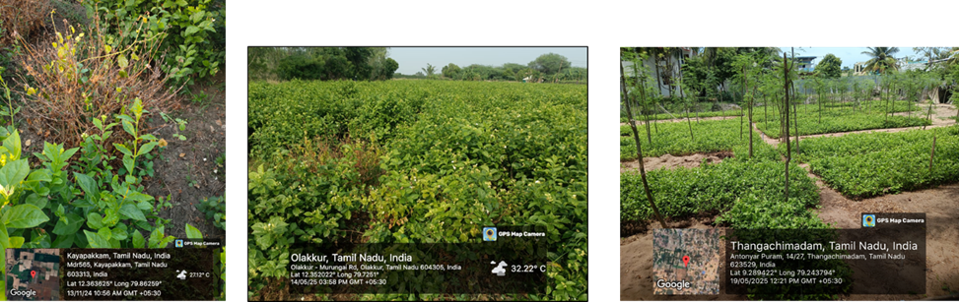

Fig.1 Survey of Agroathelia spp. disease incidence in Tamil Nadu

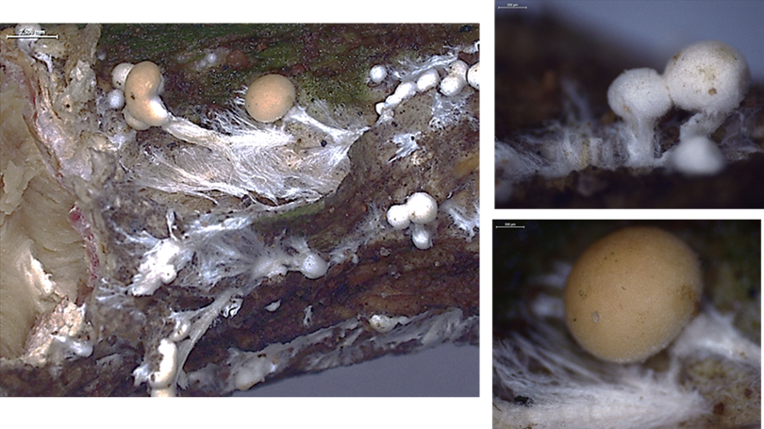

Fig 2. Microscopic character of Agroathelia delphinii

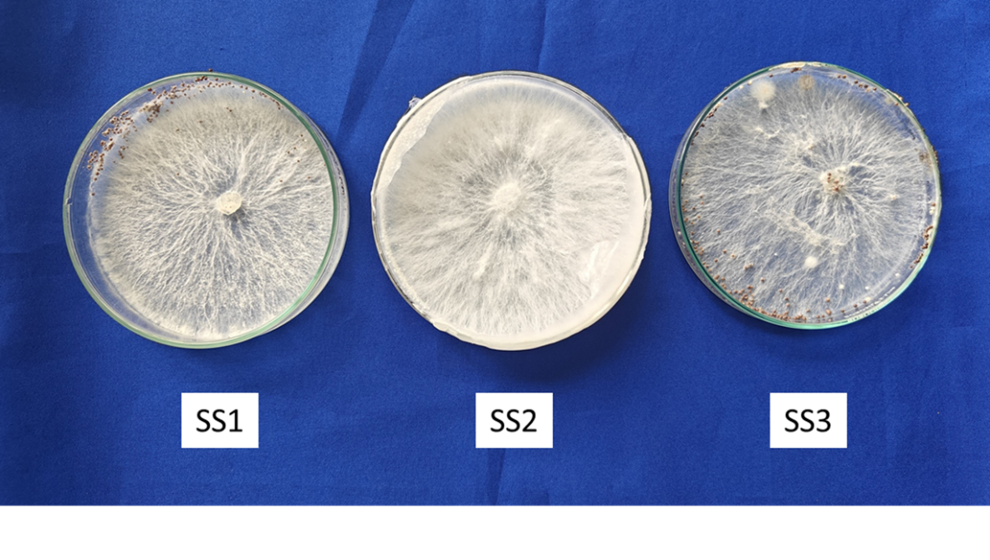
Fig 3. Cultural variation observed in different strains of Agroathelia spp

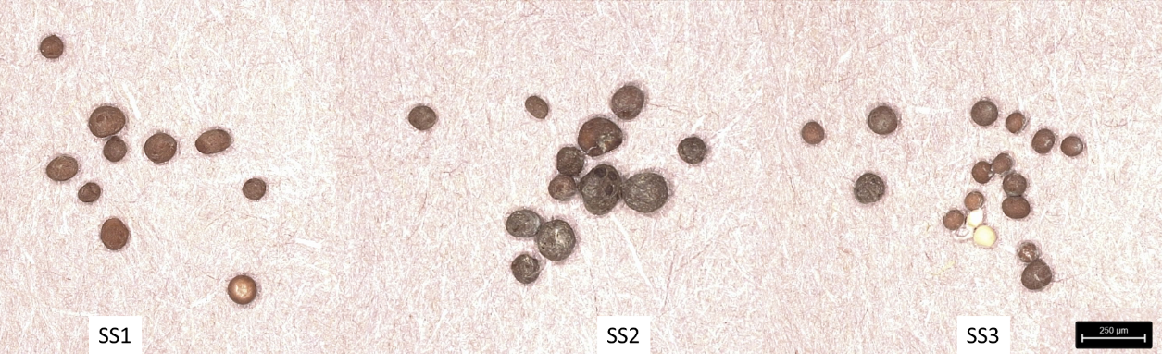
Fig 4. Sclerotial variation in different strains of Agroathelia spp.

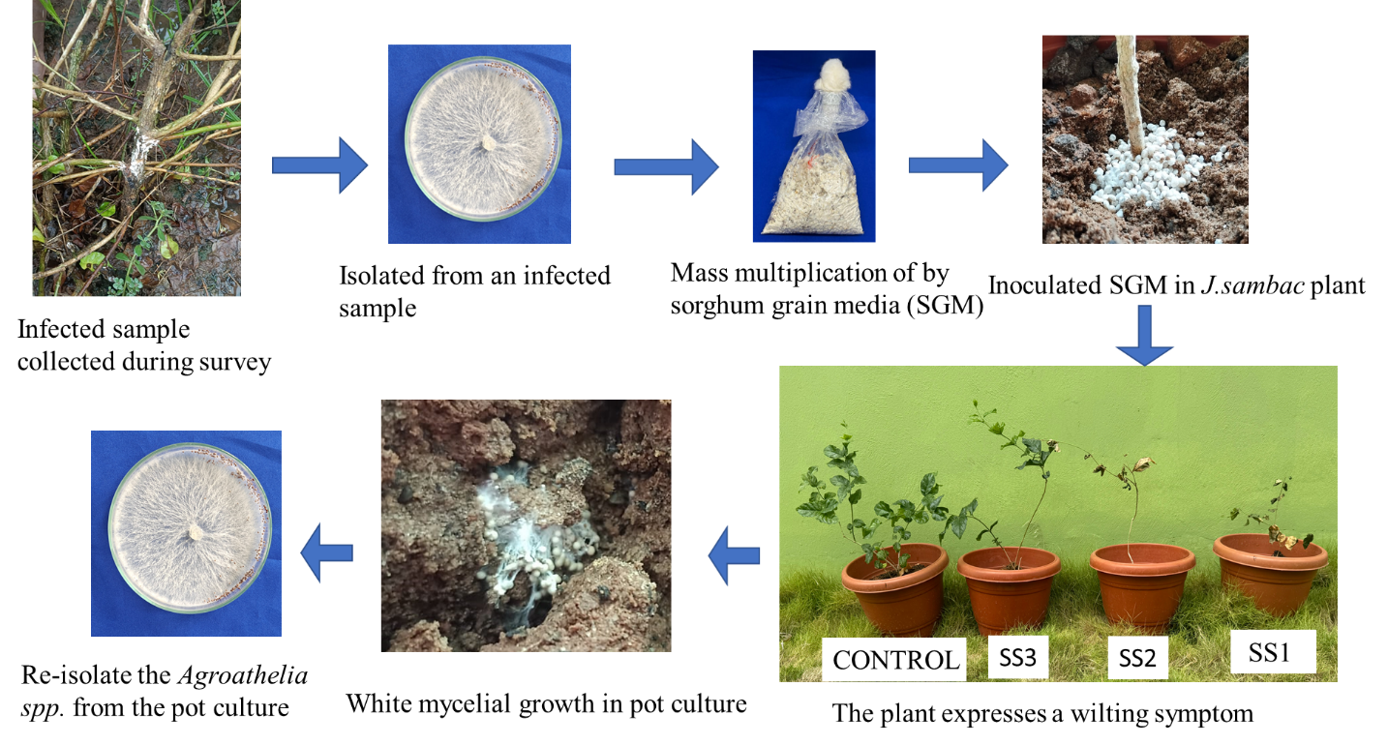
Fig. 5. Pathogenicity test for Agroathelia spp.

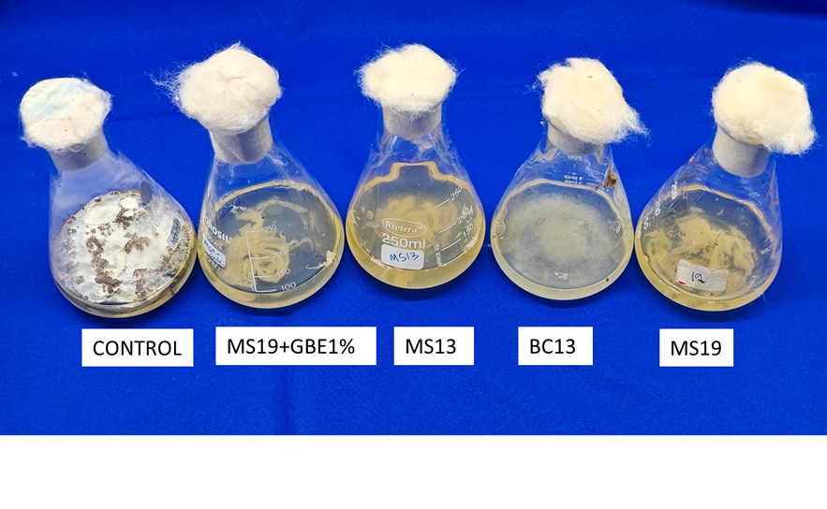
Fig 6. Efficiency of biocontrol agents in degrading oxalic acid

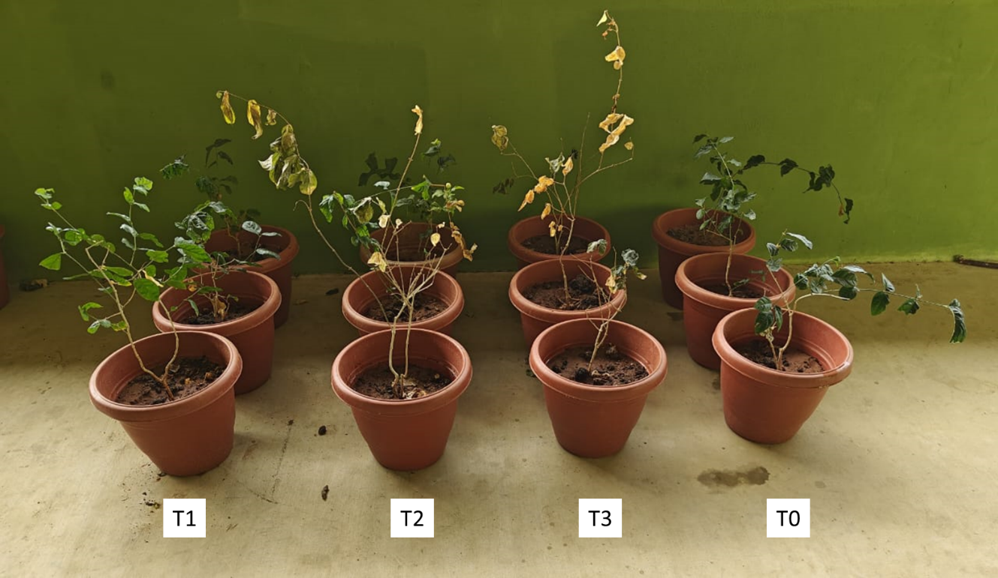

Fig. .7 Effect of sclerotial load on disease expression in pot culture.
Different concentrations of sclerotia of Sclerotium rolfsii were mixed into the top 5 cm of pot soil: T1 – 2 sclerotia/pot, T2 – 10 sclerotia/pot, T3 – 20 sclerotia/pot. Pots were monitored for symptom expression. No symptoms were observed in T1; partial wilting in T2 (2 plants affected, 1 healthy); complete wilting observed in T3. Untreated pots served as control (C), showing no symptoms.

Table 1: Geographical origin and coordinates of Agroathelia sp isolates from different districts of Tamil Nadu

Table 2: Bacterial antagonists isolated from various crops and locations
S.No | Isolate | District | Village | Geo Coordinates |  | Disease incidence  %
 |  |  |  | Latitude | Longitude
1 | SS1 | Kanchipuram | kayapakkam | 12.363625 | 79.86259 | 21.8
2 | SS2 | Villupuram | Olakkur | 12.352022 | 79.7251 | 22.5
3 | SS3 | Ramanthapuram | Thangachimadam | 9.289422 | 79.243794 | 17.1
S.No | Crops | Isolates
1 | Neem | MS1, MS2, MS3, MS4, MS5
2. | Palm tree | MS6, MS7, MS8
3. | Sesbania | MS9, MS10, MS11
4. | Tulsi (black) | MS12, MS13, MS14, MS15, MS16
5. | Tulsi (green) | MS17, MS18, MS19, MS20, MS21

Table 3: Mycelial characteristics of Agroathelia spp. Isolates

S.No | Isolates | Full growth of mycelium (Days) | Growth rate  (mm/day) | Mycelial character | Biomass (mg)
1 | SS1 | 4 | 22.5 | Sparse, dull white | 11.2
2 | SS2 | 6 | 15 | Dense, white | 9.23
3 | SS3 | 5 | 19 | Cottony upright | 9.88

Table 4: Sclerotial characteristics of Agroathelia spp, isolates

S.No | Isolates | Time required  mature (Days)** | Pattern | Color | Weight g/100 sclerotia | Number/plate **
1 | SS1 | 5 | Peripheral | Orange | 0.57 | 154
2 | SS2 | 9 | Peripheral | Brown | 0.32 | 169
3 | SS3 | 6 | Peripheral | Brown | 0.17 | 237
*Mean value of 10 sclerotia
** Mean of three replications

Table 5: Days of symptom expression and mortality recorded for different isolates
Isolates | Days of symptom expression
 | Initial | Morality
SS1 | 8 | 16
SS2 | 10 | 21
SS3 | 14 | -

Table 6: Efficiency of biocontrol agents in degrading oxalic acid production by A.delphinii.

S.No | Isolate | Oxalic acid production (mg/ml)
1 | MS19 | 0.290
2 | MS13 | 0.061
3 | BC13 | 0.260
4 | Control | 2.195
SE(d)  CV (%) |  | 0.011  1.589
*Mean value is a result of three replications

