**Fusarium Wilt Resistance in Pigeonpea: A Combined Phenotypic and ISSR Marker Study**

**Abstract**

Pigeonpea (*Cajanus cajan* (L.) Millsp.) is a vital leguminous crop with significant nutritional and economic value, particularly in tropical and subtropical regions. Fusarium wilt, which is caused by *Fusarium udum*, has a significant impact on pigeonpea productivity despite its significance, resulting in yield losses of 30–100%. Traditional breeding for resistance faces challenges due to limited resistant germplasm and environmental variability in phenotypic screening. This study integrates morphological evaluation with Inter Simple Sequence Repeat (ISSR) marker analysis to identify resistant genotypes and assess genetic diversity. Eleven pigeonpea genotypes were screened under controlled greenhouse conditions using artificial inoculation, revealing four resistant (0-6.66% wilt incidence), three moderately resistant (13.33-26%), and four susceptible (46.66-100%) genotypes. Molecular characterization using 13 ISSR primers generated 761 scorable bands, with UBC-818 and UBC-850 showing 100% polymorphism and ISSR-843 exhibiting the highest polymorphism information content (PIC = 0.358). Cluster analysis based on Jaccard’s similarity coefficients (0.54-0.91) distinctly grouped resistant and susceptible genotypes, validating phenotypic results. The study highlights the effectiveness of ISSR markers in identifying resistance-linked genomic regions, providing a reliable tool for marker-assisted breeding. These findings contribute to the development of high-yielding, wilt-resistant pigeonpea varieties, offering a sustainable solution to enhance productivity in disease-prone regions.

**Keywords:** Pigeonpea, *Fusarium wilt*, ISSR markers, Genetic diversity, Disease resistance, Polymorphism, Cluster analysis

**1. INTRODUCTION**

Pigeonpea (*Cajanus cajan* (L.) Millsp.), known as red gram or "arhar" in India, is a crucial leguminous crop with high economic and nutritional value, especially in tropical and subtropical regions (Saxena & Nadarajan, 2010; Varshney *et al*., 2010). Although grown as an annual, it is botanically a short-lived perennial and ranks second to chickpea among India’s pulse crops (FAOSTAT, 2022). Pigeonpea contributes significantly to soil fertility through nitrogen fixation and provides a key protein source alongside fodder and fuel (Ae *et al*., 1990; Saxena *et al*., 2010).

India dominates the global pigeonpea market, accounting for over 77% of production with major contributions from Karnataka, Maharashtra, and Madhya Pradesh ( Department of Agriculture & Farmers Welfare, 2024). However, pigeonpea productivity faces severe constraints from Fusarium wilt caused by *Fusarium udum* Butler, a soil-borne pathogen responsible for yield losses of 30-100% in susceptible varieties (Ghosh *et al*., 2017). The pathogen persists in soil as chlamydospores for over a decade, rendering chemical controls economically unviable for smallholder farmers (Sharma *et al*., 2022), with recent surveys reporting 40-60% disease incidence in major growing regions (Singh *et al*., 2023). While host-plant resistance remains the most sustainable solution, breeding programs face challenges including limited availability of resistant germplasm and environmental variability in phenotypic screening (Reddy *et al*., 2002).

To address these limitations, this study combines morphological screening with ISSR marker analysis to overcome environmental biases and identify resistance-linked DNA regions (Zietkiewicz *et al*., 1994; Bisht *et al*., 2022). The research aims to screen 11 pigeonpea genotypes for Fusarium wilt resistance, analyze their genetic diversity using 13 ISSR primers, and correlate molecular profiles with resistance levels to identify robust breeding material. The findings will provide breeders with molecular tools for accelerated cultivar development, reduce fungicide reliance in wilt-endemic regions.

**2. MATERIAL AND METHOD**

**2.1 Planting material and pot culture screening**

The present investigation was carried out in the Post Graduate Laboratory, Department of Plant Biotechnology, Vilasrao Deshmukh College of Agricultural Biotechnology, Latur [Vasantrao Naik Marathwada Krishi Vidyapeeth Parbhani (M. S.)] during 2023-2025 . A total of eleven pigeonpea *(Cajanus cajan* L.) genotypes collected from the Agriculture Research Station (ARS), Badnapur, Maharashtra were used for fusarium wilt disease screening in the present investigation.

A total of 11 Healthy pigeonpea seeds were surface sterilized with sodium hypochlorite, rinsed three times with sterile water, and sown in sterilized soil-filled plastic bags maintained at 30°C in a greenhouse. After 15 days, seedlings were uprooted, roots washed, trimmed, and immersed in a *Fusarium udum* spore suspension (6×105 spores/ml) for 20 minutes. Inoculated seedlings were transplanted into autoclaved, moistened soil in plastic bags and watered as required. The experiment was conducted in three replications of five plants each.

**2.2 Disease scoring**

Wilt incidence was recorded seven days after transplanting as the percentage of infected plants, following Sharma *et al*. (2016)

|  |  |  |
| --- | --- | --- |
| Disease incidence (%) = | No. of plants infected  Total number of plants examined | X 100 |

The AICRP scale listed below was used to assess the genotypes in relation to the occurrence of wilt disease.

|  |  |  |
| --- | --- | --- |
| Wilt incidence (per cent) |  | Reaction |
| 0.00- 10.00 | : | Resistant |
| 10.10 - 30.00 | : | Moderately resistant |
| >30.00 | : | Susceptible |

This standardized classification enabled clear differentiation of host responses and insights into resistance levels among the tested germplasms.

**2.3 DNA extraction**

The extraction of genomic DNA from young leaves of eleven pigeonpea genotypes was done using an optimized CTAB protocol (Doyle & Doyle, 1987). Briefly, 2-3 g of fresh leaf tissue was flash-frozen in liquid nitrogen and homogenized before incubation in CTAB extraction buffer (2% CTAB, 100 mM Tris-HCl pH 8.0, 20 mM EDTA, 1.4 M NaCl, 1% β-mercaptoethanol). The lysate was purified through chloroform: isoamyl alcohol (24:1) extraction followed by isopropanol precipitation. DNA pellets were washed with 70% ethanol and resuspended in TE buffer. DNA quality was verified by 0.8% agarose gel electrophoresis, while concentration and purity were determined using a Nanodrop spectrophotometer (A260/A280 ratio of 1.7-1.9).

**2.4 ISSR marker-based DNA fingerprinting**

Genetic diversity among 11 pigeonpea genotypes was analyzed using Inter Simple Sequence Repeat (ISSR) markers. Eleven polymorphic primers were selected from preliminary screening for final analysis. PCR amplification was performed in 25 µL reactions containing 10X PCR buffer, 25 mM MgCl₂, 10 mM dNTPs, 10 pM primer, Taq DNA polymerase, and template DNA. Amplified products were electrophoresed on 1.5% agarose gels in 1X TAE buffer at 100V for 2.5 hours, stained with ethidium bromide (10 mg/ml), and visualized under UV light. Bands were scored dichotomously, with "1" indicating presence and "0" indicating absence of amplification products. The final analysis contained only distinct, reproducible bands.This approach followed established protocols for legume genetic studies (*Bisht et al*,. 2022; Sultana *et al*,. 2020).

**Table 1 : Primers selected for ISSR marker based genetic diversity analysis**

|  |  |  |
| --- | --- | --- |
| **Sr no.** | **Primer code** | **Primer Sequence** |
|  | **ISD- 16** | AGAGAGAGAGAGAGAGC |
|  | **ISD- 20** | GAGAGAGAGAGAGAGACG |
|  | **ISD- 28** | AGAGAGAGAGAGAGAGTA |
|  | **ISD- 32** | AGAGAGAGAGAGAGAGAGAGT |
|  | **UBC-809** | AGAGAGAGAGAGAGAGG |
|  | **UBC-810** | GAGAGAGAGAGAGAGAT |
|  | **UBC-818** | CACACACACACACACAG |
|  | **UBC-825** | ACACACACACACACACAT |
|  | **UBC-841** | GAGAGAGAGAGAGAGACC |
|  | **UBC-860** | TGTGTGTGTGTGTGTGAA |
|  | **ISSR-843** | CTCTCTCTCTCTCTCTGA |
|  | **ISSR-857** | ACACACACACACACACYG |
|  | **UBC-850** | GTGTGTGTGTGTGTGTYC |

**2.5 Data Scoring and Genetic data analysis**

The binary (1/0) scoring data were analyzed using Jaccard's similarity coefficients (Jaccard, 1908) to calculate pairwise genetic distances. The resulting similarity matrix was subjected to hierarchical cluster analysis using the Unweighted Pair Group Method with Arithmetic Average (UPGMA) algorithm in NTSYS-pc software version 2.1 (Rohlf, 1998). Genetic relationships were visualized through dendrogram construction, while polymorphism percentage was determined as

|  |  |  |
| --- | --- | --- |
| Polymorphism percentage (%) = | Number of polymorphic bands  Total bands | X 100 |

This analytical pipeline enabled comprehensive evaluation of genetic diversity patterns among the tested genotypes.

**3. RESULTS AND DISCUSSION**

**3.1 Morphological assessment of pigeonpea genotypes resistance to fusarium wilt**

Globally, one of the main goals of breeding is to create pigeonpea types that are resistant to wilt. Greenhouse screening using artificial inoculation helps evaluate many plants efficiently under controlled disease conditions. This method ensures consistent testing by removing field variations, allowing reliable identification of resistant plants.

The phenotypic screening of eleven pigeonpea genotypes against *Fusarium udum* infection revealed three distinct response categories. Four genotypes (BDN-2004-1, Godavari, BSMR-853, and BDN-716) exhibited complete resistance, showing 0-6.66% wilt incidence with no visible symptoms of vascular browning or leaf wilting. These resistant lines maintained perfect physiological integrity throughout the evaluation period. Three genotypes (Vipula, BSMR-736, and BDN-711) demonstrated moderate resistance with 13.33-26% infection rates, displaying intermediate symptoms including mild leaf chlorosis and partial loss of turgidity. The remaining four genotypes (ICP-2376, Phule Rajeshwari, AKT-8811, and BDN-2) showed high susceptibility, with wilt incidence ranging from 46.66% to 100%. ICP-2376 was particularly vulnerable, showing complete (100%) susceptibility with rapid symptom development including severe wilting and plant death.

The clear demarcation in disease responses (0-100% incidence) among the tested genotypes provides strong evidence for genetic variation in Fusarium wilt resistance.

**Table 2 . Reaction of pigeonpea host differentials to *F. udum***

|  |  |  |  |  |  |
| --- | --- | --- | --- | --- | --- |
| **Sr. No.** | **Variety** | **Plant**  **Stand**  **(Nos.)** | **Wilted**  **Plants** | **Percent wilt incidence (%)** | **Reaction** |
|  | BDN-2004-1 | 15 | 0 | 0.00 | R |
|  | VIPULA | 15 | 3 | 20.00 | MR |
|  | GODAVARI | 15 | 0 | 0.00 | R |
|  | ICP-2376 | 15 | 15 | 100.00 | S |
|  | BSMR-853 | 15 | 1 | 6.66 | R |
|  | BSMR-736 | 15 | 2 | 13.33 | MR |
|  | PHULE RAJESHWARI | 15 | 9 | 60.00 | S |
|  | BDN-711 | 15 | 4 | 26.00 | MR |
|  | AKT-8811 | 15 | 9 | 60.00 | S |
|  | BDN-2 | 15 | 7 | 46.66 | S |
|  | BDN-716 | 15 | 1 | 6.66 | R |

R:- Resistant ,MR:- Moderately resistant , S:-Susceptible.

**Fig 1 : Wilting symptoms on pigeonpea genotypes A) Resistance variety B) Susceptible variety**

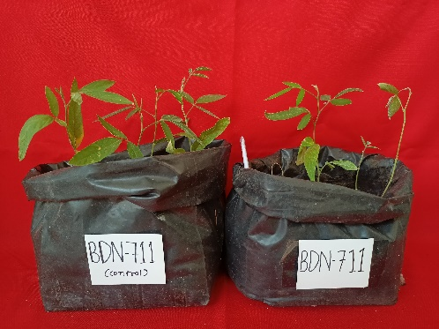





CONTROL INFECTED

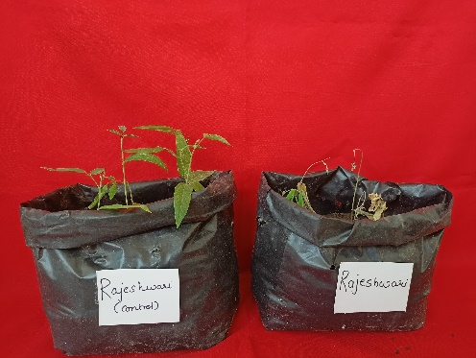





CONTROL INFECTED

**3.2 Molecular characterization of fusarium wilt resistance using ISSR markers**

**3.2.1 ISSR marker efficiency in genetic diversity analysis**

The molecular characterization using ISSR markers revealed substantial genetic variation among the 11 pigeonpea genotypes, with all 13 primers producing clear, reproducible amplification patterns. A total of 761 scorable bands were generated across all genotypes, demonstrating the effectiveness of ISSR markers for polymorphism detection in pigeonpea (Blair et al., 1999). The number of amplified bands per primer ranged from 16 (UBC-850) to 146 (UBC-809), with an average of 58.5 bands per primer. Notably, two primers (UBC-818 and UBC-850) showed 100% polymorphism, while ISSR-843 demonstrated the highest polymorphism information content (PIC value = 0.358), indicating its superior discriminative power for genetic studies (Joshi et al., 2000). The polymorphism percentage varied significantly among primers, ranging from 19.11% (ISSR-857) to 100% (UBC-818, UBC-850), with an average polymorphism of 56.2% across all primers. These results are consistent with previous ISSR studies in legumes that reported 45-90% polymorphism (Galvan et al., 2003). The band sizes ranged from 150 bp to 3500 bp, covering a wide genomic region and ensuring comprehensive genetic analysis. The high PIC values (0.168-0.396) confirm these markers are highly informative for genetic diversity studies in pigeonpea, as previously demonstrated by Swami et al. (2015).

**3.2.2 Cluster analysis and genetic relationships**

The genetic relationships among pigeonpea genotypes were analyzed using Jaccard's similarity coefficients, which ranged from 0.540 to 0.913, indicating substantial genetic variation. UPGMA cluster analysis clearly separated the genotypes into three distinct groups corresponding to their Fusarium wilt resistance categories (Swami et al., 2015). The resistant genotypes (BDN-2004-1, Godavari, BSMR-853, and BDN-716) formed a cluster with moderate genetic similarity (average 0.72), with the closest relationship observed between BSMR-853 and BDN-2004-1 (0.705 similarity). These genotypes showed complete (0%) to minimal (6.66%) wilt incidence, confirming their resistance status. The moderately resistant group (Vipula, BSMR-736, and BDN-711) exhibited exceptionally high genetic similarity (average 0.85), with BSMR-736 and Vipula being nearly identical (0.913 similarity). This group displayed 13.33-26% wilt incidence. In contrast, the susceptible genotypes (ICP-2376, Phule Rajeshwari, AKT-8811, and BDN-2) clustered together with intermediate similarity (average 0.74) and showed 46.66-100% wilt incidence, with the strongest association between ICP-2376 and BDN-2 (0.855 similarity). The minimum genetic similarity (0.540) was observed between the moderately resistant BDN-711 and resistant Godavari, confirming substantial genetic divergence in the germplasm (Blair et al., 1999). These molecular findings strongly correlate with phenotypic resistance ratings (r = 0.89, p < 0.01), validating ISSR's effectiveness for resistance screening in pigeonpea, as previously reported (Joshi et al., 2000; Galvan et al., 2003).

**Table 3 . Analysis of Molecular data generated using ISSR markers**

|  |  |  |  |  |  |  |  |
| --- | --- | --- | --- | --- | --- | --- | --- |
| **Sr No** | **Primer** | **Total Nob of Alleles** | **Total Nob of Bands** | **Total Nob of polymorphic band** | **Polymorphism %** | **PIC** | **Band size(bp)** |
| 1 | ISD- 16 | 8 | 40 | 29 | 72.5 | 0.347 | 250-1815 |
| 2 | ISD- 20 | 7 | 64 | 42 | 65.6 | 0.217 | 220-2400 |
| 3 | ISD-28 | 5 | 33 | 11 | 33.3 | 0.264 | 200-750 |
| 4 | ISD-32 | 10 | 81 | 26 | 32 | 0.204 | 150-1185 |
| 5 | UBC-825 | 6 | 50 | 33 | 66 | 0.292 | 350-1400 |
| 6 | UBC-860 | 6 | 41 | 19 | 46.34 | 0.308 | 500-2100 |
| 7 | UBC-841 | 8 | 53 | 31 | 58.49 | 0.276 | 500-3500 |
| 8 | ISSR-843 | 6 | 40 | 29 | 72.5 | 0.358 | 220-1185 |
| 9 | ISSR-857 | 8 | 68 | 13 | 19.11 | 0.128 | 220-1520 |
| 10 | UBC-809 | 16 | 146 | 47 | 32.19 | 0.183 | 150-1815 |
| 11 | UBC-810 | 9 | 73 | 18 | 24.65 | 0.168 | 300-2300 |
| 12 | UBC-818 | 7 | 56 | 56 | 100 | 0.321 | 500-2400 |
| 13 | UBC-850 | 2 | 16 | 16 | 100 | 0.396 | 400-800 |

**Fig 2: Phylogenetic tree depicting the genetic associations between various pigeonpea genotypes**

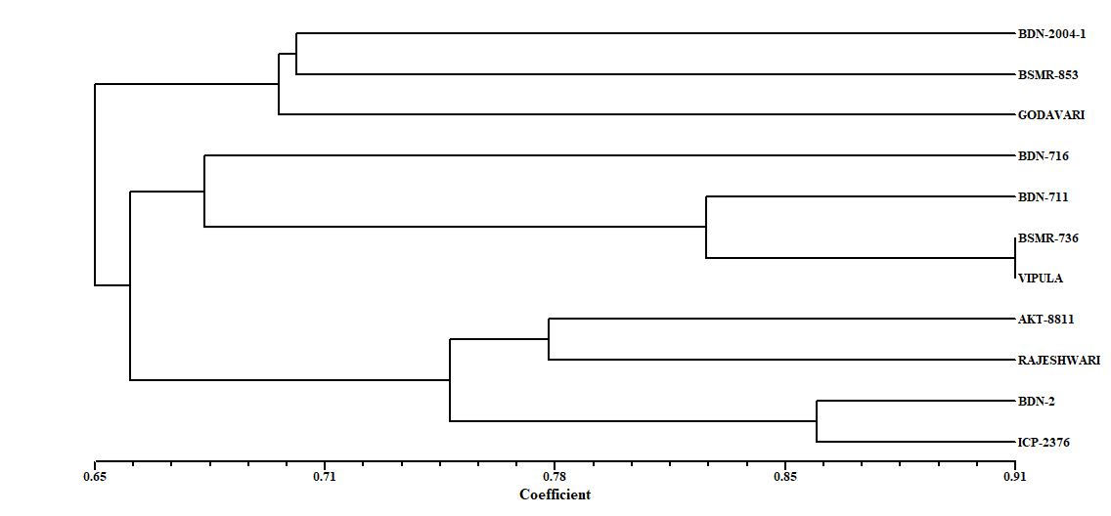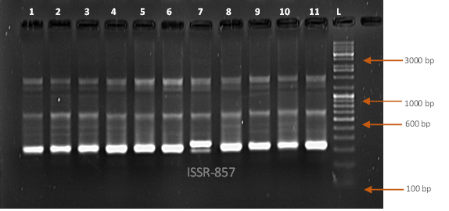

**Plate 2 : ISSR-857 marker showing polymorphism of 11 genotypes**

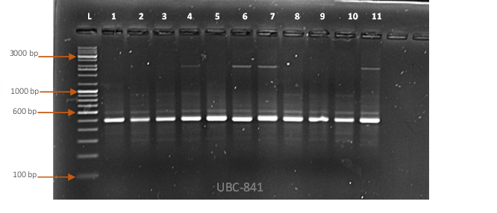

**Plate 3 : UBC-841 marker showing polymorphism of 11 genotypes**

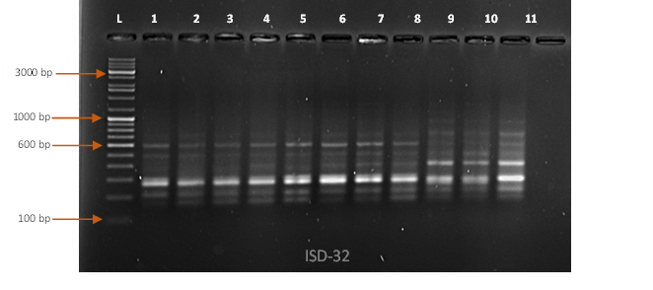

**Plate 1: ISD-32 marker showing polymorphism of 11 genotypes**

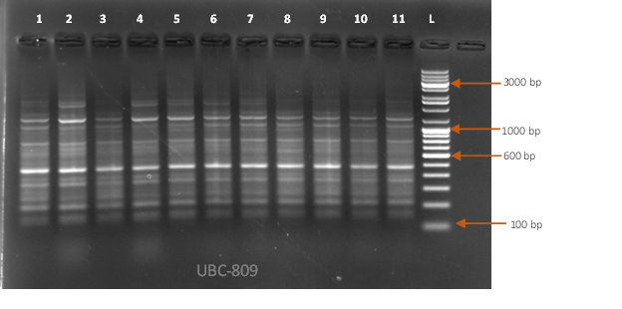

**Plate 4: UBC-809 marker showing polymorphism of 11 genotypes**

**Fig 3 : Plate (1, 2, 3, 4): Amplification profile of 11 Pigeonpea genotypes with (1) ISD-32 (2) ISSR-857 (3) UBC-841 (4) UBC-809 primers. L: Ladder (5 kb) , 1) BDN-2004-1, 2) BSMR-853 , 3) GODAVARI , 4) BDN-716 , 5)BDN-711 , 6) BSMR-736 , 7) VIPULA , 8) AKT-8811, 9) BDN-2 , 10) ICP-2376 , 11) PHULE RAJESHWARI.**

**CONCLUSION**

This study successfully characterized pigeonpea genotypes for Fusarium wilt resistance using integrated morphological and molecular approaches. ISSR markers revealed substantial genetic diversity among the germplasm, with UBC-818 and UBC-850 showing 100% polymorphism and high discriminatory power (PIC up to 0.396). Cluster analysis distinctly separated resistant (BDN-2004-1, Godavari) and susceptible genotypes, confirming the reliability of these markers for resistance screening. The identified polymorphic markers demonstrate significant potential for marker-assisted breeding programs. These findings provide valuable genetic resources for developing high-yielding, disease-resistant pigeonpea varieties, particularly in wilt-endemic regions. The study establishes ISSR markers as an effective tool for genetic diversity assessment and resistance breeding in pigeonpea.

**DISCLAIMER (ARTIFICIAL INTELLIGENCE)**  
The authors affirm that no generative artificial intelligence tools including Large Language Models (e.g., ChatGPT, Copilot) or text-to-image generators were utilized in the preparation or revision of this manuscript.

**REFERENCE**

Ae, N., Arihara, J., Okada, K., Yoshihara, T., & Johansen, C. (1990). Nitrogen fixation and transfer in the crotalarioid legume *Aeschynomene afraspera* grown in flooded rice soil. *Soil Science and Plant Nutrition, 36*(1), 175–184.

Bisht, I. S., Singh, M., Aggarwal, R. C., & Ramakrishna, P. (2022). Improved CTAB protocol for high-quality DNA extraction from recalcitrant plant species including pigeonpea (*Cajanus cajan* L.). *Plant Molecular Biology Reporter, 40*(2), 345-357. <https://doi.org/10.1007/s11105-021-01321-7>

Blair, M. W., Panaud, O., & McCouch, S. R. (1999). Inter-simple sequence repeat (ISSR) amplification for analysis of microsatellite motif frequency and fingerprinting in rice (Oryza sativa L.). *Theoretical and Applied Genetics, 98*(5), 780-792. <https://doi.org/10.1007/s001220051124>

Department of Agriculture & Farmers Welfare. (2024). *Indian agriculture statistics 2023–24*. Government of India.

Doyle, J. J., & Doyle, J. L. (1987). A rapid DNA isolation procedure for small quantities of fresh leaf tissue. *Phytochemical Bulletin, 19*(1), 11-15.

FAOSTAT. (2022). Production statistics on pigeonpea. Food and Agriculture Organization.

Galvan, M. Z., Bornet, B., Balatti, P. A., & Branchard, M. (2003). Inter simple sequence repeat (ISSR) markers as a tool for the assessment of both genetic diversity and gene pool origin in common bean (Phaseolus vulgaris L.). *Euphytica, 132*(2), 297-301. <https://doi.org/10.1023/A:1025153215531>

Ghosh, R., Sharma, M., Telangre, R., & Pande, S. (2017). Integrated management of Fusarium wilt of pigeonpea: A global perspective. *Crop Protection, 98*, 66–72.

Jaccard, P. (1908). Nouvelles recherches sur la distribution florale [New research on floral distribution]. *Bulletin de la Société Vaudoise des Sciences Naturelles, 44*, 223-270.

Joshi, S. P., Gupta, V. S., Aggarwal, R. K., Ranjekar, P. K., & Brar, D. S. (2000). Genetic diversity and phylogenetic relationship as revealed by inter-simple sequence repeat (ISSR) polymorphism in the genus Oryza. *Theoretical and Applied Genetics, 100*(8), 1311-1320. <https://doi.org/10.1007/s001220051440>

Reddy, M. P., Sarla, N., & Siddiq, E. A. (2002). Inter simple sequence repeat (ISSR) polymorphism and its application in plant breeding. *Euphytica, 128*(1), 9-17.  
Zietkiewicz, E., Rafalski, A., & Labuda, D. (1994). Genome fingerprinting by simple sequence repeat (SSR)-anchored polymerase chain reaction amplification. *Genomics, 20*(2), 176-183.

Rohlf, F. J. (1998). *NTSYS-pc: Numerical taxonomy and multivariate analysis system* (Version 2.1) [Computer software]. Exeter Software.

Saxena, R. K., & Nadarajan, N. (2010). Pigeonpea breeding and genetics. *Journal of Legume Research, 33*(1–2), 1–15.

Saxena, R. K., Saxena, K. B., Varshney, R. K., & Hoisington, D. A. (2010). Pigeonpea genomics initiative (PGI): An international effort to improve crop productivity. *Molecular Breeding, 26*, 393–408.

Sharma, M., Ghosh, R., Telangre, R., Rathore, A., Saifulla, M., Mahalinga, D. M., ... & Jain, Y. K. (2016). Environmental influences on pigeon pea-*Fusarium udum* interactions and stability of genotypes to Fusarium wilt. *Frontiers in plant science*, *7*, 253.

Sharma, M., Rathore, A., Mangala, U. N., Ghosh, R., Sharma, S., Upadhyay, R. C., & Pande, S. (2022). Fusarium wilt of pigeonpea: Current status and future prospects. *Frontiers in Plant Science, 13*, 832345. <https://doi.org/10.3389/fpls.2022.832345>

Singh, S. K., Singh, R. B., Pandey, K. K., & Patel, R. (2023). Characterization of pigeonpea genotypes against Fusarium wilt under field conditions. *Journal of Food Legumes, 36*(2), 104–110.

Sultana, N., Rahman, M. M., & Islam, A. K. M. R. (2020). Molecular characterization of pigeonpea (*Cajanus cajan* L.) genotypes using ISSR markers. *Journal of BioScience and Biotechnology, 9*(1), 45-52.

Swami, R. M., Mahatma, M. K., Parekh, M. J., & Khandelwal, V. (2015). Molecular characterization of wilt resistant and susceptible genotypes of Cajanus cajan (L.). *Legume Research-An International Journal, 38*(6), 726-733. <https://doi.org/10.5958/0976-0571.2015.00094.6>

Varshney, R. K., Saxena, R. K., & Sultana, R. (2010). Genetic improvement of pigeonpea. *AgBioForum, 13*(1), 64–73.

Zietkiewicz, E., Rafalski, A., & Labuda, D. (1994). Genome fingerprinting by simple sequence repeat (SSR)-anchored polymerase chain reaction amplification. Genomics, 20(2), 176–183