***Review Article***

**Multidimensional Strategies for Enhancing Heat Stress Tolerance in Pulses: From Trait Dissection to Genomic Innovation**

**ABSTRACT**

Heat stress (HS) poses a critical constraint to the productivity and reproductive efficiency of pulse crops, particularly in arid and semi-arid agroecologies under projected climate change scenarios. This review delineates the multifaceted plant responses to elevated temperatures, encompassing morphological adaptations, physiological adjustments (e.g., canopy temperature depression, membrane thermostability, and photosynthetic efficiency), and biochemical modifications such as reactive oxygen species (ROS) scavenging, osmolyte accumulation, and altered hormonal interactions. Recent advances in molecular genetics show that certain proteins and molecules—like transcription factors (such as DREB, HSFs, and NACs), heat shock proteins (HSPs), and small RNAs—work together to control how plants respond and adapt to heat stress. The deployment of high-throughput omics approaches—transcriptomics, proteomics, and metabolomics—has facilitated the identification of key stress-responsive genes, pathways, and candidate quantitative trait loci (QTLs). Integration of these insights into breeding pipelines through marker-assisted selection, genomic selection, and genome editing (CRISPR/Cas9) offers promising avenues for accelerating the development of heat-resilient pulse genotypes. The review underscores the imperative of systems-level approaches to dissect the genetic architecture of heat stress tolerance and to enhance climate resilience in pulse crop improvement programs.

Keywords: *pulses, heat stress, thermotolerance, genomics, legumes, breeding*

1. **INTRODUCTION**

India is the world's largest producer of pulses, accounting for 25% of global production. However, the majority of pulse-growing regions in the country are vulnerable to climate change, as the maximum threshold temperature for pulse tolerance has already surpassed 35°C. Key pulse crops such as chickpea, pigeonpea, mungbean, uradbean, lentil, and fieldpea contribute 39%, 21%, 11%, 10%, 7%, and 5% respectively to the nation's total pulse production. The estimated total production stands at 14.56 million tonnes, covering an area of 23.63 million hectares with an average yield of 625 kg/ha. Climate change is expected to negatively impact productivity due to the shortening of the crop cycle. Pulses like mungbean and uradbean, which are short-duration crops, are particularly at risk.

Abiotic stresses are a leading cause of global crop losses, reducing the yield of many plants by over 50% (Rodríguez *et al*., 2006). These stresses trigger a range of morphological, physiological, biochemical, and molecular changes that adversely affect plant growth, productivity, and yield (Wang *et al*., 2001; Bita and Gerats, 2013). Among these stresses, temperature stress has the most extensive and significant impact on various crops, leading to a substantial decrease in yield potential (Bita and Gerats, 2013).

1. **HEAT STRESS**

In the near future, global warming will challenge crops in maintaining their development, growth, reproduction, and yield (Kaushal *et al*., 2016). To mitigate the effects of heat stress, plants have evolved a variety of mechanisms, including molecular responses and changes in their physiology and biochemistry, to defend against the damage caused by increased temperatures (132). These changes have negatively impacted agricultural production (Lesk *et al.*, 2016).

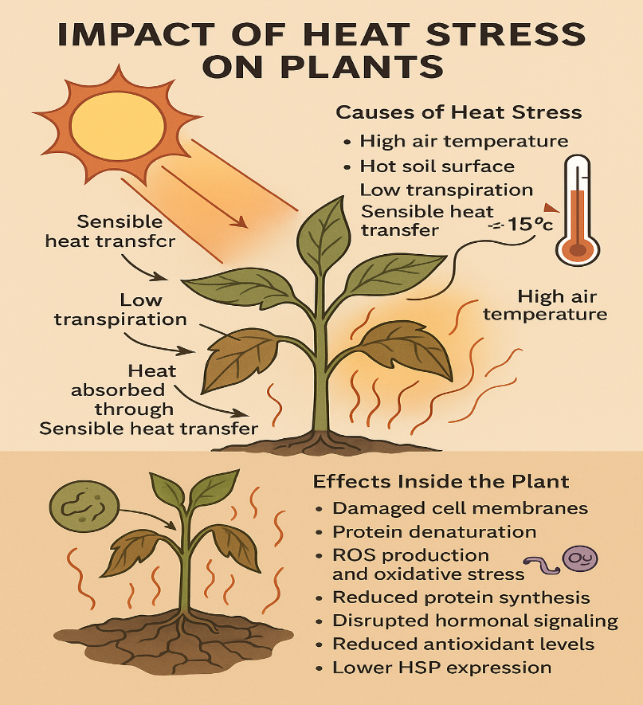

**Fig. 1: Impact of heat stress on plants**

Plants experience heat stress when:

(i)the air temperature is high, and plants absorb energy through sensible heat transfer

(ii) solar radiation heats the soil surface above air temperature; and

(iii) leaves heat up significantly due to solar radiation and inadequate heat dissipation, with temperatures rising up to 15°C above air temperature, especially in leaves with low transpiration rates (Singsaas *et al*., 1999).

Exposure to thermal stress can cause significant damage to cell membranes and protein structures, leading to the production of reactive oxygen species (ROS) and triggering oxidative stress. Additionally, heat stress reduces protein synthesis, transcription, and translation of heat shock proteins (HSPs), affects the production of phytohormones and antioxidants, and alters cell structure organization, resulting in changes in hormonal balance (Ahangar *et al*., 2017).

1. **RESPONSE MECHANISMS TO HEAT STRESS**

**(a) Morphological response**

To withstand heat stress, plants alter their morphology by expanding the root system, reducing the number and conductance of stomata, and curling, folding, and reducing leaf area to minimize water loss through evapotranspiration (Sicher *et al*., 2012). Lima *et al.* (2013) studied the cell wall structure of coffee plants exposed to heat stress (37°C), finding that the cell walls stiffened, the structural size of wall polysaccharides increased, and lignin content rose. Additionally, heat stress led to a reduction in starch granules, changes in internal membrane organization, and a decrease in the overall size of mesophyll cells, especially in the palisade parenchyma (Lima *et al*., 2013).

Abiotic factors like high temperatures combined with water shortages affect the growth and development of many plants, reducing crop productivity. Heat stress causes numerous disruptions, including destabilizing membranes and proteins, disorganizing nucleic acid and protein metabolism, degenerating membrane structure, and inhibiting photosynthesis, among other adverse effects.

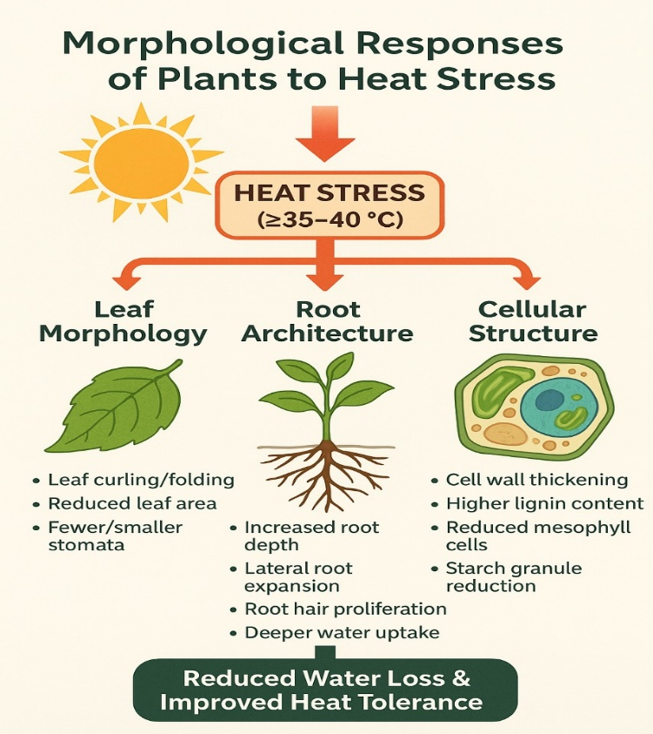

**Fig. 2: Morphological response of plants to heat stress**

**(b) Physiological response**

Heat stress induces physiological adjustments in plants. The photosynthetic apparatus is often damaged, leading to decreased transpiration due to stomatal closure and reduced CO2 levels, inhibition of photosynthetic enzymes and ATP synthase activity, reduced leaf expansion, and accelerated senescence, ultimately hampering plant development (Wahid *et al*., 2007). To mitigate the effects of heat stress, plants alter their carbon assimilation metabolism, mobilizing starch reserves in chloroplasts to release energy, sugars, and metabolites to survive stress periods and prevent further damage (Wang *et al*., 2018).

The ribulose 1,5 bisphosphate carboxylase/oxygenase (Rubisco) enzyme, crucial for carbon fixation, operates efficiently between 20 and 30°C. Above these temperatures, photosynthetic rates decrease (Yamori *et al*., 2014). Throughout evolution, plants have developed various metabolic strategies to cope with adverse conditions. The C4 and CAM photosynthetic mechanisms concentrate CO2, enhancing Rubisco's efficiency under extreme high temperatures, unlike C3 plants (Yamori *et al*., 2014). However, most crops have a C3 metabolism, fixing less carbon at high temperatures due to the lack of optimized CO2 concentration mechanisms (Betti *et al*., 2016).

**(c) Biochemical response**

Heat stress disrupts redox homeostasis, leading to ROS production and compromising the mechanisms that eliminate these toxic forms of O2 in different cell compartments, causing oxidative stress. Increased ROS levels result in molecule oxidation, membrane decomposition, enzyme inactivation, and altered gene expression (Singh *et al*., 2019). ROS-scavenging enzymes such as SOD, CAT, APX, MDHAR, DHAR, and GR, along with non-enzymatic mechanisms like ascorbate (ASA), glutathione (GSH), α-tocopherol, and flavonols, detoxify excess ROS (Ohama *et al*., 2017). Oxidative stress also leads to epigenetic changes, including histone modifications that regulate gene expression (Stief *et al*., 2014). Manipulating photosynthesis through rubisco activase and enzymes involved in ROS detoxification is a viable approach for developing heat-tolerant crops (Wang *et al*., 2018).

Plants detect temperature changes through sensors in various cellular compartments. Chloroplasts, which house the photosynthetic apparatus and are most affected by heat, are considered heat stress sensors because they alter dynamics in response to ROS/redox changes at the cellular level (Sun and Guo, 2016). Signals from these sensors rapidly trigger a specific signal transduction network involving calcium fluxes, calmodulin, CDPKs, MAPKs, phosphatases, and transcriptional regulators (Stief *et al*., 2014).

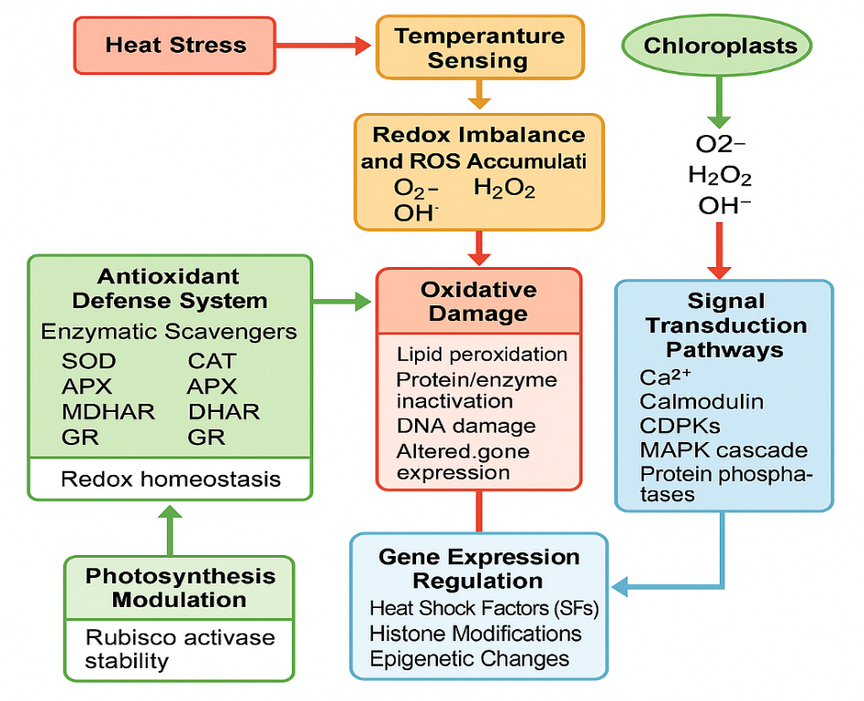

**Fig. 3: Biochemical response to heat stress**

**(d) Molecular response**

One of the most well-known responses to potential heat damage is the synthesis of heat shock proteins (HSPs), including Hsp100, Hsp90, Hsp70, Hsp60, small Hsps, and some MAPKs (Stief *et al*., 2014). Heat stress-responsive genes are regulated by various transcription factors (TFs) such as HSFs, NAC, MYB, WRKY, RAV, bZIP, AP2/ERF, and ZAT, which control the expression of stress-responsive genes by binding to cis-elements (ARE, CORE, W-box, GCC box, as-1 like) in the promoters of these genes (Sun and Guo, 2016). Heat stress-responsive genes like NADPH oxidases (Rboh), DREB2A, HsfA2, HsfA7a, HsfBs, MBF1C, and MAPK are regulated by HSFs. Additionally, TFs, epigenetic regulators, and small RNAs also regulate heat stress-responsive genes (Stief *et al*., 2014).

**(e) Hormonal regulation**

Plants under heat stress also increase the biosynthesis of several hormones to regulate their stress response. Elevated temperatures stimulate the biosynthetic pathways of hormones such as auxins, salicylic acid (SA), ABA, brassinosteroids (BRs), cytokinin (CK), jasmonate (JA), and ethylene (ET), leading to higher accumulation in plant cells to tolerate heat stress (Li *et al.*, 2021). Overexpression of the TaNAC2L transcription factor activated heat-related genes in transgenic Arabidopsis, suggesting that TaNAC2L may enhance heat tolerance by regulating stress-responsive genes (Guo *et al*., 2015). However, overexpression of the NAC transcription factor (SlJA2) reduced SA accumulation in plant cells to tolerate heat stress. Overexpression of the TaNAC2L transcription factor activated heat-related genes in transgenic *Arabidopsis*, suggesting that TaNAC2L may enhance heat tolerance by regulating stress-responsive genes. However, overexpression of the NAC transcription factor (SlJA2) reduced SA accumulation in transgenic tobacco, increasing susceptibility to heat stress (Liu *et al.*, 2017). Therefore, transcription factors regulating hormone biosynthesis pathways should be evaluated to determine if they act as positive or negative regulators for genetic engineering of heat-tolerant plants.

1. **APPROACHES TO GENERATE HEAT TOLERANT PLANTS**

**(i) Conventional breeding approach toward heat tolerance**

Traditional breeding programs aim to develop cultivars with high yield traits under non-stress conditions, which has significantly enhanced crop production per unit area and increased total agricultural output (Warren, 1998). Improving heat stress tolerance through genetic engineering is a cost-effective solution for crop production under stressful conditions (Blum, 1988). The variation in heat sensitivity across developmental stages complicates the development of thermotolerant crops (Driedonks *et al*., 2016). While breeding approaches have made notable progress in generating heat-tolerant lines in various crops, the genetic basis and extent of heat tolerance remain largely unexplored, especially in legumes. Developing new varieties is time-consuming and expensive; thus, understanding heat tolerance mechanisms would aid in devising strategies for screening germplasm of various legumes for heat tolerance traits. Utilizing and exploring wild varieties and landraces in breeding will enhance genetic diversity in crops (Driedonks *et al*., 2016).

Conventional breeding for high-temperature tolerance is one strategy to minimize the detrimental effects of heat stress on crop yield (Krishnamurthy *et al*., 2011). Breeding programs are generally conducted in regions with climatic conditions similar to where the crop will be grown. In hotter regions, breeding lines are selected under hot conditions (Mickelbart *et al*., 2015). This method has been reasonably successful, as crops grown in warmer regions tend to be more tolerant of high temperatures than those in cooler regions (Gaur *et al*., 2014). For example, the heat-tolerant chickpea genotype ICCV 92944 has been released in three countries: as JG14 in India, Yezin6 in Myanmar, and Chinadesi2 in Kenya (Gaur *et al*., 2014). Two heat-tolerant faba bean varieties, Shendi and Manami, have been released in Sudan (Gaur *et al*., 2014). A new cowpea variety with higher grain yield during high temperatures in the reproductive stage has been developed (Ehlers and Hall, 1998). Various heat-tolerant legume genotypes have been created using conventional breeding methods. Rapid generation advancement methods, heat-tolerant index, and earlier empirical methods have led to the development of tolerant chickpea genotypes (Krishnamurthy *et al*., 2011). Heat-tolerant common beans have been developed using the stress-tolerant index (STI), geometric mean (GM), and recurrent selection techniques (Porch, 2006). Sultana *et al.* (2012) developed heat-tolerant lentil genotypes using rapid initial growth habit and earliness. Mungbean, pea, and snap bean have also been made heat-tolerant using temperature-induction response and pedigree methods, respectively (Porch and Hall, 2013; Bindumadhava *et al*., 2017). Other crops such as groundnut and cowpea have been improved for elevated temperature performance using various conventional breeding methods, including solute leakage, chlorophyll fluorescence, STI (for groundnut), cross combination, pedigree breeding/backcrossing, and the pedigree method (for cowpea) (Patel and Hall, 1990; Hall, 1993, 2011; Lucas *et al*., 2013).

Despite the success of conventional breeding in developing heat-tolerant lines, the physiological and genetic basis of improvement remains unclear. This uncertainty hinders the identification of molecular biomarkers, which would assist in screening germplasm for enhanced heat tolerance and enable effective breeding of this complex trait. Additionally, in conventional breeding, the potential gain in heat stress tolerance is limited by low genetic diversity (Paran and van der Knaap, 2007). Genetic diversity for heat tolerance exists in legumes (Bindumadhava *et al*., 2017). Legume breeding programs using various classical breeding methods hold potential for technological applications that could boost global production.

**(ii) Genetic approaches for heat tolerance in legumes**

The negative effects of abiotic stresses on agricultural productivity can be mitigated through a combination of cultural practices and genetic improvement. Genetic improvement aims to develop cultivars that perform better under high temperatures, thereby enhancing economic yields (Varshney *et al*., 2011). Screening for heat stress tolerance in the field is challenging due to interactions with other environmental factors, but many traits can be effectively selected (Hall, 2011). Heat-tolerant genotypes can be selected under controlled conditions, which, while expensive, prevent interference from other factors affecting high-temperature tolerance mechanisms in field conditions (Souza *et al*., 2012). Developing effective thermotolerance markers is crucial for breeders and can help confer tolerance (Bita and Gerats, 2013). Creating superior varieties with increased tolerance requires understanding the stress response mechanisms in legumes, including changes in gene expression, transcriptome, metabolome, and proteome (Ramalingam *et al*., 2015). Limited genetic inheritance studies mean there is less understanding of the genetic basis of high-temperature tolerance in grain legumes (Jha *et al*., 2017). Various genetic analyses, including Mendelian and quantitative genetics, have been conducted to understand the genetic basis of heat stress tolerance in legumes (Miklas *et al*., 2000). Initially, genetic inheritance of key agronomic traits contributing to yield under high temperature stress, primarily governed by major or single genes, was studied in grain legumes (Hall, 1993). For instance, in cowpea, genetic control of heat tolerance was linked to a single gene based on traits such as the number of pods per peduncle and the proportion of tolerant plants under high-temperature stress in populations derived from heat-sensitive (Barnbey 23, "Magnolia," and 7964) and heat-tolerant ("Prima" and TVu4552) genotypes (Marfo and Hall, 1992). Analysis of traits such as pods per plant, seeds per plant, and seed weight in heat-tolerant genotypes revealed multiple mechanisms for thermotolerance in common bean (Rainey and Griffiths, 2005). Understanding the genetic basis of thermotolerance can improve plant performance under stress conditions, leading to enhanced productivity.

**Genetic and quantitative trait locus (QTL) mapping**

Genetic and quantitative trait locus (QTL) mapping has proven effective for identifying chromosome segments with genes that may contribute to heat tolerance (Zhang *et al*., 2012). Efforts have been made to pinpoint QTLs in mapping populations that segregate for heat tolerance traits. Numerous QTLs linked to heat tolerance have been identified in cereal crops (Wei *et al*., 2013). However, only a few heat-tolerant QTLs have been reported in legumes, such as cowpea (Pottorff *et al*., 2014) and azuki bean (Vaughan *et al*., 2005). In wheat, QTLs have been identified for traits like increased chlorophyll fluorescence and reduced canopy temperature during vegetative and reproductive stages (Lopes *et al*., 2012). Lower canopy temperatures indicate efficient water uptake linked to deep rooting, while higher chlorophyll fluorescence indicates heat-tolerant photosynthesis (Pinto and Reynolds, 2015).

Studies on heat stress effects on reproductive traits such as pollen germination, pollen tube growth, grain filling, grain weight, fruit set, and post-anthesis leaf senescence have been conducted (Driedonks *et al*., 2016). A recent QTL study on rice (*Oryza sativa*) focused on spike fertility under heat stress (Ye *et al*., 2015), building on previous work (Ye *et al*., 2012). This research confirmed the presence of a recessive QTL on chromosome 4, responsible for a 15% increase in spikelet fertility under high temperatures (Ye *et al*., 2015).

QTL studies can also investigate natural populations. While linkage mapping can detect crucial genes and QTLs, the limited number of generations and recombination events usually result in QTLs covering large regions, making gene identification a tedious fine-mapping process (Driedonks *et al*., 2016). Fine mapping is generally inefficient for detecting candidate genes (Bergelson and Roux, 2010). Various QTL studies have identified multiple QTLs per trait, ranging from two in azuki bean and rice (for improved pollen viability and spikelet number under high temperatures) to 34 in barley for heat stress-related traits. Heat tolerance depends on multiple factors and QTLs, which vary among crops (Jha *et al*., 2014). In azuki beans, Kaga *et al*. (2008) identified HQTL-1 and HQTL-2 for pollen viability traits. In cowpea, many QTLs have been detected, including Hbs-1, Hbs-2, and Hbs-3 for heat-induced seed coat browning (Pottorff *et al*., 2014), afot 1.1, afot 1.2, afot 1.3, and afot 2 for flower opening (Andargie *et al*., 2013), and Cht-1 to Cht-5 for male heat sterility (Lucas *et al*., 2013). In pigeon pea, qPD4.1 has been detected for pods per plant, and qFL4.1 and qFL5.1 for flowering (Kumawat *et al*., 2012).

Association mapping is becoming popular as a trait mapping technique, complementing conventional QTL mapping (Jha *et al*., 2017). A recent genome-wide association study (GWAS) of 300 accessions investigated marker-trait associations for thermotolerance in chickpea (Thudi *et al.*, 2017). Molecular markers from these studies can be used in marker-assisted breeding programs to transfer heat tolerance genes/QTLs into major grain legumes (Jha *et al*., 2017). Advances in next-generation sequencing (NGS) have enabled the exploration of complex genomic regions important for regulating complex traits (Edwards and Snowdon, 2013). Genotype-by-sequencing (GBS) technology produces many SNP markers (Elshire *et al*., 2011), which are used to develop genetic maps and understand complex traits in legumes (Verma *et al*., 2015). The availability of reference genome sequences for various grain legumes, such as mungbean (Kang *et al*., 2014), soybean (Schmutz *et al*., 2009), groundnut (Chen *et al*., 2016), chickpea (Jain *et al*., 2013), adzuki bean (Kang *et al*., 2015), pigeonpea (Varshney et al., 2012a), and common bean (Schmutz *et al.,* 2014), aids in focusing on important agricultural traits like thermotolerance.

QTL analysis for heat sensitivity and tolerance is gaining attention. The main advantage of QTL-based approaches is identifying loci linked to heat stress (Bita and Gerats, 2013). Identifying adaptive QTLs for heat stress helps understand tolerance mechanisms, and various studies have detected genetic markers for abiotic stresses, including heat stress (Roy *et al*., 2011). Markers linked to QTLs could enhance thermotolerance in available germplasm. QTL identification for thermotolerance involves different traits like thousand grain weight (TGW), canopy temperature depression (CTD), grain filling duration (GFD), yield (Pinto *et al.*, 2010), and traits related to senescence (Vijayalakshmi *et al*., 2010). Association genetics has recently aided QTL detection in various crop species (Ahuja *et al*., 2010). Once markers associated with QTLs are isolated, candidate QTLs can be introgressed into elite lines via MAS technology. However, complex traits like heat tolerance are controlled by small-effect QTLs or multiple pleiotropic genes, making it challenging to generate tolerant genotypes for heat stress (Bita and Gerats, 2013). To address this, techniques like marker-assisted recurrent selection (MARS), QTL pyramiding from multiple populations in the same genetic background, or genomic selection (GS) can be used (Varshney *et al.,* 2012b). The MAS approach for complex traits like heat tolerance is inefficient due to genotype-environment and gene-gene interactions, reducing breeding efficiency (Collins *et al*., 2008). Recurrent selection is a suitable method in plant breeding for traits like heat stress tolerance. There is a low probability of obtaining a superior genotype that combines all desired alleles in multiple crosses. Instead, recurrent selection gradually accumulates desired alleles through recombination cycles in different parents (Donà *et al*., 2013).

**(iii) ‘OMICS’ technology in heat tolerance**

‘Omics’ technologies, including genomics, proteomics, transcriptomics, and metabolomics, have transformed plant science research (Yuan J.S. *et al*., 2008). Significant advancements in these fields have enabled the identification of various candidate genes involved in responses to complex abiotic stresses in crop plants (Kujur *et al*., 2015). These technologies span multiple disciplines and have greatly enhanced our understanding of the molecular and genetic basis of the heat stress response, a major challenge in molecular and transgenic breeding (Reddy *et al*., 2012). Over the past decade, omics approaches have seen considerable improvements (Deshmukh *et al*., 2014). Recent research has shed light on the functions of proteins, metabolites, and many key genes and molecular processes involved in plant responses to heat stress. However, the mechanism of heat stress tolerance is highly complex due to the involvement of multiple genes and post-transcriptional regulation (Ramalingam *et al*., 2015).

**Transcriptomics**

Modern techniques like RNA sequencing have facilitated extensive expression studies, uncovering numerous heat-tolerant candidate genes in various crops (Gonzalez-Schain *et al*., 2016). However, only a few transcriptomic analyses have been conducted for heat tolerance in legumes. Initially, the cDNA-AFLP technique was used to study the expression of thermotolerant genes in cowpea (Simões-Araújo *et al*., 2002). Given the critical role of heat shock factors (HSF) in surviving heat stress, researchers found 19 and 21 HSF ESTs in *Lotus japonicus* and *Medicago truncatula*, respectively, and 25 candidate HSF ESTs in soybean (Soares-Cavalcanti *et al*., 2012). Kumar *et al.* (2015a) reported a significant 620-fold increase in the expression of the VfHsp17.9CII gene in faba bean under high-temperature treatment. Utilizing NGS technology, which offers higher resolution and better characterization of candidate genes in transcriptome sequences, researchers identified DNAJ, HSP 70, and HSP 91 genes in the ICC4958 genotype of chickpea using Illumina/Solexa sequencing (Martin *et al.*, 2013).

A recent RNA-sequencing study analyzed the complete transcriptome of heat-responsive genes in heat-sensitive (ICC 5912, ICC 4567, ICC 10685) and heat-tolerant (ICC 15614, ICC 1356,

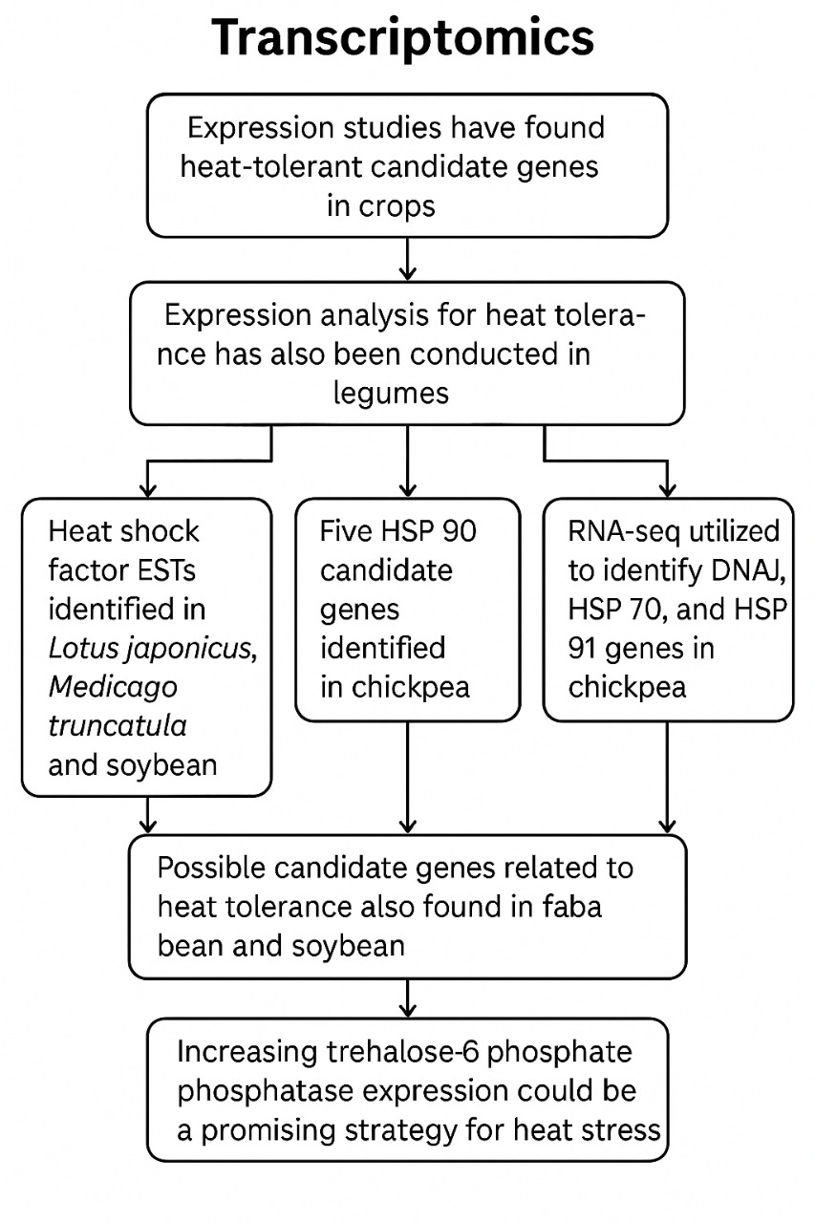

**Fig. 4: Transcriptomics illustration in pulses**

ICC 92944) chickpea genotypes (Kudapa *et al*., 2014). Further RNA-sequencing of chickpea leaves, flowers, and roots at different growth stages identified five HSP 90 candidate genes (Ca_25811, Ca_23016, Ca_09743, Ca_17680, Ca_25602) (Agarwal *et al*., 2016). In soybean, 47 out of 51 GmHsp20 genes were identified as heat-responsive based on in vivo analysis, elucidating the role of HSP 20 in thermotolerance (Lopes-Caitar *et al*., 2013). Lee *et al.* (1994) cloned the ClpB/HSP100 gene in soybean, revealing the candidate gene Glma05 g00540. Recently, the VfHsp17.9-CII gene in faba bean, which belongs to sHSP CII, was cloned, with increased accumulation observed at 38°C in pollen grains, suggesting a protective role against heat stress (Kumar *et al*., 2015a).

Exploring strategies to reduce ovary abortion, similar to methods used in maize to combat drought-induced seed loss (Guan and Koch, 2015), could be beneficial for legumes under heat stress. For example, increasing the expression of trehalose-6-phosphate phosphatase in maize has been shown to improve yield under drought conditions (Nuccio *et al*., 2015).

**Proteomics and metabolomics**

Proteomics and metabolomics are rapidly advancing fields that provide extensive and precise information on the proteins and metabolites produced in plants, including legumes, in response to various abiotic stresses (Ramalingam *et al*., 2015). In model legume species like *Medicago truncatula* and *Lotus japonicus*, as well as crop legumes like soybean, high-throughput proteome and metabolome profiling have been widely used to study nodule symbiosis, cellular and developmental processes, and stress signaling pathways. Moreover, available protein reference maps, along with proteomics and metabolomics databases, have been heavily utilized in research to explore various processes in legumes (Ramalingam *et al*., 2015).

During high-temperature stress, proteomics allows for the identification of heat-responsive proteins such as HSPs, chaperones, and those involved in signal transduction pathways, redox homeostasis, metabolic pathways, and protection (Zou *et al*., 2011). Integrating proteomics with genetic information in legumes offers promising opportunities for crop improvement and sustainable agriculture (Rathi *et al*., 2016). However, one of the main challenges in proteomics is dealing with the presence of multiple proteins, each undergoing various post-translational modifications (PTMs). Despite these challenges, proteomics is advancing rapidly, focusing on PTMs, protein quantity, and protein interactions (Champagne and Boutry, 2013).

Proteomics has significantly contributed to plant biological research and stress response studies, particularly with the increasing availability of sequenced plant genomes (Jorrín-Novo *et al*., 2015). Additionally, advancements in mass spectrometry, bioinformatics, and quantitative methods have enabled the comprehensive identification, validation, and characterization of various proteins from specific organs, tissues, or cells (Glinski and Weckwerth, 2006). The insights gained from these advanced techniques are crucial for understanding the structure and regulatory functions of proteins encoded by specific genes (Abdallah *et al*., 2012). Furthermore, proteomics provides critical information on protein levels linked to stress tolerance and changes in proteomes under stress conditions, in conjunction with transcriptomics and metabolomics analyses. This data can reveal the roles of genes expressed in the genome's functionally translated regions that are associated with desirable traits (Kosová *et al*., 2011).

In legumes, proteomic studies have mainly focused on *Medicago* to understand stress tolerance, plant growth, and seed development, all of which are crucial for agricultural research (Jorrín-Novo *et al*., 2015). Significant contributions to proteomic studies have been made in soybean at the subcellular, organ, and whole-plant levels. Techniques such as 2D-GE, MALDI-TOF-MS, LC-MS/MS, and protein sequencing have been used to elucidate heat tolerance mechanisms in soybean seedlings. For example, in a "heat-sensitive" soybean genotype, 42 protein spots involved in 13 metabolic processes were identified at different time intervals using these techniques (Wang *et al*., 2012). Further proteomic analysis of soybean leaves revealed the expression of 25 different proteins involved in key metabolic pathways, such as RuBisCo regulation, the Calvin cycle, and electron transport under high temperature (Das *et al*., 2016). Additionally, a study on root proteome dynamics during heat stress identified 30 commonly upregulated and downregulated proteins in normal and heat-stressed root hairs (Valdes-Lopez *et al*., 2016). The presence of various peroxidases, along with heat shock proteins class I and II, in heat-treated soybean roots indicates their role in heat tolerance. This information paves the way for further experiments to efficiently apply proteomics to crop legumes, primarily by characterizing proteins associated with development and stress tolerance to identify clear candidate genes (Ramalingam *et al*., 2015). Similar reference maps have been generated for crop legumes such as peanut and soybean, with 5,702 proteins identified in single root hair cells through proteome reference maps in soybean (Brechenmacher *et al.*, 2012). ICRISAT is also working on developing proteome maps for chickpea, pigeonpea, and groundnut.

Heuss-LaRosa *et al.* (1987) proposed the role of two proteins (70 and 80 KD) in thermotolerance and adaptation in cowpea. In mungbean, two HSP 70 isotypes were identified under heat stress (Wu *et al*., 1993). Zhu J. *et al*. (2006) observed the expression of HSP-interacting proteins that enhance heat stress tolerance in soybean. In another study on soybean seedlings, increased accumulation of various other proteins with chaperone functions (Chaperonin 60b subunit CPN60-b, HSP 90, Chaperonin CPN-10, and chloroplast chaperonin) was noted under heat stress (Ahsan *et al*., 2010). Tissue-specific protein roles in protecting soybean against heat stress were reported based on the differential expression of 35, 54, and 61 proteins from stems, leaves, and roots, respectively, in response to high temperature (Ahsan *et al*., 2010). ERD-related proteins, which also serve as chaperones, along with HSP70 and HSP 91, were observed to play a role in dehydration (and potentially thermotolerance) in chickpea through transcriptome analysis (Hiremath *et al*., 2011). The presence of ClpB/HSP100 protein was detected under heat stress in *Phaseolus lunatus* (Keeler *et al*., 2000), and the accumulation of ClpB/HSP100 during high temperatures was found to increase pollen viability in faba bean (Kumar *et al*., 2015b). Recently, a novel HSP protein, VfHsp17.9-CII, was identified in faba bean, which contributes to heat tolerance (Kumar *et al.*, 2015a). Das *et al.* (2016) reported increased levels of Ef-Tu protein in soybean, which are mainly involved in protecting key enzymes and proteins required for photosynthesis from heat stress. Thus, proteomic analysis can reveal various underlying thermotolerant proteins that can serve as biomarkers in breeding programs aimed at developing thermotolerant grain legume varieties (Rathi *et al*., 2016).

In addition to proteomics, metabolomics is a crucial approach to functional genomics, offering a method to identify and quantify metabolomes within a cell, tissue, or organism (Weckwerth and Kahl, 2013). Metabolomics plays a vital role in crop breeding programs as metabolites can serve as selection biomarkers due to their ability to integrate complex interactions between genotype and environment (Fernie and Schauer, 2009). Metabolite profiling in soybean genotypes has revealed that antioxidants such as flavonoids, tocopherols, phenylpropanoids, and ascorbate contribute to heat tolerance in tolerant genotypes (Chebrolu *et al*., 2016). However, little information is available on metabolomics for heat stress in plants, particularly legumes. This area needs further exploration to understand the underlying mechanisms of heat stress (Ramalingam *et al*., 2015).

1. **CONCLUSION**

Heat stress leads to significant agricultural losses, posing a threat to global food security and challenging human welfare. The scientific community stresses the importance of boosting crop yields to meet the growing food demand driven by population growth. However, there is a lack of focus on how to effectively use biotechnological tools to reduce the negative impacts of abiotic stresses on plants' morphological, physiological, biochemical, and molecular processes. During heat stress, plants undergo various adaptations that enhance their tolerance, such as activating signalling pathways that result insignificant changes in gene expression. Heat shock proteins, which accumulate during stress, act as molecular chaperones, assisting in protein folding and unfolding. The use of 'omics' technologies, including genomics, transcriptomics, proteomics, and metabolomics, is crucial for understanding the molecular basis and processes involved in plant responses to heat stress and the mechanisms of tolerance.

**REFERENCES**

Abdallah, C., Dumas-Gaudot, E., Renaut, J., & Sergeant, K. (2012). Gel‐based and gel‐free quantitative proteomics approaches at a glance. *International journal of plant genomics*, *2012*(1), 494572.

Ahanger, M. A., Akram, N. A., Ashraf, M., Alyemeni, M. N., Wijaya, L., & Ahmad, P. (2017). Plant responses to environmental stresses—from gene to biotechnology. *AoB Plants*, *9*(4), 1-17.

Ahsan, N., Donnart, T., Nouri, M. Z., & Komatsu, S. (2010). Tissue-specific defense and thermo-adaptive mechanisms of soybean seedlings under heat stress revealed by proteomic approach. *Journal of proteome research*, *9*(8), 4189-4204.

Ahuja, I., de Vos, R. C., Bones, A. M., & Hall, R. D. (2010). Plant molecular stress responses face climate change. *Trends in plant science*, *15*(12), 664-674.

Andargie, M., Pasquet, R. S., Muluvi, G. M., & Timko, M. P. (2013). Quantitative trait loci analysis of flowering time related traits identified in recombinant inbred lines of cowpea (*Vigna unguiculata*). *Genome*, *56*(5), 289-294.

Bergelson, J., & Roux, F. (2010). Towards identifying genes underlying ecologically relevant traits in Arabidopsis thaliana. *Nature Reviews Genetics*, *11*(12), 867-879.

Betti, M., Bauwe, H., Busch, F. A., Fernie, A. R., Keech, O., Levey, M., & Weber, A. P. (2016). Manipulating photorespiration to increase plant productivity: recent advances and perspectives for crop improvement. *Journal of Experimental Botany*, *67*(10), 2977-2988.

Bindumadhava HanumanthaRao, B. H., Nair, R. M., & Harsh Nayyar, H. N. (2016). Salinity and high temperature tolerance in mungbean [*Vigna radiata* (L.) Wilczek] from a physiological perspective. *Frontiers in plant science, 7*:957.

Bindumadhava, H., Nair, R. M., Nayyar, H., Riley, J. J., & Easdown, W. (2017). Mungbean production under a changing climate-insights from growth physiology. *Mysore Journal of* *Agricultural Science, 51*: 21–26.

Bita, C. E., & Gerats, T. (2013). Plant tolerance to high temperature in a changing environment: scientific fundamentals and production of heat stress-tolerant crops. *Frontiers in plant science*, *4*, 273.

Blum, A. (2018). *Plant breeding for stress environments*. CRC press.

Brechenmacher, L., Nguyen, T. H. N., Hixson, K., Libault, M., Aldrich, J., Pasa‐Tolic, L., & Stacey, G. (2012). Identification of soybean proteins from a single cell type: the root hair. *Proteomics*, *12*(22), 3365-3373.

Champagne, A., & Boutry, M. (2013). Proteomics of nonmodel plant species. *Proteomics*, *13*(3-4), 663-673.

Chebrolu, K. K., Fritschi, F. B., Ye, S., Krishnan, H. B., Smith, J. R., & Gillman, J. D. (2016). Impact of heat stress during seed development on soybean seed metabolome. *Metabolomics*, *12*(2), 28.

Chen, X., Li, H., Pandey, M. K., Yang, Q., Wang, X., Garg, V., & Yu, S. (2016). Draft genome of the peanut A-genome progenitor (*Arachis duranensis*) provides insights into geocarpy, oil biosynthesis, and allergens. *Proceedings of the National Academy of Sciences*, *113*(24), 6785-6790.

Collins, N. C., Tardieu, F., & Tuberosa, R. (2008). Quantitative trait loci and crop performance under abiotic stress: where do we stand?. *Plant physiology*, *147*(2), 469-486.

Das, A., Eldakak, M., Paudel, B., Kim, D. W., Hemmati, H., Basu, C., & Rohila, J. S. (2016). Leaf proteome analysis reveals prospective drought and heat stress response mechanisms in soybean. *BioMed research international*, *2016*(1), 6021047.

Deshmukh, R., Sonah, H., Patil, G., Chen, W., Prince, S., Mutava, R., & Nguyen, H. T. (2014). Integrating omic approaches for abiotic stress tolerance in soybean. *Frontiers in Plant science*, *5*, 244.

Dona, M., Macovei, A., Fae, M., Carbonera, D., & Balestrazzi, A. (2013). Plant hormone signaling and modulation of DNA repair under stressful conditions. *Plant Cell Reports*, *32*(7), 1043-1052.

Driedonks, N., Rieu, I., & Vriezen, W. H. (2016). Breeding for plant heat tolerance at vegetative and reproductive stages. *Plant reproduction*, *29*(1), 67-79.

Edwards, D., Batley, J., & Snowdon, R. J. (2013). Accessing complex crop genomes with next-generation sequencing. *Theoretical and Applied Genetics*, *126*(1), 1-11.

Ehlers, J. D., & Hall, A. E. (1998). Heat tolerance of contrasting cowpea lines in short and long days. *Field crops research*, *55*(1-2), 11-21.

Elshire, R. J., Glaubitz, J. C., Sun, Q., Poland, J. A., Kawamoto, K., Buckler, E. S., & Mitchell, S. E. (2011). A robust, simple genotyping-by-sequencing (GBS) approach for high diversity species. *PloS one*, *6*(5), e19379.

Fernie, A. R., & Schauer, N. (2009). Metabolomics-assisted breeding: a viable option for crop improvement?. *Trends in genetics*, *25*(1), 39-48.

Gaur, P. M., Samineni, S., Krishnamurthy, L., Varshney, R. K., Kumar, S., Ghanem, M. E., & Babbar, A. (2014). High temperature tolerance in grain legumes. *Legume Perspective,* *7*: 23–24.

Glinski, M., & Weckwerth, W. (2006). The role of mass spectrometry in plant systems biology. *Mass spectrometry reviews*, *25*(2), 173-214.

González-Schain, N., Dreni, L., Lawas, L. M., Galbiati, M., Colombo, L., Heuer, S., ... & Kater, M. M. (2016). Genome-wide transcriptome analysis during anthesis reveals new insights into the molecular basis of heat stress responses in tolerant and sensitive rice varieties. *Plant and Cell Physiology*, *57*(1), 57-68.

Guan, J. C., & Koch, K. E. (2015). A time and a place for sugar in your ears. *Nature Biotechnology*, *33*(8), 827-828.

Guo, W., Zhang, J., Zhang, N., Xin, M., Peng, H., Hu, Z., & Du, J. (2015). The wheat NAC transcription factor TaNAC2L is regulated at the transcriptional and post-translational levels and promotes heat stress tolerance in transgenic Arabidopsis. *PLoS One*, *10*(8), e0135667.

Hall, A. E. (1993). Physiology and breeding for heat tolerance in cowpea, and comparisons with other crops, 271-284.

Hall, A. E. (2011). Breeding cowpea for future climates. *Crop adaptation to climate change*, 340-355.

Heuss-LaRosa, K., Mayer, R. R., & Cherry, J. H. (1987). Synthesis of only two heat shock proteins is required for thermoadaptation in cultured cowpea cells. *Plant physiology*, *85*(1), 4-7.

Hiremath, P. J., Farmer, A., Cannon, S. B., Woodward, J., Kudapa, H., Tuteja, R., & Varshney, R. K. (2011). Large‐scale transcriptome analysis in chickpea (*Cicer arietinum* L.), an orphan legume crop of the semi‐arid tropics of Asia and Africa. *Plant biotechnology journal*, *9*(8), 922-931.

Jain, M., Misra, G., Patel, R. K., Priya, P., Jhanwar, S., Khan, A. W., & Chattopadhyay, D. (2013). A draft genome sequence of the pulse crop chickpea (*Cicer arietinum* L.). *The Plant Journal*, *74*(5), 715-729.

Jha, U. C., Bohra, A., Parida, S. K., & Jha, R. (2017). Integrated “omics” approaches to sustain global productivity of major grain legumes under heat stress. *Plant Breeding*, *136*(4), 437-459.

Jha, U. C., Bohra, A., & Singh, N. P. (2014). Heat stress in crop plants: its nature, impacts and integrated breeding strategies to improve heat tolerance. *Plant Breeding*, *133*(6), 679-701.

Jorrín‐Novo, J. V., Pascual, J., Sánchez‐Lucas, R., Romero‐Rodríguez, M. C., Rodríguez‐Ortega, M. J., Lenz, C., & Valledor, L. (2015). Fourteen years of plant proteomics reflected in Proteomics: Moving from model species and 2DE‐based approaches to orphan species and gel‐free platforms. *Proteomics*, *15*(5-6), 1089-1112.

Kaga, A., Isemura, T., Tomooka, N., & Vaughan, D. A. (2008). The genetics of domestication of the azuki bean (*Vigna angularis*). *Genetics*, *178*(2), 1013-1036.

Kang, Y. J., Kim, S. K., Kim, M. Y., Lestari, P., Kim, K. H., Ha, B. K., & Lee, S. H. (2014). Genome sequence of mungbean and insights into evolution within *Vigna* species. *Nature communications*, *5*(1), 5443.

Kang, Y. J., Satyawan, D., Shim, S., Lee, T., Lee, J., Hwang, W. J., & Lee, S. H. (2015). Draft genome sequence of adzuki bean, *Vigna angularis*. *Scientific reports*, *5*(1), 8069.

Kaushal, N., Bhandari, K., Siddique, K. H., & Nayyar, H. (2016). Food crops face rising temperatures: an overview of responses, adaptive mechanisms, and approaches to improve heat tolerance. *Cogent food & agriculture*, *2*(1), 1134380.

Keeler, S. J., Boettger, C. M., Haynes, J. G., Kuches, K. A., Johnson, M. M., Thureen, D. L., & Kitto, S. L. (2000). Acquired thermotolerance and expression of the HSP100/ClpB genes of lima bean. *Plant Physiology*, *123*(3), 1121-1132.

Kosová, K., Vítámvás, P., Prášil, I. T., & Renaut, J. (2011). Plant proteome changes under abiotic stress—contribution of proteomics studies to understanding plant stress response. *Journal of proteomics*, *74*(8), 1301-1322.

Krishnamurthy, L., Gaur, P. M., Basu, P. S., Chaturvedi, S. K., Tripathi, S., Vadez, V., & Gowda, C. L. L. (2011). Large genetic variation for heat tolerance in the reference collection of chickpea (*Cicer arietinum* L.) germplasm. *Plant Genetic Resources*, *9*(1), 59-69.

Kudapa, H., Agarwal, G., Doddamani, D., Kumar, V., Khan, A. W., Chitikineni, A., & Varshney, R. K. (2014, May). Comprehensive transcriptome analysis to identify heat stress responsive genes in chickpea (*Cicer arietinum* L.). In *Proceedings of the International Plant and Animal Genome Conference Asia*.

Kujur, A., Bajaj, D., Upadhyaya, H. D., Das, S., Ranjan, R., Shree, T., & Parida, S. K. (2015). Employing genome-wide SNP discovery and genotyping strategy to extrapolate the natural allelic diversity and domestication patterns in chickpea. *Frontiers in Plant Science*, *6*, 162.

Kumar, R., Lavania, D., Singh, A. K., Negi, M., Siddiqui, M. H., Al-Whaibi, M. H., & Grover, A. (2015). Identification and characterization of a small heat shock protein 17.9-CII gene from faba bean (*Vicia faba* L.). *Acta Physiologiae Plantarum*, *37*(9), 190.

Kumar, R., Singh, A. K., Lavania, D., Siddiqui, M. H., Al-Whaibi, M. H., & Grover, A. (2016). Expression analysis of ClpB/Hsp100 gene in faba bean (*Vicia faba* L.) plants in response to heat stress. *Saudi journal of biological sciences*, *23*(2), 243-247.

Kumawat, G., Raje, R. S., Bhutani, S., Pal, J. K., Mithra, A. S., Gaikwad, K., & Singh, N. K. (2012). Molecular mapping of QTLs for plant type and earliness traits in pigeonpea (*Cajanus cajan* L. Millsp.). *BMC genetics*, *13*(1), 84.

Lee, Y. R., Nagao, R. T., & Key, J. L. (1994). A soybean 101-kD heat shock protein complements a yeast HSP104 deletion mutant in acquiring thermotolerance. *The Plant Cell*, *6*(12), 1889-1897.

Lesk, C., Rowhani, P., & Ramankutty, N. (2016). Influence of extreme weather disasters on global crop production. *Nature*, *529*(7584), 84-87.

Li, N., Euring, D., Cha, J. Y., Lin, Z., Lu, M., Huang, L. J., & Kim, W. Y. (2021). Plant hormone-mediated regulation of heat tolerance in response to global climate change. *Frontiers in Plant Science*, *11*, 627969.

Lima, R. B., dos Santos, T. B., Vieira, L. G. E., Ferrarese, M. D. L. L., Ferrarese-Filho, O., Donatti, L., & de Oliveira Petkowicz, C. L. (2013). Heat stress causes alterations in the cell-wall polymers and anatomy of coffee leaves (*Coffea arabica* L.). *Carbohydrate polymers*, *93*(1), 135-143.

Liu, Z. M., Yue, M. M., Yang, D. Y., Zhu, S. B., Ma, N. N., & Meng, Q. W. (2017). Over-expression of SlJA2 decreased heat tolerance of transgenic tobacco plants via salicylic acid pathway. *Plant cell reports*, *36*(4), 529-542.

Lopes-Caitar, V. S., de Carvalho, M. C., Darben, L. M., Kuwahara, M. K., Nepomuceno, A. L., Dias, W. P., & Marcelino-Guimarães, F. C. (2013). Genome-wide analysis of the Hsp 20 gene family in soybean: comprehensive sequence, genomic organization and expression profile analysis under abiotic and biotic stresses. *BMC genomics*, *14*(1), 577.

Lopes, M. S., Reynolds, M. P., Manes, Y., Singh, R. P., Crossa, J., & Braun, H. J. (2012). Genetic yield gains and changes in associated traits of CIMMYT spring bread wheat in a “historic” set representing 30 years of breeding. *Crop Science*, *52*(3), 1123-1131.

Lucas, M. R., Ehlers, J. D., Huynh, B. L., Diop, N. N., Roberts, P. A., & Close, T. J. (2013). Markers for breeding heat-tolerant cowpea. *Molecular breeding*, *31*(3), 529-536.

Marfo, K. O., & Hall, A. E. (1992). Inheritance of heat tolerance during pod set in cowpea. *Crop Science*, *32*(4), 912-918.

Martin, L. B., Fei, Z., Giovannoni, J. J., & Rose, J. K. (2013). Catalyzing plant science research with RNA-seq. *Frontiers in plant science*, *4*, 66.

Miklas, P. N., Hannan, R., Smith, J. R., Beaver, J. S., Riley, R., & Antonius, S. (2000). Transferring heat tolerance and indeterminancy from Indeterminate Jamaica Red (PI 163122) to kidney bean. *Annual Report-Bean Improvement Cooperative*, *43*, 68-69.

Mickelbart, M. V., Hasegawa, P. M., & Bailey-Serres, J. (2015). Genetic mechanisms of abiotic stress tolerance that translate to crop yield stability. *Nature Reviews Genetics*, *16*(4), 237-251.

Nuccio, M. L., Wu, J., Mowers, R., Zhou, H. P., Meghji, M., Primavesi, L. F., & Lagrimini, L. M. (2015). Expression of trehalose-6-phosphate phosphatase in maize ears improves yield in well-watered and drought conditions. *Nature biotechnology*, *33*(8), 862-869.

Ohama, N., Sato, H., Shinozaki, K., & Yamaguchi-Shinozaki, K. (2017). Transcriptional regulatory network of plant heat stress response. *Trends in plant science*, *22*(1), 53-65.

Paran, I., & Van Der Knaap, E. (2007). Genetic and molecular regulation of fruit and plant domestication traits in tomato and pepper. *Journal of experimental botany*, *58*(14), 3841-3852.

Patel, P. N., & Hall, A. E. (1990). Genotypic variation and classification of cowpea for reproductive responses to high temperature under long photoperiods. *Crop Science*, *30*(3), 614-621.

Pinto, R. S., Reynolds, M. P., Mathews, K. L., McIntyre, C. L., Olivares-Villegas, J. J., & Chapman, S. C. (2010). Heat and drought adaptive QTL in a wheat population designed to minimize confounding agronomic effects. *Theoretical and applied genetics*, *121*(6), 1001-1021.

Pinto, R. S., & Reynolds, M. P. (2015). Common genetic basis for canopy temperature depression under heat and drought stress associated with optimized root distribution in bread wheat. *Theoretical and Applied Genetics*, *128*(4), 575-585.

Porch, T. G. (2006). Application of stress indices for heat tolerance screening of common bean. *Journal of Agronomy and Crop Science*, *192*(5), 390-394.

Porch, T. G., & Hall, A. E. (2013). Heat tolerance. In *Genomics and Breeding for Climate-Resilient Crops: Vol. 2 Target Traits*(pp. 167-202)*.*

Pottorff, M., Roberts, P. A., Close, T. J., Lonardi, S., Wanamaker, S., & Ehlers, J. D. (2014). Identification of candidate genes and molecular markers for heat-induced brown discoloration of seed coats in cowpea [*Vigna unguiculata* (L.) Walp]. *BMC genomics*, *15*(1), 328.

Rainey, K. M., & Griffiths, P. D. (2005). Differential response of common bean genotypes to high temperature. *Journal of the American Society for Horticultural Science*, *130*(1), 18-23.

Ramalingam, A., Kudapa, H., Pazhamala, L. T., Weckwerth, W., & Varshney, R. K. (2015). Proteomics and metabolomics: two emerging areas for legume improvement. *Frontiers in Plant Science*, *6*, 1116.

Rathi, D., Gayen, D., Gayali, S., Chakraborty, S., & Chakraborty, N. (2016). Legume proteomics: progress, prospects, and challenges. *Proteomics*, *16*(2), 310-327.

Reddy, D. S., Bhatnagar‐Mathur, P., Vadez, V., & Sharma, K. K. (2012). Grain legumes (soybean, chickpea, and peanut): omics approaches to enhance abiotic stress tolerance. *Improving crop resistance to abiotic stress*, 995-1032.

Rodríguez, M., Canales, E., Borroto, C. J., Carmona, E., Lopez, J., Pujol, M., & Borrás-Hidalgo, O. (2006). Identification of genes induced upon water-deficit stress in a drought-tolerant rice cultivar. *Journal of plant physiology*, *163*(5), 577-584.

Roy, S. J., Tucker, E. J., & Tester, M. (2011). Genetic analysis of abiotic stress tolerance in crops. *Current opinion in plant biology*, *14*(3), 232-239.

Schmutz, J., Cannon, S. B., Schlueter, J., Ma, J., Mitros, T., Nelson, W., & Jackson, S. A. (2010). Genome sequence of the palaeopolyploid soybean. *nature*, *463*(7278), 178-183.

Schmutz, J., McClean, P. E., Mamidi, S., Wu, G. A., Cannon, S. B., Grimwood, J., & Jackson, S. A. (2014). A reference genome for common bean and genome-wide analysis of dual domestications. *Nature genetics*, *46*(7), 707-713.

Sicher, R. C., Timlin, D., & Bailey, B. (2012). Responses of growth and primary metabolism of water-stressed barley roots to rehydration. *Journal of plant physiology*, *169*(7), 686-695.

Simões-Araújo, J. L., Rodrigues, R. L., Liliane, B. D. A., Mondego, J. M., Alves-Ferreira, M., Rumjanek, N. G., & Margis-Pinheiro, M. (2002). Identification of differentially expressed genes by cDNA-AFLP technique during heat stress in cowpea nodules. *FEBS letters*, *515*(1-3), 44-50.

Singh, A., Kumar, A., Yadav, S., & Singh, I. K. (2019). Reactive oxygen species-mediated signaling during abiotic stress. *Plant gene*, *18*, 100173.

Singsaas, E. L., Laporte, M. M., Shi, J. Z., Monson, R. K., Bowling, D. R., Johnson, K., & Sharkey, T. D. (1999). Kinetics of leaf temperature fluctuation affect isoprene emission from red oak (*Quercus rubra*) leaves. *Tree Physiology*, *19*(14), 917-924.

Soares-Cavalcanti, N. M., Belarmino, L. C., Kido, E. A., Pandolfi, V., Marcelino-Guimarães, F. C., Rodrigues, F. A., & Benko-Iseppon, A. M. (2012). Overall picture of expressed Heat Shock Factors in *Glycine max, Lotus japonicus* and *Medicago truncatula*. *Genetics and molecular biology*, *35*, 247-259.

Souza, M. A., Pimentel, A. J. B., & Ribeiro, G. (2012). Breeding for heat-stress tolerance. In *Plant breeding for abiotic stress tolerance* (pp. 137-156).

Stief, A., Altmann, S., Hoffmann, K., Pant, B. D., Scheible, W. R., & Bäurle, I. (2014). Arabidopsis miR156 regulates tolerance to recurring environmental stress through SPL transcription factors. *The Plant Cell*, *26*(4), 1792-1807.

Sultana, R., Vales, M. I., Saxena, K. B., Rathore, A., Rao, S., Rao, S. K., & Kumar, R. V. (2013). Waterlogging tolerance in pigeonpea (*Cajanus cajan* (L.) Millsp.): genotypic variability and identification of tolerant genotypes. *The Journal of Agricultural Science*, *151*(5), 659-671.

Sun, A. Z., & Guo, F. Q. (2016). Chloroplast retrograde regulation of heat stress responses in plants. *Frontiers in plant science*, *7*, 398.

Thudi, M., Upadhyaya, H. D., Rathore, A., Gaur, P. M., Krishnamurthy, L., Roorkiwal, M., & Varshney, R. K. (2014). Genetic dissection of drought and heat tolerance in chickpea through genome-wide and candidate gene-based association mapping approaches. *Plos one*, *9*(5), e96758.

Valdés-López, O., Batek, J., Gomez-Hernandez, N., Nguyen, C. T., Isidra-Arellano, M. C., Zhang, N., & Stacey, G. (2016). Soybean roots grown under heat stress show global changes in their transcriptional and proteomic profiles. *Frontiers in Plant Science*, *7*, 517.

Varshney, R. K., Bansal, K. C., Aggarwal, P. K., Datta, S. K., & Craufurd, P. Q. (2011). Agricultural biotechnology for crop improvement in a variable climate: hope or hype?. *Trends in plant science*, *16*(7), 363-371.

Varshney, R. K., Chen, W., Li, Y., Bharti, A. K., Saxena, R. K., Schlueter, J. A., & Jackson, S. A. (2012). Draft genome sequence of pigeonpea (*Cajanus cajan*), an orphan legume crop of resource-poor farmers. *Nature biotechnology*, *30*(1), 83.

Varshney, R. K., Ribaut, J. M., Buckler, E. S., Tuberosa, R., Rafalski, J. A., & Langridge, P. (2012). Can genomics boost productivity of orphan crops?. *Nature biotechnology*, *30*(12), 1172-1176.

Vaughan, D. A., Tomooka, N., and Kaga, A. (2005). Azuki bean [*Vigna angularis* (L.) Ohwi and Ohashi] in genetic resources, chromosome engineering and crop improvement. In: R. J. Singh and P. P. Jauhar (eds.) Grain Legumes: Vol. 1. CRC Press, Boca Roca, pp. 347–359.

Verma, S., Gupta, S., Bandhiwal, N., Kumar, T., Bharadwaj, C., & Bhatia, S. (2015). High-density linkage map construction and mapping of seed trait QTLs in chickpea (*Cicer arietinum* L.) using Genotyping-by-Sequencing (GBS). *Scientific reports*, *5*(1), 17512.

Wahid, A., Gelani, S., Ashraf, M., & Foolad, M. R. (2007). Heat tolerance in plants: an overview. *Environmental and experimental botany*, *61*(3), 199-223.

Wang, L., Ma, H., Song, L., Shu, Y., & Gu, W. (2012). Comparative proteomics analysis reveals the mechanism of pre-harvest seed deterioration of soybean under high temperature and humidity stress. *Journal of Proteomics*, *75*(7), 2109-2127.

Wang, Q., Serban, A. J., Wachter, R. M., & Moerner, W. E. (2018). Single-molecule diffusometry reveals the nucleotide-dependent oligomerization pathways of *Nicotiana tabacum* Rubisco activase. *The Journal of Chemical Physics*, *148*(12).

Wang, W. X., Vinocur, B., Shoseyov, O., & Altman, A. (2000). Biotechnology of plant osmotic stress tolerance physiological and molecular considerations. In *IV International Symposium on In Vitro Culture and Horticultural Breeding 560* (pp. 285-292).

Wang, X., Hou, L., Lu, Y., Wu, B., Gong, X., Liu, M., & Xu, S. (2018). Metabolic adaptation of wheat grain contributes to a stable filling rate under heat stress. *Journal of Experimental Botany*, *69*(22), 5531-5545.

Warren, G. F. (1998). Spectacular increases in crop yields in the United States in the twentieth century. *Weed Technology*, *12*(4), 752-760.

Weckwerth, W., and Kahl, G. (eds). (2013). *The Handbook of Plant Metabolomics*. John Wiley and Sons, New York.

Wei, H., Liu, J., Wang, Y., Huang, N., Zhang, X., Wang, L., & Zhong, X. (2013). A dominant major locus in chromosome 9 of rice (*Oryza sativa* L.) confers tolerance to 48 C high temperature at seedling stage. *Journal of Heredity*, *104*(2), 287-294.

Wu, D. H., Laidman, D. L., & Smith, C. J. (1993). Heat-shock protein 70 levels in temperature-stressed mung bean shoots. *Journal of Experimental Botany*, *44*(2), 457-461.

Yamori, W., Hikosaka, K., & Way, D. A. (2014). Temperature response of photosynthesis in C3, C4, and CAM plants: temperature acclimation and temperature adaptation. *Photosynthesis research*, *119*(1), 101-117.

Ye, C., Argayoso, M. A., Redoña, E. D., Sierra, S. N., Laza, M. A., Dilla, C. J., & Hernandez, J. E. (2012). Mapping QTL for heat tolerance at flowering stage in rice using SNP markers. *Plant Breeding*, *131*(1), 33-41.

Ye, C., Tenorio, F. A., Argayoso, M. A., Laza, M. A., Koh, H. J., Redoña, E. D., & Gregorio, G. B. (2015). Identifying and confirming quantitative trait loci associated with heat tolerance at flowering stage in different rice populations. *BMC genetics*, *16*(1), 41.

Yuan, J. S., Galbraith, D. W., Dai, S. Y., Griffin, P., & Stewart, C. N. (2008). Plant systems biology comes of age. *Trends in plant science*, *13*(4), 165-171.

Zhang, X., Wang, J., Huang, J., Lan, H., Wang, C., Yin, C., & Zhang, H. (2012). Rare allele of OsPPKL1 associated with grain length causes extra-large grain and a significant yield increase in rice. *Proceedings of the National Academy of Sciences*, *109*(52), 21534-21539.

Zhu, J., Chen, S., Alvarez, S., Asirvatham, V. S., Schachtman, D. P., Wu, Y., & Sharp, R. E. (2006). Cell wall proteome in the maize primary root elongation zone. I. Extraction and identification of water-soluble and lightly ionically bound proteins. *Plant physiology*, *140*(1), 311-325.

Zou, J., Liu, C., & Chen, X. (2011). Proteomics of rice in response to heat stress and advances in genetic engineering for heat tolerance in rice. *Plant Cell Reports*, *30*(12), 2155-2165.