***Review Article***

**Impact of Climate Variability on Uzi Fly (*Exorista bombycis*) Population Dynamics and Eco-Friendly Management in Mulberry Sericulture of NE India**

ABSTRACT

|  |
| --- |
| Mulberry sericulture serves as a vital economic backbone for rural communities across Northeast India, yet it faces significant challenges from Uzi fly (*Exorista bombycis*) infestations, which cause substantial economic losses. Climate variability, including shifts in temperature, humidity, and rainfall, directly influences Uzi fly population dynamics and silkworm rearing cycles, exacerbating pest outbreaks in the region. This review examines the host-parasite interactions of Uzi fly with silkworms, climatic patterns relevant to pest proliferation, and the resulting implications for sericulture in Northeast India. Eco-friendly management strategies, including cultural, mechanical, biological, botanical, and quarantine methods within integrated pest management (IPM) frameworks, are discussed as sustainable alternatives to chemical pesticides. Emphasis is placed on climate-informed IPM approaches that utilize weather forecasting and pest surveillance for targeted interventions, ensuring effective pest suppression while preserving silkworm health. Future perspectives highlight the need for predictive models, breeding climate-resilient silkworm strains, and advancing biopesticide-based control methods to address emerging climate challenges. Strengthening policy support and farmer training in climate-smart pest management will be essential for ensuring sustainable sericulture in Northeast India under climate variability. This review aims to guide researchers and practitioners toward resilient pest management in the mulberry sericulture sector. |

*Keywords: Uzi fly, Climate variability, Mulberry sericulture, Integrated pest management (IPM), Eco-friendly pest control, Northeast India*

1. INTRODUCTION

Mulberry sericulture plays a pivotal role in the rural economy of Northeast India, offering livelihoods to many families while preserving traditional practices. This region is unique in producing all five known commercial silks, including mulberry silk, which is extensively cultivated in states like Assam and West Bengal [1]. However, the industry faces persistent challenges, particularly from pests such as the Uzi fly (*Exorista bombycis*) (Diptera:Tachinidae), a significant parasitoid of silkworms that causes considerable cocoon weight loss and high infestation rates, threatening the economic sustainability of sericulture in Northeast India [2]. Understanding the influence of climate variability on Uzi fly population dynamics is therefore essential for developing resilient and sustainable sericulture practices.

Northeast India is regarded as a hotspot of sericulture biodiversity, with its diverse forest-based food plants and sericigenous insects playing an important role in poverty alleviation and rural livelihood security [3]. The region holds a unique place on the silk map of India, producing all four commercially significant silk varieties—muga, eri, tasar, and mulberry—underscoring its contribution to national silk production. Mulberry sericulture, in particular, is a key economic activity supporting rural households, while the northeastern states, Jharkhand, and Chhattisgarh are home to large tribal populations who predominantly practice vanya silk production, linking sericulture closely with the livelihoods of socio-economically disadvantaged communities [4]. The favourable climate and abundant natural resources in Northeast India further support silkworm rearing, making sericulture a critical income-generating activity for many families.

Among the constraints faced by the industry, the Uzi fly (*Exorista bombycis* L.) is one of the most damaging larval endoparasitoids of the silkworm *Bombyx mori*, causing significant reductions in cocoon and silkworm weights and leading to substantial cocoon damage [2]. As an agro-based and labour-intensive industry with a history dating back to 200 B.C., sericulture in India is highly vulnerable to pest infestations, which can severely affect silk yield and quality. Uzi fly infestations are reported throughout the year, with higher incidences during the rainy season, followed by winter and summer. The extent of damage caused by Uzi fly infestation can range between 10% and 40%, leading to economic losses for sericulture farmers. Interestingly, although Uzi fly is a damaging parasitoid, it has potential as a biological control agent against other agricultural pests. Moreover, it is targeted by several natural enemies, including *Nesolynx thymus* (Girault), an ectoparasitoid commonly used in integrated pest management strategies, alongside physical and chemical methods, for the sustainable control of Uzi fly in sericulture [5].

In the context of Northeast India, understanding the impact of climate variability on Uzi fly populations is critical for sustainable sericulture, as climate change affects both silkworm physiology and pest dynamics. Climatic factors such as temperature, humidity, and rainfall significantly influence Uzi fly infestation rates, as observed in West Bengal [2,6]. These factors can exacerbate Uzi fly outbreaks, leading to reduced silk production and financial losses for farmers, making it essential to monitor and predict infestation patterns under changing climatic conditions.

Despite the importance of these challenges, there remains a lack of region-specific studies examining the influence of climate variability on Uzi fly dynamics in Northeast India. Emerging climate stress factors highlight the need for targeted research to develop adaptive and climate-resilient management strategies for sustainable sericulture in the region [3]. While biological control methods offer a promising alternative to chemical pesticides, their effectiveness can vary with environmental conditions. Additionally, promoting local entrepreneurship for producing biological control agents can facilitate community-based pest management solutions, strengthening sustainable sericulture practices in Northeast India.

1. **HOST-PARASITE INTERACTION OF UZIFLY AND SILKWORM: PARASITIZATION OF SILKWORMS, LARVAL EMERGENCE, AND PUPATION**

The interaction between the uzi fly (*Exorista sorbillans*) and the mulberry silkworm (*Bombyx mori*) significantly influences silkworm development, particularly during the larval and pupation stages, leading to substantial economic losses in sericulture. The uzi fly, an endo-larval parasitoid, primarily targets late instar silkworm larvae for oviposition. Das Gupta (1962) reported that the fecundity of the uzi fly was around 300 eggs, typically laid on the dorso-ventral surface of the silkworm larvae, with adult emergence occurring through the anterior portion of the puparium using the growing membrane of the head. Sriharan et al. (1971) [7] further noted that females begin laying eggs on the second day after emergence, with fecundity reaching up to 380 eggs, and peak oviposition occurring between four- and seven-days post-emergence. The IVth and Vth instar larvae are generally preferred over the IIIrd instar for oviposition, with the incubation period ranging from two days in summer to three days in winter. A black scar often forms at the maggot entry site, and the pre-pupal stage lasts approximately 0.27 to 0.33 days, during which the maggots actively seek out dark crevices or burrow slightly into the soil for pupation [8].

Parasitization by the uzi fly has a pronounced negative impact on cocoon and pupal weights, reducing them by 58.7% and 68.9%, respectively. Furthermore, all affected cocoons exhibit marking, and 76.1% display characteristic larval emergence holes [2]. Infestation during the fifth larval instar leads to reduced food intake and nutrient absorption, contributing to a 50.7% decline in cocoon weight. This parasitization results in increased larval mortality, abnormal cocoon formation, and early spinning, with parasitized larvae showing reduced feeding, lower pupal weights, and the production of deformed cocoons, while no adult emergence occurs from the infested pupae [8,9]. Additionally, larvae infested by the uzi fly often begin spinning cocoons approximately a day earlier than healthy larvae, leading to the formation of structurally abnormal cocoons [6,8].

The emergence of uzi fly larvae from silkworm cocoons is evident, with 76.1% of the affected cocoons displaying exit holes, and multiple uzi fly pupae are frequently found within a single host, indicating a high degree of parasitization [2]. Although parasitization by the uzi fly can result in a 20–30% reduction in cocoon production due to increased mortality before spinning, a deeper understanding of this host-parasite relationship is essential for developing effective management strategies in sericulture to mitigate these losses [1,9].

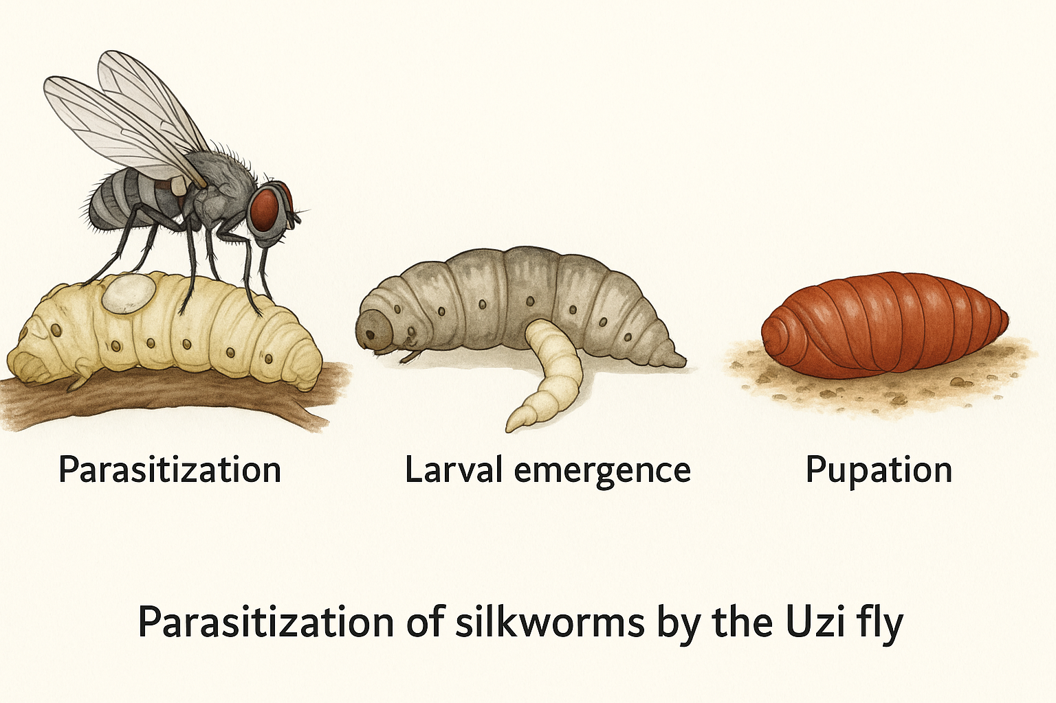

*Figure 1. Host-parasite interaction between Uzi fly (Exorista bombycis) and silkworm (Bombyx mori), illustrating parasitization, larval emergence, and pupation stages during infestation (Source: Author’s own illustration).*

1. **CLIMATIC PATTERNS RELEVANT TO UZI FLY IN NE INDIA**

The North Eastern (NE) region of India, including Assam, Meghalaya, Nagaland, and Manipur, has a subtropical climate marked by high rainfall, elevated relative humidity, and moderate temperatures, creating a favourable environment for mulberry cultivation and silkworm rearing throughout the year [10,11,12]. However, these climatic parameters also significantly shape the seasonal abundance, survival, and reproductive rates of the Uzi fly (*Exorista bombycis*). High humidity and rainfall during the monsoon months provide optimal conditions for rapid multiplication of Uzi fly populations, while moderate temperatures facilitate their development and fecundity [10,12]. Conversely, the cooler and drier winter periods typically reduce Uzi fly activity, yet recent trends of warmer winters and erratic rainfall have extended the pest's breeding window, increasing infestation risks during periods that previously posed lower threats [10].

Average temperatures in the region range from 24°C to 30°C, with around 25°C being ideal for silkworm development [12], while relative humidity near 79±2% supports silkworm physiological processes and indirectly sustains Uzi fly activity by prolonging host availability [10,12]. Erratic rainfall patterns, a key feature of climate variability in NE India, affect mulberry leaf quality and silkworm rearing cycles, influencing Uzi fly host availability and timing of parasitism [10]. Rising summer temperatures can stress silkworms, making them more susceptible to parasitism, while fluctuations in winter temperatures can disrupt rearing schedules, aligning silkworm availability with periods of heightened Uzi fly activity [10,11]. Climatic factors such as temperature and humidity significantly influence Uzi fly infestation rates, as evident in Figure 1.

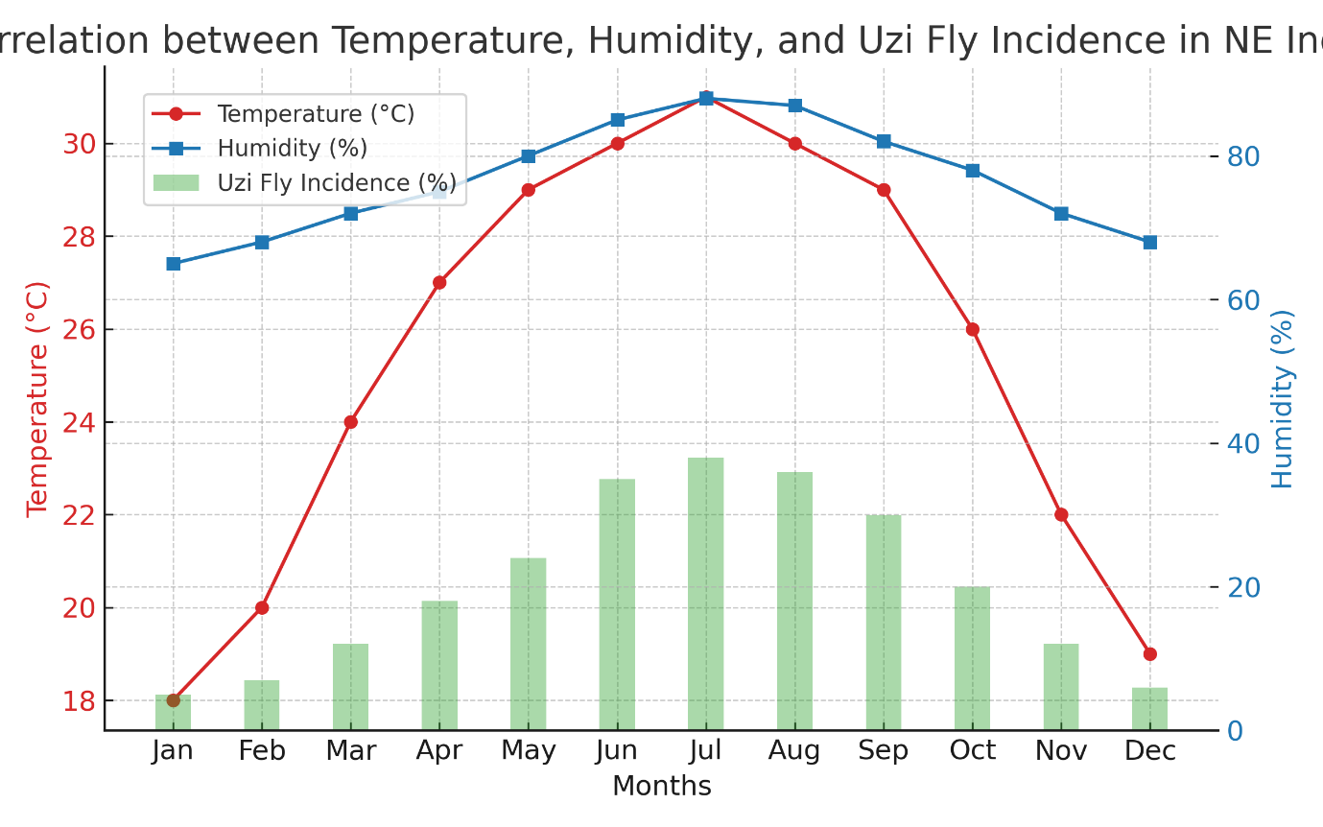

*Figure 2. Correlation between average temperature, relative humidity, and Uzi fly incidence in Northeast India, illustrating higher pest occurrences during periods of elevated humidity and temperature, which aligns with seasonal climatic patterns in the region (Source: Author’s own graph).*

Understanding these climatic patterns is essential as they directly and indirectly influence the timing and intensity of Uzi fly outbreaks, affecting silkworm health and cocoon productivity. Incorporating weather forecasting into sericulture management can help predict periods of high Uzi fly risk, supporting the implementation of targeted, eco-friendly pest management practices. Additionally, ongoing climate variability underscores the need for developing resilient mulberry varieties and silkworm races while designing region-specific strategies to manage Uzi fly within the changing climatic landscape of NE India [6,10,12].

1. **ECO-FRIENDLY MANAGEMENT STRATEGIES FOR UZI FLY IN MULBERRY SERICULTURE**

The sustainable management of the Uzi fly (*Exorista bombycis*/*E. sorbillans*) in mulberry sericulture is critical to reducing cocoon yield losses while preserving environmental safety and silkworm health in NE India. While chemical insecticides are effective, their use can harm silkworms, natural enemies, and the environment, highlighting the necessity of eco-friendly management approaches for sustainable sericulture systems [13,14].

* 1. **Cultural Control**

Adjusting rearing schedules to avoid peak Uzi fly activity and harvesting mature larvae early can reduce exposure to ovipositing females. Crop rotation and intercropping disrupt the pest's lifecycle, while ploughing rearing plots exposes pupae to predators and sunlight, reducing their survival. Maintaining cleanliness in the rearing field and dusting with bleaching powder can deter infestations. Avoiding continuous rearing, especially from December to April, further helps reduce infestation risks [15,16,17].

* 1. **Mechanical Control**

Mechanical methods, including the use of nylon mosquito nets during the peak infestation period (December to March), can provide 80–90% control against Uzi fly infestations. Careful removal of Uzi fly eggs from late-instar larvae using forceps and the collection of maggots emerging from cocoons in designated containers reduces pest load. Using electricity-operated stifling chambers within 3–5 days after spinning prevents the emergence of Uzi fly maggots from infested cocoons [16,17,18].

* 1. **Trap-Based Management**

The deployment of black sticky traps, attractant-baited traps, and light traps during peak adult emergence effectively reduces adult Uzi fly populations within rearing areas [14,18]. Additionally, pheromone traps have shown potential in capturing adults, reducing their reproductive potential and population density [17]. These traps provide a cost-effective, residue-free method that can be easily adopted by smallholder farmers. Regular monitoring of trap catches can also assist in determining peak pest periods, aiding in timely intervention planning and reducing the need for broader control measures.

* 1. **Biological Control**

Biological control, particularly the use of parasitoids, is effective in managing Uzi fly populations. Parasitoids such as *Nesolynx thymus* and *Dirhinus giffardii* parasitize Uzi fly pupae, reducing adult emergence [18]. *Nesolynx thymus* is mass-reared on housefly pupae and distributed in nylon pouches, each releasing approximately 10,000 adults. It is recommended to release *N. thymus* during the third to fifth day of the silkworm's fifth instar at a rate of two pouches per 100 developing Uzi flies near infestation areas, with pouches later placed near manure pits post-cocoon harvest for continued biological control [18]. The conservation and introduction of such parasitoids effectively manage pest populations while preserving ecological balance [11,14].

* 1. **Botanical and Organic Approaches**

Botanical extracts such as neem (*Azadirachta indica*), pongamia (*Pongamia pinnata*), and custard apple (*Annona squamosa*) exhibit insecticidal and repellent properties against Uzi fly adults while remaining safe for silkworms [19]. Neem-based formulations effectively reduce Uzi fly adult activity in rearing areas without harming silkworms, providing a natural and sustainable pest management option [19,20]. These botanicals are biodegradable and environmentally safe, aligning with the principles of organic sericulture. Additionally, their use supports integrated approaches by reducing dependence on synthetic chemicals while maintaining pest suppression levels.

* 1. **Environmental Hygiene**

Maintaining clean and sanitized rearing houses, removing decaying organic matter, and managing vegetation around rearing premises reduce resting and breeding sites for Uzi flies, thereby lowering infestation risks [18]. Regular sanitation practices form a critical foundation for preventing Uzi fly outbreaks within rearing environments. Maintaining proper waste disposal and drainage around rearing facilities further reduces the habitat suitability for adult Uzi flies [19]. These measures also help in controlling other secondary pests, indirectly supporting overall silkworm health and productivity.

* 1. **Quarantine Method**

Quarantine practices are essential for preventing the spread of Uzi fly infestations. Isolating newly procured silkworm eggs and larvae and monitoring them for signs of infestation before their introduction into the main rearing facility can prevent the accidental spread of Uzi flies. Imposing restrictions on the transportation of seed cocoons between regions and maintaining regular surveillance of cocoon markets, grainages, and reeling units are important measures for effective quarantine management [14,18].

* 1. **Integrated Approach**

While each eco-friendly strategy contributes to Uzi fly management, reliance on a single method may result in inconsistent control and the potential development of pest resistance [18]. An integrated application of cultural, mechanical, biological, botanical, and quarantine methods within an IPM framework ensures sustainable and effective Uzi fly management. This comprehensive approach is vital for protecting silkworm crops from severe Uzi fly damage while supporting the long-term sustainability and resilience of sericulture under the pressures of climate variability [14].

1. **CLIMATE-INFORMED INTEGRATED PEST MANAGEMENT (IPM) APPROACHES FOR UZI FLY CONTROL**

Climate variability, including changes in temperature, humidity, and rainfall, significantly influences the population dynamics of the Uzi fly and the timing of silkworm rearing cycles in NE India. Integrating climate data with pest monitoring and ecological insights enables targeted, effective, and environmentally sustainable management of Uzi fly infestations in the mulberry sericulture systems of NE India [19]. Weather-based forecasting systems help identify high-risk periods for pest outbreaks, allowing sericulturists to adjust rearing schedules and synchronize silkworm rearing with periods of reduced pest pressure. Warmer winters and erratic rainfall can extend the Uzi fly’s breeding period in NE India, while timely weather monitoring supports the effective application of biological control agents, such as *Nesolynx thymus*, to ensure maximum pest suppression [18,20].

Climate-informed IPM in NE India aligns eco-friendly strategies—including cultural and mechanical controls, trap-based methods, biological control, botanical interventions, sanitation practices, and quarantine measures—with weather forecasts and pest surveillance data to enhance management outcomes against Uzi fly infestations [19,20].

Additionally, the development and adoption of climate-resilient silkworm races and mulberry varieties suitable for NE India can indirectly mitigate the impact of Uzi fly infestations by improving silkworm health under fluctuating climatic conditions. Farmer training on climate-pest linkages in NE India further promotes the timely adoption of interventions, reducing pesticide dependence and preventing crop losses[21].

Advanced forecasting models, such as the Weather Research and Forecasting (WRF) system, and the use of degree-day thresholds provide real-time, location-specific data relevant to NE India, guiding pest risk assessments and informed decision-making for sericulturists [20,21,22,23]. Decision support tools integrated with weather forecasts enhance the precision of interventions while reducing environmental impacts, and mobile technologies facilitate timely dissemination of pest risk information to farmers in NE India [22,24]. Local weather monitoring systems in the region play a critical role in providing accurate, site-specific data that supports prompt and effective pest management responses [22,25].

While climate-informed IPM offers clear advantages for improving the efficiency and sustainability of Uzi fly management in NE India, challenges such as uncertainties in weather predictions and the need for continuous adaptation to evolving climatic conditions may affect implementation. Nevertheless, adopting climate-informed IPM ensures sustainable pest management, reduces reliance on chemicals, and enhances the resilience of mulberry sericulture systems in NE India under climate variability [21].

1. **FUTURE PERSPECTIVES AND RESEARCH PRIORITIES**

Advancing climate-resilient sericulture in NE India requires strategies that enhance sustainability while effectively managing pests like the Uzi fly. Key directions include developing early warning systems, breeding climate-resilient silkworm strains, and adopting eco-friendly pest control methods.

Biodiversification within sericulture ecosystems can improve resilience against climate variability and pest outbreaks, as diverse systems better suppress pest populations [26]. Climate-Smart Pest Management (CSPM), integrating research, policy, and extension services, will be essential for reducing pest-induced losses while supporting ecosystem health [27]. Predictive models and early warning systems can aid in anticipating Uzi fly outbreaks, enabling timely interventions that reduce crop losses in NE India [23,28].

Breeding programs focused on genetic selection of silkworm strains that can withstand climate stress and pest pressures are critical for sustainable sericulture [29]. Research on biopesticides and RNA interference (RNAi) offers promising, environmentally safe pest control options, while pheromone-based strategies can reduce reliance on chemical pesticides [27,30]. Strong policy frameworks and extension services are vital for promoting climate-smart sericulture practices, especially in climate-sensitive regions like NE India [28].

While these future strategies provide a roadmap for sustainable sericulture under climate variability, continued research and technological investments will be necessary to ensure effective adaptation to changing climatic conditions.

1. **CONCLUSION**

Uzi fly infestations, intensified by climate variability, pose a major challenge to sustainable mulberry sericulture in Northeast India. Understanding the impact of climatic parameters on Uzi fly population dynamics and silkworm vulnerability is essential for developing effective management strategies. Eco-friendly approaches, including cultural, mechanical, biological, botanical, and quarantine measures within integrated frameworks, provide viable alternatives to chemical control while ensuring environmental safety and silkworm health. Climate-informed IPM approaches that incorporate weather monitoring and predictive models can enhance the precision of interventions, reducing pesticide dependency and crop losses under changing climatic conditions. Future advancements, including the development of climate-resilient silkworm strains, early warning systems, and eco-friendly pest control methods, are critical for improving the resilience of sericulture in the region. By aligning pest management strategies with climate realities, the sustainability and productivity of mulberry sericulture in Northeast India can be preserved, securing livelihoods and promoting environmentally responsible silk production.

References

1. Ashraf H, Qamar A. Silkworm *Bombyx mori* as a model organism: A review. *Physiological Entomology*. 2023; *48*(4), 107-121.
2. Srikanth J, Kumar P, Mallikarjunappa S. STUDIES ON THE UZI FLY PARASITIZATION OF THE MULBERRY SILKWORM, BOMBYX MORI L. *Séricologia*. 1991; *31*(2), 323-328.
3. Dhyani SK, Chauhan DS, Kumar D, Kushwaha V, Lepcha ST. Sericulture-based agroforestry systems for hilly areas of north-east India. *Agroforestry Systems*. 1996; *34*, 247-258.
4. Ahmed SA, Singh NI, Sarkar CR. Role of forest biodiversity in conservation of non-mulberry (vanya) silk in India. *Munis Entomology & Zoology*. 2015; *10*(1), 342-357.
5. Sowmya P, Rajitha K. Uzi fly [*Exorista bombycis* (Louis)]-a menace to sericulture industry: a review. *Biochemical & Cellular Archives*. 2021; *21*.
6. Bhat MR, Brahma D, Bora NR, Vas M, Ashick Rajah R, Vasanth V, Ashwin Niranjan M. Role of integrated pest management in agriculture. *International Journal of Zoology and Applied Biosciences*. 2024; *9*(2), 40-46.
7. Sriharan TP, Samson MV, Krishnaswami S, Dutta RK. Laboratory investigation on Uzi fly T. bombycis Beck. A tachinid parasite of silkworms (*Bombyx mori* L.). Indian Journal of Sericulture. 1971;10(1):14-22.
8. Kumar JB, Manjunath D. Comparative Performance of *Trichomalopsis Uziae.* A Pupal Parasitoid of The Tachinid *Exorista Bombycis*. 2021; 365-370.
9. Chavan SS. Effect of botanicals on oviposition action against uji fly (*Exorista bombycis* Louis.) and their hatchability on silkworm. 2012; 196-198.
10. Sharma A, Chanotra S, Gupta R, Kumar R. Influence of climate change on cocoon crop loss under subtropical conditions. *International Journal of Current Microbiology and Applied Sciences*. 2020; *9*(5), 167-171.
11. Chanotra S, Angotra J. Implications of Meteorological Forecasting for Accelerating the Success Rate in Sericulture: New Avenues in Seriindustry: A Review. *Agricultural Reviews*. 2025; *46*(1).
12. Senapati MD, Hazarika AK. Identification of some productive bivoltine hybrids of mulberry silkworm, *Bombyx mori*, L. through rearing under rain fed seticulture of North eastern region of India. *The Clarion-International Multidisciplinary Journal*. 2012; *1*(1), 93-104.
13. Ambulkar PL, Sharma AK, Jhade RK. Pests and Diseases of Silkworm. *INSECT PEST MANAGEMENT*. 2021; 118.
14. Baruah JP, Kalita C. Integrated pest management of uzi fly (*Exorista sorbillans*) in Muga silkworm *Antheraea assamensis* Helfer (Lepidoptera: saturniidae): A review. *Journal of Entomology and Zoology Studies.* 2020; 8(4):341-343
15. Bindroo BB, Sahu AK, Chakravorty R. Muga culture in North-Eastern Region: Problems Prospects. *Indian Silk.* 2008; 46(9): 16- 20.
16. Eswara Reddy SG. Integrated management of Uzi fly, *Exorista bombycis* (Louis) (Diptera: Tachinidae) in muga silkworm, *Antheraea assamensis* hefler (Lepidoptera: Saturniidae) under outdoor rearing conditions of Assam (India). *Munis Entomology & Zoology*. 2011; 6(2):1012- 1013.
17. Singh A, Kumar V, Majumdar M, Guha L, Neog K. A Comprehensive Review of Insect Pest Management in Muga Silkworm (*Antheraea assamensis* Helfer): Current Scenario and Future Prospects. *Journal of Experimental Agriculture International*, 2024; *46*(5), 47-55.
18. Sengupta M. Sericulture, Sustainable Environment and Income Generation. *ENVIRONMENT AND SOCIOBIOLOGY*. 2016; *13*(2), 201-206.
19. Murugesh KA. Management of Uzi fly, *Exorista bombycis* (Louis) with Botanical Insecticides. *Madras Agricultural Journal*. 2023; *99*(jul-sep), 1.
20. Nayini SY, Nalagoni CSR, Banala RR, Raju SS. A comparative study to evaluate the efficiency of Coleus forskohlii root extract and Forskolin as a repellent against Uzi fly (*Exorista bombycis*). *Journal of Bio-Pharma Research*. 2017; *6*(3), 860-866.
21. Chandra A, Bhagawati K, Kalita H, Angami T. Weather-based fruit fly population dynamics prediction model for the mid-hills of Eastern Himalayan region of India. *Current World Environment*. 2022; *17*(3), 690.
22. Olatinwo R, Hoogenboom G. Weather-based pest forecasting for efficient crop protection. In *Integrated pest management.* 2014; (pp. 59-78). Academic Press.
23. Weltzin J, Crimmins TM, Posthumous E, Rosemartin A, Gerst KL. Phenology forecasts predict pest seasonal activity to support decision making. *USGS Report*. 2018; 3.
24. Lu L, Elbakidze L. Weather Forecast Based Conditional Pest Management: A Stochastic Optimal Control Investigation. 2011.
25. Paliwal S, Gangwar R, Bhatt S. Rural Marketing-An Outline. *AGRICULTURE & FOOD E-NEWSLETTER*. 2023.
26. ALTIERI MA. Insect pest management in the agroecosystems of the future. *ACCADEMIA NAZIONALE ITALIANA DI ENTOMOLOGIA*. 2012; 1987.
27. Heeb L, Jenner E, Cock MJ. Climate-smart pest management: building resilience of farms and landscapes to changing pest threats. *Journal of pest science*. 2019; *92*(3), 951-969.
28. Fand BB, Kamble AL, Kumar M. Will climate change pose serious threat to crop pest management: A critical review. *International journal of scientific and Research publications*. 2012; *2*(11), 1-14.
29. Chidawanyika F, Mudavanhu P, Nyamukondiwa C. Biologically based methods for pest management in agriculture under changing climates: challenges and future directions. *Insects*. 2012; *3*(4), 1171-1189.
30. Singh RN, Saratchandra B. The development of botanical products with special reference to seri-ecosystem. *Caspian Journal of Environmental Sciences*. 2005; *3*(1), 1-8.