Original Research Article
Faunal diversity and abundance of syrphids in Litchi and Guava ecosystems, including a new record of Scaeva latimaculata (Brunetti, 1923) from the Shivalik Hills, Himachal Pradesh, India

Abstract
Himachal Pradesh is situated in the western Himalayas. Kangra district of the state, especially Shivalik hills are known to retain a rich treasure of climatic variability, favourable for diversified vegetation and insect population. The current study was undertaken to examine the abundance and diversity of syrphid flies (under Diptera order) in litchi and guava. Total 6 different locations in the Kangra district were surveyed from the year 2019 to 2020. Field studies on litchi were conducted during the year 2019 at Palampur, Nagrota Bagwan, Sulah, Saliana while on guava during 2020 at Palampur, Bharwar and Nurpur. Syrphids formed one of the major insect visitor groups followed by honeybees and were anticipated to enhance pollination in the region. A total of 7 genera and 10 species identified under two subfamilies (Eristalinae and Syrphinae) were collected. In addition, Scaeva latimaculata (Brunetti, 1923) was identified as a new record from, Kangra district in litchi fruit crop. Litchi ecosystem was declared more diverse with species richness of 8 when compared to guava with species richness of 4. Simpson Index calculated to determine the diversity score of species was more for litchi ecosystem (0.85) than the guava ecosystem (0.71). In a similar trend, the Shannon-Weiner diversity index and Pielou’s Evenness was determined to be higher for litchi ecosystem (1.98, 0.95) when compared to guava ecosystem (1.28, 0.95) which indicated more uniform distribution of all species in litchi ecosystem. Collectively in both habitats, Eristalini syrphids (48.89 %) were dominant, while individual fruit crop had different trend of visitors where litchi attracted more Eristalini syrphids while guava attracted more syrphids from Syrphini tribe. Results also highlighted Nagrota Bagwan (28.89 %) to be the most frequently visited location with syrphid fauna, followed by Palampur (26.67 %) and Sulah (14.45 %) while Sulah was documented richest, with syrphid fauna belonging to three different tribes in comparison to any other location. These records of syrphid flies from different sites will enrich the prevailing data on syrphid fauna and their spatial arrangement within the two selected ecosystems i.e. litchi and guava.
Key words: Abundance, diversity, guava, litchi, species richness, syrphid
Introduction
Dipterans constitute an array of important flower visitors. The Syrphidae being one of Diptera's largest family approximately contain 6000 species in 180 genera worldwide (Pape & Thompson 2017). worldwide (Kuznetsov 2002) and is considered to be very significant group of insects. They are distinguished from bees on the basis of having a single pair of wings. Like bees, many dipteran flies also forage for nectar and pollen and assist in pollination. Syrphidae has hoverflies as pollinators of the many crops (Sutherland et al. 1999). A few species of syrphids eat pollen like bees but most of them only feed on nectar. About 199 genera of syrphid flies belong to 3 subfamilies namely Eristalinae, Microdontinae and Syrphinae are known worldwide (Dusek and Laska 1980; Mitra et al. 2004). Among them 355 species are currently recorded in India (Sengupta et al. 2016). The first extensive survey in HP reflected 49 species of Syrphidae under 27 genera and 9 tribes (Sengupta et al. 2016).
Diversity studies are of paramount importance. Besides, morphological diversity, syrphids possess wider array of niches where they carry out different roles i.e. some larvae are saprophagous, some are mycetophagous, others are predatory on Hemipterans and Thysanopterans, and still others are plant-sucking. Due to this heterogeneous eating habit of syrphid larvae, they are found in almost every habitat except for very dry areas.
Fly taxa are highly variable with respect to body size. Commonly hover flies are characterized by a spurious vein, located parallel to the fourth longitudinal wing vein (Mukherjee et al. 2006). Being hairy, they also pick up and move pollen from a wide variety of flowers (Stavert et al. 2016). Furthermore, they do not sting the farm workers as in the case of bees. Flies, despite being present in various biomes, have been studied far less than bees (Larson et al. 2001). They can be as efficient as, or better than, bees for pollinating some crops (Orford et al. 2015), and are often responsible for transporting high pollen loads in both natural and modified systems.
Pollination is one of the most fascinating processes in the natural world and hover flies are considered potential pollinating agents after honey bees. In general, syrphid flies pollinate flowers that are small and grow in shady, moist environments. Increasing decline of pollinators around the world calls for abundance studies of various non-conventional and wild pollinators. Syrphid being one of the abundant insect visitors of many crop habitats sometimes also regarded as an alternate pollinator and hence, needs conservation. The present proposal aims to identify them in litchi and guava ecosystems in Shivalik hill range of Himachal Pradesh.
Litchi and guava are highly cross-pollinated crops and need insects to assist with pollination. These are two important fruit crops of HP especially in Kangra district (Shivalik hills). Litchi is being grown in the state on an area of about 3.303 thousand ha with fruit production of 3.292 thousand MT while guava is being grown on 0.772 thousand ha and produces 0.521 thousand MT (Anonymous 2018). Various syrphid fauna visit their blooms along with prominent honey bee species. Present study, is therefore, intended at enhancing the information on syrphid fauna from the state of Himachal Pradesh. This study is expected to offer an insight into the abundance of syrphid fauna as well as serve as an important tool to harness them as imperative pollinator in future.
Materials and methods
Studies were carried out at Bee Research Station, Nagrota Bagwan (Elevation: 870 m Coordinates: 32.1054° N, 76.3789° E) of Chaudhary Sarwan Kumar Himachal Pradesh Agriculture University, Palampur, District Kangra, Himachal Pradesh, India during 2019-20 to generate information on relative abundance of different syrphid fauna on guava and litchi. In the first year i.e. 2019, records were taken on litchi crop while in the succeeding year, 2020, similar observations were taken on guava. Species richness and diversity indices were also assessed for both the ecosystems. The field studies for litchi (var. Culcuttia) were conducted at Palampur, Nagrota Bagwan, Sulah and Saliana while in guava (var. Allahabad Safeda) at Palampur, Bharwar and Nurpur of the Kangra district (Fig. 1). The experimental procedure followed during survey was as under:
Visual records and sweep net collection
Observations were recorded as number of syrphids visiting blooms of litchi and guava trees, which were randomly selected in the orchard. A total number of visiting insects/m² on the randomly selected canopy area of each tree at full bloom periods were counted for one minute as per method by Amin et al. 2018 with slight modifications. The branches of these trees were chosen in such a manner, that they had approximately the same dimensions with respect to their spread, phase of flowering, number of flowers and height above ground, covering all possible directions (Anita et al. 2012; Kaur and Sharma 2020).
Sweep net method was used preferentially for their collection. Both dry and wet methods of collection (in 70 % Ethyl alcohol) were considered. All the specimens were first poisoned with Ethyl acetate in an air tight killing jar, and later carried back to the laboratory. Then, they were carefully mounted on insect pins, labelled and kept in the collection box for further preservation. For close up photographs of pinned insects NIKON COOLPIX L310 21X optical zoom camera and Canon SX740 HS camera were used alternatively. The collected specimens from each site were got identified with help of taxonomists at ICAR-IARI, New Delhi.
Species richness (S) and Relative abundance (%)
Species richness was simply the total number of species present in an ecosystem while relative abundance of each species was calculated using the following formula:

$$Relative abundance \left(\%\right)=\frac{(Population of a specific species (ith) visiting flowers)}{(Total population of all species visiting flowers)}×100$$

Determination of diversity indices:
Three diversity measures were used in this study with the assumption that individuals are sampled randomly from an infinitely large population at different locations.
- Shannon-Wiener diversity index (H´)
The Shannon-Wiener diversity index, as detailed by Shannon and Weaver 1949, is widely used since it considers both species richness and evenness and computed by using the following formula:
 |  | _{S}
H' | = - | ∑ | (p_{i}) | (log₂p_{i})
 |  | i=1

- Simpson Index (D)
This is another important diversity index which measures the diversity score of a community based on richness and evenness. It was used because; Shannon-Wiener diversity index alone cannot be used to compare habitats that differ greatly in species richness. Following formula was used:

 |  |  | S
D | = | 1- | ∑ | (p_{i})²
 |  |  | i=1

- Pielou’s evenness index (J')
It describes the individual’s equipartition in the habitat. It is ranging from 0 (no evenness) to 1 (complete evenness). It was estimated by employing succeeding formula:

J' = H'/ H_{max}
Where,
H'= Shannon-Wiener diversity index
p_{i}= Proportion of total sample belonging to the i^{th} species.
S= Total number of species present in an ecosystem i.e. Species richness.
∑= Sum from species 1 to species S
D= Simpson’s index of diversity.
n= Frequency of a species or number of organisms of a species
J'= Evenness of allotment of individuals among the species i.e. Pielou’s evenness index.
H_{max} = Maximum species diversity (H') = Log₂S
Statistical analysis
The data collected as Species richness, Relative abundance, Diversity and Evenness indices of hover flies were studied under two different ecosystems for comparison. Diversity profile was worked out by PAST 4.03 (Hammer et al. 2001) software to check the variation in species distribution.

Results

Predominant species and richness
A total of 12 species framework was recorded (10 different species with 2 common to litchi and guava) in 6 different locations of Shivalik hill region in district Kangra. These 10 species were identified as Eristalodes paria (Bigot, 1880); Eristalis tenax L., 1758; Eoseristalis arbustorum L., 1758; Eristalinus arvorum F., 1787; Scaeva latimaculata (Brunetti, 1923); Episyrphus balteatus (De Geer, 1776); Melanostoma sp.; Episyrphus viridaureus (Wiedemann, 1824); Eristalis sp. and Paragus sp.
Among two different types of ecosystems i.e. litchi and guava, there had been an evident difference in species composition of syrphids. Litchi in the year 2019, attracted 8 hover fly species belonging to 4 tribes under 2 subfamilies (Table 1), on the contrary guava during the year 2020, attracted only 4 hover fly species belonging to 3 tribes of the 2 subfamilies under family Syrphidae (Table 2). For the first time Scaeva latimaculata (Brunetti, 1923) species was recorded from Kangra district. During the field survey, it’s all the six samples were recorded from litchi orchards of Sulah location, in the year 2019. In both the ecosystems, 2 species i.e. Eristalis tenax L., 1758 and Episyrphus viridaureus (Wiedemann, 1824) were common belonging to Eristalini and Syrphini tribes of the Eristalinae and Syrphinae subfamilies under family Syrphidae, respectively.
Investigations revealed that, out of total (n=90), litchi had 57 while guava had 33 syrphids, consequently litchi ecosystem was more visitor-frequent. Species richness in litchi ecosystem was recorded more (S=8) as compared to guava ecosystem (S=4). On comparing all the collected species, Eristalis tenax L., 1758 and Episyrphus viridaureus (Wiedemann, 1824) were found to be the most predominant visitors while Eristalodes paria (Bigot,1880) and Eristalis sp. were among the least abundant (Table 4). The per cent relative abundance (Fig. 3) shows distribution trends of syrphid fauna in both the ecosystems, together.
Contribution subfamily-wise and tribe-wise
Both the subfamilies i.e. Eristalinae and Syrphinae had 50 per cent share in the recorded sampling. Among the four tribes, Eristalini had the maximum share of species (48.89 %) followed by Syrphini (38.89 %), followed by Paragini (7.78 %) while least number of species was represented by Bacchini (4.44 %). Table 3 and Fig. 2 highlight the tribe-wise distribution of syrphid fauna in litchi and guava ecosystems collectively. Species belonging to Eristalinae subfamily are more abundant in litchi ecosystem while those belonging to Syrphinae subfamily are more abundant in guava ecosystem.
Diversity indices

The data yielded on diversity and evenness indices (Table 5) depicted species diversity and their distribution at two given horticultural ecosystems. The dominance of species was observed by, Simpson Index which recorded higher value for litchi ecosystem (0.85) than guava ecosystem (0.71). The Shannon-Weiner diversity index (Fig. 4) also registered higher value for litchi ecosystem (1.98) when compared to guava ecosystem (1.28). These results indicated that litchi ecosystem was more diverse. Pielou’s Evenness value estimated for litchi ecosystem showed a value 0.95, which was found to be comparatively higher than guava (0.92). This straight away suggested that all species in litchi ecosystem have uniform distribution while large disparity between numbers of individuals within each species existed in guava ecosystem.

Discussion
During the survey on syrphid flies in HP (India), in 2019-20, 10 different syrphid species were collected as important bloom visitors of litchi and guava. In our study conducted in both the crop ecosystems collectively, 10 species were collected. As per Kumari et al. 2023 and Wahid and Singh 2024, Diptera constituted approx. 24 % and 20 % abundance respectively, out of all the insect visitors in litchi blooms.
Similar studies on litchi were confirmed by Das et al. 2019. Furthermore, results on diversity of syrphid flies by Sajjad et al. 2010 and Khan and Hanif 2016 were quite similar to our findings.
Among two different types of ecosystems i.e. litchi and guava, there had been an evident difference in species composition of syrphids. Litchi attracted 8 hover fly species belonging to 4 tribes under 2 subfamilies, on the contrary guava, attracted only 4 hover fly species belonging to 3 tribes of the 2 subfamilies under family Syrphidae. Out of total (n=90), litchi had 57 while guava had 33 individuals, consequently litchi ecosystem was more visitor-frequent. Species richness in litchi ecosystem was recorded higher than the guava ecosystem. This reflects the suitable composition of different food sources in the former ecosystem and healthiness of surrounding environment. On comparing all the collected species, Eristalis tenax L., 1758 and Episyrphus viridaureus (Wiedemann, 1824) were more frequent visitors while Eristalodes paria (Bigot,1880) and Eristalis sp. were declared least present. This could be due to various reasons; out of them weather factors can be prominent ones as both the field records were taken in different years. The per cent relative abundance was determined for both the ecosystems, together. In a similar study conducted by Khan 2017 at Kashmir, Eristalis tenax L.,1758 was established as the most distributed syrphid species in the floricultural ecosystem, which supports our results. But as per Srivastava et al. 2017, in litchi blooms at Muzaffarpur, Bihar, other than Apis genera important visitors were Episyrphus balteatus, Syrpus sp, Erisyrphus sp, etc.
Both the subfamilies i.e. Eristalinae and Syrphinae had 50 per cent share in the recorded sampling. These results corroborated with Khan and Hanif, 2016. Among the four tribes, Eristalini had the maximum share of species (48.89 %) followed by Syrphini (38.89 %), followed by Paragini (7.78 %) while least number of species was represented by Bacchini (4.44 %). In a similar study by Karki et al. 2024, a total of eighteen insect species among the recorded insects in litchi, the order Diptera was the most abundant, accounting for 51.12% of the total, and was represented by five families: Syrphidae, Sarcophagidae, Calliphoridae, Muscidae, and Tachinidae.
Species belonging to Eristalinae subfamily are more abundant in litchi ecosystem while those belonging to Syrphinae subfamily are more abundant in guava ecosystem. It can be implicated that more Eristalinae visitors were collected from litchi blooms while more Syrphinae visitors were collected from guava blooms.
The diversity and evenness indices depicted species diversity and their distribution at two given horticultural ecosystems. The dominance of species in litchi crop was evident by, Simpson Index, Shannon-Weiner diversity index. Pielou’s Evenness value estimated for litchi ecosystem showed a higher value than guava which suggested that all species in litchi ecosystem have uniformly distributed than the guava ecosystem. Thangjam et al. 2019, in a similar way conducted his trial for comparison of ecosystems, in which they professed horticultural ecosystem as more diversified, which supports our findings. These deviations may be attributed to so many factors, few out of them being the time, specific crop and weather conditions. Provided the magnitude of study area and repetitions conducted, such a study needs more refinement. Although this study covers biodiversity aspect, exhaustive studies on syrphid utilization as important pollinating agents needs to be harnessed in future.

Statements and Declarations:
Competing interests:
No potential conflict of interest (financial or non-financial) was reported by the authors.
References
Amin D, Ahmad M, Shifa, Ibrahim S (2018) Insect pollinator diversity in major traditional leafy vegetables kale (Brassica oleracea var. acephala) and knol-khol (Brassica oleracea var. gongylodes) of Kashmir Himalayas. Int J Curr Microbiol Appl Sci 7(3):3082-3089. https://doi.org/10.20546/ijcmas.2018.703.358
Anita M, Sivaram V, Jayaramappa KV (2012) Influence of bee attractants on pollination and yield parameters in guava (Psidium guajava L.). Int J Plant Reprod Biol 4(1): 13-16
Anonymous (2018) Horticulture Area Production Info System. Ministry of Agriculture and Farmers' Welfare. http://aps.dac.gov.in (Accessed on 21st December 2018).
Das R, Jha S, Halder A (2019) Insect pollinators of litchi with special reference to foraging behavior of honeybees. Int J Pharmacognosy and Phytochem Res 8(4): 396-401
Dusek J, Laska P, (1980) European species of Metasyrphus: Key, descriptions and notes (Diptera, Syrphidae). Acta Entomol Bohemoslov 73: 263-282
Hammer Ø, Harper DAT, Ryan PD (2001) PAST: Paleontological statistics software package for education and data analysis. Palaeontol Electron 4(1): 19-20
Karki, N., & Kattel, I. P. (2024). Diversity and Relative Abundance of Insect Visitors of Litchi (Litchi chinensis Sonn.) at Baisjagar, Tanahun, Nepal. Agro Environ. Sustain. 2(3), 133-138.
Kaur H, Sharma SK (2020) Foraging fidelity of honeybees and abundance of insect visitors on some Horticultural crops. Int J Chem Stud 8(3): 1974-1978. https://doi.org/10.22271/chemi.2020.v8.i3aa.9494
Khan AA (2017) Distribution, Relative Abundance, Species Diversity and Richness of Syrphid Flies in Floricultural Ecosystem of Kashmir. Int J Curr Microbiol Appl Sci 6(9): 1539- 1552
Khan SA, Hanif H (2016) Diversity and fauna of hoverflies (Syrphidae) in Chakwal, Pakistan. Int J Zool 1(1):22-23
Kumari, P., Rana, S., Bhargava, B., & Reddy, S. E. (2023). Diversity, Abundance and Impact of Insect Visitors in Litchi chinensis Production. Agron. 13(2), 298.
Kuznetsov SYu (2002) The phylogeny of the family Syrphidae (Diptera), pp.189. In: Proceedings of the 12th Congress of Russian Entomological Society, (NAUKA., Eds) St. Petersburg., 19-24 August 2002. Russian Entomological Society, Russia
Larson B.M.H., Kevan P.G., Inouye D.W. Flies and flowers: Taxonomic diversity of anthophiles and pollinators. Can. Entomol. 2001;133:439–465.
Mitra B, Parui P, Sharma RM (2004) A preliminary study on the Dipteran Flower Visitors/ Pollinators of Himachal Pradesh. Annals of Forestry 12(1): 119-124
Mukherjee M, Parui P, Mitra B (2006) Insecta, Diptera, Syrphidae. Fauna of Arunachal Pradesh. State fauna series 13(2):331-354
Orford K.A., Vaughan I.P., Memmott J. The forgotten flies: The importance of non-syrphid Diptera as pollinators. Proc. R. Soc. B Biol. Sci. 2015;282:20142934.
Pape, T. & Thompson, F. C. 2016. Systema Dipterorum (version 2.0, Jan 2011), In: Species 2000 and ITIS Catalogue of Life, 29th October 2014 (Roskov, Y., Abucay, L., Orrell, T., Nicolson, D., Kunze, T., Culham, A., Bailly, N., Kirk, P., Bourgoin, T., De Walt, R. E., Decock, W. & De Wever, A. eds). Digital resource at www.catalogueoflife.org/col, Species 2000: Naturalis, Leiden, the Netherlands.
Rai VL, Srivastava P, Bisht K, Mishra VK (2017) Diversity and relative abundance of pollinating insects visiting litchi (Litchi chinensis Sonn.) inflorescence under Tarai agro-climatic condition. J Exp Zool 20(1): 221-227
Sajjad A, Saeed S, Ashfaq M (2010) Seasonal Variation in Abundance and Composition of Hoverfly (Diptera: Syrphidae) Communities in Multan, Pakistan. Pak J Zool 42(2): 105-115
Sengupta J, Naskar A, Maity A, Hazra S, Banerjee D (2016) New distributional records and annotated keys of hover flies (Insecta: Diptera: Syrphidae) from Himachal Pradesh, India. J Adv Zool 37(1): 31-54
Sengupta, J., Naskar, A., Maity, A., Hazra, S., Mukhopadhyay, E., Banerjee, D & Ghosh, S. 2016. An Updated Distributional Account of Indian Hover flies (Insecta: Diptera: Syrphidae). J Entomol Zool Stud 4 (6): 381-396.
Shannon CE, Weaver W (1949) The mathematical theory of communication. University of Illinois Press, Urbana, USA
Srivastava, K., Sharma, D., Pandey, S. D., Anal, A. K. D., & Nath, Vishal. (2017). Dynamics of climate and pollinator species influencing litchi (Litchi chinensis) in India. Indian J. Agric. Sci. 87(2), 266-269.
Stavert J.R., Liñán-Cembrano G., Beggs J.R., Howlett B.G., Pattemore D.E., Bartomeus I. Hairiness: The missing link between pollinators and pollination. PeerJ. 2016;4:e2779.
Sutherland JP, Sullibvan MS, Poppy GM (1999) The influence of floral characters on the foraging behavior of the hoverfly, Episyrphus balteatus. Entomol Exp Appl 93:157–164
Thangjam R, Kadam V, Ningthoujam K, Sorokhaibam M (2019) Hoverflies of Assam (Diptera: Syrphidae): New records and their diversity. J Entomol Zool Stud 7(4): 965-969
Wahid, F., & Singh, B. K. P. (2024). Diversity and relative abundance of insect visitors to litchi inflorescence with special reference to the foraging behaviour of honeybee (Apis mellifera l.). Entomon. 49(1), 135-140.

Table 1 Syrphid diversity of litchi at different locations of Kangra district in 2019
Sr. No. | Location | Insect species | Order | Family
1. | Sulah | Eristalodes paria | Diptera | Syrphidae
 |  | Melanostoma sp. | Diptera | Syrphidae
 |  | Scaeva latimaculata | Diptera | Syrphidae
2. | Palampur | Eristalis tenax | Diptera | Syrphidae
3. | Saliana | Eristalinus arvorum | Diptera | Syrphidae
4. | Nagrota Bagwan | Eoseristalis arbustorum | Diptera | Syrphidae
 |  | Episyrphus balteatus | Diptera | Syrphidae
 |  | Episyrphus viridaureus | Diptera | Syrphidae

Table 2 Syrphid diversity of guava at different locations of Kangra district in 2020
Sr. No. | Location | Insect species | Order | Family
1. | Palampur | Eristalis tenax | Diptera | Syrphidae
2. | Bharwar | Eristalis sp. | Diptera | Syrphidae
 |  | Paragus sp. | Diptera | Syrphidae
3. | Nurpur | Episyrphus viridaureus | Diptera | Syrphidae

Table 3 Tribe-wise distribution of Syrphid fauna in litchi and guava during 2019-2020
Sr. No. | Tribe | Percentage (%)
1. | Eristalini | 48.89
2. | Syrphini | 38.89
3. | Paragini | 7.78
4. | Bacchini | 4.44

Table 4 Abundance and species richness of Syrphid fauna from Kangra district of Himachal Pradesh during 2019-20
Sr. No. | Syrphid species | Subfamily | Tribe | #Ecosystem |  | *Frequency | Relative Abundance %
 |  |  |  | Litchi | Guava
1. | Eristalodes paria | Eristalinae | Eristalini | 3 | 0 | 3 | 3.33
2. | Eristalis tenax | Eristalinae | Eristalini | 13 | 11 | 24 | 26.67
3. | Eoseristalis arbustorum | Eristalinae | Eristalini | 9 | 0 | 9 | 10.00
4. | Eristalinus arvorum | Eristalinae | Eristalini | 5 | 0 | 5 | 5.56
5. | Eristalis sp. | Eristalinae | Eristalini | 0 | 3 | 3 | 3.33
6. | Scaeva latimaculata | Syrphinae | Syrphini | 6 | 0 | 6 | 6.67
7. | Episyrphus balteatus | Syrphinae | Syrphini | 10 | 0 | 10 | 11.11
8. | Melanostoma sp. | Syrphinae | Bacchini | 4 | 0 | 4 | 4.44
9. | Episyrphus viridaureus | Syrphinae | Syrphini | 7 | 12 | 19 | 21.11
10. | Paragus sp. | Syrphinae | Paragini | 0 | 7 | 7 | 7.78
 |  |  |  | 57 | 33 | 90

#Each value for particular crop ecosystem represents total no. of individuals of a species observed.
*Frequency represents total individuals in two ecosystems collectively.

Table 5 Diversity indices of Syrphids observed during survey at Kangra district of Himachal Pradesh during 2019-20
Ecological indices | Ecosystems
Ecological indices | Litchi | Guava
Shannon-Weiner diversity index (H´) | 1.98 | 1.28
Pielou’s Evenness index (J´) | 0.95 | 0.92
Simpson’s index (D) | 0.85 | 0.71

Table 6 Location wise distribution of syrphid fauna at Kangra district of Himachal Pradesh during 2019-20
Sr. No. | Location | Ecosystem |  | Frequency | Relative Abundance %
 |  | Litchi | Guava
1. | Palampur | 13 | 11 | 24 | 26.67
2. | Nagrota Bagwan | 26 | 0 | 26 | 28.89
3. | Sulah | 13 | 0 | 13 | 14.45
4. | Saliana | 5 | 0 | 5 | 5.56
5. | Bharwar | 0 | 10 | 10 | 11.12
6. | Nurpur | 0 | 12 | 12 | 13.34
 | Total | 57 | 33 | 90

Table 7 Checklist of syrphids (Tribewise) recorded from different locations.at Kangra district of Himachal Pradesh during 2019-20
Sr. No. | Insect |  | Locations
 | Tribe | Species | Palampur | Nagrota Bagwan | Sulah | Saliana | Bharwar | Nurpur
1. | Eristalini | Eristalodes paria | − | − | + | − | − | −
 |  | Eristalis tenax | + | − | − | − | − | −
 |  | Eoseristalis arbustorum | − | + | − | − | − | −
 |  | Eristalinus arvorum | − | − | − | + | − | −
 |  | Eristalis sp. | − | − | − | − | + | −
2. | Syrphini | Scaeva latimaculata | − | − | + | − | − | −
 |  | Episyrphus balteatus | − | + | − | − | − | −
 |  | Episyrphus viridaureus | − | + | − | − | − | +
3. | Bacchini | Melanostoma sp. | − | − | + | − | − | −
4. | Paragini | Paragus sp. |  | − | − |  | + | −
+ = presence; − = absence.

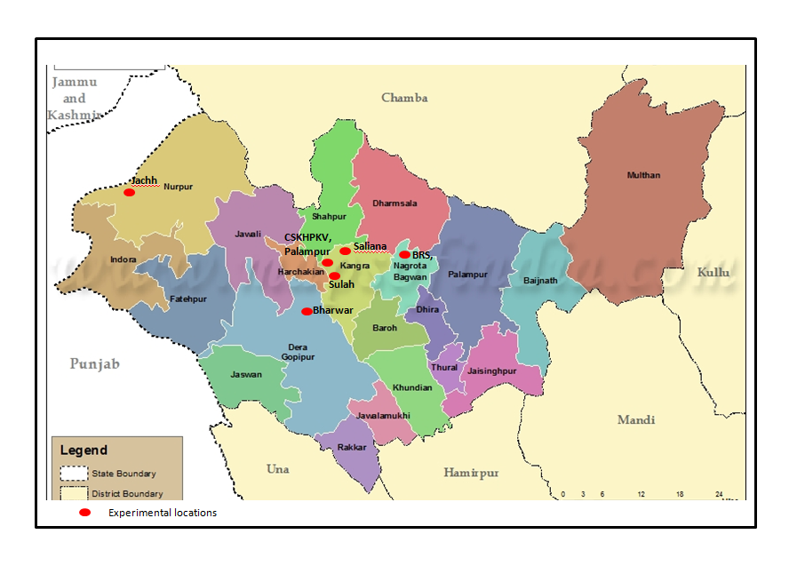 Fig. 1 Map of Himachal Pradesh showing the experimental locations

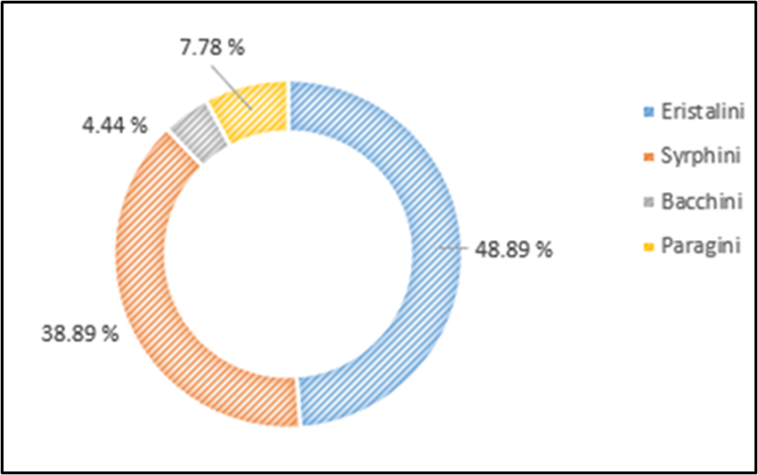

Fig. 2 Tribe-wise distribution of Syrphid fauna in litchi and guava during 2019-2020

Fig. 3 Percent relative abundance of Syrphid fauna in litchi and guava during 2019-2020
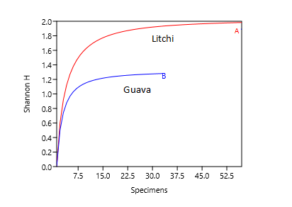
Fig. 4 Diversity profile of different species of syrphids in Kangra district

Fig. 5 Hoverflies reported from Kangra district of Himachal Pradesh (India)
a. Eristalodes paria b. Eristalis tenax c. Eoseristalis arbustorum
d. Eristalinus arvorum

Fig. 6 Hoverflies reported from Kangra district of Himachal Pradesh (India)
a. Scaeva latimaculata b. Episyrphus balteatus c. Melanostoma sp.
d. Episyrphus viridaureus

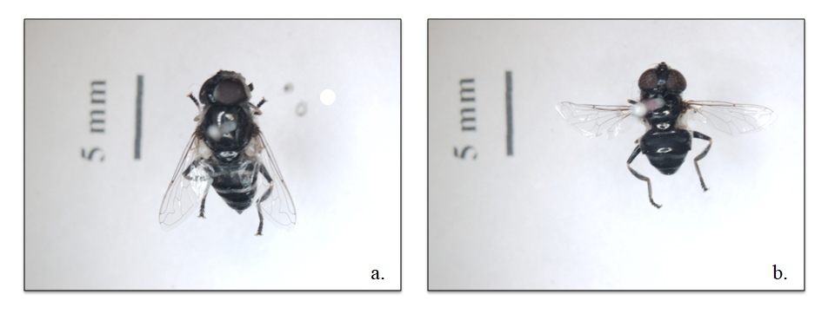
Fig. 7 Hoverflies reported from Kangra district of Himachal Pradesh (India)
a. Eristalis sp. b. Paragus sp.

