Review Article

Artificial intelligence and Internet of things in sericulture: Transforming sustainability, efficiency, and rural livelihoods

.
ABSTRACT

Sericulture remains a critical livelihood source and cultural asset in rural economies, yet faces persistent challenges including climate variability, pest outbreaks, labour dependence, and inconsistent cocoon quality, constraining its global competitiveness. Advanced technologies such as Artificial Intelligence (AI), Machine Learning (ML), Internet of Things (IoT), and drones offer transformative potential to address these challenges by enhancing disease detection, environmental monitoring, cocoon grading, and operational efficiency across the sericulture value chain. These technologies enable predictive analytics for yield forecasting, real-time environmental control in rearing houses, and precision pest management in mulberry cultivation, supporting consistent quality and higher productivity while reducing chemical and water use. However, barriers including high initial investment, limited technical literacy, and infrastructural gaps must be addressed systematically to ensure inclusive adoption and scalability. Leveraging targeted policy frameworks, research investment, and capacity-building initiatives will facilitate the integration of smart technologies, aligning sericulture with global sustainability goals and shifting consumer preferences for eco-friendly and traceable silk products. Embracing technological innovations will position sericulture as a modern, sustainable industry, strengthening rural livelihoods while enhancing competitiveness in the evolving global silk economy.

Keywords: Artificial Intelligence, IoT, Drone technology, Smart sericulture, Disease detection

1. INTRODUCTION

Sericulture, encompassing mulberry cultivation and silkworm rearing, plays a crucial role in rural livelihoods across Asia, particularly in India, which is the second-largest silk producer globally (Rahmathulla, 2012; Singh et al., 2016). This agro-based, labour-intensive activity not only sustains rural economies but also contributes to preserving traditional knowledge and practices associated with silk production (Singh et al., 2016). However, despite its socioeconomic significance, the sector faces persistent challenges including climate variability, pest outbreaks, labour dependence, and inconsistent cocoon quality, all of which limit its global competitiveness and reduce the ability of farmers to realise stable incomes (Mahadeva, 2018; Nadaf et al., 2021).
The impacts of climate change, such as irregular rainfall patterns, temperature fluctuations, and increased incidence of pest infestations, further exacerbate the vulnerabilities faced by sericulture farmers, affecting mulberry leaf quality and silkworm health, which are critical for high-quality cocoon production (Rahmathulla, 2012; Mahadeva, 2018). With the increasing global demand for sustainable, traceable silk products aligned with eco-conscious consumer preferences, there is an urgent need to transform the sericulture sector through modernisation and technology integration to enhance its resilience and competitiveness (De Abreu & van Deventer, 2022; Saikia & Saikia, 2023).
Advanced technologies, including Artificial Intelligence (AI) and Machine Learning (ML), have demonstrated significant promise in predictive analytics, disease detection, and automated grading within broader agricultural systems, offering avenues for improved operational efficiency and decision support in sericulture as well (Eli-Chukwu, 2019; Wang et al., 2024; Nadaf et al., 2021; Sharma, 2021). By applying AI and ML models to sericulture, it becomes possible to detect foliar diseases in mulberry crops, predict silkworm disease outbreaks, and support data-driven decisions for timely interventions, thereby reducing crop losses and ensuring consistent cocoon yield (Nadaf et al., 2021; Sharma, 2021; Wang et al., 2024).
The Internet of Things (IoT) offers additional potential by enabling real-time monitoring of rearing environments, such as maintaining optimal temperature, humidity, and carbon dioxide levels within silkworm rearing houses, which is essential for silkworm health and for mitigating climate-related risks (Doloi et al., 2019; Prathibha et al., 2017). This technology allows for continuous data collection and analysis, empowering farmers to adjust management practices promptly to prevent disease outbreaks or environmental stresses (Prathibha et al., 2017; De Abreu & van Deventer, 2022).
Drone technology is another critical enabler for precision sericulture, facilitating targeted pesticide application, mulberry crop monitoring, and field surveillance, thereby reducing manual labour requirements while improving pest management practices (Ahirwar et al., 2019; Mogili & Deepak, 2018; Subramanian et al., 2021). The integration of drones with IoT systems enables comprehensive monitoring of mulberry crop health and canopy coverage, supporting timely interventions to enhance leaf quality and availability for silkworm rearing (Ahirwar et al., 2019; Subramanian et al., 2021).
However, the ethical deployment of AI within agriculture, including sericulture, requires careful consideration of privacy, inclusivity, and transparency to ensure that technological advancements do not widen socioeconomic disparities within rural communities (Cockburn et al., 2018; Wang et al., 2024). The goal should be to utilise AI, ML, IoT, and drone technologies in a manner that promotes environmental sustainability while equitably benefiting smallholder sericulture farmers and empowering them through accessible technology adoption pathways (De Abreu & van Deventer, 2022; Wang et al., 2024).
With these evolving opportunities, it becomes imperative to evaluate the potential of integrating advanced technologies within the sericulture sector, addressing the challenges associated with traditional practices while aligning production with the global demand for sustainable and high-quality silk products (De Abreu & van Deventer, 2022; Saikia & Saikia, 2023). This review thus critically examines the prospects of AI, IoT, and drone technologies in transforming sericulture towards enhanced productivity, quality consistency, and climate resilience, contributing to sustainable rural livelihoods and the global silk economy.

- AI AND ML APPLICATIONS IN SERICULTURE

  - Disease Detection and Pest Management
AI and ML models enable rapid disease detection in mulberry and silkworm rearing, which is critical for preventing yield losses and ensuring the economic viability of sericulture (Nadaf et al., 2021; Eli-Chukwu, 2019). By leveraging advanced image processing and convolutional neural network (CNN) techniques, early detection of foliar diseases such as leaf spot, powdery mildew, and other fungal infections in mulberry plantations is now feasible, enabling timely and targeted interventions that significantly reduce chemical pesticide use and associated costs (Al Bashish et al., 2011; Schrickte et al., 2016; De Abreu & van Deventer, 2022).
For silkworms, the application of AI in visually analysing larval conditions and cocoon quality has shown effectiveness in detecting diseases such as grasserie and pebrine, reducing mortality rates while enhancing productivity (Sharma, 2021; Nadaf et al., 2021). Advanced pest prediction models using ML algorithms can also forecast pest outbreaks, including the uzi fly, by analysing climatic parameters, thus supporting integrated pest management (IPM) frameworks in sericulture for proactive, data-driven interventions (Rahmathulla, 2012; De Abreu & van Deventer, 2022).

  - Predictive Analytics and Yield Forecasting
AI-driven models predict cocoon yields using climatic data, rearing parameters, and historical datasets, aiding farmers in scheduling and planning resource allocation with greater accuracy and efficiency (Ramya et al., 2015; Srikantaiah & Deeksha, 2021). These models can incorporate factors such as temperature, humidity, mulberry leaf availability, and silkworm health indicators, allowing for dynamic forecasting that supports timely decision-making in resource management and labour allocation (Ramya et al., 2015). Such predictive analytics not only help in anticipating yield fluctuations due to seasonal variations but also in identifying optimal rearing windows to maximise cocoon quality and quantity (Srikantaiah & Deeksha, 2021).
Predictive systems are increasingly being integrated with IoT sensors for real-time data collection, which improves model accuracy and responsiveness by providing continuous environmental and physiological data (Doloi et al., 2019; Prathibha et al., 2017). This integration enables the models to adjust predictions dynamically as new data is captured, enhancing their reliability under varying climatic conditions (Doloi et al., 2019). Additionally, IoT-based monitoring facilitates early detection of anomalies, allowing corrective actions that help in reducing losses and improving overall productivity within sericulture operations (Prathibha et al., 2017). By leveraging AI-driven predictive analytics combined with IoT systems, sericulture can transition towards a more data-driven, resilient, and profitable enterprise.

- IoT IN SMART SERICULTURE

  - Environmental Monitoring
IoT-based systems allow continuous monitoring of temperature, humidity, and CO₂ levels within rearing houses, supporting optimal environmental conditions essential for healthy silkworm development and consistent cocoon production (Doloi et al., 2019; Srinivas et al., 2019; Prathibha et al., 2017; Deepthi & Sastry, 2021; Friha et al., 2021; Quy et al., 2022). Maintaining stable environmental parameters through real-time monitoring reduces climate-related risks, supports silkworm health, and enhances cocoon quality and yield, thereby addressing challenges posed by fluctuating weather conditions (Figure 1) (Srinivas et al., 2019; Rokhade et al., 2021).
Additionally, these IoT-based monitoring frameworks facilitate early warning systems for environmental anomalies, allowing immediate corrective actions and minimising production losses (Doloi et al., 2019; Friha et al., 2021). Integration of 6LoWPAN protocols and image processing further advances environmental and disease monitoring, automating the detection of anomalies in rearing conditions and reducing the reliance on manual monitoring (Schrickte et al., 2016; Prathibha et al., 2017). These technologies collectively enhance operational efficiency while ensuring the sustainability and scalability of sericulture practices under varying climatic scenarios (Quy et al., 2022; Doloi et al., 2019).

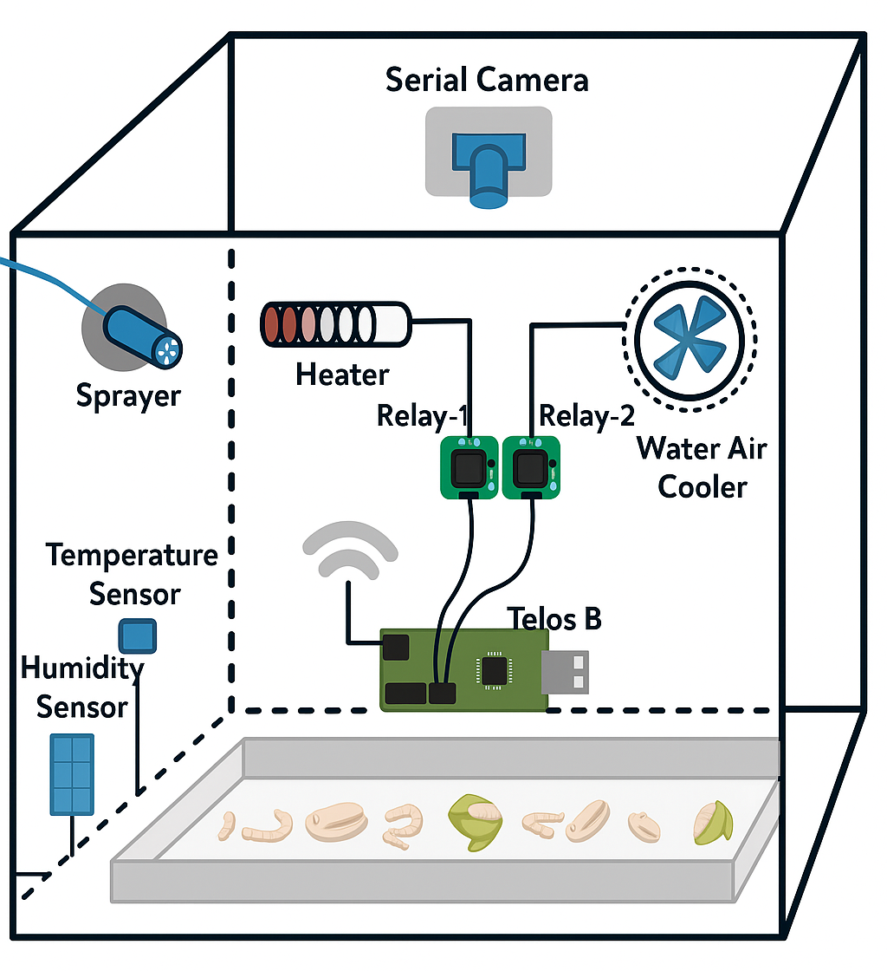
Figure-1 Smart Sericulture System Prototype (Deepthi & Sastry, 2021).

  - GIS and Remote Sensing Applications
Geospatial technologies support site selection, mulberry crop health monitoring, and pest hotspot mapping, providing valuable spatial and temporal data to optimise sericulture practices (Sharma et al., 2012; Singh et al., 2016; Sharma & Kapoor, 2020). These technologies assist in identifying suitable areas for mulberry cultivation by analysing soil type, moisture content, and climate conditions, ensuring better crop performance and resource utilisation (Sharma et al., 2012; Sharma & Kapoor, 2020).
Additionally, GIS and remote sensing facilitate continuous monitoring of mulberry crop health, enabling the detection of stress factors such as pest infestations, water deficiencies, and disease outbreaks at an early stage (Singh et al., 2016; Sharma & Kapoor, 2020). The SILKS system employs GIS and remote sensing to provide site-specific advisories, supporting sericulturists in making informed decisions regarding pest management, irrigation scheduling, and fertiliser application (Singh et al., 2016). By incorporating these spatial tools, sericulture can enhance productivity, minimise risks associated with climate variability, and contribute towards sustainable sericulture practices aligned with precision farming initiatives (Sharma et al., 2012; Singh et al., 2016).

- DRONE APPLICATIONS IN SERICULTURE
Drone technologies facilitate mulberry plantation monitoring, pest detection, and precision pesticide application, reducing labour while enhancing effectiveness in sericulture (Ahirwar et al., 2019; Mogili & Deepak, 2018; Subramanian et al., 2021). The use of drones enables rapid assessment of large mulberry fields, detecting variations in plant health and soil moisture levels, which is crucial for timely irrigation management and pest control interventions (Li et al., 2024). Drones equipped with high-resolution cameras assist in monitoring canopy health, leaf density, and pest outbreaks, facilitating data-driven decisions for integrated pest management (IPM) and ensuring effective pesticide usage while minimising environmental impacts (Li et al., 2024; Subramanian et al., 2021).
The integration of drones with IoT frameworks further strengthens real-time monitoring and targeted interventions in sericulture, aligning with precision agriculture practices adopted in other sectors (Slimani et al., 2023). Additionally, drones can be utilised for mapping disease hotspots within plantations, enabling focused rearing and crop management strategies to reduce disease spread and increase operational efficiency (Ahirwar et al., 2019; Mogili & Deepak, 2018; Subramanian et al., 2021).

- CASE STUDIES AND INDUSTRY APPLICATIONS
Reshamandi’s establishment of Asia’s second-largest silk cocoon mandi demonstrates the potential of technology-driven market systems in sericulture, integrating digital platforms to enhance transparency, price realisation, and stakeholder participation across the value chain (Anonymous, 2022; Pyingkodi et al., 2022). This initiative showcases how digital interventions can bridge gaps between farmers and buyers, creating a seamless supply chain that ensures fair pricing, quality traceability, and real-time inventory management, significantly empowering sericulture farmers while aligning with market demands (Anonymous, 2022).
Automated cocoon grading systems using vibration impact acoustic emission analysis have further transformed post-harvest operations in sericulture, improving grading accuracy while reducing manual drudgery and variability in cocoon sorting processes (Prasobhkumar et al., 2019; Prasobhkumar et al., 2018). By enabling objective, standardised quality assessments, these technologies assist farmers in receiving fair prices for their produce while enhancing the quality of raw silk extracted by reeling units (Prasobhkumar et al., 2018). The deployment of such systems also addresses inefficiencies in manual sorting, reduces the workload on labourers, and minimises human errors in grading (Prasobhkumar et al., 2019).
Image processing-based systems have similarly advanced cocoon sorting and disease detection practices, enabled rapid and consistent assessment of cocoon quality while facilitated early detection of infections (Figure 2) (Reddy & Bhaskar, 2022). By integrating these systems, sericulture operations can maintain high-quality standards and reduce disease-related losses, thus enhancing the economic sustainability of silk production while ensuring product consistency for downstream processes (Reddy & Bhaskar, 2022).

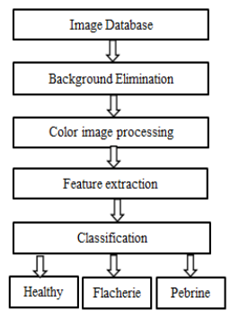
Figure-2 Diagram illustrating the image processing workflow for sericulture (Deepthi & Sastry, 2021).

In parallel, automated silkworm egg counting systems using image processing techniques have been developed to improve accuracy and reduce manual errors in grainages and seed production centres, facilitating efficiency in the early stages of sericulture operations (Pathan & Harale, 2016). These systems assist in handling large volumes of silkworm eggs with precision, reducing the labour-intensive nature of traditional egg counting and mitigating inconsistencies caused by manual counting methods (Pathan & Harale, 2016). Further advancements in this area have incorporated enhanced image processing algorithms and automated workflows to improve counting accuracy, operational efficiency, and handling speed in silkworm egg management, building upon earlier systems to reduce manual dependency and enhance productivity in grainages (Pavitra & Raghavendra, 2022).
Collectively, these case studies highlight the transformative impact of technology integration across the sericulture value chain—from seed production to cocoon grading and market integration—demonstrating practical pathways towards achieving smart, efficient, and quality-focused sericulture systems (Anonymous, 2022; Pyingkodi et al., 2022; Prasobhkumar et al., 2019; Prasobhkumar et al., 2018; Reddy & Bhaskar, 2022; Pathan & Harale, 2016; Pavitra & Raghavendra, 2022).

- CHALLENGES AND CONSTRAINTS

  - Economic and Infrastructure Constraints
High initial investments in AI, IoT, and drone systems remain a significant barrier for smallholder sericulture farmers who often operate with limited financial resources and risk-bearing capacities (De Abreu & van Deventer, 2022; Saikia & Saikia, 2023). The cost of acquiring and maintaining advanced technological tools, coupled with the need for supporting infrastructure such as sensors, connectivity modules, and data management systems, can be prohibitive for individual farmers and small cooperatives, especially in developing regions where sericulture is a primary livelihood (De Abreu & van Deventer, 2022).
Additionally, inadequate rural connectivity and irregular power supply further hinder the effective utilisation of these technologies, limiting the scalability of smart sericulture initiatives across diverse geographies ((Deepthi & Sastry, 2021; De Abreu & van Deventer, 2022; Dawn et al., 2023). Even in regions where pilot projects have demonstrated the potential of AI and IoT integration, the lack of a robust supply chain for maintenance and servicing of devices often leads to operational discontinuities and underutilisation of the deployed systems (Saikia & Saikia, 2023). Addressing these economic and infrastructural barriers requires systematic policy support, the establishment of shared technology hubs, and financing models that reduce the financial burden on smallholders while encouraging adoption.

  - Technical Literacy
Limited technical skills and digital literacy among farmers present another critical constraint in the widespread adoption of AI, IoT, and drone technologies in sericulture (Cockburn et al., 2018; Oliveira & Silva, 2023). Effective utilisation of these advanced tools necessitates a fundamental understanding of data interpretation, sensor handling, and device maintenance, which many sericulture practitioners currently lack, especially in rural contexts where education levels may be lower (Cockburn et al., 2018). This gap in technical literacy can result in underutilisation or misuse of devices, reducing their intended benefits and discouraging further adoption (Oliveira & Silva, 2023).
Moreover, the complexity of interpreting AI-driven analytics for disease detection, environmental monitoring, and yield forecasting can be daunting for farmers unfamiliar with digital platforms, leading to a reliance on intermediaries and reducing the independence of smallholder operations (Oliveira & Silva, 2023). To overcome these challenges, it is essential to implement targeted training programs and capacity-building initiatives tailored to local contexts, fostering digital confidence among farmers and ensuring they can leverage technological advancements effectively to improve productivity and sustainability in sericulture (Cockburn et al., 2018; Oliveira & Silva, 2023).

- FUTURE PROSPECTS AND STRATEGIC ROADMAP
The integration of blockchain for silk supply chain transparency, coupled with AI for pest prediction and quality grading, can transform sericulture towards precision and sustainability (Abeyratne & Monfared, 2016; De Abreu & van Deventer, 2022). Automated cocoon sex identification using fluorescence (Thomas & Thomas, 2020; Zhang et al., 2010) and advanced image-based disease detection (Thomas & Thomas, 2022; Xiong et al., 2021) can enhance productivity and breeding efficiency, supporting consistent supply of high-quality silk. The broader application of AI in agriculture demonstrates challenges such as data privacy, technical literacy, and high initial investment, which are also relevant for its effective integration into sericulture systems and require systematic addressing for successful deployment (Vijayreddy, 2023; De Abreu & van Deventer, 2022).
Additionally, the Central Silk Board’s policy frameworks and annual strategies support the adoption of advanced technology in sericulture, aligning with national goals for sustainable rural development while empowering farmer communities (Anonymous, 2021; Singh et al., 2016). Collaboration between government, research institutions, and private sectors will accelerate the transition towards smart sericulture, ensuring inclusive growth and positioning India to meet rising global demands for sustainable and traceable silk products (Qadir et al., 2023; De Abreu & van Deventer, 2022).

- Conclusion

AI, IoT, and drone technologies have the potential to transform sericulture by enhancing disease detection, environmental monitoring, cocoon grading, and operational efficiency, supporting consistent quality and higher productivity. However, addressing challenges related to cost, infrastructure, and technical literacy is essential to ensure inclusive adoption and meaningful impact across smallholder farmers and sericulture clusters. Leveraging technological innovations alongside targeted policy support will enable sericulture to align with global sustainability goals while strengthening rural livelihoods and competitiveness in the silk sector. As global markets shift toward eco-friendly and traceable textile products, integrating these advanced technologies can position sericulture to meet evolving consumer demands. Strategic investments in research, capacity building, and public-private partnerships will be key to realising this transformation while ensuring environmental sustainability and economic resilience. By embracing these advancements, sericulture can secure its place as a modern, sustainable industry that uplifts rural communities and contributes to the broader goals of climate-smart agriculture and circular economies in textile value chains.

References

- Abeyratne SA, Monfared RP. Blockchain ready manufacturing supply chain using distributed ledger. International journal of research in engineering and technology. 2016; 5(9), 1-10.
- Ahirwar S, Swarnkar R, Bhukya S, Namwade G. Application of drone in agriculture. International Journal of Current Microbiology and Applied Sciences. 2019; 8(01), 2500-2505.
- Al Bashish D, Braik M, Bani-Ahmad S. Detection and classification of leaf diseases using K-means-based segmentation and. Information technology journal. 2011; 10(2), 267-275.
- Anonymous. Retrieved from https://www.indiaretailer.com/news/reshamandi- expands-offline-presence-opens-asia-s-2nd-largest- silk-cocoon-mandi. 13198 on 17th Oct, 2022.
- Anonymous. Annual Report 2020-21. Central Silk Board, Ministry of Textiles, Government of India. 2021.
- Cockburn IM, Henderson R, Stern S. The impact of artificial intelligence on innovation: An exploratory analysis. In The economics of artificial intelligence: An agenda. 2018; (pp. 115-146). University of Chicago Press.
- Dawn N, Ghosh T, Ghosh S, Saha A, Mukherjee P, Sarkar S, Guha S, Sanyal T. Implementation of Artificial Intelligence, Machine Learning, and Internet of Things (IoT) in revolutionizing Agriculture: A review on recent trends and challenges. International Journal of Experimental Research and Review. 2023; 30, 190-218.
- De Abreu CL, van Deventer JP. The application of artificial intelligence (AI) and internet of things (IoT) in agriculture: A systematic literature review. In Southern African Conference for Artificial Intelligence Research. 2022; (pp. 32-46). Springer, Cham.
- Deepthi HS, Sastry AS. Image processing based smart sericulture system using IoT. International Journal of Advances in Agricultural Science and Technology. 2021; 8(9), 23-31.
- Doloi A, Barkataki N, Saikia M, Saikia D. Development of a wireless sensor network based smart multiple ambient conditions sensing system for the rearing process of eri silkworm. International Journal of Advanced Technology and Engineering Exploration. 2019; 6(52), 50-60.
- Eli-Chukwu NC. Applications of artificial intelligence in agriculture: A review. Engineering, Technology & Applied Science Research. 2019; 9(4).
- Friha O, Ferrag MA, Shu L, Maglaras L, Wang X. Internet of things for the future of smart agriculture: A comprehensive survey of emerging technologies. IEEE/CAA Journal of Automatica Sinica. 2021; 8(4), 718-752.
- Li WQ, Han XX, Lin ZB, Rahman A. Enhanced pest and disease detection in agriculture using deep learning-enabled drones. Acadlore Transactions on AI and Machine Learning. 2024; 3(1), 1-10.
- Mahadeva A. Insect pest infestation, an obstacle in quality mulberry leaves production. Asian J. Biol. Sci. 2018; 11(1), 41-52.
- Mogili UR, Deepak BBVL. Review on application of drone systems in precision agriculture. Procedia computer science. 2018; 133, 502-509.
- Nadaf HA, Vishaka GV, Chandrashekharaiah M, Rathore MS, Srinivas C. Scope and potential applications of artificial intelligence in tropical tasar silkworm Antheraea mylitta D. seed production. J. Entomol. Zool. Stud. 2021; 9, 899-903.
- Oliveira RCD, Silva RDDSE. Artificial intelligence in agriculture: benefits, challenges, and trends. Applied Sciences. 2023; 13(13), 7405.
- Pathan SS, Harale AD. Silkworm Egg Counting System Using Image Processing Algorithm-A Review. International Research Journal of Engineering and Technology (IRJET). 2016; 3(06).
- Pavitra HV, Raghavendra CG. An overview on detection, counting and categorization of silkworm eggs using image analysis approach. Global Transitions Proceedings. 2022; 3(1), 285-288.
- Prasobhkumar P, Francis CR, Gorthi SS. Automated quality assessment of cocoons using a smart camera-based system. Engineering in agriculture, environment and food. 2018; 11(4), 202-210.
- Prasobhkumar PP, Francis CR, Gorthi SS. Cocoon quality assessment system using vibration impact acoustic emission processing. Engineering in Agriculture, Environment and Food. 2019; 12(4), 556-563.
- Prathibha SR, Hongal A, Jyothi MP. IoT based monitoring system in smart agriculture. In 2017 international conference on recent advances in electronics and communication technology (ICRAECT). March, 2017; (pp. 81-84). IEEE.
- Pyingkodi M, Thenmozhi K, Nanthini K, Karthikeyan M, Palarimath S, Erajavignesh V, Kumar GBA. Sensor based smart agriculture with IoT technologies: a review. In 2022 international conference on computer communication and informatics (ICCCI). January, 2022; (pp. 1-7). IEEE.
- Qadir J, Islam T, Sudan N, Aryan S. Grass Root innovations for Better Performance of Sericulture Industry. In Biological Forum–An International Journal. 2023; (Vol. 15, No. 4, pp. 996-999).
- Quy VK, Hau NV, Anh DV, Quy NM, Ban NT, Lanza S, Randazzo G, Muzirafuti A. IoT-enabled smart agriculture: architecture, applications, and challenges. Applied Sciences. 2022; 12(7), 3396.
- Rahmathulla VK. Management of climatic factors for successful silkworm (Bombyx mori L.) crop and higher silk production: a review. Psyche: A Journal of Entomology. 2012; 2012(1), 121234.
- Reddy BL, Bhaskar M. Smart Sericulture System using Image Processing. International Journal of Engineering Research and Technology (IJERT). 2022; 11(01).
- Rokhade S, Guruprasad MK, Mallesh MS, Banu S, Jyoti SN, Thippesha D. Smart sericulture system based on IoT and image processing technique. In 2021 International Conference on Computer Communication and Informatics (ICCCI). January, 2021; (pp. 1-4). IEEE.
- Saikia S, Saikia M. Smart Sericulture and IoT: A Review. In Biological Forum–An International Journal. 2023; (Vol. 15, No. 1, pp. 545-549).
- Schrickte LF, Montez CB, Oliveira RSD, Pinto ASR. Design and implementation of a 6LoWPAN gateway for wireless sensor networks integration with the internet of things. International Journal of Embedded Systems. 2016; 8(5-6), 380-390.
- Sharma K, Kapoor B. Sericulture as a profit-based industry—a review. Indian journal of pure and Applied biosciences. 2020; 8(4), 550-562.
- Sharma NK, Jeyaseelan AT, Kumar R. Geospatial Technology for Sericulture Development in Jharkhand: A Pilot Study. 2025.
- Sharma R. Artificial intelligence in agriculture: a review. In 2021 5th international conference on intelligent computing and control systems (ICICCS). May, 2021; (pp. 937-942). IEEE.
- Singh PS, Handique BK, Chutia D, Das PT, Goswami J, Goswami C, Prabhakar CJ, Dhanraj K, Raju PLN. Conceptualization and development of Sericulture Information Linkages and Knowledge System (SILKS). Journal of Geomatics. 2016; 10(2), 108-113.
- Slimani H, El Mhamdi J, Jilbab A. Drone-assisted plant disease identification using artificial intelligence: A critical review. International Journal of Computing and Digital Systems. 2023; 14(1), 10433-10446.
- Srikantaiah KC, Deeksha A. Mulberry leaf yield prediction using machine learning techniques. In 3rd International Conference on Integrated Intelligent Computing Communication & Security (ICIIC 2021). September, 2021; (pp. 393-398). Atlantis Press.
- Srinivas B, Kumari K, Reddy G, Niranjan N, Hariprasad SA, Sunil MP. IoT based automated sericulture system. Int J Recent Technol Eng (IJRTE). 2019; 8(2).
- Subramanian KS, Pazhanivelan S, Srinivasan G, Santhi R, Sathiah N. Drones in insect pest management. Frontiers in Agronomy. 2021; 3, 640885.
- Thomas S, Thomas J. A review on existing methods and classification algorithms used for sex determination of silkworm in sericulture. In International Conference on Intelligent Systems Design and Applications. December, 2020; (pp. 567-579). Cham: Springer International Publishing.
- Thomas S, Thomas J. Non-destructive silkworm pupa gender classification with X-ray images using ensemble learning. Artificial Intelligence in Agriculture. 2022; 6, 100-110.
- Vijayreddy D. Cultivating Crop Health in the Digital Era: Harnessing AI for Plant Pathology. Agri Tech Today. 2023; 1(9), 33-35.
- Wang Y, Fu EY, Zhai X, Yang C, Pei F. Introduction of artificial intelligence. In Intelligent building fire safety and smart firefighting. 2024; (pp. 65-97). Cham: Springer Nature Switzerland.
- Xiong H, Cai J, Zhang W, Hu J, Deng Y, Miao J, Tan Z, Hua L, Cao J, Wu, X. Deep learning enhanced terahertz imaging of silkworm eggs development. Iscience. 2021; 24(11).
- Zhang Y, Yu X, Shen W, Ma Y, Zhou L, Xu N, Yi S. Mechanism of fluorescent cocoon sex identification for silkworms Bombyx mori. Science China Life Sciences. 2010; 53(11), 1330-1339.

