Original Research Article

In Vitro Suppression of Fusarium spp. Infecting Major Crops

.
ABSTRACT
Aims: To evaluate the efficacy of six fungicides against three Fusarium spp. affecting different crops viz., Fusarium vertificllioides (maize), F. udum (redgram) and F. oxysporum f.sp. ciceris (chickpea) under in vitro conditions using poisoned food technique
Study design: Completely randomized in vitro laboratory experiment
Place and Duration of Study: Department of Plant Pathology, College of Agriculture, Rajendranagar, Professor Jayashankar Telangana Agricultural University conducted during 2023-24
Methodology: A total of six fungicides viz., Captan 50 WP, Thiram 75% DS, Tebuconazole 5.36% FS, Carboxin 37.5% + Thiram 37.5% DS, Prochloraz 24.4% + Tebuconazole 12.1% EW and Thiphanate Methyl 450 g/l + Pyraclostrobin 50 g/l were evaluated at six different concentrations (25, 50. 100, 250, 500 and 1000 ppm) against three selected Fusarium species isolated from maize, redgram and chickpea using the poisoned food technique. Mycelial growth inhibition was assessed after incubation.
Results:Among the tested fungicides, Carboxin 37.5% + Thiram 37.5% DS and Prochloraz 24.4% + Tebuconazole 12.1% EW were the most effective across all Fusarium spp., with mycelia inhibition percentages ranging from 72.4% to 91.6% at higher concentrations. Captan 50 WP and Thiram 75% DS were the least effective with lowest inhibition percentages ranging between 28.6% and 47.3%. Further, the percent inhibition of mycelia growth was increased with increase in the concentration of fungicides.
Conclusion: Carboxin 37.5% + Thiram 37.5% DS and Prochloraz 24.4% + Tebuconazole 12.1% EW formulations are promising and may be recommended as seed treatment options for effective management of Fusarium wilt diseases in maize, redgram and chickpea. Field-level validation is necessary to confirm their effectiveness under field-conditions.

Keywords: Fusarium, poisoned food technique, fungicides, in vitro, mycelial growth

- INTRODUCTION

The agricultural productivity is threatened by the incidence of various pests and diseases with estimated yield losses of 20 – 40% each year across the world (Savary et al., 2019). Among the various diseases affecting different crops, fungal diseases caused by Fusarium spp. Are important determinants of the dynamics of plant populations both in natural and agricultural environments (Omidvari et al., 2023). Fusarium spp. are either seed- or soil-borne in nature. There are several reports indicating that majority of pathogens that lead to the production of abnormal seedlings are seed-borne fungi (Ahmed et al., 2013). These seed-borne mycoflora can cause deterioration of seed, affect the germination resulting in seed and seedling mortality and cause significant variation in plant morpholoty (Gebeyaw, 2020). Hence, sowing of healthy, disease-free and high quality seed is important for securing higher crop yields and food production (Moumni et al.,2023).
Though the use of disease-free or certified seeds is commonly recommended as primary management strategy (Murolo et al., 2022), the challenges arising by subsequent infections by soil-borne pathogens is a significant concern for farmers. This is a major factor limiting the crop production especially when the seeds are sown in cool, moist soil conditions that favor the growth of many soil-borne pathogens, while simultaneously hindering germination and seedling emergence (Lamichhane et al., 2020). Several soil-borne pathogens of genera Fusarium, Phytophthora, Pythium, Rhizoctonia, Sclerotium and Verticillium etc. can cause 50-75% yield losses in cereals, pulses, oilseeds, vegetables, fruits and ornamentals (Panth et al., 2020).
Host plant resistance is the most effective and reliable strategy to manage seed and soil-borne diseases. However, pathogens tend to evolve continuously into new races due to high pathogenic variability and mutability resulting in host plants losing resistance to the pathogens (Monga et al., 2018). Therefore, a combination of genetic and chemical control methods is a feasible strategy to improve the control efficacy.
Chemical seed treatment with systemic fungicides is an effective and commonly adopted method for many crops throughout the world for management of seed and soil-borne diseases (Lamichhane et al., 2020; Ayesha et al., 2021). Chemical seed treatment typically involves applying pesticides such as fungicides, insecticides, nematicides and rodenticides etc. to seeds to protect them from diseases and pests that affect seeds and seedlings (White and Hoppin, 2004). Use of fungicides for seed treatment is mainly to control fungal pathogens that are of seed and soil-borne in nature affecting seeds and seedlings both pre- and post-emergence (Lamichhane et al., 2020).
Although there are many fungicides available for managing Fusarium spp., it is important to identify the most effective broad-spectrum fungicide at the optimal dose for combating various species of Fusarium. Hence the present study was carried out to evaluate the effectiveness and optimum doses of different seed treatment fungicides against three Fusarium spp. under in vitro conditions.

2. material and methods

The experiment was carried out in the Department of Plant Pathology, College of Agriculture, Rajendranagar, Professor Jayashankar Telangana Agricultural University (PJTAU), Hyderabad, Telangana state, India during July – August, 2024. Pure cultures of three Fusarium spp. causing wilt diseases in three major crops viz., F. vertificllioides, F. udum and F. oxysporum f.sp. ciceris were obtained from the Microbial Culture Collection Centre, Department of Plant Pathology, College of Agriculture, Rajendranagar, PJTAU, Hyderabad, Telangana state, India (Table 1).

Table 1. List of Fusarium spp. used in the present study
S. No. | Name of the pathogen (disease caused) | Host crop | Place of collection | Latitude & Longitude
1. | Fusarium verticillioides (Post flowering stalk rot) | Maize (Zea mays L.) | Kondapaka, Karimnagar, 505502, Telangana | 18.39989022, 79.44059428
2. | Fusarium udum (Wilt) | Pigeonpea (Cajanus cajan L.) | Regional Agricultural Research Station, Warangal 506007, Telangana | 18.01410785, 79.60305643
3. | Fusarium oxysporum f. sp. ciceris (Wilt) | Chickpea (Cicer arietinum L.) | Tadwai, Nizamabad 503120, Telangana | 18.32825397, 78.25308682

2.1 Evaluation of fungicides against Fusarium spp. under in vitro conditions
Six fungicides (Table 2), commonly used for seed treatment were selected from the pesticides recommended as per the Central Insecticides Board & Registration Committee, India (CIB & RC, 2024) were tested for their efficacy against the Fusarium pathogens at six concentrations viz., 100, 250, 500, 1000, 1500 and 2000 ppm using the poisoned food technique (Nene and Thapliyal, 1993) under in vitro conditions.

Table 2. List of the fungicides used in the present study
S. No. | Name of the fungicide | Trade name | Mode of action | Manufacturing company
1. | Captan 50 WP | Captaf | Non systemic | Rallis India Ltd.
2. | Thiram 75% WS | Seedcap | Non systemic | Jaivik Crop Care Ltd.
3. | Tebuconazole 5.36% FS | Raxil | Systemic | Bayer Crop Science Ltd.
4. | Carboxin 37.5% + Thiram 37.5% DS | Vitavax power | Systemic & contact | Dhanuka Agritech Ltd.
5. | Prochloraz 24.4% + Tebuconazole 12.1% EW | Zamir | Systemic | Adama Ind. Pvt. Ltd.
6. | Thiophanate methyl 450 g/l + Pyraclostrobin 50 g/l | Xelora | Systemic | BASF Ind. Ltd.

Stock solution of 100000 ppm concentration was prepared using 10 ml of sterilized distilled water. Desired concentration of fungicide was obtained by diluting the stock solution using the following formula
$$C1V1=C2V2$$
Where, C1 = concentration of the stock solution (mg/L), V1 = volume of the stock solution to be added (mg/L), C2 = desired concentration (mg/L) and V2 = volume of Potato Dextrose Agar (PDA) in which fungicide is to be amended (ml).
The required quantity of each fungicide was added separately to the sterilized PDA medium, mixed thoroughly and poured in sterilized 90 mm diameter glass Petri plates and allowed to solidify. Three replications were maintained. A control plate was also maintained, where medium was not supplemented with any fungicides. Each plate was inoculated with 5 mm discs of 5 days old pathogen cultures taken with the help of sterilized cork borer and incubated at 25 ± 2⁰C for 7 days. Mycelial growth of the pathogen was recorded daily in the control plate starting from the initiation of the pathogen growth in correspondence to treatment plates till the fungal growth was full in control. Based on the observations recorded, the per cent growth inhibition will be calculated by the formula as mentioned (Vincent, 1947).
$$I=\frac{\left(C-T\right)}{C}x 100$$

Where I = Per cent inhibition of mycelial growth over control
C = Mycelial growth of the pathogen in control (mm)
T = Mycelial growth of the pathogen in treatment (mm)

2.2 Statistical Analysis
The data collected were analysed by analysis of variance (ANOVA) depending on the experimental design (completely randomized design) using the Statistical Package for Agricultural Scientists (OPSTAT). Duncan Multiple Range Test (DMRT) was used to analyse the data.
3. results and discussion

The fungicides showed significant variation in their efficacy against different Fusarium species, with distinct inhibition patterns noted for each pathogen.

3.1 Effect of fungicides on mycelial growth of F. verticillioides under in vitro conditions
All the fungicides evaluated in this study significantly (P = .05) suppressed the mycelial growth of F. verticillioides across the concentration gradient when compared to the untreated control (Figure 1 and supplementary figure 1). Notably, carboxin 37.5% + thiram 37.5% DS and prochloraz 24.4% + tebuconazole 12.1% EW demonstrated complete inhibition of mycelial growth at concentrations from 250 ppm up to 2000 ppm. Their effectiveness declined only at the lowest tested concentration (100 ppm), highlighting their strong dose-dependent activity. Conversely, thiram 75% DS showed comparatively lower efficacy, with inhibition ranging from 0.00% at 100 ppm to 89.54% at 1500 ppm. This fungicide consistently performed the least among all treatments tested. These results suggest that while thiram alone has limited efficacy, its combination with carboxin substantially enhances antifungal performance, possibly due to their complementary modes of action. These findings are similar to the earlier reports by Khokhar et al. (2014) and Jyothi & Saifulla (2017), who documented the effectiveness of tebuconazole-based formulations against F. verticillioides. The consistency of these observations across studies underscores the reliability of triazole-based fungicides in managing this pathogen under controlled conditions.
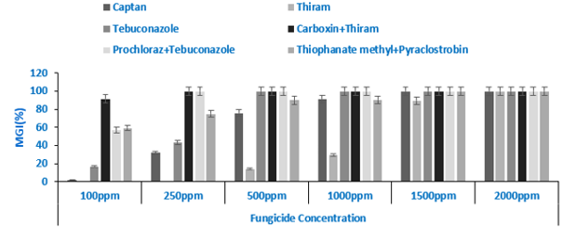

Figure 1. Efficacy of fungicides on per cent mycelial growth inhibition of F. verticillioides

3.2 Effect of Fungicides on Mycelial Growth of F. udum under In Vitro Conditions
In the case of F. udum, distinct differences were observed among fungicides and concentrations (Figure 2 and supplementary figure 2). The fungicide combination prochloraz 24.4% + tebuconazole 12.1% EW again emerged as the most effective treatment, completely inhibiting mycelial growth at higher concentrations and showing strong suppression even at lower levels (85.36% at 100 ppm). This was followed closely by carboxin + thiram, which achieved 80.41% to 100% inhibition across the tested range. By contrast, thiram 75% DS remained the least effective, with inhibition values ranging from 0.00% to 84.37%. These results emphasize not only the superior efficacy of combination fungicides but also the need for integrated approaches when dealing with soil-borne pathogens like F. udum. These results are in agreement with Patel et al. (2021), who highlighted the complete inhibition of mycelial growth and sporulation of F. udum by carboxin + thiram and tebuconazole. The reproducibility of such effects across different isolates and experimental setups strengthens the case for these fungicides as frontline options in Fusarium wilt management.
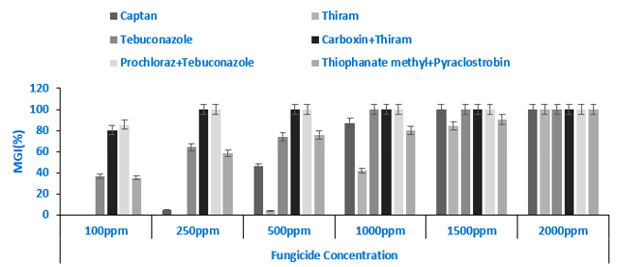

Figure 2. Efficacy of fungicides on per cent mycelial growth inhibition of F. udum

3.3 Effect of Fungicides on Mycelial Growth of F. oxysporum f. sp. ciceris under In Vitro Conditions
Similar to the trends observed with other Fusarium species, carboxin + thiram and prochloraz + tebuconazole exhibited complete inhibition of F. oxysporum f. sp. ciceris mycelial growth at concentrations between 250 and 2000 ppm (Figure 3 and supplementary figure 3. These fungicides consistently outperformed others, indicating their broad-spectrum efficacy against diverse Fusarium spp. In contrast, thiram 75% DS again was the least effective, with inhibition percentages ranging from as low as 3.17% at 100 ppm to 91.78% at 1500 ppm. The inferior performance of thiram alone, particularly at lower concentrations, reaffirms the importance of using synergistic combinations for enhanced control. Our findings are in agreement with that of Ravichandran and Hegde (2015), who reported that tebuconazole and carbendazim effectively inhibited the radial growth of F. oxysporum f. sp. ciceris under laboratory conditions. Likewise, Golakiya et al. (2018) found tebuconazole 25.9% EC to be among the most potent fungicides against this pathogen.
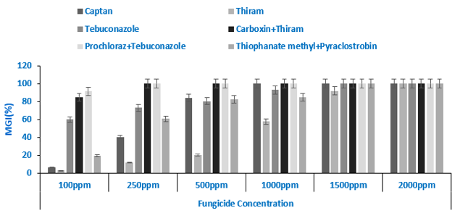

Figure. 3. Efficacy of fungicides on per cent mycelial growth inhibition of F. oxysporum f. sp. ciceris

4. Conclusion

The study demonstrated the potential use of systemic fungicides as seed treatment, particularly the combination formulations of Carboxin 37.5% + Thiram 37.5% DS and Prochloraz 24.4% + Tebuconazole 12.1% EW in effectively suppressing the mycelial growth of F. verticillioides, F. udum and F. oxysporum f.sp. ciceris. Future studies validating their efficacy under field conditions are essential for their application in integrated wilt disease management in maize, redgram and chickpea.

CONSENT

Not applicable.

ETHICAL APPROVAL

Not applicable.

References

Ahmed, M., Hossain, M., Hassan, K. & Dash, C.K. (2013). Seed health and quality test of three rice varieties for the detection of fungi associated with seed sample. Universal Journal of Plant Science, 1(2), 37-42. https://doi.org/10.13189/ujps.2013.010202
Ayesha, M.S., Suryanarayanan, T.S., Nataraja, K.N., Prasad, S.R. and Shaanker, R.U., 2021. Seed treatment with systemic fungicides: time for review. Frontiers in Plant Science, 12, 654512. https://doi/.org/10.3389/fpls.2021.654512
CIB & RC. Major uses of pesticides (2024). Central Insecticide Board & Registration Committee,Faridabad,Haryana. https://ppqs.gov.in/sites/default/files/fungicides_31.03.2024.pdf. Accessed on June, 2025.
Gebeyaw, M. (2020). Review on: Impact of seed-borne pathogens on seed quality. American Journal of Plant Biology, 5, 77-81. https://doi.org/10.11648/j.ajpb.20200504.11
Golakiya, B.B., Bhimani, M.D. & Akbari, L.F. (2018). Efficacy of different fungicides for the management of chickpea wilt (Fusarium oxysporum f. sp. ciceri). International Journal of Chemical Studies, 6(2),199-205. https://doi.org/10.13140/RG.2.2.32521.88160

Jyothi, V. & Saifulla, M. (2017). In-vitro evaluation of bioagents and chemical fungicides against dry root rot of chickpea caused by Macrophomina phaseolina in southern parts of Karnataka. Bulletin of Environment Pharmacology and Life Sciences, 6(2), 412-417.
Khokhar, M.K., Sharma, S.S. & Gupta, R.E.N.U. (2014). Integrated management of post flowering stalk rot of maize caused by Fusarium verticillioides. Indian Phytopathology, 67(3), 228-33.
Lamichhane, J.R., You, M.P., Laudinot, V., Barbetti, M.J. & Aubertot, J.N. (2020). Revisiting sustainability of fungicide seed treatments for field crops. Plant Disease, 104(3), 610-623. https://doi.org/10.1094/PDIS-06-19-1157-FE
Monga, D., Sain, S.K., Nakkeeran, S., Bhattiprolu, S.L., Rajani, V.V., Kulkarni, V. & Rao, M.S.L. (2018). Effectiveness of seed treatment with recommended fungicides on seed, soil borne diseases and productivity of cotton. Journal of Mycology and Plant Pathology 48(3), 311-323.
Moumni, M., Brodal, G. & Romanazzi, G. (2023). Recent innovative seed treatment methods in the management of seedborne pathogens. Food Security, 15(5), 1365-1382. https://doi.org/10.1007/s12571-023-01384-2
Murolo, S., Moumni, M., Mancini, V., Allagui, M.B., Landi, L. & Romanazzi, G. (2022). Detection and quantification of Stagonosporopsis cucurbitacearum in seeds of Cucurbita maxima using droplet digital polymerase chain reaction. Frontiers in Microbiology, 12, 764447. https://doi.org/10.3389/fmicb.2021.764447
Nene Y L & Thapliyal P N (1993). Fungicides in Plant Disease Control. Third edition Oxford and IBH publishing company, New Delhi. 691.
Omidvari, M., Abbaszadeh-Dahaji, P., Hatami, M. & Kariman, K. (2023). Biocontrol: a novel eco-friendly mitigation strategy to manage plant diseases. Plant stress mitigators, 27-56.
Panth, M., Hassler, S.C. & Baysal-Gurel, F. (2020). Methods for management of soilborne diseases in crop production. Agriculture, 10(1), 16. https://doi.org/10.3390/agriculture10010016
Patel, M., Kumar, S. & Mishra, S. (2021). Comparative efficacy of combi fungicides and solo fungicides against Fusarium udum causing wilt of pigeonpea. Pharma Innovation, 10(5), 1310-1314.
Ravichandran, S. and Hedge, Y.R., 2015. Evaluation of fungicides against Fusarium oxysporum ciceri causing chickpea wilt. Chemical Science Review and Letters, 4(16), 1042-1046.
Savary, S., Willocquet, L., Pethybridge, S.J., Esker, P., McRoberts, N. & Nelson, A. (2019). The global burden of pathogens and pests on major food crops. Nature Ecology & Evolution, 3(3), 430-439. https://doi.org/10.1038/s41559-018-0793-y
Vincent, J.M., (1947). Distortion of fungal hyphae in the presence of certain inhibitors. Nature, 159(4051), 850-850.
White, K.E. & Hoppin, J.A. (2004). Seed treatment and its implication for fungicide exposure assessment. Journal of Exposure Science & Environmental Epidemiology, 14(3), 195-203. https://doi.org/10.1038/sj.jea.7500312

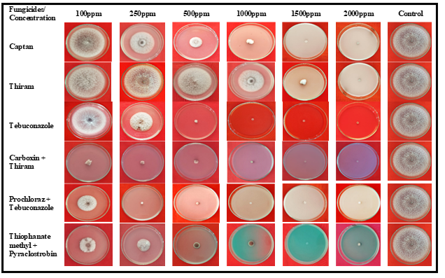

Supplementay Figure 1. Effect of different fungicides on mycelial growth of Fusarium verticillioides under in vitro conditions

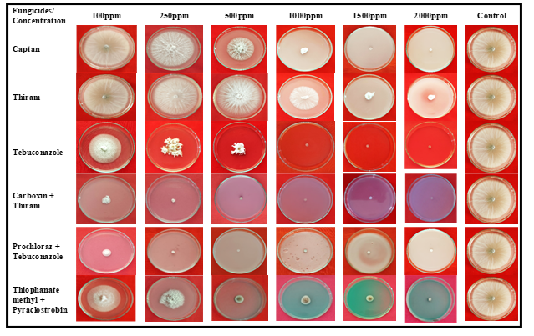
Supplementary Figure 2. Effect of different fungicides on mycelial growth of Fusarium udum under in vitro conditions

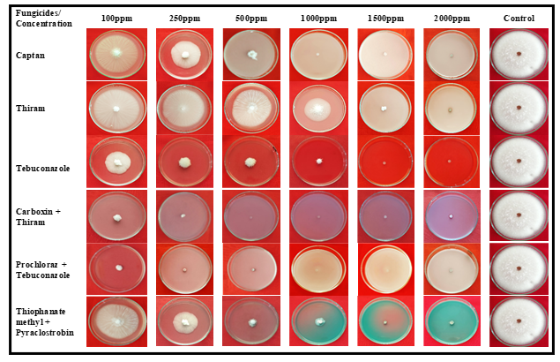

Supplementary Figure 3. Effect of different fungicides on mycelial growth of Fusarium oxysporum f. sp. ciceris under in vitro conditions

