**Optimization of Somatic Embryogenesis in a Seedless Grape Cultivar**

**Abstract**

An efficient in vitro regeneration system is necessary in order that biotechnological tools are able to be successfully applied in grapevine (*Vitis vinifera* L.), especially with conventional breeding's limitations. This study intended to develop a reproducible somatic embryogenesis SE protocol and *Vitis vinifera* cultivar shoot regeneration. In the present study, anther and leaf disc explants of the grape cv. Thompson seedless is used. MS, ½ MS, WPM, and C2D media, each supplemented by varying concentrations of BAP and 2,4-D, were used to culture explants. From anthers, 8.8 µM BAP with 4.5 µM 2,4-D (T3) gave the highest SE response among the treatments. In terms of leaf discs, 4.8 µM BAP with 4.5 µM 2,4-D, namely (T2), was very effective, specifically on MS medium. Compact calli exceeded powdery callus types or watery ones in embryogenic potential. For regeneration purposes, the highest shoot was initiated with 2.2 µM BAP (T3) in anthers and 4.4 µM BAP (T3) in leaf discs; with ½ MS and MS media, it responded best, respectively. Critical influence from explant type, basal medium, and precise PGR concentrations determines SE and regeneration efficiency. These results strongly support applications downstream, like transforming genes, and also eliminating viruses in the grapevine.

**Keywords:** Regeneration, Somatic embryo, Grapevine, Explant effect, shoot initiation

**Abbreviations:**

SE: Somatic Embryogenesis

2,4-D: 2, 4-Dichlorophenoxyacetic acid

BAP: 6-Benzylaminopurine

C2D: [Chee & Pool Vitis Medium](https://www.bing.com/ck/a?!&&p=f01f402ca3a18b4ac57f579d7f5c8976dec3cd6d6ec9a356c67c96c22e4c2de4JmltdHM9MTc1Mjk2OTYwMA&ptn=3&ver=2&hsh=4&fclid=16fb2de1-9aac-6e8f-3fc2-39bd9b1e6f67&psq=CHEE+AND+POOL+&u=a1aHR0cHM6Ly93d3cuYXR6bGFicy5jb20vYzI4Ny5odG1s&ntb=1)

MS: Murashige and Skoog

WPM: Woody Plant Medium

**Introduction**

Grapevine (Vitis spp.) is one of the most important fruit crops cultivated worldwide. The development of an efficient *in vitro* regeneration protocol is the basis for the application of each biotechnological approach and can be used to speed up genetic improvement programs (Sabbadini *et al.,* 2019a, b). Somatic embryogenesis is an efficient regeneration model system for functional studies as well as for largescale plant propagation in many crops, including grapevine (Von Arnold *et al.,* 2002*;* Correia *et al.,* 2019). In grapevine (*Vitis spp.*) most frequently adopted regeneration method is somatic embryogenesis, which has been used not only for genetic engineering (Franks *et al*., 1998;Gambino *et al*., 2005*),* but also for virus eradication (Goussard *et al*., 1991*;* Gambino *et al*., 2006*)*, *in vitro* mutant isolation (Franks *et al*., 2002), germplasm cryopreservation (Gray and Compton 1993), and production of synthetic seeds (Das *et al*., 2006*).* Although somatic embryogenesis was proved to be a successful tool for grapevine in vitro regeneration and optimized for many *Vitis* species, this technique is strongly genotype-dependent, and its efficiency varies according to the starting explant chosen (Vidal *et al.,* 2009). One of the most common starting tissues is anthers, but SE has also been obtained from ovaries, stigmas, and styles (Martinelli *et al*., 2009), anther filaments, and whole flowers (Gambino *et al*., 2007). Less commonly, tendrils, leaf discs, leaves, petioles, and stem nodal explants have been used for somatic embryogenesis induction (maillot *et al*., 2006). Different types of media are used for the induction and regeneration of somatic embryogenesis. Both NN69 (Nitsch and Nitsch, 1969) and MS (Murashige and Skoog, 1962) media have been employed to start somatic embryogenesis in grapevines. Additionally, the kind of explant, the medium's composition, the donor plant's physiological state, and the culture circumstances all have a significant influence (Martinelli *et al.,* 2001; Prado *et al.,* 2010).

Given the above, the present study was undertaken to develop and standardize an efficient and reproducible protocol for somatic embryogenesis in grapevine.

**Material and Methodology**

**Plant Material**

Explants of Vitis vinifera cv. Thompson Seedless were obtained from five-year-old vines located at the field (latitude 18º29′38.68″N, longitude 73º59′10.05″E) of ICAR–NRCG, Manjari, Pune, India.

**Explant Preparation**

Unopened flower buds and leaf discs of *Vitis vinifera* L. cv. ‘Thompson Seedless’ was gathered from healthy field-grown plants in the early morning hours. The explants were thoroughly washed under running tap water for 15–20 minutes, then treated with a 1% Tween-20 solution (three times for 5 minutes) and rinsed with distilled water (three times for 5 minutes). Surface sterilization was carried out using a 0.1% HgCl₂ solution for 5 minutes, followed by three rinses with distilled water.

**Culture Media and Inoculation**

Anther and leaf disc explants of Vitis vinifera cv. Thompson Seedless were cultured on MS, ½ MS, C2D, and WPM media, supplemented with various concentrations of BAP and 2,4-D, as shown in Table 1. The media contained 3% sucrose, 0.8% agar, and the pH was adjusted to 5.8 before autoclaving. The explants were aseptically excised and inoculated onto the media. The cultures were sealed with parafilm and incubated in darkness at 25°C for 3-4 weeks to induce embryogenic callus formation, and maintained at 25 ± 2°C. Embryogenic calli of *Vitis vinifera* cv. Thompson Seedless underwent subculturing 2-3 times on CIM for 4-5 weeks, under a 16-hour photoperiod at 25 ± 2 °C to promote the proliferation of embryogenic calli.

**Table 1.** **Treatment combinations of BAP and 2,4-D were used to induce somatic embryogenesis from explants of *Vitis vinifera* cv. Thompson Seedless.**

|  |  |  |
| --- | --- | --- |
| **Treatment No.** | **Anther (BAP + 2,4-D µM)** | **Leaf Disc (BAP + 2,4-D µM)** |
| T1(Control) | |  | | --- | | 0.00 + 0.00 µM | | |  | | --- | | 0.00 + 0.00 µM | |
| T2 | |  |  | | --- | --- | |  | 0.4 + 4.9 µM | | |  |  | | --- | --- | |  | 4.8 + 4.5 µM | |
| T3 | |  |  | | --- | --- | |  | 8.8 + 4.5 µM | | |  |  | | --- | --- | |  | 0.4 + 4.5 µM | |
| T4 | |  |  | | --- | --- | |  | 4.8 + 2.2 µM | | |  |  | | --- | --- | |  | 4.4 + 9.0 µM | |
| T5 | |  |  | | --- | --- | |  | 4.8+ 13.5 µM | | |  |  | | --- | --- | |  | 8.8 + 13.5 µM | |

Note- BAP: 6-Benzylaminopurine; 2,4-D: 2,4-Dichlorophenoxyacetic acid

**Regeneration**

After 5 weeks on proliferation medium, fully-grown embryos from anther coupled with leaf explants were placed on each of the four different regeneration media supplemented by different concentrations of BAP, i.e., C2D, MS, ½ MS, and WPM. Treatment details appear in Table 2. The cultures were kept beneath a light with a 16/8 hours photoperiod for 5-6 weeks. For shoot formation, 2-3 subcultures were performed every two-week interval. Data were recorded during the experiment.

**Table 2. BAP concentrations used for shoot regeneration from anther and leaf disc explants of *Vitis vinifera* cv. Thompson Seedless.**

|  |  |  |
| --- | --- | --- |
| **Treatment No.** | **Anther (BAP µM)** | **Leaf Disc (BAP µM)** |
| T1 (Control) | 0.00 | 0.00 |
| T2 | 0.8 | 2.2 |
| T3 | 2.2 | 4.4 |
| T4 | 4.4 | 6.6 |
| T5 | 6.6 | 8.8 |

Note- BAP: 6-Benzylaminopurine

**Statistical analysis**

Analysis of variance was performed using OPSTAT software.

**Result and Discussion**

According to Correia et al. (2016), somatic embryogenesis is a unique developmental process that showcases cellular totipotency, demonstrating that somatic cells possess all the genetic components needed for plant development without the need for sexual fertilization. Previous research has indicated that various explants, including anthers, ovaries, and leaf discs, can initiate and sustain callus growth when treated with auxin alone (Matsuda 1992) or in combination with BAP and 2,4-D (Krul and Worley 1977; Bouquet *et al*., 1982; Rajsekaran and Mullins 1983; Martinelli *et al*., 1991).

In the present study, anther-derived explants of *Vitis vinifera* cv. Thompson Seedless showed significant variation in somatic embryogenesis (SE) across different media and hormonal treatments. Among the four media evaluated, ½ MS recorded the highest mean SE induction (5.808), followed by WPM (5.385), MS (4.684), and C2D (4.118). ½ MS and WPM were significantly superior to C2D and MS as shown in Table 3. The superior performance of ½ MS may be due to its lower salt concentration, which promotes cellular differentiation under reduced osmotic stress (Gray & Benton, 1991). WPM also performed well, likely because of its suitability for woody plants (Martinelli *et al*., 2001). Among the five treatments (T1–T5), T3 exhibited the highest embryogenic response (mean = 7.605), followed by T3 (7.605a), T4 (6.768b), T5 (5.191c), T2 (4.43d), T1 (1e). Moreover, Stamp and Meredith (1988) also observed enhanced embryogenic response in Thompson Seedless when explants were cultured on media combining 2,4-D and BAP, highlighting the role of these regulators in regeneration protocols.

The somatic embryogenesis (SE) response of leaf disc explants in *Vitis vinifera* cv. Thompson Seedless was significantly affected by both the basal medium and growth regulator treatment. four media were tested, MS medium supported the highest overall SE response (Mean B = 5.788), significantly outperforming WPM (5.5), C2D (5.056), and ½ MS (4.513), as shown in Table 3. The better performance of MS could be attributed to its balanced salt composition and higher nutrient availability, which is often reported to enhance callus induction and embryo formation in grapevine leaf tissues (Martinelli *et al*., 2001; Dhekney *et al*., 2009). The low performance of ½ MS suggests that reduced salt concentration may not support adequate metabolic activity for leaf disc-derived callus in Thompson Seedless. Among the five treatments, T2 showed the highest mean SE response (7.741), followed by T3 (6.621), T4 (5.821), T5 (4.888), and T1 (1.0) as shown in Table 3. Treatment T2 was especially effective on MS medium (9.18) and WPM (8.016), indicating that this combination of BAP and 2,4-D created a favourable hormonal environment for embryogenic competence. Similar trends have been observed in grapevine tissue culture, where balanced cytokinin-to-auxin ratios improve somatic embryo induction from vegetative tissues (Stamp & Meredith, 1988; Maillot et al., 2006). This study further supports the great efficacy of BAP and 2,4-D for inducing somatic embryogenesis. (Martinelli and Gribaudo, 2001; Perrin *et al*., 2004; López-Pérez *et al*., 2005; Pinto-Sintra, 2007; Oláh *et al*., 2009)

**Table 3: Effect of Different Media and Treatments on Somatic Embryogenesis in Anther and Leaf Explants of *Vitis vinifera* cv. Thompson Seedless**

|  |  |  |  |  |  |  |  |  |  |  |  |
| --- | --- | --- | --- | --- | --- | --- | --- | --- | --- | --- | --- |
| **Anther Somatic Embryogenesis** | | | | | | **Leaf Somatic Embryogenesis** | | | | | |
|  | 1/2 MS | MS | C2D | WPM | **(Mean) Treatment** |  | **1/2 MS** | **MS** | **C2D** | **WPM** | **(Mean) Treatment** |
| T1 | 1* | 1* | 1* | 1* | 1*e | T1 | 1* | 1* | 1* | 1* | 1*e |
| T2 | 4.911 | 4.161 | 3.739 | 4.911 | 4.43d | T2 | 6.649 | 9.18 | 7.118 | 8.016 | 7.741a |
| T3 | 8.989 | 6.895 | 6.125 | 8.412 | 7.605a | T3 | 5.846 | 7.118 | 6.403 | 7.118 | 6.621b |
| T4 | 8.016 | 6.125 | 5.568 | 7.364 | 6.768b | T4 | 4.911 | 6.403 | 5.846 | 6.125 | 5.821c |
| T5 | 6.125 | 5.239 | 4.161 | 5.239 | 5.191c | T5 | 4.161 | 5.239 | 4.911 | 5.239 | 4.888d |
| **Mean (Media)** | 5.808a | 4.684c | 4.118d | 5.385b |  | **Mean  (Media)** | 4.513d | 5.788a | 5.056c | 5.5b |  |
|  | CD at 5% | | | | |  | CD at 5% | | | | |
| Treatments | 0.402 | | | | | Treatments | 0.389 | | | | |
| Media | 0.36 | | | | | Media | 0.348 | | | | |
| Treatments x Media | 0.804 | | | | | Treatments x Media | 0.778 | | | | |

Note- CD = Critical Difference at 5% for treatments, media, and their interaction. *The values shown are √% transformed data. The data in the parentheses is the original % value.

**Regeneration**

In the present study on the effect of basal media and BAP treatments on shoot initiation from anther-derived embryogenic callus, among the four basal media tested, ½ MS medium recorded the highest mean shoot initiation response (5.386), which was significantly greater than that observed in MS (4.231), C2D (4.203), and WPM (5.01) as shown in Table 4. These findings suggest that the reduced salt concentration in ½ MS may offer a more favourable osmotic environment for callus development and shoot organogenesis, as also reported by Kaur *et al*. (2018) and Hussain *et al*. (2011).

Among the treatments, T3 showed the highest overall shoot initiation response (6.53), followed by T4 (6.117), T5 (5.003), T2 (4.888), and T1 (1.0) as shown in Table 4. Treatment T3 was particularly effective in ½ MS (7.587) and WPM (7.118) media, where it recorded the highest individual responses, while the lowest response was consistently observed in T1 across all media, confirming the essential role of cytokinin (BAP) in promoting shoot regeneration. These findings align with previous studies where optimized BAP concentrations were shown to enhance organogenic potential in grapevine tissue cultures (Gambino et al., 2007; López et al., 2005).

The effect of different basal media and BAP treatments on shoot initiation from leaf disc-derived embryogenic callus of *Vitis vinifera* cv. Thompson Seedless. Among the four basal media tested, MS medium showed the highest overall mean shoot initiation response (4.947), followed by WPM (4.591), C2D (4.053), and ½ MS (3.81) as shown in Table 4. Based on the critical difference for media, MS was significantly superior to ½ MS and C2D, confirming its higher capacity to support shoot induction. These findings align with earlier studies reporting that the full-strength MS medium, with its richer nutrient content, often supports better morphogenic responses in grapevine tissue cultures (Martinelli et al., 2001; Gambino et al., 2007).

Among the BAP treatments, Treatment T3 exhibited the highest mean shoot regeneration response (6.686), followed by T4 (5.661), T5 (4.454), T2 (3.95), and T1 (control, 1.0) as shown in Table 4. The superiority of T3 was particularly notable in MS medium, where it achieved the maximum shoot response of 8.016, followed by high responses in WPM (7.364) and C2D (6.125). This indicates that the optimal cytokinin concentration in T3 is critical for enhancing regeneration, consistent with previous findings on cytokinin-stimulated shoot organogenesis in grapevine (López et al., 2005; Kaur et al., 2018).

|  |  |  |  |  |  |  |  |  |  |  |  |
| --- | --- | --- | --- | --- | --- | --- | --- | --- | --- | --- | --- |
| **Anther Regeneration** | | | | | | **Leaf Regeneration** | | | | | |
|  | 1/2 MS | MS | C2D | WPM | (Mean) Treatment |  | 1/2 MS | MS | C2D | WPM | (Mean) Treatment |
| T1 | 1* | 1* | 1* | 1* | 1*e | T1 | 1* | 1* | 1* | 1* | 1e |
| T2 | 5.568 | 4.583 | 4.161 | 5.239 | 4.888d | T2 | 3.317 | 4.161 | 3.739 | 4.583 | 3.95d |
| T3 | 7.587 | 5.568 | 5.846 | 7.118 | 6.53a | T3 | 5.239 | 8.016 | 6.125 | 7.364 | 6.686a |
| T4 | 6.649 | 5.846 | 5.846 | 6.125 | 6.117b | T4 | 4.911 | 6.649 | 5.239 | 5.846 | 5.661b |
| T5 | 6.125 | 4.161 | 4.161 | 5.568 | 5.003c | T5 | 4.583 | 4.911 | 4.161 | 4.161 | 4.454c |
| **Mean (Media)** | 5.386a | 4.231c | 4.203d | 5.01b |  | **Mean (Media)** | 3.81 | 4.947 | 4.053 | 4.591 |  |
|  | CD at 5% | | | | |  | CD at 5% | | | | |
| Treatments | 0.366 | | | | | Treatments | 0.386 | | | | |
| Media | 0.328 | | | | | Media | 0.346 | | | | |
| Treatments x Media | 0.733 | | | | | Treatments x Media | 0.733 | | | | |

**Table 4: Effect of Different Media and Treatments on Regeneration Response from anther and leaf**

Note - CD = Critical Difference at 5% for treatments, media, and their interaction. *The values shown are √% transformed data. The data in the parentheses are the original % value.

In our study, it was observed that embryogenic callus obtained through anther culture gave the best result in ½ MS, whereas in case of embryogenic callus derived from leaf disc gave an effective result in MS media. In summary, T3 showed the highest response for both somatic embryogenesis and regeneration in anther and leaf explants. These results are consistent with previous studies that have reported the influence of cytokinin level and salt strength on shoot organogenesis of woody plants (Martinelli and Gribaudo, 2009; Chandra *et al*., 2010).

Calli were classified into three types based on their texture and morphology: watery, powdery, and compact. This classification was based on previous studies indicating that embryo production is strongly associated with callus type (Perrin et al., 2004; Lopez et al., 2005; Gambino et al., 2007). Watery calli lacked embryogenic potential and disintegrated easily when touched with a scalpel. Powdery calli appeared white, bulky, and friable, and were also non-embryogenic. In contrast, compact calli were dense, milky white, and retained their structure, showing the highest embryogenic potential. In our study, anther-derived calli were predominantly compact and highly embryogenic as shown in Fig. 1, while leaf disc-derived calli were also compact and milky but less so than those from anthers, and took longer to develop embryogenic features shown in Fig. 2.

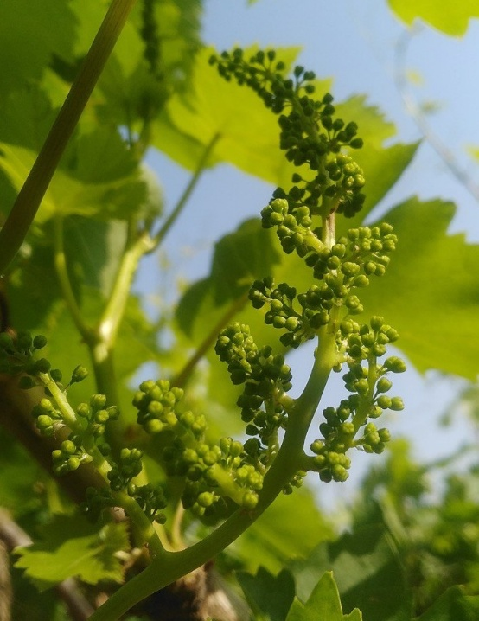 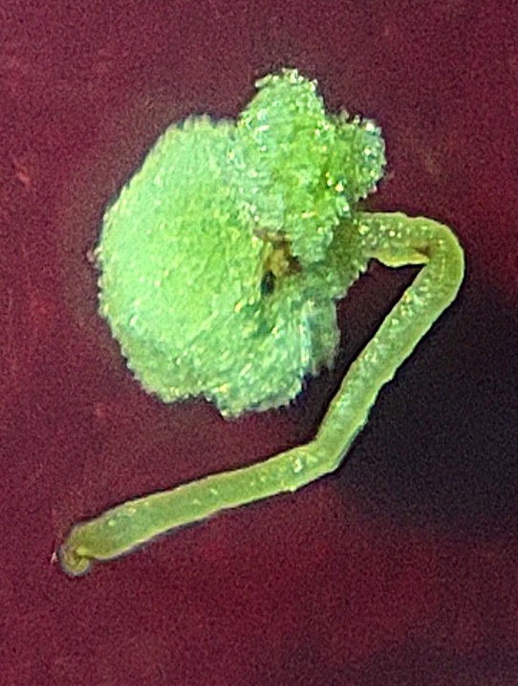

b

a

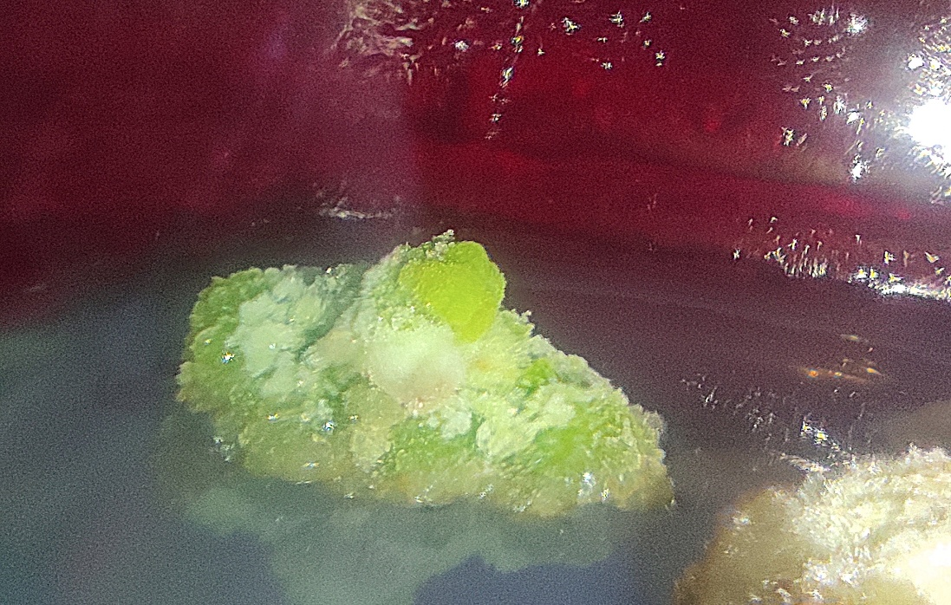 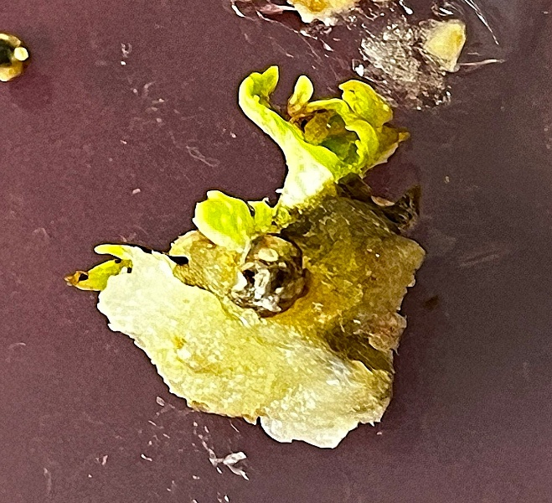

d

c

Fig. 1– Somatic embryogenesis and plantlet formation in grape (*Vitis vinifera* L. cv. Thompson Seedless) from anther explant. a. Explant selection. b. Callus induction from anther. c. Maturation of embryo. d. Plant regeneration of embryo.

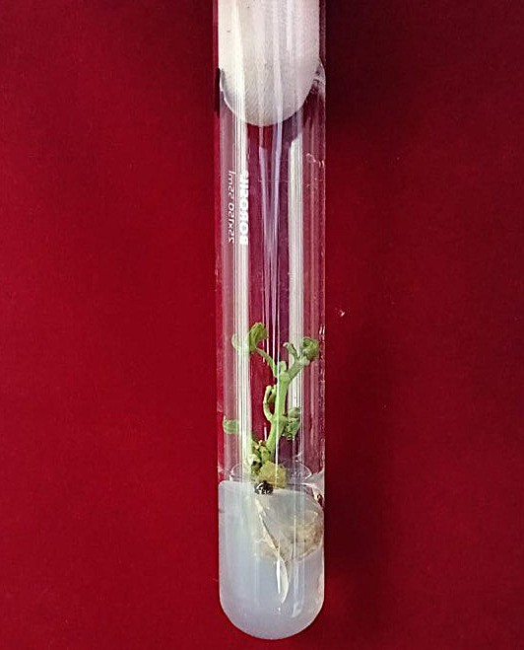 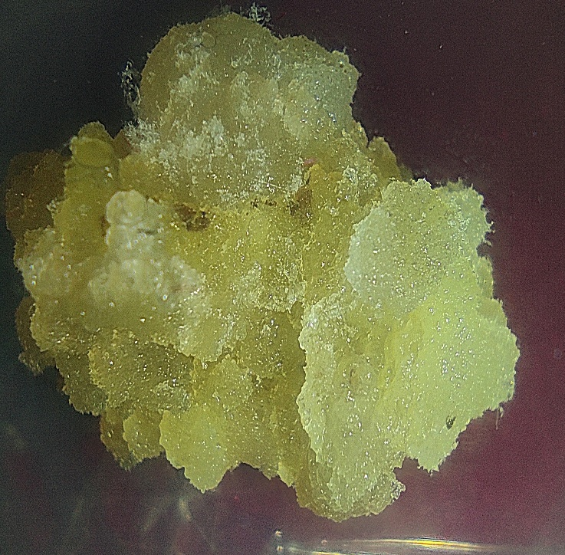 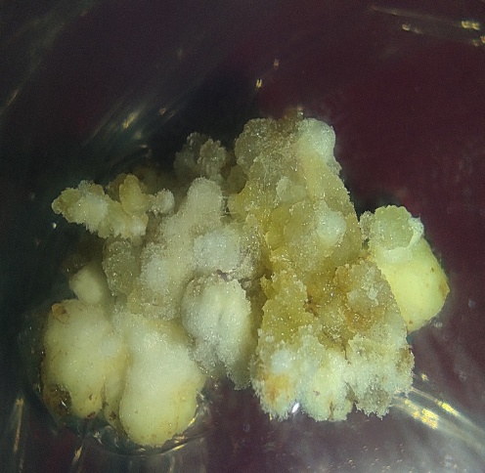 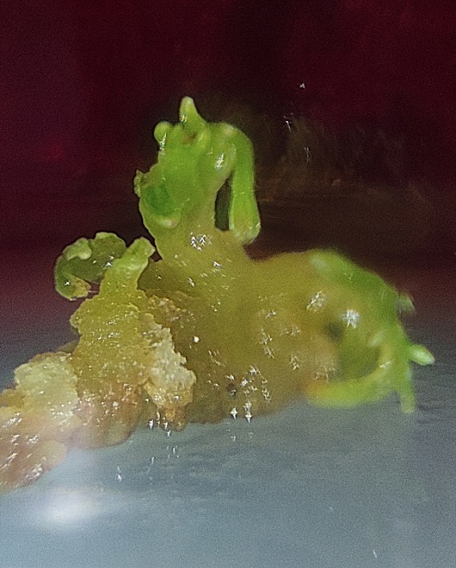

c

d

b

a

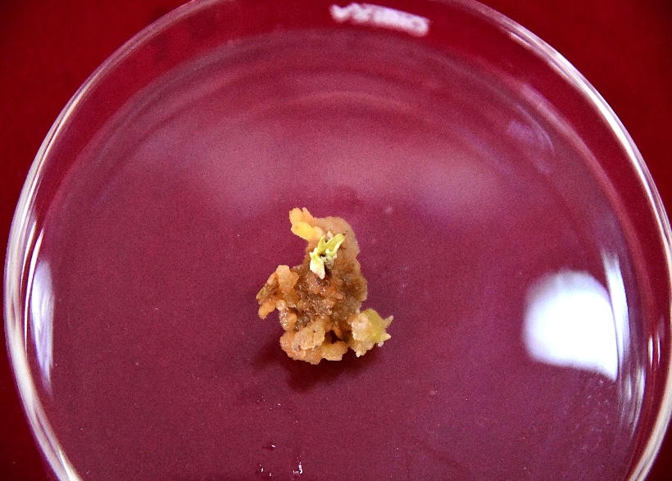

e

Fig. 2– Somatic embryogenesis and plantlet formation in grape (*Vitis vinifera* L. cv. Thompson Seedless) from leaf disc explant. a. Explant selection. b. Callus induction from leaf disc. c. Maturation of somatic embryo. d. Plant regeneration of the leaf disc embryo. e. shoot initiation from leaf disc

Disclaimer (Artificial intelligence)

Option 1: NO

Author(s) hereby declare that NO generative AI technologies such as Large Language Models (ChatGPT, manuscript.

Option 2:

Author(s) hereby declare that generative AI technologies such as Large Language Models, etc. have been used during the writing or editing of manuscripts. This explanation will include the name, version, model, and source of the generative AI technology and as well as all input prompts provided to the generative AI technology

Details of the AI usage are given below:

1.

2.

3.

**REFERENCES**

Bouquet, A., Piganeau, B. and Lamaison, A. M. (1982). Influence du génotype sur la production de cals, d'embryoïdes et de plantes entières par culture d'anthères in vitro dans le genre Vitis.

Chandra, S., Bandopadhyay, R., Kumar, V. and Chandra, R. (2010). Acclimatization of tissue cultured plantlets: from laboratory to land. *Biotechnology letters*, *32*(9), 1199-1205.

Compton, M. E. and Gray, D. J. (1993). Shoot Organogenesis and Plant Regeneration from Cotyledons of Diploid, Triploid, and Tetraploid. *J. Amer. Soc. Hort. Sci*, *118*(1), 151-157.

Correia, S., Alhinho, A. T., Casimiro, B., Miguel, C. M., Oliveira, M., Veríssimo, P. and Canhoto, J. (2019). NEP-TC a rRNA methyltransferase involved on somatic embryogenesis of tamarillo (*Solanum betaceum* Cav.). *Frontiers in Plant Science*, *10*, 438.

Das, D. K., Nirala, N. K., Redoy, M. K., Sopory, S. K. and Upadhyaya, K. C. (2006). Encapsulated somatic embryos of grape (*Vitis vinifera* L.): an efficient way for storage and propagation of pathogen-free plant material. *VITIS-GEILWEILERHOF-*, *45*(4), 179.

Dhekney, S. A., Li, Z. T., Compton, M. E. and Gray, D. J. (2009). Optimizing initiation and maintenance of Vitis embryogenic cultures. *HortScience*, *44*(5), 1400-1406.

Franks, T., Botta, R., Thomas, M. R. and Franks, J. (2002). Chimerism in grapevines: implications for cultivar identity, ancestry and genetic improvement. *Theoretical and Applied Genetics*, *104*(2), 192-199.

Franks, T., Gang He, D. and Thomas, M. (1998). Regeneration of transgenic shape Vitis vinifera L. Sultana plants: genotypic and phenotypic analysis. *Molecular Breeding*, *4*(4), 321-333.

Gambino, G., Gribaudo, I., Leopold, S., Schartl, A. and Laimer, M. (2005). Molecular characterization of grapevine plants transformed with GFLV resistance genes: I. *Plant Cell Reports*, *24*(11), 655-662.

Gambino, G., Ruffa, P., Vallania, R. and Gribaudo, I. (2007). Somatic embryogenesis from whole flowers, anthers and ovaries of grapevine (Vitis spp.). *Plant cell, tissue and organ culture*, *90*(1), 79-83.

Kaur, A., Reddy, M. S. and Kumar, A. (2018). Direct somatic embryogenesis of potato [Solanum tuberosum (L.)] cultivar ‘Kufri Chipsona 2’. *Plant Cell, Tissue and Organ Culture (PCTOC)*, *134*(3), 457-466.

Krul, W. R. and Worley, J. F. (1977). Formation of adventitious embryos in callus cultures of'Seyval', a French hybrid grape.

Maillot, P., Kieffer, F. and Walter, B. (2006). Somatic embryogenesis from stem nodal sections of grapevine. *VITIS-GEILWEILERHOF-*, *45*(4), 185.

Martinelli, L. U. C. I. A. and Gribaudo, I. (2001). Somatic embryogenesis in grapevine. In *Molecular biology & biotechnology of the grapevine* (pp. 327-351). Dordrecht: Springer Netherlands.

Martinelli, L. U. C. I. A. and Gribaudo, I. (2009). Strategies for effective somatic embryogenesis in grapevine: an appraisal. *Grapevine molecular physiology & biotechnology*, 461-493.

Martinelli, L., Scienza, A., Gianazza, E. and Villa, P. L. (1991, April). Somatic embryogenesis from leaves and petioles of grapevine. In *International Symposium on Plant Biotechnology and its Contribution to Plant Development, Multiplication and Improvement 289* (pp. 243-244).

Matsuta, N. (1992). Effect of auxin on somatic embryogenesis from leaf callus in grape (*Vitis* spp.). *Japanese Journal of Breeding*, *42*(4), 879-883.

Murashige, T. and Skoog, F. (1962). A revised medium for rapid growth and bio assays with tobacco tissue cultures. *Physiologia plantarum*, *15*(3).

Nitsch, J. P. and Nitsch, C. (1969). Haploid plants from pollen grains. *Science*, *163*(3862), 85-87.

Oláh, R., Zok, A., Pedryc, A., Howard, S. and Kovács, L. G. (2009). Somatic embryogenesis in a broad spectrum of grape genotypes. *Scientia horticulturae*, *120*(1), 134-137.Pinto-Sintra, A., 2007. Establishment of embryogenic cultures and plant regeneration in the Portuguese cultivar ‘Touriga Nacional’ of *Vitis vinifera* L. *Plant Cell Tissue Organ Cult.* 88, 253–265.

Perrin, M., Gertz, C. and Masson, J. E. (2004). High efficiency initiation of regenerable embryogenic callus from anther filaments of 19-grapevine genotypes grown worldwide. *Plant Science*, *167*(6), 1343-1349.

Pinto-Sintra, A. L. (2007). Establishment of embryogenic cultures and plant regeneration in the Portuguese cultivar ‘Touriga Nacional’of Vitis vinifera L. *Plant cell, tissue and organ culture*, *88*(3), 253-265.

Prado, M. J., Grueiro, M. P., González, M. V., Testillano, P. S., Domínguez, C., López, M. and Rey, M. (2010). Efficient plant regeneration through somatic embryogenesis from anthers and ovaries of six autochthonous grapevine cultivars from Galicia (Spain). *Scientia Horticulturae*, *125*(3), 342-352.

Rajasekaran, K. and Mullins, M. G. (1983). The origin of embryos and plantlets from cultured anthers of hybrid grapevines. *American Journal of Enology and Viticulture*, *34*(2), 108-113.

Sabbadini, S., Capriotti, L., Molesini, B., Pandolfini, T., Navacchi, O., Limera, C. and Mezzetti, B. (2019). Comparison of regeneration capacity and Agrobacterium-mediated cell transformation efficiency of different cultivars and rootstocks of Vitis spp. via organogenesis. *Scientific reports*, *9*(1), 582.

Stamp, J. A., & Meredith, C. P. (1988). Somatic embryogenesis from leaves and anthers of grapevine. *Scientia Horticulturae*, *35*(3-4), 235-250.

Usman, M., Hussain, Z. and Fatima, B. (2011). Somatic embryogenesis and shoot regeneration induced in cucumber leaves. *Pak. J. Bot*, *43*(2), 1283-1293.

Vidal, J. R., Rama, J., Taboada, L., Martin, C., Ibanez, M., Segura, A. and González-Benito, M. E. (2009). Improved somatic embryogenesis of grapevine (Vitis vinifera) with focus on induction parameters and efficient plant regeneration. *Plant cell, tissue and organ culture*, *96*(1), 85-94.

Von Arnold, S., Sabala, I., Bozhkov, P., Dyachok, J.and Filonova, L. (2002). Developmental pathways of somatic embryogenesis. *Plant cell, Tissue and Organ culture*, *69*(3), 233-249.