Identification of Trichoderma Strains isolated from Copper Mining Locations of Uttarakhand using BiOLOG Microstation System

Abstract
Twenty one Trichoderma stains ((20 isolates of TCMS series viz., TCMS-2, 4, 5, 12, 14a, 14b, 15, 16, 24, 32, 34, 36, 43, 60, 62, 64, 65, 72, 85 & 93 were isolated from the rhizospheric soil samples collected from different copper mining sites of Uttarakhand hills and one isolate of SBIT series i.e., SBIT-32 was collected from the Sri Biotech limited) were characterized/identified using BioLOG Microsystem Version 4.2. Cultures were incubated for 72 hours in the BioLOG Microsystem plates and the incubated plates were analyzed using Bio-Log Microsystem Version 4.2 for species identification. The BioLOG Microsystem determine the Trichoderma species based on various carbon source (substrate) utilization patterns among the 95 BioLOG substrates. Of these, ten isolates (TCMS-4, 12, 14a 15, 32, 34, 43, 72, 85 and 93) were identified as T. viride, five (TCMS 16, 24, 36, 60 and 65) were T. harzianum, three (TCMS 5, 14b and SBIT) were T. koningii and three isolates (TCMS 2, 62 and 64) belonged to Hypocrea lixii. The identified Trichoderma species may be further screened for their antagonistic potential and successfully used for the sustainable management of crop diseases in the organic cultivation system or in the integrated disease management strategies.
Key words: Biological control, Characterization, Biopesticides, Sustainability, Organic farming.
Introduction
Trichoderma is a soil inhabitant fungus which grow in diverse habitats. The fungi belonging to the genus under Deuteromycotina, Hyphomycetes, Moniliales, and Moniliaceae. This genus comprises large number of fungal species and are widely used for bio-control of plant diseases incited by fungal and bacterial pathogens. In addition, it was also found effective in increasing plant growth and development (Harman and Bjorkmann, 1998; Singh et al., 2006). These species alone or in combination with other Trichoderma species or compatible chemical fungicides have been used for the control of several diseases like root rots, wilts, damping off, white rot, collar rots etc. in a wide variety of crops (Samuels, 1996). Researchers are interested in this genus because of its novel biological properties against several plant pathogens and biotechnological applications. The ecological role of this genus is to play role in the decomposition of plant residues in soil. It is very difficult to identify the Trichoderma species based on morphological/microscopic or cultural characters. Keeping the above factors in view, a study was carried out on “Identification of Trichoderma isolates collected from copper mining areas of Uttarakhand using BioLOG Microsystem”.
Review of literature
The genus Trichoderma was first erected by Persoon (Cook and Baker, 1983; Bisset, 1991 a, b). Genus Trichoderma have traditionally been classified as Fungi Imperfectii as they were reported to produce only asexual spores i.e., conidia (Singh et al., 2006). With the recent advances in molecular taxonomy, many of the species have been reclassified as belonging to the genus Hypocrea of the class Ascomycetes (Gams and Bisset, 1998; Druzhinina et al., 2005). The teleomorph of this genus is Hypocrea Fr. under Hypocreales, Ascomycotina (Rifai and Webster, 1966a).
Rifai (1969) outlined the speciation concept with in genus Trichoderma and given nine species aggregates. Bisset (1992) elevated Rifai’s species aggregates to species level and recognized two to several species within each of five sections of the genus.
Kullnig et al. (2000) examined 76 isolates from Russia, Nepal and northern India, reporting five undescribed taxa. A similar study was carried out by Kubicek et al. (2002) in south-east Asia, in which seven new species were found among 96 strains (Bissett et al., 2003). Trichoderma isolates, representing different species and genotypes from three taxonomic sections of this genus (T. sect. Trichoderma, T. sect. Pachybasium and T. sect. Longibrachiatum) were chosen and screened for tolerance to increasing osmotic pressure and temperature while carbon assimilation was investigated using Phenotype Microarray technique with BioLog TM FF MicroPlates. Metabolic profiles based on growth and respiration on 95 carbon substrates was assessed on Biolog FF MicroPlates™. Ninety-six strains were isolated in total, and identified at the species level by analysis of morphological and biochemical characters (Biolog system), and by sequence analysis of their internal transcribed spacer regions 1 and 2 (ITS1 and 2) of the rDNA cluster, using ex-type strains and taxonomically established isolates of Trichoderma as reference.
Material and Methods
Collection of soil samples, isolation, and purification of Trichoderma
Extensive collections of soil samples were carried out in different farming situations from the copper mining areas of Uttarakhand such as Nainital, Bageshwar and Tehri Garwal districts. Approachable locations of copper mining sites were selected and visited for soil sampling. Generally healthy plants were selected from standing crop of a location and rhizospheric soil was collected. Plant was gently and carefully uprooted and soil tightly adhering to root was collected. Five such samples were collected randomly from the crop fields, mixed and 1/4th part of the sample was used as composite rhizospheric soil sample of the region. Soil samples were air dried for four hours. Isolation was done by employing serial dilution technique. Ten gram soil was suspended in 100 ml of sterile distilled water (1:10) and stirred well. The soil particles were allowed to settle down, 10 ml of clear supernatant was then transferred to another flask containing 90 ml sterile distilled water (1:100). Finally, suspension of 1:1000 dilutions was prepared by following same procedure.
Trichoderma selective medium (TSM) (Elad et al., 1981; Mukherjee, 1991) was used for isolation of Trichoderma. One ml soil suspension was taken with the help of 5 ml pipette and poured on the Petri plate seeded with TSM. The entire process was done in an inoculation chamber under aseptic conditions. The plates were incubated at 28±1⁰ C for 5 days. Trichoderma isolates were purified by single spore culture. The spores of the isolates were inoculated onto a Petri plate seeded with PDA medium. Sub-culturing was done from the growing front of the single new colony. Small number of spores were taken on the tip of a sterilized inoculating needle and streaked on potato dextrose agar poured Petri dishes. This process was repeated by taking inoculum from the edges of colonies growing in the freshly streaked Petri plate, and again streaking it in PDA plates. Colony arising from single spore was picked up and inoculated on a fresh plate. This culture was finally maintained and used for further studies.

Out of 49 Trichoderma strains isolated from the soil, 21 potential isolates were identified using BioLOG Microstation system including the isolate (SBIT) collected from the Sri BioTech Laboratory, Hyderabad were named as SBIT Series.
Characterization of Trichoderma isolates using BiOLOG Microstation System (Version 4.2)
The Microstation System/Microlog is an easy-to-use yet advanced tool for identifying and characterizing microorganisms. Combined databases include over 1,900 species of aerobic bacteria, anaerobic bacteria, fungi and yeasts. Biolog’s patented microbial identification technology with 95 carbon source utilization tests in a microtiter plate format (microplate™) can recognize over 4 x 10²⁸ possible metabolic patterns.
Principle
Biolog’s innovative, patented technology uses each microbe’s ability to use particular carbon sources to produce a unique pattern or “fingerprint” for that microbe. As a microorganism begins to use the carbon sources in certain wells of the microplate, it respires. For bacteria, this respiration process reduces a tetrazolium redox dye and those wells change color to purple. The end result is a pattern of colored wells on the microplate that is characteristic of that microorganism. For fungi, respiration and assimilation are detected. The color change in the wells is reddish orange due to the respiration of fungi, which reduces the dye. Assimilation or growth is detected by the turbidity of the well. A fungal pattern is readable either visually or by a fiber optic reading instrument the microstation reader. The fingerprint data is fed into the software, which searches its extensive database and makes identification in seconds. By developing a simple tool that allows 95 simultaneous carbon source (depicted in Table 1) utilization tests. Biolog has accomplished its goal of producing an efficient, easy-to-use, powerful, and reliable microbe identification system (Table 1).
Microbial Identification Process
Microbial identification involves four basic steps. These steps apply to all identifications.
Isolation of a pure culture on Biolog media
As a first step to accurate microbe identification and to generate well isolated colonies. Always use Biolog recommended culture media and growth conditions.
Preparion of inoculum at specified cell density
Microbiologists are sometimes trained to prepare cell suspensions by judging cell density by eye. This practice not yields accurate and reproducible results. Cell density determines oxygen concentration, a key parameter to control when testing microorganisms in microplates. In addition, Biolog has carefully optimized the required inoculating fluids.
Inoculation and incubation of microplate
Pipette the specified amount of cell suspension into the microplate, put the lid on, and incubate under the same conditions of temperature and atmosphere used to culture the microorganism.

Table 1: Substrates of BiOLOG Microstation System (Version 4.2) culture plates
Micro-wells | A | B | C | D | E | F | G | H
1 | Water | A Cyclodextrin | D Glucose 1 phosphate | D Mannitol | D Ribose | G Amino Butyric Acid | Saccharic Acid | Glycyl L Glutamic Acid
2 | Tween 80 | B Cyclodextrin | Glucuronamide | D Mannose | Salicin | Bromosuccinic Acid | Sebacic Acid | L Ornithine
3 | N Acetyl D galactosamine | Dextrin | D Glucuronic Acid | D Melezitose | Sedoheptulose | Fumaric Acid | Succinamic Acid | L Phenylalanine
4 | N Acetyl D Glucosamine | I Erythritol | Glycerol | D Melibiose | D Sorbitol | B Hydroxy Butyric Acid | Succinic Acid | Succinic Acid
5 | N Acetyl β D mannosamine | D Fructose | Glycogen | A Methyl D Galactoside | L Sorbose | G Hydroxy Butyric Acid | Succinic Acid Mono Methyl Ester | Succinic Acid Mono Methyl Ester
6 | Adonitol | L Fucose | M Inositol | A Methyl D Galactoside | Stachyose | P Hydroxyphenyl Acetic Acid | N Acetyl L Glutamic Acid | L Serine
7 | Amygdolin | D Galactose | 2 Keto D Gluconic Acid | B Methyl D Galactoside | Sucrose | A Keto Glutaric Acid | Alaninamide | L Threonine
8 | D Arabinose | D Galacturonic Acid | D Lactose | A Methyl D Glucoside | D Tagatose | D Lactic Acid Methyl Ester | L Alanin | Aminoethanol
9 | L Arabinose | Gentibiose | Lactulose | B Methyl D Galactoside | D Trehalose | L Lactic Acid | L Alanyl Glycine | Putrescine
10 | D Arabitol | D Gluconic Acid | Maltitol | Palatinose | Turanose | D Malic Acid | L Asperagine | Adenosine
11 | Arbutin | D Glucosamine | Maltose | D Raffinose | Xylitol | L Malic Acid | L Aspartic Acid | Uridin
12 | D Cellobiose | D Glucose | Maltotriose | L Rhamnose | D Xylose | Quinic Acid | L Glutamic Acid | Adenosine 5¹ Mono Phosphate

Reading the microplate and identification of the fungi
After an appropriate incubation time, read microplates either by eye or using the microstation reader. In either case, the pattern formed in the wells is entered into the software, which searches the database and provides identification in seconds.
Preparing inoculum
The fungus was isolated and cultured on PDA, a liquid inoculum was prepared with following standards.
Organism type | Inoculating Fluid | Turbidity Standards | Inoculum density
Filamentous Fungi | FF-IF (Filamentous Fungi- Inoculating Fluid) | FF (Filamentous Fungi) | 75% T (Turbidity)
Protocol for inoculation
Bio-Log microplates were labelled with the organism name/number and plate type (side of the microplate). Using aseptic technique, the suspension was poured into a multichannel pipette reservoir.
Eight sterile tips were firmly attached to the pipettor and filled the tips with the suspension. Primed the tips by dispensing once back into the reservoir. Filled all microplate wells by placing the tips at an angle inside the top of the wells. For filamentous fungi 100 μl inoculums suspension per well was added. Covered the microplate with its lid. Incubated at 26⁰C for 72 Hours.
Reading of microplate using the plate reader BiOLOG microstation system (Version 4.2, GEN II)
- Log on to Micro-Log 4.20.05 software.
- Select the Set up tool.
- Select the reader Type: Bio-Tek and Com Port: 1.
- Then, click on the Initialize Reader.
- After initialization, fix the microplate in Bio-Log Microstation in appropriate position.
- Name the output file, where it should be saved.
- Then select the Data tool and provide details regarding Plate No., Sample Type, Plate Type, Strain No. and incubation time.
- Click on the Read this button.
- Finally, save results and identification of the sample with most matching species.

Results and Discussion
Identification of selected potential Trichoderma isolates using Bio-Log System (BiOLOG Microstation System- Version 4.2)
Twenty one Trichoderma isolates (20 isolates of TCMS series viz., TCMS-2, 4, 5, 12, 14a, 14b, 15, 16, 24, 32, 34, 36, 43, 60, 62, 64, 65, 72, 85 & 93 and one isolate of SBIT series i.e., SBIT-32) were characterized/identified using BioLOG Microsystem version 4.2 after 72 hour incubation time, were used for species identification. Species of Trichoderma strains were identified based on various carbon source (substrate) utilization patterns among the 95 biolog substrates.
Of these, ten isolates (TCMS-4, 12, 14a 15, 32, 34, 43, 72, 85 and 93) were identified as T. viride, five (TCMS 16, 24, 36, 60 and 65) were T. harzianum, three (TCMS 5, 14b and SBIT) were T. koningii and three isolates (TCMS 2, 62 and 64) belonged to Hypocrea lixii. (plates 1).
Similarly, Kullnig et al. (2000) examined 76 isolates from Russia, Nepal and northern India, reporting five undescribed taxa. A similar study was carried out by Kubicek et al. (2002) in south-east Asia, in which seven new species were found among 96 strains (Bissett et al., 2003) using metabolic profiles based on growth and respiration on 95 carbon substrates assessed on Biolog FF MicroPlates™. Isolates of Trichoderma harzianum revealed metabolic and genetic variability that explain the broad distribution of this species aggregate in diverse habitats. Christian et al., (2003) identified 96 strains of Trichoderma at the species level by analysis of morphological and biochemical characters (Biolog system) using ex-type strains and taxonomically established isolates of Trichoderma as reference. Seventy-eight isolates were identified as T. harzianum (37 strains) T. virens (16 strains), T. spirale (8 strains), T. koningii (3 strains), T. atroviride (3strains), T. asperellum (4 strains), H. jecorina (anamorph: T. reesei; 2 strains), T. viride (2 strains), T. hamatum (1 strain) and T. ghanense (1 strain). A similar study was conducted by Lilliana et al. (2009) for diversity analysis of 183 isolates using Biolog system. A comparatively high diversity of species was found, comprising 29 taxa: T. asperellum (60 isolates), T. atroviride (3), T. brevicompactum (5), T. crassum (3), T. erinaceum (3), T. gamsii (2), T. hamatum (2), T. harzianum (49), T. koningiopsis (6), T. longibrachiatum (3), T. ovalisporum (1), T. pubescens (2), T. rossicum (4), T. spirale (1), T. tomentosum (3), T. virens (8), T. viridescens (7) and H. jecorina (3) along with 11 currently undescribed species.
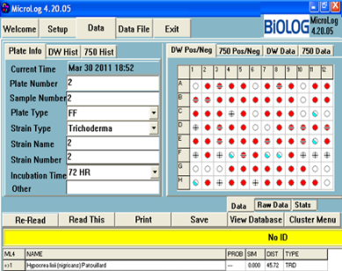 | 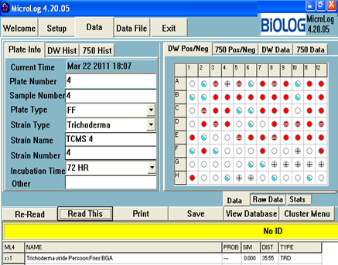 | 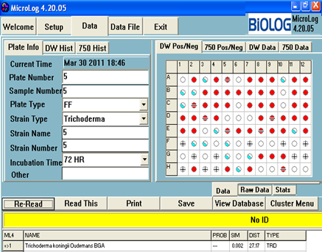
TCMS 2: Hypocrea lixii | TCMS 4: T viride | TCMS 5: T. koningii
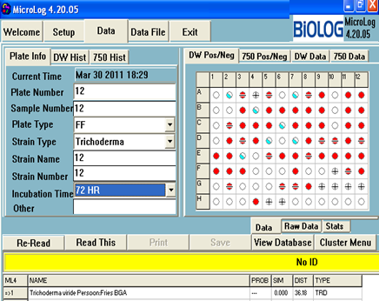 | 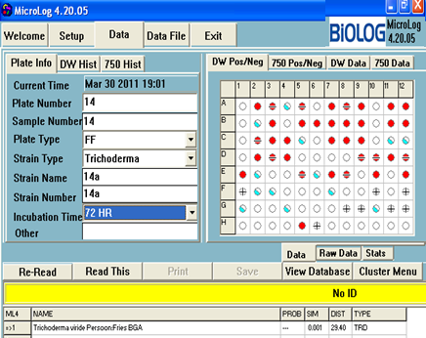 | 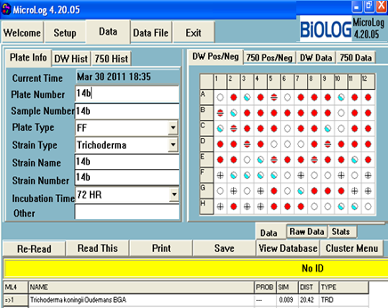
TCMS 12: T viride | TCMS 14a: T viride | TCMS 14b: T. koningii
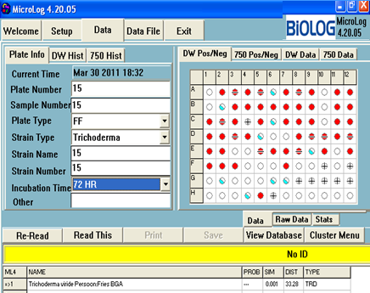 | 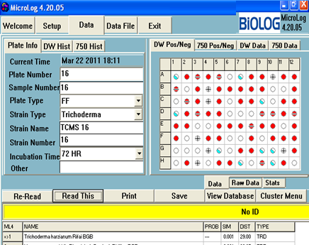 | 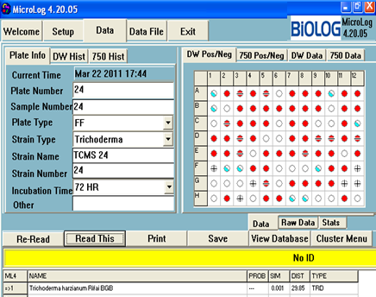
TCMS 15: T viride | TCMS 16: T harzianum | TCMS 24: T harzianum
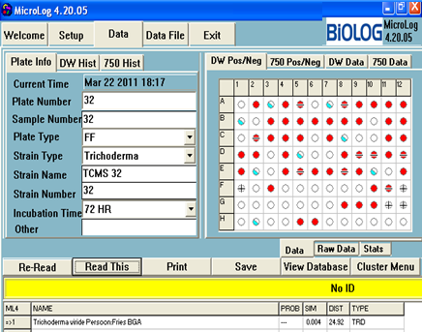 | 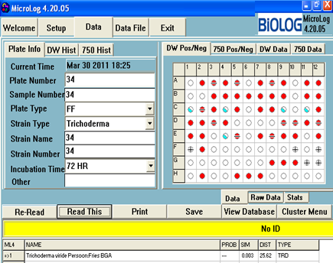 | 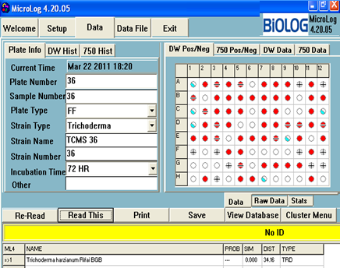
TCMS 32: T viride | TCMS 34: T viride | TCMS 36: T harzianum
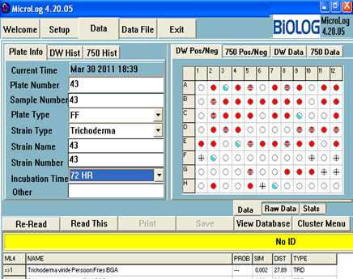 | 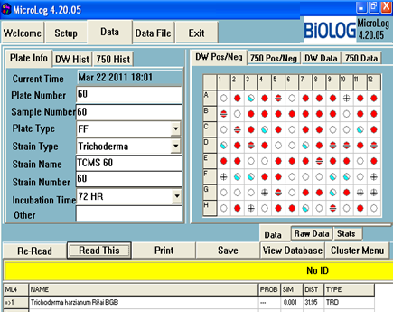 | 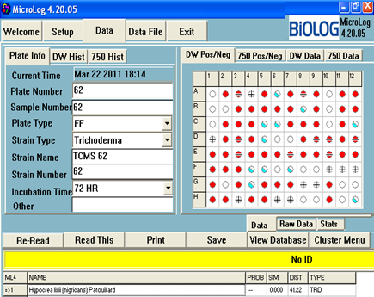
TCMS 43: T viride | TCMS 60: T harzianum | TCMS 62: Hypocrea lixii
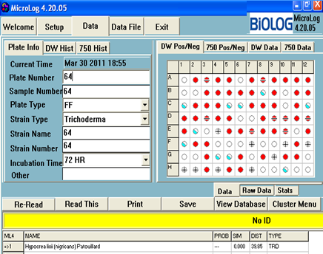 | 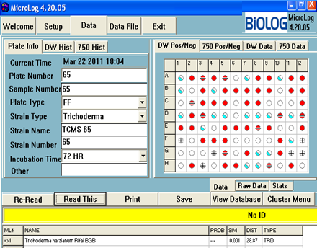 | 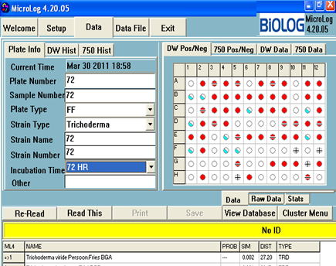
TCMS 64: Hypocrea lixii | TCMS 65: T harzianum | TCMS 72: T viride
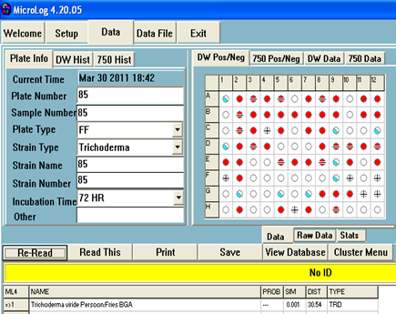 | 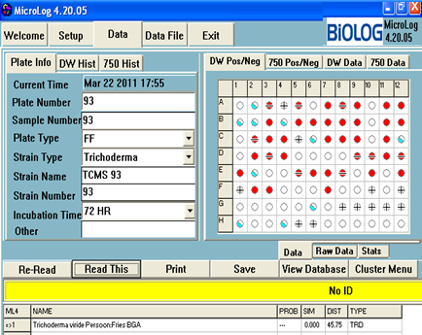 | 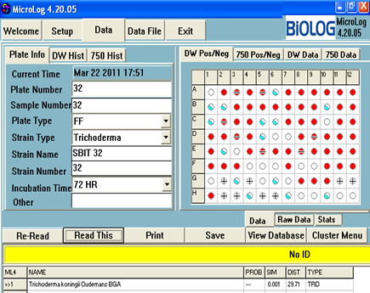
TCMS 85: T viride | TCMS 93: T viride | SBIT: T. koningii
Plate 1: Identification of Trichoderma spp. (TCMS 2) using BioLog Micro-station system
Conclusion
In the present study, BioLOG Microstation System was used to identify the Trichoderma strains isolated from the cooper mining sites of Uttarakhand. It was found that the BioLOG Microstation System is easy to handle, update, and is customized for specific needs. It identifies the fungi based on per cent utilization of carbon sources available in the BioLOG Microplate/s. Compared to molecular detection method, BioLOG Microstation System method is easier and didn’t require much inputs for the identification of fungi.The large number of organisms in Biolog's data base warrants ongoing verification of assigned identities with known authentic isolates. In summary, although the Biolog system offers great promise, its identifications should be viewed cautiously. BioLOG Microstation System is useful to identify the Trichoderma upto the species level. Once the Trichoderma identified with the BioLOG Microstation System, details about the species may be obtained from the data base of the Trichoderma or somewhere else and then utilized for specific purposes of the identified species after thorough screening.

References
Bisset, J. 1991a. A revision of the genus Trichoderma. II. Infrageneric classification. Canadian Journal of Botany 69: 2357-2372.
Bisset, J. 1991b. A revision of the genus Trichoderma. III. Section Pachybasium. Canadian Journal of Botany 69: 2373-2417.
Bisset, J. 1992. Molecular characterization of Trichoderma atroviride. Can. J Bot. 70: 639-641.
Bissett, J.; Szacaks, G.; Nolan, C.A.; Druzhinina, I.; Grandiger, C. and Kubicek, C., 2003. New species of Trichoderma from Asia. Can. J. Bot. 81: 570–586.
Christian, P.; Kubicek.; John Bissett.; Irina Druzhinina.; Cornelia Kullnig-Gradinger. and George Szakacs. 2003. Genetic and metabolic diversity of Trichoderma: a case study on South-East Asian isolates. Fungal Genetics and Biology 38: 310–319.
Cook, R.J. and Baker, K.F. 1983. The nature and practices of biological control of plant pathogens. St. Paul, MN: APS Books, pp: 599.
Druzhinina, I. S.; Kopchinskiy, A. G.; Komón, M.; Bissett, J.; Szakacs, G. and Kubicek, C. P., 2005. An oligonucleotide barcode for species identification in Trichoderma and Hypocrea, Fungal Genet. Biol. 42: 813–828.
Gams, W. and Bisset, J. 1998. Morphology and identification of Trichoderma.In Trichoderma and Gliocladium, vol. 1.Basic biology, taxonomy and genetics.Edited by G. E. Harman and C. P. Kubicek. London: Taylor and Francis. pp. 3-31.
Harman, G.E. and Bjorkmann, T. 1998. Potential and existing uses of Trichoderma and Gliocladium for plant disease control and plant growth enhancement.Edited by G. E. Harman and C. P. Kubicek. London: Taylor and Francis. Trichoderma and Gliocladium, vol.2.Enzymes, biological control and commercial applications, pp. 229–265.
Kubicek, C.; Bissett, J.; Druzhinina, I.; Kullnig-Grandiger, C. and Szakacs, G. 2002. Genetic and metabolic diversity of Trichoderma: a case study on South East Asian isolates. Fungal Genet. Biol. 38: 310–319.
Kullnig, C.; Szakacs, G. and Kubicek, C. 2000. Molecular identification of Trichoderma species from Russia, Siberia and the Himalaya. Mycol. Res. 104: 1117–1125.
Lilliana, Hoyos-Carvajal.; Sergio, Orduz. and John, Bissett. 2009. Genetic and metabolic biodiversity of Trichoderma from Colombia and adjacent neotropic regions. Fungal Genetics and Biology 46: 615–631.
Rifai M.A. 1969. A revision of the genus Trichoderma. Mycological Papers. 116: 1-56.
Rifai, M.A. and Webster, J. 1966a. Culture studies on Hypocrea and Trichoderma. II. H. aureoviridis and H. rufa, F. sterilis, F. nov. Trans. Brit. mycol. Soc. 49 (2): 289-296.
Samuels G.J. 1996. Trichoderma: a review of biology and systematics of the genus. Mycological Research. 100: 923-935.
Singh, S.K.; Sharma, V.P.; Sharma, S.R., Satish Kumar and Mugdha Tiwari 2006. Molecular characterization of Trichoderma taxa causing green mould disease in edible mushrooms. Current Science 90(3): 427-431.

