**“Parental Polymorphism and Hybrid testing in linseed *(Linum usitatissimum* L.) by using molecular markers.”**

**Abstract:** Linseed (*Linum usitatissimum* L.) is a valuable oilseed crop known for its nutritional and industrial significance. Despite its importance, linseed yield remains suboptimal in India due to limited genetic advancement. This study aimed to assess parental polymorphism and confirm hybrid purity using Random Amplified Polymorphic DNA (RAPD) markers. A linseed hybrid (FR.111 × LSL.93) and its parental lines, including a dwarf genotype, were evaluated both morphologically and molecularly. Morphological analysis revealed variation in traits such as seed yield per plant, days to flowering, and plant height, indicating heterosis in the F₁ generation. Genomic DNA was extracted using a modified CTAB method and amplified with five RAPD primers. Electrophoresis of PCR products generated clear banding patterns that were used to assess genetic similarity and hybridity. The presence of parent-specific bands in F₁ individuals confirmed the hybrid's genetic authenticity and purity. The study demonstrated the effectiveness of RAPD markers in detecting polymorphism and verifying hybrid identity. These findings highlight the utility of molecular markers in linseed breeding programs, offering a rapid and reliable method for hybrid confirmation. Integration of marker-assisted selection (MAS) can significantly enhance the efficiency of linseed improvement and support the development of high-yielding, genetically diverse cultivars.

**Keywords:** Linseed (*Linum usitatissimum* L.), Oilseed crop, Random Amplified Polymorphic DNA (RAPD).

**INTRODUCTION**

Linseed (*Linum usitatissimum* L.; 2n=30), a member of the *Linaceae* family and order *Geraniales*, is one of the earliest domesticated crops, valued for its dual utility as both an oilseed and Fiber crop. The genus *Linum* comprises over 300 species, although *L. usitatissimum* is the only species cultivated extensively for economic purposes. Commonly referred to as flax or flaxseed, linseed has been utilized since ancient times for food, Fiber, and medicinal applications, with historical records indicating its cultivation as early as 10,000 BCE in the Fertile Crescent. It later spread through trade routes and colonization to regions such as North America and Australia (Muir *et al*., 2003). Linseed holds significant nutritional and industrial value. It is a rich source of alpha-linolenic acid (ALA), a vital omega-3 fatty acid known for its anti-inflammatory and cardioprotective effects (Simopoulos, 2002). The seeds are also abundant in protein, dietary Fiber, magnesium, and B-complex vitamins, making them a key ingredient in food, cosmetic, pharmaceutical, and textile industries (Wojtasik *et al.,* 2015).Globally, linseed is cultivated on approximately 3 million hectares, with Canada, China, the USA, and India being major producers (FAO, 2024). In India, linseed is an important oilseed crop cultivated on about 468,000 hectares, with states like Maharashtra contributing significantly despite relatively low average yields. Agronomic practices suggest that linseed grows best in temperate regions with loamy soils, and is often rotated with cereal crops to manage root diseases (CFIA, 2012). Modern plant breeding programs have increasingly adopted molecular marker technologies to enhance crop improvement efforts. Techniques such as RAPD, SSR, and AFLP have been used to study genetic diversity, identify breeding lines, and support marker-assisted selection (MAS) (Bastia *et al*., 2001; *Fu et al.,* 2005). These tools are crucial for assessing parental polymorphism and verifying hybrid purity—two key aspects for ensuring the success of breeding programme. Given the agronomic, economic, and nutritional importance of linseed, it is essential to enhance its genetic potential through molecular breeding approaches. The present study aims to investigate “Parental polymorphism and hybrid testing in linseed (*Linum usitatissimum* L.) using molecular markers”**,** with the following specific objectives: To study the phenotypic characteristics of parents and F₁ hybrids in linseed. To assess hybrid purity in F₁ populations using molecular markers.

**MATERIAL AND METHODS**

Seeds of linseed hybrid namely FR. 111 × LSL. 93 (Medium) and parental line LSL-93 (Dwarf), FR. 111 (Medium) was collected from Oilseed Research Station Latur (MS). The experiment was conducted at Department of Plant Biotechnology, Vilasrao Deshmukh College of Agricultural Biotechnology, Latur (M.S.) during the year 2024-25.

**Methodology**

**2.1.1 Morphological analysis**

Observations were record on five randomly selected plants in each entry from each replication. Observations were record for the various traits of agronomical in given linseed germplasm as follows

**2.1.2 Height of plants (cm)**

The height of plants from the base, to the tip of the main stem was recorded in centimetres.

**2.1.3 Number of branches per plant**

The number of branches arising from the main stem was recorded of five randomly selected plants of each genotype and express in number**.**

**2.1.4 Number of capsules per plants**

The total number of seed-bearing capsules on the plant was counted and recorded.

**2.1.5 Duration for 50% flowering**

For each genotype, number of days taken from the day of sowing to the day on which 50% of plants show flowering was recorded.

**2.1.6 Weight of seeds (gm)**

Weights of 1000 seeds were recorded in gram in respect of each select plant in each replication.

**2.1.7 Number of seeds per capsules**

Seeds of five capsules at various height was taken from each genotype and the mean number of seeds per capsule was recorded.

**2.1.8 Yield per plant (gm)**

Yield per plant will be record in grams in respect of each select plant in each replication.

**2.1.9 Day of maturity**

Day to maturity will be taken from the date of sowing to stage when 50% of main branches have matured capsule, when the capsules colour changed from green to brownish.

**2.2 DNA extraction and Quantification.**

DNA was extracted by Cetyl Trimethyl Ammonium Bromide (CTAB) protocol given by Doyle and Doyle (1990) with some modifications and quantification was done by spectrophotometer. DNA was diluted in 0.1 T. E buffer to a concentration of 50 ng/micro-Liter for PCR analysis.

**2.3 Primer screening and polymerase chain reaction**

Five RAPD primers (Eurofins Genomics, India) were used for the present investigation. The list of the primers with their sequences is given in the below. Table No. PCR reaction ware performed using a 25 μl reaction mixture containing 10X PCR buffer with MgCl2, 10 mM dNTPs, 10 pmol primer, 1 U of Taq DNA polymerase, 50 ng/µl template DNA and sterile distilled water. For DNA amplification the DNA thermal cycler (Sens quest Lab cycler, Germany) was programmed as follows: incubation at 94⁰C for 10 min; 35 cycles at 94⁰C for 1 min (denaturation), 37⁰C for 1 min (annealing) and 72⁰C for 1min (extension), followed by one final extension cycle of 10 min at 72⁰C. After completion of the cycles the samples were kept at 4⁰C till electrophoresis. The amplified products were resolved on 1.5% for RAPD marker at 5V/cm for 1 to 1.5 hr. After electrophoresis, the gel was taken out for observation of banding pattern and photographed on a Gel Documentation System (Alpha-Inno tech, USA).

**Table No 1: List of RAPD primers used for hybrid purity assessment**

|  |  |  |  |
| --- | --- | --- | --- |
| **Sr. No** | **Primer** | **Sequences** | **No of Base Pairs** |
| 1 | OPA-1 | CAGGCCCTTC | 10 |
| 2 | OPA-2 | TGCCGAGCTG | 10 |
| 3 | OPA-3 | AGTCAGCCAC | 10 |
| 4 | OPA-4 | AATCGGGCTG | 10 |
| 5 | OPA-5 | CTGAGACGGA | 10 |

**Genetic Purity Test in Hybrid Seeds**

The percentage of hybrid genetic purity were calculated based on banding pattern that appears on the individual plant samples, with the following formula.

Purity hybrid (%) = {1-[NH/TS]} × 100%

Where: TS (total sample) =number of samples/individual plants were tested.

NH (non-hybrid) = number of samples/individual plants having the same banding pattern with female or male parents.

**RESULTS AND DISCUSSION**

**3.1 Development of F1**

In present investigation, two parental genotypes were used for crossing of which one genotype was dwarf and remaining genotype was tall. The FR-111 (Tall), used as female and LSL-93 (Dwarf) used as male parent. These genotypes were crossed successfully to obtained tall hybrid. The F1 hybrid seeds were harvested from particular cross after seed set and maturity.

**3.2 Development of F1 hybrid**

**3.2.1 Crossing programme**

In present investigation, two parental linseed genotypes were used for crossing in which female parent FR-111 was tall and male parent LSL-93 was dwarf. These genotypes were crossed successfully to obtained tall hybrid. The F1 hybrid seeds were harvested from cross after seed set and maturity.

**3.2.2 Morphological characterization**

Morphological traits of hybrid and its parental lines were observed throughout growing season.

**3.2.3 Plant height (cm)**

The plant height of female parent FR-111 is 50.15 and plant height of LSL-93 is 36.70cms. whereas (FR-111 x LSL-93) is 70.76 cm.

**3.2.4 Number of branches per plant**

The number of branches per plant for different parents FR-111 is 3.50 and 2.70. and branches of per hybrid as (FR-111 x LSL-93) varies from 4. 10.

**3.2.5 Number of capsules per plants**

The mean performance of parents for the number of capsules per plant ranged from 68.29 (FR-111). The cross FR-111x LSL-93 (71.98) produced.

**3.2.6 Duration for 50 % flowering**

The variation for days to 50 per cent flowering ranged from 39 days (LSL-93) to 47 days (FR-11) While crosses have 50% flowering is 43 days (FR-111 x LSL-93)

**3.2.7 1000 Weight of seeds (gm)**

The 1000 seeds weight of parents ranged from 5.90 g to 8.80 g. The line, FR-111 (5.90 g) had the lowest weight and the tester LSL-93 (8.80 g) had the highest weight. Among crosses weight of 1000 seeds is 8.82g (FR-111 x LSL-93).

**3.2.8 No of seeds per capsules**

Among the parents, the number of seeds per capsule varied from 6.95 (FR-111) and 7.45 (LSL-93). While crosses have no of seeds per capsules is 6.15 (FR-111 x LSL-93).

**3.2.9 Yield per plant (gm)**

The mean performance of the parents for seed yield per plant ranged from 2.20 g to 3.30. The line, FR-111 (2.60 g) had the lowest weight and the tester LSL-93 (3.25 g) had the highest weight. Among crosses yield per plant is 3.90 g (FR-111 x LSL-93)

**3.2.10 Day of maturity**

The lines, FR-111 (93 days) and tester LSL-93 (85 days) were found earlier than all the parents. Among the crosses, days to maturity ranged from 90 days (FR-111 x LSL-93).

**Table No 2. Agromorphological characteristics of parents and F1 cross estimated mid parent heterosis and heterobeltiosis**

|  |  |  |  |  |  |  |
| --- | --- | --- | --- | --- | --- | --- |
| Sr. No | Character | Female Parent FR-111 | Male Parent LSL-93 | Hybrids FR-111 X LSL-93 | Mid Parent Heterosis (%) | Heter-Obeltosis (%) |
| 1 | Days to 50 percent flowering | 47 | 34 | 43 | 6.96 | -8.51 |
| 2 | Days to maturity | 93 | 95 | 90 | -10 | -3.23 |
| 3 | Plant height (cm) | 50.15 | 36.23 | 47.08 | 9.25 | -6.12 |
| 4 | Number of branches per plant | 3.5 | 3.2 | 4.1 | 22.5 | 17.14 |
| 5 | Number of capsules per plant | 68.29 | 47.11 | 71.98 | 24.74 | 5.4 |
| 6 | Number of seeds per capsules | 6.95 | 8.45 | 6.15 | -20.12 | 5.15 |
| 7 | 1000 seed weight (g) | 5.9 | 8.8 | 8.82 | 20.03 | 7.82 |
| 8 | Seed yield per plant (g) | 2.6 | 3.25 | 3.9 | 33.22 | 4.85 |

Agromorphological characteristics of parents (P1 and P2) and F1 cross were recorded and also estimated mid parent heterosis for 12 characteristics. F1 plants had highest seed yield per plant (3.9 g) than both parents thus showed significant positive relative heterosis (4.85%). In breeders view a yield contributing character plays important role in selection of parents. Hence, for increasing production the selection of these parents will be key event. However, negative hererosis observed in cross characters viz. days to 50% flowering (-8.51), days to maturity (-3.23) and plant height (-6.1).

**3.2 DNA isolation and quality analysis**

The genomic DNA was extracted from young leaves of maize hybrid and their respective parents by Cetyl Trimethyl Ammonium Bromide (CTAB) DNA extraction method given by Doyle and Doyle (1990) with some modifications. This method yielded qualitatively as well as quantitatively pure genomic DNA. The quantification of extracted DNA was done by measuring absorbance at 260 nm wavelengths. Purity of DNA was checked by reading absorbance ratio of A260/280 for protein contamination. The quantitative and qualitative analysis was done by resolving DNA on 0.8% agarose gel. The concentrations of all samples were ranged between 500-1400 ng/μl. Working samples were prepared by diluting with sterile nuclease free water to obtain final concentrations of 50 ng/μl for RAPD analysis.

**3.3 Hybrid confirmation based on RAPD fingerprint profile analysis**

RAPD analysis would be very useful in breeding for rapid and early verification of hybrid population and even purity testing of different seed lots, allowing the detection of true hybrids and verification of parentage of the hybrids and lines/cultivars. RAPD analysis has been successfully used for hybrid and parentage verification of other crop plants. RAPD marker fingerprinting data was used for hybrid confirmation. The present study utilized total 5 RAPD markers for identification of linseed hybrid (FR-111×LSL-93) along with their female parental line (FR-111) and male parental line (LSL-93) hybrid confirmation discussed here under was donby comparing banding patterns of hybrids with their respective parents as described by

+ indicates presence of band

while – indicates absence of band.

**MPS**-Male parent specific band

**FPS**-Female parent specific band

**Table No 3: Types of RAPD markers observed in hybrid and their parents**

|  |  |  |  |  |  |
| --- | --- | --- | --- | --- | --- |
| **Markers Type** | **Female**  **(F)** | **Male (M)** | **Cross (H)** | **Nature** | **Remark** |
| 1 | **+** | **+** | **+** | Monomorphic | Good marker to confirm hybrid of its respective parents (male and/or female |
| 2 | **-** | **+** | **+** | MPS |
| 3 | **+** | **-** | **+** | FPS |
| 4 | **+** | **-** | **-** | - | Good markers to identify self and off types |
| 5 | **-** | **+** | **-** | - |
| 6 | **-** | **-** | **+** | Cross specific | Useful for identification of cross |

Akhare *et al.* (2008). Different types of markers have been designated for hybrid confirmation as per convenience in Coffea arabica (Mishra *et al.,* 2011) and cotton (Mehetre *et al.,* 2004). For hybrid purity analysis, the banding patterns was observed in the parents and hybrids (Table No. 2). Five RAPD primers viz., OPA-1, OPA-2, OPA-3, OPA-4 and OPG-5 (Figs. No. 1, 2, 3, 4 and 5) were used to confirm the purity and identity of the hybrid. Confirmation of hybrid was achieved by three primers amplified the specific allele size of OPG-5 (300 bp) and OPA-3 (350 bp) in hybrid and male parent but not amplified in female parent. This primer was used to confirm the true hybrid. These primers produced MPS band of Type 2 marker (Fig No. 5 and 3). OPA-1 and OPA-4 amplified the specific allele of size 500 bp and 600 bp respectively in hybrid and female parent but not amplified in male parent. These primers produced FPS band of Type 3 maker and used for hybrid confirmation (Fig No. 1 and 4). Out of primers one primers were found to be monomorphic of Type 1 marker viz. OPA-2 (Fig No. 2). Similar investigations based on RAPD analysis have been successfully employed for parentage verification, hybrid confirmation, cultivar identification and purity testing in maize (Asif *et al,* 2006; Mrutu 2015) and other crops such as sorghum (Shaikh, 2015; Akhare *et* *al*., 2008), rice (Deshmukh *et al.,* 2013) and cotton (Asif *et al,* 2009 and Dongre *et al.* 2005).

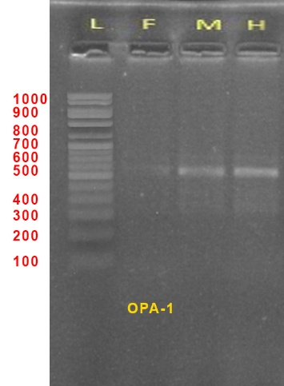

Fig No 1: Banding Profile of hybrid and parents obtained by Primer OPA-1

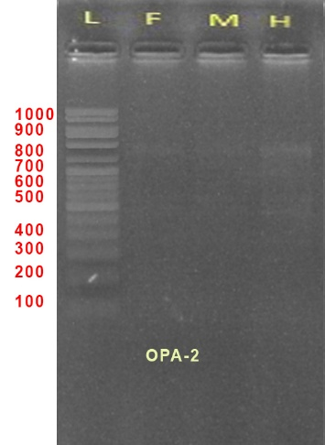

Fig No 2: Banding Profile of hybrid and parents obtained by Primer OPA-2

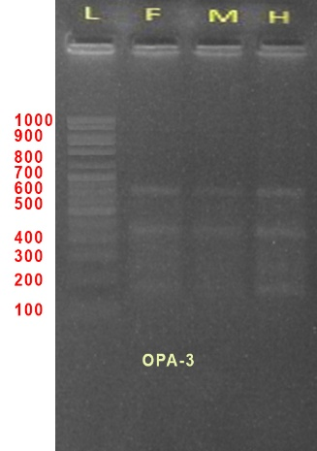

Fig No 3: Banding Profile of hybrid and parents obtained by Primer OPA-3

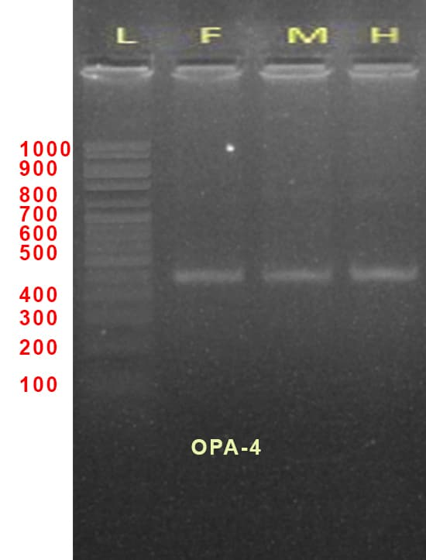

Fig No 4: Banding Profile of hybrid and parents obtained by Primer OPG-4

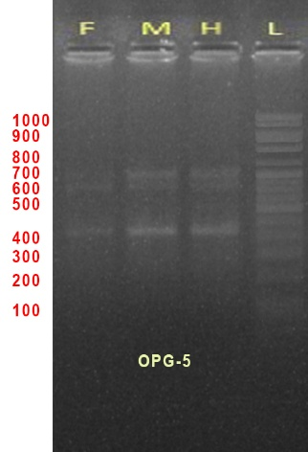

Fig No 5: Banding Profile of hybrid and parents obtained by Primer OPG-5

**REFERENCES**

Akhare AA, Sakhare SB, Kulwal PL, Dhumale DB, Kharkar, A. RAPD profile studies in sorghum for identification of hybrid and their parents. Intl. J. Integrative Biol 2008; 3:1-18.

Asif M, Rahman MU and Zafar Y. Genotyping analysis of six maize (*Zea mays* L.) hybrid using DNA fingerprinting technology. Pak. J. Bot 2006; 38:1425- 1430. 3.

Asif M, Rahman MU, Mirza JI and Zafar Y. Parentage Confirmation of Cotton Hybrids Using Molecular Markers. Pak. J. Bot 2009;41(2):695-701.

Bastia, T., & Singh, R. (2001). Molecular markers for genetic diversity in linseed (*Linum usitatissimum* L.). Journal of Genetics and Breeding, 55(2), 147-155

Deshmukh CU, Saxena RR, Xalxo SM, Sharma D and Verulkar SB. Hybrid purity testing in rice (*Oryza sativa* L) using microsatellite markers. Elec. J. Plant Breed 2013;4(1):1021-1026.

Dongre A and Pakhi V. Identification of cotton hybrid through the combination of PCR based RAPD, ISSR and microsatellite markers. Jr. Plant Biochem. Biotechnol 2005; 14:53-55.

Doyle JJ and Doyle JL. Isolation of plant DNA from fresh tissue. Focus 1990; 12:13–15.

Fu. Y. B. (2005). Geographic patterns of RAPD variation in cultivated flax. Crop Science, 45(3),

Mehetre SS, Gomes M and Eapen S. RAPD analysis of hybrid nature of the offspring of Gossypium hirsutum × G. raimond. Current Sci 2004; 87:25-28.

Mishra MK, Narayana S, Bhat AM, Nayani S, Kumar SS, Kumar A and Jayarama. Genetic molecular analysis of Coffea arabica (Rubiaceae) hybrids using SRAP markers. Rev. Biol. Trop 2011;59(2):607-617.

Mrutu BA. Assessment of seed genetic purity of hybrid maize variety UH6303 in southern highlands of Tanzania by random amplified polymorphic DNA (RAPD) markers. African J. Agric. Res 2015; 10:2911-2918.

Simopoulos, A. P. (2002). The importance of the ratio of omega-6/omega-3 essential fatty acids. Biomedicine & pharmacotherapy, 56(8), 365-379.

Wojtasik, W., Zieliński, H., & Miśta, M. (2015). Flax - a multipurpose crop: A review of its uses. Journal of Food Science and Technology, 52(4), 2485-2494. doi: 10.1007/s13394-014 1435-9.